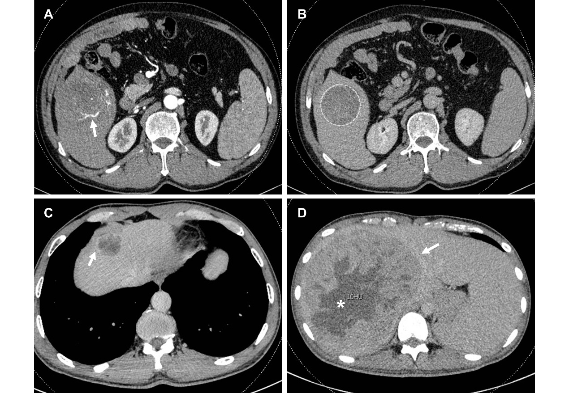
Figure S1: Imaging Features of Hepatocellular carcinoma on enhanced CT (I). A is the intratumoral artery in the arterial phase (arrow); B is the smooth edge of the tumor in the delayed phase (dotted line); C is the unsmooth edge in the delayed phase (arrowhead); D is intratumoral necrosis (*) and the arrow is the delayed tumor capsule.
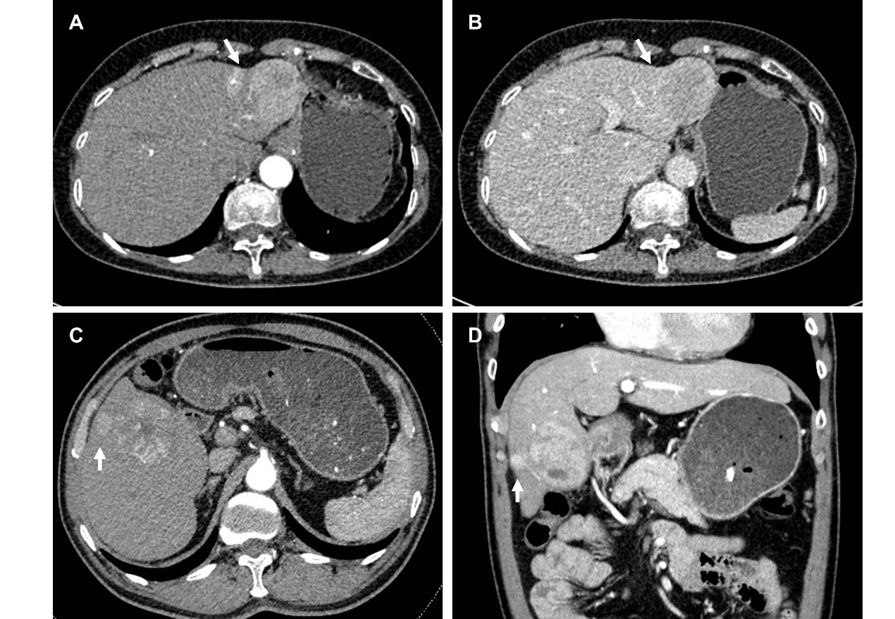
Figure S2: Imaging Features of Hepatocellular carcinoma on enhanced CT (II). A is peritumoral enhancement in the arterial phase (arrow), B is peritumoral enhancement regression in the delayed phase (arrow), C is peritumoral satellite nodule in the transverse position (arrowhead), and D is peritumoral satellite nodule in the coronal position (arrowhead).
Figure S3: Images show a highly differentiated hepatocellular carcinoma (HCC) in the right hemiliver of a 42-year-old man. A is the typical enhancement pattern of HCC: non-rim arterial hyperenhancement on the late arterial phase (arrow), non-peripheral wash-out appearance on the delayed phase (*); Microscopic examination with hematoxylin and eosin staining reveals the highly differentiated HCC (B).
Figure S4: Images show a medium-low differentiated hepatocellular carcinoma (HCC) in the right hemiliver of a 54-year-old man. The arterial phase (A) was not significantly enhanced (*), and the delayed phase (B) was a wash-out appearance (*). Contrast-enhanced CT (C) 2 years after surgery showed no obvious signs of recurrence. Microscopic examination with hematoxylin and eosin staining reveals the medium-low differentiated HCC (B).

