Flow Chemistry-Enabled Asymmetric Synthesis of Cyproterone Acetate: A Chemo-biocatalytic Approach
Yajiao Zhang,ª Minjie Liu,ª Xianjing Zheng,ª Liang Gao,ª Li Wan,ª Dang Cheng,ª Fen-Er Chen,*^{a,b}

[a] M. Liu, X. Zheng, L. Gao, L. Wan, D. Cheng, Prof. Dr. F.-E. Chen
Engineering Center of Catalysis and Synthesis for Chiral Molecules, Fudan University
Shanghai 200433 (China)
[b] Prof. Dr. F.-E. Chen
Institute of Flow Chemistry and Engineering, School of Chemistry and Materials, Jiangxi Normal University
Nanchang 330022 (China)
E-mail: rfchen@fudan.edu.cn

Table of Content
1. General Information 3
Figure S1 Protein expression of ReM2 examined by SDS-PAGE. 4
Figure S2 The complex structure of ReM2 assembled with FAD and 4-AD in the catalytic center for Δ¹-dehydrogenation. 5
2. Representative synthesis of cyproterone acetate (4) and its derivates. 6
Scheme S1 Neumann's asymmetric synthesis of cyproterone acetate. 6
Scheme S2 Kongkathip's synthesis of 16β-chloro-cyproterone acetate. 7
Scheme S3 Manosroi's asymmetric synthesis of cyproterone acetate. 8
3. Reaction Optimization 9
Table S1 Condition screening for ethynylation of 10 in batch. 9
Table S2 Condition screening for ethynylation of 10 with ethylmagnesium bromide in flow. 10
Table S3 Acid-mediated Rupe rearrangement of 12. 11
Table S4 Eaton′s reagent-catalyzed Rupe rearrangement of 12 in flow. 12
Table S5 Condition screening for Mukaiyama hydration of 9 in flow. 13
Table S6 Condition screening for C6, C7-dehydrogenation of 8 in flow. 14
Table S7 Condition screening for C20-ketalization of 13 in flow. 15
Table S8 Effect of reaction parameters on the catalytic C1, C2-cyclopropanation of 7. 16
Table S9 Condition screening for Corey-Chaykovsky C1, C2-cyclopropanation of 7 in batch. 17
Table S10 Condition screening for C6, C7-epoxidation of 6 in flow. 18
Table S11 Condition screening for C6, C7-epoxide opening/chlorination/dehydration/deprotection cascade reaction of 14 in flow. 19
Table S12 Condition screening for the O-acetylation of 5 in flow. 20
Scheme S4 The diagram for the ten-step continuous-flow synthesis of cyproterone acetate. 24
Figure S3 Fully continuous-flow synthesis platform for cyproterone acetate. 26
Figure S4 Graphical representation of the device used for the gravity L/L separator and the solvent evaporation/switch. 32
Table S13 Removal of solvents in a continuous-flow platform using the in-line evaporator/concentrator device. 33
4. Substrate synthesis and characterization 34
5. Co-catalyzed Mukaiyama Hydration Substrate Scope 56
6. Ni-catalyzed Cyclopropanation Substrate Scope 62
7. NMR Data 69
8. Chiral HPLC Data 118
9. X-Ray Diffraction Data 121
10. Reference 124

1. General Information
1.1 General considerations
Chemicals and solvents were purchased from Bidepharm, Leyan, Energy chemical, Sigma-Aldrich, Macklin, Aladdin, and used as received unless otherwise noted. DCM was freshly distilled and stored in a Schlenk tube. All other solvents were degassed and stored over activated 4 Å molecular sieves prior to use. All other reagents and starting materials were purchased from commercial vendors and used without further purification unless otherwise noted.
1.2 Physical methods
The thin-layer chromatography (TLC) was performed using 0.2 mm commercial silica gel plates impregnated with a fluorescent indicator (254 nm). A UV light (254 nm) was used to visualize TLC plates. Granular silica gel was used for flash column chromatography (60 Å pore size, 40-63 µm, 4-6% H₂O content, Synthware). ¹H NMR spectra were recorded with a Bruker AM400 (400 MHz) spectrometer. Chemical shifts are reported in parts per million (ppm) units on the delta (δ) scale, and are referenced from the residual protium in the CDCl₃ (δ = 7.26 ppm)、DMSO-d₆ (δ = 2.50 ppm), and CD₃OD (δ = 3.31 ppm). Data are reported as follows: chemical shift, [multiplicity (s = singlet, d = doublet, t = triplet, m = multiplet), coupling constant in Hertz (Hz). ¹³C NMR spectra were recorded with a Bruker AM 400 (100 MHz) spectrometer. Chemical shifts are referenced from the carbon resonances of CDCl₃ (δ = 77.23 ppm)、DMSO-d₆ (δ = 39.50 ppm), and CD₃OD (δ = 49.0 ppm). An Autopol I polarimeter was used to measure optical rotations. Measurement of melting points was carried out on an MP450 full-automatic melting-point instrument. Diastereomeric ratio of 8d-8f were determined from the corresponding Mukaiyama hydration products using chiral HPLC chromatography. An Agilent HPLC 1220 Series system and n-hexane and isopropanol were used for HPLC analyses. High resolution mass spectra (HRMS) were recorded on a Bruker microTOF Q III spectrometer with electrospray ionization (ESI).
For crystallization of 8, a 3:7 mixture of dichloromethane (DCM) and methanol (MeOH) was used for ultrasonic dissolution. The solution was then sealed with filter paper and placed at a constant temperature of 25°C for 10 weeks, resulting in the precipitation of colorless, transparent prismatic single crystals. For 6d and 6g, the compounds were respectively placed in 50 mL Erlenmeyer flasks and dissolved in a 1:10 mixture of DCM and dimethylformamide (DMF) using ultrasonic techniques. These solutions were also sealed with filter paper and kept at a constant temperature of 30°C for 5 days, leading to the precipitation of colorless, transparent prismatic single crystals.
1.3 Construction of E. coli expression strain of 3-ketosteroid dehydrogenase (Δ¹-KstD) and preparation of whole-cell catalysts and cell lysate
Phenazine methosulfate (PMS), Isopropyl-β-D-1-thiogalactopyranoside (IPTG, > 99%) and Ampicillin trihydrate were purchased from Sigma-Aldrich (China). Tryptone and yeast extract were purchased from OXOID (Shanghai, China). NaCl, Tris and all other chemicals are of chemical purity and commercially available.
The engineered Δ¹-KstD ReM2 (an improved dual-point mutant I51L/I350T of Δ¹-KstD from Rhodococcus erythropolis WY 1406) was ligated into pET-21a between NdeI and HindIII sites to generate the recombinant plasmid pET-21a-ReM2. The plasmid was then transferred into E. coli BL21 (DE3) for the protein expression.
E. coli BL21 (DE3) harbouring ReM2 was grown in Luria-Bertani (LB) broth containing 100 μg/mL ampicillin at 37 °C and 200 rpm. The culture was inoculated into 25 mL of ampicillin-containing LB medium and grown at 37 °C and 200 rpm. When the culture’s optical density (OD600 nm) reached 0.6-0.8, the protein expression was induced at 18 °C by adding 0.1 mM of IPTG. After cultivation for 24 h, the wet whole-cells were harvested by centrifugation (8000 rpm, 15 min, 4 °C) and resuspended using Tris-HCl buffer (pH 8.0) or reserved at -20 °C.
For large-scale whole-cell Δ¹-dehydrogenation using ReM2, the E. coli strain harbouring pET-21a-ReM2 was used for high-density fermentation in a 5-L glass tank. The media preparation and seed growth were conducted according to the reference¹. During the fermentation, air flow rate and stirrer speed were set at 3.0 vvm and 700 rpm for cell growth at 37 °C. Protein expression was induced by adding 10.0 g lactose when OD600 reached 20. The temperature for protein expression was 18 °C. The protein expression was examined using Sodium Dodecyl Sulfate Polyacrylamide Gel Electrophoresis (SDS-PAGE).
For E. coli cell lysate preparation, the whole-cells were lysed by ultrasonication in an ice bath using an ultrasonic cell grinder (Scientz JY96-IIN, Ningbo) and the lysate was stored at 4 °C for further use.

Figure S1 Protein expression of ReM2 examined by SDS-PAGE.
Following ultrasonic crushing and centrifugation, SDS-PAGE analysis was conducted on the supernatant of enzyme samples. Lane M, molecular weight standards; lane 1, E. coli-pET-21a; lane 2-5, E. coli-pET-21a-ReM2. The red rectangle represents that the size of ReM2 protein is about 60 kDa.

Figure S2 The complex structure of ReM2 assembled with FAD and 4-AD in the catalytic center for Δ¹-dehydrogenation.
The binding mode and hydrogen bonding between ReM2 and 4-AD were obtained from the lowest binding energy frame after molecular dynamic simulation using Amber20. The four key residues involved in the Δ¹-dehydrogenation reaction are shown in red sticks. 4-AD and FAD are depicted with green and orange sticks, respectively. Hydrogen bonds are shown in yellow dashed lines, and the distances (Å) are labelled in black on the lines.
1.4 Continuous-flow equipment
The continuous-flow system was established, including commercially available feeding equipment, continuous-flow reactors, process control units, etc.
The feeding equipment: syringe pump (Fusion 101, CHEMYX), plunger pump (MPF0102D, SANOTAC), plunger pump (SP0530, SANOTAC), plunger pump (AP0015, SANOTAC), plunger pump (SF0105A, SANOTAC), plunger pump (SH0530, SANOTAC) and peristaltic pump (BT101L, LEADFLUID).
Continuous reactors: PTFE Coil reactor (0.8 mm I. D., 1.6 mm O. D. and 1.6 mm I. D., 3.2 mm O. D.), Peek Coil reactor (2.1 mm I. D., 3.2 mm O. D.), Oscillation agitate reactor (OAR, 30 mL) (Shenzhen E-zheng tech Co., Ltd in China).
Process control units: stainless steel one-way valve (SS-CVG01A-K1F, Shanghai Xitai Fluid Technology Co., Ltd), back pressure valve (45 psi, IDEX Corporation), liquid-liquid membrane separator and thermostat (Integral XT150, Lauda), Gravity L/L separator (Glass, 1.0 cm I. D., 1.2 cm O. D., 15 mL), Gravity L/L separator (Glass, 2.25 cm I. D., 2.5 cm O. D., 100 mL), Packed-bed (40 mm I.D.).
The fully continuous-flow platform is constructed occupying an area of approximately 16 square meters (4 x 4 m²) in the laboratory.

2. Representative synthesis of cyproterone acetate (4) and its derivates.
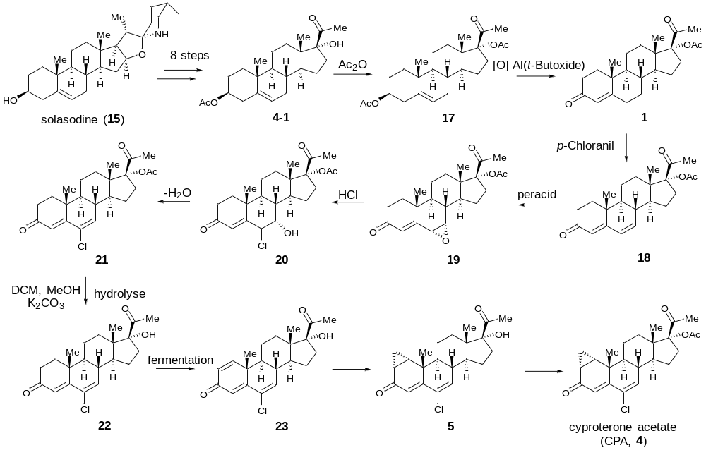

Scheme S1 Neumann's asymmetric synthesis of cyproterone acetate².

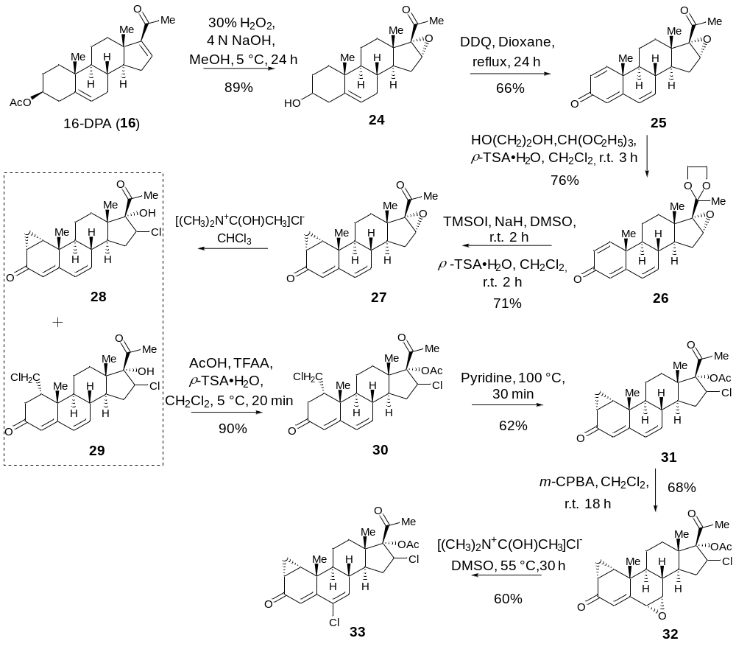

Scheme S2 Kongkathip's synthesis of 16β-chloro-cyproterone acetate³.

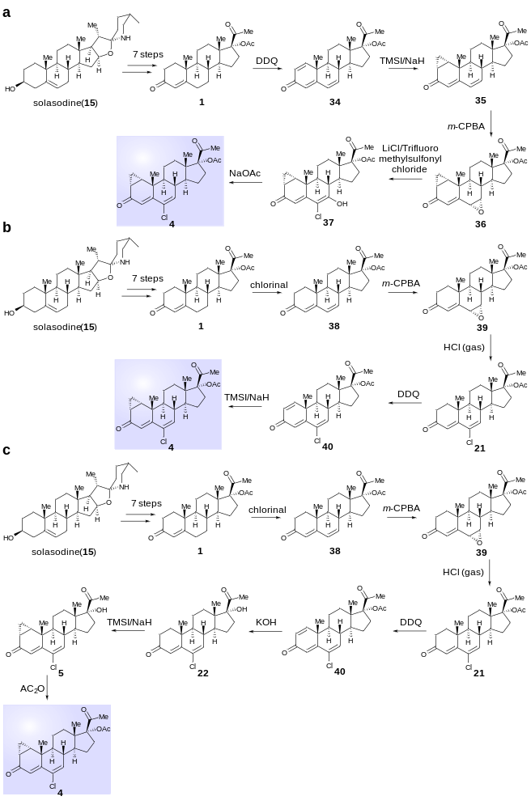

Scheme S3 Manosroi's asymmetric synthesis of cyproterone acetate⁴.

3. Reaction Optimization

Table S1 Condition screening for ethynylation of 10 in batch.ª
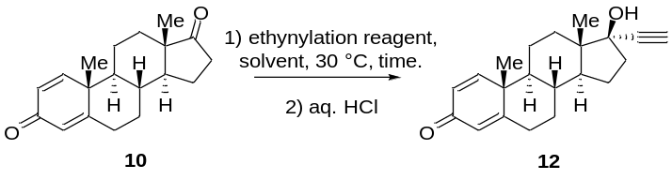

Entry | Reagent | Solvent | Time (h) | Conv. (%)^{b}
1 | C₂HNa (2.0 equiv.) | THF | 3.0 | n.r.^{c}
2 | C₄H₉LiN₂ (2.0 equiv.) | THF | 3.0 | n.r.^{c}
3 | C₂HMgBr (2.0 equiv.) | THF | 3.0 | 99
4 | C₂HMgBr (1.5 equiv.) | THF | 3.0 | 99
5 | C₂HMgBr (1.0 equiv.) | THF | 3.0 | 90
6 | C₂HMgBr (1.5 equiv.) | THF | 2.0 | 99
7 | C₂HMgBr (1.5 equiv.) | THF | 1.5 | 99 (87.3)^{d}
8 | C₂HMgBr (1.5 equiv.) | THF | 1.0 | 85
9 | C₂HMgBr (1.5 equiv.) | THF/DMF (4:1) | 1.5 | n.r.^{c}
10 | C₂HMgBr (1.5 equiv.) | THF/DMSO (4:1) | 1.5 | n.r.^{c}
11 | C₂HMgBr (1.5 equiv.) | THF/HMPA (4:1) | 1.5 | n.r.^{c}
12 | C₂HMgBr (1.5 equiv.) | THF/DCE (4:1) | 1.5 | 99
13 | C₂HMgBr (1.5 equiv.) | THF/DCE (1:1) | 2.0 | 99
14 | C₂HMgBr (1.5 equiv.) | THF/DCE/HMPA (4: 5:1) | 2.0 | 55
15 | C₂HMgBr (1.5 equiv.) | THF/DCE/HMPA (21:25:4) | 2.0 | 72
16 | C₂HMgBr (1.5 equiv.) | THF/DCE/HMPA (22:25:3) | 2.0 | 95
17 | C₂HMgBr (1.5 equiv.) | THF/DCE/HMPA (9:10:1) | 2.0 | 99 (85)^{d}
18 | C₂HMgBr (1.5 equiv.) | THF/DCE/HMPA (47:50: 3) | 2.0 | 99
19 | C₂HMgBr (1.5 equiv.) | THF/DCE/HMPA (49: 50:1) | 2.0 | 99
ª Unless otherwise noted: all reactions were performed using 10 (100.0 mg, 0.35 mmol, 1.0 equiv.) in DCE/HMPA (600 μL), ethynylation reagent (1.0-2.0 equiv.) in anhydrous THF (400 μL) at 30 °C for 1-3 h.
^{b} Determined by LC-MS analysis of the reaction mixtures.
^{c} No reaction.
^{d} Isolated yield.

Table S2 Condition screening for ethynylation of 10 with ethylmagnesium bromide in flow.ª
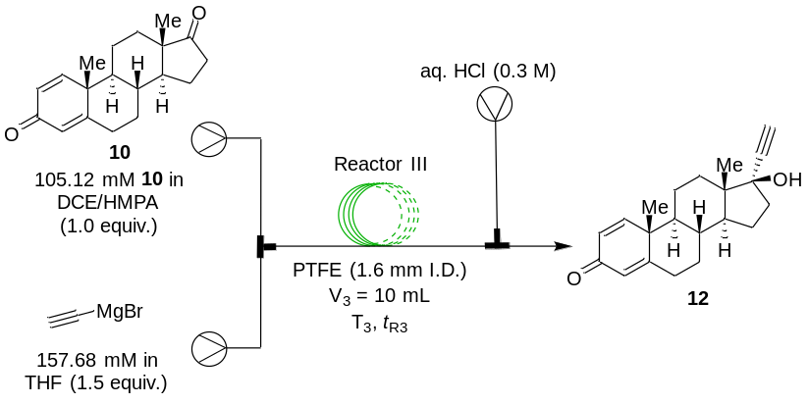

Entry | Solvent | T₃. (°C) | t_{R3} (min) | Conv. (%)^{c}
1^{b} | THF | 30 | 18 | Clogging
2^{b} | THF/DCE (5:5) | 30 | 18 | Clogging
3 | THF/HMPA (19:1) | 30 | 18 | 48
4 | THF/DCE/HMPA (9:10:1) | 30 | 18 | 22
5 | THF/DCE/HMPA (9:10:1) | 40 | 18 | 61
6 | THF/DCE/HMPA (9:10:1) | 45 | 18 | 76
7 | THF/DCE/HMPA (9:10:1) | 50 | 18 | 98
8 | THF/DCE/HMPA (9:10:1) | 50 | 12 | 88
9 | THF/DCE/HMPA (9:10:1) | 55 | 12 | 98
10 | THF/DCE/HMPA (9:10:1) | 55 | 9 | 82
11 | THF/DCE/HMPA (9:10:1) | 60 | 9 | 98 (83.1)^{d}
ª Unless otherwise noted: all reactions were performed using 10 (105.12 mM) in DCE/HMPA, and Grignard reagent ethylmagnesium bromide (157.68 mM, 1.5 equiv.) in anhydrous THF at 30-60 °C for 9-18 min in Reactor III.
^{b} Coil was blocked.
^{c} Determined by LC-MS analysis of the reaction mixture.
^{d} Isolated yield.

Table S3 Acid-mediated Rupe rearrangement of 12.ª
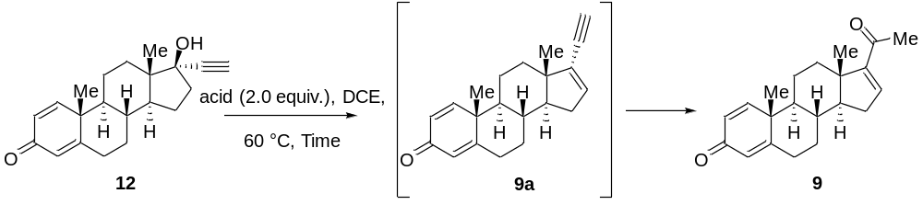

Entry | Acids (2.0 equiv.) | Time (h) | Conv. of 12 (%)^{b} | Yield of 9a (%)^{c} | Yield of 9 (%)^{d}
1 | TfOH | 20 | N.R.^{e} | - | -
2 | H₂SO₄ | 6 | 99 | 80 | 10
3 | Eaton's reagent | 6 | 99 | 15 | 78
4 | MeSO₃H | 20 | 20 | N.D.^{f} | N.D.
5 | Amberlyst15 | 20 | 80 | 30 | 42
6 | TsOH | 20 | N.R. | - | -
7 | AlCl₃ | 20 | 99 | N.D. | N.D.
8 | Acetic acid | 20 | N.R. | - | -
ª Unless otherwise noted: all reactions were performed using 12 (100.0 mg, 0.3 mmol, 1.0 equiv.), and acid (2.0 equiv.) in DCE (1.0 mL) at 60 °C.
^{b, c} Determined by LC-MS analysis of the reaction mixture.
^{d} Isolated yield.
^{e} No reaction.
^{f} No detection.

Table S4 Eaton′s reagent-catalyzed Rupe rearrangement of 12 in flow.ª
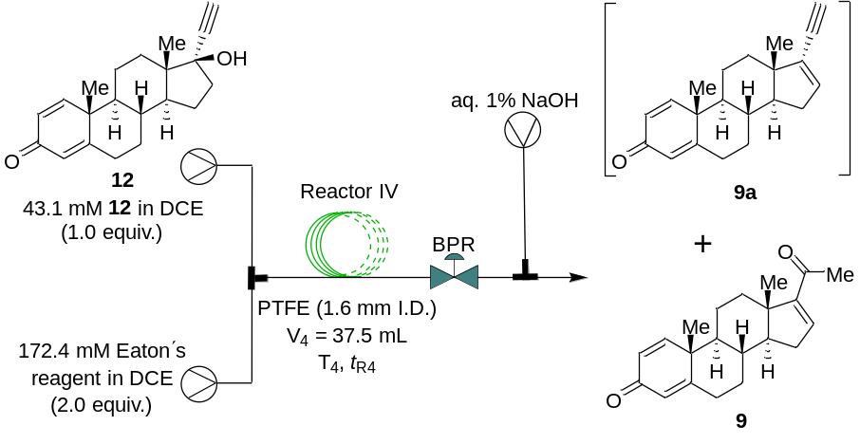

Entry | Temp.  (°C) | BPR  (bar) | t_{R4}  (min) | Conv.  (%)^{b} | Yield  (%)^{c} of 9a | Yield  (%)^{c} of 9
1 | 60 | 4.0 | 30 | 53 | 43 | 10
2 | 70 | 4.0 | 30 | 70 | 55 | 15
3 | 80 | 4.0 | 30 | 99 | 18 | 65
4 | 90 | 4.0 | 30 | 99 | 15 | 53
5 | 100 | 4.0 | 30 | 99 | 7 | 41
6 | 80 | 3.0 | 30 | 99 | 21 | 74
7 | 80 | 3.0 | 25 | 99 | 15 | 82 (73)^{d}
8 | 80 | 3.0 | 20 | 99 | 8 | 79
9 | 80 | 2.0 | 20 | 99 | 18 | 75
10 | 80 | 2.0 | 15 | 91 | 15 | 66
ª Unless otherwise noted: all reactions were performed using 12 (43.1 mM) in DCE, and with Eaton′s reagent (7.7 wt% P₂O₅ in methanesulfonic acid, 1.5 equiv.) in DCE at a temperature range of 60-100 °C for 15-30 min under 2.0-4.0 bar back-pressure in Reactor IV.
^{b,c} Determined by LC-MS analysis of the reaction mixture.
^{d} Isolated yield.

Table S5 Condition screening for Mukaiyama hydration of 9 in flow.ª
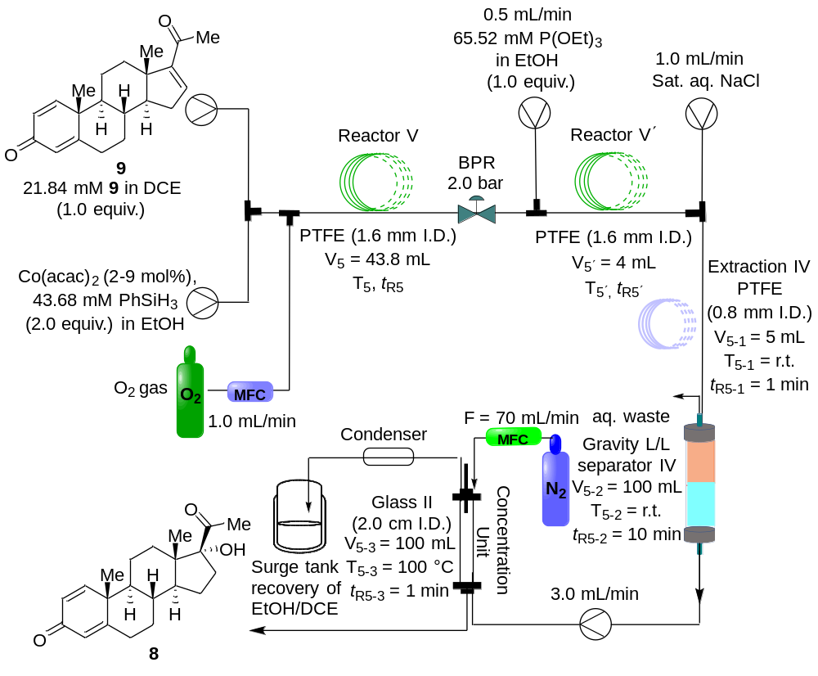

Entry | Solvent (1:1) | Temp. (°C) | Co(acac)₂ (X mol%) | Time (min) | Conv. (%)^{b}
1 | EtOH | 25 | 2 | 10 | 99 (80)^{c}
2 | EtOH/DCE | 25 | 2 | 10 | 33
3 | EtOH/DCE | 25 | 3 | 15 | 51
4 | EtOH/DCE | 25 | 6 | 15 | 74
5 | EtOH/DCE | 25 | 9 | 15 | 83
6 | EtOH/DCE | 30 | 9 | 15 | 93
7 | EtOH/DCE | 35 | 9 | 15 | 99
8 | EtOH/DCE | 35 | 9 | 12.5 | 99 (78.3)^{c}
9 | EtOH/DCE | 35 | 9 | 10 | 92
ª General procedure unless otherwise noted: reactions were performed using 9 (21.84 mM) in DCE, Co(acac)₂ (2-9 mol%), and PhSiH₃ (2.0 equiv.) in EtOH at 25-35 °C. The reactions were conducted at a temperature range of 25-35 °C under a pressure of 2.0 bar for 10-15 min, with a flow of 1 mL/min of oxygen.
^{b} Determined by LC-MS analysis of the reaction mixture.
^{c} Isolated yield.

Table S6 Condition screening for C6, C7-dehydrogenation of 8 in flow.ª
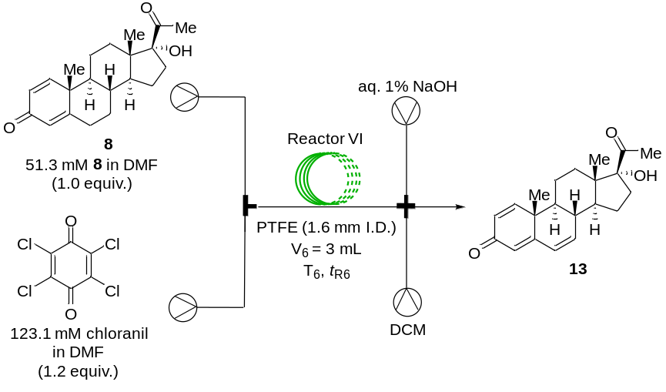
Entry | T₆ (°C) | t_{R6} (min) | Conv. (%)^{b}
1 | 100 | 15 | 30
2 | 120 | 15 | 99
3 | 120 | 10 | 90
4 | 130 | 10 | 99
5 | 130 | 6 | 97
6 | 140 | 6 | 99
7 | 140 | 4 | 99 (83)^{c}
ª General procedure unless otherwise noted: reactions were performed using 8 (51.3 mM, 1.0 equiv.) in DMF, chloranil (1.2 equiv.) in DMF at 100-140 °C for 4-15 min in Reactor VI.
^{b} Determined by LC-MS analysis of the reaction mixture.
^{c} Isolated yield.

Table S7 Condition screening for C20-ketalization of 13 in flow.ª
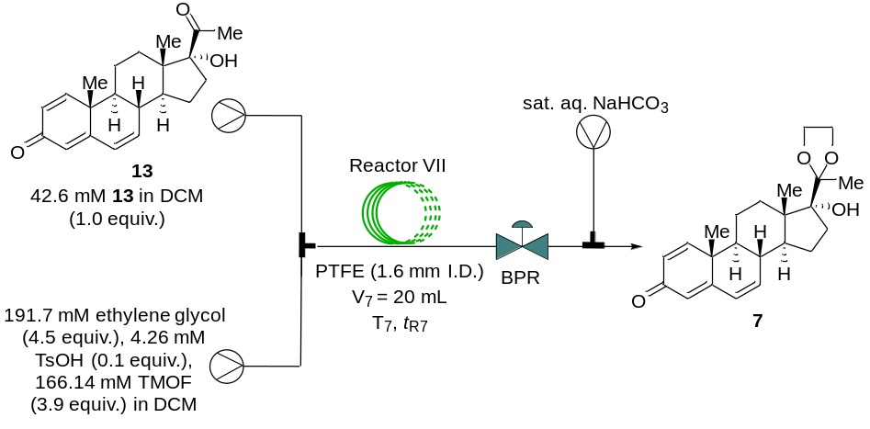
Entry | T₇ (°C) | t_{R7} (min) | BPR (bar) | Conv. (%)^{b}
1 | 40 | 20 | 4.0 | 66
2 | 50 | 20 | 4.0 | 82
3 | 60 | 20 | 4.0 | 87
4 | 70 | 20 | 4.0 | 94
5 | 80 | 20 | 4.0 | 96
6 | 90 | 20 | 4.0 | 98 (92)^{c}
7 | 90 | 15 | 4.0 | 93
8 | 90 | 15 | 6.0 | 94
9 | 100 | 15 | 6.0 | 77
ª Unless otherwise noted: all reactions were performed using a solution of DCM crude 13 from the Δ⁶-dehydrogenation, TsOH (0.1 equiv.), ethylene glycol (4.5 equiv.), and trimethyl orthoformate (TMOF, 3.9 equiv.) in DCM at 40-100 °C for 15-20 min in Reactor VII and with the use of 4.0-6.0 bar back-pressure.
^{b} Determined by LC-MS analysis of the reaction mixtures.
^{c} Isolated yield.

Table S8 Effect of reaction parameters on the catalytic C1, C2-cyclopropanation of 7.ª
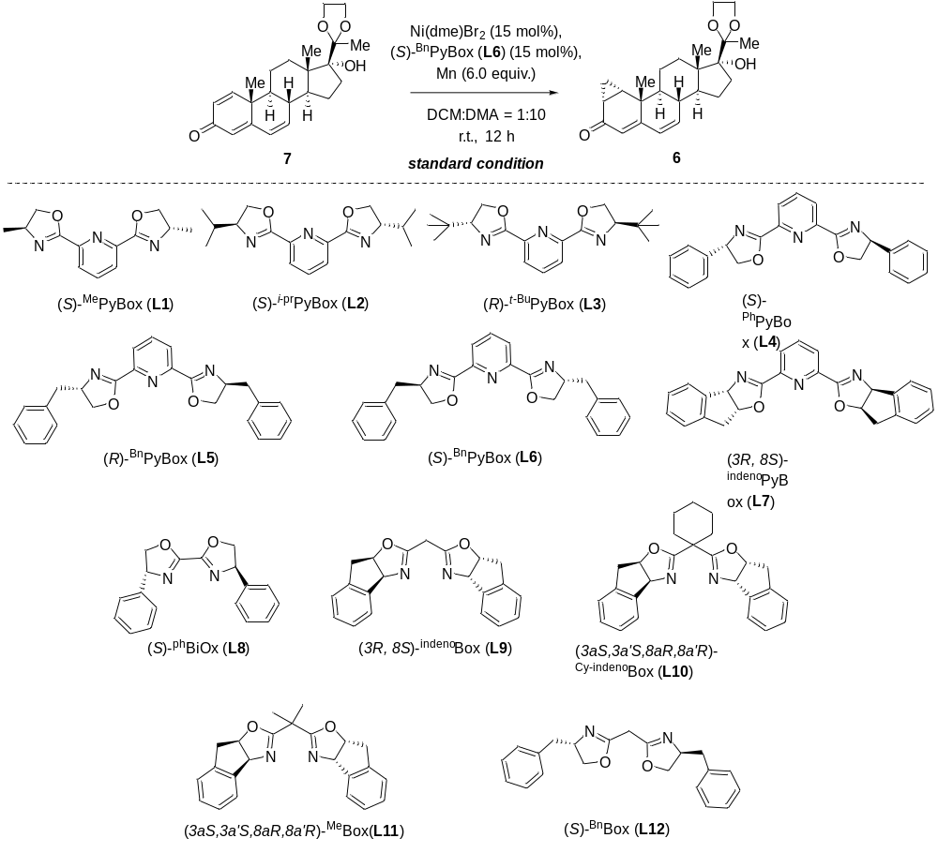
Entry | Variation from standard conditions | Yield (%)^{b}
1 | None | 62
2 | (S)-^{Me}PyBox (L1) instead of L6 | 56
3 | (S)-^{i-pr}PyBox (L2) instead of L6 | 92
4 | (R)-^{t-Bu}PyBox (L3) instead of L6 | 81
5 | (S)-^{Ph}PyBox (L4) instead of L6 | 17
6 | (R)-^{Bn}PyBox (L5) instead of L6 | 75
7 | (3R, 8S)-^{indeno}PyBox (L7) instead of L6 | 49
8 | (S)-^{ph}BiOx (L8) instead of L6 | 13
9 | (3R, 8S)-^{indeno}Box (L9) instead of L6 | 28
10 | (3aS,3a'S,8aR,8a'R)-^{Cy-indeno}Box (L10) instead of L6 | 15
11 | (3aS,3a'S,8aR,8a'R)-^{Me}Box (L11) instead of L6 | 8
12 | (S)-^{Bn}Box (L12) instead of L6 | 17
13 | No Ni(dme)Br₂ | 0
14 | Mn (4.0 equiv.) | 60
15 | Zn instead of Mn | 58
16 | 50°C instead of r.t. | 52
17 | CH₂Br₂ instead of CH₂Cl₂ | 0
ª Standard Conditions: steroid substrate 7 (0.3 mmol, 1.0 equiv.), Ni(dme)Br₂ (15 mol%), Lignad (15 mol%), Mn (6.0 equiv.), 1:10 DCM/DMA, r.t., 20 h. The yield of 6 was determined by LC-MS integration against steroid substrate 7 as an external standard.

Table S9 Condition screening for Corey-Chaykovsky C1, C2-cyclopropanation of 7 in batch.ª
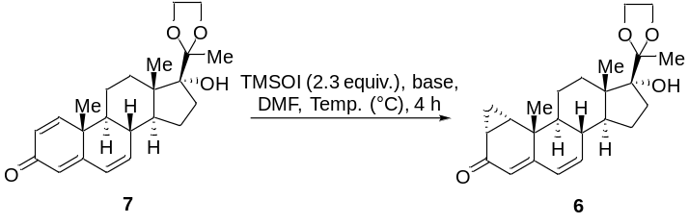
Entry | Base | Equiv. | Temp. (°C) | Yield (%) of 6
1 | NaH | 3.0 | 25 | 92
2 | LiHMDS | 3.0 | 25 | 69
3 | NODX | 3.0 | 25 | n.r.
4 | ^{t}BuOK | 3.0 | 25 | 87
5 | LDA | 3.0 | 25 | 37
6 | MeONa | 3.0 | 25 | 98
7 | MeONa | 2.5 | 25 | 85
8 | MeONa | 2.5 | 30 | 91
9 | MeONa | 2.5 | 35 | 95
10 | MeONa | 2.5 | 40 | 98
11 | MeONa | 2.0 | 40 | 92
ª Unless otherwise noted: all reactions were performed using 7 (111.0 mg, 0.3 mmol, 1.0 equiv.) in DMF(1 mL), Ylide in DMF(1 mL) at 25-40 °C for 4 h.
^{b} Determined by LC-MS analysis of the reaction mixture.
^{c} Isolated yield.

Table S10 Condition screening for C6, C7-epoxidation of 6 in flow.ª
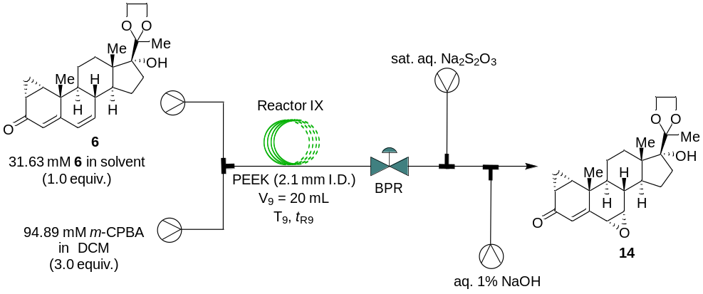
Entry | Solvent | T₉ (°C) | t_{R9} (min) | BPR (bar) | Conv. (%)^{b}
1 | DCM | 25 | 20 | 0 | 39
2 | DCM | 80 | 20 | 4.0 | 98
3 | DCM | 90 | 20 | 4.0 | 99
4 | DCM | 90 | 15 | 4.0 | 99
5 | DCM | 90 | 10 | 4.0 | 96
6 | DCM | 100 | 10 | 4.0 | 99
7 | DCM/DMF (2:1) | 100 | 10 | 4.0 | 51
8 | DCM/DMF (2:1) | 110 | 10 | 4.0 | 72
9 | DCM/DMF (2:1) | 120 | 10 | 4.0 | 84
10 | DCM/DMF (2:1) | 120 | 10 | 6.0 | 91
11 | DCM/DMF (2:1) | 120 | 15 | 6.0 | 95
12 | DCM/DMF (2:1) | 120 | 20 | 6.0 | 99 (65.3)^{c}
13 | DCM/DMF (2:1) | 110 | 20 | 6.0 | 99 (71.8)^{c}
ª Unless otherwise noted: all reactions were performed in Reactor IX using 6 (31.63 mM) in DCM, with 94.89 mM m-CPBA (3.0 equiv.) in DCM, at a temperature range of 25-120 °C for 10-20 min, under a back-pressure of 4.0-6.0 bar.
^{b} Determined by LC-MS analysis of the reaction mixture.
^{c} Isolated yield.

Table S11 Condition screening for C6, C7-epoxide opening/chlorination/dehydration/deprotection cascade reaction of 14 in flow.ª
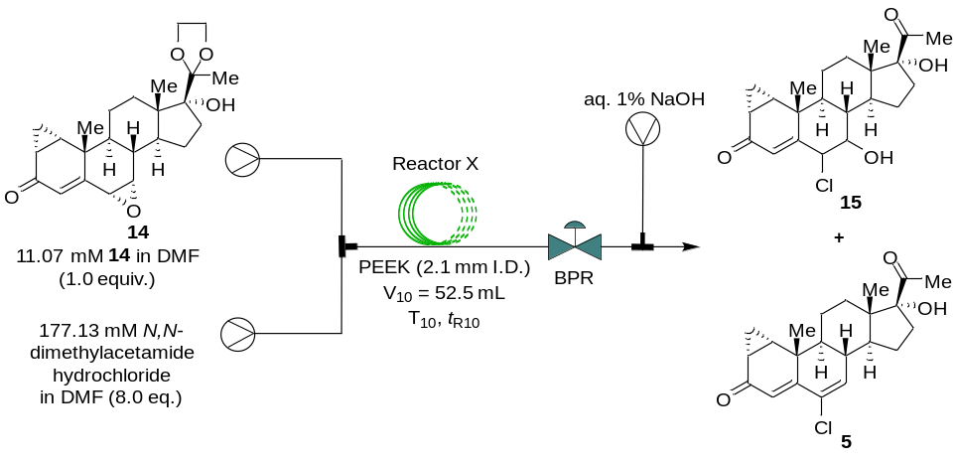
Entry | Solvent | T₁₀ (°C) | t_{R10} (min) | BPR (bar) | Conv. (%)^{b} | Yield (%)^{c} of 5/15
1 | DMF | 120 | 20 | 8 | 99 | 40/60
2 | DMF | 140 | 20 | 8 | 99 | 54/46
3 | DMF | 170 | 20 | 8 | 99 | 65/35
4 | DMF | 170 | 30 | 8 | 99 | 77/23
5 | DMF | 170 | 40 | 8 | 99 | 95/5
6 | DMF | 180 | 40 | 8 | 99 | 98/2
7 | DMF | 180 | 40 | 12 | 99 | 98/2
8 | DMF | 180 | 35 | 16 | 99 | 98 (67)^{d}/2
ª Unless otherwise noted: all reactions were conducted using 14 (11.07 mM) in DMF, with 177.13 mM of N,N-dimethylacetamide hydrochloride (8.0 equivalents) also dissolved in DMF. The reactions were performed at a temperature range of 80-180 °C for 20-40 min in Reactor X, under a back-pressure ranging from 8.0 to 16.0 bar.
^{b,c} Determined by LC-MS analysis of the reaction mixture.
^{d} Isolated yield.

Table S12 Condition screening for the O-acetylation of 5 in flow.ª
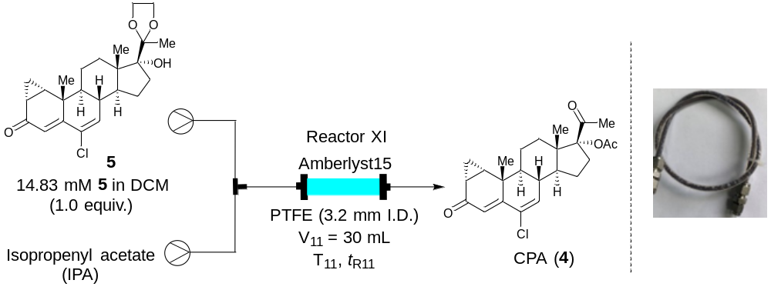

Entry | T₁₁ (°C) | t_{R11} (min) | Conv. (%)^{c}
1 | 25 | 15 | 21
2 | 30 | 15 | 43
3 | 40 | 15 | 68
4 | 40 | 20 | 83
5 | 40 | 25 | 96
6^{b} | 40 | 15 | 98 (75)^{d}
ª Unless otherwise noted: all reactions were performed in Reactor XI using 5 (14.83 mM, 1.0 equiv.), 2.5 g Amberlyst15, and a mixture of Isopropenyl acetate (IPA) and DCM in a 3:1 ratio, at a temperature range of 25-40 °C for 15-25 min.
^{b} 3.5 g Amberlyst15
^{c} Determined by LC-MS analysis of the reaction mixture.
^{d} Isolated yield.

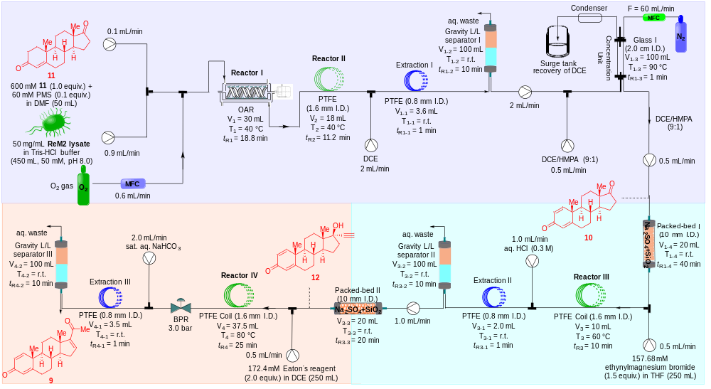
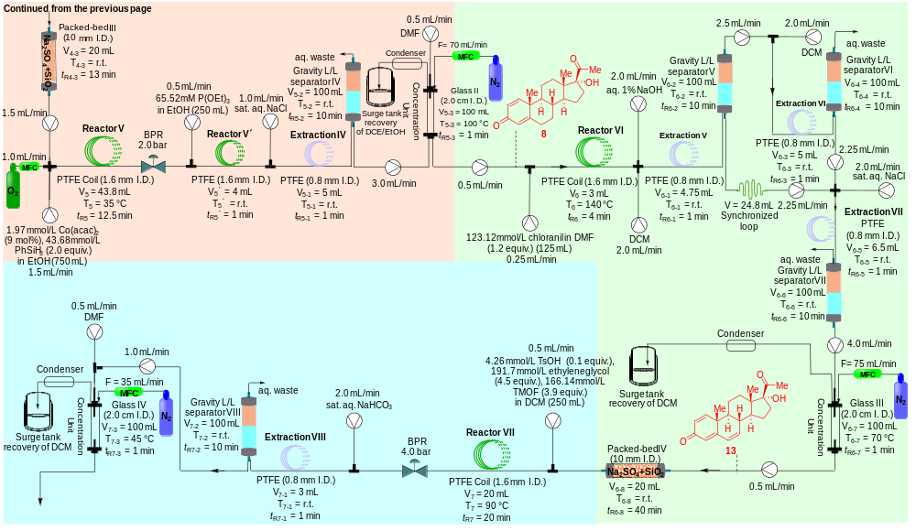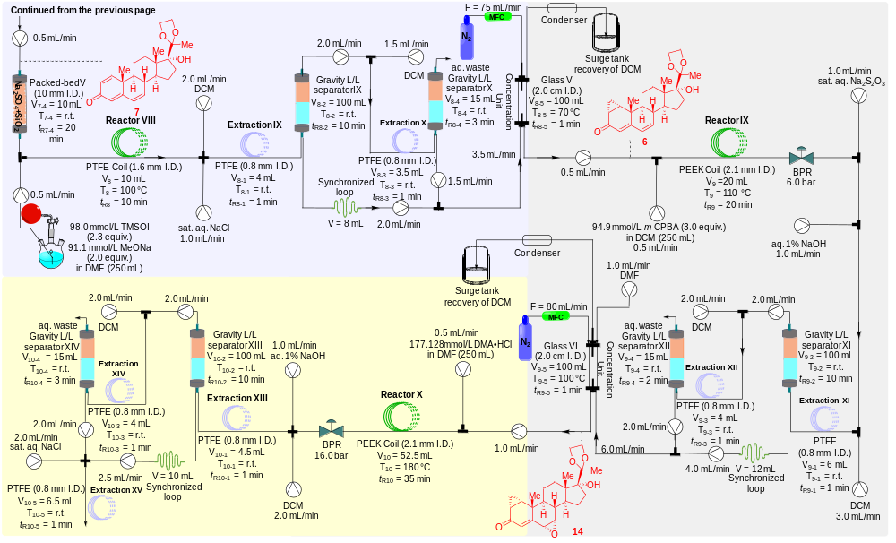
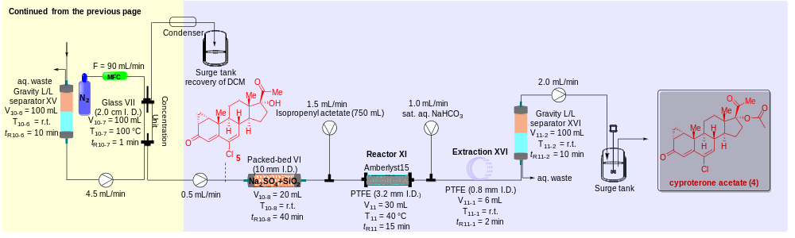

Scheme S4 The diagram for the ten-step continuous-flow synthesis of cyproterone acetate.

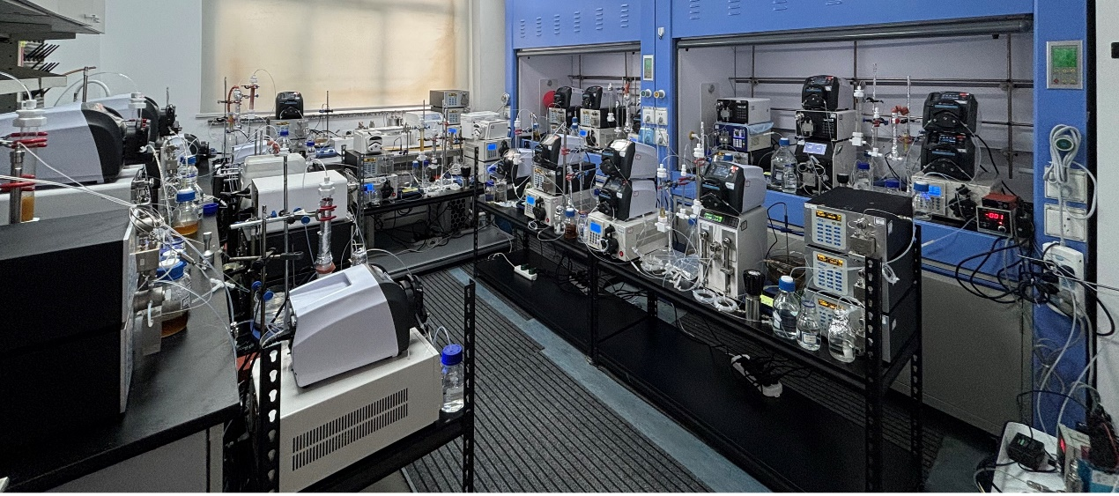
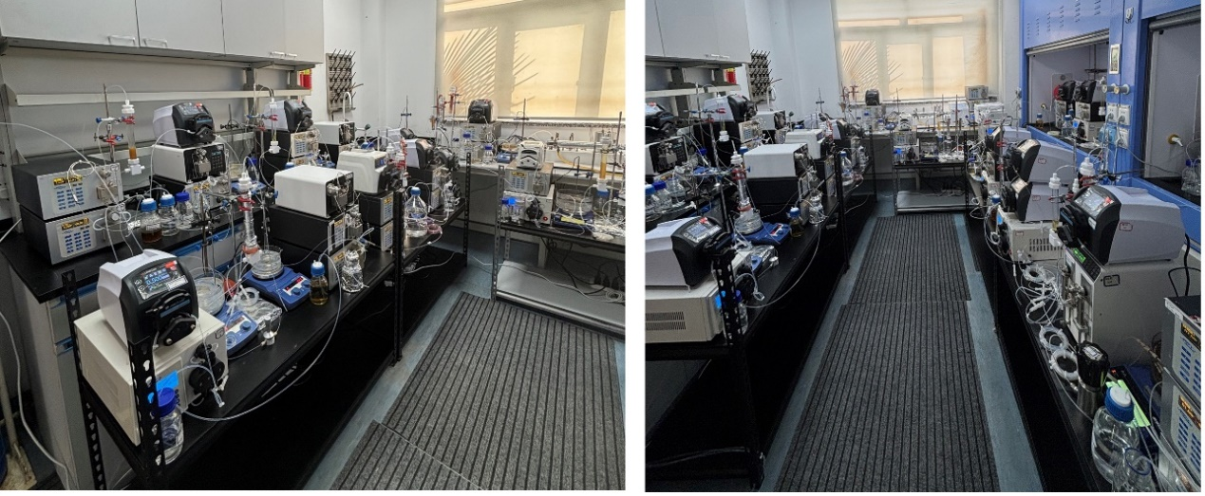
Zone 1
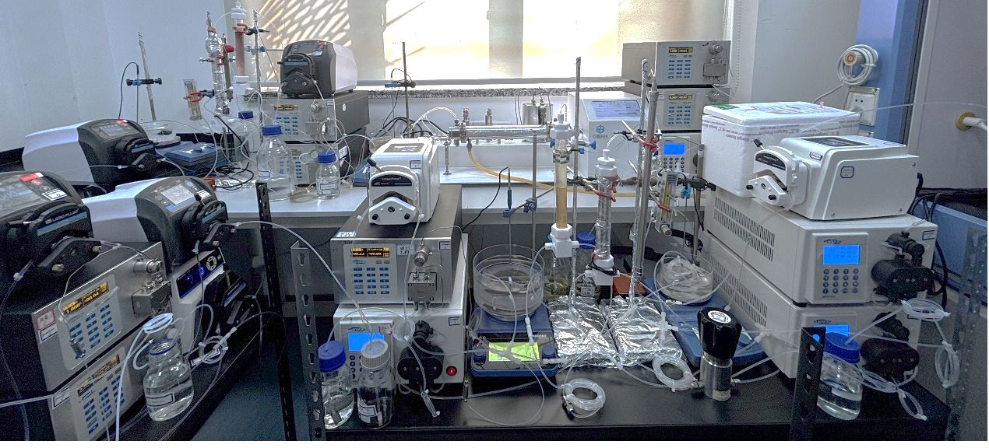
4-AD
Zone 4
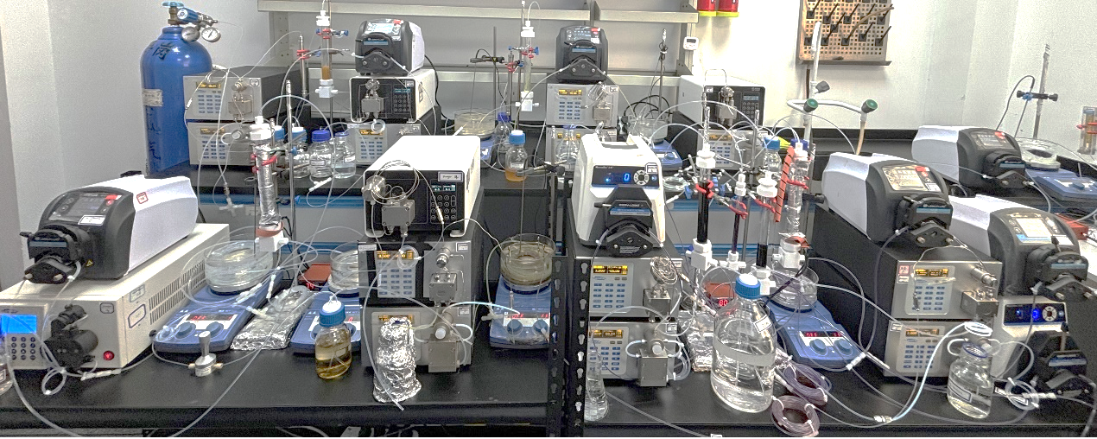
Zone 4
Zone 3
Zone 2
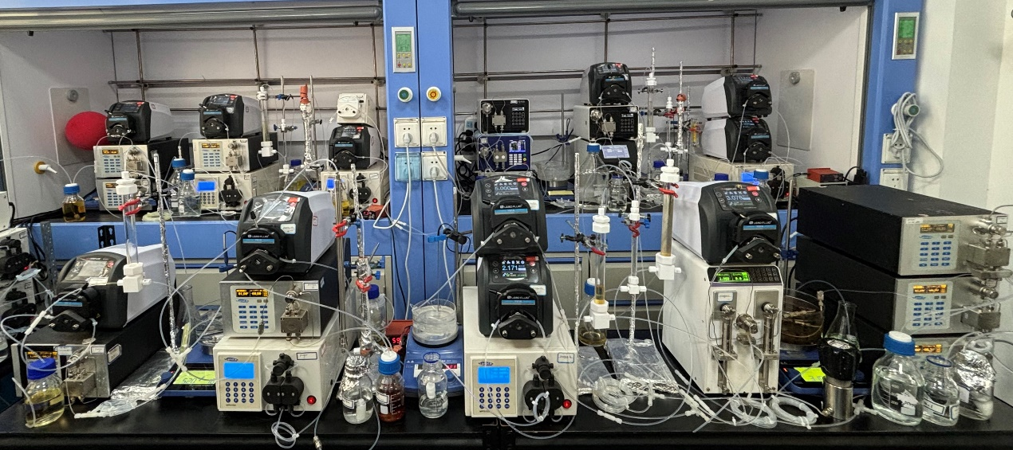
Product
Zone 8
Zone 7
Zone 6
Zone 5
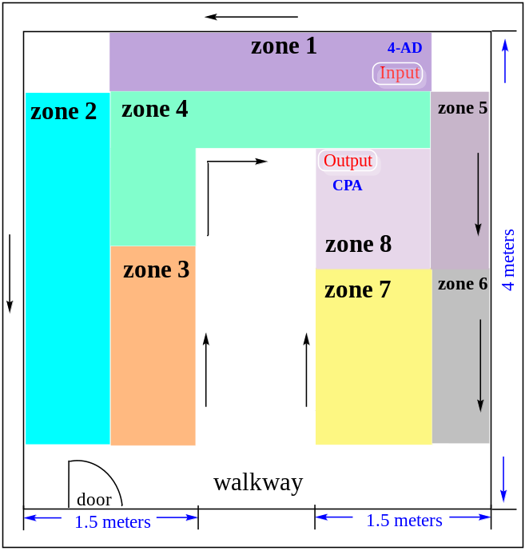

Figure S3 Fully continuous-flow synthesis platform for cyproterone acetate.

Continuous-flow synthesis has significant advantages compared over traditional batch mode, such as effective mass/heat transfer, easy scalability, short reaction time, concise synthesis operation, more environmental friendliness, and constant production through avoiding purification and isolation of intermediates. To date, some reports have described the continuous-flow total synthesis of biologically active natural products and active pharmaceutical ingredients (APIs). In these elegant processes, researchers have alternatively used single-step continuous-flow or combinations of batch and continuous-flow operations to generate of complex natural products in higher yields and shorter reaction times compared with batch synthesis. Although technological improvements have made it possible to synthesize natural products using a continuous-flow process, these methods may be subject to certain limitations, such as inevitable offline purification and separation, as well as solvent switching from upstream conditions. Therefore, the development of a fully continuous-flow technology for multi-step steroidal synthesis, including online post-processing work, will be a significant and formidable challenge in the field of steroidal drug synthesis. After completing the batch synthesis of cyproterone acetate and optimizing the conditions for single-step and multi-step continuous-flow synthesis, we continued to develop more efficient synthetic procedures to explore the construction of the 10-step continuous-flow synthesis of cyproterone acetate.
We started our investigation by performing ReM2-catalyzed specific Δ¹-dehydrogenation of 4-AD (11) under flow conditions for the preparation of ADD (10) in Oscillation agitate reactor I. Stream I (0.1 mL/min) containing a solution of PMS (3.0 mmol, 0.1 equiv.) and 4-AD (8.58 g, 30.0 mmol, 1.0 equiv.) dissolved in DMF (50 mL), stream II (0.9 mL/min) containing the supernatant of E. coli cell lysate (50.0 mg/mL) in Tris-HCl buffer (50 mM, pH 8.0, 450 mL), two streams of materials were pumped into a cross-type mixer and mixed with O₂ gas (0.6 mL/min) before being introduced into the OAR (V₁ = 30 mL, 400 rpm) and PTFE coil reactor II (V₂ = 18 mL). These three streams were pumped at a total flow rate of 1.6 mL/min, the resulting mixture was passed through an Oscillation agitation reactor I and a PTFE coil reactor II, both maintained at 40 °C, with residence times of 18.8 minutes and 11.2 minutes, respectively. The output stream of the crude 10 solution from the in-flow was delivered into the in-line work-up. A plunger pump was used to introduce DCM (2.0 mL/min), and the effluent was extracted by DCM via one PTFE coil extraction (t_{R1-1} = 1 min) to provide the DCM solution of 10, and the solution was separated via online liquid-liquid separation by Gravity separator I (t_{R1-2} = 10 min) to provide the lower layer of DCM solution containing product 10 and mixed with DCE/HMPA (9:1, 0.5 mL/min) through a T-piece mixer. Subsequently, the solution was evaporated in Tube-in-tube device (t_{R1-3} = 1 min, T = 90 °C, N₂, F = 60 mL/min) for a 5-fold concentration after the residual H₂O was adsorbed by a fixed bed packed column containing Na₂SO₄ and SiO₂ (10 mL internal volume, 1:1, t_{R1-4} = 40 min). At this point, a mixed solution of DCE/HMPA containing 10 was obtained for subsequent reaction, with a total residence time of 82 min.
Next is the ethynylation reaction between 10 and Grignard reagent to synthesize 12. Ethynyl magnesium bromide (157.68 mM, 0.5 mL/min) dissolved in THF (250 mL) and the upstream DCE/HMPA mixed solution containing product 10 were pumped at a total flow rate of 1.0 mL/min via plunger pumps and mixed through a T-piece mixer, then the resulting mixture was passed through a PTFE reactor III (V₃ = 10 mL) at 60 °C with a 10 min residence time. The output stream of the crude 12 solution from the in-flow was delivered into the in-line work-up. After being mixed and quenched with aq. HCl (0.3 M, 1.0 mL/min) through the T-piece mixer, the reaction mixture is introduced into Extraction coil II (t_{R3-1} = 1 min) for extraction. And the solution was separated via online liquid-liquid separation by Gravity separator II (t_{R3-2} = 10 min), providing the lower layer of DCE solution containing product 12 for the next Rupe rearrangement reaction, with a total residence time of 41 min.
The next step is the Rupe rearrangement between 12 and Eaton's reagent to synthesize 9. Eaton′s reagent (172.4 mM, 0.5 mL/min) dissolved in DCE (250 mL) and the upstream DCE solution (1.0 mL/min) containing product 12 were pumped at a total flow rate of 1.5 mL/min via plunger pumps and mixed through a T-piece mixer, then the resulting mixture was passed through a PTFE reactor IV (V₄ = 37.5 mL) at 80 °C with a 25 min residence time under a back pressure of 5.0 bar. The output stream of the crude 9 solution from the in-flow was delivered into the in-line work-up. After being mixed and quenched with sat. aq. NaHCO₃ (2.0 mL/min) through the T-piece mixer, the reaction mixture is introduced into Extraction coil III (t_{R4-1} = 1 min) for extraction. And the solution was separated via online liquid-liquid separation by Gravity separator III (t_{R4-2} = 10 min) to provide the lower layer of DCE solution containing product 9 for the subsequent reaction, with a total residence time of 49 min.
Afterwards, Cobalt-catalyzed Mukaiyama hydration of 9 was performed by pumping 1.97 mM of Co(acac)₂ and 43.68 mM of PhSiH₃, both dissolved in EtOH at a flow rate of 1.5 mL/min for a total volume of 750 mL, and the upstream DCE solution (also at 1.5 mL/min) containing product 9 into a cross-mixer. The mixture was then mixed with O₂ gas (at a flow rate of 1.0 mL/min) before being introduced into the PTFE coil reactor V (V₅ = 43.8 mL). These three streams were pumped at a total flow rate of 3.0 mL/min and the resulting mixture was passed through the PTFE coil reactor V at 35 °C with a 12.5 min residence time under a back pressure of 2.0 bar. Then the reaction mixture continuous mixing with P(OEt)₃ dissolved in EtOH (65.52 mM, 0.5 mL/min, 250 mL) through a PTFE coil reactor V' (V_{5'} = 4 mL) at room temperature. The output stream of the crude 8 solution from the in-flow was delivered into the in-line work-up. After being mixed with sat. aq. NaCl (1.0 mL/min) through the T-piece mixer, the reaction mixture is introduced into Extraction coil IV (t_{R5-1} = 1 min) for extraction. And the solution was separated via online liquid-liquid separation by Gravity separator IV (t_{R5-2} = 10 min) to provide the lower layer of DCE/EtOH solution containing product 8 and mixed with DMF (0.5 mL/min, 250 mL) through a T-piece mixer. Subsequently, the solution was evaporated in Tube-in-tube device (t_{R1-3} = 1 min, T = 100 °C, N₂, F = 70 mL/min) for a 7-fold concentration (V = 0.5 mL/min). At this point, a solution of DMF containing 8 was obtained for the next step, with a total 25.5 min residence time.
Then, dehydrogenation of the C6 and C7 positions of 8 was performed using chloranil as the oxidant to synthesize 13. Chloranil (123.1 mM) dissolved in DMF (0.25 mL/min, 250 mL) and the upstream DMF solution (0.5 mL/min) containing product 8 were pumped at a total flow rate of 0.75 mL/min via plunger pumps and mixed through a T-piece mixer, then the resulting mixture was passed through a PTFE reactor IV (V₆ = 3 mL) at 140 °C with a 4 min residence time. The output stream of the crude 8 solution from the in-flow was delivered into the in-line work-up. The reaction mixture was continuously mixed with aq. 1% NaOH (2.0 mL/min, 1000 mL) and DCM (2.0 mL/min, 1000 mL) through a Cross-type mixer and then introduced into Extraction coil V (t_{R6-1} = 1 min) for extraction. And the solution was separated via online liquid-liquid separation (flow rate controlled by the peristaltic pump: V = 2.0 mL/min) by Gravity separator IV (t_{R6-2} = 10 min) to provide the lower layer of DCM/EtOH solution containing product 13 and enters Synchronized loop (20 mL). The upper layer and DCM (2.0 mL/min, 1000 mL) undergo secondary extraction through the Extraction coil VI (t_{R6-3} = 1 min) before being introduced into the Gravity L/L separator VI (t_{R6-4} = 10 min) for layering. After that, the lower layer (flow rate controlled by the peristaltic pump: V = 2.0 mL/min) DCM solution containing 13 (2.0 mL/min) was taken. Then the two streams of DCM solution containing 13 were mixed with sat. aq. NaCl in a cross-type mixer. After being washed through the Extraction coil VII (t_{R6-5} = 1 min), then the mixed solution was introduced into the Gravity L/L separator VII (t_{R6-6} = 10 min) for layering. The lower layer (flow rate controlled by the peristaltic pump: V = 4.0 mL/min) DCM solution containing 13 was then taken. Subsequently, the solution was evaporated in a Tube-in-tube apparatus (t_{R6-7} = 1 min, T = 70 °C, N₂ flow rate = 75 mL/min) to achieve an 8-fold concentration (output flow rate V = 0.5 mL/min), after the residual H₂O and impurities were adsorbed by a fixed bed packed column containing a 1:1 mixture of Na₂SO₄ and SiO₂ (with an internal volume of 10 mL, t_{R6-7} = 40 min). At this point, a solution of 13 in DCM was obtained, which was intended for a subsequent C20 ketalization reaction, with a total residence time of 78 min.
4.26 mM TsOH/191.7 mM ethylene glycol/166.14 mM TMOF dissolved in DCM (0.5 mL/min, 250 mL) and the upstream DCM solution (0.5 mL/min) containing product 13 were pumped at a total flow rate of 1.0 mL/min via plunger pumps and mixed through a T-piece mixer, then the resulting mixture was passed through a PTFE reactor VII (V₇ = 20 mL) at 90 °C with a 20 min residence time under a back pressure of 4.0 bar. The output stream of the crude 7 solution from the in-flow was delivered into the in-line work-up. After being mixed and quenched with sat. aq. NaHCO₃ (2.0 mL/min, 1000 mL) through the T-piece mixer, the reaction mixture was introduced into Extraction coil VIII (t_{R7-1} = 1 min) for extraction. And the solution was separated via online liquid-liquid separation by Gravity separator VIII (t_{R7-2} = 10 min) to provide the lower layer of DCM solution containing product 7 and mixed with DMF (0.5 mL/min) through a T-piece mixer. Subsequently, the solution was evaporated in Tube-in-tube device (t_{R7-3} = 1 min, T = 45 °C, N₂, F = 35 mL/min) for a 3-fold concentration (V = 0.5 mL/min). At this point, a solution of DMF containing 7 was obtained for the next step, with a total 52 min residence time.
Next, Corey-Chaykovsky cyclopropanation between 7 and trimethyl sulfoxide iodide (TMSOI) in flow via a sequential nucleophilic addition/ring-closure mechanisms to form C1, C2 cyclopropane of 6. Under nitrogen conditions, a solution of TMSOI (98.0 mmol, 2.5 equiv.) and MeONa (91.6 mmol, 2.3 equiv.) in DMF (0.5 mL/min, 250 mL) and pre-reacted for 1 h at room temperature in batch-mode. And the upstream DMF solution (0.5 mL/min) containing product 7 were pumped at a total flow rate of 1.0 mL/min via plunger pumps and mixed through a T-piece mixer. Then the liquid solution was passed through a PTFE coil reactor VIII (10.0 mL, 1.6 mm I. D., 3.2 mm O. D.) at 100 °C with a 10 min residence time. Then the output of the reaction mixture was quenched with sat. aq. NaCl, and the output stream of the crude 6 solution from the in-flow was delivered into the in-line work-up. A plunger pump was used to introduce DCM (2.0 mL/min), and the effluent was extracted by DCM via an extraction coil IX (t_{R8-1} = 1 min) and the solution was separated via online liquid-liquid separation by Gravity separator IX (t_{R8-2} = 10 min) to provide the lower layer of DCM solution containing product 6, and then enters Synchronized loop (V = 10 mL). The upper layer of the solution is subjected to a secondary DCM extraction. The mixed solution is then layered through Gravity separator X (t_{R8-4} = 3 min). The lower layer of the output solution is combined with the DCM solution from Gravity separator IX. This combined solution containing product 6 in DCM/DMF is evaporated in an online Concentration unit (Tube-in-tube, F = 75 mL/min, T₈₋₅ = 70 °C) to obtain an 8-fold concentrated solution of DCM containing product 6. At this point, a solution of DCM containing 6 was obtained for use in subsequent continuous-flow reactions, with a total 26 min residence time.
Following that is the synthesis of 14 through the C6, C7-epoxidation of 6 with m-chloroperoxybenzoic acid (m-CPBA). 94.9 mM m-CPBA dissolved in DCM (0.5 mL/min, 250 mL) and the upstream DCM/DMF solution (0.5 mL/min) containing product 6 were pumped at a total flow rate of 1.0 mL/min via plunger pumps and mixed through a T-piece mixer, then the resulting mixture was passed through a PTFE reactor IX (V₉ = 10 mL) at 110 °C with a 20 min residence time under a back pressure of 6.0 bar. The output stream of the crude 14 solution from the in-flow was delivered into the in-line work-up. The output of the reaction mixture was quenched with sat. aq. Na₂S₂O₃ (1.0 mL/min, 500 mL) through the T-piece mixer to remove m-CPBA. The reaction mixture then continued to be quenched by mixing with aq. 1% NaOH (1.0 mL/min, 500 mL) through another T-piece mixer to remove the remaining m-CPBA, and then the solution introduced into the Extraction coil XI (t_{R9-1} = 1 min) for extraction. Then the solution separated via online liquid-liquid separation using the Gravity separator XI (t_{R9-2} = 10 min), to isolate the lower layer containing the DCM solution with product 14. This lower layer then enters the Synchronized loop (V = 12 mL). Meanwhile, the upper layer of the solution is subjected to a secondary extraction process using DCM. Then the mixed solution is layered through Gravity separator XII (t_{R9-4} = 2 min). The lower layer of the resulting output solution is combined with the DCM solution obtained from Gravity separator XI. This combined solution containing product 14 in DCM was evaporated in an online Concentration unit (Tube-in-tube, N₂ flow rate = 80 mL/min, T₉₋₅ = 100 °C) to obtain a 6-fold concentrated solution of DCM containing product 14. At this point, a solution of DCM containing 14 was obtained for the next cascade reaction, and with a total 35 min residence time.
Subsequently, the synthesis of 5 is achieved via a cascade of reactions involving epoxide ring-opening/chlorination/dehydration/deprotection of 14 with N, N-dimethylacetamide hydrochloride (DMA·HCl). 177.13 mM DMA·HCl dissolved in DMF (0.5 mL/min, 250 mL) and the upstream DCM solution (1.0 mL/min) containing product 14 were pumped at a total flow rate of 1.5 mL/min via plunger pumps and mixed through a T-piece mixer, then the resulting mixture was passed through a PTFE reactor X (V₁₀ = 53 mL) at 180 °C with a 35 min residence time under a back pressure of 16.0 bar. The output stream of the crude 5 solution from the in-flow was delivered into the in-line work-up. Then the output of the reaction mixture was quenched with aq. 1% NaOH and a plunger pump was used to introduce DCM (2.0 mL/min, 1000 mL), the effluent was extracted by DCM via an extraction coil XIII (t_{R10-1} = 1 min) and the solution was separated via online liquid-liquid separation by Gravity separator XIII (t_{R10-2} = 10 min) to provide the lower layer of DCM solution containing product 5, and then entered Synchronized loop (V = 12 mL). The upper layer of the solution was subjected to a secondary DCM (2.0 mL/min, 1000 mL) extraction via an extraction coil XIV (t_{R10-3} = 1 min), and the mixed solution is then layered through Gravity separator XIV (t_{R10-4} = 3 min). The lower layer of the output solution is combined with the DCM solution from Gravity separator XIII. Then the combined DCM solution containing 5 was mixed with sat. aq. NaCl in a Cross-type mixer. After being washed through the Extraction coil XV (t_{R10-5} = 1 min), then the mixed solution was introduced into the Gravity L/L separator XV (t_{R10-6} = 10 min) for layering. The lower layer DCM solution containing 5 was then taken. Subsequently, the solution was evaporated in Tube-in-tube device (t_{R10-7} = 1 min, T = 100 °C, N₂, F = 90 mL/min) for a 10-fold concentration (V = 0.5 mL/min) after the residual H₂O and impurities were adsorbed by a fixed bed packed column containing Na₂SO₄ and SiO₂ (10 mL internal volume, 1:1, t_{R10-8} = 40 min). At this point, a solution of DCM containing 5 was obtained for conducting the final reaction step, with a total 102 min residence time.
The final reaction involved the synthesis of cyproterone acetate through the C17O-acetylation of 5. 1.5 mL/min Isopropenyl acetate (IPA, 750 mL) and the upstream DCM solution (0.5 mL/min) containing product 5 were pumped at a total flow rate of 2.0 mL/min via plunger pumps and mixed through a T-piece mixer, then the resulting mixture was passed through a PTFE reactor XI (V₁₁ = 30 mL) at 40 °C with a 15 min residence time. The output stream of the crude 4 solution from the in-flow was delivered into the in-line work-up. After being mixed and quenched with sat. aq. NaHCO₃ (1.0 mL/min, 500 mL) through the T-piece mixer, the reaction mixture is introduced into Extraction coil XVI (t_{R11-1} = 2 min) for extraction. And the solution was separated via online liquid-liquid separation by Gravity separator XVI (t_{R11-2} = 10 min) to provide the lower layer of DCM/IPA solution containing product 4. At this point, a solution of DCM/IPA containing 4 was obtained for subsequent recrystallization, with a total 27 min residence time.
By the above system, a platform for the fully continuous-flow asymmetric synthesis of cyproterone acetate using 4-AD as the starting material through a chemo-biocatalytic approach with a 10-step process has been successfully developed. The overall yield of the fully continuous-flow synthesis of cyproterone acetate is 9.65%, with a total 8.62 h residence time and a space-time yield of 99.5 mg/h. Compared to the traditional batch mode, this multi-step fully continuous-flow synthesis process offers advantages such as improved catalytic efficiency, time savings and enhanced sustainable production capacity. Without factoring in the post-processing time of the batch mode, this fully continuous-flow synthesis process significantly reduces the total reaction time from 95 h to 8.62 h, and substantially increases the space-time yield of the reaction from 44.1 mg/h to 99.5 mg/h.

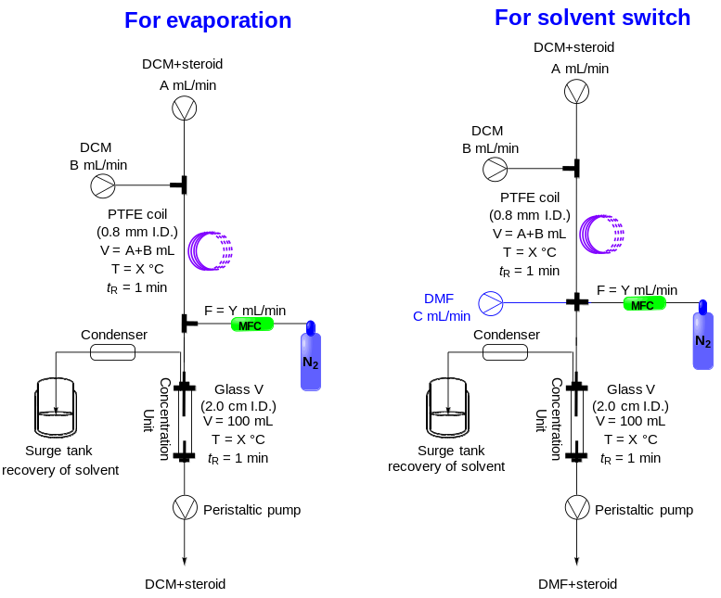

Figure S4 The graphical representation of the Tube-in-tube evaporator/concentrator device used for the gravity L/L separator and the solvent evaporation/switch.
We have designed an online concentration device (Tube-in -tube evaporator/concentrator) that exposes solvent vapor, formed from a high-surface-area solution through temperature regulation, to a desolvation gas (N₂), enabling the rapid and efficient removal of solvent (Figure S4). To assess the effectiveness of this device, a rigorous evaluation was conducted, examining the evaporation rate of DCM and its dependence on varying flow velocities, temperatures and nitrogen volumes (Table S13).

Table S13 Removal rate of solvents in a continuous-flow platform using the in-line Tube-in-tube evaporator/concentrator device (the values shown in bule were the parameters used in the fully continuous-flow in this work).
Entry | Solvent | V/t_{R} (mL/min)ª | T (°C) | F (mL/min)^{b} | Solvent removed (%)
1 | DCE | 2.5 | 80 | 40 | 52
2 | DCE | 2.5 | 80 | 60 | 70
3 | DCE | 2.5 | 80 | 80 | 100
4 | DCE | 2.5 | 90 | 40 | 64
5 | DCE | 2.5 | 90 | 60 | 80
6 | DCE/EtOH | 3.5 | 90 | 70 | 80
7 | DCE/EtOH | 3.5 | 90 | 80 | 95
8 | DCE/EtOH | 3.5 | 90 | 90 | 100
9 | DCE/EtOH | 3.5 | 100 | 70 | 85
10 | DCE/EtOH | 3.5 | 100 | 80 | 100
11 | DCE/EtOH | 3.5 | 100 | 90 | 100
12 | DCM | 1.5 | 40 | 20 | 34
13 | DCM | 1.5 | 40 | 30 | 50
14 | DCM | 1.5 | 40 | 40 | 60
15 | DCM | 1.5 | 45 | 30 | 40
16 | DCM | 1.5 | 45 | 35 | 65
17 | DCM | 1.5 | 45 | 40 | 70
18 | DCM | 4 | 60 | 60 | 65
19 | DCM | 4 | 60 | 70 | 75
20 | DCM | 4 | 60 | 80 | 90
21 | DCM | 4 | 70 | 70 | 80
22 | DCM | 4 | 70 | 75 | 88
23 | DCM | 4 | 70 | 80 | 95
24 | DCM | 5 | 90 | 80 | 80
25 | DCM | 5 | 90 | 85 | 82
26 | DCM | 5 | 90 | 90 | 85
27 | DCM | 5 | 100 | 80 | 85
28 | DCM | 5 | 100 | 85 | 88
29 | DCM | 5 | 100 | 90 | 90
30 | DCM | 6 | 90 | 80 | 70
31 | DCM | 6 | 90 | 85 | 75
32 | DCM | 6 | 90 | 90 | 82
33 | DCM | 6 | 100 | 80 | 83
34 | DCM | 6 | 100 | 85 | 85
35 | DCM | 6 | 100 | 90 | 88
ª Flow rate of solution entering the Tube-in-tube evaporation device.
^{b} N₂ gas flow rate.

4. Substrate synthesis and characterization
4.1 General procedures for enzymatic Δ¹-dehydrogenation of 11.
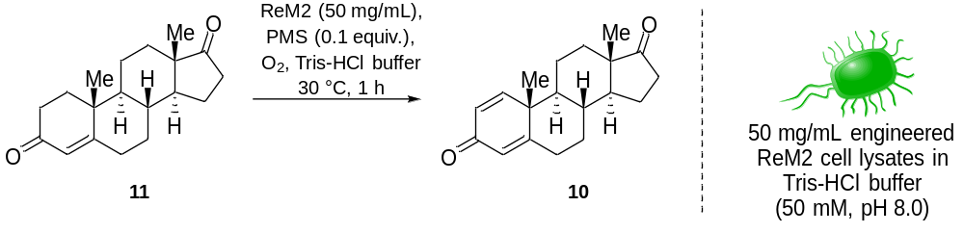
androsta-1, 4-diene-3, 17-dione (10):
Batch mode: To a solution of 4-androsta-3, 17-dione (11, 34.32 g, 120.0 mmol, 1.0 equiv.) in DMF (200 mL) was added a supernatant of 100.00 g of induced E. coli wet whole-cells (ReM2, expressing Δ¹-KstD) after disruption in 1.8 L Tris-HCl solution (50 mM, pH 8.0) and 60 mM PMS under a 2.0 atm oxygen atmosphere. The resulting mixture was shaken at 30°C, 200 rpm, and monitored by HPLC. After 1 h, the mixture was extracted with DCM (3 × 1000 mL). The combined DCM layers were dried with anhydrous Na₂SO₄, concentrated in vacuo to give the crude 10, which was further purified by column chromatography on silica gel (200-300 mesh, PE:EA = 5:1) to afford pure Androsta-1, 4-diene-3, 17-dione (10) with a yield of 89 % (30.33 g).
White powder. m.p.: 137.4-138.5 °C. [Lit.⁵: m.p.: 128-129 °C.]. ¹H NMR (400 MHz, CDCl₃) δ 7.07 (d, J = 10.2 Hz, 1H), 6.25 (dd, J = 10.1, 1.8 Hz, 1H), 6.10 (s, 1H), 2.60 - 2.38 (m, 3H), 2.22 - 2.04 (m, 2H), 2.04 - 1.93 (m, 1H), 1.93 - 1.80 (m, 3H), 1.79 - 1.56 (m, 2H), 1.34 - 1.28 (m, 2H), 1.27 (s, 3H), 1.21 - 1.07 (m, 2H), 0.96 (s, 3H). ¹³C NMR (101 MHz, CDCl₃) δ 186.2, 168.2, 155.3, 127.7, 124.2, 52.3, 50.4, 47.7, 43.4, 35.6, 35.1, 32.6, 32.3, 31.2, 22.1, 21.9, 18.7, 13.8. FTIR (KBr): n_{max} = 2954, 2921, 2870, 2849, 1739, 1656, 1620, 1462, 1377 cm⁻¹. HRMS (ESI) m/z calculated for C₁₉H₂₅O₂, [M + H]⁺ = 285.1849, found: C₁₉H₂₅O₂, 285.1849. [α] _{D}²⁵ = 121.0 (c = 0.27, CHCl₃).

4.2 Continuous-flow for enzymatic Δ¹-dehydrogenation of 11.
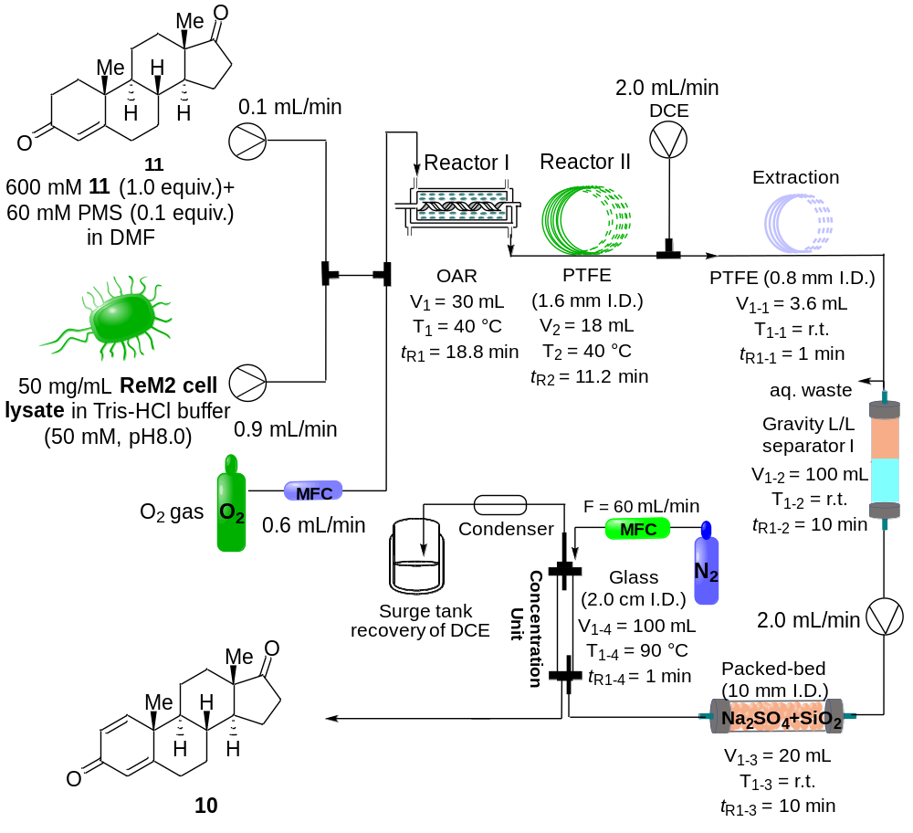
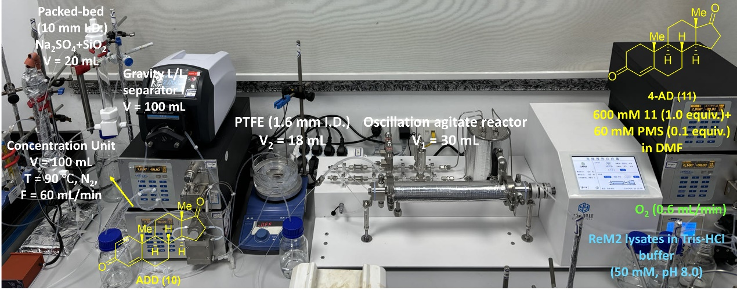
Flow mode: Three flow streams were delivered into the flow reactor I and reactor II by the syringe pump (Fusion 101, CHEMYX) and plunger pump (MPF0502C, SANOTAC). Stream I (0.1 mL/min) contains a solution of PMS (3.0 mmol, 0.1 equiv.) and 4-AD (8.58 g, 30.0 mmol, 1.0 equiv.) in DMF (50 mL), stream II (0.9 mL/min) containing the supernatant of ReM2 cell lysate (50.0 mg/mL) in Tris-HCl buffer (50 mM, pH 8.0, 450 mL), and stream III contains O₂ gas (0.6 mL/min), respectively. These three streams were pumped at a total flow rate of 1.6 mL/min and mixed through a cross-mixer, then the resulting mixture was passed through an Oscillation agitate reactor I (OAR, 30 mL, 400 rpm) at 40 °C with a 18.8 min residence time. The outlet of the OAR was connected to a PTFE coil reactor II (101 mL, 1.6 mm I. D., 3.2 mm O. D.) at 40 °C with a 11.2 min residence time. The output stream of the crude 10 solution from the in-flow was delivered into the in-line work-up. A plunger pump was used to introduce 1, 2-dichloroethane (DCE, 2.0 mL/min), and the effluent was extracted by DCE via one PTFE coil extraction separator to provide the DCE solution of 10. Which was evaporated in tube-in-tube device after the residual H₂O was adsorbed by a packed-bed column containing a mixture of 1:1 Na₂SO₄/SiO₂ (with an internal volume of 10 mL). After the stabilization of reaction system, the output flow from reactor I and reactor II were collected for 8.33 h. The conversion of 11 was determined by LC-MS. The output of the reaction mixture was further purified by column chromatography on silica gel (200-300 mesh, PE:EA = 5:1) to afford pure 10 with a yield of 87.6 % (7.46 g).
4.3 General procedures for ethynylation of 10.
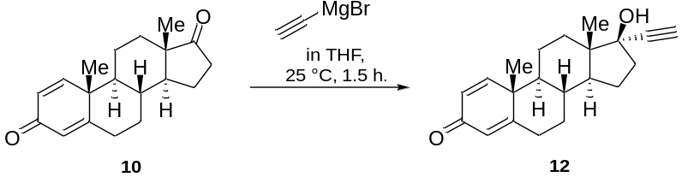
Δ^{1, 4}-diene-3-one-propargylic alcohol (12):
Batch mode: Δ^{1, 4}-diene-3-one-propargylic alcohol (12) was synthesized starting from androsta-1, 4-diene-3, 17-dione (10): A solution of 10 (30.00 g, 105.0 mmol, 1.0 equiv.) in dried THF (300 mL) under a nitrogen atmosphere was cooled to 0 °C. Subsequently, 0.5 M ethynylmagnesium bromide (315 mL, 157.5 mmol, 1.5 equiv.) was added dropwise. Afterward, the reaction mixture was stirred at 25 °C for 1.5 h until consumption of the starting substrate 10. Subsequently, 3.0 M HCl (200 mL) was added and the mixture was stirred at room temperature for another 20 min. The reaction mixture was diluted with EA (2 × 500 mL), and the organic solution was sequentially washed with water (2 × 300 mL) and brine (2 × 300 mL). The organic portion was dried over Na₂SO₄ and evaporated to give the crude product 12, which was further purified by column chromatography on silica gel (200-300 mesh, PE:EA = 4:1) to afford pure 12 with a yield of 87.3% (28.58 g).
White powder. m.p.: 220.6-222.8 °C. [α] _{D}²⁵ =10.0 (c = 0.20, CHCl₃). [Lit.⁶: m.p.: 227-229 °C.]. ¹H NMR (400 MHz, CDCl₃) δ 7.09 (d, J = 10.1 Hz, 1H), 6.26 (dd, J = 10.1, 1.7 Hz, 1H), 6.10 (s, 1H), 2.57 (s, 1H), 2.54 - 2.44 (m, 1H), 2.43 - 2.27 (m, 2H), 2.07 - 1.92 (m, 3H), 1.89 - 1.80 (m, 1H), 1.79 - 1.63 (m, 5H), 1.54 - 1.34 (m, 2H), 1.26 (s, 3H), 1.17 - 1.04 (m, 2H), 0.94 (s, 3H). ¹³C NMR (101 MHz, CDCl₃) δ 186.4, 169.0, 155.8, 127.5, 123.9, 87.1, 79.5, 74.3, 52.0, 49.5, 46.9, 43.5, 38.8, 36.1, 33.1, 32.8, 32.3, 23.2, 22.6, 18.7, 12.8. HRMS (ESI) m/z calculated for C₂₁H₂₇O₂, [M + H]⁺ = 311.2006, found: C₂₁H₂₇O₂, 311.2004.

4.4 Continuous-flow for ethynylation of 10.
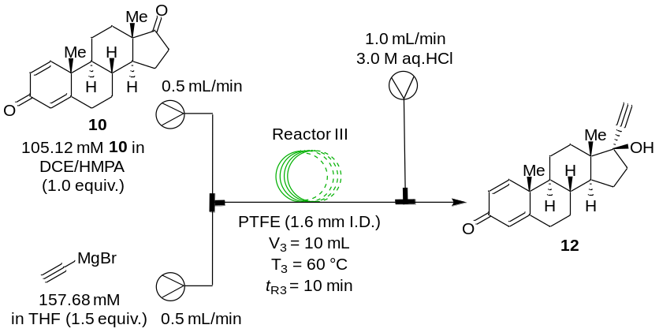
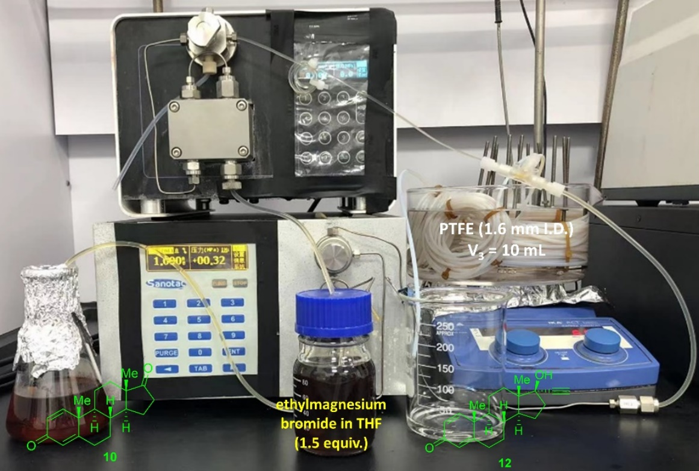
Flow mode: Ethynylation of androsta-1, 4-diene-3, 17-dione (10) to Δ^{1, 4}-diene-3-one-propargylic alcohol (12) in flow: two flow streams were delivered into the PTFE reactor by the plunger pumps, with stream I (0.5 mL/min) contains a solution of the purified 10 (105.12 mM, 1.0 equiv.) in DCE/HMPA (9:1, 250 mL), and stream II (0.5 mL/min) contains a solution of ethynylmagnesium bromide (157.68 mM, 1.5 equiv.) in THF (250 mL). These two streams were pumped at a total flow rate of 2.0 mL/min and mixed through a T-piece mixer. Then the liquid solution was passed through a PTFE coil reactor (10.0 mL, 1.6 mm I. D., 3.2 mm O. D.) at 60 °C with a 10 min residence time. The output of the reaction mixture was quenched with 3.0 M aq. HCl to afford crude 12. After the stabilization of reaction system, the output flow from PTFE coil reactor was collected for 8.33 h. The conversion of 10 was determined by LC-MS. The output of the reaction mixture was further purified by column chromatography on silica gel (200-300 mesh, PE:EA = 4:1) to afford pure 12 with a yield of 82 % (6.68 g).

4.5 General procedures for Rupe rearrangement of 12.
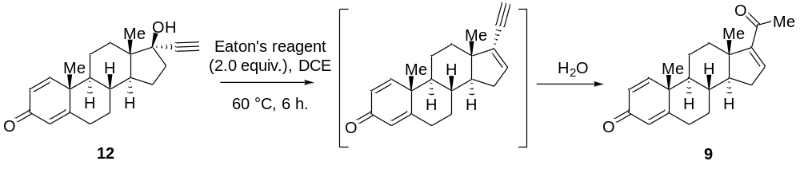
Δ^{1, 4, 16}-triene-3, 20-dione (9):
Batch mode: Δ^{1, 4, 16}-triene-3, 20-dione (9) was synthesized starting from Δ^{1, 4}-diene-3-one-propargylic alcohol (12): A solution of 12 (28.00 g, 90.2 mmol, 1.0 equiv.) in DCE (280 mL) under a nitrogen atmosphere was cooled to 0 °C. Subsequently, Eaton's reagent (MeSO₃H·P₂O₅, 42.90 g, 180.4 mmol, 2.0 equiv.) was added dropwise. The reaction mixture was stirred for 6 h at 60 °C until consumption of the starting substrate 12. After cooling to 0 °C, the reaction mixture was quenched by saturated NaHCO₃ aqueous solution (sat. aq. NaHCO₃, 200 mL) and extracted with DCM (3 × 300 mL). The combined organic layer was washed with brine (2 × 200 mL) and dried with Na₂SO₄. After filtration and concentration in vacuo, the crude product 9 was purified by column chromatography on silica gel (200-300 mesh, PE:EA = 6:1) to afford pure 9 with a yield of 78% (21.84 g).
White powder. m.p.: 184.6-185.8°C. ¹H NMR (400 MHz, CDCl₃) δ 7.08 (d, J = 10.1 Hz, 1H), 6.71 (d, J = 1.8 Hz, 1H), 6.25 (dd, J = 10.1, 1.7 Hz, 1H), 6.10 (s, 1H), 2.61-2.30 (m, 4H), 2.28 (s, 3H), 2.11 (ddd, J = 19.8, 11.4, 4.7 Hz, 1H), 2.04-1.95 (m, 1H), 1.92-1.76 (m, 3H), 1.48-1.33 (m, 2H), 1.28 (s, 3H), 1.22-1.11 (m, 2H), 0.99 (s, 3H). ¹³C NMR (101 MHz, CDCl₃) δ 196.6, 186.3, 168.7, 155.7, 155.0, 144.0, 127.5, 124.0, 55.2, 52.7, 46.3, 43.7, 34.4, 33.8, 33.4, 32.7, 32.2, 27.1, 22.8, 18.7, 15.9. FTIR (KBr): n_{max} = 2953, 2923, 2850, 1656, 1625, 1460, 1375, 1225, 885 cm⁻¹. HRMS (ESI) m/z calculated for C₂₁H₂₇O₂, [M + H]⁺ = 311.2006, found 311.2004. [α]_{D}²⁵ = 125.4 (c = 0.30, CHCl₃).
4.6 Continuous-flow for Rupe rearrangement of 12.
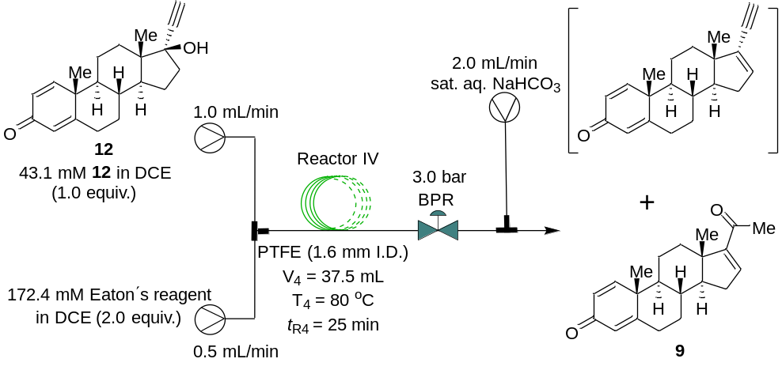
Flow mode: Rupe rearrangement of Δ^{1, 4}-diene-3-one-propargylic alcohol (12) to Δ^{1, 4, 16}-triene-3, 20-dione (9) in flow: two flow streams were delivered into the PTFE reactor by the plunger pumps, with stream I (1.0 mL/min) contains a solution of the purified 12 (43.10 mM, 1.0 equiv.) in DCE (500 mL), and stream II (0.5 mL/min) contains a solution of MeSO₃H·P₂O₅ (172.40 mM, 2.0 equiv.) in DCE (250 mL). These two streams were pumped at a total flow rate of 1.5 mL/min and mixed through a T-piece mixer. Then the liquid solution was passed through a PTFE coil reactor (37.5 mL, 1.6 mm I. D., 3.2 mm O. D.) at 60-100 °C with a 20-30 min residence time. The outlet of the PTFE coil reactor was connected to a back-pressure regulator to control a stable system pressure at 3.0 bar. Then the output of the reaction mixture was quenched with sat. aq. NaHCO₃. After the stabilization of the reaction system, the output flow from the PTFE coil reactor IV was collected for 8.33 h. The conversion of 12 was determined by LC-MS. The output of the reaction mixture was further purified by column chromatography on silica gel (200-300 mesh, PE:EA = 6:1) to afford pure 9 with a yield of 76 % (5.07 g).
4.7 Two-step sequential-flow synthesis of 9 via ethynylation/Rupe rearrangement.
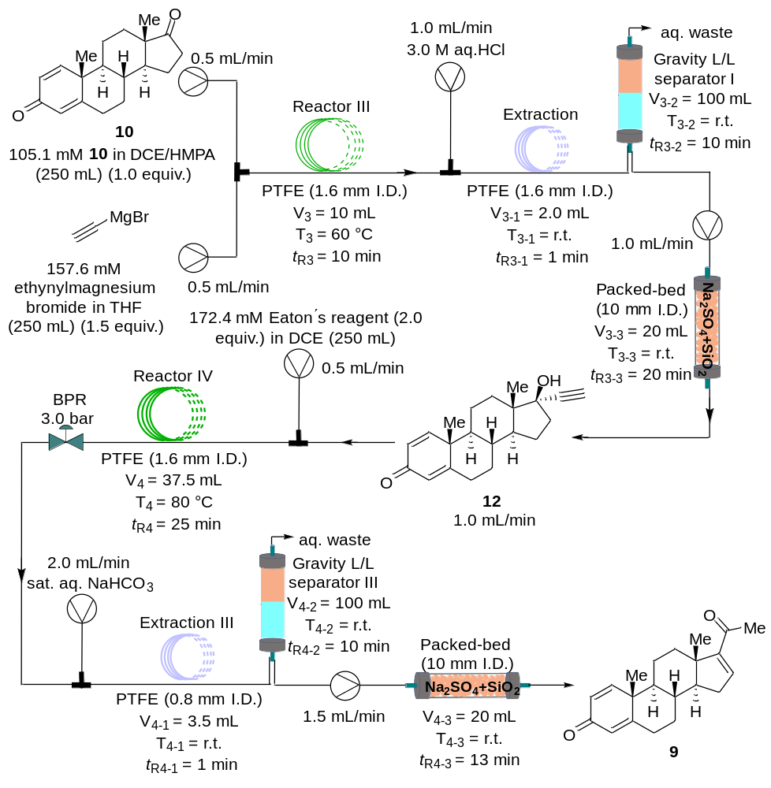
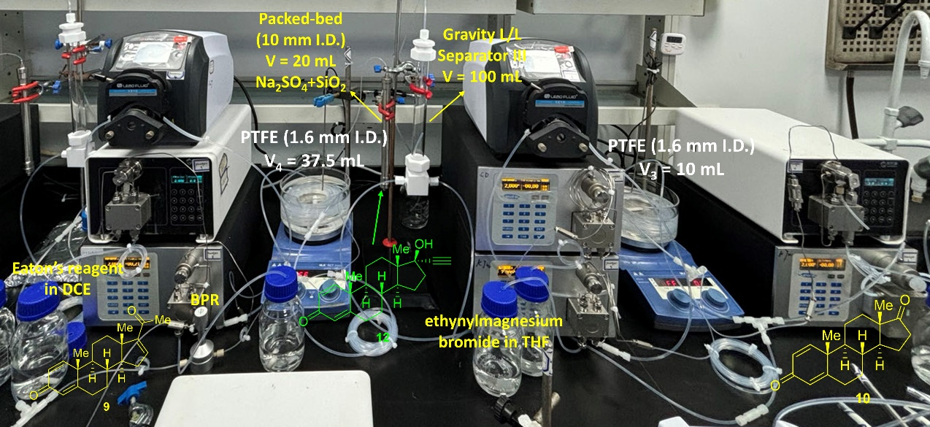
A two-step continuous-flow synthesis integrated platform for Δ^{1, 4, 16}-triene-3, 20-dione (9). Δ^{1, 4, 16}-triene-3, 20-dione (9) was synthesized starting from androsta-1, 4-diene-3, 17-dione (10) (105.12 mM, 250 mL) via ethynylation/Rupe rearrangement in flow: an online post-processing device including two extraction units (PTFE coil), two gravity liquid-liquid separators (100 mL, Gravity L/L separator), and two drying units (20 mL, Packed-bed filled with a 1:1 mixture of Na₂SO₄ and SiO₂) for connecting the two reactions. The output of the ethynylation reaction mixture was quenched with 3.0 M HCl aqueous solution to afford crude 12, which was then transported to a PTFE coil (1.6 mm I.D., t_{R3-1} = 1.0 min) for online extraction. Then the solution undergoes online liquid-liquid separation through a gravity L/L separator to obtain a DCE and THF solution containing crude 12. Subsequently, the residual H₂O was adsorbed and the magnesium salts formed during the ethynylation reaction were trapped by a packed-bed column containing a 1:1 mixture of Na₂SO₄ and SiO₂ (with an internal volume of 20 mL). LC-MS analysis of the reaction mixture indicates that 12 exhibits high purity (>95%) for subsequent Rupe rearrangement. The output solution from Reactor III, after undergoing online post-processing, is mixed with the DCE solution of Eaton's reagent (MeSO₃H·P₂O₅, 2.0 equiv.) through a T-piece mixer, and then flows into reactor IV at 80 °C with a 25 min residence time. The outlet of the PTFE coil reactor IV was connected to a back-pressure regulator to control a stable system pressure at 3.0 bar. Then the output of the reaction mixture was quenched with sat. aq. NaHCO₃ to afford crude 9, which was then transported to a PTFE coil (1.6 mm I.D., t_{R4-1} = 1.0 min) for online extraction. Subsequently, the solution undergoes online liquid-liquid separation through a gravity L/L separator to obtain a DCE solution containing crude 9. Following this, the residual H₂O was adsorbed by a packed-bed column filled with a 1:1 mixture of Na₂SO₄ and SiO₂ (with an internal volume of 20 mL). After the stabilization of the reaction system, the output flow from the PTFE coil reactor was collected for 8.33 h. The output of the reaction mixture was further purified by column chromatography on silica gel (200-300 mesh, PE:EA = 6:1) to afford pure 9 with a yield of 62.3 % (4.65 g).

4.8 General procedures for Mukaiyama hydration of 9.
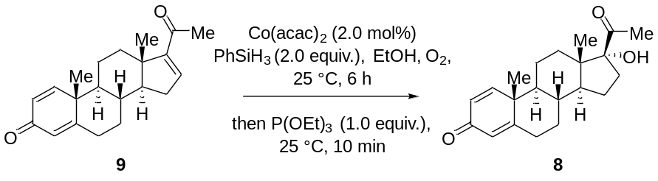
17α-hydroxy-Δ^{1, 4}-diene-3, 20-dione (8):
Batch mode: A solution of PhSiH₃ (14.60 g, 135.2 mmol, 2.0 equiv.) in EtOH (105 mL) was added to a solution containing Δ^{1, 4, 16}-triene-3, 20-dione (9) (21.00 g, 67.6 mmol, 1.0 equiv.) and Cobalt (II) acetylacetonate (Co(acac)₂, 348.0 mg, 1.4 mmol, 2.0 mol%) in EtOH (105 mL), all at 0 °C. Then, the reaction mixture was stirred at room temperature for 6 h. After complete consumption of the starting substrate 9, P(OEt)₃ (11.20 g, 67.6 mmol, 1.0 equiv.) was added, and the mixture was stirred at room temperature for 10 min. Then, the solution was quenched by the addition of H₂O (100 mL). The phases were separated, and the aqueous layer was extracted with DCM (3 × 200 mL). The combined organic phases were washed with brine (2 × 200 mL) and dried with Na₂SO₄. After filtration and removal of the solvents in vacuo the crude product 8 was purified by column chromatography (200-300 mesh) on silica gel (PE:EA = 4:1) to afford pure 8 with a yield of 82.1% (18.24 g).
White powder. m.p.: 232.1-233.2 °C. [α]_{D}²⁵ =20.7 (c = 0.18, CHCl₃). [Lit.⁷: m.p.: 199-200 °C. [α] _{D}²⁵ = 94.0 (c = 0.02, CHCl₃).]. ¹H NMR (400 MHz, CDCl₃) δ 7.04 (d, J = 10.1 Hz, 1H), 6.23 (dd, J = 10.1, 1.5 Hz, 1H), 6.07 (s, 1H), 2.68 (ddd, J = 14.6, 11.4, 2.9 Hz, 1H), 2.48 (td, J = 13.3, 4.5 Hz, 1H), 2.41-2.32 (m, 1H), 2.27 (s, 3H), 2.01-1.94 (m, 1H), 1.87-1.77 (m, 2H), 1.77-1.65 (m, 4H), 1.65-1.51 (m, 2H), 1.46-1.34 (m, 2H), 1.23 (s, 3H), 1.15-1.05 (m, 2H), 0.78 (s, 3H). ¹³C NMR (101 MHz, CDCl₃) δ 211.5, 186.3, 168.9, 155.6, 127.6, 124.0, 89.7, 51.8, 49.6, 48.4, 43.5, 35.4, 33.6, 33.5, 32.8, 30.0, 27.9, 24.1, 22.3, 18.8, 15.5. FTIR (KBr): n_{max} = 2954, 2923, 2868, 2852, 1660, 1460, 1377 cm⁻¹. HRMS (ESI) m/z calculated for C₂₁H₂₉O₃, [M + H]⁺ = 329.2111, found: C₂₁H₂₉O₃, 329.2111.

4.9 Co-catalyzed Mukaiyama hydration of 9 via continuous-flow.
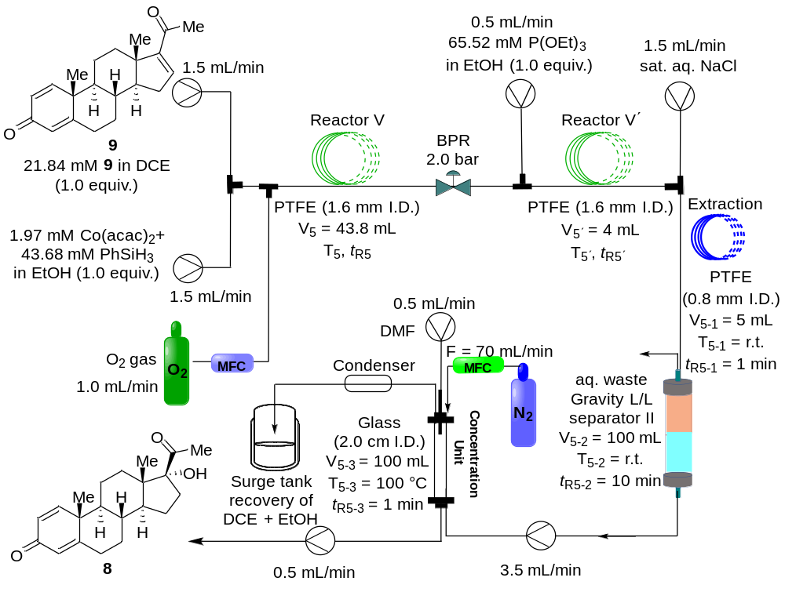
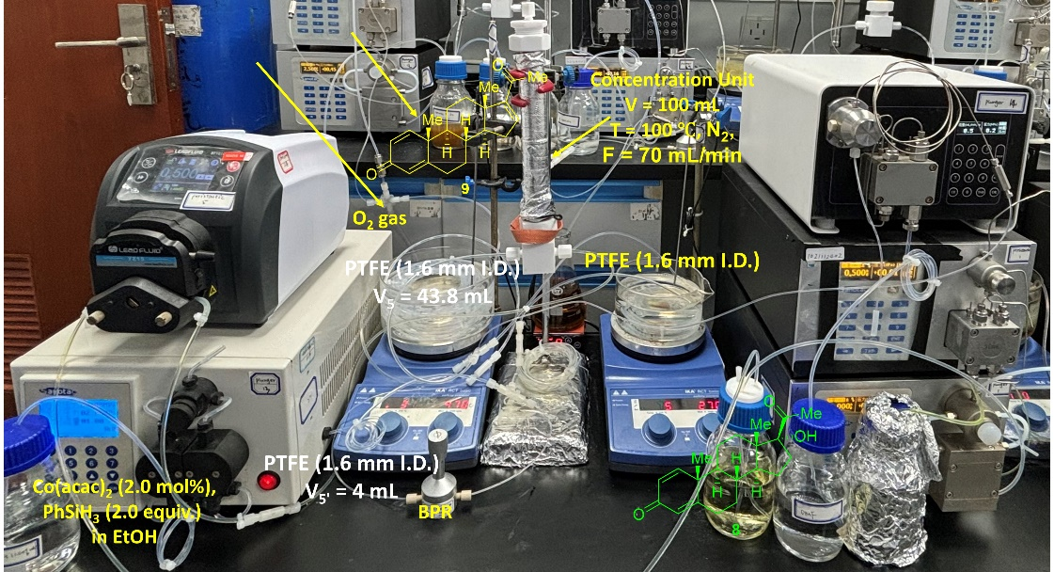
Flow mode: Mukaiyama hydration of Δ^{1, 4, 16}-triene-3, 20-dione (9) to 17α-hydroxy-Δ^{1, 4}-diene-3, 20-dione (8) in flow: two flow streams, Stream I (1.5 mL/min) containing a solution of the purified 9 (21.84 mM, 1.0 equiv.) in DCE (750 mL), and Stream II (1.5 mL/min) containing a solution of Co(acac)₂ (1.97 mM, 9.0 mol%) and PhSiH₃ (43.68 mM, 2.0 equiv.) in EtOH (750 mL), were delivered into the PTFE reactor by plunger pumps, the stream III containing O₂ gas (1.0 mL/min). These three streams, pumped at a total flow rate of 3.5 mL/min and mixed through a cross-shaped mixer, were then passed through a PTFE coil reactor (43.8 mL, 1.6 mm I.D., 3.2 mm O.D.) at 35 °C with a residence time of 7.5 min. The outlet of the PTFE coil reactor was connected to a back-pressure regulator to maintain a stable system pressure at 2.0 bar. Subsequently, the output of the reaction mixture was mixed with P(OEt)₃ (65.5 mM, 1.0 equiv.) in EtOH (250 mL) using a T-piece mixer at room temperature for 10 min. The output stream of the crude 8 solution was delivered into the in-line work-up. The reaction mixture is quenched by mixing with a saturated aqueous NaCl solution using a T-piece mixer and then fed into the Extraction coil for extraction. The effluent is separated via a Gravity Liquid-Liquid separator to obtain the lower layer, which contains the product 8 in a DCE/EtOH solution.
After the stabilization of the reaction system, the output flow from the PTFE coil reactor IV was collected for 8.33 h. The conversion of 9 was determined by LC-MS. The output of the reaction mixture was further purified by column chromatography on silica gel (200-300 mesh, PE:EA = 4:1) to afford pure 8 with a yield of 78.3 % (4.20 g).
4.10 General procedures for Δ⁶-dehydrogenation of 8.
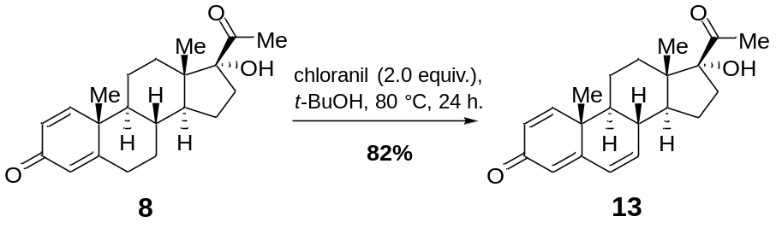
17α-hydroxy-Δ^{1, 4, 6}-triene-3, 20-dione (13)
Batch mode: Chloranil (26.95 g, 109.6 mmol, 2.0 equiv.) was added to a solution of 8 (18.00 g, 54.8 mmol, 1.0 equiv.) in t-BuOH (180 mL). The reaction mixture was stirred at 80 °C for 24 h and then was poured into sat. aq. NaCO₃ (100 mL), The organic phase was separated and the aqueous phase was extracted with DCM (3 × 200 mL). The combined organic phase was washed with H₂O (3 × 200 mL), brine (3 × 200 mL), dried with anhydrous Na₂SO₄ and concentrated under reduced pressure to give crude product 13. Which was purified by chromatography on silica gel (PE:EA = 6:1) to provide pure 13 with a yield of 81.7% (14.62 g).
White powder. m.p.: 234-236 °C. ¹H NMR (400 MHz, CDCl₃) δ 7.06 (d, J = 10.1 Hz, 1H), 6.24 (d, J = 10.1 Hz, 2H), 6.03 (dd, J = 17.7, 7.1 Hz, 2H), 2.86 (s, 1H), 2.74 (t, J = 12.3 Hz, 1H), 2.28 (s, 3H), 2.06-1.91 (m, 2H), 1.85 (t, J = 13.1 Hz, 1H), 1.81-1.43 (m, 7H), 1.19 (s, 3H), 0.81 (s, 3H). ¹³C NMR (101 MHz, CDCl₃) δ 211.4, 186.4, 162.4, 152.7, 137.9, 128.2, 127.9, 123.9, 89.4, 48.6, 47.9, 47.9, 41.1, 37.8, 33.6, 30.1, 27.9, 23.4, 21.3, 20.8, 15.4. FTIR (KBr): n_{max} = 3473, 2975, 2945, 2862, 1701, 1645, 1560, 1579, 1348, 1194, 895 cm⁻¹. HRMS (ESI) m/z calculated for C₂₁H₂₇O₃, [M + H]⁺ = 327.1955, found: C₂₁H₂₇O₃, 327.1950. [α] _{D}²⁵ = 8.53 (c = 0.15, CHCl₃).

4.11 Continuous-flow synthesis of 13 via Δ⁶-dehydrogenation.
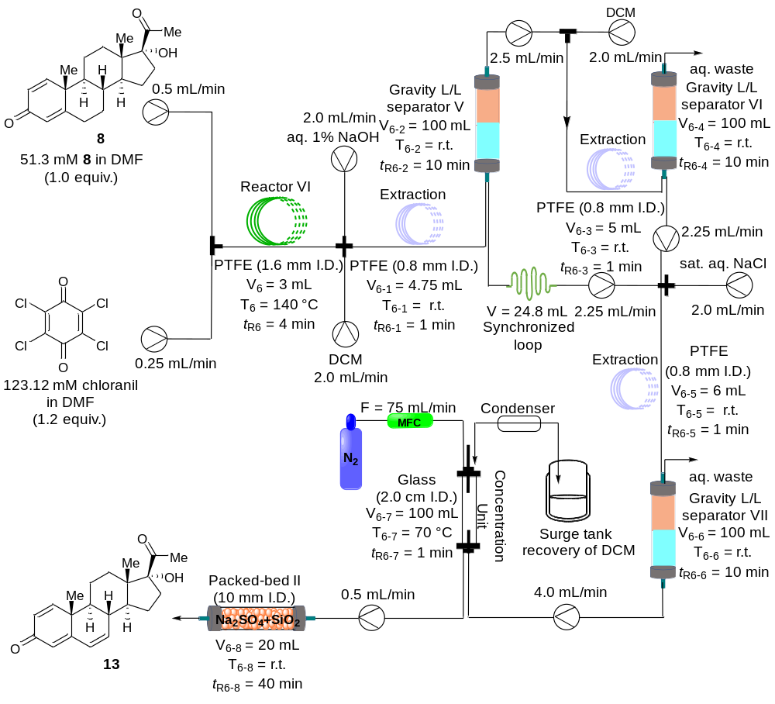
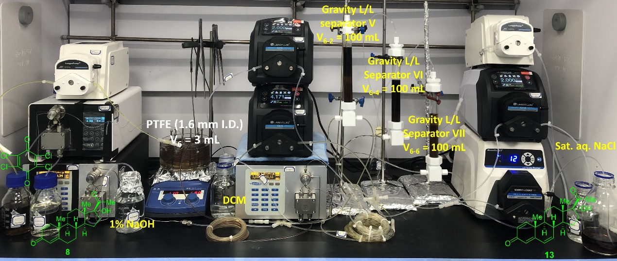
Flow mode: C6, C7-dehydrogenation of 17α-hydroxy-Δ^{1, 4}-diene-3, 20-dione (8) to 17α-hydroxy-Δ^{1, 4, 6}-triene-3, 20-dione (13) in flow: two flow streams were delivered into the PTFE reactor by the plunger pump and peristaltic pump, Stream I (0.5 mL/min) containing a solution of the purified 8 (51.3 mM, 1.0 equiv.) in DMF (250 mL), and Stream II (0.25 mL/min) containing a solution of chloranil (123.12 mM, 1.2 equiv.) in DMF (125 mL). These two streams were pumped at a total flow rate of 0.75 mL/min and mixed through a T-piece mixer. Then the liquid solution was passed through a PTFE coil reactor (3.0 mL, 1.6 mm I. D., 3.2 mm O. D.) at 140 °C with a 4 min residence time. The output stream of the crude 13 solution from the in-flow was delivered into the in-line work-up system. A plunger pump was utilized to introduce DCM (2.0 mL/min). The effluent was then extracted with DCM through an extraction coil, and the resulting solution was separated via online liquid-liquid separation using Gravity separator V (t_{R6-2} = 10 min). This process yielded the lower layer of a DCM/DMF solution containing product 13, which then entered the Synchronized loop (V = 24.8 mL) (The synchronization loop coil was used to match the time-scale between Gravity L/L separator V and Gravity L/L separator VI, ensuring DCM effluent could synchronously enter Gravity L/L separator VII). The upper layer of the solution was subjected to a secondary DCM extraction. The mixed solution was then layered through Gravity separator VI (t_{R6-4} = 10 min). The lower layer of the output solution was combined with the DCM/DMF solution from Gravity separator V. This combined solution was then mixed with H₂O in a T-piece mixer, and further layered through Gravity separator VII (t_{R6-6} = 10 min). The upper layer outputs waste water, while the lower layer containing product 13 in DCM was evaporated in an online Concentration unit (Tube-in-tube, F = 75 mL/min, T₆₋₇ = 70 °C) to obtain an 8-fold concentrated solution of DCM containing product 13. The effluent then passes through a stainless steel column (loaded with 1:1 Na₂SO₄/SiO₂) to remove water molecules (t_{R6-8} = 40 min). After the stabilization of the reaction system, the output flow from the PTFE coil reactor VI was collected for 8.33 h. The conversion of 8 was determined by LC-MS. The output of the reaction mixture was further purified offline by column chromatography on silica gel (200-300 mesh, PE:EA = 6:1) to afford pure 13 with a yield of 83% (3.47 g).
4.12 General procedures for C20-ketalization of 13.
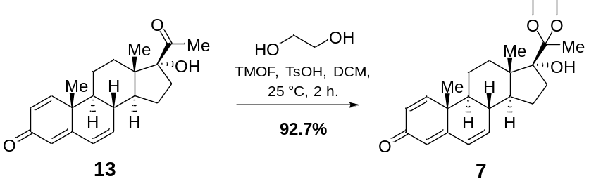
17α-hydroxy-Δ^{1, 4, 6}-triene-3-one-20-ketal (7):
Batch mode: 17α-hydroxy-Δ^{1, 4, 6}-triene-3-one-20-ketal (7) was synthesized starting from 17α-hydroxy-Δ^{1, 4, 6}-triene-3, 20-dione (13): Under nitrogen atmosphere, a solution of 13 (14.00 g, 42.9 mmol, 1.0 equiv.), trimethyl orthoformate (TMOF, 17.80 g, 167.3 mmol, 3.9 equiv.), ethylene glycol (12.00 g, 193.0 mmol, 4.5 equiv.) and TsOH (18.3 mg, 4.3 mmol, 0.1 equiv.) dissolved in DCM (140 mL). The reaction mixture was stirred at 25 °C for 2 h and then was poured into sat. aq. NaHCO₃ (70 mL), The organic phase was separated and the aqueous phase was extracted with DCM (2 × 70 mL). The combined organic phase was washed with H₂O (2 × 200 mL), brine (2 × 200 mL), dried with anhydrous Na₂SO₄ and concentrated under reduced pressure to give crude product 7. Which was purified by chromatography on silica gel (PE:EA = 4:1) to provide pure 7 with a yield of 92.7% (14.73 g).
White powder. m.p.: 180.2-181.7 °C. ¹H NMR (400 MHz, DMSO-d₆) δ 7.20 (d, J = 10.1 Hz, 1H), 6.31 (dd, J = 9.8, 2.4 Hz, 1H), 6.21-6.03 (m, 2H), 5.96 (s, 1H), 4.01-3.88 (m, 2H), 3.88-3.73 (m, 2H), 2.50 (s, 2H), 2.28 (t, J = 10.7 Hz, 1H), 2.14 (t, J = 11.9 Hz, 1H), 2.03-1.84 (m, 1H), 1.83-1.68 (m, 3H), 1.58 (dd, J = 16.6, 6.6 Hz, 2H), 1.49-1.36 (m, 1H), 1.34-1.26 (m, 1H), 1.24 (s, 3H), 1.15 (s, 3H), 0.86 (s, 3H). ¹³C NMR (101 MHz, DMSO-d₆) δ 185.5, 163.1, 154.0, 139.6, 127.9, 127.6, 123.4, 112.7, 86.1, 65.7, 63.1, 48.6, 48.2, 46.8, 41.2, 37.6, 31.9, 31.4, 22.5, 21.4, 21.2, 21.1, 14.9. FTIR (KBr): n_{max} = 3409, 2978, 2939, 2895, 2860, 1651, 1599, 1364, 1184, 1084, 1051, 880 cm⁻¹. HRMS (ESI) m/z calculated for C₂₃H₃₁O₄, [M + H]⁺ = 371.2217, found: C₂₃H₃₁O₄, 371.2213. [α] _{D}²⁵ = 23.52 (c = 0.13, CHCl₃).
4.13 Continuous-flow C20-ketalization of 13.
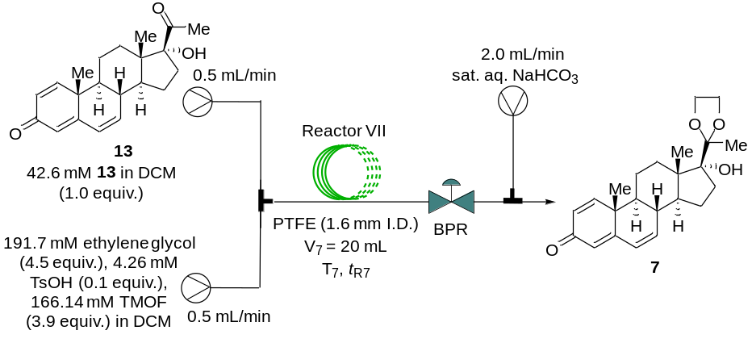
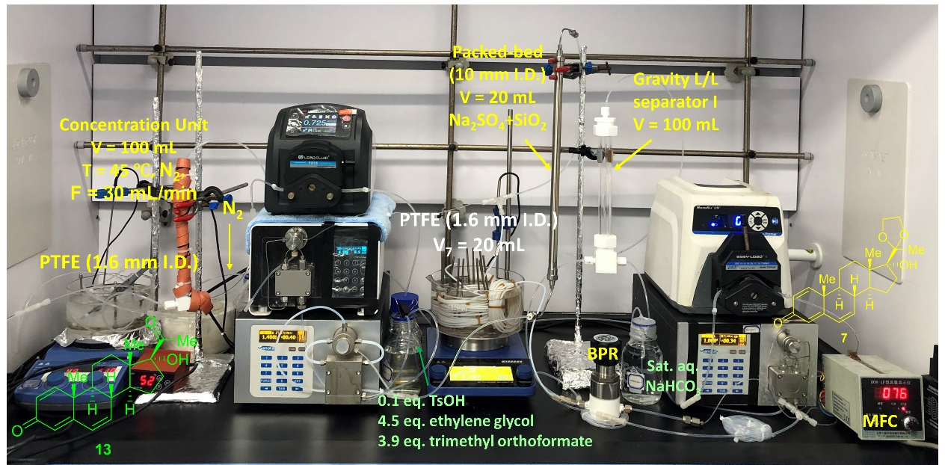
Flow mode: C20-ketalization of 17α-hydroxy-Δ^{1, 4, 6}-triene-3, 20-dione (13) to 17α-hydroxy-Δ^{1, 4, 6}-triene-3-one-20-ketal (7) in flow: two flow streams were delivered into the PTFE reactor by the plunger pumps, Stream I (0.5 mL/min) containing a solution of the purified 13 (42.6 mM, 1.0 equiv.) in DCM (250 mL), and Stream II (0.5 mL/min) containing a solution of trimethyl orthoformate (166.1 mM, 3.9 equiv.), ethylene glycol (191.7 mM, 4.5 equiv.) and TsOH (4.3 mM, 0.1 equiv.) dissolved in DCM (250 mL). These two streams were pumped at a total flow rate of 1.0 mL/min and mixed through a T-piece mixer. Then the liquid solution was passed through a PTFE coil reactor (20.0 mL, 1.6 mm I. D., 3.2 mm O. D.) at 90 °C with a 20 min residence time. The outlet of the PTFE coil reactor was connected to a back-pressure regulator to control a stable system pressure at 4.0 bar. Then the output of the reaction mixture was quenched with sat. aq. NaHCO₃. After the stabilization of the reaction system, the output flow from the PTFE coil reactor VII was collected for 8.33 h. The conversion of 13 was determined by LC-MS. The output of the reaction mixture was further purified by column chromatography on silica gel (200-300 mesh, PE:EA = 4:1) to afford pure 7 with a yield of 92 % (3.62 g).
4.14 General procedures for Corey-Chaykovsky cyclopropanation of 7.
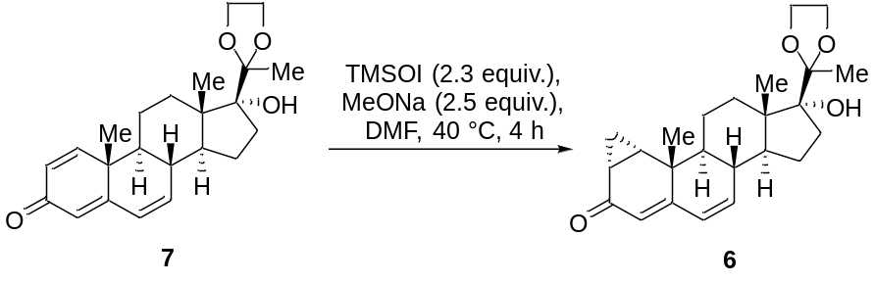
17α-hydroxy-1α, 2α-cyclopropyl-Δ^{4, 6}-diene-3-one-20-ketal (6)
Batch mode: 17α-hydroxy-1α, 2α-cyclopropyl-Δ^{4, 6}-diene-3-one-20-ketal (6) was synthesized starting from 17α-hydroxy-Δ^{1, 4, 6}-triene-3-one-20-ketal (7). A solution of TMSOI (19.10 g, 86.9 mmol, 2.3 equiv.) in 70 mL dry DMF under a nitrogen atmosphere was cooled to 0 °C. Subsequently, MeONa (5.10 g, 94.5 mmol, 2.5 equiv.) was added dropwise and the reaction mixture was stirred at room temperature for 1 h form a sulfur ylide solution. Next a solution of 7 (14.00 g, 37.8 mmol, 1.0 equiv.) dissolved in dry DMF (70 mL) was then added and the reaction mixture was stirred at 40 °C for 4 h. The conversion of starting material was calculated based on LC-MS integration, after complete consumption of the starting substrate 7, the reaction was quenched by the addition of H₂O (100 mL). The aqueous solution was extracted with DCM (3 × 200 mL). The combined organic phases were washed with H₂O (2 × 200 mL), brine (2 × 200 mL) and dried with Na₂SO₄. After filtration and removal of the solvents in vacuo the crude product 6 was purified by column chromatography on silica gel (200-300 mesh, PE:EA = 4:1) to afford pure 6 with a yield of 85.2% (12.38 g).
White powder. m.p.: 75-77°C. ¹H NMR (400 MHz, CD₃OD) δ 6.24-6.02 (m, 2H), 5.48 (s, 1H), 4.06-3.81 (m, 4H), 2.37-2.22 (m, 2H), 2.09-1.97 (m, 2H), 1.95-1.78 (m, 5H), 1.77-1.58 (m, 2H), 1.57-1.45 (m, 1H), 1.43-1.35 (m, 1H), 1.34 (s, 3H), 1.33-1.27 (m, 2H), 1.22 (s, 3H), 0.95 (s, 3H), 0.83-0.76 (m, 1H). ¹³C NMR (101 MHz, CD₃OD) δ 200.5, 159.4, 140.8, 127.3, 118.7, 112.5, 86.9, 65.4, 63.0, 48.6, 47.6, 46.7, 37.4, 37.2, 31.7, 31.3, 25.7, 24.8, 22.0, 21.9, 20.5, 19.9, 13.7, 12.5. FTIR (KBr): n_{max} = 2932, 2869, 1648, 1618, 1368, 1179, 1068, 1039, 950, 884 cm⁻¹. HRMS (ESI) m/z calculated for C₂₃H₃₁O₄, [M + H]⁺ = 371.2217, found: C₂₃H₃₁O₄, 371.2213. [α]_{D}²⁵ = 119.55 (c = 0.11, CHCl₃).

4.15 Continuous-flow Corey-Chaykovsky cyclopropanation of 7.
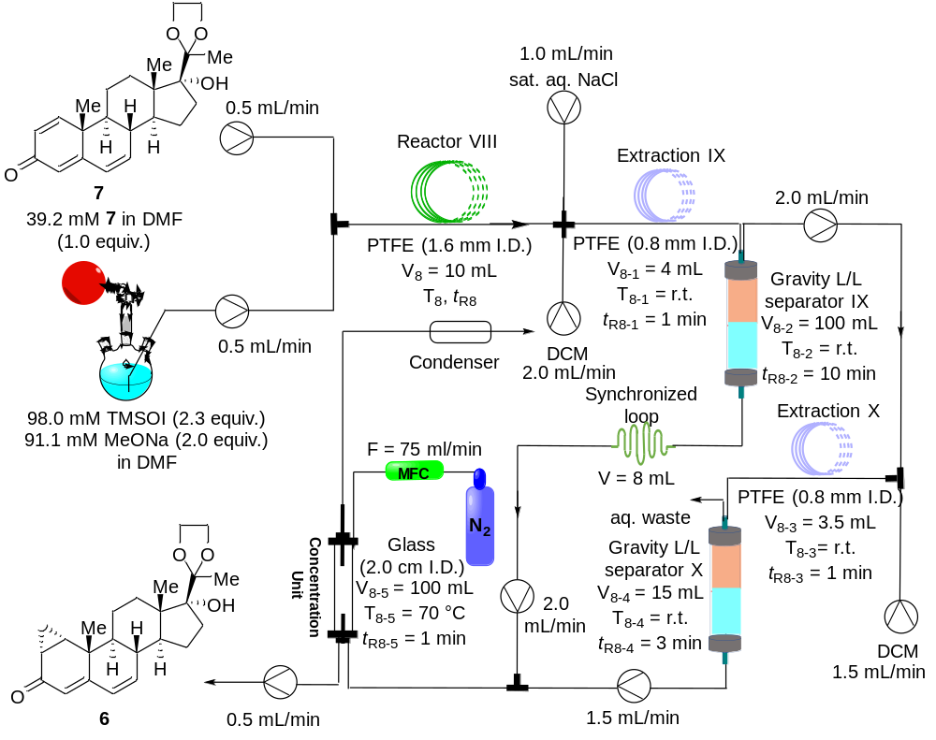
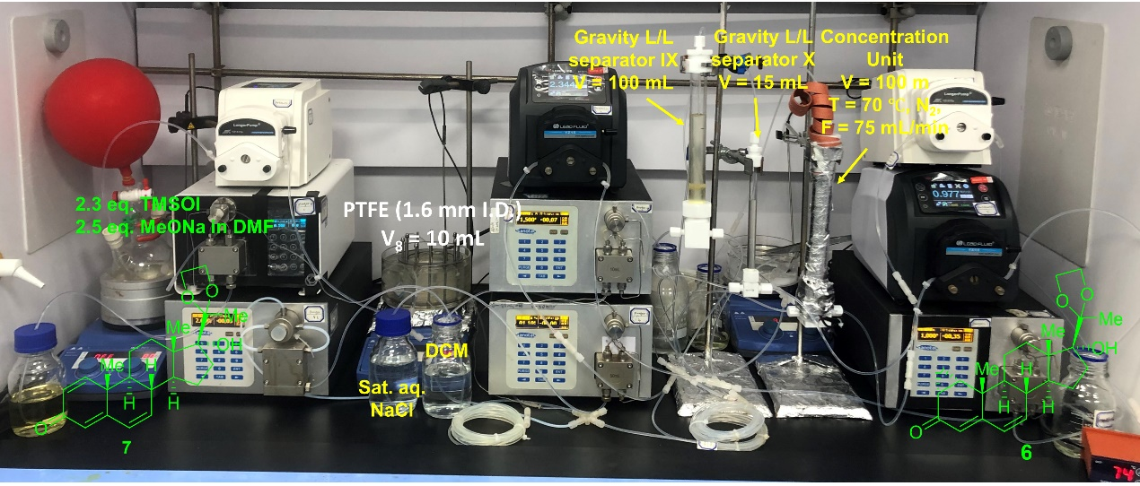
Flow mode: 17α-hydroxy-Δ^{1, 4, 6}-triene-3-one-20-ketal (7) to 17α-hydroxy-1α, 2α-cyclopropyl-Δ^{4, 6}-diene-3-one-20-ketal (6) in flow: two flow streams were delivered into the PTFE reactor by the plunger pumps, Stream I (0.5 mL/min) containing a solution of the purified 7 (39.2 mM, 1.0 equiv.) in anhydrous DMF (250 mL), and Stream II (0.5 mL/min) containing a solution of TMSOI (98.0 mM, 2.5 equiv.) and MeONa (91.6 mM, 2.3 equiv.) in DMF (250 mL). These two streams were pumped at a total flow rate of 1.0 mL/min and mixed through a T-piece mixer. Then the liquid solution was passed through a PTFE coil reactor (10.0 mL, 1.6 mm I. D., 3.2 mm O. D.) at 100 °C with a 10 min residence time. Then the output of the reaction mixture was quenched with sat. aq. NaCl, and the output stream of the crude 6 solution from the in-flow was delivered into the in-line work-up. A plunger pump was used to introduce DCM (2.0 mL/min), and the effluent was extracted by DCM via an extraction coil and the solution was separated via online liquid-liquid separation by Gravity separator IX (t_{R8-2} = 10 min) to provide the lower layer of a mixture DCM/DMF solution containing product 6, and then entered the Synchronized loop (V = 8 mL). The upper layer of the solution was subjected to a secondary DCM extraction. The mixed solution was then layered through Gravity separator X (t_{R8-4} = 10 min). The lower layer of the output solution was combined with the DCM/DMF solution from Gravity separator IX. This combined solution containing product 6 in DCM/DMF was evaporated in an online Concentration unit (Tube-in-tube, F = 70 mL/min, T₈₋₅ = 70 °C) to obtain an 8-fold concentrated solution of DCM containing product 6. After the stabilization of the reaction system, the output flow from the PTFE coil reactor VIII was collected for 8.33 h. The conversion of 7 was determined by LC-MS. The output of the reaction mixture was further purified by column chromatography on silica gel (200-300 mesh, PE:EA = 4:1) to afford pure 6 with a yield of 80.7% (3.03 g).
4.16 Nickel-catalyzed cyclopropanation of 7.
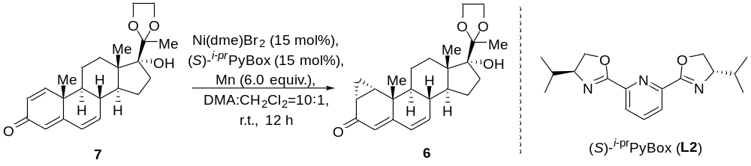
Nickel-catalyzed cyclopropanation of 17α-hydroxy-Δ^{1, 4, 6}-triene-3-one-20-ketal (7)
In a N₂-filled glovebox, Ni(dme)Br₂ (13.8 mg, 45 μmol, 15 mol%), (S)-^{i-pr}PyBox (13.5 mg, 45 μmol, 15 mol%), and Mn (98.9 mg, 1.8 mmol, 6.0 equiv.) were added to a 2-dram reaction vial charged with a magnetic stir bar. A 1.3 mL stock solution containing 7 (111.1 mg, 0.3 mmol, 1.0 equiv.) dissolved in 1:10 DCM:DMA was then added. The reaction vial was sealed and removed from the glovebox, the reaction mixture was stirred at room temperature for 12 h. An aliquot was taken from the crude mixture, diluted with MeOH, and filtered through a 1.5 cm silica pad. The conversion of starting material was calculated based on LC-MS integration. The reaction mixture was quenched by the addition of H₂O (500 μL). The phases were separated, and the aqueous layer was extracted with DCM (3 × 5 mL). The combined organic phases were washed with brine (2 × 5 mL) and dried with Na₂SO₄. After filtration and removal of the solvents in vacuo, the crude 6 was purified by column chromatography (200-300 mesh) on silica gel (PE:EA = 4:1) to afford pure 6 with a yield of 92% (106.0 mg).

4.17 General procedures for C6, C7-epoxidation of 6.
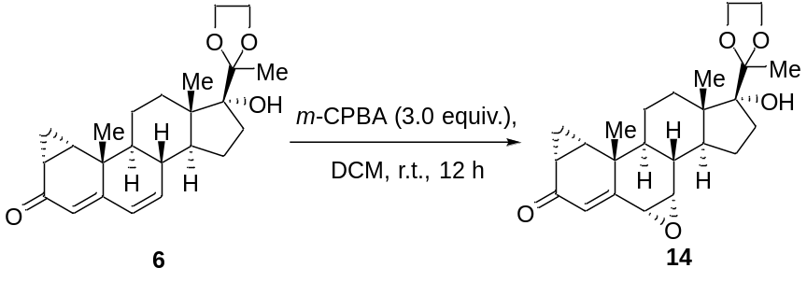
17α-hydroxy-6α, 7α-epoxy-1α, 2α-cycloppropyl-Δ⁴-ene-3-one-20-ketal (14)
Batch mode: 17α-hydroxy-6α, 7α-epoxy-1α, 2α-cycloppropyl-Δ⁴-ene-3-one-20-ketal (14) was synthesized starting from 17α-hydroxy-1α, 2α-cyclopropyl-Δ^{4, 6}-diene-3-one-20-ketal (6): m-CPBA (21.54 g, 124.8 mmol, 4.0 equiv.) was added to a solution of 6 (12.00 g, 31.2 mmol, 1.0 equiv.) in DCM (120 mL). The reaction mixture was stirred at room temperature for 12 h and then was poured into 1% NaOH (100 mL), The organic phase was separated and the aqueous phase was extracted with DCM (2 × 100 mL). The combined organic phase was washed with Na₂S₂O₃ (200 mL), H₂O (2 × 200 mL), brine (2 × 200 mL), dried with anhydrous Na₂SO₄ and concentrated under reduced pressure to give crude product 14. The crude product was purified by chromatography on silica gel (PE:EA = 8:1) to provide pure 14 with a yield of 72% (8.90 g).
White powder. m.p.: 170.6-172.4 °C. ¹H NMR (400 MHz, DMSO-d₆) δ 7.95-7.81 (m, 2H), 7.71 (d, J = 8.0 Hz, 1H), 7.55 (dd, J = 10.0, 6.1 Hz, 1H), 4.03-3.88 (m, 1H), 3.87-3.74 (m, 1H), 3.52-3.33 (m, 6H), 2.48 (d, J = 16.2 Hz, 3H), 2.25-1.95 (m, 2H), 1.96-1.65 (m, 3H), 1.65-1.34 (m, 3H), 1.33-1.00 (m, 7H), 0.91-0.68 (m, 2H). FTIR (KBr): n_{max} = 2925, 2871, 2854, 1728, 1659, 1373, 1244, 1183, 1083, 1044, 967 cm⁻¹. HRMS (ESI) m/z calculated for C₂₄H₃₃O₅, [M + H]⁺ = 401.2323, found 401.2323. [α] _{D}²⁵ = 163.88 (c = 0.13, CHCl₃).
4.18 Continuous-flow C6, C7-epoxidation of 6.
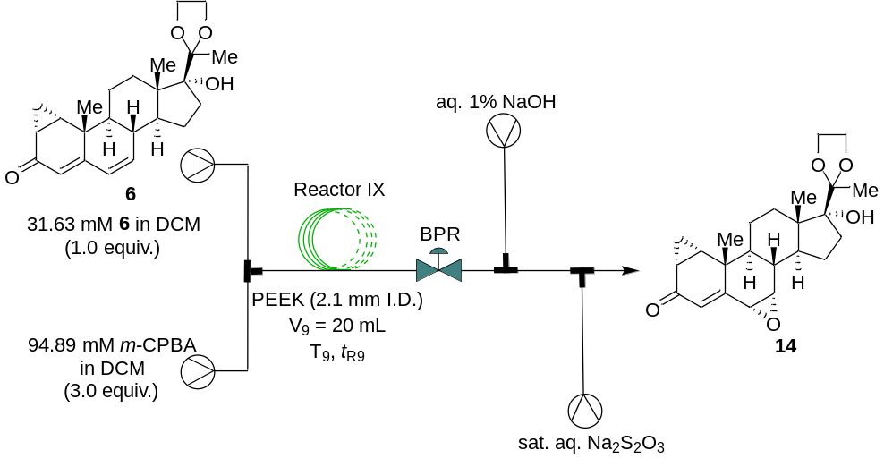
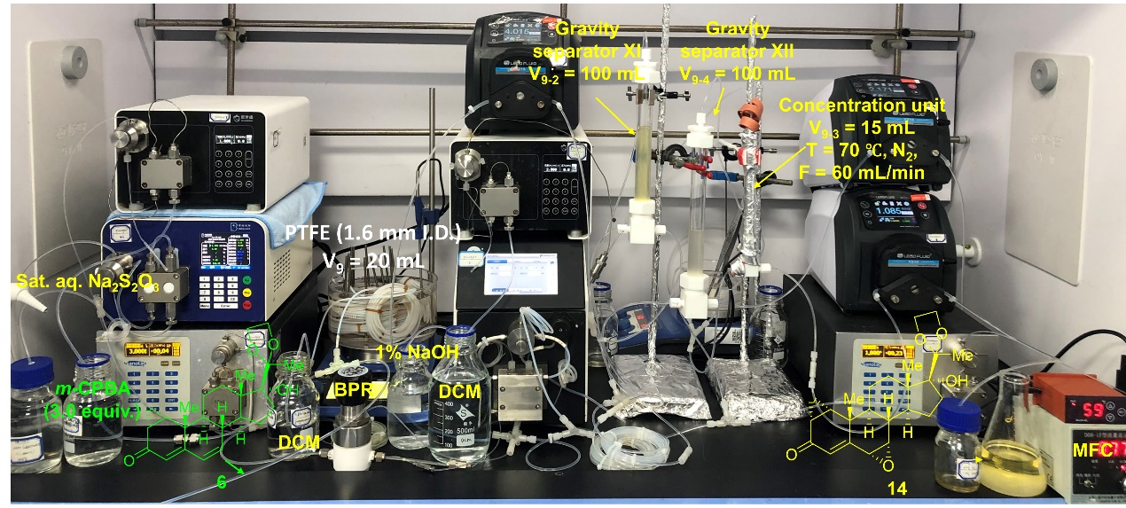
Flow mode: 17α-hydroxy-1α, 2α-cyclopropyl-Δ^{4, 6}-diene-3-one-20-ketal (6) to 17α-hydroxy-6α, 7α-epoxy-1α, 2α-cycloppropyl-Δ⁴-ene-3-one-20-ketal (14) in flow: two flow streams were delivered into the PEEK reactor by the plunger pumps, Stream I (0.5 mL/min) containing a solution of the purified 6 (31.6 mM, 1.0 equiv.) in DCM (250 mL), and Stream II (0.5 mL/min) containing a solution of m-CPBA (94.9 mM, 3.0 equiv.) in DCM (250 mL). These two streams were pumped at a total flow rate of 1.0 mL/min and mixed through a T-piece mixer. Then the liquid solution was passed through a PEEK coil reactor (20.0 mL, 1.6 mm I. D., 3.2 mm O. D.) at 110 °C with a 20 min residence time. The outlet of the PEEK coil reactor was connected to a back-pressure regulator to control a stable system pressure at 6.0 bar. Then the output of the reaction mixture was quenched with aq. 1% NaOH and sat. aq. Na₂S₂O₃. After the stabilization of the reaction system, the output flow from the PEEK coil reactor IX was collected for 8.33 h. The conversion of 6 was determined by LC-MS. The output of the reaction mixture was further purified by column chromatography on silica gel (200-300 mesh, PE:EA = 8:1) to afford pure 14 with a yield of 70% (2.21 g).
4.19 General procedures for C6, C7 ring-opening/C6-chlorination/dehydration/C20-deprotection cascade of 14.
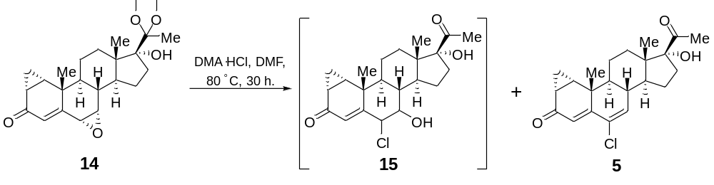
17α-hydroxy-1α, 2α-cyclopropyl-6-chloro-Δ^{4, 6}-diene-3, 20-dione (5):
Batch mode: 17α-hydroxy-1α, 2α-cyclopropyl-6-chloro-Δ^{4, 6}-diene-3, 20-dione (5) was synthesized starting from 17α-hydroxy-6α, 7α-epoxy-1α, 2α-cycloppropyl-Δ⁴-ene-3-one-20-ketal (14). A solution of 14 (8.50 g, 21.1 mmol, 1.0 equiv.) in dry DMF (85 mL) was added with dry N, N-dimethylacetamide hydrochloride (20.80 g, 168.9 mmol, 8.0 equiv.) and then the mixture was stirred at 80 °C under N₂ for 30 h. After addition to 1% NaOH (85 mL), the reaction mixture was extracted with DCM (3 × 100 mL) and the combined organic phase was washed with water (300 mL), brine (2 × 300 mL), dried with anhydrous Na₂SO₄ and evaporated under reduced pressure to provide crude 17α-hydroxy-1α, 2α-cyclopropyl-6-chloro-Δ^{4, 6}-diene-3, 20-dione (5). The crude 5 was purified by column chromatography on silica gel (200-300 mesh, PE:EA = 6:1) to afford pure 5 with a yield of 70% (5.57 g).
White powder. m.p.: 194-196 °C. ¹H NMR (400 MHz, CD₃OD) δ 6.37 (d, J = 2.3 Hz, 1H), 6.08 (s, 1H), 2.90-2.64 (m, 1H), 2.46-2.36 (m, 1H), 2.20 (d, J = 2.5 Hz, 3H), 2.12-1.82 (m, 7H), 1.72-1.56 (m, 2H), 1.57-1.45 (m, 3H), 1.41-1.28 (m, 4H), 1.25 (s, 3H), 0.93-0.83 (m, 3H), 0.71 (s, 3H). ¹³C NMR (101 MHz, CD₃OD) δ 212.9, 201.1, 155.6, 139.8, 130.5, 120.4, 90.8, 49.5, 49.3, 49.2, 48.6, 40.3, 39.9, 33.8, 31.8, 27.5, 27.3, 26.3, 23.7, 23.2, 21.9, 15.1, 13.5. FTIR (KBr): n_{max} = 2924, 2854, 1715, 1638, 1606, 1460, 1376, 890 cm⁻¹. HRMS (ESI) m/z calculated for C₂₂H₂₈ClO₃, [M + H]⁺ = 375.1721, found 375.1718. [α] _{D}²⁵ = 185.47 (c = 0.1, CHCl₃).
7, 17α-dihydroxy-1α, 2α-cyclopropyl-6-chloro-Δ⁴-ene-3, 20-dione (15)
¹H NMR (400 MHz, CD₃OD) δ 5.82 (s, 1H), 4.47 (d, J = 2.5 Hz, 1H), 3.83 (s, 1H), 2.73 (ddd, J = 14.5, 11.6, 2.8 Hz, 1H), 2.38-2.27 (m, 1H), 2.20 (s, 3H), 2.17-2.09 (m, 1H), 1.97 (ddd, J = 17.8, 16.9, 8.0 Hz, 3H), 1.89-1.81 (m, 2H), 1.74-1.66 (m, 1H), 1.59-1.53 (m, 1H), 1.48 (s, 3H), 1.35-1.25 (m, 5H), 0.91-0.85 (m, 2H), 0.69 (s, 3H). ¹³C NMR (101 MHz, CD₃OD) δ 211.9, 199.0, 159.2, 127.1, 89.9, 71.4, 62.0, 46.8, 44.2, 41.6, 38.8, 34.0, 32.5, 30.3, 28.5, 26.4, 26.0, 25.7, 22.6, 21.2, 13.8, 12.3. HRMS (ESI) m/z calculated for C₂₂H₃₀ClO₄, [M + H]⁺ = 393.1827, found 393.1836.
4.20 Continuous-flow synthesis of 5 via C6, C7 ring-opening/C6-chlorination/dehydration/C20-deprotection cascade.
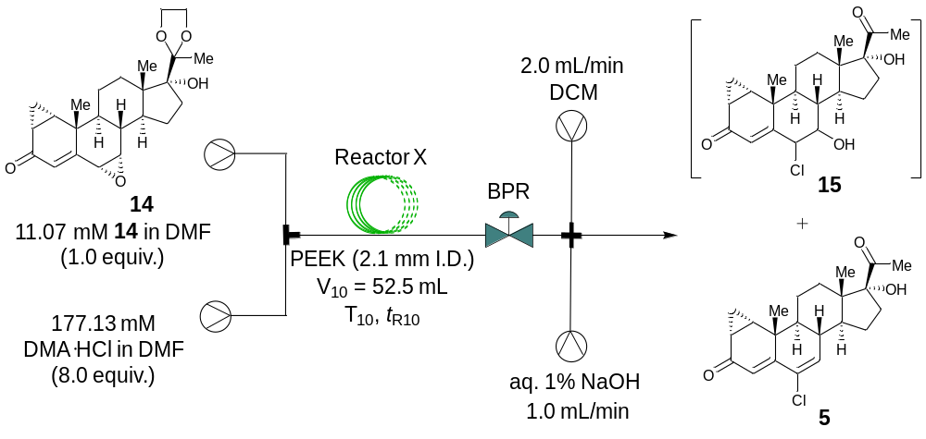
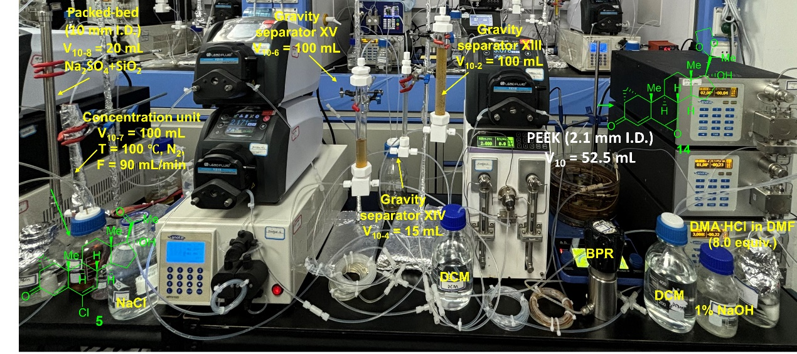
Flow mode: 17α-hydroxy-6α, 7α-epoxy-1α, 2α-cycloppropyl-Δ⁴-ene-3-one-20-ketal (14) to 17α-hydroxy-1α, 2α-cyclopropyl-6-chloro-Δ^{4, 6}-diene-3, 20-dione (5) in flow: two flow streams were delivered into the PEEK reactor by the plunger pumps, Stream I (1.0 mL/min) containing a solution of the purified 14 (11.07 mmol, 1.0 equiv.) in anhydrous DMF (500 mL), and Stream II (0.5 mL/min) containing a solution of DMA·HCl (177.1 mM, 8.0 equiv.) in DMF (250 mL). These two streams were pumped at a total flow rate of 1.5 mL/min and mixed through a T-piece mixer. Then the liquid solution was passed through a PEEK coil reactor (52.5 mL, 1.6 mm I. D., 3.2 mm O. D.) at 180 °C with a 35 min residence time. The outlet of the PEEK coil reactor was connected to a back-pressure regulator to control a stable system pressure at 16.0 bar. Then the output of the reaction mixture was quenched with aq. 1% NaOH, and the aqueous phase was extracted with DCM. After the stabilization of the reaction system, the output flow from the PEEK coil reactor X was collected for 8.33 h. The conversion of 14 was determined by LC-MS. The output of the reaction mixture was further purified by column chromatography on silica gel (200-300 mesh, PE:EA = 6:1) to afford pure 5 with a yield of 67% (1.38 g).
4.21 General procedures for C17 O-acetylation of 5.
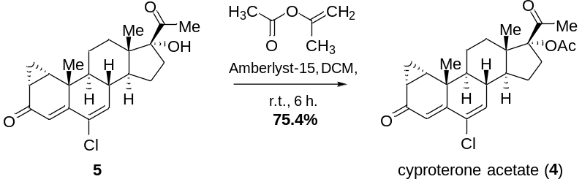
Cyproterone acetate (4):
Batch mode: Cyproterone acetate was synthesized starting from 17α-hydroxy-1α, 2α-cyclopropyl-6-chloro-Δ^{4, 6}-diene-3, 20-dione (5). In N₂-atmosphere, Amberlyst15 hydrogen form (8.39 g, 26.7 mmol, 2.0 equiv.) were added to a 2-dram reaction vial charged with a magnetic stir bar. A 50.0 mL stock solution containing 5 (5.00 g, 13.3 mmol, 1.0 equiv.) dissolved in 1:3 DCM:Isopropenyl acetate was then added. The reaction mixture was stirred at room temperature for 6 h and then was poured into H₂O (50 mL), The organic phase was separated and the aqueous phase was extracted with DCM (2 × 50 mL). The combined organic phase was washed with H₂O (2 × 200 mL), brine (2 × 200 mL), dried with anhydrous Na₂SO₄ and concentrated under reduced pressure to give crude product 4. The crude product was purified by chromatography on silica gel (PE:EA = 6:1) to provide pure 4 with a yield of 75.4% (4.19 g).
White powder. m.p.: 206.5-207.5 °C. ¹H NMR (400 MHz, CDCl₃) δ 6.20 (d, J = 2.3 Hz, 1H), 6.15 (s, J = 1.0 Hz, 1H), 2.98 (ddd, J = 15.7, 10.9, 1.8 Hz, 1H), 2.37-2.25 (m, 1H), 2.05 (s, 3H), 2.04-1.94 (m, 3H), 1.93 (d, J = 2.9 Hz, 1H), 1.91-1.86 (m, 1H), 1.86-1.82 (m, 1H), 1.83-1.76 (m, 1H), 1.71 (td, J = 7.8, 6.4 Hz, 1H), 1.66-1.59 (m, 1H), 1.55 (dd, J = 12.6, 4.0 Hz, 1H), 1.52-1.37 (m, 2H), 1.27 (td, J = 9.0, 7.9, 4.9 Hz, 1H), 1.21 (s, 3H), 0.87 (dd, J = 6.4, 4.5 Hz, 1H), 0.71 (s, 3H). ¹³C NMR (101 MHz, CDCl₃) δ 203.8, 198.1, 170.6, 152.3, 136.6, 130.2, 120.4, 96.2, 48.7, 47.7, 47.2, 38.7, 38.3, 31.0, 30.3, 26.4, 26.1, 25.3, 23.2, 22.9, 21.2, 20.8, 14.2, 12.4. FTIR (KBr): n_{max} = 1740, 1718, 1651, 1370, 1351, 1257, 1245, 962, 898, 584 cm⁻¹. HRMS (ESI) m/z calculated for C₂₄H₃₀ClO₄, [M + H]⁺ = 417.1827, found 417.1832. [α] _{D}²⁵ = 144.75 (c = 0.13, CHCl₃) or [α]_{D}²⁰ = 156.45 (c = 1.0, acetone).
4.22 Continuous-flow C17O-acetylation synthesis of 4.
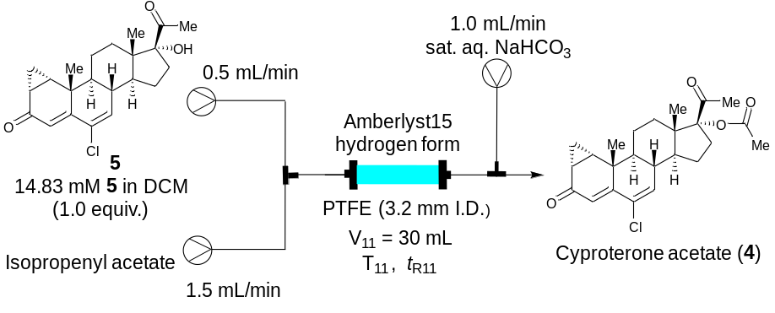
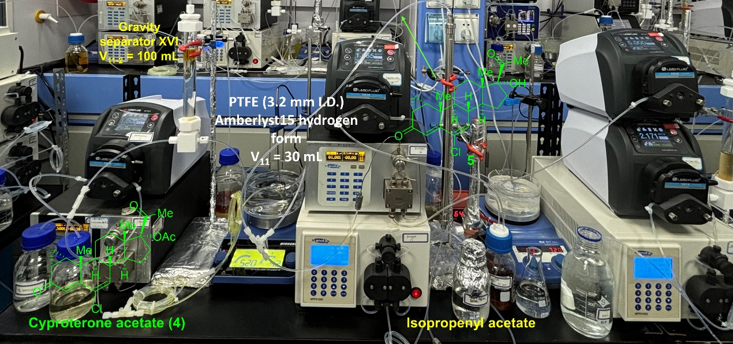
Flow mode: 17α-hydroxy-1α, 2α-cyclopropyl-6-chloro-Δ^{4, 6}-diene-3, 20-dione (5) to cyproterone acetate in flow: two flow streams were delivered into the Packed bed reactor (filled Amberlyst15 hydrogen form (8.39 g, 26. 7 mmol, 2.0 equiv.)) by the plunger pumps, Stream I (0.5 mL/min) containing a solution of the purified 5 (14.83 mM, 1.0 equiv.) in anhydrous DCM (250 mL), and Stream II (1.5 mL/min) containing Isopropenyl acetate (750 mL). These two streams were pumped at a total flow rate of 2.0 mL/min and mixed through a T-piece mixer. Then the liquid solution was passed through a PTFE coil reactor XI (30.0 mL, 3.2 mm I. D.) at 40 °C with a 15 min residence time. Then the output of the reaction mixture was quenched with sat. aq. NaHCO₃. After the stabilization of the reaction system, the output flow from the PTFE coil reactor XI was collected for 8.33 h. The conversion of 5 was determined by LC-MS. The output of the reaction mixture was further purified by column chromatography on silica gel (200-300 mesh, PE:EA = 6:1) to afford pure 4 with a yield of 75% (1.15 g).

5. Co-catalyzed Mukaiyama Hydration Substrate Scope
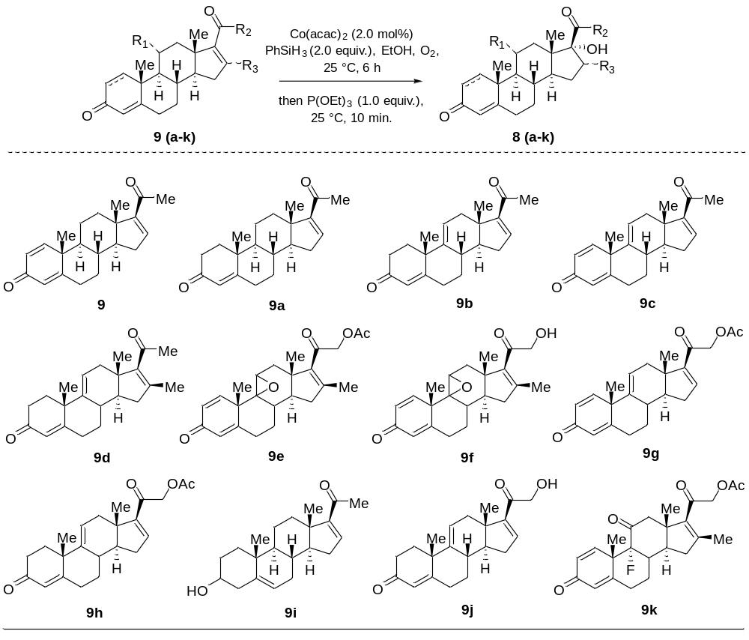
General procedures for Mukaiyama hydration of 9-9k.
A solution of PhSiH₃ (0.6 mmol, 2.0 equiv.) in EtOH (500 μL) was added to a solution of 9-9k (0.3 mmol, 1.0 equiv.) and Co(acac)₂ (2.0 mol%) in EtOH (500 μL) at 0 °C. Then, the reaction mixture was stirred at 25 °C for 6 h. After complete consumption of the starting substrate 9-9k, then P(OEt)₃ (0.3 mmol, 1.0 equiv.) was added, and the mixture was stirred at room temperature for 10 min. The reaction mixture was quenched by the addition of H₂O (1.0 mL). The phases were separated, and the aqueous layer was extracted with DCM (3 × 2 mL). The combined organic phases were washed with brine (2 × 2 mL) and dried with Na₂SO₄. After filtration and removal of the solvents in vacuo the crude product 8-8k was purified by column chromatography (200-300 mesh) on silica gel (PE:EA = 8:1) to afford pure 8-8k. The diastereoselectivities of 8-8c, 8g-8h were determined by 2D NMR analysis, and the diastereoselectivities of 8d-8f were determined by HPLC analysis on a chiral stationary phase (Chiralcel AD-H column).

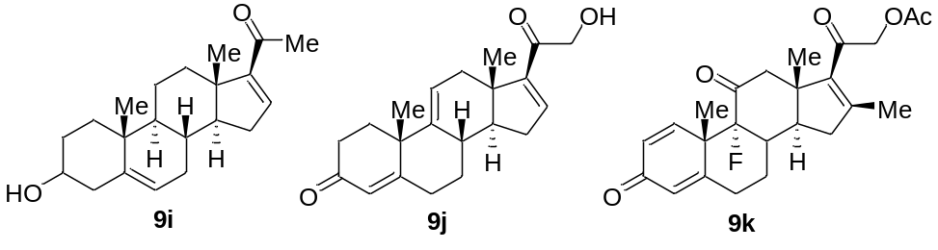
9i: White powder. ¹H NMR (400 MHz, CDCl₃) δ 6.70 (dd, J = 3.4, 1.9 Hz, 1H), 5.36 (dt, J = 5.2, 1.9 Hz, 1H), 3.52 (tt, J = 10.6, 4.4 Hz, 1H), 2.40 (dt, J = 12.6, 4.0 Hz, 1H), 2.36-2.28 (m, 2H), 2.26 (s, 3H), 2.10-1.98 (m, 2H), 1.90-1.78 (m, 2H), 1.70-1.65 (m, 1H), 1.64-1.57 (m, 3H), 1.56-1.50 (m, 2H), 1.49-1.37 (m, 2H), 1.36-1.28 (m, 1H), 1.13-1.06 (m, 1H), 1.04 (s, 3H), 1.03-0.96 (m, 1H), 0.92 (s, 3H). ¹³C NMR (100 MHz, CDCl₃) δ 196.8, 155.3, 144.4, 141.4, 121.0, 71.7, 56.4, 50.5, 46.1, 42.3, 37.1, 36.7, 34.6, 32.2, 31.6, 31.5, 30.2, 27.1, 20.7, 19.3, 15.7. FTIR (KBr): n_{max} = 3437, 2953, 2925, 2857, 1661, 1652, 1586, 1456, 1435, 1373, 1236, 1056, 972 cm⁻¹. HRMS (ESI) m/z calculated for C₂₁H₃₁O₂, [M + H]⁺ = 315.2319, found 315.2320. [α] _{D}²⁵ = -33.6 (c = 0.27, CHCl₃).
9j: White powder. m.p.: 211-212 °C. [Lit.⁸: m.p.: 215-220 °C, [α] _{D}²⁰ = 142 (c = 1.0, CHCl₃)]. ¹H NMR (400 MHz, CDCl₃) δ 6.77 (dd, J = 3.5, 2.0 Hz, 1H), 5.75 (d, J = 1.8 Hz, 1H), 5.56 (dt, J = 6.0, 2.0 Hz, 1H), 4.49 (qd, J = 17.9, 4.6 Hz, 2H), 3.28 (t, J = 4.7 Hz, 1H), 2.68-2.35 (m, 7H), 2.26-2.09 (m, 4H), 2.08-1.96 (m, 1H), 1.59 (dt, J = 11.4, 5.8 Hz, 1H), 1.36 (s, 3H), 1.23-1.10 (m, 1H), 0.90 (s, 3H). ¹³C NMR (100 MHz, CDCl₃) δ 199.2, 196.3, 169.3, 149.7, 145.3, 144.2, 124.1, 119.1, 65.0, 52.1, 44.7, 41.1, 37.3, 35.0, 34.2, 33.7, 33.3, 32.6, 31.7, 26.2, 15.6. FTIR (KBr): n_{max} = 3436, 2959, 2924, 2865, 1668, 1609, 1435, 1367, 1345, 1056, 956 cm⁻¹. HRMS (ESI) m/z calculated for C₂₁H₂₇O₃, [M + H]⁺ = 327.1955, found: 327.1952. [α] _{D}²⁵ = 183.9 (c = 0.29, CHCl₃).
9k: White powder. ¹H NMR (400 MHz, CDCl₃) δ 7.48 (d, J = 10.3 Hz, 1H), 6.28 (dd, J = 10.3, 1.9 Hz, 1H), 6.16 (d, J = 1.9 Hz, 1H), 4.97-4.67 (m, 2H), 3.01 (d, J = 12.4 Hz, 1H), 2.80 (dd, J = 12.5, 5.7 Hz, 1H), 2.60 (tdd, J = 13.7, 5.5, 1.7 Hz, 1H), 2.50-2.22 (m, 5H), 2.18 (s, 3H), 2.12 (s, 3H), 1.89-1.80 (m, 1H), 1.71 (qd, J = 13.2, 4.5 Hz, 1H), 1.53 (s, 3H), 0.97 (s, 3H). ¹³C NMR (100 MHz, CDCl₃) δ 204.0 (d, J = 27.3 Hz), 191.8, 186.0, 170.4, 162.5, 153.7, 151.5, 142.9, 129.6, 126.9, 68.3, 50.7 (d, J = 2.9 Hz), 50.6, 46.2, 46.4 (d, J = 2.6 Hz), 39.1, 37.6 (d, J = 20.7 Hz), 31.3, 26.5, 21.4 (d, J = 5.9 Hz), 20.5, 18.6, 17.1. FTIR (KBr): n_{max} = 2954, 2924, 2869, 2851, 1748, 1731, 1662, 1627, 1603, 1455, 1379, 1227, 1071, 888 cm⁻¹. HRMS (ESI) m/z calculated for C₂₄H₂₈FO₅, [M + H]⁺ = 415.1910, found 415.1912. [α] _{D}²⁵ = 133.4 (c = 0.28, CHCl₃).

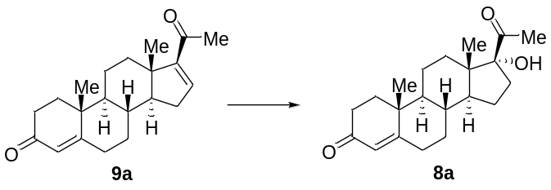
9a: White powder, m.p.: 182-183 °C. [Lit.⁹: m.p.: 182-184 °C]. ¹H NMR (400 MHz, CDCl₃) δ 6.70 (dd, J = 3.4, 1.9 Hz, 1H), 5.73 (s, 1H), 2.50-2.27 (m, 6H), 2.26 (s, 3H), 2.12-2.04 (m, 1H), 2.04-1.98 (m, 1H), 1.92-1.83 (m, 1H), 1.81-1.73 (m, 1H), 1.71-1.58 (m, 2H), 1.58-1.47 (m, 1H), 1.42 (td, J = 11.7, 6.6 Hz, 1H), 1.33 (td, J = 12.7, 5.0 Hz, 1H), 1.21 (s, 3H), 1.12 (ddd, J = 26.0, 12.3, 4.2 Hz, 1H), 1.04-0.95 (m, 1H), 0.94 (s, 3H). ¹³C NMR (100 MHz, CDCl₃) δ 199.5, 196.7, 170.9, 155.1, 144.1, 124.0, 55.6, 54.0, 46.0, 38.7, 35.5, 34.4, 33.9, 33.8, 32.7, 32.1, 31.8, 27.1, 20.7, 17.2, 15.8. FTIR (KBr): n_{max} = 2953, 2924, 2858, 1679, 1659, 1643, 1374, 1227, 1191, 868 cm⁻¹. HRMS (ESI) m/z calculated for C₂₁H₂₉O₂, [M + H]⁺ = 313.2162, found 313.2162. [α] _{D}²⁵ = 147.0 (c = 0.23, CHCl₃).
9a (93.7 mg, 0.3 mmol, 1.0 equiv.) performed via the general procedure without any modification to obtained crude 8a. Which was separated through column chromatography (filled with SiO₂, PE:EA = 8:1) to provide pure 8a (85.3 mg, 85% yield). White powder, m.p.191-192 °C, [Lit.¹⁰: m.p.: 192-193 °C]. ¹H NMR (400 MHz, CDCl₃) δ 5.72 (s, 1H), 2.83 (s, 1H), 2.68 (ddd, J = 14.7, 11.4, 3.0 Hz, 1H), 2.48-2.33 (m, 3H), 2.33-2.29 (m, 1H), 2.27 (s, 3H), 2.08-1.97 (m, 1H), 1.91-1.78 (m, 2H), 1.77-1.54 (m, 6H), 1.48-1.29 (m, 3H), 1.18 (s, 3H), 1.16-1.04 (m, 1H), 1.02-0.92 (m, 1H), 0.75 (s, 3H). ¹³C NMR (101 MHz, CDCl₃) δ 211.6, 199.5, 170.9, 123.9, 89.8, 53.3, 49.9, 48.2, 38.5, 35.7, 35.4, 33.9, 33.5, 32.8, 32.0, 30.0, 27.9, 23.9, 20.5, 17.4, 15.4. FTIR (KBr): n_{max} = 2955, 2923, 2855, 1702, 1663, 1458, 1377, 1362, 1191 cm⁻¹. HRMS (ESI) m/z calculated for C₂₁H₃₀NaO₃, [M + Na]⁺ = 353.2087, found 353.2083. [α] _{D}²⁵ = 112.0 (c = 0.31, CHCl₃).

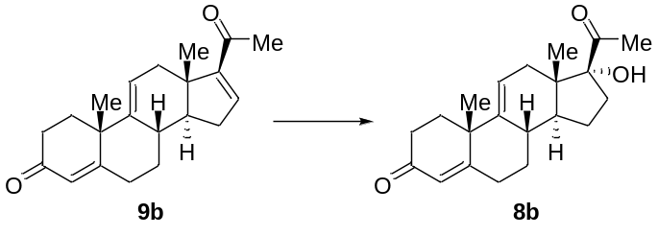
9b: White powder, m.p.: 208-209 °C, [Lit.¹¹: m.p.: 208-210 °C, [α] _{D}²⁵ = 237 (c = 1.00).]. ¹H NMR (400 MHz, CDCl₃) δ 6.72 (dd, J = 3.4, 1.9 Hz, 1H), 5.75 (d, J = 1.8 Hz, 1H), 5.55 (dt, J = 6.1, 2.0 Hz, 1H), 2.65-2.54 (m, 2H), 2.52-2.43 (m, 3H), 2.41-2.32 (m, 2H), 2.28 (s, 3H), 2.20-2.09 (m, 4H), 2.07-1.99 (m, 1H), 1.57 (dt, J = 11.4, 5.7 Hz, 1H), 1.35 (s, 3H), 1.22-1.08 (m, 1H), 0.86 (s, 3H). ¹³C NMR (101 MHz, CDCl₃) δ 199.3, 196.5, 169.6, 153.7, 145.0, 143.9, 124.0, 119.5, 52.5, 44.2, 41.1, 37.6, 35.1, 34.3, 33.7, 32.9, 32.7, 31.8, 27.0, 26.2, 15.4. FTIR (KBr): n_{max} = 2955, 2925, 2866, 1658, 1589, 1463, 1376, 1308, 1228, 1186, 975, 870 cm⁻¹. HRMS (ESI) m/z calculated for C₂₁H₂₇O₂, [M + H]⁺ = 311.2006, found 311.2005. [α] _{D}²⁵ = 210.3 (c = 0.30, CHCl₃).
9b (93.1 mg, 0.3 mmol, 1.0 equiv.) performed via the general procedure without any modification to obtained crude 8b. Which was separated through column chromatography (filled with SiO₂, PE:EA = 8:1) to provide pure 8b (74.9 mg, 76%). White powder, ¹H NMR (400 MHz, CDCl₃) δ 5.78 (s, 1H), 5.56 (d, J = 5.8 Hz, 1H), 2.81-2.74 (m, 1H), 2.72 (s, 1H), 2.66-2.48 (m, 4H), 2.42-2.35 (m, 1H), 2.31 (s, 3H), 2.23 (d, J = 13.4 Hz, 1H), 2.19-2.11 (m, 2H), 2.09-1.98 (m, 2H), 1.91-1.85 (m, 1H), 1.74-1.66 (m, 2H), 1.52-1.44 (m, 1H), 1.36 (s, 3H), 1.20 (dd, J = 13.8, 3.7 Hz, 1H), 0.73 (s, 3H). FTIR (KBr): n_{max} = 2955, 2924, 2868, 2853, 1702, 1656, 1463, 1377 cm⁻¹. HRMS (ESI) m/z calculated for C₂₁H₂₉O₃, [M + H]⁺ = 329.2111, found 329.2109. [α] _{D}²⁵ = 33. 3 (c = 0.21, CHCl₃).

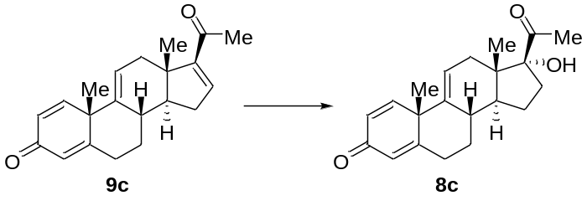
9c (92.5 mg, 0.3 mmol, 1.0 equiv.) performed via the general procedure without any modification to obtained crude 8c. Which was separated through column chromatography (filled with SiO₂, PE:EA = 8:1) to provide pure 8c (78.3 mg, 80% yield). White powder, ¹H NMR (400 MHz, CDCl₃) δ 7.21 (d, J = 10.2 Hz, 1H), 6.30 (dd, J = 10.2, 1.9 Hz, 1H), 6.09 (s, 1H), 5.58 (dd, J = 5.1, 3.0 Hz, 1H), 2.93-2.62 (m, 3H), 2.61-2.38 (m, 3H), 2.37-2.32 (m, 1H), 2.30 (s, 3H), 2.25-2.17 (m, 1H), 2.05-1.98 (m, 1H), 1.93-1.81 (m, 2H), 1.70-1.68 (m, 1H), 1.51-1.48 (m, 1H), 1.44 (s, 3H), 0.75 (s, 3H). ¹³C NMR (101 MHz, CDCl₃) δ 211.4, 186.4, 166.7, 154.6, 142.5, 127.3, 123.9, 120.5, 89.4, 36.8, 34.9, 33.75, 32.2, 32.2, 29.7, 27.7, 26.7, 25.0, 22.7, 15.3, 14.1. FTIR (KBr): n_{max} = 3374, 2956, 2925, 2854, 1708, 1663, 1622, 1605, 1451, 1378, 1350, 883 cm⁻¹. HRMS (ESI) m/z calculated for C₂₁H₂₇O₃, [M + H]⁺ = 327.1955, found 327.1952. [α] _{D}²⁵ = -19.0 (c = 0.33, CHCl₃).

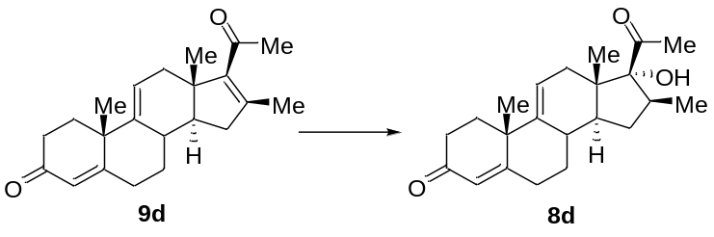
9d¹² (97.3 mg, 0.3 mmol, 1.0 equiv.) performed via the general procedure without any modification to obtained crude 8d. Which was separated through column chromatography (filled with SiO₂, PE:EA = 8:1) to provide pure 8d (77.1 mg, 75% yield). White powder, m.p: 167.2-168.3°C. ¹H NMR (400 MHz, CDCl₃) δ 5.74 (1 H, d, J = 1.2), 5.50 (1 H, dd, J = 16.3, 4.9), 2.97 (1 H, s), 2.68-2.42 (4 H, m), 2.39-2.31 (1 H, m), 2.26 (3 H, s), 2.25-1.99 (6 H, m), 1.83-1.70 (1 H, m), 1.65 (1 H, ddd, J = 17.0, 5.8, 1.5), 1.34 (3 H, s), 1.19 (3 H, d, J = 7.2), 1.17-1.08 (2 H, m), 0.87 (3 H, s). ¹³C NMR (100 MHz, CDCl₃) δ 211.0, 199.5, 170.0, 143.8, 123.9, 118.9, 90.0, 47.5, 47.2, 46.9, 41.0, 37.1, 36.0, 34.3, 33.8, 33.3, 32.9, 32.3, 30.0, 26.1, 20.1, 15.3. HRMS (ESI) m/z calculated for C₂₂H₃₁O₃, [M + H]⁺ = 343.2268, found: 343.2274. [α] _{D}²⁰ = 152.3 (c = 0.45, CHCl₃).

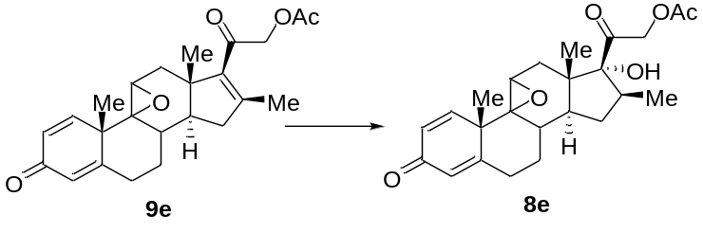
9e¹² (118.9 mg, 0.3 mmol, 1.0 equiv.) performed via the general procedure without any modification to obtained crude 8e. Which was separated through column chromatography (filled with SiO₂, PE:EA = 8:1) to provide pure 8e (109.4 mg, 88% yield). White powder, m.p: 224.4-225.9 °C. ¹H NMR (400 MHz, CDCl₃) δ 6.65 (1 H, d, J = 10.1), 6.19 (1 H, d, J = 10.1), 6.14 (1 H, s), 5.02 (d, J = 17.7 Hz, 1H), 4.81 (d, J = 17.7 Hz, 1H), 3.21 (1 H, s), 2.77-2.59 (1 H, m), 2.58-2.39 (2 H, m), 2.37-2.21 (4 H, m), 2.17 (3 H, s), 2.16-2.02 (2 H, m), 1.84 (1 H, d, J = 14.7), 1.66 (1 H, td, J = 11.8, 5.4), 1.49 (1 H, s), 1.45 (3 H, s), 1.12 (3 H, d, J = 6.4), 0.95 (3 H, s). ¹³C NMR (100 MHz, CDCl₃) δ 204.9, 186.5, 170.9, 166.1, 153.1, 127.7, 124.7, 88.5, 69.5, 65.8, 62.8, 50.6, 48.2, 47.4, 44.3, 35.9, 33.8, 30.9, 30.6, 29.5, 23.6, 20.7, 20.0, 17.5. HRMS (ESI) m/z calcd for C₂₄H₃₀NaO₆, [M + Na]⁺ = 437.1935, found: 437.1938. [α] _{D}²⁵ = 86.0 (c = 0.50, Dioxane), [Lit.¹³: [α] _{D} = 108 (CHCl₃).].

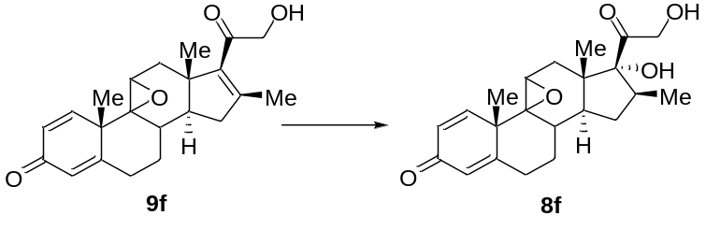
9f¹² (106.3 mg, 0.3 mmol, 1.0 equiv.) performed via the general procedure without any modification to obtained crude 8f. Which was separated through column chromatography (filled with SiO₂, PE:EA = 8:1) to provide pure 8f (35.8 mg, 32% yield). White powder, m.p: 236.8-238.0 °C. ¹H NMR (400 MHz, DMSO-d₆) δ 6.62 (1 H, d, J = 10.2), 6.10 (1 H, s), 6.08 (1 H, s), 5.25 (1 H, s), 4.51 (1 H, t, J = 5.8), 4.35 (dd, J = 19.4, 6.0 Hz, 1H), 4.10 (dd, J = 19.4, 5.7 Hz, 1H), 3.19 (1 H, s), 2.76-2.59 (1 H, m), 2.49-2.30 (2 H, m), 2.29-2.15 (2 H, m), 2.15-1.91 (2 H, m), 1.75-1.46 (2 H, m), 1.37 (3 H, s), 1.35-1.26 (1 H, m), 1.01 (3 H, d, J = 6.4), 0.91 (1 H, dd, J = 14.2, 11.3), 0.86 (3 H, s). ¹³C NMR (100 MHz, DMSO-d₆) δ 212.2, 185.3, 166.1, 153.1, 127.7, 124.5, 87.7, 68.1, 66.1, 62.6, 47.5, 47.3, 46.4, 44.1, 36.0, 33.7, 31.4, 30.9, 29.2, 24.0, 20.5, 18.4. HRMS (ESI) m/z calculated for C₂₂H₂₉O₅, [M + H]⁺ = 373.2010, found: 373.2003. [α] _{D}²⁵ = 35.0 (c = 0.50, Dioxane).

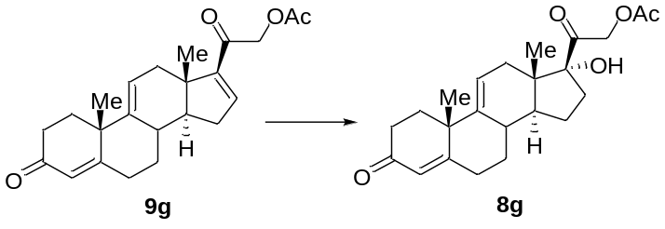
9g: White powder, ¹H NMR (400 MHz, CDCl₃) δ 6.77 (dd, J = 3.4, 1.9 Hz, 1H), 5.75 (d, J = 1.8 Hz, 1H), 5.54 (dt, J = 6.1, 2.0 Hz, 1H), 5.09-4.85 (m, 2H), 2.67-2.31 (m, 7H), 2.23-2.14 (m, 5H), 2.14-2.08 (m, 2H), 2.07-1.98 (m, 1H), 1.58 (td, J = 11.4, 6.8 Hz, 1H), 1.35 (s, 3H), 1.22-1.09 (m, 1H), 0.88 (s, 3H). ¹³C NMR (100 MHz, CDCl₃) δ 199.2, 190.3, 170.4, 169.4, 150.3, 145.1, 143.6, 124.1, 119.2, 65.6, 52.0, 44.9, 41.1, 37.3, 35.0, 34.2, 33.7, 33.3, 32.6, 31.7, 26.2, 20.5, 15.5. FTIR (KBr): n_{max} = 2952, 2923, 2851, 1746, 1682, 1672, 1459, 1381, 1366, 1242, 1226, 887 cm⁻¹. HRMS (ESI) m/z calculated for C₂₃H₂₉O₄, [M + H]⁺ = 369.2060, found: 369.2063. [α] _{D}²⁵ = 253.0 (c = 0.32, CHCl₃).
9g (110.5 mg, 0.3 mmol, 1.0 equiv.) performed via the general procedure without any modification to obtained crude 8g. Which was separated through column chromatography (filled with SiO₂, PE:EA = 8:1) to provide pure 8g (96.2 mg, 83% yield). White powder, ¹H NMR (400 MHz, CDCl₃) δ 5.77 (d, J = 1.3 Hz, 1H), 5.58 (d, J = 5.8 Hz, 1H), 5.10 (d, J = 17.5 Hz, 1H), 4.87 (d, J = 17.5 Hz, 1H), 2.90-2.75 (m, 1H), 2.70 (d, J = 16.8 Hz, 1H), 2.64-2.43 (m, 3H), 2.42-2.33 (m, 1H), 2.31-2.22 (m, 2H), 2.20 (s, 3H), 2.17-1.82 (m, 6H), 1.62-1.45 (m, 2H), 1.36 (s, 3H), 1.24-1.13 (m, 1H), 0.68 (s, 3H). ¹³C NMR (101 MHz, CDCl₃) δ 204.9, 199.4, 170.7, 169.6, 144.1, 124.1, 118.7, 89.7, 67.8, 47.9, 46.9, 41.0, 37.6, 34.8, 34.3, 33.8, 32.9, 32.2, 31.9, 26.2, 24.3, 20.6, 14.4. FTIR (KBr): n_{max} = 3417, 2955, 2924, 2869, 2851, 1741, 1722, 1660, 1616, 1603, 1415, 1377, 1239 cm⁻¹. HRMS (ESI) m/z calculated for C₂₃H₃₀O₄, [M + H]⁺ = 387.2172, found: 387.2173. [α] _{D}²⁵ = 56.4 (c = 0.22, CHCl₃).

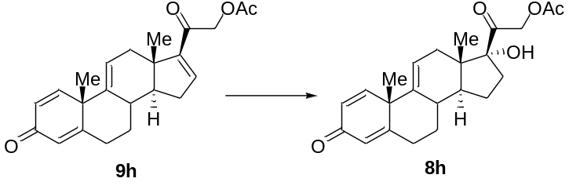
9h: White power, m.p. 170-172 °C. [Lit.¹⁴: m.p.: 171-172 °C]. ¹H NMR (400 MHz, CDCl₃) δ 7.20 (d, J = 10.2 Hz, 1H), 6.76 (dd, J = 3.5, 2.0 Hz, 1H), 6.27 (dd, J = 10.3, 1.9 Hz, 1H), 6.05 (t, J = 1.8 Hz, 1H), 5.55 (dt, J = 6.2, 1.9 Hz, 1H), 5.09-4.82 (m, 2H), 2.67 (tdd, J = 13.9, 5.1, 1.7 Hz, 1H), 2.59-2.38 (m, 4H), 2.23-2.06 (m, 6H), 1.52 (td, J = 11.3, 6.9 Hz, 1H), 1.42 (s, 3H), 1.22 (qd, J = 12.8, 4.5 Hz, 1H), 0.90 (s, 3H). ¹³C NMR (100 MHz, CDCl₃) δ 190.2, 186.3, 170.3, 166.4, 154.5, 150.0, 143.5, 143.4, 127.3, 123.8, 121.1, 65.5, 52.3, 46.0, 45.1, 37.4, 34.3, 34.2, 33.4, 31.9, 26.7, 20.5, 15.4. FTIR (KBr): n_{max} = 2954, 2922, 2869, 1748, 1678, 1656, 1462, 1378, 1235, 1216 cm⁻¹. HRMS (ESI) m/z calculated for C₂₃H₂₇O₄, [M + H]⁺ = 367.1904, found: 367.1902. [α] _{D}²⁵ = 128.8 (c = 0.32, CHCl₃).
9h (109.9 mg, 0.3 mmol, 1.0 equiv.) performed via the general procedure without any modification to obtained crude 8h. Which was separated through column chromatography (filled with SiO₂, PE:EA = 8:1) to provide pure 8h (93.4 mg, 81% yield). White power, m.p. 217-218 °C. [Lit.¹⁴: m.p.: 217-220 °C]. ¹H NMR (400 MHz, CDCl₃) δ 7.21 (d, J = 10.2 Hz, 1H), 6.27 (dd, J = 10.2, 1.7 Hz, 1H), 6.05 (s, 1H), 5.57 (d, J = 5.7 Hz, 1H), 5.06 (d, J = 17.6 Hz, 1H), 4.86 (d, J = 17.6 Hz, 1H), 3.09 (s, 1H), 2.82-2.60 (m, 3H), 2.49-2.38 (m, 1H), 2.38-2.26 (m, 1H), 2.22-2.18 (m, 1H), 2.17 (s, 3H), 2.02-1.89 (m, 2H), 1.88-1.83 (m, 1H), 1.67-1.55 (m, 1H), 1.49-1.42 (m, 1H), 1.41 (s, 3H), 1.26-1.15 (m, 1H), 0.66 (s, 3H). ¹³C NMR (101 MHz, CDCl₃) δ 205.3, 186.6, 170.7, 167.4, 155.1, 142.3, 127.1, 123.6, 120.8, 89.5, 68.0, 48.2, 47.1, 46.0, 36.9, 34.9, 34.6, 32.2, 32.0, 26.7, 24.6, 20.6, 14.2. FTIR (KBr): n_{max} = 3430, 2954, 2923, 2869, 2851, 1736, 1724, 1670, 1461, 1377, 1276, 1257, 1238, 1148, 1044 cm⁻¹. HRMS (ESI) m/z calculated for C₂₃H₂₈O₅, [M + H]⁺ = 385.2010 found: 385.2004. [α] _{D}²⁵ = 53.6 (c = 0.31, CHCl₃).

6. Ni-catalyzed Cyclopropanation Substrate Scope
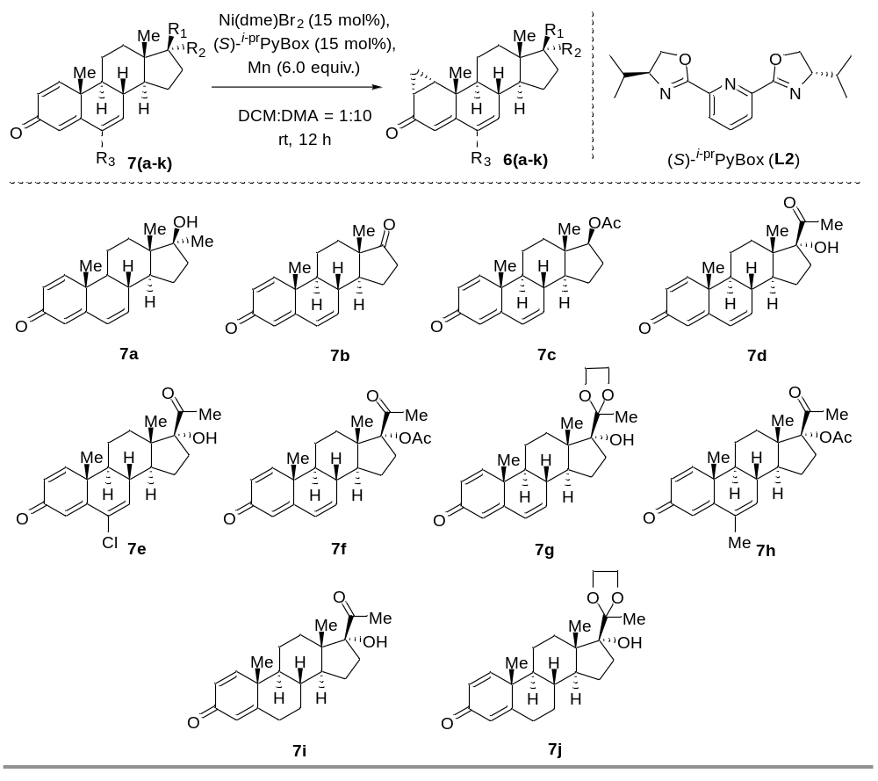General procedure Nickel-catalyzed cyclopropanation of 7a-7j
In a N₂-filled glovebox, Ni(dme)Br₂ (13.8 mg, 45 μmol, 15 mol%), (S)-^{i-pr}PyBox (13.5 mg, 45 μmol, 15 mol%), and Mn (98.9 mg, 1.8 mmol, 6.0 equiv.) were added to a 2-dram reaction vial charged with a magnetic stir bar. A 1.3 mL stock solution containing 7a-7j (0.3 mmol, 1.0 equiv.) dissolved in 1:10 DCM:DMA was then added. The reaction vial was sealed and removed from the glovebox, the reaction mixture was stirred at room temperature for 12 h. An aliquot was taken from the crude mixture, diluted with MeOH, and filtered through a 1.5 cm silica pad. The conversion of starting material was calculated based on LC-MS integration. The reaction mixture was quenched by the addition of H₂O (500 μL). The phases were separated, and the aqueous layer was extracted with DCM (3 × 5 mL). The combined organic phases were washed with brine (2 × 5 mL) and dried with Na₂SO₄. After filtration and removal of the solvents in vacuo, the crude 6a-6j was purified by column chromatography on silica gel (200-300 mesh, PE:EA = 4:1-10:1) to afford pure 6a-6j.
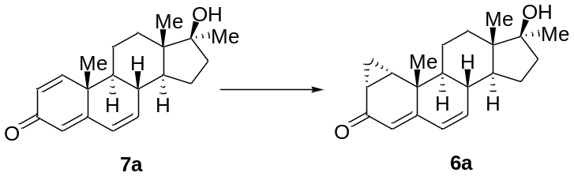
7a: White power, m.p.: 230-231°C. [Lit.¹⁵: m.p.: 230-232 °C]. ¹H NMR (400 MHz, CDCl₃) δ 7.08 (d, J = 10.1 Hz, 1H), 6.33-6.13 (m, 2H), 6.11-5.93 (m, 2H), 2.43-2.28 (m, 1H), 1.97-1.80 (m, 3H), 1.73-1.25 (m, 8H), 1.22 (s, 6H), 0.99 (s, 3H). ¹³C NMR (101 MHz, CDCl₃) δ 186.4, 162.6, 153.0, 137.9, 128.1, 127.7, 123.8, 81.1, 48.5, 48.0, 45.9, 41.2, 38.9, 38.7, 31.4, 25.9, 22.7, 21.6, 20.8, 13.9. FTIR (KBr): n_{max} = 2955, 2926, 2870, 1651, 1622, 1598, 1463, 1376, 1157, 909 cm⁻¹. HRMS (ESI) m/z calculated for C₂₀H₂₇O₂, [M + H]⁺ = 298.426, found: 298.426. [α] _{D}²⁵ = -18.07 (c = 0.21, CHCl₃).
7a (89.5 mg, 0.3 mmol, 1.0 equiv.) performed via the general procedure without any modification to obtained crude 6a. Which was separated through column chromatography (filled with SiO₂, PE:EA = 4:1) to provide pure 6a (73.8 mg, 78.7% yield). White power, ¹H NMR (400 MHz, CDCl₃) δ 6.22-5.91 (m, 2H), 5.52 (s, 1H), 2.27 (t, J = 10.2 Hz, 1H), 2.02-1.80 (m, 4H), 1.78-1.28 (m, 10H), 1.26 (s, 3H), 1.23 (s, 3H), 0.99 (s, 3H), 0.86-0.76 (m, 1H). ¹³C NMR (101 MHz, CDCl₃) δ 198.7, 157.1, 139.0, 128.0, 120.1, 81.3, 48.8, 48.0, 46.0, 38.8, 38.5, 37.1, 31.5, 25.9, 25.8, 25.2, 22.8, 22.7, 20.9, 13.8, 12.6. FTIR (KBr): n_{max} = 3513, 2954, 2924, 2871, 2851, 1641, 1461, 1378, 1193, 1084 cm⁻¹. HRMS (ESI) m/z calculated for C₂₁H₂₉O₂, [M + H]⁺ = 312.453, found: 312.453. [α] _{D}²⁵ = 186.74 (c = 0.25, CHCl₃).

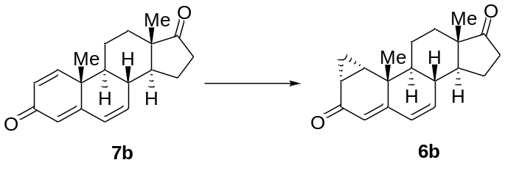
7b: White power, ¹H NMR (400 MHz, CDCl₃) δ 7.08 (d, J = 10.2 Hz, 1H), 6.39-6.22 (m, 2H), 6.11 (dt, J = 10.9, 5.5 Hz, 1H), 6.05 (s, 1H), 2.68-2.39 (m, 2H), 2.23-2.09 (m, 2H), 2.01-1.87 (m, 2H), 1.84-1.66 (m, 2H), 1.60-1.44 (m, 2H), 1.41-1.29 (m, 1H), 1.24 (s, 3H), 1.01 (s, 3H). ¹³C NMR (101 MHz, CDCl₃) δ 186.1, 161.7, 152.4, 135.7, 128.5, 128.3, 124.3, 48.8, 48.4, 47.8, 41.1, 37.5, 35.5, 31.2, 21.4, 21.2, 20.8, 13.8. FTIR (KBr): n_{max} = 2956, 2923, 2869, 1738, 1652, 1601, 1457, 1376, 1184, 1083 cm⁻¹. HRMS (ESI) m/z calculated for C₁₉H₂₃O₂, [M + H]⁺ = 283.1697, found: 283.1699. [α] _{D}²⁵ =78.7 (c = 0.25, CHCl₃).
7b (84.7 mg, 0.3 mmol, 1.0 equiv.) performed via the general procedure without any modification to obtained crude 6b. Which was separated through column chromatography (filled with SiO₂, PE:EA = 8:1) to provide pure 6b (68.2 mg, 76.7% yield). White power, ¹H NMR (400 MHz, CDCl₃) δ 6.17-6.01 (m, 2H), 5.54 (s, 1H), 2.65-2.48 (m, 1H), 2.38 (dd, J = 24.5, 13.8 Hz, 1H), 2.26-2.08 (m, 2H), 2.03-1.88 (m, 3H), 1.78-1.47 (m, 4H), 1.44-1.31 (m, 2H), 1.30-1.25 (m, 1H), 1.24 (s, 3H), 0.99 (s, 3H), 0.91-0.71 (m, 1H). ¹³C NMR (101 MHz, CDCl₃) δ 198.5, 156.4, 136.7, 128.9, 120.6, 48.9, 48.8, 48.0, 37.1, 37.1, 35.6, 31.3, 25.6, 25.2, 22.7, 21.4, 20.5, 13.7, 12.6. FTIR (KBr): n_{max} = 2959, 2928, 2865, 1739, 1653, 1615, 1460, 1378 cm⁻¹. HRMS (ESI) m/z calculated for C₂₀H₂₅O₂, [M + H]⁺ = 297.1853, found: 297.1853. [α] _{D}²⁵ = 310.3 (c = 0.28, CHCl₃).

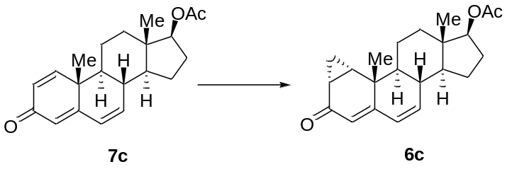
7c: White power, m.p.: 151-152 °C. [Lit.¹⁶: m.p.: 151-153 °C, [α] _{D}²⁰ = -9]. ¹H NMR (400 MHz, CDCl₃) δ 7.05 (d, J = 10.1 Hz, 1H), 6.24 (dd, J = 8.3, 1.7 Hz, 2H), 6.07-5.92 (m, 2H), 4.69-4.54 (m, 1H), 2.42-2.14 (m, 2H), 2.04 (s, 3H), 1.89-1.80 (m, 2H), 1.70-1.49 (m, 3H), 1.48-1.41 (m, 1H), 1.32-1.27 (m, 1H), 1.19 (s, 3H), 0.90 (s, 3H). ¹³C NMR (101 MHz, CDCl₃) δ 186.3, 171.0, 162.3, 152.8, 137.3, 128.1, 127.9, 123.9, 81.9, 48.3, 48.2, 43.0, 41.1, 37.8, 36.4, 27.4, 23.1, 21.4, 21.1, 20.8, 12.1. FTIR (KBr): n_{max} = 2953, 2923, 2872, 2851, 1723, 1652, 1602, 1456, 1376, 1245, 1037, 890 cm⁻¹. HRMS (ESI) m/z calculated for C₂₁H₂₈O₃, [M + H]⁺ = 327.1960, found: 327.1961. [α] _{D}²⁵ = -1.1 (c = 0.25, CHCl₃).
7c (97.9 mg, 0.3 mmol, 1.0 equiv.) performed via the general procedure without any modification to obtained crude 6c. Which was separated through column chromatography (filled with SiO₂, PE:EA = 5:1) to provide pure 6c (81.0 mg, 79.3% yield). ¹H NMR (400 MHz, CDCl₃) δ 6.16-5.86 (m, 2H), 5.53 (s, 1H), 4.74-4.58 (m, 1H), 2.32-2.19 (m, 2H), 2.08 (s, 3H), 1.95 (tdd, J = 10.6, 5.9, 4.8 Hz, 1H), 1.93-1.85 (m, 2H), 1.66 (d, J = 7.6 Hz, 1H), 1.64-1.43 (m, 3H), 1.39-1.23 (m, 5H), 1.22 (s, 3H), 0.91 (d, J = 8.9 Hz, 3H), 0.84-0.76 (m, 1H). ¹³C NMR (101 MHz, CDCl₃) δ 198.7, 171.1, 156.8, 138.3, 128.3, 120.3, 82.1, 48.6, 48.2, 43.1, 37.4, 37.1, 36.6, 27.5, 25.7, 25.2, 23.1, 22.8, 21.2, 20.8, 12.6, 11.9. FTIR (KBr): n_{max} = 2956, 2924, 2869, 1724, 1652, 1620, 1378, 1272, 1254, 1046, 1032 cm⁻¹. HRMS (ESI) m/z calculated for C₂₂H₃₀O₃, [M + H]⁺ = 341.2119, found: 341.2118. [α] _{D}²⁵ = 153.7 (c = 0.25, CHCl₃).

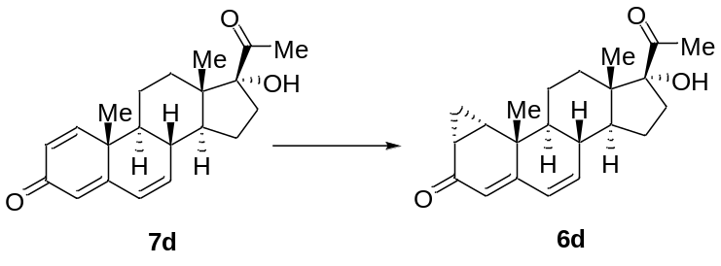
7d: White power, m.p.: 234-236 °C. ¹H NMR (400 MHz, CDCl₃) δ 7.06 (d, J = 10.1 Hz, 1H), 6.24 (d, J = 10.1 Hz, 2H), 6.03 (dd, J = 17.7, 7.1 Hz, 2H), 2.86 (s, 1H), 2.74 (t, J = 12.3 Hz, 1H), 2.28 (s, 3H), 2.06-1.91 (m, 2H), 1.85 (t, J = 13.1 Hz, 1H), 1.81-1.43 (m, 7H), 1.19 (s, 3H), 0.81 (s, 3H). ¹³C NMR (101 MHz, CDCl₃) δ 211.4, 186.4, 162.4, 152.7, 137.9, 128.2, 127.9, 123.9, 89.4, 48.6, 47.9, 47.9, 41.1, 37.8, 33.6, 30.1, 27.9, 23.4, 21.3, 20.8, 15.4. FTIR (KBr): n_{max} = 3473, 2975, 2945, 2862, 1701, 1645, 1560, 1579, 1348, 1194, 895 cm⁻¹. HRMS (ESI) m/z calculated for C₂₁H₂₇O₃, [M + H]⁺ = 327.1955, found: C₂₁H₂₇O₃, 327.1950. [α] _{D}²⁵ = 8.53 (c = 0.15, CHCl₃).
7d (97.9 mg, 0.3 mmol, 1.0 equiv.) performed via the general procedure without any modification to obtained crude 6d. Which was separated through column chromatography (filled with SiO₂, PE:EA = 10:1) to provide pure 6d (81.0 mg, 79.3% yield). White power, ¹H NMR (400 MHz, CDCl₃) δ 6.06 (dt, J = 21.1, 6.6 Hz, 2H), 5.53 (s, 1H), 2.85 (s, 1H), 2.81-2.69 (m, 1H), 2.31 (d, J = 10.0 Hz, 3H), 2.25 (t, J = 10.7 Hz, 1H), 2.05-1.87 (m, 4H), 1.86-1.74 (m, 2H), 1.72-1.61 (m, 2H), 1.61-1.45 (m, 3H), 1.38 (ddd, J = 25.0, 14.4, 9.1 Hz, 1H), 1.32-1.24 (m, 1H), 1.22 (s, 3H), 0.84 (s, 3H). ¹³C NMR (101 MHz, CDCl₃) δ 211.4, 198.7, 156.8, 138.9, 128.3, 120.3, 89.5, 48.8, 48.3, 48.0, 37.4, 37.0, 33.6, 30.2, 27.9, 25.7, 25.2, 23.4, 22.8, 20.7, 15.3, 12.6. FTIR (KBr): n_{max} = 2958, 2925, 2869, 1701, 1636, 1616, 1459, 1378, 1100, 1072 cm⁻¹. HRMS (ESI) m/z calculated for C₂₂H₂₉O₃, [M + H]⁺ = 341.2119, found: 341.2118. [α] _{D}²⁵ =157.1 (c = 0.25, CHCl₃).

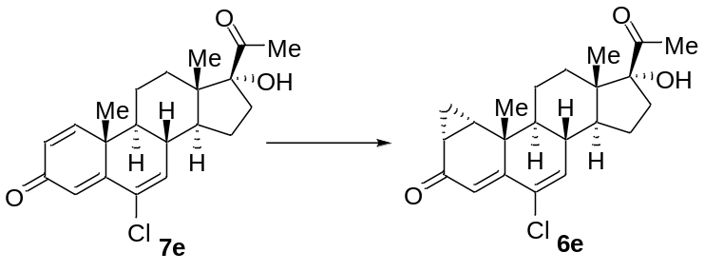
7e: White power, ¹H NMR (400 MHz, CDCl₃) δ 7.05 (d, J = 10.1 Hz, 1H), 6.60 (s, 1H), 6.29 (d, J = 10.1 Hz, 1H), 6.21 (s, 1H), 2.82-2.66 (m, 2H), 2.48-2.33 (m, 1H), 2.29 (s, 3H), 2.02 (tt, J = 16.5, 8.2 Hz, 2H), 1.88 (d, J = 9.8 Hz, 1H), 1.78 (dd, J = 19.3, 8.3 Hz, 1H), 1.69-1.64 (m, 1H), 1.60 (dd, J = 11.7, 3.9 Hz, 2H), 1.50 (d, J = 11.3 Hz, 2H), 1.24 (s, 3H), 0.82 (s, 3H). ¹³C NMR (101 MHz, CDCl₃) δ 211.1, 185.9, 158.1, 152.6, 135.4, 129.6, 128.1, 124.2, 89.2, 48.6, 47.7, 47.5, 42.4, 38.8, 33.6, 30.0, 27.9, 23.3, 21.3, 20.7, 15.3. HRMS (ESI) m/z calculated for C₂₂H₂₅ClNaO₃, [M + Na]⁺ = 383.1384, found: 383.1380.
7e (108.3 mg, 0.3 mmol, 1.0 equiv.) performed via the general procedure without any modification to obtained crude 6e. Which was separated through column chromatography (SiO₂, PE:EA = 10:1) to provide pure 6e (98.0 mg, 87.1% yield). m.p.: 193-194 °C. ¹H NMR (400 MHz, CD₃OD) δ 6.37 (d, J = 2.3 Hz, 1H), 6.08 (s, 1H), 2.90-2.64 (m, 1H), 2.46-2.36 (m, 1H), 2.20 (d, J = 2.5 Hz, 3H), 2.12-1.82 (m, 7H), 1.72-1.56 (m, 2H), 1.57-1.45 (m, 3H), 1.41-1.28 (m, 4H), 1.25 (s, 3H), 0.93-0.83 (m, 3H), 0.71 (s, 3H). ¹³C NMR (101 MHz, CD₃OD) δ 212.9, 201.1, 155.6, 139.8, 130.5, 120.4, 90.8, 49.5, 49.3, 49.2, 48.6, 40.3, 39.9, 33.8, 31.8, 27.5, 27.3, 26.3, 23.7, 23.2, 21.9, 15.1, 13.5. FTIR (KBr): n_{max} = 2924, 2854, 1715, 1638, 1606, 1460, 1376, 890 cm⁻¹. HRMS (ESI) m/z calculated for C₂₂H₂₈ClO₃, [M + H]⁺ = 375.1721, found 375.1718. [α] _{D}²⁵ = 182.21 (c = 0.1, CHCl₃).

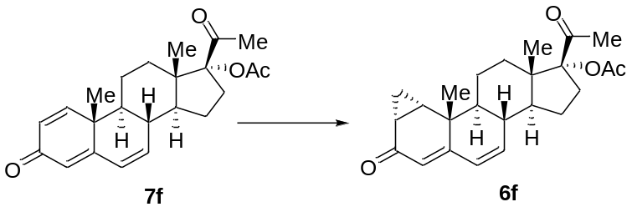
7f: White power, ¹H NMR (400 MHz, CDCl₃) δ 7.07 (d, J = 10.1 Hz, 1H), 6.39-6.21 (m, 2H), 6.03 (d, J = 5.5 Hz, 2H), 3.01 (dt, J = 13.7, 11.8 Hz, 1H), 2.35 (t, J = 10.4 Hz, 1H), 2.08 (s, 3H), 2.06 (s, 3H), 2.04-1.75 (m, 5H), 1.70-1.59 (m, 2H), 1.59-1.41 (m, 2H), 1.21 (s, 3H), 0.76 (s, 3H). ¹³C NMR (101 MHz, CDCl₃) δ 203.8, 186.2, 170.6, 162.0, 152.6, 137.4, 128.3, 128.1, 124.1, 96.2, 49.0, 47.7, 47.1, 41.0, 38.0, 31.0, 30.3, 26.4, 23.3, 21.5, 21.2, 20.7, 14.4. FTIR (KBr): n_{max} = 2953, 2924, 2869, 1730, 1714, 1652, 1640, 1601, 1375, 1258, 1246, 888 cm⁻¹. HRMS (ESI) m/z calculated for C₂₃H₂₉O₄, [M + H]⁺ = 369.2060, found: 369.2060. [α] _{D}²⁵ = 44.0 (c = 0.32, CHCl₃).
7f (110.5 mg, 0.3 mmol, 1.0 equiv.) performed via the general procedure without any modification to obtained crude 6f. Which was separated through column chromatography (filled with SiO₂, PE:EA = 5:1) to provide pure 6f (102.5 mg, 89.3% yield). White power, ¹H NMR (400 MHz, CDCl₃) δ 6.23-5.87 (m, 2H), 5.55 (s, 1H), 3.26-2.83 (m, 1H), 2.27 (t, J = 10.2 Hz, 1H), 2.14 (s, 3H), 2.09 (s, 3H), 2.02-1.80 (m, 5H), 1.74-1.62 (m, 3H), 1.61-1.35 (m, 3H), 1.31-1.24 (m, 1H), 1.23 (s, 3H), 0.93-0.82 (m, 1H), 0.76 (s, 3H). ¹³C NMR (101 MHz, CDCl₃) δ 203.9, 198.5, 170.7, 156.6, 138.4, 128.4, 120.4, 96.4, 49.0, 48.2, 47.3, 37.6, 37.0, 31.2, 30.4, 26.4, 25.6, 25.2, 23.3, 22.7, 21.2, 20.9, 14.3, 12.6. FTIR (KBr): n_{max} = 2952, 2924, 2869, 2852, 1730, 1714, 1641, 1621, 1459, 1376, 1250 cm⁻¹. HRMS (ESI) m/z calculated for C₂₄H₃₁O₄, [M + H]⁺ = 383.2233, found: 383.2233. [α] _{D}²⁵ = 175.7 (c = 0.33, CHCl₃).

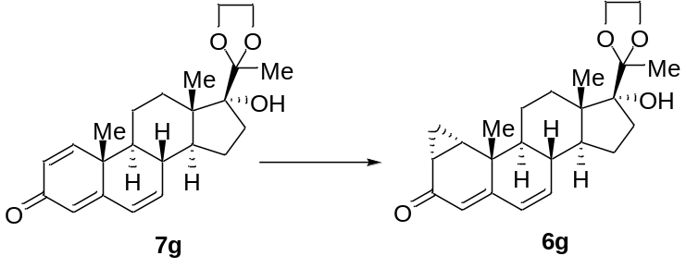
7g: White power, m.p.: 180.2-181.7 °C. ¹H NMR (400 MHz, DMSO-d₆) δ 7.20 (d, J = 10.1 Hz, 1H), 6.31 (dd, J = 9.8, 2.4 Hz, 1H), 6.21-6.03 (m, 2H), 5.96 (s, 1H), 4.01-3.88 (m, 2H), 3.88-3.73 (m, 2H), 2.50 (s, 2H), 2.28 (t, J = 10.7 Hz, 1H), 2.14 (t, J = 11.9 Hz, 1H), 2.03-1.84 (m, 1H), 1.83-1.68 (m, 3H), 1.58 (dd, J = 16.6, 6.6 Hz, 2H), 1.49-1.36 (m, 1H), 1.34-1.26 (m, 1H), 1.24 (s, 3H), 1.15 (s, 3H), 0.86 (s, 3H). ¹³C NMR (101 MHz, DMSO-d₆) δ 185.5, 163.1, 154.0, 139.6, 127.9, 127.6, 123.4, 112.7, 86.1, 65.7, 63.1, 48.6, 48.2, 46.8, 41.2, 37.6, 31.9, 31.4, 22.5, 21.4, 21.2, 21.1, 14.9. FTIR (KBr): n_{max} = 3409, 2978, 2939, 2895, 2860, 1651, 1599, 1364, 1184, 1084, 1051, 880 cm⁻¹. HRMS (ESI) m/z calculated for C₂₃H₃₁O₄, [M + H]⁺ = 371.2217, found: C₂₃H₃₁O₄, 371.2213. [α] _{D}²⁵ = 23.52 (c = 0.13, CHCl₃).
7g (111.1 mg, 0.3 mmol, 1.0 equiv.) performed via the general procedure without any modification to obtained crude 6g. Which was separated through column chromatography (filled with SiO₂, PE:EA = 6:1) to provide pure 6g (95.2 mg, 82.5% yield). m.p.: 75-77 °C. ¹H NMR (400 MHz, CD₃OD) δ 6.24-6.02 (m, 2H), 5.48 (s, 1H), 4.06-3.81 (m, 4H), 2.37-2.22 (m, 2H), 2.09-1.97 (m, 2H), 1.95-1.78 (m, 5H), 1.77-1.58 (m, 2H), 1.57-1.45 (m, 1H), 1.43-1.35 (m, 1H), 1.34 (s, 3H), 1.33-1.27 (m, 2H), 1.22 (s, 3H), 0.95 (s, 3H), 0.83-0.76 (m, 1H). ¹³C NMR (101 MHz, CD₃OD) δ 200.5, 159.4, 140.8, 127.3, 118.7, 112.5, 86.9, 65.4, 63.0, 48.6, 47.6, 46.7, 37.4, 37.2, 31.7, 31.3, 25.7, 24.8, 22.0, 21.9, 20.5, 19.9, 13.7, 12.5. FTIR (KBr): n_{max} = 2932, 2869, 1648, 1618, 1368, 1179, 1068, 1039, 950, 884 cm⁻¹. HRMS (ESI) m/z calculated for C₂₃H₃₁O₄, [M + H]⁺ = 371.2217, found: C₂₃H₃₁O₄, 371.2213. [α] _{D}²⁵ = 119.55 (c = 0.11, CHCl₃).

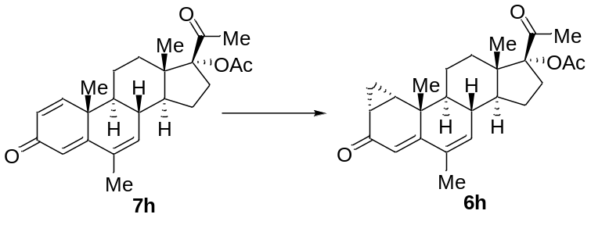
7h: White power, ¹H NMR (400 MHz, CDCl₃) δ 7.09 (d, J = 10.1 Hz, 1H), 6.29 (dd, J = 10.1, 1.7 Hz, 1H), 6.21 (s, 1H), 5.84 (s, 1H), 5.31 (s, 1H), 3.08-2.93 (m, 1H), 2.32 (t, J = 10.4 Hz, 1H), 2.08 (s, 3H), 2.06 (s, 3H), 2.02-1.70 (m, 7H), 1.70-1.58 (m, 2H), 1.57-1.43 (m, 2H), 1.19 (s, 3H), 0.76 (s, 3H). ¹³C NMR (101 MHz, CDCl₃) δ 203.9, 186.5, 170.6, 163.2, 153.4, 134.5, 131.9, 127.8, 121.7, 96.2, 49.1, 47.9, 47.1, 41.2, 37.7, 31.1, 30.3, 26.4, 23.3, 21.6, 21.2, 20.6, 19.3, 14.4. FTIR (KBr): n_{max} = 2954, 2924, 2868, 2854, 1729, 1708, 1657, 1645, 1610, 1460, 1364, 1260, 1247, 888 cm⁻¹. HRMS (ESI) m/z calculated for C₂₄H₃₂O₄, [M + H]⁺ = 383.2234, found: 383.2233. [α] _{D}²⁵ = -38.77 (c = 0.30, CHCl₃).
7h (114.8 mg, 0.3 mmol, 1.0 equiv.) performed via the general procedure without any modification to obtained crude 6h. Which was separated through column chromatography (filled with SiO₂, PE:EA = 5:1) to provide pure 6h (102.7 mg, 86.3% yield). White power, ¹H NMR (400 MHz, CDCl₃) δ 5.87 (s, 1H), 5.72 (s, 1H), 3.17-2.86 (m, 1H), 2.33-2.17 (m, 1H), 2.13 (s, 3H), 2.08 (s, 3H), 2.05-1.84 (m, 5H), 1.84-1.82 (m, 2H), 1.75-1.35 (m, 6H), 1.31-1.22 (m, 2H), 1.19 (s, 3H), 0.92-0.82 (m, 1H), 0.75 (s, 3H). ¹³C NMR (101 MHz, CDCl₃) δ 204.0, 199.1, 170.7, 157.4, 136.4, 131.5, 117.8, 96.5, 49.1, 48.2, 47.3, 37.1, 37.0, 31.2, 30.4, 26.4, 26.0, 25.0, 23.3, 22.9, 21.2, 20.9, 19.9, 14.3, 12.6. FTIR (KBr): n_{max} = 2954, 2924, 2869, 2852, 1730, 1645, 1459, 1377, 1246 cm⁻¹. HRMS (ESI) m/z calculated for C₂₅H₃₃O₄, [M + H]⁺ = 397.2377, found: 397.2377. [α] _{D}²⁵ = 73.1 (c = 0.17, CHCl₃).

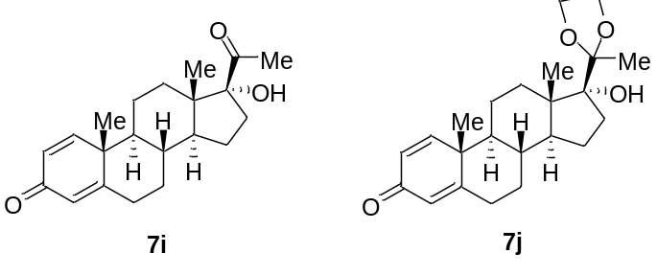
7i: White power, m.p.: 232.1-233.2 °C. ¹H NMR (400 MHz, CDCl₃) δ 7.04 (d, J = 10.1 Hz, 1H), 6.23 (dd, J = 10.1, 1.5 Hz, 1H), 6.07 (s, 1H), 2.68 (ddd, J = 14.6, 11.4, 2.9 Hz, 1H), 2.48 (td, J = 13.3, 4.5 Hz, 1H), 2.41-2.32 (m, 1H), 2.27 (s, 3H), 2.01-1.94 (m, 1H), 1.87-1.77 (m, 2H), 1.77-1.65 (m, 4H), 1.65-1.51 (m, 2H), 1.46-1.34 (m, 2H), 1.23 (s, 3H), 1.15-1.05 (m, 2H), 0.78 (s, 3H). ¹³C NMR (101 MHz, CDCl₃) δ 211.5, 186.3, 168.9, 155.6, 127.6, 124.0, 89.7, 51.8, 49.6, 48.4, 43.5, 35.4, 33.6, 33.5, 32.8, 30.0, 27.9, 24.1, 22.3, 18.8, 15.5. HRMS (ESI) m/z calculated for C₂₁H₂₉O₃, [M + H]⁺ = 329.2111, found: 329.2111. [α] _{D}²⁵ = 20.7 (c = 0.18, CHCl₃).
7j: White power, ¹H NMR (400 MHz, DMSO-d₆) δ 7.20 (d, J = 10.1 Hz, 1H), 6.12 (dd, J = 10.1, 1.4 Hz, 1H), 5.98 (s, 1H), 3.98-3.89 (m, 2H), 3.87-3.72 (m, 2H), 2.33 (d, J = 12.5 Hz, 1H), 2.09 (t, J = 11.7 Hz, 1H), 1.89 (d, J = 12.3 Hz, 1H), 1.77-1.51 (m, 7H), 1.45-1.32 (m, 1H), 1.21 (d, J = 11.7 Hz, 6H), 1.17-1.09 (m, 1H), 1.03-0.83 (m, 2H), 0.82 (s, 3H). ¹³C NMR (101 MHz, DMSO-d₆) δ 185.5, 170.2, 157.1, 127.1, 123.5, 112.7, 86.3, 65.8, 63.1, 52.6, 49.9, 46.4, 43.7, 35.0, 34.0, 32.6, 31.9, 31.3, 23.3, 22.4, 21.2, 19.0, 15.1. HRMS (ESI) m/z calculated for C₂₃H₃₃O₄, [M + H]⁺ = 373.2373, found: 373.2376.

7. NMR Data
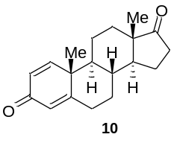
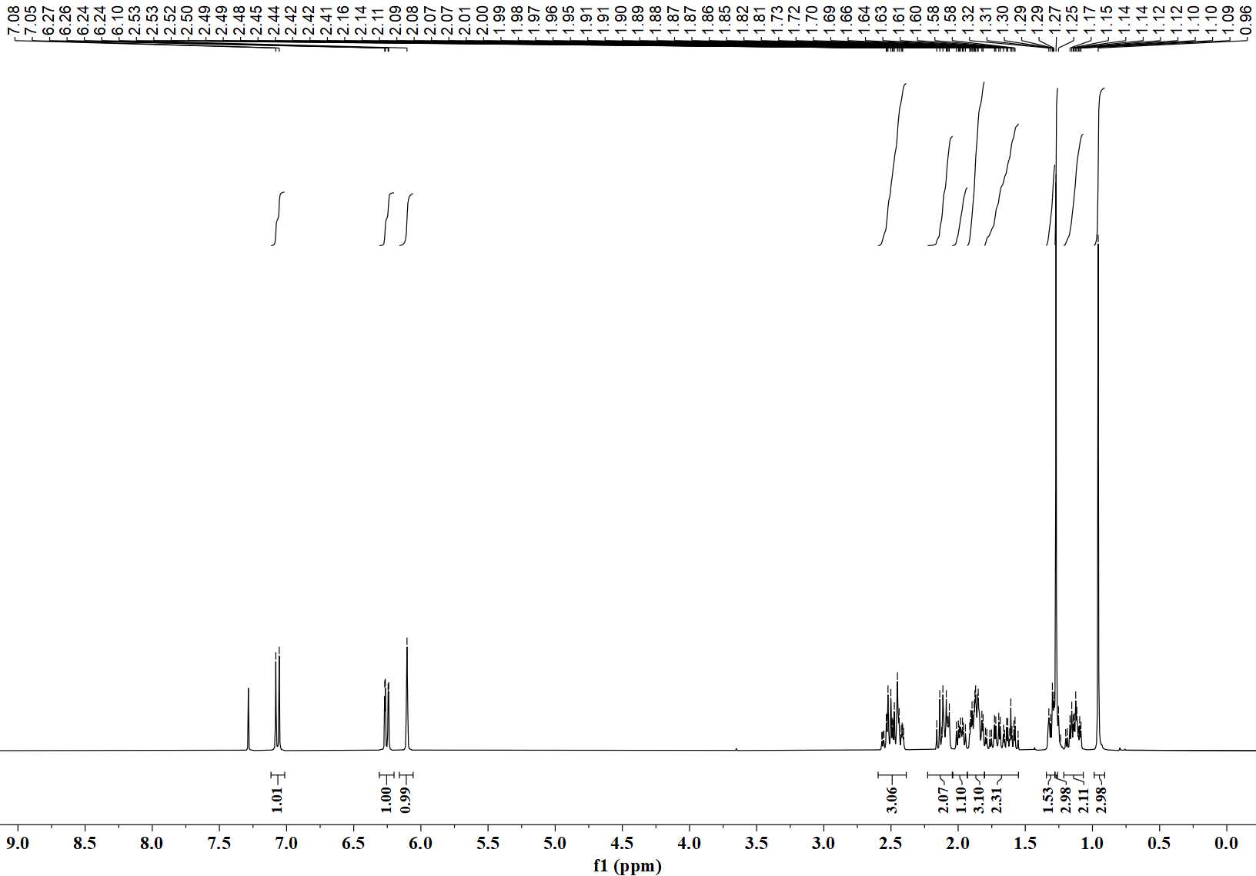
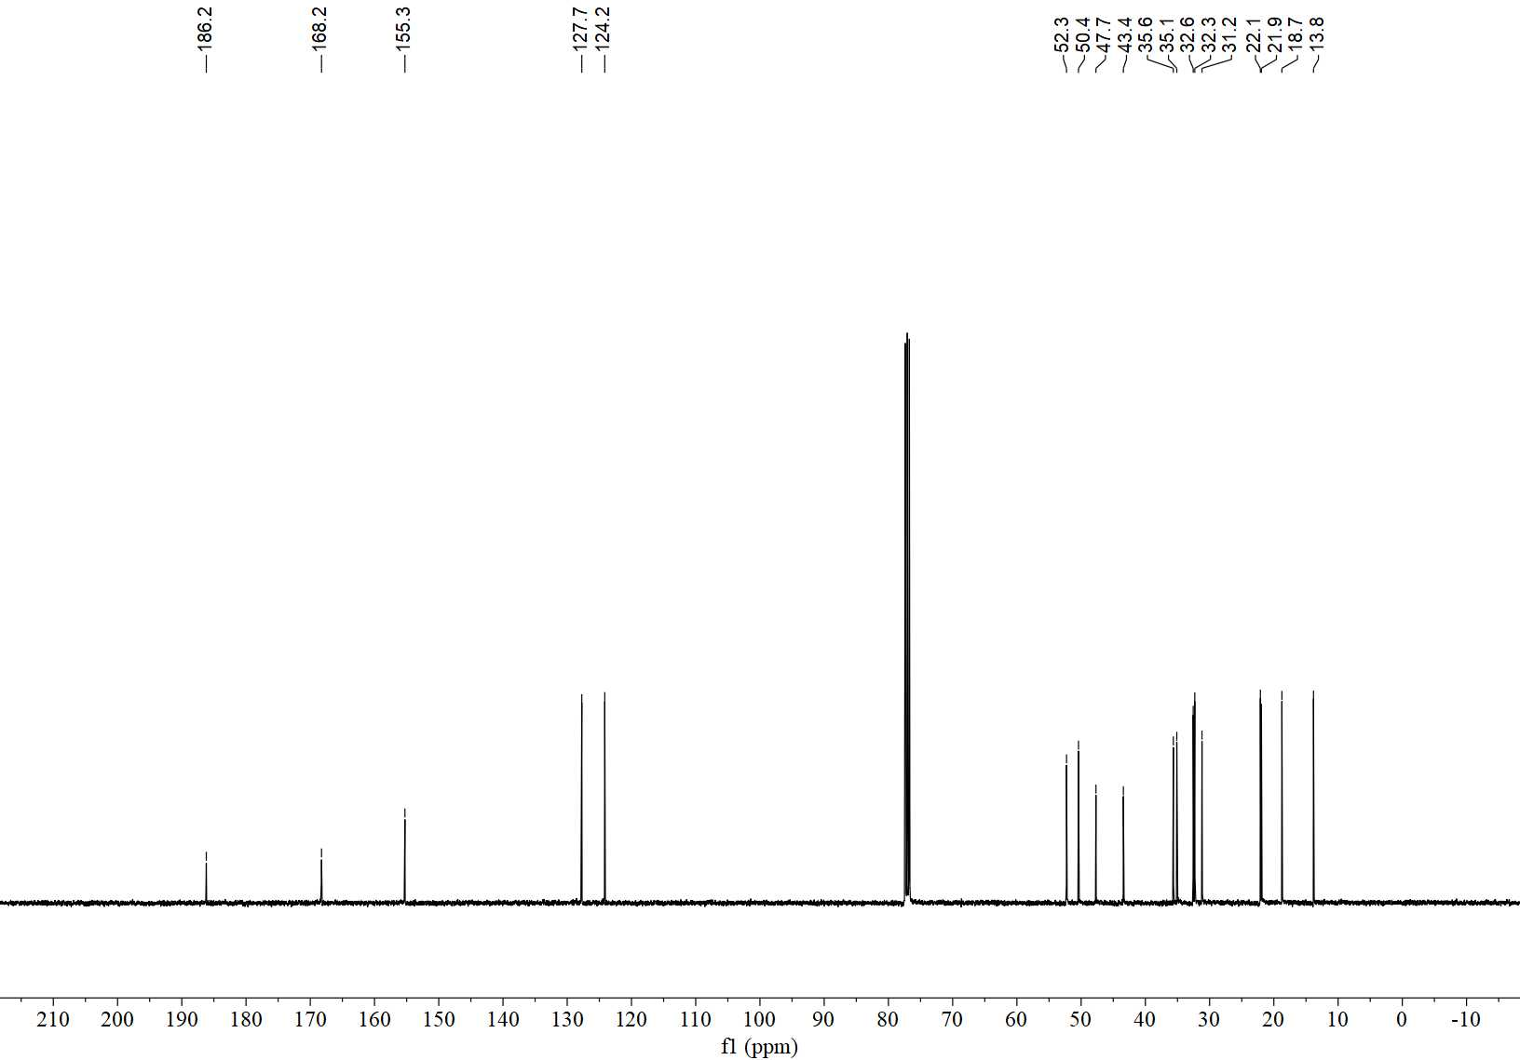
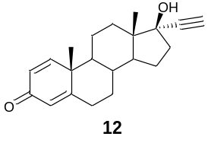
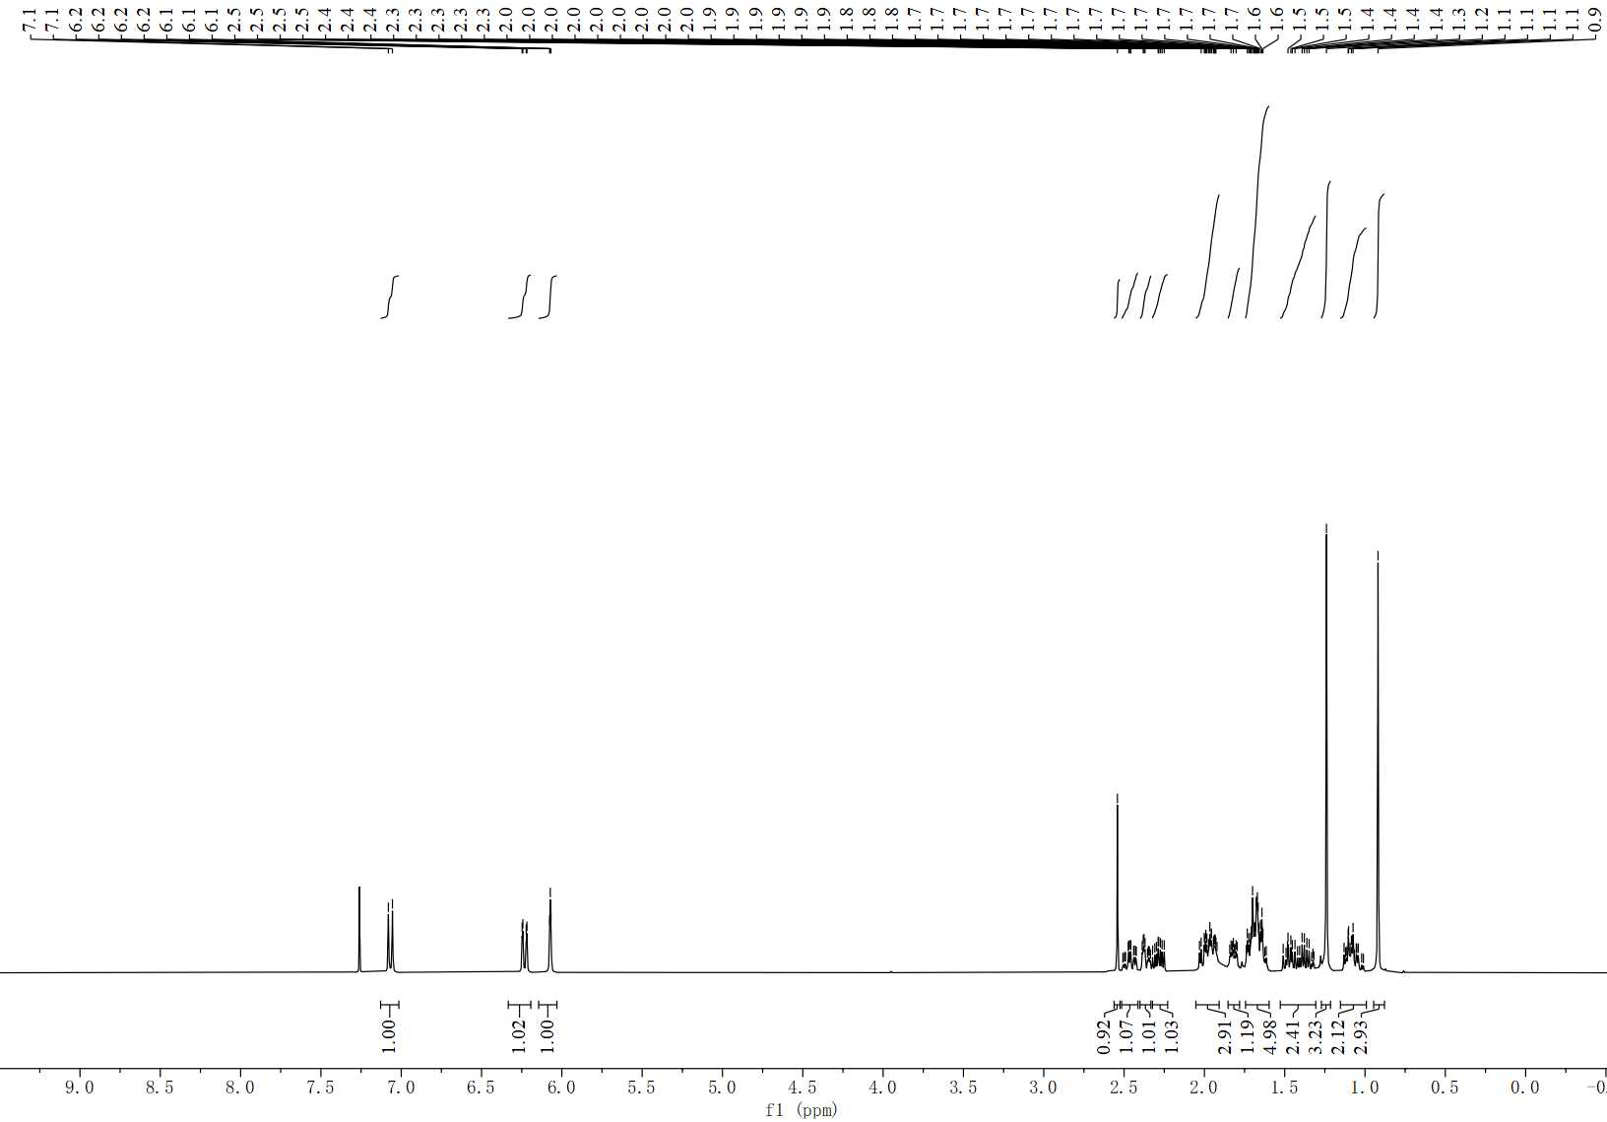
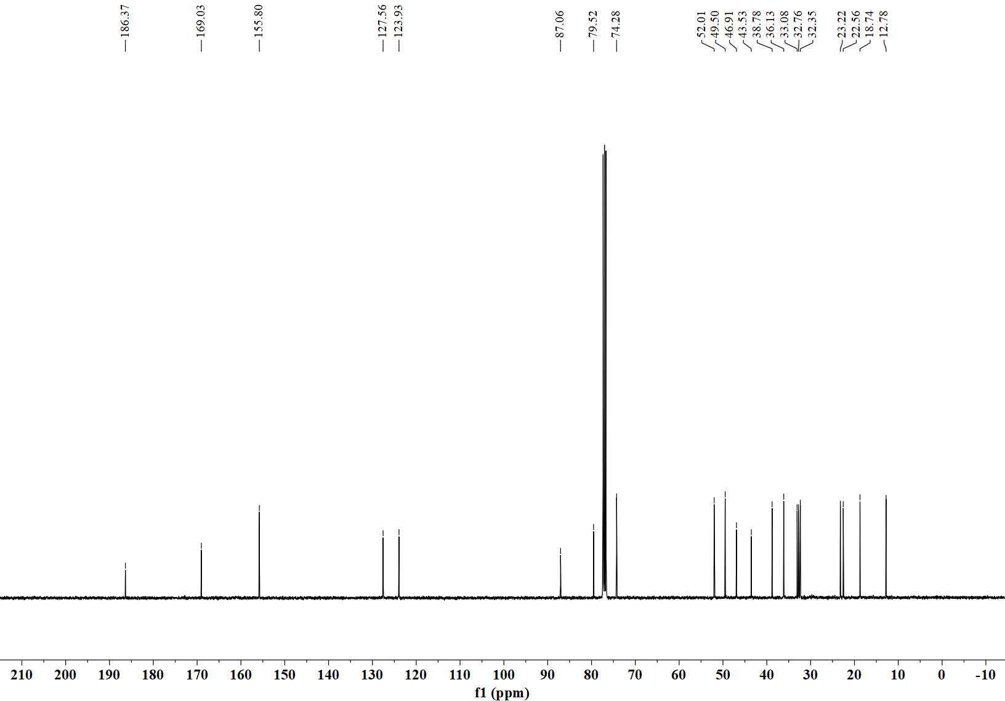
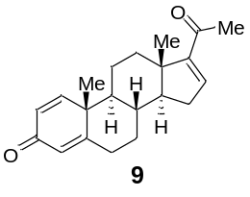
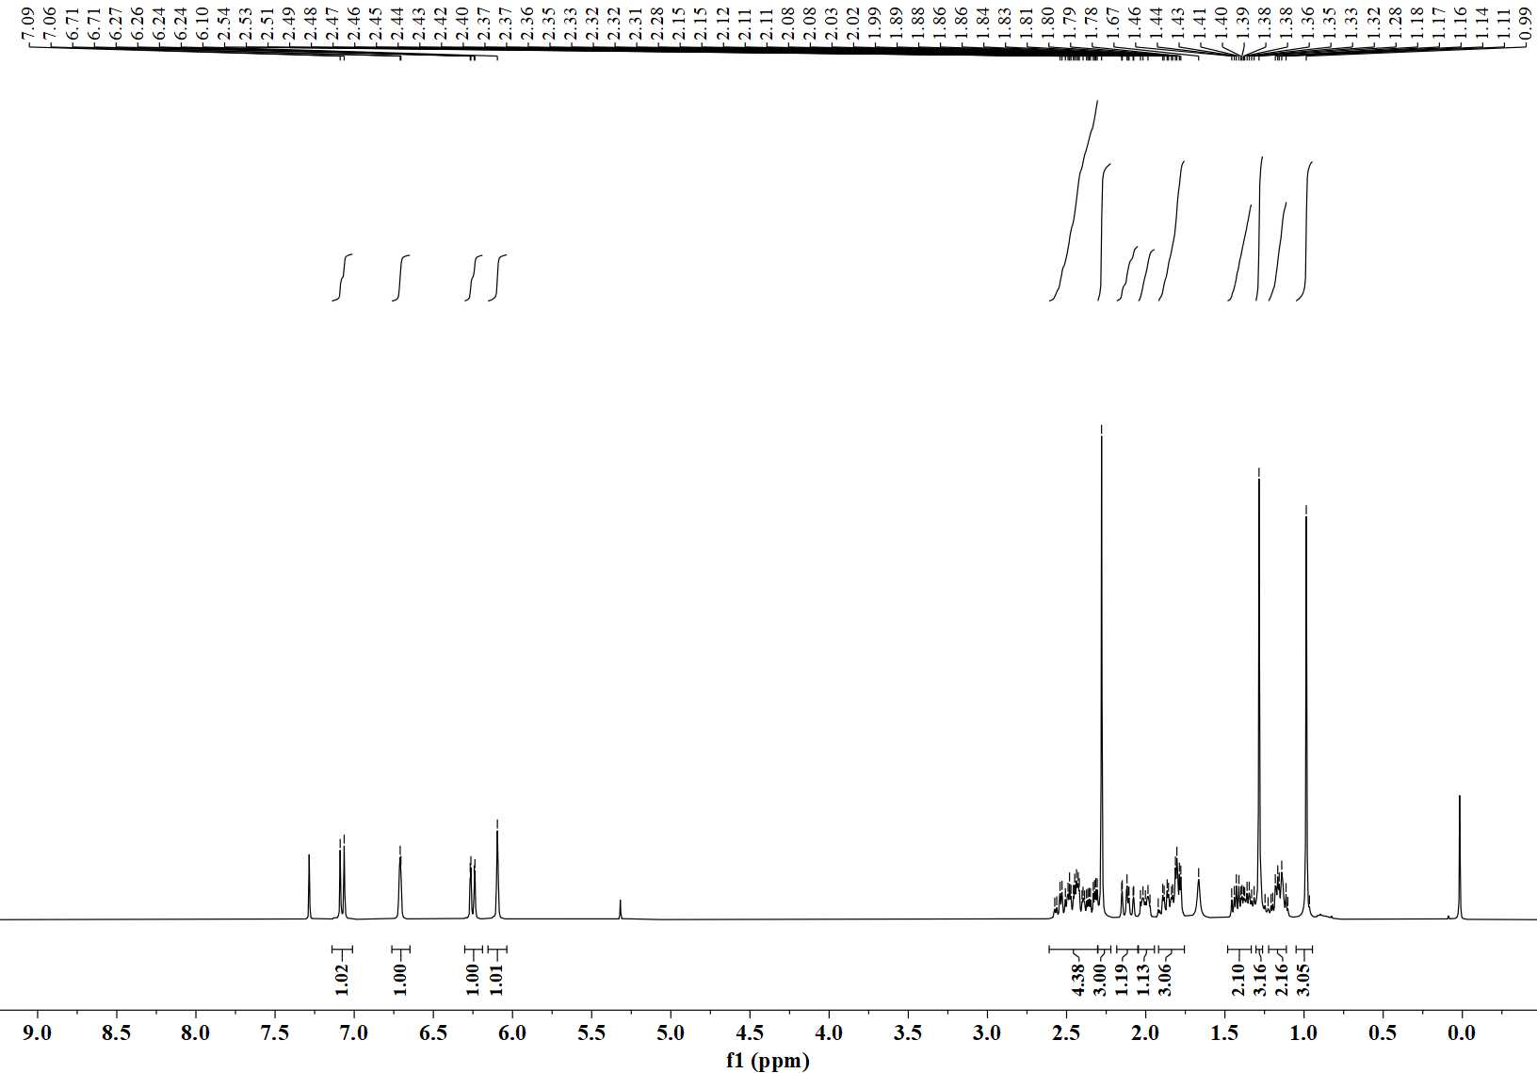
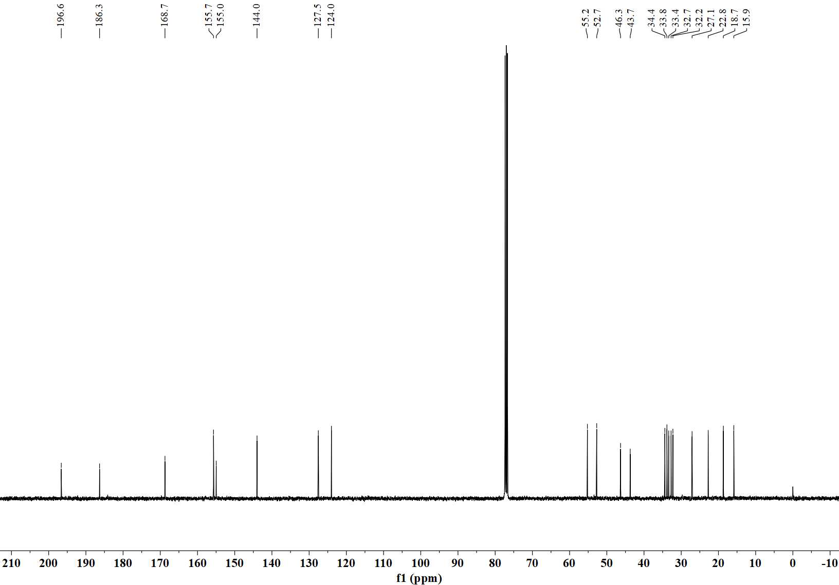
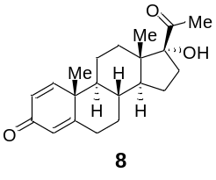
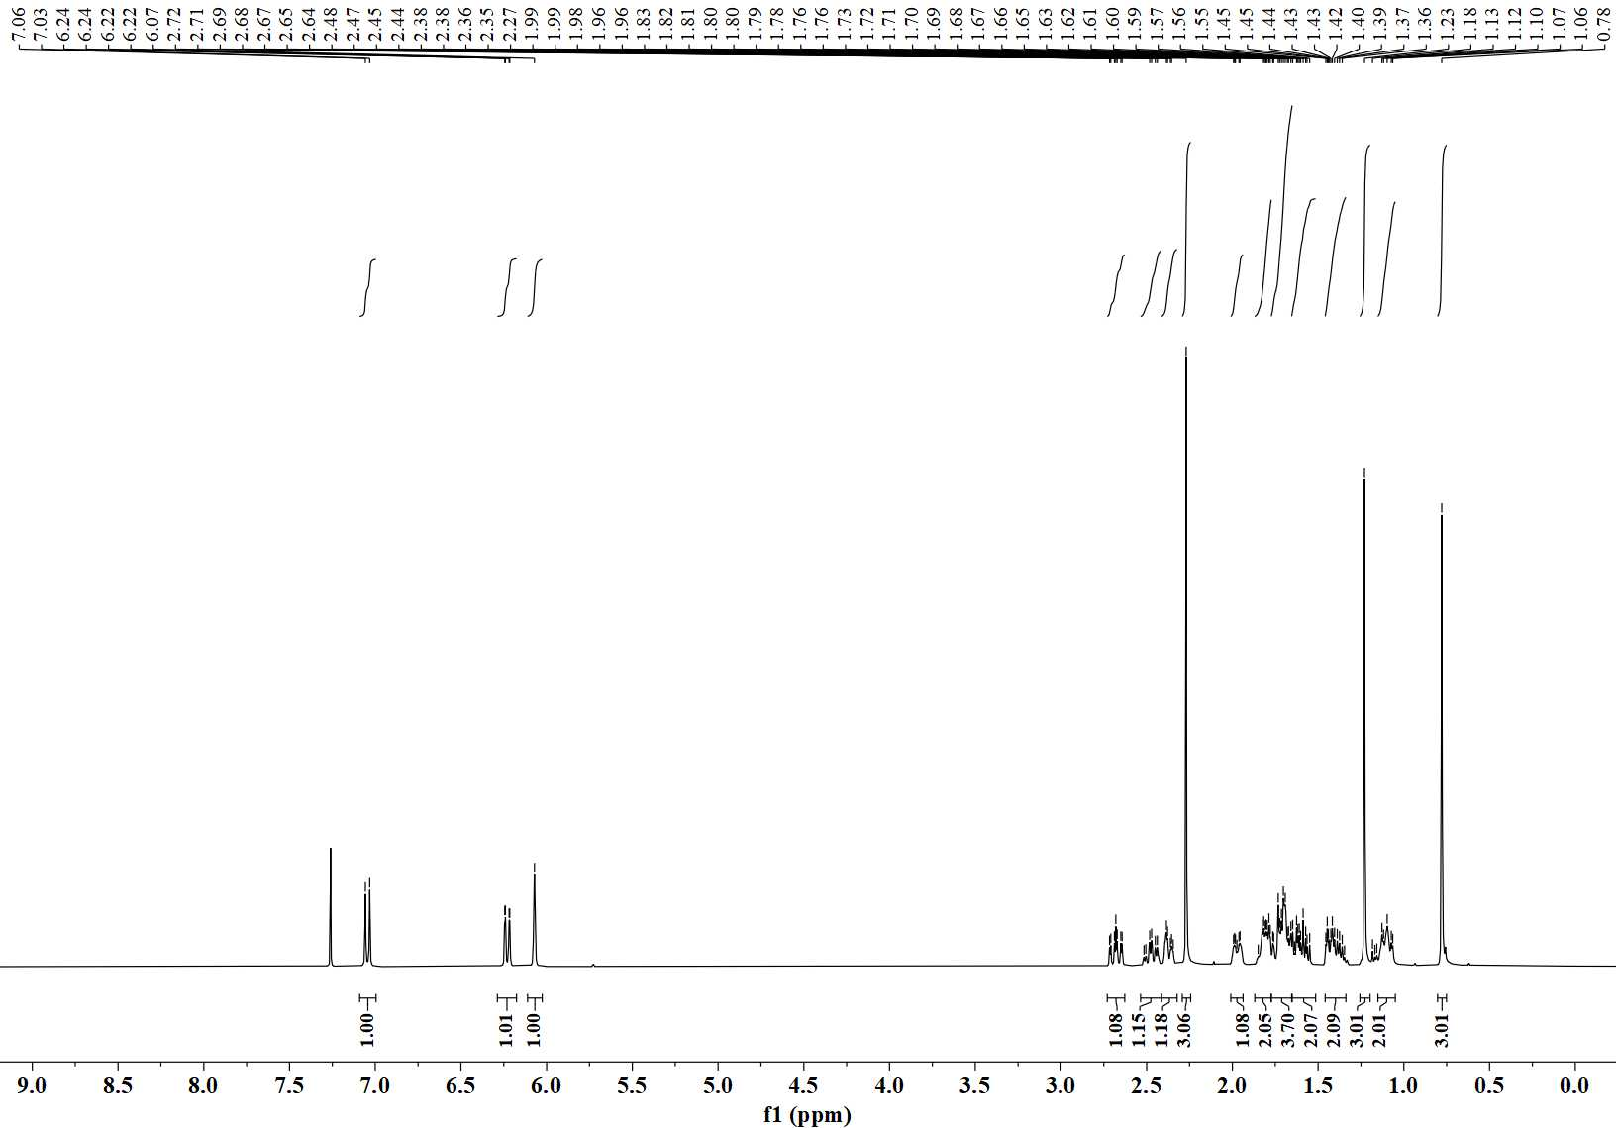
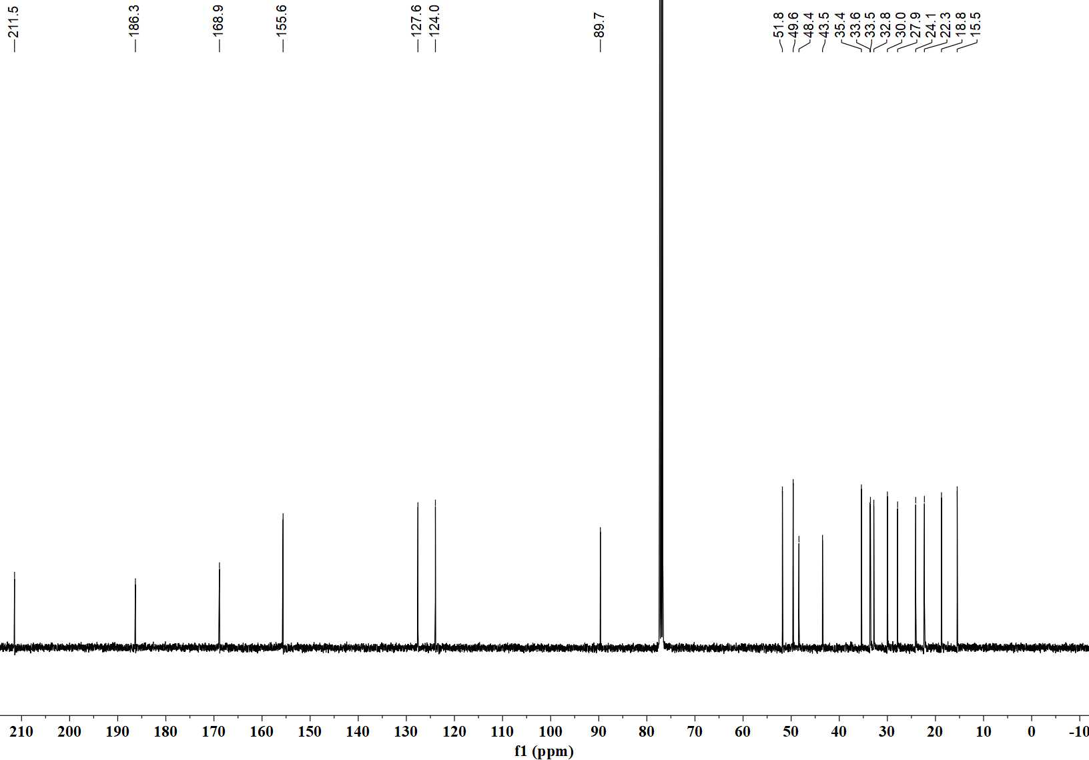
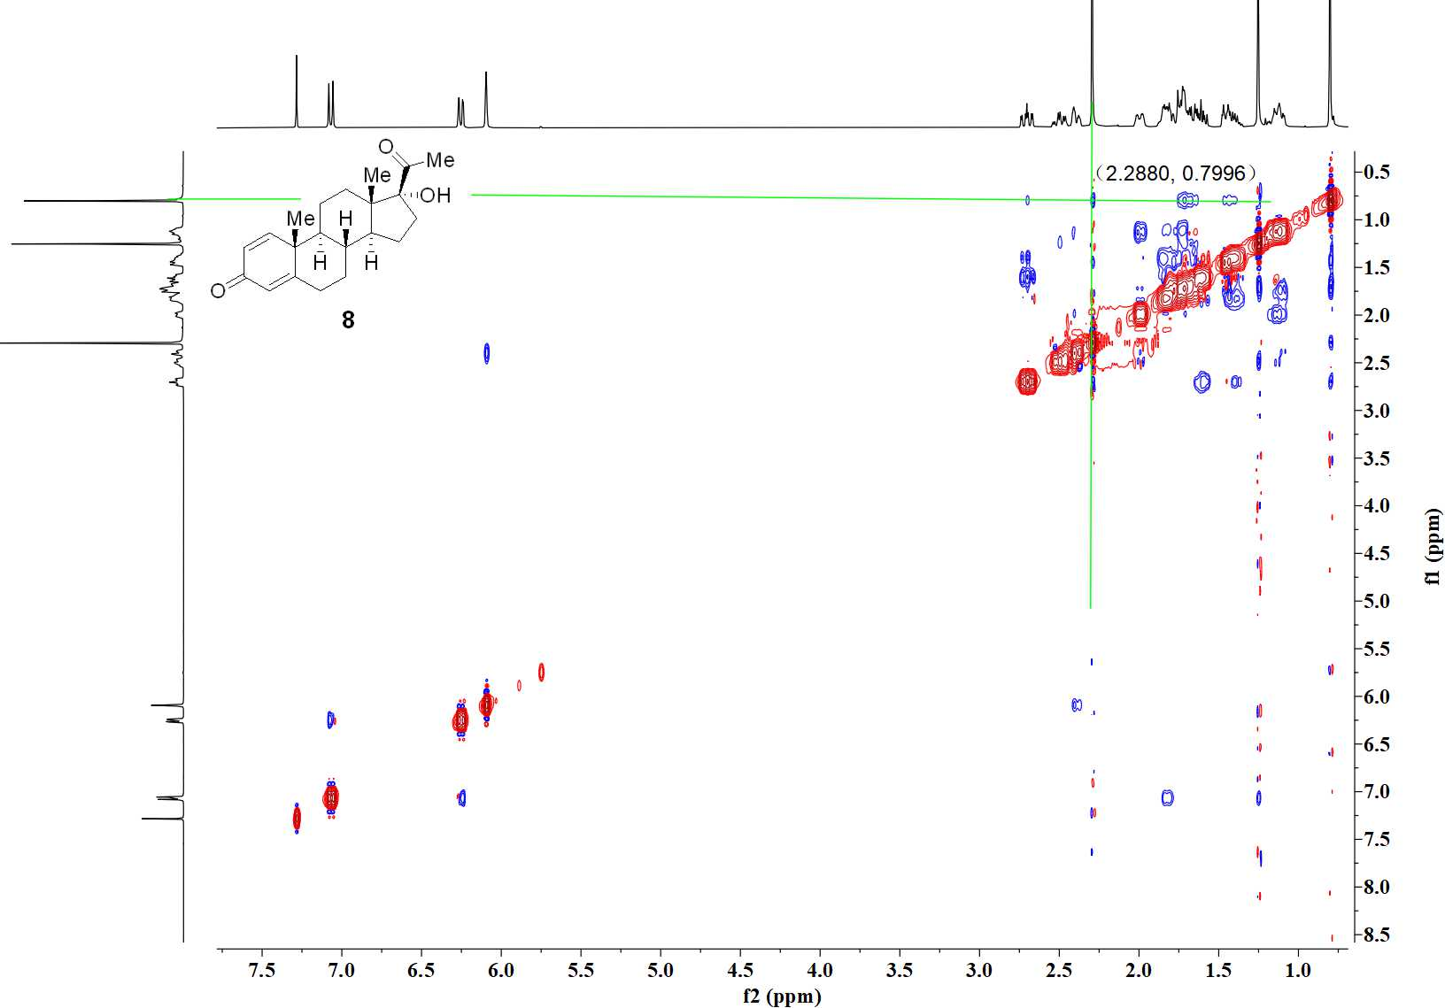

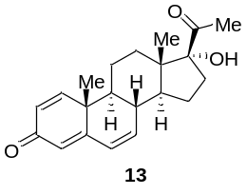
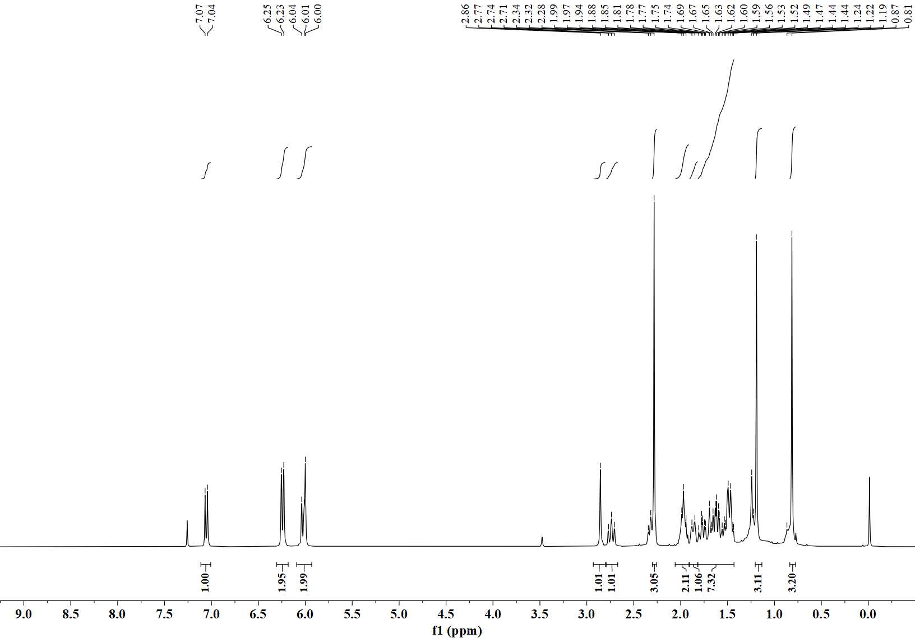
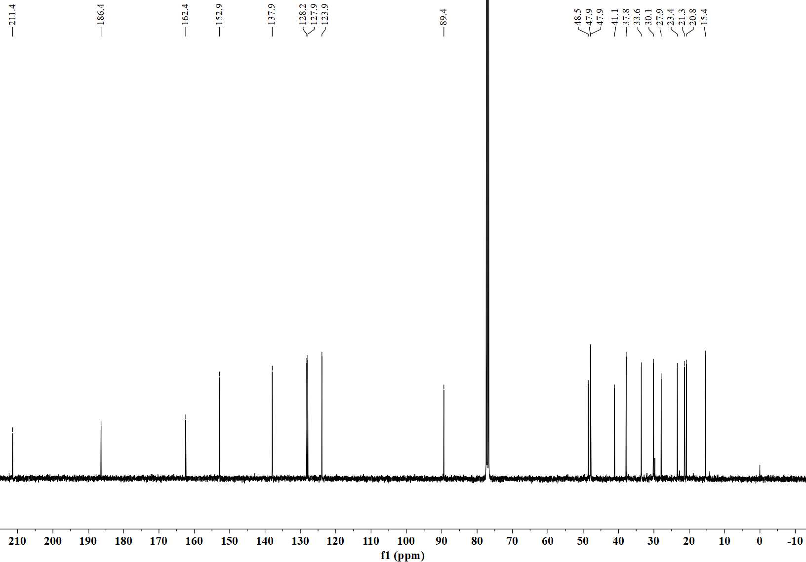
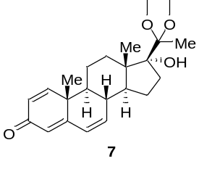
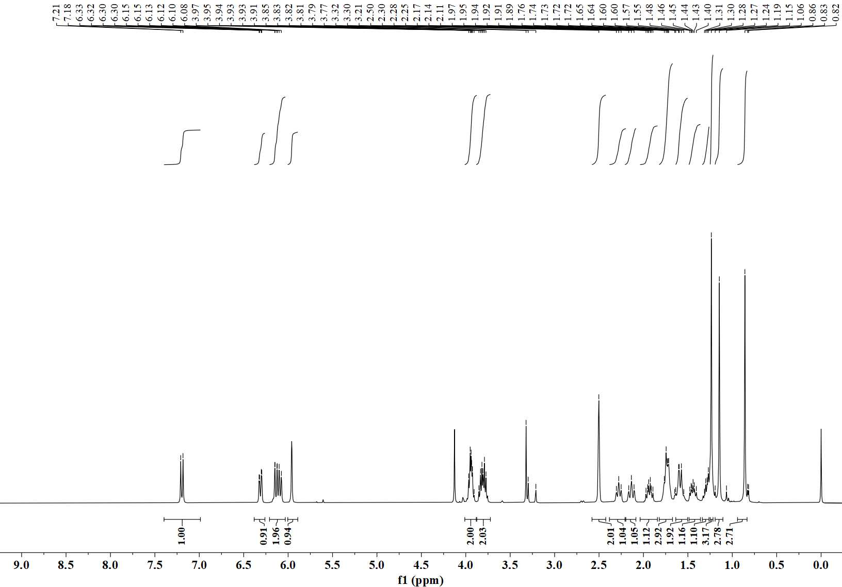
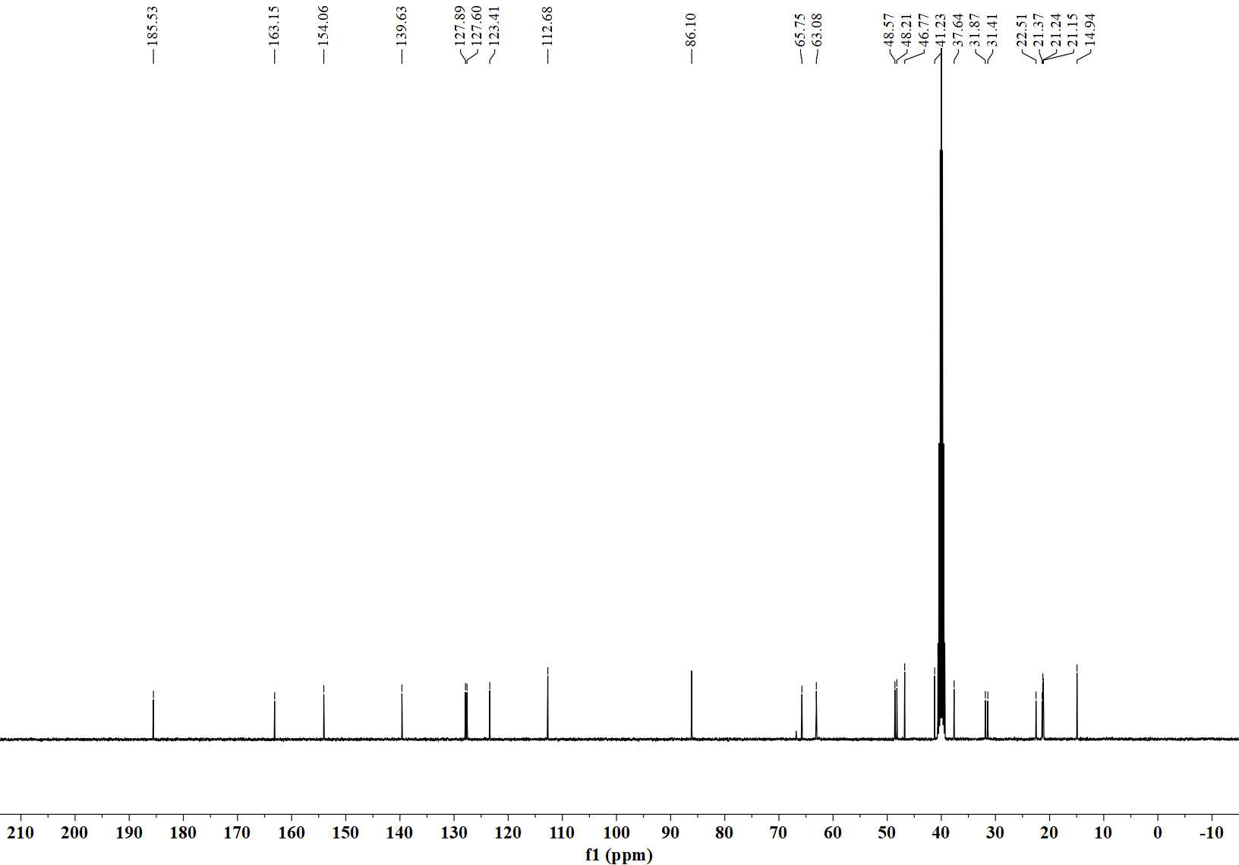
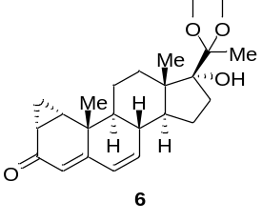
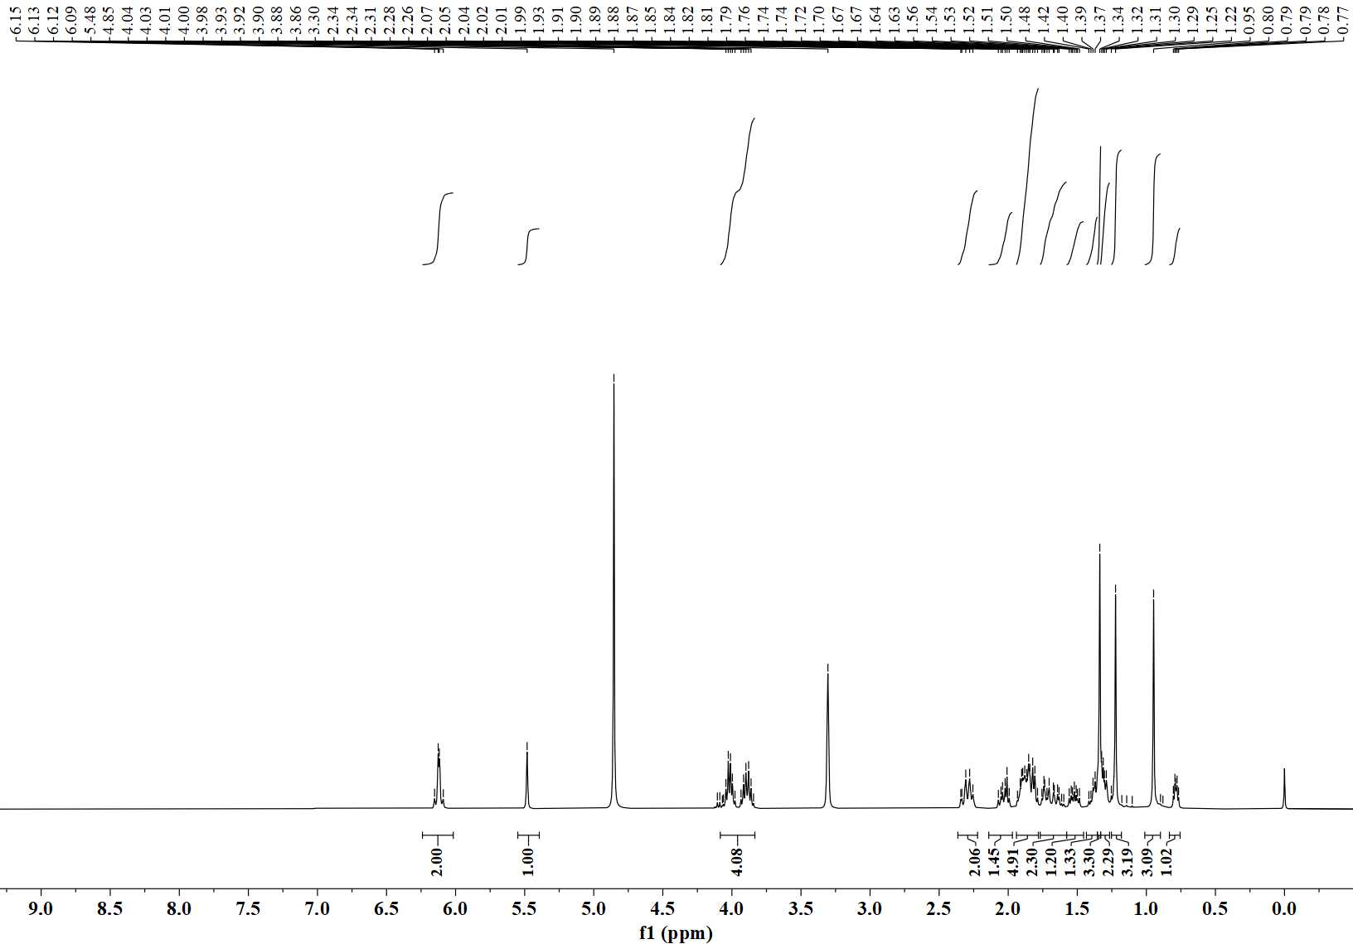
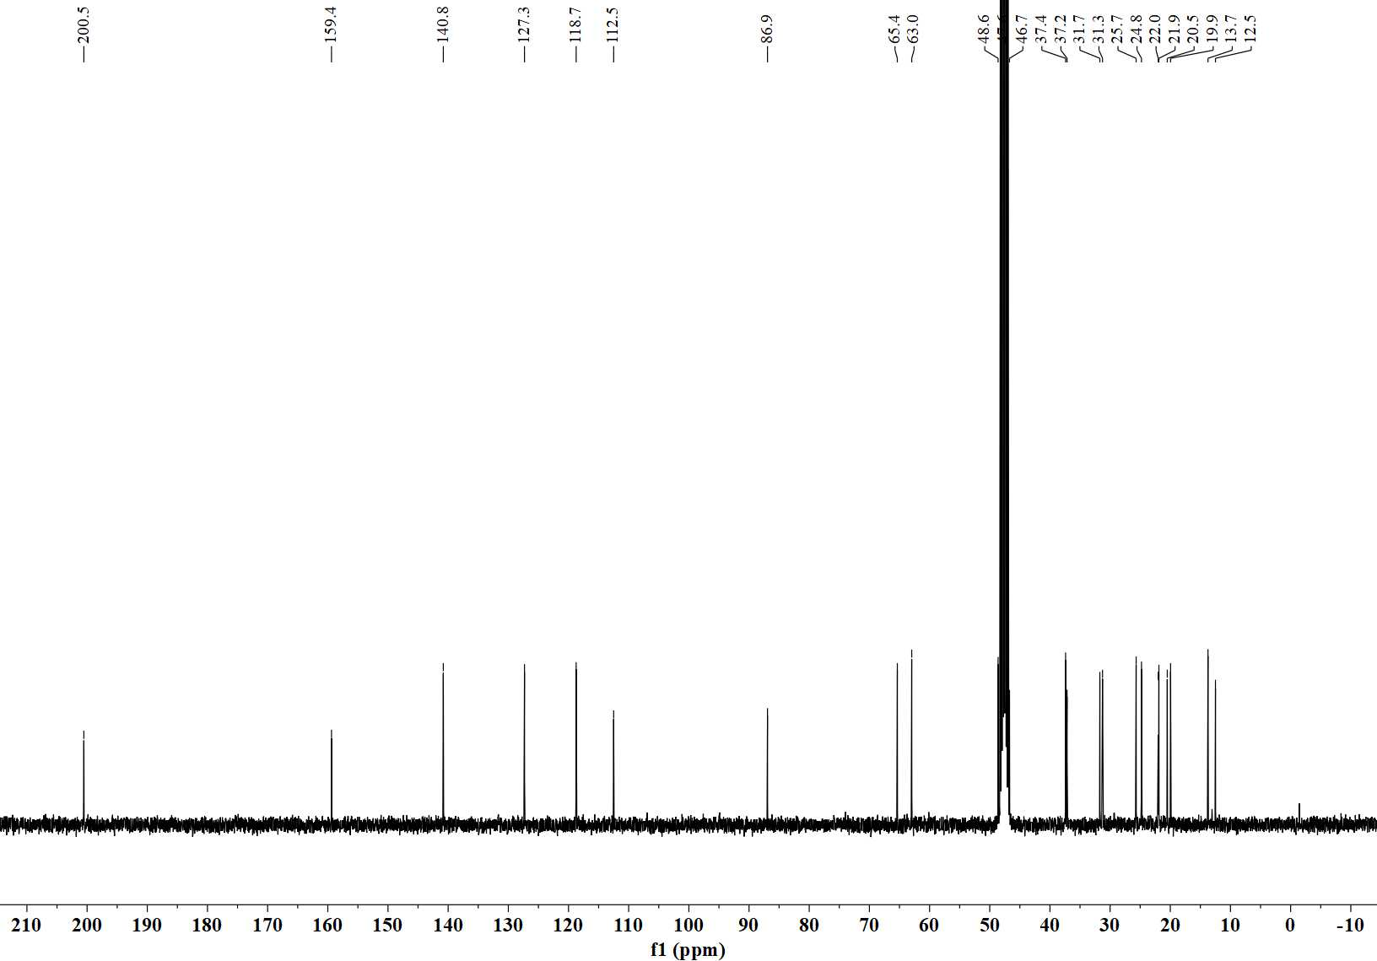
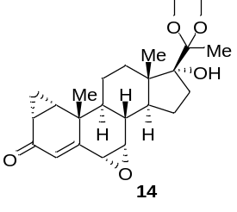
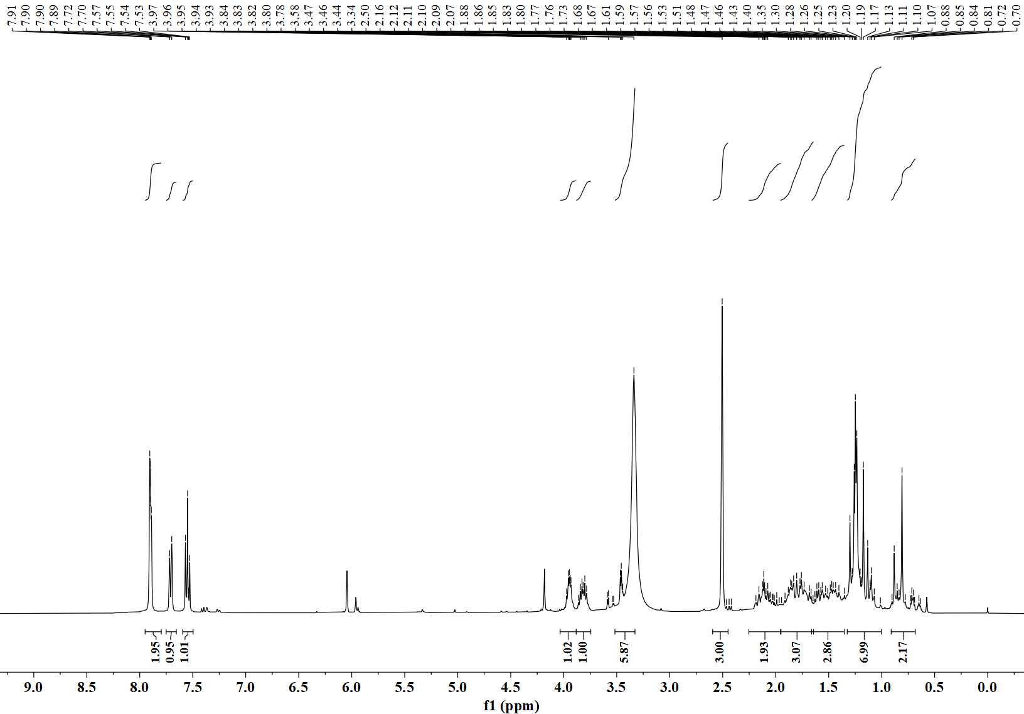

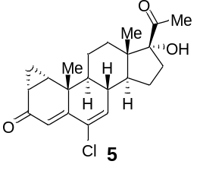
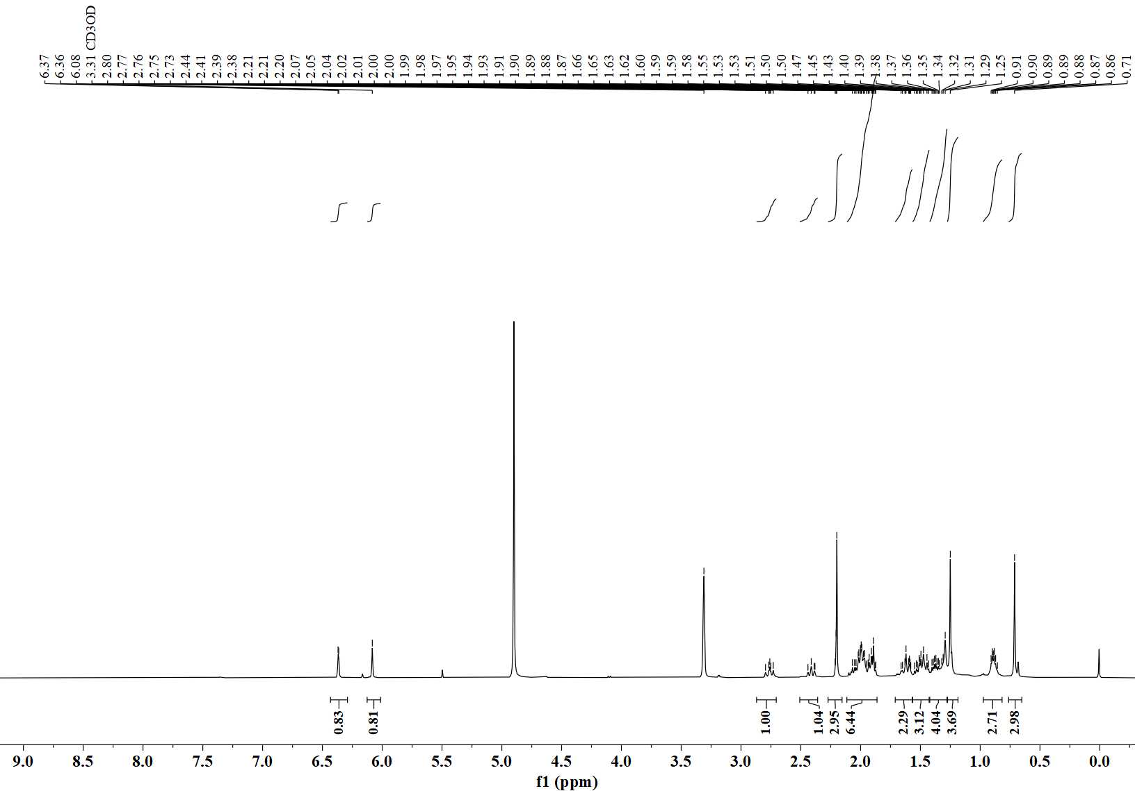
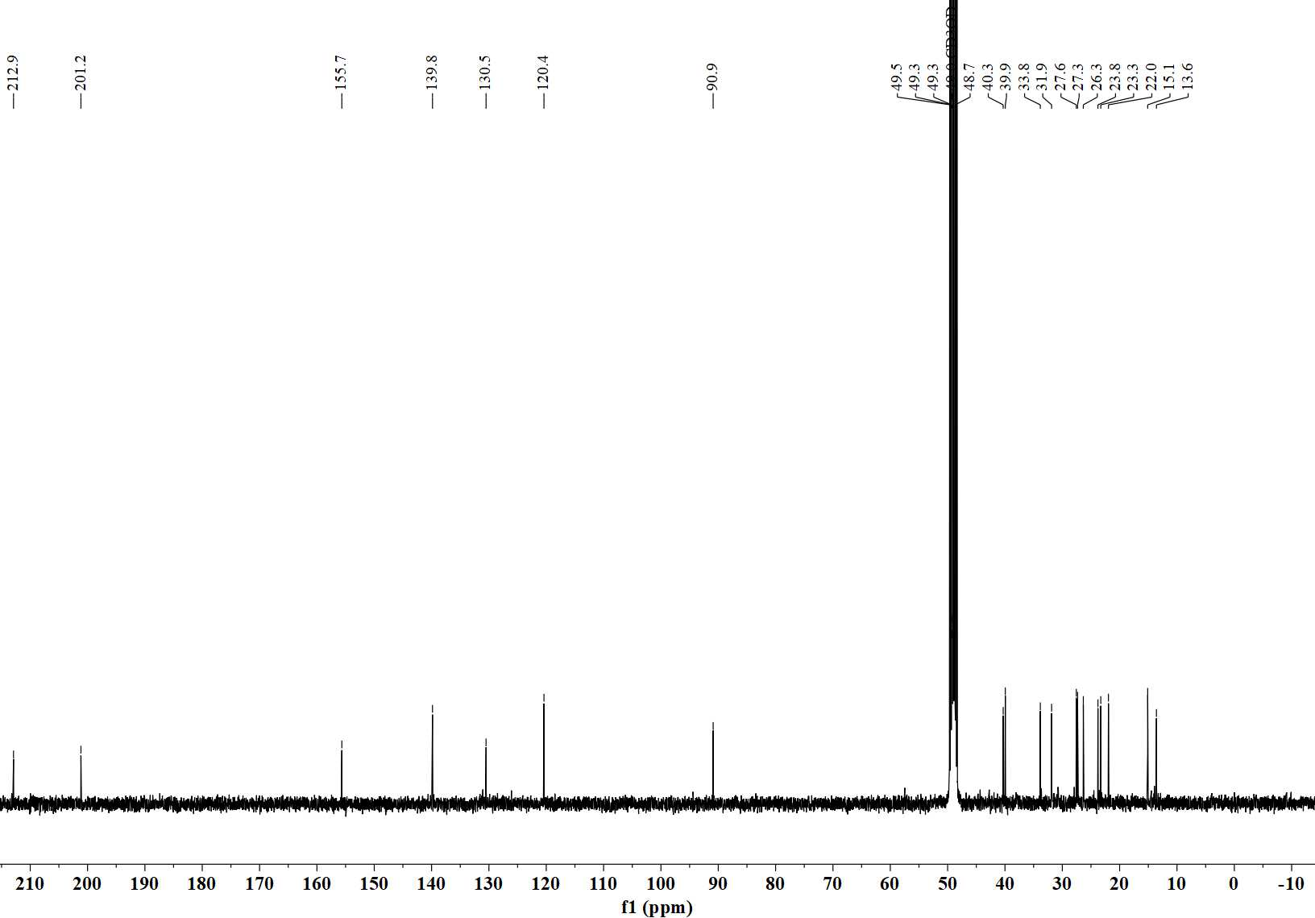
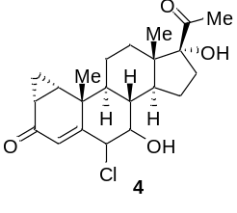
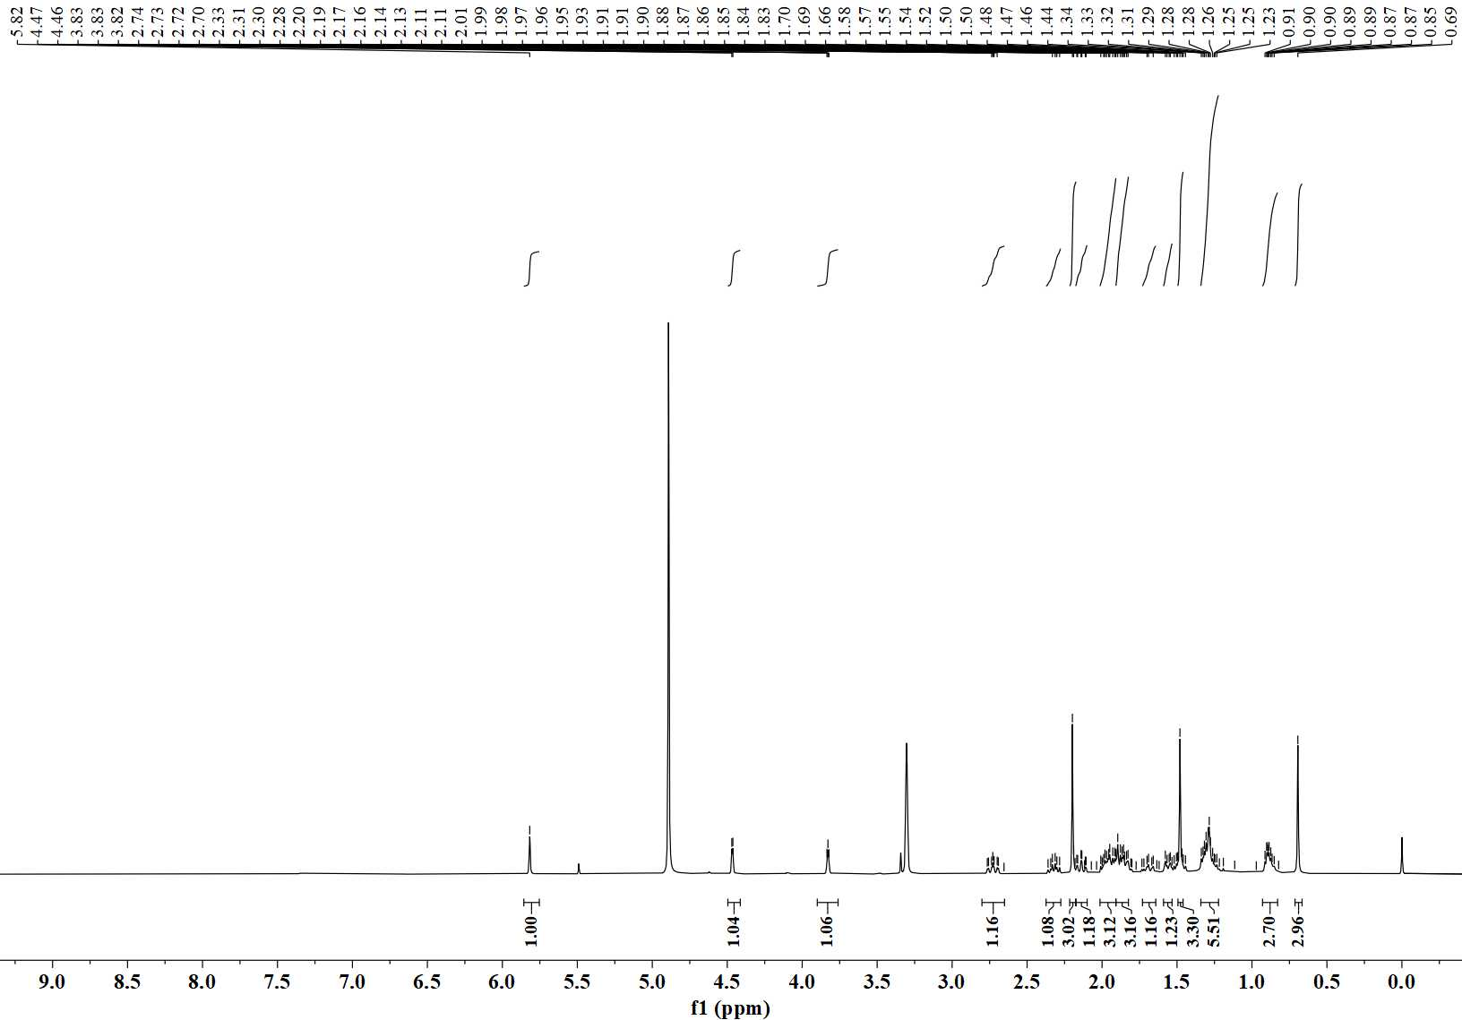
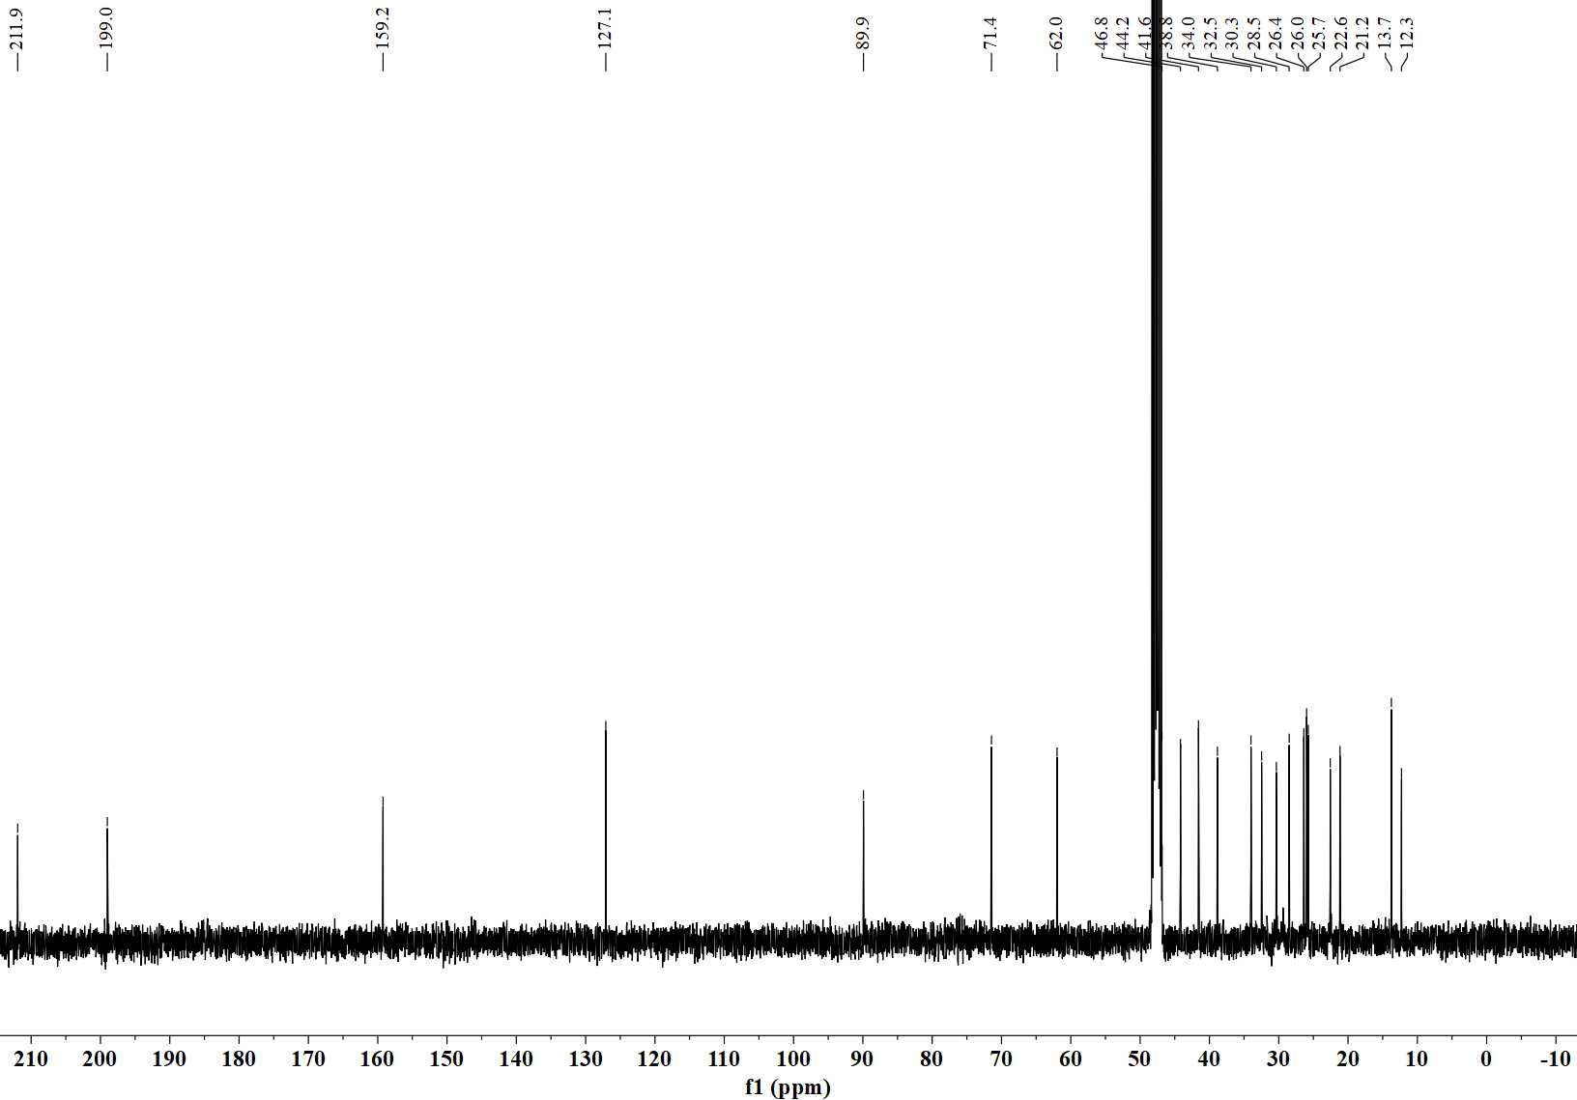
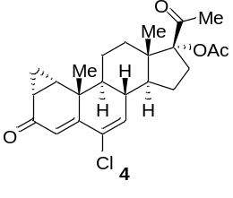
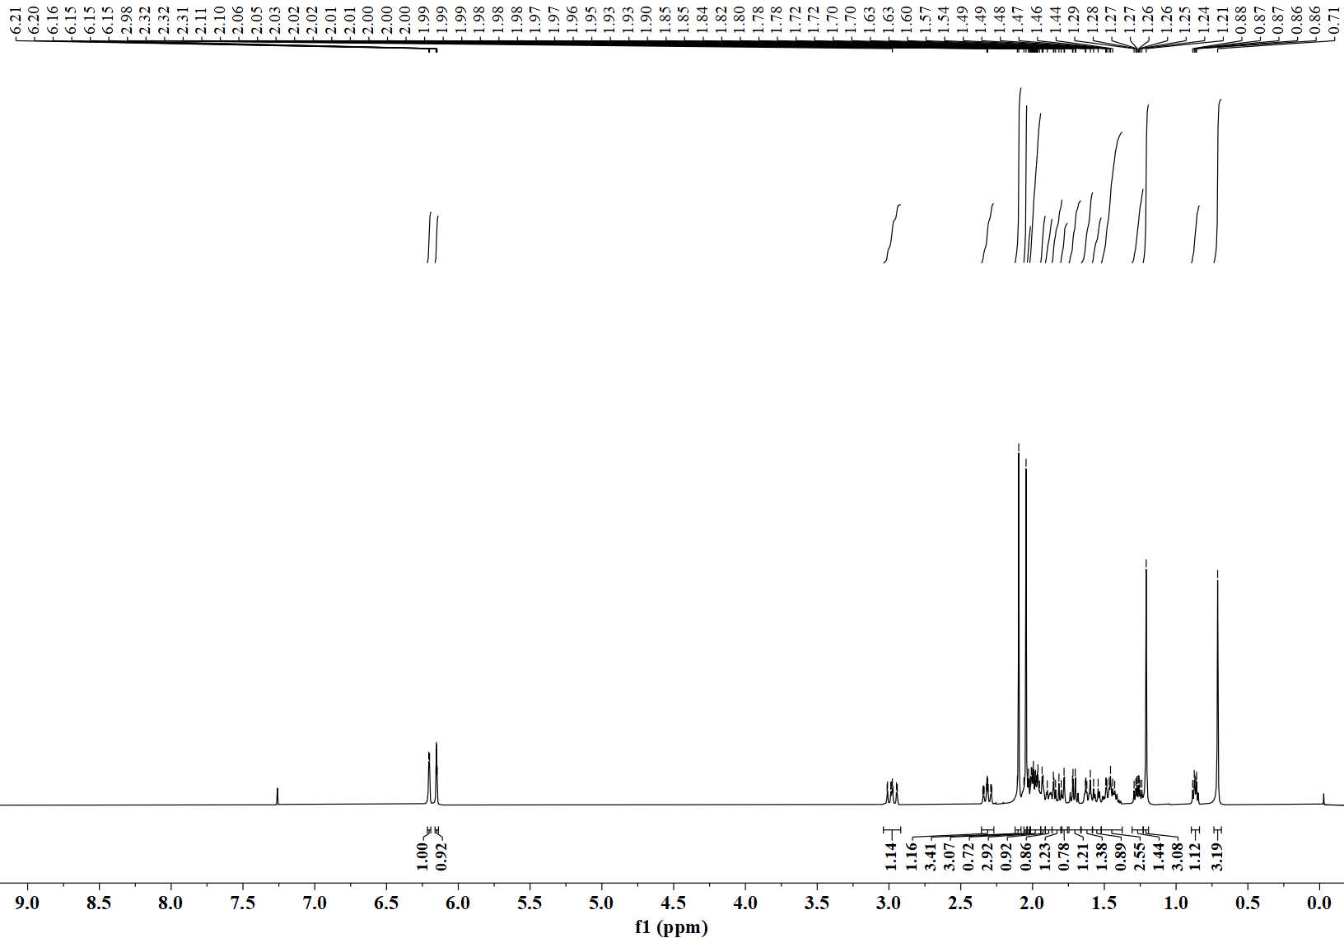
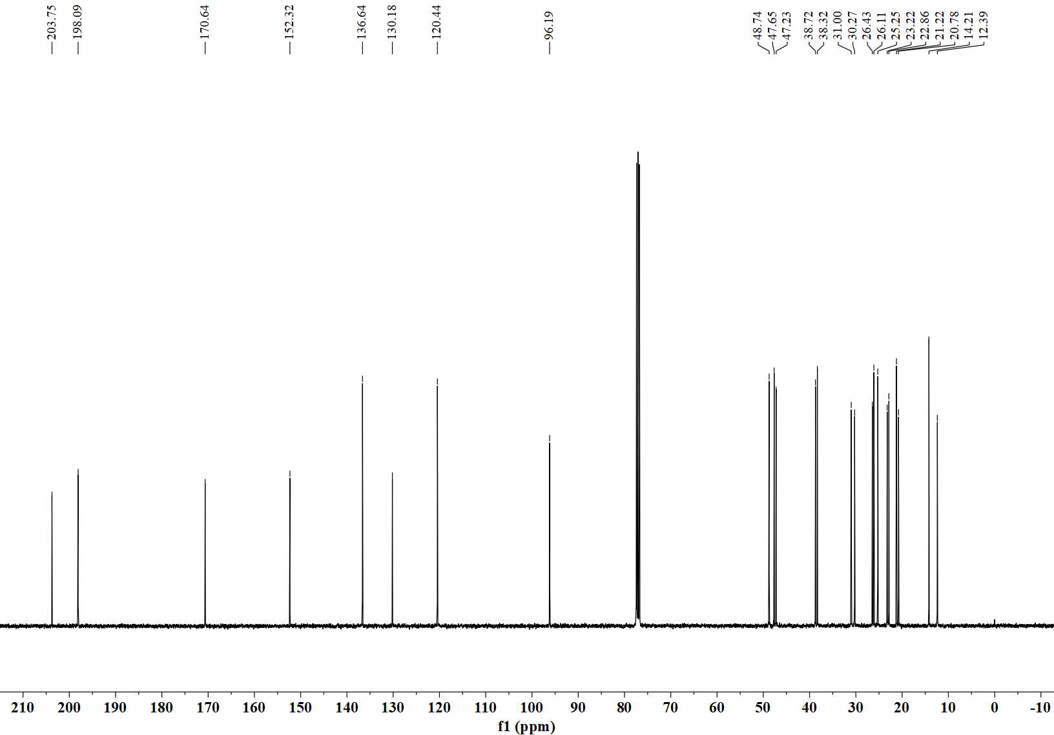
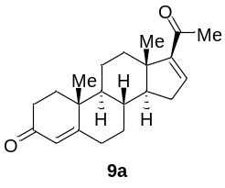
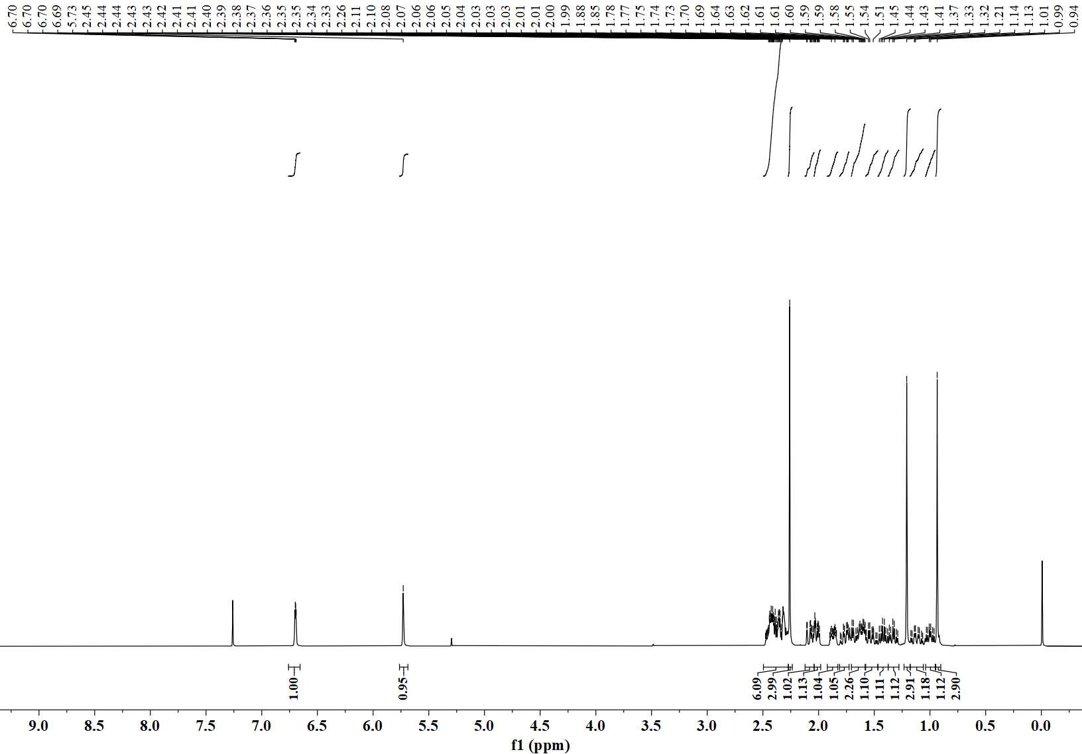
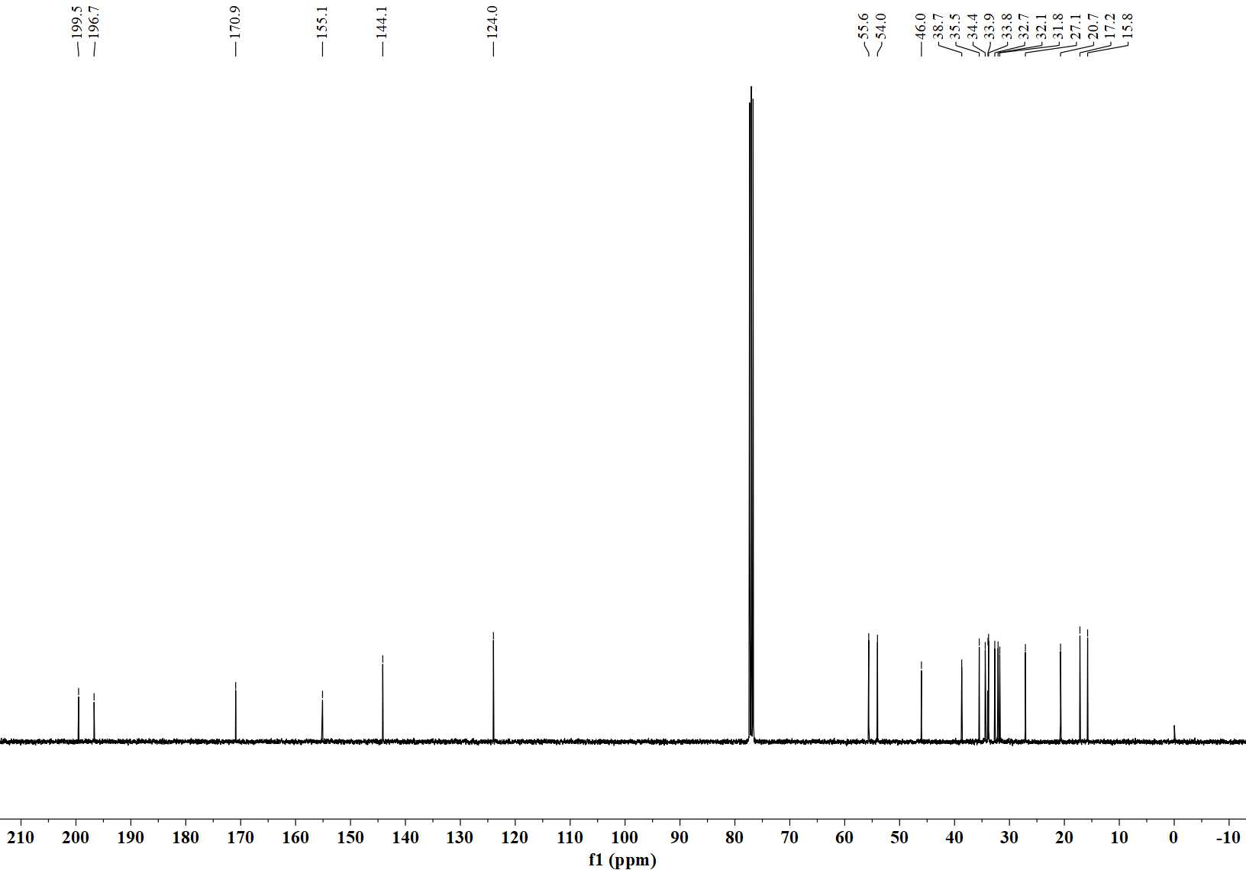

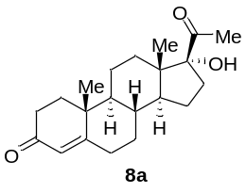
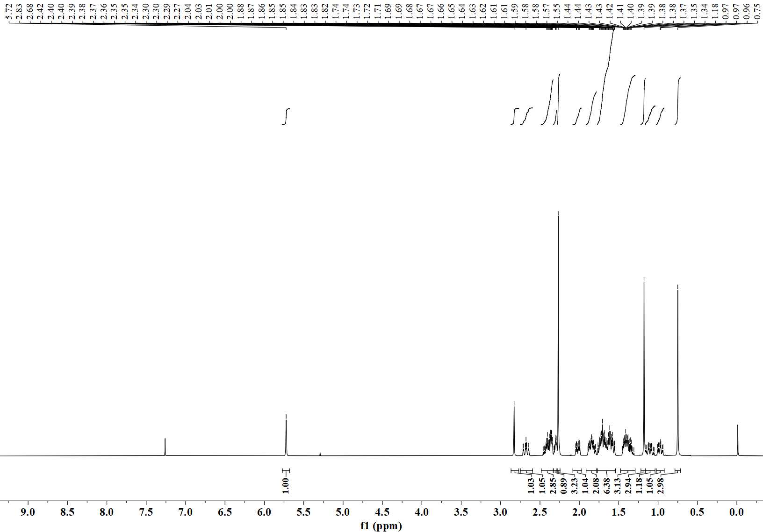
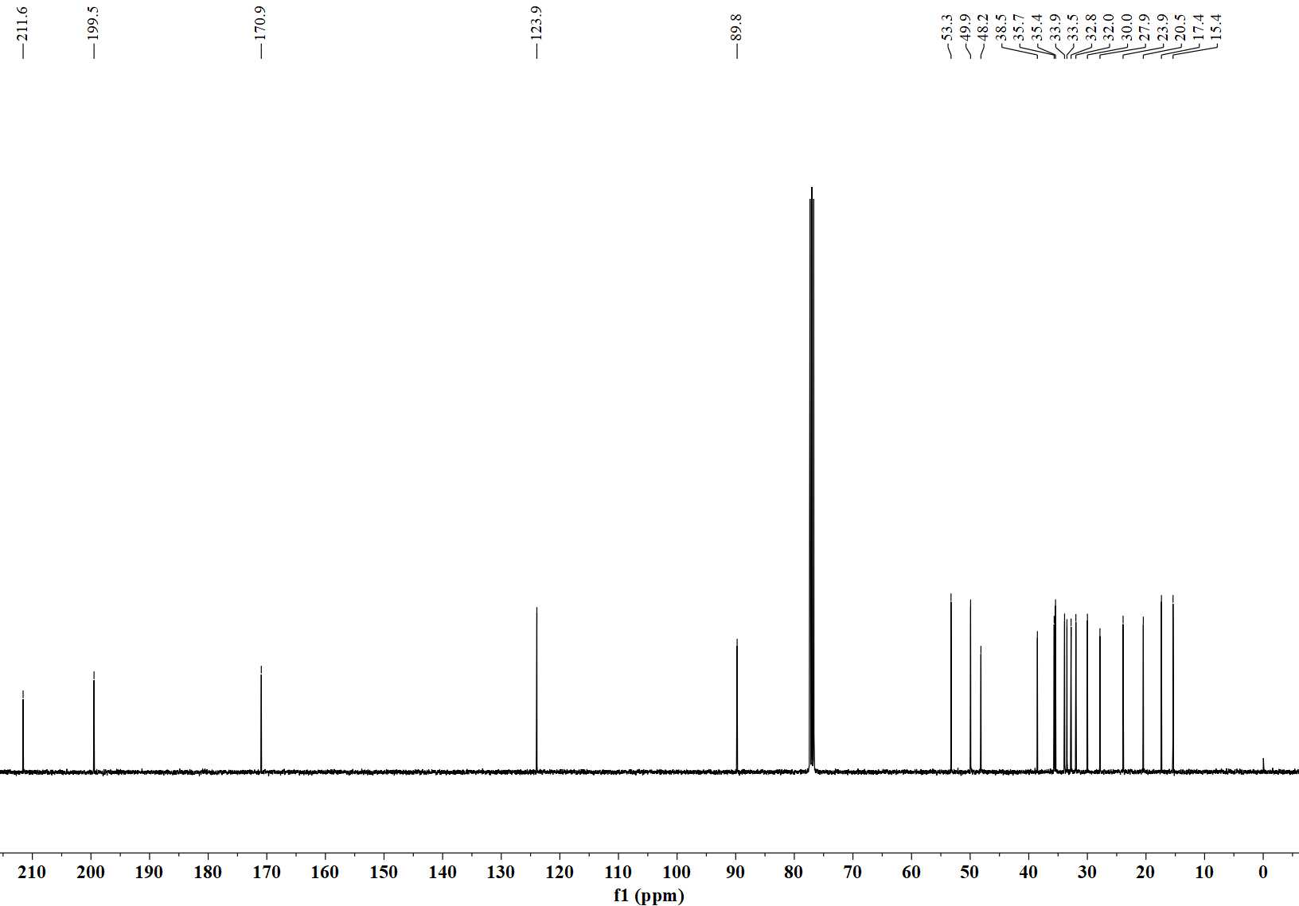

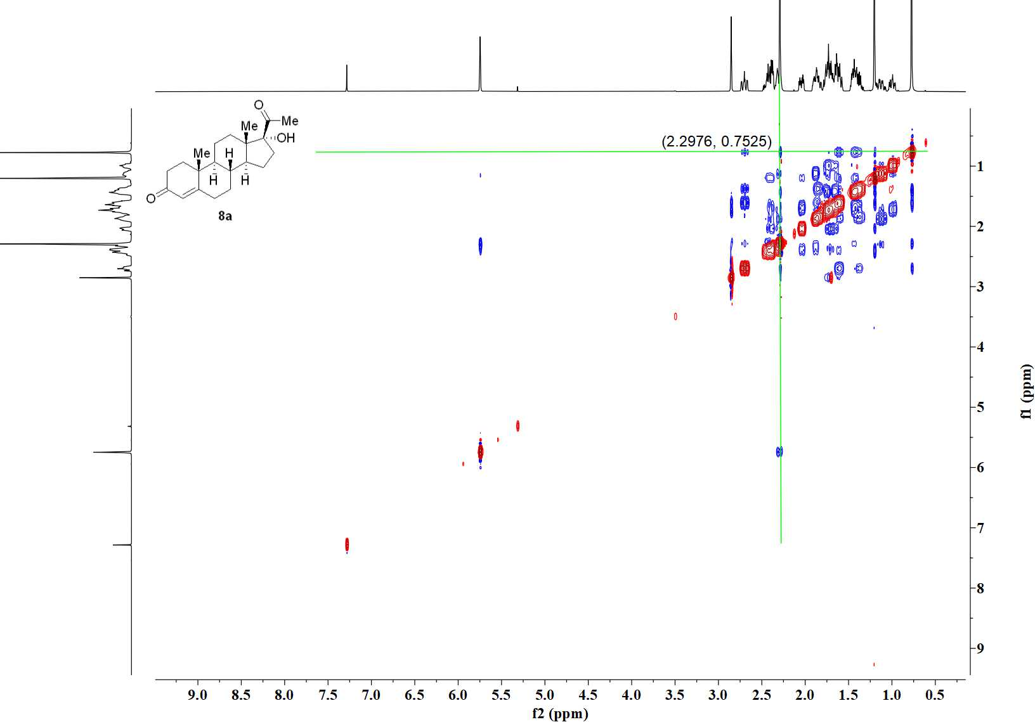

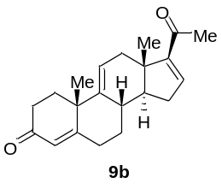
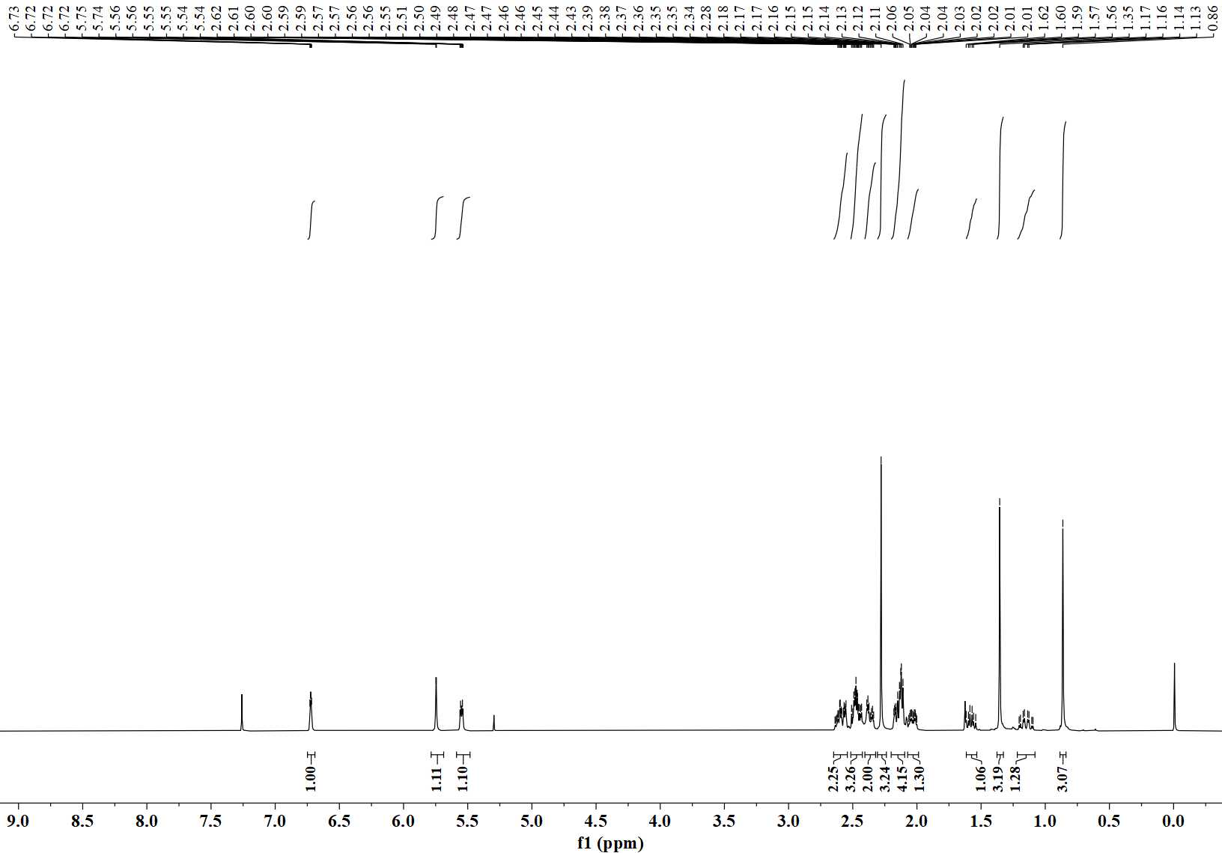
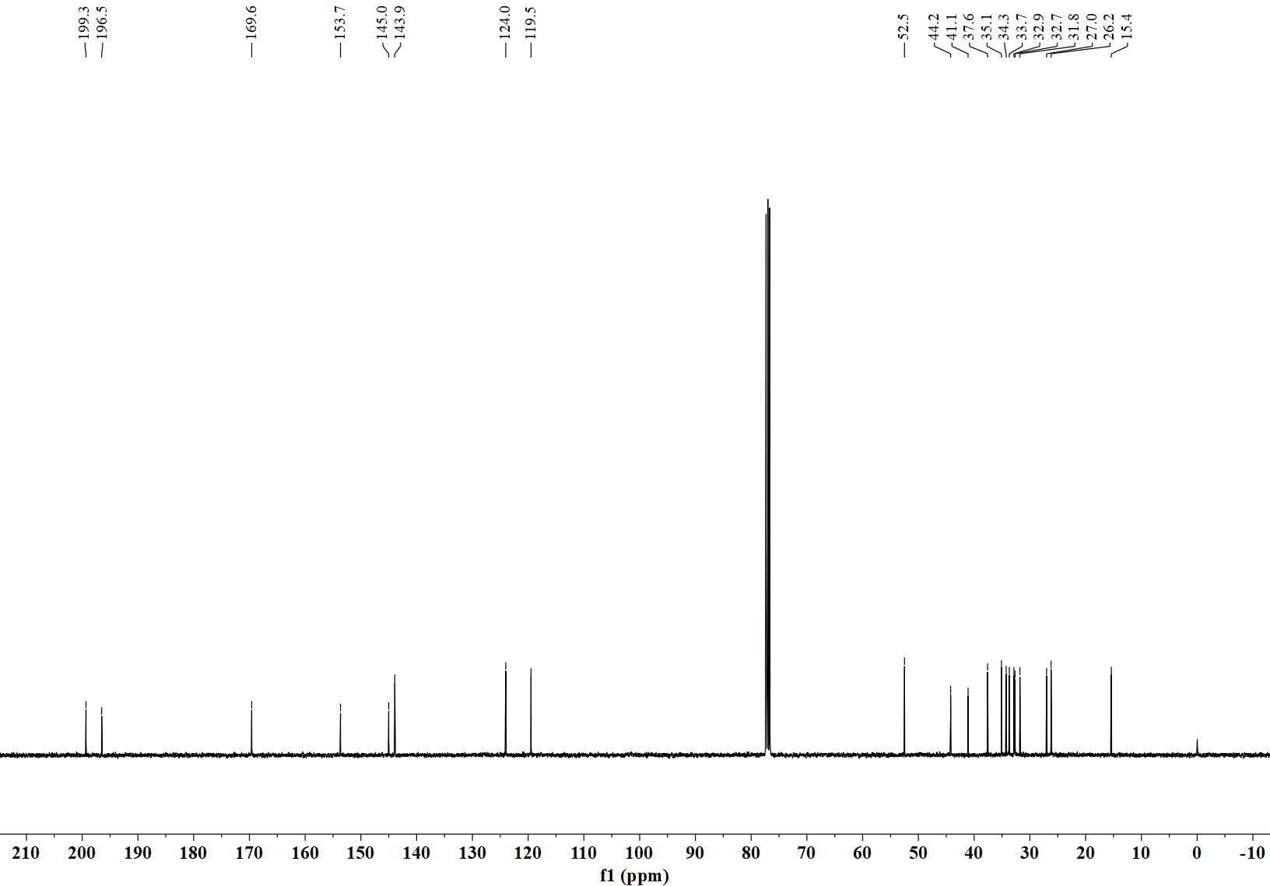
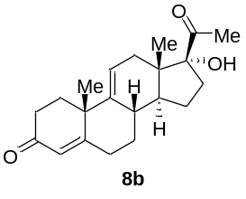
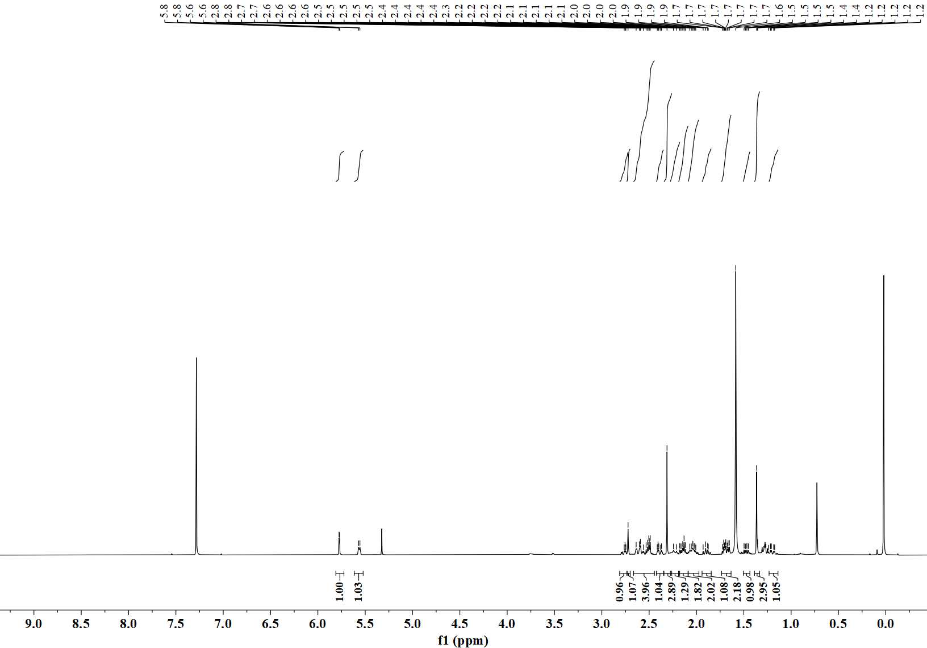
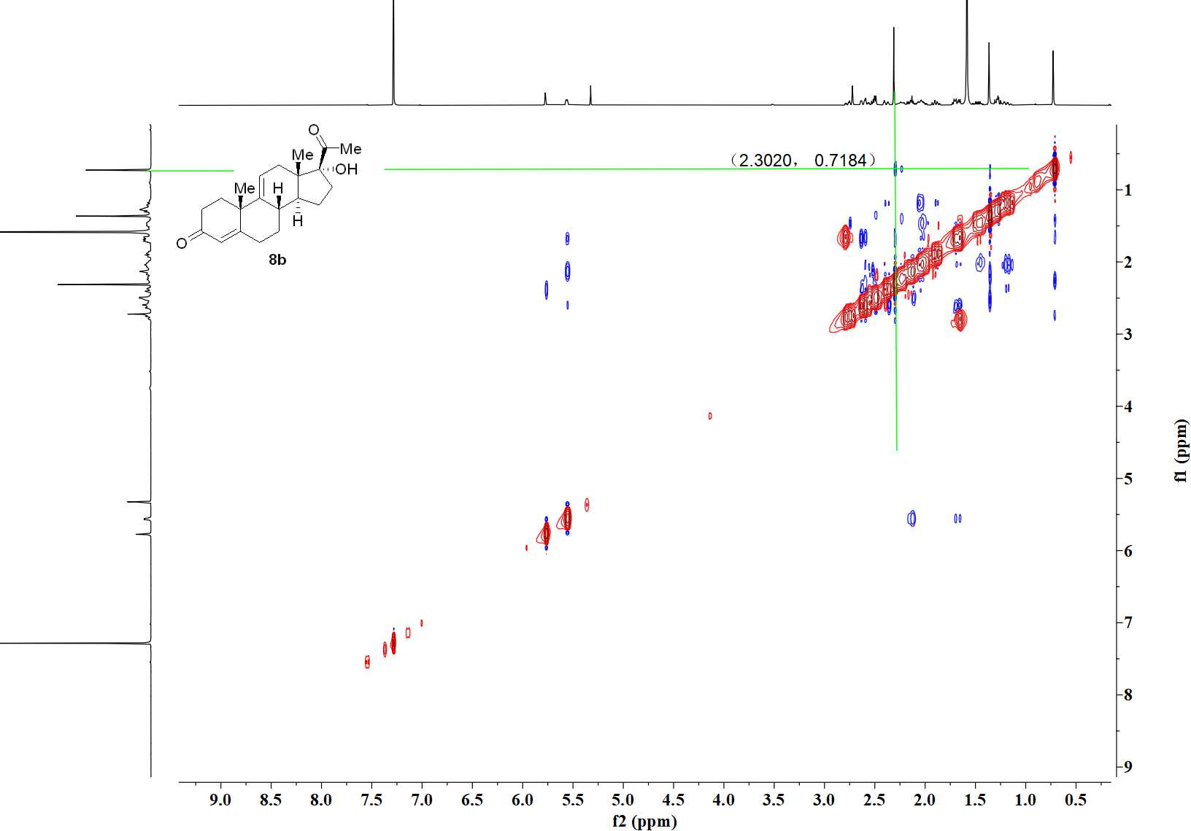
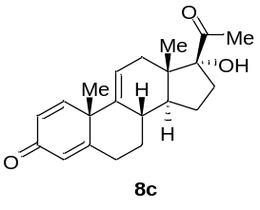
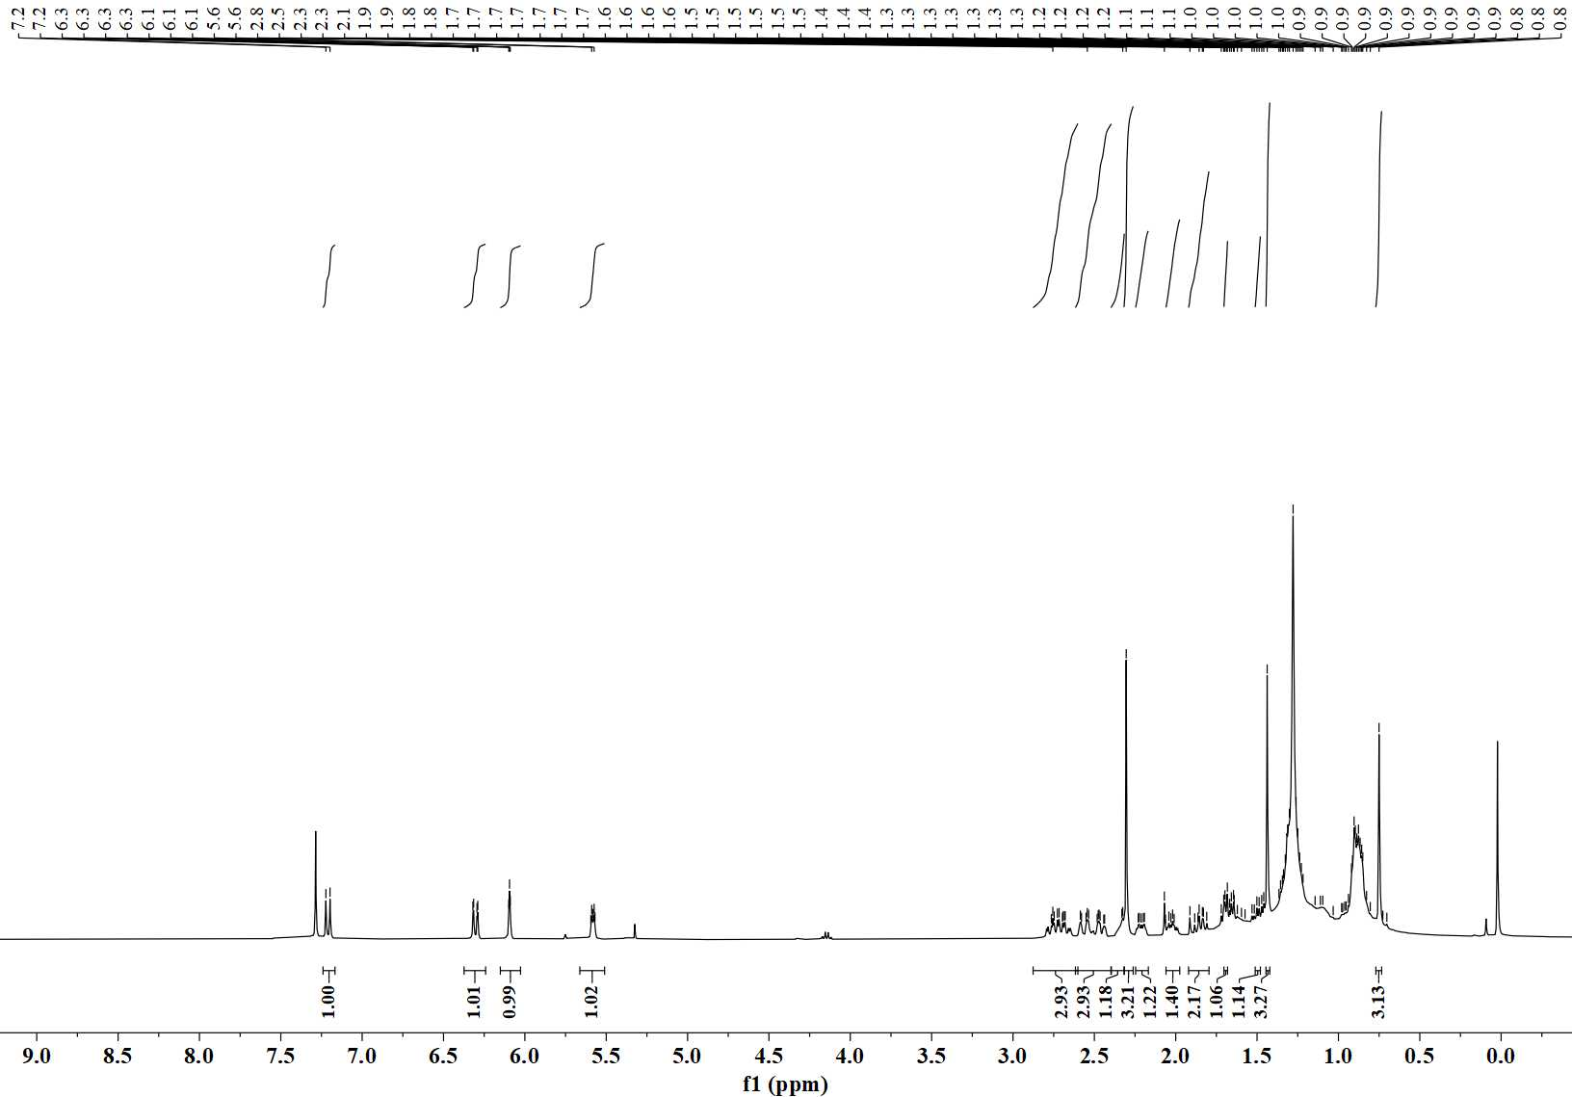
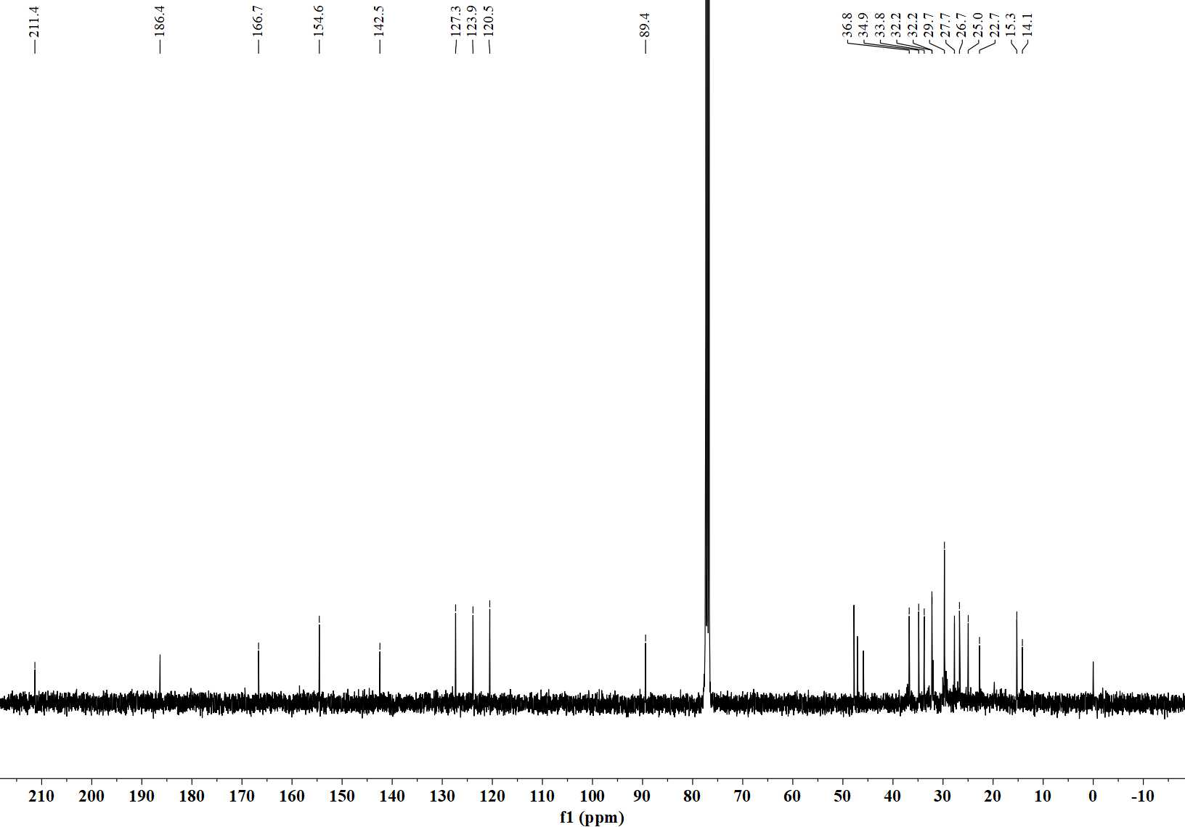
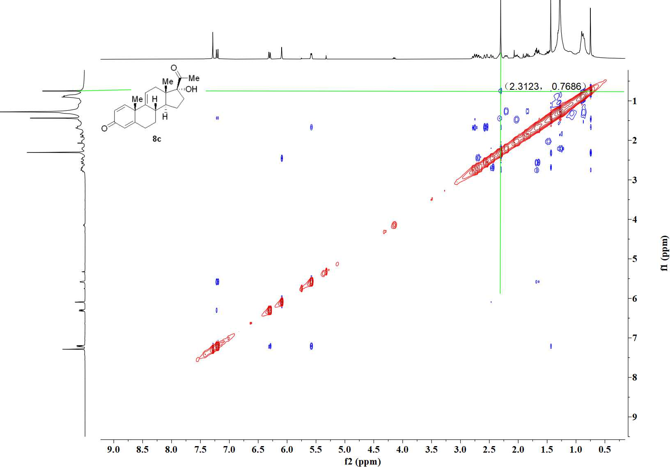

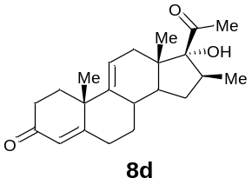
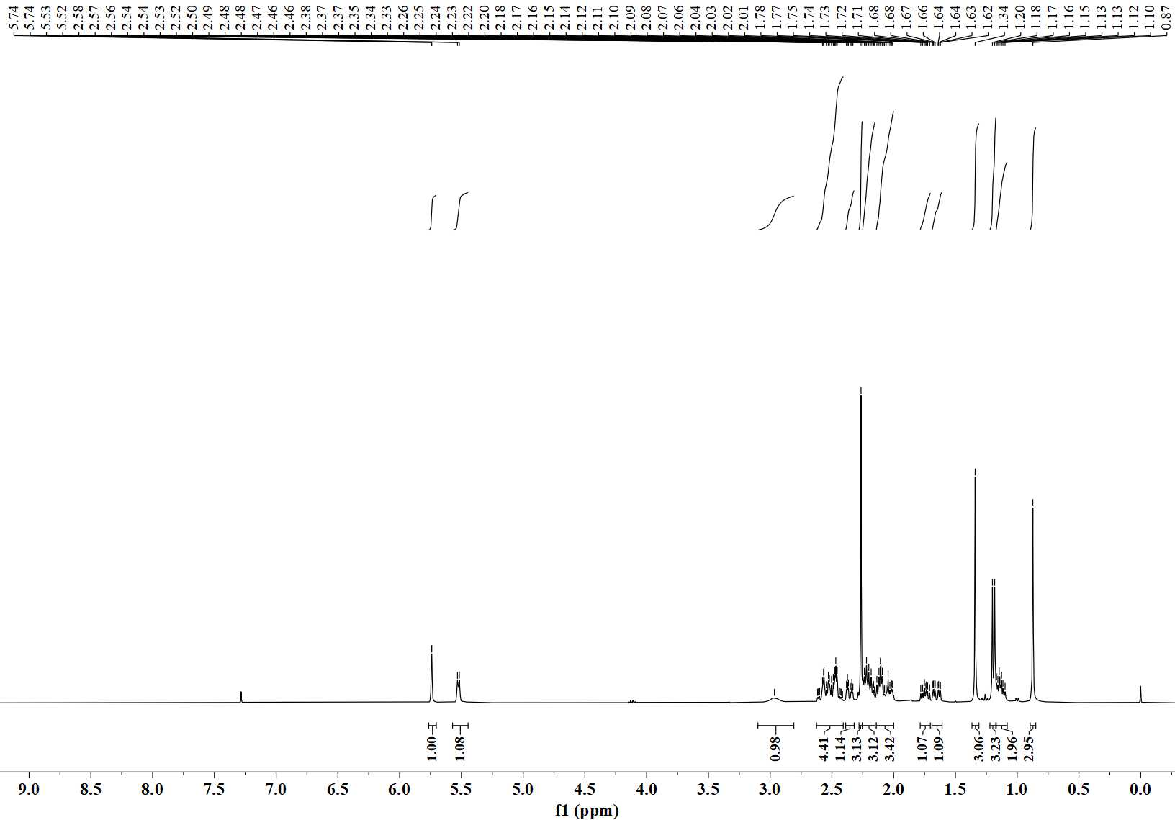
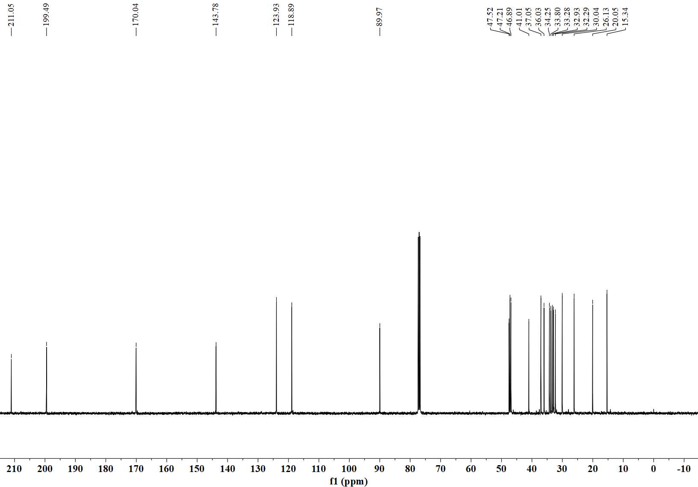
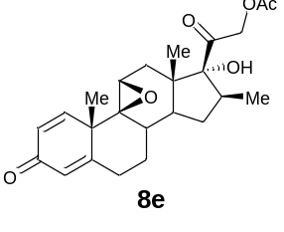
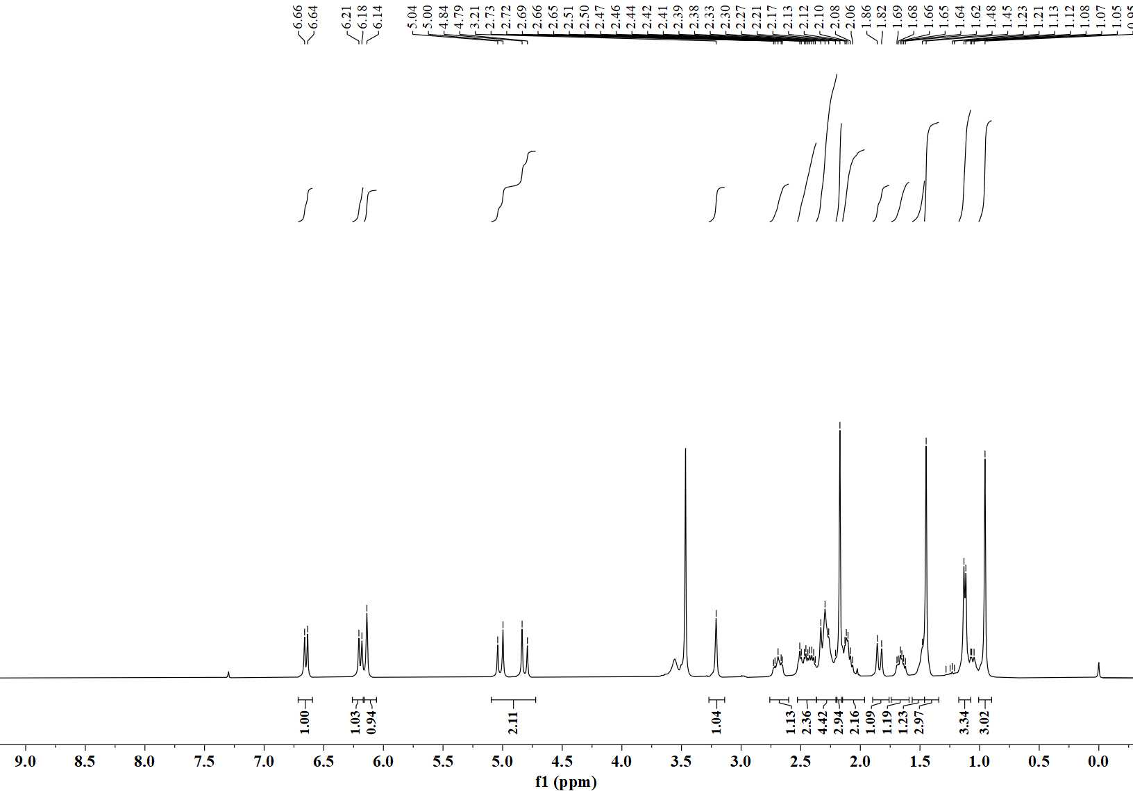
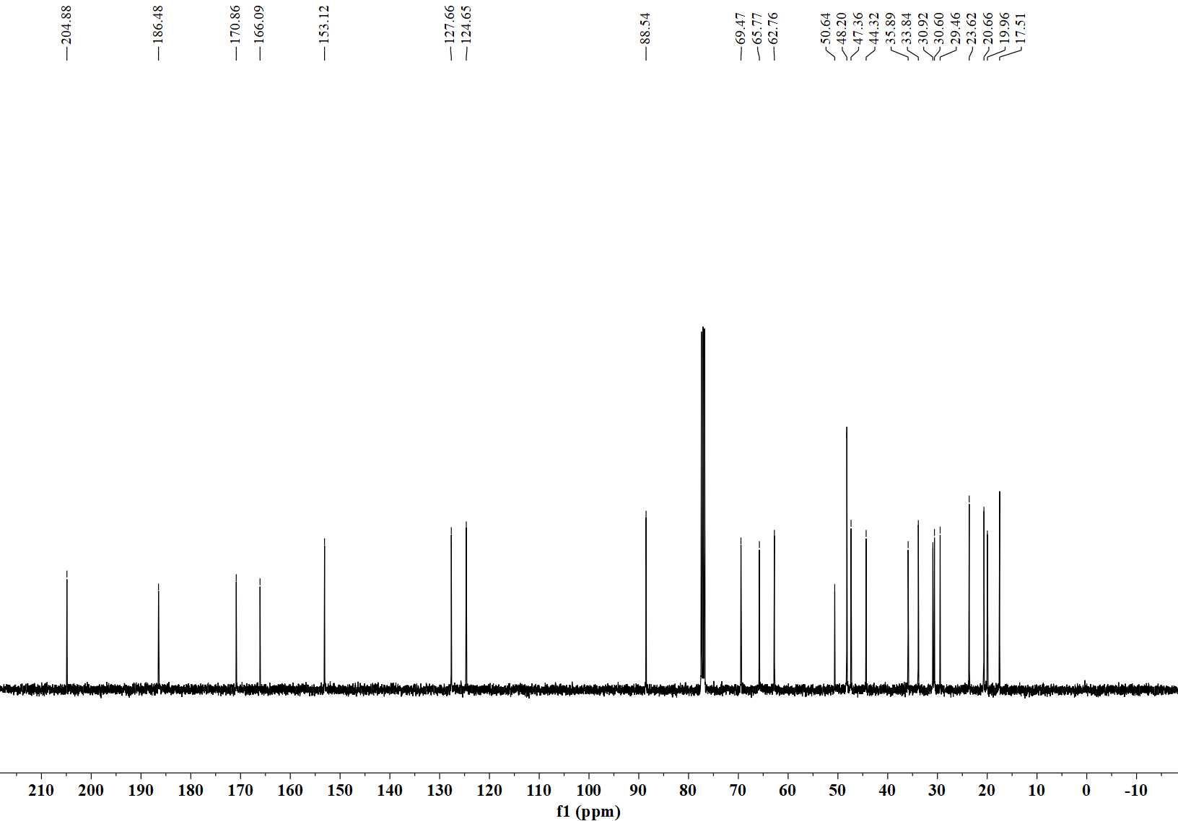
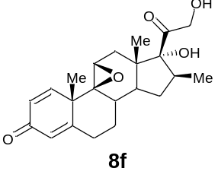
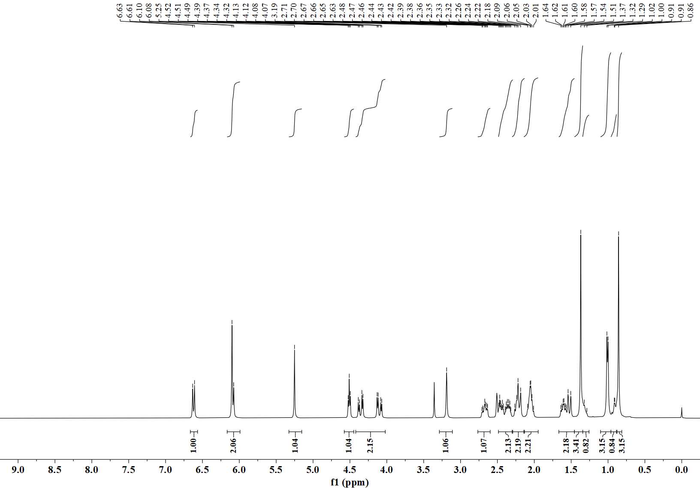
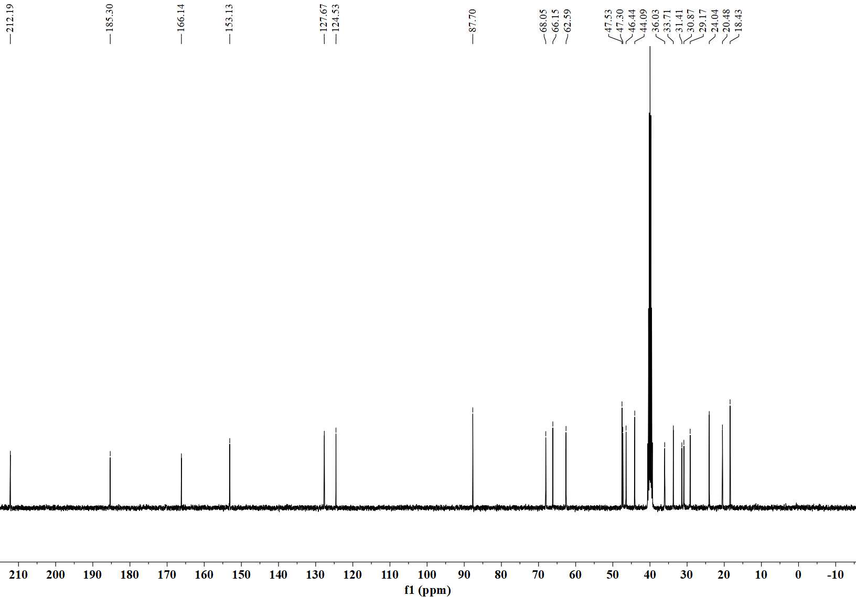
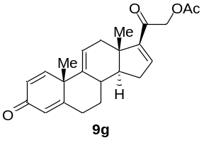
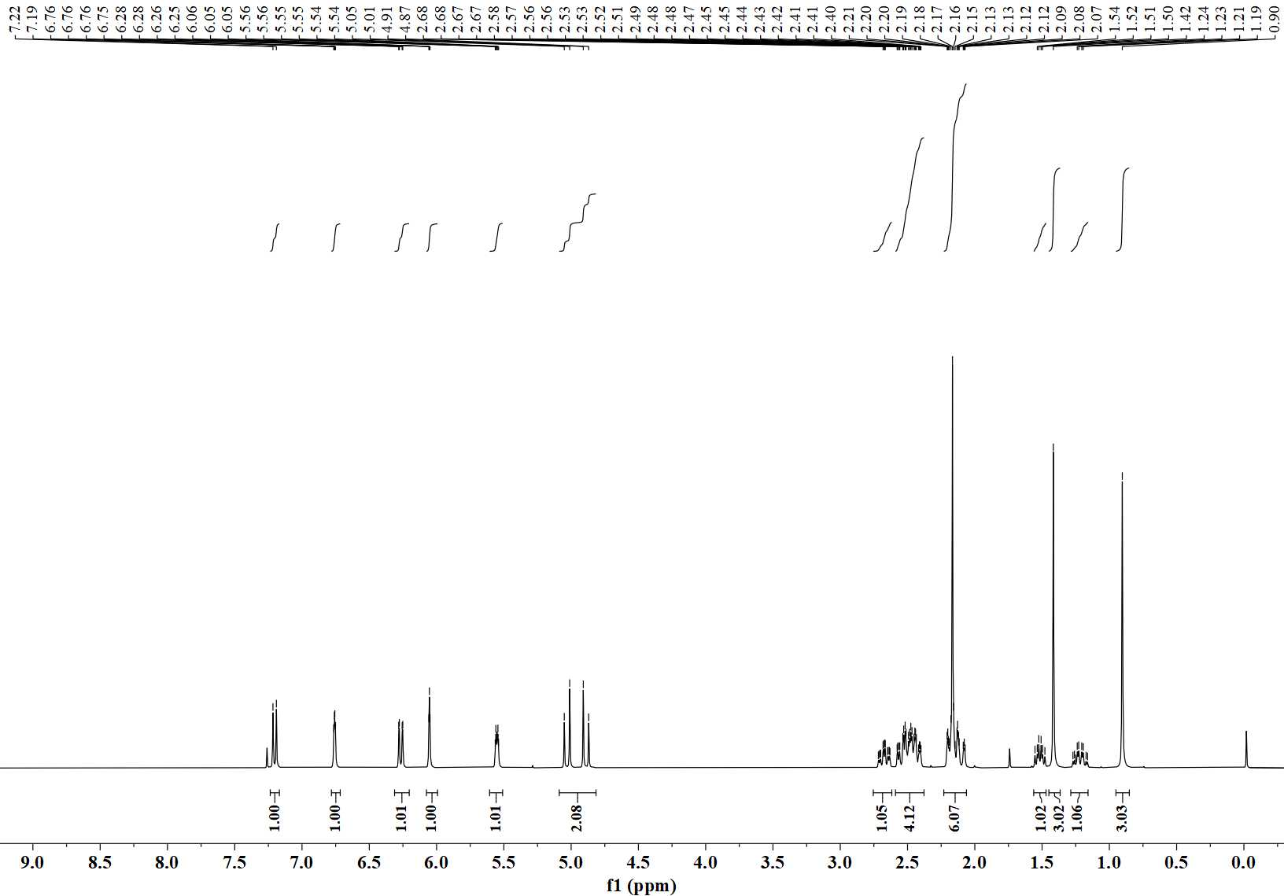
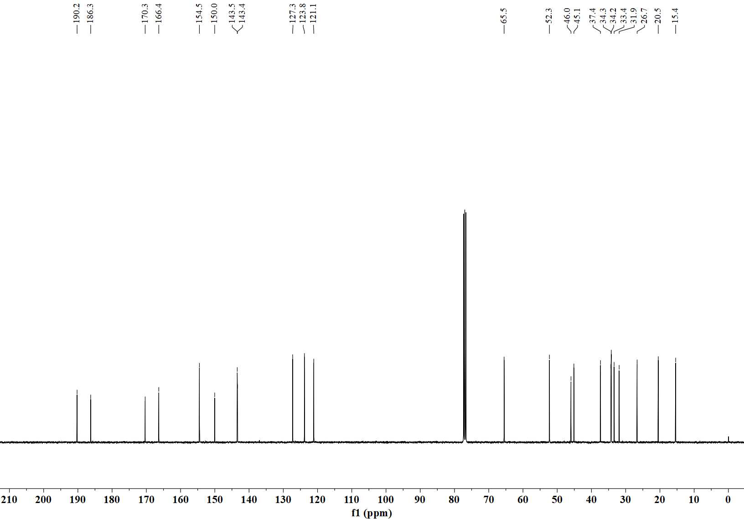
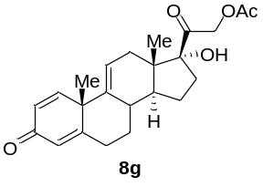
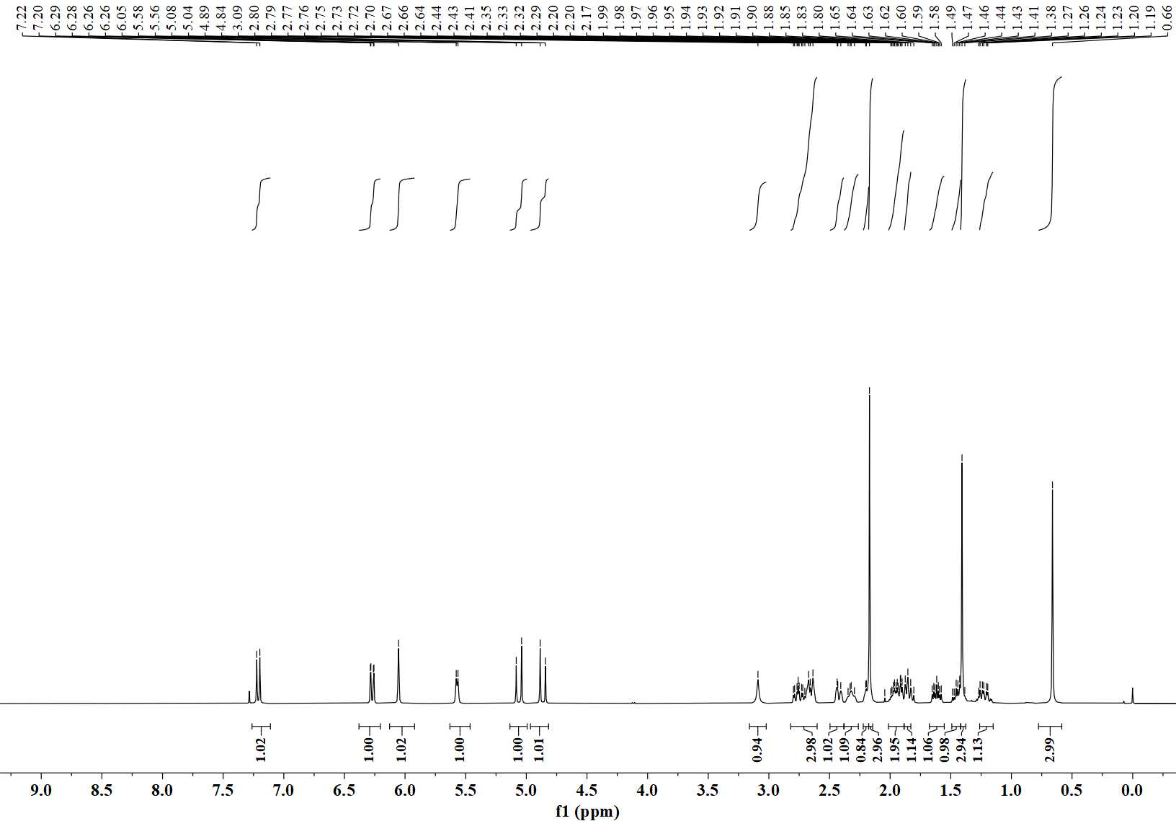
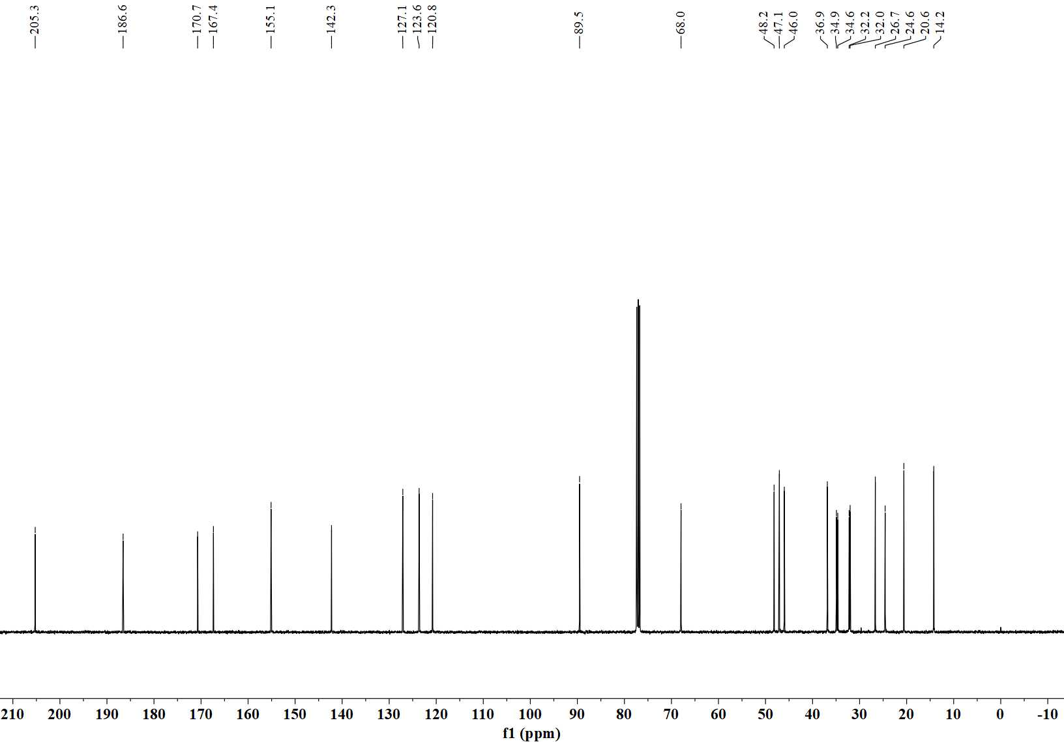

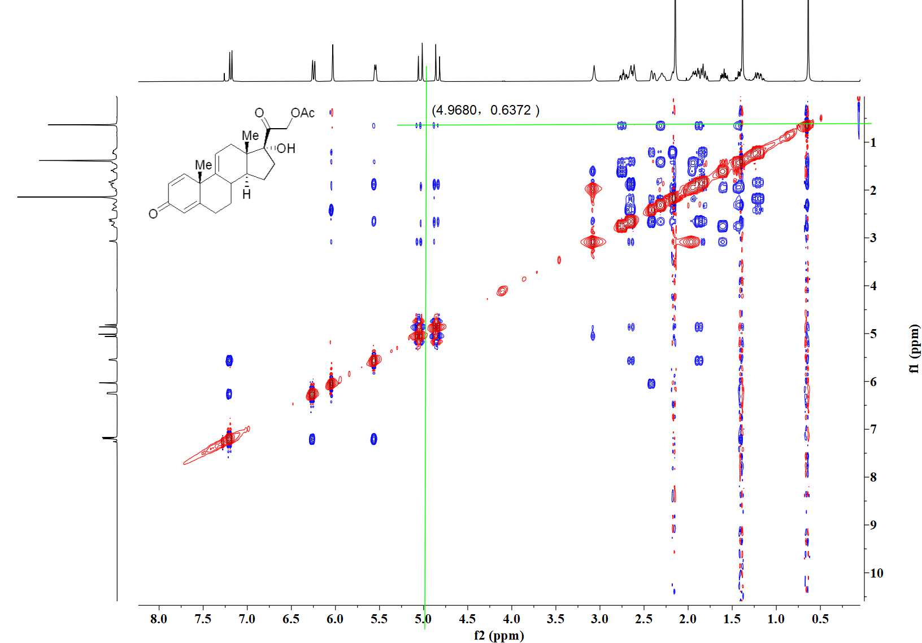

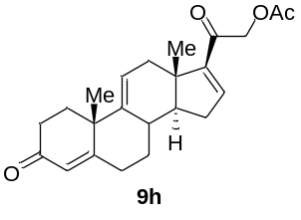
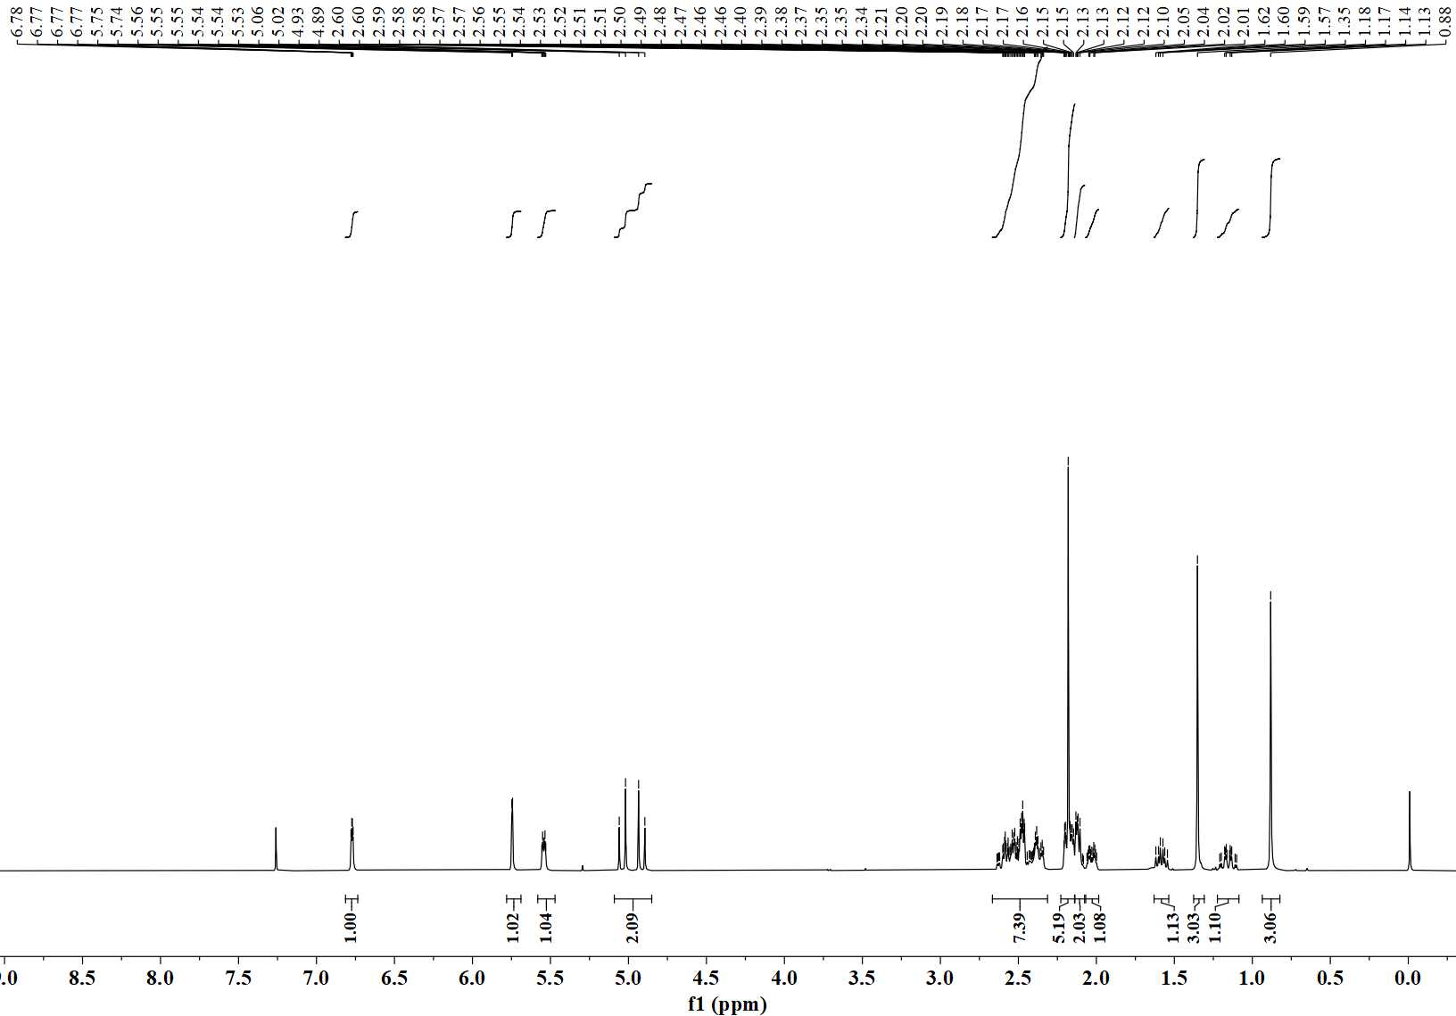
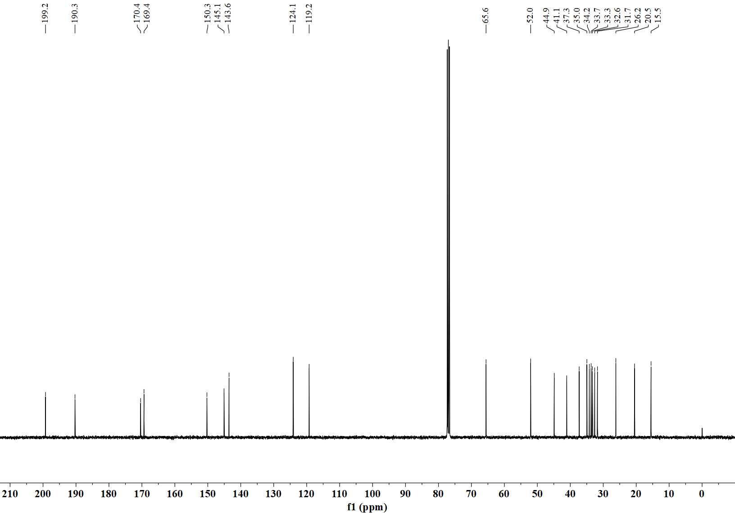
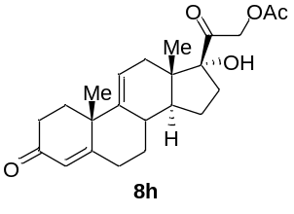
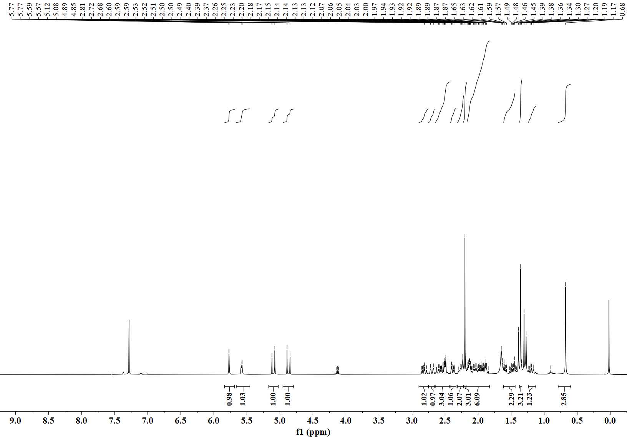
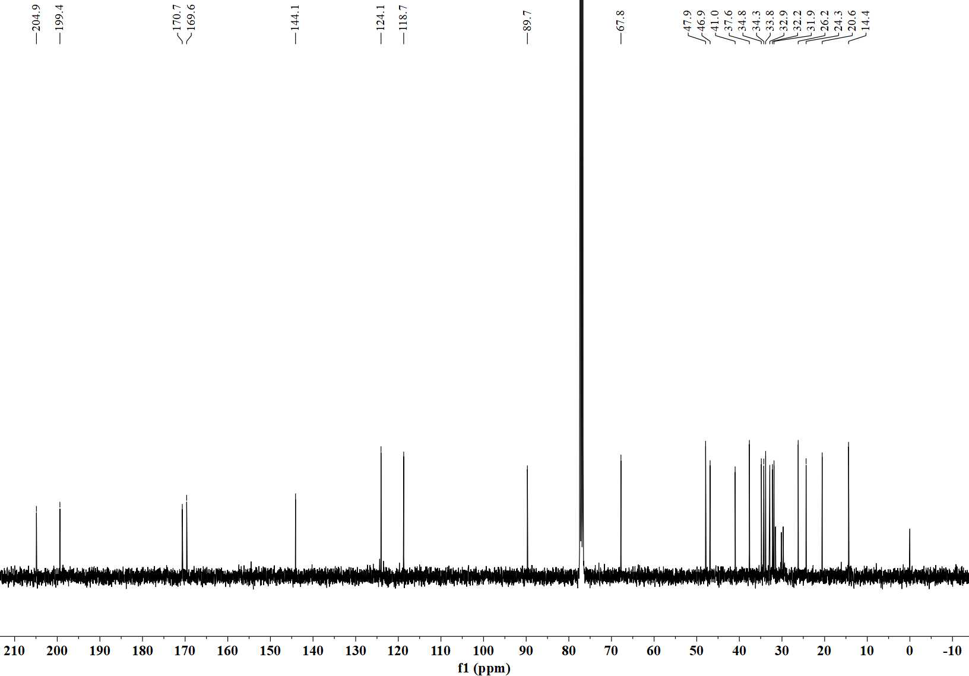
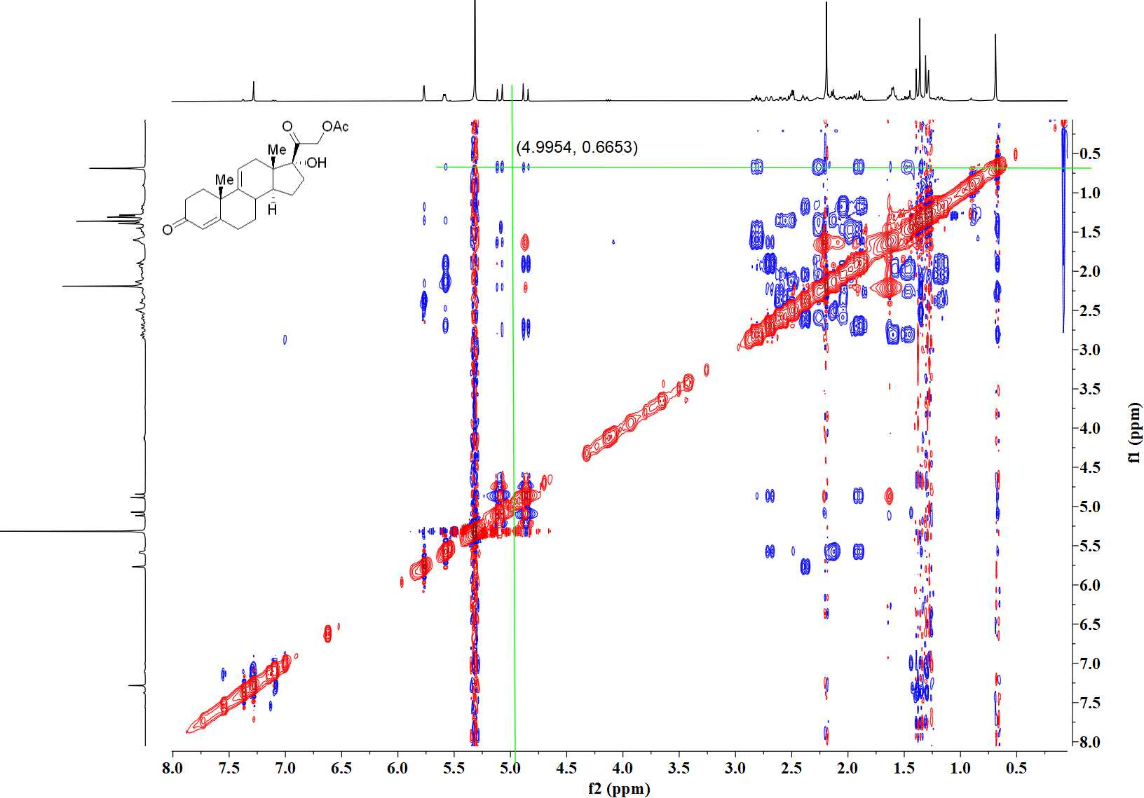

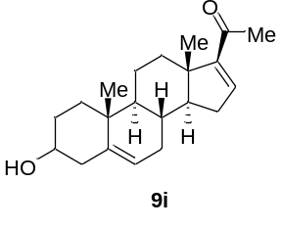
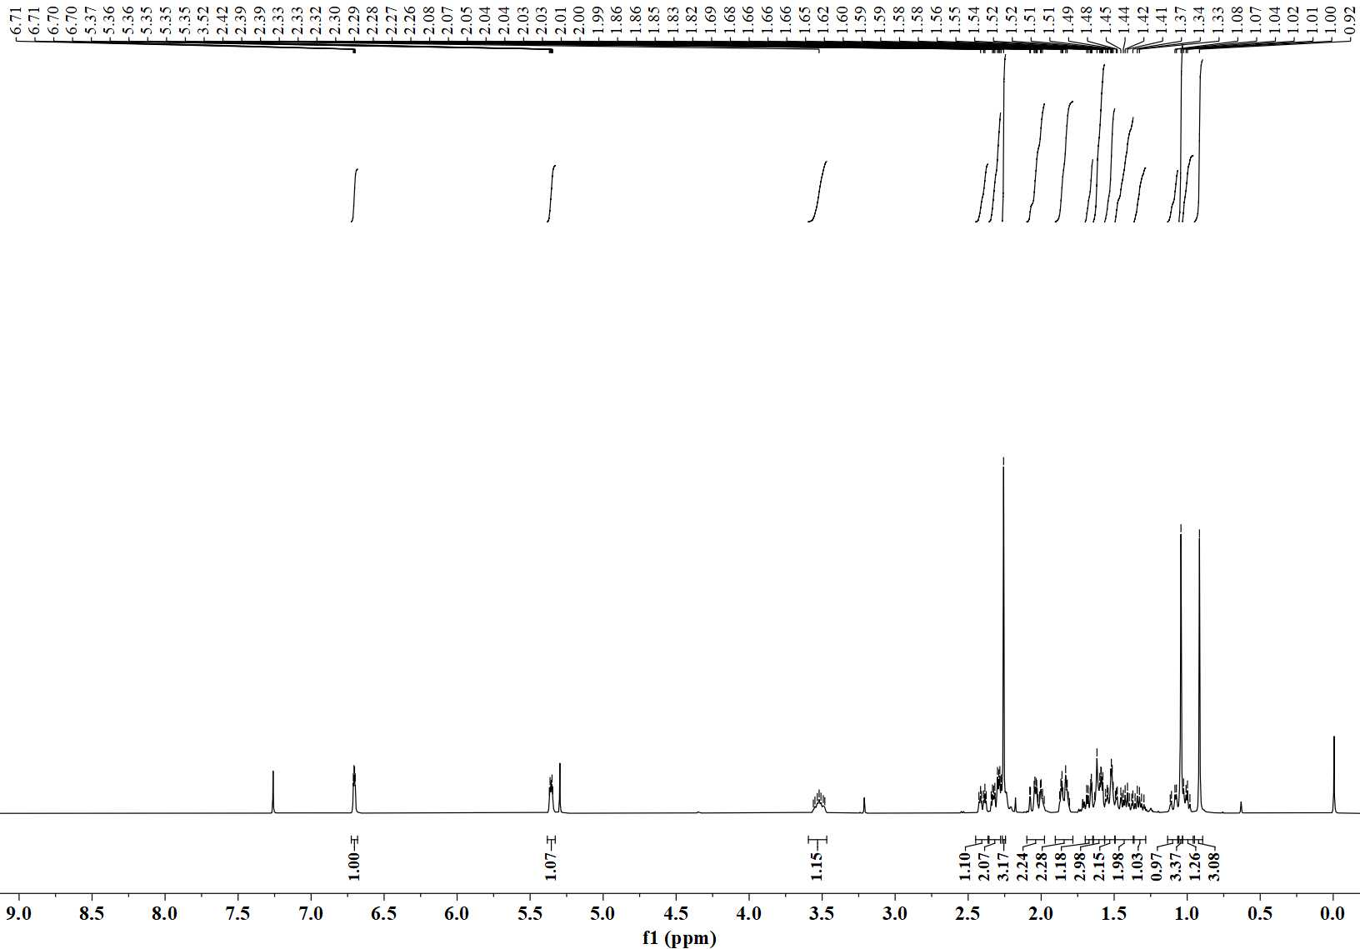
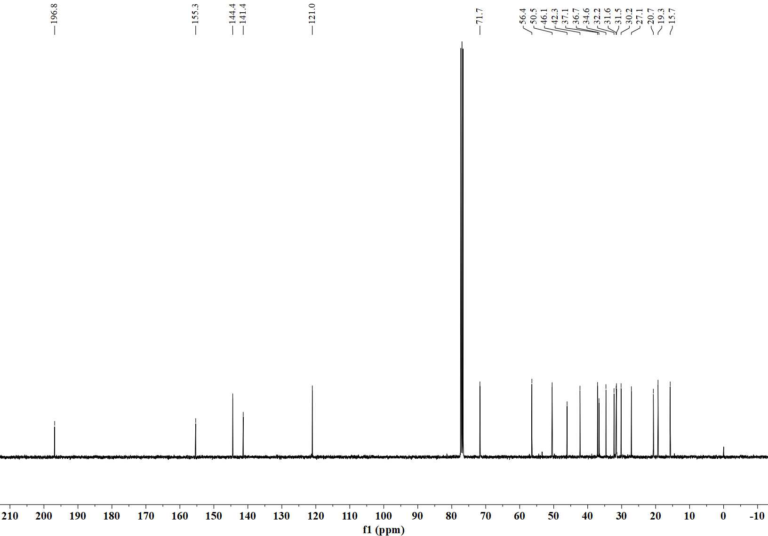
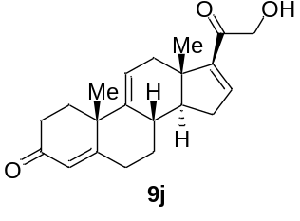
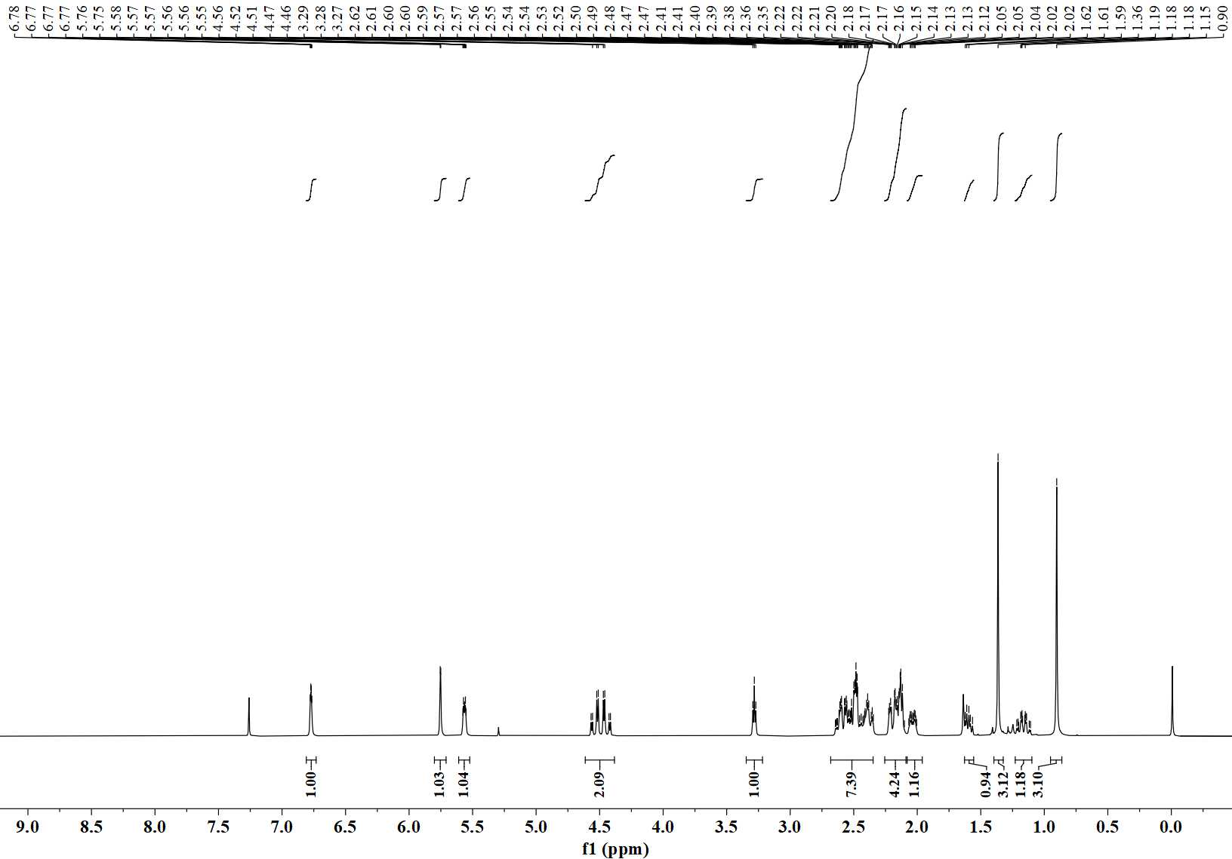
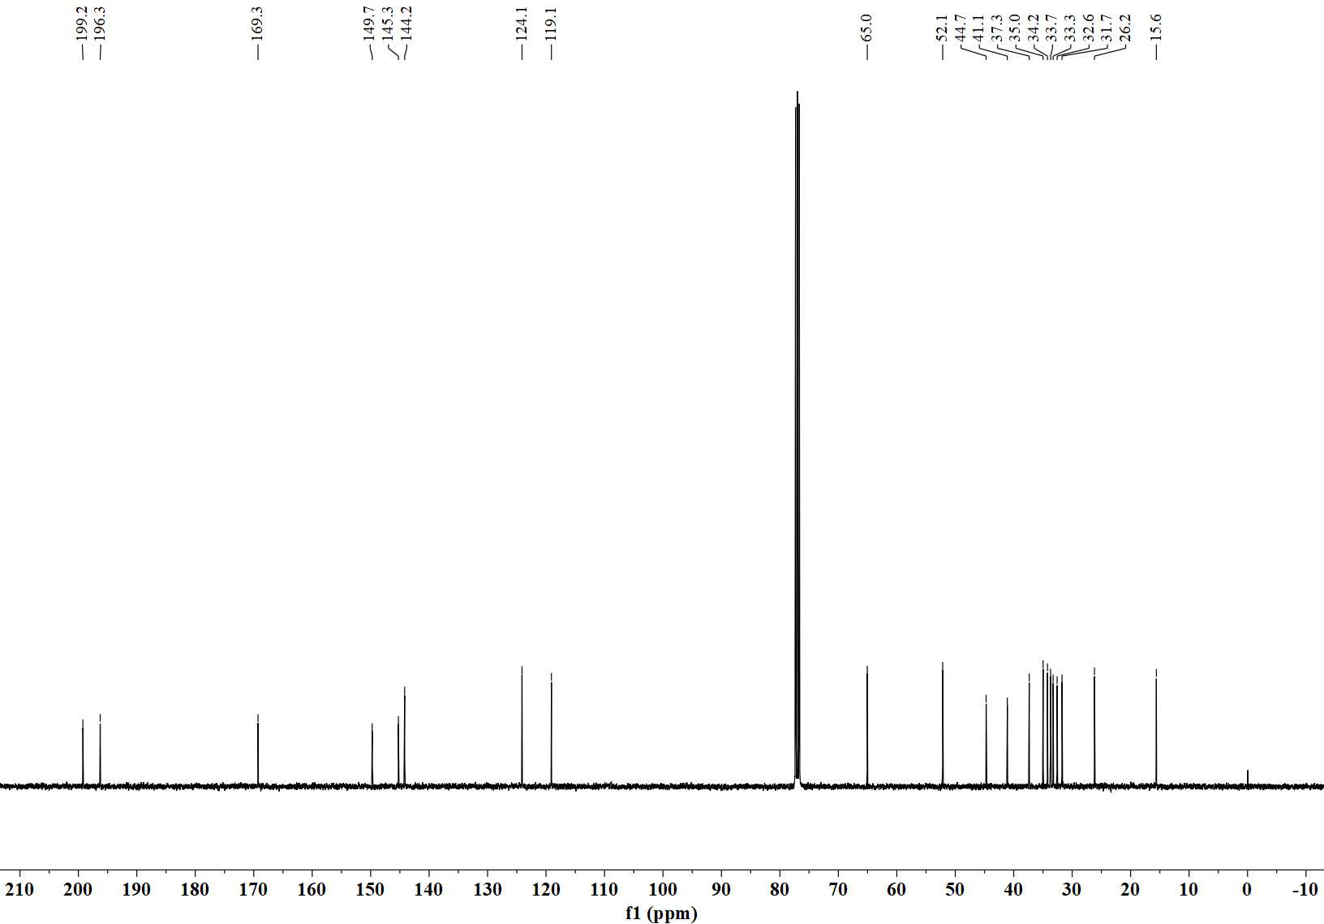
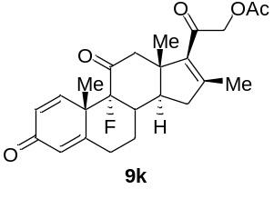
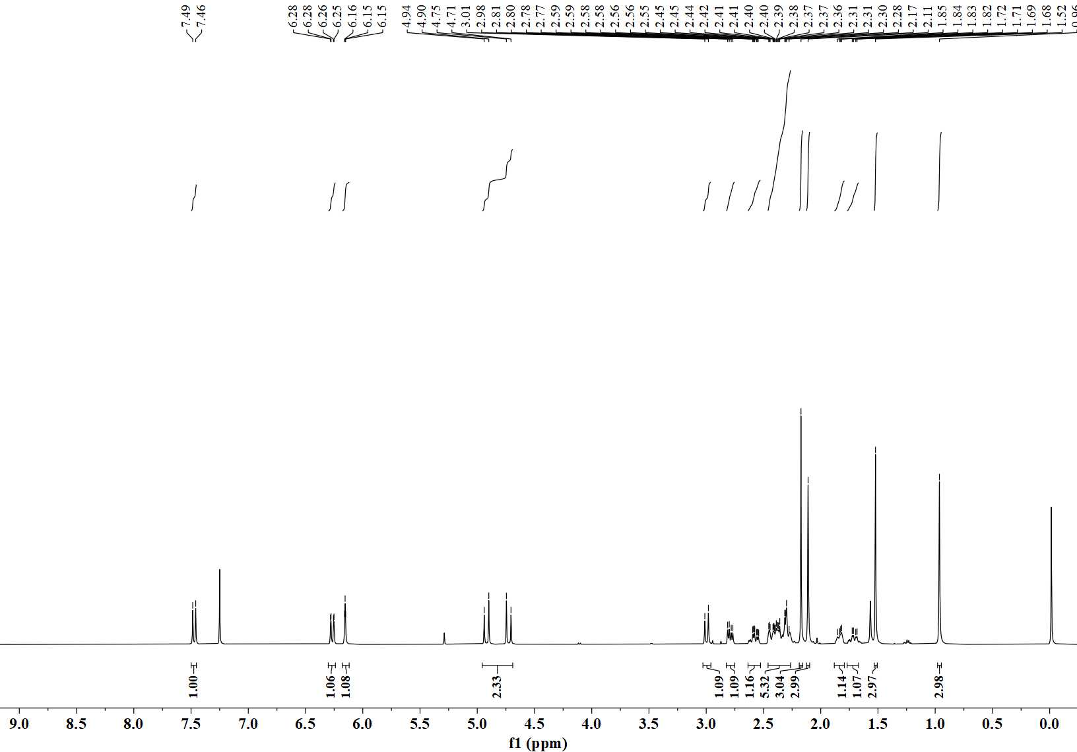
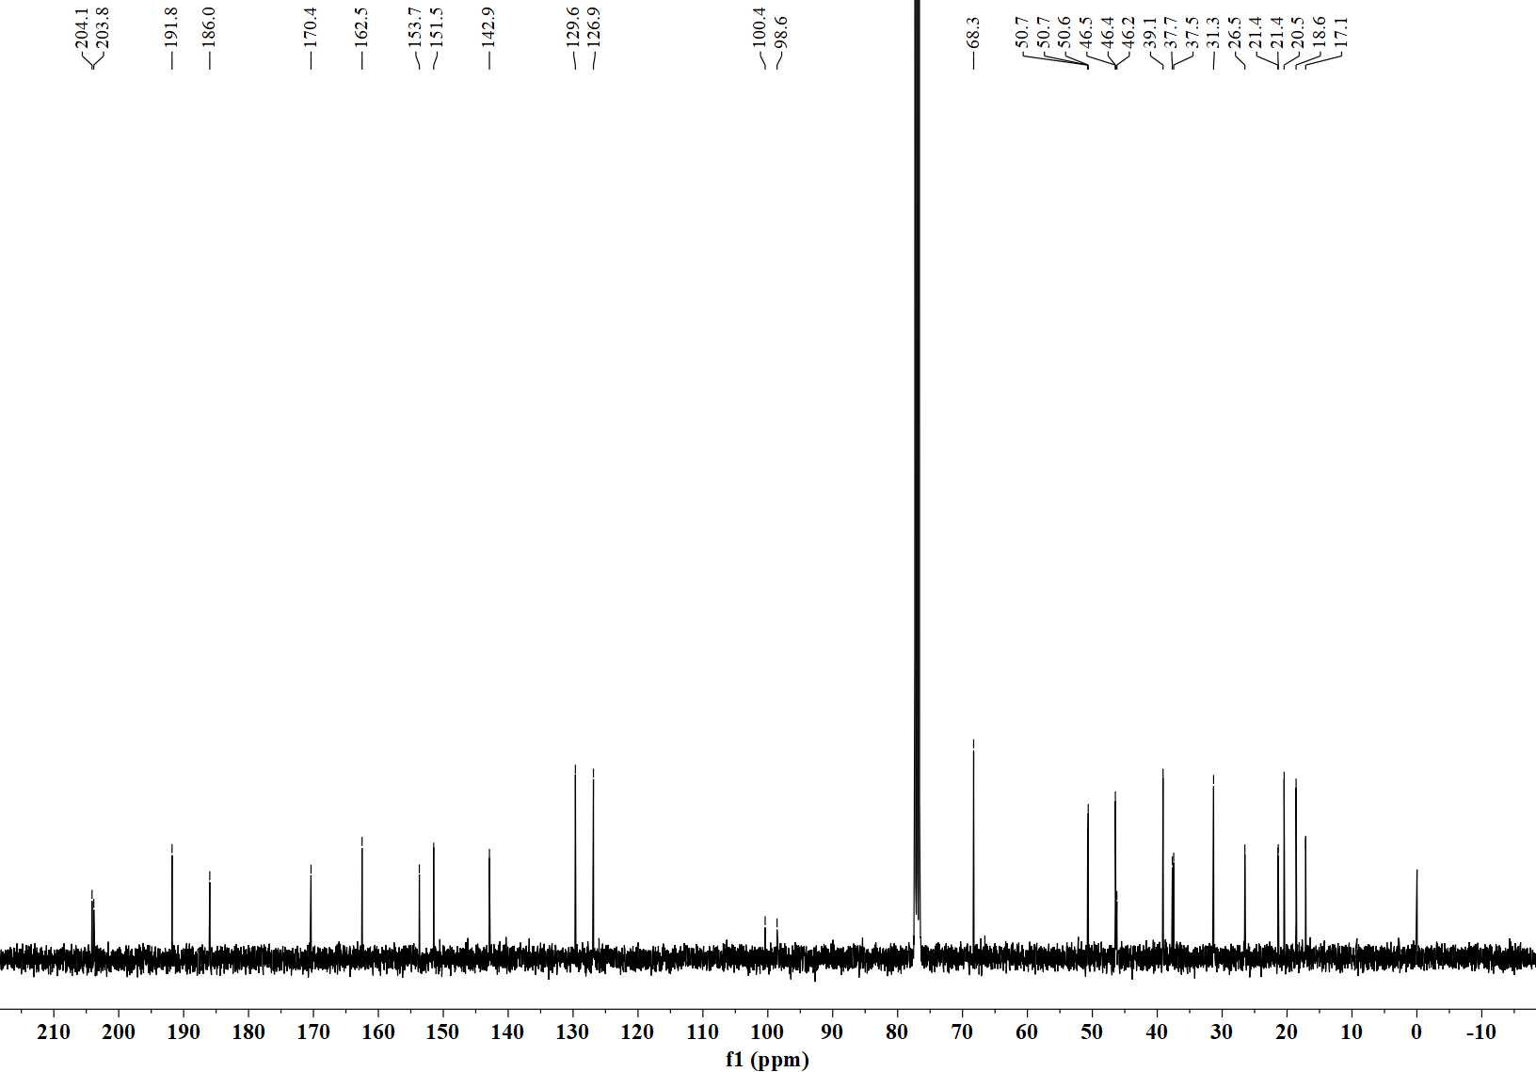
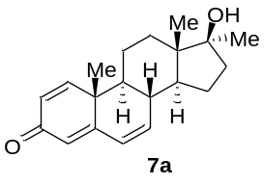
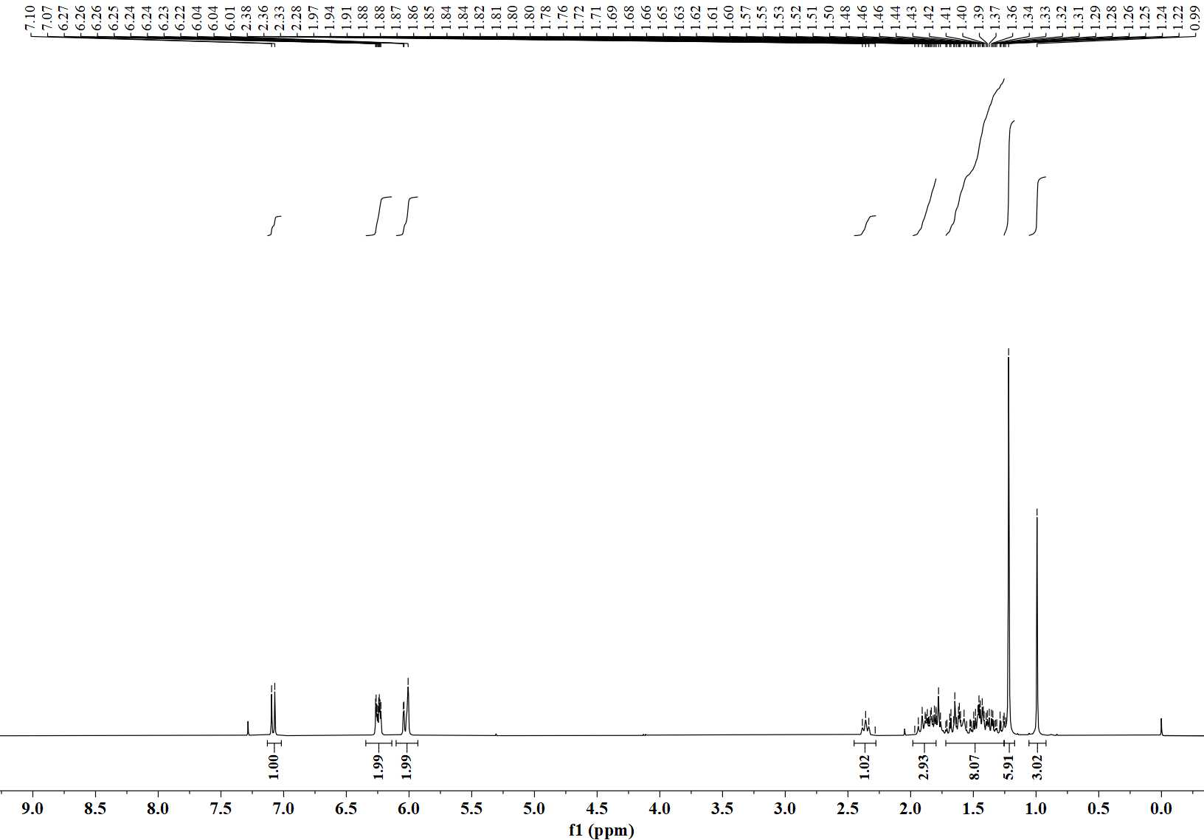
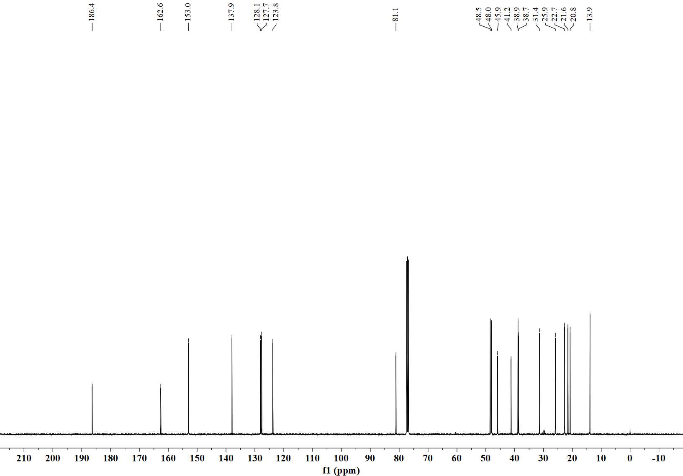
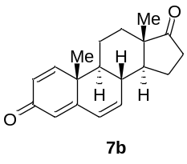
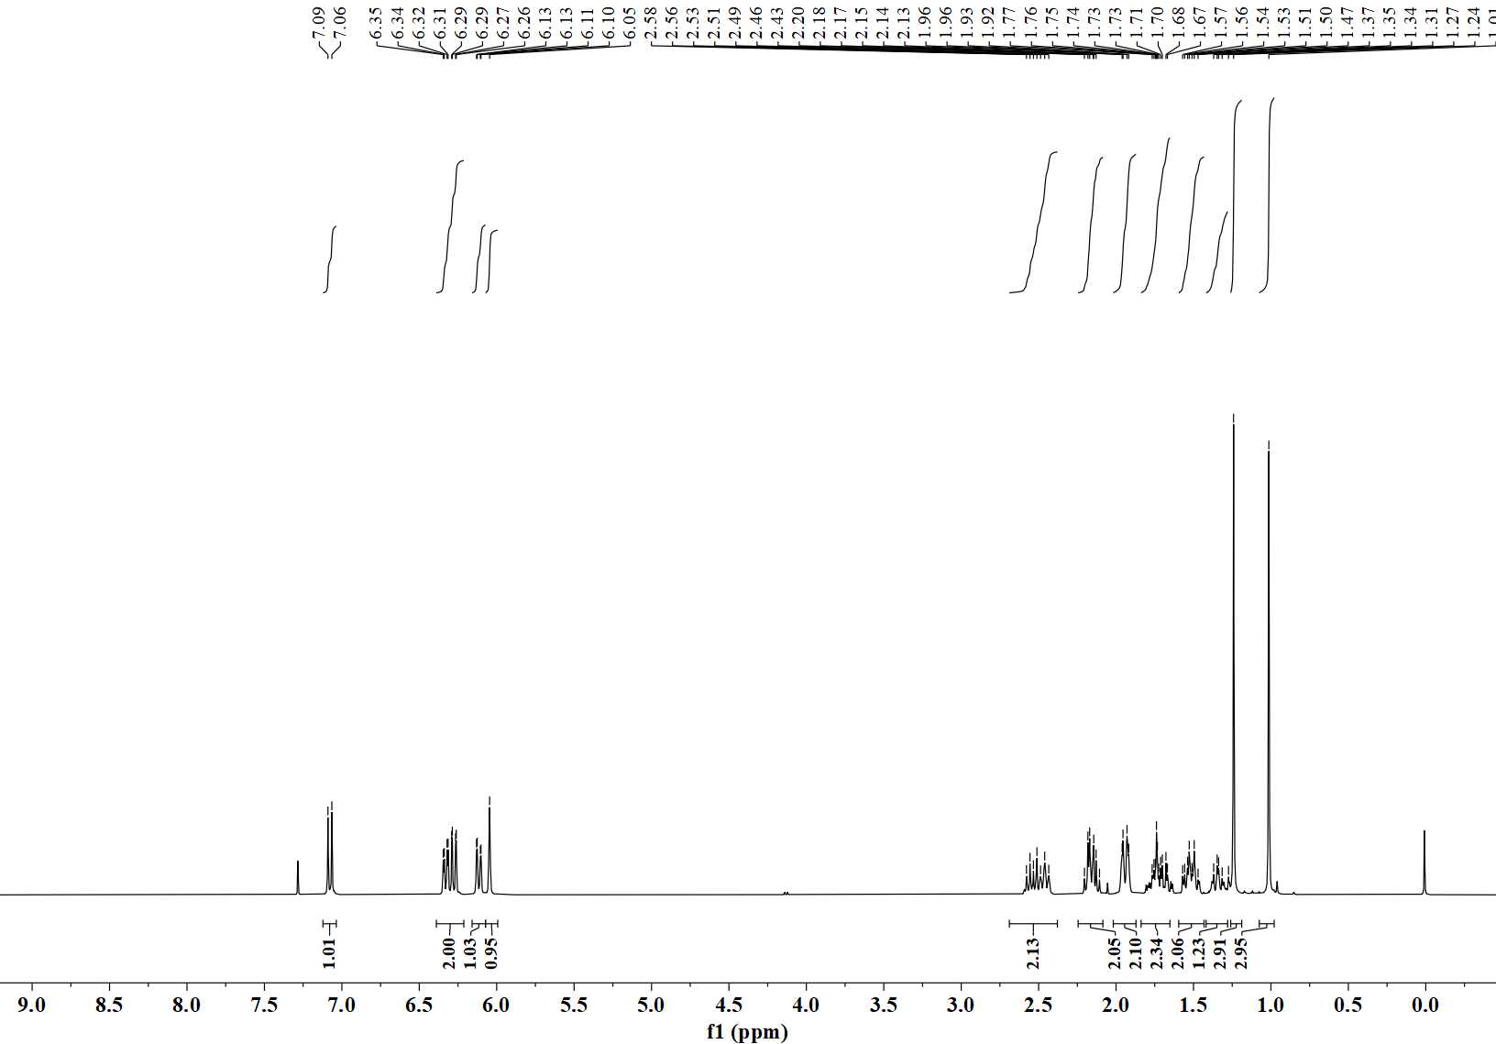
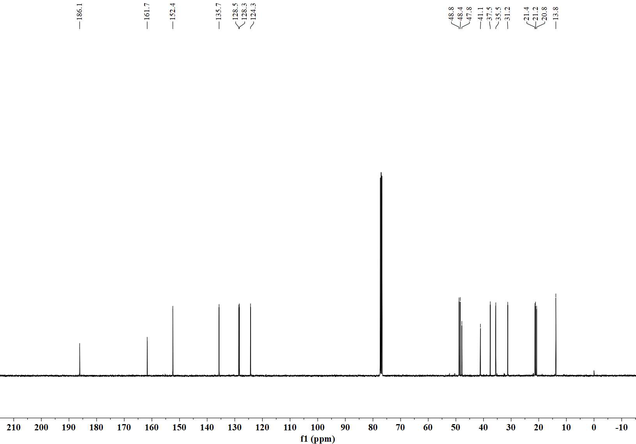
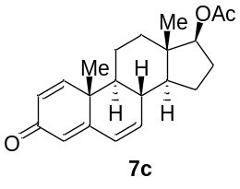
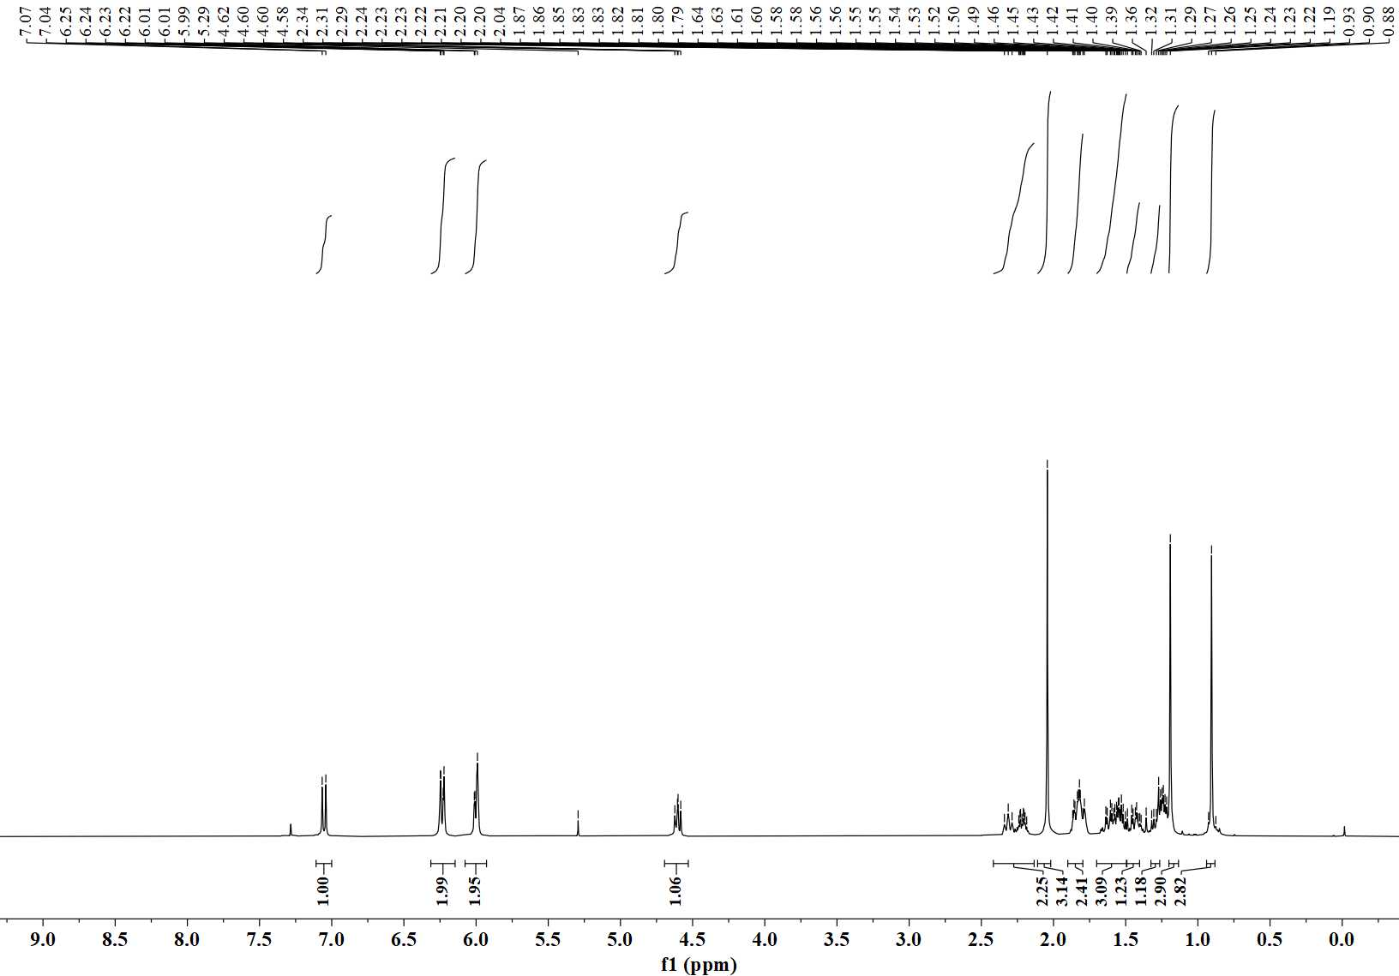
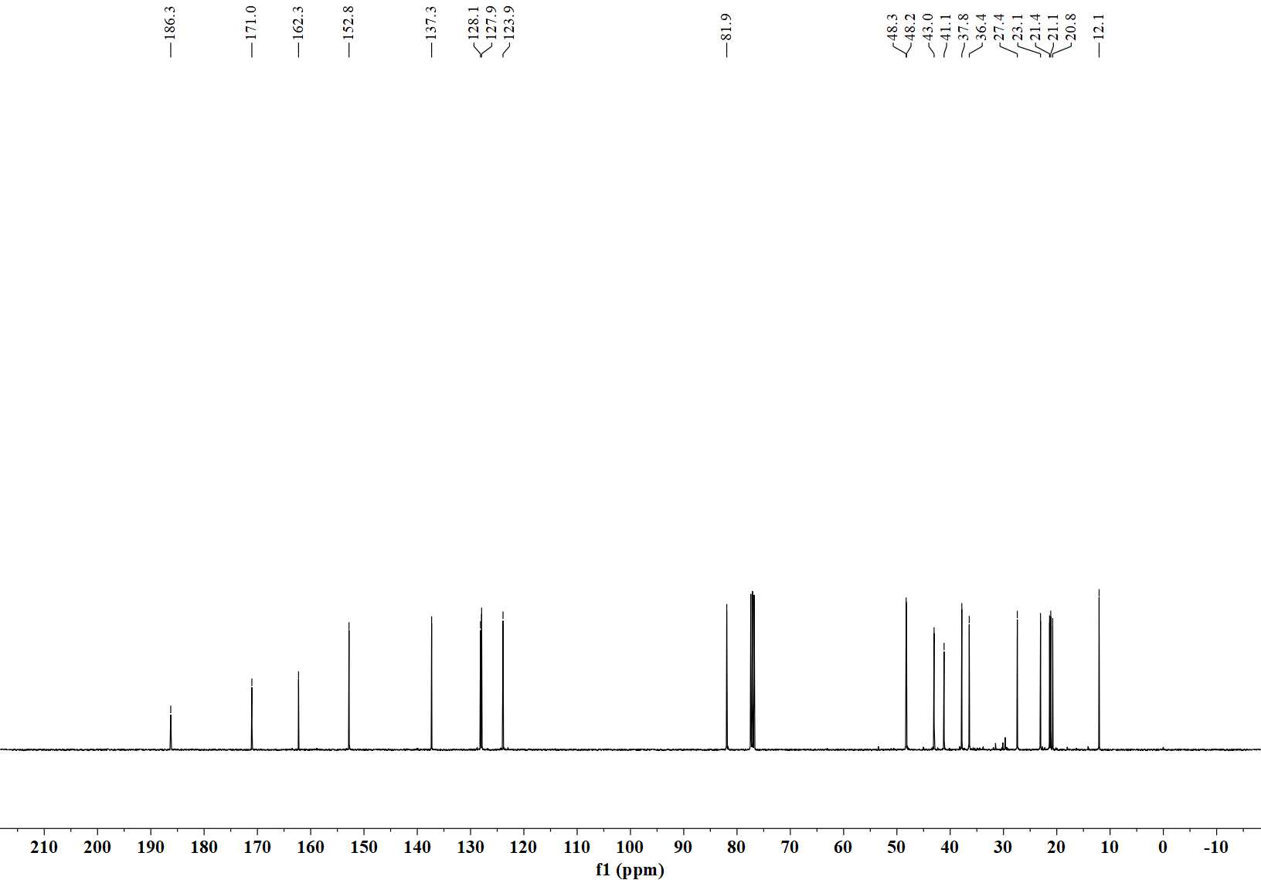
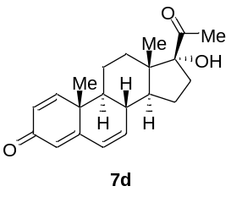
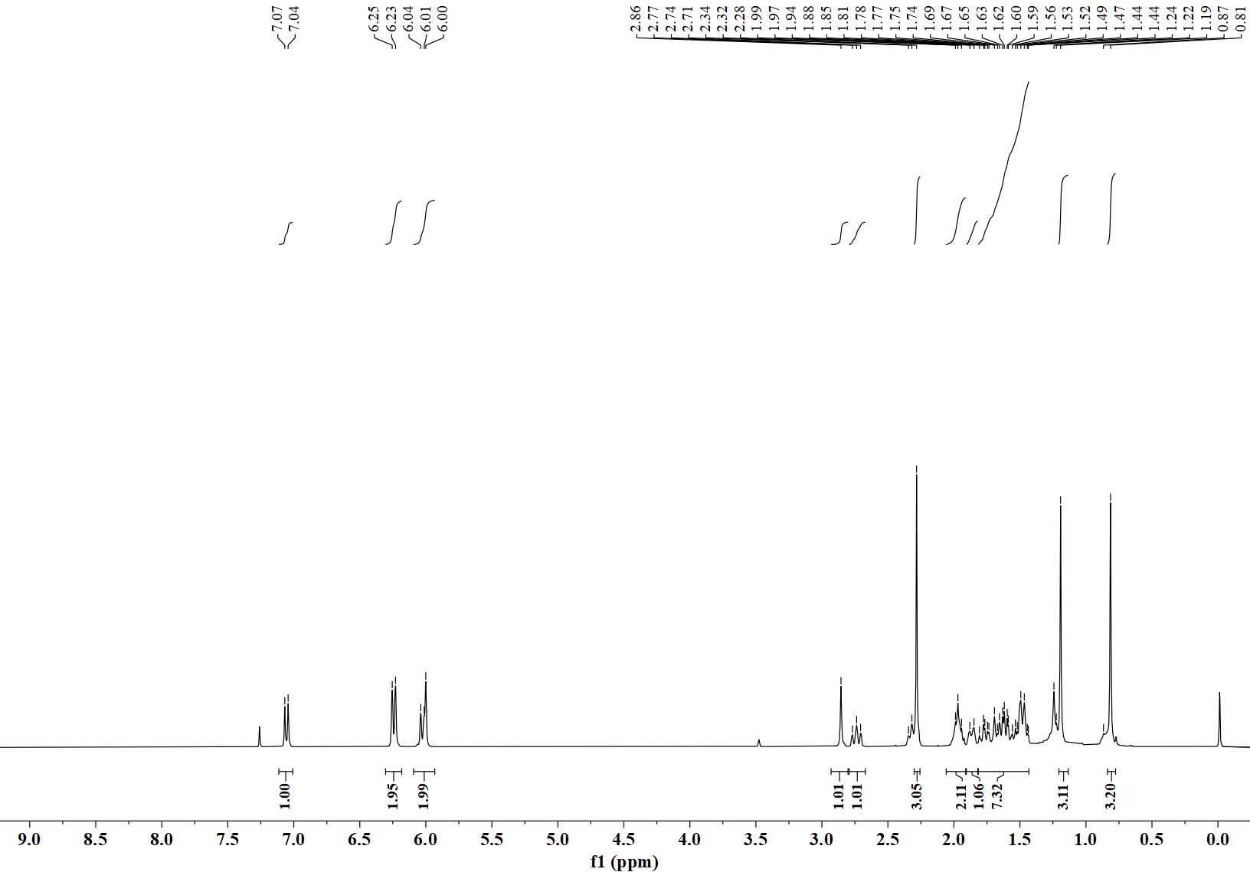
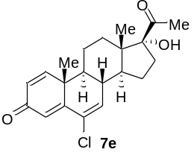
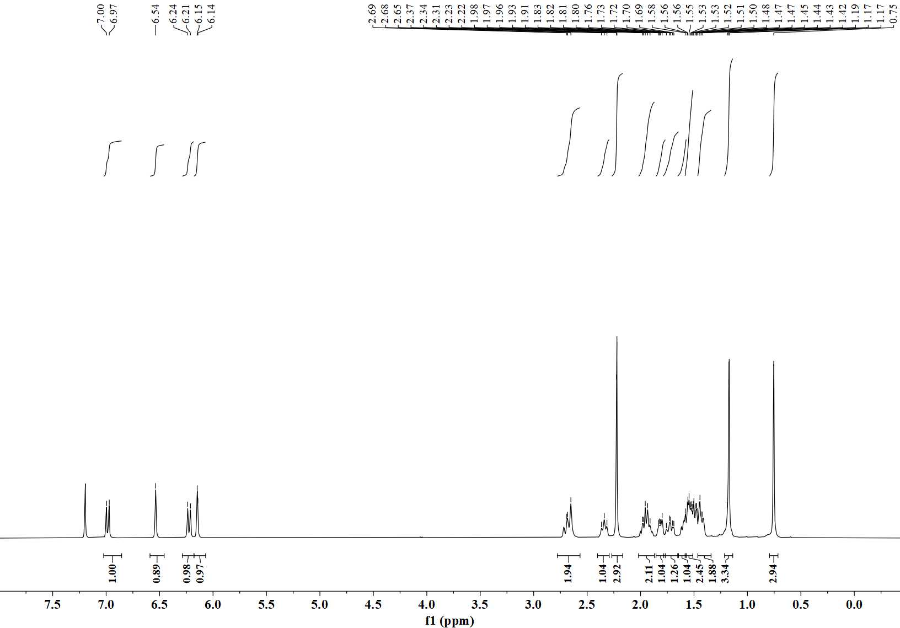
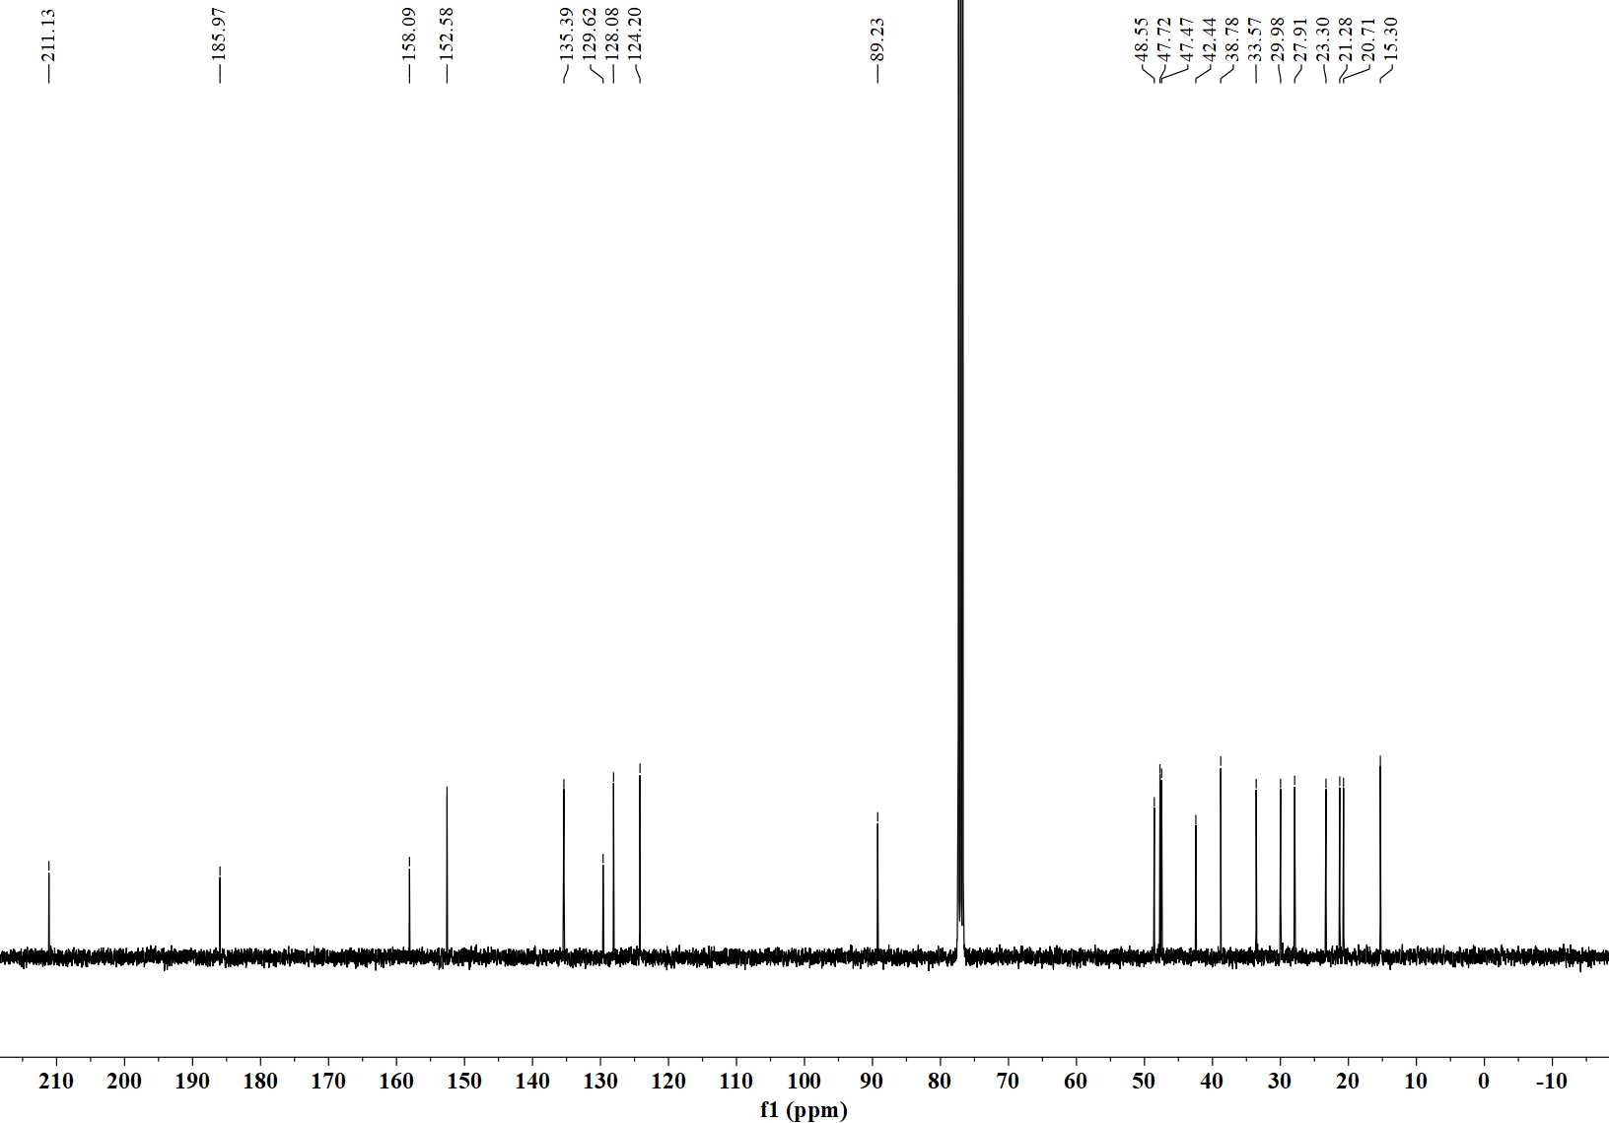
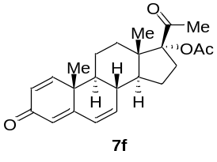
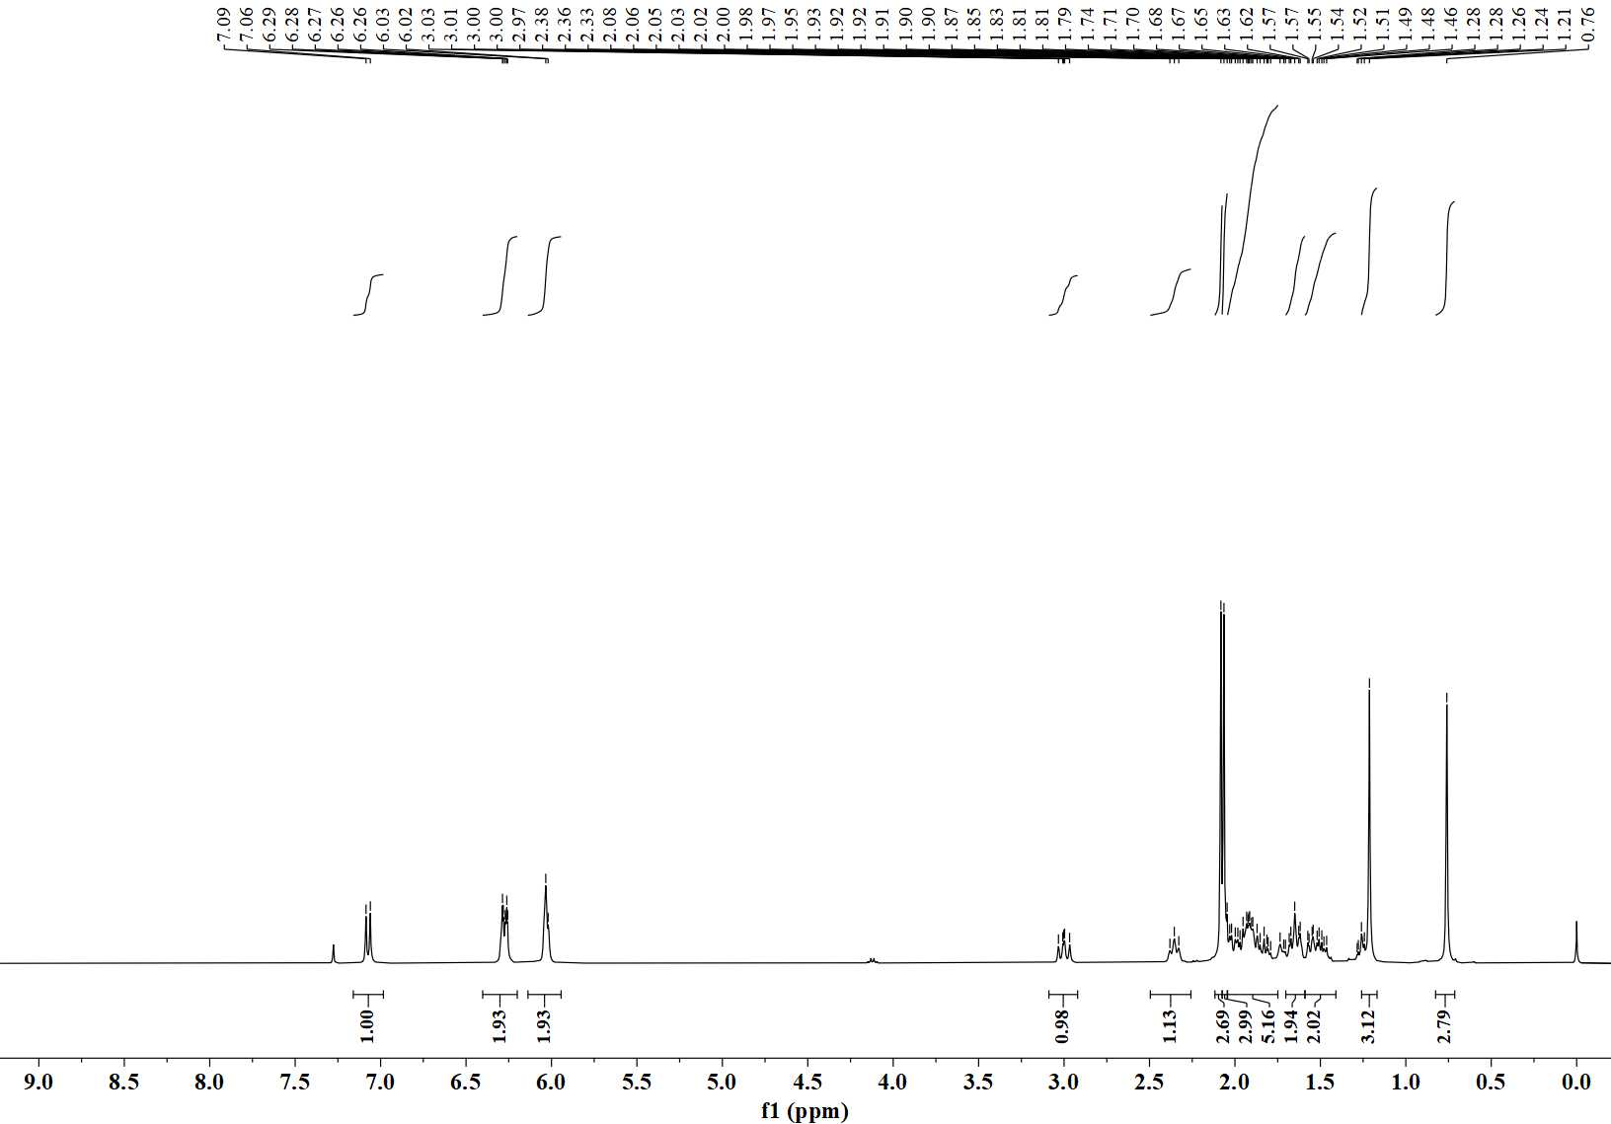
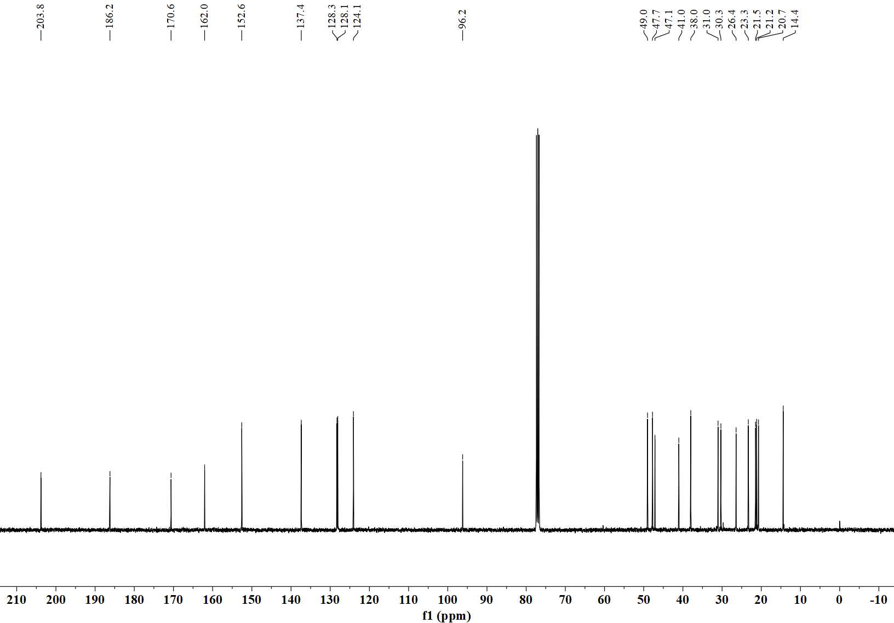
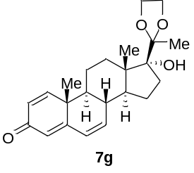
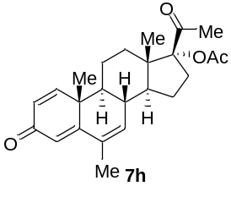
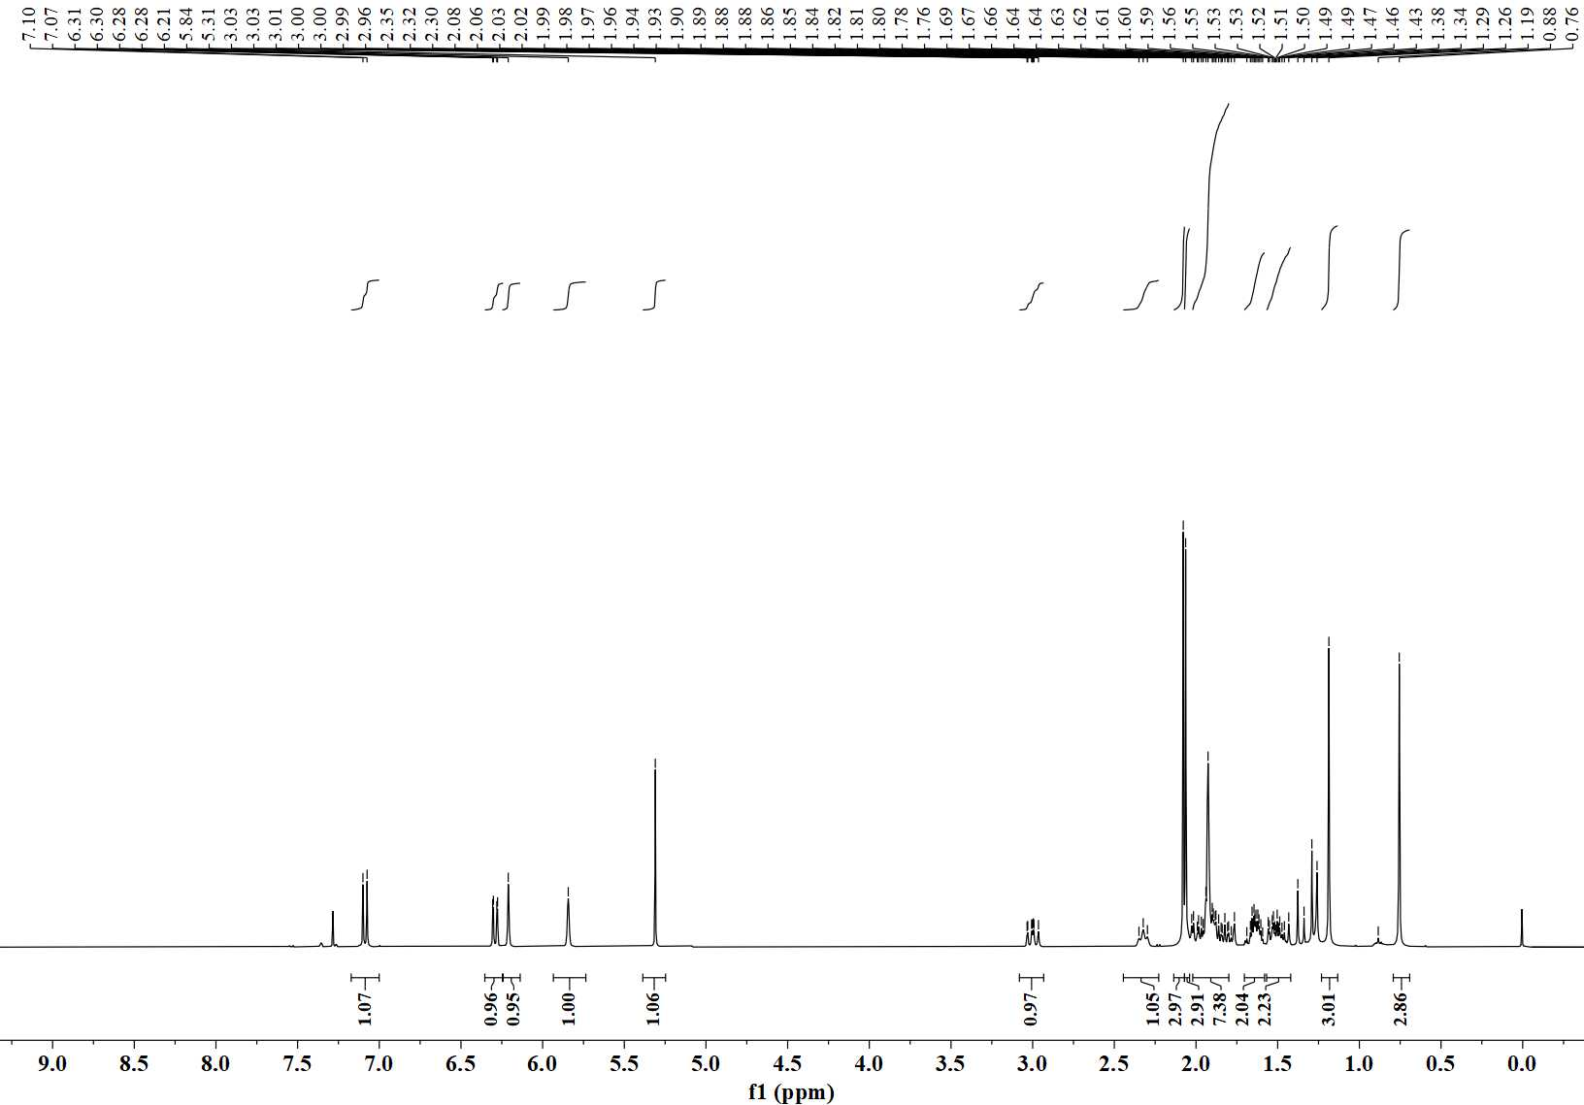
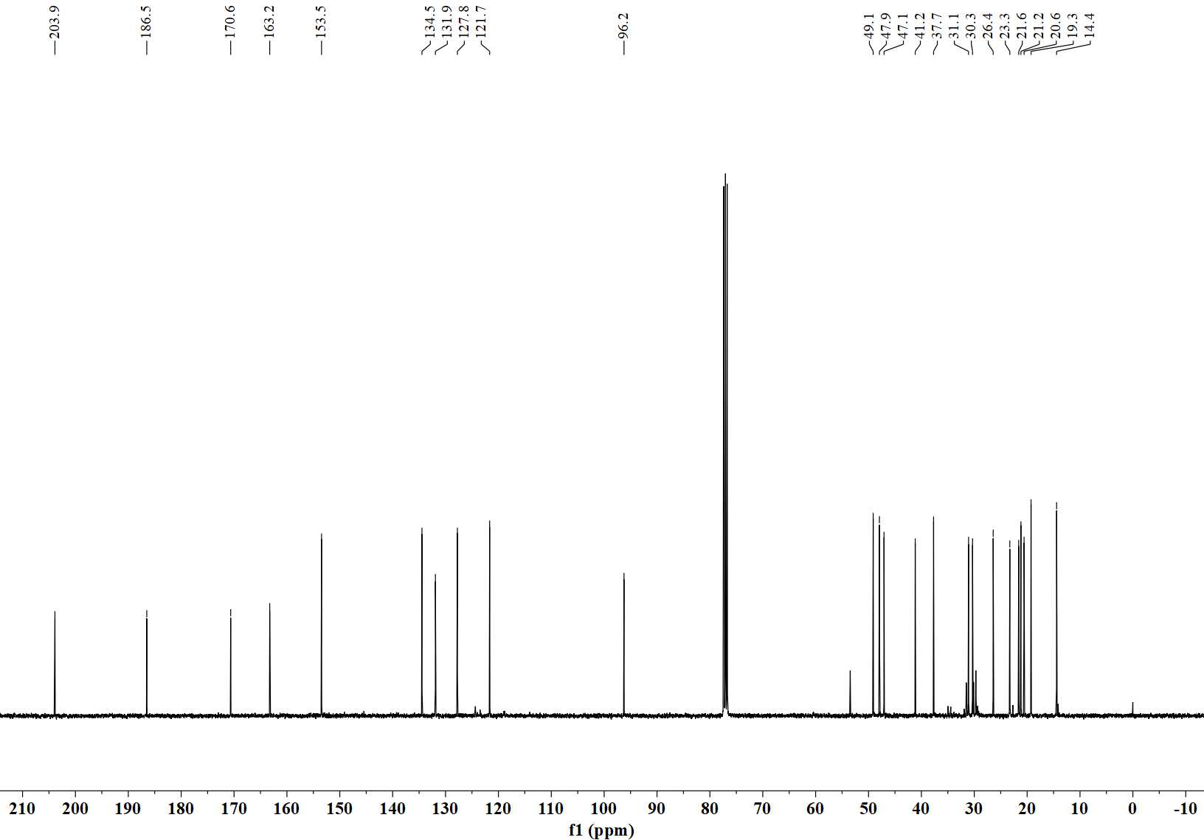
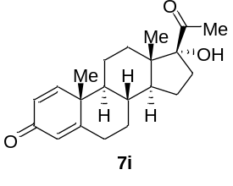
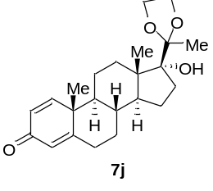
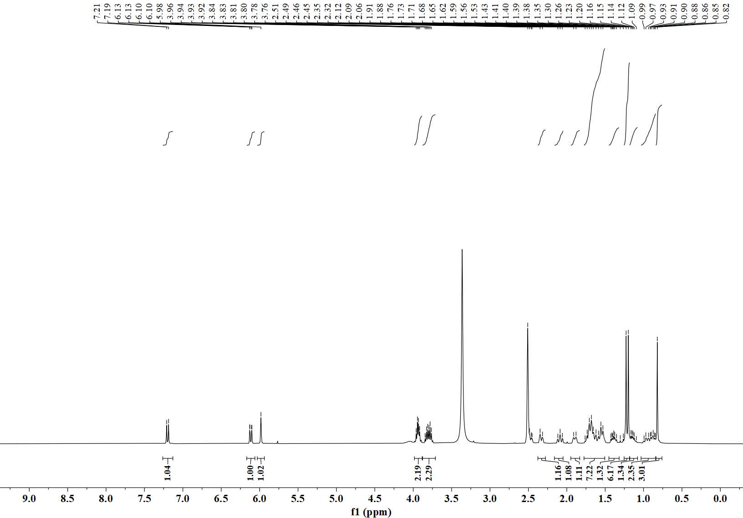
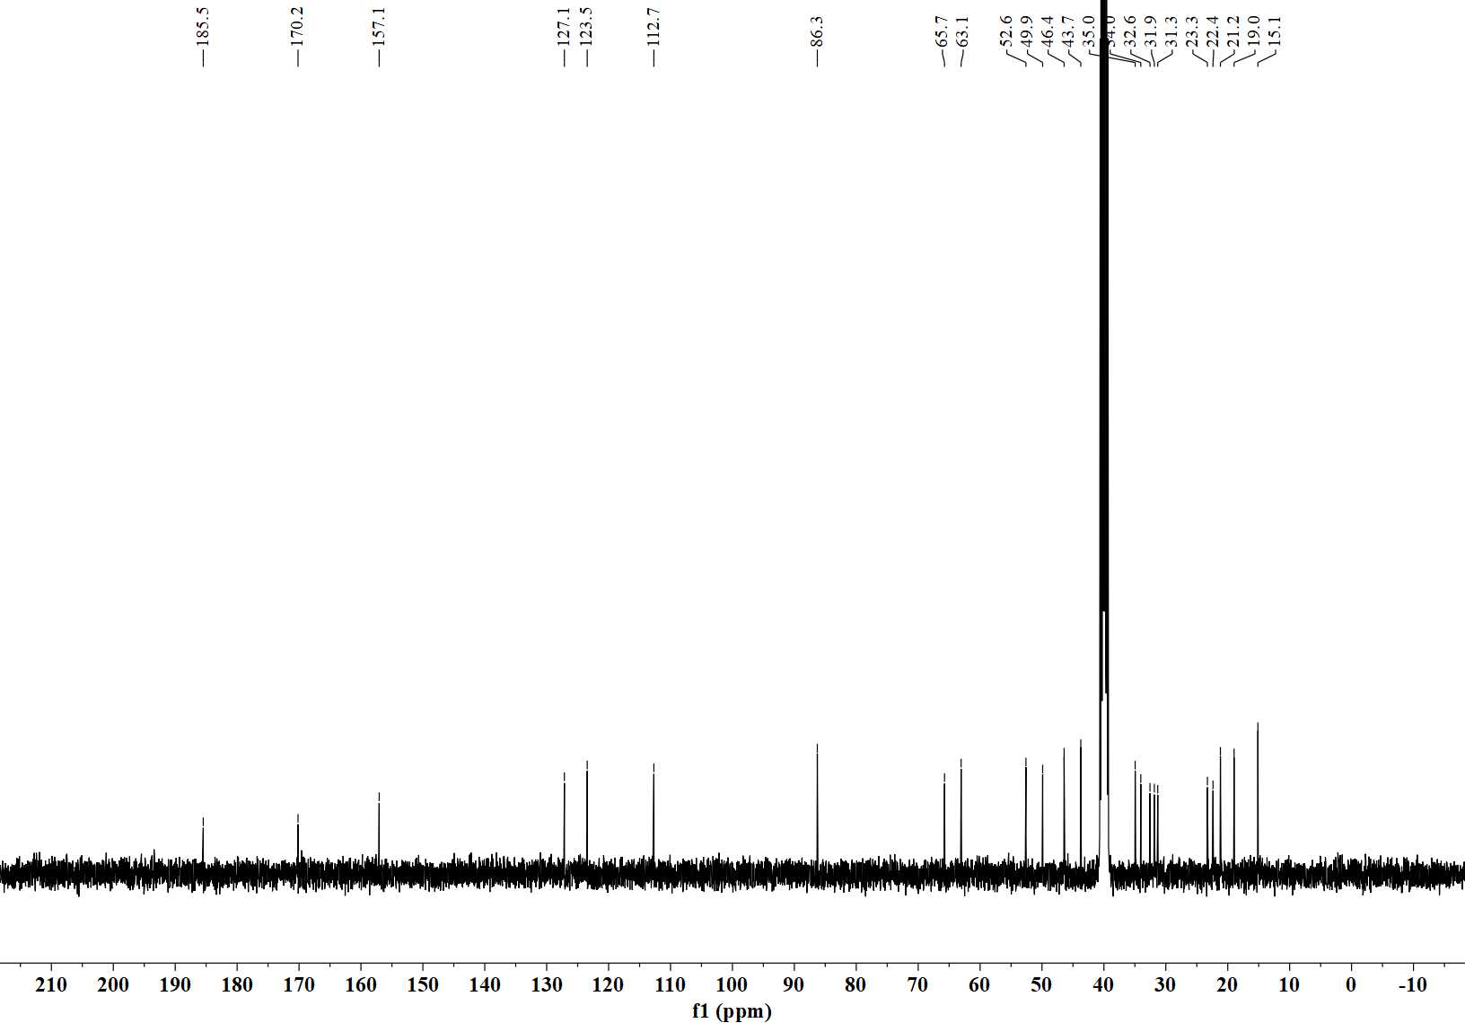
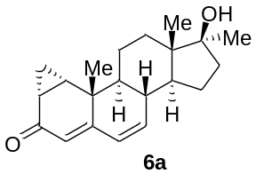
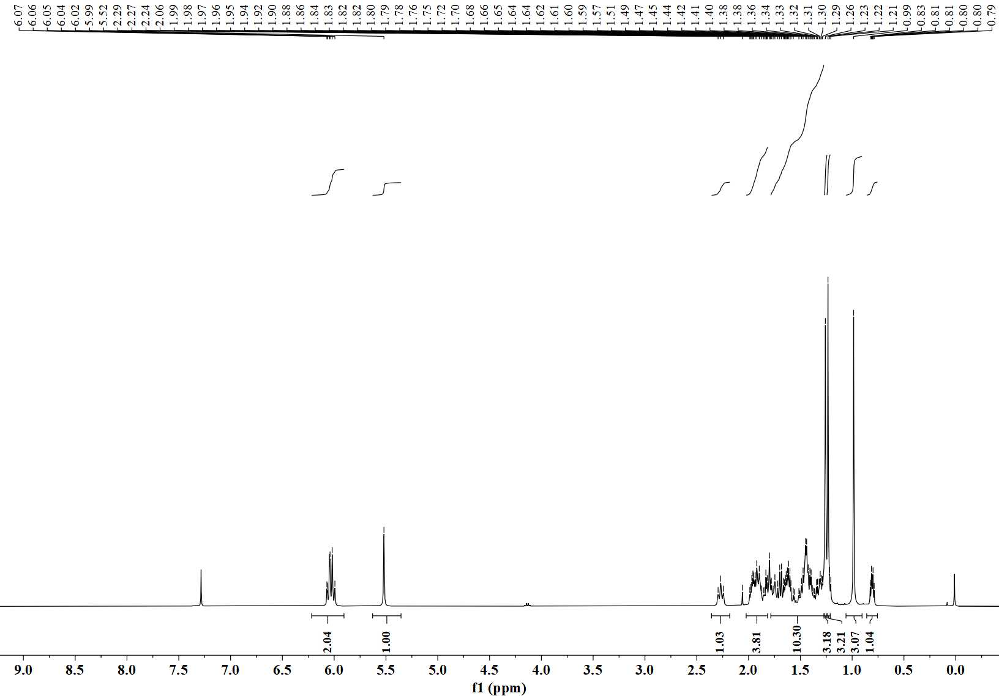
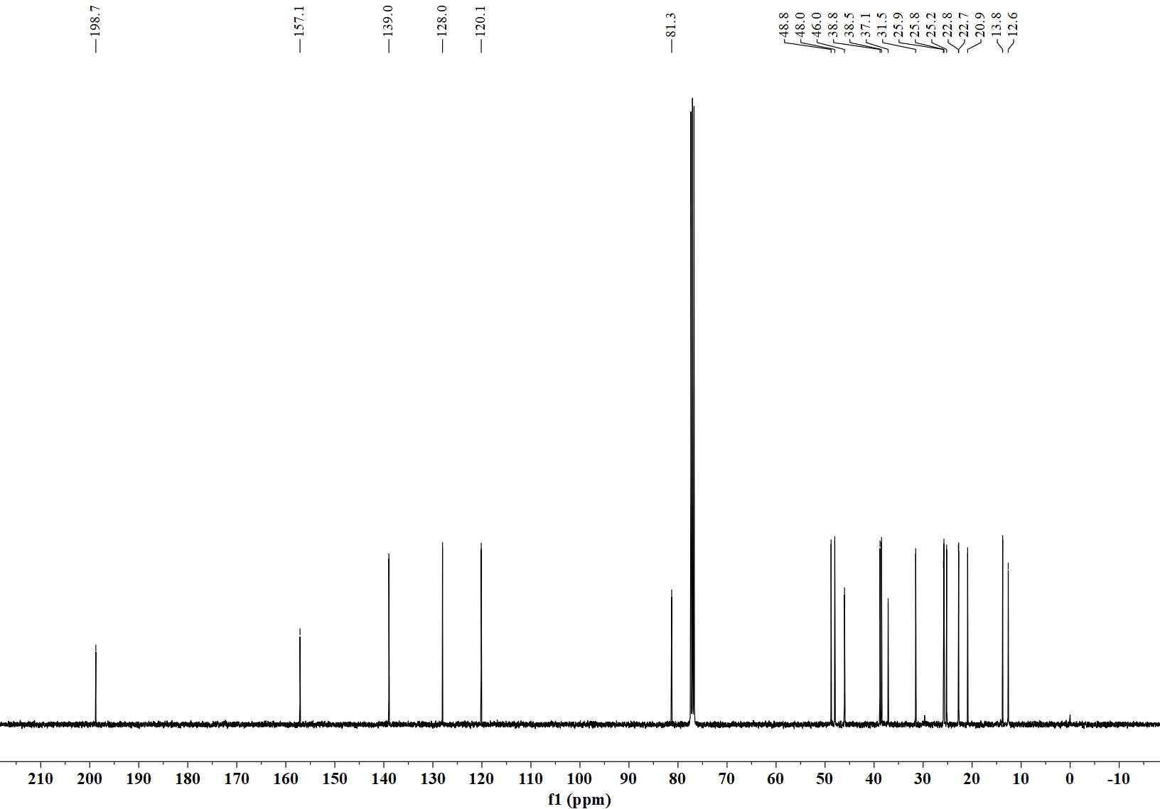
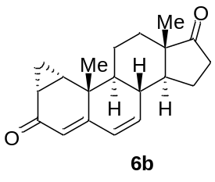
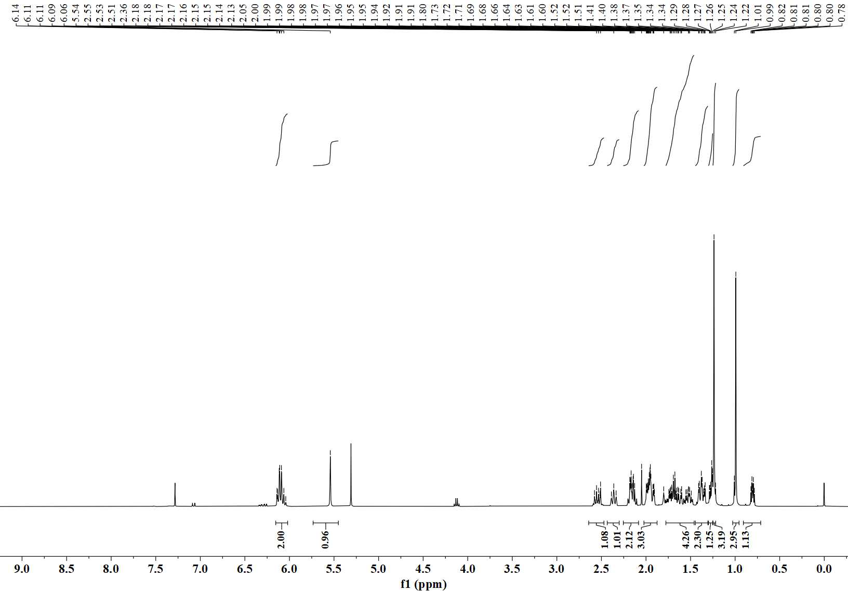
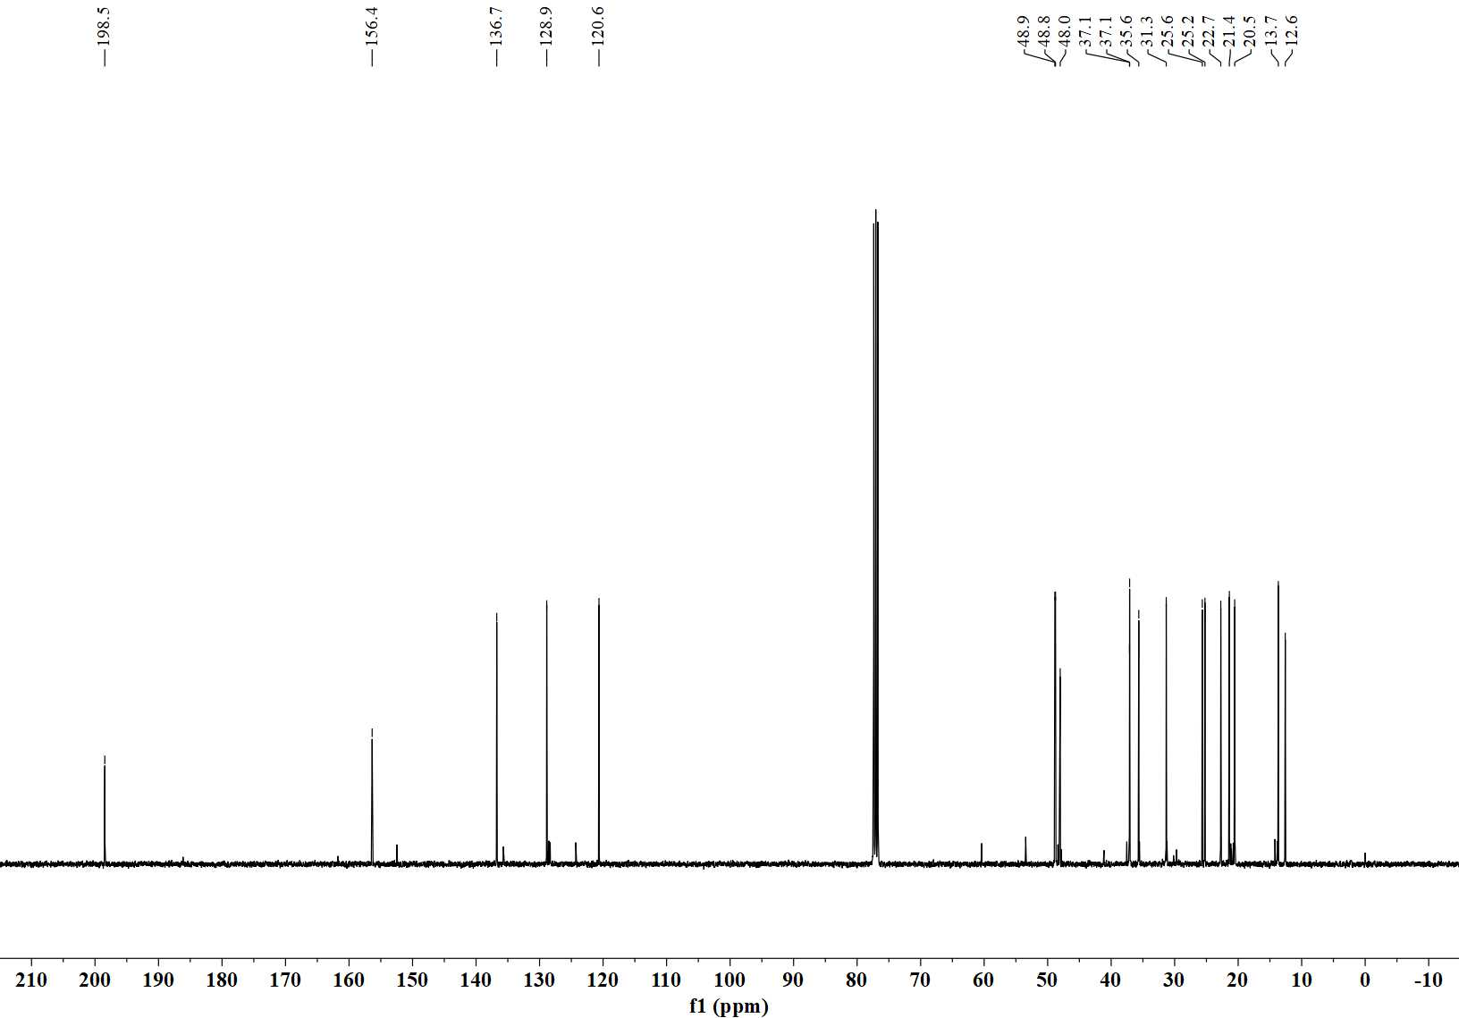
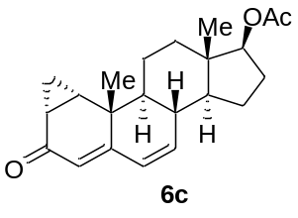
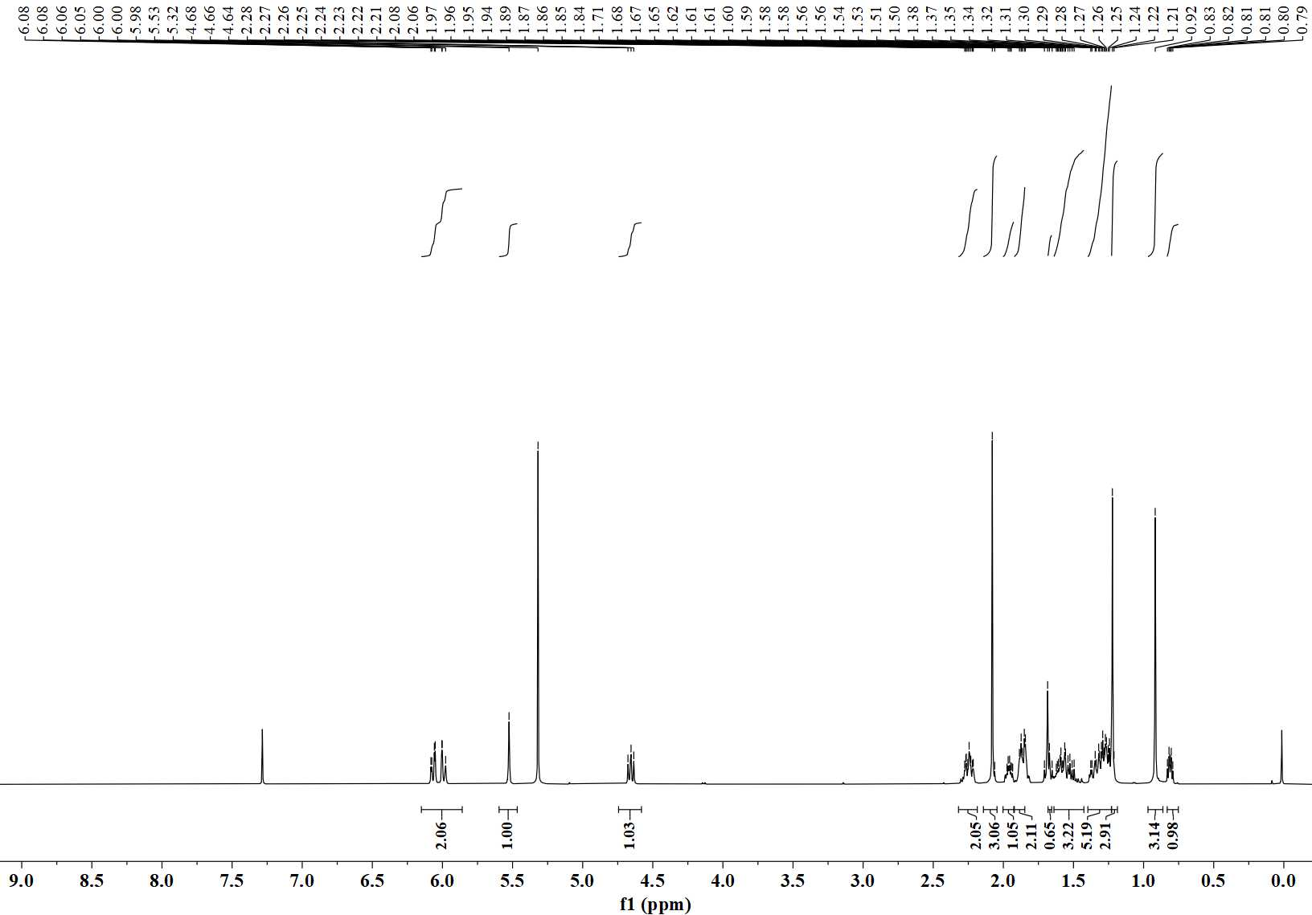
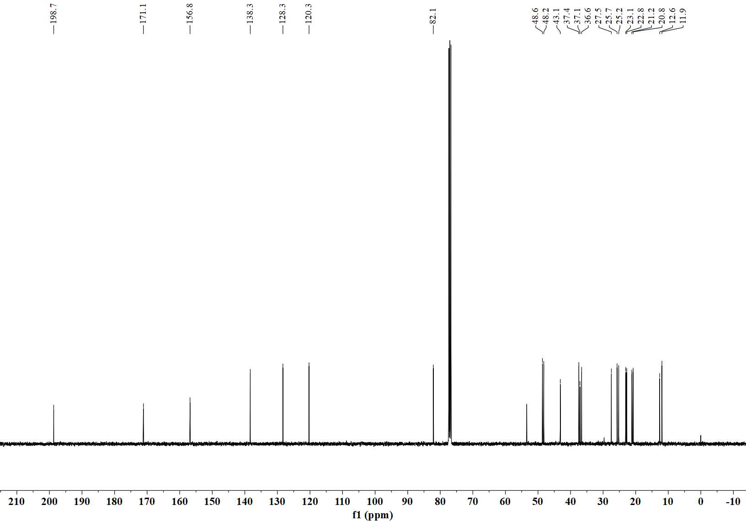
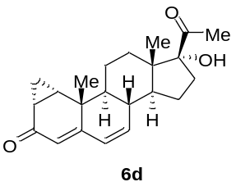
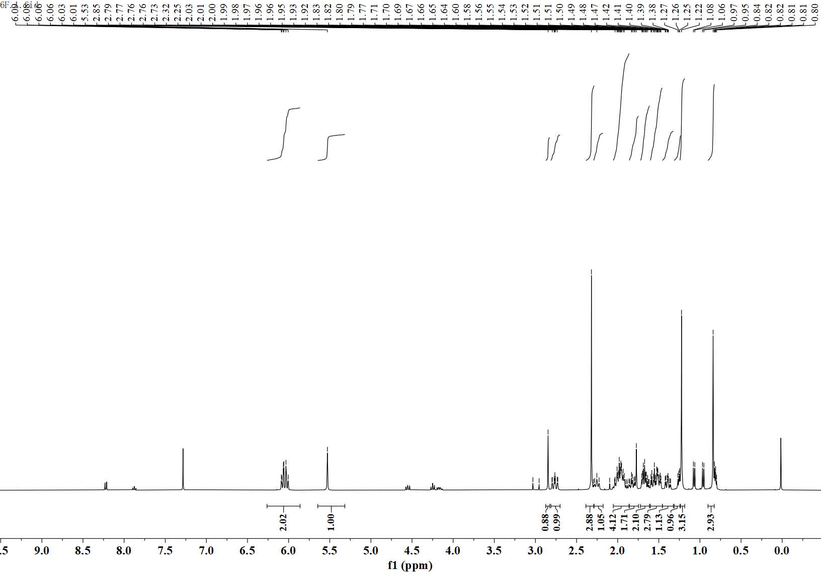
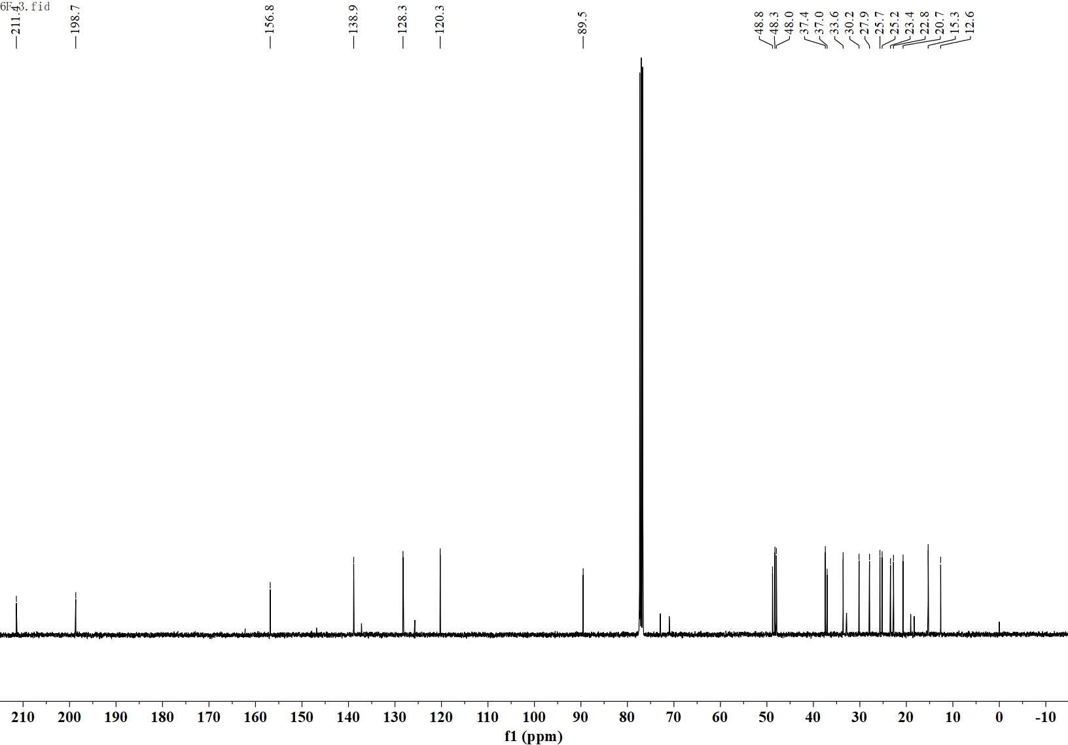
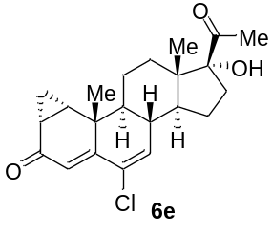
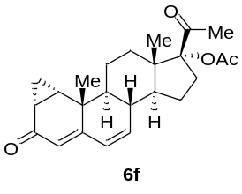
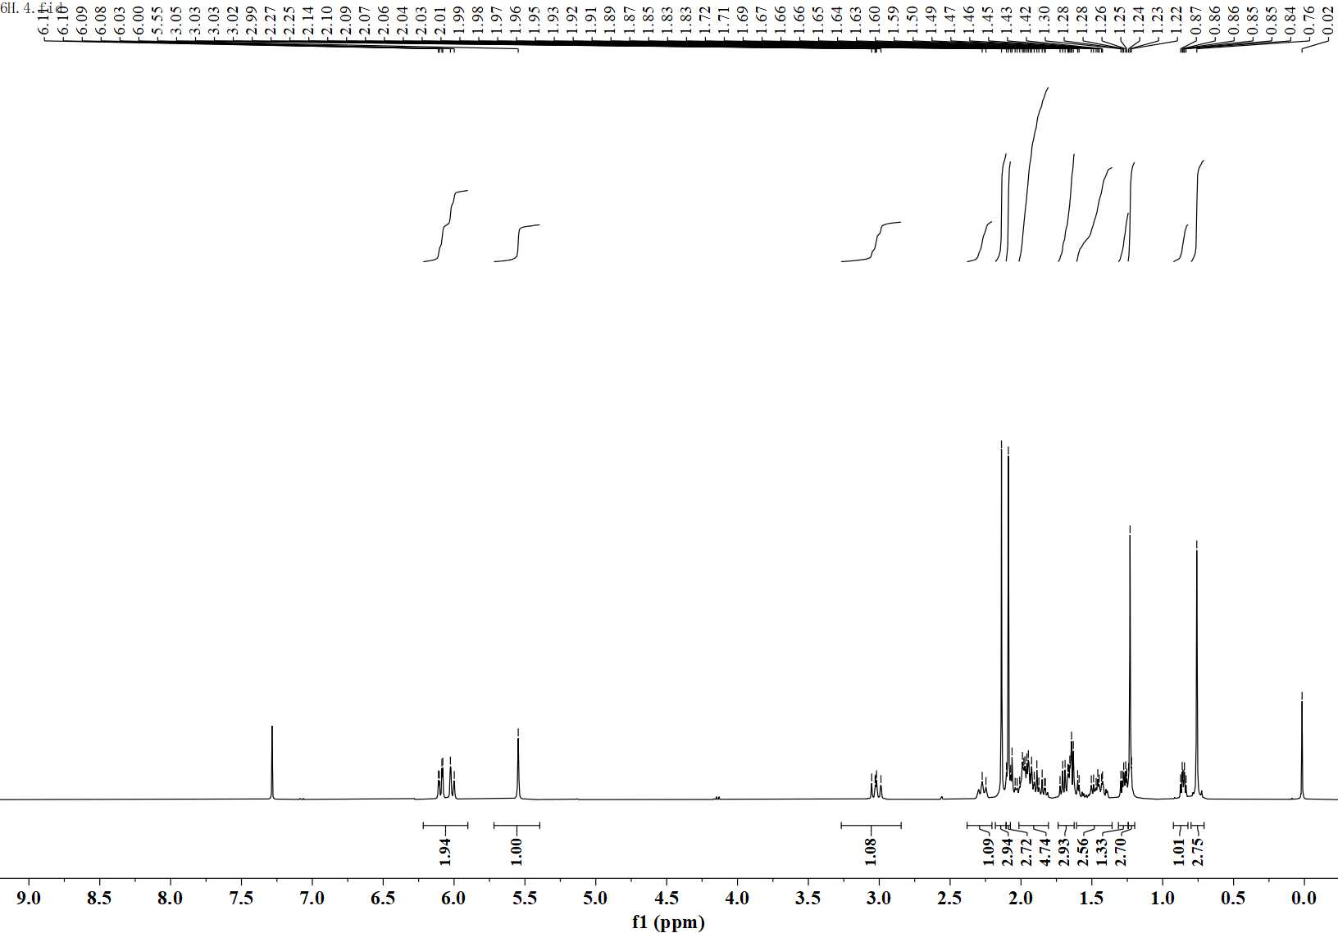
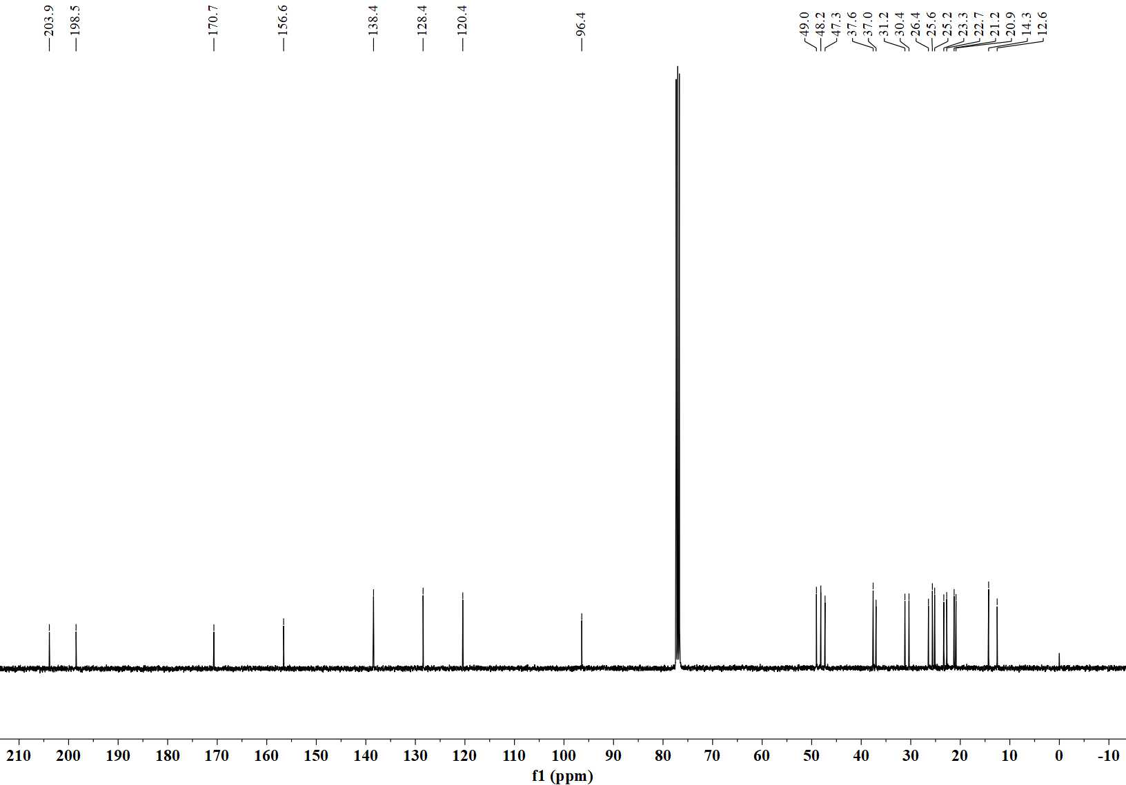
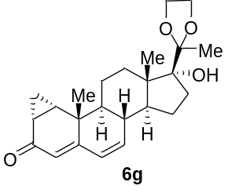
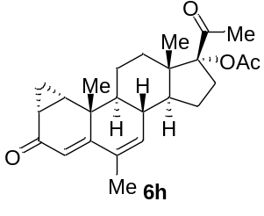
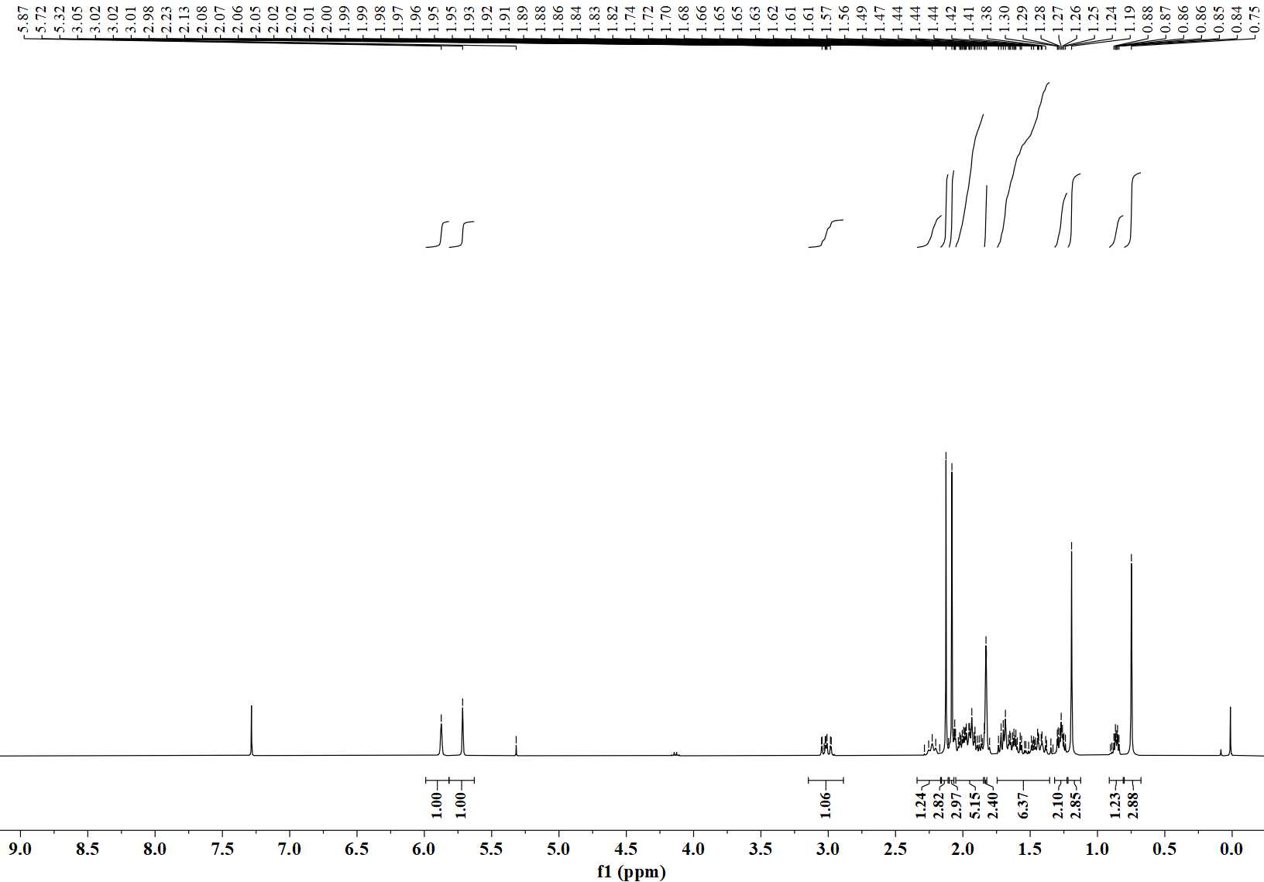
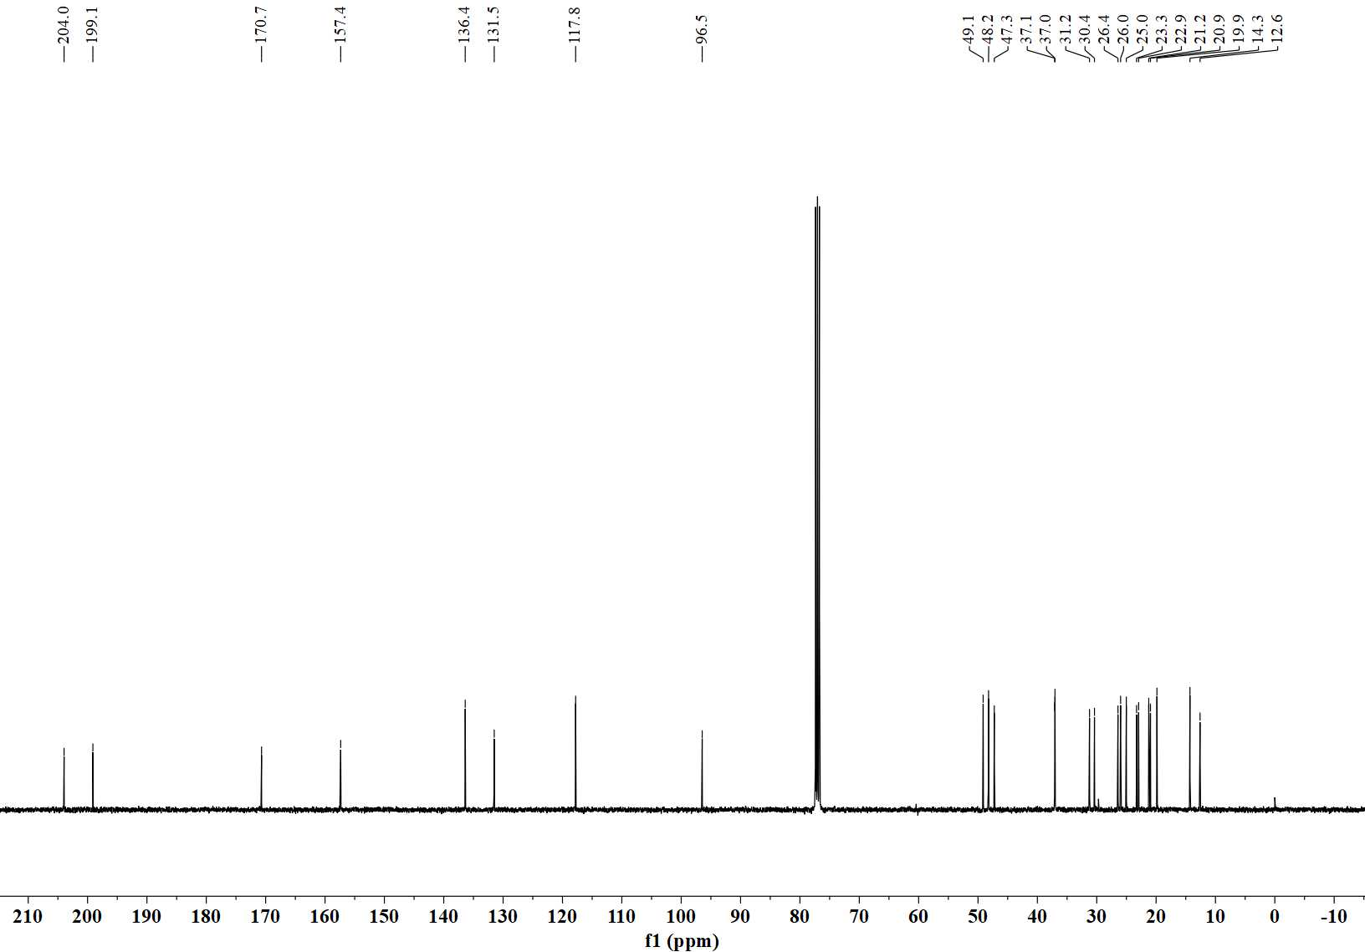

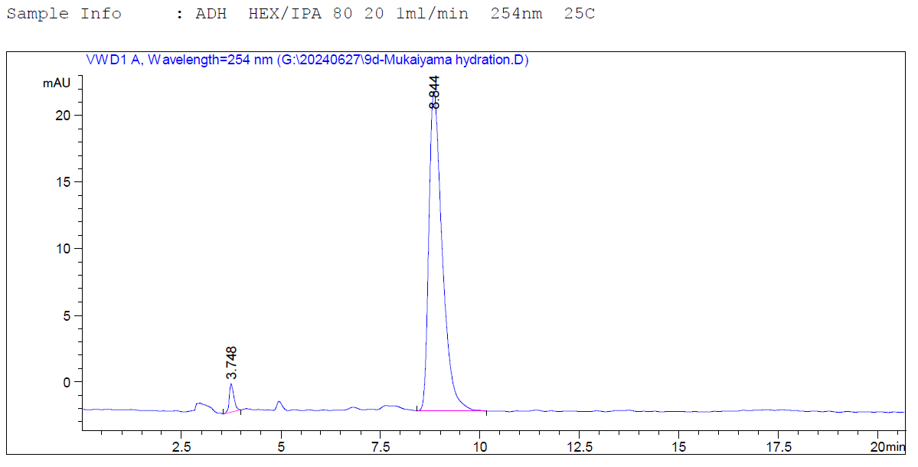
8. Chiral HPLC Data

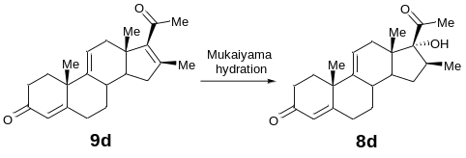

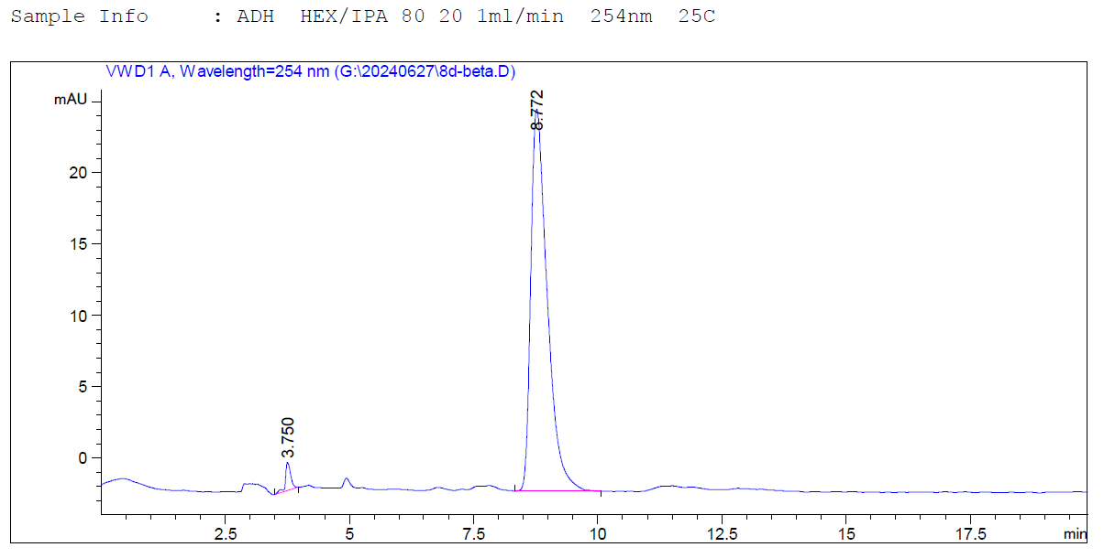

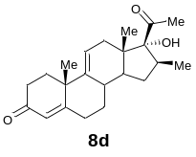

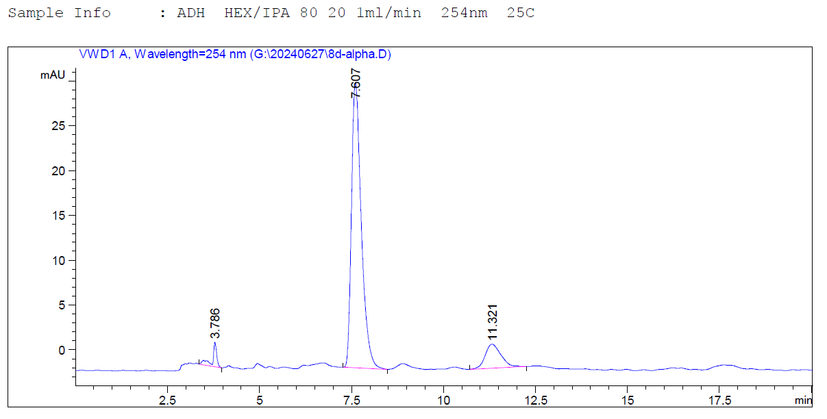

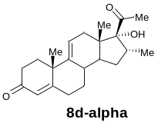

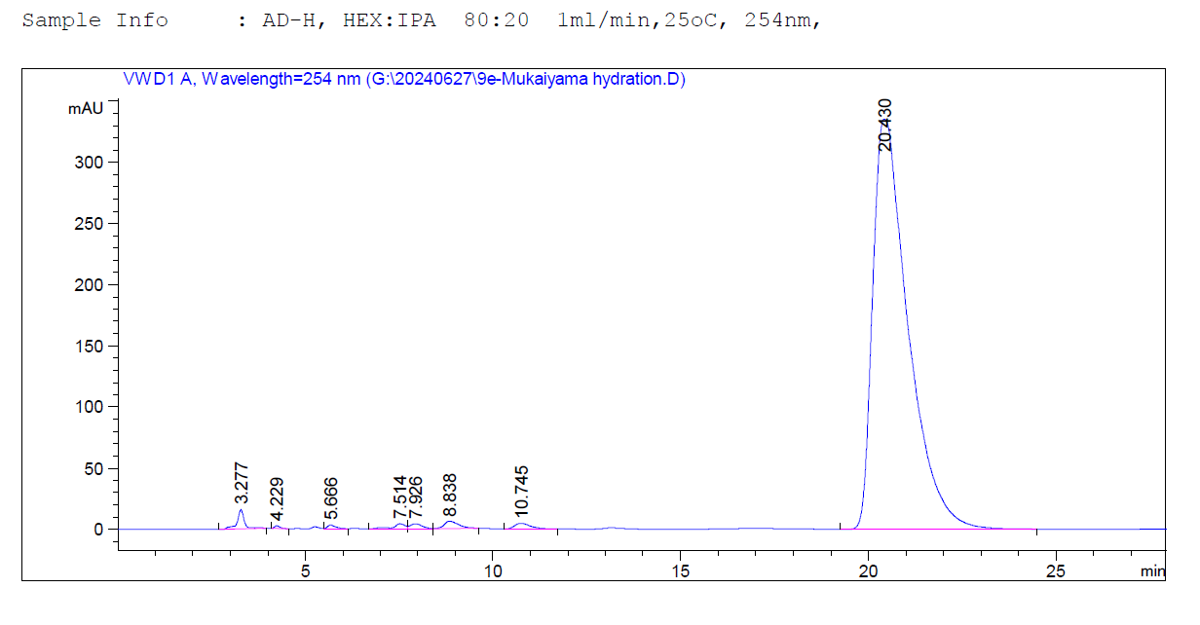

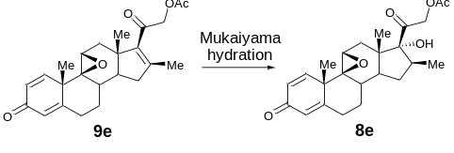

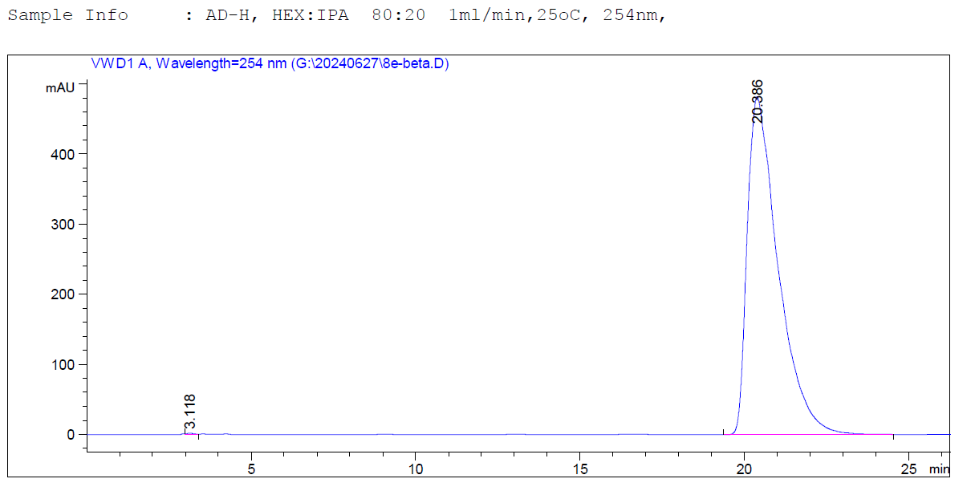

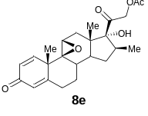

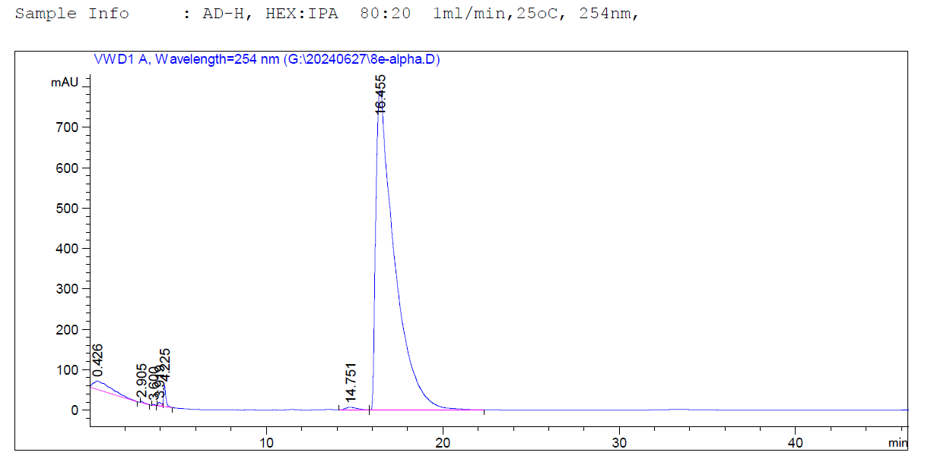

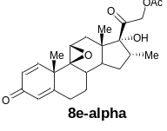

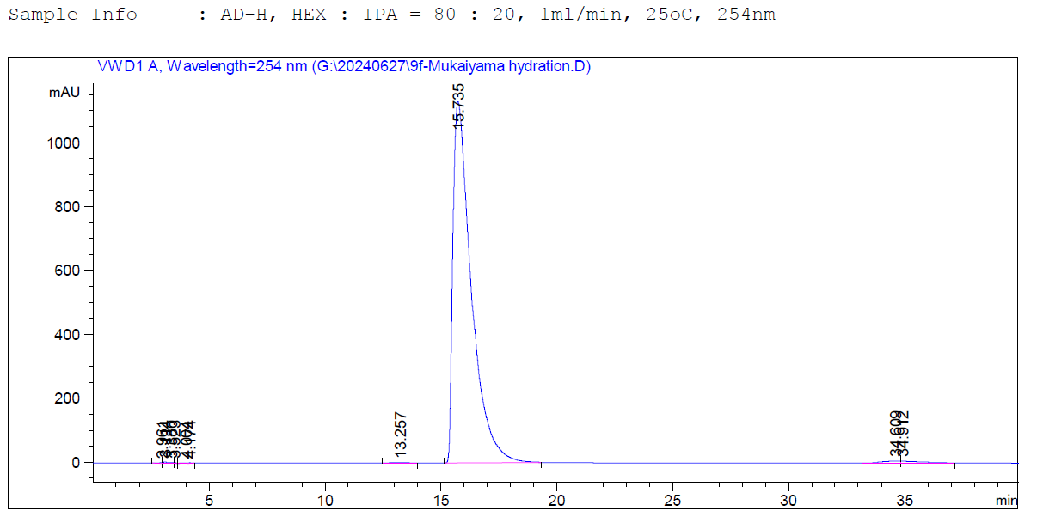

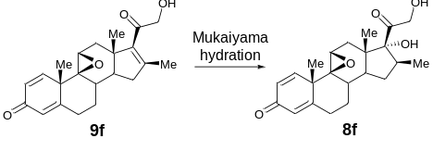

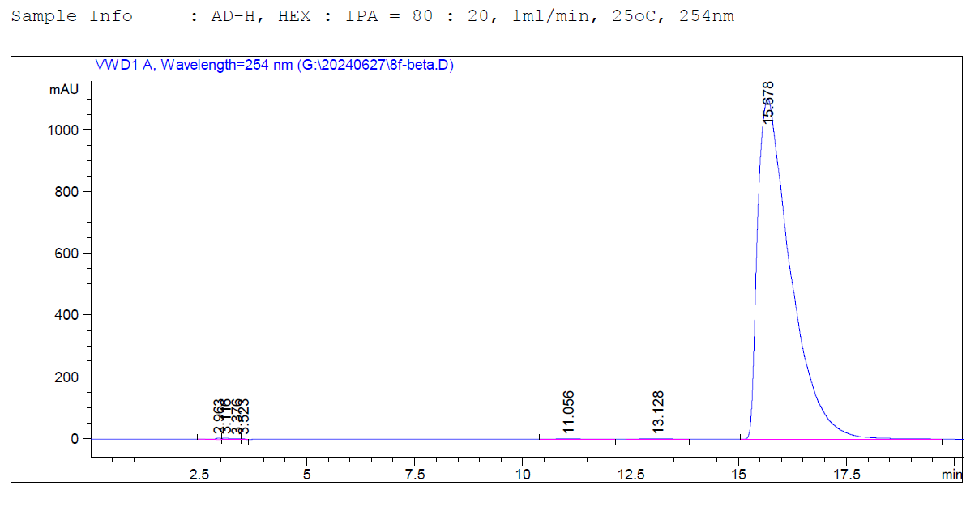

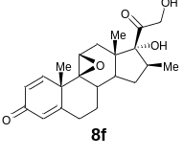

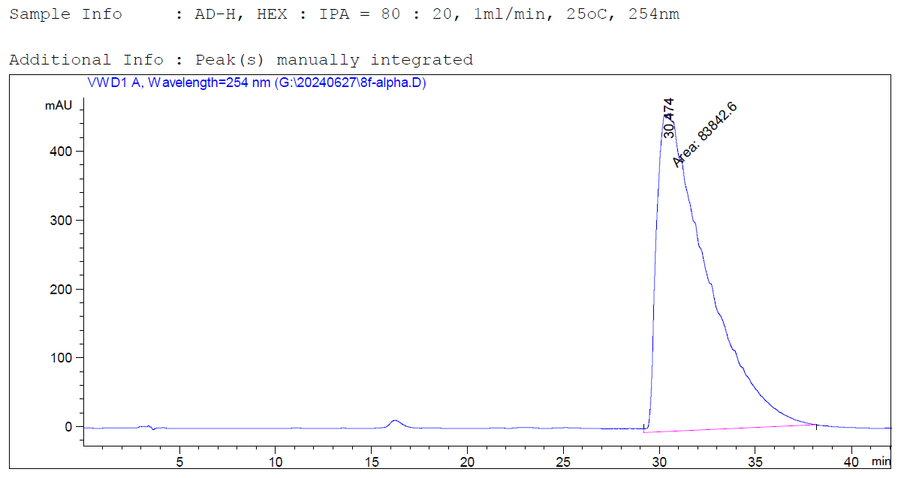

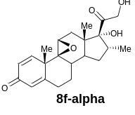

9. X-Ray Diffraction Data
X-ray of 8
(CDCC 2345000)
Crystal data
Chemical formula | C₂₁H₂₈O₃
M_{r} | 328.43
Crystal system, space group | Orthorhombic, P2₁2₁2₁
Temperature (K) | 223(2)
Wavelength (Å) | 1.54178
a, b, c (Å) | 7.7725(9), 9.9318(10), 22.425(2)
α, β, γ (°) | 90, 90, 90
V (Å³) | 1731.1(3)
Z | 4
F (000) | 712
D_{x} (Mg m⁻³) | 1.260
No. of reflections for cell measurement | 9520
θ range (°) for data collection | 3.942 to 70.852
Absorption coefficient (mm⁻¹) | 0.651
Crystal size (mm³) | 0.210 × 0.170 × 0.050
Structure refinement
Absorption correction | Semi-empirical from equivalents
Independent reflections | 3308 [R(int) = 0.0270]
Tmax, Tmin | 0.877, 0.776
Index ranges | -9 < = h < = 9, -10 < = k < = 12, -27 < = l < = 27
Refinement method | Full-matrix least-squares on F²
Goodness-of-fit on F² | 1.036
Final R indices [I > 2 sigma (I)] | R1 = 0.0307, wR2 = 0.0785
R indices (all data) | R1 = 0.0316, wR2 = 0.0793
Absolute structure parameter | 0.04 (8)
Largest diff. peak and hole (Å⁻³) | 0.179-0.141 e.
X-ray of 6d
(CDCC 2345002)
Crystal data
Chemical formula | C₂₂H₂₈O₃
M_{r} | 340.44
Crystal system, space group | Monoclinic, P2₁2₁2₁
Temperature (K) | 203(2)
Wavelength (Å) | 1.54178
a, b, c (Å) | 7.7725(9), 9.9318(10), 22.425(2)
α, β, γ (°) | 90, 90, 90
V (Å³) | 913.94(15)
Z | 2
F (000) | 368
D_{x} (Mg m⁻³) | 1.237
No. of reflections for cell measurement | 5136
θ range (°) for data collection | 3.915 to 68.978
Absorption coefficient (mm⁻¹) | 0.636
Crystal size (mm³) | 0.120 × 0.080 × 0.050
Structure refinement
Absorption correction | Semi-empirical from equivalents
Independent reflections | 3104 [R(int) = 0.0313]
Tmax, Tmin | 0.774, 0.684
Index ranges | -7 < = h < = 7, -15 < = k < = 14, -13 < = l < = 13
Refinement method | Full-matrix least-squares on F²
Goodness-of-fit on F² | 1.057
Final R indices [I > 2 sigma (I)] | R1 = 0.0349, wR2 = 0.0870
R indices (all data) | R1 = 0.0389, wR2 = 0.0900
Absolute structure parameter | 0.17(14)
Largest diff. peak and hole (Å⁻³) | 0.168-0.132 e.

X-ray of 6g
(CDCC 2345010)
Crystal data
Chemical formula | C₂₄H₃₄O₅
M_{r} | 402.51
Crystal system, space group | Orthorhombic, P2₁2₁2₁
Temperature (K) | 223(2)
Wavelength (Å) | 1.54178
a, b, c (Å) | 7.6974(2), 15.4550(4), 17.8901(5)
α, β, γ (°) | 90, 90, 90
V (Å³) | 2128.27(10)
Z | 4
F (000) | 872
D_{x} (Mg m⁻³) | 1.256
No. of reflections for cell measurement | 10084
θ range (°) for data collection | 4.944 to 70.787°
Absorption coefficient (mm⁻¹) | 0.695
Crystal size (mm³) | 0.350 × 0.250 × 0.150
Structure refinement
Absorption correction | Semi-empirical from equivalents
Independent reflections | 4054 [R(int) = 0.0352]
Tmax, Tmin | 0.840, 0.720
Index ranges | -8 < = h < = 9, -18 < = k < = 17, -21 < = l < = 21
Refinement method | Full-matrix least-squares on F²
Goodness-of-fit on F² | 1.087
Final R indices [I>2sigma(I)] | R1 = 0.0392, wR2 = 0.1008
R indices (all data) | R1 = 0.0445, wR2 = 0.1057
Absolute structure parameter | -0.02(10)
Largest diff. peak and hole (Å⁻³) | 0.171-0.188 e.

10. Reference
[1] Xu, X., Zhang, Y., Wang, S., et al. “Nonpolarity paving” in substrate tunnel of a Limnobacter sp. phenylacetone monooxygenase for efficient single whole-cell synthesis of esomeprazole. Bioorg. Chem., 125, 105867 (2022).
[2] Pucci, E., Petraglia, F. Treatment of androgen excess in females: Yesterday, today and tomorrow. Gynecol. Endocrinol., 11, 411-433 (1997).
[3] Sakee, U., Kongkathip, N., Kongkathip, B. The first syntheses of 16β-chloro- and 16β-bromo-cyproterone acetate. Synthetic Commun., 33, 1695-1706 (2003).
[4] Manosroi, A., Manosroi, J., Buddhasukh, D., et al. Process for the preparation of cyproterone acetate from solasodine[P]. EP1359154A1, 2003.
[5] Roleira, F. M. F., Costa, S. C., Gomes, A. R., et al. Design, synthesis, biological activity evaluation and structure-activity relationships of new steroidal aromatase inhibitors. The case of C-ring and 7β substituted steroids. Bioorg. Chem., 131, 106286 (2023).
[6] Sondheimer, F., Velasco, M., Rosenkranz, G. Steroids. LXXI. Synthesis of 1-dehydroprogesterone and 1-dehydro-17-ethinyltestosterone. J. Am. Chem. Soc., 77, 5673-5676 (1955).
[7] Choudhary, M. I., Nasir, M., Khan, S. N., et al. Microbial hydroxylation of hydroxyprogesterones and α-glucosidase inhibition activity of their metabolites. Z. Naturforsch. B. 62, 593-599 (2007).
[8] van Leusen, D., Batist, J. N. M., Lei, J., et al. Synthesis of 17-(2-methoxy-3-oxazolin-4-yl)-, 17-(3-oxazolin-4-yl)-, and 17-(2-oxazolin-4-ylidene) substituted steroids and their use as precursors of corticosteroids. J. Org. Chem., 59, 5650-5657 (1994).
[9] Bume, D. D., Harry, S. A., Pitts, C. R., et al. Sensitized aliphatic fluorination directed by terpenoidal enones: A “visible light” approach. J. Org. Chem., 83, 1565-1575 (2018).
[10] Zhou, Z.-H., Zhang, X., Huang, Y.-F., et al. Synthesis of α-hydroxy ketones by copper(I)-catalyzed hydration of propargylic alcohols: CO₂ as a cocatalyst under atmospheric pressure. Chinese J. Catal., 40, 1345-1351 (2019).
[11] Bernstein, S., Brown, J. J., Feldman, L. I., et al. 16-Hydroxylated steroids. X. The synthesis of 21-deoxytriamcinolone. J. Am. Chem. Soc., 81, 4956-4962 (1959).
[12] Wei, J., Zhang, Y., Liu, M., et al. Divergent chemo- and biocatalytic route to 16β-methylcorticoids: Asymmetric synthesis of betamethasone dipropionate, clobetasol propionate, and beclomethasone dipropionate. Angew. Chem. Int. Edit., 63, e202313952 (2024).
[13] Taub, D., Hoffsommer, R. D., Slates, H. L., et al. 16β-Methyl cortical steroids. J. Am. Chem. Soc., 82, 4012-4026 (1960).
[14] Andryushina, V. A., Stytsenko, T. S., Karpova, N. V., et al. Efficient synthesis of 21-acetoxypregna-1, 4, 9(11), 16-tetraene-3, 20-dione, a key intermediate in the synthesis of highly active fluorinated corticosteroids from 9α-hydroxyandrostenedione. Pharmaceutical Chemistry Journal, 52, 776-780 (2018).
[15] Kocór, M., Gumulka, M. Steroids XII a novel addition reaction of mercuric salts with unsaturated steroidal ketones. Tetrahedron Lett., 10, 3067-3070 (1969).
[16] Kaufmann, S., Pataki, J., Rosenkranz, G., et al. Steroids. VI. The Wohl-Ziegler bromination of steroidal 1, 4-dien-3-ones. Partial synthesis of Δ⁶-dehydroestrone and equilenin. J. Am. Chem. Soc., 72, 4531-4534 (1950).

