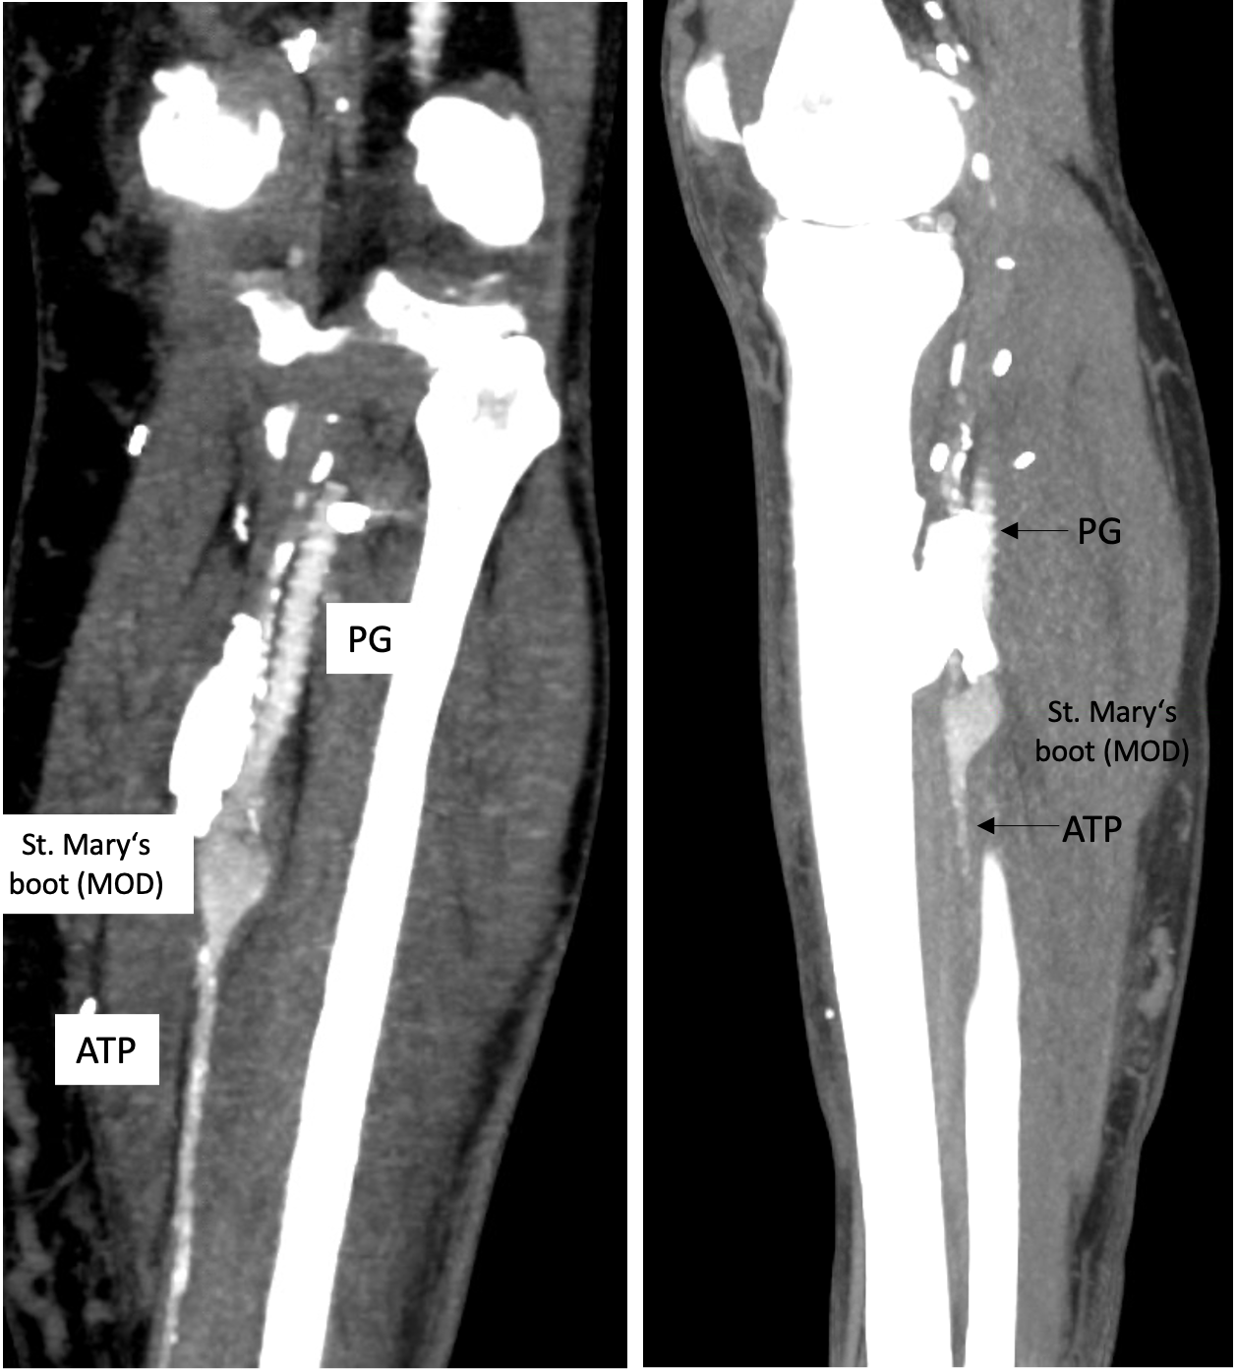
Supplemental Fig2: CT-Angiogram with coronal (right) and longitudinal (left) section depiction distal anastomosis between tibialis posterior artery (ATP) and prosthetic graft (PG) with St. mary’s boot anastomotic modification. The patient was followed up after 36 months.

