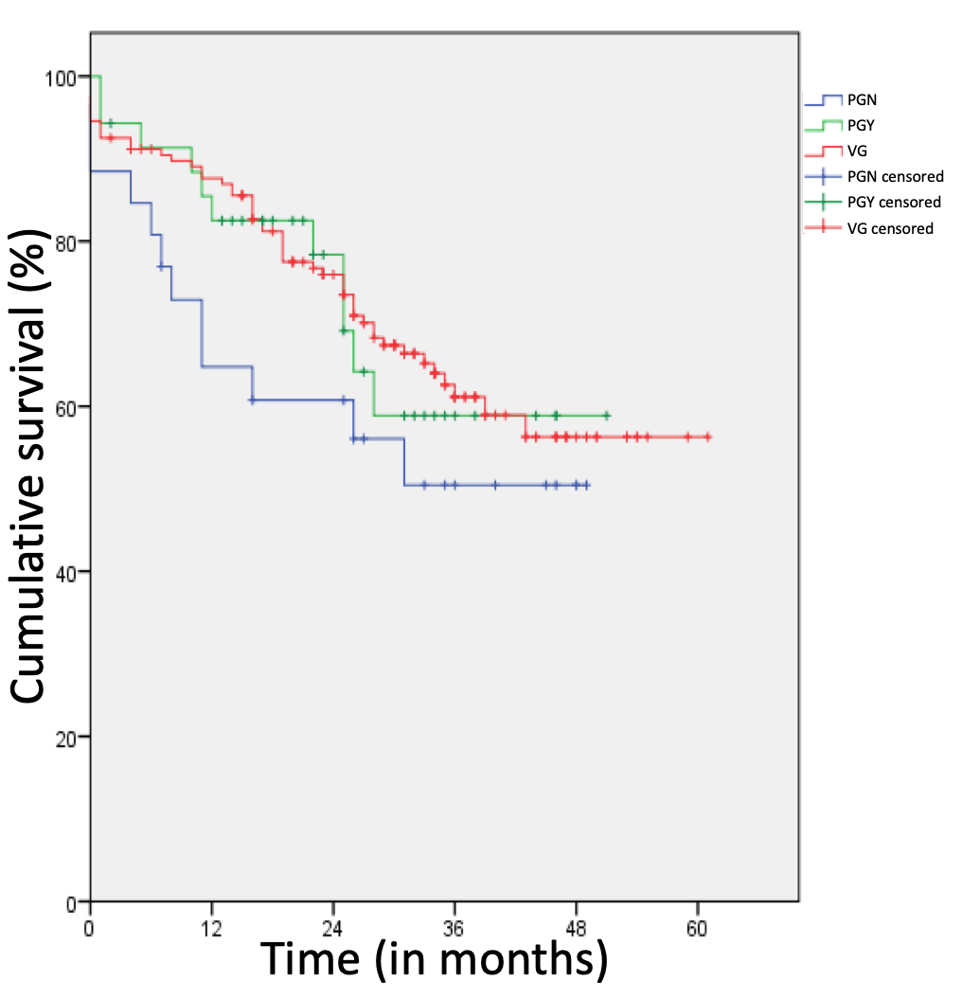
Supplemental Fig1: Kaplan-meier plots for cumulative survival. No significant difference between the three groups (p<0.375).
PGN: prosthetic graft without MOD
PGY: prosthetic graft with modification of the distal anastomosis (MOD)
VG: autogenous venous graft REBEL

