Room-temperature Ferromagnetism, Perpendicular Magnetic Anisotropy, and Anisotropic Magnetoresistance in Epitaxially Stabilized Air-stable Chromium Tellurides
Anna Tschesche, Pia Henning, Tobias Meyer, Jasnamol Palakkal*
Institute of Materials Physics, Georg-August-University of Göttingen, Göttingen 37077, Germany
*E-mail: jpalakkal@uni-goettingen.de
Keywords: epitaxy, 2D materials, tellurides, ferromagnetism, perpendicular magnetic anisotropy

Supplementary information
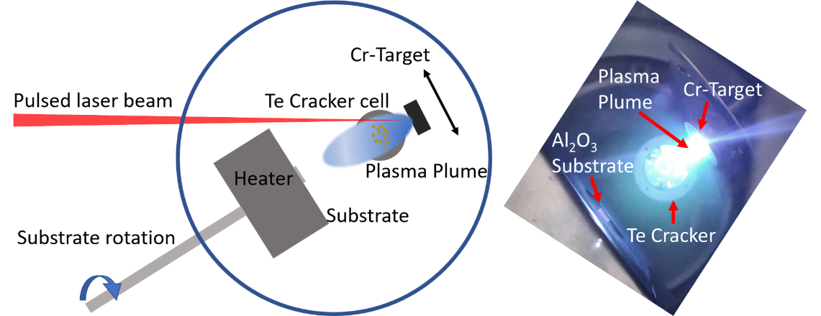
Fig. S1 Hybrid PLD. Schematic of the hybrid PLD (left) and the inside view of the UHV chamber during deposition (right).
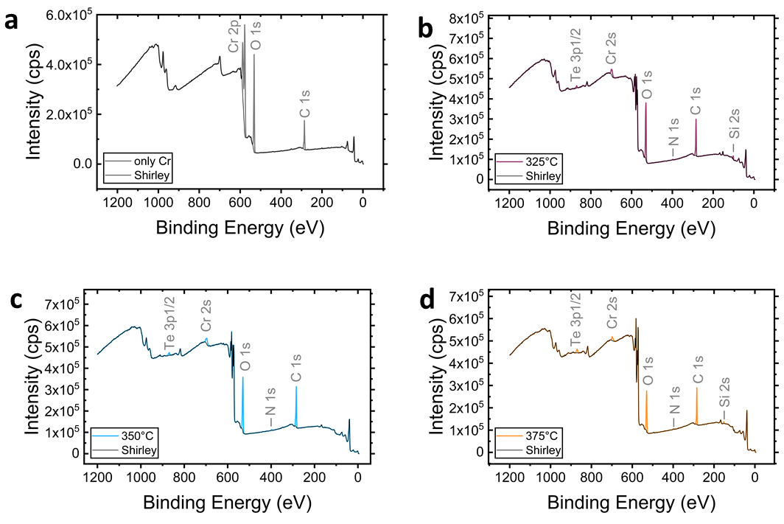
Fig. S2. XPS survey spectrum of the samples a. only Cr and Cr_{(1+δ)}Te₂ samples grown at different T_{EC} of b. 325 °C, c. 350 °C, and d. 375 °C.
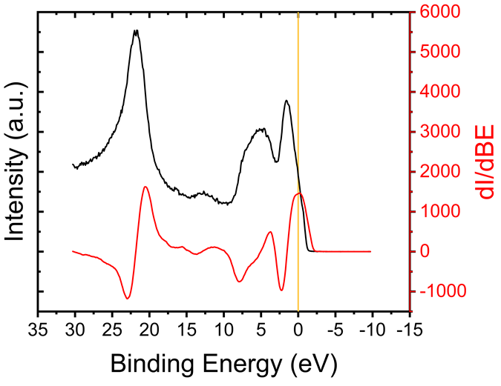
Fig. S3. The energy spectrum was calibrated by setting the peak of slope at the Fermi edge to 0 for only the Cr sample.
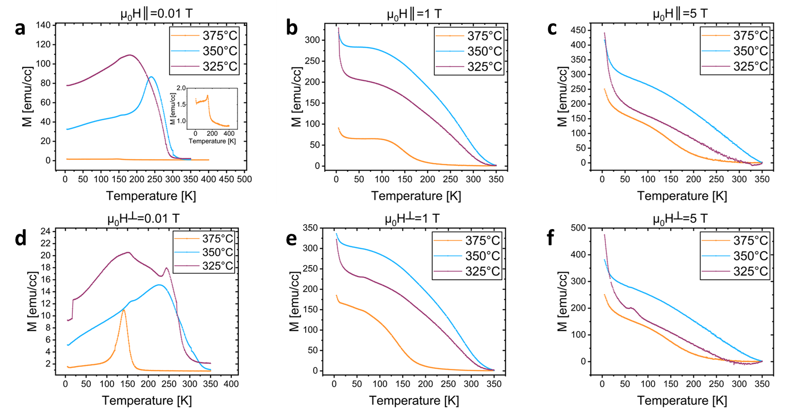
Fig. S4. ZFC M vs. T measured under 0.01 T, 1 T, and 5 T in parallel (∥) orientation for the samples grown at different T_{EC}.
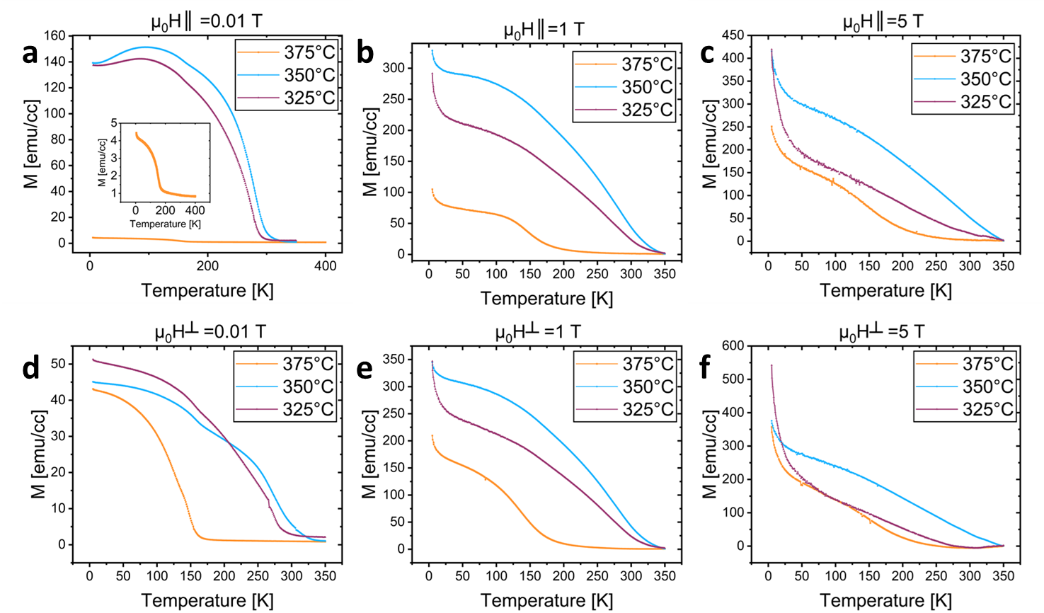
Fig. S5. FC M vs. T measured under 0.01 T, 1 T, and 5 T in parallel (∥) orientation for the samples grown at different T_{EC}.
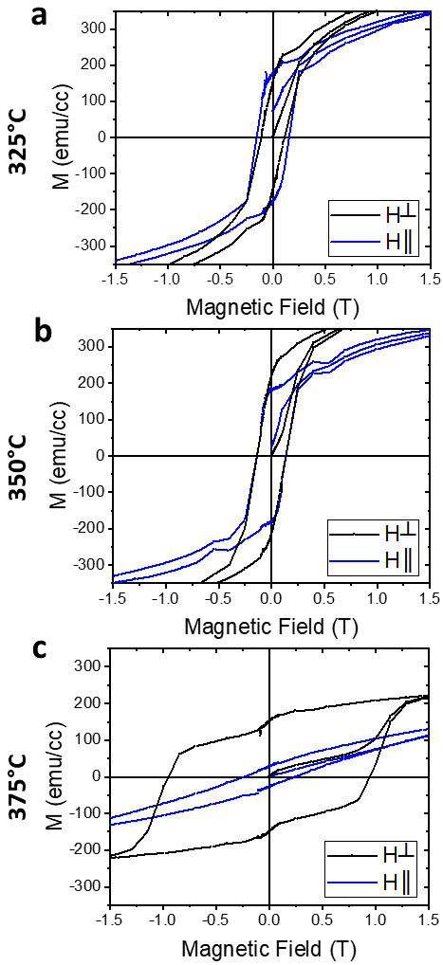
Fig. S6 The ZFC hysteresis curve (M vs. H for H = ±1.5 T) of the b. 325, d. 350 and f. 375 °C sample measured at 5 K for perpendicular and parallel directions.

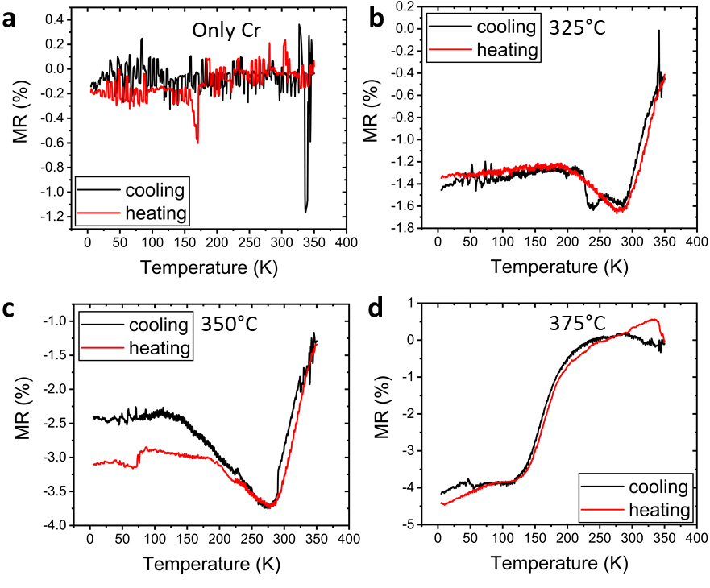
Fig. S7. The magnetoresistance (MR) as a function of temperature (calculated using the data shown in Fig. 9) for samples: a. Only Cr, b. 325 °C, c. 350 °C, and d. 375 °C.
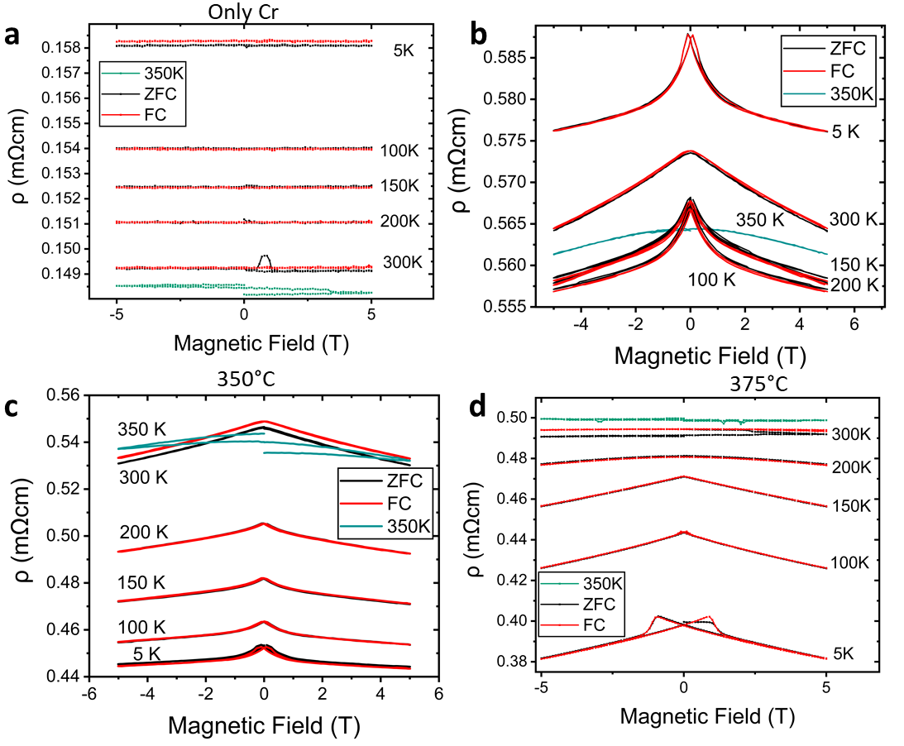
Fig. S8 Resistivity (ρ) as a function of the magnetic field at different temperatures for samples: a. Only Cr, b. 325 °C, c. 350 °C, and d. 375 °C.
DATA AVAILABILITY
All data related to this work and the files described in the supplementary information are publicly available at the universal research data repository for the Göttingen Campus (GRO.data) using the link https://doi.org/10.25625/LBPMCL.
ACKNOWLEDGEMENTS
Deutsche Forschungsgemeinschaft (DFG) supported this project under project 429646908 and Collaborative Research Centre (CRC) 1073. AT, PH, and JP acknowledge the financial support received from Ministerium für Wissenschaft, Forschung und Kunst (MWK), Lower Saxony under ‘Zukunft.niedersachsen’.
AUTHOR CONTRIBUTIONS
AT conducted the thin film deposition and performed the acquisition, analysis, and interpretation of data with respect to XRD, XPS, AFM, SQUID, and Magnetoresistance. PH supervised the acquisition of data with respect to XRD, XPS, AFM, and SQUID. TM performed acquisition, analysis, and interpretation of TEM results. JP conceived the idea, designed, supervised, and interpreted the work. AT wrote the initial draft of the manuscript. PH and TM edited the draft manuscript. JP edited and finalized the manuscript.
COMPETING INTERESTS
The authors declare no competing interests.
ADDITIONAL INFORMATION
Supplementary information The following file is available: CrTe_SI.pdf
Correspondence and requests for materials should be addressed to Jasnamol Palakkal.

