Supplementary Material:
Supplemental Table 1. Statistical analysis results, P-values and R-values, regarding the impact of reading-light color and 90 minutes reading time on the IOP and its fluctuation in the dominant and auxiliary eyes of the 14 subjects.
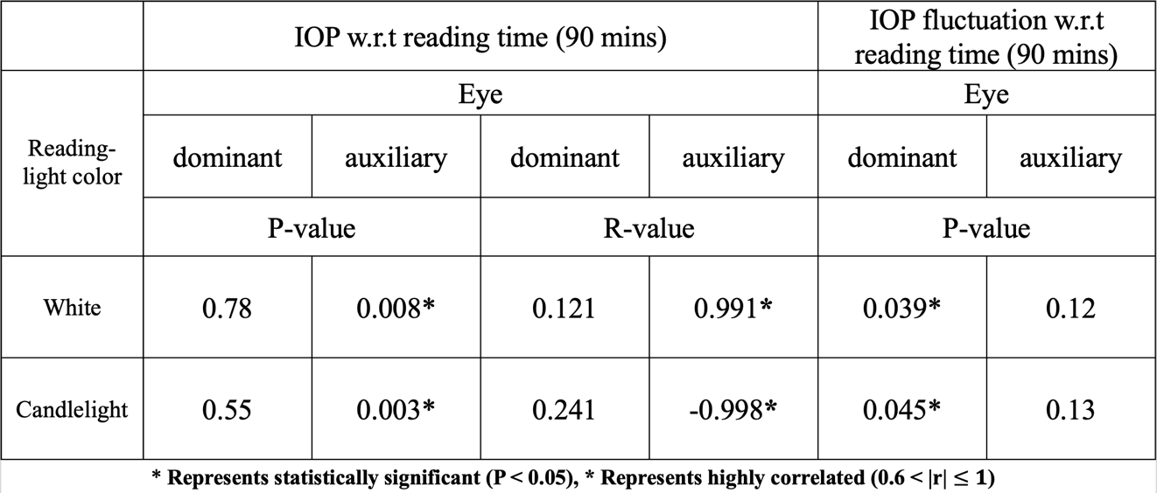

Supplemental Table 2. Statistical analysis results, P-values and R-values, regarding the effect of myopic diopter on the IOP in the dominant and auxiliary eyes of the 14 subjects after 30, 60 and 90 minutes of reading.
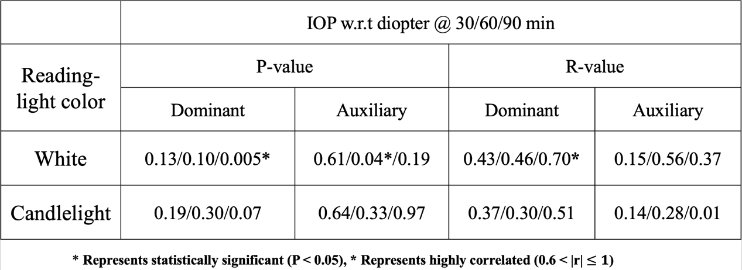

Supplemental Table 3. Statistical analysis results, P-values, regarding the effects of reading time on the IOP of subjects with different degree of myopia after 90 minutes of reading under white light and candlelight.
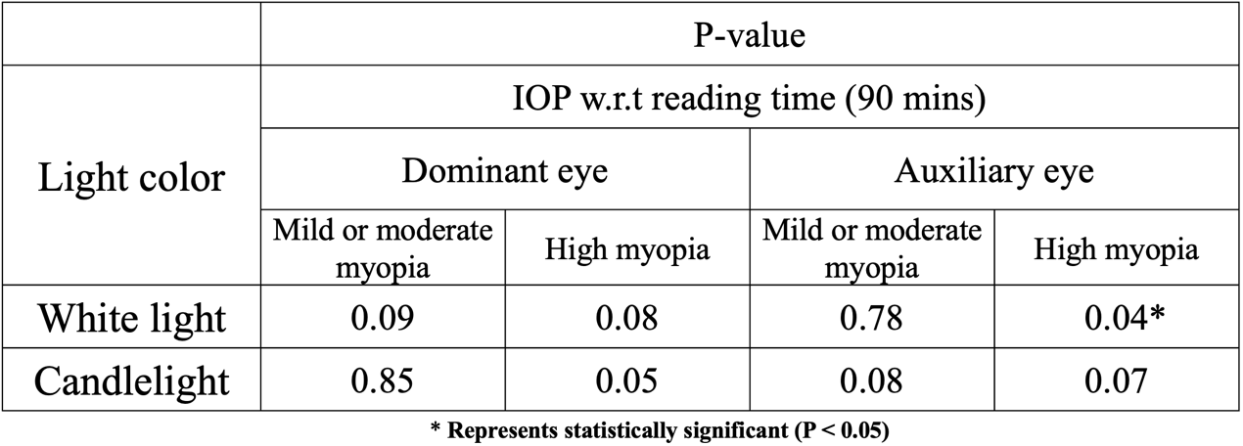

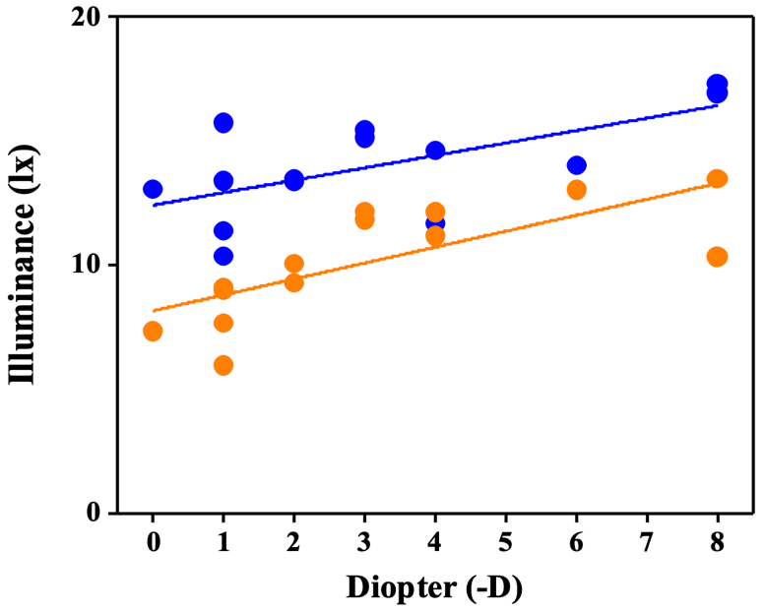
Supplemental Figure 1. Reading illuminance of subjects with various diopters upon reading a 12-pt text under white light and candlelight.

Supplemental Table 4. Statistical analysis results, P-values and R-values, regarding the effect of myopic diopter on reading illuminance of subjects when reading under white light and candlelight.
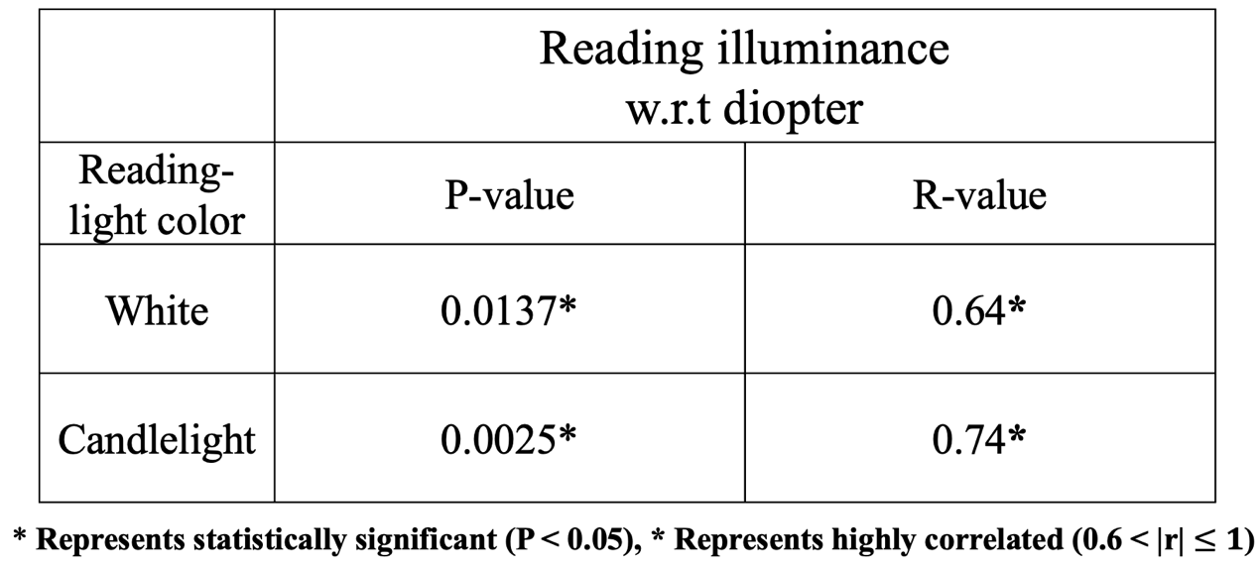

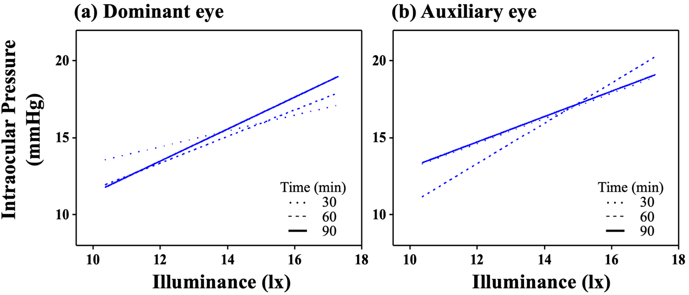
Supplemental Figure 2. IOP in the (a) dominant and (b) auxiliary eyes of subjects with various reading illuminance after for 30, 60 and 90 minutes under white light.

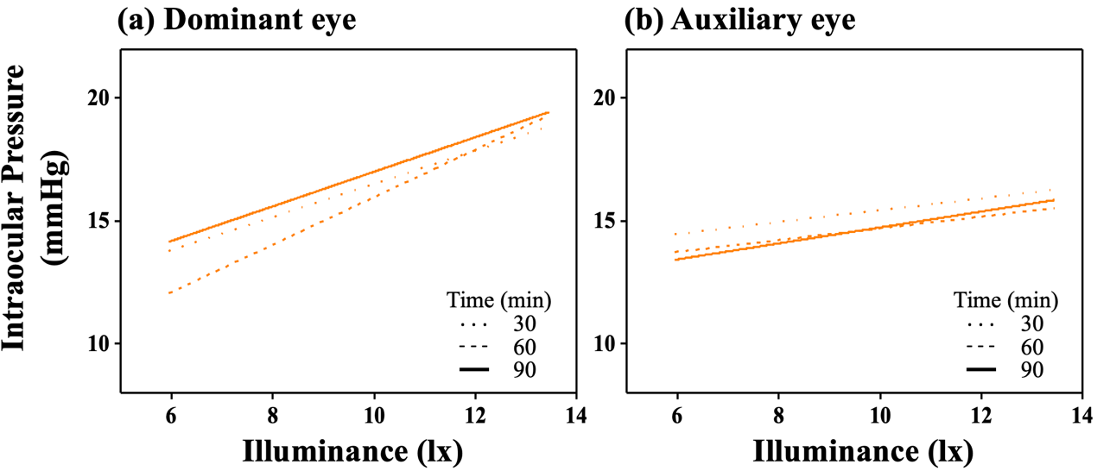
Supplemental Figure 3. IOP in the (a) dominant and (b) auxiliary eyes of subjects with various reading illuminance after for 30, 60 and 90 minutes under candlelight.

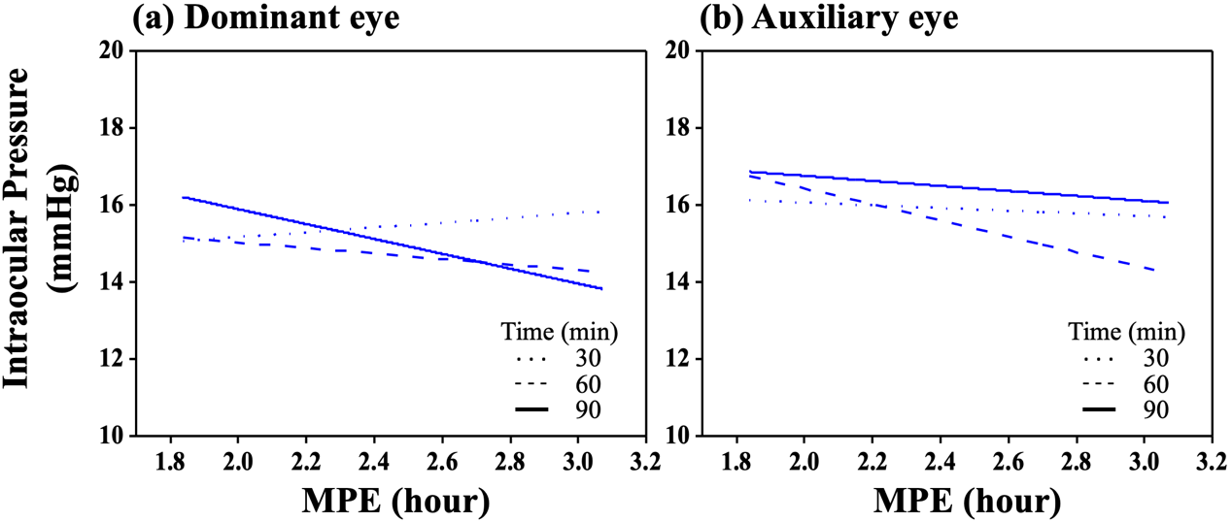
Supplemental Figure 4. IOP in the (a) dominant and (b) auxiliary eyes of subjects with various MPE after for 30, 60 and 90 minutes under white light.

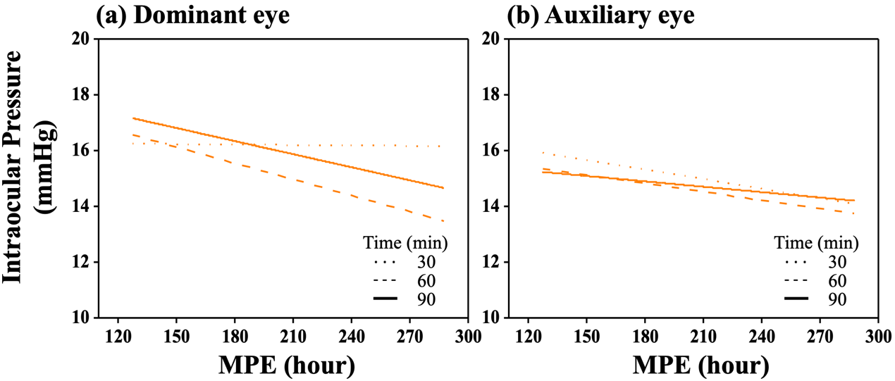
Supplemental Figure 5. IOP in the (a) dominant and (b) auxiliary eyes of subjects with various MPE after for 30, 60 and 90 minutes under candlelight.

Supplemental Table 5. Statistical analysis results, P-values, regarding the effect of reading illuminance on the IOP in the dominant and auxiliary eyes of the 14 subjects after reading for 30, 60 and 90 minutes under white light and candlelight.
