Supplementary Materials
Testing The Character-Length Word-Abstraction Association
- R Code For Plots: ConcreteAbstractLinguistics.R

To validate the hypothesized positive correlation between word length and abstractness, we utilized the lexicon developed by Köper and Schulte im Walde (2016), which includes 350,000 German lemmas. Each lemma in this dictionary is assigned a score reflecting its degree of abstractness or concreteness. These scores were derived by training an algorithm on five different sets of human-labeled training data, enabling the algorithm to accurately evaluate unseen words. The training data distinguish between abstract terms (Abst), which represent non-sensory experiences (e.g., "idea," "politics"), and concrete terms (Conc), which denote entities perceptible through the senses (e.g., "image," "scent"). This approach ensures a robust and reliable assessment of the abstractness of words based on their length.
Figure 1SA presents a scatter plot illustrating the correlation between word abstractness and word length, with values mean-centered to differentiate more abstract words (values below zero) from more concrete words (values above zero). The diameter of each circle indicates the count of words within each linguistic category that share the same character length. This visualization reveals that nouns, personal pronouns (PPROPN), verbs, and adjectives (ADJ) are the categories with the highest number of observations.
The relationship between abstractness and word length shows variability across different lexical classes. However, the trendline, represented in black with a gray confidence band, reveals a general pattern: regardless of lexical distinctions, there is a prevailing tendency for longer words to exhibit increased abstractness. This observation highlights a robust overarching trend across diverse lexical features, suggesting a fundamental linguistic attribute where word length correlates positively with abstractness.
The grouped boxplots in Figure 1SB effectively illustrate the relationship between word length and mean-centered abstractness across diverse lexical categories, contextualized by the 'BigWords' variable from our dataset. This analysis reveals a general trend where increased word length correlates with greater abstractness. However, notable deviations from this pattern are observed in auxiliary verbs, particles, and personal pronouns.
A t-test comparing words longer than seven characters to those with seven or fewer yields significant results, with means of 4.790 and 4.999, respectively (df = 32,667; p-value < 2.2e-16). This statistical evidence robustly supports the hypothesis that linguistic complexity, as manifested in longer word forms, is associated with higher levels of abstractness.
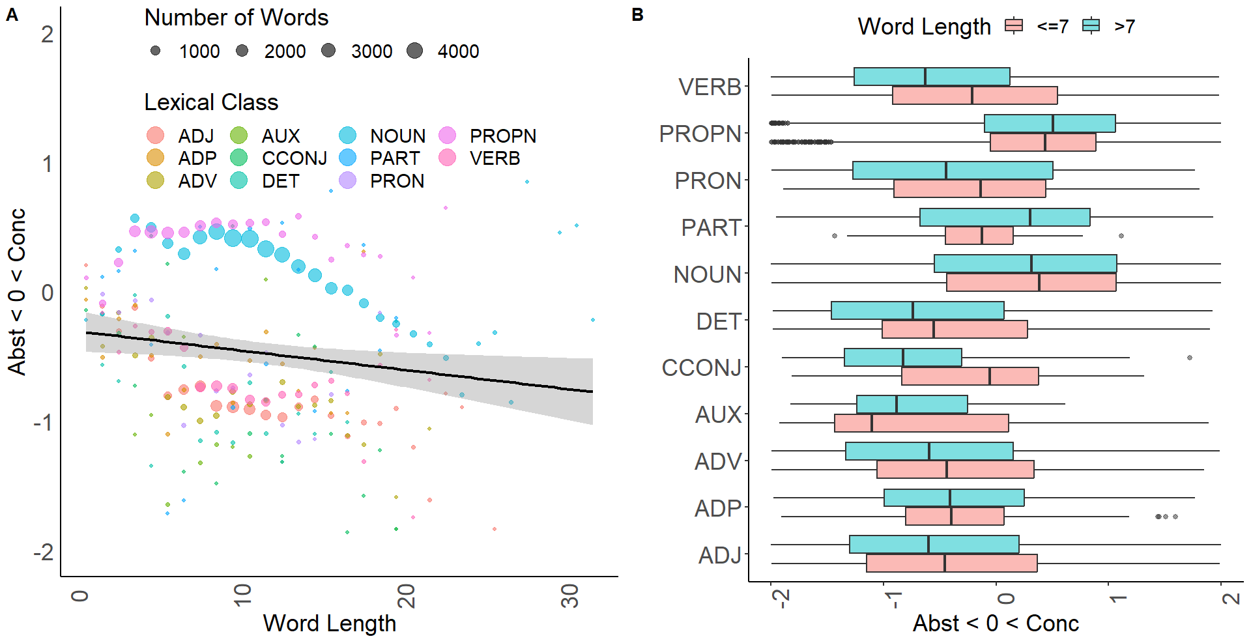
Figure 1S: Interplay Between Lexical Class, Word Length, and Abstractness/Concreteness
Summary Statistics for Best GAM Models (DaysPassedReturnVacation as Main Predictor)
- R Code For Plots: VisualizingBiphasicNatureMemories.R

The Generalized Additive Models (GAMs) below investigate the association between a smoothed term of the predictor variable DaysPassedReturnVacation—representing the number of days elapsed between encoding and retrieval—and our linguistic response variables. The Restricted Maximum Likelihood (REML) method is used to estimate the smoothing parameters by maximizing the restricted likelihood. REML is particularly effective for complex models and data structures, such as those with correlated observations or hierarchical data. This approach strikes an optimal balance between fit and complexity, resulting in more reliable and interpretable models (Wood, 2017).
To refine the models, the following variables and their interactions were incrementally added to the initial simple models. The algorithm varied the sequence of introducing potential control variables to identify the optimal models for WordCount and Posemo based on the lowest AIC. All variables were standardized during this process to ensure consistency and comparability.

Variable Name | Description | Consideration Rationale
CustomerAge | Customer age | overexpression of A2AR in aged hippocampal neurons shift from LTD to LTP (Temido-Ferreira et al., 2020)
VacationTemperature | Average temperature at the location during the customer’s stay at the hotel | Ambient temperature exhibits consistent positive correlations with serotonergic activity (McMorris et al., 2006; Ishiwata, Hasegawa & Greenwood, 2017), while the effect on dopamine is more mixed and appears to depend on the specific brain region (Chauhan et al., 2017; Ishiwata, Hasegawa & Greenwood, 2017)
RetrievalTemperature | Average temperature at the customer’s home on the day of review provision
TimeZonesCrossed | The number of time zones crossed to reach a destination significantly impacts the likelihood of experiencing disrupted sleep upon arrival. This disruption, in turn, affects cognitive functions such as memory encoding. The greater the number of time zones traversed, the higher the probability of sleep disturbances, which can impair cognitive processes during the initial period of adjustment. | Sleep deprivation impairs LTP in hippocampus Brief periods of sleep deprivation negatively impact the acquisition, consolidation, and retrieval of memories (Heckman, Kuhn, Meerlo & Havekes, 2020), impairs LTP in the hippocampus (Campbell, Guinan, & Horowitz, 2002; Kreutzmann, Havekes, Abel, & Meerlo, 2015). The capacity to encode new memories is the most vulnerable to sleep loss (Cousins & Fernández, 2019)
RetrievalSunshineDuration | Sunshine duration on the retrieval day at the customer’s home | UV exposure which depends on latitude (Lambert et al., 2002; Spindelegger et al., 2012) is positively correlated with globally increased serotonergic activity, which should be more beneficial for LTD induction  High 5-HT transmission reduces quantity of retrieved information (Meeter, Talamini, Schmitt & Riedel, 2006)  People write longer and more negative reviews on rainy days due to weather induced incidental emotions and lower opportunity costs (Brandes & Dover, 2022)
PredictionError | Difference between the CumulativeRating (the expectation of the hotel based on the average review seen by the customer during booking) and the rating provided by the customer) | Prediction errors impact synaptic plasticity via dopamine and serotonin, which facilitate LTP and LTD, respectively (Wert-Carvajal, Reneaux, Tchumatchenko & Clopath, 2022)
VacationDuration | Number of days spent at the hotel | The duration of an individual's vacation positively correlates with the volume of experiences and information they are likely to discuss post-vacation.

The model that resulted in the lowest AIC value - indicating the best fit among the models considered were the following:

Best Model (Posemo; AIC = 1744625)
Family: gaussian
Link function: identity

Formula:
Posemo ~ s(DaysPassedReturnVacation) + s(PredictionError) + s(VacationTemperature)

Parametric coefficients:
Estimate Std. Error t value Pr(>|t|)
(Intercept) 6.21389 0.00804 772.8 <2e-16 ***
---
Signif. codes: 0 ‘***’ 0.001 ‘**’ 0.01 ‘*’ 0.05 ‘.’ 0.1 ‘ ’ 1

Approximate significance of smooth terms:
edf Ref.df F p-value
s(DaysPassedReturnVacation) 8.664 8.952 140.2 <2e-16 ***
s(PredictionError) 7.774 8.611 2131.3 <2e-16 ***
s(VacationTemperature) 8.554 8.944 347.3 <2e-16 ***
---
Signif. codes: 0 ‘***’ 0.001 ‘**’ 0.01 ‘*’ 0.05 ‘.’ 0.1 ‘ ’ 1

R-sq.(adj) = 0.0721 Deviance explained = 7.22%
GCV = 19.431 Scale est. = 19.429 n = 300551

Relative Importance Scores
The resulting importance scores will indicate the relative importance of each predictor in the model. The importance scores are derived from the F-values of the smooth terms in your GAM model, normalized to sum up to 1. Higher scores suggest more relevant predictors.

Variable Importance
s(DaysPassedReturnVacation_z) 0.3466586
s(VacationTemperature_z) 0.3422822
s(PredictionError_z) 0.3110592
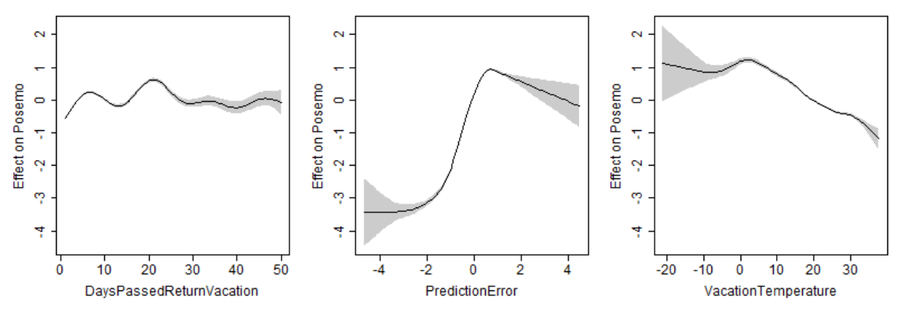
Figure 2S: Predictors for the Optimal GAM Model for Posemo

Best Model (WordCount; AIC = 595873)
Family: gaussian
Link function: identity

Formula:
WC ~ s(DaysPassedReturnVacation) + s(VacationDuration) + s(CustomerAge) +
s(PredictionError)

Parametric coefficients:
Estimate Std. Error t value Pr(>|t|)
(Intercept) 145.4534 0.9106 159.7 <2e-16 ***
---
Signif. codes: 0 ‘***’ 0.001 ‘**’ 0.01 ‘*’ 0.05 ‘.’ 0.1 ‘ ’ 1

Approximate significance of smooth terms:
edf Ref.df F p-value
s(DaysPassedReturnVacation) 8.024 8.671 16.59 <2e-16 ***
s(VacationDuration) 4.562 5.539 273.80 <2e-16 ***
s(CustomerAge) 7.842 8.562 283.25 <2e-16 ***
s(PredictionError) 6.891 8.016 169.49 <2e-16 ***
---
Signif. codes: 0 ‘***’ 0.001 ‘**’ 0.01 ‘*’ 0.05 ‘.’ 0.1 ‘ ’ 1

R-sq.(adj) = 0.106 Deviance explained = 10.7%
GCV = 37018 Scale est. = 36994 n = 44611

Relative Importance Scores
Variable Importance
s(DaysPassedReturnVacation_z) 0.2937139
s(CustomerAge_z) 0.2870559
s(PredictionError_z) 0.2522444
s(VacationDuration_z) 0.1669858

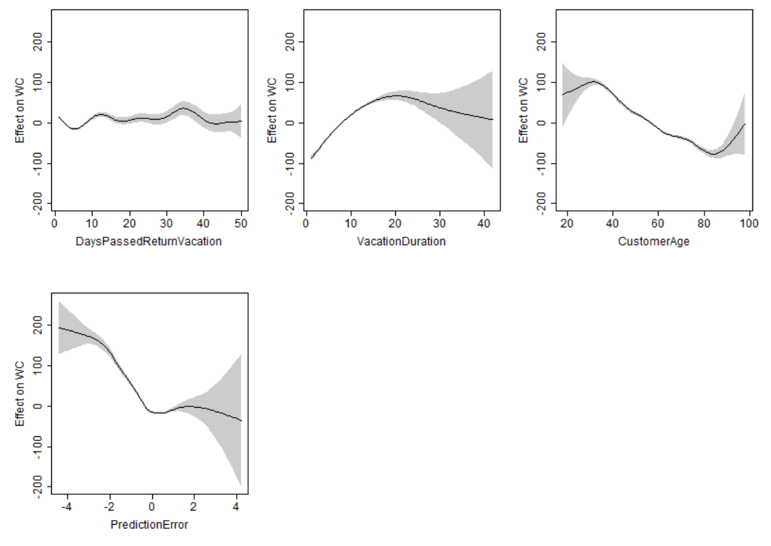
Figure 3S: Predictors for the Optimal GAM Model for WC
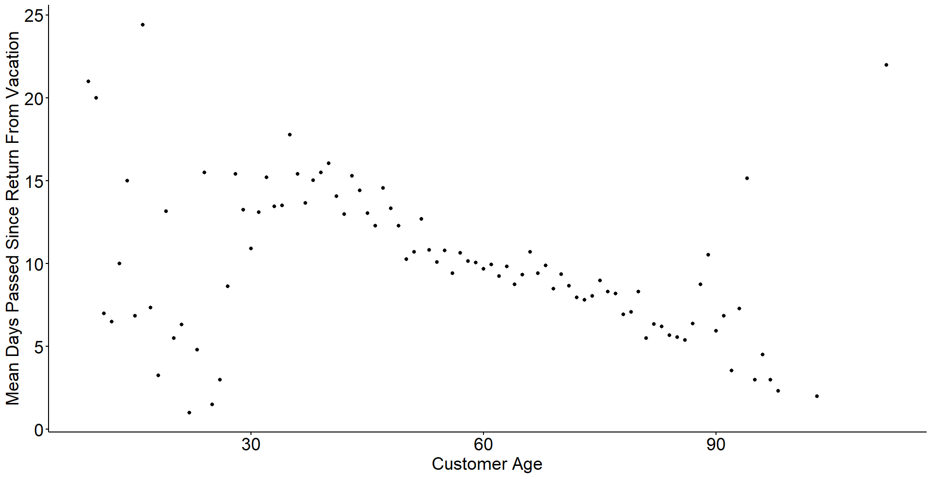
Figure 4S: Effect of Customer Age on Delay in Review Provision

Best Model (BigWords; AIC = 317311)
Family: gaussian
Link function: identity

Formula:
BigWords ~ s(DaysPassedReturnVacation) + s(TimeZonesCrossed) +
s(CustomerAge)

Parametric coefficients:
Estimate Std. Error t value Pr(>|t|)
(Intercept) 27.29725 0.03669 744.1 <2e-16 ***
---
Signif. codes: 0 ‘***’ 0.001 ‘**’ 0.01 ‘*’ 0.05 ‘.’ 0.1 ‘ ’ 1

Approximate significance of smooth terms:
edf Ref.df F p-value
s(DaysPassedReturnVacation) 3.455 4.244 6.605 1.87e-05 ***
s(TimeZonesCrossed) 8.387 8.843 41.280 < 2e-16 ***
s(CustomerAge) 3.891 4.808 129.587 < 2e-16 ***
---
Signif. codes: 0 ‘***’ 0.001 ‘**’ 0.01 ‘*’ 0.05 ‘.’ 0.1 ‘ ’ 1

R-sq.(adj) = 0.0235 Deviance explained = 2.39%
GCV = 61.421 Scale est. = 61.399 n = 45619

Relative Importance Scores
Variable Importance

s(TimeZonesCrossed_z) 0.5330798
s(CustomerAge_z) 0.2473196
s(DaysPassedReturnVacation_z) 0.2196006

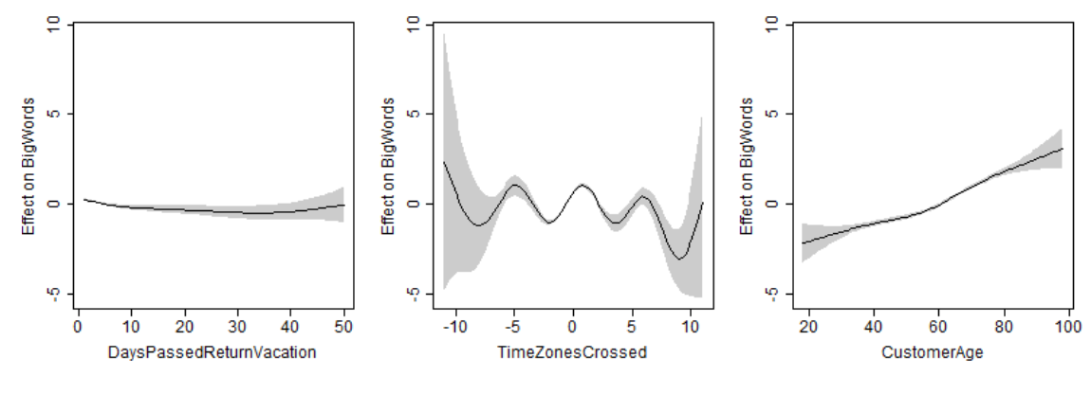
Figure 5S: Predictors for the Optimal GAM Model for BigWords

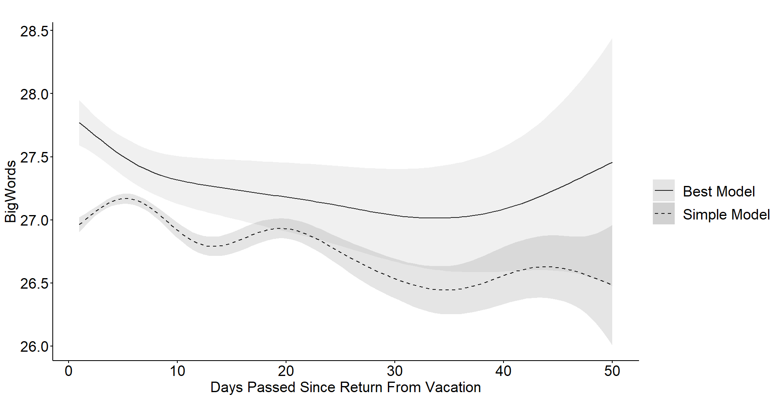
Figure 6S: Comparison of the Optimal GAM Model with the Simple GAM Model for BigWords

Best Model (Negemo; AIC = 1081767)
Family: gaussian
Link function: identity

Formula:
Negemo ~ s(DaysPassedReturnVacation) + s(VacationTemperature) +
s(PredictionError)

Parametric coefficients:
Estimate Std. Error t value Pr(>|t|)
(Intercept) 1.055032 0.002669 395.3 <2e-16 ***
---
Signif. codes: 0 ‘***’ 0.001 ‘**’ 0.01 ‘*’ 0.05 ‘.’ 0.1 ‘ ’ 1

Approximate significance of smooth terms:
edf Ref.df F p-value
s(DaysPassedReturnVacation) 1.091 1.176 4.516 0.0236 *
s(VacationTemperature) 4.375 5.444 188.249 <2e-16 ***
s(PredictionError) 8.376 8.891 990.749 <2e-16 ***
---
Signif. codes: 0 ‘***’ 0.001 ‘**’ 0.01 ‘*’ 0.05 ‘.’ 0.1 ‘ ’ 1

R-sq.(adj) = 0.0321 Deviance explained = 3.21%
GCV = 2.1413 Scale est. = 2.1412 n = 300551

Relative Importance Scores
Variable Importance
s(PredictionError_z) 0.60220644
s(VacationTemperature_z) 0.31688974
s(DaysPassedReturnVacation_z) 0.08090382

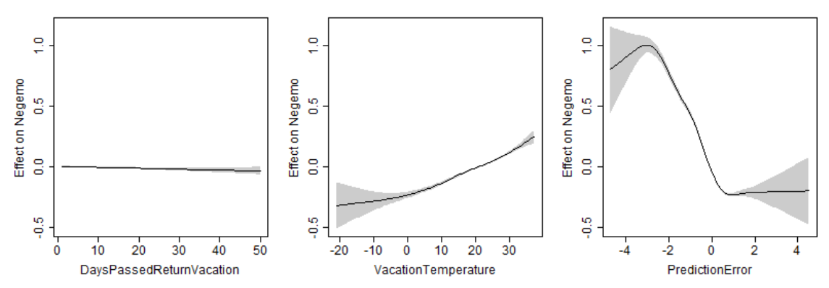
Figure 7S: Predictors for the Optimal GAM Model for Negemo

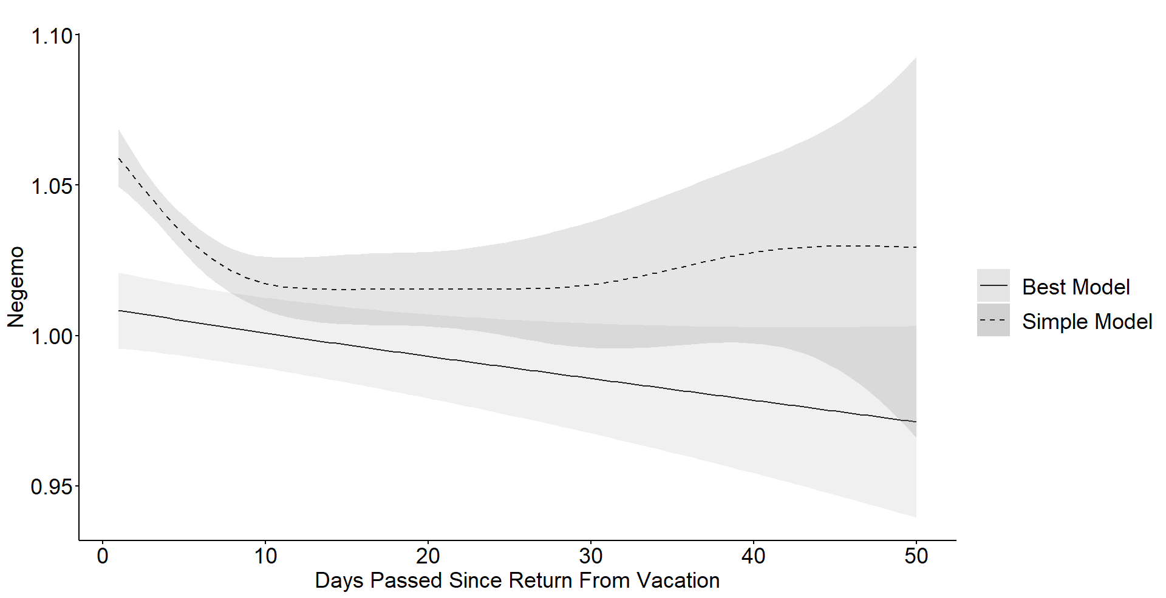
Figure 8S: Comparison of the Optimal GAM Model with the Simple GAM Model for Negemo

