Fault Geometry and Kinematics Within the Anatolian Microplate from Restored Pleistocene Lava Flows
Gülin Gençoğlu Korkmaz, Janet C. Harvey, Martin Danišík, Lindsay M. Schoenbohm, and Axel K. Schmitt

Supplementary Information
Supplementary Note 1.
Supplementary Figure 1-2.
Supplementary Table 1-2.
Supplementary References

Supplementary Data Files (Table 3-8).
Supplementary Note 1.
Previous fault offset rates and lava flow ages
Previously reported displacement rates for the Tuz Gölü Fault Zone (TGFZ) are based on offset geological features and geodetic models (Table 1). Long-term vertical displacement rates between c. 5 and 3 Ma were determined based on faulted ignimbrite deposits as 0.03 to 0.05 mm/a for the western flank, and 0.08 to 0.13 mm/a for the eastern flank of the TGFZ¹. Similar vertical displacement rates of 0.05 mm/a². were estimated based on ⁴⁰Ar/³⁹Ar feldspar geochronology yielding an eruption age of 5.19 ± 0.37 Ma for Kızılkaya Ignimbrite³. Hasandağ lavas dissected by the Helvadere and Altunhisar segments of the TGFZ were dated by ⁴⁰Ar/³⁹Ar geochronology with ages between 0.18 and 1.5 Ma⁴, but the dates obtained for some of these flows are inconsistent with other geochronological and stratigraphic constraints so that correlation and inferred dextral slip rates of 0.58 to 3.53 mm/a therefore remain tenuous (see below). For the southernmost segment of the TGFZ (Bor Segment), rates for normal slip based on thermoluminescence dating and electrical resistivity tomography across faulted tuff and travertine deposits fall within the range of 0.0714–0.112 mm/a⁵.
Block models based on geodetic data (Global Positioning System, GPS) indicate normal slip at a rate of ~1 mm/a and right-lateral slip at 5 mm/a along the central and/or southern segments of the TGFZ⁶. Comparatively faster normal slip rates of 2 mm/a and slightly slower strike-slip rates of 1.8 mm/a were determined through block modeling for the Acıpınar and Helvadere segments based on Global Navigation Satellite Systems (GNNS) and GPS data⁷. In a departure from preceding findings, kinematic analysis of geodetic data (Interferometric Synthetic Aperture Radar, InSAR, and GPS) yielded right-lateral slip at 3 mm/a, with the TGFZ distinctly lacking any vertical displacement⁸.
Existing age determinations for lava flows from the eastern part of Hasandağ that are dissected by the TGFZ were compiled and assigned to the lava flows (F1–4) sampled here (Supplementary Table 2). In this comparison, ages are consistently reported as ka and with uncertainties at the 2σ level.
Two ages are available for F1: (1) a hornblende ⁴⁰Ar/³⁹Ar plateau age of 190 ± 50 ka that integrates the steps from ~40–90% cumulative ³⁹Ar released (TG12V-19 in Krystopowicz ⁴), and (2) a zircon (U-Th)/He age of 41.0 ± 5.6 ka based on 9 replicate analyses (sample 17-BF-08 in Friedrichs et al.⁹)The initial and late Ar release steps are significantly older than the plateau age, resulting in an integrated age of 470 ± 50 ka⁴. This suggests that hornblende contains excess ⁴⁰Ar, and that this also affected the steps used for calculating the plateau age. The F1 ⁴⁰Ar/³⁹Ar age therefore in interpreted to overestimate the eruption age.
F2 has been dated using ⁴⁰Ar/³⁹Ar geochronology on samples TG12V-13 and TG12V-14 collected to the east and west of the TGFZ, respectively⁴. Initial and final heating steps for TG12V-13 reveal progressively older ages compared to the plateau age, again suggesting the presence of excess ⁴⁰Ar in the hornblende. The hornblende ⁴⁰Ar/³⁹Ar plateau age integrating over ~75% of the cumulative ³⁹Ar release is determined at 280 ± 50 ka, whereas the integrated age over all steps is 530 ± 60 ka. The hornblende ⁴⁰Ar/³⁹Ar release pattern for TG12V-14 is again U-shaped with initial and late ³⁹Ar release steps exhibiting significantly older ages than the intermediate steps, resulting in an integrated age of 590 ± 50 ka. The plateau age integrating ~55% of the cumulative ³⁹Ar release is 400 ± 20 ka⁴. Although the release patterns for F2 sampled on both sides of the TGFZ are similar, with the youngest intermediate steps overlapping zero age, the calculated plateau ages show significant disparity. Due to the potential contribution of excess ⁴⁰Ar even to the intermediate steps, the hornblende ⁴⁰Ar/³⁹Ar ages for F2 may therefore not accurately reflect the timing of eruption.
For F3, three previous ages exist from two studies, all from the eastern side of the TGFZ: (1) a whole-rock ⁴⁰Ar/³⁹Ar integrated age of 130 ± 50 ka that includes ~90% of the cumulative ³⁹Ar released (TG12V-17) and (2) a whole-rock ⁴⁰Ar/³⁹Ar integrated age of 180 ± 50 ka also comprising ~90% of the cumulative ³⁹Ar released (TG12V-08; both reported in Krystopowicz⁴), and (3) a K-Ar age of 84 ± 4.4 ka from groundmass of dacitic rocks (sample CKUZ-DM-10 in Kuzucuoğlu et al.¹⁰). The continuously rising trend in age for heating steps of samples TG12V-17 and TG12V-08⁴ suggests the presence of extraneous Ar at high temperatures. The K-Ar groundmass age is ambiguous as it is described as a sample from a dacitic flow, whereas F2 is basaltic andesite. In any case, it is significantly younger compared to the average whole-rock ⁴⁰Ar/³⁹Ar age of 160 ± 40 ka.
Previous investigations have delineated four ages for Flow 4. Among them, two ⁴⁰Ar/³⁹Ar ages are reported for the western part of the TGFZ⁴. A biotite ⁴⁰Ar/³⁹Ar plateau age of 290 ± 30 ka (R11KP10) is indistinguishable from the integrated age of 294 ± 7 ka. The corresponding hornblende ⁴⁰Ar/³⁹Ar age for another sample of F4 from the western part of the TGFZ (TG12V-02) is 260 ± 20 ka (plateau for ~40% of cumulative ³⁹Ar released) and an integrated age of 290 ± 20 ka⁴. For the eastern part of F4, a groundmass K-Ar age of 99 ± 4.4 ka is reported for what is described as a trachytic basaltic rock (CKUZ 97/8-05), whereas our compositional data indicate that F4 is dacitic in composition. However, another sample from the eastern part of F4 (TG12V-07) yielded an integrated hornblende ⁴⁰Ar/³⁹Ar age of 1480 ± 80 ka⁴, but a hump-shaped pattern and a lack of a plateau within the heating steps age suggests that this age is unreliable. The notable incongruity that emerges between F4 K-Ar and Ar-Ar ages for samples collected from the eastern and western parts of the TGFZ hints at problems such as excess ⁴⁰Ar, and in some cases violates stratigraphic constraints for F4 overlying pyroclastic deposits that were dated by zircon U-Pb geochronology and which require an emplacement of F4 after 339 ± 50 ka¹¹.
Comparing previous ages for F1–4, a pattern emerges where disequilibrium-corrected zircon (U-Th)/He ages agree with the comparatively imprecise whole-rock ⁴⁰Ar/³⁹Ar age (143 ± 7 ka vs. 160 ± 40 ka for F3, respectively). By contrast, hornblende and biotite ⁴⁰Ar/³⁹Ar ages in Krystopowicz⁴ are always older than ZDD ages from the literature and this study. The presence of extraneous ⁴⁰Ar within hydrous silicate minerals such as biotite is a well-known complication for dating young volcanic rocks in continental environments¹², and we suspect a similar pattern here. Lastly, K-Ar ages on groundmass are younger than ⁴⁰Ar/³⁹Ar ages on whole-rock for the same flow for unknown reasons.

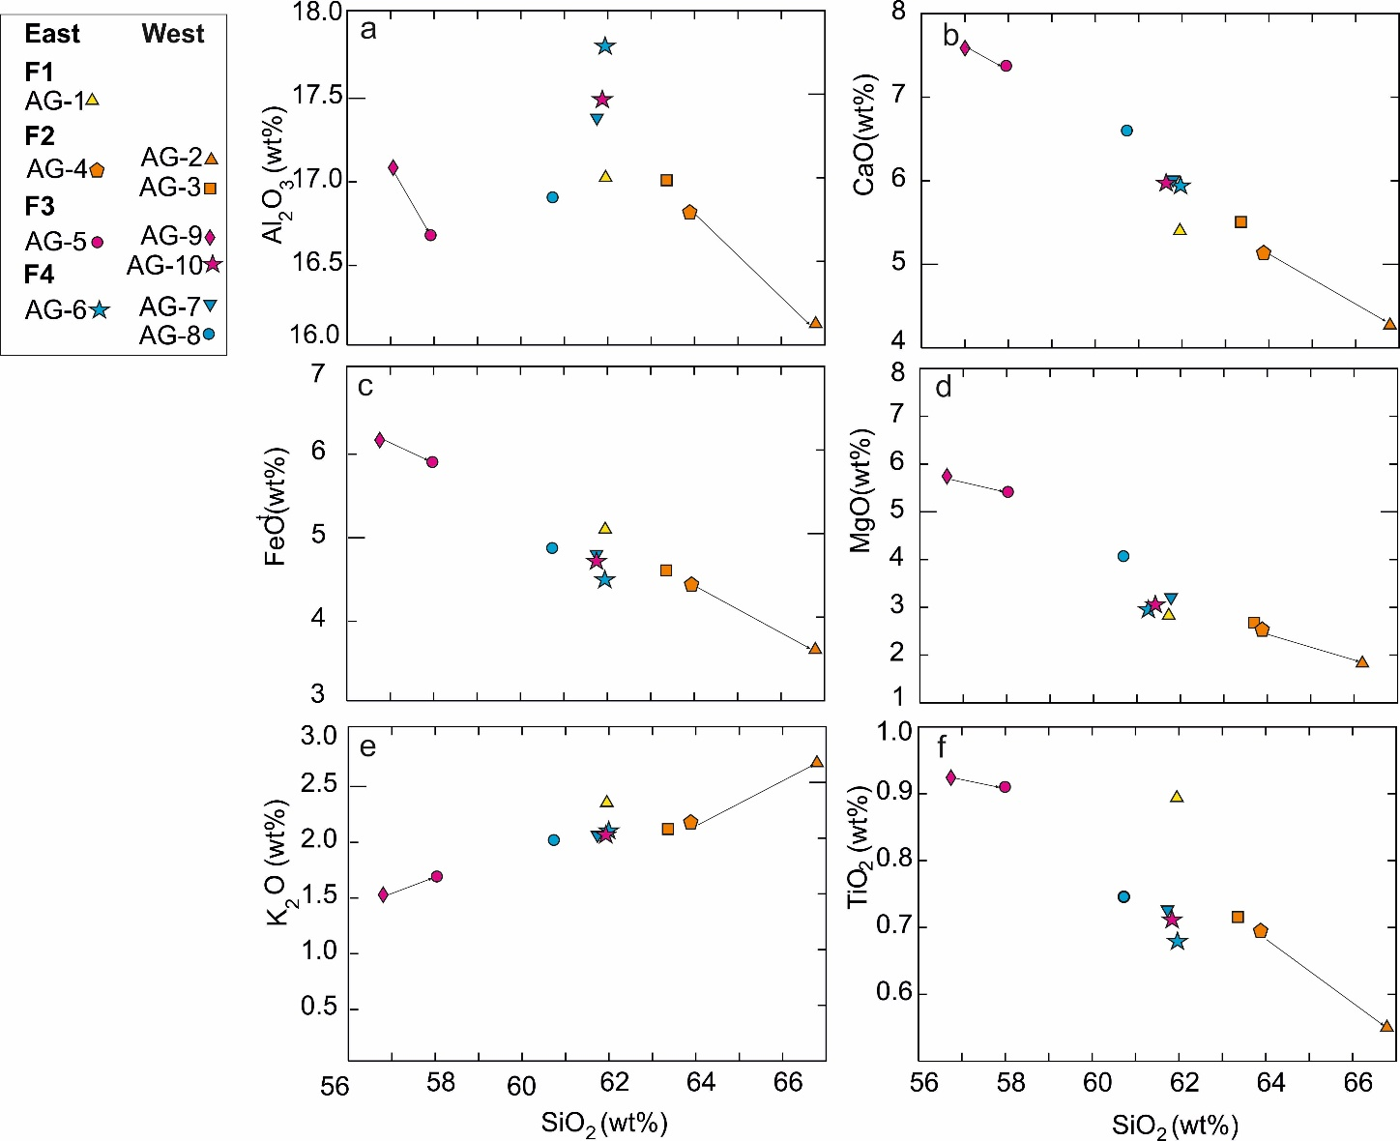
Supplementary Fig. 1 SiO₂ versus selected major oxides bivariate diagram of the investigated rocks. The straight lines between rock pairs represent possible fractional crystallization or mixing trends.

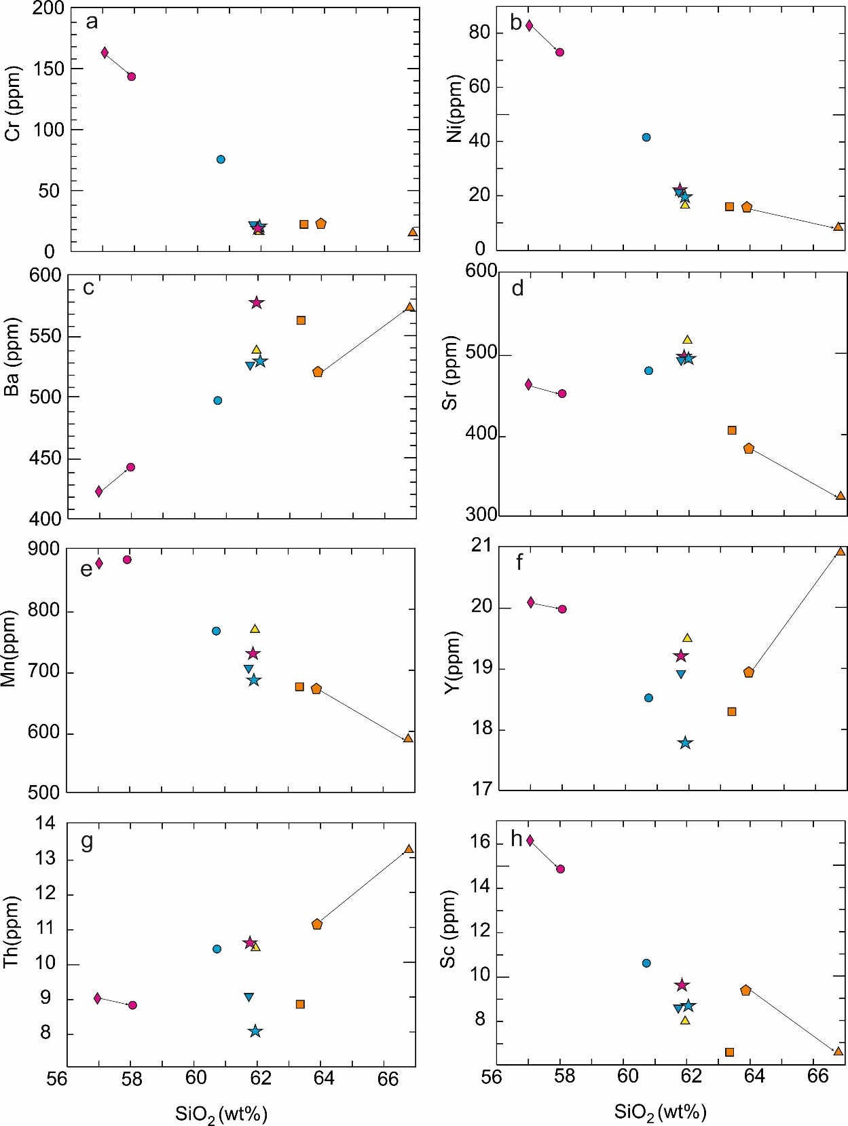
Supplementary Fig. 2 SiO₂ versus selected trace elements bivariate diagram of the investigated rocks. The straight lines between rocks represent the possible relationship of fractional crystallization
Flow (F) -Direction (W/E)-Sample | Rock Clas. (TAS) | Mineral contents |  |  |  |  |  |  |  |  |  |  |  |  |  |  |  |  |  |  |  |  | Other properties
Flow (F) -Direction (W/E)-Sample | Rock Clas. (TAS) | Ol |  | Cpx |  | Opx |  | Amp |  | Bt |  | Ilm |  | TiMgt |  | Qz |  | Pl |  | Ap | Zrn
Flow (F) -Direction (W/E)-Sample | Rock Clas. (TAS) | P | M | P | M | P | M | P | M | P | M | P | M | P | M | P | M | P | M | M | M
F1-E-AG1 | Andesite | + | - | + | + | ++ | + | + | - | 0 | 0 | + | + | + | + | - | - | ++ | ++ | 0 | 0 | Pl= Sieve-textured, Amp= Thick opaque reaction rims, black opacitizied, opacitic dirty cores, Qz= Ocellar textured, Bt= formed through both the breakdown process of amphiboles and as separate crystals with fine and/or coarse-grained reaction rims.
F2-W-AG2 | Dacite | + | - | + | + | ++ | + | ++ | + | 0 | - | + | + | + | + | - | 0 | ++ | ++ | 0 | 0 | Pl= Sieve-textured, Amp= Rare oxidized, rare thin opaque reaction rims, rare resorbed surfaces, rarely transformed into prx, Bt= formed as separate crystals with thin/fine reaction rim, Qz= rare separate fresh crystals
F2-W-AG3 | Dacite | - | - |  | + | + | + | + | - | - | 0 | + | + | + | + | - | - | ++ | ++ | 0 | 0 | Pl= Sieve-textured, Amp= Thick opaque reaction rims, rare black opacitizied, rare opacitic dirty cores, internal breakdown patches of cores containing fine grained reaction products, Bt= rare and formed through the breakdown process of amphiboles
F2-E-AG4 | Dacite | + | - | ++ | + | ++ | + | + | - | - | 0 | + | + | + | + | - | - | ++ | ++ | 0 | 0 | Pl= Sieve-textured, Amp= Thick opaque reaction rims, black opacitizied, opacitic dirty cores, rare black opacitizied rims overgrowth by prx, transformed into prx, Bt= rare and observed as inclusion in plagioclase, and formed through the breakdown process of amphiboles
F3-E-AG5 | Andesite | ++ | + | ++ | + | + | + | + | - | - | - | + | + | + | + | - | - | ++ | ++ | 0 | 0 | Pl= Sieve-textured, Amp= rare thick opaque reaction rims, resorbed surfaces, Cpx= resorbed surfaces, Qz= Embayed and Ocellar textured
F4-E-AG6 | Andesite | + | - | + | + | ++ | + | + | - | 0 | - | + | + | + | + | - | - | ++ | ++ | 0 | 0 | Pl= Sieve-textured, Amp= Thick opaque reaction rims, black opacitizied, rare thick opaque reaction rims, Qz= ocellar textured
F4-W-AG7 | Andesite | + | - | - | + | ++ | + | + | - | 0 | 0 | + | + | + | + | - | - | ++ | ++ | 0 | 0 | Pl= Sieve-textured, Amp= thick opaque reaction rims, rare reaction rim-free, reaction rim overgrowth by prx, black opacitizied, opacitic dirty cores, Ol= overgrowth by opx, Bt= formed through both the breakdown process of amphiboles and as separate crystals with fine and/or coarse-grained reaction rims, Qz= Embayed and Ocellar-textured
F4-W-AG8 | Andesite | + | - | ++ | + | + | + | + | - | 0 | 0 | + | + | + | + | - | - | ++ | ++ | 0 | 0 | Pl= Sieve-textured, Amp= thick opaque reaction rims, black opacitizied, opacitic dirty cores, rarely breakdown into cpx±opx±pl, Ol= overgrowth by cpx,Bt= formed through both the breakdown process of amphiboles and as separate crystals with fine and/or coarse-grained reaction rims, Qz= Ocelli and embayed-textured
F3-W-AG9 | Basaltic-andesite | ++ | + | ++ | + | + | + | + | - | - | - | + | + | + | + | - | - | ++ | ++ | 0 | 0 | Pl= Sieve-textured, Amp=rare thick opaque reaction rims, rare resorbed surfaces, Cpx= rare resorbed surfaces, Qz= Embayed and Ocellar-textured
F3-W-AG10* | Andesite | + | + | + | + | ++ | + | + | - | 0 | 0 | + | + | + | + | - | 0 | ++ | ++ | 0 | 0 | Pl= Sieve-textured, Amp=thick opaque reaction rims, black opacitizied, opacitic dirty cores, Bt= formed through both the breakdown process of amphiboles and as separate crystals without or with fine and/or coarse-grained reaction rims, Qz= Embayed and Ocellar-textured, rare separate fresh crystals
Supplementary Table 1.
Notes: Rock Clas. (TAS): Total Alkali-Silica Rock Classification¹³; M: Microlite; P: Phenocryst; ++: abundant; +: moderate; 0: accessory; -: absent. Mineral abbreviations are based on Whitney and Evans¹⁴. * Dome complex near F3 vent, but compositionally unrelated to F3
Supplementary Table 1 Mineral Composition and Prominent Textural Properties of the Investigated Rocks
Supplementary Table 2.
Supplementary Table 2. Previous age determinations of the Hasandağ lava flows offset by the TGFZ in comparison to results from this study.

Flow (F)- Direction to TGFZ (W/E) |  | ²³⁸U -²³⁰Th age (ka) – Sample code  (this study) | Diseq. -cor. (U-Th)/He age (ka) –  Sample code  (this study) |  | ⁴⁰Ar -³⁹Ar age (ka) –  Sample code⁴ | K-Ar age (ka) –  Sample code¹⁰ | ZDD eruption age (ka)  Sample code⁹
F1-E | 59.0^{+27.1}_{-21.7} - AG1 |  |  | 38.4 ±2.2- AG1 | 190±50 - TG12V-19 | N.D. | 41.0±5.6 - 17-BF-08
F2-W | 131⁺⁵¹₋₃₅- AG2 |  |  | 98.6±4.4 - AG2 | 400±200 - TG12V-14 | N.D. | N.D.
F2-W | 155⁺⁹₋₉ - AG3 |  |  | N.D. | 400±200 - TG12V-14 | N.D. | N.D.
F2-E | 165⁺¹⁴²₋₆₀ - AG4 |  |  | 92.2±4.8 - AG4 | 280±150 - TG12V-13 | N.D. | N.D.
F3-E | 211⁺⁹¹₋₄₉ - AG5 |  |  | 143±7 - AG5 | 130±10; 180±50 - TG12V-08; -17 | 84±4 - CKUZ-DM-10 | N.D.
F4-E | 243^{+∞}₋₈₄ - AG6 |  |  | 155±9 - AG6 | 1480±80 - TG12V-07 | 99±4 - CKUZ-97/8- 05 | N.D.
F4-W | 292^{+∞}₋₁₀₅ - AG7 |  |  | 149±7 - AG7 | 260±20; 290±30 - TG12V-02; R11KP10 | N.D. | N.D.
F4-W | 322⁺⁵⁴₋₃₆ - AG8 |  |  | N.D. | 260±20; 290±30 - TG12V-02; R11KP10 | N.D. | N.D.
F3-W | 246⁺²⁴⁶₋₇₀ - AG9 |  |  | N.D. | N.D. | N.D. | N.D.
F3-W | 294⁺³⁵₋₂₆ - AG10 |  |  | N.D. | N.D. | N.D. | N.D.
Note:
ZDD eruption age: Eruption age calculated by MCHeCalc program¹⁵ from a range of single grain of disequilibrium corrected (U–Th)/He dates obtained on the same sample.
N.D.: Not determined.
Uncertainties at 2σ level.

Supplementary References
1. Özsayın E, Ciner A, Rojay B, Dirik K, Melnick D, Fernández-Blanco D, Bertotti G, Schildgen T, Garcin Y, Strecker M & Sudo M. Plio-Quaternary extensional tectonics of the Central Anatolian Plateau: A case study from the Tuz Gölü Basin, Turkey. Turk J Earth Sci 22, (2013).
2. Kürçer A & Gökten YE. Neotectonic-period characteristics, seismicity, geometry and segmentation of the Tuz Gölü fault zone. Bulletin of the Mineral Research and Exploration 149, 19-68 (2014).
3. Aydar E, Schmitt A, Cubukcu H, Akin L, Ersoy O, Şen E, Duncan R & Atici G. Correlation of ignimbrites in the central Anatolian volcanic province using zircon and plagioclase ages and zircon compositions. Journal of Volcanology and Geothermal Research 213, 83–97 (2012).
4. Krystopowicz NJ. Constraining deformation, uplift, and activity along the Tuz Gölü fault zone, Central Anatolia, Turkey. In: Graduate Department of Earth Sciences ). University of Toronto (2015).
5. Öztürk MZ, Şener MF, Şener M & Şahiner E. Tuzgölü Fay Zonu Bor Segmenti’nin Kuvaterner Atım Miktarı. Niğde Ömer Halisdemir Üniversitesi Mühendislik Bilimleri Dergisi 7, 1049-1053 (2018).
6. Aktuğ B, Parmaksız E, Kurt M, Lenk O, Kılıçoğlu A, Gürdal MA & Özdemir S. Deformation of Central Anatolia: GPS implications. Journal of Geodynamics 67, 78-96 (2013).
7. Gezgin C, Tiryakioglu I, Ekercin S & Gürbüz E. Tuz Gölü Fay Zonu (TGFZ) Güney Kesimine ait Tektonik Hareketlerin GNSS Gözlemleri ile İzlenmesi. 20, 456-464 (2020).
8. Özbey V, Şengör AMC & Özeren MS. Tectonics in a very slowly deforming region in an orogenic belt. Tectonophysics 827, 229272 (2022).
9. Friedrichs B, Atıcı G, Danisik M, Atakay E, Çobankaya M, Harvey JC, Yurteri E & Schmitt AK. Late Pleistocene eruptive recurrence in the post-collisional Mt. Hasan stratovolcanic complex (Central Anatolia) revealed by zircon double-dating. Journal of Volcanology and Geothermal Research 404, 107007 (2020).
10. Kuzucuoğlu C, Gündoğdu Atakay E, Mouralis D, Atıcı G, Guillou H, Türkecan A & Pastre JF. Geomorphology and tephrochronology review of the Hasandağ volcano (southern Cappadocia, Turkey). Mediterranean Geoscience Reviews, (2020).
11. Aydın F, Schmitt AK, Siebel W, Sönmez M, Ersoy Y, Lermi A, Dirik K & Duncan R. Quaternary bimodal volcanism in the Niğde Volcanic Complex (Cappadocia, central Anatolia, Turkey): age, petrogenesis and geodynamic implications. Contributions to Mineralogy and Petrology 168, 1078 (2014).
12. Hora JM, Singer BS, Jicha BR, Beard BL, Johnson CM, de Silva S & Salisbury M. Volcanic biotite-sanidine 40Ar/39Ar age discordances reflect Ar partitioning and pre-eruption closure in biotite. Geology 38, 923-926 (2010).
13. Irvine T & Baragar WRA. A Guide to the Chemical Classification of the Common Volcanic Rocks. Canadian Journal of Earth Sciences 8, 523-548 (1971).
14. Whitney DL & Evans BW. Abbreviations for names of rock-forming minerals. American Mineralogist 95, 185-187 (2009).
15. Schmitt AK, Stockli DF, Lindsay JM, Robertson R, Lovera OM & Kislitsyn R. Episodic growth and homogenization of plutonic roots in arc volcanoes from combined U–Th and (U–Th)/He zircon dating. Earth and Planetary Science Letters 295, 91-103 (2010).

