Supplementary Materials
Supplementary Figures
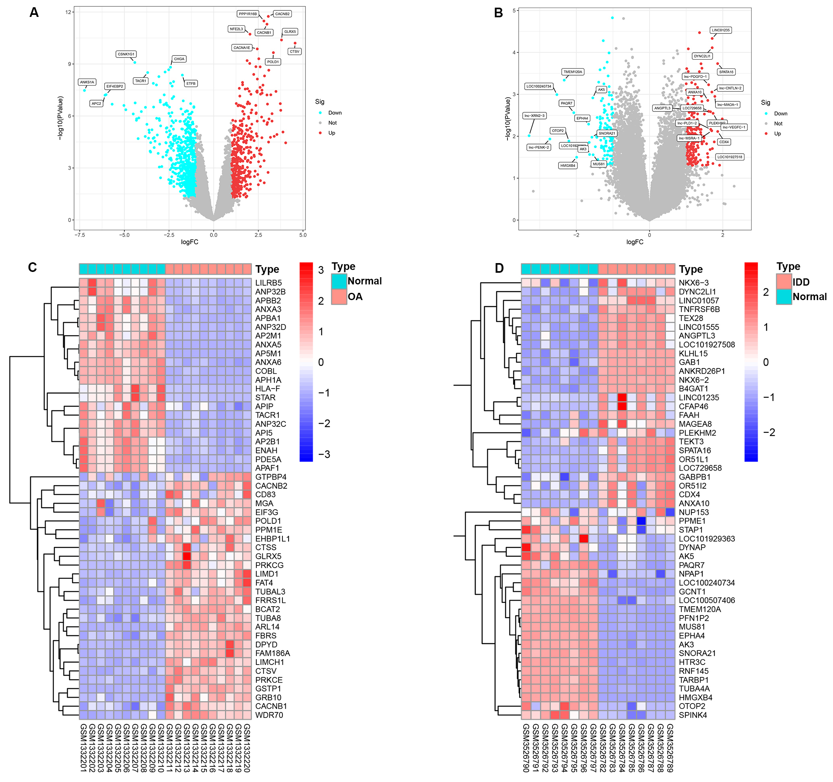
Supplementary Figure 1. Volcano diagrams and heat map of the DEG expression in OA and IDD patients.
(A, C) Volcano diagrams and heat map of the DEGs expression in OA. (B, D) Volcano diagrams and Heat map of the DEGs expression in IDD.

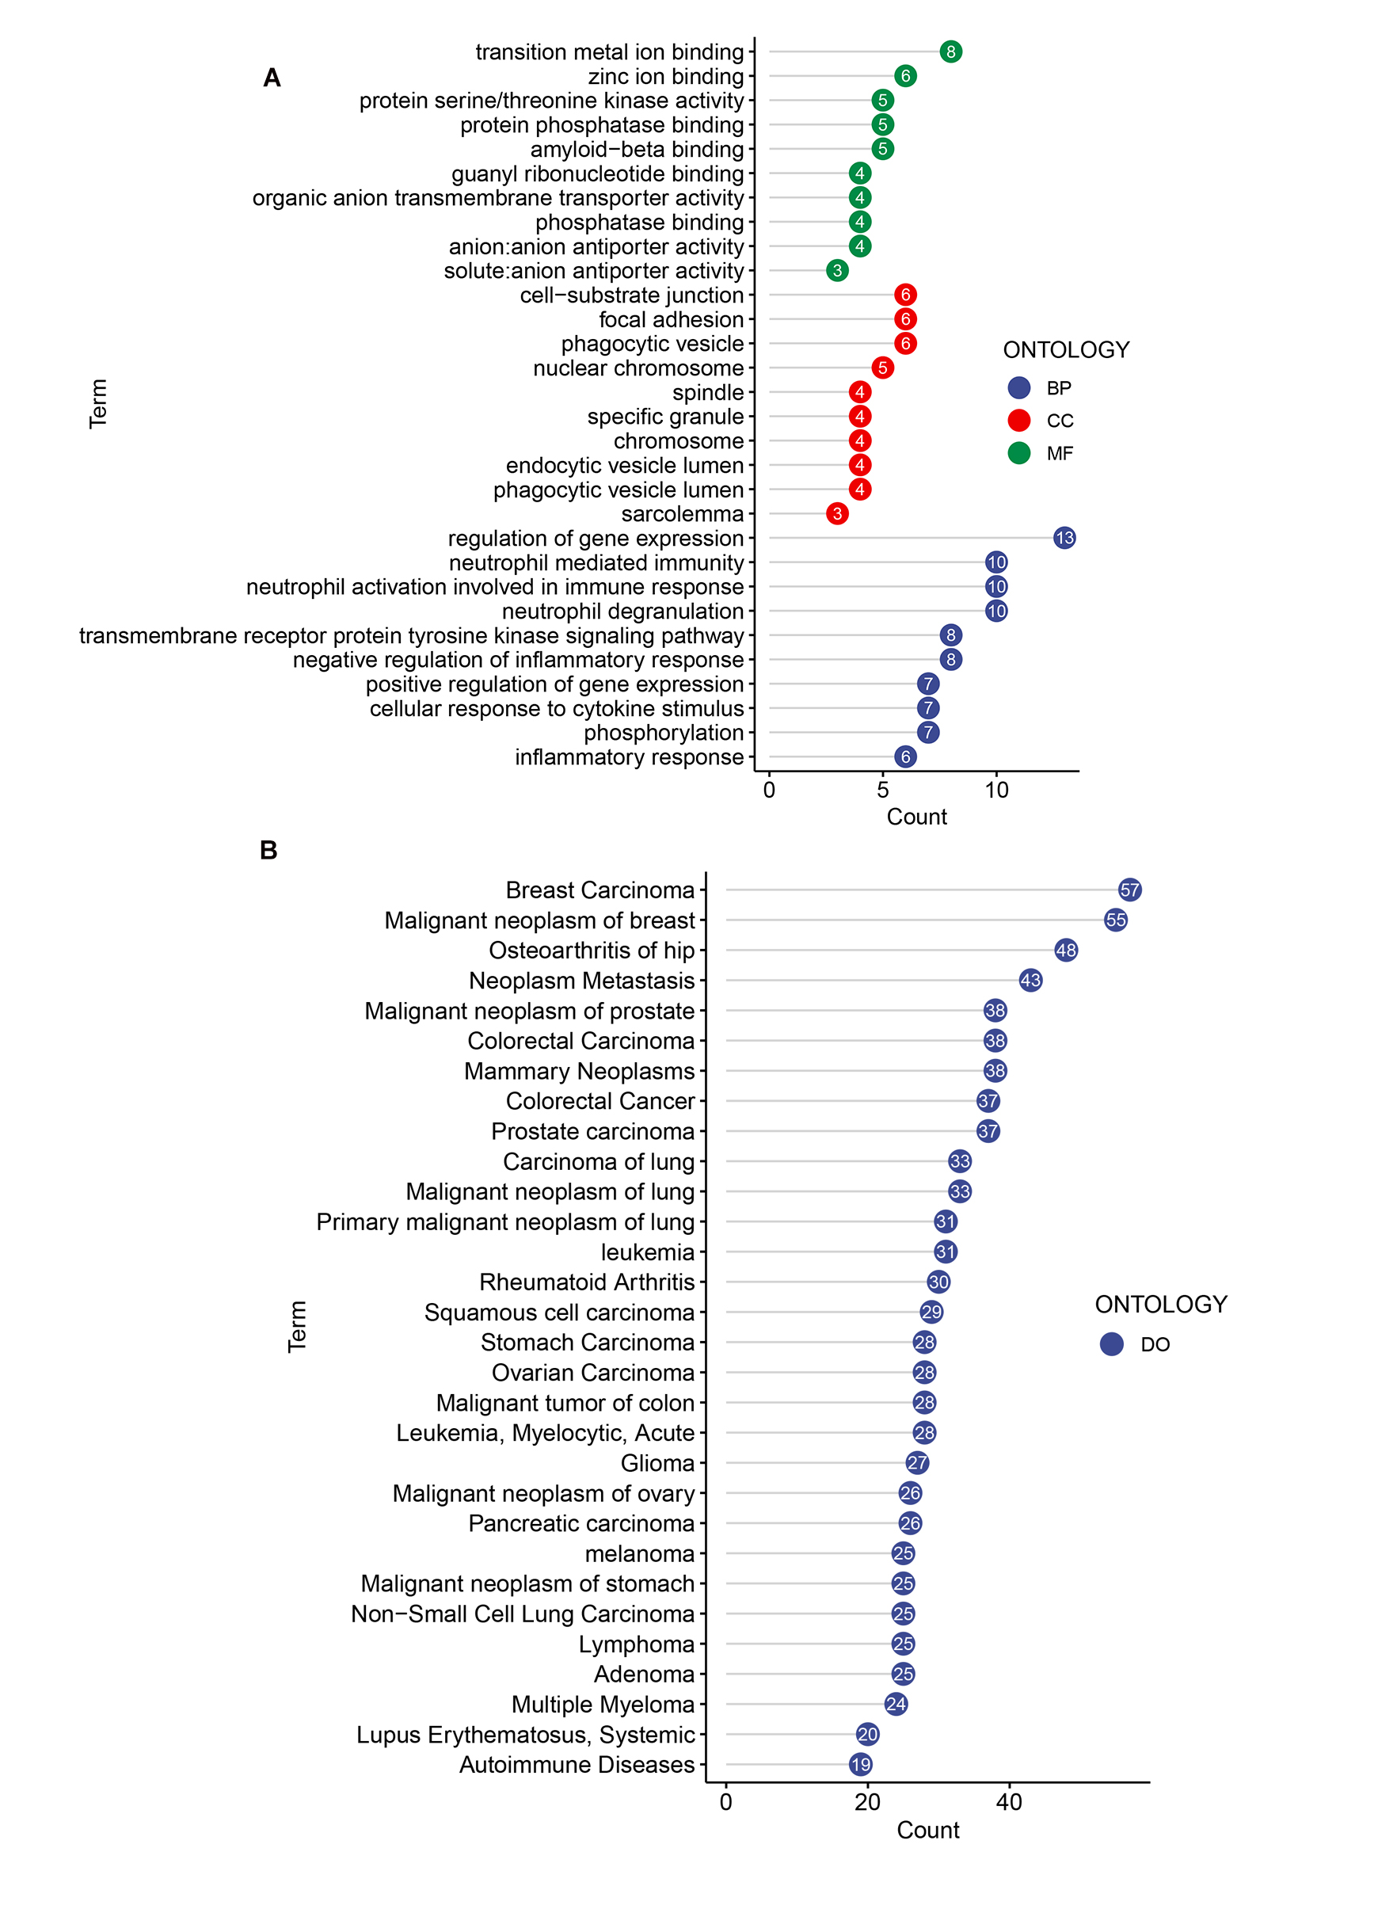
Supplementary Figure 2. GO and DO enrichment analysis of shared hub genes.
(A) The bubble chart of GO enrichment analysis of the shared hub genes between IDD and OA. (B) The bubble chart of DO enrichment analysis of the common hub genes between IDD and OA.
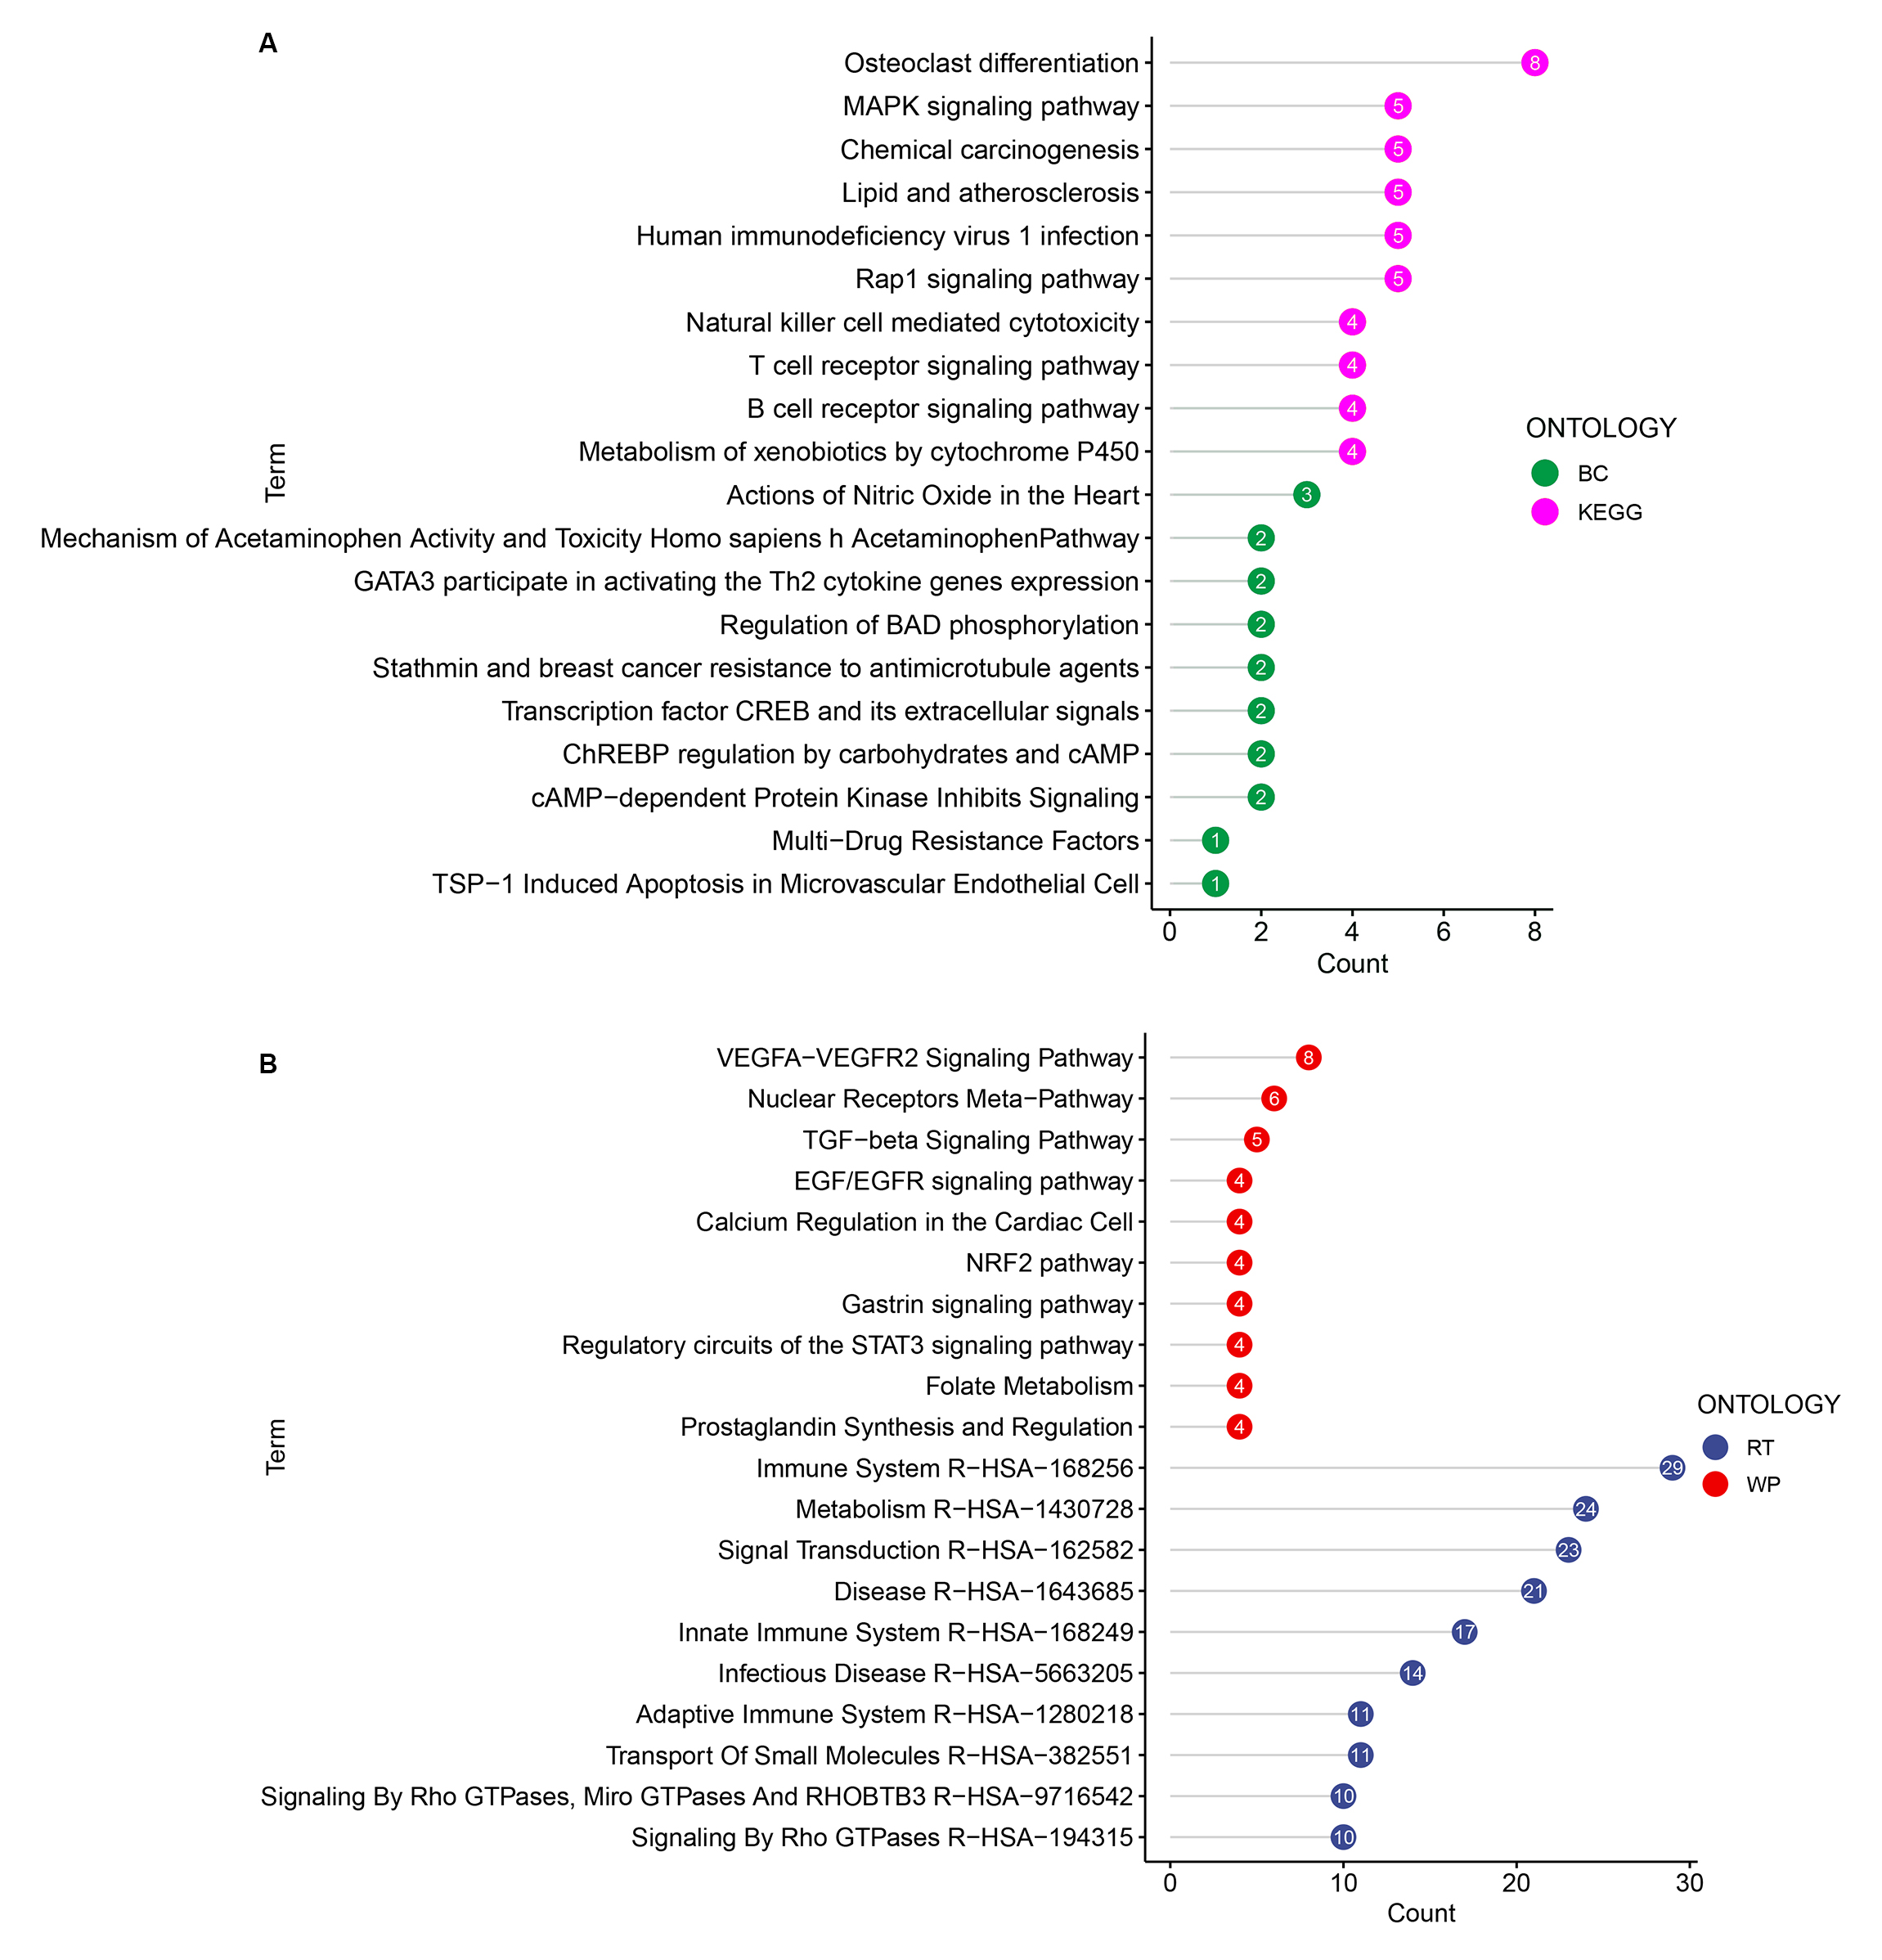
Supplementary Figure 3. The pathway enrichment of the common hub genes is represented as bubble graphs using the Enricher web tool.
(A) Biocarta pathway and KEGG pathway. (B) Reactome pathway and Wikipathway.

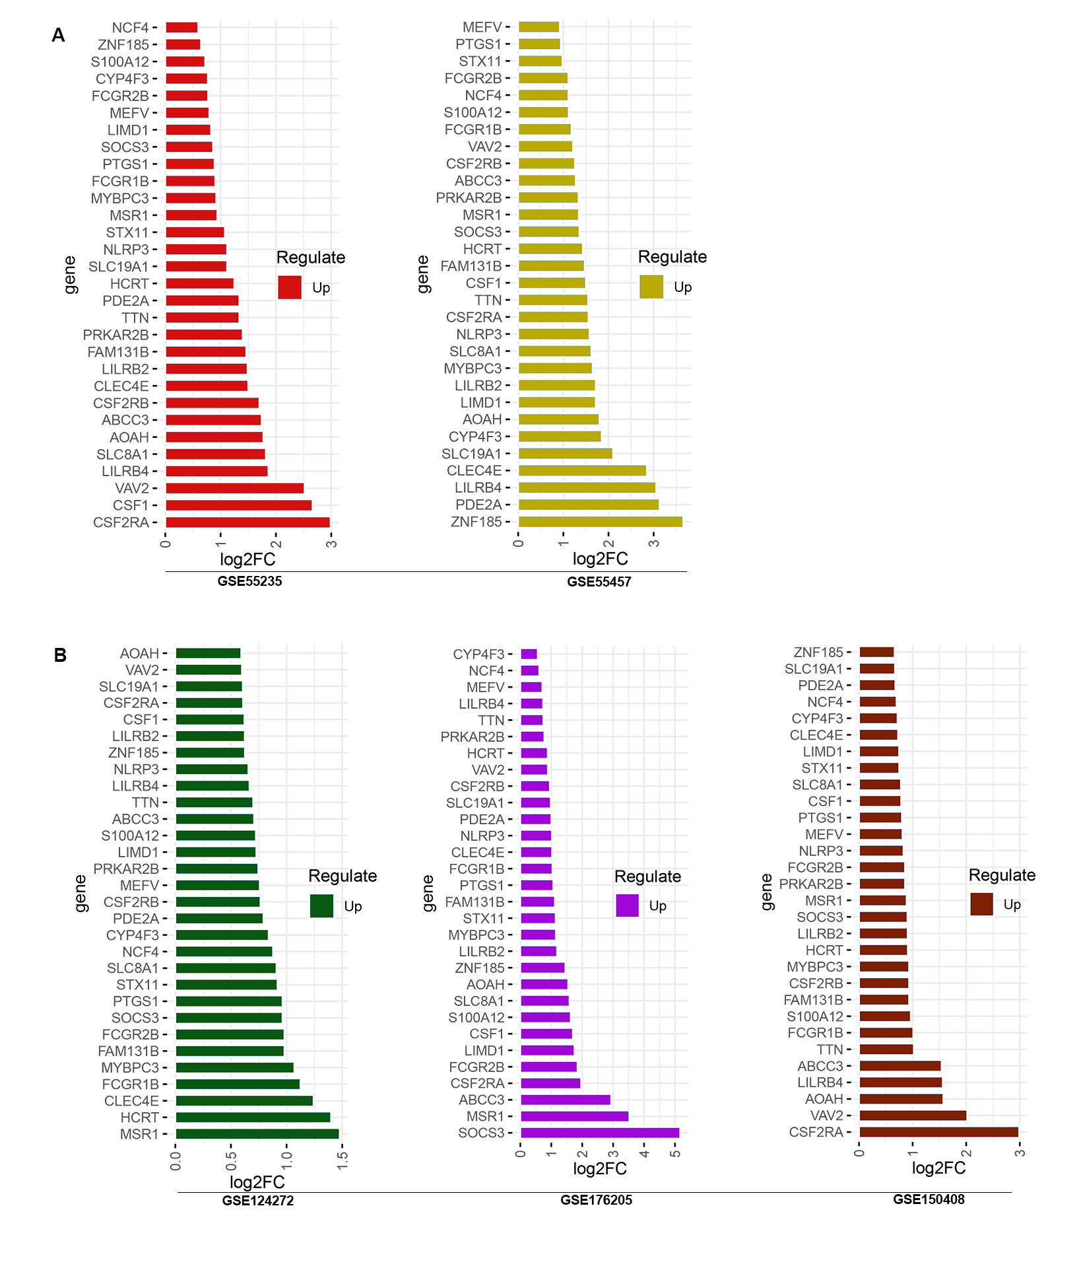
Supplementary Figure 4. The histogram of upregulated DEGs between IDD and OA.
(A, B) Histograms of differentially expressed genes upregulated between IDD and OA in different datasets.

Supplementary Figure 5. Immune infiltration characteristic of upregulated DEGs in OA diseases. (A) ssGSEA score of upregulated DEGs in OA dataset. (B) The difference in ssGSEA score of upregulated DEGs between OA patients and controls. (D-G) Correlation analysis between upregulating the ssGSEA score of DEG and different immune cells in OA patients.

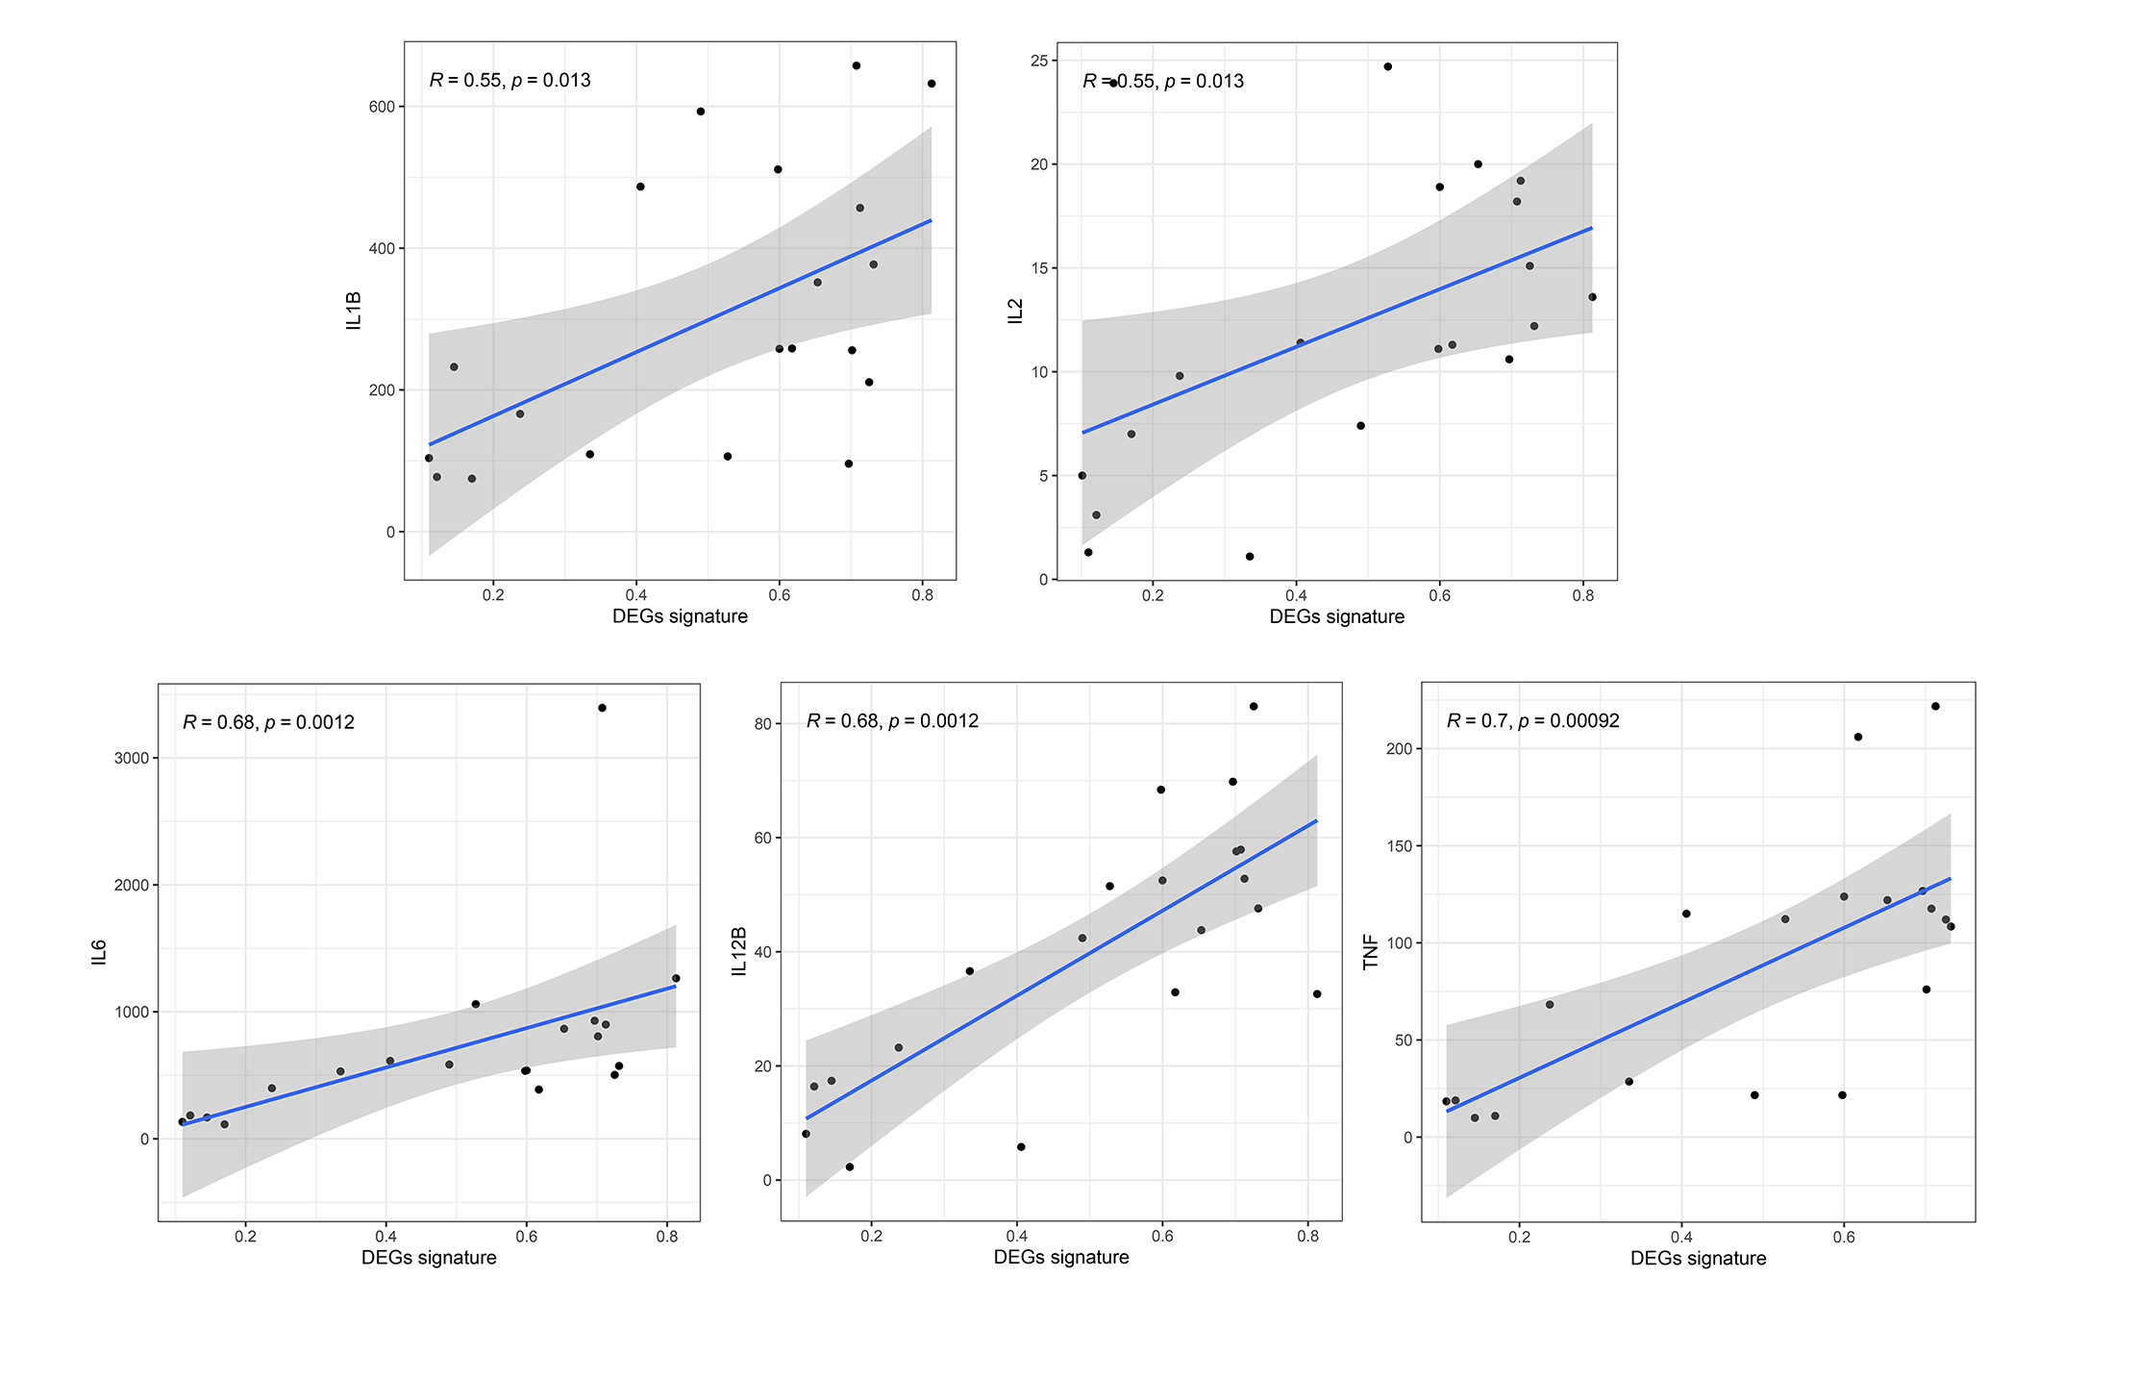
Supplementary Figure 6. Correlation analysis of inflammatory factors with DEGs signature (ssGSEA score).

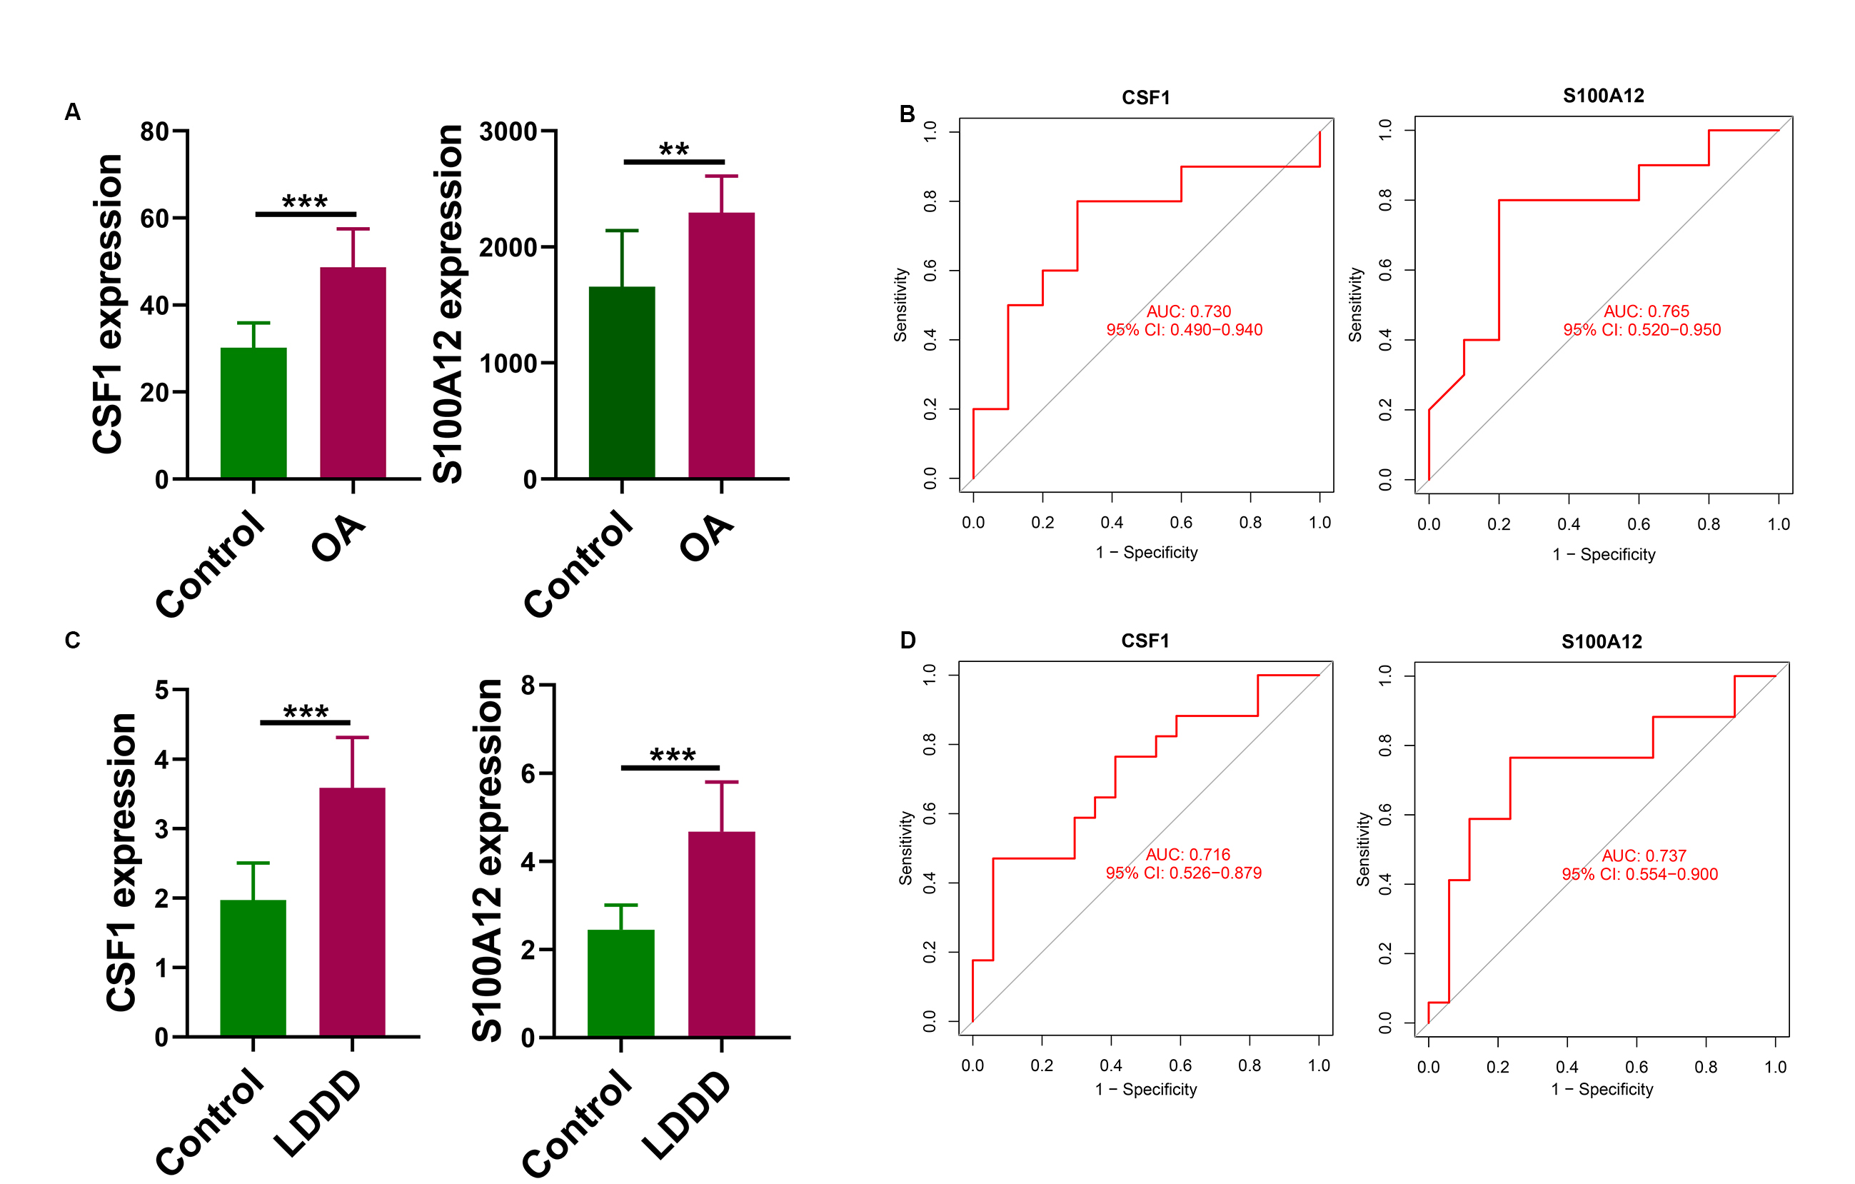
Supplementary Figure 7. Expression and ROC curve analysis of the CSF1 and S100A12 in OA patients from the verification cohort.
(A, C) The difference in expression levels of CSF1 and S100A12 in OA and IDD patients from the verification cohort. (B, D) ROC curve analysis of CSF1 and S100A12 in OA and IDD from verification dataset.

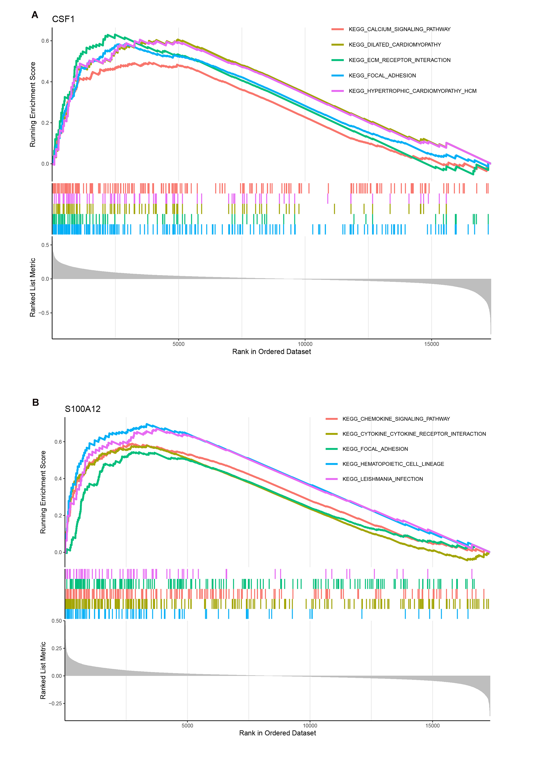
Supplementary Figure 8. GSEA function enrichment analysis of CSF1 and S100A12 in OA.
GSEA function enrichment analysis of CSF1 (A) and S100A12 (B) in OA.

Supplementary Table
Supplementary Table S1 GO enrichment analysis of shared DEGs.
ONTOLOGY | Term | GeneRatio | pvalue | Count
BP | regulation of gene expression | 0.012048193 | 0.008468 | 13
BP | neutrophil degranulation | 0.020790021 | 4.31E-04 | 10
BP | neutrophil activation involved in immune response | 0.020618557 | 4.60E-04 | 10
BP | neutrophil mediated immunity | 0.020491803 | 4.82E-04 | 10
BP | negative regulation of inflammatory response | 0.037735849 | 2.94E-05 | 8
BP | transmembrane receptor protein tyrosine kinase signaling pathway | 0.01980198 | 0.002212 | 8
BP | phosphorylation | 0.0175 | 0.008024 | 7
BP | cellular response to cytokine stimulus | 0.014522822 | 0.020494 | 7
BP | positive regulation of gene expression | 0.014522822 | 0.020494 | 7
BP | inflammatory response | 0.044117647 | 1.29E-04 | 6
CC | phagocytic vesicle | 0.06 | 2.32E-05 | 6
CC | focal adhesion | 0.015503876 | 0.023523 | 6
CC | cell-substrate junction | 0.015228426 | 0.025398 | 6
CC | nuclear chromosome | 0.060240964 | 1.12E-04 | 5
CC | phagocytic vesicle lumen | 0.6 | 1.79E-06 | 4
CC | endocytic vesicle lumen | 0.14 | 2.23E-04 | 4
CC | chromosome | 0.025 | 0.01334 | 4
CC | specific granule | 0.025 | 0.01334 | 4
CC | spindle | 0.020833333 | 0.024267 | 4
CC | sarcolemma | 0.057692308 | 0.003253 | 3
MF | transition metal ion binding | 0.017977528 | 0.003984 | 8
MF | zinc ion binding | 0.017857143 | 0.012611 | 6
MF | amyloid-beta binding | 0.0625 | 9.42E-05 | 5
MF | protein phosphatase binding | 0.040650407 | 6.97E-04 | 5
MF | protein serine/threonine kinase activity | 0.014534884 | 0.047153 | 5
MF | anion:anion antiporter activity | 0.21 | 3.63E-06 | 4
MF | phosphatase binding | 0.035087719 | 0.004129 | 4
MF | organic anion transmembrane transporter activity | 0.027777778 | 0.009337 | 4
MF | guanyl ribonucleotide binding | 0.018691589 | 0.034207 | 4
MF | solute:anion antiporter activity | 0.2 | 7.81E-05 | 3

Supplementary Tablse S2 DO enrichment analysis of shared DEGs.
ONTOLOGY | Term | GeneRatio | pvalue | Count
DO | Breast Carcinoma | 0.011484989 | 5.59E-09 | 57
DO | Malignant neoplasm of breast | 0.010882469 | 9.70E-08 | 55
DO | Osteoarthritis of hip | 0.011808118 | 9.69E-08 | 48
DO | Neoplasm Metastasis | 0.010969388 | 5.21E-06 | 43
DO | Mammary Neoplasms | 0.015919564 | 1.61E-09 | 38
DO | Colorectal Carcinoma | 0.012964858 | 4.19E-07 | 38
DO | Malignant neoplasm of prostate | 0.011732016 | 5.08E-06 | 38
DO | Prostate carcinoma | 0.011764706 | 6.74E-06 | 37
DO | Colorectal Cancer | 0.011218921 | 2.02E-05 | 37
DO | Malignant neoplasm of lung | 0.013474888 | 1.40E-06 | 33
DO | Carcinoma of lung | 0.013327948 | 1.79E-06 | 33
DO | Autoimmune Diseases | 0.017924528 | 8.26E-06 | 19
DO | leukemia | 0.015971149 | 7.99E-08 | 31
DO | Primary malignant neoplasm of lung | 0.01366843 | 2.43E-06 | 31
DO | Rheumatoid Arthritis | 0.016366612 | 8.05E-08 | 30
DO | Squamous cell carcinoma | 0.015458422 | 4.71E-07 | 29
DO | Leukemia, Myelocytic, Acute | 0.016441574 | 2.24E-07 | 28
DO | Malignant tumor of colon | 0.013993003 | 5.53E-06 | 28
DO | Ovarian Carcinoma | 0.012709941 | 3.32E-05 | 28
DO | Stomach Carcinoma | 0.011774601 | 0.000128 | 28
DO | Lupus Erythematosus, Systemic | 0.017969452 | 4.44E-06 | 20
DO | Glioma | 0.012211669 | 9.48E-05 | 27
DO | Pancreatic carcinoma | 0.013911182 | 1.45E-05 | 26
DO | Multiple Myeloma | 0.018292683 | 2.96E-07 | 24
DO | Malignant neoplasm of ovary | 0.012833169 | 0.000058 | 26
DO | Adenoma | 0.025 | 3.10E-10 | 25
DO | Lymphoma | 0.019127774 | 6.75E-08 | 25
DO | Non-Small Cell Lung Carcinoma | 0.011145787 | 0.000731 | 25
DO | Malignant neoplasm of stomach | 0.010425354 | 0.001894 | 25
DO | melanoma | 0.010187449 | 2.60E-03 | 25

Supplementary Tablse S3 BioCarta and KEGG pathway enrichment analysis of shared DEGs.
ONTOLOGY | Term | GeneRatio | pvalue | Count
BC | Actions of Nitric Oxide in the Heart | 0.07 | 0.00176 | 3
BC | cAMP-dependent Protein Kinase Inhibits Signaling | 0.05 | 2.50E-02 | 2
BC | ChREBP regulation by carbohydrates and cAMP | 0.05 | 2.18E-02 | 2
BC | Transcription factor CREB and its extracellular signals | 0.07 | 1.03E-02 | 2
BC | Stathmin and breast cancer resistance to antimicrotubule agents | 0.08 | 8.19E-03 | 2
BC | Regulation of BAD phosphorylation | 0.09 | 0.00754 | 2
BC | GATA3 participate in activating the Th2 cytokine genes expression | 0.11 | 0.00517 | 2
BC | Mechanism of Acetaminophen Activity and Toxicity Homo sapiens h AcetaminophenPathway | 0.29 | 0.000664 | 2
BC | TSP-1 Induced Apoptosis in Microvascular Endothelial Cell | 0.14 | 0.0392 | 1
BC | Multi-Drug Resistance Factors | 0.17 | 3.37E-02 | 1
KEGG | Osteoclast differentiation | 0.0629921 | 6.63E-07 | 8
KEGG | Rap1 signaling pathway | 0.0238095 | 0.00709 | 5
KEGG | Human immunodeficiency virus 1 infection | 0.0235849 | 0.00737 | 5
KEGG | Lipid and atherosclerosis | 0.0232558 | 7.81E-03 | 5
KEGG | Chemical carcinogenesis | 0.0209205 | 1.20E-02 | 5
KEGG | MAPK signaling pathway | 0.0170068 | 2.66E-02 | 5
KEGG | Metabolism of xenobiotics by cytochrome P450 | 0.0526316 | 0.000937 | 4
KEGG | B cell receptor signaling pathway | 0.0493827 | 0.00119 | 4
KEGG | T cell receptor signaling pathway | 0.0384615 | 0.00297 | 4
KEGG | Natural killer cell mediated cytotoxicity | 0.0305344 | 0.00674 | 4

Supplementary Table S4 Reactome and WikiPathways enrichment analysis of shared DEGs.
ONTOLOGY | Term | GeneRatio | pvalue | Count
RT | Immune System | 0.014925373 | 9.72E-07 | 29
RT | Metabolism | 0.011713031 | 4.69E-04 | 24
RT | Signal Transduction | 0.009330629 | 1.13E-02 | 23
RT | Disease | 0.012096774 | 7.46E-04 | 21
RT | Innate Immune System | 0.016425121 | 7.77E-05 | 17
RT | Infectious Disease | 0.014568158 | 0.00114 | 14
RT | Transport Of Small Molecules | 0.015580737 | 0.00234 | 11
RT | Adaptive Immune System | 0.015006821 | 0.00312 | 11
RT | Signaling By Rho GTPases | 0.01552795 | 0.00378 | 10
RT | Signaling By Rho GTPases, Miro GTPases And RHOBTB3 | 0.015151515 | 4.49E-03 | 10
WP | VEGFA-VEGFR2 Signaling Pathway | 0.018518519 | 3.33E-03 | 8
WP | Nuclear Receptors Meta-Pathway | 0.018808777 | 0.00995 | 6
WP | TGF-beta Signaling Pathway | 0.037878788 | 0.000959 | 5
WP | Prostaglandin Synthesis and Regulation | 0.088888889 | 1.25E-04 | 4
WP | Folate Metabolism | 0.057971014 | 6.51E-04 | 4
WP | Regulatory circuits of the STAT3 signaling pathway | 0.051282051 | 1.03E-03 | 4
WP | Gastrin signaling pathway | 0.035087719 | 0.00413 | 4
WP | NRF2 pathway | 0.02739726 | 0.00979 | 4
WP | Calcium Regulation in the Cardiac Cell | 0.026666667 | 0.0107 | 4
WP | EGF/EGFR signaling pathway | 0.024691358 | 0.0139 | 4

Supplementary Table S5 131 hub genes were identified based on degree>10.
Rank | Name | Score | Rank | Name | Score | Rank | Name | Score
1 | MAPK14 | 80 | 42 | SHMT1 | 28 | 87 | SYNGR1 | 18
2 | MPO | 66 | 42 | LIMCH1 | 28 | 87 | PLXNB3 | 18
2 | ARG1 | 66 | 42 | SLC7A1 | 28 | 87 | SERBP1 | 18
4 | ALDH18A1 | 64 | 42 | PDE2A | 28 | 87 | GINS3 | 18
5 | MET | 60 | 49 | SLC4A4 | 26 | 87 | SLC4A3 | 18
6 | CSF1 | 58 | 49 | SLC8A1 | 26 | 87 | FBLN2 | 18
7 | TTN | 56 | 49 | PDLIM7 | 26 | 97 | CLOCK | 16
8 | SOCS3 | 54 | 49 | FCGR1B | 26 | 97 | LIMK2 | 16
9 | NCF4 | 52 | 49 | ANXA3 | 26 | 97 | APBA2 | 16
10 | FCGR2B | 50 | 49 | GPX7 | 26 | 97 | SETBP1 | 16
10 | CCNB2 | 50 | 49 | VAV2 | 26 | 97 | NR1I3 | 16
10 | S100A12 | 50 | 56 | GNLY | 24 | 97 | LMAN1 | 16
13 | RAD51 | 48 | 56 | FAM131B | 24 | 97 | IVD | 16
14 | SLC7A11 | 46 | 56 | MEFV | 24 | 97 | HIST1H2BK | 16
14 | PTGS1 | 46 | 56 | AKR1C1 | 24 | 97 | FXYD1 | 16
14 | BIRC5 | 46 | 56 | NFASC | 24 | 97 | SCAMP5 | 16
17 | LILRB2 | 44 | 56 | KLHL2 | 24 | 97 | ZNF185 | 16
17 | STX11 | 44 | 56 | CENPF | 24 | 108 | KLHL3 | 14
19 | NLRP3 | 42 | 56 | ID1 | 24 | 108 | PRDM5 | 14
19 | XPO6 | 42 | 56 | ANXA6 | 24 | 108 | KPNA5 | 14
19 | SMC2 | 42 | 56 | SLC2A5 | 24 | 108 | CA14 | 14
22 | CSF2RB | 40 | 56 | NCR3 | 24 | 108 | CIB2 | 14
22 | CD247 | 40 | 67 | GPC3 | 22 | 108 | NCKIPSD | 14
22 | CPNE6 | 40 | 67 | PDCD11 | 22 | 108 | MSRB1 | 14
25 | CYP1B1 | 38 | 67 | ACSBG1 | 22 | 108 | LIMD1 | 14
26 | MSR1 | 36 | 67 | ADH1C | 22 | 116 | ROR2 | 12
27 | CLEC4E | 34 | 67 | PAK6 | 22 | 116 | XYLB | 12
27 | CSF2RA | 34 | 67 | NADK | 22 | 116 | BCKDHB | 12
27 | EIF2AK3 | 34 | 73 | SLC25A4 | 20 | 116 | HCRT | 12
27 | GSTM1 | 34 | 73 | LAMP5 | 20 | 116 | AKAP12 | 12
27 | PPP5C | 34 | 73 | BCCIP | 20 | 116 | IFITM2 | 12
32 | AOAH | 32 | 73 | KIAA0101 | 20 | 116 | DCHS1 | 12
32 | LTF | 32 | 73 | RPS4X | 20 | 116 | SFMBT1 | 12
34 | LILRB4 | 30 | 73 | CDX1 | 20 | 116 | ELAC2 | 12
34 | TCF4 | 30 | 73 | SLC26A1 | 20 | 125 | KCNV2 | 10
34 | SLC19A1 | 30 | 73 | ADM | 20 | 125 | PCBP4 | 10
34 | MAPRE3 | 30 | 73 | DDIT4 | 20 | 125 | ST6GAL1 | 10
34 | PDE5A | 30 | 73 | PICALM | 20 | 125 | RTN3 | 10
34 | YES1 | 30 | 73 | PDE4DIP | 20 | 125 | MBOAT2 | 10
34 | PRKAR2B | 30 | 73 | MYBPC3 | 20 | 125 | F2RL1 | 10
34 | CACNA1E | 30 | 73 | ST8SIA3 | 20 | 125 | PERP | 10
42 | FA2H | 28 | 73 | SH2D1A | 20 | 87 | CYP4F3 | 18
42 | BUB1B | 28 | 87 | COL17A1 | 18 | 87 | SYNGR3 | 18
42 | FOSB | 28 | 87 | ABCC3 | 18

Supplementary Table S6 The potential diagnostic genes were identified based on LASSO regression and SVM-RFE method.
Lasso.genes | SVM-RFE.gene
VAV2 | HAPLN1
CSF1 | CTHRC1
PDE5A | S100A12
LIMCH1 | NEUROD1
GPX7 | BGN
FOSB | THY1
DDIT4 | GC
CSF1 | ADH7
COPZ2 | CWH43
S100A12 | CHGB
ANKH | C3
 | CA2
 | TMEM27
 | CSF1
 | CYP2C19
 | SH3GL2
 | STYK1
 | HOXC9
 | COL1A1
 | SERPINE1
 | IGFBP4
 | MAL

