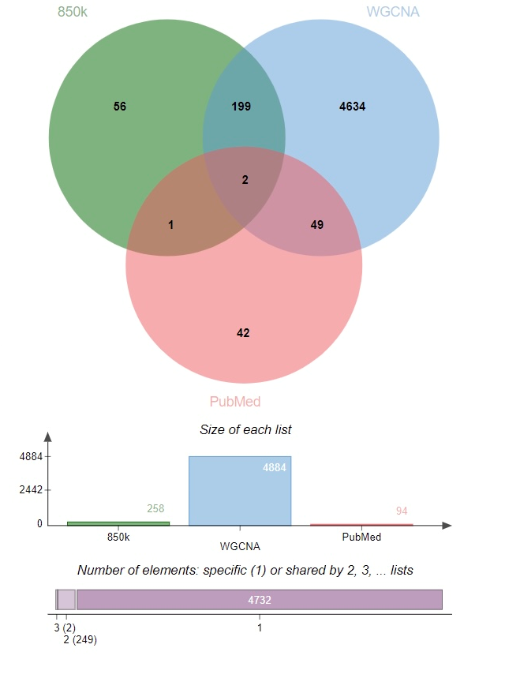
Supplementary Fig 1. Venn diagram of intersection of three data sets: methylation locus genes in the methylation array, methylation locus genes based on the yellow and gray modules of WGCNA, and published genes associated with NSSI, self-harm, schizophrenia, depression, autism spectrum disorders, and other NSSI related mental or neurological disorders.

