Supplementary Methods
1. Definitions
Human Wellbeing
We define human wellbeing according to the Intergovernmental Science-Policy Platform on Biodiversity and Ecosystem Services (IPBES) global assessment report on biodiversity and ecosystem services ¹. Wellbeing is “A perspective on a good life that comprises access to basic resources, freedom and coarithhoice, health and physical, including psychological, well-being, good social relationships, security, equity, peace of mind and spiritual experience. Well-being is achieved when individuals and communities can act meaningfully to pursue their goals and can enjoy a good quality of life. The concept of human well-being is used by many countries and societies.” ^{1(p.1054)}. Impacts of legume intensification on human well-being are recorded across 10 variables derived from multidimensional well-being frameworks ¹⁻⁴ and categorised for analysis into two primary subcomponents of well-being: 1) economic well-being (profit, financial security, physical capital, savings in cost of labour) and 2) non-economic well-being (natural capital, social relations, education, health, food security, employment opportunities)
Ecosystem Services
We define ecosystem services as the benefits people obtain from ecosystems (Millenium Assessment, 2005). We acknowledge that a broader definition of nature’s contributions to people has been developed to also encompass nature’s gifts ¹, but wished to maintain categories of services similar to a recent synthesis of joint outcomes for ecosystem services and wellbeing from input-intensified agriculture ⁵. We therefore categorise outcomes for ecosystem services following the Millennium Ecosystem Assessment breakdown of ecosystem service categories⁶: provisioning services (food; freshwater; fuelwood; fibre; biochemicals; genetic resources); regulating services (climate regulation; disease and pest regulation; water regulation; water purification; pollination); and supporting services (soil formation; nutrient cycling; primary production). and biodiversity (habitat, species, and soil organic carbon). Cultural ecosystem services was defined as a separate ecosystem service category in the Millenium Assessment; IPBES instead recognizes that culture mediates the relationship between people and all of the benefits that people obtain from ecosystems, so cultural services was excluded from our analysis.
Biodiversity
Biodiversity is defined as the variability among living organisms from all sources including terrestrial, marine and other aquatic ecosystems and the ecological complexes of which they are a part ¹. Because there is widespread acknowledgement that the classification of “ecosystem services” by the Millenium Assessment does not represent all ways of understanding the diverse contributions that nature makes to human quality of life¹, we also extracted information on changes in biodiversity following legume-intensified agricultural interventions. We categorised impacts on biodiversity as either: 1) changes to individual species populations or communities of species (species diversity, richness, composition, population abundance, or behaviour); 2) changes to ecosystem quality or function (ecosystem condition, or the processes underlying functional communities e.g. predation, competition, commensalism, parasitism); 3) changes to ecosystem extent (amount of native vegetation); and 4) changes to organic soil carbon (a surrogate for biodiversity as improving soil carbon has been shown to support biodiversity as well as numerous ecosystem services such as primary productivity, nutrient cycling, water formation, soil stability) ⁷.

Legume intensification in agrarian landscapes
The term legume intensification in agrarian landscapes is used throughout as referring to the movement from a monoculture or simplified cropping or horticulture system to a system that includes one or more intercrops or rotations of a grain legume intended for food (as opposed to livestock fodder or cover crops). Broadly speaking, the purpose of the intensification is to increase the value of output per hectare. We classified all cases according to three different types of intensification: 1) grain legume intercropping, 2) grain legume rotations, or (3) a mix of grain legume intercropping and rotations. We follow the definitions of Bellouin et al. (2019) ⁸ to describe different legume intensification systems:
Intercropping: The simultaneous cultivation in the same field of two or more crops (different species) for all or part of their growth cycle. All crop species are harvested. Can be classified as row, strip, or mixed intercropping.
Rotation: Recurrent succession of a set of selected crops grown on a particular agricultural land each season or each year according to a definite plan. Here, we do not consider as rotation, a system with temporal overlap of two or more crops

2. Literature Review Methodology
Our research question seeks to answer the following knowledge gap: What is the relationship between ecosystem services and human well-being outcomes from legume intensification in agrarian landscapes? We address these knowledge gaps by performing a targeted review of studies that simultaneously evaluate environmental and human well-being outcomes of legume food-crop intercropping and rotational cropping, to identify system characteristics under which positive outcomes can be achieved for people and the environment.
2.1. Search Strategy
We adopted a systematic review strategy, combining targeted searches of two literature databases, Scopus and Web of Science, to secure a sufficient and robust set of the core peer-reviewed literature. We followed the PRISMA (Preferred Reporting Items for Systematic Reviews and Meta-analyses) guidelines for reporting ^{9,10}. The pool of research that employs an ecosystem service framework to explore both social and ecological outcomes of agricultural intensification is recent and modest in size. For this reason, we adopted a sampling strategy that combined different targeted word searches, to secure a sufficient and robust set of the core peer-reviewed literature. The searches combined terms associated with 1) legume intensification in agrarian landscapes using intercropping or rotations, 2) ecosystem services, and 3) wellbeing.
The initial searches took place in September 2021 using Web of Science and Scopus, combining terms associated with 1) crop type in agrarian landscapes, 2) ecosystem services (ES) or biodiversity, and 3) well-being.

Search String:
TOPIC= (legume* OR pulse* OR bean* OR pea* OR chickpea OR lentil OR cowpea OR soybean)
AND (agricul* OR “farm*” OR “crop*” OR “cultivat*”)
AND ("mono*crop*" OR "inter*crop*" OR "mixed*crop" OR "sequential crop*" OR "sole*crop" OR rotation OR "single*crop*" OR "multiple*crop*")
AND ("ecosystem service*" OR "environmental service*" OR biodiversity OR (species AND habitat) OR (nutrient* AND cycl*) OR (nitrogen AND fix* ) OR productivity OR "primary product" OR “soil*form*” OR “soil fertility” OR "soil conservation" OR pollinat* OR "climate regulat*" OR emission* OR "pest control*" OR “disease control*” OR "water purif*" OR "water regulat*" OR "water use" OR fresh*water OR "water footprint" OR "water conservation" OR "ecosystem health" OR “food suppl*”)
AND (well*being OR welfare OR poverty OR income OR profitability OR livelihood* OR assets OR "socio*economic" OR housing OR tenure OR education OR employment OR assets OR "natural capital" OR "human capital" OR "financial capital" OR "social capital" OR "community network*" OR autonomy OR marriage OR child* OR security OR safety OR freedom OR justice OR “social relation*” OR "empower*" OR governance OR “human health” OR “human nutrition” OR "mental health" OR "physical health" )

2.2. Selection criteria
Our literature search in June 2022 returned 1466 articles. This search was redone in June 2023 to update with newer articles, adding an additional 81 articles and resulting in a total of 1547 articles for screening (785 Scopus, 762 Web of Science; Fig. S1). Titles, abstracts, and keywords of all citations were exported as .RIS files and search results de-duplicated to remove redundant citations identified from multiple sources. Endnote citation management software was used for file management and abstract/title screening. In the initial abstract and title screening process, we used five inclusion criteria to keep articles that:
1. Examined the effect (or association) of legume intercropping or rotational cropping.
2. Reported on grain legumes (for human food, not for livestock or cover cropping)
3. Were focused on an agrarian system (agricultural rather than urban)
4. Reported empirical research (not perspectives or opinions)
5. Were published in a peer-reviewed journal or is a thesis or dissertation.
This initial stage resulted in 370 articles for full text screening. During full text review, the following criteria were used to exclude irrelevant articles that had not been excluded during abstract/title screening:
1. Study is published in a language other than English.
2. Publication is not an empirical research study (e.g., is a review, declaration, law, blog, brief, book chapter, or conference proceeding).
3. Study is not in a peer-reviewed journal or a thesis or a dissertation.
4. Study does not investigate a grain legume grown for food (e.g. focus on fodder or forage legume).
5. Study does not measure a human well-being outcome (focus on environment)
6. Study does not measure an environmental outcome (focus on well-being)
7. Legume results not presented (focus on non-legume crop)
8. No comparator (control, e.g. continuous monocrop of the cereal that was intercropped in the treatment)
9. Study of legume or main crop genetics and cultivars rather than intercropping or rotational cropping.
The specifications for accepting a study for review were: a. Setting: anywhere. b. Population: anywhere. c. Intervention(s): Intercropping with grain legumes; Rotational cropping with grain legumes. d. Outcome/s of interest: Our outcomes of interest were environmental health (ecosystem services and biodiversity) and human well-being (economic and non-economic; Table S1). We included studies that reported both qualitative and quantitative outcomes. e. Study design: non-experimental (e.g. observational, qualitative recall surveys), quasi experimental, true experiments. 182 articles met these criteria for coding and data extraction (Figure S1).

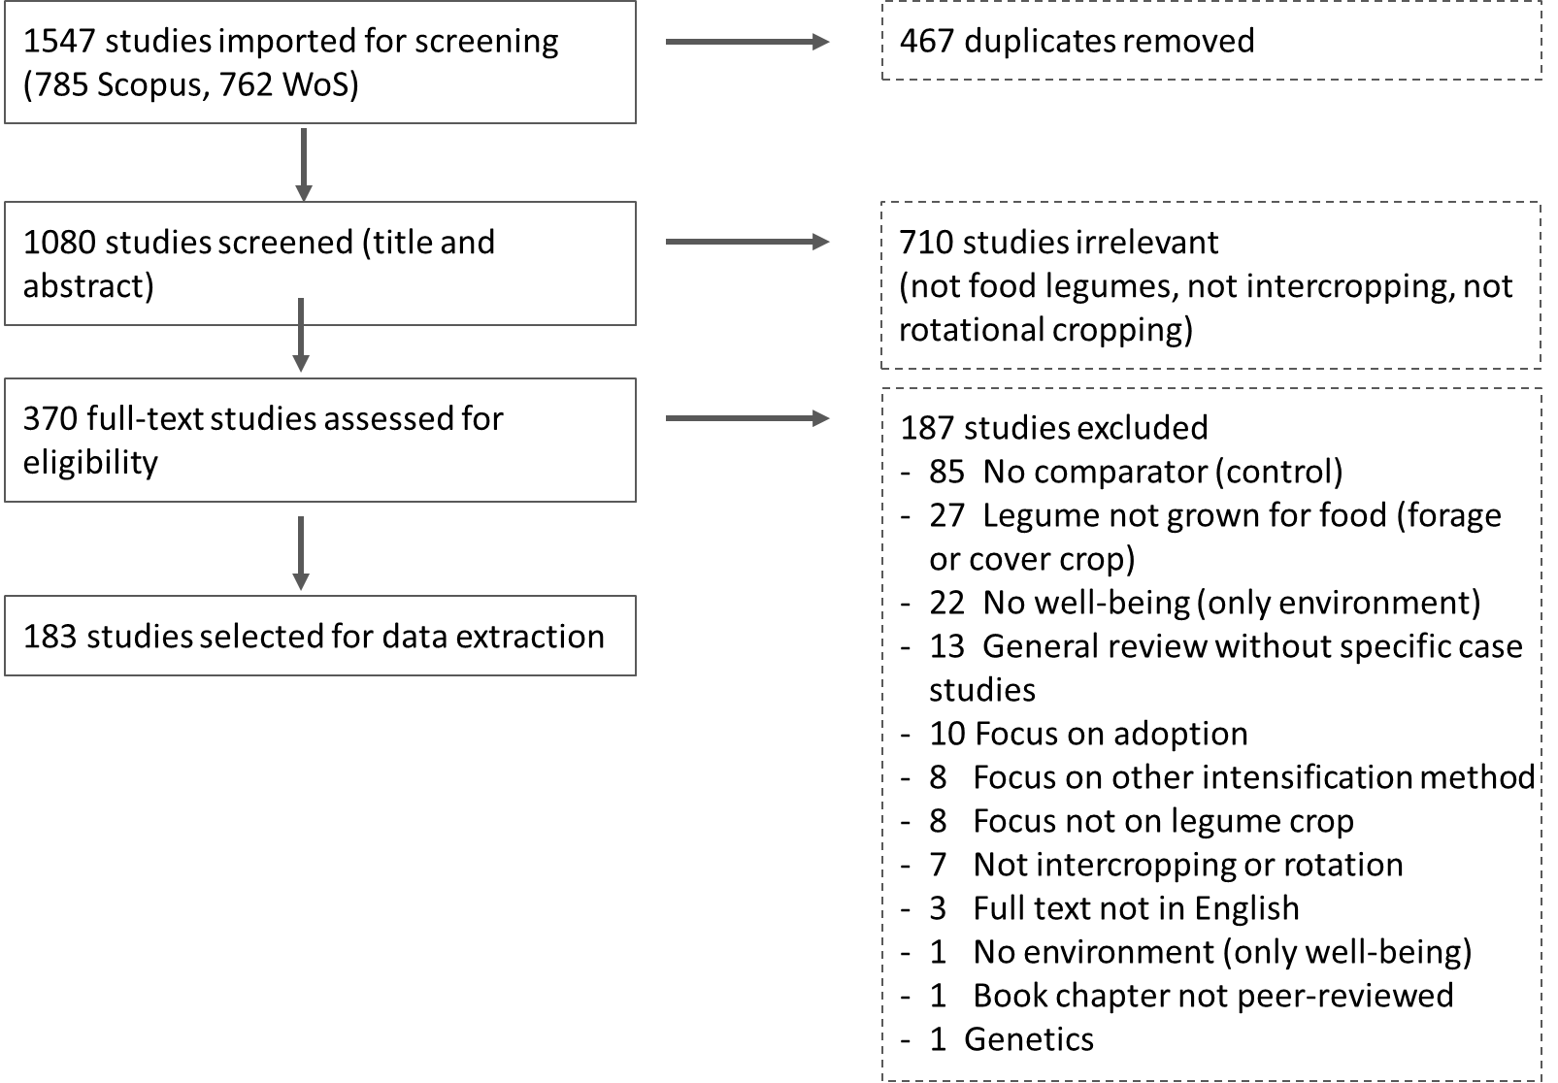
Figure S1. PRISMA diagram.

2.3. Coding and data extraction
We identified 382 specific cases within the 182 articles reviewed, that reported both social and ecosystem service outcomes of agricultural intensification. A case was constituted by the lowest geographical level at which authors presented results for different types of intensification. For example, the reporting of aggregate outcomes across multiple geographical locations was coded as one case, whereas data broken down either per distinctive type of legume intensification or per geographical location within one reviewed paper was coded as multiple cases.
A data extraction template (in Excel) was used to document all themes of interest. The data extraction template was tested by the review team before use, and data extracted by independent reviewers for each study. For each case (an individual system of legume intensification) within a study, we used a deductive scoring code to independently assess information on: a) publication year, b) methodological approach (study design, study duration, sample size) and year of intervention, c) geographic region of the case study, d) site characteristics, e) type and definition of intensification process, f) main crop and legume crop in focus, g) factors enabling and/or constraining the intensification, h) primary intensification actors (whether study was farmer or researcher-led), i) other drivers of ecosystem service and wellbeing change that were addressed, j) impacts on ecosystem services, k) impacts on wellbeing, and l) moderators (effect modifiers, e.g. other agricultural interventions and practices, fertiliser, irrigation).
We followed Rasmussen et al. (2018) ⁵ to evaluate environmental and human well-being outcomes (Table S1). Impacts on ecosystem services were disaggregated into primary subcomponents of provisioning services (which we divided into food and non-food), regulating services, and supporting services, as well as biodiversity and soil organic carbon⁶. Impacts on human wellbeing were recorded across 10 variables derived from multidimensional wellbeing frameworks¹⁻⁴ and categorised for analysis into two primary subcomponents of economic and non-economic wellbeing. Because employment outcomes are complex (increased employment opportunities can be positive for the community, but negative for an individual farmer if it means increased labour costs), we split employment outcomes into an economic (reduction in labour costs from intensification) and non-economic (increased opportunity for jobs) outcome.
Because of the diversity of methods and approaches used in the cases, we coded outcomes as both quantitative where reported, and qualitative (positive, negative, or ambiguous), informed by whether the intervention increased (positive), decreased (negative), or had an ambiguous effect (both increase and decrease, or neutral) on an individual outcome. When impacts were recorded in multiple directions for different subcategories, the aggregate direction of ecosystem service change was taken as the overall indicator for analysis, while a tie between e.g. positive and negative impacts was coded as an ambiguous result.
Following a piloting phase designed to check the coding form and to harmonise coding practice between three coders, each case was coded by a single researcher, then data were validated by a second researcher. Following coding of all cases, the coders used their overview of the research to produce expert assessments of their level of confidence in outcomes recorded for different categories of ecosystem services and human wellbeing, using a bespoke data quality assessment tool adapted from published advice on quality assessment ¹¹⁻¹⁴ that considers risk of bias and quality of evidence for each article (Table S2). A very low level of evidence strength suggests that assessment is often anecdotal, sampling design is not reported or inadequate to capture sufficient variability in the study context, or that potential confounding effects were not reported or analysed, whilst a high level reflects robust sampling design and statistical analysis.
Table S1. Environmental and Human Well-being Outcomes
Ecosystem Services | Provisioning | Food  Freshwater  Fuel  Fibre  Biochemicals  Genetic resources
 | Regulating | Climate regulation  Water purification  Water regulation  Pest/Weed/Disease regulation  Pollination
 | Supporting | Soil formation  Primary production  Nutrient cycling
Biodiversity | Biodiversity | Species  Ecosystems  Land use  Soil organic matter (incl. carbon)
Well-being | Economic well-being | Income  Financial security (economic risk/stability)  Physical capital (material assets)  Savings in labour costs
Well-being | Non-economic well-being | Education  Natural capital  Food security  Employment gain  Health  Social relations or values  Property rights  Social justice

Table S2. Quality assessment coding framework (adapted from Higgins et al., 2011; Haddaway et al., 2017; Haddaway et al., 2020; Pullin et al., 2018) ¹¹⁻¹⁴
Score | Category | Study spatial design | Study temporal design | Were potential confounders (e.g. differences in soil fertility, rainfall, or disturbance between treatments) at baseline adjusted for in analysis? | Was reporting of intervention characteristics (e.g. inputs, methods) sufficient? | Risk of bias (bias in characteristics of surveyed people) | Were valid and reliable tools (e.g. statistics, standard error) used to assess participant outcomes?
Quantitative studies
2 | Highest validity | Spatial replication 3 or more plots per treatment, has a control and treatment | 2 or more years of data collection | No confounding variables, or confounding variables adequately replicated in design and incorporated in analysis | Report study context, randomization, replicates, fertiliser and irrigation treatments | Low - Bias, if present, is unlikely to alter the results seriously | Yes - good evidence and analysed
1 | Medium validity | Spatial replication 2 plots per treatment, has a control and treatment | 1 year of data collection | Confounding variables described but not dealt with in design and analysis | Report some but not all of study context, randomization, replicates, fertiliser or irrigation treatments | Medium/ Unclear - A risk of bias that raises some doubt about the results | Unclear - some evidence but not analysed
0 | Low validity | Spatial replication not reported, or no replication | Unclear, or incomplete season of growth | Confounding variables not described or dealt with | Do not report study context, randomization, replicates, fertiliser or irrigation treatments | High - Bias may alter the results seriously | No
Qualitative studies
2 | Highest validity | Spatial replication 3 or more plots per treatment, has a control and treatment | >2 years of data collection | No confounding variables, or confounding variables adequately replicated in design and incorporated in analysis | Report study context, randomization, replicates, fertiliser and irrigation treatments | Low - Bias, if present, is unlikely to alter the results seriously | Yes - good evidence and analysed
1 | Medium validity | Spatial replication 2 plots per treatment, has a control and treatment | 1 year of data collection | Confounding variables described but not dealt with in design and analysis | Report some but not all of study context, randomization, replicates, fertiliser or irrigation treatments | Medium/Unclear - A risk of bias that raises some doubt about the results | Unclear - some evidence but not analysed
0 | Low validity | Spatial replication not reported | Unclear, or incomplete season of growth | Confounding variables not described or dealt with | Do not report study context, randomization, replicates, fertiliser or irrigation treatments | High - Bias may alter the results seriously | No

2.4. Data synthesis
We synthesised the included studies to understand the knowns and unknowns about the benefits of introducing grain legumes as intercrops or rotational crops on the environment (biodiversity or ecosystem services) and human well-being.

2.4.1 Meta-data
The legume-intensified cases that we reviewed comprise 74 unique agri-food systems, the most prevalent being grain intensified with soybean (14% of cases), cowpea (13%) or groundnut (10%). Non-grain agri-food systems (main crop a fruit, vegetable or sugar cane) comprised 15% of all cases, and 13% of cases incorporated more than one legume into the intercrop or rotation. The most common study design was experimental research, typically at a research station (n = 114 studies) rather than on-farm (n = 12), followed by recall studies (e.g. household surveys, farmer interviews, group discussions; n = 17) and short-term collaborative interventions on farms (e.g. Participatory Action Research; n = 19). Less commonly adopted designs include 7 longitudinal on-farm research studies, 9 modelling or simulation studies supported by empirical data and 4 reviews. Analysed studies come from 263 locations across 43 countries (Supplementary Figure S2), located in Africa (50%), Asia (38%), America (8%), Europe (3%) and Oceania (2%). India, Malawi, and Kenya had a higher representation in the studies, featuring 56, 23, and 22 study locations respectively (Supplementary Figure S2).
The majority of cases relied on quantitative data (337 cases from 159 studies), while fewer cases relied on a qualitative approach (8 cases from 7 studies) or a mix of qualitative and quantitative data (37 cases from 16 studies). Most studies (87%) were assessed as high quality (all possible confounding variables reported, temporal and spatial replicates, appropriate statistical analysis of results, and low risk of bias). The most common study design was experimental research, typically at a research station (114 studies) rather than on-farm (12 studies), followed by recall (e.g. household surveys, farmer interviews, group discussions; 17 studies) and collaborative interventions on farms (e.g. Participatory Action Research; 19 studies). Less commonly adopted designs include longitudinal on-farm research (7 studies), model-based design (9 studies) and reviews (4 studies).
Researchers were the primary intensification actors in most cases (usually studies conducted on experimental research stations; 237 cases), with farmer-led intensification reported in 54 cases, and joint farmer-researcher intensification research in 68 cases. National and regional policies supported or initiated legume intensification in 23 of the cases. Analysed studies come from 263 locations across 43 countries (Figure S2), located in Africa (50%), Asia (38%), America (8%), Europe (3%) and Oceania (2%). India, Malawi, and Kenya had a higher representation in the studies, featuring 56, 23, and 22 study locations respectively.
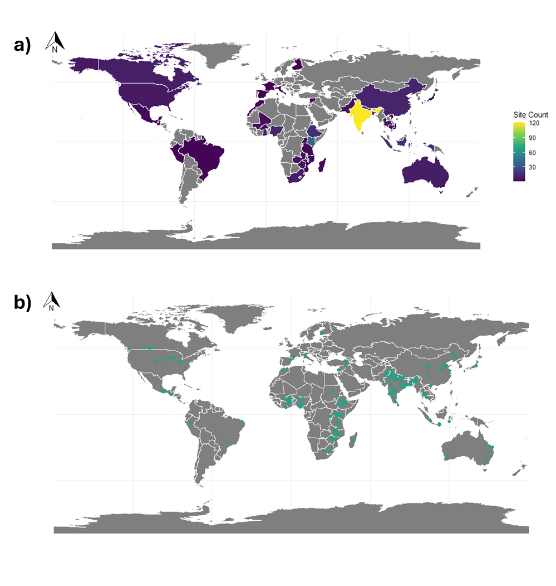
Figure S2. Locations of legume intensification sites reviewed, with colour of country indicating number of study sites in that country (a), and green dots indicating the exact location of the study (b).
2.4.2. Factors influencing joint outcomes
For outcomes that could be quantified as a ratio (intervention:control), we first calculated the impact of the intensification independently for each outcome. Qualitative outcomes were recorded as positive, negative, or ambiguous. Next, we followed the methods of Rasmussen et al. (2018) ⁵ to categorize each case according to its joint outcomes, by first aggregating the reported outcomes for ecosystem services and well-being separately as either win, lose, or mixed (ambiguous or neutral), then combining them to form a joint outcome. For example, win–win represents a case where only positive outcomes are reported for both ecosystem services and well-being, whereas lose-mix represents a case where only negative outcomes are reported for ecosystem services and a mix of positive, ambiguous neutral or negative outcomes reported for well-being.
For cases with evidence of outcomes for people and nature from legume-diversified agricultural intensification, we identified key intervention characteristics that may influence outcomes^{5,15-19}. We wanted to determine if there was a significant association between a given intervention characteristic, represented as a nominal categorical variable (grain legume introduced, intensification actors, location, other agronomic practices undertaken simultaneously, watering (rainfed or irrigated), and fertiliser practices) and a case’s joint outcomes for ecosystem services and well-being (Figure S3, S4). We ran Fisher’s exact tests because we were comparing categorical variables and contingency tables revealed that both the observed and expected values in at least one of the cells of the contingency table was less than five ^{20,21}. We also examined whether methodological factors related to temporal and spatial replication in each case might influence the social-ecological outcomes reported (Figure S3).
2.4.3. Quality of evidence
We also investigated three methodological factors that could influence the quality of evidence for environmental or wellbeing outcomes in legume-intensified systems: the study design, the timescale of intervention, and number of study replicates^{22,23}. There was a significant association between study design and quality of evidence (as assessed by authors using a bespoke quality assessment rubric). Longitudinal (on-farm) studies are more likely to be assessed as having high evidence cases (Fisher’s Exact Test, p=0.001). Experimental studies are more likely to be medium quality and least likely to be low quality. Modelling and recall cases are most likely to be assessed as low quality, due to the anecdotal nature of much of the evidence in recall studies, and a lack of reporting about confounding variables and data sources from modelling studies. We observed that space for time approaches and 1-year experiments are more likely to be allocated to the lowest quality of evidence category, whereas cases with more than 2 years of data collection are less likely to be associated with low quality evidence (Fisher’s Exact Test, p=0.05) (Figure S3). Cases with only 1 replicate per treatment and those that did not report the number of replicates are most likely to have low quality evidence and least likely to be assessed as having high quality evidence (Fisher’s Exact Test, p=0.001). High quality evidence is more likely to come from cases with 2-10 replicates per treatment (Figure S3).

3. Analysis of Joint Outcomes
3.1. Pairwise frequencies of outcomes
We developed two datasets to represent co-occurrence between ecosystem services and wellbeing outcomes. The first represented joint positive outcomes, with all quantitative and qualitative outcomes converted to either 0 (not positive) or 1 (positive). We then ran a correlation analysis on this presence-absence dataset to develop a matrix representing the frequency that each individual ecosystem services and wellbeing outcome were both positive in a given study, and developed circle graphs to represent joint co-occurrence of positive outcomes for individual outcome pairs (ecosystem services-wellbeing). We then repeated this for joint negative outcomes.

3.2. Modelling relationships between environmental and social outcomes
With the goal of investigating potential correlations between the overall outcomes for ecosystem services and wellbeing, we developed three sets of regression models using R statistical software, version 4.3.1. The first set of models were Generalised Linear Models (GLMs) relating the overall ecosystem services outcomes (independent variable) to overall wellbeing (dependent variable) for each case with quantitative data. To quantify the value for each variable, we averaged the outcomes for all ecosystem services outcomes with quantitative data, to derive an “average environmental outcome”, and we did the same for economic wellbeing outcomes and non-economic wellbeing outcomes. We kept economic and non-economic wellbeing separate as they can be influenced by different social-ecological factors. We logarithmically transformed ecosystem service outcomes due to right-skewedness of data. We then built two models, one predicting the effect of averaged ecosystem services outcomes on economic wellbeing (n =317 cases) and one predicting the effect of ecosystem services on non-economic wellbeing (n =185).
The second set of models interrogated relationships between different ecosystem service categories and wellbeing. We fitted GLMs with the averaged outcome for each broad category of ecosystem service (provisioning services, supporting services, regulating services, or biodiversity/soil organic carbon) as the independent variable and each economic or non-economic wellbeing outcome as dependent variables. Eight model combinations resulted from this process.
The third set of models interrogated relationships between each individual ecosystem service and wellbeing outcome. We developed linear log-log models that accounted for the exponential distributions of individual outcome variables. The broader categories of ecosystem services (provisioning, supporting, regulating, soil organic carbon, and biodiversity) were disaggregated into individual service variables (e.g. yield, climate regulation, primary production, pest regulation, nutrient cycling, etc). The broader categories of economic and non-economic wellbeing were also disaggregated into individual variables (e.g: profit, savings in labour cost, health, food security, etc). We fitted log-log models for each of the multiple possible combinations of one ecosystem service variable (independent variable) paired with one wellbeing variable (dependent variable), excluding pairs with less than 9 cases, obtaining 30 possible outcome pairs for modelling. We also fitted non-least square models (NLS), but the log-log models gave more parsimonious results as evaluated by goodness-of-fit tests (AIC and adjusted R2).

4. Supplementary Results
4.1. Influence of intervention characteristics on joint outcomes
There is no statistically significant association between the time period assessed and joint outcome (p=0.056, Fisher’s Exact Test). ‘Win-win’ outcomes are reported in cases assessing a multitude of different time periods, ranging from one year (including space for time experiments) to more than 10 years, but more than half (57%) assess a period of 2-5 years. 13 of the 16 cases dominated by ‘lose’ outcomes (lose-lose, lose-mix, and mix-lose) assess a period of less than 5 years. The most likely type of outcome to occur (‘win-win’) is also reported across cases with different numbers of replicates per treatment, but cases with predominantly negative outcomes (lose-lose, lose-mix and mix-lose) are more likely to be reported in cases with only a single replicate per treatment, and less likely to be reported in cases with more than 10 replicates (p=0.028, Fisher’s Exact Test). However, cases with all negative outcomes for wellbeing but all positive outcomes for ecosystem services (win-lose) are also more likely to have more than 10 replicates. We note that only 17% of the total number of cases have more than 10 replicates, with the majority (64%) having 2-5 replicates per treatment (Figure S3).
There was a significant association between the joint outcomes of legume intensification and a case’s watering (p=0.005, Fisher’s Exact Test), fertiliser (p=0.002, Fisher’s Exact Test), and other simultaneous agronomic practices p=0.001, Fisher’s Exact Test). Irrigated systems are significantly more likely to have mixed outcomes for ecosystem services and wellbeing and less likely to have joint positive outcomes, whilst rainfed systems are more likely to have win-win outcomes - win-win outcomes resulted from 40% of rainfed systems compared with 24% of irrigated systems. Systems with no synthetic fertiliser addition are more likely to have win-win outcomes than those with synthetic fertiliser, and systems with more than 200kg N/ha (Zhao et al. 2022) are least likely to be win-win and most likely to be lose-lose (Figure S4). There is no significant effect of the cropping system (intercrop or rotation; p=0.107, Fisher’s Exact Test; win-win outcomes in 42% of intercrop and 29% of rotation cases) or choice of legume to be introduced (p=0.142, Fisher’s Exact Test) on joint outcomes (although pigeon peas are more likely to result in mix-mix outcomes, cowpeas in negative ecosystem services outcomes, and chickpeas in win-win outcomes) (Figure S4). Of the other agronomic interventions implemented at the same time as legume intensification, tillage practices on their own are significantly more likely to result in joint outcomes that are negative for wellbeing but positive for ecosystem services (win-lose or mix-lose), but if combined with other conservation agriculture practices such as residue retention, are more likely to result in win-win outcomes (Figure S4). Experiments with spacing or rotations of legume intensification more often lead to positive or mixed outcomes for wellbeing and negative outcomes for ecosystem services (lose-mix), whereas seed improvement has positive outcomes for ecosystem services but mixed outcomes for wellbeing (win-mix). There is no significant association between the intensification actor and joint outcomes, although farmer-led research is more likely to have overall positive outcomes (win-win, win-mix; 76% of 54 farmer-led cases) than have mostly negative outcomes.
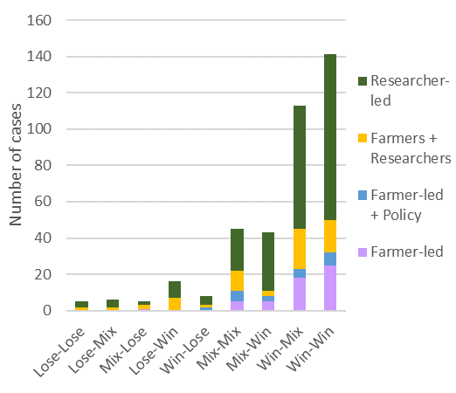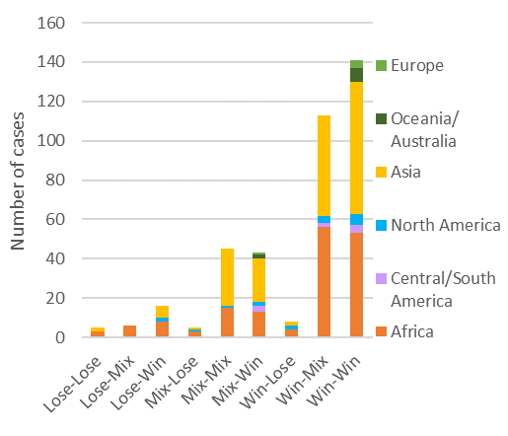
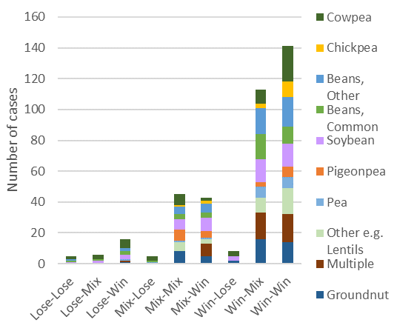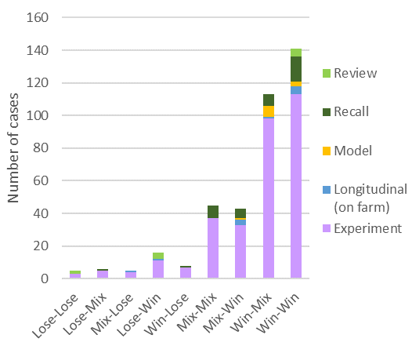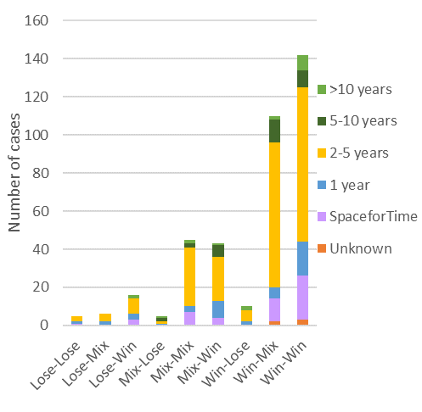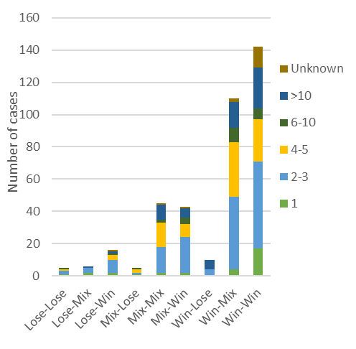
Figure S3. Distribution of joint outcomes in relation to (a) whether a study case was researcher- or farmer-led; (b) the continent where the study occurred; (c) the main legume being introduced into the food system; (d) the methodological approach to data collection for each case; (e) the time scale of the study; (f) the number of replicates in the study.
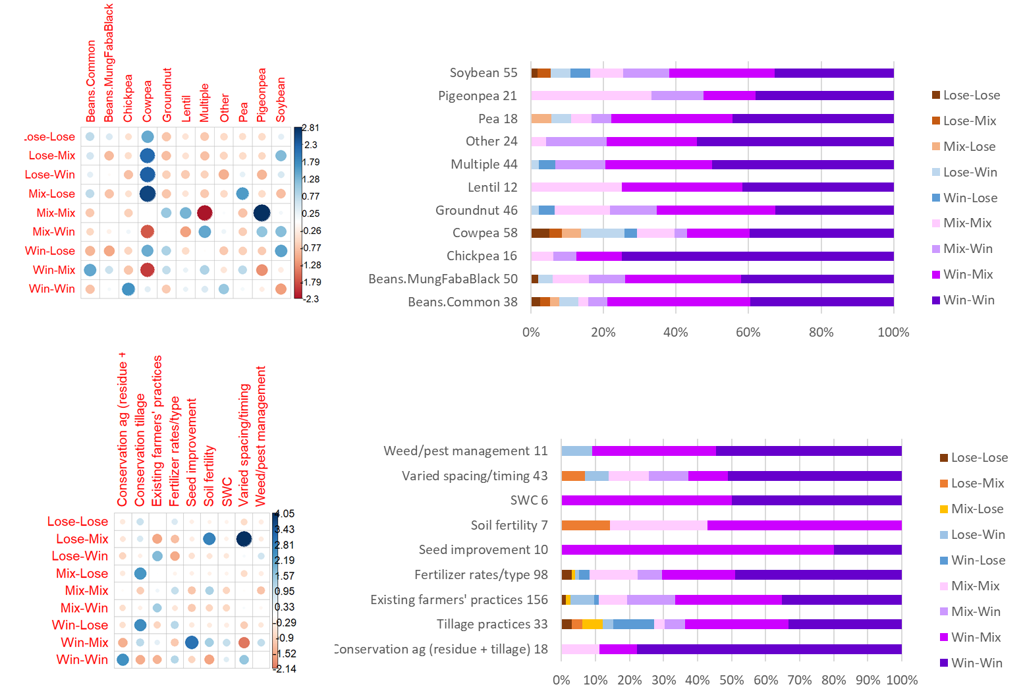
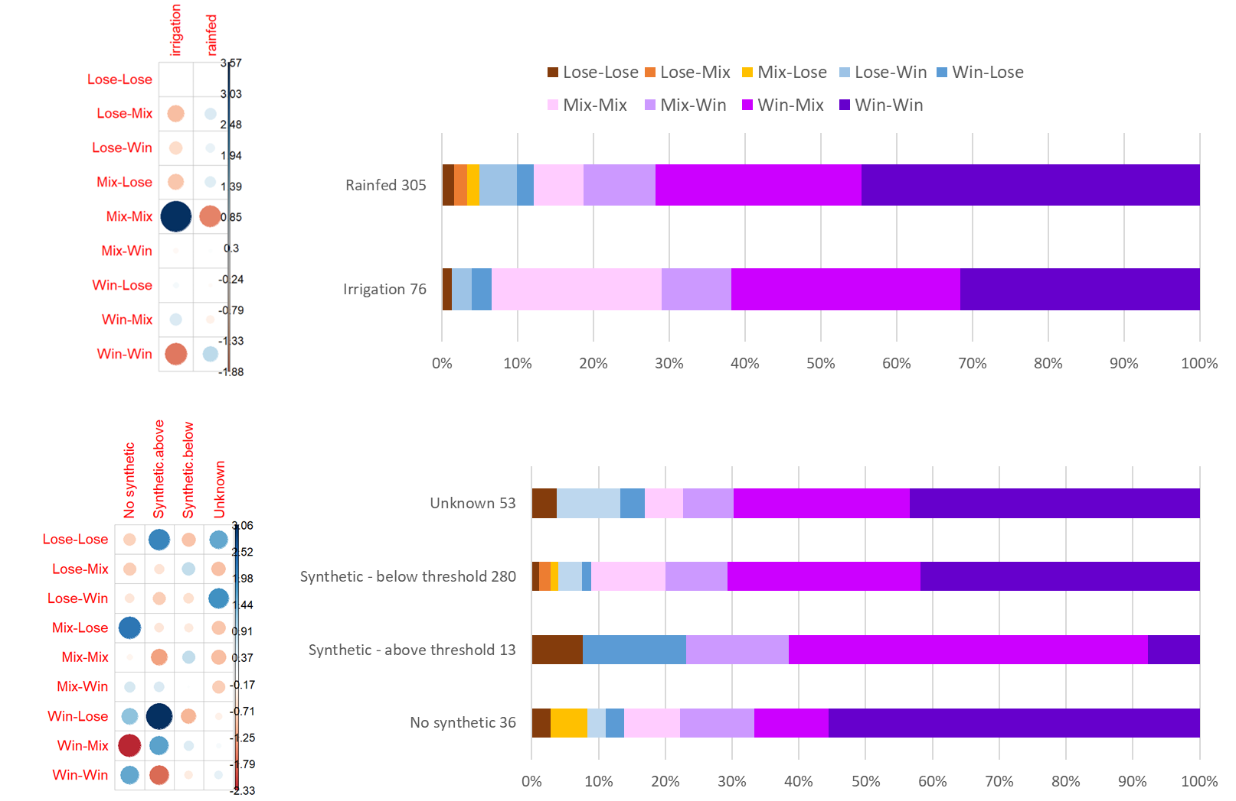
Figure S4. Joint outcomes for ecosystem services and wellbeing categorised in relation to each case’s (a) grain legume introduced into agri-food system, (b) additional agronomic practices, (c) water source (rainfed vs irrigation) and (d) fertiliser use.

4.2. Relationships between ecosystem services and wellbeing
Both aggregated models relating overall averaged ecosystem services outcomes to overall average wellbeing (non-economic or economic) for each case with quantitative data were significant (Table S3). The positive effect of ecosystem services on wellbeing was higher for economic wellbeing (effect size = 0.006 +/- 0.001) than non-economic wellbeing (effect size 0.004 +/- 0.001). Of the eight model combinations relating broad ecosystem service categories (provisioning services, regulating services, supporting services and biodiversity/soil organic carbon), three models were significant (Table S3). Greater change in food provisioning was linked to greater change in both economic and non-economic wellbeing outcomes, and more positive changes in biodiversity or soil carbon were associated with a greater change in economic wellbeing (Table S3). There was no statistically significant relationship between change in regulating or supporting services and change in wellbeing (either economic or non-economic). Both regulating and supporting services were still more likely to be positively than negatively affected by legume intensification (Fisher’s exact test, p<0.001), but there was no influence of the magnitude of this change on wellbeing.

Table S3: Summary of aggregated ecosystem services and wellbeing models
- Significant Models
Dependent | Model | Parameter | Estimate | Standard Error | P value | AIC | R2 | Degrees of freedom | Residual Deviance
Economic Wellbeing | GLM | Intercept | 1.5719 | 0.0896 | <0.001 | 1083 | 0.0162 | 316 | 555.2
 |  | All Ecosystem Services | 0.0061 | 0.0014 | <0.001
Non-economic Wellbeing | GLM | Intercept | 1.3111 | 0.0371 | <0.001 | 204.9 | 0.1221 | 184 | 31.7
 |  | All Ecosystem Services | 0.0038 | 0.0007 | <0.001
Economic Wellbeing | GLM | Intercept | 1.5783 | 0.0847 | <0.001 | 1071 | 0.0227 | 314 | 542.2
 |  | Provisioning Services | 0.0059 | 0.0012 | <0.001
Non-economic Wellbeing | GLM | Intercept | 1.3106 | 0.0318 | <0.001 | 175.6 | 0.2499 | 183 | 27.1
 |  | Provisioning Services | 0.0034 | 0.0004 | <0.001
Economic Wellbeing | GLM | Intercept | 1.4003 | 0.0884 | <0.001 | 156.9 | 0.1575 | 70 | 34.8
 |  | Biodiversity & Soil Organic Carbon | 0.0052 | 0.0009 | <0.001

- Not Significant Models
Dependent | Model | Parameter | Estimate | Standard Error | P value | AIC | R2 | Degrees of freedom | Residual Deviance
Non-economic Wellbeing | GLM | Intercept | 1.5148 | 0.1229 | <0.001 | 82 | 0.0010 | 39 | 15.5
 |  | Biodiversity & Soil Organic Carbon | -0.0020 | 0.0073 | 0.79
Economic Wellbeing | GLM | Intercept | 1.7243 | 0.1371 | <0.001 | 237.1 | 0.0016 | 80 | 80.4
 |  | Regulating Services | -0.0018 | 0.0031 | 0.55
Non-economic Wellbeing | GLM | Intercept | 1.4917 | 0.0706 | <0.001 | 61.7 | 0.0002 | 51 | 8.9
 |  | Regulating Services | -0.0002 | 0.0019 | 0.93
Economic Wellbeing | GLM | Intercept | 1.5384 | 0.0892 | <0.001 | 427.5 | 0.0024 | 153 | 137.7
 |  | Supporting Services | 0.0010 | 0.0010 | 0.32
Non-economic Wellbeing | GLM | Intercept | 1.3888 | 0.0750 | <0.001 | 138.8 | 0.0018 | 75 | 25.3
 |  | Supporting Services | 0.0004 | 0.0009 | 0.63

Using linear models (LM) with logarithmic transformation enabled us to investigate relationships between each individual ecosystem services and wellbeing outcomes. From the 30 possible combinations between ecosystem services and wellbeing (providing at least 9 data points per variable combination), 6 models were significant. All pairwise models with statistically significant relationships between individual ecosystem services and wellbeing outcomes had positive effect sizes (Figure 5 in main text, Table S4).
The individual model results demonstrate that when legume intensification leads to higher yields of agricultural food provisioning (measured either as Cumulative and Equivalent Yield), specific economic and non-economic outcomes also increase (profit, natural capital, food security and savings in labour cost) (Table S4). Cases with increased yield reported greater positive change in economic wellbeing variables of profit (P < 0.001) and savings in labour cost (p = 0.014). There was also a significant positive relationship between yield and the non-economic wellbeing variables of food security (p = 0.003) and natural capital (p < 0.001). Primary production had a statistically significant relationship with the wellbeing outcome of profit (p = 0.003) with cases that reported greater changes in primary production also reporting greater profit. Likewise, cases reporting an increase in soil organic carbon were associated with a greater increase in profit (p = 0.006).

Table S4: Summary of individual models relating ecosystem services to wellbeing outcomes
- Significant Models
Dependent | Model | Parameter | Estimate | Standard Error | P value | AIC | Adjusted R2 | Degrees of freedom | Residual standard Error
Profit (Economic) | NL Log transf | Intercept | 0.2278 | 0.0317 | <0.001 | 245.0 | 0.347 | 239 | 0.399
 |  | Yield (Equivalent & Cumulative) | 0.8850 | 0.0781 | <0.001
Savings in labour cost (Economic) | NL Log transf | Intercept | -0.1668 | 0.0380 | <0.001 | -12.3 | 0.108 | 44 | 0.203
 |  | Yield (Equivalent & Cumulative) | 0.1786 | 0.0704 | 0.015
Food security (Non-economic) | NL Log transf | Intercept | 0.1085 | 0.1356 | 0.442 | 17.5 | 0.567 | 10 | 0.428
 |  | Yield (Equivalent & Cumulative) | 1.0744 | 0.2735 | 0.003
Natural Capital (Non-economic) | NL Log transf | Intercept | 0.2467 | 0.0215 | <0.001 | -35.1 | 0.166 | 134 | 0.210
 |  | Yield (Equivalent & Cumulative) | 0.3062 | 0.0581 | <0.001
Profit (Economic) | NL Log transf | Intercept | 0.3488 | 0.0741 | <0.001 | 129.6 | 0.096 | 79 | 0.526
 |  | Primary Production | 0.5744 | 0.1868 | 0.003
Profit (Economic) | NL Log transf | Intercept | 0.3512 | 0.0694 | <0.001 | 94.8 | 0.100 | 62 | 0.492
 |  | Soil Organic Carbon | 0.4898 | 0.1735 | 0.006
- Not Significant Models
Dependent | Model | Parameter | Estimate | Standard Error | P value | AIC | Adjusted R2 | Degrees of freedom | Residual standard Error
Employment (Non-economic) | NL Log transf. | Intercept | 0.4276 | 0.1933 | 0.063 | 3.4 | 0.048 | 7 | 0.237
 |  | Yield (Equivalent & Cumulative) | 0.2969 | 0.2506 | 0.275
Financial Security (Economic) | NL Log transf. | Intercept | 0.0099 | 0.0346 | 0.778 | -28.9 | -0.034 | 26 | 0.135
 |  | Yield (Equivalent & Cumulative) | 0.0178 | 0.0549 | 0.748
Health (Non-economic) | NL Log transf. | Intercept | 0.2321 | 0.0361 | <0.001 | -15.0 | -0.036 | 27 | 0.175
 |  | Yield (Equivalent & Cumulative) | 0.0114 | 0.0823 | 0.891
Physical capital (Economic) | NL Log transf. | Intercept | -0.0806 | 0.0564 | 0.171 | -34.0 | -0.042 | 17 | 0.089
 |  | Yield (Equivalent & Cumulative) | 0.1310 | 0.2501 | 0.607
Profit (Economic) | NL Log transf. | Intercept | 0.6858 | 0.1247 | <0.001 | 133.2 | -0.016 | 51 | 0.819
 |  | Yield non legume | 0.1413 | 0.3185 | 0.659
Natural Capital (Non-economic) | NL Log transf. | Intercept | 0.3270 | 0.0913 | 0.006 | -0.4 | -0.067 | 9 | 0.200
 |  | Yield non legume | 0.1571 | 0.2585 | 0.558
Profit (Economic) | NL Log transf. | Intercept | 0.5273 | 0.1083 | <0.001 | 52.8 | 0.925 | 29 | 0.535
 |  | Climate Regulation | -0.2598 | 0.4405 | 0.560
Natural Capital (Non-economic) | NL Log transf. | Intercept | 0.2924 | 0.0650 | 0.001 | -3.1 | 0.156 | 12 | 0.189
 |  | Climate Regulation | 0.4637 | 0.2514 | 0.090
Profit (Economic) | NL Log transf. | Intercept | 0.7483 | 0.2259 | 0.004 | 50.3 | -0.031 | 18 | 0.772
 |  | Pest Regulation | -0.3508 | 0.5381 | 0.523
Natural Capital (Non-economic) | NL Log transf. | Intercept | 0.3677 | 0.0869 | 0.001 | 8.9 | -0.069 | 14 | 0.284
 |  | Pest Regulation | -0.0440 | 0.2260 | 0.848
Profit (Economic) | NL Log transf. | Intercept | 0.2401 | 0.0933 | 0.015 | 48.0 | 0.008 | 34 | 0.446
 |  | Water Regulation | 0.2782 | 0.2464 | 0.267
Natural Capital (Non-economic) | NL Log transf. | Intercept | 0.3428 | 0.0337 | <0.001 | -20.3 | -0.034 | 24 | 0.152
 |  | Water Regulation | 0.04297 | 0.0988 | 0.667
Profit (Economic) | NL Log transf. | Intercept | 0.1162 | 0.1902 | 0.554 | 25.5 | 0.002 | 11 | 0.556
 |  | Soil Formation | 0.8459 | 0.8374 | 0.334
Savings in labour cost (Economic) | NL Log transf. | Intercept | -0.0999 | 0.1106 | 0.390 | 5.4 | -0.096 | 9 | 0.261
 |  | Soil Formation | 0.1336 | 0.3747 | 0.730
Profit (Economic) | NL Log transf. | Intercept | 0.4192 | 0.0620 | <0.001 | 153.1 | -0.008 | 101 | 0.499
 |  | Nutrient Cycling | -0.0482 | 0.1089 | 0.659
Financial Security (Economic) | NL Log transf. | Intercept | 0.0323 | 0.0401 | 0.429 | -27.8 | -0.045 | 22 | 0.125
 |  | Nutrient Cycling | 0.0104 | 0.1862 | 0.956
Natural Capital (Non-economic) | NL Log transf. | Intercept | 0.2485 | 0.0529 | <0.001 | 7.0 | -0.028 | 32 | 0.253
 |  | Nutrient Cycling | -0.0297 | 0.1008 | 0.770
Health (Non-economic) | NL Log transf. | Intercept | 0.1112 | 0.0406 | 0.015 | -15.0 | 0.105 | 15 | 0.139
 |  | Nutrient Cycling | 0.1592 | 0.0937 | 0.110
Natural Capital (Non-economic) | NL Log transf. | Intercept | 0.2703 | 0.0517 | <0.001 | 5.2 | 0.037 | 25 | 0.248
 |  | Primary Production | 0.2968 | 0.2106 | 0.171
Health (Non-economic) | NL Log transf. | Intercept | 0.2100 | 0.0596 | 0.003 | -2.7 | -0.050 | 14 | 0.197
 |  | Primary Production | 0.0805 | 0.1503 | 0.601
Food Security (Non-economic) | NL Log transf. | Intercept | -0.0678 | 0.3070 | 0.830 | 26.1 | 0.118 | 10 | 0.612
 |  | Primary Production | 0.8859 | 0.5640 | 0.147
Financial Security (Economic) | NL Log transf. | Intercept | 0.0870 | 0.0575 | 0.154 | -15.3 | 0.049 | 13 | 0.128
 |  | Soil Organic Carbon | -0.3821 | 0.2913 | 0.212
Natural Capital (Non-economic) | NL Log transf. | Intercept | 0.3020 | 0.0380 | <0.001 | -17.0 | -0.033 | 23 | 0.159
 |  | Soil Organic Carbon | -0.0329 | 0.2442 | 0.894
Profit (Economic) | NL Log transf. | Intercept | 0.0903 | 0.0507 | 0.125 | -4.7 | -0.165 | 6 | 0.143
 |  | Biodiversity | 0.0124 | 0.1236 | 0.924

References
1 IPBES. Summary for policymakers of the global assessment report on biodiversity and ecosystem services of the Intergovernmental Science-Policy Platform on Biodiversity and Ecosystem Services. (IPBES secretariat, 2019).
2 Alkire, S. & Santos, M. E. Measuring Acute Poverty in the Developing World: Robustness and Scope of the Multidimensional Poverty Index. World Dev. 59, 251-274, doi:10.1016/j.worlddev.2014.01.026 (2014).
3 Nussbaum, M. C. Creating capabilities : the human development approach. (Belknap Press of Harvard University Press, 2011).
4 Woodhouse, E. et al. Guiding principles for evaluating the impacts of conservation interventions on human well-being. Philosophical transactions of the Royal Society of London. Series B. Biological sciences 370, 20150103-20150103, doi:10.1098/rstb.2015.0103 (2015).
5 Rasmussen, L. V. et al. Social-ecological outcomes of agricultural intensification. Nat. Sustain. 1, 275-282, doi:10.1038/s41893-018-0070-8 (2018).
6 Millennium Ecosystem Assessment. Ecosystems and Human Well-being: Biodiversity Synthesis. (World Resources Institute, 2005).
7 Masciandaro, G., Macci, C., Peruzzi, E. & Doni, S. in The Future of Soil Carbon (eds C. Garcia, P. Nannipieri, & T. Hernandez) (Academic Press, 2018).
8 Beillouin, D., Ben-Ari, T. & Makowski, D. Evidence map of crop diversification strategies at the global scale. Environ. Res. Lett. 14, 123001, doi:10.1088/1748-9326/ab4449 (2019).
9 Page, M. J. et al. The PRISMA 2020 statement: an updated guideline for reporting systematic reviews. BMJ (Online) 372, n71-n71, doi:10.1136/bmj.n71 (2021).
10 Shamseer, L. et al. Preferred reporting items for systematic review and meta-analysis protocols (PRISMA-P) 2015: elaboration and explanation. BMJ (Online) 349, g7647-g7647, doi:10.1136/bmj.g7647 (2015).
11 Haddaway, N. R. et al. Eight problems with literature reviews and how to fix them. Nature ecology & evolution 4, 1582-1589, doi:10.1038/s41559-020-01295-x (2020).
12 Haddaway, N. R. et al. How does tillage intensity affect soil organic carbon? A systematic review. Environmental evidence 6, 1-48, doi:10.1186/s13750-017-0108-9 (2017).
13 Higgins, J. P. T. et al. The Cochrane Collaboration’s tool for assessing risk of bias in randomised trials. BMJ 343, 889-893, doi:10.1136/bmj.d5928 (2011).
14 Pullin, A., Frampton, G., Livoreil, B. & Petrokofsky, G. (Collaboration for Environmental Evidence, 2018).
15 Li, C. et al. Syndromes of production in intercropping impact yield gains. Nat. Plants 6, 653-660, doi:10.1038/s41477-020-0680-9 (2020).
16 Martin-Guay, M.-O., Paquette, A., Dupras, J. & Rivest, D. The new Green Revolution: Sustainable intensification of agriculture by intercropping. The Science of the total environment 615, 767-772, doi:10.1016/j.scitotenv.2017.10.024 (2018).
17 Mupangwa, W. et al. Maize yields from rotation and intercropping systems with different legumes under conservation agriculture in contrasting agro-ecologies. Agriculture, ecosystems & environment 306, 107170, doi:10.1016/j.agee.2020.107170 (2021).
18 Tang, X. et al. Intercropping legumes and cereals increases phosphorus use efficiency; a meta-analysis. Plant Soil 460, 89-104, doi:10.1007/s11104-020-04768-x (2021).
19 Thierfelder, C. & Mhlanga, B. Short-term yield gains or long-term sustainability? – a synthesis of Conservation Agriculture long-term experiments in Southern Africa. Agriculture, ecosystems & environment 326, 107812, doi:10.1016/j.agee.2021.107812 (2022).
20 Bower, K. M. When to use Fisher's exact test. ASQ Six Sigma Forum Magazine 2, 35 (2003).
21 McCrum-Gardner, E. Which is the correct statistical test to use? British journal of oral & maxillofacial surgery 46, 38-41, doi:10.1016/j.bjoms.2007.09.002 (2008).
22 Lira, P. K., de Souza Leite, M. & Metzger, J. P. Temporal Lag in Ecological Responses to Landscape Change: Where Are We Now? Current landscape ecology reports 4, 70-82, doi:10.1007/s40823-019-00040-w (2019).
23 Ziter, C., Graves, R. A. & Turner, M. G. How do land-use legacies affect ecosystem services in United States cultural landscapes? Landsc. Ecol. 32, 2205-2218, doi:10.1007/s10980-017-0545-4 (2017).

