Table 2. The candidate drugs and corresponding genes for pulmonary fibrosis post-COVID-19 associated ARDS.
Genes | Drugs | Interaction Score | Chemical Formula | Structure
FCER1A | omalizumab | 27.48 | NA | NA
 | mizolastine | 20.61 | C₂₄H₂₅FN₆O | 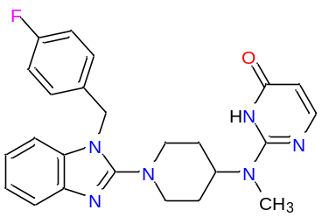
 | desloratadine | 10.3 | C₁₉H₁₉ClN₂ | 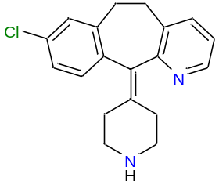
GATA2 | epoetin alfa | 2.44 | NA | NA
 | azacitidine | 0.91 | C₈H₁₂N₄O₅ | 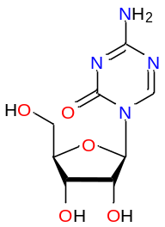
 | bortezomib | 0.52 | C₁₉H₂₅BN₄O₄ | 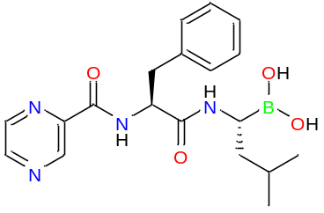
CLC | moxidectin | 20.61 | C₃₇H₅₃NO₈ | 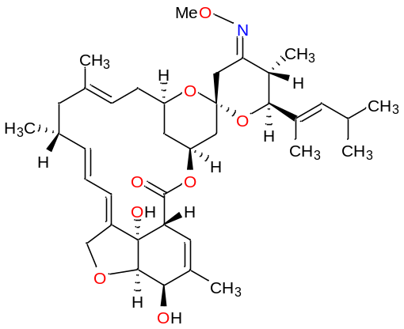
HDC | omeprazole | 1.87 | C₁₇H₁₉N₃O₃S | 