Appendix

Appendix 1. Study Eligibility Criteria
Study characteristic | Inclusion criteria | Exclusion criteria
Population | Required to meet both: 1. patients with diabetes; 2. adults (≥18 years of age) | None
Intervention | “Intervention” must meet all the following criteria:  - A series of medical visits (at least two) where at least one healthcare professional (including a prescribing clinician) cares for groups of patients;  - The medical provider addresses each patient’s unique medical needs individually, with the potential to change medications, but in the context of the group setting. | The study excluded if exposure meets any of the following criteria:  - Not a group visit;  - No prescribing clinician was present at the group visit meeting;  - No plan for adjusting medications when indicated.
Comparator | Usual care or other quality improvement strategy | None.
Outcome | - Patient and/or staff experience  - Treatment adherence (attendance, medications, self-management)  - Biophysical markers (e.g., HbA1c, blood pressure)  - Symptom severity  - Functional status  - Utilization of medical resources | None
Timing | Outcomes reported at least 3 weeks from randomization and initiation of intervention | Outcomes reported less than 3 weeks from randomization and initiation of intervention.
Setting | - Outpatient settings, specifically primary care or specialty clinic/practice | - Conducted in an inpatient or nonmedical community setting (i.e., senior centers)
Study design ^{b} | - Patient or cluster RCTs;  - Nonrandomized cluster-controlled trials;  - Controlled before-and-after studies;  - Interrupted time series designs. | Cross-sectional studies and other observational study designs are not explicitly listed as “included” study designs.
Publications | - Published from 1996 to present  - Peer-reviewed article | - Published before 1996^{c}
Note: a: A prescribing clinician may be a medical doctor, doctor of osteopathy, advanced practice registered nurse (APRN), physician assistant, or doctor of pharmacy.
b: Study designs recommended by the Cochrane Effective Practice and Organization of Care Group.
c: Shared medical appointments were introduced by Beck et al. in their seminal article in 1997.
Abbreviations: HbA1c, glycosylated hemoglobin; KQ, key question; RCT, randomized controlled trial

Appendix 1. Search Strategy ( January 2012 to February 2024)
a: Medline (via PubMed)
Step | Category | Terms
1 | Terms for “group appointment” | (Visit[ti] OR visits[ti] OR appointment[ti] OR appointments[ti] OR clinic[ti] OR clinics[ti] OR "Appointments and Schedules"[Mesh]) AND (group[ti] OR shared[ti] OR cluster[ti])
2 | Terms for “shared visits” | (Shared medical appointment[tiab] OR shared medical appointments[tiab] OR group care[tiab] OR group medical appointment[tiab] OR group medical appointments[tiab] OR cluster visit[tiab] OR cluster visits[tiab] OR group visit[tiab] OR group visits[tiab] OR shared medical visit[tiab] OR shared medical visits[tiab] OR group medical clinic[tiab] OR group medical clinics[tiab])
3 | Combined intervention terms | #1 OR #2
4 | Terms of RCT study design | (randomized controlled trial[pt] OR controlled clinical trial[pt] OR randomized[tiab] OR randomised[tiab] OR randomization[tiab] OR randomisation[tiab] OR placebo[tiab] OR drug therapy[sh] OR randomly[tiab] OR trial[tiab] OR groups[tiab] OR clinical trial[pt] OR clinical trial[tw] OR clinical trials[tw] OR evaluation studies[pt] OR evaluation studies as topic[MeSH Terms] OR evaluation study[tw] OR evaluation studies[tw] OR intervention study[tw] OR intervention studies[tw] OR cohort studies[MeSH Terms] OR cohort[tw] OR longitudinal studies[MeSH Terms] OR longitudinal[tw] OR longitudinally[tw] OR prospective[tw] OR prospectively[tw] OR follow up[tw] OR comparative study[pt] OR comparative study[tw] OR systematic[subset] OR meta-analysis[pt] OR meta-analysis as topic[MeSH Terms] OR meta-analysis[tw] OR meta-analyses[tw]) NOT (Editorial[pt] OR Letter[pt] OR Case Reports[pt] OR Comment[pt]) NOT (animals[mh] NOT humans[mh])
5 | Intervention AND RCT | #3 AND #4
6 | Terms for observational studies | pre-post[tiab] OR post-test[tiab] OR posttest[tiab] OR pretest[tiab] OR pre-test[tiab] OR pretest[tiab] OR quasi-experiment*[tiab] OR quasiexperimental*[tiab] OR quasirandom*[tiab] OR quasi-random*[tiab] OR quasi-control*[tiab] OR quasi control*[tiab] OR (time series[tiab] AND interrupt[tiab]) OR (time points[tiab] AND (multiple[tiab] OR one[tiab] OR two[tiab] OR three[tiab] OR four[tiab] OR five[tiab] OR six[tiab] OR seven[tiab] OR eight[tiab] OR nine[tiab] OR ten[tiab]) OR month*[tiab] OR day*[tiab] OR week*[tiab] OR hour*[tiab]) OR (before[tiab] AND after[tiab]) OR (*before[tiab] AND during[tiab])
7 | Intervention and Observational | #3 AND #6
8 | Applies limits to combined RCT and observational studies | #5 OR #7
9 | Diabetes | #8 AND diabetes[tw]
b: Embase
Step | Category | Terms
1 | Terms for “group appointment” | (visit:ti OR visits:ti OR appointment:ti OR appointments:ti OR clinic:ti OR clinics:ti OR 'hospital management'/de) AND (group:ti OR shared:ti OR cluster:ti)
2 | Terms for “shared visits” | 'shared medical appointment':ab,ti OR 'shared medical appointments':ab,ti OR 'group care':ab,ti OR 'group medical appointment':ab,ti OR 'group medical appointments':ab,ti OR 'cluster visit':ab,ti OR 'cluster visits':ab,ti OR 'group visit':ab,ti OR 'group visits':ab,ti OR 'shared medical visit':ab,ti OR 'shared medical visits':ab,ti OR 'group medical clinic':ab,ti OR 'group medical clinics':ab,ti
3 | Combined intervention terms | #1 OR #2
4 | Terms for RCT study design | ('randomized controlled trial':it OR 'controlled clinical trial':it OR 'clinical trial':it OR 'evaluation study':it OR 'comparative study':it OR 'meta analysis':it OR randomized:ab,ti OR randomised:ab,ti OR randomization:ab,ti OR randomisation:ab,ti OR placebo:ab,ti OR randomly:ab,ti OR trial:ab,ti OR groups:ab,ti OR 'clinical trial' OR 'clinical trials' OR 'evaluation study' OR 'evaluation studies' OR cohort OR longitudinal OR longitudinally OR prospective OR prospectively OR 'follow up' OR 'comparative study' OR 'meta analysis' OR 'meta analyses' OR 'systematic review'/exp/mj OR 'drug therapy':lnk OR 'evaluation study'/de OR 'cohort analysis'/de OR 'longitudinal study'/de OR 'meta analysis (topic)'/de) NOT (editorial:it OR letter:it OR 'case report':it OR comment:it) NOT ('animal'/de NOT 'human'/de)
5 | Intervention AND RCT | #3 AND #4
6 | Terms for observational studies | 'pre post':ab,ti OR 'post test':ab,ti OR pretest:ab,ti OR 'pre test':ab,ti OR 'quasi experiment*':ab,ti OR quasiexperiment*:ab,ti OR quasirandom*:ab,ti OR 'quasi random*':ab,ti OR 'quasi control*':ab,ti OR quasicontrol*:ab,ti OR ('time series':ab,ti AND interrupt:ab,ti) OR ('time points':ab,ti AND (multiple:ab,ti OR one:ab,ti OR two:ab,ti OR three:ab,ti OR four:ab,ti OR five:ab,ti OR six:ab,ti OR seven:ab,ti OR eight:ab,ti OR nine:ab,ti OR ten:ab,ti)) OR month*:ab,ti OR day*:ab,ti OR week*:ab,ti OR hour*:ab,ti OR (before:ab,ti AND after:ab,ti) OR (before:ab,ti AND during:ab,ti)
7 | Intervention and Observational | #3 AND #6
8 | Applies limits to combined RCT and observational studies | #5 OR #7
9 | Diabetes | #8 AND diabetes:ti,ab,kw
c: EBSCO
Step | Category | Terms
1 | Terms for “group appointment” | (TI ( visit OR visits OR appointment OR appointments OR clinic OR clinics ) OR SU ( "Appointments and Schedules" ) )AND TI ( group OR shared OR cluster )
2 | Terms for “shared visits” | TI ( "shared medical appointment" OR "shared medical appointments" OR "group care" OR "group medical appointment" OR "group medical appointments" OR "cluster visit" OR "cluster visits" OR "group visit" OR "group visits" OR "shared medical visit" OR "shared medical visits" OR "group medical clinic" OR "group medical clinics" ) OR AB ( "shared medical appointment" OR "shared medical appointments" OR "group care" OR "group medical appointment" OR "group medical appointments" OR "cluster visit" OR "cluster visits" OR "group visit" OR "group visits" OR "shared medical visit" OR "shared medical visits" OR "group medical clinic" OR "group medical clinics" )
3 | Combined intervention terms | #1 OR #2
4 | Terms for RCT study design | TI ( randomized OR randomised OR randomization OR randomisation OR placebo ) OR AB ( randomized OR randomised OR randomization OR randomisation OR placebo ) OR SU drug therapy OR TI ( randomly OR trial OR groups ) OR AB ( randomly OR trial OR groups ) OR TX ( “clinical trial” OR “clinical trials” ) OR SU "evaluation studies " OR TX ( "evaluation study" OR evaluation studies ) OR SU ("intervention studies" )OR TX ( "intervention study" OR "intervention studies" ) OR SU( "cohort studies" )OR TX (cohort )OR SU( "longitudinal studies") OR TX ( "longitudinal” OR longitudinally OR "prospective" OR prospectively OR "follow up" ) OR TX ("comparative study" )OR SU (meta-analysis) OR TX ( "meta-analysis" OR "meta-analyses" ) NOT SU ( animals NOT humans )  with limits: meta-analysis, randomized controlled trials, comparative studies, longitudinal method, clinical trials
5 | Intervention AND RCT | #3 AND #4
6 | Terms for observational studies | TI ( “pre-post” OR “post-test” OR “post test” OR pretest OR pre-test OR “pre test” OR quasi-experiment* OR quasiexperiment* OR quasirandom* OR quasi-random* OR quasi-control* OR quasicontrol* OR ("time series" AND interrupt) OR (“time points” AND (multiple OR one OR two OR three OR four OR five OR six OR seven OR eight OR nine OR ten OR month* OR day* OR week* OR hour*)) OR (before AND after) OR (*before AND during ) OR AB ( “pre-post” OR “post-test” OR “post test” OR pretest OR pre-test OR “pre test” OR quasi-experiment* OR quasiexperiment* OR quasirandom* OR quasi-random* OR quasi-control* OR quasicontrol* OR ("time series" AND interrupt) OR (“time points” AND (multiple OR one OR two OR three OR four OR five OR six OR seven OR eight OR nine OR ten OR month* OR day* OR week* OR hour*) )OR (before AND after) OR (*before AND during ))
7 | Intervention and Observational | #3 AND #6
8 | Applies limits to combined RCT and observational studies | #5 OR #7
9 | Diabetes | #8 AND TX(diabetes)
d: PsycINFO
Step | Category | Terms
1 | Terms for “group appointment” | TI ( visit OR visits OR appointment OR appointments OR clinic OR clinics ) OR SU ( “Appointments and Schedules” )  AND TI ( group OR shared OR cluster )
2 | Terms for “shared visits” | TI ( "shared medical appointment" OR "shared medical appointments" OR "group care" OR "group medical appointment" OR "group medical appointments" OR "cluster visit" OR "cluster visits" OR "group visit" OR "group visits" OR "shared medical visit" OR "shared medical visits" OR "group medical clinic" OR "group medical clinics" ) OR AB ( "shared medical appointment" OR "shared medical appointments" OR "group care" OR "group medical appointment" OR "group medical appointments" OR "cluster visit" OR "cluster visits" OR "group visit" OR "group visits" OR "shared medical visit" OR "shared medical visits" OR "group medical clinic" OR "group medical clinics" )
3 | Combined intervention terms | #1 OR #2
4 | Terms for RCT study design | TI ( randomized OR randomised OR randomization OR randomisation OR placebo ) OR AB ( randomized OR randomised OR randomization OR randomisation OR placebo ) OR SU drug therapy OR TI ( randomly OR trial OR groups ) OR AB ( randomly OR trial OR groups ) OR TX ( “clinical trial” OR “clinical trials” ) OR SU "evaluation studies " OR TX ( "evaluation study" OR evaluation studies ) OR SU ("intervention studies" )OR TX ( "intervention study" OR "intervention studies" ) OR SU( "cohort studies" )OR TX (cohort )OR SU( "longitudinal studies") OR TX ( "longitudinal” OR longitudinally OR "prospective" OR prospectively OR "follow up" ) OR TX ("comparative study" )OR SU (meta-analysis) OR TX ( "meta-analysis" OR "meta-analyses" ) NOT SU ( animals NOT humans )  with limits: meta-analysis, randomized controlled trials, comparative studies, longitudinal method, clinical trials
5 | Intervention AND RCT | #3 AND #4
6 | Terms for observational studies | TI ( “pre-post” OR “post-test” OR “post test” OR pretest OR pre-test OR “pre test” OR quasi-experiment* OR quasiexperiment* OR quasirandom* OR quasi-random* OR quasi-control* OR quasicontrol* OR ("time series" AND interrupt) OR (“time points” AND (multiple OR one OR two OR three OR four OR five OR six OR seven OR eight OR nine OR ten OR month* OR day* OR week* OR hour*) OR (before AND after) OR (*before AND during ) OR AB ( “pre-post” OR “post-test” OR “post test” OR pretest OR pre-test OR “pre test” OR quasi-experiment* OR quasiexperiment* OR quasirandom* OR quasi-random* OR quasi-control* OR quasicontrol* OR ("time series" AND interrupt) OR (“time points” AND (multiple OR one OR two OR three OR four OR five OR six OR seven OR eight OR nine OR ten OR month* OR day* OR week* OR hour*) OR (before AND after) OR (*before AND during )
7 | Intervention and Observational | #3 AND #6
8 | Applies limits to combined RCT and observational studies | #5 OR #7
9 | Diabetes | #8 AND TX(diabetes)
e: Web of Science
Step | Category | Terms
1 | Terms for “group appointment” | (TI =( visit OR visits OR appointment OR appointments OR clinic OR clinics ) OR TS =( “Appointments and Schedules”) )AND (TI= ( group OR shared OR cluster ) )
2 | Terms for “shared visits” | TS=( "shared medical appointment" OR "shared medical appointments" OR "group care" OR "group medical appointment" OR "group medical appointments" OR "cluster visit" OR "cluster visits" OR "group visit" OR "group visits" OR "shared medical visit" OR "shared medical visits" OR "group medical clinic" OR "group medical clinics" )
3 | Combined intervention terms | #1 OR #2
4 | Terms for RCT study design | TS=(randomized OR randomised OR randomization OR randomisation) OR TS=(placebo ) OR TS=(“drug therapy”) OR TS= (randomly OR trial) OR TS=( groups ) OR TS=( “clinical trial” OR “clinical trials” OR “evaluation studies” OR “evaluation study”) OR TS=(“comparative study” OR meta-analysis OR meta-analyses OR systematic) OR TS=(“evaluation studies as the topic” OR “clinical trials as topic” OR “cohort studies” OR “longitudinal studies” OR “meta-analysis as topic”) NOT DT=(Editorial OR Letter OR “Case Reports” OR Comment ) NOT TS=(animals) NOT TS=(humans)
5 | Intervention AND RCT | #3 AND #4
6 | Terms for observational studies | TS=( pre-post OR post-test OR “post test” OR pretest OR pre-test OR “pre test” OR quasi-experiment* OR quasi-experiment* OR quasirandom* OR quasi-random* OR quasi-control* OR quasi control*) OR TS= ("time series" AND interrupt) OR TS= (“time points” AND (multiple OR one OR two OR three OR four OR five OR six OR seven OR eight OR nine OR ten ) OR month* OR day* OR week* OR hour* OR (before AND after) OR (*before AND during ) )
7 | Intervention and Observational | #3 AND #6
8 | Applies limits to combined RCT and observational studies | #5 OR #7
9 | Diabetes | #8 AND TS=diabetes
f: CINAHL
Step | Category | Terms
1 | Terms for “group appointment” | (TI ( visit OR visits OR appointment OR appointments OR clinic OR clinics ) OR SU ( "Appointments and Schedules" ) )AND TI ( group OR shared OR cluster )
2 | Terms for “shared visits” | TI ( "shared medical appointment" OR "shared medical appointments" OR "group care" OR "group medical appointment" OR "group medical appointments" OR "cluster visit" OR "cluster visits" OR "group visit" OR "group visits" OR "shared medical visit" OR "shared medical visits" OR "group medical clinic" OR "group medical clinics" ) OR AB ( "shared medical appointment" OR "shared medical appointments" OR "group care" OR "group medical appointment" OR "group medical appointments" OR "cluster visit" OR "cluster visits" OR "group visit" OR "group visits" OR "shared medical visit" OR "shared medical visits" OR "group medical clinic" OR "group medical clinics" )
3 | Combined intervention terms | #1 OR #2
4 | Terms for RCT study design | TI ( randomized OR randomised OR randomization OR randomisation OR placebo ) OR AB ( randomized OR randomised OR randomization OR randomisation OR placebo ) OR SU drug therapy OR TI ( randomly OR trial OR groups ) OR AB ( randomly OR trial OR groups ) OR TX ( “clinical trial” OR “clinical trials” ) OR SU "evaluation studies " OR TX ( "evaluation study" OR evaluation studies ) OR SU ("intervention studies" )OR TX ( "intervention study" OR "intervention studies" ) OR SU( "cohort studies" )OR TX (cohort )OR SU( "longitudinal studies") OR TX ( "longitudinal” OR longitudinally OR "prospective" OR prospectively OR "follow up" ) OR TX ("comparative study" )OR SU (meta-analysis) OR TX ( "meta-analysis" OR "meta-analyses" ) NOT SU ( animals NOT humans )  with limits: meta-analysis,randomized controlled trials,comparative studies, longitudinal method, clinical trials
5 | Intervention AND RCT | #3 AND #4
6 | Terms for observational studies | TI ( “pre-post” OR “post-test” OR “post test” OR pretest OR pre-test OR “pre test” OR quasi-experiment* OR quasiexperiment* OR quasirandom* OR quasi-random* OR quasi-control* OR quasicontrol* OR ("time series" AND interrupt) OR (“time points” AND (multiple OR one OR two OR three OR four OR five OR six OR seven OR eight OR nine OR ten OR month* OR day* OR week* OR hour*)) OR (before AND after) OR (*before AND during ) OR AB ( “pre-post” OR “post-test” OR “post test” OR pretest OR pre-test OR “pre test” OR quasi-experiment* OR quasiexperiment* OR quasirandom* OR quasi-random* OR quasi-control* OR quasicontrol* OR ("time series" AND interrupt) OR (“time points” AND (multiple OR one OR two OR three OR four OR five OR six OR seven OR eight OR nine OR ten OR month* OR day* OR week* OR hour*) )OR (before AND after) OR (*before AND during ))
7 | Intervention and Observational | #3 AND #6
8 | Applies limits to combined RCT and observational studies | #5 OR #7
9 | Diabetes | #8 AND TX(diabetes)
g: CNKI and WangFang
Step | Category | Terms
1 | Terms for “group appointment” | “共享门诊” OR “团体医疗访问”
2 | Terms for “shared visits” | “糖尿病”
3 | Combined intervention terms | #1 AND #2

Appendix 3. Detailed Study Characteristics of Shared Medical Appointments for Diabetes
Study  Design | Location  Setting  Organization  Total N | Age in Years (SD)  Sex (%)  Race/ethnicity (%) | Target Condition  Mean Baseline HbA1c% (SD)  (for Diabetes Studies) | SMA Planned Visits  Study Duration | Describe the process of SMA implementation | Quality
RCT
Wagner, 2001 | US  Primary care  HMO  707 | 60.7(NR)  Male (53)  White (72.8) | Types 1 and 2 diabetes  HbA1c: 7.5 (NR) | 8 visits  24 months | Yes | Good
Trento, 2001 | Italy  Diabetes Clinic  University-affiliated clinic  112 | 61.5 (NR)  Male (54)  NR | Type 2 diabetes  HbA1c: 7.4 (1.4) | 7-8 visits  24 months | No | Good
Clancy, 2003 | US  Primary care  University-affiliated clinic  120 | 54.0 (NR)  Male (22)  Black (77.5) | Type 2 diabetes  HbA1c: 10.5 (NR) | 6 visits  6 months | Yes | Good
Trento, 2005 | Italy  Diabetes Clinic  University-affiliated clinic  62 | Median 27-31 (NR)  Male (60)  NR | Type 1 diabetes  HbA1c: 8.26 (0.15) | 15 visits  36 months | Yes | Fair
Clancy, 2007 | US  Primary care  University-affiliated clinic  186 | 56.0 (NR)  Male (28)  Black (83.3) | Type 2 diabetes  HbA1c: 9.3 (0.2) | 12 visits  12 months | Yes | Fair
Edelman, 2010 | US  Primary care  VA Health System  239 | 60.8 (10.0)  Male (96.2)  White(42.9); African(54.1); American/Other(3.0) | Diabetes; hypertension  HbA1c: 9.2 (1.3) | 7 visits  12 months | Yes | Fair
Gutierrez, 2011 | US  Primary care  University-affiliated clinic  103 | NR (NR)  Male (NR)  Hispanic (100) | Type 2 diabetes  HbA1c: NR (NR) | 36 visits offered  17 months | No | Poor
Naik,  2011 | US  Primary care  VA Health System  87 | 63.6 (7.9)  Male (NR)  Black (31.0) | Type 2 diabetes  HbA1c: 8.86 (1.3) | 4 visits  3 months intervention; 12 months follow-up | Yes | Fair
Sadur,  2011 | US  Primary care  HMO  185 | 56.0 (9.1)  Male (57)  White (74.6) | Types 1 and 2 diabetes  HbA1c: 9.7 (1.8) | 6 visits  6 months | No | Good
Taveira, 2011 | US  Primary care  VA Health System  88 | 60.8 (9.6)  Male (98  White (99) | Types 1 and 2 diabetes  HbA1c: 8.3 (1.7) | 9 visits  6 months | Yes | Fair
Liu,  2012 | China  Primary care  Health Care Clinic  208 | 61.99(9.8)  Male (37.8)  Chinese 100 | Type 2 diabetes  HbA1c: NR | 12 visits  12 months |  | Good
Jackson, 2013 | US  Primary care  VA Health System  239 | NR  Male (96)  White36.4; African American59; other4. 6 | Types 1 and 2 diabetes  HbA1c: 9.2 (0.1) | NR  42 months | Yes | Good
Berry,  2016 | US  Primary care  the Community-based Health Center  80 | 51.4(8.5)  Male (NR)  non-Hispanic Black (77.4), non-Hispanic White (17.9), bilingual Hispanic (2.4), Asian Pacific (1.2), and American Indian (1.2) | Type 2 diabetes  HbA1c: 8.8 (2.1) | 5 visits  15 months | No | Good
Vaughan,  2017 | US  Primary care  Community Clinics  50 | 51.3 (NR)  Male (16)  98 Hispanic Patients | Type 2 diabetes  HbA1c: 8.7 (2.5) | 6 visits  6 months | Yes | Fair
Wu,  2018 | US  Primary care  VA Health System  214 | 65.4 (NR)  Male (96)  Caucasian76.8  African American10.8  Other12.4 | Type 2 diabetes  HbA1c: 8.2 (1.5) | once weekly for over 4 weeks, followed by 4 booster sessions held once every 3 months  13 months | Yes | Fair
Singer  2018  RCT | Israel  Tertiary Outpatient  Specialist Clinic  60 | 53.2(15.3)  Male (NR)  NR | Type 2 diabetes  HbA1c: 8.3 (1.2) | 4 visits  36 months | Yes | Fair
Vaughan, 2020 | USA  University-affiliated clinic  non-profit community clinic  89 | 55.99 (7.12)  male(22.73)  NR | type 2 diabetes  HbA1c: 9.02 (1.98) | Once a month, 180min at a time  6 months | No | Good
Lou  2020 | China  Primary care  Local CHCs and Hospital  1095 | 66.29(8.93)  Male (48.3)  Chinese 100 | Type 2 diabetes  HbA1c: 7.76 (1.68) | 24 visits  24months | No | Good
Karaivanov 2021 | US  Primary care  Community Clinics  23 | 51.15 (9.10)  Male (38)  NR | Type 2 diabetes  HbA1c: 6.7 (1.32) | 6 visits  6 months | Yes | Fair
Vaughan, 2021 | USA  Government VA  non-profit community clinic  59 | 52.5 (7.8)  male(40.9)  Latino(a)s | type 2 diabetes  HbA1c: 7.61（1.2） | NR  12 mouths | No | Good
Heisler, 2021 | USA  Private clinic/integrated system (HMO)  VA Health System  1537 | 67.1 (9.2)  male (97)  / | type 2 diabetes  HbA1c: 9.1 ( 1.5) | NR  2 years | No | Good
Baig,  2022 | five Midwestern states  healthcare  six CHCs  133 | 55.1 (11.8)  male (29.4)  Non-Hispanic White (31.4); Non-Hispanic Black (43.1); Hispanic or Latino(17.6); Native American(7.8) | type 2 diabetes  HbA1c: 10.2（1.7） | CHCs were asked to hold six monthly GVs with 8–10 patients per group.GVs at the sites lasted from 120–210 min, the median being 120 min.  12 mouths | No | Good
Yang 2023 | China  Diabetes Clinic  University-affiliated clinic  86 | 51.25(3.14)  Male (53)  NR | Type 2 diabetes  HbA1c: NR (NR) | 6 visits  6 months | Yes | Fair
Suzanne 2023 | Boston  Primary care  /  309 | 55.54 (11.5)  Male (0)  African American or Black (63)  Hispanic or Latino (34) | Type 2 diabetes  HbA1c: 9.70 (1.7) | 8 visits  6 months | Yes | Fair
Observational studies
Bray,  2005 | US  Primary care  University-affiliated clinic  160 | 59.4 (14.3)  Male (44)  NR | Diabetes; hypertension  HbA1c: 8.2 (2.6) | 4 visits  12 months | Yes | Fair
Culhane-Pera,  2005 | US  Federally qualified health center  Government  61 | 56.8 (NR)  Male (36)  NR | Type 2 diabetes  HbA1c: 9.3 (NR) | 7 visits  28 months | No | Poor
Kirsh,  2007 | US  Primary care  VA Health System  79 | 61.0 (9.9)  Male (NR)  NR | Type 2 diabetes  HbA1c: 10.4 (0.3) | NA (drop-in)  4 months) | No | Poor
Jessee, 2012 | US  Primary care  Uncertain  26 | 56 (NR)  Male (NR)  NR | Type 2 diabetes  HBA1c: 9.27 (NR) | 3 visits  3 months | Yes | Good
Watts,  2015 | US  Primary care  VA Health System  1290 | 62.6(9.09)  Male (96)  White (24.4)  AA (61.4) | Types 2 diabetes  HbA1c: NR (NR) | 8 visits  3 months | No | Poor
Mallow, 2015 | US  Primary care  Affiliated clinic  104 | NR  Male (26.1)  White (95.5) | Types 2 diabetes  HbA1c: NR (NR) | 6 visits  12 months | Yes | Fair
Marianne, 2016 | US  Primary care  VA Health System  988 | 70.1(9.4)  Male (98)  White (71.7) | Types 2 diabetes  HbA1c: 8.55 (1.72) | NR  36 months | No | Poor
Newby, 2016 | US  Primary care  Private clinic  250 | 57 (NR)  Male (41.2)  AA100 | Types 2 diabetes  HbA1c: 9.4 (1.95) | 12 visits  12 months | Yes | Fair
Hartzler,  2018 | US  Primary care  VA Health System  59 | NR  Male (37.3)  NR | Types 2 diabetes  HbA1c: 9.98 (1.83) | 15 visits  15 months | Yes | Good
Omogbai,  2018 | US  Primary care  VA Health System  30 | 64.7(5.36)  Male (100)  White (60)  AA (27)  Hispanic (13) | Types 1 and 2 diabetes  HbA1c:10.35 (0.83) | 6 visits  6 months | Yes | Fair
Noya,  2020 | US  Primary care  Government  139 | 54.2(NR)  Male (45.3)  White (16.5)  Latinx (69.1) | Types 2 diabetes  HbA1c:  Site1:9.75 (1.86)  Site2:9.12 (1.90) | 18 visits  6 months | No | Good
Wang,  2020 | China  Yangzhou First People's Hospital  Endocrine Clinic  98 | 41～70  male(57)  Chinese | type 2 diabetes  HbA1c: 7.41 (1.87) | NR  6 mouths | Yes | Good
Li,  2021 | China  University-affiliated clinic  Endocrinology Clinic  30 | 59.69(6.91)  male(53.85)  Chinese | type 2 diabetes  HbA1c: 6.97（0.89） | Once a month, 90~120min  3months | Yes | Fair
Pan,  2021 | China  Government VA  Community Outpatient Clinic  78 | 39-82(NR)  male(46.15)  Chinese | Types 1 and 2 diabetes  HbA1c: NR (NR) | NR  21 mouths | Yes | Good
Papadakis, 2021 | USA  Cleveland Clinic  Cleveland Family Internal Medicine  2509 | 60 (9.6)  male(30.4)  White1(64.6) ; Black (30); Asian/other (5.4) | type 2 diabetes  HbA1c: 6 (0.2) | NR  24 mouths | No | Good
Naik,  2022 | USA  Primary care  CHC  272 | 53.5 (12.2)  male(32)  NR | type 2 diabetes  HbA1c: NR (NR) | Once a month,  6 months | No | Poor
Yang,  2022 | China  Community Health Service Center  Cangzhou tertiary hospitals and community health service centers  24 | 42~70 (NR)  male(45.8)  Chinese | type 2 diabetes  HbA1c: NR (NR) | NR  4个月 | Yes | Poor
Tracy 2023 | USA  Primary care  GovernmentVA  48 | 55 (12)  Male (32)  Black/African American (67) | Type 2 diabetes  HbA1c: 9.84 (1.78) | NR  12 months | No | Fair
Adrienne 2023 | USA  Diabetes Clinic  Government VA  37 | 58.43 (11.80)  Male (27)  NR | Type 2 diabetes  HbA1c: NR | 6 visits  6 months | Yes | Fair
Tian 2023 | China  Diabetes Clinic  University-affiliated clinic  124 | 54.57 ± 12.23  Male (61)  NR | Type 2 diabetes  HbA1c: 7.92 (1.95) | NR  12 months | Yes | Fair
Connor 2023 | USA  Diabetes Clinic  Government VA  43 | 70.1 (8.9)  Male(44)  White (52) , black (44) | Type 2 diabetes  HbA1c: 7.05 (7.45) | 8 visits  4 months | No | Fair
Andrea 2023 | USA  Primary care  GovernmentVA  Complete data on 30 or 60 patients with type 2 diabetes per PHC respectively | NR  NR  NR | Type 2 diabetes  NR | 6 visits  15 months | NO | Poor
Martha 2023 | Mexico  Diabetes Clinic  Private clinic  38 | 41 - 64 (NR)  Male (5)  NR | Types 1 and 2 diabetes  HbA1c: NR | NR  5 months | Yes | Poor
Abbreviations: VA: Veterans Affairs; HMO, health maintenance organization; NR, not reported; RCT, randomized controlled trial; SD, standard deviation

Appendix 4. HbA1c and SBP heterogeneity analysis forest plot
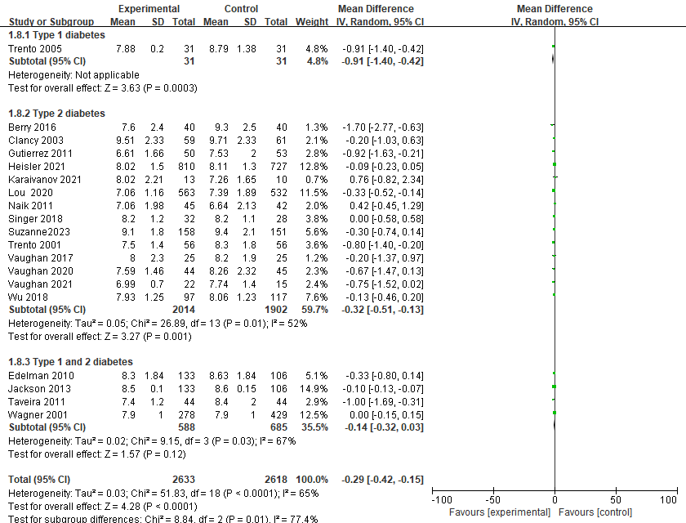
A: Forest plot for changes in HbA1c: after excluding partial bias studies
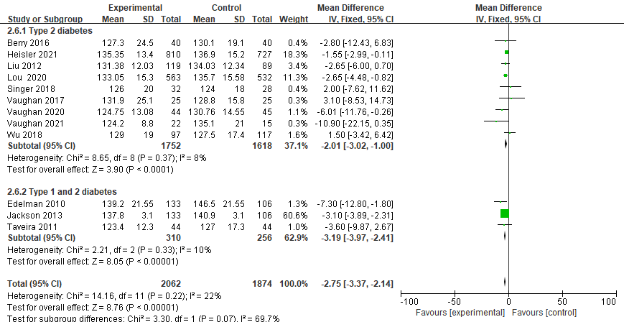
B: Forest plot of SBP changes: after excluding partial bias studies
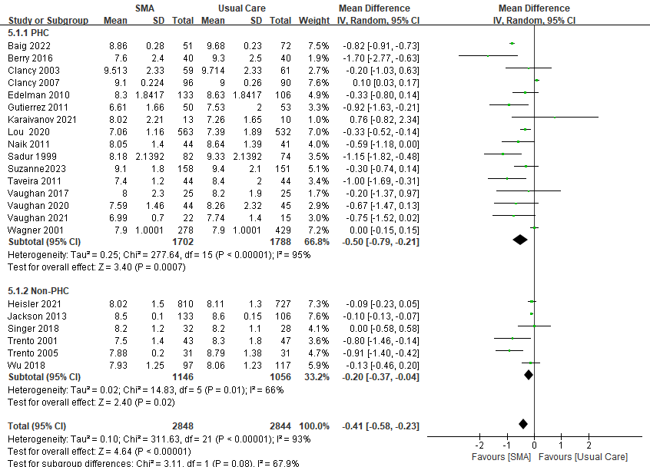
C: Forest plot for changes in HbA1c with PHC setting
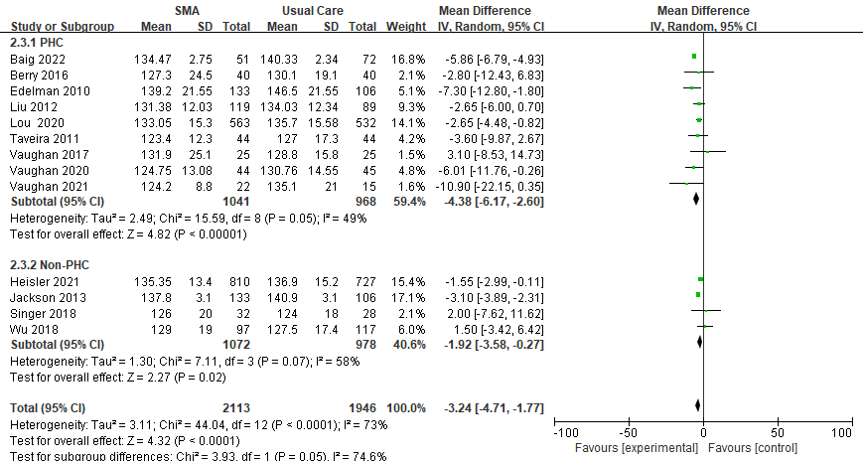
D: Forest plot for changes in SBP with PHC setting
Note: CI: confidence interval; SD: standard deviation

Appendix 5. Summary of Effects of Diabetes SMA on Clinical and Economic Outcomes
Study | Costs measured | Method of cost assignment | Cost difference (SMA vs usual care)
Wagner,  2001 | Total healthcare costs. | GHC administrative data systems | SMA: 2,122.0  SMA vs usual care: 2,208.0  P=0.79
Clancy,  2003 | Facility utilization (i.e., Emergency and outpatient visits and inpatient stays) | Not specified | +$1396 (p=0.0003)
Trento,  2005 | Labor costs of personnel involved in both SMA and control | Average salaries of personnel in Italian NHS | +$207 (no statistical testing reported)
Clancy,  2007 | Facility utilization charges (i.e., charges for the group sessions, emergency and outpatient visits, and inpatient stays) | Billing database of the healthcare system | -$3065 (p<0.05)
Edelman,  2010 | Estimated the cost of a group medical clinic (GMC) | Totaling the labor costs associated with the group sessions, those associated with follow-up calls to patients, and nurse training costs | The annual cost of GMC was $460 per patient.
Jackson,  2013 | Outpatient Expenditures  , Total Expenditures | Not specified | -$1963(p=0.19)  -$7506(p=0.003)
Wu,  2018 | Total VHA Expenditure, VHA Outpatient Expenditure, VHA Inpatient Expenditure, VHA Pharmacy/Medication Expenditure, VHA fee-basis (outsource referral/transfer) costs | A variety of VHA sources that included pharmacy/medication costs, the Fee basis files, outpatient costs, and the hospitalization-related costs from the VHA in patient files | -$1532(p=0.05)  +$124(p=0.19)  +$447(p=0.03)  -$198(p=0.41)  -2005(p=0.08)
Vaughan,  2020 | medications cost | Not specified | The emphasis on low-cost hypoglycemic agents was critical.

Appendix 6. Summarize the results of hospital and emergency room visits
Study | Had an emergency room visit during the intervention |  | P-value | Had a hospitalization during the intervention |  | P-value | Had a primary care visit during the intervention |  | P-value
Study | SMA intervention | Usual Care | P-value | SMA intervention | Usual Care | P-value | SMA intervention | Usual Care | P-value
Wagner ^{A}, 2001 RCT | 0.1 | 0.2 | 0.04 | 16.9 | 21.0 | 0.10 | 6.4 | 5.5 | 0.05
Jackson ^{B}, 2013 RCT | / | / | / | 0.11 | 0.07 | 0.28 | / | / | /
Singer ^{C}, 2018 RCT | 9 | 9 | 0.51 | 11 | 11 | 0.32 | 9 | 10 | 0.22
Baig ^{D}, 2022 RCT | 11 | 10 | 0.10 | 7 | 10 | 0.21 | 47 | 65 | 0.72
Edelman ^{E}, 2010 RCT | 0.9 | 1.3 | ＜0.001 | 32 | 23 | 0.8 | 5.3 | 6.2 | 0.010
Sadur ^{F}, 2011 RCT | Visits to the Urgent Care Clinic and the Emergency Department did not differ significantly before or after the intervention. |  |  |  |  |  |  |  | 0.06
Note: A: Average number of times during the trial (mean/year);
B: Probability of hospitalization during the trial;
C: Comparison between individual and group care in patients with type 1 diabetes;
D: Number of people making healthcare utilization during the trial
E: Relative reduction in the number of comparisons between the two groups during the trial
F: The study was only summarized, and no statistical reporting was done

