Appendix 1
Figure S1.
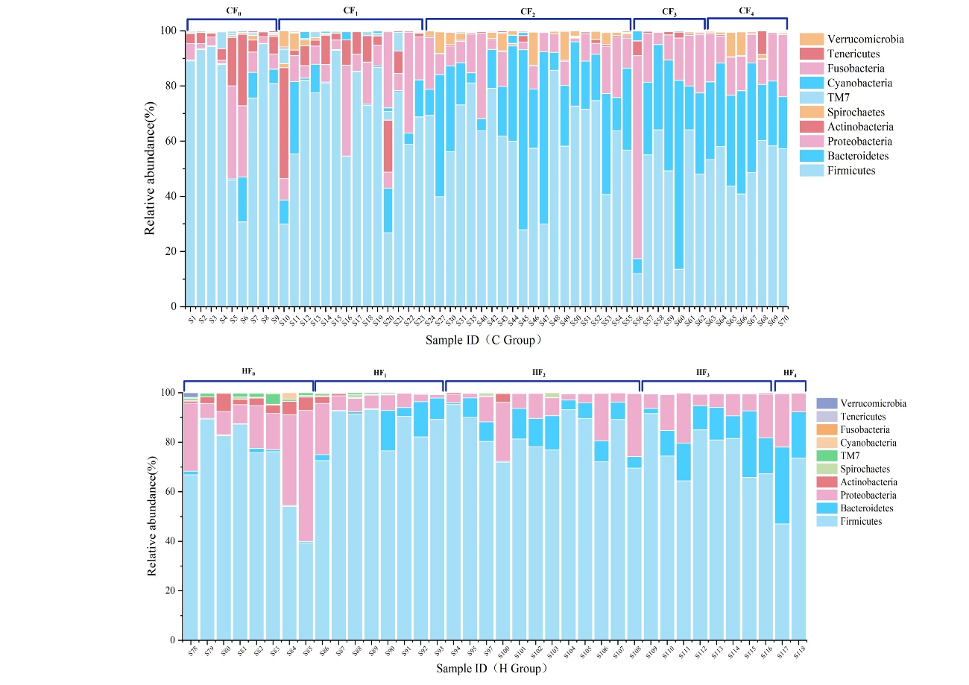
Figure S1. (a) Stacked bar chart of top 10 phyla in the control group. (b) Stacked bar chart of top 10 phyla in the high-fiber group. The x-axis represents sample identifiers, the y-axis indicates relative abundance, and different colors represent distinct phyla.

Figure S2.
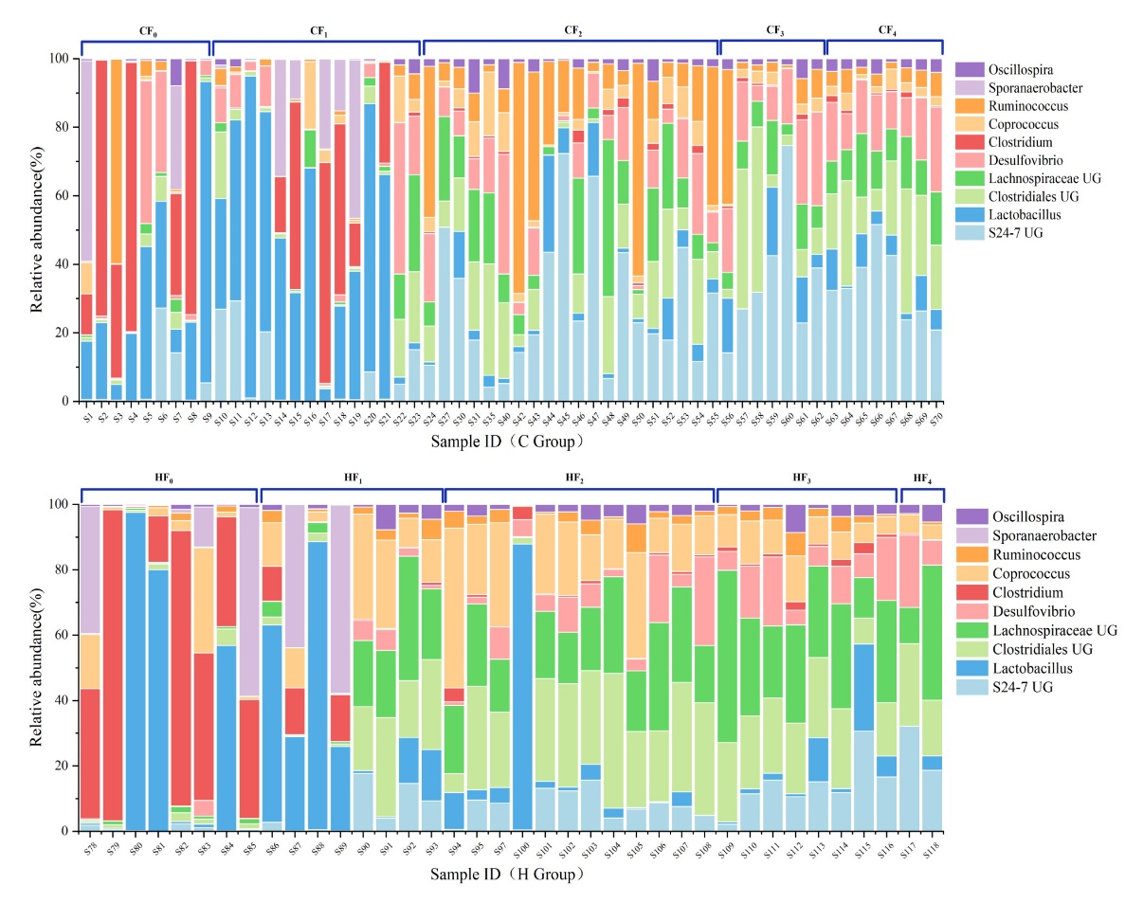
Figure S2. (a) Stacked bar chart of the top 10 genera in the control group. (b) Stacked bar chart of the top 10 genera in the high-fiber group. The x-axis represents sample identifiers, the y-axis indicates relative abundance, and different colors represent distinct phyla.

Figure S3.
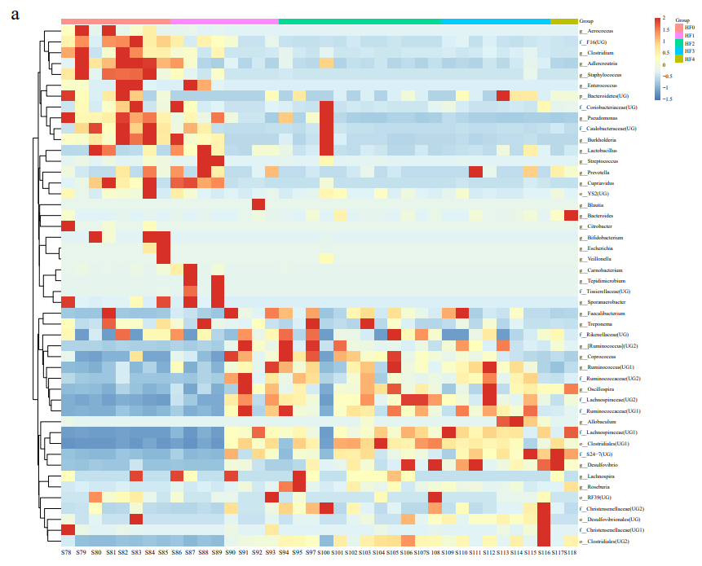
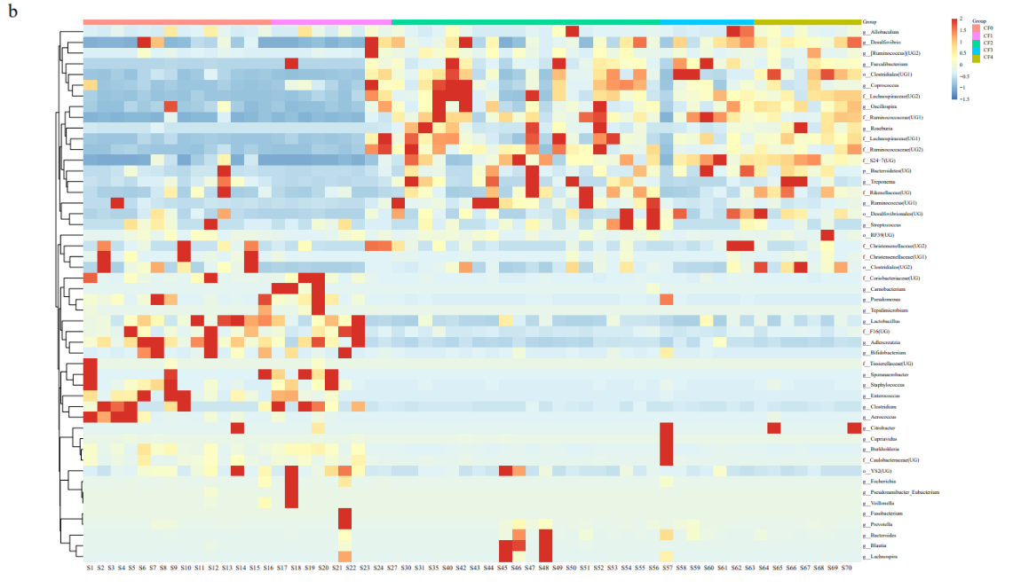
Figure S3. (a) Relative abundance of the top 50 OTUs in the control group samples. (b) Relative abundance of the top 50 OTUs in the high-fiber group samples.

Figure S4.
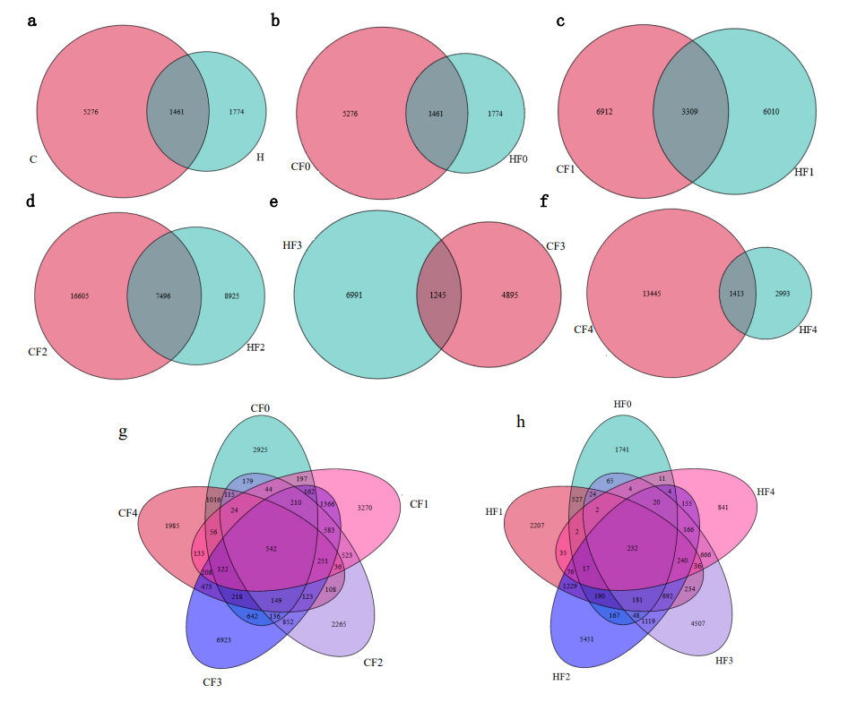
Figure S4. (a) Venn diagram of shared OTUs among all samples in the high and control groups. (b-f) Venn diagrams of shared OTUs among F0-F4 generation samples in the high and control groups.

Table S1 Nutritional composition table of high and normal fiber diets for mouse feed
Nutritional Composition of Mouse Growth Maintenance Feed
Group | C | H
Crude Fiber ≤ | 5% | 13%
Crude Ash≤ | 8% | 0
Moisture and Other Volatile Substances≤ | 10% | 10%
Crude Protein≥ | 18% | 18%
Crude Fat ≥ | 4% | 4%
Total Phosphorus | 0.6-1.2% | 0.6-1.2%
Calcium | 1.0-1.8% | 1.0-1.8%

Table S2 Sample identification of root voles in multi-generational high-fiber and low-fiber feeding experiments
Normal fiber group |  |  |  |  | High-fiber group
ID | Generation |  | Sex ratio (F/M) |  | ID | Generation |  | Sex ratio (F/M)
S₁-S₁₄ |  | CF₀ |  | 1 :1 | S₇₈-S₈₅ |  | HF₀ |  | 1 :1
S₁₅-S₂₃ |  | CF₁ |  | 1: 1.25 | S₈₆-S₉₃ |  | HF₁ |  | 1 :1
S₂₄, S₂₇, S₃₀-S₃₁, S₃₅, S₄₀, S₄₂-S₅₅ |  | CF₂ |  | 1 :1 | S₉₄-S₉₅, S₉₇, S₁₀₀-S₁₀₈ |  | HF₂ |  | 1 :1
S₅₆-S₆₂ |  | CF₃ |  | 1.33: 1 | S₁₀₉-S₁₁₆ |  | HF₃ |  | 1 :1
S₆₃-S₇₀ |  | CF₄ |  | 1 :1 | S₁₁₇-S₁₁₈ |  | HF₄ |  | 1 :1

Table S3 Results of PERMANOVA analysis for high and control groups across different generations
Pairs |  |  | R² | p.value
CF₀ | Vs | CF₁ | 0.050 | 0.309
CF₀ | Vs | CF₂ | 0.578 | 0.001*
CF₀ | Vs | CF₃ | 0.507 | 0.001*
CF₀ | Vs | CF₄ | 0.715 | 0.001*
CF₁ | Vs | CF₂ | 0.396 | 0.001*
CF₁ | Vs | CF₃ | 0.316 | 0.013
CF₁ | Vs | CF₄ | 0.523 | 0.003*
CF₂ | Vs | CF₃ | 0.0560 | 0.181
CF₂ | Vs | CF₄ | 0.087 | 0.069
CF₃ | Vs | CF₄ | 0.243 | 0.008*
HF₀ | Vs | HF₁ | 0.322 | 0.008*
HF₀ | Vs | HF₂ | 0.731 | 0.001*
HF₀ | Vs | HF₃ | 0.842 | 0.001*
HF₀ | Vs | HF₄ | 0.774 | 0.017*
HF₁ | Vs | HF₂ | 0.222 | 0.023*
HF₁ | Vs | HF₃ | 0.247 | 0.052
HF₁ | Vs | HF₄ | 0.131 | 0.347
HF₂ | Vs | HF₃ | 0.077 | 0.178
HF₂ | Vs | HF₄ | 0.071 | 0.229
HF₃ | Vs | HF₄ | 0.101 | 0.492
Table S4 Inter- and intra-group similarity of high-fiber and control groups across generations based on the Bray-Curtis distance matrix
Group | Similarity | Group | Similarity | Group | Similarity
CF₀_vs._CF₁ | 0.134 | HF₀_vs._HF₁ | 0.069 | HF₀_vs._CF₀ | 0.159
CF₁_vs._CF₂ | 0.0674 | HF₁_vs._HF₂ | 0.120 | HF₁_vs._CF₁ | 0.139
CF₃_vs._CF₂ | 0.161 | HF₃_vs._HF₂ | 0.245 | HF₂_vs._CF₂ | 0.032
CF₄_vs._CF₃ | 0.222 | HF₃_vs._HF₄ | 0.025 | HF₃_vs._CF₃ | 0.029
 |  |  |  | HF₄_vs._CF₄ | 0.122

Table S5 Firmicutes to Bacteroidetes ratio across generations in high-fiber and control groups
Mean F/B ratio (Firmicutes to Bacteroidetes ratio) ± 1/2SE
CF₀ | 146.438 ± 21.691 | HF₀ | 185.789 ± 31.406
CF₁ | 278.279 ± 57.345 | HF₁ | 175.647 ± 49.628
CF₂ | 5.073 ± 0.598 | HF₂ | 39.360 ± 9.206
CF₃ | 1.921 ± 0.204 | HF₃ | 10.880 ± 2.289
CF₄ | 1.992 ± 0.128 | HF₄ | 2.714 ± 0.425
C | 80.784 ± 13.256 | H | 90.954 ± 14.180

Appendix 2
16S rRNA gene sequencing
In the process of 16S rRNA sequencing, DNA was first extracted from various samples using the QIAAGEN fecal DNA kit (QIAamp PowerFecal Pro DNA Kit), a method chosen for its efficiency in isolating high-quality microbial DNA from fecal samples, which is essential for accurate downstream 16S rRNA gene analysis (refer to the manufacturer's protocol). Subsequently, the DNA concentration and purity were assessed using the BioTek Epoch full-wavelength spectrophotometer. The A260/A280 ratio, indicative of DNA purity, was determined following standard spectrophotometric principles, with ratios between 1.8 and 2.0 generally indicating pure DNA. Next, use the Nanodrop to perform an initial quantification of DNA and assess the quality of DNA extraction through 1.2% agarose gel electrophoresis. To further ensure the accuracy of DNA quantification, also conduct precise measurements using the Qubit® dsDNA HS Assay Kit and Qubit fluorescence quantifier, which are crucial steps for preparing the PCR reaction mixture[1]. Following this, the V3-V4 hypervariable regions of the 16S rRNA gene were amplified using primers 341F and 805R. This primer set targets a conserved nucleotide sequence that is widely present across a broad range of bacterial strains, thereby allowing for the detection of a large number of bacteria in samples [2]. Pfu high-fidelity DNA polymerase from TransGen Biotech, Beijing, was used for PCR amplification. The number of cycles was minimized while maintaining consistent PCR conditions for sequencing the same batch of samples. Moreover, a negative control sample was prepared to assess the potential presence of microbes in the environment and solutions, and their subsequent impact on the sample groups. Also, another tube containing the DNA template, primers, dNTPs, buffer solution, and Taq polymerase was prepared for qPCR. This tube was later used for real-time quantification of the amplified product through qPCR. In conclusion, the obtained PCR products were sequenced using the Illumina MiSeq next-generation sequencing platform. The results aimed to portray the composition and biodiversity of the bacterial samples.
Data processing
Successful library preparation for sequencing was performed using the NEBNext Ultra DNA Library Prep Kit before sequencing on the Illumina NovaSeq 6000. The DNA extracts from the samples were amplified using PCR targeting the 16S rRNA V3 region and sequenced using the QIIME high-variable region sequencing method which was further saved in the format ‘Fast-q’. At the same time, Miseq sequencing of PE data was performed and samples were also subjected to a quality control check. In fact, several feature steps applied in the process include filtering the data, assembling the data and eliminating data duplication. Throughout the quality control process, tools such as Trimmomatic (V0.36), Pear (V0.96), Flash (V1.20) and Vsearch (V2.7.1) were employed. First, sequence data are sorted from high to low based on relative abundance. Based on sequence similarity, the data are organized into Operational Taxonomic Units (OTUs), with detailed bioinformatics analysis conducted on those with over 97% similarity. The QIIME platform is utilized, referencing the 16S bacterial and archaeal ribosomal databases from Silva2 (Release 128/132), RDP (version 16) [3], and classification is performed using the Bayesian algorithm of RDP classifier. Additionally, normalization of species abundance for OTUs is carried out. QIIME was utilized for bioinformatics analysis, encompassing quality filtering, denoising using the DADA2 algorithm, establishment of phylogenetic relationships, and filtration and extraction of valid data from raw sequencing data [4]. OTU clustering and species classification analyses were conducted to generate OTU species abundance profiles. Based on normalized OTU species abundance profiles, further analyses, including abundance and diversity indices, were performed on OTUs.

REFERENCES
1. Robin JD, Ludlow AT, LaRanger R, Wright WE, Shay JW. Comparison of DNA Quantification Methods for Next Generation Sequencing. Sci Rep. 2016;6(1); doi: 10.1038/srep24067.
2. Parulekar NN, Kolekar P, Jenkins A, Kleiven S, Utkilen H, Johansen A, et al. Characterization of bacterial community associated with phytoplankton bloom in a eutrophic lake in South Norway using 16S rRNA gene amplicon sequence analysis. PLoS One. 2017;12(3):e0173408; doi: 10.1371/journal.pone.0173408.
3. Caporaso JG, Kuczynski J, Stombaugh J, Bittinger K, Bushman FD, Costello EK, et al. QIIME allows analysis of high-throughput community sequencing data. Nat Methods. 2010;7(5):335-6; doi: 10.1038/nmeth.f.303.
4. Callahan B, McMurdie P, Rosen M, Han A, Johnson AJ, Holmes S. DADA2: High resolution sample inference from amplicon data. 2015.

