Table S1 Nutritional composition table of high and normal fiber diets for mouse feed
Nutritional Composition of Mouse Growth Maintenance Feed
Group | C | H
Crude Fiber ≤ | 5% | 13%
Crude Ash≤ | 8% | 0
Moisture and Other Volatile Substances≤ | 10% | 10%
Crude Protein≥ | 18% | 18%
Crude Fat ≥ | 4% | 4%
Total Phosphorus | 0.6-1.2% | 0.6-1.2%
Calcium | 1.0-1.8% | 1.0-1.8%

Table S2 Sample identification of root voles in multi-generational high-fiber and low-fiber feeding experiments
Normal fiber group |  |  |  |  | High-fiber group
ID | Generation |  | Sex ratio (F/M) |  | ID | Generation |  | Sex ratio (F/M)
S₁-S₁₄ |  | CF₀ |  | 1 :1 | S₇₈-S₈₅ |  | HF₀ |  | 1 :1
S₁₅-S₂₃ |  | CF₁ |  | 1: 1.25 | S₈₆-S₉₃ |  | HF₁ |  | 1 :1
S₂₄, S₂₇, S₃₀-S₃₁, S₃₅, S₄₀, S₄₂-S₅₅ |  | CF₂ |  | 1 :1 | S₉₄-S₉₅, S₉₇, S₁₀₀-S₁₀₈ |  | HF₂ |  | 1 :1
S₅₆-S₆₂ |  | CF₃ |  | 1.33: 1 | S₁₀₉-S₁₁₆ |  | HF₃ |  | 1 :1
S₆₃-S₇₀ |  | CF₄ |  | 1 :1 | S₁₁₇-S₁₁₈ |  | HF₄ |  | 1 :1

Figure S1
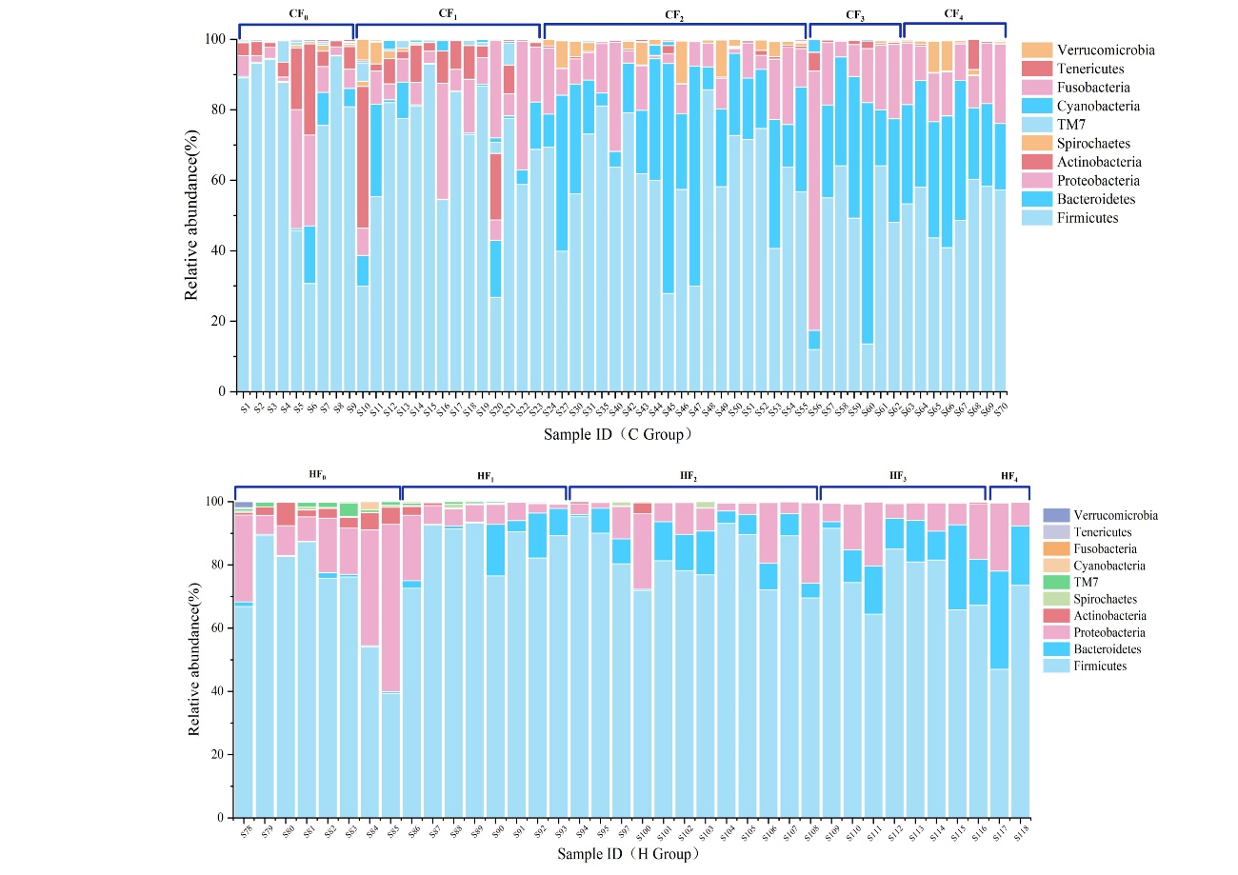
Figure S1. (a) Stacked bar chart of top 10 phyla in the control group. (b) Stacked bar chart of top 10 phyla in the high-fiber group. The x-axis represents sample identifiers, the y-axis indicates relative abundance, and different colors represent distinct phyla.

Figure S2
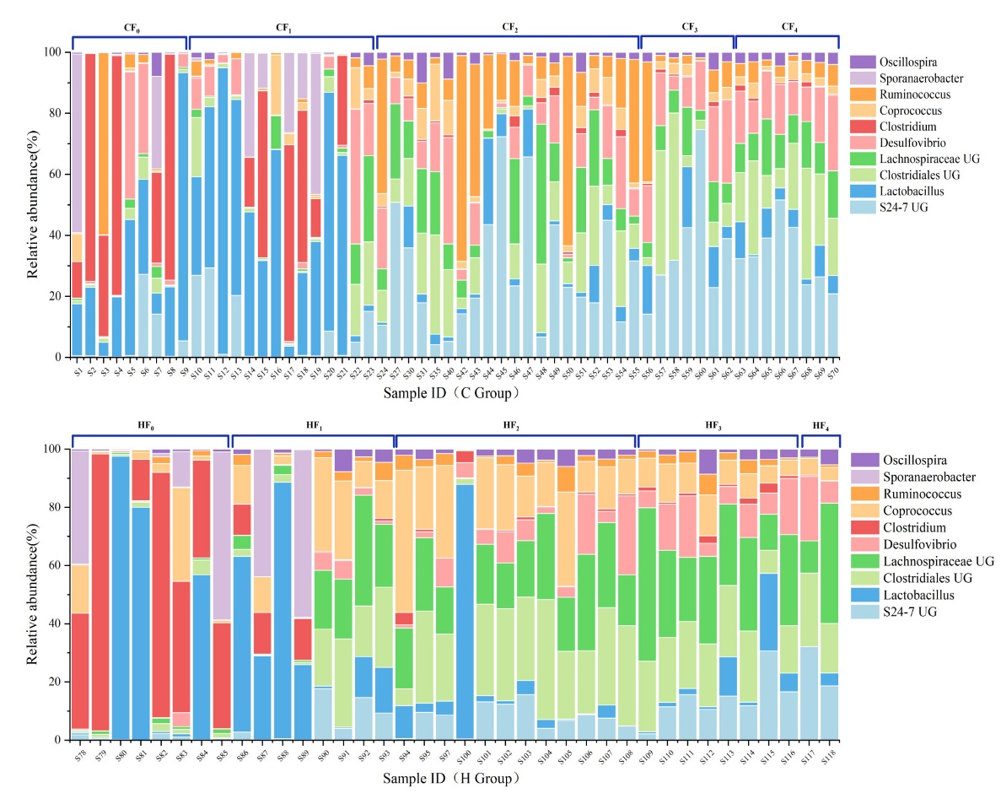
Figure S2. (a) Stacked bar chart of the top 10 genera in the control group. (b) Stacked bar chart of the top 10 genera in the high-fiber group. The x-axis represents sample identifiers, the y-axis indicates relative abundance, and different colors represent distinct phyla.

Table S3 Results of PERMANOVA analysis for high and control groups across different generations
Pairs |  |  | R² | p.value
CF₀ | Vs | CF₁ | 0.050 | 0.309
CF₀ | Vs | CF₂ | 0.578 | 0.001*
CF₀ | Vs | CF₃ | 0.507 | 0.001*
CF₀ | Vs | CF₄ | 0.715 | 0.001*
CF₁ | Vs | CF₂ | 0.396 | 0.001*
CF₁ | Vs | CF₃ | 0.316 | 0.013
CF₁ | Vs | CF₄ | 0.523 | 0.003*
CF₂ | Vs | CF₃ | 0.0560 | 0.181
CF₂ | Vs | CF₄ | 0.087 | 0.069
CF₃ | Vs | CF₄ | 0.243 | 0.008*
HF₀ | Vs | HF₁ | 0.322 | 0.008*
HF₀ | Vs | HF₂ | 0.731 | 0.001*
HF₀ | Vs | HF₃ | 0.842 | 0.001*
HF₀ | Vs | HF₄ | 0.774 | 0.017*
HF₁ | Vs | HF₂ | 0.222 | 0.023*
HF₁ | Vs | HF₃ | 0.247 | 0.052
HF₁ | Vs | HF₄ | 0.131 | 0.347
HF₂ | Vs | HF₃ | 0.077 | 0.178
HF₂ | Vs | HF₄ | 0.071 | 0.229
HF₃ | Vs | HF₄ | 0.101 | 0.492

Figure S3.
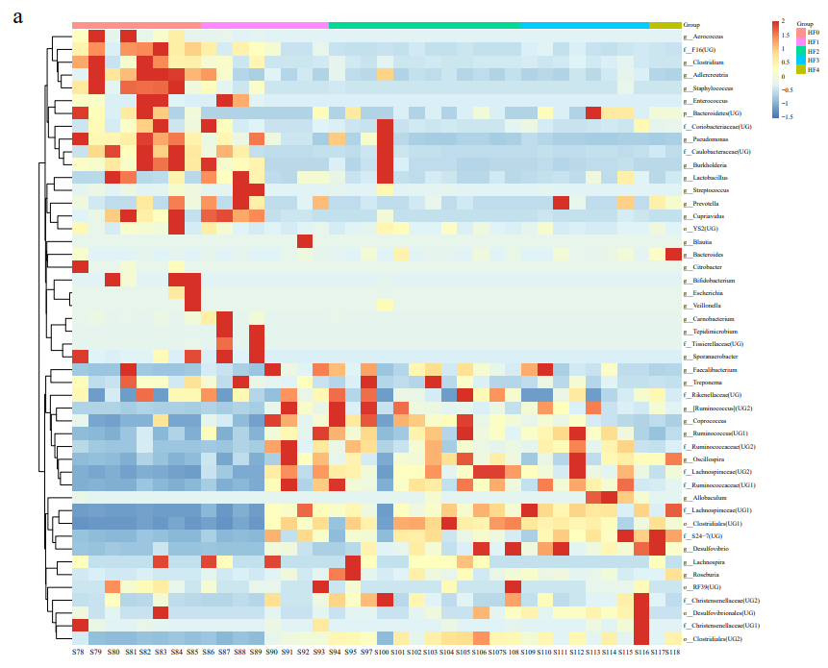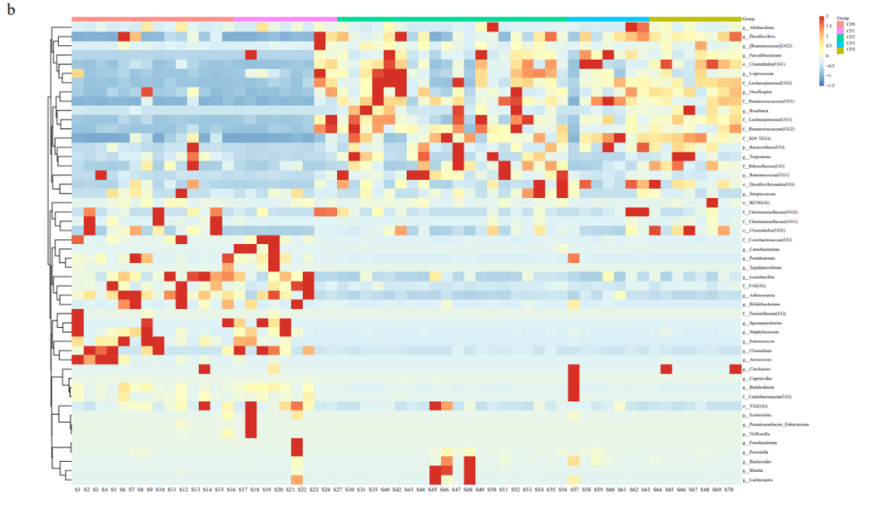
Figure S3. (a) Relative abundance of the top 50 OTUs in the control group samples. (b) Relative abundance of the top 50 OTUs in the high-fiber group samples.

Figure S4
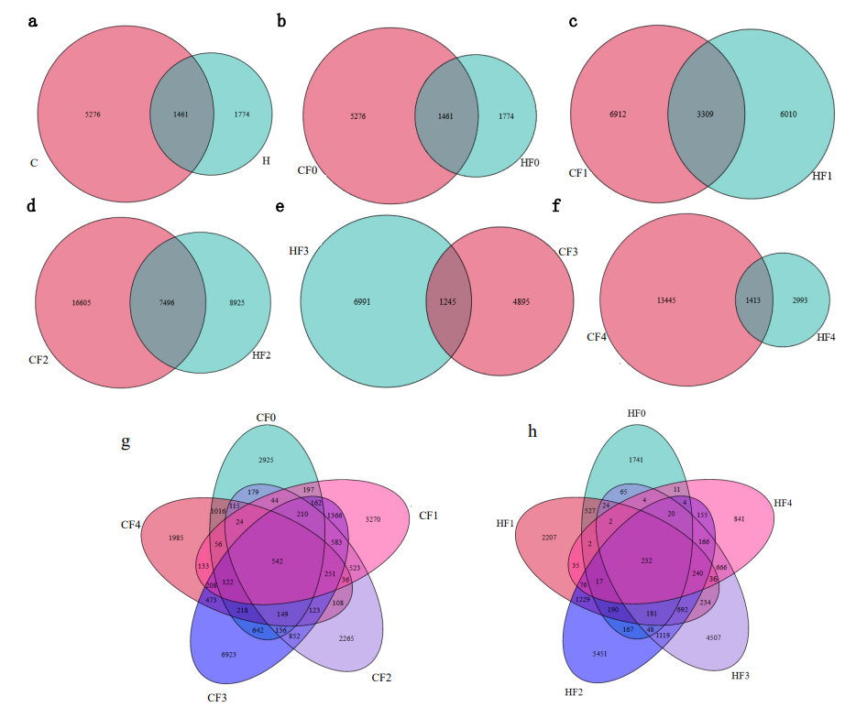
Figure S4. (a) Venn diagram of shared OTUs among all samples in the high and control groups. (b-f) Venn diagrams of shared OTUs among F0-F4 generation samples in the high and control groups.

