Supporting Information for

Nanostructured porous carbon derived from polypyrrole nanoribbons for capacitive deionization and lithium–sulfur batteries

Quanqi Zhang,ª Kanglong Shi,ª Chuan Sun,^{c} Wen Wen,ª Shuai Han,ª Qing-Chao Zhao,^{b,}* Yongpeng Li,ª Zhuyin Sui^{a,}*

ª School of Chemistry & Chemical Engineering, Yantai University, Yantai 264005, China
^{b} State Key Laboratory of Mineral Processing, Beijing 102628, China
^{c} National Innovation Institute of Defense Technology, Academy of Military Sciences of the People’s Liberation Army of China, Beijing 100071, China

* Corresponding Authors.
E-mails: zqc0808@foxmail.com (Q. Zhao); suizy@ytu.edu.cn (Z. Sui)
1.1 Instrumental characterization
Scanning electron microscopy images were captured utilizing an S-4800 microscope from Hitachi Ltd. in Japan. X-ray diffraction patterns were generated on a Philips X'Pert PRO diffractometer sourced from PANalytical B.V. in the Netherlands, employing Cu Kα radiation. Raman spectroscopic analysis was performed on a Renishaw instrument, using a 532 nm laser as the excitation source at ambient temperature. For X-ray photoelectron spectroscopy, spectra were recorded on an ESCALab220i-XL spectrometer manufactured by VG Scientific Ltd. in the UK. Nitrogen adsorption-desorption isotherms of the samples were determined at 77 K on a Micromeritics Tristar II 3020 analyzer. Before measurement, all samples underwent degassing at 120 °C under vacuum conditions for a minimum duration of 12 hours.
1.2 Electrochemical Measurement
The electrodes were crafted by combining 85% by weight of the active material with 5% polytetrafluoroethylene, which was dispersed at 60% in water, and 10% conductive carbon black. For all electrochemical evaluations, a two-electrode configuration was employed, utilizing a sandwich-style cell design. Each cell incorporated two electrodes, separated by an insulating membrane to ensure electrical isolation. The experiments were conducted in a NaCl solution, subjecting the electrodes to a potential window spanning from 0 to 1 V.
1.3 Capacitive deionization test
The electrodes were fabricated by integrating the freshly synthesized samples (NCNR or NCP) with polytetrafluoroethylene and carbon black in a ratio of 85:10:5 by weight. This blend was then compressed onto a nickel foam substrate with an 80 mm diameter and left to dry under vacuum conditions at 80 °C for 12 h. To assess the capacitive deionization capabilities, a device was constructed using two identical electrodes in a symmetrical configuration. The desalination evaluation was performed in a batch-processing mode, utilizing a NaCl aqueous solution flowing at a rate of 20 mL per minute. During these tests, a constant voltage of 1.2 V was applied, and the concentration variations within the NaCl solution were continually monitored using a conductivity meter.
1.4 Electrochemical performance testing of electrode materials for lithium-sulfur batteries
The NCNR-S and NCP-S composites were synthesized employing a melting-diffusion approach. Specifically, 40 mg of NCNR or NCP was intimately blended with 60 mg of sublimed sulfur, and this mixture was subjected to heat treatment at 155 °C for 12 h to yield NCNR-S and NCP-S, respectively. Subsequently, an electrode slurry comprising 70% by weight of the active material (either NCNR-S or NCP-S), 10% polyvinylidene fluoride as binder, and 20% carbon black for conductivity enhancement, was uniformly coated onto a carbon-coated aluminum foil substrate. This coated foil was then dried under vacuum at 50 °C for 6 h. The assembled 2032-type coin cells utilized lithium metal as the anode, Celgard 2400 polypropylene as the separator, and a mixed electrolyte solution containing 1.0 M lithium bis(trifluoromethane) sulfonamide and 0.1 M lithium nitrate dissolved in a 1:1 volume ratio of 1,2-dimethoxy ethane and 1,3-dioxolane, all within a glove box environment.
Electrochemical characterizations were performed, including cyclic voltammetry using a CHI 760E electrochemical workstation to trace the voltammetric curves, galvanostatic charge-discharge tests on a 2001A Land battery tester to evaluate rate capability and cycling durability, and electrochemical impedance spectroscopy measurements on the same CHI 760E system, spanning a frequency range from 100 kHz to 0.01 Hz.

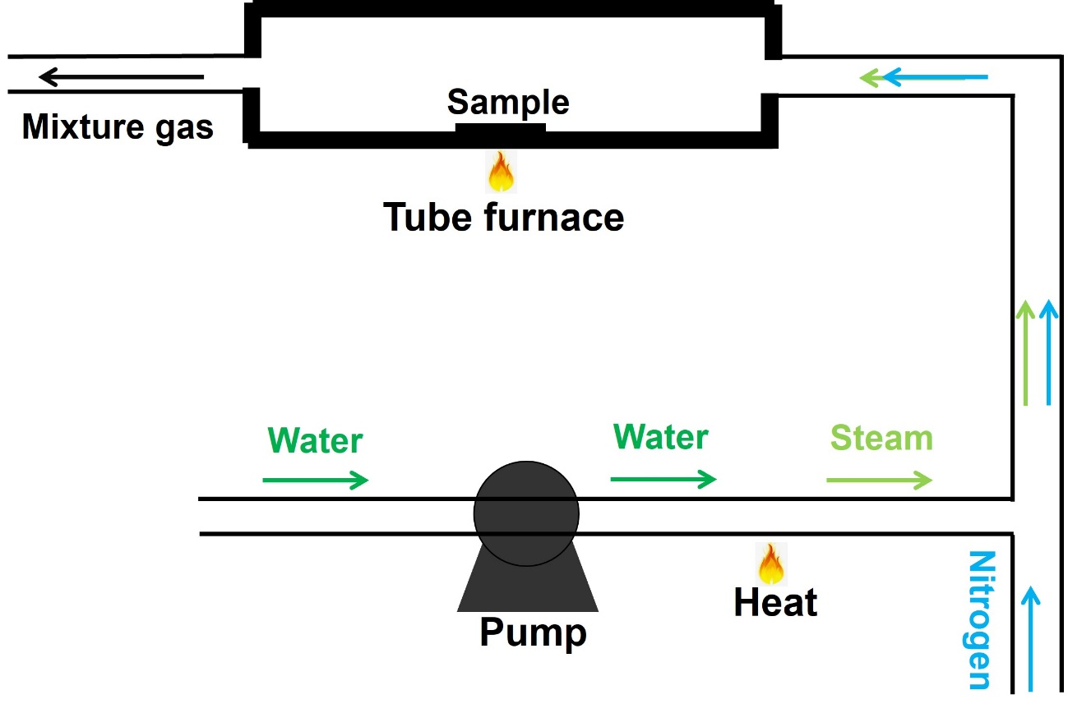
Fig. S1 Schematic diagram of the preparation process of NCP and NCNR through steam activation of PPy samples (particles and nanoribbons).

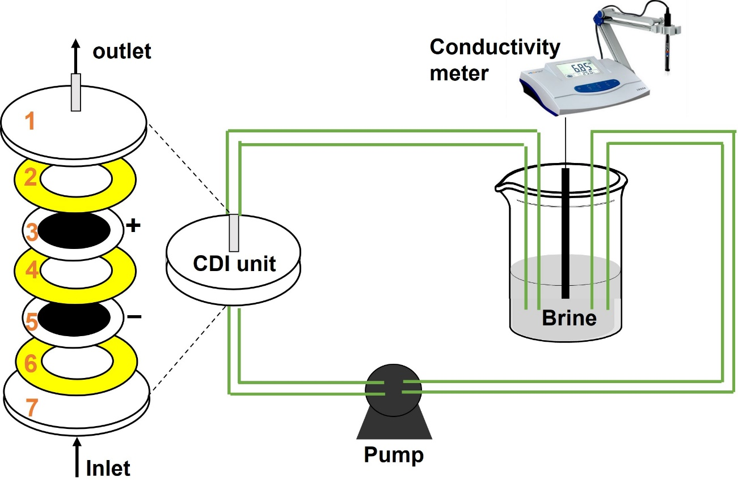
Fig. S2 Schematic diagram for capacitive deionization cell set-up (1 and 7 represent polypropylene plates; 2, 4, and 6 represent silicone gaskets; 3 and 5 represent the working electrodes).

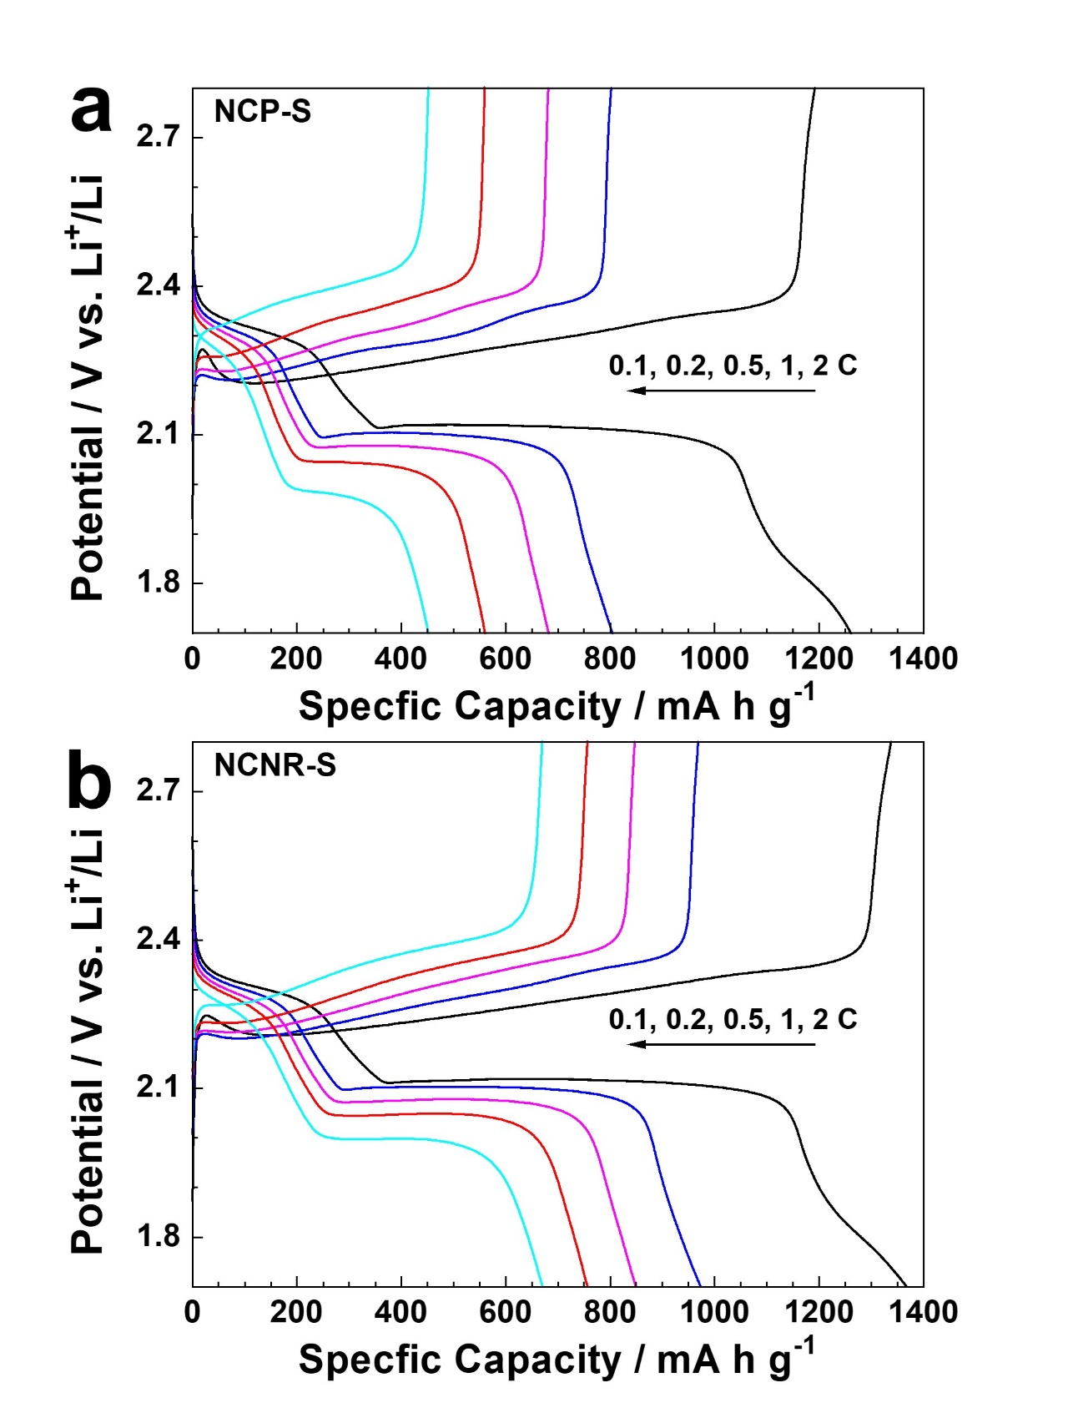
Fig. S3 The charging and discharging curves of batteries using NCP-S (a) and NCNR-S (b) as cathodes at different current densities.

Table S1. Porosity parameters of PPy particles, PPy nanoribbons, NCP, and NCNR.
Sample | S_{BET} (m² g^{–1}) ª | S_{Langmuir} (m² g^{–1}) ^{b} | V_{total} (cm³ g^{–1}) ^{c}
PPy particles | 18 | 26 | 0.03
PPy nanoribbons | 127 | 178 | 0.51
NCP | 747 | 1052 | 0.53
NCNR | 1258 | 1738 | 1.63
ª Specific surface area according to the BET method. ^{b} Specific surface area based on the Langmuir equation. ^{c} total pore volume calculated at P/P₀=0.97.

