Supplementary Material
Supplementary Table 1. Genes within genome-wide significant shared genomic segments in stillbirths
Locus Cytoband | Genes within Shared Regions | Pedigree# (cases sharing/total cases) | P | µ¹ | Size in Mb | Region²
15q26.3 | ADAMTS17; ASB7; CERS3; CERS3-AS1; DNM1P46; HSP90B2P; IGF1R; LINC02244; LINS1; LOC102723335; LOC105371017; LOC400464; LRRC28; LUNAR1; LYSMD4; MEF2A; PGPEP1L; PRKXP1; SPATA41; SYNM; SYNM-AS1; TTC23; TTC23-AS1 | A (2/2) | 2.7x10-5 | 0.01 | 1.81 | 98954683–100761210
15q26.3 | ADAMTS17; ALDH1A3; ALDH1A3-AS1; ASB7; CERS3; CERS3-AS1; GCAWKR; LINS1; LOC102723335; LRRK1; PRKXP1; SPATA41 | B (2/2) | 1.36x10-4 | 0.02 | 1.23 | 99916971-101155417
16p13.13-p13.12 | BCAR4; CPPED1; GSPT1; LITAF; LOC101927131; LOC105371083; LOC400499; MIR4718; NPIPB2; RMI2; RSL1D1; SHISA9; SNN; SNX29; TNFRSF17; TXNDC11; ZC3H7A | B (2/2) | 1.3x10-4 | 0.02 | 2.00 | 11425854 - 13456003
9p13.3-p13.1 | ALDH1B1; CLTA; DCAF10; EBLN3P; EXOSC3; FBXO10; FRMPD1; GNE; GRHPR; LOC105376032; LOC105376034; MELK; MIR4475; MIR4476; MIR4540; PAX5; POLR1E; RNF38; SHB; SLC25A51; TOMM5; TRMT10B; ZBTB5; ZCCHC7 | B (2/2) | 2.1x10-4 | 0.03 | 2.20 | 36189000 - 38396005
6p22.2-p22.1 | ABT1; BTN1A1; BTN2A1; BTN2A2; BTN2A3P; BTN3A1 - BTN3A3; GABBR1; GPX5; GPX6; GUSBP2; H1-3 - H1-6; H2AC11 - H2AC17; H2AC6 - H2BC15; H2BC17; H2BC4 - H2BC6; H2BC6-AS1; H2BC7 - H3C12; H3C4; H3C6 - H3C8; H4C11 - H4C13; H4C4 - H4C9; HCG11; HCG14; HCG15; HCG4; HCG4B; HCG9; HCP5B; HLA-A; HLA-F; HLA-F-AS1; HLA-G; HLA-H; HLA-J; HLA-V; HMGN4; IFITM4P; LARRPM; LINC00240; LINC00533; LINC01012; LINC01015; LINC01556; LINC01623; LINC02829; LINC03003; LOC100131289; LOC105374988; LOC105374989; LOC285819; MAS1L; MIR3143; MOG; NKAPL; OR10C1; OR11A1; OR12D1; OR12D2; OR12D3; OR14J1; OR2B2; OR2B3; OR2B6; OR2B8P; OR2H1; OR2H2; OR2I1P; OR2J1 - OR2J3; OR2W1; OR2W1-AS1; OR5V1; PGBD1; POLR1H; POLR1HASP; POM121L2; PPP1R11; PRSS16; RNF39; SCAND3; SNORD32B; TOB2P1; TRIM27; TRIM31; TRIM31-AS1; UBD; VN1R10P; ZBED9-AS1; ZFP57; ZKSCAN3; ZKSCAN4; ZKSCAN8; ZKSCAN8P1; ZNF165; ZNF184; ZNF204P; ZNF311; ZNF322; ZNF391; ZSCAN12; ZSCAN12P1; ZSCAN16; ZSCAN16-AS1; ZSCAN23; ZSCAN26; ZSCAN31; ZSCAN9 | B (2/2) | 1.0x10-4 | 0.01 | 4.00 | 26106870 - 30106665
14q32.2 | LINC02914 | C (3/3) | 3.1x10-5 | 0.03 | 0.79 | 98337930 – 99132229
Bold highlights indicate genes in the overlapping segment

Supplementary Figure 1. Manhattan plot of genome-wide shared genomic segments analysis in Pedigree A.
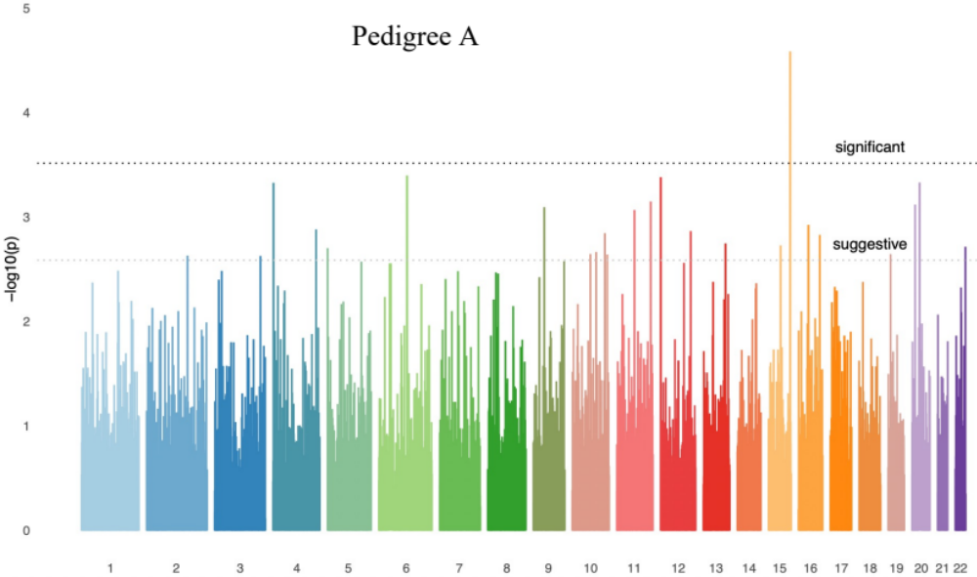

Supplementary Figure 2. Manhattan plot of genome-wide shared genomic segments analysis in Pedigree B.
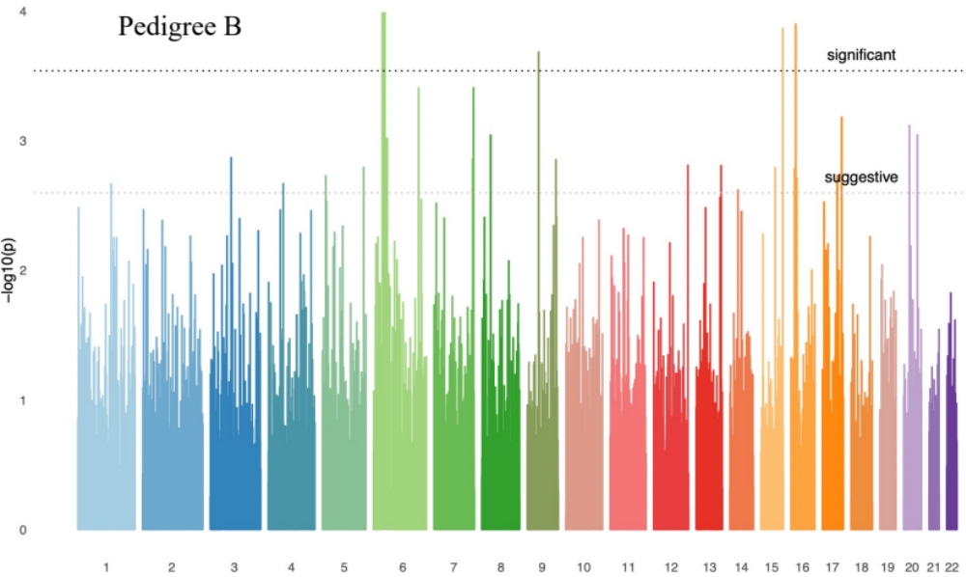

Supplementary Figure 3. Manhattan plot of genome-wide shared genomic segments analysis in Pedigree C.
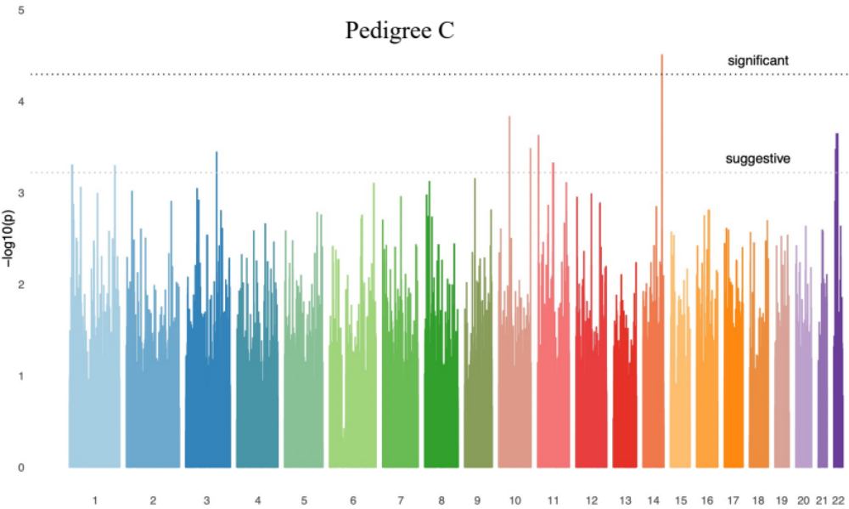

Supplementary Figure 4. Shared genomic segments in the 15q26.3 region, shared in stillbirths in Pedigree A and Pedigree B.
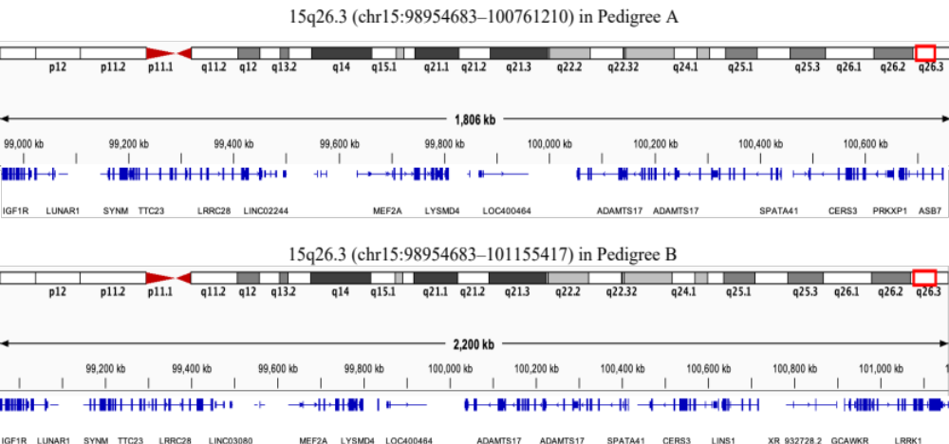

Supplementary Figure 5. Shared genomic segments in the 16p13.13-p13.12, 9p13.3-p13.1, and 6p22.2-p22.1 regions, shared in stillbirths in Pedigree B.
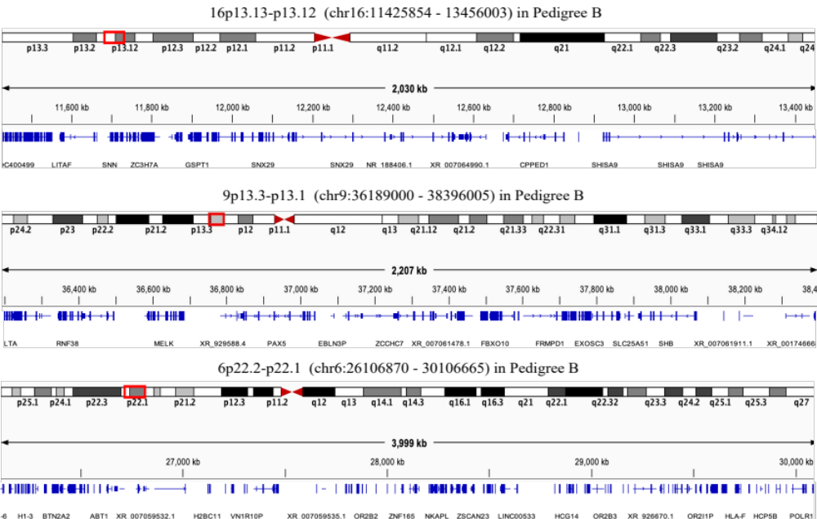
Supplementary Figure 6. A shared genomic segment in the 14q32.2 region, shared in stillbirths in Pedigree C.
