Supplementary Material Information
- Building List: For the building list used in this research, data on planned residential buildings from 2015 to 2019 were prepared by creating two separate residential categories. Prior to this classification phase, planned building data was obtained from the site containing all shapefiles from 2002 to 2019. The dataset used in this research was generated from WONINGWAARDE_2019_INFLATIE, which can be accessed at https://maps.amsterdam.nl/open_geodata/. The classified and analyzed building list used in this research has been included as Excel files and is available upon request. The dataset includes buildings that were classified and for which construction decisions were made between 2015 and 2019. The tables present information on building names, years, units, and the results of the analyses conducted. An Excel file named "DATASET" has also been included as supplementary material.
- Amenity Class Codes Based on Dataset of Geofabrik: The amenity class codes used in this research are based on the dataset provided by Geofabrik, which can be accessed at http://download.geofabrik.de/osm-data/amenities.pdf.
- Amenities: Amenities and their corresponding data from different years were obtained from OpenStreetMap.

Supplementary Table 1
Amenity Class Codes Based On Dataset Of Geofabrik

Geofabrik
https://www.geofabrik.de/data/geofabrik-osm-gis-standard-0.6.pdf
Art and Culture: '2721','2722', '2723', '2725','2724','2731','2732','2733','2737','2014','2201'
Emergency: '2001','2002'
Education: '2081', '2082', '2083','2084'
Grocery: '2501','2516','2502'
Health : 2101, 2110, 2120, 2121, 2129, 2013
Leisure : '2204','2202', '2203', '2205','2206','2251','2252','2253','2254','2255','2256','2257','2743','2744'
Restaurant and Cafe :'2301','2302', '2303', '2304','2305','2306','2307'
Service: '2542','2562', '2564', '2567','2601','2602','2307'
Shop:'2503','2504','2505','2311','2512','2513','2514','2515','2517','2520','2519','2521','2522','2524','2523','2525','2526','2527','2528','2529','2530','2546'

Supplementary Table 2
The Tourist-Related Amenity Codes

OSM (OpenStreetMap) Data
Touristic Related Amenities
- [amenity=museum]
- [amenities=monument]
- [building=museum]
- [tourism=gallery]
- [tourism=museum]
- [amenities=tourist]
- [cafe=tourist]
- [gift=tourists]
- [shop=gift]
- [shop=souvenir]
- [shops=tourist]
- [restaurant=tourist]
- [amenities=tourist]

Supplementary Table 3
Average Number Of Amenities Within A 15-Minute

REPURPOSED BUILDINGS | YEAR1 | YEAR2 | YEAR3 | YEAR4 | YEAR5 | AVERAGE NUMBER OF AMENITIES
X1 | 6,33 | 7,22 | 13,56 | 13,56 | 23,67 | 12,87
X2 | 7,67 | 7,89 | 15,44 | 15,44 | 29,11 | 15,11
X3 | 15,22 | 15,33 | 32,44 | 32,44 | 36,11 | 26,31
X4 | 41,11 | 41,78 | 43,56 | 43,56 | 44,11 | 42,82
X5 | 4,56 | 4,89 | 8,22 | 8,22 | 10,44 | 7,27
X6 | 7,44 | 8,00 | 16,56 | 16,56 | 18,00 | 13,31
X7 | 8,44 | 9,22 | 18,33 | 18,33 | 20,00 | 14,87
X8 | 3,44 | 13,00 | 14,44 | 14,44 | 14,67 | 12,00
X9 | 5,22 | 13,78 | 15,56 | 15,56 | 15,22 | 13,07
X10 | 5,22 | 5,67 | 9,11 | 9,11 | 25,00 | 10,82
X11 | 67,11 | 71,78 | 90,00 | 90,00 | 101,56 | 84,09
X12 | 8,78 | 9,11 | 10,22 | 10,22 | 11,56 | 9,98
X13 | 19,00 | 19,22 | 40,56 | 40,56 | 44,11 | 32,69
X14 | 9,78 | 10,11 | 25,11 | 25,11 | 27,11 | 19,44
X15 | 22,33 | 28,67 | 40,33 | 40,33 | 43,56 | 35,04
X16 | 59,67 | 88,11 | 146,78 | 146,78 | 165,44 | 121,36
X17 | 31,56 | 32,89 | 38,33 | 38,33 | 40,89 | 36,40
X18 | 6,11 | 6,67 | 6,78 | 6,78 | 6,78 | 6,62
X19 | 29,22 | 29,78 | 31,33 | 31,33 | 32,00 | 30,73
X20 | 7,22 | 8,00 | 10,00 | 10,00 | 10,33 | 9,11
X21 | 69,67 | 78,44 | 116,11 | 116,11 | 121,67 | 100,40
X22 | 35,00 | 37,22 | 47,33 | 47,33 | 53,00 | 43,98
X23 | 29,78 | 30,56 | 56,33 | 56,33 | 59,67 | 46,53
X24 | 82,00 | 124,22 | 197,22 | 197,22 | 225,56 | 165,24
X25 | 15,56 | 16,00 | 16,11 | 15,89 | 14,67 | 15,64
X26 | 131,78 | 174,33 | 206,56 | 235,44 | 242,56 | 198,13
X27 | 6,11 | 6,22 | 6,56 | 7,67 | 7,00 | 6,71
X28 | 8,89 | 15,89 | 17,89 | 30,67 | 29,67 | 20,60
X29 | 88,78 | 98,89 | 118,67 | 129,56 | 122,56 | 111,69
X30 | 8,33 | 14,78 | 16,56 | 29,22 | 27,78 | 19,33
X31 | 6,33 | 10,56 | 12,22 | 21,67 | 20,89 | 14,33
X32 | 124,67 | 140,89 | 164,44 | 181,44 | 177,00 | 157,69
X33 | 42,00 | 46,89 | 53,78 | 60,11 | 55,44 | 51,64
X34 | 31,22 | 32,78 | 35,89 | 35,33 | 34,00 | 33,84
X35 | 31,00 | 32,56 | 35,78 | 35,22 | 34,00 | 33,71
X36 | 48,78 | 70,22 | 78,33 | 86,00 | 87,22 | 74,11
X37 | 6,78 | 7,00 | 6,89 | 6,89 | 5,89 | 6,69
X38 | 130,56 | 150,56 | 175,44 | 195,78 | 198,00 | 170,07
X39 | 46,33 | 48,33 | 50,22 | 51,11 | 49,44 | 49,09
X40 | 143,67 | 185,78 | 219,00 | 252,33 | 257,33 | 211,62
X41 | 7,22 | 8,11 | 9,33 | 9,78 | 8,89 | 8,67
X42 | 143,44 | 186,56 | 219,89 | 252,78 | 258,78 | 212,29
X43 | 27,22 | 35,22 | 38,22 | 40,89 | 40,56 | 36,42
X44 | 137,00 | 179,78 | 211,78 | 243,78 | 248,44 | 204,16
X45 | 9,67 | 10,00 | 11,11 | 11,67 | 10,67 | 10,62
X46 | 25,33 | 32,22 | 45,56 | 47,44 | 42,67 | 38,64
X47 | 119,89 | 160,67 | 189,44 | 216,44 | 225,33 | 182,36
X48 | 73,22 | 101,78 | 117,44 | 128,22 | 136,00 | 111,33
X49 | 58,67 | 62,67 | 66,33 | 68,44 | 63,89 | 64,00
X50 | 55,89 | 60,00 | 67,44 | 76,11 | 70,67 | 66,02
X51 | 6,44 | 6,44 | 7,44 | 8,33 | 8,22 | 7,38
X52 | 94,89 | 109,22 | 136,44 | 148,22 | 146,11 | 126,98
X53 | 97,11 | 111,89 | 140,56 | 152,33 | 150,11 | 130,40
X54 | 59,00 | 64,67 | 72,67 | 83,22 | 77,00 | 71,31
X55 | 2,11 | 3,00 | 3,67 | 4,44 | 4,22 | 3,49
X56 | 8,78 | 10,33 | 11,67 | 12,33 | 11,78 | 10,98
X57 | 1,56 | 2,22 | 3,56 | 10,67 | 9,67 | 5,53
X58 | 2,44 | 2,89 | 4,22 | 10,11 | 9,67 | 5,87
X59 | 13,67 | 16,00 | 30,44 | 29,00 | 29,44 | 23,71
X60 | 10,56 | 13,00 | 27,00 | 25,33 | 25,67 | 20,31
X61 | 0,78 | 1,11 | 2,33 | 1,78 | 2,44 | 1,69
X62 | 3,44 | 5,00 | 12,11 | 10,89 | 11,67 | 8,62
X63 | 3,44 | 5,00 | 12,11 | 10,89 | 11,67 | 8,62
X64 | 162,33 | 192,44 | 220,89 | 228,44 | 232,89 | 207,40
X65 | 16,22 | 16,78 | 16,89 | 15,78 | 17,11 | 16,56
X66 | 45,67 | 49,56 | 51,22 | 46,67 | 51,11 | 48,84
X67 | 34,56 | 38,56 | 40,78 | 38,00 | 41,11 | 38,60
X68 | 3,44 | 4,22 | 4,67 | 3,67 | 3,67 | 3,93
X69 | 175,56 | 211,67 | 242,22 | 244,44 | 249,67 | 224,71
X70 | 4,00 | 4,33 | 4,33 | 4,22 | 4,33 | 4,24
X71 | 7,11 | 7,33 | 7,78 | 7,44 | 8,11 | 7,56
X72 | 139,56 | 161,44 | 179,78 | 171,56 | 179,67 | 166,40
X73 | 34,33 | 37,22 | 37,67 | 35,44 | 39,56 | 36,84
X74 | 8,44 | 13,11 | 14,00 | 11,78 | 13,11 | 12,09
X75 | 4,78 | 5,00 | 5,89 | 5,33 | 5,89 | 5,38
X76 | 27,78 | 42,78 | 44,67 | 38,67 | 41,22 | 39,02
X77 | 27,11 | 42,00 | 43,89 | 38,22 | 40,78 | 38,40
X78 | 188,67 | 221,44 | 252,11 | 258,78 | 265,22 | 237,24
X79 | 186,67 | 219,33 | 248,78 | 255,67 | 262,11 | 234,51
X80 | 167,67 | 198,56 | 230,89 | 237,11 | 242,22 | 215,29
X81 | 98,00 | 110,11 | 122,78 | 130,78 | 135,78 | 119,49
X82 | 177,56 | 209,22 | 241,11 | 244,89 | 250,67 | 224,69
X83 | 30,11 | 40,67 | 42,33 | 37,67 | 40,78 | 38,31
X84 | 152,89 | 177,33 | 197,00 | 199,67 | 205,22 | 186,42
X85 | 158,78 | 185,78 | 206,33 | 208,78 | 214,56 | 194,84
X86 | 10,56 | 11,67 | 12,33 | 11,67 | 12,56 | 11,76
X87 | 9,00 | 10,11 | 10,78 | 10,22 | 10,89 | 10,20
X88 | 37,00 | 44,67 | 51,33 | 53,00 | 57,33 | 48,67
X89 | 3,33 | 4,56 | 11,33 | 10,11 | 10,89 | 8,04
X90 | 45,78 | 62,89 | 67,78 | 65,89 | 70,00 | 62,47
X91 | 79,56 | 92,22 | 104,67 | 99,00 | 106,00 | 96,29
X92 | 157,78 | 186,67 | 214,11 | 222,67 | 227,00 | 201,64
X93 | 168,11 | 197,00 | 224,33 | 233,11 | 237,89 | 212,09
X94 | 12,22 | 13,56 | 14,11 | 13,44 | 14,67 | 13,60
X95 | 99,89 | 122,89 | 142,11 | 136,89 | 140,44 | 128,44
X96 | 11,56 | 12,33 | 13,22 | 12,67 | 13,78 | 12,71
X97 | 149,56 | 176,56 | 202,78 | 212,11 | 216,22 | 191,44
X98 | 3,44 | 4,00 | 4,67 | 4,89 | 5,33 | 4,47
X99 | 3,22 | 3,89 | 4,56 | 4,67 | 5,00 | 4,27
X100 | 6,00 | 15,78 | 14,67 | 15,33 | 19,11 | 14,18
X101 | 6,44 | 14,00 | 12,89 | 13,56 | 15,89 | 12,56
X102 | 6,00 | 14,89 | 13,78 | 14,44 | 17,78 | 13,38
X103 | 50,33 | 55,67 | 54,44 | 58,22 | 95,89 | 62,91
X104 | 15,00 | 15,22 | 14,22 | 15,44 | 20,33 | 16,04
X105 | 3,67 | 3,56 | 2,89 | 2,89 | 3,11 | 3,22
X106 | 78,00 | 83,56 | 76,89 | 82,00 | 122,11 | 88,51
X107 | 9,56 | 10,22 | 9,44 | 10,56 | 14,22 | 10,80
X108 | 31,11 | 32,11 | 29,33 | 32,33 | 44,89 | 33,96
X109 | 105,78 | 112,44 | 110,22 | 116,44 | 180,33 | 125,04
X110 | 70,33 | 79,44 | 76,22 | 81,44 | 118,78 | 85,24
X111 | 35,89 | 37,44 | 35,67 | 38,22 | 54,78 | 40,40
X112 | 113,89 | 126,00 | 132,78 | 139,44 | 218,56 | 146,13
X113 | 10,67 | 11,56 | 10,89 | 11,89 | 13,22 | 11,64
X114 | 3,89 | 4,89 | 5,00 | 8,89 | 10,44 | 6,62
X115 | 91,22 | 99,44 | 102,67 | 105,67 | 167,67 | 113,33
X116 | 10,67 | 13,22 | 12,33 | 14,22 | 20,22 | 14,13
X117 | 83,11 | 91,11 | 84,67 | 90,22 | 134,78 | 96,78
X118 | 219,11 | 251,78 | 255,22 | 261,89 | 400,33 | 277,67
X119 | 4,22 | 4,67 | 4,22 | 4,67 | 7,22 | 5,00
X120 | 161,67 | 178,78 | 181,44 | 187,22 | 285,56 | 198,93
X121 | 6,78 | 6,78 | 5,89 | 6,22 | 6,56 | 6,44
X122 | 18,22 | 18,89 | 18,00 | 20,11 | 24,56 | 19,96
X123 | 229,56 | 263,44 | 265,89 | 271,22 | 413,33 | 288,69
X124 | 92,11 | 97,00 | 88,44 | 93,33 | 137,11 | 101,60
X125 | 13,56 | 14,11 | 13,44 | 14,67 | 19,89 | 15,13
X126 | 95,56 | 102,00 | 98,78 | 104,56 | 166,00 | 113,38
X127 | 171,22 | 196,11 | 205,56 | 209,44 | 317,56 | 219,98
X128 | 65,33 | 62,67 | 66,56 | 73,89 | 74,89 | 68,67
X129 | 23,56 | 22,11 | 23,00 | 23,89 | 23,44 | 23,20
X130 | 62,44 | 58,56 | 64,67 | 64,44 | 60,22 | 62,07
X131 | 252,22 | 254,22 | 259,89 | 259,33 | 261,22 | 257,38
X132 | 215,33 | 223,33 | 227,89 | 228,44 | 220,00 | 223,00
X133 | 10,89 | 10,33 | 11,44 | 11,33 | 11,00 | 11,00
X134 | 14,78 | 13,67 | 15,67 | 17,00 | 17,33 | 15,69
X135 | 11,33 | 9,67 | 10,33 | 10,33 | 13,11 | 10,96
X136 | 262,44 | 264,22 | 269,56 | 269,11 | 269,67 | 267,00
X137 | 35,00 | 31,44 | 33,89 | 34,00 | 36,33 | 34,13
average of years | 56,60 | 65,53 | 74,10 | 77,30 | 86,55 | 72,01

NEWLY CONSTRUCTED BUILDINGS | YEAR1 | YEAR2 | YEAR3 | YEAR4 | YEAR5 | AVERAGE NUMBER OF AMENITIES
X1 | 7,44 | 8,44 | 11,11 | 14,22 | 17,00 | 11,64
X2 | 2,67 | 2,67 | 2,89 | 4,22 | 11,56 | 4,80
X3 | 7,33 | 7,56 | 7,44 | 7,11 | 7,22 | 7,33
X4 | 2,22 | 2,11 | 2,00 | 2,44 | 2,44 | 2,24
X5 | 47,33 | 47,67 | 51,89 | 55,56 | 57,00 | 51,89
X6 | 7,33 | 8,00 | 8,22 | 9,56 | 9,78 | 8,58
X7 | 1,78 | 3,56 | 3,67 | 4,44 | 4,67 | 3,62
X8 | 2,11 | 3,89 | 4,00 | 4,67 | 5,22 | 3,98
X9 | 7,22 | 8,11 | 8,33 | 9,78 | 10,00 | 8,69
X10 | 7,00 | 7,89 | 8,22 | 9,89 | 10,11 | 8,62
X11 | 6,56 | 6,22 | 8,44 | 8,78 | 17,00 | 9,40
X12 | 5,00 | 5,33 | 7,44 | 9,00 | 23,56 | 10,07
X13 | 5,00 | 5,67 | 8,44 | 10,67 | 11,33 | 8,22
X14 | 0,67 | 0,89 | 1,00 | 1,11 | 1,78 | 1,09
X15 | 6,33 | 6,44 | 6,56 | 6,44 | 6,67 | 6,49
X16 | 8,44 | 9,11 | 10,67 | 11,67 | 12,33 | 10,44
X17 | 6,56 | 6,44 | 9,00 | 10,11 | 11,44 | 8,71
X18 | 0,56 | 0,56 | 1,11 | 1,67 | 1,67 | 1,11
X19 | 7,56 | 7,67 | 11,78 | 22,00 | 24,11 | 14,62
X20 | 4,67 | 5,22 | 9,56 | 14,00 | 14,44 | 9,58
X21 | 6,33 | 6,33 | 7,78 | 9,00 | 10,00 | 7,89
X22 | 7,67 | 10,67 | 16,56 | 19,11 | 22,00 | 15,20
X23 | 4,33 | 4,44 | 4,33 | 4,33 | 4,33 | 4,36
X24 | 64,11 | 97,89 | 123,56 | 141,67 | 158,67 | 117,18
X25 | 2,56 | 2,78 | 3,44 | 3,78 | 4,44 | 3,40
X26 | 25,56 | 25,56 | 26,89 | 29,00 | 30,00 | 27,40
X27 | 6,78 | 6,67 | 7,00 | 8,22 | 9,67 | 7,67
X28 | 7,22 | 7,67 | 8,00 | 9,33 | 11,11 | 8,67
X29 | 6,00 | 6,22 | 7,44 | 7,89 | 10,00 | 7,51
X30 | 6,78 | 6,56 | 7,00 | 7,78 | 9,56 | 7,53
X31 | 7,22 | 7,11 | 7,56 | 8,44 | 10,11 | 8,09
X32 | 7,22 | 7,11 | 7,56 | 8,44 | 10,11 | 8,09
X33 | 7,22 | 7,11 | 7,56 | 8,44 | 10,22 | 8,11
X34 | 7,22 | 7,11 | 7,56 | 8,33 | 10,11 | 8,07
X35 | 5,11 | 5,67 | 6,56 | 6,89 | 7,89 | 6,42
X36 | 8,11 | 8,56 | 9,22 | 10,33 | 10,78 | 9,40
X37 | 3,22 | 12,11 | 12,56 | 13,11 | 13,22 | 10,84
X38 | 3,44 | 12,11 | 12,56 | 12,89 | 13,22 | 10,84
X39 | 0,22 | 0,22 | 0,33 | 0,33 | 0,33 | 0,29
X40 | 31,78 | 32,89 | 35,22 | 37,56 | 40,11 | 35,51
X41 | 1,56 | 7,22 | 8,00 | 7,89 | 8,44 | 6,62
X42 | 1,89 | 8,11 | 8,89 | 8,67 | 9,56 | 7,42
X43 | 4,67 | 5,22 | 5,56 | 5,89 | 5,44 | 5,36
X44 | 4,67 | 5,33 | 5,44 | 5,78 | 5,22 | 5,29
X45 | 4,78 | 5,33 | 5,67 | 6,11 | 5,67 | 5,51
X46 | 8,22 | 8,89 | 11,22 | 19,33 | 20,67 | 13,67
X47 | 0,56 | 0,67 | 0,78 | 1,11 | 1,67 | 0,96
X48 | 4,56 | 12,33 | 13,33 | 14,33 | 14,00 | 11,71
X49 | 4,78 | 5,22 | 5,00 | 5,00 | 5,11 | 5,02
X50 | 4,44 | 4,56 | 4,33 | 4,22 | 4,33 | 4,38
X51 | 7,22 | 7,56 | 8,44 | 9,67 | 10,11 | 8,60
X52 | 2,67 | 2,33 | 2,22 | 2,44 | 3,00 | 2,53
X53 | 3,22 | 9,33 | 11,56 | 12,67 | 13,78 | 10,11
X54 | 3,56 | 9,22 | 13,44 | 13,78 | 14,44 | 10,89
X55 | 1,67 | 1,67 | 1,67 | 1,78 | 1,56 | 1,67
X56 | 44,44 | 45,33 | 47,33 | 49,00 | 49,89 | 47,20
X57 | 45,22 | 46,11 | 48,11 | 49,78 | 50,89 | 48,02
X58 | 3,67 | 3,78 | 4,44 | 4,78 | 5,56 | 4,44
X59 | 6,89 | 7,00 | 8,33 | 9,78 | 10,22 | 8,44
X60 | 64,00 | 72,89 | 84,67 | 111,78 | 117,67 | 90,20
X61 | 0,00 | 0,00 | 0,00 | 0,00 | 0,00 | 0,00
X62 | 0,56 | 0,56 | 0,89 | 0,89 | 0,67 | 0,71
X63 | 9,22 | 10,67 | 17,11 | 27,22 | 28,22 | 18,49
X64 | 15,00 | 15,78 | 17,00 | 17,78 | 18,44 | 16,80
X65 | 0,11 | 0,33 | 0,44 | 0,44 | 0,78 | 0,42
X66 | 2,78 | 3,44 | 5,89 | 8,78 | 8,67 | 5,91
X67 | 9,00 | 9,33 | 9,67 | 11,11 | 11,56 | 10,13
X68 | 10,89 | 11,22 | 11,67 | 12,78 | 13,44 | 12,00
X69 | 10,67 | 11,00 | 11,33 | 12,33 | 13,00 | 11,67
X70 | 10,56 | 12,11 | 18,56 | 29,33 | 30,33 | 20,18
X71 | 77,56 | 86,00 | 100,67 | 124,33 | 137,22 | 105,16
X72 | 2,56 | 2,44 | 2,44 | 3,00 | 3,67 | 2,82
X73 | 62,56 | 66,78 | 79,22 | 102,56 | 109,56 | 84,13
X74 | 8,44 | 9,22 | 12,22 | 19,22 | 20,33 | 13,89
X75 | 22,44 | 23,78 | 29,11 | 41,89 | 43,78 | 32,20
X76 | 5,89 | 5,67 | 7,00 | 7,67 | 7,78 | 6,80
X77 | 31,00 | 32,44 | 36,22 | 43,56 | 47,00 | 38,04
X78 | 12,44 | 13,00 | 16,44 | 19,89 | 21,00 | 16,56
X79 | 7,89 | 8,33 | 10,00 | 12,89 | 15,33 | 10,89
X80 | 0,67 | 0,89 | 1,00 | 1,11 | 1,78 | 1,09
X81 | 0,67 | 0,89 | 1,00 | 1,11 | 1,33 | 1,00
X82 | 9,11 | 10,33 | 13,44 | 17,44 | 18,22 | 13,71
X83 | 32,00 | 31,89 | 33,33 | 35,89 | 36,33 | 33,89
X84 | 5,00 | 5,22 | 5,67 | 5,56 | 5,56 | 5,40
X85 | 8,00 | 8,11 | 12,67 | 22,89 | 25,22 | 15,38
X86 | 10,33 | 10,89 | 11,11 | 12,67 | 14,22 | 11,84
X87 | 10,33 | 10,89 | 11,11 | 12,67 | 14,33 | 11,87
X88 | 0,11 | 0,33 | 0,44 | 0,44 | 1,11 | 0,49
X89 | 9,78 | 10,22 | 12,33 | 13,11 | 13,67 | 11,82
X90 | 5,56 | 5,67 | 10,22 | 19,56 | 21,78 | 12,56
X91 | 4,11 | 4,33 | 4,22 | 3,78 | 4,11 | 4,11
X92 | 34,44 | 35,11 | 36,56 | 36,78 | 37,78 | 36,13
X93 | 8,22 | 8,89 | 11,67 | 18,67 | 19,78 | 13,44
X94 | 6,67 | 6,89 | 6,89 | 7,44 | 8,44 | 7,27
X95 | 2,78 | 3,11 | 4,44 | 12,44 | 12,00 | 6,96
X96 | 2,89 | 3,22 | 4,56 | 13,67 | 13,11 | 3,67
X97 | 3,33 | 3,11 | 3,67 | 3,89 | 3,44 | 2,11
X98 | 1,22 | 1,22 | 2,11 | 2,00 | 2,56 | 1,00
X99 | 0,89 | 1,00 | 1,00 | 1,67 | 1,11 | 10,33
X100 | 8,78 | 9,56 | 10,33 | 10,22 | 10,22 | 5,56
X101 | 4,56 | 4,67 | 5,56 | 6,44 | 6,67 | 2,67
X102 | 2,11 | 2,11 | 2,67 | 3,44 | 4,11 | 10,89
X103 | 8,00 | 8,44 | 10,89 | 10,44 | 8,89 | 3,00
X104 | 2,44 | 2,44 | 3,00 | 3,56 | 3,67 | 2,78
X105 | 2,44 | 2,33 | 2,78 | 3,33 | 3,56 | 0,22
X106 | 0,22 | 0,11 | 0,22 | 0,56 | 0,44 | 21,33
X107 | 14,67 | 17,67 | 21,33 | 22,78 | 20,78 | 75,11
X108 | 60,44 | 66,33 | 75,11 | 85,33 | 79,22 | 36,33
X109 | 17,56 | 25,56 | 36,33 | 38,11 | 31,00 | 8,44
X110 | 7,00 | 7,33 | 8,44 | 9,89 | 10,00 | 3,44
X111 | 2,44 | 3,22 | 3,44 | 4,00 | 3,89 | 12,00
X112 | 9,33 | 11,00 | 12,00 | 12,78 | 12,22 | 12,78
X113 | 9,67 | 11,67 | 12,78 | 13,56 | 13,00 | 0,89
X114 | 0,33 | 0,56 | 0,89 | 1,67 | 1,33 | 6,89
X115 | 5,22 | 6,33 | 6,89 | 7,89 | 7,11 | 7,44
X116 | 5,67 | 6,89 | 7,44 | 8,44 | 7,56 | 3,11
X117 | 3,67 | 3,56 | 3,11 | 3,11 | 2,89 | 0,56
X118 | 0,44 | 0,56 | 0,56 | 0,33 | 0,22 | 166,44
X119 | 112,56 | 141,33 | 166,44 | 185,78 | 190,22 | 0,56
X120 | 0,56 | 0,56 | 0,56 | 0,56 | 0,33 | 0,56
X121 | 0,56 | 0,56 | 0,56 | 0,56 | 0,33 | 63,44
X122 | 48,89 | 54,89 | 63,44 | 72,56 | 68,56 | 6,00
X123 | 5,44 | 5,67 | 6,00 | 5,56 | 5,33 | 141,22
X124 | 83,89 | 115,22 | 141,22 | 164,89 | 159,44 | 1,00
X125 | 0,89 | 1,00 | 1,00 | 1,67 | 1,11 | 1,11
X126 | 0,89 | 1,00 | 1,11 | 1,89 | 1,89 | 18,56
X127 | 9,11 | 11,89 | 18,56 | 19,33 | 16,67 | 20,56
X128 | 10,67 | 13,44 | 20,56 | 21,44 | 18,89 | 47,56
X129 | 36,78 | 40,78 | 47,56 | 51,67 | 48,00 | 13,78
X130 | 11,78 | 12,78 | 13,78 | 13,44 | 12,11 | 12,78
X131 | 7,33 | 7,11 | 6,78 | 7,00 | 6,78 | 7,00
X132 | 7,78 | 7,67 | 7,11 | 7,22 | 6,89 | 7,33
X133 | 1,44 | 1,44 | 1,67 | 1,89 | 2,11 | 1,71
X134 | 0,89 | 1,00 | 1,11 | 1,78 | 1,11 | 1,18
X135 | 7,33 | 7,11 | 6,67 | 6,78 | 6,56 | 6,89
X136 | 3,89 | 8,00 | 8,44 | 9,00 | 7,89 | 7,44
X137 | 4,89 | 5,89 | 8,22 | 10,33 | 9,44 | 7,76
X138 | 2,56 | 2,89 | 3,89 | 10,44 | 10,11 | 5,98
X139 | 2,56 | 2,89 | 4,00 | 10,67 | 10,33 | 6,09
X140 | 11,89 | 12,67 | 14,56 | 15,11 | 13,78 | 13,60
X141 | 31,44 | 35,78 | 39,33 | 39,67 | 36,22 | 36,49
X142 | 6,78 | 7,78 | 9,11 | 9,78 | 8,67 | 8,42
X143 | 91,11 | 104,33 | 123,78 | 135,11 | 131,11 | 117,09
X144 | 86,78 | 99,78 | 121,11 | 130,11 | 121,89 | 111,93
X145 | 53,67 | 56,56 | 59,44 | 62,22 | 59,44 | 58,27
X146 | 6,78 | 7,11 | 8,67 | 9,11 | 8,00 | 7,93
X147 | 2,78 | 3,22 | 3,89 | 4,33 | 4,22 | 3,69
X148 | 2,56 | 3,33 | 4,00 | 3,78 | 3,22 | 3,38
X149 | 1,67 | 2,56 | 2,89 | 3,22 | 2,78 | 2,62
X150 | 2,44 | 3,33 | 3,78 | 3,67 | 3,22 | 3,29
X151 | 5,33 | 5,11 | 6,22 | 7,11 | 7,22 | 6,20
X152 | 12,22 | 13,33 | 15,11 | 15,67 | 14,33 | 14,13
X153 | 6,44 | 8,44 | 9,44 | 18,00 | 17,11 | 11,89
X154 | 9,78 | 11,67 | 13,33 | 14,67 | 13,00 | 12,49
X155 | 58,56 | 71,00 | 90,33 | 94,56 | 83,78 | 79,64
X156 | 25,44 | 32,44 | 47,00 | 49,22 | 43,56 | 39,53
X157 | 1,56 | 1,67 | 1,89 | 2,44 | 2,56 | 2,02
X158 | 1,56 | 1,67 | 1,89 | 2,44 | 2,56 | 2,02
X159 | 18,00 | 21,22 | 24,33 | 25,78 | 24,89 | 22,84
X160 | 10,67 | 12,67 | 13,67 | 14,44 | 13,44 | 12,98
X161 | 10,67 | 12,56 | 13,56 | 14,33 | 13,44 | 12,91
X162 | 10,67 | 12,67 | 13,67 | 14,44 | 13,44 | 12,98
X163 | 0,33 | 0,44 | 0,44 | 0,78 | 0,89 | 0,58
X164 | 2,89 | 3,00 | 2,56 | 2,78 | 2,78 | 2,80
X165 | 0,33 | 0,44 | 0,44 | 0,78 | 0,89 | 0,58
X166 | 0,89 | 1,00 | 1,11 | 1,78 | 1,11 | 1,18
X167 | 0,89 | 1,00 | 1,00 | 1,67 | 1,11 | 1,13
X168 | 0,89 | 1,00 | 1,11 | 1,33 | 1,11 | 1,09
X169 | 0,89 | 1,00 | 1,11 | 1,78 | 1,11 | 1,18
X170 | 6,67 | 8,44 | 8,78 | 9,44 | 8,78 | 8,42
X171 | 0,33 | 0,56 | 0,67 | 0,78 | 0,89 | 0,64
X172 | 52,22 | 58,56 | 67,00 | 76,22 | 72,67 | 65,33
X173 | 2,56 | 3,67 | 3,78 | 4,00 | 3,78 | 3,56
X174 | 62,56 | 71,78 | 86,11 | 96,22 | 90,78 | 81,49
X175 | 27,56 | 33,33 | 47,44 | 50,11 | 47,11 | 41,11
X176 | 26,67 | 32,00 | 45,78 | 48,33 | 45,00 | 39,56
X177 | 5,56 | 7,56 | 7,89 | 15,33 | 14,56 | 10,18
X178 | 5,11 | 5,44 | 6,22 | 6,44 | 6,56 | 5,96
X179 | 16,89 | 20,67 | 25,78 | 26,89 | 24,00 | 22,84
X180 | 6,56 | 11,22 | 14,56 | 15,67 | 13,89 | 12,38
X181 | 40,00 | 41,44 | 41,67 | 42,22 | 42,33 | 41,53
X182 | 12,11 | 17,22 | 18,33 | 17,44 | 19,89 | 17,00
X183 | 5,22 | 6,33 | 7,78 | 7,22 | 7,78 | 6,87
X184 | 3,89 | 6,89 | 8,44 | 6,56 | 7,00 | 6,56
X185 | 29,00 | 76,56 | 87,89 | 87,44 | 92,11 | 74,60
X186 | 6,56 | 9,22 | 10,67 | 7,89 | 7,89 | 8,44
X187 | 13,00 | 18,00 | 20,22 | 16,89 | 19,44 | 17,51
X188 | 1,67 | 2,44 | 3,56 | 3,22 | 3,56 | 2,89
X189 | 5,22 | 7,78 | 8,89 | 6,44 | 6,33 | 6,93
X190 | 6,00 | 8,78 | 10,22 | 7,00 | 6,89 | 7,78
X191 | 6,78 | 11,78 | 14,00 | 10,33 | 10,44 | 10,67
X192 | 1,22 | 2,33 | 5,44 | 3,89 | 4,78 | 3,53
X193 | 6,22 | 6,22 | 6,44 | 6,44 | 7,22 | 6,51
X194 | 24,00 | 58,33 | 65,78 | 62,00 | 66,33 | 55,29
X195 | 4,78 | 8,56 | 11,56 | 10,33 | 11,89 | 9,42
X196 | 5,89 | 8,44 | 10,89 | 10,33 | 11,56 | 9,42
X197 | 5,11 | 7,56 | 9,44 | 8,67 | 9,67 | 8,09
X198 | 41,89 | 101,56 | 118,67 | 93,89 | 97,00 | 90,60
X199 | 3,78 | 7,56 | 10,78 | 7,89 | 8,56 | 7,71
X200 | 3,56 | 6,67 | 9,78 | 6,78 | 7,44 | 6,84
X201 | 6,56 | 12,11 | 14,89 | 12,33 | 13,44 | 11,87
X202 | 5,44 | 9,89 | 13,00 | 10,11 | 10,89 | 9,87
X203 | 7,44 | 9,56 | 10,56 | 9,56 | 10,22 | 9,47
X204 | 4,22 | 5,00 | 5,56 | 5,44 | 5,89 | 5,22
X205 | 9,89 | 12,89 | 13,22 | 12,00 | 13,00 | 12,20
X206 | 4,89 | 6,11 | 6,33 | 5,22 | 7,11 | 5,93
X207 | 70,89 | 166,56 | 200,00 | 178,89 | 187,11 | 160,69
X208 | 8,00 | 20,67 | 23,89 | 18,78 | 20,67 | 18,40
X209 | 0,56 | 0,89 | 1,89 | 1,33 | 2,00 | 1,33
X210 | 6,89 | 8,44 | 9,11 | 7,56 | 9,78 | 8,36
X211 | 6,44 | 11,11 | 12,44 | 9,78 | 10,44 | 10,04
X212 | 10,00 | 13,00 | 13,22 | 11,56 | 14,33 | 12,42
X213 | 9,22 | 11,67 | 12,00 | 10,33 | 13,11 | 11,27
X214 | 0,78 | 1,00 | 1,33 | 1,11 | 1,56 | 1,16
X215 | 4,44 | 7,89 | 11,00 | 8,22 | 8,89 | 8,09
X216 | 11,00 | 13,22 | 15,89 | 12,89 | 13,78 | 13,36
X217 | 10,44 | 9,33 | 11,00 | 8,67 | 9,00 | 9,69
X218 | 27,89 | 71,89 | 82,22 | 82,33 | 86,44 | 70,16
X219 | 28,11 | 73,56 | 83,89 | 84,22 | 88,67 | 71,69
X220 | 1,44 | 1,00 | 2,00 | 0,56 | 0,56 | 1,11
X221 | 7,00 | 8,00 | 8,78 | 7,00 | 7,67 | 7,69
X222 | 1,78 | 1,89 | 2,67 | 2,56 | 3,56 | 2,49
X223 | 3,33 | 3,89 | 4,78 | 3,22 | 5,44 | 4,13
X224 | 3,33 | 3,89 | 4,78 | 3,22 | 5,44 | 4,13
X225 | 3,44 | 5,33 | 6,33 | 5,67 | 6,22 | 5,40
X226 | 3,67 | 5,33 | 6,56 | 5,67 | 6,11 | 5,47
X227 | 5,44 | 10,00 | 27,00 | 23,56 | 24,44 | 18,09
X228 | 5,11 | 9,44 | 26,33 | 23,00 | 23,78 | 17,53
X229 | 5,11 | 8,78 | 24,00 | 21,00 | 21,78 | 16,13
X230 | 4,89 | 8,78 | 23,78 | 20,78 | 21,56 | 15,96
X231 | 3,67 | 5,89 | 7,00 | 6,44 | 7,00 | 6,00
X232 | 3,67 | 5,89 | 6,67 | 6,33 | 6,89 | 5,89
X233 | 1,78 | 2,11 | 2,44 | 3,00 | 3,78 | 2,62
X234 | 28,56 | 75,89 | 86,78 | 87,00 | 91,67 | 73,98
X235 | 5,00 | 8,89 | 23,56 | 20,78 | 21,22 | 15,89
X236 | 7,00 | 10,56 | 22,56 | 20,89 | 21,11 | 16,42
X237 | 21,00 | 53,56 | 60,78 | 56,44 | 60,56 | 50,47
X238 | 7,11 | 10,78 | 11,89 | 9,67 | 10,33 | 9,96
X239 | 37,11 | 78,89 | 94,56 | 82,89 | 88,33 | 76,36
X240 | 35,22 | 77,11 | 91,22 | 82,56 | 88,00 | 74,82
X241 | 28,67 | 75,11 | 85,89 | 85,89 | 90,56 | 73,22
X242 | 8,56 | 7,22 | 8,78 | 6,56 | 6,78 | 7,58
X243 | 8,67 | 20,78 | 25,22 | 23,89 | 25,78 | 20,87
X244 | 0,22 | 0,44 | 0,78 | 0,89 | 1,22 | 0,71
X245 | 0,22 | 0,44 | 0,78 | 0,89 | 1,22 | 0,71
X246 | 0,22 | 0,44 | 1,56 | 0,78 | 1,11 | 0,82
X247 | 0,22 | 0,44 | 1,56 | 0,78 | 1,11 | 0,82
X248 | 0,22 | 0,44 | 0,78 | 0,89 | 1,22 | 0,71
X249 | 4,22 | 9,11 | 10,56 | 9,22 | 9,78 | 8,58
X250 | 5,56 | 10,56 | 11,78 | 10,67 | 11,67 | 10,04
X251 | 1,78 | 1,89 | 2,22 | 2,44 | 3,33 | 2,33
X252 | 4,67 | 8,11 | 22,78 | 19,89 | 20,44 | 15,18
X253 | 9,56 | 13,00 | 13,89 | 13,22 | 14,22 | 12,78
X254 | 6,33 | 6,78 | 7,11 | 7,11 | 7,89 | 7,04
X255 | 6,22 | 6,33 | 6,56 | 6,56 | 7,22 | 6,58
X256 | 6,11 | 6,22 | 6,56 | 6,56 | 7,33 | 6,56
X257 | 6,11 | 6,22 | 6,44 | 6,44 | 7,22 | 6,49
X258 | 2,56 | 2,67 | 3,00 | 2,89 | 3,22 | 2,87
X259 | 1,78 | 3,78 | 8,11 | 6,56 | 7,33 | 5,51
X260 | 8,00 | 13,89 | 15,11 | 13,56 | 14,78 | 13,07
X261 | 3,67 | 3,89 | 4,33 | 4,22 | 4,67 | 4,16
X262 | 5,11 | 7,56 | 8,56 | 6,67 | 6,56 | 6,89
X263 | 8,56 | 12,44 | 13,22 | 12,67 | 13,78 | 12,13
X264 | 2,00 | 5,11 | 14,78 | 13,89 | 14,56 | 10,07
X265 | 5,44 | 7,44 | 8,33 | 7,56 | 8,22 | 7,40
X266 | 6,67 | 8,11 | 8,33 | 9,44 | 10,11 | 8,53
X267 | 10,33 | 10,56 | 9,11 | 9,56 | 9,44 | 9,80
X268 | 1,67 | 1,67 | 1,22 | 1,22 | 1,33 | 1,42
X269 | 2,00 | 2,00 | 1,67 | 1,89 | 1,78 | 1,87
X270 | 11,78 | 12,44 | 11,33 | 13,22 | 12,89 | 12,33
X271 | 4,56 | 5,67 | 4,44 | 5,11 | 5,33 | 5,02
X272 | 14,78 | 15,78 | 15,00 | 16,33 | 17,11 | 15,80
X273 | 7,11 | 7,56 | 6,67 | 6,89 | 6,89 | 7,02
X274 | 9,00 | 18,00 | 17,00 | 17,67 | 17,78 | 15,89
X275 | 4,56 | 4,89 | 5,00 | 5,89 | 6,11 | 5,29
X276 | 4,11 | 4,22 | 4,33 | 5,44 | 5,78 | 4,78
X277 | 0,11 | 0,11 | 0,11 | 0,11 | 0,11 | 0,11
X278 | 169,89 | 191,11 | 197,22 | 204,22 | 206,11 | 193,71
X279 | 7,67 | 9,44 | 9,56 | 10,67 | 11,44 | 9,76
X280 | 8,11 | 9,78 | 9,89 | 11,22 | 12,00 | 10,20
X281 | 8,44 | 10,22 | 10,33 | 11,56 | 12,33 | 10,58
X282 | 8,44 | 10,22 | 10,33 | 11,67 | 12,44 | 10,62
X283 | 6,44 | 8,00 | 8,11 | 9,56 | 10,11 | 8,44
X284 | 7,00 | 8,67 | 8,56 | 10,11 | 10,67 | 9,00
X285 | 6,44 | 7,89 | 8,00 | 9,44 | 10,00 | 8,36
X286 | 4,00 | 5,11 | 4,78 | 5,44 | 5,56 | 4,98
X287 | 5,78 | 7,22 | 7,33 | 8,33 | 8,78 | 7,49
X288 | 6,44 | 8,00 | 8,11 | 9,56 | 10,11 | 8,44
X289 | 7,78 | 8,78 | 8,11 | 8,89 | 9,56 | 8,62
X290 | 12,44 | 13,22 | 12,67 | 13,78 | 14,33 | 13,29
X291 | 5,44 | 5,67 | 5,67 | 6,44 | 6,78 | 6,00
X292 | 4,22 | 4,78 | 4,33 | 5,11 | 5,78 | 4,84
X293 | 6,22 | 7,11 | 6,33 | 7,00 | 7,67 | 6,87
X294 | 89,44 | 103,11 | 102,78 | 105,33 | 106,56 | 101,44
X295 | 10,33 | 11,00 | 10,89 | 12,22 | 15,78 | 12,04
X296 | 6,44 | 6,22 | 5,67 | 6,00 | 5,89 | 6,04
X297 | 5,67 | 5,44 | 5,11 | 5,33 | 5,22 | 5,36
X298 | 11,22 | 24,89 | 23,11 | 23,78 | 24,00 | 21,40
X299 | 114,33 | 129,44 | 126,78 | 130,67 | 131,44 | 126,53
X300 | 20,00 | 21,33 | 18,00 | 19,89 | 20,78 | 20,00
X301 | 21,44 | 22,78 | 19,44 | 21,44 | 23,11 | 21,64
X302 | 1,56 | 2,00 | 1,67 | 3,22 | 5,67 | 2,82
X303 | 13,44 | 14,11 | 13,33 | 15,22 | 15,78 | 14,38
X304 | 126,22 | 136,78 | 126,78 | 133,56 | 134,11 | 131,49
X305 | 7,22 | 7,56 | 6,33 | 6,56 | 6,56 | 6,84
X306 | 2,44 | 3,00 | 3,22 | 3,44 | 3,78 | 3,18
X307 | 8,11 | 8,78 | 8,67 | 9,78 | 13,22 | 9,71
X308 | 8,22 | 9,00 | 8,89 | 10,00 | 13,44 | 9,91
X309 | 3,89 | 4,00 | 3,56 | 4,00 | 4,33 | 3,96
X310 | 7,33 | 7,56 | 6,56 | 6,44 | 6,78 | 6,93
X311 | 7,89 | 9,89 | 9,33 | 11,00 | 10,89 | 9,80
X312 | 10,00 | 12,00 | 12,00 | 14,22 | 14,11 | 12,47
X313 | 13,89 | 16,44 | 16,00 | 18,33 | 19,22 | 16,78
X314 | 2,78 | 3,33 | 3,67 | 4,00 | 4,33 | 3,62
X315 | 20,67 | 21,33 | 20,67 | 22,78 | 23,33 | 21,76
X316 | 21,33 | 21,89 | 21,22 | 23,44 | 24,11 | 22,40
X317 | 5,89 | 6,56 | 6,33 | 6,89 | 7,00 | 6,53
X318 | 3,89 | 4,56 | 4,78 | 5,22 | 5,44 | 4,78
X319 | 19,22 | 21,33 | 17,22 | 18,56 | 18,78 | 19,02
X320 | 4,00 | 4,22 | 4,00 | 6,56 | 10,00 | 5,76
X321 | 16,56 | 18,33 | 14,11 | 15,33 | 15,56 | 15,98
X322 | 108,56 | 118,89 | 125,44 | 128,89 | 130,78 | 122,51
X323 | 9,00 | 9,67 | 9,00 | 9,78 | 9,89 | 9,47
X324 | 8,44 | 9,11 | 8,44 | 9,22 | 9,33 | 8,91
X325 | 13,89 | 14,44 | 13,11 | 14,44 | 14,22 | 14,02
X326 | 5,11 | 5,44 | 5,00 | 5,44 | 5,67 | 5,33
X327 | 0,44 | 0,78 | 0,89 | 1,22 | 1,22 | 0,91
X328 | 7,33 | 7,22 | 6,00 | 5,89 | 6,67 | 6,62
X329 | 12,00 | 12,78 | 12,22 | 13,33 | 13,00 | 12,67
X330 | 9,78 | 10,11 | 8,56 | 9,22 | 9,44 | 9,42
X331 | 110,44 | 121,00 | 126,56 | 129,67 | 131,44 | 123,82
X332 | 0,78 | 1,00 | 0,89 | 1,22 | 1,22 | 1,02
X333 | 0,44 | 0,78 | 0,89 | 1,22 | 1,22 | 0,91
X334 | 1,11 | 1,33 | 1,11 | 1,56 | 1,56 | 1,33
X335 | 1,78 | 1,56 | 1,11 | 1,22 | 1,22 | 1,38
X336 | 2,67 | 2,89 | 2,89 | 3,22 | 3,67 | 3,07
X337 | 3,00 | 3,22 | 3,22 | 3,56 | 4,00 | 3,40
X338 | 6,78 | 7,22 | 6,33 | 6,78 | 7,22 | 6,87
X339 | 5,44 | 5,44 | 4,67 | 4,89 | 4,89 | 5,07
X340 | 9,78 | 9,56 | 8,11 | 8,00 | 8,78 | 8,84
X341 | 1,22 | 1,11 | 1,11 | 1,22 | 1,33 | 1,20
X342 | 24,56 | 24,11 | 22,56 | 24,78 | 24,78 | 24,16
X343 | 92,22 | 102,67 | 97,33 | 103,11 | 104,22 | 99,91
X344 | 121,67 | 134,89 | 127,78 | 134,44 | 134,33 | 130,62
X345 | 2,78 | 3,00 | 3,00 | 3,33 | 3,56 | 3,13
X346 | 9,78 | 10,89 | 10,67 | 11,89 | 15,89 | 11,82
X347 | 0,00 | 0,00 | 0,00 | 0,00 | 0,00 | 0,00
X348 | 7,44 | 8,44 | 7,56 | 8,22 | 8,22 | 7,98
X349 | 10,67 | 10,44 | 12,22 | 13,89 | 14,89 | 12,42
X350 | 13,89 | 13,33 | 14,67 | 18,67 | 21,67 | 16,44
X351 | 16,78 | 16,00 | 18,22 | 18,78 | 19,00 | 17,76
X352 | 2,89 | 2,67 | 3,33 | 4,11 | 5,11 | 3,62
X353 | 2,89 | 2,67 | 3,33 | 4,11 | 5,11 | 3,67
X354 | 2,56 | 2,33 | 3,00 | 3,44 | 4,56 | 2,11
X355 | 2,89 | 2,67 | 3,33 | 4,00 | 5,00 | 1,00
X356 | 2,00 | 1,78 | 2,44 | 2,78 | 3,33 | 10,33
X357 | 0,67 | 0,67 | 0,67 | 0,78 | 1,22 | 5,56
X358 | 15,89 | 14,22 | 16,33 | 16,00 | 18,44 | 2,67
X359 | 2,11 | 1,78 | 2,11 | 2,00 | 3,00 | 10,89
X360 | 28,11 | 25,56 | 28,56 | 28,67 | 30,67 | 3,00
X361 | 23,00 | 20,89 | 23,56 | 23,44 | 25,56 | 2,78
X362 | 86,22 | 79,56 | 84,78 | 85,22 | 98,22 | 0,22
X363 | 2,44 | 3,22 | 3,56 | 3,44 | 4,89 | 21,33
X364 | 74,22 | 68,67 | 73,78 | 74,44 | 82,89 | 75,11
X365 | 9,67 | 9,00 | 9,56 | 10,56 | 11,56 | 36,33
X366 | 22,33 | 20,33 | 22,56 | 22,44 | 24,67 | 8,44
X367 | 13,78 | 12,89 | 14,11 | 14,22 | 15,22 | 3,44
X368 | 16,44 | 15,33 | 16,78 | 16,89 | 18,78 | 12,00
X369 | 80,22 | 76,33 | 81,78 | 82,33 | 90,11 | 12,78
X370 | 12,00 | 10,56 | 10,56 | 11,11 | 13,89 | 0,89
X371 | 10,00 | 10,11 | 11,33 | 12,11 | 14,33 | 6,89
X372 | 9,44 | 9,56 | 10,67 | 11,56 | 13,89 | 7,44
X373 | 7,56 | 7,56 | 8,89 | 9,22 | 9,56 | 3,11
X374 | 6,11 | 5,89 | 6,56 | 6,78 | 7,56 | 0,56
X375 | 5,89 | 5,44 | 5,78 | 5,67 | 8,56 | 166,44
X376 | 4,33 | 4,56 | 5,00 | 5,22 | 6,89 | 0,56
X377 | 39,78 | 36,89 | 39,67 | 40,33 | 43,22 | 0,56
X378 | 40,00 | 37,44 | 40,22 | 40,89 | 43,44 | 63,44
X379 | 0,00 | 0,00 | 0,00 | 0,00 | 0,00 | 6,00
X380 | 122,44 | 127,44 | 133,44 | 141,89 | 152,33 | 141,22
X381 | 15,22 | 13,22 | 13,56 | 14,11 | 17,33 | 1,00
X382 | 31,89 | 28,89 | 32,00 | 32,11 | 36,78 | 1,11
X383 | 9,00 | 9,00 | 10,11 | 13,67 | 15,00 | 18,56
X384 | 33,44 | 31,22 | 35,22 | 35,11 | 37,89 | 20,56
X385 | 34,67 | 31,89 | 36,33 | 36,22 | 39,11 | 47,56
X386 | 34,22 | 31,67 | 35,89 | 35,89 | 38,56 | 13,78
X387 | 37,11 | 34,89 | 39,00 | 39,00 | 41,67 | 38,33
X388 | 35,00 | 32,78 | 36,89 | 36,89 | 39,67 | 36,24
X389 | 37,11 | 34,89 | 39,00 | 39,00 | 41,67 | 38,33
X390 | 35,00 | 32,78 | 36,89 | 36,89 | 39,67 | 36,24
X391 | 24,00 | 21,89 | 24,67 | 24,56 | 26,11 | 24,24
X392 | 4,11 | 3,67 | 4,11 | 4,78 | 5,56 | 4,44
X393 | 4,11 | 3,67 | 4,11 | 4,78 | 5,56 | 4,44
X394 | 6,33 | 5,44 | 5,33 | 5,78 | 7,67 | 6,11
X395 | 13,22 | 13,11 | 15,67 | 16,00 | 16,56 | 14,91
X396 | 12,78 | 12,56 | 14,89 | 14,89 | 15,78 | 14,18
X397 | 13,56 | 13,00 | 15,33 | 15,33 | 16,56 | 14,76
X398 | 13,44 | 12,78 | 14,89 | 14,56 | 15,44 | 14,22
X399 | 7,33 | 7,00 | 8,11 | 8,89 | 10,56 | 8,38
X400 | 190,11 | 183,11 | 191,33 | 189,78 | 202,67 | 191,40
X401 | 9,78 | 9,00 | 9,78 | 10,44 | 13,22 | 10,44
X402 | 15,56 | 14,44 | 16,67 | 18,00 | 20,00 | 16,93
X403 | 82,33 | 75,89 | 81,78 | 81,67 | 95,22 | 83,38
X404 | 2,44 | 2,78 | 3,44 | 3,78 | 4,78 | 3,44
X405 | 11,22 | 9,78 | 10,00 | 10,78 | 13,56 | 11,07
X406 | 28,78 | 27,78 | 29,78 | 31,67 | 39,11 | 31,42
X407 | 1,67 | 1,11 | 1,56 | 1,56 | 2,67 | 1,71
X408 | 21,11 | 17,78 | 19,67 | 21,33 | 26,44 | 21,27
X409 | 257,44 | 259,33 | 266,89 | 266,89 | 273,11 | 264,73
X410 | 256,89 | 258,89 | 266,44 | 266,33 | 272,67 | 264,24
X411 | 46,78 | 44,33 | 48,11 | 48,78 | 50,89 | 47,78
X412 | 13,78 | 12,67 | 13,78 | 13,56 | 15,89 | 13,93
X413 | 6,78 | 5,56 | 6,00 | 5,78 | 7,56 | 6,33
X414 | 12,11 | 11,78 | 13,11 | 16,67 | 18,44 | 14,42
X415 | 31,33 | 30,89 | 34,56 | 35,00 | 37,89 | 33,93
X416 | 5,56 | 4,78 | 5,22 | 5,11 | 6,33 | 5,40
X417 | 4,89 | 4,11 | 4,56 | 4,44 | 5,78 | 4,76
average of years | 15,93 | 18,74 | 20,95 | 21,99 | 22,94 | 20,11

Supplementary Table 4

The Number of Amenities Comparison for Each Year: A 5-Year Period Analysis of Amenities in the Isochrones of Repurposed and Newly Constructed Buildings
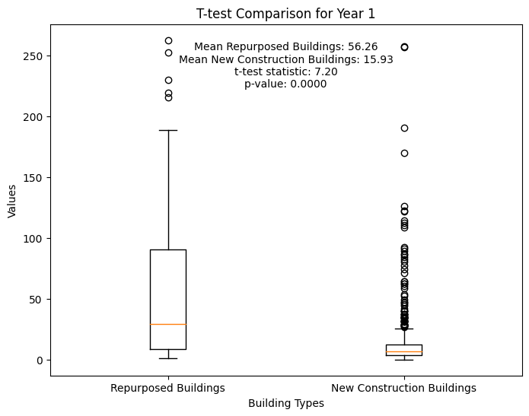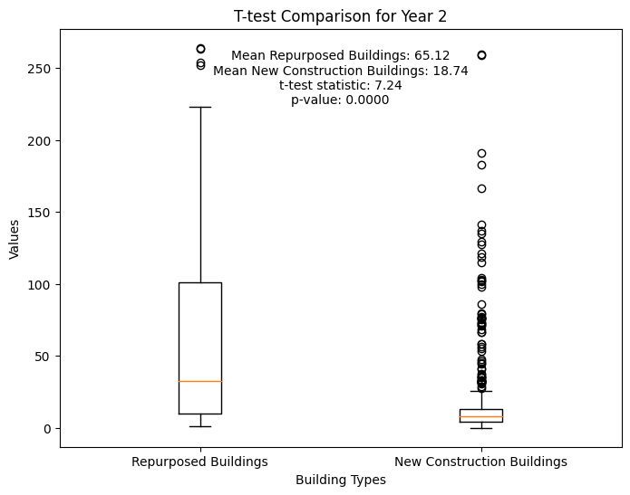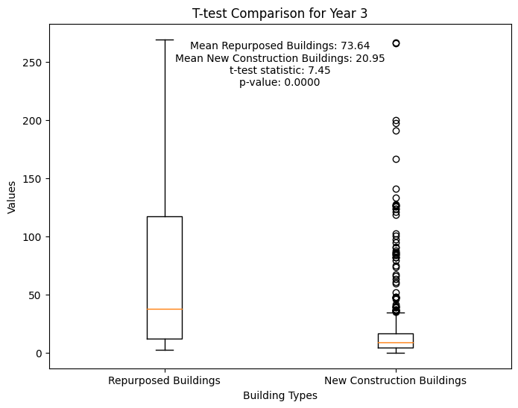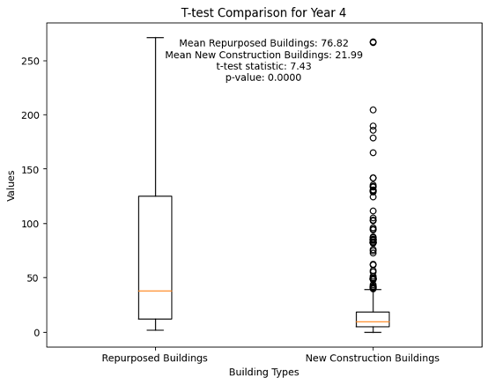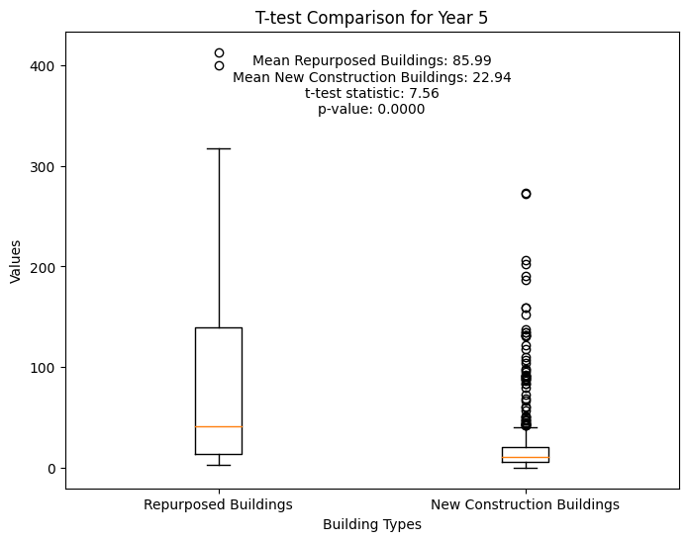

Supplementary Table 5
The Average Diversity Comparison of Amenities in the Isochrones of Repurposed and Newly Constructed Buildings

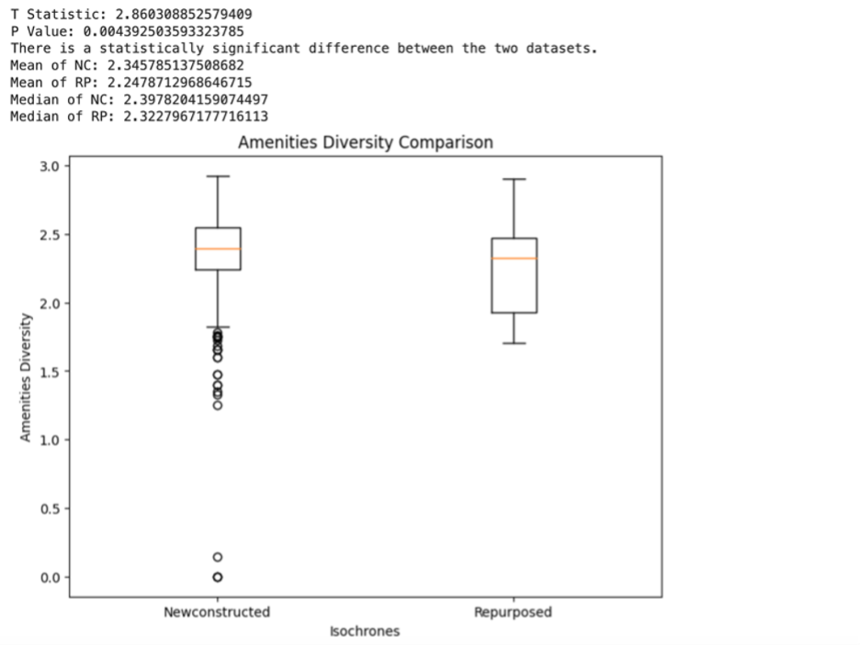

Supplementary Table 6

REPURPOSED BUILDINGS ISOCHRONES
AVERAGE NUMBER OF AMENITIES | AVERAGE NUMBER OF TOURIST RELATED AMENITIES
12,87 | 0,6
15,11 | 2,6
26,31 | 4
42,82 | 4,6
7,27 | 0
13,31 | 2
14,87 | 2
12,00 | 0
13,07 | 0
10,82 | 0,8
84,09 | 10,2
9,98 | 0,8
32,69 | 4,2
19,44 | 1,4
35,04 | 15,8
121,36 | 72
36,40 | 1,4
6,62 | 0
30,73 | 3
9,11 | 1
100,40 | 21,2
43,98 | 1,6
46,53 | 3,4
165,24 | 97,6
15,64 | 0
198,13 | 123,6
6,71 | 0
20,60 | 3
111,69 | 26,8
19,33 | 2,8
14,33 | 0,8
157,69 | 52,2
51,64 | 3,2
33,84 | 4,6
33,71 | 4,8
74,11 | 49,4
6,69 | 0
170,07 | 65,2
49,09 | 5,6
211,62 | 125
8,67 | 0
212,29 | 126,2
36,42 | 16,2
204,16 | 119,4
10,62 | 0
38,64 | 1,8
182,36 | 113,4
111,33 | 71,6
64,00 | 8,6
66,02 | 7
7,38 | 0
126,98 | 46,2
130,40 | 46,6
71,31 | 13
3,49 | 1
10,98 | 0
5,53 | 0
5,87 | 0,2
23,71 | 3
20,31 | 3
1,69 | 0
8,62 | 0,4
8,62 | 0,4
207,40 | 134,2
16,56 | 0
48,84 | 9,2
38,60 | 1,8
3,93 | 0,2
224,71 | 124,8
4,24 | 1
7,56 | 0
166,40 | 52,6
36,84 | 5,8
12,09 | 0
5,38 | 0,4
39,02 | 2,6
38,40 | 2,6
237,24 | 142,4
234,51 | 141,4
215,29 | 138,8
119,49 | 65,2
224,69 | 131,8
38,31 | 1,2
186,42 | 76,2
194,84 | 83,2
11,76 | 0
10,20 | 0
48,67 | 12
8,04 | 0,4
62,47 | 6,2
96,29 | 24,2
201,64 | 127,8
212,09 | 133,2
13,60 | 0
128,44 | 70,8
12,71 | 0
191,44 | 129
4,47 | 0,4
4,27 | 0,4
14,18 | 1,8
12,56 | 1,8
13,38 | 1,8
62,91 | 6,4
16,04 | 0,2
3,22 | 0
88,51 | 11,4
10,80 | 0
33,96 | 0
125,04 | 37,2
85,24 | 8,8
40,40 | 0,8
146,13 | 55,4
11,64 | 0,2
6,62 | 1
113,33 | 71,2
14,13 | 0,4
96,78 | 11,4
277,67 | 150
5,00 | 2,2
198,93 | 89,8
6,44 | 0
19,96 | 3,2
288,69 | 156,8
101,60 | 27,2
15,13 | 0
113,38 | 34,2
219,98 | 135
68,67 | 7,6
23,20 | 1
62,07 | 10,6
257,38 | 150,6
223,00 | 146,2
11,00 | 0
15,69 | 0,6
10,96 | 1
267,00 | 164,6
10,16 | 0
34,13 | 2,8
71,57 | 30,4942029 | 42,61%
NEWLY CONSTRUCTED ISOCHRONES
AVERAGE NUMBER OF AMENITIES | AVERAGE NUMBER OF TOURIST RELATED AMENITIES
11,64 | 0,2
4,80 | 0,8
7,33 | 1
2,24 | 0,6
51,89 | 8,2
8,58 | 1
3,62 | 0
3,98 | 0
8,69 | 1
8,62 | 1
9,40 | 2,4
10,07 | 0,8
8,22 | 0,2
1,09 | 0
6,49 | 1
10,44 | 0
8,71 | 3
1,11 | 0
14,62 | 0
9,58 | 0,2
7,89 | 1
15,20 | 6,4
4,36 | 0,6
117,18 | 54
3,40 | 0
27,40 | 3,6
7,67 | 0
8,67 | 0
7,51 | 0,2
7,53 | 0
8,09 | 0
8,09 | 0
8,11 | 0
8,07 | 0
6,42 | 1
9,40 | 0
10,84 | 1
10,84 | 1
0,29 | 0
35,51 | 1,4
6,62 | 1
7,42 | 1
5,36 | 0,4
5,29 | 0
5,51 | 0,4
13,67 | 2
0,96 | 0
11,71 | 0,4
5,02 | 0,6
4,38 | 0,6
8,60 | 0
2,53 | 0
10,11 | 2
10,89 | 1,6
1,67 | 0
47,20 | 5,4
48,02 | 5,4
4,44 | 0,8
8,44 | 1
90,20 | 21,8
0,00 | 0
0,71 | 2
18,49 | 2,4
16,80 | 0
0,42 | 0,2
5,91 | 1
10,13 | 0
12,00 | 0
11,67 | 1
20,18 | 26,4
105,16 | 0
2,82 | 21,2
84,13 | 2
13,89 | 1,6
32,20 | 2
6,80 | 2,4
38,04 | 0
16,56 | 0,2
10,89 | 0
1,09 | 0
1,00 | 1
13,71 | 3,6
33,89 | 0
5,40 | 0
15,38 | 0,8
11,84 | 0,8
11,87 | 0
0,49 | 0
11,82 | 0
12,56 | 0,6
4,11 | 3,6
36,13 | 2
13,44 | 1
7,27 | 0,8
6,96 | 0,8
3,67 | 1,4
2,11 | 0
1,00 | 0
10,33 | 0
5,56 | 0,2
2,67 | 0,2
10,89 | 2
3,00 | 0,2
2,78 | 0,2
0,22 | 0
21,33 | 1,4
75,11 | 11,8
36,33 | 0,6
8,44 | 0
3,44 | 0,2
12,00 | 1,8
12,78 | 1,8
0,89 | 0
6,89 | 1
7,44 | 1
3,11 | 0
0,56 | 0
166,44 | 77
0,56 | 0
0,56 | 0
63,44 | 5,8
6,00 | 0,6
141,22 | 76
1,00 | 0
1,11 | 0
18,56 | 2
20,56 | 2
47,56 | 2,6
13,78 | 0,6
12,78 | 1,2
7,00 | 1,2
7,33 | 0,2
1,71 | 0
1,18 | 1,2
6,89 | 1,8
7,44 | 0
7,76 | 0,8
5,98 | 0,8
6,09 | 0
13,60 | 7
36,49 | 1
8,42 | 40,6
117,09 | 35,8
111,93 | 5
58,27 | 1
7,93 | 0
3,69 | 0,6
3,38 | 0,6
2,62 | 0,6
3,29 | 0
6,20 | 0
14,13 | 2,8
11,89 | 2
12,49 | 19,2
79,64 | 2,4
39,53 | 0,2
2,02 | 0,2
2,02 | 3,8
22,84 | 0
12,98 | 0
12,91 | 0
12,98 | 0
0,58 | 0,2
2,80 | 0
0,58 | 0
1,18 | 0
1,13 | 0
1,09 | 0
1,18 | 0
8,42 | 0
0,64 | 7,8
65,33 | 0
3,56 | 8,4
81,49 | 2,8
41,11 | 2,2
39,56 | 2,2
10,18 | 0
5,96 | 0
22,84 | 0,4
12,38 | 4,6
41,53 | 2
17,00 | 0,4
6,87 | 1
6,56 | 17,2
74,60 | 0,8
8,44 | 2,2
17,51 | 0,4
2,89 | 0,4
6,93 | 0,8
7,78 | 0,8
10,67 | 0
3,53 | 0
6,51 | 5,8
55,29 | 0,2
9,42 | 0,2
9,42 | 0,2
8,09 | 24,2
90,60 | 1
7,71 | 1
6,84 | 2
11,87 | 2
9,87 | 2
9,47 | 1,4
5,22 | 1
12,20 | 0,8
5,93 | 61,2
160,69 | 2
18,40 | 0
1,33 | 0
8,36 | 1
10,04 | 0,8
12,42 | 0,8
11,27 | 0
1,16 | 1
8,09 | 2
13,36 | 3
9,69 | 9,2
70,16 | 10
71,69 | 0
1,11 | 0
7,69 | 0
2,49 | 0,8
4,13 | 0,8
4,13 | 2,4
5,40 | 2,4
5,47 | 0,6
18,09 | 0,6
17,53 | 0,6
16,13 | 0,6
15,96 | 2,4
6,00 | 2,4
5,89 | 0
2,62 | 12,6
73,98 | 1,6
15,89 | 1
16,42 | 4,8
50,47 | 1
9,96 | 8,4
76,36 | 8,4
74,82 | 11,8
73,22 | 2
7,58 | 14,4
20,87 | 0
0,71 | 0
0,71 | 0
0,82 | 0
0,82 | 0
0,71 | 0
8,58 | 0
10,04 | 0,4
2,33 | 1,6
15,18 | 2,6
12,78 | 0
7,04 | 0
6,58 | 0
6,56 | 0
6,49 | 0,4
2,87 | 0
5,51 | 0
13,07 | 1,4
4,16 | 0,8
6,89 | 0,6
12,13 | 0,6
10,07 | 1
7,40 | 0,4
8,53 | 1
9,80 | 0
1,42 | 0
1,87 | 1
12,33 | 0
5,02 | 2
15,80 | 2
7,02 | 2,8
15,89 | 0
5,29 | 0
4,78 | 0
0,11 | 124,2
193,71 | 0,4
9,76 | 0,4
10,20 | 0,4
10,58 | 0,4
10,62 | 0,4
8,44 | 0,4
9,00 | 0,4
8,36 | 0,4
4,98 | 0,4
7,49 | 0,4
8,44 | 1
8,62 | 2
13,29 | 1,6
6,00 | 1
4,84 | 1
6,87 | 82,2
101,44 | 1
12,04 | 1
6,04 | 1
5,36 | 2,2
21,40 | 81
126,53 | 2
20,00 | 2
21,64 | 0
2,82 | 1
14,38 | 45,2
131,49 | 2
6,84 | 0,6
3,18 | 0
9,71 | 1
9,91 | 2,2
3,96 | 0,8
6,93 | 0,8
9,80 | 0,8
12,47 | 0,8
16,78 | 0
3,62 | 2,2
21,76 | 2,2
22,40 | 0
6,53 | 0,6
4,78 | 0
19,02 | 1
5,76 | 0
15,98 | 75,8
122,51 | 0
9,47 | 0
8,91 | 0
14,02 | 2
5,33 | 0
0,91 | 0,2
6,62 | 0,2
12,67 | 1
9,42 | 76,8
123,82 | 0
1,02 | 0
0,91 | 0
1,33 | 0
1,38 | 0,6
3,07 | 1,6
3,40 | 0,8
6,87 | 0
5,07 | 0,8
8,84 | 0
1,20 | 2
24,16 | 13
99,91 | 24,4
130,62 | 0,6
3,13 | 1
11,82 | 0
0,00 | 0,8
7,98 | 0,8
12,42 | 2,8
16,44 | 2
17,76 | 0,6
3,62 | 0,6
3,67 | 0,6
2,11 | 0,6
1,00 | 0,6
10,33 | 0
5,56 | 2
2,67 | 0
10,89 | 4
3,00 | 4
2,78 | 12,2
0,22 | 0,8
21,33 | 15,4
75,11 | 0,4
36,33 | 4
8,44 | 0
3,44 | 0
12,00 | 8,2
12,78 | 0,8
0,89 | 0,6
6,89 | 0,6
7,44 | 0,6
3,11 | 0,6
0,56 | 1
166,44 | 0,8
0,56 | 1,8
0,56 | 1,8
63,44 | 0
6,00 | 56,4
141,22 | 0,8
1,00 | 9,8
1,11 | 0,8
18,56 | 4,8
20,56 | 6,8
47,56 | 6,8
13,78 | 6,8
38,33 | 6,8
36,24 | 6,8
38,33 | 6,8
36,24 | 4
24,24 | 2,2
4,44 | 2,2
4,44 | 0,8
6,11 | 1,2
14,91 | 1,2
14,18 | 1,2
14,76 | 1,2
14,22 | 2,4
8,38 | 85,4
191,40 | 1
10,44 | 0,6
16,93 | 15
83,38 | 0,8
3,44 | 0,8
11,07 | 3,2
31,42 | 0
1,71 | 2
21,27 | 155,2
264,73 | 153,2
264,24 | 3,8
47,78 | 0
13,93 | 0,6
6,33 | 0,8
14,42 | 3
33,93 | 0,6
5,40 | 0,6
4,76 | 0,2
19,93 | 4,83 | 24,24%

