Supplementary Data
Figure S1. Relative importance of each variable in the prediction of the Val142Ile or Ser43Asn mutation based on the random forest classifier and SHAP values including random distributed categorical and continuous variables.
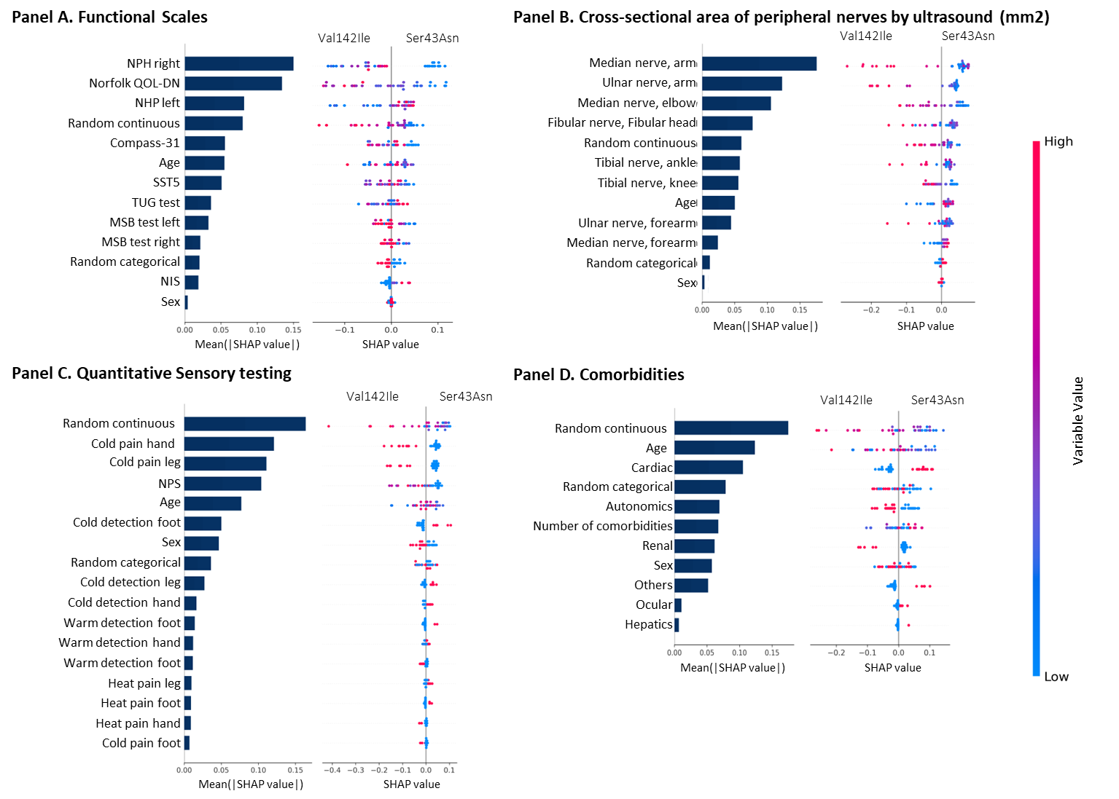
In each panel, models were adjusted between variables of the same domain, in addition to sex and age. In each panel, the left side represents the relative importance of the variable, expressed in terms of the Mean(|Shap value|). The right side of each point represents the SHAP value (contribution to the prediction), the further away from 0, the higher the contribution is considered. The colour represents the value of the variable to each prediction, towards red the value of a continuous variable is higher, in a categorical variable it is the value assigned to class 1. For sex: female=0, male=1. In the quantitative sensory test: Hyposensitivity=1, Normal=0. In comorbidities: No=0, Yes=1. NSI: Neurological Impairment Scale, TUG: Timed Up and go test, SST5:5-time Sit down-to-Stand up test, NHP: Nine-hole peg test, QOL-DN: Quality of Life-Diabetic Neuropathy, MSB: Monopodal static balance, Compass-31: Composite Autonomic Symptom Score-31, NPS: Neuropathic Pain Scale.
Figure S2. Relative importance of each variable in the prediction of the Val142Ile or Ser43Asn mutation based on the random forest classifier and SHAP values stratified by sex.
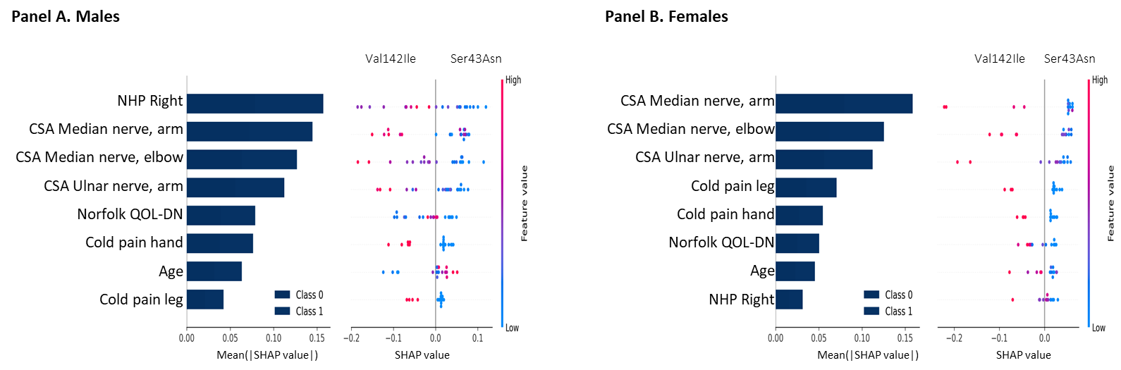

In each panel, the left side represents the relative importance of the variable, expressed in terms of the Mean(|Shap value|). The right side of each point represents the SHAP value (contribution to the prediction), the further away from 0, the higher the contribution is considered. The colour represents the value of the variable to each prediction, towards red the value of a continuous variable is higher, in a categorical variable it is the value assigned to class 1. For sex: female=0, male=1. In the quantitative sensory test: Hyposensitivity=1, Normal=0. In comorbidities: No=0, Yes=1. NSI: Neurological Impairment Scale, TUG: Timed Up and go test, SST5:5-time Sit down-to-Stand up test, NHP: Nine-hole peg test, QOL-DN: Quality of Life-Diabetic Neuropathy, MSB: Monopodal static balance, Compass-31: Composite Autonomic Symptom Score-31, NPS: Neuropathic Pain Scale.

Table S1. Detailed description of comorbidities in the analysed population. Number of participants by condition and mutations. Each participant may have several conditions
Condition | Val142Ile | Ser43Asn
Cardiac
Cardiopathy | 2 | 1
Heart transplant | 0 | 3
Arterial Hypertension | 0 | 2
Arrhythmia with Pacemaker | 0 | 2
Hypertrophic Cardiomyopathy | 0 | 1
Heart Failure | 0 | 1
Pericardial Effusion | 0 | 1
Hepatic
Liver transplant | 0 | 1
Renal
Urolithiasis | 3 | 1
Renal insufficiency | 0 | 1
Autonomic
Dry eyes | 0 | 2
Orthostatic hypotension | 2 | 8
Vasomotor Instability | 0 | 2
Chronic Diarrhea | 3 | 2
Erectile Dysfunction | 0 | 1
Cutaneous Discoloration | 0 | 1
Chronic Constipation | 0 | 2
Hypohidrosis | 1 | 1
Ocular
Glaucoma | 1 | 2
Keratoconus | 0 | 1
Periorbital Hyperpigmentation | 0 | 1
Others
Carpal Tunnel Syndrome | 4 | 4
De Quervain’s Tenosynovitis | 0 | 1
Rotator Cuff Syndrome | 0 | 1
Hypothyroidism | 0 | 1
Myopia | 0 | 1
Insulin Resistance | 0 | 1

Table S2. Contribution of each variable in the model by domains and final model. Estimated contribution by mean absolute Shap value.
 | Mean(|SHAP value|)* |  |  |  | Mean(|SHAP value|)*
Characteristics | Model 1 | Model 2 |  | Characteristics | Model 1 | Model 2
Functional Scales |  |  |  | Cross-sectional area of the peripheral nerves by ultrasound (mm2)
Neurological Impairment Scale | 0.029 | - |  | Median nerve, forearm | 0.029 | -
Timed Up and go test | 0.026 | - |  | Median nerve, elbow | 0.129 | 0.121
5-time Sit down-to-Stand up test | 0.067 | - |  | Median nerve, arm | 0.216 | 0.207
Nine-hole peg test, right | 0.189 | 0.087 |  | Ulnar nerve, forearm | 0.027 | -
Nine-hole peg test, left | 0.095 | - |  | Ulnar nerve, arm | 0.151 | 0.158
Norfolk Quality of Life-Diabetic Neuropathy | 0.158 | 0.093 |  | Fibular nerve, Fibular head | 0.075 | -
Composite Autonomic Symptom Score-31 | 0.046 | - |  | Tibial nerve, knee | 0.075 | -
Monopodal static balance test, right | 0.024 | - |  | Tibial nerve, ankle | 0.087 | -
Monopodal static balance test, left | 0.068 | - |  | Comorbidities | -
NPS | 0.104 | - |  | Cardiacs, yes | 0.159 | -
Quantitative Sensory testing, Hyposensitivity |  |  |  | Hepatics, yes | 0.002 | 0.003
Cold detection hand | 0.047 | - |  | Renal, yes | 0.110 | -
Cold detection leg | 0.038 | - |  | Ocular, yes | 0.014 | -
Cold detection foot | 0.065 | - |  | Otros, yes | 0.059 | -
Warm detection hand | 0.026 | - |  | Autonomics, yes | 0.084 | -
Warm detection leg | 0.016 | - |  | Number of comorbidities | 0.094 | -
Warm detection foot | 0.017 | - |  | Age, Mean (SD) | - | 0.005
Cold pain hand | 0.178 | 0.047 |  | Sex, Female | - | 0.036
Cold pain leg | 0.143 | 0.065
Cold pain foot | 0.015 | -
Heat pain hand | 0.008 | -
Heat pain leg | 0.015 | -
Heat pain foot | 0.017 | -
*(Mean(|SHAP value|)): mean absolute Shap value. Model 1: model grouping variables such as functional scales, sensory measures, the cross-sectional area (CSA) by ultrasound, and comorbidities adjusted for age and sex. Model 2: model including the most contributory variables from each model 1 and adjusted for age and sex.

