A glance at Quality-of-Life Post-Epilepsy Surgery: A Meta-Analysis and Systematic Review

Supplementary Material
- Brief search
Search Strategy URL
We conducted an extensive search across all major medical databases, with a primary focus on PubMed,
to identify studies examining the impact of epilepsy surgery on quality of life (QoL). The following search
terms and filters were applied:
• Search Terms: (epilepsy surgery) AND (quality of life)
• Filters:
o Study Type: Clinical Trial, Randomized Controlled Trial
o Language: English
o Population: Adult (19-44 years)
o Publication Date Range: 2004 - 2024
o Sorting: By publication date
This comprehensive search strategy was designed to capture a wide range of studies, ensuring the inclusion
of both recent and relevant trials. The focus on randomized controlled trials (RCTs) and clinical trials
helps to ensure the reliability and validity of the findings regarding QoL improvements post-epilepsy
surgery. The application of these filters aimed to refine the search to the most pertinent and high-quality
studies available within the specified time frame.
Detailed Query:
(("epilepsie"[All Fields] OR "epilepsy"[MeSH Terms] OR "epilepsy"[All Fields] OR "epilepsies"[All
Fields] OR "epilepsy s"[All Fields]) AND ("surgery"[MeSH Subheading] OR "surgery"[All Fields] OR
"surgical procedures, operative"[MeSH Terms] OR ("surgical"[All Fields] AND "procedures"[All
Fields] AND "operative"[All Fields]) OR "operative surgical procedures"[All Fields] OR "general
surgery"[MeSH Terms] OR ("general"[All Fields] AND "surgery"[All Fields]) OR "general
surgery"[All Fields] OR "surgery s"[All Fields] OR "surgerys"[All Fields] OR "surgeries"[All Fields])
AND ("quality of life"[MeSH Terms] OR ("quality"[All Fields] AND "life"[All Fields]) OR "quality of
life"[All Fields])) AND ((clinicaltrial[Filter] OR randomizedcontrolledtrial[Filter]) AND
(english[Filter]) AND (adult[Filter]) AND (2004:2024[pdat]))
Translations
epilepsy: "epilepsie"[All Fields] OR "epilepsy"[MeSH Terms] OR "epilepsy"[All Fields] OR
"epilepsies"[All Fields] OR "epilepsy's"[All Fields]
surgery: "surgery"[Subheading] OR "surgery"[All Fields] OR "surgical procedures, operative"[MeSH
Terms] OR ("surgical"[All Fields] AND "procedures"[All Fields] AND "operative"[All Fields]) OR
"operative surgical procedures"[All Fields] OR "general surgery"[MeSH Terms] OR ("general"[All
Fields] AND "surgery"[All Fields]) OR "general surgery"[All Fields] OR "surgery's"[All Fields] OR
"surgerys"[All Fields] OR "surgeries"[All Fields]
quality of life: "quality of life"[MeSH Terms] OR ("quality"[All Fields] AND "life"[All Fields]) OR
"quality of life"[All Fields]

- ROBSON-I
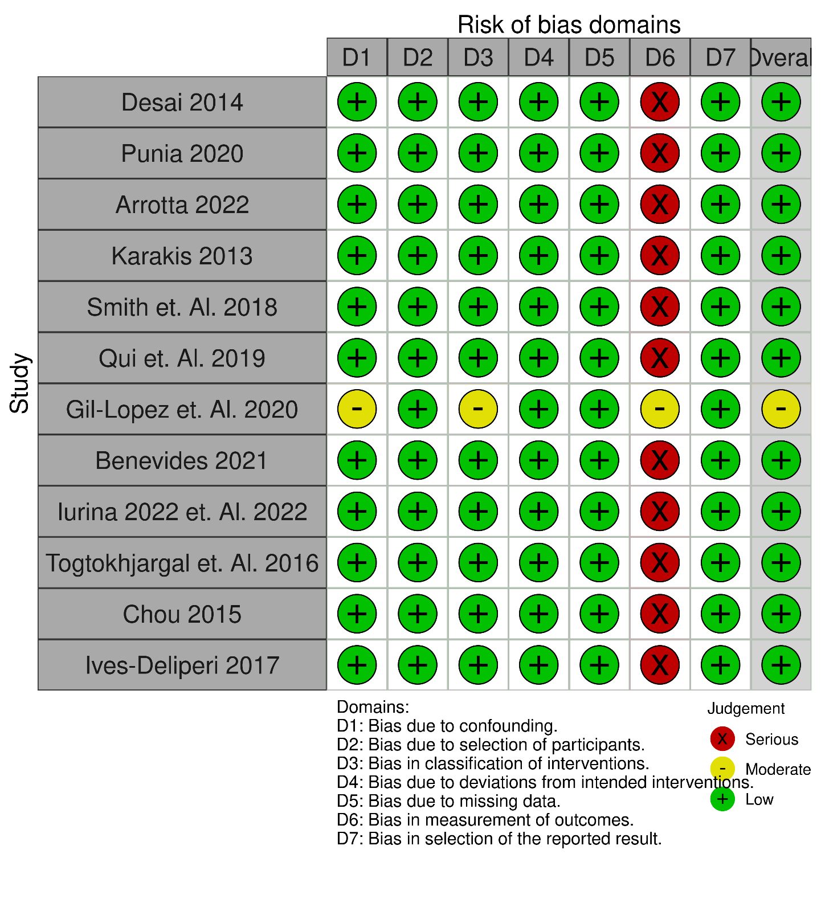

- ROB 2.0
