Table 2: The CIE coordinates and images, CRI and CCT parameters corresponding to C102, Rh6G, and composite on 405 nm laser excitation.
Dye in silica composite | Concentration (mM) | CIE coordinate |  | CIE Diagram | CRI |  | CCT  (K)
Dye in silica composite | Concentration (mM) | X | Y | CIE Diagram | R_{a} | Re | CCT  (K)
D65 | ⁻⁻⁻ | 0.33 | 0.33 | 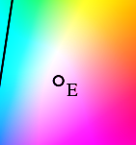 | 100 |  | 6500
Rh6G | 0.1 | 0.38 | 0.38 | 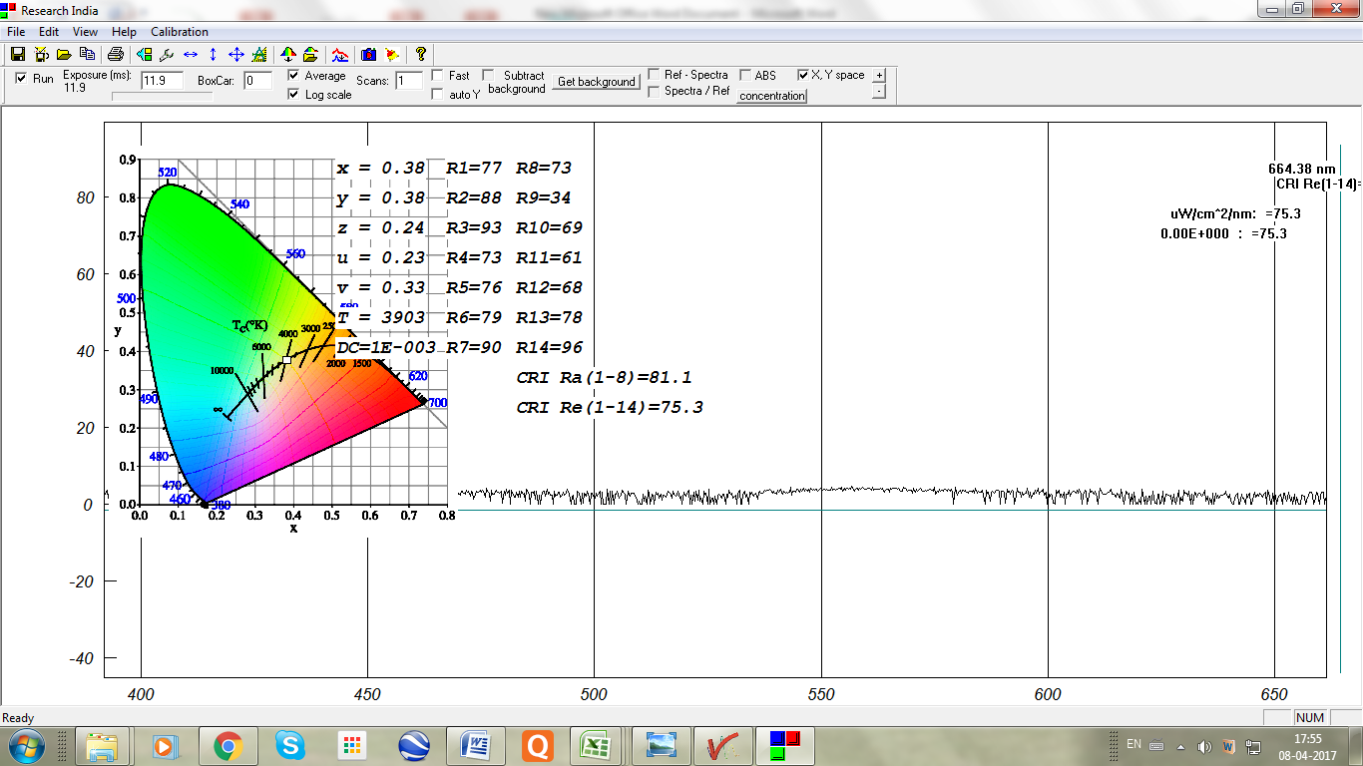 | 81.1 | 75.3 | 3903
C102 | 0.1 | 0.32 | 0.27 | 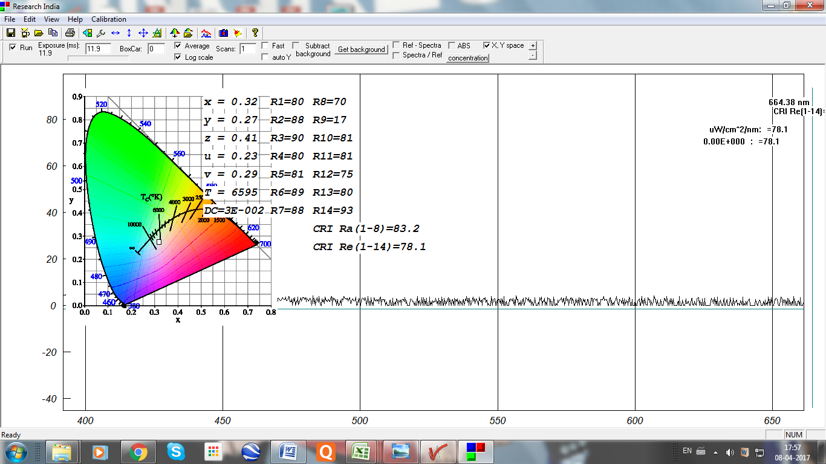 | 83.2 | 78.1 | 6595
C102 + Rh6G | 0.1 + 3.047 | 0.35 | 0.33 | 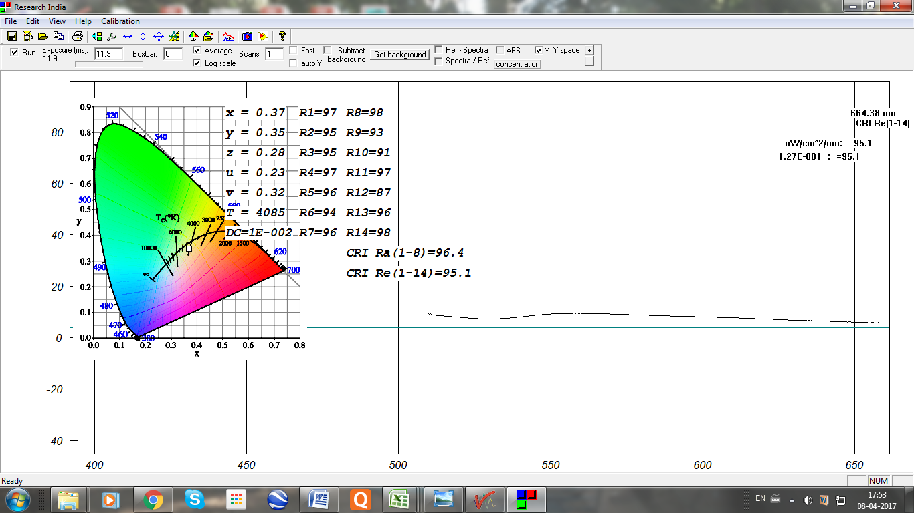 | 92.8 | 91.7 | 4831

