Spectroscopic study of tunable white light stimulation from organic dyes infused in silica nanocomposite

Rashmi¹, Ashutosh Kumar Dikshit², Y. Dwivedi³*

¹Division of Physics, Department of Science, Faculty of Science and Technology, Alliance University, Bengaluru 562106, India
²Department of Electronics and Communication Engineering, Vignan's Foundation for Science, Technology, and Research, Vadlamudi, Guntur-522213, India
³Department of Physics, National Institute of Technology Kurukshetra, Haryana 136119, India

*Corresponding Author: yashjidwivedi@nitkkr.ac.in

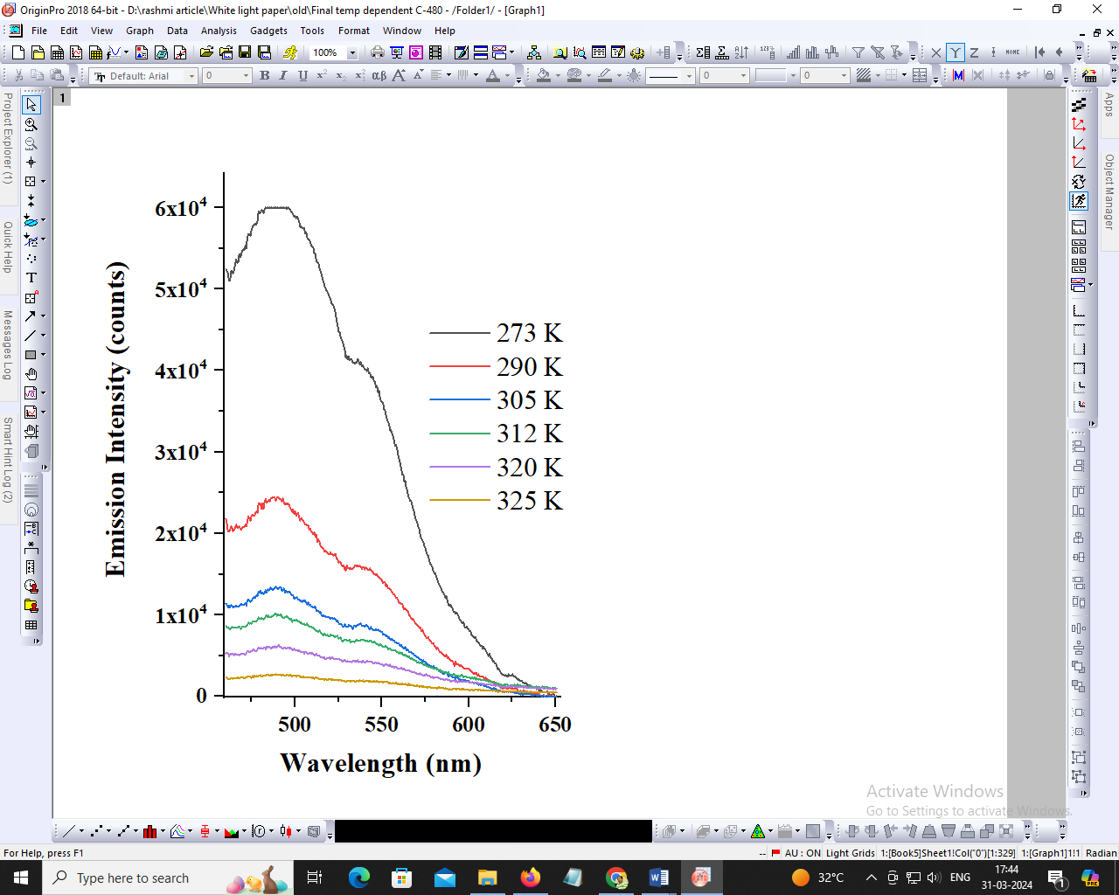
Figure S1:) Luminescence spectra of composite in mSi (C102+Rh6G; 0.1+0.1mM) on 405 nm LED excitation.

