Supplementary Figure 1. Plot of the directed acyclic graphs (DAG) for the association of LLIN use and malaria positive household.
The graphical model is available at
https://dagitty.net/development/dags.html?id=u6S1Pj
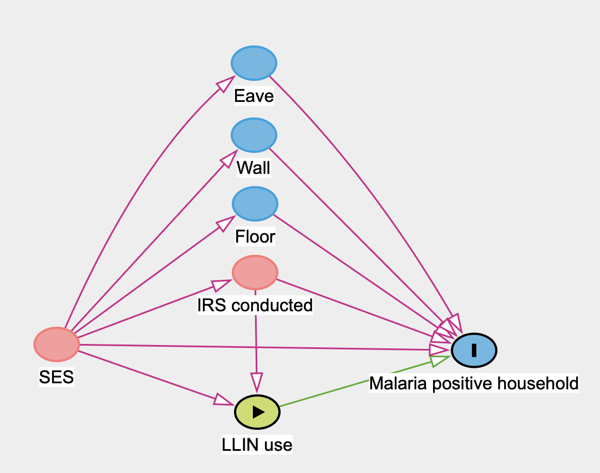
dag {
bb="0,0,1,1"
"IRS conducted" [pos="0.440,0.426"]
"LLIN use" [exposure,pos="0.443,0.614"]
"Malaria positive household" [outcome,pos="0.708,0.531"]
Eave [pos="0.439,0.145"]
Floor [pos="0.440,0.334"]
SES [pos="0.198,0.523"]
Wall [pos="0.439,0.241"]
"IRS conducted" -> "LLIN use"
"IRS conducted" -> "Malaria positive household"
"LLIN use" -> "Malaria positive household"
Eave -> "Malaria positive household" [pos="0.589,0.304"]
Floor -> "Malaria positive household"
SES -> "IRS conducted"
SES -> "LLIN use"
SES -> "Malaria positive household"
SES -> Eave [pos="0.303,0.263"]
SES -> Floor
SES -> Wall
Wall -> "Malaria positive household"
}

