Supporting information
Intrinsically Anisotropic 1D NbTe₄ for Self-Powered Polarization-Sensitive Photodetection
Huahu Luo^{1,#}, Fafa Wu^{1,#}, Chaowei He¹, Wanfu Shen², Chunguang Hu², Weina Zhao^{3,}*, Peng Yu^{1,}*, Guowei Yang¹
¹State Key Laboratory of Optoelectronic Materials and Technologies, Guangzhou Key Laboratory of Flexible Electronic Materials and Wearable Devices, Nanotechnology Research Center, School of Materials Science and Engineering, Sun Yat-sen University, Guangzhou 510275, P.R. China
² State Key Laboratory of Precision Measuring Technology and Instruments, Tianjin University, Tianjin 300072, P. R. China.
³School of Environmental Science and Engineering, Guangdong University of Technology, Guangzhou 510006, P. R. China
#These authors contributed equally to this paper
*e-mail: zhaowngd@gdut.edu.cn, yupeng9@mail.sysu.edu.cn

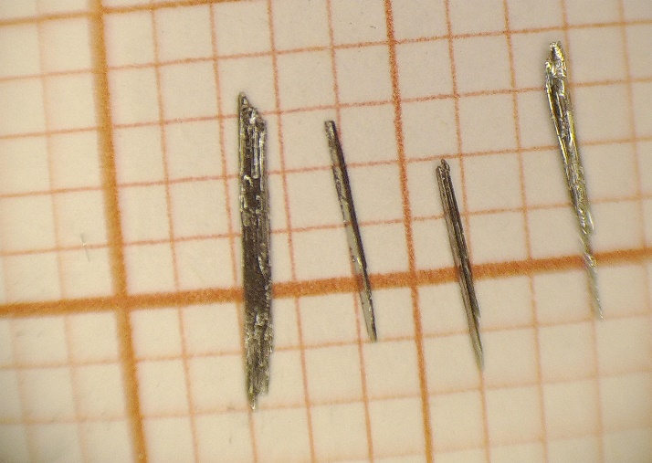
Fig. S1 The optical image of NbTe₄ single crystals.

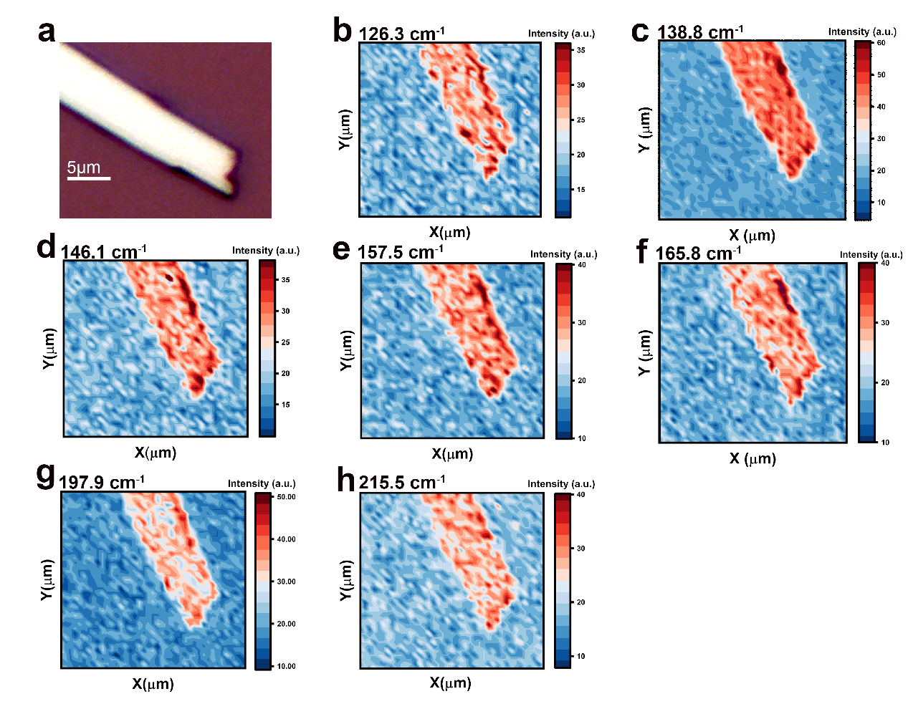
Fig. S2 The Raman mapping of NbTe₄. a) The optical image of NbTe₄. b-h) The Raman mapping at the 126.3, 138.8, 146.1, 157.5, 165.8 197.9 and 215.5 cm⁻¹, respectively.
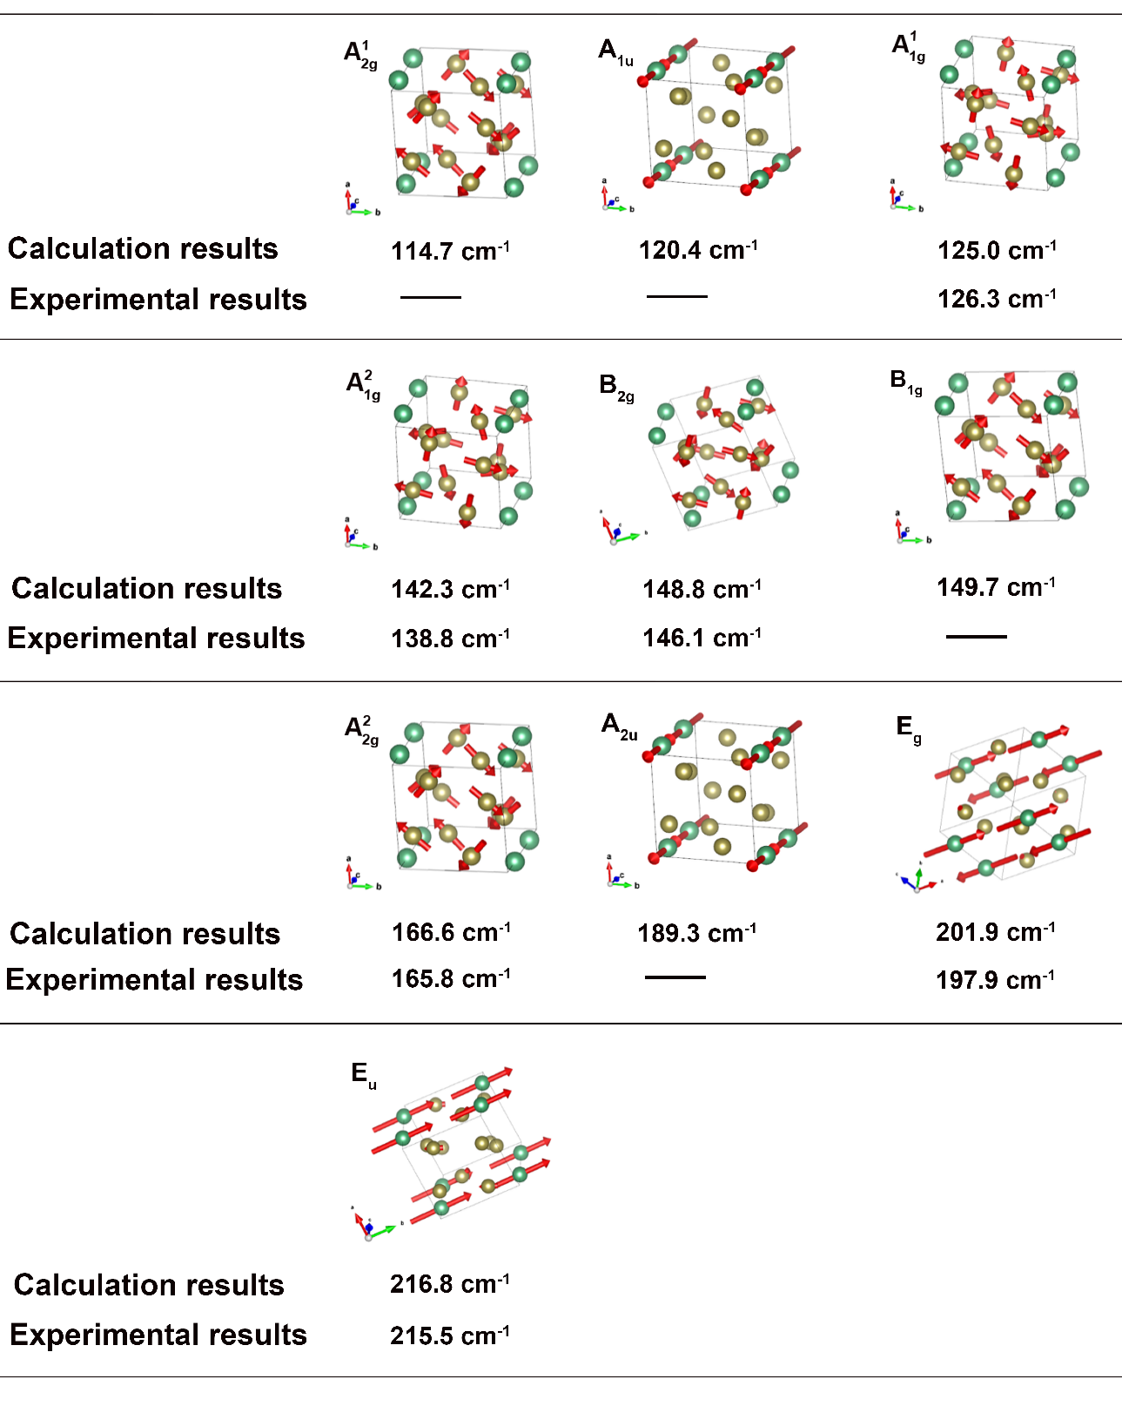
Fig. S3 Vibrational symmetry of phonon modes for NbTe₄ along with their respective mode frequencies experimental results. The green and yellow spheres represent Nb and Te atoms, respectively.

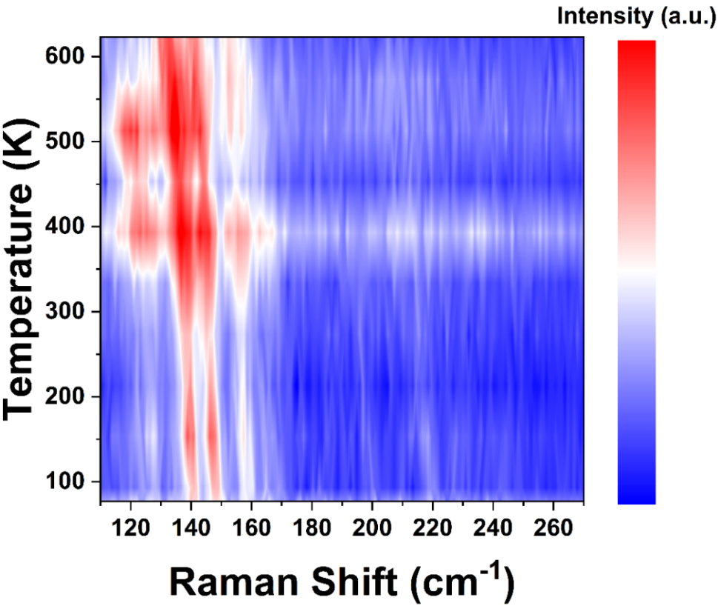
Fig. S4 The contour plot of temperature-dependent Raman spectroscopy of NbTe₄.

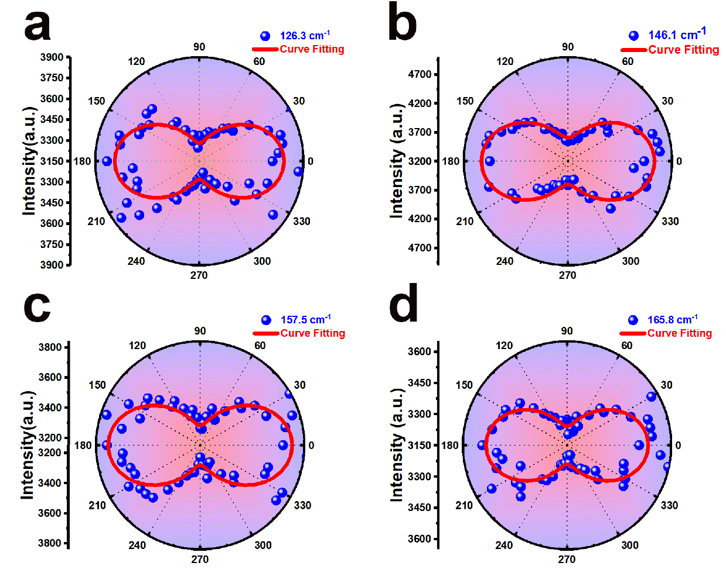
Fig. S5 Polar plots of Polar plots of Raman peak intensity with polarization angle at a) 126.3 cm⁻¹, b) 146.1 cm⁻¹, c) 157.7 cm⁻¹, and d) 165.8 cm⁻¹, respectively.
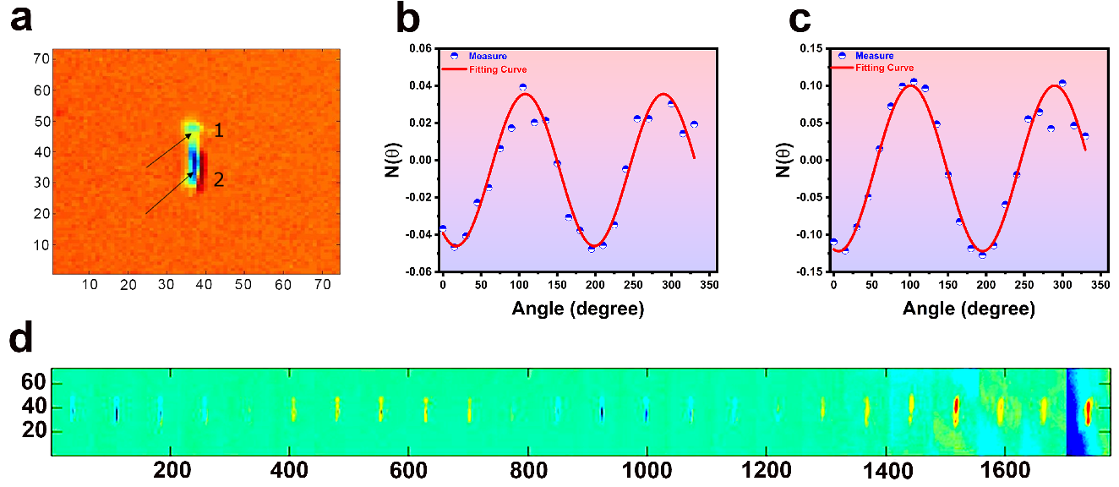
Fig. S6 a) ADRDM optical image of NbTe₄ on an isotropic SiO₂/Si substrate. b) Angle-dependence ADRDM results of NbTe₄ in the area marked by the position 1 and (c) position 2 in a). d) ADRDM images of NbTe₄ as a function of the rotation angle.

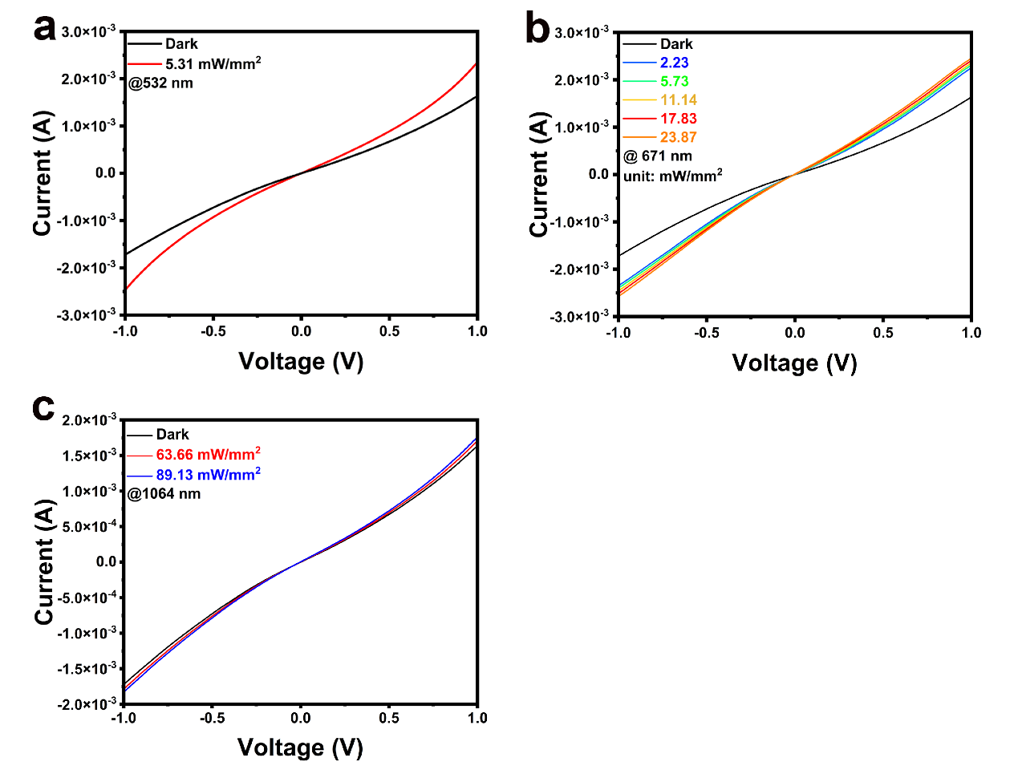
Fig. S7 Typical I-V curves under different power density at a) 532, b) 671 and c) 1064 nm, respectively.
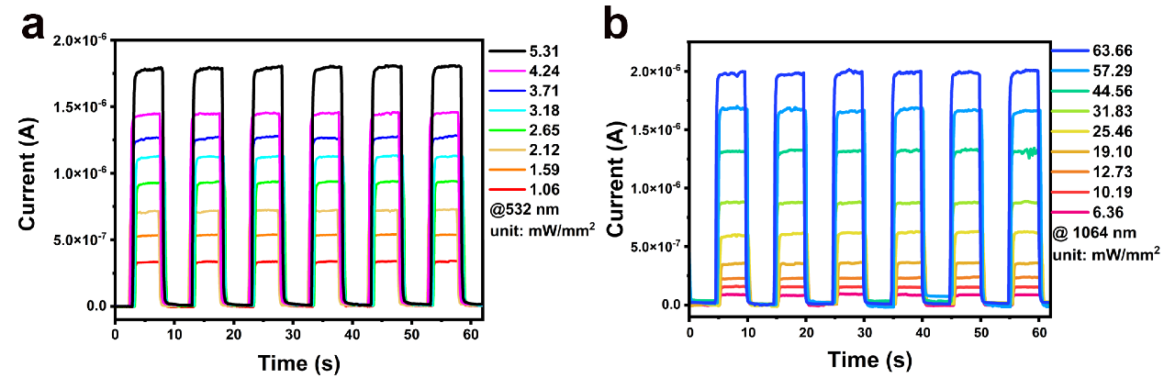
Fig. S8 Time-resolved dynamic photoresponse curves under different power density under a)532 and b)1064 nm laser, respectively.

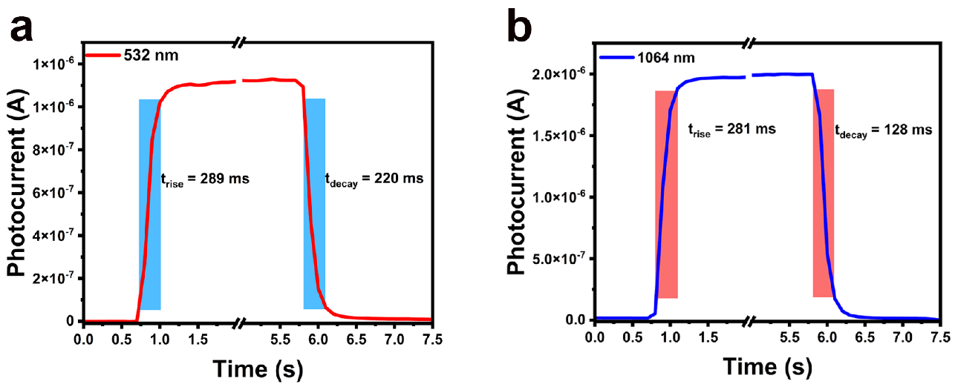
Fig. S9 Rise times and decay times under a) 532 and b) 1064 nm light, respectively.

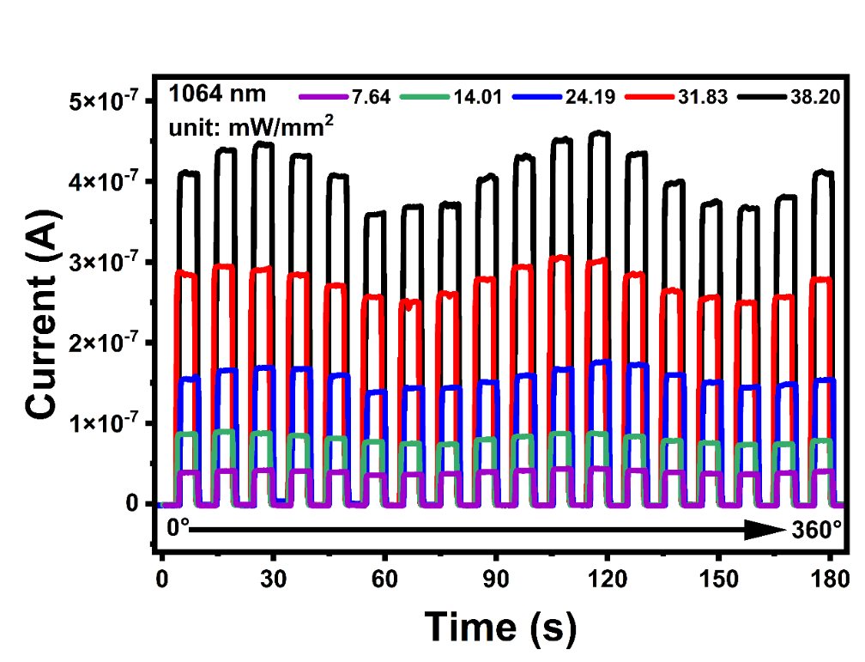
Fig. S10 Angle-resolved photocurrents under different power density at 1064 nm.

