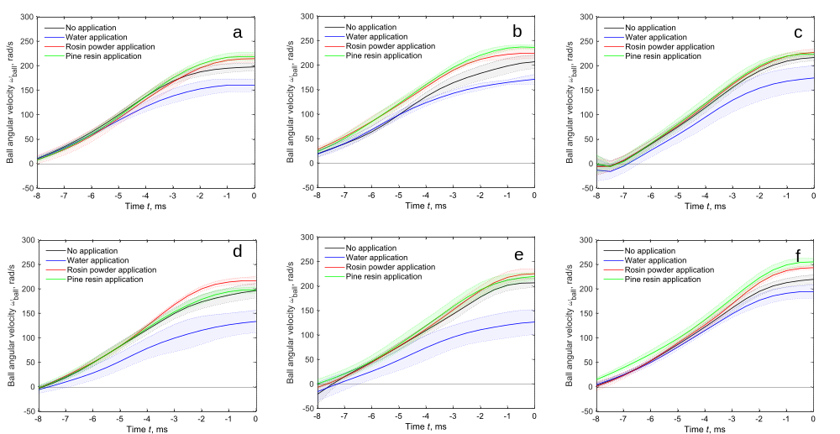
Fig. S1. Time series change in the ball angular velocity ω_{ball} for each participant. The solid line indicates the within-participant mean, and the shaded area indicates the within-participant mean ± standard deviation.
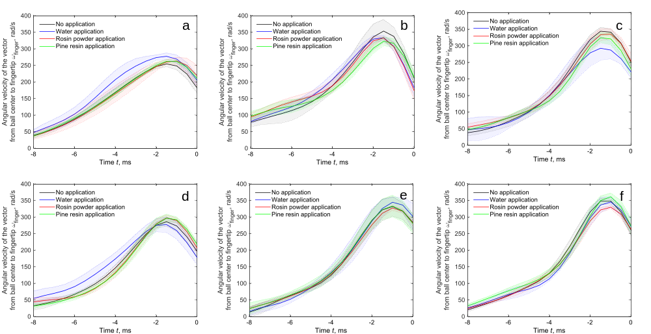
Fig. S2. Time series change in the angular velocity of the vector from the ball center to the fingertip ω_{finger} for each participant. The solid line indicates the within-participant mean, and the shaded area indicates the within-participant mean ± standard deviation.
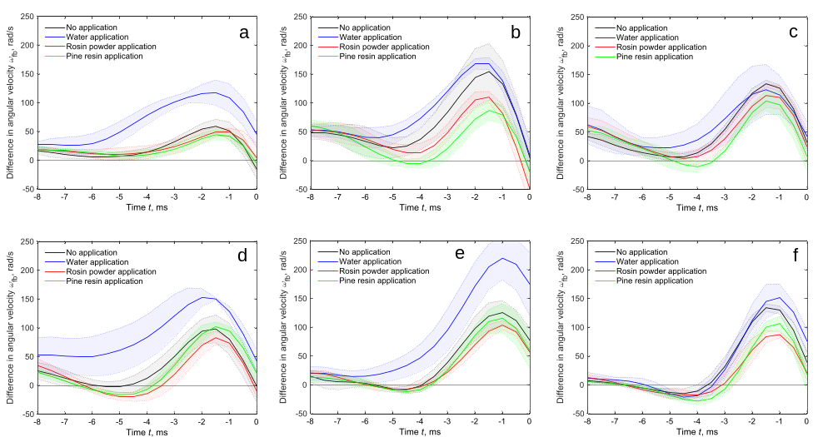Fig. S3. Time series change in the difference between the ball angular velocity and angular velocity of the vector from the ball center to the fingertip Δω_{fb} for each participant. The solid line indicates the within-participant mean, and the shaded area indicates the within-participant mean ± standard deviation.

