Supporting Information
for
Highly Tunable Flexible AgCu/Cotton Pressure Sensor using Surface Morphological Engineering for Enhanced Performance
Jiaojiao Zheng*, Tianyu Cao, Jianxiao Wang, Wenhao Xu, Yihan Qu, Jiafen Wang, Yunlong Wu, Yanyan Song, Lizhong He, Xudong Chen, Jie Yang*, Yinhu Qu
School of Materials Science and Engineering, Xi’an Key Laboratory of Textile Composites, Xi’an Polytechnic University, Xi’an 710048, PR China
*Email address: zhengjiaojiao@xpu.edu.cn

Supplementary Figures and Tables

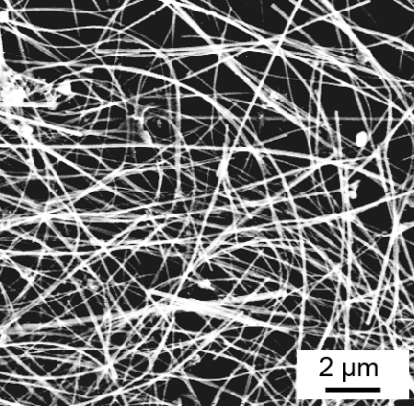
Supplementary Fig.1 SEM image of the obtained Cu NWs.

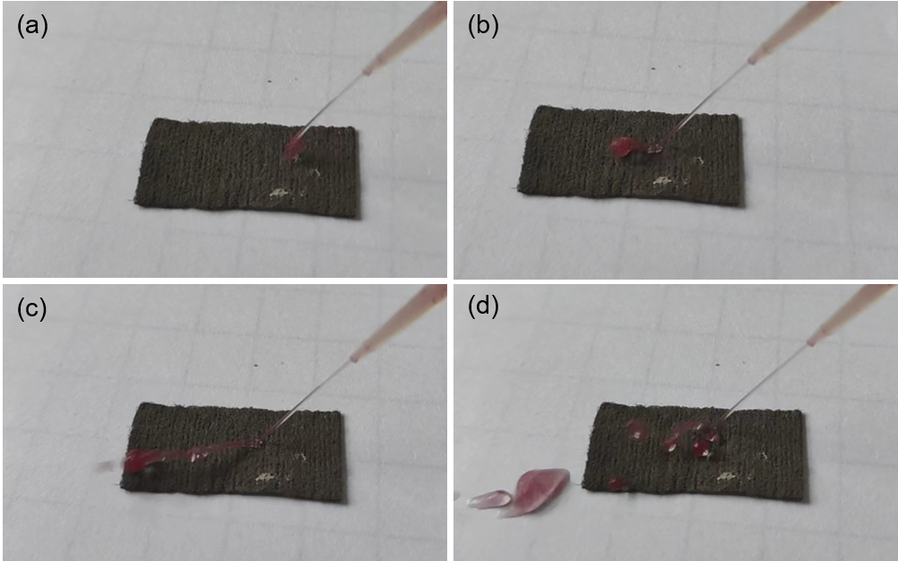
Supplementary Fig.2 A jet of water (dyed with red ink) bounced off from the AgCu/cotton fabric.

Supplementary Fig.3 The electrical stability of the AgCu/cotton under HCl (a), NaOH (b), and NaCl droplets (c) on its surface. WCAs of the AgCu/cotton after immersed in different solutions for 5 min (d).

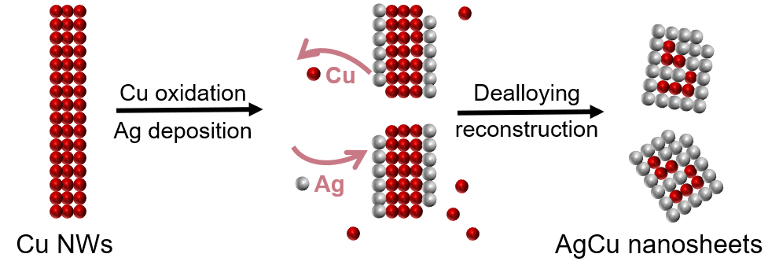
Supplementary Fig.4 Schematic illustrating the possible formation mechanism of AgCu nanosheets.

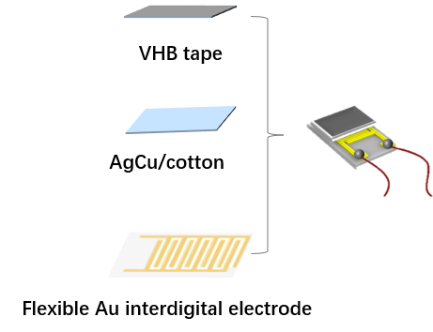
Supplementary Fig.5 Fabrication process of the AgCu/cotton sensor.

Supplementary Tab. 1 Comparison of select piezoresistive pressure sensors based on microengineered features.
Structure | Structure fabrication method | Sensitivity  (kPa⁻¹) | Sensing  Range | Waterproof-ness | Breath-ability | Ref.
Interlocked micropillars | Silicon mold | 10.41 | <2.5 kPa | NR | NR | 12
Hybrid porous | Epipremnum aureum leaf and sugar as template | 83.9 | <140 Pa | NR | NR | 16
Microspinous | Abrasive paper template | 151.4 | 0~4.7 kPa | NR | NR | 20
Random spinosum | Abrasive paper template | 25.1 | 0~2.6 kPa | NR | NR | 22
Porous and surface pillars | NaCl powders and nonwoven fabric as template | 10.0805 | 1 Pa~1 kPa | NR | NR | 1
Interlocked  connection | Silicon wafer mold | 20.08 | 0.05−0.8 kPa | NR | NR | 2
Interlocked nanocone array | AAO template | 268.36 | 0~200 Pa | NR | NR | 3
Surface wrinkles and dome-like microstructure | Pre-strained VHB tape as substrate | 178 | 100-200 Pa | NR | NR | 4
Microcone array | Plant leaf template | 528.87 | <2 kPa | NR | NR | 5
Multiscale surface | Surface wrinkling and rose petal-template | 70 | <0.5 kPa | NR | NR | 6
Wrinkled structure | Pre-stretched polyacrylate tape as substrate | 148.26 | 7-16 kPa | NR | NR | 7
Irregular microdome | Internal popping of microspheres | 50.45 | 0-50 Pa | NR | NR | 8
Hierarchical gradient protrusion | Dip-coating and galvanic replacement | 117 | 2-7.5 kPa | Yes | Yes | Our work
Note: NR represent not reported.

Supplementary Tab. 2 Elemental contents of AgCu/cotton fabrics calculated by EDS results.
Element  (At%) | Samples
Element  (At%) | AgCu/cotton-1 | AgCu/cotton-2 | AgCu/cotton-3 | AgCu/cotton-4
C | 72.71 | 57.47 | 72.74 | 58.12
N | 9.33 | 9.13 | 6.68 | 7.72
Ag | 16.99 | 32.95 | 20.26 | 33.92
Cu | 0.97 | 0.45 | 0.31 | 0.24

Supplementary References
[1] Li, W.; Jin, X.; Han, X.; Li, Y.; Wang, W.; Lin, T.; Zhu. Z. Synergy of Porous Structure and Microstructure in Piezoresistive Material for High-Performance and Flexible Pressure Sensors. ACS Appl. Mater. Interfaces 2021, 13, 19211-19220.
[2] Mao, Y.; Ji, B.; Chen, G.; Hao, C.; Zhou, B.; Tian, Y. Robust and Wearable Pressure Sensor Assembled from Ag NW-Coated PDMS Micropillar Sheets with High Sensitivity and Wide Detection Range. ACS Appl. Nano Mater. 2019, 2, 3196-3205.
[3] Lu, Y; He, Y.; Qiao, J.; Niu, X.; Li, X.; Liu, H.; Liu. L. Highly Sensitive Interlocked Piezoresistive Sensors Based on Ultrathin Ordered Nanocone Array Films and Their Sensitivity Simulation. ACS Appl. Mater. Interfaces 2020, 12, 55169-55180.
[4] Jia, J.; Huang, G.; Deng, J.; Pan. K. Skin-Inspired Flexible and High-Sensitivity Pressure Sensors Based on rGO Films with Continuous Gradient Wrinkles. Nanoscale 2019,11, 4258-4266.
[5] Yang, J.; Liu, L.; Zhang, D.; Zhang, H.; Ma, J.; Zheng, J.; Wang, C. Dual-Stage Surficial Microstructure to Enhance the Sensitivity of MXene Pressure Sensors for Human Physiological Signal Acquisition. ACS Appl. Mater. Interfaces 2024, 16, 1096-1106.
[6] Yu, S.; Li, L.; Wang, J.; Liu, E.; Zhao, J.; Xu, F.; Cao, Ya.; Lu. C. Light-Boosting Highly Sensitive Pressure Sensors Based on Bioinspired Multiscale Surface Structures. Adv. Funct. Mater. 2020, 30, 1907091.
[7] Yan, J.; Ma, Y.; Li, X.; Zhang, C.; Cao, M.; Chen, W.; Luo, S.; Zhu, M.; Gao. Y. Flexible and High-Sensitivity Piezoresistive Sensor Based on MXene Composite with Wrinkle Structure. Ceram. Int. 2020, 46, 23592-23598.
[8] Jung, Y.; Choi, J.; Lee, W.; Ko, J. S.; Park, I.; Cho. H. Irregular Microdome Structure-Based Sensitive Pressure Sensor using Internal Popping of Microspheres. Adv. Funct. Mater. 2022, 32, 2201147.

