Supplementary information

Antibody responses against influenza A decline with successive years of annual influenza vaccination: results from an Australian Healthcare Worker cohort
Contents
Timing of blood collection 2
Influenza A(H1N1)pdm09 3
Genetic diversity 3
Summary of raw antibody analyses 4
Relationship between baseline titre, number of prior vaccinations and day 14 post-vaccination GMTs for A(H1N1)pdm09 7
Regression results 8
Predictors of post-vaccination GMT 8
Predictors of post-vaccination seropositivity 10
Predictors of post-vaccination geometric mean rise 12
Predictors of post-vaccination seroconversion 14
Influenza A(H3N2) 16
Genetic diversity 16
Summary of raw antibody analyses 18
Relationship between baseline titre, number of prior vaccinations and day 14 post-vaccination GMT 21
Predictors of post-vaccination GMT 22
Predictors of post-vaccination seropositivity 24
Predictors of post-vaccination geometric mean rise 26
Predictors of post-vaccination seroconversion 28

Timing of blood collection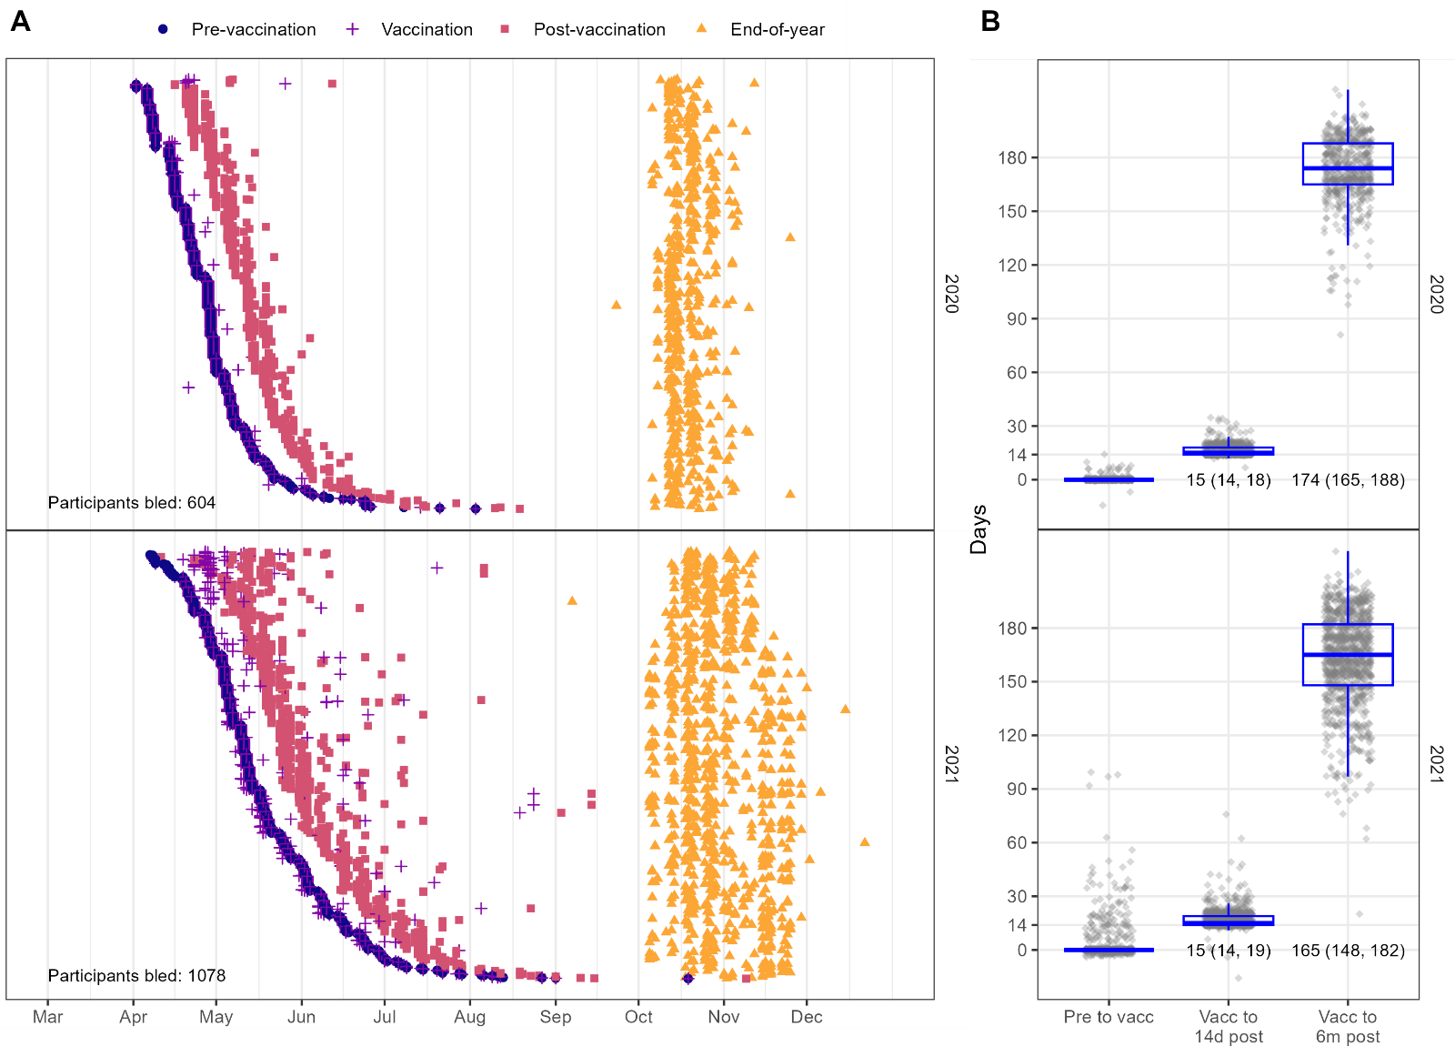
Supplementary Figure 1. Timing of blood collection and vaccination for all study participants. Only vaccinated HCWs from whom a blood sample was available for serology are shown. A. Scatter showing the timing of bleeds ordered by recruitment date for 2020 and 2021. Each horizontal set of points indicates an individual. B. Boxplots showing the median number of days between visits. The lower and upper hinges on the boxes correspond to the first and third quartiles. The upper whisker extends from the hinge to the largest value no further than 1.5 * IQR from the hinge. The lower whisker extends from the hinge to the smallest value at most 1.5 * IQR of the hinge. Number shown at base of the plots are median (IQR) days since vaccination.

Influenza A(H1N1)pdm09

Genetic diversity

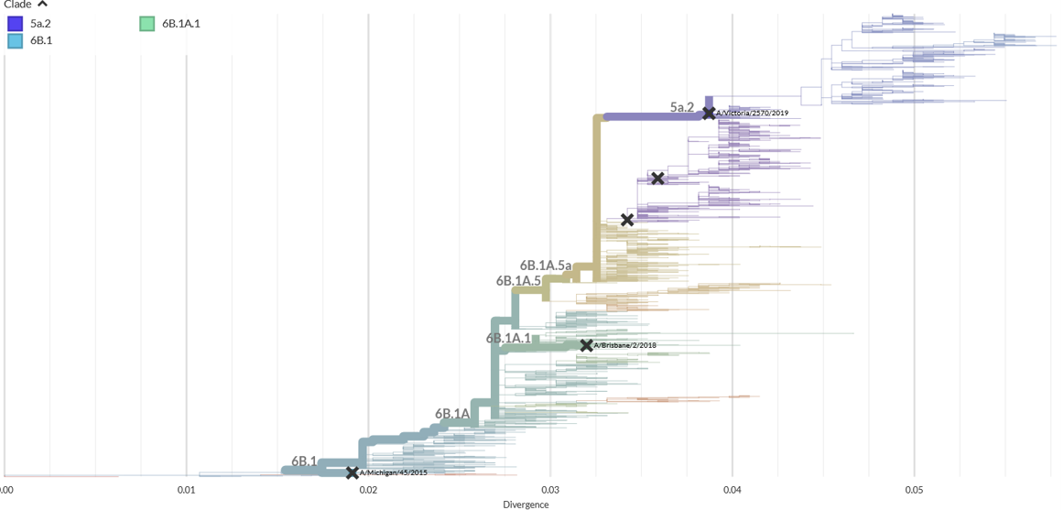
  ​Year | A(H1N1)pdm09​ vaccine virus
  2021​ | A/Victoria/2570/2019 ​  (6B.1A.5a.2)​
  2020​ | A/Brisbane/02/2018 ​  (6B1.A.1)​
  2019​ | A/Michigan/45/2015 ​  (6B.1)​
  2018​ | A/Michigan/45/2015 ​  (6B.1)​
  2017​ | A/Michigan/45/2015 ​  (6B.1)​
  2016​ | A/California/7/2009 ​  (1)​
  2015​ | A/California/7/2009 ​  (1)​
Supplementary Figure 2. Phylogenetic tree showing the genetic divergence of A(H1N1)pdm09 viruses. Image reproduced from www.nextstrain.org.

Summary of raw antibody analyses
Supplementary Table 1. Summary of antibody analyses for A(H1N1)pdm09. Colours identify the highest (darker colour) and lowest (lighter colour) values.
 | Year | Virus | Substrate |  | Bleed |  | 0 prior |  | 1 prior |  | 2 prior |  | 3 prior |  | 4 prior |  | 5 prior
GMT | 2020 | A/Brisbane/02/2018 | cell |  | Pre-vaccination |  | 8.9 (7.2, 11) |  | 41 (31, 54) |  | 27 (21, 35) |  | 45 (35, 59) |  | 28 (23, 35) |  | 23 (20, 26)
 |  |  |  |  | 14d post |  | 84 (54, 132) |  | 93 (72, 119) |  | 49 (37, 64) |  | 67 (52, 85) |  | 43 (35, 54) |  | 35 (31, 40)
 |  |  |  |  | 6m post |  | 43 (28, 66) |  | 58 (45, 74) |  | 37 (27, 49) |  | 54 (42, 70) |  | 32 (26, 40) |  | 28 (25, 32)
GMT | 2020 | A/Brisbane/02/2018 | egg |  | Pre-vaccination |  | 11 (8.4, 15) |  | 80 (58, 111) |  | 55 (41, 75) |  | 99 (78, 125) |  | 65 (51, 84) |  | 49 (43, 56)
 |  |  |  |  | 14d post |  | 193 (127, 292) |  | 193 (153, 242) |  | 110 (84, 144) |  | 149 (118, 188) |  | 109 (90, 131) |  | 87 (77, 98)
 |  |  |  |  | 6m post |  | 91 (60, 138) |  | 123 (97, 156) |  | 73 (55, 97) |  | 120 (94, 153) |  | 73 (58, 90) |  | 59 (52, 67)
GMT | 2021 | A/Victoria/2570/2019 | cell |  | Pre-vaccination |  | 9.5 (6.1, 15) |  | 25 (18, 34) |  | 21 (17, 26) |  | 19 (16, 23) |  | 20 (17, 23) |  | 13 (13, 14)
 |  |  |  |  | 14d post |  | 202 (94, 430) |  | 86 (66, 113) |  | 85 (68, 106) |  | 74 (60, 89) |  | 62 (52, 74) |  | 43 (39, 46)
 |  |  |  |  | 6m post |  | 75 (33, 170) |  | 53 (41, 69) |  | 46 (37, 57) |  | 42 (35, 50) |  | 41 (35, 48) |  | 28 (26, 30)
GMT | 2021 | A/Victoria/2570/2019 | egg |  | Pre-vaccination |  | 17 (8.3, 37) |  | 54 (40, 75) |  | 47 (36, 60) |  | 38 (31, 46) |  | 43 (35, 53) |  | 27 (25, 29)
 |  |  |  |  | 14d post |  | 926 (624, 1375) |  | 382 (300, 486) |  | 346 (277, 431) |  | 292 (238, 360) |  | 271 (221, 332) |  | 218 (199, 239)
 |  |  |  |  | 6m post |  | 299 (166, 538) |  | 197 (155, 249) |  | 161 (128, 204) |  | 138 (110, 173) |  | 145 (119, 177) |  | 103 (94, 114)
Seropositivity  (% GMT ≥ 40) | 2020 | A/Brisbane/02/2018 | cell |  | Pre-vaccination |  | 5/52 (9.6%) |  | 41/70 (59%) |  | 34/68 (50%) |  | 46/65 (71%) |  | 40/74 (54%) |  | 106/259 (41%)
 |  |  |  |  | 14d post |  | 33/52 (63%) |  | 63/71 (89%) |  | 48/69 (70%) |  | 55/68 (81%) |  | 54/75 (72%) |  | 143/261 (55%)
 |  |  |  |  | 6m post |  | 28/47 (60%) |  | 48/66 (73%) |  | 38/64 (59%) |  | 48/62 (77%) |  | 44/72 (61%) |  | 118/251 (47%)
Seropositivity  (% GMT ≥ 40) | 2020 | A/Brisbane/02/2018 | egg |  | Pre-vaccination |  | 11/52 (21%) |  | 56/70 (80%) |  | 50/68 (74%) |  | 58/65 (89%) |  | 59/74 (80%) |  | 179/259 (69%)
 |  |  |  |  | 14d post |  | 46/52 (88%) |  | 70/71 (99%) |  | 60/69 (87%) |  | 65/68 (96%) |  | 71/75 (95%) |  | 228/262 (87%)
 |  |  |  |  | 6m post |  | 37/47 (79%) |  | 62/66 (94%) |  | 53/64 (83%) |  | 56/62 (90%) |  | 61/72 (85%) |  | 189/252 (75%)
Seropositivity  (% GMT ≥ 40) | 2021 | A/Victoria/2570/2019 | cell |  | Pre-vaccination |  | 2/15 (13%) |  | 25/54 (46%) |  | 35/81 (43%) |  | 46/114 (40%) |  | 49/135 (36%) |  | 109/625 (17%)
 |  |  |  |  | 14d post |  | 14/15 (93%) |  | 49/55 (89%) |  | 70/81 (86%) |  | 95/115 (83%) |  | 106/137 (77%) |  | 402/628 (64%)
 |  |  |  |  | 6m post |  | 8/10 (80%) |  | 37/47 (79%) |  | 54/76 (71%) |  | 73/111 (66%) |  | 92/134 (69%) |  | 289/599 (48%)
Seropositivity  (% GMT ≥ 40) | 2021 | A/Victoria/2570/2019 | egg |  | Pre-vaccination |  | 4/15 (27%) |  | 40/54 (74%) |  | 55/81 (68%) |  | 67/114 (59%) |  | 89/135 (66%) |  | 309/625 (49%)
 |  |  |  |  | 14d post |  | 15/15 (100%) |  | 55/55 (100%) |  | 81/81 (100%) |  | 110/115 (96%) |  | 132/137 (96%) |  | 596/628 (95%)
 |  |  |  |  | 6m post |  | 10/10 (100%) |  | 46/47 (98%) |  | 71/76 (93%) |  | 99/111 (89%) |  | 124/134 (93%) |  | 510/599 (85%)
GMR | 2020 | A/Brisbane/02/2018 | cell | 14d post |  | 9.5 (6.4, 14) |  | 2.3 (1.8, 2.8) |  | 1.8 (1.5, 2) |  | 1.5 (1.3, 1.7) |  | 1.6 (1.4, 1.8) |  | 1.5 (1.5, 1.7)
 |  |  |  | 6m post |  | 5.1 (3.5, 7.4) |  | 1.4 (1.2, 1.7) |  | 1.2 (1.1, 1.3) |  | 1.2 (1.1, 1.4) |  | 1.2 (1.1, 1.3) |  | 1.2 (1.2, 1.3)
GMR | 2020 | A/Brisbane/02/2018 | egg | 14d post |  | 17 (11, 27) |  | 2.4 (1.8, 3.2) |  | 1.9 (1.6, 2.3) |  | 1.6 (1.3, 1.9) |  | 1.7 (1.5, 2) |  | 1.8 (1.6, 1.9)
 |  |  |  | 6m post |  | 8.1 (5.4, 12) |  | 1.5 (1.2, 1.9) |  | 1.2 (1, 1.3) |  | 1.2 (1.1, 1.4) |  | 1.2 (1.1, 1.3) |  | 1.2 (1.1, 1.3)
GMR | 2021 | A/Victoria/2570/2019 | cell | 14d post |  | 21 (8.4, 53) |  | 3.4 (2.6, 4.6) |  | 4.1 (3.4, 5) |  | 3.8 (3.2, 4.5) |  | 3.2 (2.8, 3.7) |  | 3.2 (3, 3.4)
 |  |  |  | 6m post |  | 6.1 (2.7, 14) |  | 2.1 (1.6, 2.8) |  | 2.3 (2, 2.7) |  | 2.2 (2, 2.5) |  | 2.1 (1.9, 2.4) |  | 2.1 (2, 2.3)
GMR | 2021 | A/Victoria/2570/2019 | egg | 14d post |  | 53 (22, 131) |  | 6.9 (4.7, 10) |  | 7.4 (5.7, 9.6) |  | 7.7 (6.3, 9.5) |  | 6.3 (5.2, 7.6) |  | 8.1 (7.4, 8.9)
 |  |  |  | 6m post |  | 12 (4.8, 31) |  | 3.8 (2.6, 5.5) |  | 3.6 (3, 4.4) |  | 3.7 (3.2, 4.3) |  | 3.3 (2.8, 3.9) |  | 3.8 (3.6, 4.1)
Seroconversion  (% GMR ≥4) | 2020 | A/Brisbane/02/2018 | cell |  | 14d post |  | 40/52 (77%) |  | 20/70 (29%) |  | 14/68 (21%) |  | 4/65 (6.2%) |  | 6/74 (8.1%) |  | 24/258 (9.3%)
 |  |  |  |  | 6m post |  | 25/47 (53%) |  | 6/65 (9.2%) |  | 2/63 (3.2%) |  | 2/59 (3.4%) |  | 1/71 (1.4%) |  | 3/248 (1.2%)
Seroconversion  (% GMR ≥4) | 2020 | A/Brisbane/02/2018 | egg |  | 14d post |  | 43/52 (83%) |  | 17/70 (24%) |  | 15/68 (22%) |  | 6/65 (9.2%) |  | 12/74 (16%) |  | 41/259 (16%)
 |  |  |  |  | 6m post |  | 32/47 (68%) |  | 8/65 (12%) |  | 3/63 (4.8%) |  | 2/59 (3.4%) |  | 2/71 (2.8%) |  | 4/249 (1.6%)
Seroconversion  (% GMR ≥4) | 2021 | A/Victoria/2570/2019 | cell |  | 14d post |  | 12/15 (80%) |  | 25/54 (46%) |  | 52/81 (64%) |  | 73/114 (64%) |  | 69/135 (51%) |  | 314/625 (50%)
 |  |  |  |  | 6m post |  | 7/10 (70%) |  | 14/46 (30%) |  | 27/76 (36%) |  | 34/110 (31%) |  | 36/132 (27%) |  | 194/597 (32%)
Seroconversion  (% GMR ≥4) | 2021 | A/Victoria/2570/2019 | egg |  | 14d post |  | 13/15 (87%) |  | 35/54 (65%) |  | 60/81 (74%) |  | 92/114 (81%) |  | 98/135 (73%) |  | 500/625 (80%)
 |  |  |  |  | 6m post |  | 8/10 (80%) |  | 25/46 (54%) |  | 47/76 (62%) |  | 63/110 (57%) |  | 75/132 (57%) |  | 353/597 (59%)
Values shown are mean (95%CI) or n (%)

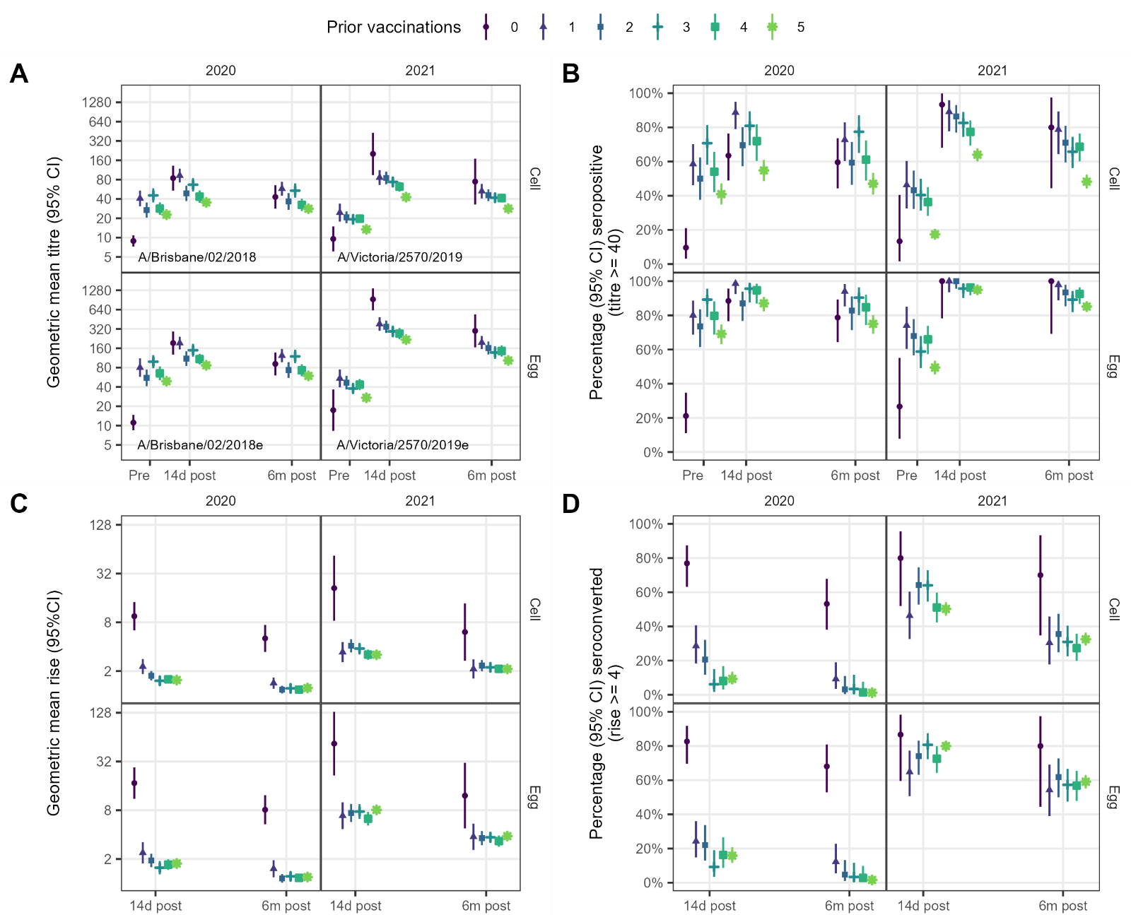
Supplementary Figure 3. Summary of observed antibody responses to vaccination for A(H1N1)pdm09. A. Geometric mean titres. B. Seropositivity (percent of participants with a titre ≥40). C. Geometric mean rise (ratio of post-vaccination to pre-vaccination titres). D. Seroconversion (percent of participants with at least a 4-fold rise in titre per-to-post vaccination). Data replicate those shown in Supplementary Table 1. Points show means for each outcome, vertical bars show 95% confidence intervals.

Relationship between baseline titre, number of prior vaccinations and day 14 post-vaccination GMTs for A(H1N1)pdm09
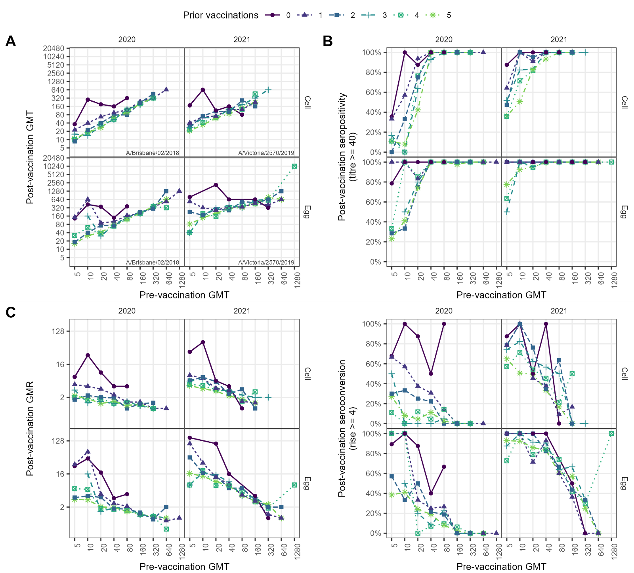
Supplementary Figure 4. Relationship between pre- and 14d post- vaccination HI antibody responses, by number of prior years vaccinated for A(H1N1)pdm09. A. Geometric mean titres (GMT); B. Seropositivity (percent with a titre of at least 40). C. Geometric mean titre ratios (GMRs) (post-to-pre-vaccination titre ratio). D. Seroconversion (percent with at least a 4-fold rise in titre post-vaccination). Points show means for each outcome and vaccination group.

Regression results for A(H1N1)pdm09

Predictors of post-vaccination GMT
Supplementary Table 2. Predictors of post-vaccination geometric mean titre (GMT) against A(H1N1)pdm09 using linear regression.
 | Cell-grown antigen |  |  |  | Egg-grown antigen
 | 2020  A/Brisbane/02/2018 |  | 2021  A/Victoria/2570/2019 |  | 2020  A/Brisbane/02/2018 |  | 2021  A/Victoria/2570/2019
 | n | Estimate | n | Estimate | n | Estimate | n | Estimate
(Intercept) | 584 | 72 (56, 92) | 1007 | 190 (120, 310) | 584 | 190 (140, 250) | 1007 | 680 (390, 1200)
Prior vaccinations
0 | 52 | ref | 13 | ref | 52 | ref | 13 | ref
1 | 69 | 0.32 (0.25, 0.42) | 53 | 0.28 (0.17, 0.48) | 69 | 0.31 (0.23, 0.42) | 53 | 0.35 (0.19, 0.66)
2 | 68 | 0.22 (0.17, 0.29) | 78 | 0.31 (0.18, 0.51) | 68 | 0.21 (0.16, 0.28) | 78 | 0.33 (0.18, 0.61)
3 | 64 | 0.22 (0.17, 0.28) | 112 | 0.26 (0.16, 0.42) | 64 | 0.23 (0.17, 0.31) | 112 | 0.29 (0.16, 0.51)
4 | 74 | 0.21 (0.16, 0.26) | 133 | 0.23 (0.14, 0.38) | 74 | 0.2 (0.15, 0.27) | 133 | 0.28 (0.15, 0.49)
5 | 257 | 0.2 (0.16, 0.25) | 618 | 0.22 (0.14, 0.35) | 257 | 0.2 (0.15, 0.25) | 618 | 0.3 (0.17, 0.53)
Log2 baseline titre (ref = 5) |  | 1.7 (1.6, 1.8) |  | 1.5 (1.4, 1.6) |  | 1.4 (1.4, 1.5) |  | 1.3 (1.2, 1.3)
Age in decades (ref = 18 years) |  | 0.91 (0.86, 0.97) |  | 0.78 (0.74, 0.82) |  | 0.85 (0.8, 0.91) |  | 0.78 (0.73, 0.83)
Sex
Female | 475 | ref | 857 | ref | 475 | ref | 857 | ref
Male | 109 | 0.98 (0.85, 1.1) | 150 | 0.97 (0.84, 1.1) | 109 | 0.95 (0.81, 1.1) | 150 | 0.95 (0.8, 1.1)
BMI (ref = 20) |  | 1 (1, 1) |  | 1 (1, 1) |  | 1 (1, 1) |  | 1 (1, 1)
Presence of any health conditions
No | 480 | ref | 819 | ref | 480 | ref | 819 | ref
Yes | 104 | 1.1 (0.92, 1.2) | 188 | 1 (0.88, 1.2) | 104 | 1.1 (0.89, 1.2) | 188 | 1 (0.88, 1.2)
Brand
Sanofi | 210 | ref | 879 | ref | 210 | ref | 879 | ref
GSK | 216 | 0.98 (0.86, 1.1) | 0 |  | 216 | 0.93 (0.8, 1.1) | 0
Seqirus | 158 | 0.77 (0.67, 0.88) | 128 | 0.95 (0.81, 1.1) | 158 | 0.74 (0.63, 0.87) | 128 | 0.7 (0.58, 0.84)

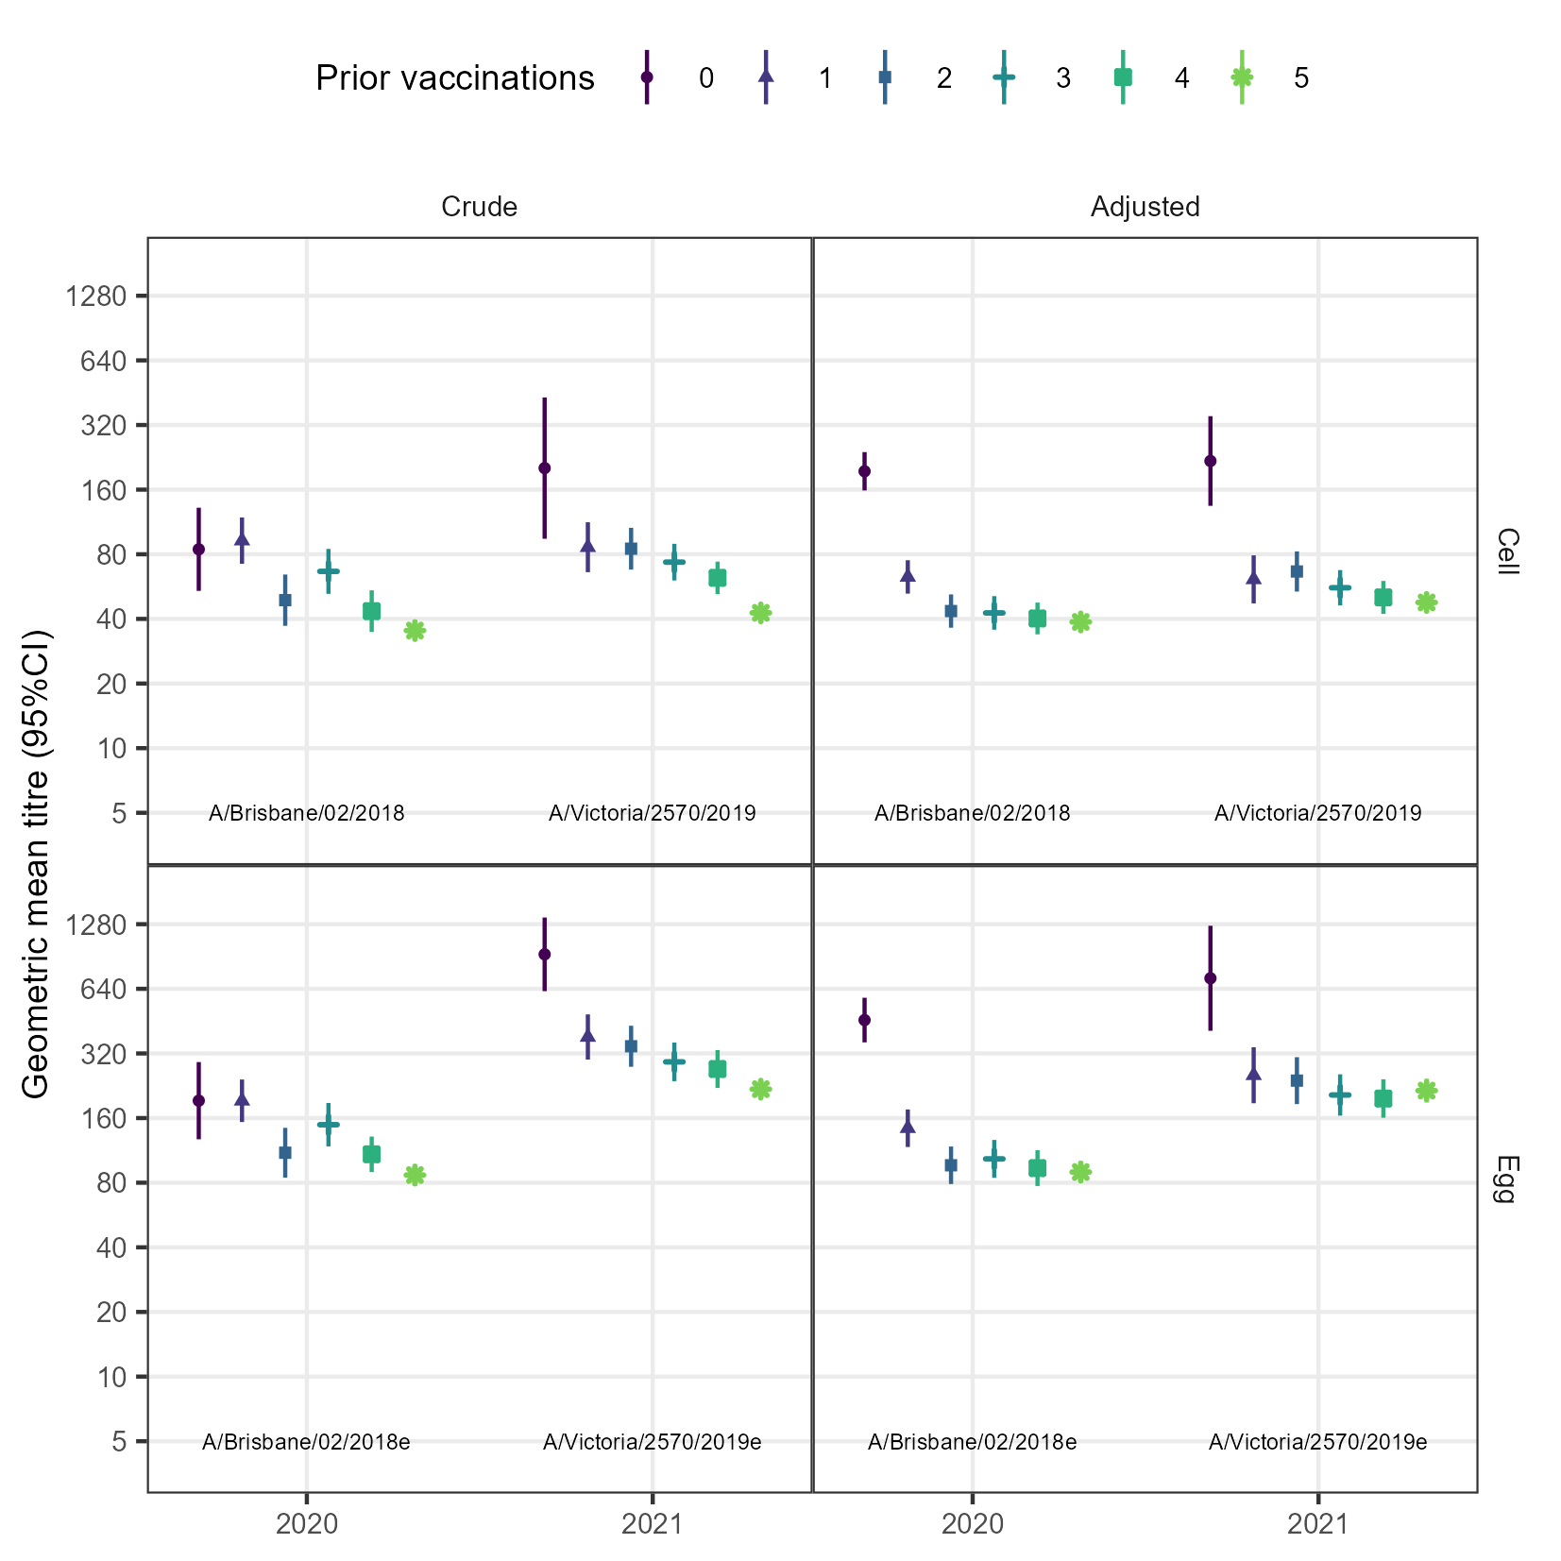
Supplementary Figure 5. Comparison of crude and adjusted 14d post-vaccination geometric means titres for A(H1N1)pdm09. Adjusted GMTs were estimated from linear regression models that included baseline titre, vaccine brand, age, sex, BMI and pre-existing health conditions.

Predictors of post-vaccination seropositivity
Supplementary Table 3. Predictors of post-vaccination seropositivity against A(H1N1)pdm09 using logistic regression. Models were adjusted for baseline titre and number of prior vaccinations, only, as very high seropositivity resulted in sparse data in less parsimonious models. Estimates not shown for egg-grown antigens because some of the fitted probabilities were 0 or 1.
 | Cell-grown antigens |  |  |  | Egg-grown antigens
 | 2020  A/Brisbane/02/2018 |  | 2021  A/Victoria/2570/2019 |  | 2020  A/Brisbane/02/2018
 | n | Estimate | n | Estimate | n | Estimate
(Intercept) | 584 | 0.63 (0.31, 1.2) | 1007 | 7.3 (0.91, 58) | 584 | 4 (1.6, 9.7)
Prior vaccinations
0 | 52 | ref | 13 | ref | 52 | ref
1 | 69 | 0.37 (0.098, 1.4) | 53 | 0.27 (0.028, 2.6) | 69 | 1.7 (0.17, 16)
2 | 68 | 0.073 (0.022, 0.24) | 78 | 0.21 (0.023, 1.9) | 68 | 0.06 (0.014, 0.26)
3 | 64 | 0.038 (0.009, 0.16) | 112 | 0.14 (0.017, 1.2) | 64 | 0.073 (0.01, 0.52)
4 | 74 | 0.055 (0.016, 0.19) | 133 | 0.083 (0.0098, 0.7) | 74 | 0.23 (0.043, 1.3)
5 | 257 | 0.021 (0.0074, 0.06) | 618 | 0.061 (0.0075, 0.49) | 257 | 0.044 (0.013, 0.15)
Log2 baseline titre (ref 5) |  | 9.2 (6.2, 14) |  | 3.2 (2.7, 3.8) |  | 4.8 (3.3, 7)
Notes: Estimates for egg-grown antigens in 2021 are not shown because some of the estimated probabilities were 0 or 1.
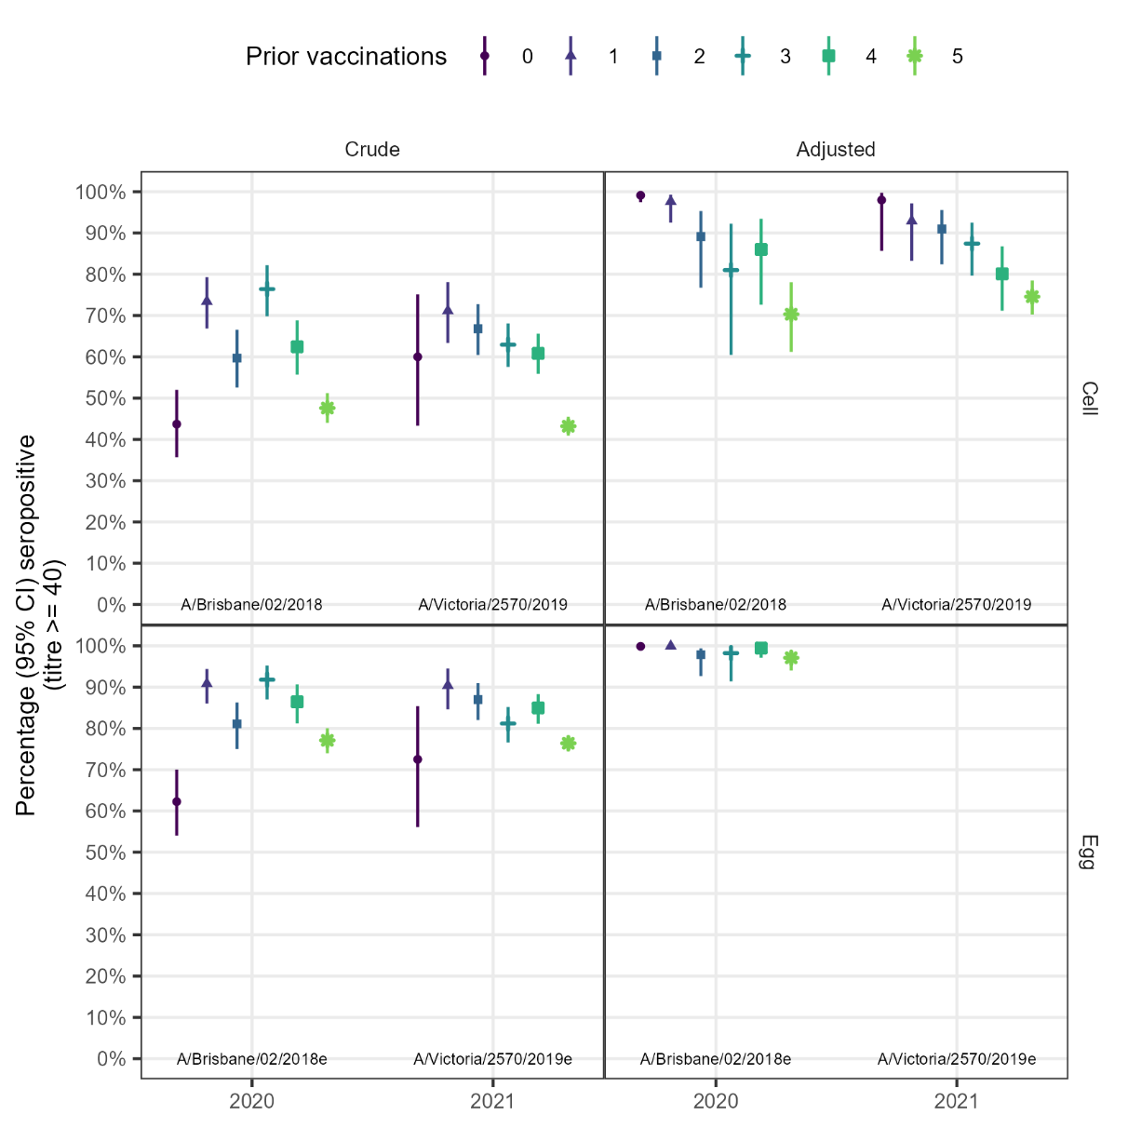
Supplementary Figure 6. Comparison of crude and adjusted percentage seropositivity for A(H1N1)pdm09. Adjusted seropositivity was estimated from logistic regression adjusting for baseline titre. Adjustment for other variables led to sparse data bias. Estimates for A/Victoria/2570/2019 were too unreliable for prediction, with some probabilities of 0 or 1 predicted (as shown bottom left).

Predictors of post-vaccination geometric mean rise
Supplementary Table 4. Predictors of post-vaccination geometric mean rise against A(H1N1)pdm09 using linear regression.
 | Cell-grown antigens |  |  |  | Egg-grown antigens
 | 2020  A/Brisbane/02/2018 |  | 2021  A/Victoria/2570/2019 |  | 2020  A/Brisbane/02/2018 |  | 2021  A/Victoria/2570/2019
 | n | Estimate | n | Estimate | n | Estimate | n | Estimate
(Intercept) | 584 | 15 (12, 19) | 1007 | 40 (25, 64) | 584 | 41 (31, 54) | 1007 | 150 (85, 260)
Prior vaccinations
0 | 52 | ref | 13 | ref | 52 | ref | 13 | ref
1 | 69 | 0.33 (0.25, 0.42) | 53 | 0.28 (0.16, 0.47) | 69 | 0.32 (0.24, 0.43) | 53 | 0.35 (0.19, 0.65)
2 | 68 | 0.23 (0.18, 0.29) | 78 | 0.31 (0.18, 0.51) | 68 | 0.22 (0.16, 0.29) | 78 | 0.34 (0.19, 0.62)
3 | 64 | 0.22 (0.17, 0.29) | 112 | 0.26 (0.16, 0.43) | 64 | 0.23 (0.17, 0.31) | 112 | 0.3 (0.17, 0.53)
4 | 74 | 0.21 (0.16, 0.27) | 133 | 0.23 (0.14, 0.39) | 74 | 0.21 (0.16, 0.28) | 133 | 0.28 (0.16, 0.51)
5 | 257 | 0.2 (0.16, 0.25) | 618 | 0.22 (0.14, 0.36) | 257 | 0.2 (0.16, 0.26) | 618 | 0.31 (0.18, 0.55)
Log2 baseline titre (ref 5) |  | 0.84 (0.81, 0.88) |  | 0.74 (0.71, 0.78) |  | 0.72 (0.69, 0.75) |  | 0.64 (0.62, 0.67)
Age in decades (ref 18) |  | 0.92 (0.87, 0.97) |  | 0.78 (0.74, 0.83) |  | 0.86 (0.81, 0.92) |  | 0.78 (0.74, 0.84)
Brand
Sanofi | 210 | ref | 879 | ref | 210 | ref | 879 | ref
GSK | 216 | 0.98 (0.86, 1.1) | 0 |  | 216 | 0.92 (0.8, 1.1) | 0
Seqirus | 158 | 0.76 (0.66, 0.88) | 128 | 0.95 (0.81, 1.1) | 158 | 0.73 (0.62, 0.86) | 128 | 0.69 (0.57, 0.83)

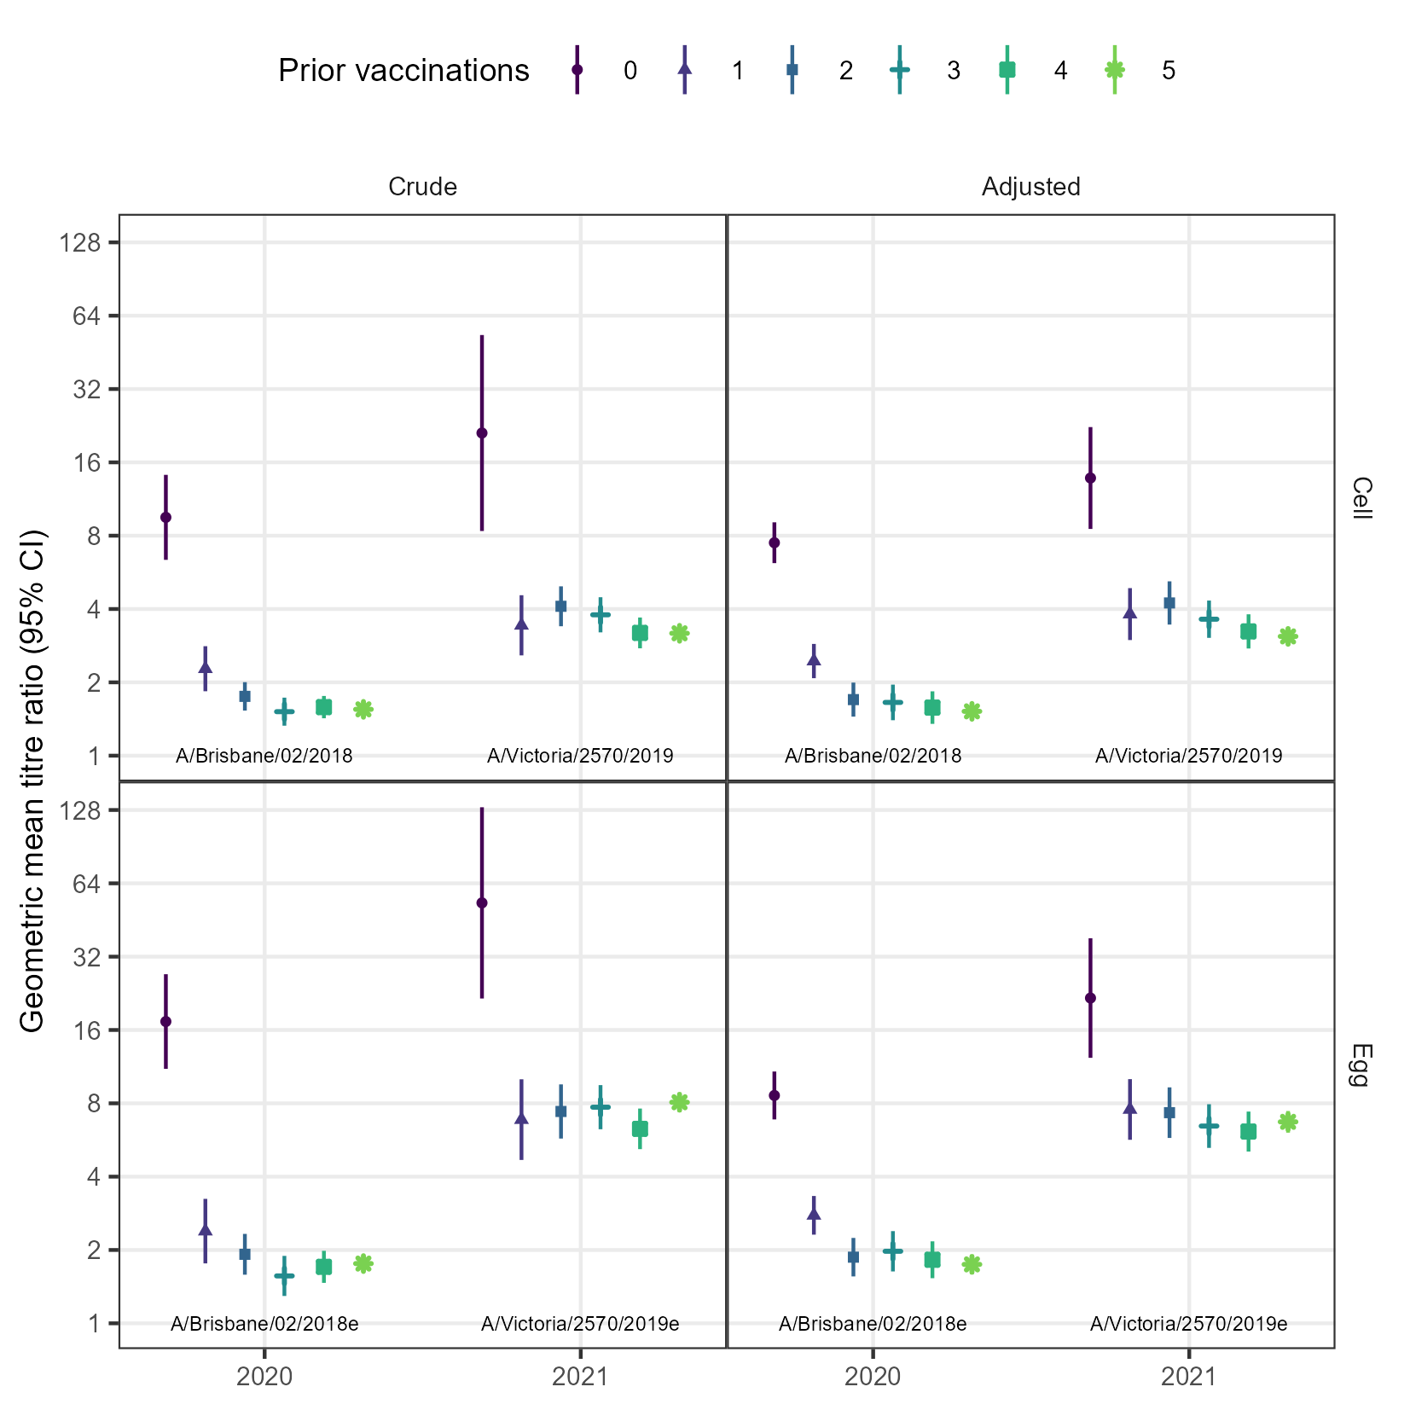
Supplementary Figure 7. Comparison of crude and adjusted geometric mean titre ratios (GMR) for A(H1N1)pdm09. Adjusted GMRs were estimated from linear regression models that included baseline titre, age, and vaccine brand.

Predictors of post-vaccination seroconversion
Supplementary Table 5. Predictors of post-vaccination seroconversion for A(H1N1)pdm09
 | Cell-grown antigens |  |  |  | Egg-grown antigens
 | 2020  A/Brisbane/02/2018 |  | 2021  A/Victoria/2570/2019 |  |  | 2020  A/Brisbane/02/2018 |  | 2021  A/Victoria/2570/2019
 | n | Estimate | n | Estimate |  | n | Estimate | n | Estimate
(Intercept) | 584 | 19 (6.4, 57) | 1007 | 11 (2.8, 47) |  | 584 | 74 (20, 270) | 1007 | 93 (13, 650)
Prior vaccinations
0 | 52 | ref | 13 | ref |  | 52 | ref | 13 | ref
1 | 69 | 0.27 (0.11, 0.69) | 53 | 0.94 (0.21, 4.3) |  | 69 | 0.21 (0.072, 0.64) | 53 | 1.2 (0.17, 8.6)
2 | 68 | 0.12 (0.048, 0.31) | 78 | 2 (0.45, 8.9) |  | 68 | 0.14 (0.047, 0.4) | 78 | 1.6 (0.22, 11)
3 | 64 | 0.04 (0.011, 0.14) | 112 | 1.7 (0.39, 7.2) |  | 64 | 0.09 (0.026, 0.32) | 112 | 1.9 (0.28, 13)
4 | 74 | 0.043 (0.014, 0.13) | 133 | 0.96 (0.23, 4.1) |  | 74 | 0.12 (0.041, 0.36) | 133 | 1.4 (0.21, 9.8)
5 | 257 | 0.048 (0.021, 0.11) | 618 | 0.87 (0.21, 3.5) |  | 257 | 0.093 (0.037, 0.23) | 618 | 1.8 (0.26, 12)
Log2 baseline titre (ref 5) |  | 0.55 (0.45, 0.67) |  | 0.54 (0.48, 0.61) |  |  | 0.42 (0.34, 0.51) |  | 0.45 (0.39, 0.51)
Age in decades (ref 18) |  | 0.7 (0.54, 0.92) |  | 0.56 (0.49, 0.65) |  |  | 0.68 (0.51, 0.9) |  | 0.59 (0.5, 0.7)
Brand
Sanofi | 210 | ref | 879 | ref |  | 210 | ref | 879 | ref
GSK | 216 | 0.86 (0.48, 1.5) | 0 |  |  | 217 | 0.9 (0.51, 1.6) | 0
Seqirus | 158 | 0.47 (0.24, 0.92) | 128 | 1.1 (0.72, 1.6) |  | 158 | 0.43 (0.22, 0.83) | 128 | 0.58 (0.35, 0.96)

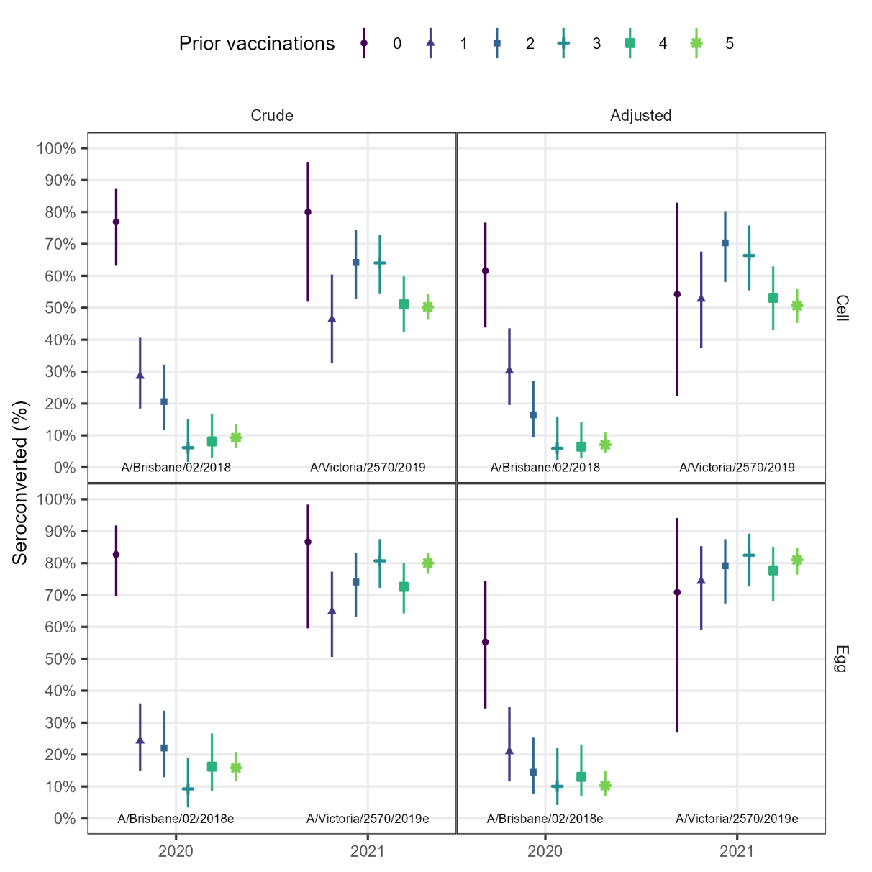
Supplementary Figure 8. Comparison of raw and adjusted seroconverted proportion for A(H1N1)pdm09. Adjusted seroconversion was estimated from logistic regression models that included number of prior vaccinations, baseline titre, age, and vaccine brand.

Influenza A(H3N2)

Genetic diversity
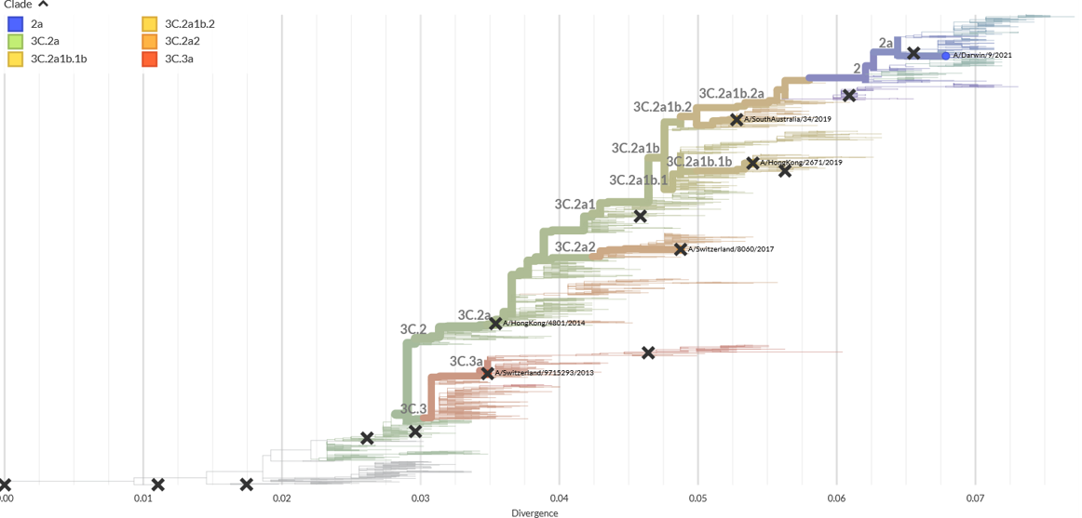
  Year ​ | A(H3N2)​ vaccine virus
  2021 | A/Hong Kong/2671/2019​  (3C.2a1b.1b)​
  2020​ | A/South Australia/34/2019 ​  (3C.2a1b.2)​
  2019​ | A/Switzerland/8060/2017 ​  (3C.2a2)​
  2018​ | A/Singapore/160019/2016 ​  (3C.2a1)​
  2017​ | A/Hong Kong/4801/2014 ​  (3C.2a)​
  2016​ | A/Hong Kong/4801/2014 ​  (3C.2a)​
  2015​ | A/Switzerland/9715293/2013 ​(3C.3a)​
Supplementary Figure 9. Phylogenetic tree showing the genetic divergence of A(H3N2). Image reproduced from www.nextstrain.org.

Supplementary Table 6. Summary of major antigenic changes in A(H3N2) candidate vaccine viruses
 |  |  | Antigenic Site and Amino Acid Position (H3 numbering) ª
 |  |  | Site E |  |  | Site A |  |  |  |  |  | Site B |  |  |  | Site C | Site D
 | Substrate | clade | 62 | 92 | 261 | 131 | 135 | 137 | 138 | 142 | 144 | 128 | 159 | 160 | 193 | 311 | 96 | 121 | 171 | 219
A/Switzerland/9715293/2013 | Egg | 3c3a | E | K | R | T | T ⁺ | S | S | G | N ⁺ | A ⁻ | S | K ⁻ | F | Q | N | N | N | S
 | Cell | 3c3a | E | K | R | T | T ⁺ | S | S | G | N ⁺ | A ⁻ | S | K ⁻ | F | Q | N | N | N | Y
A/Hong Kong/4801/2014 | Egg | 3c2a | E | K | R | T | T ⁺ | S | A | R | S ⁻ | T ⁺ | Y | K ⁻ | F | H | S ^{e} | N | N | S
 | Cell | 3c2a | E | K | R | T | T ⁺ | S | A | R | S ⁻ | T ⁺ | Y | T ⁺ | F | H | N | N | N | S
A/Singapore/160019/2016 | Egg | 3c2a1 | E | K | R | T | T ⁺ | S | A | G | S ⁻ | T ⁺ | Y | K ⁻ | F | H | N | K | K | S
 | Cell | 3c2a1 | E | K | R | T | T ⁺ | S | A | G | S ⁻ | T ⁺ | Y | T ⁺ | F | H | N | K | K | S
A/Switzerland/8060/2017 | Egg | 3c2a2 | E | K | Q | K | T ⁺ | S | A | K | S ⁻ | T ⁺ | Y | K ⁻ | F | H | S ^{e} | N | N | S
 | Cell | 3c2a2 | E | K | Q | K | T ⁺ | S | A | K | S ⁻ | T ⁺ | Y | T ⁺ | F | H | S ^{e} | N | N | S
A/South Australia/34/2019 ​ | Egg | 3c2a1b+ | G | R | R | K | T ⁺ | S | A | G | S ⁻ | T ⁺ | Y | K ⁻ | F | Q | N | K | K | F
 | Cell | 3c2a1b+ | G | R | R | K | T ⁺ | S | A | G | S ⁻ | T ⁺ | Y | T ⁺ | F | Q | N | K | K | F
A/Hong Kong/2671/2019 | Egg | 3c2a1b.1b | G | R | R | T | K | F | S | G | S ⁻ | A ⁻ | Y | I ⁻ | S | Q | N | K | K | S
 | Cell | 3c2a1b.1b | G | R | R | T | K | F | S | G | S ⁻ | A ⁻ | Y | T ⁺ | S | Q | N | K | K | S

Summary of raw antibody analyses
Supplementary Table 7. Summary of antibody analyses for A(H3N2)
 | Year | Virus | Substrate |  | Bleed |  | 0 prior |  | 1 prior |  | 2 prior |  | 3 prior |  | 4 prior |  | 5 prior
GMT | 2020 | A/South Australia/34/2019 | cell |  | Pre-vaccination |  | 17 (13, 21) |  | 29 (24, 36) |  | 31 (25, 37) |  | 30 (25, 36) |  | 33 (27, 39) |  | 28 (25, 31)
 |  |  |  |  | 14d post |  | 55 (42, 72) |  | 57 (48, 69) |  | 46 (38, 55) |  | 47 (39, 55) |  | 47 (40, 54) |  | 40 (36, 44)
 |  |  |  |  | 6m post |  | 44 (35, 57) |  | 48 (40, 59) |  | 39 (32, 48) |  | 46 (39, 54) |  | 42 (36, 48) |  | 37 (34, 40)
GMT | 2020 | A/South Australia/34/2019 | egg |  | Pre-vaccination |  | 35 (24, 50) |  | 130 (93, 182) |  | 143 (104, 196) |  | 174 (131, 231) |  | 163 (125, 212) |  | 140 (121, 162)
 |  |  |  |  | 14d post |  | 386 (264, 564) |  | 401 (313, 513) |  | 301 (239, 380) |  | 354 (278, 451) |  | 297 (237, 373) |  | 240 (209, 274)
 |  |  |  |  | 6m post |  | 212 (149, 302) |  | 224 (171, 293) |  | 192 (144, 258) |  | 237 (184, 304) |  | 202 (156, 260) |  | 165 (144, 190)
GMT | 2021 | A/Darwin/726/2019 | cell |  | Pre-vaccination |  | 32 (23, 45) |  | 36 (27, 48) |  | 30 (24, 36) |  | 30 (25, 36) |  | 30 (26, 36) |  | 26 (24, 28)
 |  |  |  |  | 14d post |  | 106 (65, 173) |  | 76 (57, 101) |  | 69 (56, 83) |  | 64 (53, 76) |  | 56 (47, 66) |  | 47 (44, 51)
 |  |  |  |  | 6m post |  | 75 (43, 130) |  | 49 (36, 68) |  | 47 (39, 56) |  | 44 (36, 52) |  | 43 (36, 51) |  | 36 (33, 40)
GMT | 2021 | A/Hong Kong/2671/2019 | egg |  | Pre-vaccination |  | 73 (47, 113) |  | 80 (60, 106) |  | 77 (62, 94) |  | 83 (71, 98) |  | 76 (65, 90) |  | 69 (64, 74)
 |  |  |  |  | 14d post |  | 335 (202, 555) |  | 231 (180, 296) |  | 205 (170, 248) |  | 205 (172, 244) |  | 175 (149, 207) |  | 151 (140, 163)
 |  |  |  |  | 6m post |  | 197 (120, 324) |  | 138 (105, 181) |  | 130 (106, 158) |  | 135 (113, 162) |  | 125 (107, 148) |  | 109 (101, 119)
Seropositivity  (% GMT ≥ 40) | 2020 | A/South Australia/34/2019 | cell |  | Pre-vaccination |  | 16/52 (31%) |  | 35/70 (50%) |  | 36/68 (53%) |  | 36/65 (55%) |  | 47/74 (64%) |  | 128/259 (49%)
 |  |  |  |  | 14d post |  | 39/52 (75%) |  | 57/71 (80%) |  | 49/69 (71%) |  | 54/68 (79%) |  | 62/75 (83%) |  | 178/261 (68%)
 |  |  |  |  | 6m post |  | 34/47 (72%) |  | 46/66 (70%) |  | 41/64 (64%) |  | 49/62 (79%) |  | 53/72 (74%) |  | 167/251 (67%)
Seropositivity  (% GMT ≥ 40) | 2020 | A/South Australia/34/2019 | egg |  | Pre-vaccination |  | 28/52 (54%) |  | 60/70 (86%) |  | 61/68 (90%) |  | 62/65 (95%) |  | 71/74 (96%) |  | 236/259 (91%)
 |  |  |  |  | 14d post |  | 49/52 (94%) |  | 71/71 (100%) |  | 68/69 (99%) |  | 67/68 (99%) |  | 74/75 (99%) |  | 255/261 (98%)
 |  |  |  |  | 6m post |  | 45/47 (96%) |  | 64/66 (97%) |  | 60/64 (94%) |  | 60/62 (97%) |  | 69/72 (96%) |  | 239/251 (95%)
Seropositivity  (% GMT ≥ 40) | 2021 | A/Darwin/726/2019 | cell |  | Pre-vaccination |  | 9/15 (60%) |  | 31/54 (57%) |  | 43/81 (53%) |  | 62/114 (54%) |  | 70/135 (52%) |  | 279/625 (45%)
 |  |  |  |  | 14d post |  | 13/15 (87%) |  | 46/55 (84%) |  | 65/81 (80%) |  | 93/115 (81%) |  | 102/137 (74%) |  | 430/628 (68%)
 |  |  |  |  | 6m post |  | 9/10 (90%) |  | 34/47 (72%) |  | 56/76 (74%) |  | 73/111 (66%) |  | 93/134 (69%) |  | 350/599 (58%)
Seropositivity  (% GMT ≥ 40) | 2021 | A/Hong Kong/2671/2019 | egg |  | Pre-vaccination |  | 13/15 (87%) |  | 45/54 (83%) |  | 70/81 (86%) |  | 100/114 (88%) |  | 115/135 (85%) |  | 522/625 (84%)
 |  |  |  |  | 14d post |  | 15/15 (100%) |  | 54/55 (98%) |  | 81/81 (100%) |  | 113/115 (98%) |  | 136/137 (99%) |  | 602/628 (96%)
 |  |  |  |  | 6m post |  | 10/10 (100%) |  | 44/47 (94%) |  | 73/76 (96%) |  | 106/111 (95%) |  | 131/134 (98%) |  | 549/599 (92%)
GMR | 2020 | A/South Australia/34/2019 | cell | 14d post |  | 3.3 (2.7, 4.2) |  | 2 (1.6, 2.4) |  | 1.5 (1.3, 1.7) |  | 1.5 (1.3, 1.7) |  | 1.5 (1.3, 1.7) |  | 1.4 (1.4, 1.5)
 |  |  |  | 6m post |  | 2.8 (2.3, 3.5) |  | 1.7 (1.4, 2) |  | 1.3 (1.1, 1.4) |  | 1.5 (1.3, 1.7) |  | 1.3 (1.2, 1.5) |  | 1.3 (1.2, 1.4)
GMR | 2020 | A/South Australia/34/2019 | egg | 14d post |  | 11 (7.2, 17) |  | 3.1 (2.3, 4) |  | 2.1 (1.7, 2.6) |  | 2 (1.6, 2.4) |  | 1.9 (1.6, 2.2) |  | 1.7 (1.6, 1.9)
 |  |  |  | 6m post |  | 6.2 (4.1, 9.4) |  | 1.8 (1.5, 2.2) |  | 1.3 (1.1, 1.5) |  | 1.4 (1.2, 1.6) |  | 1.3 (1.2, 1.5) |  | 1.1 (1.1, 1.2)
GMR | 2021 | A/Darwin/726/2019 | cell | 14d post |  | 3.3 (2.4, 4.7) |  | 2.1 (1.7, 2.7) |  | 2.3 (1.9, 2.7) |  | 2.1 (1.8, 2.4) |  | 1.8 (1.6, 2.1) |  | 1.8 (1.7, 1.9)
 |  |  |  | 6m post |  | 2.5 (1.6, 3.7) |  | 1.4 (1.1, 1.6) |  | 1.6 (1.4, 1.8) |  | 1.4 (1.3, 1.6) |  | 1.4 (1.3, 1.6) |  | 1.4 (1.3, 1.5)
GMR | 2021 | A/Hong Kong/2671/2019 | egg | 14d post |  | 4.6 (2.9, 7.2) |  | 2.9 (2.3, 3.6) |  | 2.7 (2.2, 3.2) |  | 2.4 (2.1, 2.9) |  | 2.3 (2, 2.7) |  | 2.2 (2.1, 2.3)
 |  |  |  | 6m post |  | 2.6 (1.8, 3.8) |  | 1.7 (1.4, 2) |  | 1.7 (1.5, 1.9) |  | 1.6 (1.4, 1.8) |  | 1.6 (1.5, 1.8) |  | 1.6 (1.5, 1.7)
Seroconversion  (% GMR ≥4) | 2020 | A/South Australia/34/2019 | cell |  | 14d post |  | 29/52 (56%) |  | 19/70 (27%) |  | 7/68 (10%) |  | 5/65 (7.7%) |  | 8/74 (11%) |  | 20/258 (7.8%)
 |  |  |  |  | 6m post |  | 20/47 (43%) |  | 9/65 (14%) |  | 4/63 (6.3%) |  | 3/59 (5.1%) |  | 6/71 (8.5%) |  | 17/248 (6.9%)
Seroconversion  (% GMR ≥4) | 2020 | A/South Australia/34/2019 | egg |  | 14d post |  | 45/52 (87%) |  | 28/70 (40%) |  | 20/68 (29%) |  | 15/65 (23%) |  | 20/74 (27%) |  | 47/258 (18%)
 |  |  |  |  | 6m post |  | 30/47 (64%) |  | 16/65 (25%) |  | 6/63 (9.5%) |  | 8/59 (14%) |  | 7/71 (9.9%) |  | 10/248 (4%)
Seroconversion  (% GMR ≥4) | 2021 | A/Darwin/726/2019 | cell |  | 14d post |  | 7/15 (47%) |  | 13/54 (24%) |  | 29/81 (36%) |  | 31/114 (27%) |  | 29/135 (21%) |  | 140/625 (22%)
 |  |  |  |  | 6m post |  | 4/10 (40%) |  | 5/46 (11%) |  | 11/76 (14%) |  | 8/110 (7.3%) |  | 19/132 (14%) |  | 71/597 (12%)
Seroconversion  (% GMR ≥4) | 2021 | A/Hong Kong/2671/2019 | egg |  | 14d post |  | 10/15 (67%) |  | 20/54 (37%) |  | 37/81 (46%) |  | 37/114 (32%) |  | 41/135 (30%) |  | 189/625 (30%)
 |  |  |  |  | 14d post |  | 4/10 (40%) |  | 9/46 (20%) |  | 15/76 (20%) |  | 20/110 (18%) |  | 19/132 (14%) |  | 86/597 (14%)
Values shown are mean (95%CI) or n (%)

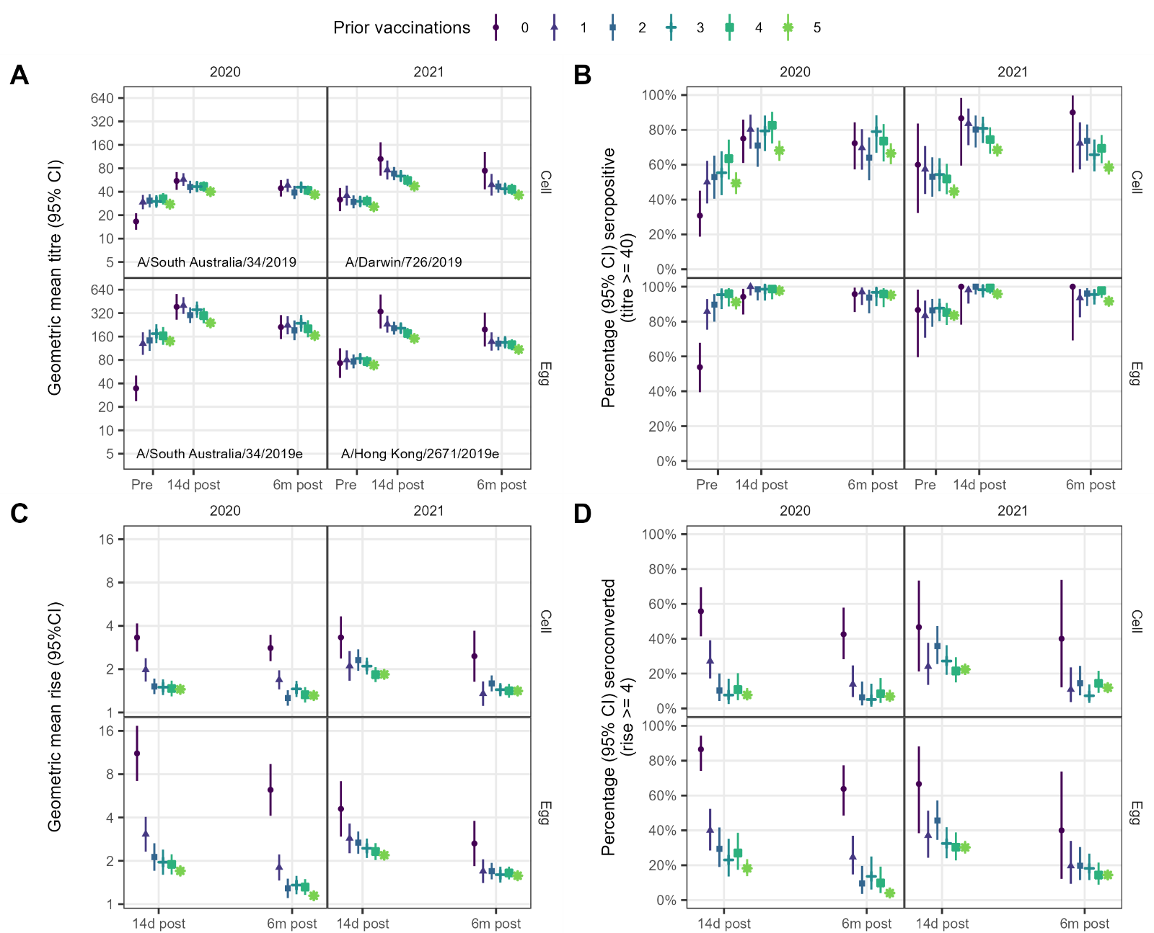
Supplementary Figure 10. Summary of observed antibody responses to vaccination for A(H3N2). A. Geometric mean titres. B. Seropositivity (percent of participants with a titre ≥40). C. Geometric mean rise (ratio of post-vaccination to pre-vaccination titres). D. Seroconversion (percent of participants with at least a 4-fold rise in titre per-to-post vaccination). Data replicate those shown in Supplementary Table 1. Points show means for each outcome, vertical bars show 95% confidence intervals.

Relationship between baseline titre, number of prior vaccinations and day 14 post-vaccination GMT
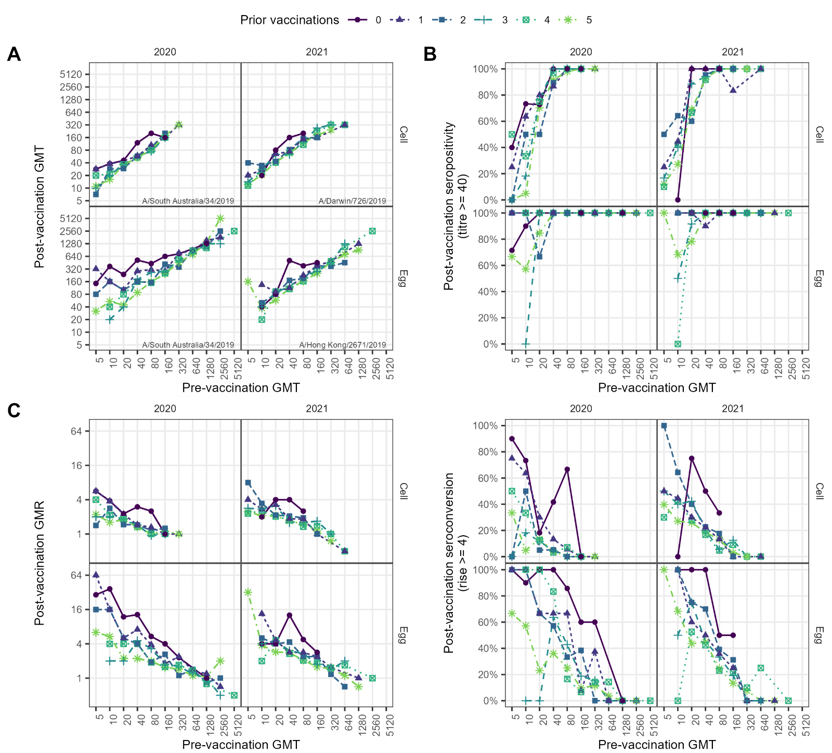
Supplementary Figure 11. Relationship between pre- and 14d post- vaccination HI antibody responses, by number of prior years vaccinated for A(H3N2). A. Geometric mean titres (GMT); B. Seropositivity (percent with a titre of at least 40). C. Geometric mean titre ratios (GMRs) (post-to-pre-vaccination titre ratio). D. Seroconversion (percent with at least a 4-fold rise in titre post-vaccination). Points show means for each outcome and vaccination group

Regression results for A(H3N2)

Predictors of post-vaccination GMT
Supplementary Table 8. Predictors of post-vaccination geometric mean titre (GMT) for A(H3N2) using linear regression.
 | Cell-grown HI titres |  |  |  | Egg-grown
 | 2020  A/South Australia/34/2019 |  | 2021  A/Darwin/726/2019 |  | 2020  A/South Australia/34/2019 |  | 2021  A/Hong Kong/2671/2019
 | n | Estimate | n | Estimate | n | Estimate | n | Estimate
(Intercept) | 584 | 30 (24, 37) | 1007 | 32 (21, 47) | 584 | 120 (87, 160) | 1007 | 86 (56, 130)
Prior vaccinations
0 | 52 | ref | 13 | ref | 52 | ref | 13 | ref
1 | 69 | 0.68 (0.56, 0.83) | 53 | 0.61 (0.4, 0.92) | 69 | 0.45 (0.34, 0.61) | 53 | 0.65 (0.42, 1)
2 | 68 | 0.53 (0.44, 0.65) | 78 | 0.64 (0.43, 0.96) | 68 | 0.33 (0.25, 0.44) | 78 | 0.6 (0.39, 0.91)
3 | 64 | 0.52 (0.43, 0.64) | 112 | 0.58 (0.39, 0.86) | 64 | 0.33 (0.24, 0.44) | 112 | 0.55 (0.36, 0.84)
4 | 74 | 0.53 (0.44, 0.64) | 133 | 0.52 (0.35, 0.76) | 74 | 0.31 (0.23, 0.41) | 133 | 0.52 (0.34, 0.79)
5 | 257 | 0.51 (0.43, 0.6) | 618 | 0.53 (0.36, 0.78) | 257 | 0.26 (0.2, 0.34) | 618 | 0.52 (0.35, 0.78)
Log2 baseline titre (ref 5) |  | 1.6 (1.5, 1.6) |  | 1.7 (1.6, 1.7) |  | 1.5 (1.5, 1.6) |  | 1.5 (1.5, 1.6)
Age (ref 18) |  | 0.94 (0.9, 0.98) |  | 0.91 (0.87, 0.95) |  | 0.95 (0.89, 1) |  | 0.84 (0.81, 0.88)
Sex
Female | 475 | ref | 857 | ref | 475 | ref | 857 | ref
Male | 109 | 0.94 (0.84, 1.1) | 150 | 0.92 (0.82, 1) | 109 | 0.95 (0.8, 1.1) | 150 | 0.93 (0.82, 1.1)
BMI (ref = 20) |  | 1 (1, 1) |  | 1 (1, 1) |  | 1 (0.99, 1) |  | 1 (1, 1)
Presence of any health conditions
No | 480 | ref | 819 | ref | 480 | ref | 819 | ref
Yes | 104 | 1.1 (0.96, 1.2) | 188 | 0.98 (0.88, 1.1) | 104 | 1.1 (0.97, 1.4) | 188 | 0.96 (0.85, 1.1)
Brand
Sanofi | 210 | ref | 879 | ref | 210 | ref | 879 | ref
GSK | 216 | 1 (0.93, 1.1) | 0 |  | 216 | 1.2 (1.1, 1.4) | 0
Seqirus | 158 | 0.87 (0.77, 0.98) | 128 | 0.8 (0.71, 0.91) | 158 | 1.1 (0.96, 1.3) | 128 | 0.84 (0.74, 0.97)

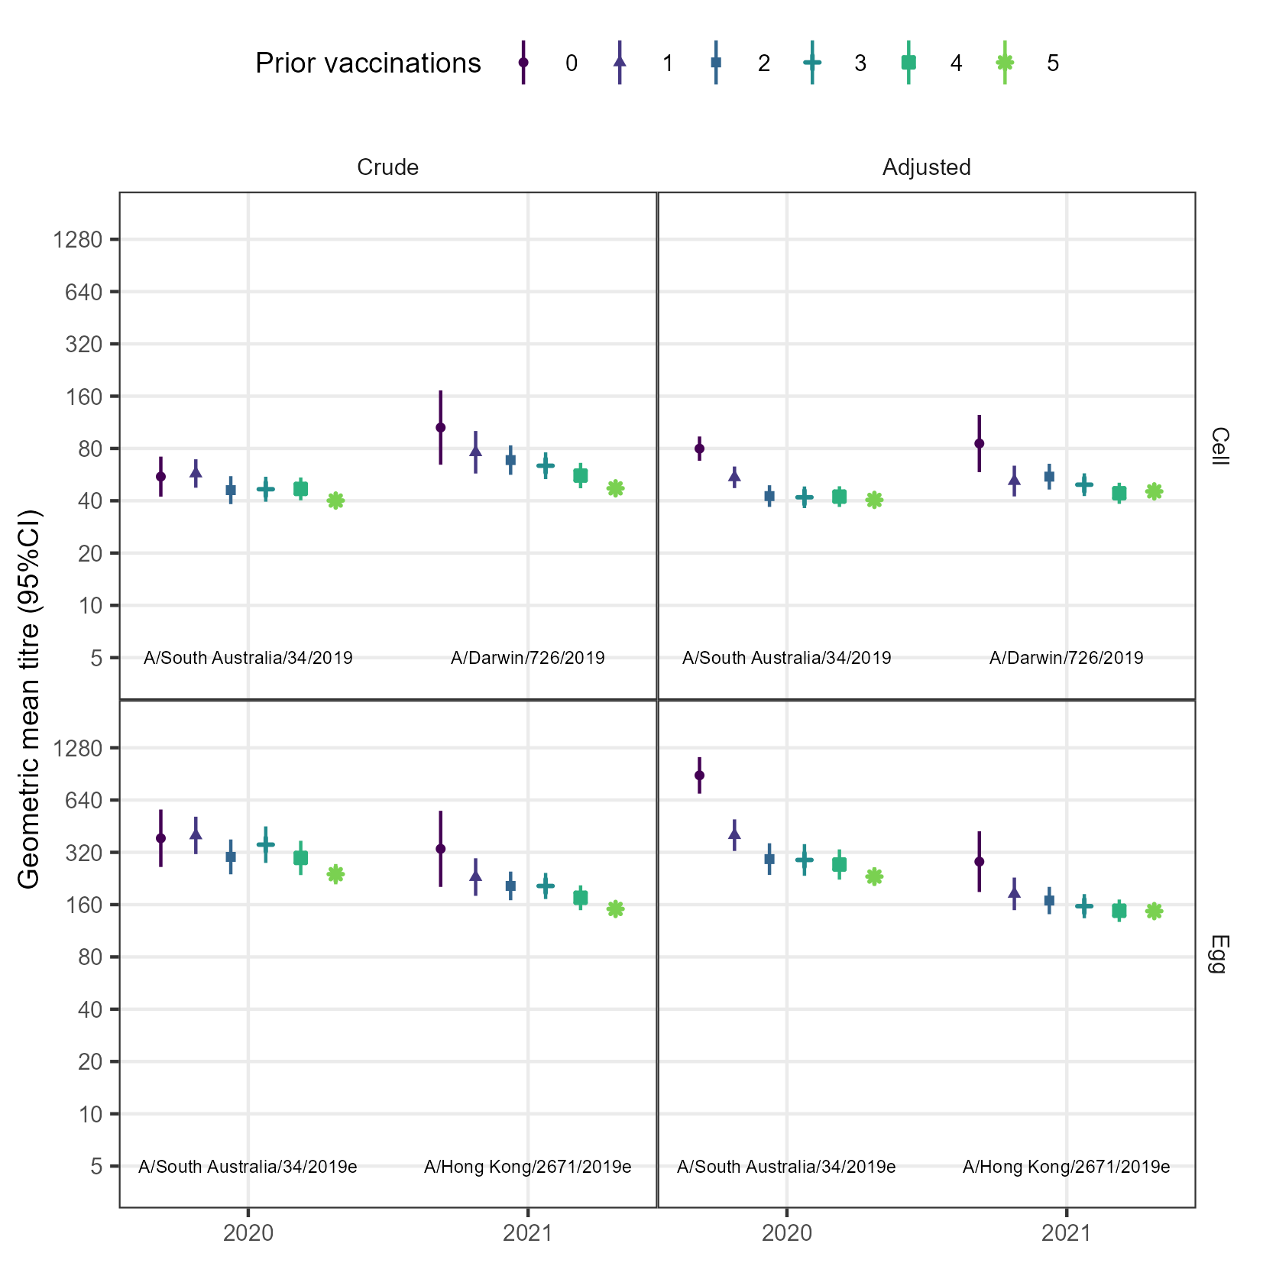
Supplementary Figure 12. Comparison of crude and adjusted geometric mean titres (GMT) for A(H3N2). Adjusted GMTs were estimated from linear regression models that included baseline titre, vaccine brand, age, sex, BMI and pre-existing health conditions.

Predictors of post-vaccination seropositivity
Supplementary Table 9. Predictors of post-vaccination seropositivity for cell-grown A(H3N2) using logistic regression. Models were adjusted for baseline titre and number of prior vaccinations, only, as very high seropositivity resulted in sparse data in less parsimonious models. Estimates not shown for egg-grown antigens because some of the fitted probabilities were 0 or 1.

 | Cell-grown antigens
 | 2020  A/Brisbane/02/2018 |  | 2021  A/Victoria/2570/2019
 | n | Estimate | n | Estimate
(Intercept) | 584 | 1.9 (0.68, 5.5) | 1007 | 6.5 (1.3, 32)
Prior vaccinations
0 | 52 | ref | 14 | ref
1 | 69 | 0.023 (0.0065, 0.079) | 53 | 0.19 (0.033, 1.1)
2 | 68 | 0.011 (0.003, 0.039) | 78 | 0.18 (0.034, 1)
3 | 64 | 0.007 (0.0017, 0.029) | 112 | 0.16 (0.03, 0.82)
4 | 74 | 0.0041 (0.0011, 0.016) | 133 | 0.11 (0.021, 0.56)
5 | 257 | 0.0048 (0.0015, 0.016) | 617 | 0.099 (0.02, 0.49)
Log2 baseline titre (ref 5) |  | 6.8 (4.8, 9.6) |  | 2.5 (2.2, 2.9)

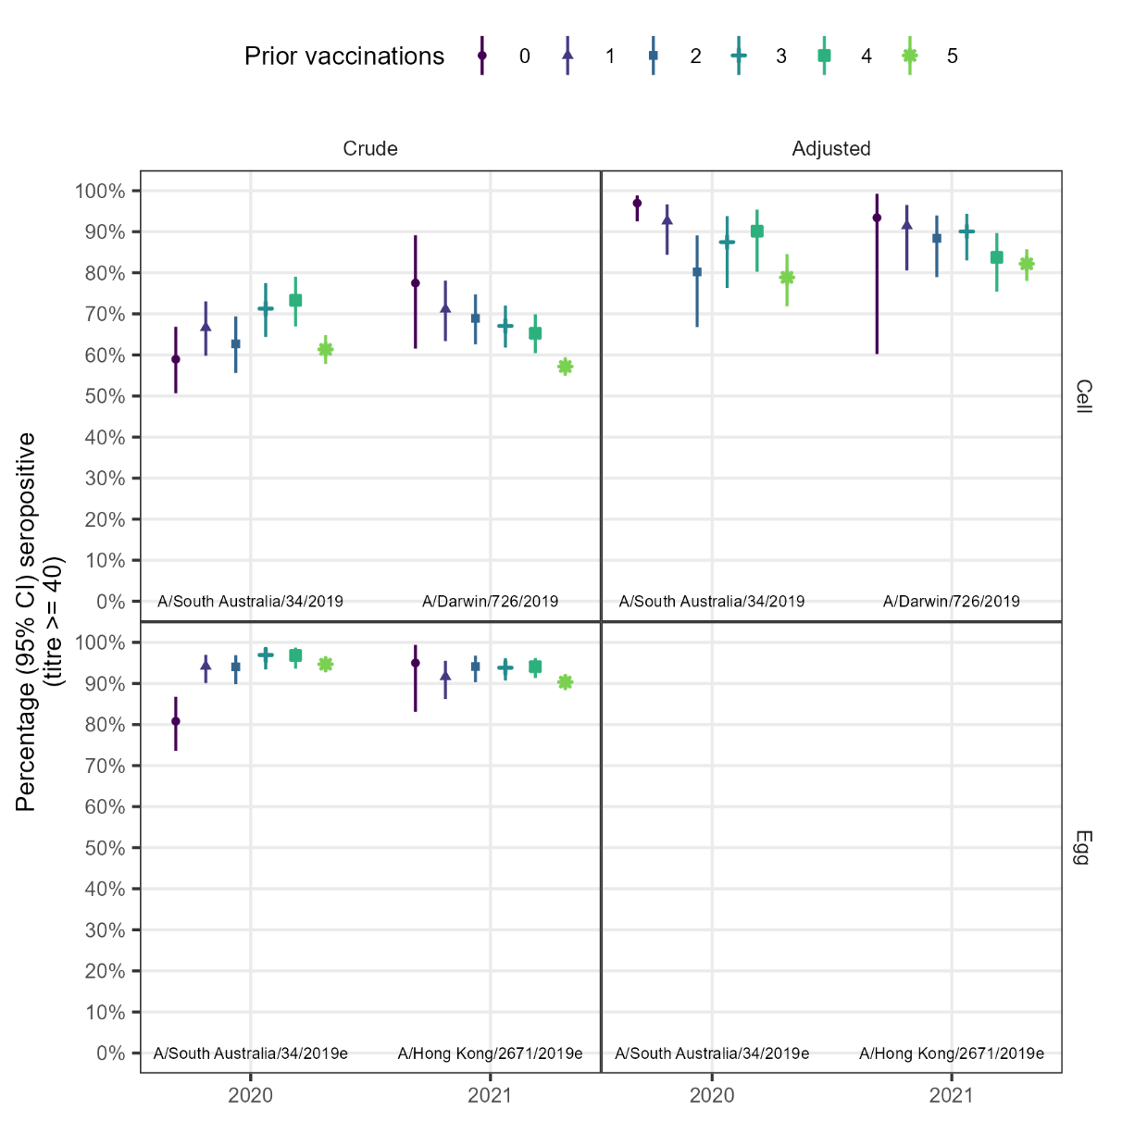
Supplementary Figure 13. Comparison of crude and adjusted percentage seropositivity for A(H3N2). Adjusted seropositivity was estimated from logistic regression adjusting for baseline titre. Adjustment for other variables led to sparse data bias. Estimates for egg-grown antigens were too unreliable for prediction, with some probabilities of 0 or 1 estimated.

Predictors of post-vaccination geometric mean rise
Supplementary Table 10. Predictors of post-vaccination geometric mean rise for A(H3N2) using linear regression.
 | Cell-grown HI titres |  |  |  | Egg-grown
 | 2020  A/South Australia/34/2019 |  | 2021  A/Darwin/726/2019 |  | 2020  A/South Australia/34/2019 |  | 2021  A/Hong Kong/2671/2019
 | n | Estimate | n | Estimate | n | Estimate | n | Estimate
(Intercept) | 584 | 6 (4.9, 7.5) | 1007 | 6.7 (4.5, 9.9) | 584 | 24 (18, 33) | 1007 | 19 (12, 28)
Prior vaccinations
0 | 52 | ref | 13 | ref | 52 | ref | 13 | ref
1 | 69 | 0.69 (0.57, 0.84) | 53 | 0.61 (0.4, 0.93) | 69 | 0.46 (0.34, 0.61) | 53 | 0.66 (0.42, 1)
2 | 68 | 0.54 (0.44, 0.66) | 78 | 0.66 (0.44, 0.99) | 68 | 0.34 (0.25, 0.45) | 78 | 0.61 (0.4, 0.94)
3 | 64 | 0.53 (0.43, 0.65) | 112 | 0.61 (0.41, 0.9) | 64 | 0.33 (0.24, 0.45) | 112 | 0.58 (0.38, 0.89)
4 | 74 | 0.54 (0.44, 0.65) | 133 | 0.54 (0.36, 0.79) | 74 | 0.31 (0.23, 0.42) | 133 | 0.54 (0.36, 0.82)
5 | 257 | 0.52 (0.44, 0.61) | 618 | 0.55 (0.38, 0.81) | 257 | 0.27 (0.21, 0.34) | 618 | 0.54 (0.36, 0.81)
Log2 baseline titre (ref 5) |  | 0.79 (0.76, 0.82) |  | 0.83 (0.8, 0.86) |  | 0.76 (0.73, 0.79) |  | 0.75 (0.73, 0.78)
Age (ref 18) |  | 0.94 (0.9, 0.98) |  | 0.92 (0.88, 0.96) |  | 0.95 (0.89, 1) |  | 0.85 (0.81, 0.89)
Brand
Sanofi | 210 | ref | 879 | ref | 210 | ref | 879 | ref
GSK | 216 | 1 (0.93, 1.1) | 0 |  | 216 | 1.2 (1.1, 1.4) | 0
Seqirus | 158 | 0.87 (0.78, 0.98) | 128 | 0.8 (0.7, 0.91) | 158 | 1.1 (0.97, 1.3) | 128 | 0.84 (0.73, 0.96)

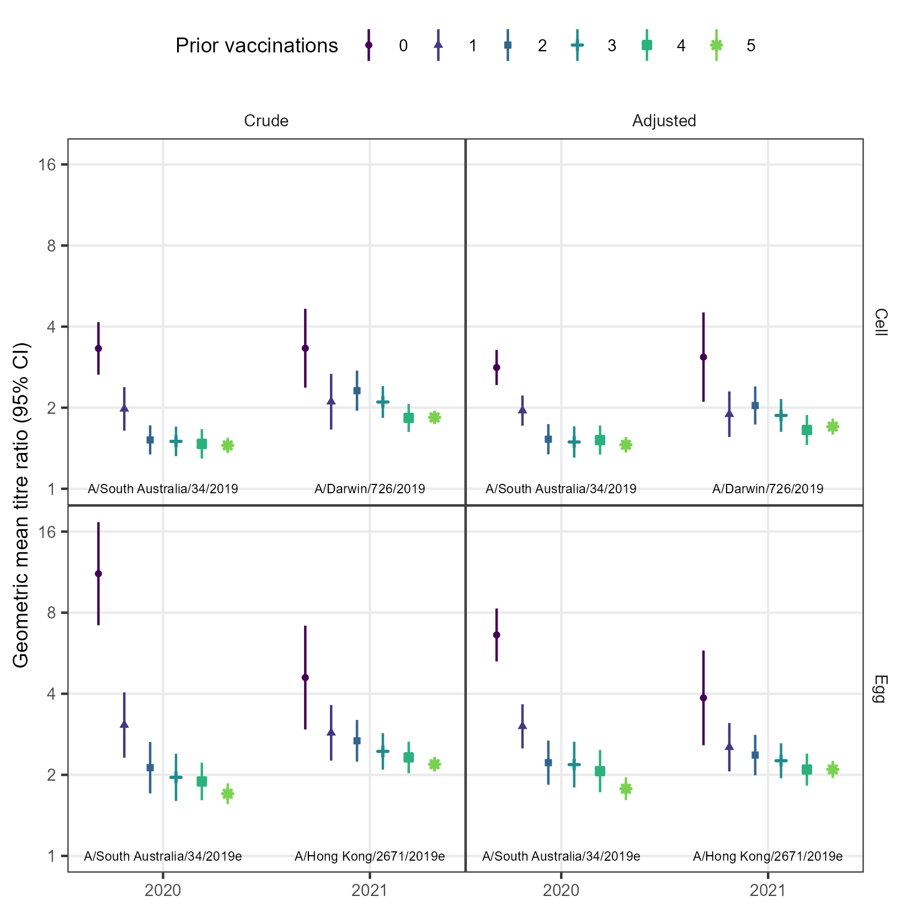
Supplementary Figure 14. Comparison of crude and adjusted geometric mean ratios for A(H3N2). Adjusted GMRs were estimated from a linear regression model that included baseline titre, age, and vaccine brand.

Predictors of post-vaccination seroconversion

Supplementary Table 11. Predictors of post-vaccination seroconversion for A(H3N2)
 | Cell-grown HI titres |  |  |  | Egg-grown
 | 2020  A/South Australia/34/2019 |  | 2021  A/Darwin/726/2019 |  | 2020  A/South Australia/34/2019 |  | 2021  A/Hong Kong/2671/2019
 | n | Estimate | n | Estimate | n | Estimate | n | Estimate
(Intercept) | 584 | 17 (4.4, 62) | 1007 | 6.7 (2, 22) | 584 | 82 (22, 310) | 1007 | 96 (25, 370)
Prior vaccinations
0 | 52 | ref | 13 | ref | 52 | ref | 13 | ref
1 | 69 | 0.48 (0.2, 1.2) | 53 | 0.27 (0.073, 1) | 69 | 0.17 (0.057, 0.48) | 53 | 0.41 (0.11, 1.5)
2 | 68 | 0.13 (0.047, 0.37) | 78 | 0.47 (0.14, 1.6) | 68 | 0.11 (0.038, 0.33) | 78 | 0.59 (0.17, 2.1)
3 | 64 | 0.094 (0.03, 0.29) | 112 | 0.3 (0.091, 1) | 64 | 0.091 (0.03, 0.27) | 112 | 0.35 (0.1, 1.2)
4 | 74 | 0.16 (0.058, 0.42) | 133 | 0.23 (0.067, 0.76) | 74 | 0.11 (0.039, 0.33) | 133 | 0.29 (0.084, 0.99)
5 | 257 | 0.081 (0.037, 0.18) | 618 | 0.25 (0.079, 0.8) | 257 | 0.052 (0.02, 0.14) | 618 | 0.33 (0.1, 1.1)
Log2 baseline titre (ref 5) |  | 0.37 (0.28, 0.5) |  | 0.58 (0.51, 0.67) |  | 0.5 (0.42, 0.58) |  | 0.43 (0.37, 0.5)
Age (ref 18) |  | 0.83 (0.63, 1.1) |  | 0.82 (0.7, 0.97) |  | 0.89 (0.71, 1.1) |  | 0.61 (0.52, 0.72)
Brand
Sanofi | 210 | ref | 879 | ref | 210 | ref | 879 | ref
GSK | 216 | 0.6 (0.3, 1.2) | 0 |  | 216 | 1.8 (1, 3) | 0
Seqirus | 158 | 0.55 (0.26, 1.2) | 128 | 0.44 (0.25, 0.74) | 158 | 1.3 (0.72, 2.3) | 128 | 0.58 (0.35, 0.95)

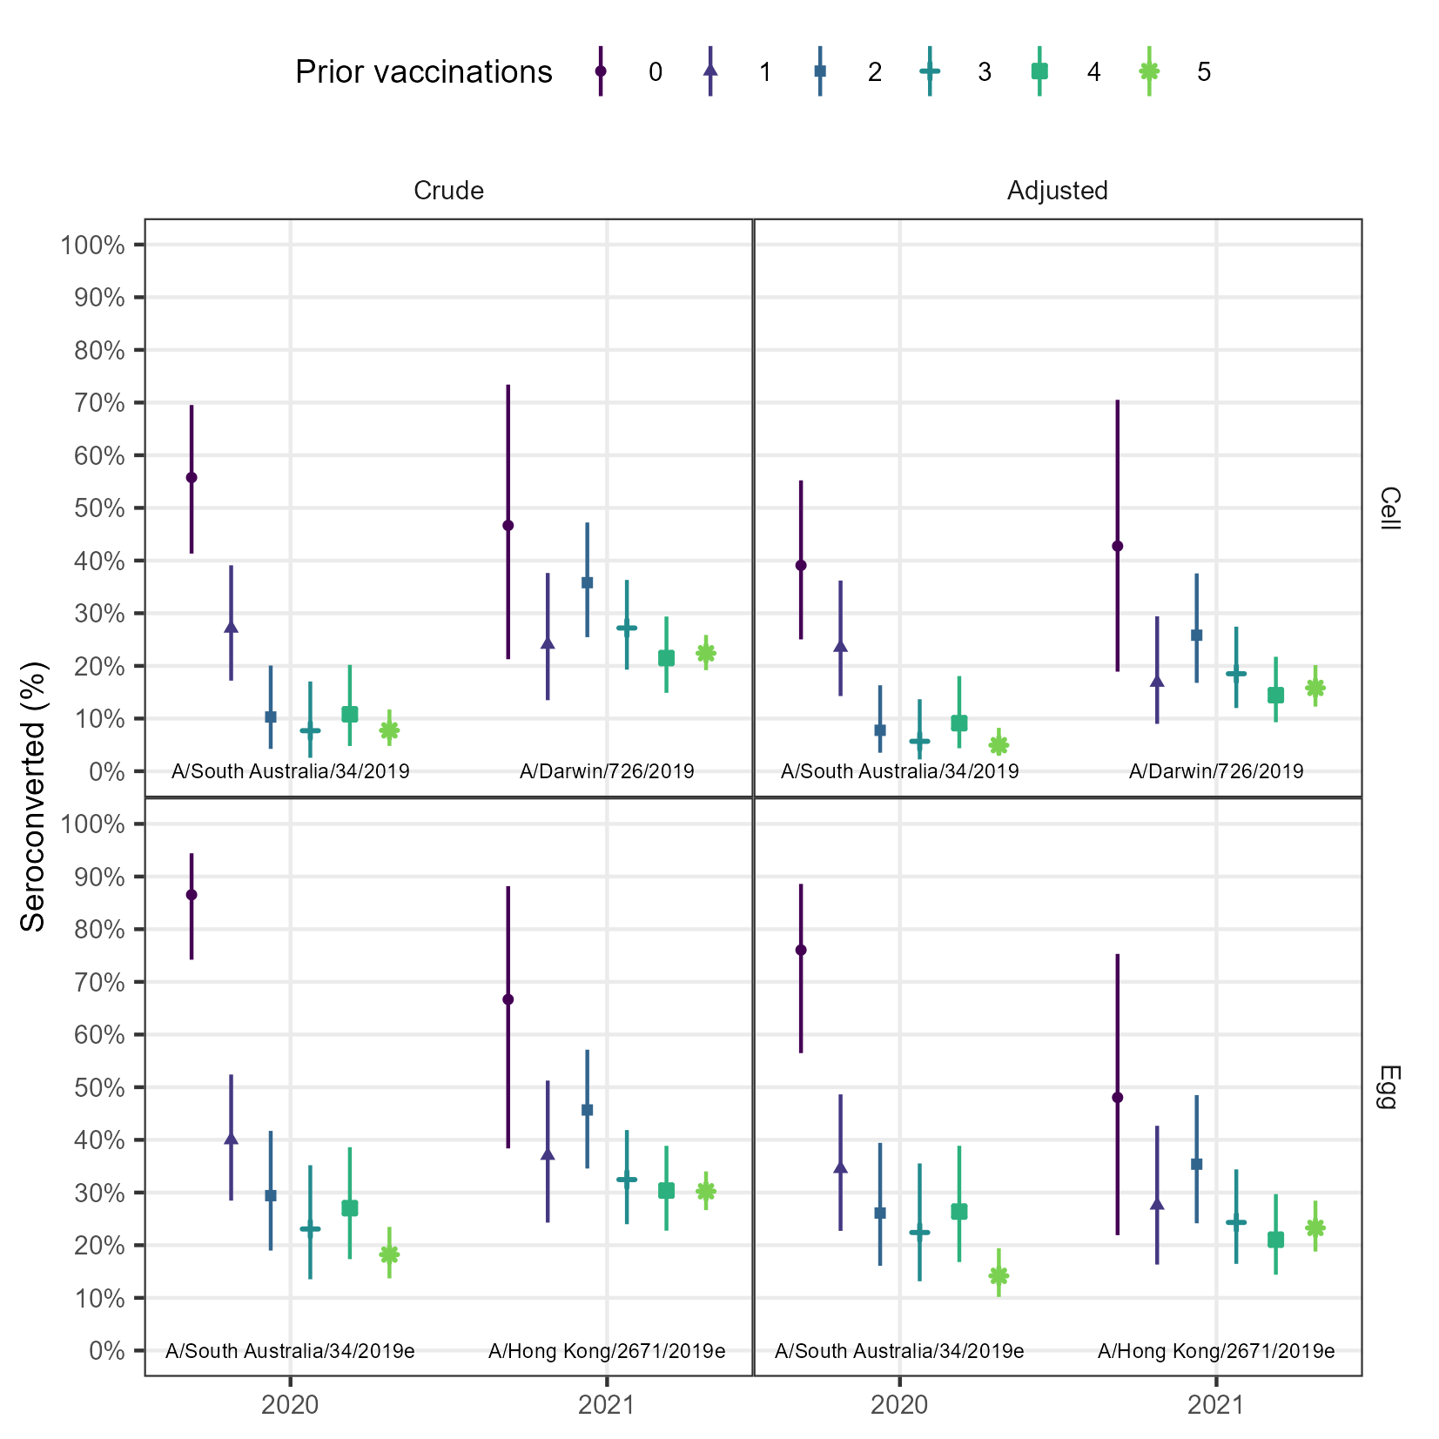
Supplementary Figure 15. Comparison of crude and adjusted percentage seroconverted for A(H3N2). Adjusted seroconversion was estimated from the a logistic regression model that included number of prior vaccinations, baseline titre, age, and vaccine brand.

