Extended data
Extended Data Table 1: Demographic and clinical characteristics
†Eye-closed dataset, #Eye-open dataset, *Wireless dataset, ªNot effective, refused to take.
Extended Data Table 2: BNST-NAc DBS induced volume of tissue activated (VTA) and its overlap with (left and right) BNST and NAc at the last follow-up
Extended Data Table 3: Stimulation parameters
Extended Data Table 4: Changes in the outcome measures during the open-label phase (n = 26)
ªHigher scores in DARS, WHOQOL-BREF and SF-36 means better state.
Extended Data Table 5: Mean scores during the crossover trial (n = 18)
Extended Data Table 6: Adverse events

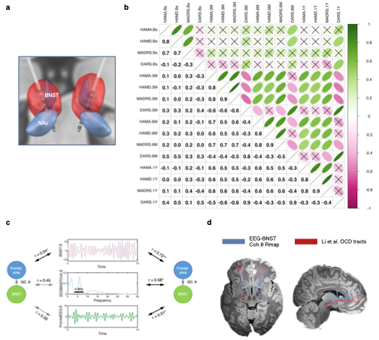
Extended Data Fig. 1: a. Example BNST-NAc DBS induced VTA at final follow-up, showing significant overlap on the BNST and extending to the NAc and VIC. b. Correlation matrix of the depression (HAMD, MADRS), anxiety (HAMA) and anhedonia (DARS) scores at pre- and postoperative 3-month (n = 26), 6-month (n = 26) and 1-year (n = 21). X symbol indicates non-significant. c. Granger causality (GC) of theta band of top-down (Frontal EEG -> BNST) and bottom-up (BNST -> Frontal EEG) and correlations with frontal EEG and BNST theta power and frontal-BNST theta coherence. *p < 0.05, **p < 0.01. d. Fiber tracts (blue) related to lower frontal EEG-BNST theta coherence power (predicting better clinical outcomes) overlaid with fiber tracts with the open-source tracts available for optimal OCD DBS targets (red).

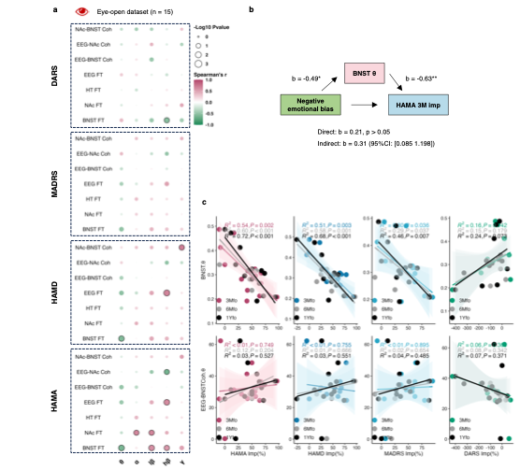
Extended Data Fig. 2: a. Correlation matrix between 3-month clinical improvements and spectral activity features in the eye-open dataset (n = 15). b. Mediation model of the indirect effect of negative emotional bias on clinical outcomes via theta biomarkers. *p < 0.05, **p < 0.01. c. Linear regression prediction of 3-month (n = 15), 6-month (n = 15), 1-year (n = 14) clinical improvements by BNST theta power and theta coherence between frontal EEG and BNST in the eye-open dataset.

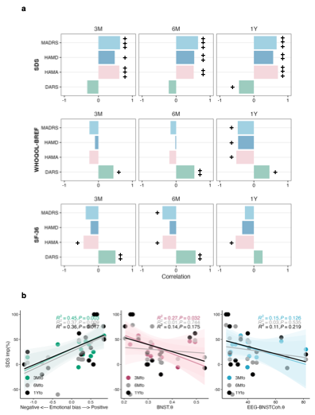
Extended Data Fig. 3: a. Bar plot representing correlation (Spearman’s or Pearson’s r) between depression (HAMD, MADRS), anxiety (HAMA) and anhedonia (DARS) improvements and quality-of-life and disability outcomes at 3, 6 months and 1 year. ⁺p < 0.05, ⁺⁺p < 0.01, ⁺⁺⁺p < 0.001. a. Linear regression prediction of 3-month (n = 17), 6-month (n = 17) and 1-year (n = 15) SDS improvements by negative emotional bias, BNST theta power and theta coherence between frontal EEG and BNST in the eye-closed dataset. Shading represents 95% CI.

