Supplementary Material
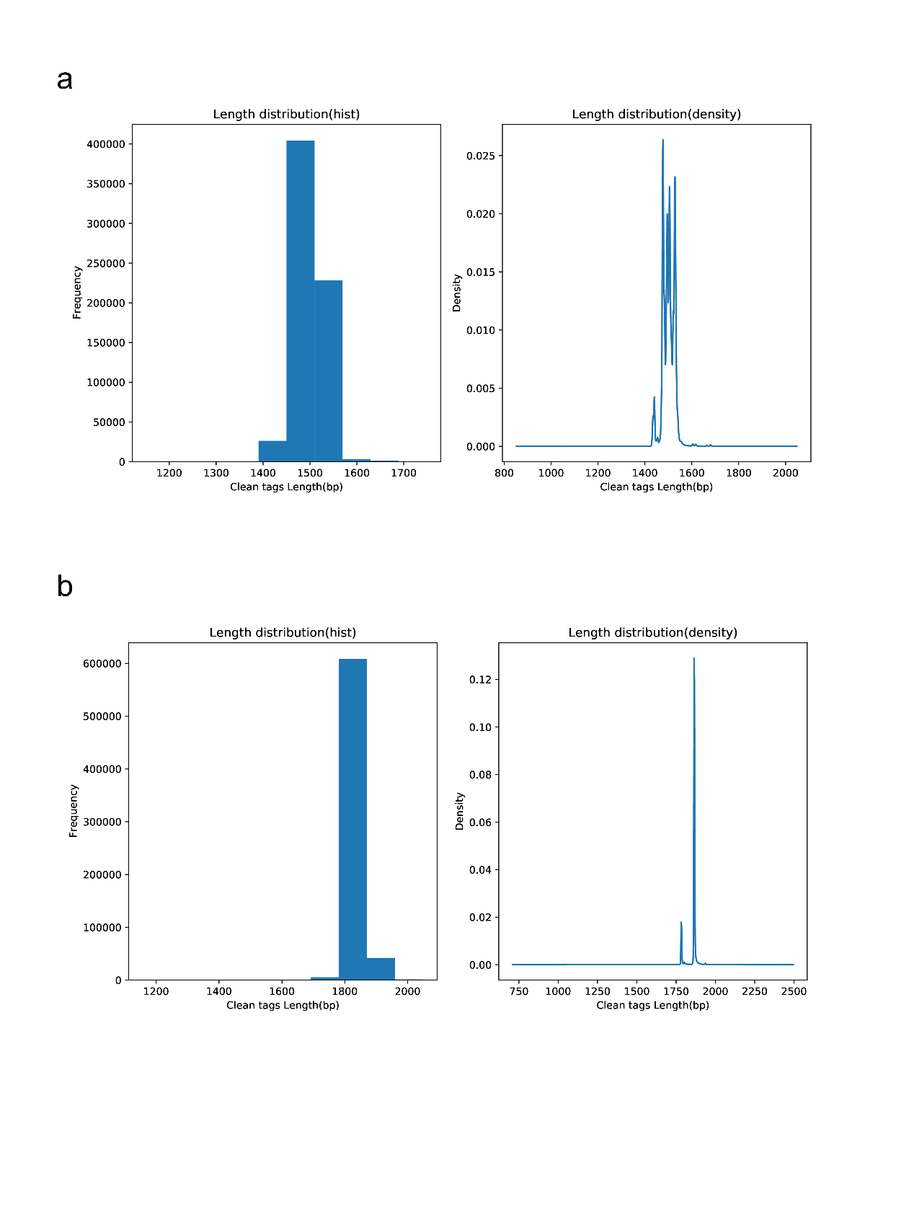
Fig. S1. Length distributions of the detected DNA sequences via 16S (a) and 18S (b) sequencing. Clustering was performed when the sequence similarity was > 97%.

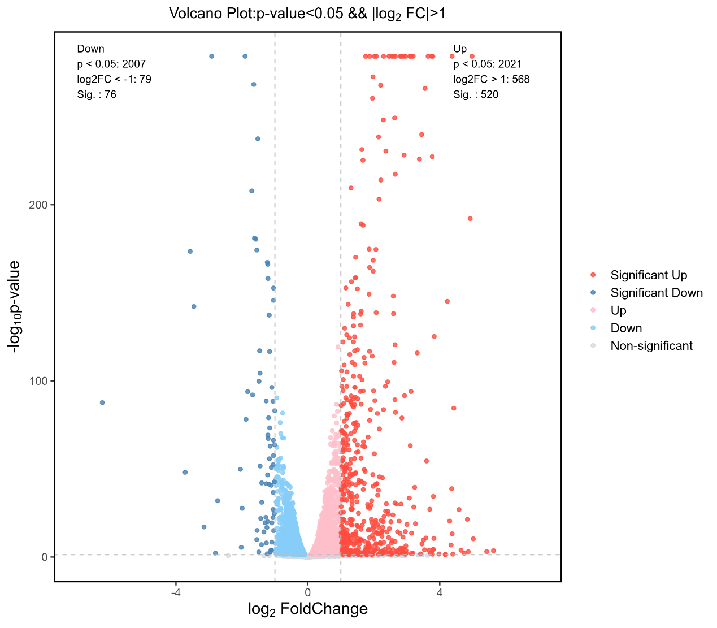
Fig. S2. Volcano plot of centered and scaled FPKM values of DEGs

Table S1. 16S rDNA sequence information
 | Sample ID | Clean tags | Valid tags | Valid percent | valid mean Length | OTU counts | Total OTUs
F1 |  | 7521 | 4780 | 63.56% | 1496.31 | 84 | 263
S1 |  | 7480 | 6040 | 80.75% | 1491.23 | 133 | 263
D1 |  | 7526 | 5193 | 69.00% | 1496.53 | 124 | 263
F2 |  | 7206 | 4870 | 67.58% | 1479.63 | 69 | 263
S2 |  | 7509 | 5517 | 73.47% | 1495.16 | 105 | 263
D2 |  | 7526 | 6288 | 83.55% | 1498.02 | 130 | 263
F3 |  | 7523 | 6576 | 87.41% | 1485.21 | 99 | 263
S3 |  | 7536 | 6455 | 85.66% | 1507.9 | 98 | 263
D3 |  | 7446 | 5154 | 69.22% | 1503.91 | 81 | 263
F4 |  | 7512 | 6426 | 85.54% | 1517.16 | 89 | 263
S4 |  | 7492 | 6906 | 92.18% | 1511.17 | 89 | 263
D4 |  | 7487 | 6898 | 92.13% | 1515.01 | 99 | 263
F5 |  | 7687 | 6496 | 84.51% | 1493.76 | 55 | 263
S5 |  | 4340 | 3598 | 82.90% | 1514.15 | 68 | 263
D5 |  | 7516 | 5328 | 70.89% | 1499.85 | 97 | 263
F6 |  | 7537 | 4548 | 60.34% | 1489.71 | 91 | 263
S6 |  | 7423 | 5759 | 77.58% | 1493.23 | 108 | 263
D6 |  | 7397 | 5881 | 79.51% | 1491.15 | 116 | 263
F7 |  | 7383 | 6636 | 89.88% | 1500.95 | 120 | 263
S7 |  | 7163 | 6613 | 92.32% | 1499.5 | 121 | 263
D7 |  | 7430 | 6726 | 90.52% | 1494.39 | 133 | 263
F8 |  | 7511 | 6209 | 82.67% | 1488.57 | 74 | 263
S8 |  | 6581 | 6193 | 94.10% | 1510.12 | 87 | 263
D8 |  | 6093 | 5668 | 93.02% | 1517.66 | 75 | 263
F9 |  | 7485 | 5305 | 70.88% | 1493.49 | 81 | 263
S9 |  | 4686 | 3721 | 79.41% | 1489.21 | 106 | 263
D9 |  | 6222 | 5141 | 82.63% | 1490.45 | 129 | 263
F10 |  | 7601 | 5458 | 71.81% | 1490.89 | 90 | 263
S10 |  | 5065 | 4550 | 89.83% | 1504.05 | 98 | 263
D10 |  | 5901 | 4583 | 77.66% | 1502.47 | 101 | 263
F11 |  | 7493 | 6656 | 88.83% | 1499.4 | 137 | 263
S11 |  | 5090 | 3698 | 72.65% | 1511.08 | 117 | 263
D11 |  | 7595 | 6439 | 84.78% | 1501.01 | 115 | 263
F12 |  | 7458 | 7029 | 94.25% | 1504.4 | 91 | 263
S12 |  | 7467 | 6519 | 87.30% | 1484.16 | 47 | 263
D12 |  | 7503 | 7000 | 93.30% | 1505.85 | 84 | 263
F13 |  | 7471 | 6274 | 83.98% | 1508.78 | 98 | 263
S13 |  | 7401 | 6293 | 85.03% | 1510.32 | 85 | 263
D13 |  | 7543 | 6570 | 87.10% | 1498.75 | 107 | 263
F14 |  | 7596 | 7135 | 93.93% | 1494.29 | 86 | 263
S14 |  | 7301 | 7111 | 97.40% | 1495.35 | 104 | 263
D14 |  | 7141 | 6493 | 90.93% | 1495.51 | 130 | 263
F15 |  | 7982 | 7673 | 96.13% | 1509.4 | 35 | 263
S15 |  | 7359 | 7053 | 95.84% | 1509.15 | 36 | 263
D15 |  | 7484 | 7333 | 97.98% | 1508.6 | 33 | 263
F16 |  | 6802 | 3587 | 52.73% | 1509.29 | 51 | 263
S16 |  | 6372 | 3471 | 54.47% | 1484.88 | 43 | 263
D16 |  | 6931 | 6006 | 86.65% | 1497.97 | 77 | 263
F17 |  | 8029 | 6866 | 85.52% | 1507.65 | 86 | 263
S17 |  | 7161 | 6706 | 93.65% | 1504.93 | 93 | 263
D17 |  | 6847 | 6528 | 95.34% | 1505.34 | 103 | 263
F18 |  | 8471 | 7868 | 92.88% | 1511.37 | 39 | 263
S18 |  | 8109 | 7723 | 95.24% | 1519.06 | 50 | 263
D18 |  | 7661 | 6382 | 83.31% | 1509 | 55 | 263
F19 |  | 8381 | 6799 | 81.12% | 1489.66 | 60 | 263
S19 |  | 7146 | 6970 | 97.54% | 1492.5 | 87 | 263
D19 |  | 7285 | 6361 | 87.32% | 1505.27 | 70 | 263
F20 |  | 7150 | 5933 | 82.98% | 1494.82 | 87 | 263
S20 |  | 7409 | 6997 | 94.44% | 1507.53 | 60 | 263
D20 |  | 7435 | 7084 | 95.28% | 1514.25 | 41 | 263
F21 |  | 8069 | 7706 | 95.50% | 1485.24 | 54 | 263
S21 |  | 6926 | 6634 | 95.78% | 1459.62 | 55 | 263
D21 |  | 8367 | 8068 | 96.43% | 1488.4 | 80 | 263
F22 |  | 8160 | 7483 | 91.70% | 1501.03 | 91 | 263
S22 |  | 7427 | 6582 | 88.62% | 1494.3 | 96 | 263
D22 |  | 8575 | 8150 | 95.04% | 1489.49 | 100 | 263
F23 |  | 8073 | 7914 | 98.03% | 1492.98 | 43 | 263
S23 |  | 7295 | 6824 | 93.54% | 1495.21 | 90 | 263
D23 |  | 8552 | 7916 | 92.56% | 1478.2 | 81 | 263
F24 |  | 6924 | 6225 | 89.90% | 1495.93 | 65 | 263
S24 |  | 7913 | 7345 | 92.82% | 1491.98 | 68 | 263
D24 |  | 7196 | 6790 | 94.36% | 1519.55 | 67 | 263
F25 |  | 7192 | 6901 | 95.95% | 1512.4 | 115 | 263
S25 |  | 8434 | 8279 | 98.16% | 1505.99 | 65 | 263
D25 |  | 8373 | 8180 | 97.69% | 1505.22 | 81 | 263
F26 |  | 7030 | 5636 | 80.17% | 1488.84 | 101 | 263
S26 |  | 6918 | 6640 | 95.98% | 1520.28 | 62 | 263
D26 |  | 8263 | 5776 | 69.90% | 1519.16 | 66 | 263
F27 |  | 7358 | 6151 | 83.60% | 1499.33 | 75 | 263
S27 |  | 6806 | 6645 | 97.63% | 1496.82 | 83 | 263
D27 |  | 8038 | 7683 | 95.58% | 1495.67 | 89 | 263
F28 |  | 7704 | 6941 | 90.10% | 1488.79 | 161 | 263
S28 |  | 8321 | 7667 | 92.14% | 1486.48 | 104 | 263
D28 |  | 6820 | 6021 | 88.28% | 1505.39 | 116 | 263
F29 |  | 7618 | 7274 | 95.48% | 1500.83 | 104 | 263
S29 |  | 8220 | 7784 | 94.70% | 1497.86 | 72 | 263
D29 |  | 7131 | 6254 | 87.70% | 1494.3 | 106 | 263
F30 |  | 8509 | 5381 | 63.24% | 1496.81 | 89 | 263
S30 |  | 8196 | 4497 | 54.87% | 1490.27 | 109 | 263
D30 |  | 7250 | 5231 | 72.15% | 1497.58 | 118 | 263

Table S2. 18S rDNA sequence information
Sample ID | Clean tags | Valid tags | Valid percent | valid mean length |  | OTU counts | Total OTUs
F1 | 7532 | 7381 | 98.00% | 1866.05 | 18 |  | 80
S1 | 7462 | 7336 | 98.31% | 1866.86 | 12 |  | 80
D1 | 7490 | 7361 | 98.28% | 1865.68 | 19 |  | 80
F2 | 7464 | 7359 | 98.59% | 1867.2 | 8 |  | 80
S2 | 7505 | 7395 | 98.53% | 1867.14 | 8 |  | 80
D2 | 7475 | 7336 | 98.14% | 1867.05 | 12 |  | 80
F3 | 7570 | 7459 | 98.53% | 1866.83 | 11 |  | 80
S3 | 7504 | 7374 | 98.27% | 1867.25 | 7 |  | 80
D3 | 7490 | 7327 | 97.82% | 1865.48 | 18 |  | 80
F4 | 7420 | 7220 | 97.30% | 1859.85 | 18 |  | 80
S4 | 7424 | 7201 | 97.00% | 1840.01 | 23 |  | 80
D4 | 7594 | 7377 | 97.14% | 1832.9 | 22 |  | 80
F5 | 7432 | 7307 | 98.32% | 1866.95 | 9 |  | 80
S5 | 7564 | 7432 | 98.25% | 1861.98 | 25 |  | 80
D5 | 7333 | 7232 | 98.62% | 1866.83 | 14 |  | 80
F6 | 7560 | 7441 | 98.43% | 1866.57 | 14 |  | 80
S6 | 7446 | 7232 | 97.13% | 1859.37 | 25 |  | 80
D6 | 7482 | 7380 | 98.64% | 1861.45 | 14 |  | 80
F7 | 7543 | 7412 | 98.26% | 1867.1 | 8 |  | 80
S7 | 5384 | 5240 | 97.33% | 1853.47 | 17 |  | 80
D7 | 7478 | 7337 | 98.11% | 1865.43 | 12 |  | 80
F8 | 5763 | 5610 | 97.35% | 1851.92 | 23 |  | 80
S8 | 7503 | 7350 | 97.96% | 1833.9 | 21 |  | 80
D8 | 7409 | 7232 | 97.61% | 1837.56 | 25 |  | 80
F9 | 7561 | 7492 | 99.09% | 1865.72 | 7 |  | 80
S9 | 7523 | 7436 | 98.84% | 1865.65 | 11 |  | 80
D9 | 7537 | 7435 | 98.65% | 1865.73 | 12 |  | 80
F10 | 7500 | 7435 | 99.13% | 1865.64 | 6 |  | 80
S10 | 7554 | 7417 | 98.19% | 1834.32 | 16 |  | 80
D10 | 7405 | 7206 | 97.31% | 1858.63 | 18 |  | 80
F11 | 7565 | 7438 | 98.32% | 1866.11 | 10 |  | 80
S11 | 7562 | 7392 | 97.75% | 1865.54 | 9 |  | 80
D11 | 7539 | 7428 | 98.53% | 1865.6 | 9 |  | 80
F12 | 5231 | 5157 | 98.59% | 1860.1 | 15 |  | 80
S12 | 7533 | 7374 | 97.89% | 1857.99 | 19 |  | 80
D12 | 7398 | 7259 | 98.12% | 1862.59 | 18 |  | 80
F13 | 7411 | 7322 | 98.80% | 1865.35 | 14 |  | 80
S13 | 7551 | 7394 | 97.92% | 1859.95 | 15 |  | 80
D13 | 7478 | 7411 | 99.10% | 1865.37 | 7 |  | 80
F14 | 7765 | 7763 | 99.97% | 1864.52 | 11 |  | 80
S14 | 5833 | 5474 | 93.85% | 1862.75 | 7 |  | 80
D14 | 8578 | 8571 | 99.92% | 1869.41 | 14 |  | 80
F15 | 7420 | 7416 | 99.95% | 1844.28 | 16 |  | 80
S15 | 6814 | 6805 | 99.87% | 1840.82 | 19 |  | 80
D15 | 6777 | 6720 | 99.16% | 1846.26 | 17 |  | 80
F16 | 7337 | 7280 | 99.22% | 1867.12 | 11 |  | 80
S16 | 7349 | 7141 | 97.17% | 1873.96 | 15 |  | 80
D16 | 4821 | 4062 | 84.26% | 1804.54 | 9 |  | 80
F17 | 8012 | 7984 | 99.65% | 1863.43 | 20 |  | 80
S17 | 8566 | 8562 | 99.95% | 1864.89 | 13 |  | 80
D17 | 6860 | 6857 | 99.96% | 1865.15 | 7 |  | 80
F18 | 7862 | 7836 | 99.67% | 1837.54 | 21 |  | 80
S18 | 5815 | 5476 | 94.17% | 1856.33 | 13 |  | 80
D18 | 5851 | 5560 | 95.03% | 1867.13 | 8 |  | 80
F19 | 7607 | 7605 | 99.97% | 1846 | 18 |  | 80
S19 | 8515 | 8512 | 99.96% | 1834.3 | 17 |  | 80
D19 | 7145 | 6758 | 94.58% | 1829.73 | 16 |  | 80
F20 | 5113 | 4748 | 92.86% | 1859.02 | 15 |  | 80
S20 | 7487 | 7454 | 99.56% | 1846.58 | 21 |  | 80
D20 | 7925 | 7919 | 99.92% | 1856.8 | 19 |  | 80
F21 | 8591 | 8589 | 99.98% | 1865.08 | 6 |  | 80
S21 | 7628 | 7618 | 99.87% | 1865.51 | 10 |  | 80
D21 | 6630 | 6075 | 91.63% | 1867.55 | 10 |  | 80
F22 | 5596 | 5308 | 94.85% | 1838.71 | 11 |  | 80
S22 | 5333 | 5068 | 95.03% | 1864.4 | 13 |  | 80
D22 | 6555 | 6146 | 93.76% | 1864.7 | 14 |  | 80
F23 | 7417 | 7413 | 99.95% | 1865.36 | 9 |  | 80
S23 | 7296 | 7292 | 99.95% | 1846.09 | 17 |  | 80
D23 | 5755 | 5353 | 93.01% | 1857.19 | 18 |  | 80
F24 | 7950 | 7950 | 100.00% | 1865.38 | 10 |  | 80
S24 | 8497 | 8493 | 99.95% | 1865.44 | 11 |  | 80
D24 | 5422 | 4975 | 91.76% | 1867.71 | 12 |  | 80
F25 | 8360 | 8351 | 99.89% | 1843.49 | 19 |  | 80
S25 | 6878 | 6874 | 99.94% | 1798.08 | 13 |  | 80
D25 | 8220 | 8214 | 99.93% | 1803.99 | 16 |  | 80
F26 | 7083 | 7082 | 99.99% | 1865.3 | 9 |  | 80
S26 | 8559 | 8517 | 99.51% | 1806.91 | 26 |  | 80
D26 | 7764 | 7668 | 98.76% | 1848.47 | 31 |  | 80
F27 | 8149 | 8127 | 99.73% | 1865.29 | 12 |  | 80
S27 | 8242 | 8213 | 99.65% | 1844.56 | 21 |  | 80
D27 | 8525 | 8040 | 94.31% | 1853.21 | 18 |  | 80
F28 | 7710 | 7707 | 99.96% | 1865.21 | 10 |  | 80
S28 | 7543 | 7466 | 98.98% | 1865.89 | 9 |  | 80
D28 | 6807 | 6804 | 99.96% | 1865.16 | 7 |  | 80
F29 | 7844 | 7828 | 99.80% | 1838.21 | 20 |  | 80
S29 | 6932 | 6924 | 99.88% | 1813.67 | 17 |  | 80
D29 | 8051 | 7855 | 97.57% | 1856.55 | 20 |  | 80
F30 | 7715 | 7664 | 99.34% | 1866.1 | 13 |  | 80
S30 | 6983 | 6968 | 99.79% | 1869.37 | 15 |  | 80
D30 | 7953 | 7862 | 98.86% | 1866.96 | 19 |  | 80

Table S3. Indices of α diversity of the three groups according to 16S rDNA sequencing
Samples | Observed Species | Chao1 | Goods’ Coverage | Shannon | Simpson
Group F | 67.013 | 79.273 | 1 | 2.994 | 0.74
Group S | 69.915 | 92.968 | 1 | 3.079 | 0.74
Group D | 70.687 | 88.903 | 1 | 3.4 | 0.79

Table S4. Indices of α diversity of the three groups according to 18S rDNA sequencing
Samples | Observed Species | Chao1 | Goods’ Coverage | Shannon | Simpson
Group F | 12.33 | 12.548 | 1 | 0.34* | 0.14*
Group S | 17.44 | 18.484 | 1 | 0.7 | 0.27
Group D | 15.901 | 17.857 | 1 | 0.74 | 0.28

Table S5. Relative abundances of significantly different bacterial genera.
Group F-Group S |  |  |  |  | Group S-Group D
Taxon | Group F mean | Group S mean | P |  | Taxon | Group S mean | Group D mean | P
Campylobacter | 0.032 | 0.069 |  | 0.010 | Prevotella | 0.085 | 0.135 | 0.031
Leptotrichia | 0.060 | 0.034 |  | 0.023 | Capnocytophaga | 0.120 | 0.082 | 0.035
Streptococcus | 0.028 | 0.063 |  | 0.001 | Lactobacillus | 0.031 | 0.067 | 0.040
Actinomyces | 0.025 | 0.041 |  | 0.007 | Leptotrichia | 0.034 | 0.027 | 0.019
Lactobacillus | 0.010 | 0.031 |  | 0.006 | Propionibacterium | 0.010 | 0.031 | 0.026
Corynebacterium | 0.028 | 0.011 |  | 0.006 | Veillonellaceae [G-1] | 0.002 | 0.009 | 0.003
Propionibacterium | 0.000 | 0.010 |  | 0.000 | Mitsuokella | 0.001 | 0.006 | 0.016
Granulicatella | 0.002 | 0.007 |  | 0.033 | Treponema | 0.002 | 0.005 | 0.018
Alloprevotella | 0.006 | 0.002 |  | 0.032 | Alloprevotella | 0.002 | 0.004 | 0.050
Scardovia | 0.001 | 0.005 |  | 0.006 | Olsenella | 0.000 | 0.002 | 0.013
Dialister | 0.001 | 0.001 |  | 0.029 | Fretibacterium | 0.000 | 0.001 | 0.016
Flavitalea | 0.000 | 0.000 |  | 0.035 | Erysipelotrichaceae [G-1] | 0.000 | 0.001 | 0.031
Bacillus | 0.000 | 0.000 |  | 0.030 | Peptostreptococcaceae [XI][G-1] | 0.000 | 0.000 | 0.033

Table S6. Relative abundances of the significantly different bacterial species.
Group F-Group S |  |  |  | Group S-Group D
Taxon | Group F mean | Group P mean | P | Taxon | Group S mean |  | Group D mean | P
Campylobacter gracilis | 0.022 | 0.059 | 0.028 | Prevotella denticola | 0.020 | 0.038 |  | 0.003
Corynebacterium matruchotii | 0.028 | 0.011 | 0.006 | Propionibacterium acidifaciens | 0.010 | 0.031 |  | 0.026
Actinomyces sp. HMT 448 | 0.013 | 0.025 | 0.012 | Capnocytophaga sp. HMT 412 | 0.017 | 0.009 |  | 0.047
Capnocytophaga sp. HMT 412 | 0.008 | 0.017 | 0.039 | Leptotrichia hongkongensis | 0.013 | 0.010 |  | 0.020
Streptococcus mutans | 0.001 | 0.023 | 0.000 | Prevotella sp. HMT 300 | 0.006 | 0.017 |  | 0.012
Prevotella denticola | 0.004 | 0.020 | 0.007 | Capnocytophaga sp. HMT 336 | 0.013 | 0.004 |  | 0.040
Prevotella melaninogenica | 0.008 | 0.014 | 0.027 | Selenomonas sputigena | 0.005 | 0.010 |  | 0.038
Lactobacillus pentosus | 0.000 | 0.021 | 0.025 | Prevotella oris | 0.003 | 0.006 |  | 0.042
Cardiobacterium hominis | 0.011 | 0.004 | 0.045 | Mitsuokella sp. HMT 131 | 0.001 | 0.006 |  | 0.018
Propionibacterium acidifaciens | 0.000 | 0.010 | 0.000 | Veillonellaceae [G-1] bacterium HMT 155 | 0.001 | 0.005 |  | 0.002
Campylobacter concisus | 0.004 | 0.007 | 0.016 | Prevotella multiformis | 0.000 | 0.005 |  | 0.044
Aggregatibacter segnis | 0.007 | 0.002 | 0.027 | Selenomonas dianae | 0.002 | 0.002 |  | 0.033
Granulicatella adiacens | 0.002 | 0.007 | 0.033 | Lactobacillus oris | 0.001 | 0.004 |  | 0.021
Prevotella sp. HMT 300 | 0.002 | 0.006 | 0.037 | Treponema socranskii | 0.001 | 0.003 |  | 0.029
Alloprevotella tannerae | 0.006 | 0.001 | 0.010 | Alloprevotella tannerae | 0.001 | 0.003 |  | 0.014
Scardovia wiggsiae | 0.000 | 0.005 | 0.014 | Lactobacillus gasseri | 0.000 | 0.003 |  | 0.003
Lactobacillus vaginalis | 0.001 | 0.003 | 0.033 | Veillonellaceae [G-1] bacterium HMT 132 | 0.000 | 0.002 |  | 0.005
Prevotella salivae | 0.001 | 0.002 | 0.014 | Prevotella pallens | 0.002 | 0.000 |  | 0.014
Lactobacillus paracasei | 0.000 | 0.002 | 0.036 | Actinomyces sp. HMT 896 | 0.001 | 0.002 |  | 0.037
Dialister pneumosintes | 0.001 | 0.001 | 0.029 | Olsenella profusa | 0.000 | 0.002 |  | 0.014
Actinomyces dentalis | 0.001 | 0.000 | 0.038 | Actinomyces dentalis | 0.000 | 0.001 |  | 0.019
Lactobacillus fermentum | 0.000 | 0.001 | 0.035 | Veillonellaceae [G-1] bacterium HMT 150 | 0.000 | 0.001 |  | 0.013
Scardovia inopinata | 0.000 | 0.000 | 0.042 | Selenomonas sp. HMT 919 | 0.000 | 0.001 |  | 0.021
Flavitalea sp. HMT 320 | 0.000 | 0.000 | 0.035 | Erysipelotrichaceae [G-1]bacterium HMT 904 | 0.000 | 0.001 |  | 0.031
Bacillus anthracis | 0.000 | 0.000 | 0.030

Table S7 Oligonucleotide probe sequences in FISH
species | Oligonucleotide probes | sequence(5’–3’)
Streptococcus mutans⁴²  Actinomyces viscosus ²¹ | MUT590 (labeled with Cy5)  ACT218 (labeled with 6,FAM) | 5’-ACTCCAGACTTTCCTGAC-3’  5′-CGAGCCCCATCCCCCACCA-3′
Candida albicans ²¹ | EUK516 (labeled with Cy3) | 5′-ACCAGACTTGCCCTCC-3′

