Supporting Information
For
Template-Based Fabrication of Copper Oxide for Persulfate Activation: Investigating Non-Radical Mechanisms in Efficient Bisphenol A Degradation
Jiayun Liuª, Zhiyi Laiª, Kaiyong Wangª, Jianning Wu ^{a*}, Shengchao Yangª, Zhiyong Liu ª, Guihua Meng^{a*},Xuhong Guo ^{a,b}
ª School of Chemistry and Chemical Engineering, Shihezi University/State Key Laboratory Incubation Base for Green Processing of Chemical Engineering, Shihezi, Xinjiang 832003, PR China.
^{b} State Key Laboratory of Chemical Engineering, East China University of Science and Technology, Shanghai 200237, P. R. China.
*Corresponding author: Jianning Wu, Ph.D.；Guihua Meng, Ph.D.
E-mail: wjn_shzu@sina.com; mghua0726@sina.com

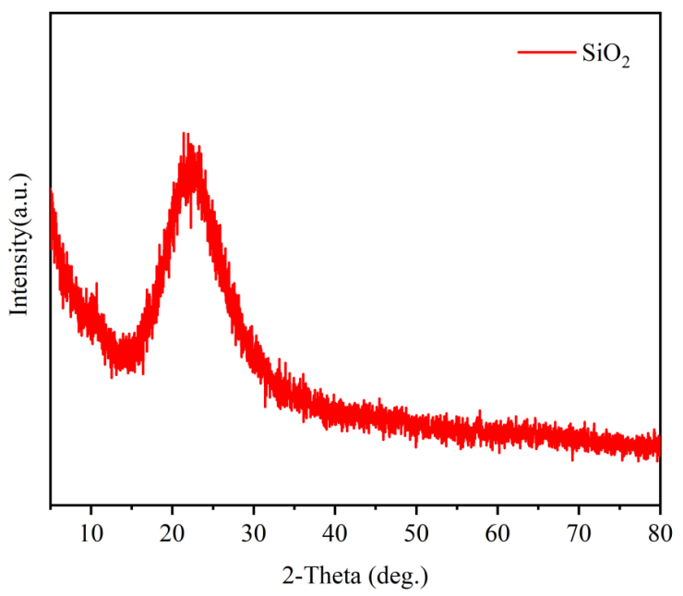
Fig. S1 The X-Ray diffraction (XRD) pattern of SiO₂.
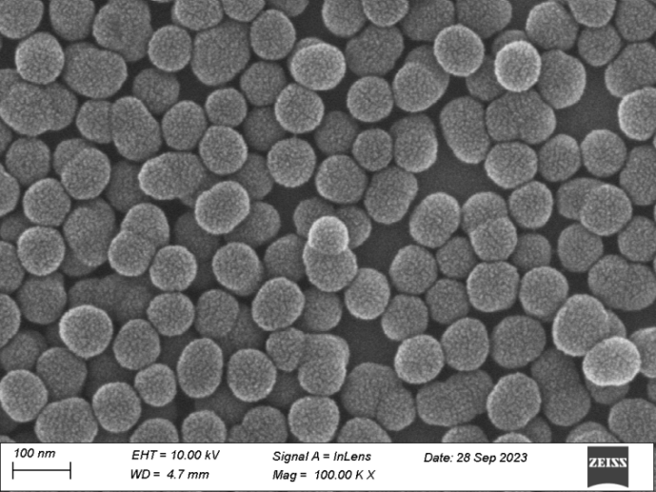
Fig. S2 The scanning electron microscopy (SEM) image of SiO₂.
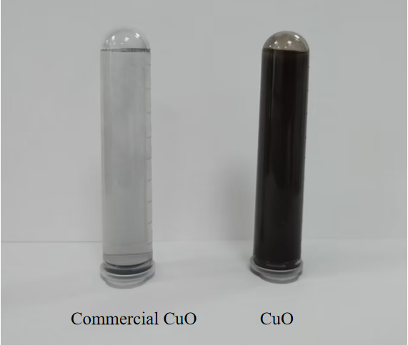
Fig. S3 Different CuO particles dispersed in aqueous solutions ([CuO] = 0.5 g/L).
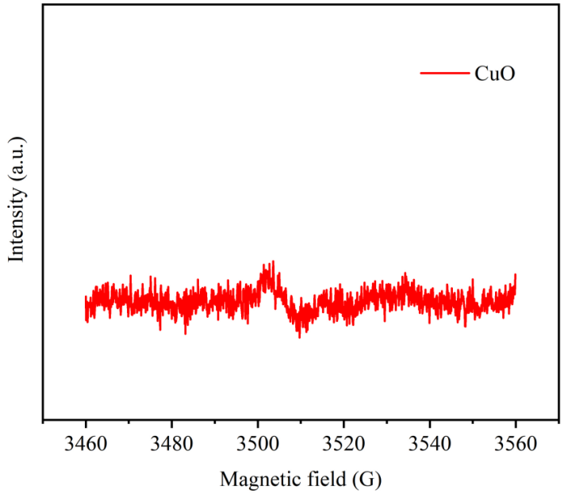
Fig. S4 Solid state EPR spectra of the CuO catalysts.

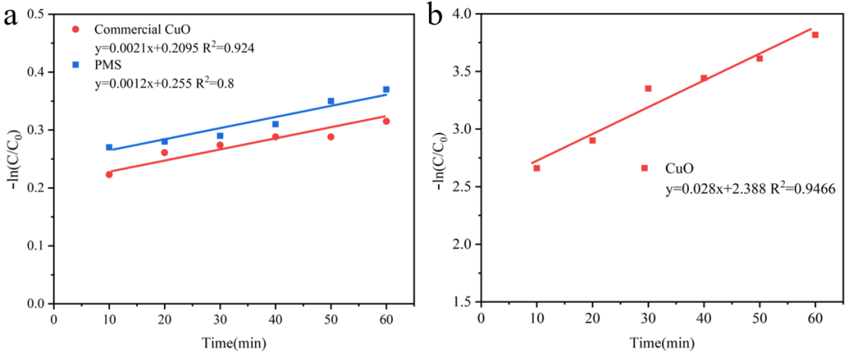
Fig. S5 The pseudo first-order model of BPA degradation in different CuO/PMS systems.
.
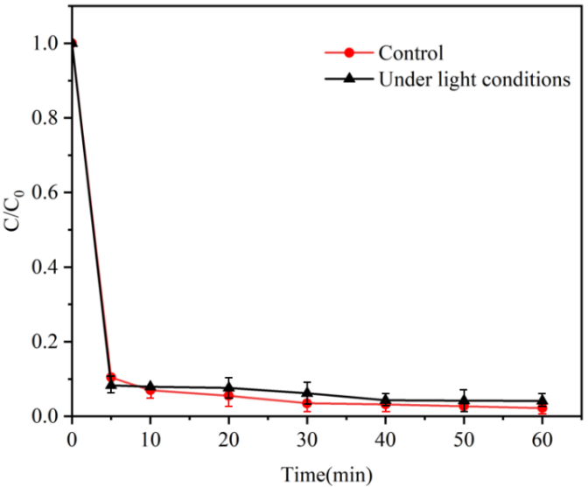
Fig. S6 Degradation of BPA under light-avoidance conditions. ([CuO]₀ = 0.1 g/L, [BPA]₀ = 30 mg/L, [PMS]₀ = 0.5 mM, pH=6.8, T = 25 ℃).
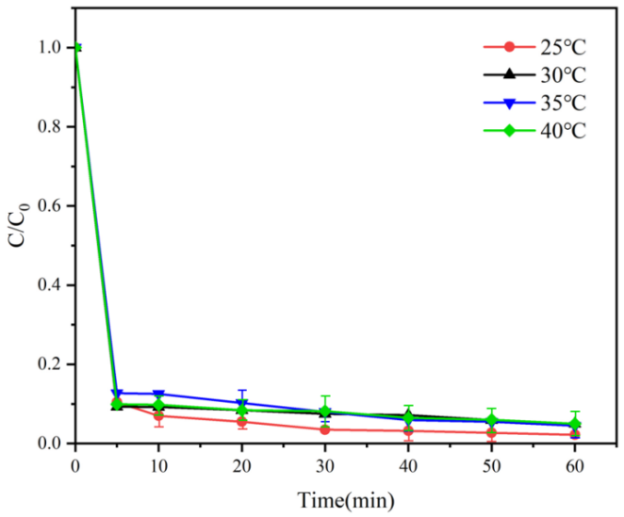
Fig. S7 The reaction temperature.([CuO]₀ = 0.1 g/L, [BPA]₀ = 30 mg/L, [PMS]₀ = 0.5 mM, pH=6.8). .
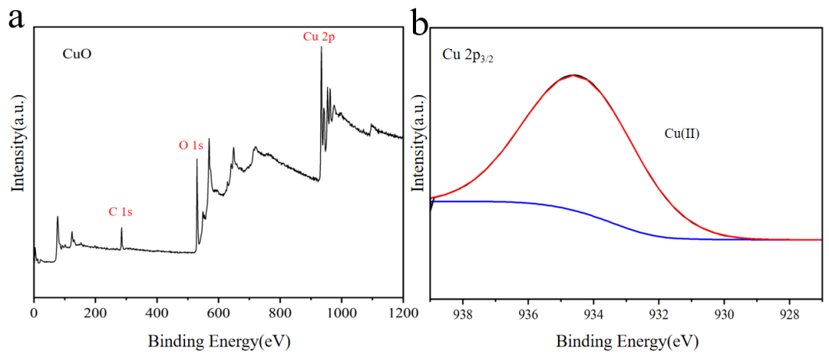
Fig. S8 XPS spectra of CuO catalysts: (a) the survey spectrum; (b) Cu 2p_{3/2}.
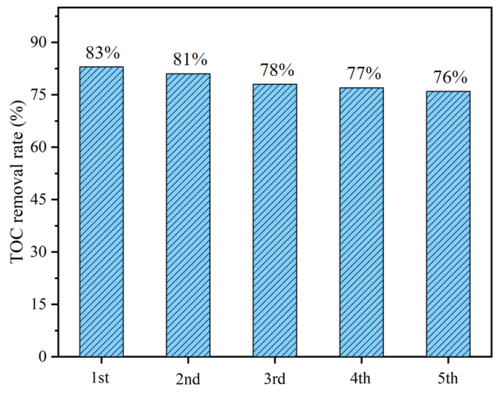
Fig. S9. TOC removal in the CuO@UiO-66-NH₂/PMS oxidation.
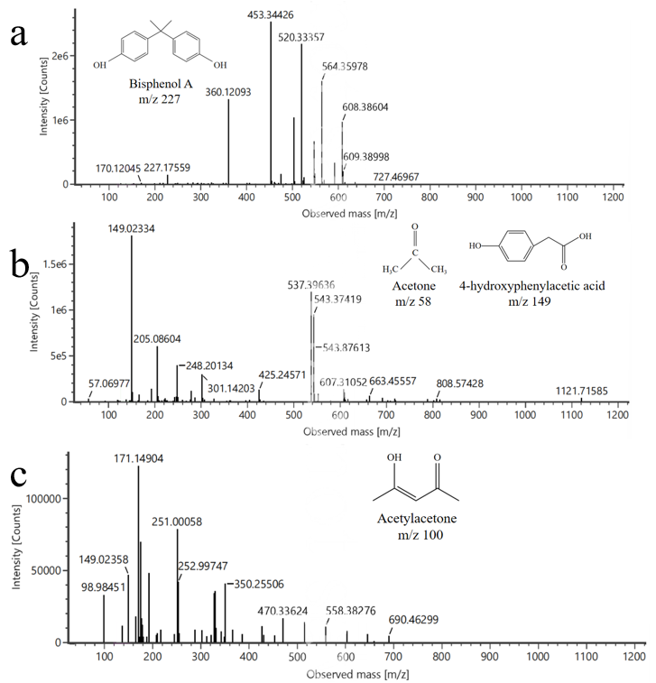
Fig. S10. Extraction of mass spectra of BPA degradation products in the CuO system.

Table. S1. Detected intermediates of BPA degradation by LC-MS.
Name | Formula | Structure | m/z
Bisphenol A | C₁₅H₁₆O₂ | 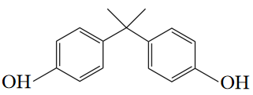 | 227
4-hydroxyphenylacetic acid | C₈H₈O₃ | 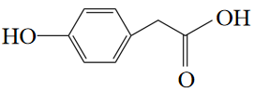 | 149
Acetone | C₃H₆O | 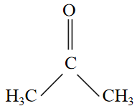 | 58
Acetylacetone | C₅H₈O₂ | 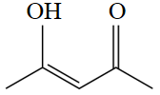 | 100

