Supplementary Information

Metal Organic Framework (MOF-808) Incorporated Composite Solid Polymer Electrolyte for Stable All-Solid-State Lithium Batteries

Zexing Hong¹, Peize Li¹, Qiyao Zou¹, Long Gu¹, Jianwen Wang¹, Liting Deng¹, Chao Wang¹, Yuying Zhang¹, Mengxian Li¹, Chunzhen Yang^{1,*}

¹School of Materials, Sun Yat-sen University, Shenzhen, 518107, China
² Institute of Advanced Science Facilities, Shenzhen, 518107, China
Contact: yangchzh6@mail.sysu.edu.cn;

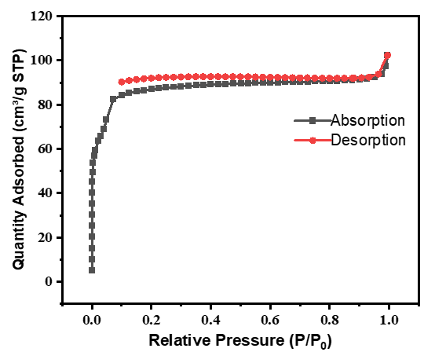
Figure S1. N₂ adsorption/desorption isotherms of the MOF-808 material.

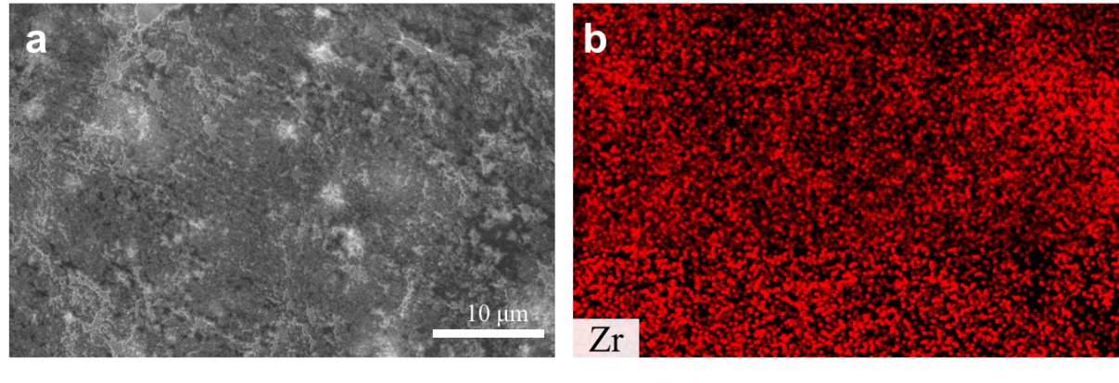
Figure S2. (a) SEM image of the as-prepared PEO-LiTFSI/MOF-808 composite SPE film. (b) EDS elemental mapping of Zr on surface of the PEO-LiTFSI/MOF-808 SPE film.

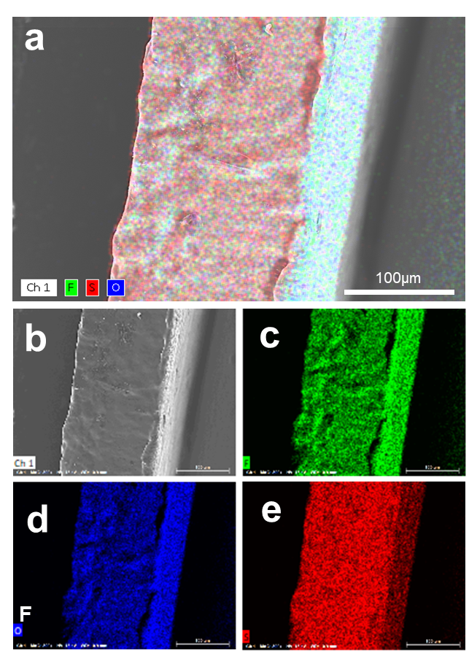
Figure S3. (a, b) SEM image showing the cross-section of the as-prepared PEO-LiTFSI SPE film; EDS elemental mapping of (c) fluorine, (d) oxygen, (e) sulfur in PEO-LiTFSI SPE film.

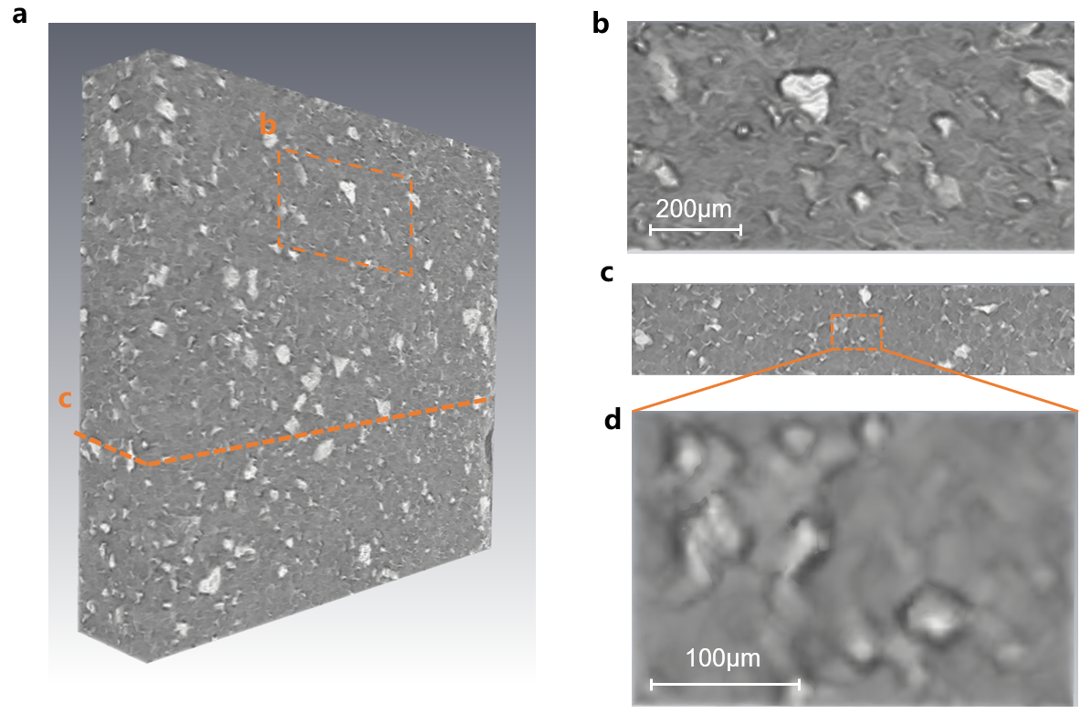

Figure S4. (a) Visualization of the PEO-LiTFSI/MOF-808 membrane, imaged using X-ray CT; (b) top- and (c) side-view of the reconstructed tomography. (d) Zoom-in image from the red rectangle at the cross-section of the composite SPE membrane.

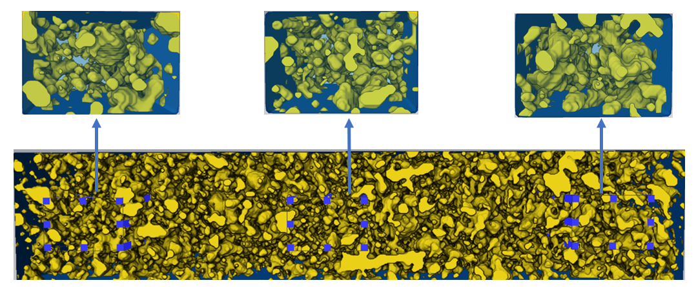
Figure S5. Microstructure analysis of the reconstructed CT analysis for the PEO-LiTFSI/MOF-808 membrane.

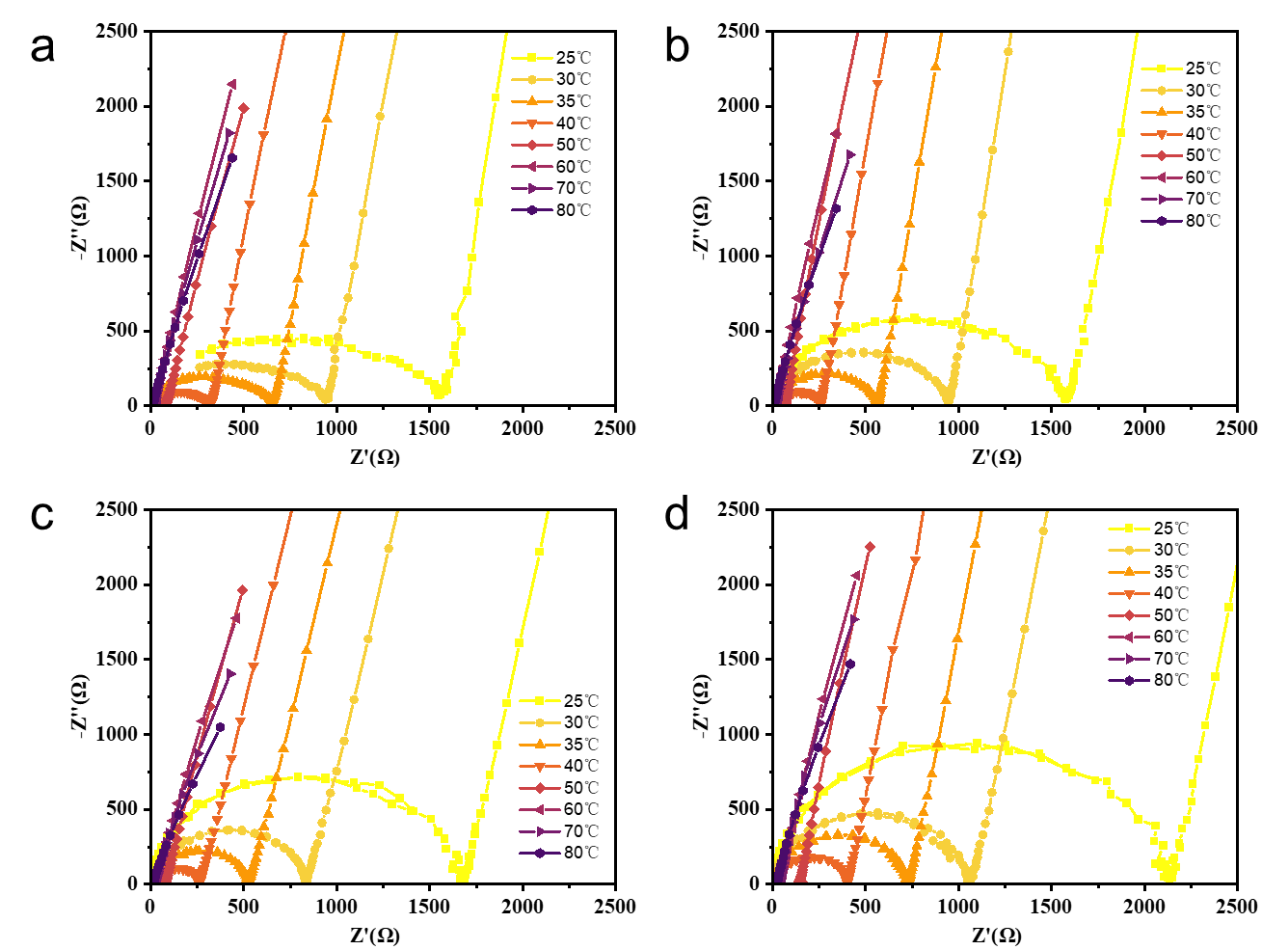
Figure S6. Impedance spectra of (a) PEO-LiTFSI membrane and PEO-LiTFSI/MOF-808 membrane with (b) 5 wt.% MOF, (c) 15 wt.% MOF and (d) 20 wt.% MOF contents measured at different temperatures within a range of 25-80 ℃.

Figure S7. Impedance spectra of the PEO-LiTFSI/MOF membrane with different MOF contents measured at 60℃.

Figure S8. (a) Schematic of the assembled ASSB cells. Charge/discharge curves of LFP||PEO-LiTFSI||Li (b) and LFP||PEO-LiTFSI/MOF-808||Li (c) cells at different current rate. (d) Comparison of the derived dQ/dV profiles. Rate performance (e) and calculated specific capacitance of the assembled LFP||PEO-LiTFSI||Li and LFP||PEO-LiTFSI/MOF-808||Li cells at different current rates.

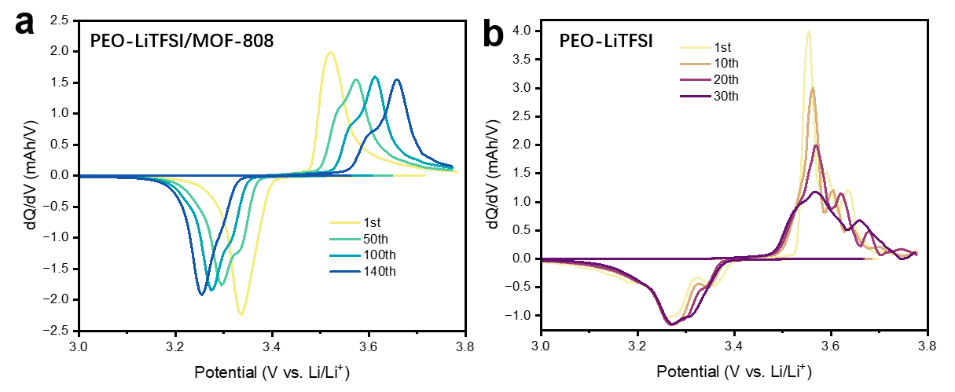
Figure S9. Comparison of the dQ/dV profiles of the LFP||PEO-LiTFSI/MOF-808||Li cell (a) and LFP||PEO-LiTFSI||Li cell (b) at 0.5 C and 60 ℃.

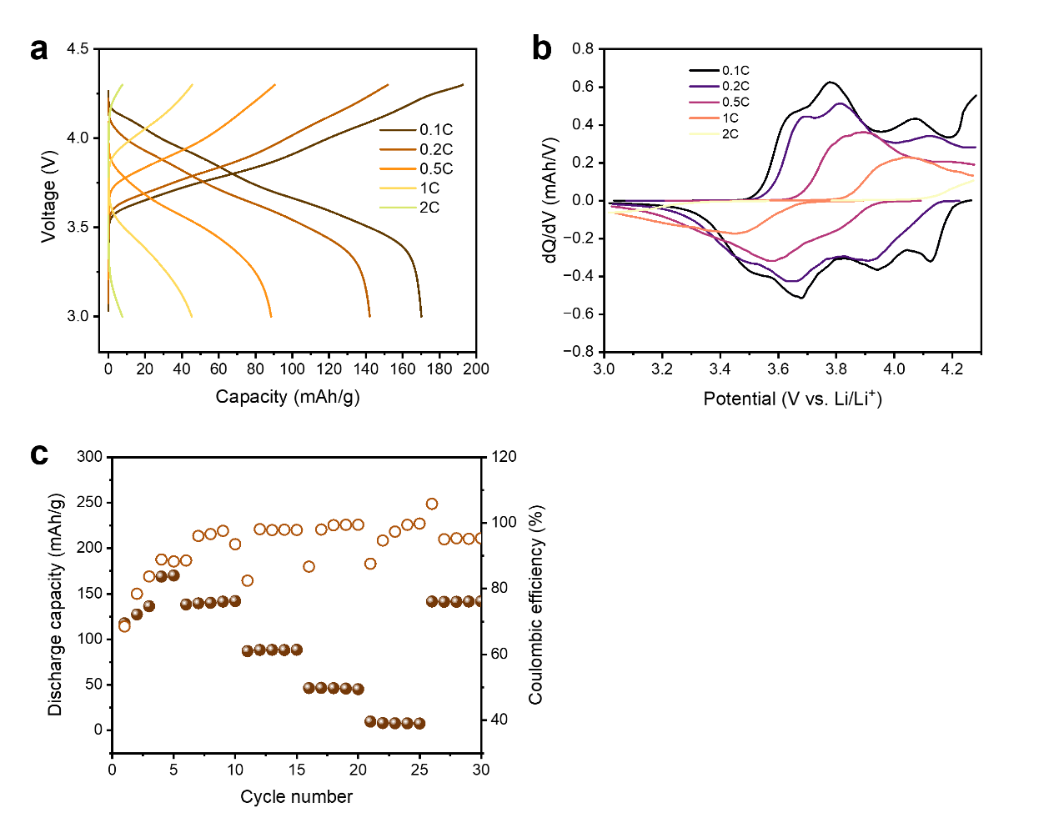
Figure S10. (a) Charge/discharge profiles, (b) differential capacity curves and (c) rate performance of NCM811||PEO-LiTFSI/MOF-808||Li cell at different rates at 50 ℃.

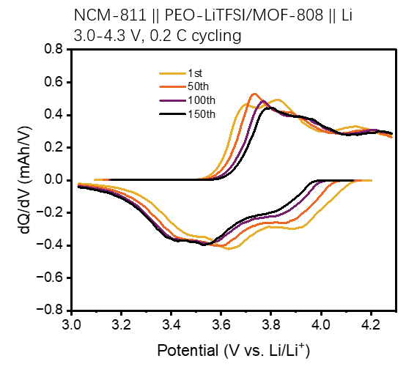
Figure S11. Evolution of dQ/dV profiles of NCM811||PEO-LiTFSI/MOF-808||Li cell along 150 charge-discharge cycles at 0.2 C at 50 ℃.

Table S1.The atomic composition analysis of the as-prepared PEO-LiTFSI/0.1MOF-808 SPE film.

Element | At. No. | Mass Norm(%) | Atom(%) | Abs.error(%)(3 sigma)
O | 8 | 0.2 | 0.4 | 0.0
F | 9 | 17.2 | 29.1 | 0.3
S | 16 | 63.6 | 63.8 | 0.5
Zr | 40 | 19.0 | 6.7 | 0.3
 |  | 100.0 | 100.0

Table S2.Activation energy value of CSPEs with different contents of MOF-808.

contents of MOF (wt%) | Ea (eV)  25-50℃ 50-80℃
0 | 1.16 | 0.54
5 | 1.09 | 0.56
10 | 1.06 | 0.50
15 | 1.08 | 0.51
20 | 1.07 | 0.51

Table S3. Comparison of electrochemical performance with other CSPE based on PEO-LiTFSI polymer electrolyte in Li/LiFePO4 cells.

MOF | working temperature (℃) | cycle rate (C) | specific capacity (mAh g⁻¹) | Ref.
MOF-5 | 80 | 1 | 151 | ¹
Al(OH)(1,4-NDC) | 60 | 0.2 | 160.5 | ²
Al-BTC-MOF | 70 | 1 | 118 | ³
Mg-BTC-MOF | 70 | 1 | 110 | ⁴
Ni-BTC-MOF | 70 | 0.1 | 118 | ⁵
ZIF-8 | 60 | 0.5 | 130.5 | ⁶
HKUST-1 | 50 | 0.1 | 155 | ⁷
Bi/HMT-MOFs | 60 | 1 | 124.2 | ⁸
ZIF-67 | 60 | 0.5 | 149 | ⁹
Ce-MOF | 60 | 1 | 161.6 | ¹⁰
Zr-MOF(MOF-808) | 60 | 0.2  0.5  1 | 164.5  155.1  115.6 | This work

References
[1] Yuan, C.; Li, J.; Han, P.; Lai, Y.; Zhang, Z.; Liu, J. Enhanced Electrochemical Performance of Poly(Ethylene Oxide) Based Composite Polymer Electrolyte by Incorporation of Nano-Sized Metal-Organic Framework. Journal of Power Sources 2013, 240, 653–658.
[2] Zhang, Z.; You, J.-H.; Zhang, S.-J.; Wang, C.-W.; Zhou, Y.; Li, J.-T.; Huang, L.; Sun, S.-G. Metal Organic Framework Nanorod Doped Solid Polymer Electrolyte with Decreased Crystallinity for High-Performance All-Solid-State Lithium Batteries. ChemElectroChem 2020, 7 (5), 1125–1134.
[3] Gerbaldi, C.; Nair, J. R.; Kulandainathan, M. A.; Kumar, R. S.; Ferrara, C.; Mustarelli, P.; Stephan, A. M. Innovative High Performing Metal Organic Framework (MOF)-Laden Nanocomposite Polymer Electrolytes for All-Solid-State Lithium Batteries. J. Mater. Chem. A 2014, 2 (26), 9948–9954.
[4] Angulakshmi, N.; Kumar, R. S.; Kulandainathan, M. A.; Stephan, A. M. Composite Polymer Electrolytes Encompassing Metal Organic Frame Works: A New Strategy for All-Solid-State Lithium Batteries. J. Phys. Chem. C 2014, 118 (42), 24240–24247.
[5] Suriyakumar, S.; Kanagaraj, M.; Angulakshmi, N.; Kathiresan, M.; Nahm, K. S.; Walkowiak, M.; Wasiński, K.; Półrolniczak, P.; Stephan, A. M. Charge–Discharge Studies of All-Solid-State Li/LiFePO4 Cells with PEO-Based Composite Electrolytes Encompassing Metal Organic Frameworks. RSC Adv. 2016, 6 (99), 97180–97186.
[6] Lei, Z.; Shen, J.; Zhang, W.; Wang, Q.; Wang, J.; Deng, Y.; Wang, C. Exploring Porous Zeolitic Imidazolate Frame Work-8 (ZIF-8) as an Efficient Filler for High-Performance Poly(Ethyleneoxide)-Based Solid Polymer Electrolytes. Nano Res. 2020, 13 (8), 2259–2267.
[7] Sun, C.-C.; Yusuf, A.; Li, S.-W.; Qi, X.-L.; Ma, Y.; Wang, D.-Y. Metal Organic Frameworks Enabled Rational Design of Multifunctional PEO-Based Solid Polymer Electrolytes. Chemical Engineering Journal 2021, 414, 128702.
[8] Xu, J.; Ma, G.; Wang, N.; Zhao, S.; Zhou, J. Borderline Metal Centers on Nonporous Metal-Organic Framework Nanowire Boost Fast Li-Ion Interfacial Transport of Composite Polymer Electrolyte. Small 2022, 18 (40), 2204163.
[9] Zou, Y.; Ao, Z.; Zhang, Z.; Chen, N.; Zou, H.; Lv, Y.; Huang, Y. Metal-Organic Framework Modified PEO-Based Solid Electrolyte for High-Performance All-Solid-State Lithium Metal Batteries. Chemical Engineering Science 2023, 275, 118705.
[10] Wu, X.; Chen, K.; Yao, Z.; Hu, J.; Huang, M.; Meng, J.; Ma, S.; Wu, T.; Cui, Y.; Li, C. Metal Organic Framework Reinforced Polymer Electrolyte with High Cation Transference Number to Enable Dendrite-Free Solid State Li Metal Conversion Batteries. J. Power Sources 2021, 501, 229946.

