Additional File 3: Preliminary Theory of Change map
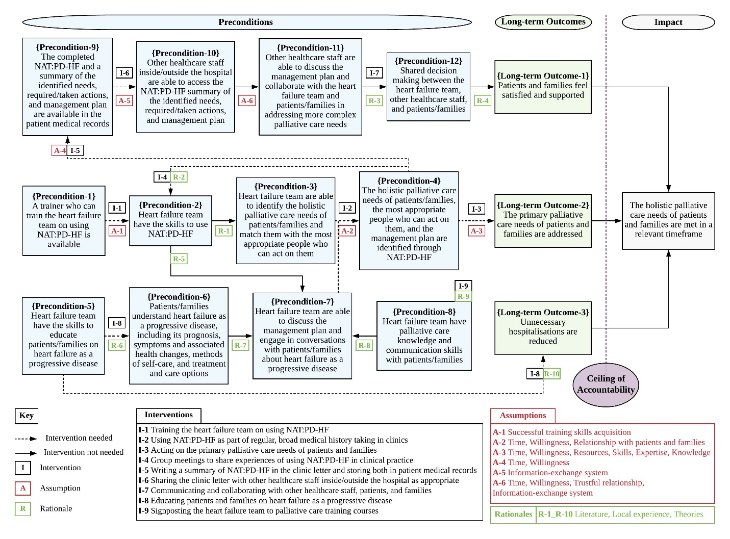
Description of data: The preliminary Theory of Change map underpinning the intervention developed through group workshops with service providers

