Characterization of polyvinyl alcohol-borax/agarose (PVA-B/AG) double network hydrogel utilized for the cleaning of works of art
Ehab Al-Emam^{1,2*}, Hilde Soenen³, Joost Caen⁴, Koen Janssens²
¹ Department of Conservation, Faculty of Archaeology, Sohag University, 82524, Sohag, Egypt
² AXES, Faculty of Science, University of Antwerp, Groenenborgerlaan 171, 2020 Antwerp, Belgium
³ Nynas NV, Groenenborgerlaan 171, Antwerp 2020, Belgium
⁴ ARCHES, Faculty of Design Sciences, University of Antwerp, Blindestraat 9, 2000 Antwerp, Belgium
* Ehab Al-Emam (corresponding author)
Tel: 032494696945
Email: ehab.al-emam@uantwerpe.be; ehab_alemam@arch.sohag.edu.eg

Hydrogel synthesis
Stock solutions of PVA 10% and borax 6% were prepared in purified water (ASTM: type II water). In case of PVA-B, the stock solutions were mixed together and diluted to the desired concentrations (3% or 4 % of PVA and 0.6% of borax). The cleaning agents were added and mixed well before the addition of the borax to allow crosslinking of the PVA polymer and thus to obtain the hydrogel. For the PVA-B/AG DN hydrogels, the same procedure was used, except for mixing AG with the diluted PVA stock solution at 90 °C under constant stirring until the AG polymer was fully dissolved. When a cleaning system was added, the solution was left to cool down to c. 45 °C, especially in the case of the organic solvents, and finally the borax was added (see Fig. 1). Later, the prepared hydrogels were confined in syringes (with no air inside to prevent the evaporation of the liquids); these were kept in the refrigerator (c. 5 °C) until the hydrogels were subjected to a measurement. Mostly, the color of the hydrogels changes when the cleaning agents are added. Fig. S2 displays the color of the hydrogels loaded with the investigated cleaning agents.
It is worth noting that the hydrogels loaded with 20% p-xylene formed white hydrogels and expelled part of the liquid after the addition of borax. This expelling issue is usually observed when less polar solvents are incorporated in PVA-B systems [1]. This may be ascribed to the difference in polarity between the incorporated solvent and water (the main solvent of the two gellants; PVA and AG). The expelled liquid was collected and its density was estimated based on its mass and volume. The density measurements confirmed that the expelled liquid was p-xylene. It was noticed that the amount of the expelled liquid was not the same for the different hydrogel formulations, especially for those containing agarose. Thus, 10 ml of the 3% PVA-B and 3%/1% PVA-B/AG formulations were prepared four times and the volume of expelled liquids was collected. The average amount of the expelled liquid was calculated and it was confirmed that the 3%/1% PVA-B/AG hydrogel has the ability to retain 19.6±0.4% of the low polarity solvent (20% p-xylene) while the 3% PVA-B hydrogel could only retain 15.1±1.3% (see Tables S1 and S2). In order to minimize the expulsion of the low polarity solvents from the hydrogel, the PVA solution should be intensively mixed (using a high-speed vortex mixer) to form a white emulsion prior to the addition of the borax. The poorer the mixing the more liquid is expelled. Furthermore, also increasing the amount of the prepared hydrogel may cause more solution being expelled (see Table S3 where 20 ml of the hydrogels were prepared). Regarding the formulations loaded with 0.5% EDTA, some syneresis occurred after the addition of the borax. Likewise, the 3%/1% PVA-/AG hydrogel caused minimal syneresis unlike the 3% PVA-B hydrogel that expelled a significant amount of the liquid.
Table S1: The measured amount of expelled xylene from 3% PVA-B. The prepared amount of the hydrogel formulations is 10 ml.
# | Volume (ml) | Mass (g) | Density (g/ml) | Expelled Xyl (%) | Remaining concentration of Xyl (20%)
1 | 0.43 | 0.3747 | 0.871 | 21.5 | 15.7
2 | 0.54 | 0.4684 | 0.867 | 27 | 14.6
3 | 0.34 | 0.2905 | 0.854 | 17 | 16.6
4 | 0.65 | 0.5603 | 0.862 | 32.5 | 13.5

Table S2: The measured amount of expelled xylene from 3%/1% PVA-B/AG. The prepared amount of the hydrogel formulations is 10 ml.
# | Volume (ml) | Mass (g) | Density (g/ml) | Expelled Xyl (%) | Remaining concentration of Xyl (20%)
1 | 0.031 | 0.0271 | 0.874 | 1.55 | 19.7
2 | 0 | 0 | 0 | 0 | 20
3 | 0.043 | 0.0369 | 0.858 | 2.15 | 19.6
4 | 0.1 | 0.0875 | 0.875 | 5 | 19

Table S3: The measured amount of expelled xylene from the hydrogels investigated in the vertical flow tests. The prepared amount of the hydrogel formulations is 20 ml.
Hydrogel formulation | Volume (ml) | Mass (g) | Density (g/ml) | Expelled Xyl (%) | Remaining concentration of Xyl (20%)
3% PVA-B | 0.807 | 0.6995 | 0.867 | 40.35 | 11.9
3%/1% PVA-B/AG | 0.27 | 0.2344 | 0.868 | 13.5 | 17.3
4%PVA-B | 0.265 | 0.2325 | 0.877 | 13.25 | 17.4

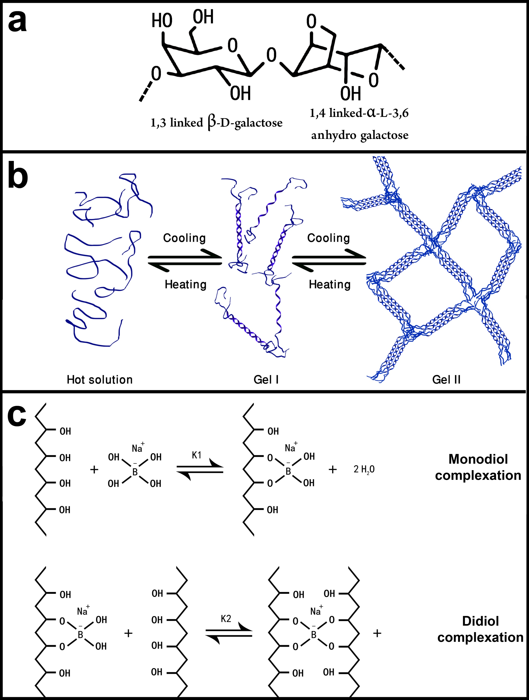
Figure S1: a) Agarose chemical structure. b) Gelation process of agarose. c) Crosslinking of PVA by a borax.

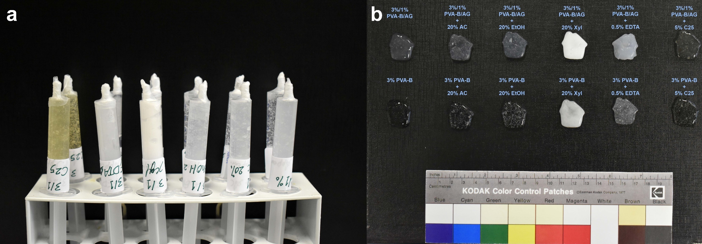
Figure S2: a) 3%/1% PVA-B/AG (front row) and 3% PVA- B (back row) hydrogels, loaded with different cleaning agents (right to left: only water, 20% AC, 20% EtOH, 20% Xyl, 0.5% EDTA, 5% C25), confined in syringes. b) The color of the corresponding hydrogel formulations against a black background.

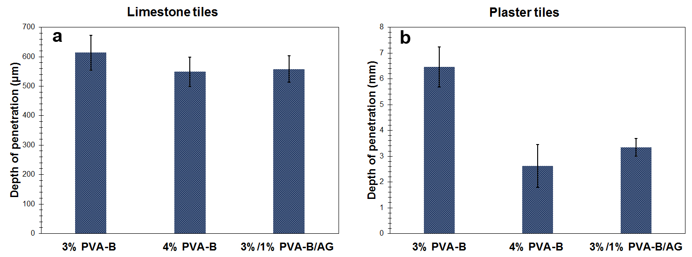
Figure S3: Depth of penetration of liquid phase into a) limestone and b) plaster tiles. The error bars are based on the standard deviation of the data.

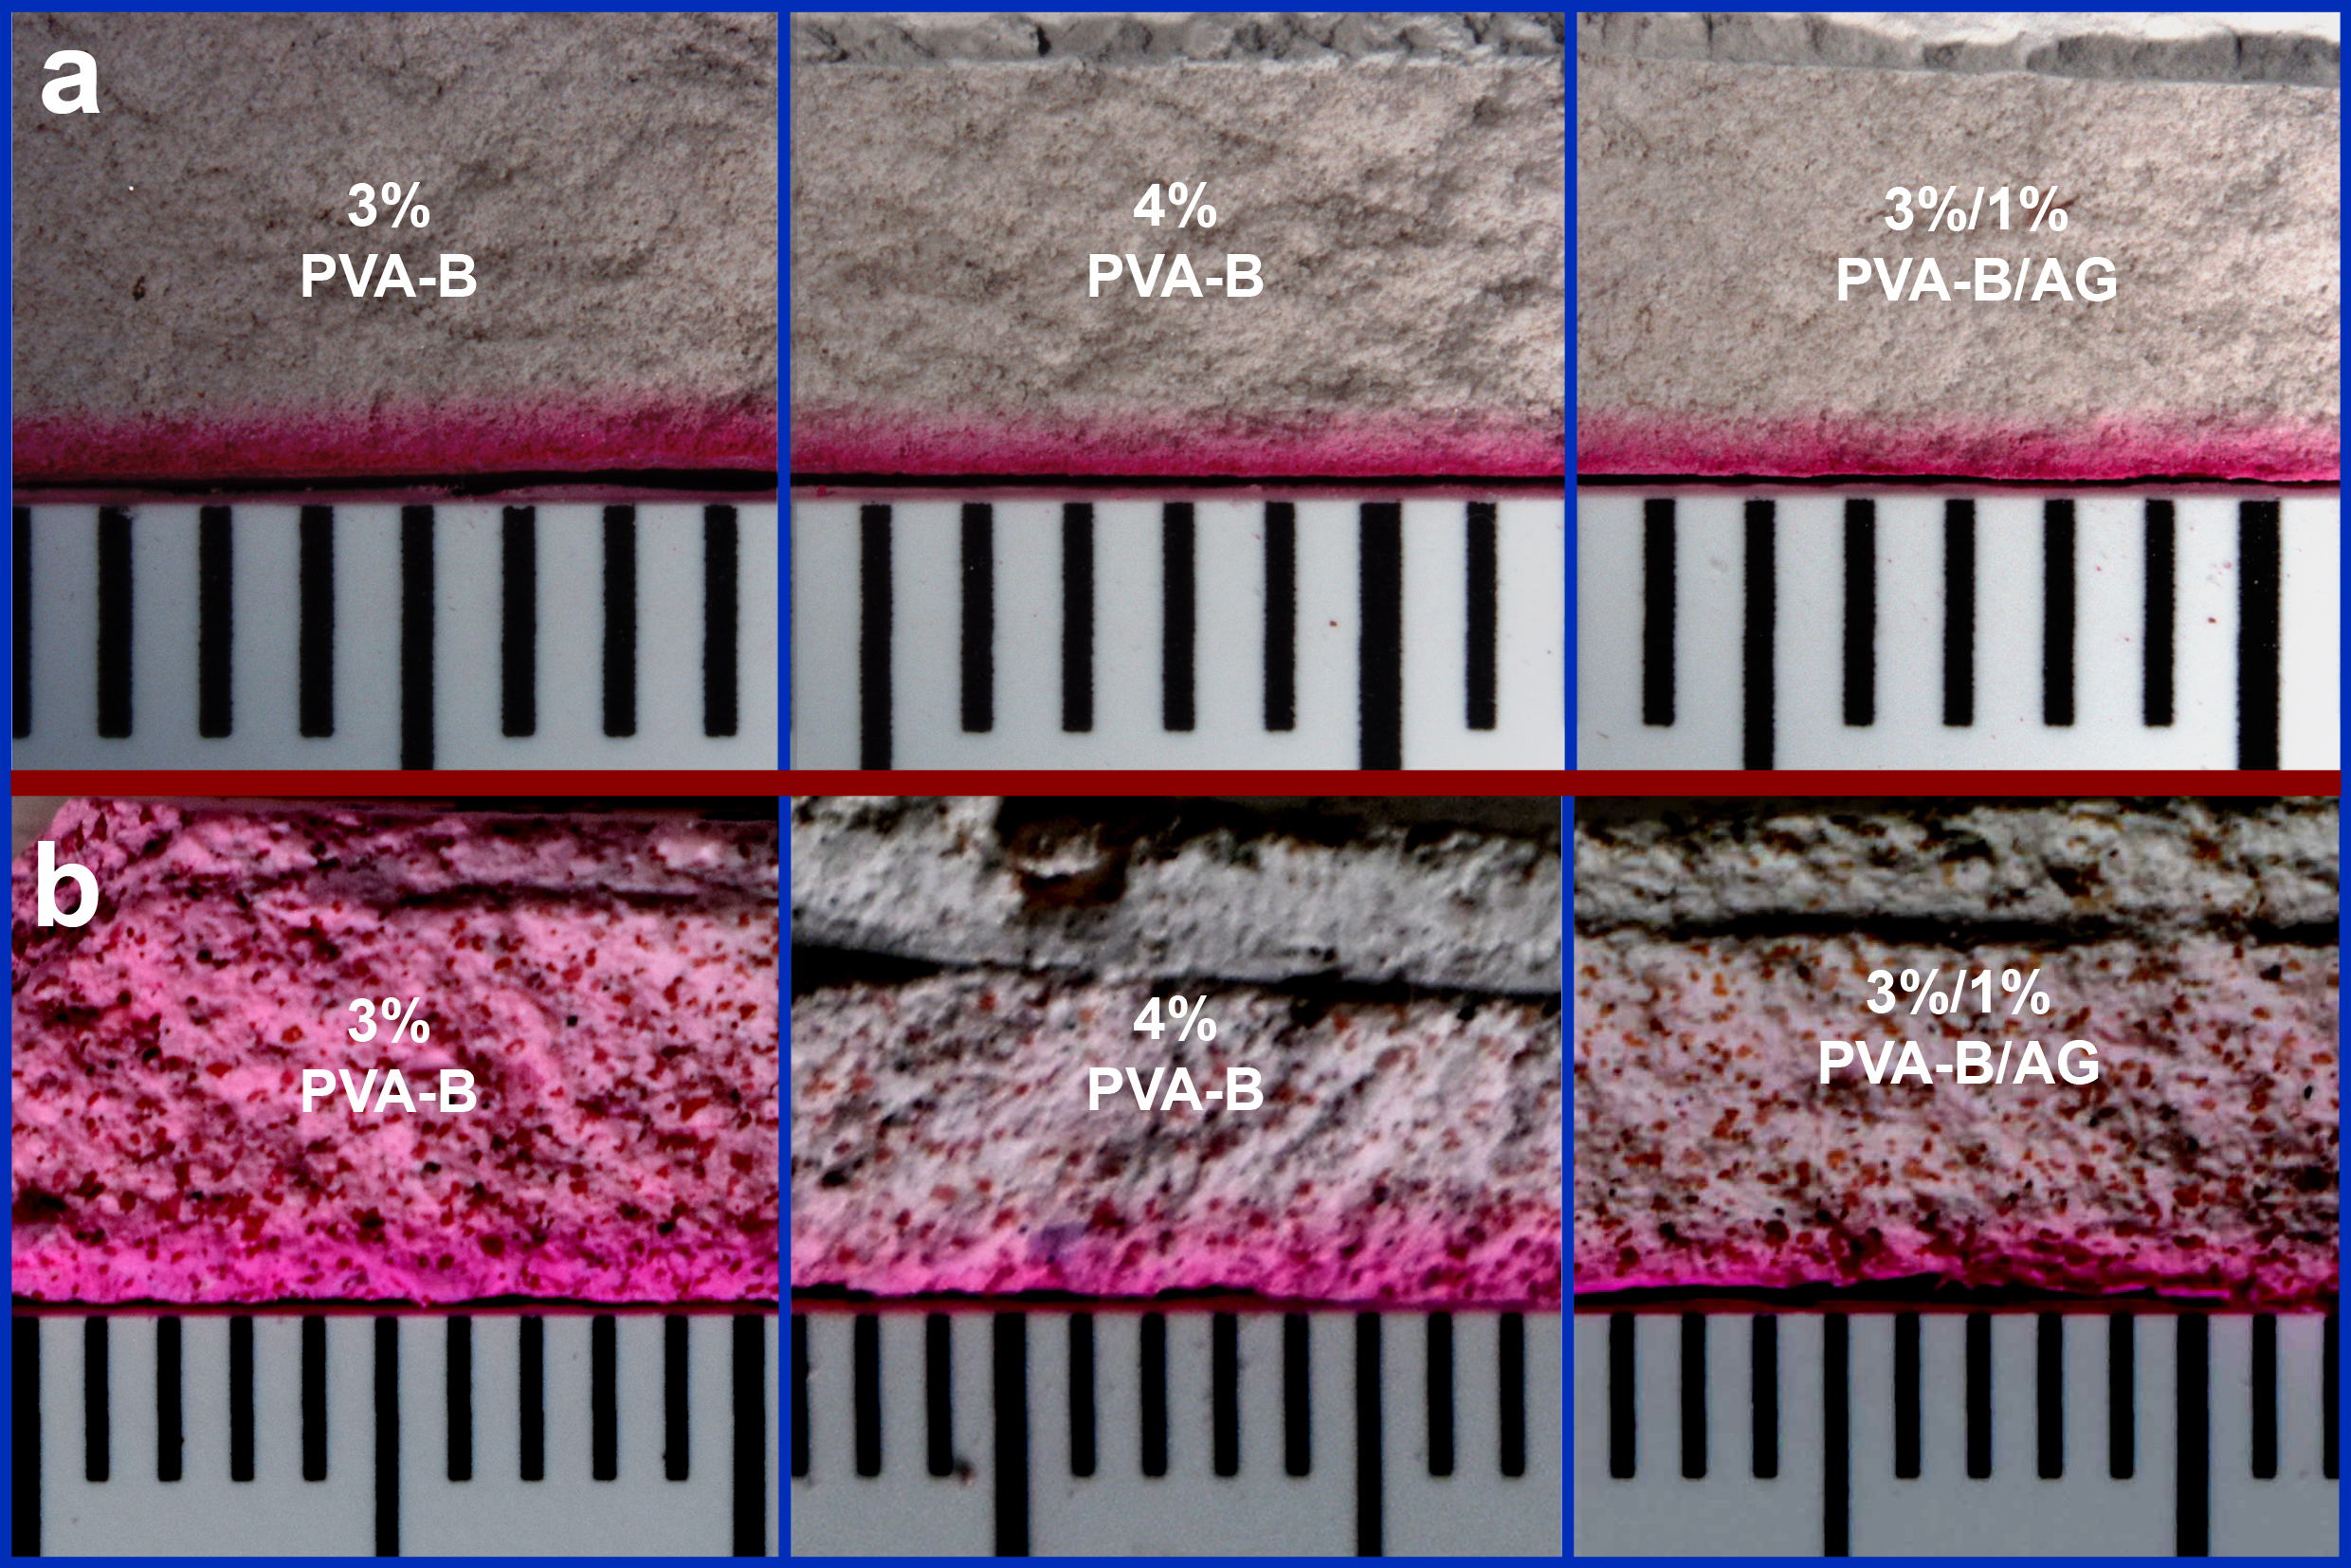
Figure S4: Cross sections of tiles treated with 3% PVA-B, 4% PVA-B, and 3%/1% PVA-B/AG formulations dyed with rhodamine B dye to track the diffusion of the liquid phase. The diffusion of rhodamine B dye into a) limestone tiles and b) plaster tiles. Vertical ruler marks spaced 1 mm apart.
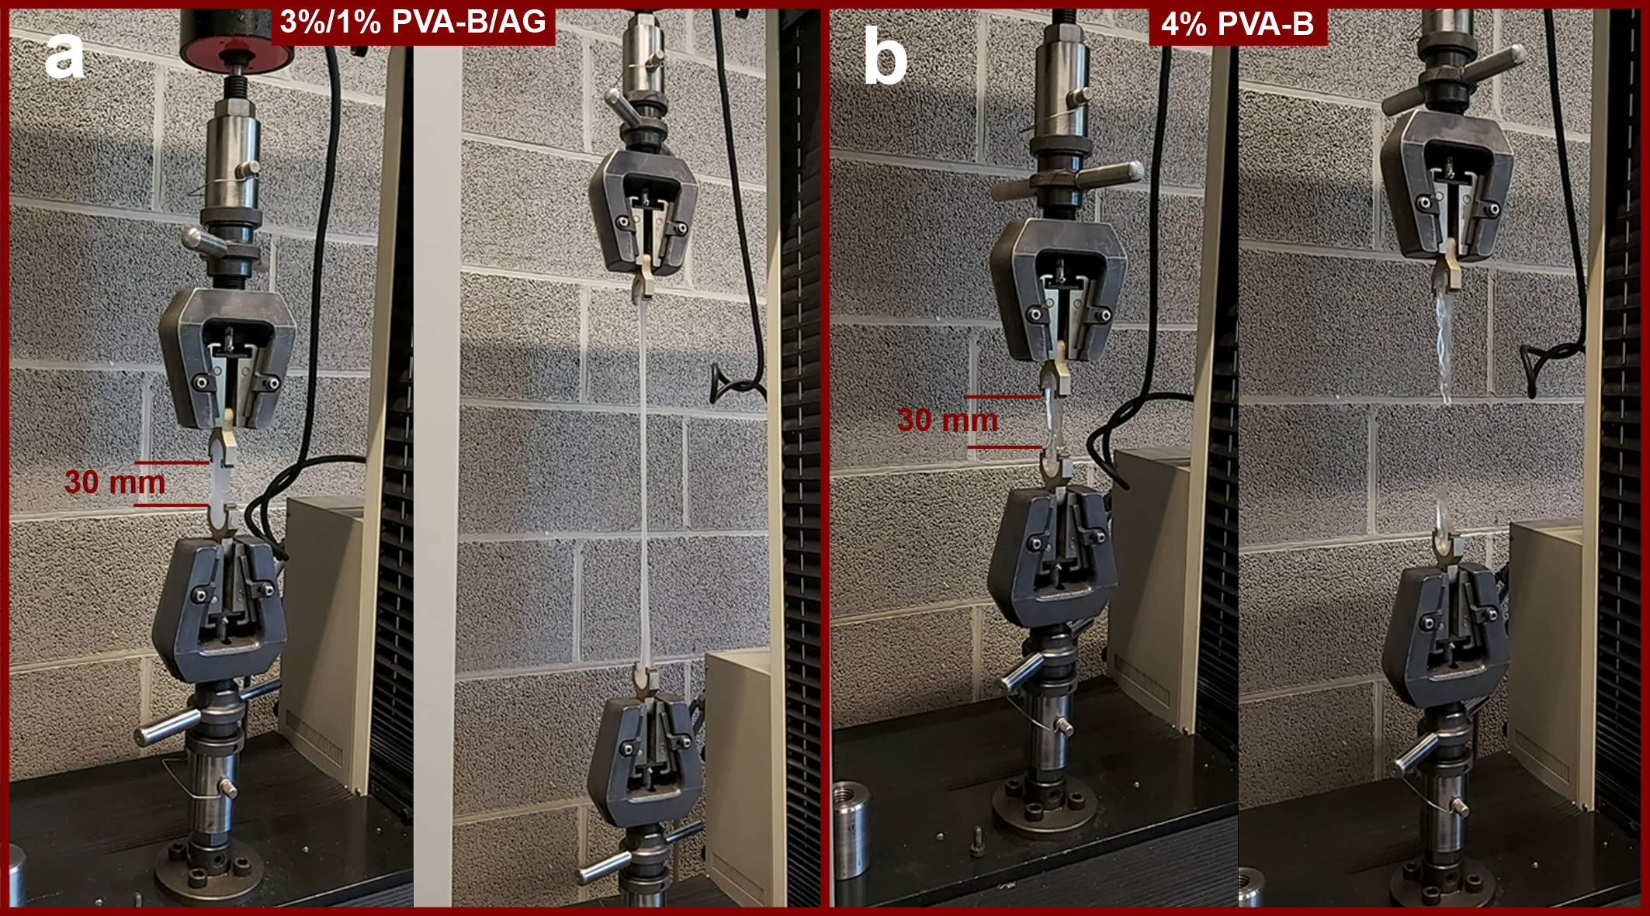
Figure S5: Illustrating the elongation of a) the 3%/1% PVA-B/AG DN hydrogel to the maximum gauge of the tensile testing machine. b) In the same conditions, the 4% PVA-B hydrogel broke.

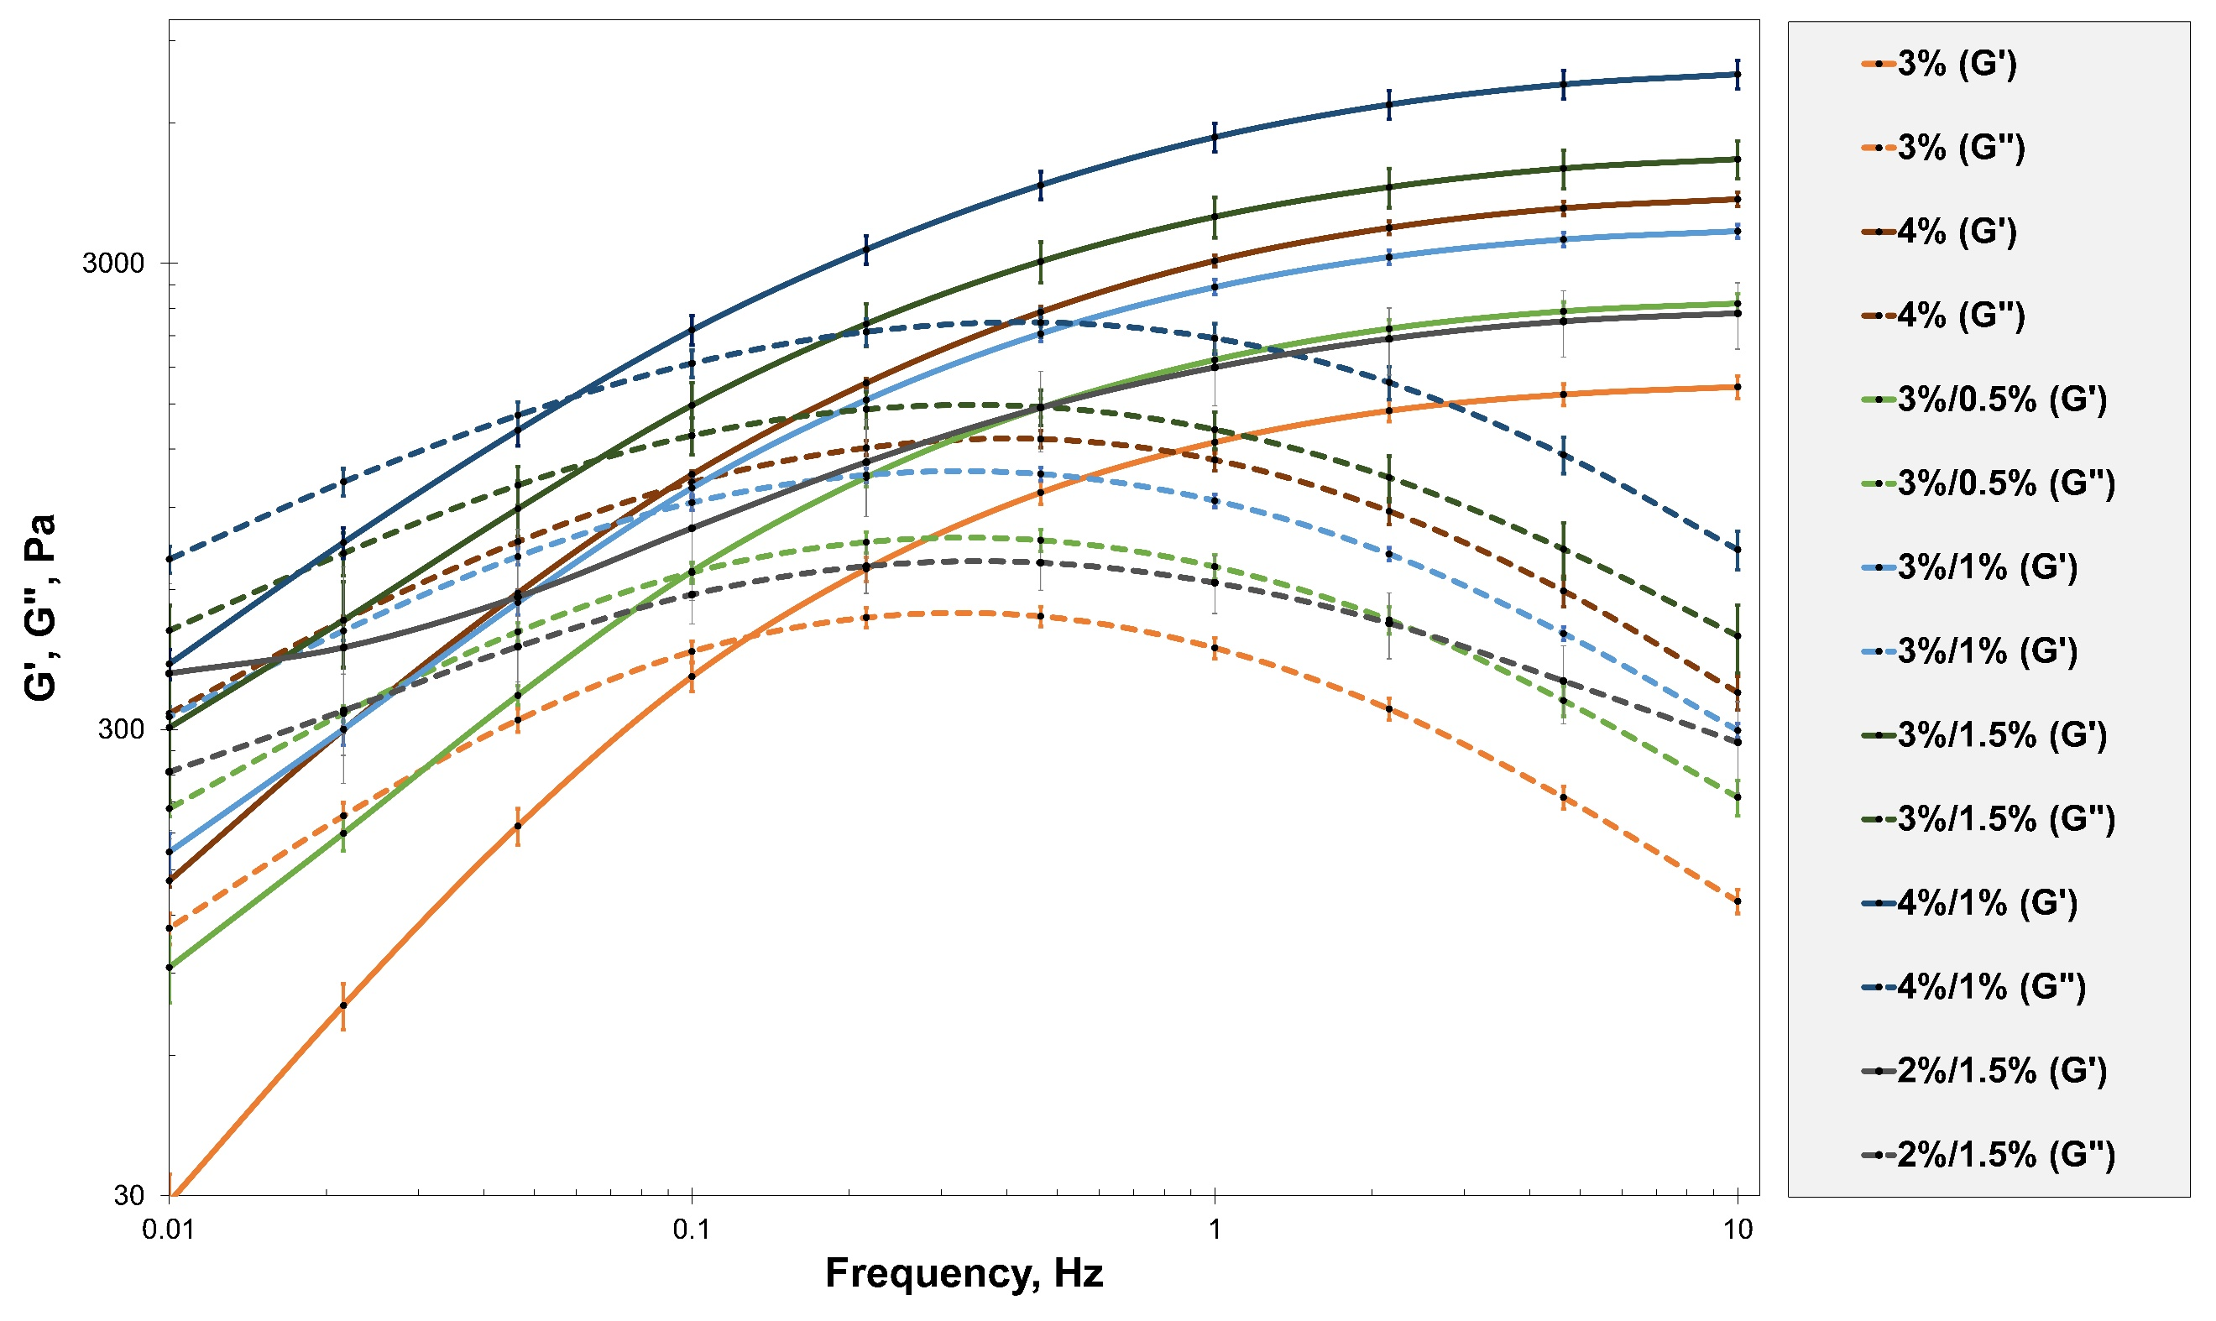
Figure S6: Frequency sweep curves of the investigated hydrogel formulations with only water (no cleaning agents).
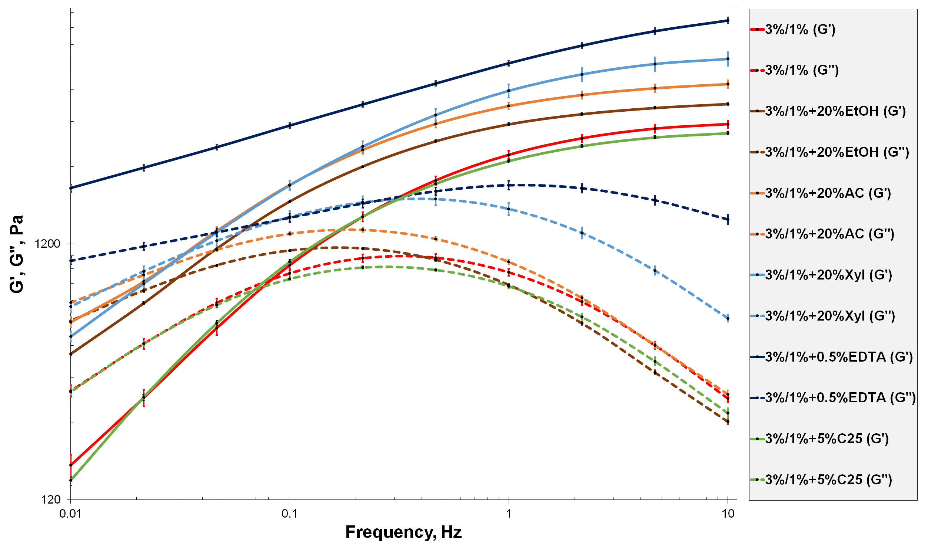
Figure S7: Frequency sweep curves of the 3%/1% PVA-B/AG hydrogel formulation loaded with the investigated cleaning agents.

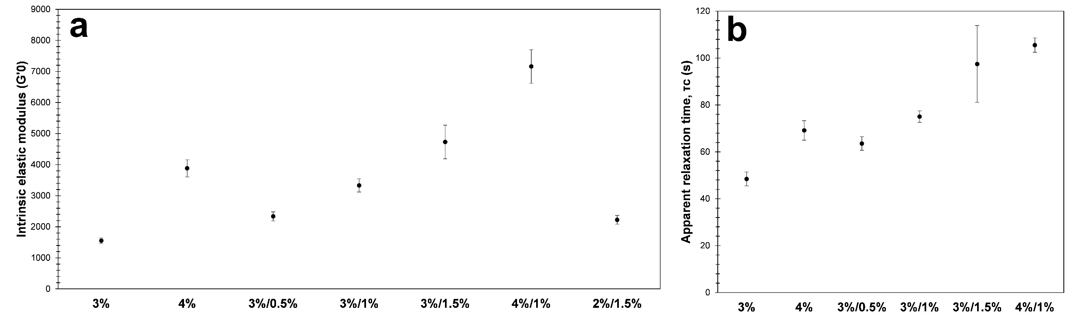
Figure S8: a) Intrinsic storage modulus (G’₀, in Pa) and b) apparent relaxation time (τ_{c}, in s) of the investigated hydrogel formulations (no cleaning agents were loaded). The error bars represent the standard deviation.

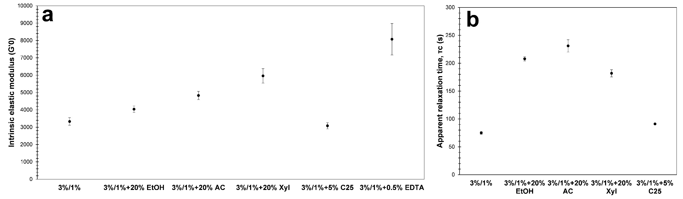
Figure S9: a) Intrinsic storage modulus (G’₀, in Pa) and b) apparent relaxation time (τ_{c}, in s) of the investigated hydrogel formulations loaded with various cleaning agents. The error bars represent the standard deviation.

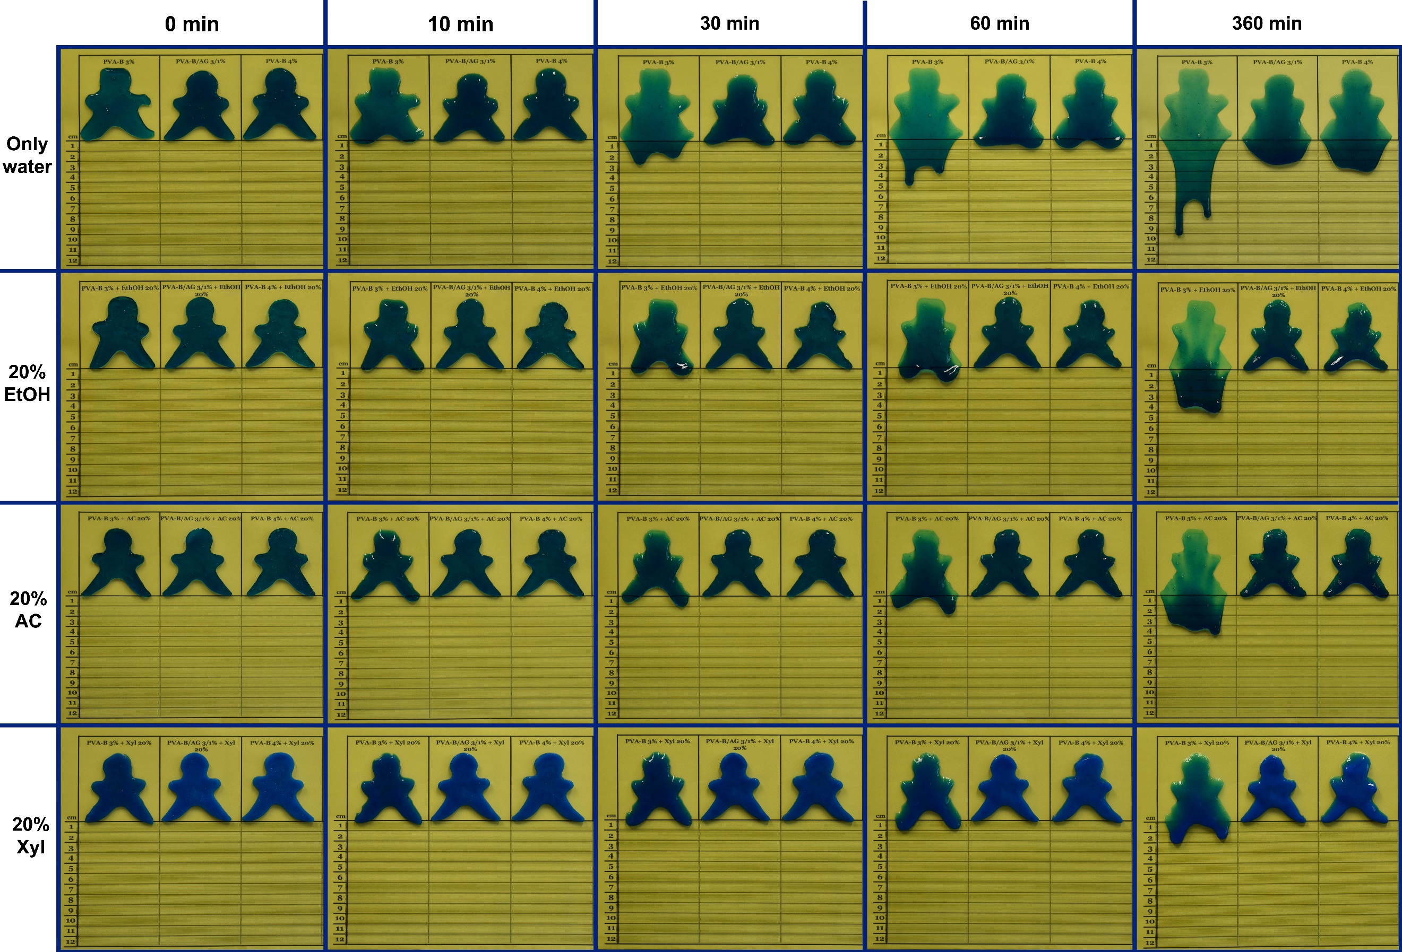
Figure S10: Vertical flow test of 3% PVA-B (left), 3%/1% PVA-B/AG (middle), and 4% PVA-B (right) hydrogels at different time intervals (with and without solvents). The hydrogels were dyed with methylene blue for better visibility.

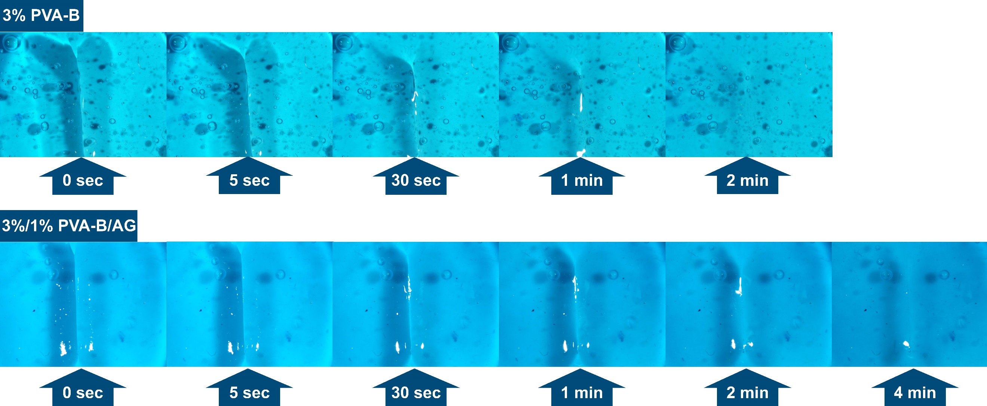
Figure S11: Self-healing behavior of 3% PVA-B and 3%/1% PVA-B/AG hydrogels under microscope. The hydrogels were dyed with methylene blue for better visibility.

References

1. Angelova LV, Terech P, Natali I, Dei L, Carretti E, Weiss RG. Cosolvent gel-like materials from partially hydrolyzed poly(vinyl acetate)s and borax. Langmuir. 2011;27(18):11671-82.

