Soot removal from ancient Egyptian complex painted surfaces using a double network gel: Empirical tests on the ceiling of the sanctuary of Osiris in the temple of Seti I – Abydos

Ehab Al-Emam^{1,2*}, Abdel Ghafour Motawea³, Joost Caen⁴, Koen Janssens²

¹ Department of Conservation, Faculty of Archaeology, Sohag University, 82524 Sohag, Egypt
² AXES, Faculty of Science, University of Antwerp, Groenenborgerlaan 171, 2020 Antwerp, Belgium
³ Department of Archaeological Conservation, Sohag, Ministry of Antiquities, Egypt
⁴ ARCHES, Faculty of Design Sciences, University of Antwerp, Blindestraat 9, 2000 Antwerp, Belgium

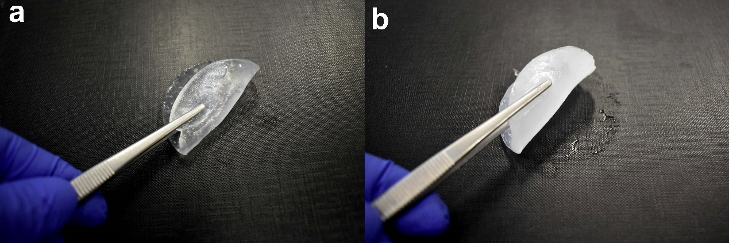
Figure S1: Shows the syneresis degree of the gel composites. a) GC1 shows no expelled liquids when being lifted from a hydrophobic surface while b) GC3 left a liquid layer on the surface.

Table S1: The appearance and the stability of the gel composites over 30 days. During this stability test, the gel composites were put in covered Petri dishes and preserved in the refrigerator (5 °C). It is worth noting that after a long period, the volatile solvents may evaporate from the gels especially when the gels are not covered well in the container. (+) Stable, (-) minor syneresis, (--) moderate syneresis, and (---) significant syneresis.
 | Gel composites (GC) | After 1 Day | After 3 Days | After 18 Days | After 30 Days
First cleaning test | GC1 | (+)  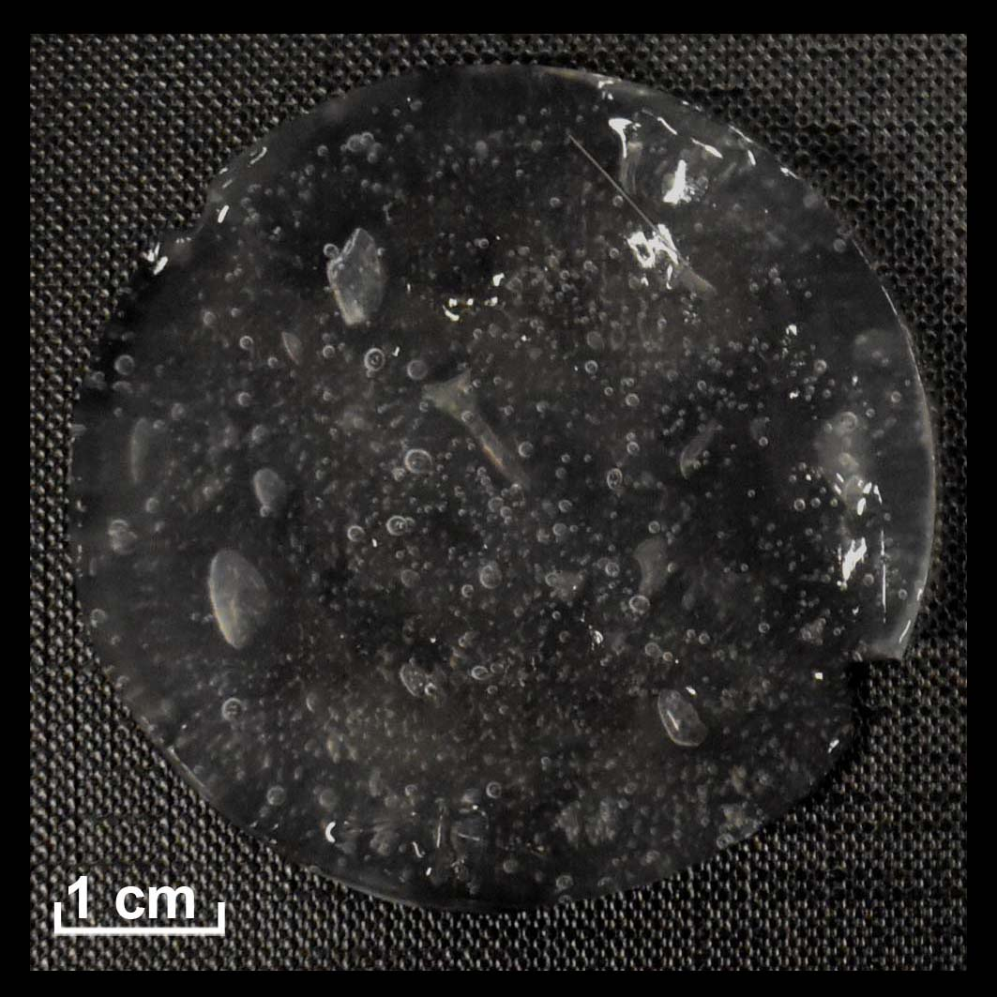 | (+)  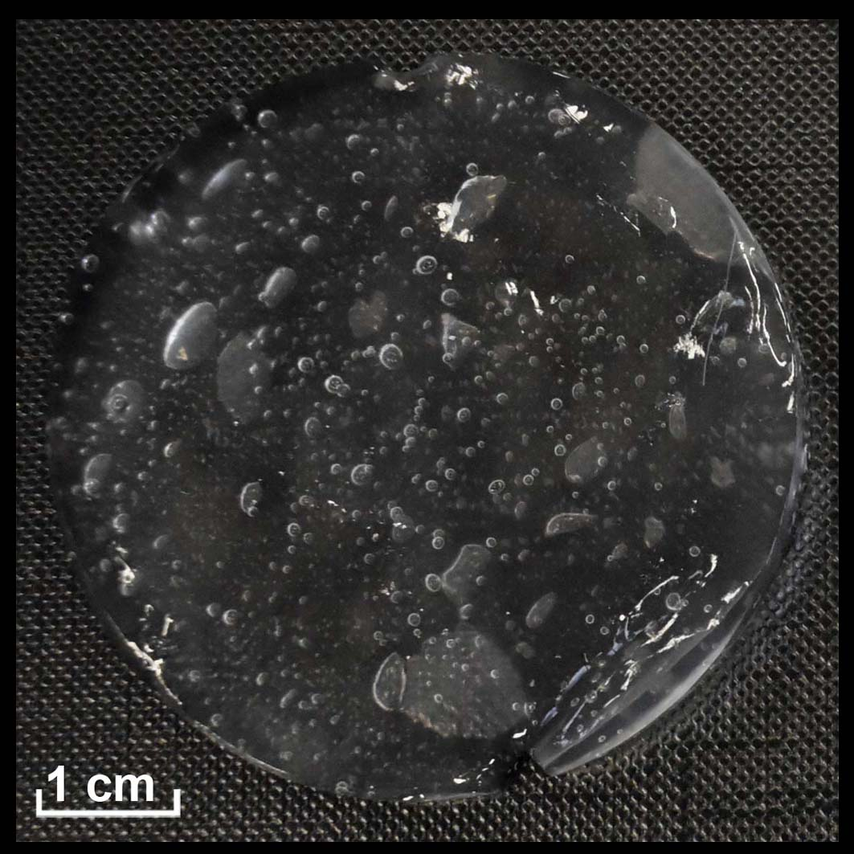 | (-)  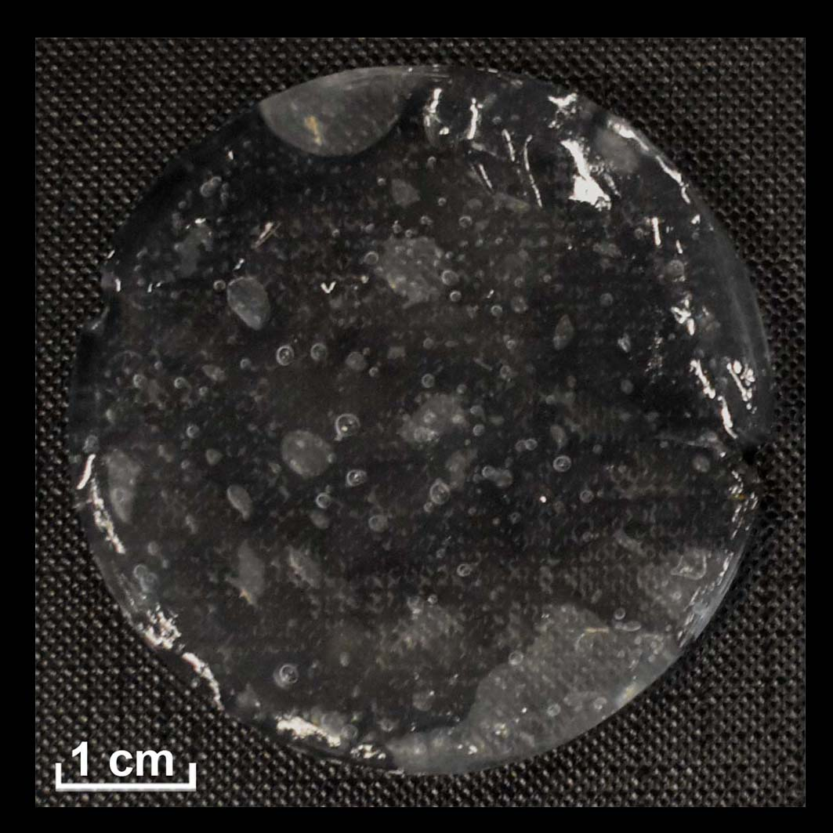 | (-)  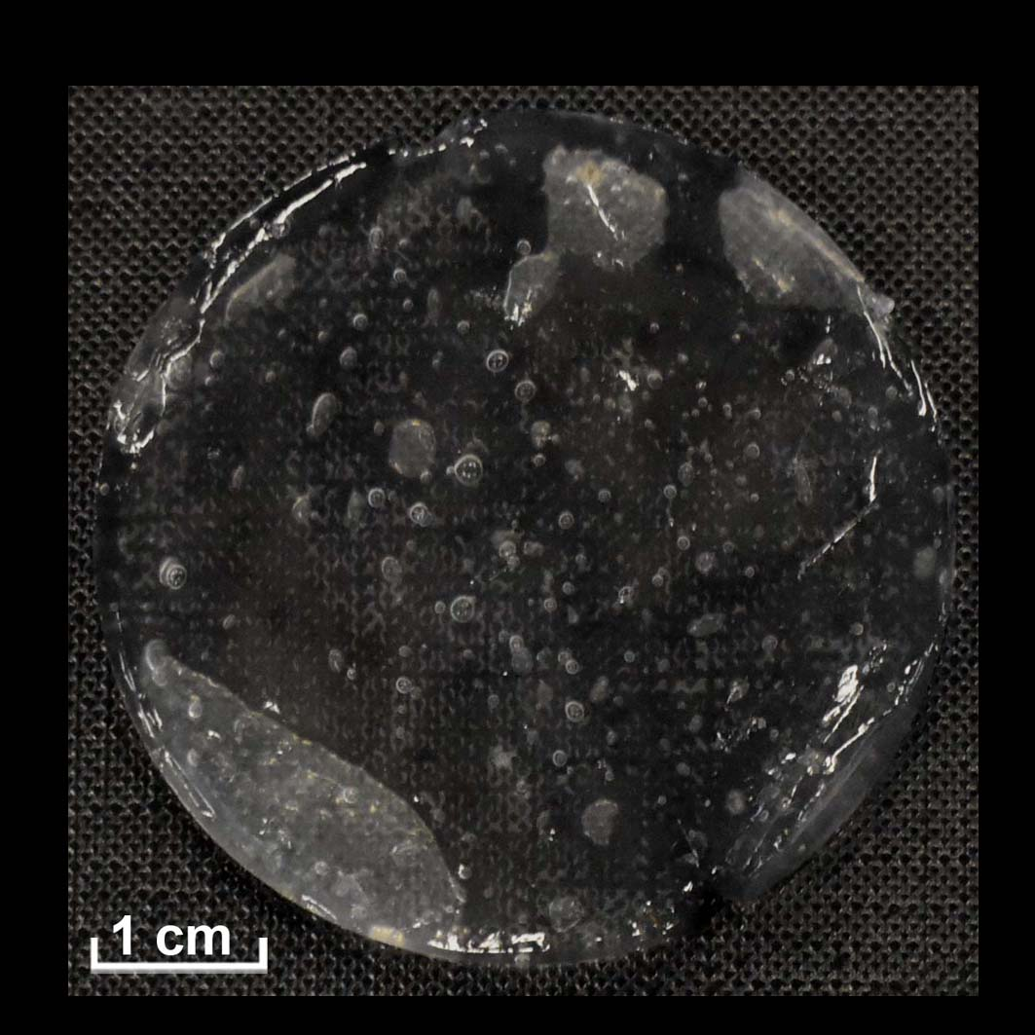
First cleaning test | GC2 | (-)  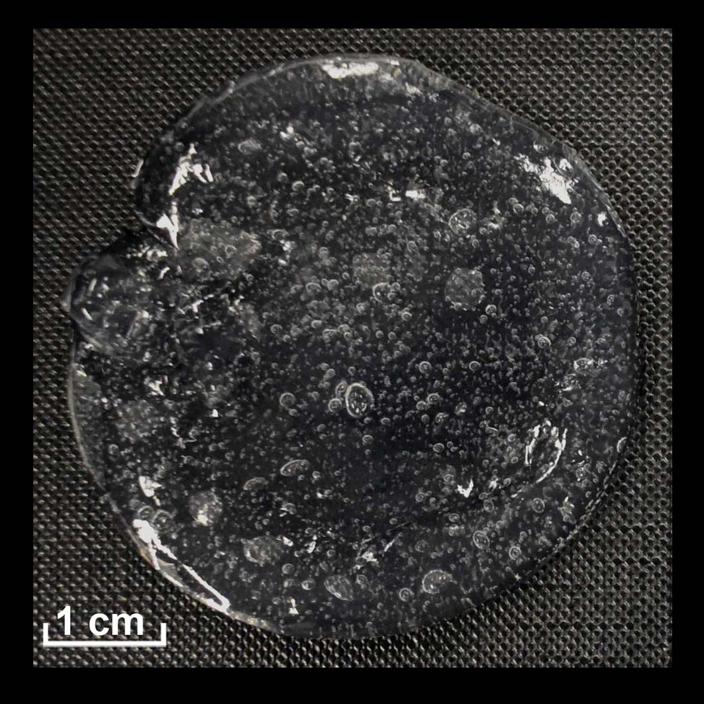 | (--)  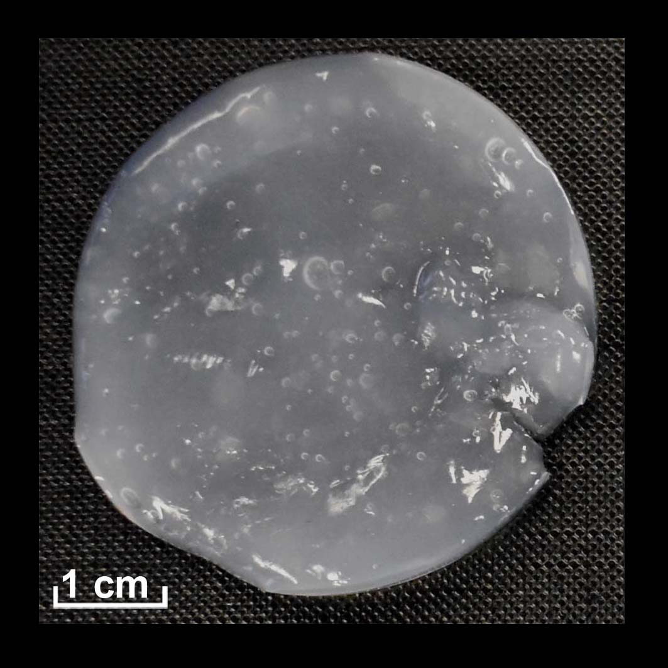 | (--)  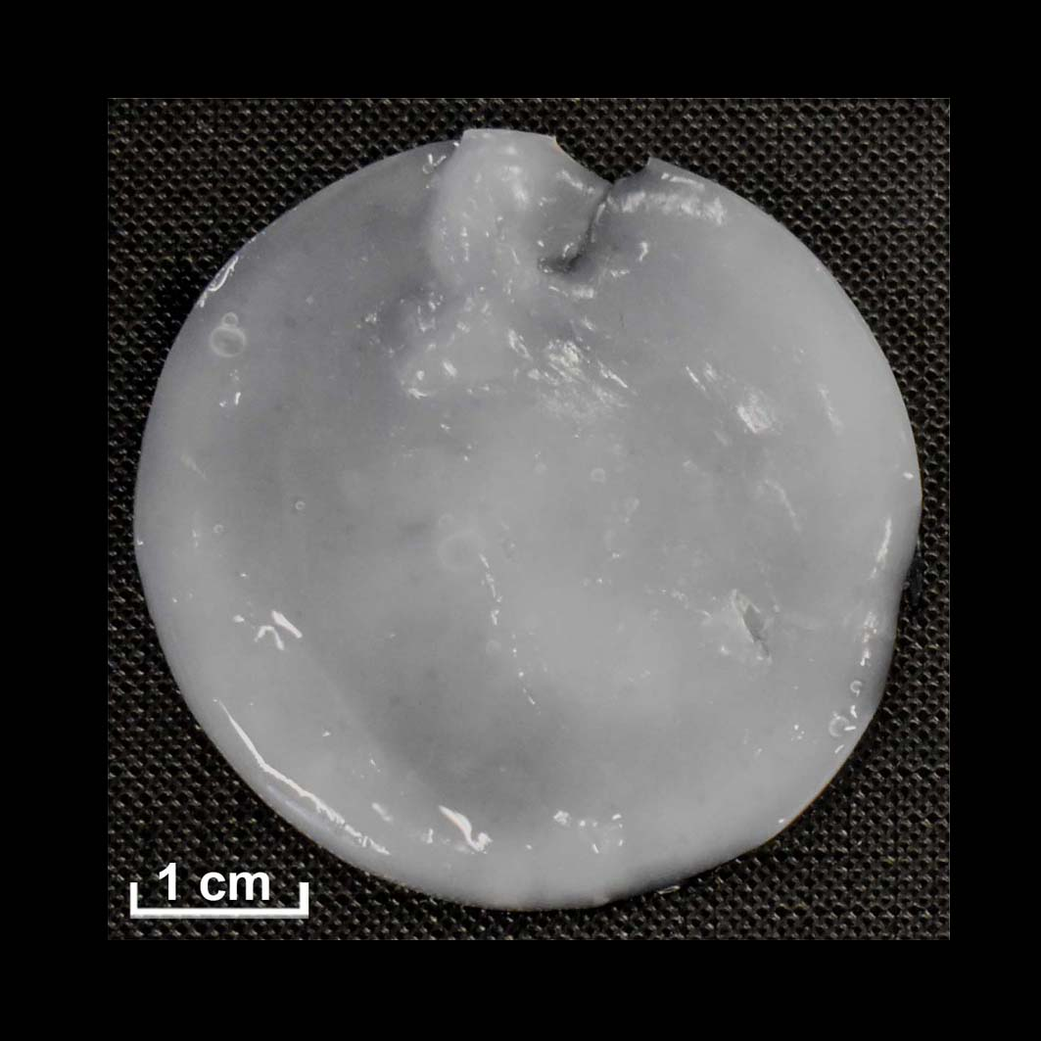 | (--)  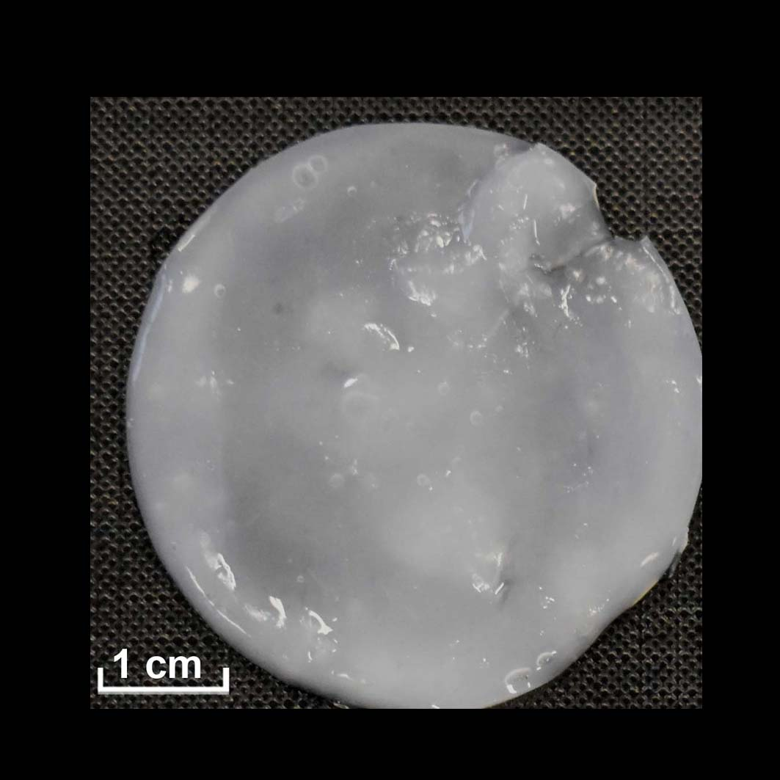
First cleaning test | GC3 | (-)  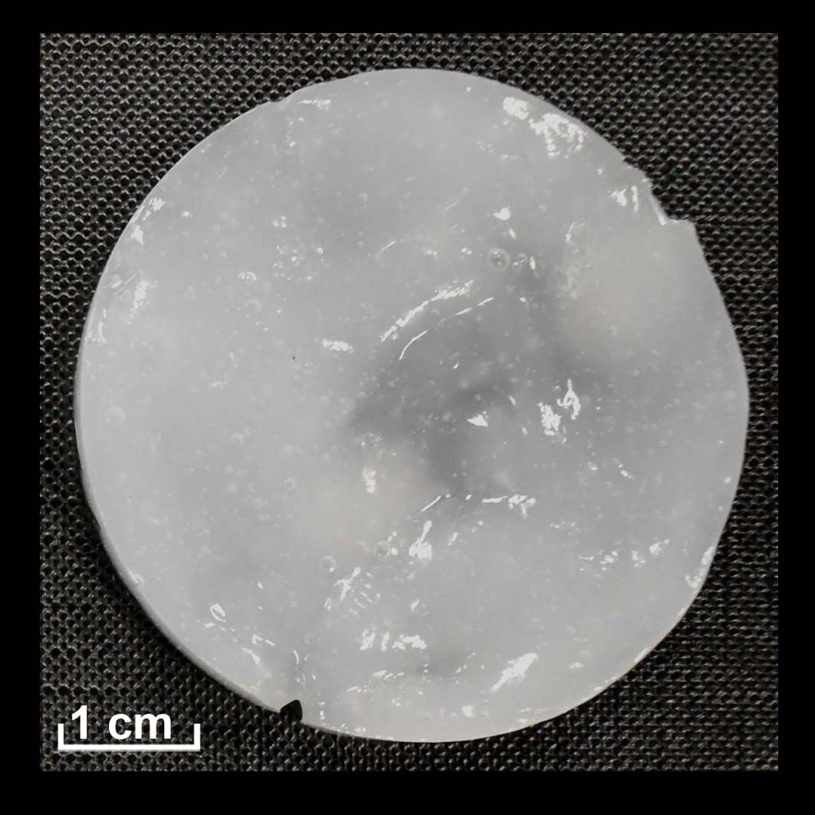 | (-)  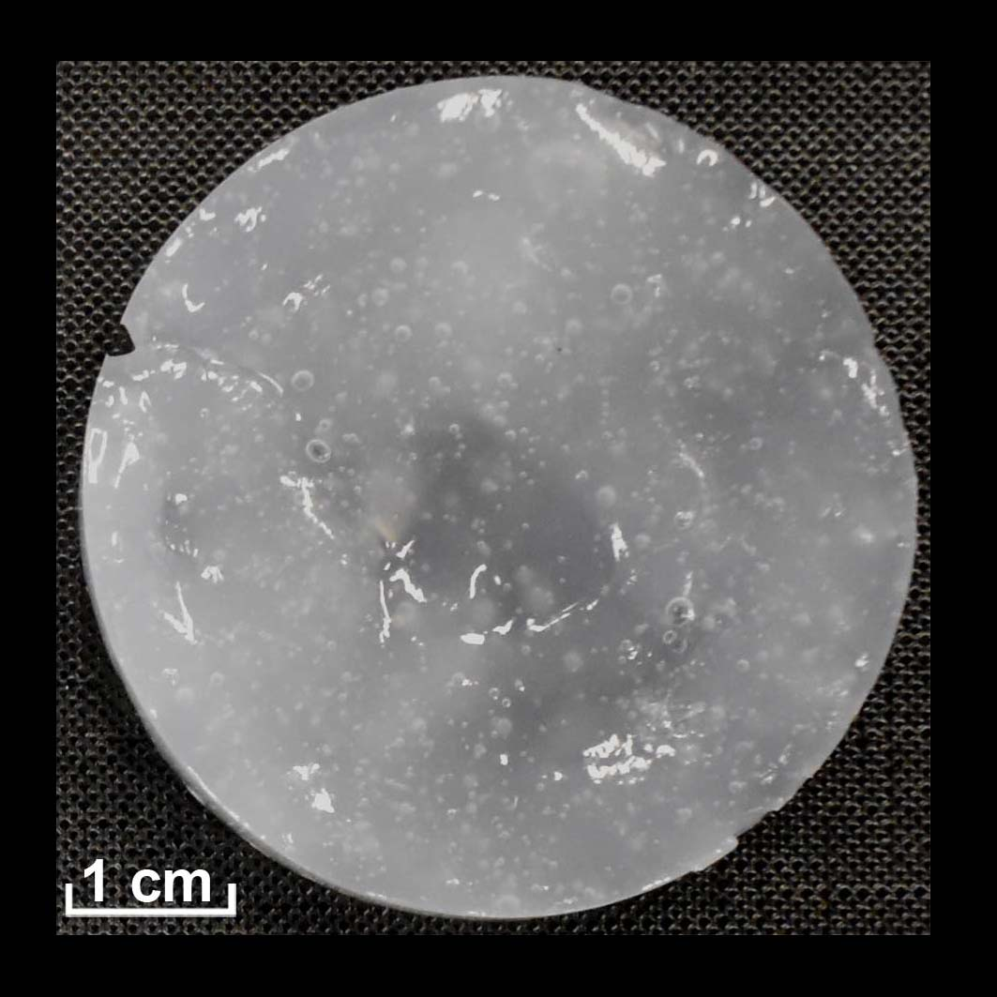 | (-)  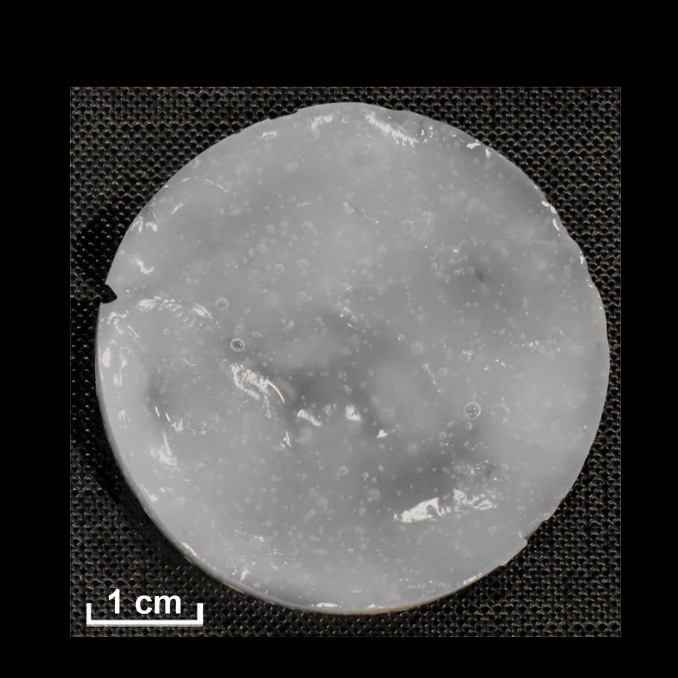 | (--)  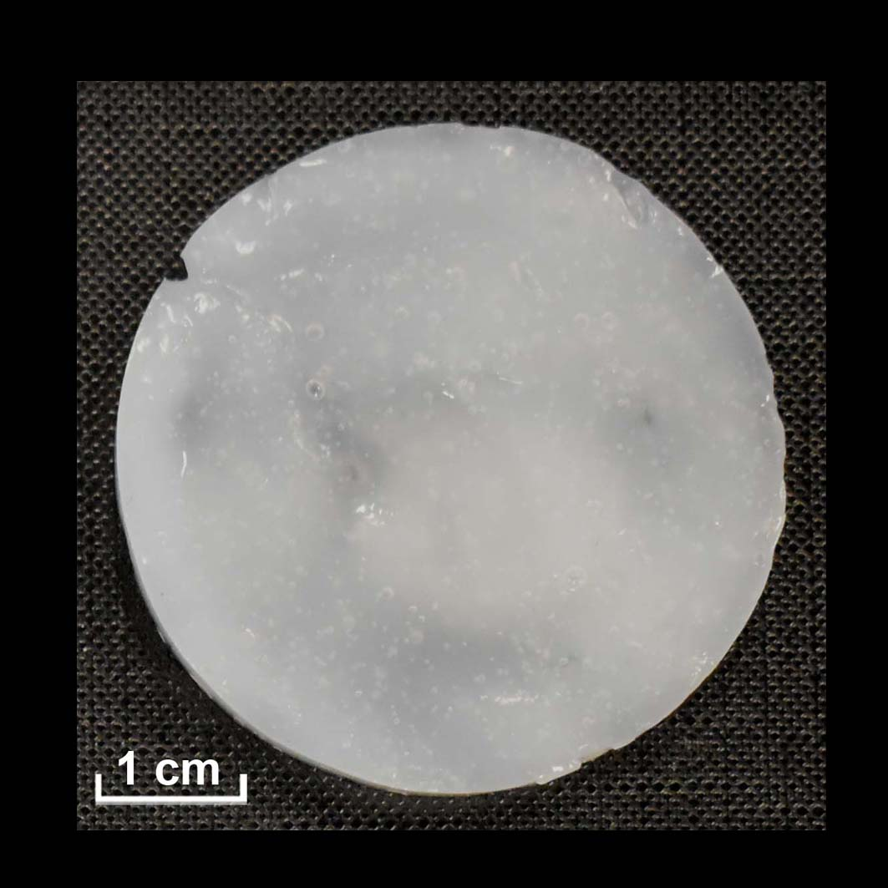
First cleaning test | GC4 | (-)  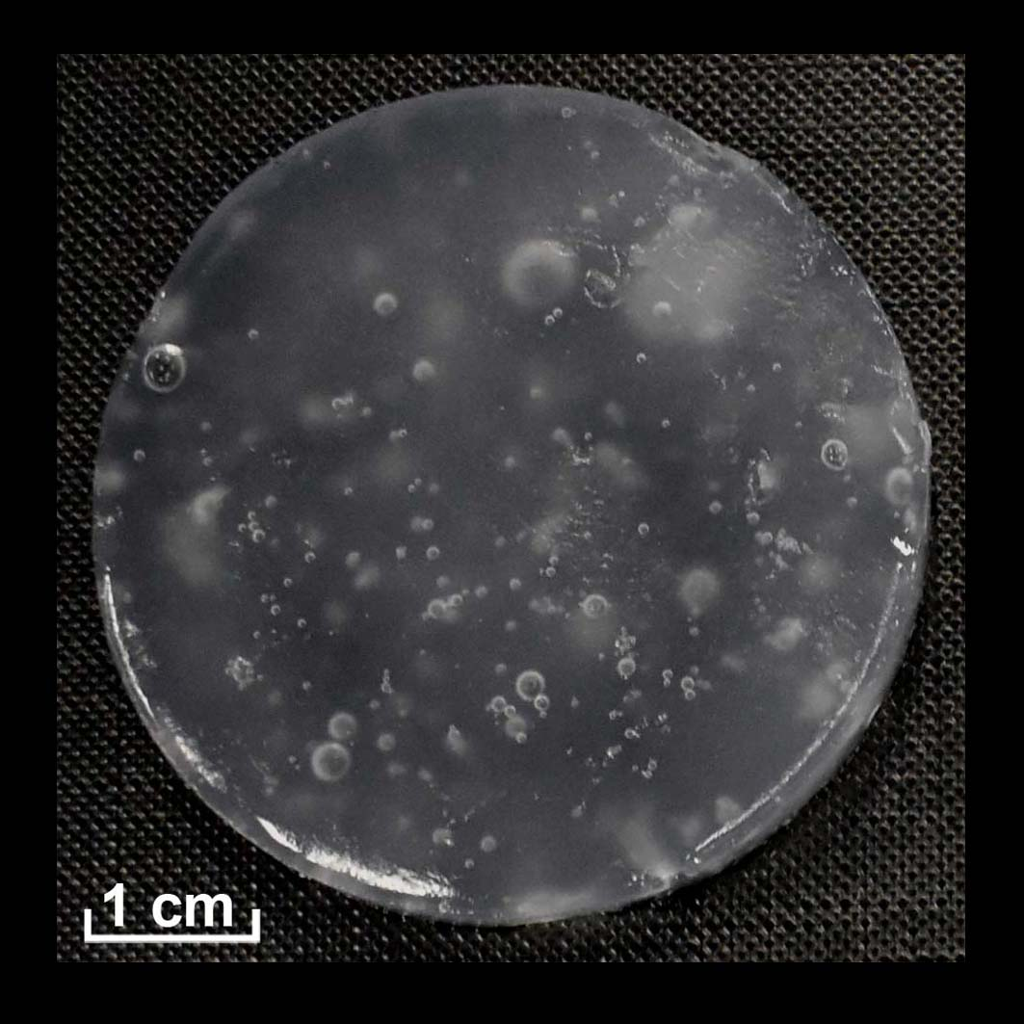 | (-)  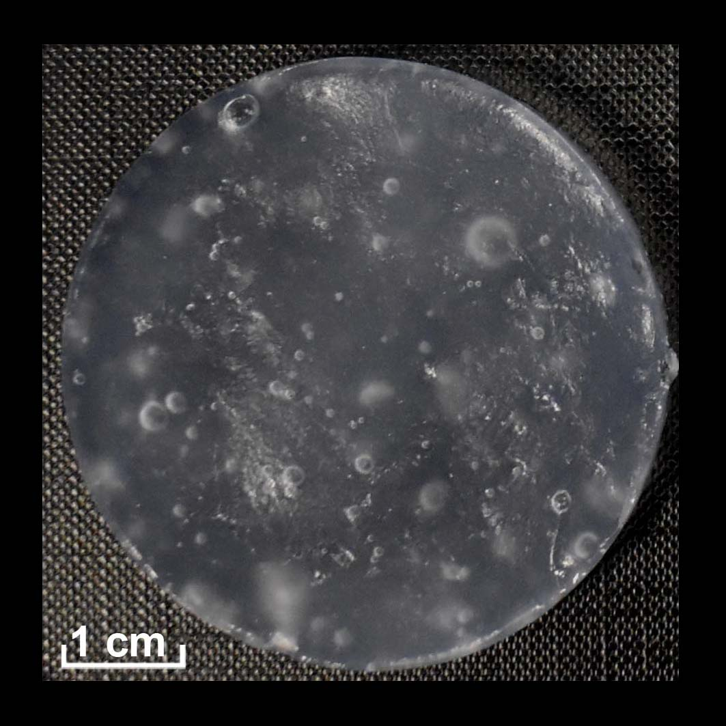 | (-)  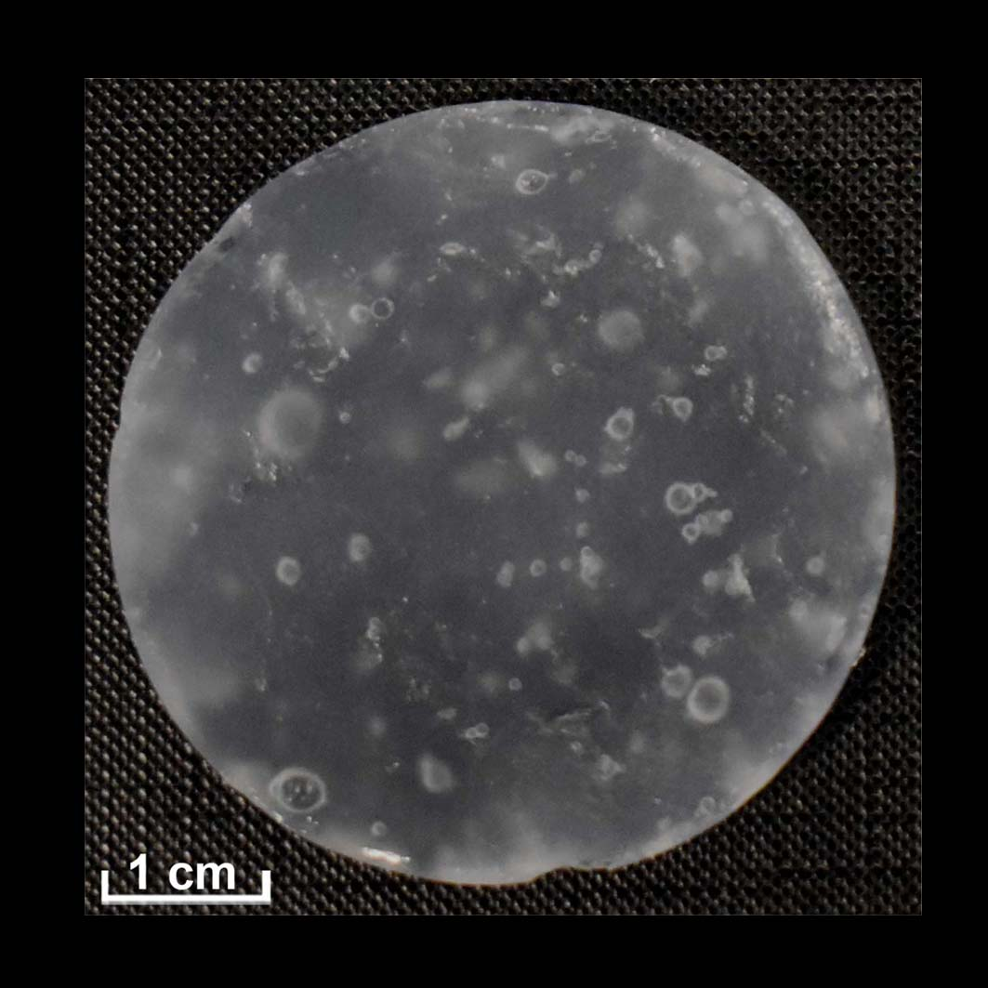 | (-)  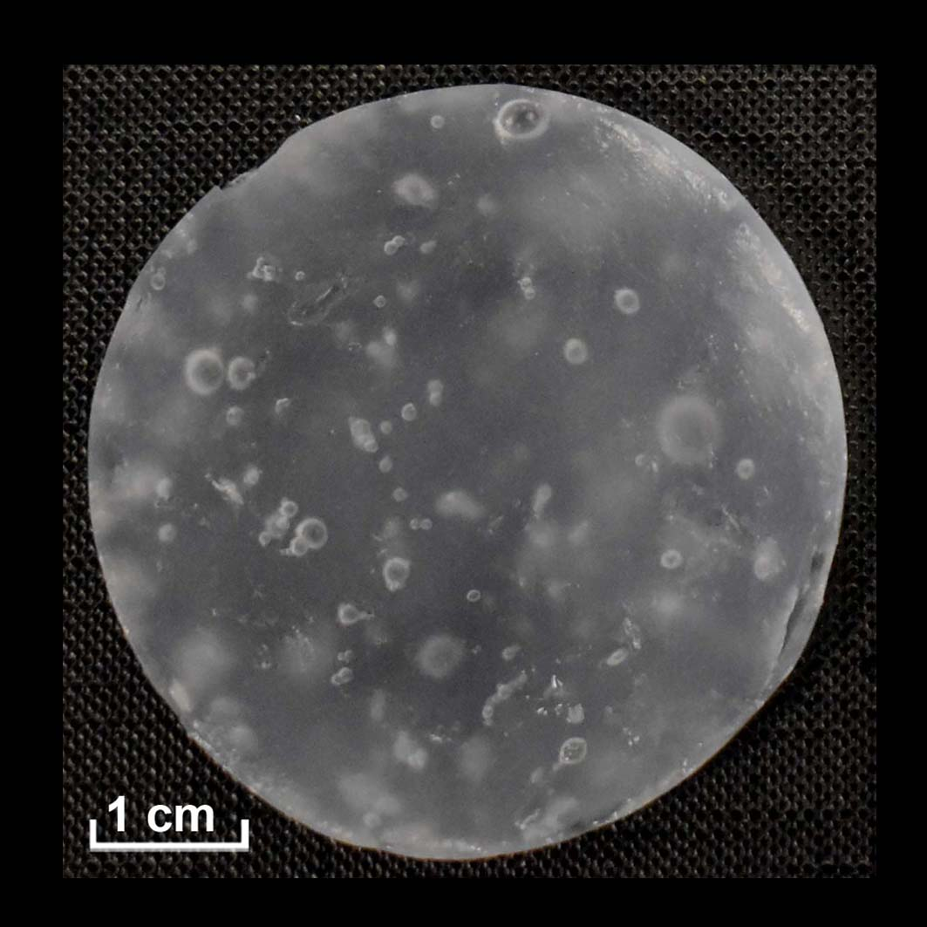
First cleaning test | GC5 | (-)  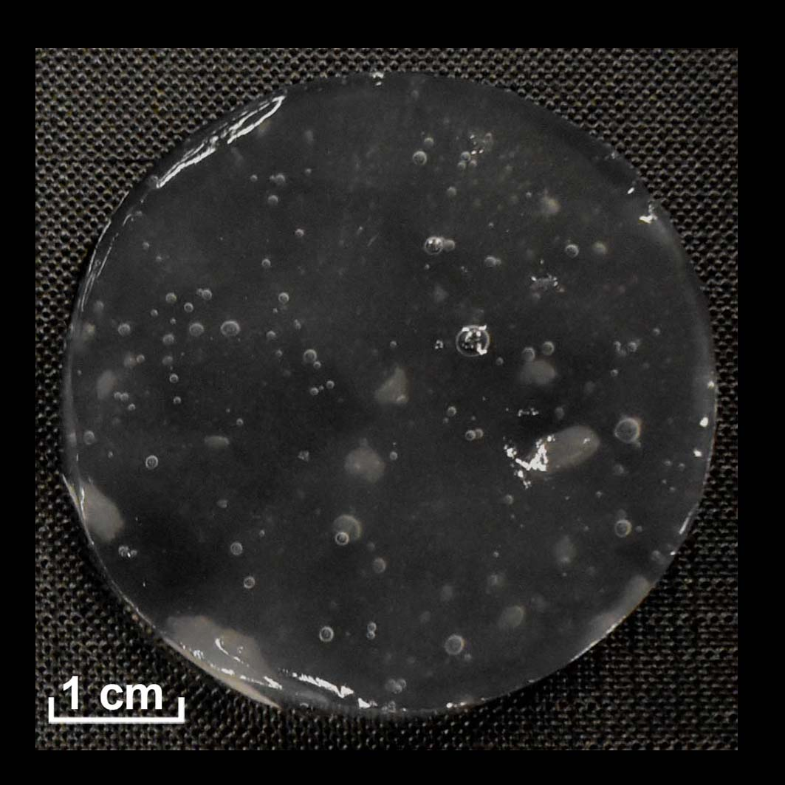 | (-)  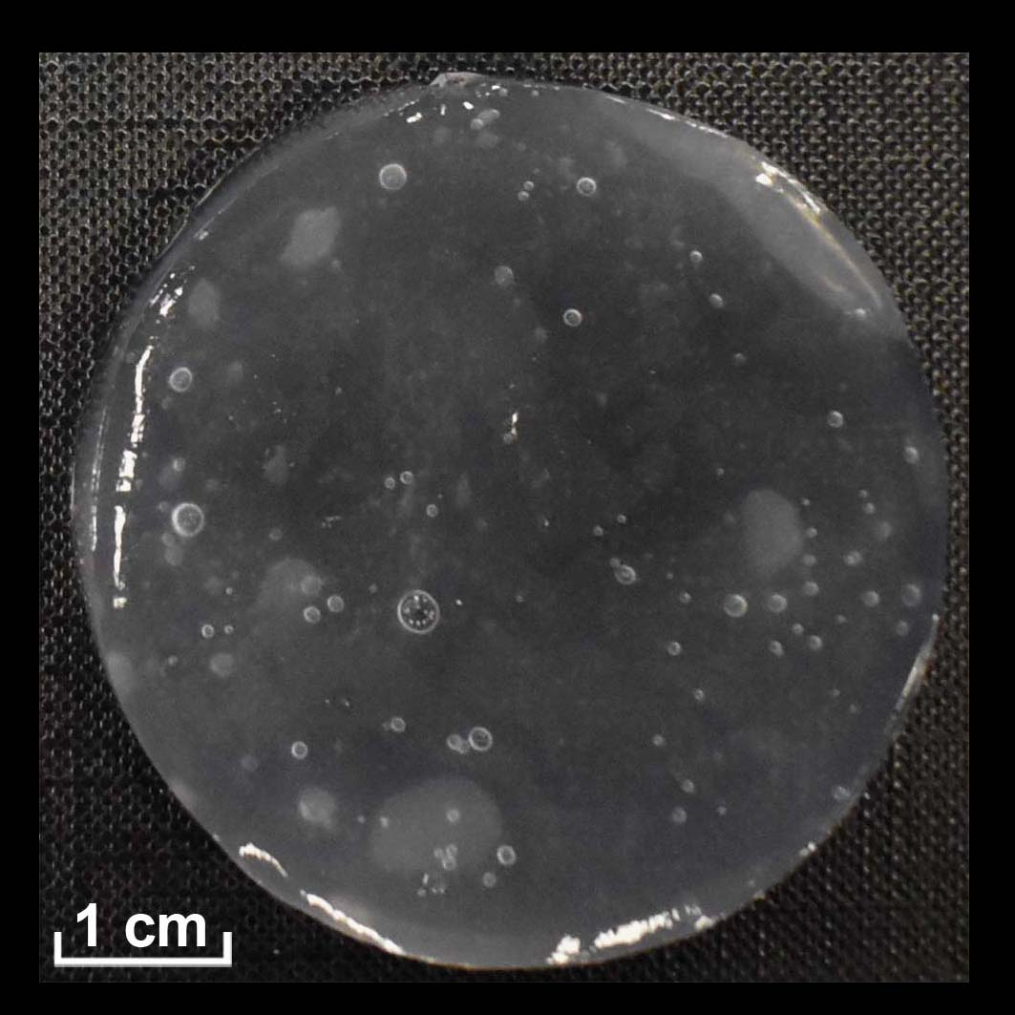 | (-)  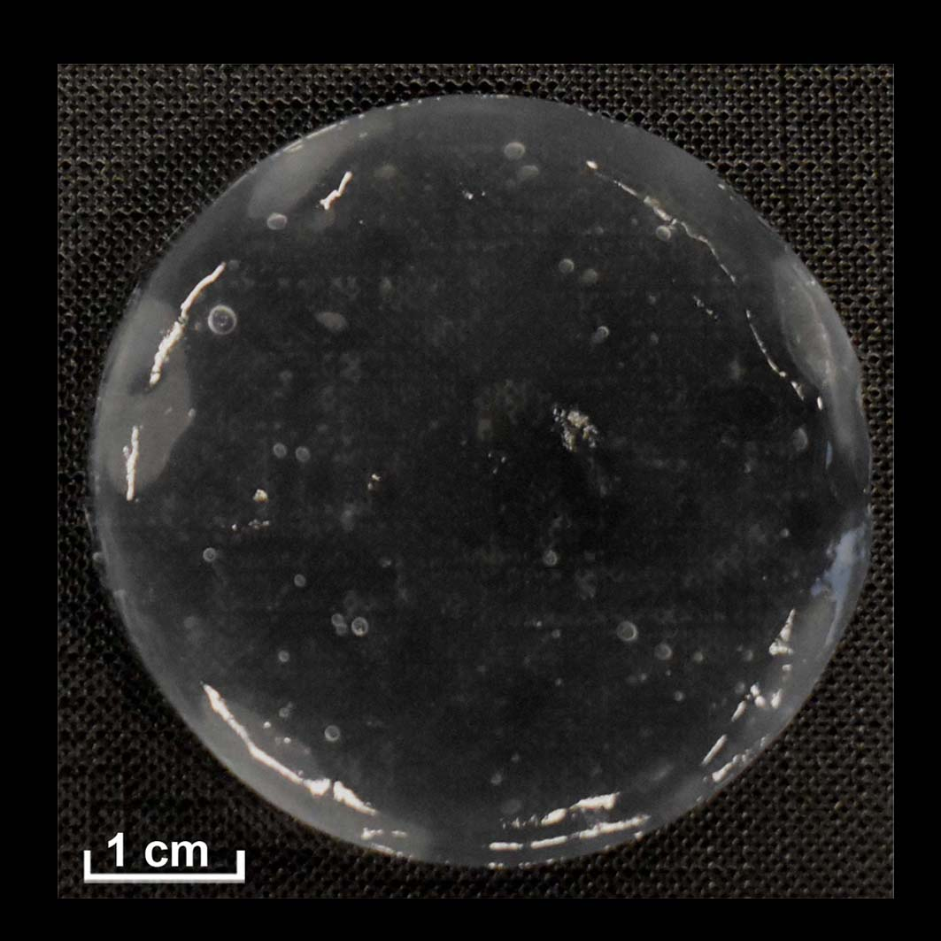 | (-)  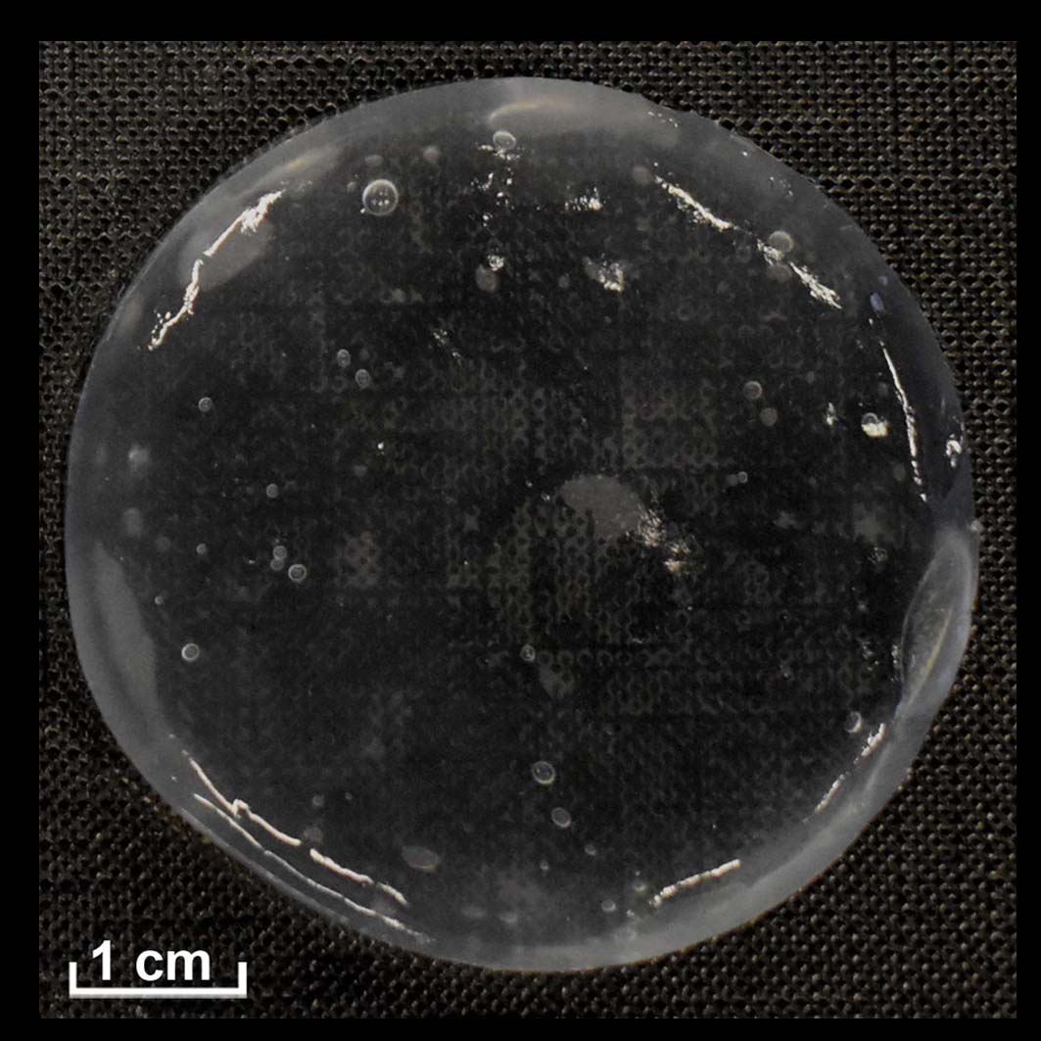
First cleaning test | GC6 | (+)  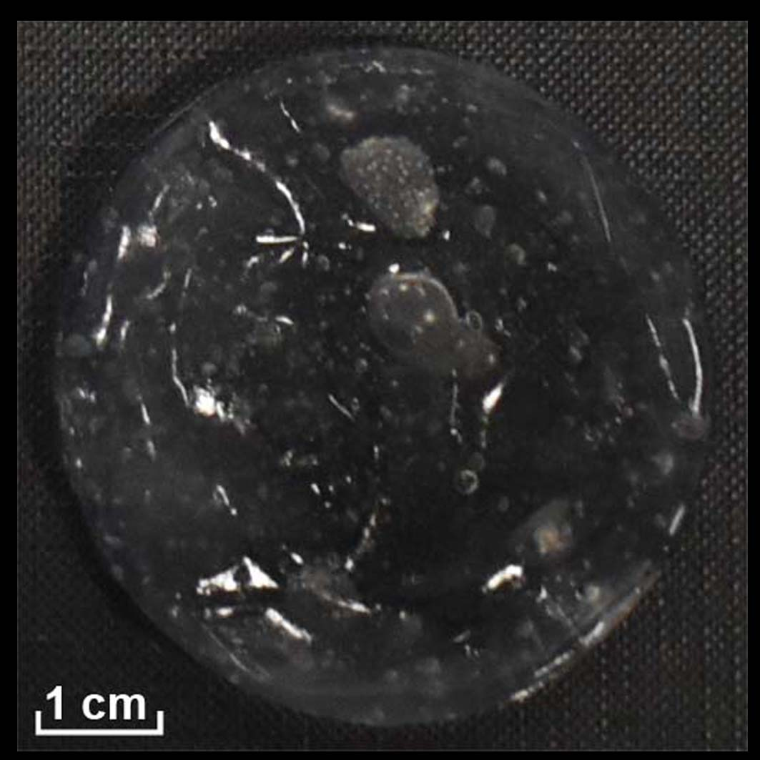 | (---)  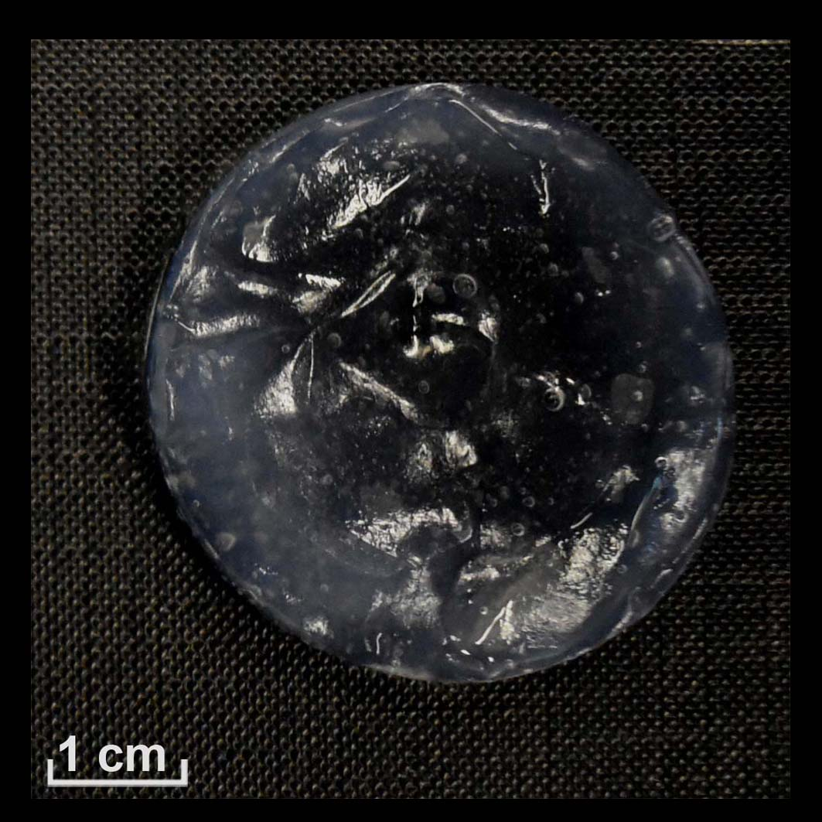 | (---)  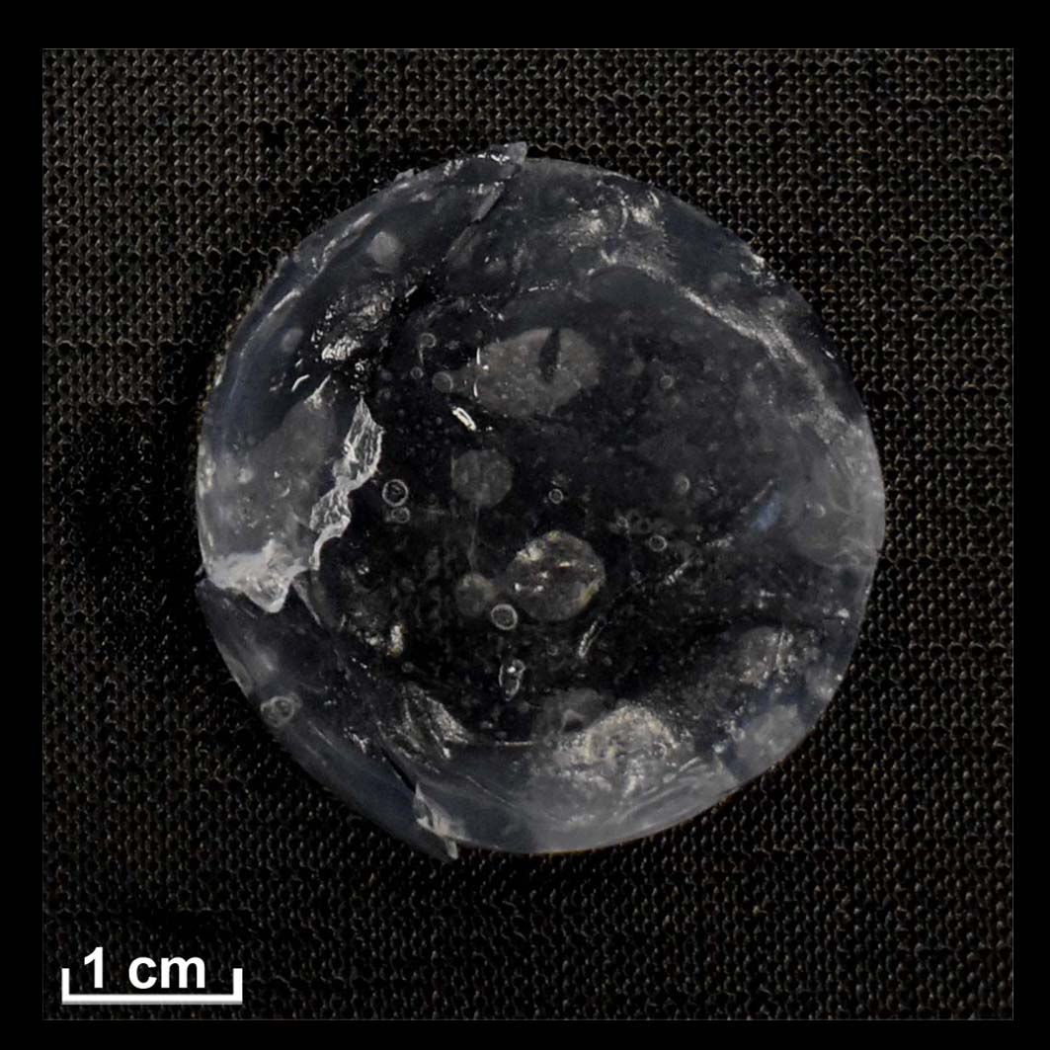 | (---)  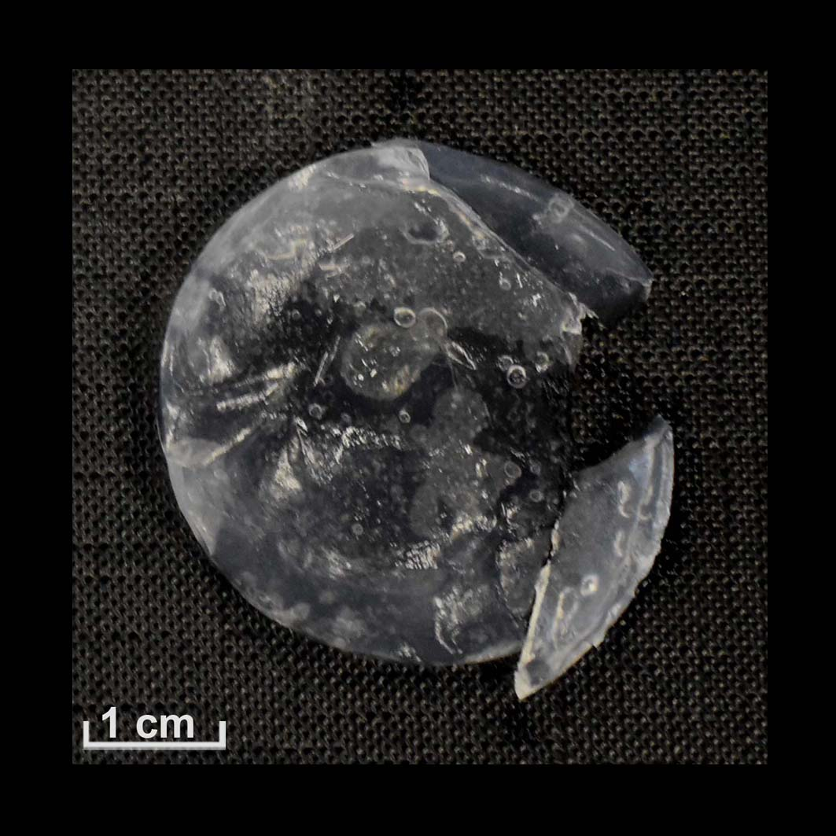
Second cleaning test | GC1 | (+) | (+) | (-) | (-)
Second cleaning test | GC2 | (-) | (--) | (--) | (--)
Second cleaning test | GC3 | (+)  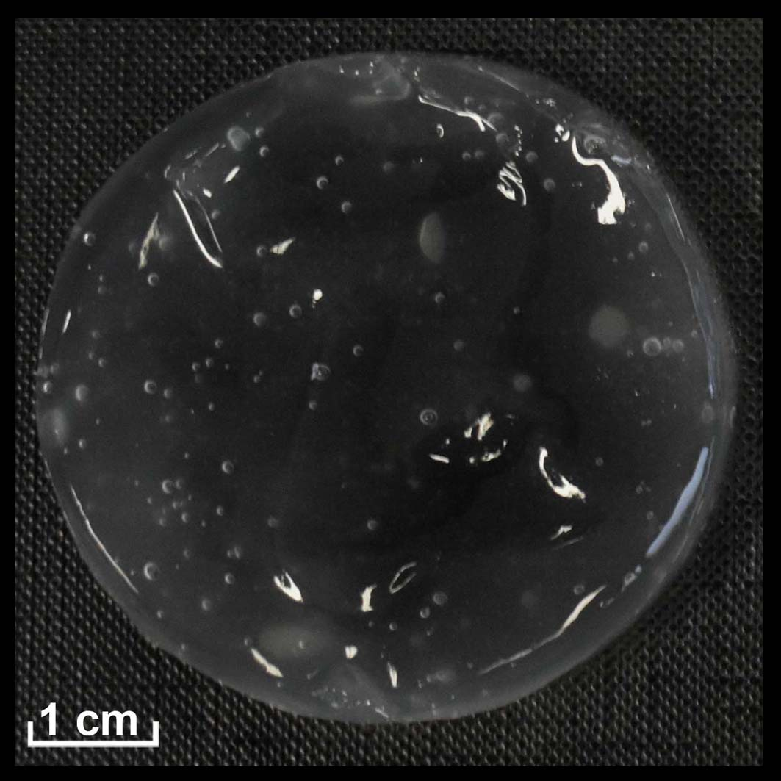 | (+)  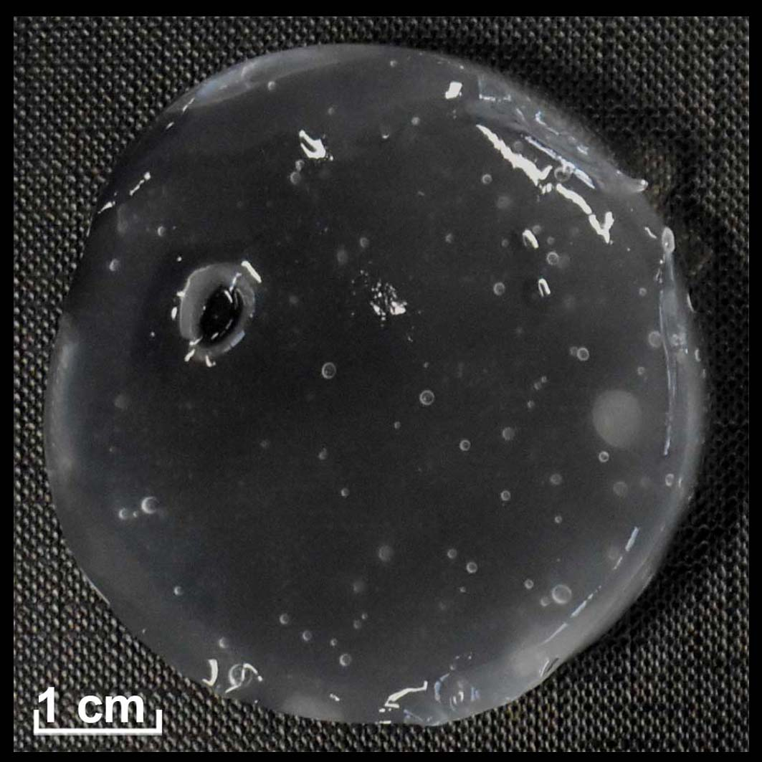 | (+)  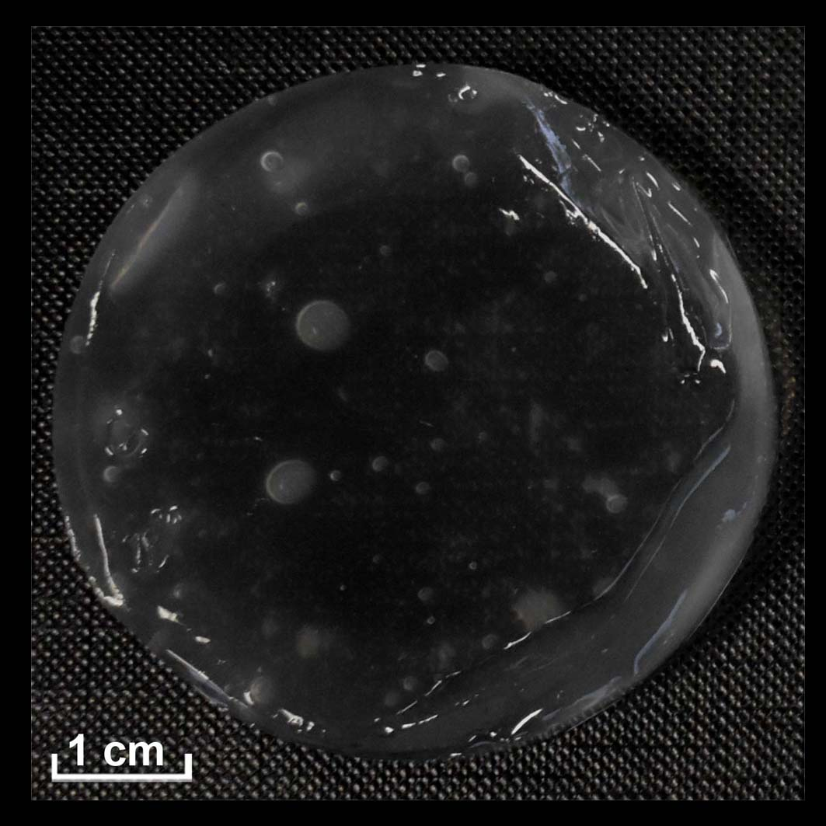 | (+)  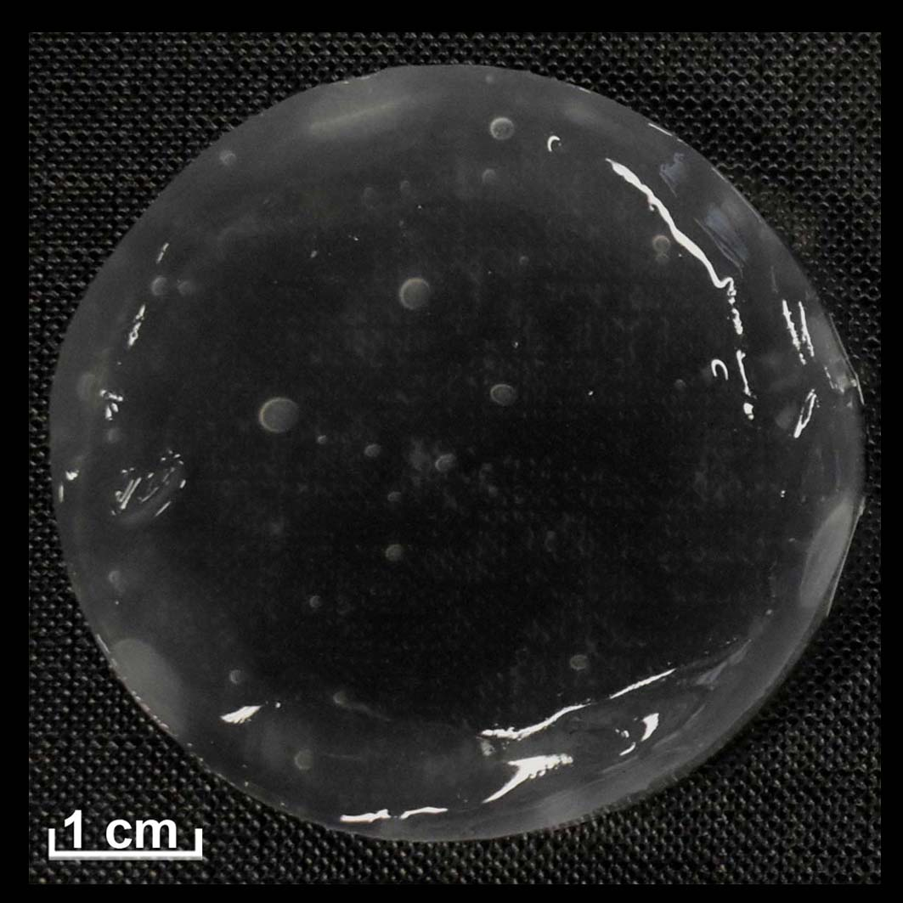
Second cleaning test | GC4 | (+)  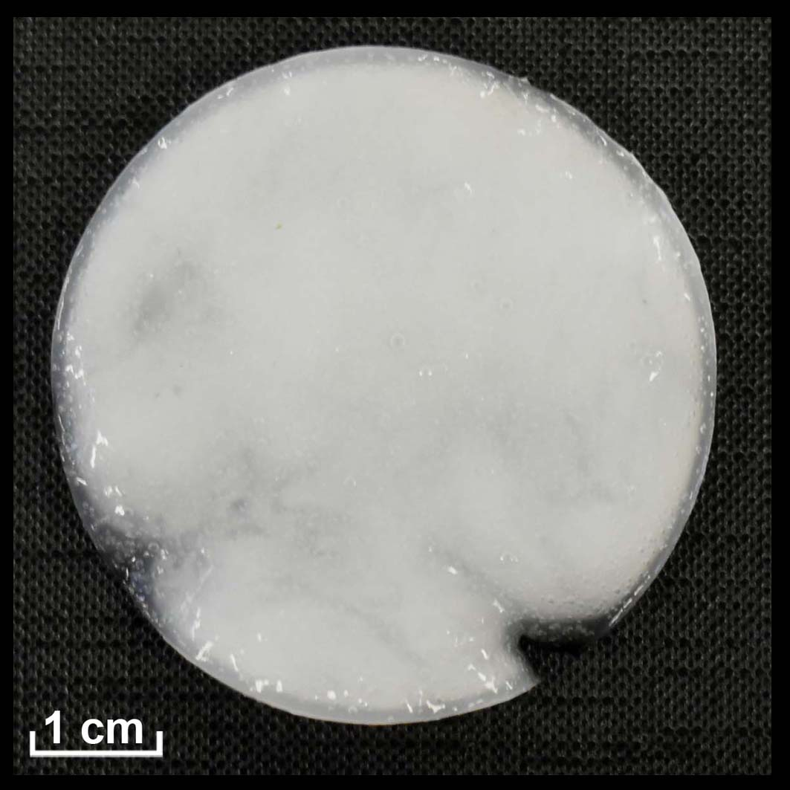 | (+)  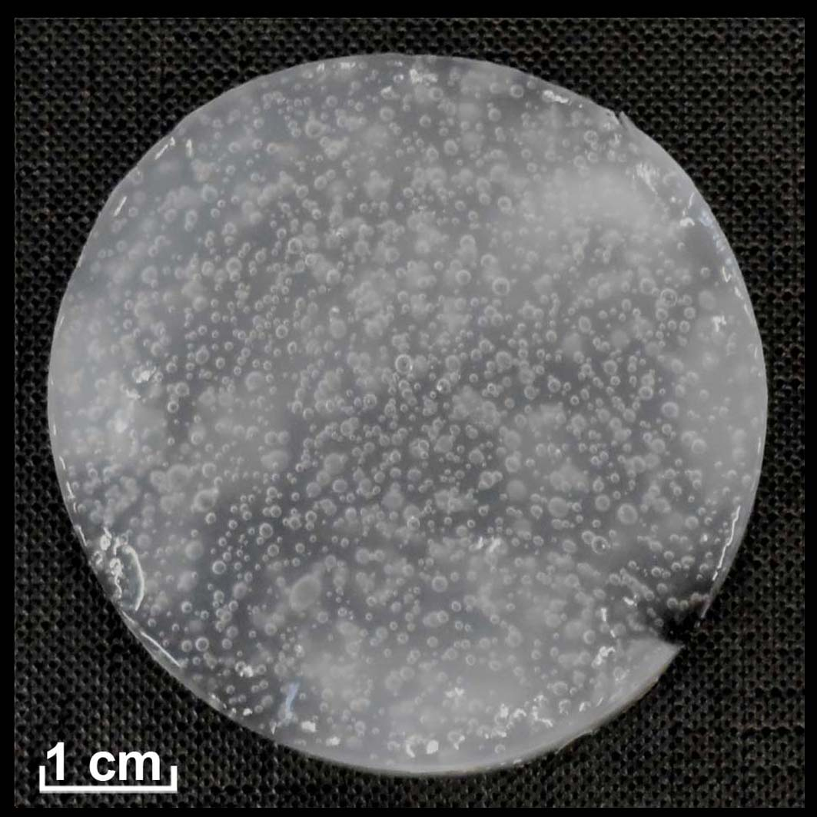 | (+)  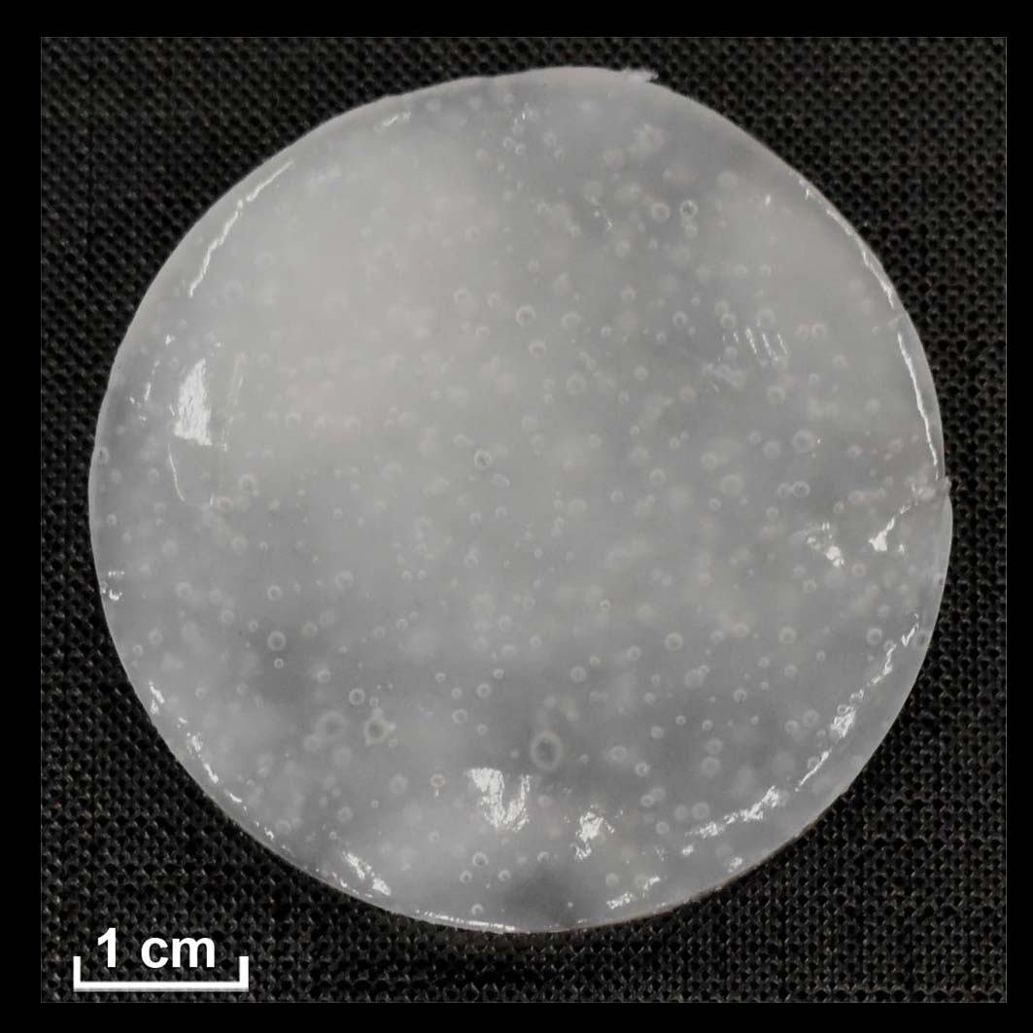 | (+)  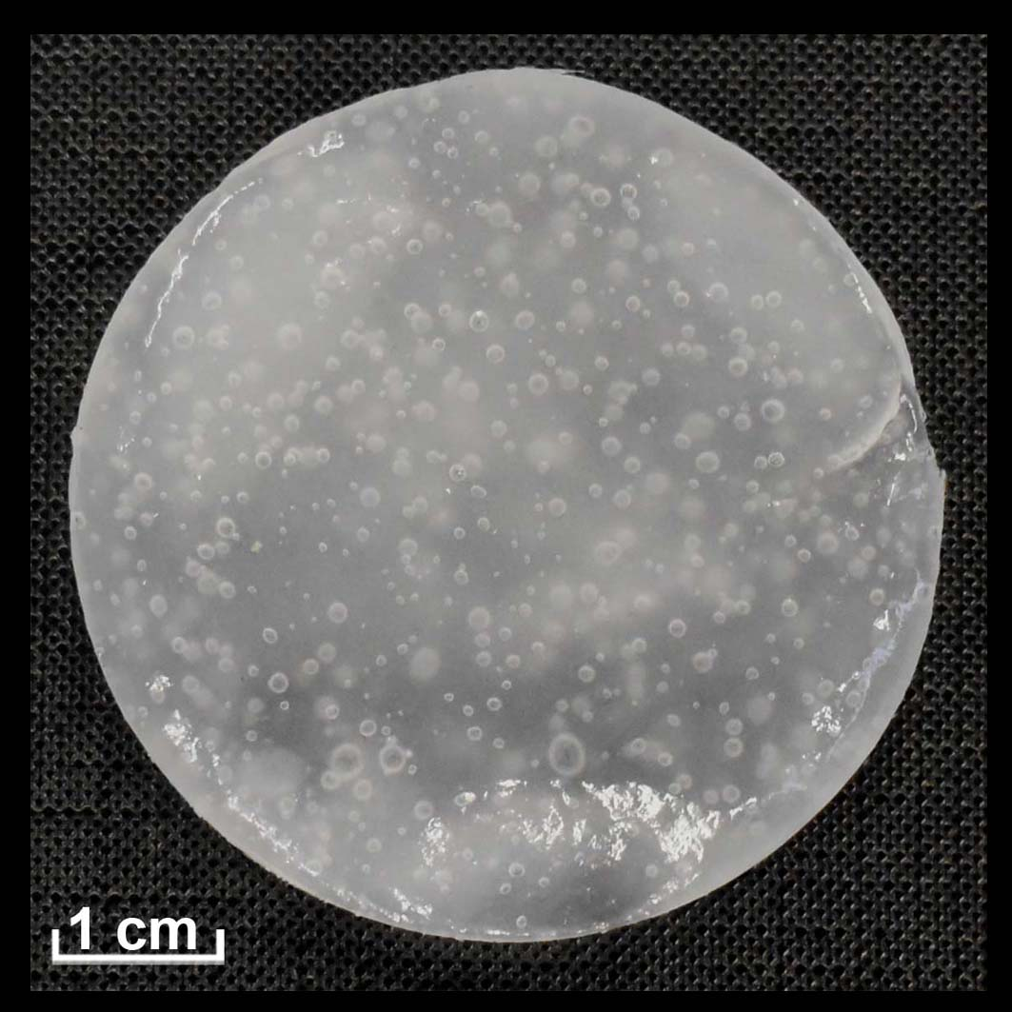
Second cleaning test | GC5 | (+)  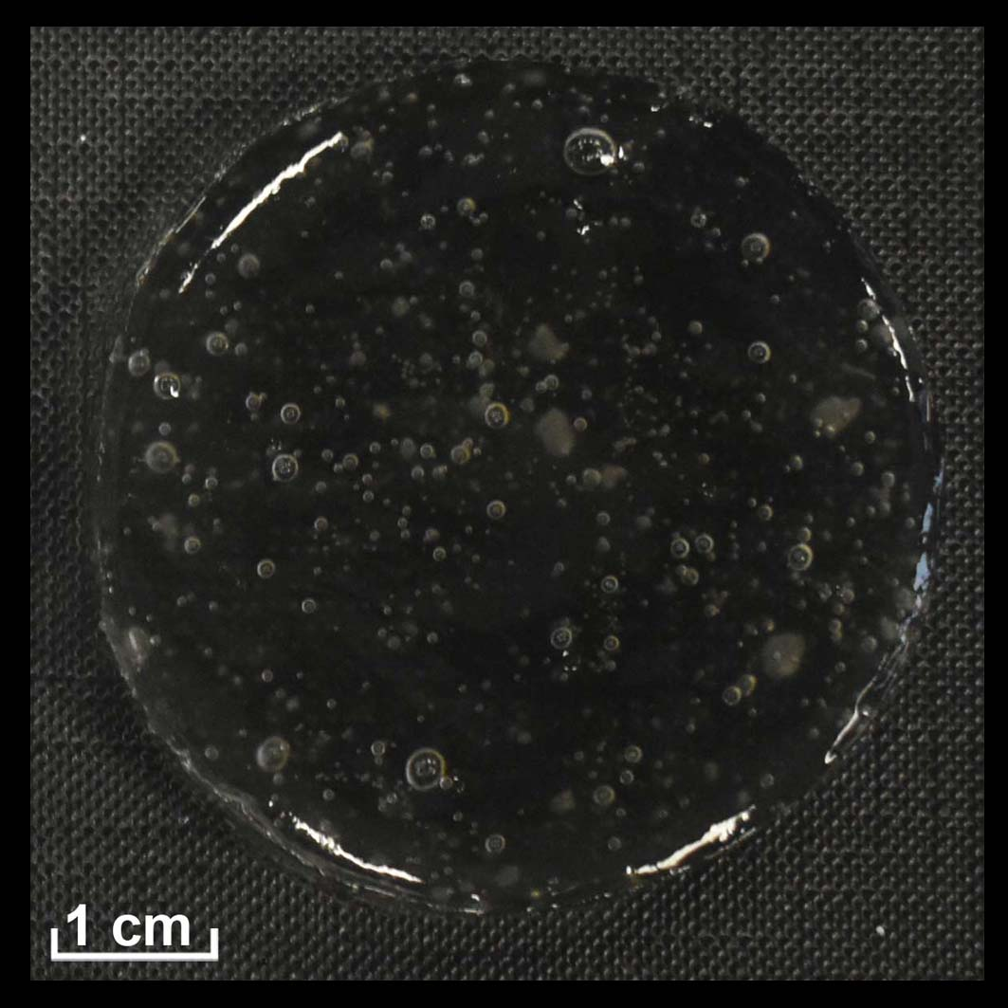 | (+)  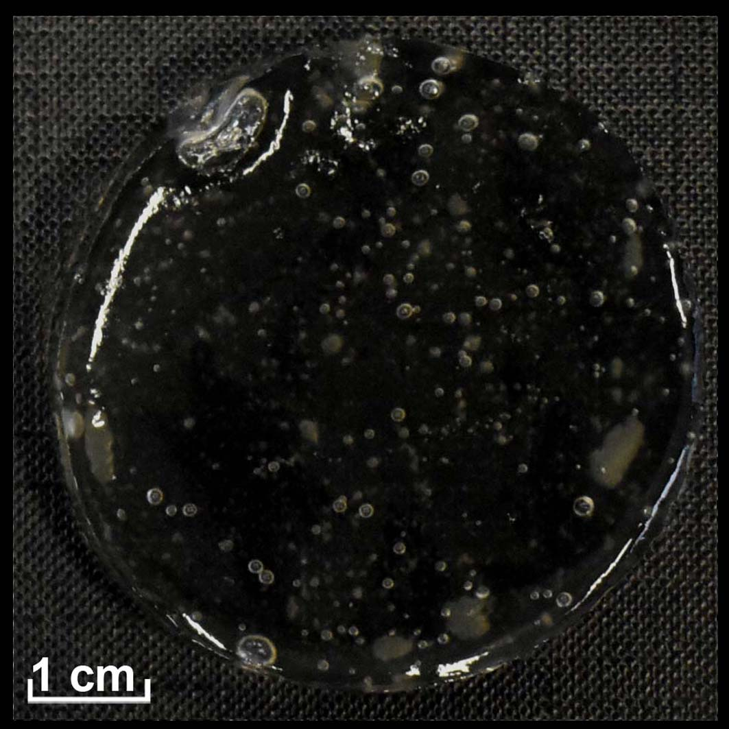 | (+)  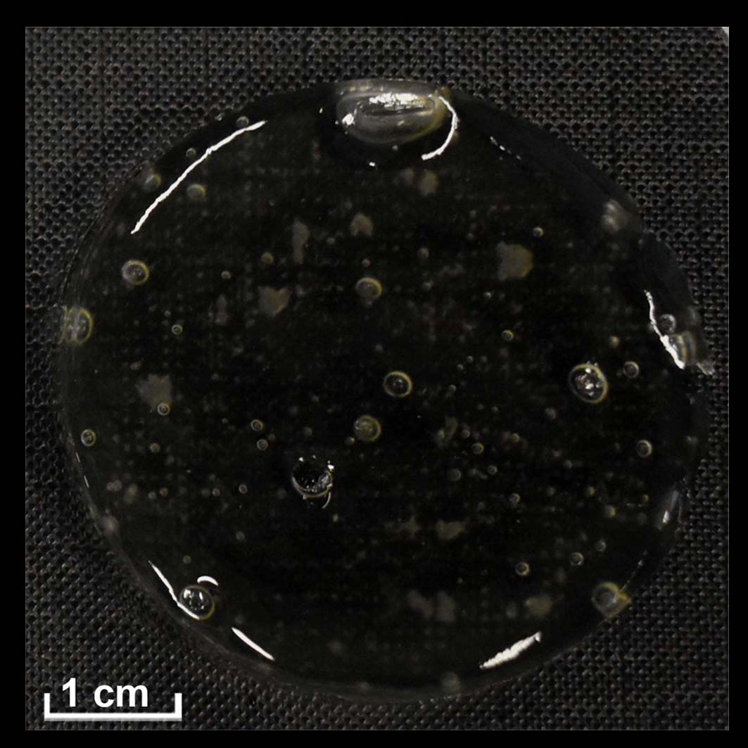 | (+)  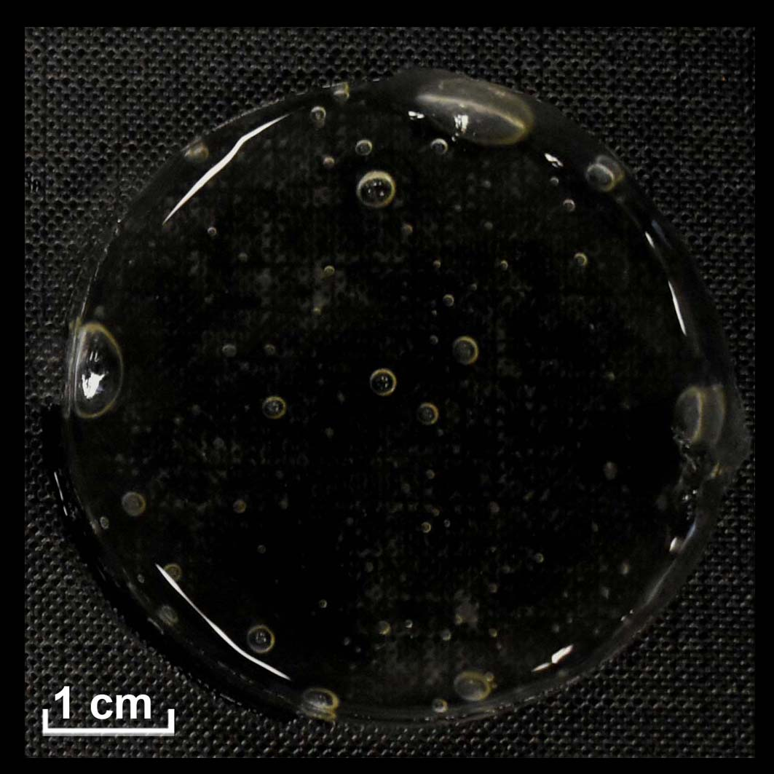

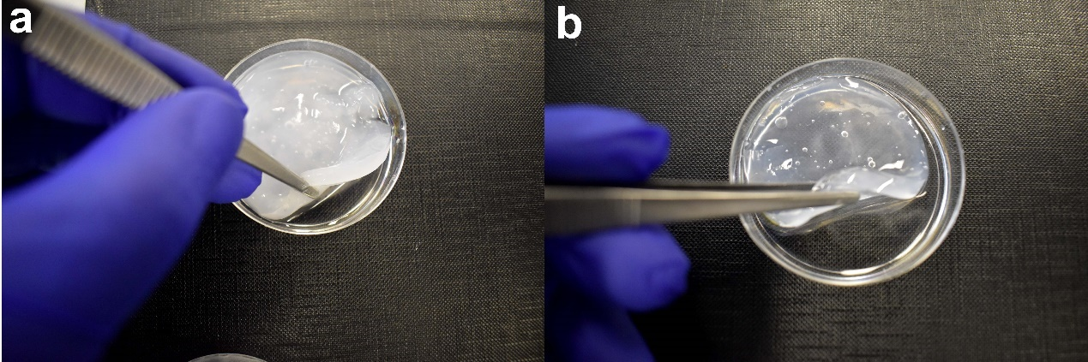
Figure S2: Images illustrating the increased syneresis in some gel composites after 3 days. a) The syneresis effect increased in GC2 from a superficial layer covering its surface to being surrounded by the expelled liquid. b) GC6 shrank due to expelling a significant amount of its liquids. It is worth mentioning that GC6 showed no syneresis after preparation.
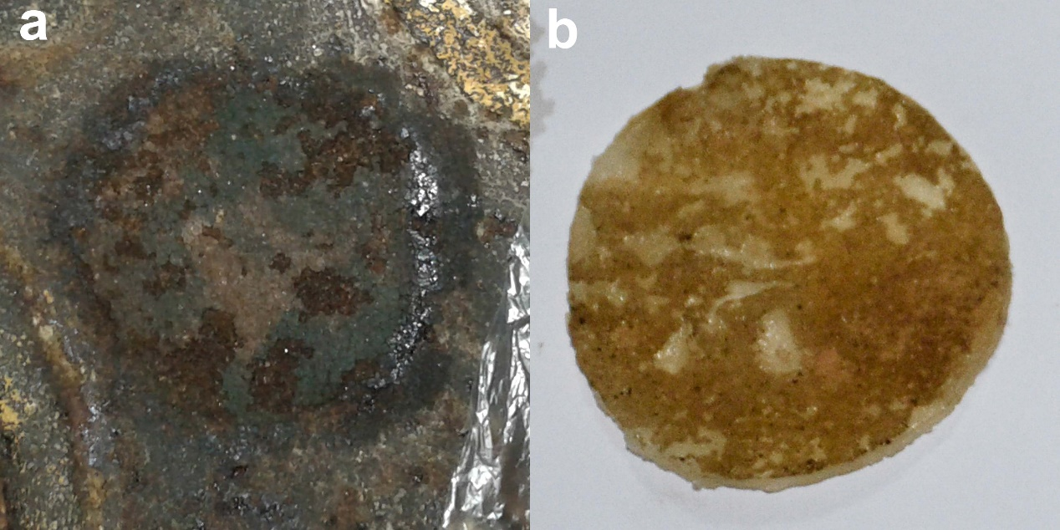
Figure S3: a) The surface after peeling-off GC2 (the first cleaning test) and before being treated with a dry cotton swab. It is obvious that the soot is partially removed and consequently the blue paint layer became partially visible. b) A gel composite after being peeled-off. It is clear that the gel removed part of the soot particles.
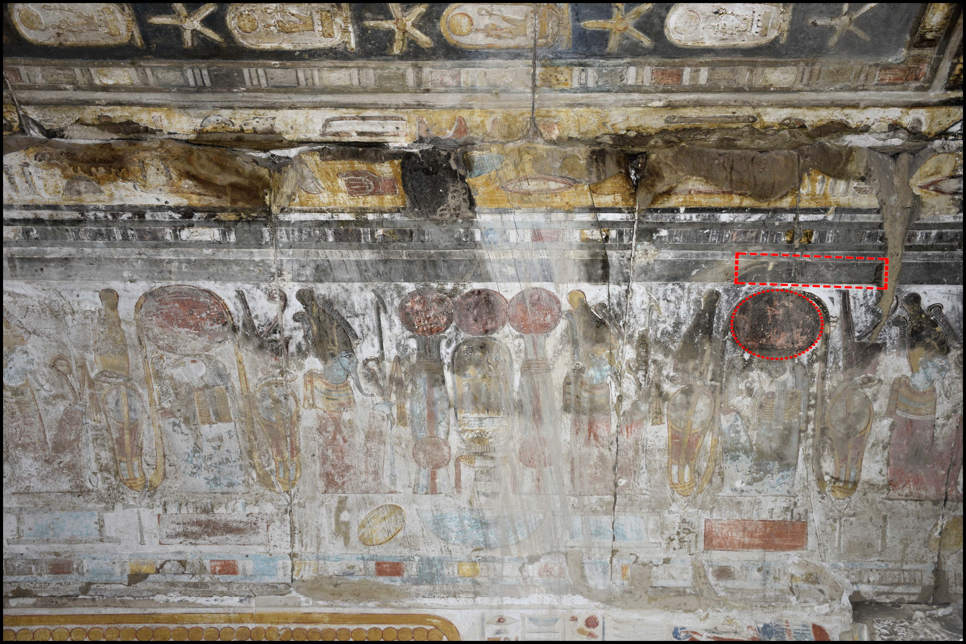
Figure S4: Selected areas for the second test located on the side of the vaulted ceiling, North wall.

Table S2: Results of CIE-Lab measurements of the soot layer, red and blue paint after cleaning by gel composites and ΔL*values.
Gel composites  (GC) | Soot layer |  |  |  |  |  | Blue paint layer (After cleaning) |  |  | Red paint layer (After cleaning) |  |  | ΔL*
Gel composites  (GC) | Covering blue paint layer |  |  | Covering red paint layer
Gel composites  (GC) | L* | a* | b* | L* | a* | b* | L* | a* | b* | L* | a* | b* | Blue paint | Red paint
GC1 | 33.1 ±3.6 | 0 | 1.7 ±0.9 | 28.4 ±4.5 | 2 ±1.2 | 4.1 ±1.5 | 35.2 ±3.9 | -0.2 ± 0.4 | 2.5 ±1.4 | 32.8 ±4.7 | 15.4 ±4.3 | 20.5 ±2.6 | 2.1 | 4.4
GC2 |  |  |  |  |  |  | 45.7 ±4.6 | 0.1 ±0.6 | 4.8 ±2.4 | 39 ±4.1 | 19.2 ±2 | 22.3 ±2.2 | 12.6 | 10.6
GC3 |  |  |  |  |  |  | 40.7 ±3.7 | 1.5 ±1.4 | 9.6 ±4.2 | 35.2 ±4.1 | 8.6 ±4.7 | 10.7 ±5.2 | 7.7 | 6.8
GC4 |  |  |  |  |  |  | 34.3 ±5 | 2.3 ±1.4 | 12 ±3.8 | 31.9 ±3.7 | 16.1 ±2 | 18.8 ±2.7 | 1.2 | 3.5
GC5 |  |  |  |  |  |  | 21.6 ±4.6 | 4.6 ±2.4 | 14 ±4.6 | 29.8 ±3.3 | 4.1 ±2.3 | 13 ±4.7 | -11.5 | 1.4

