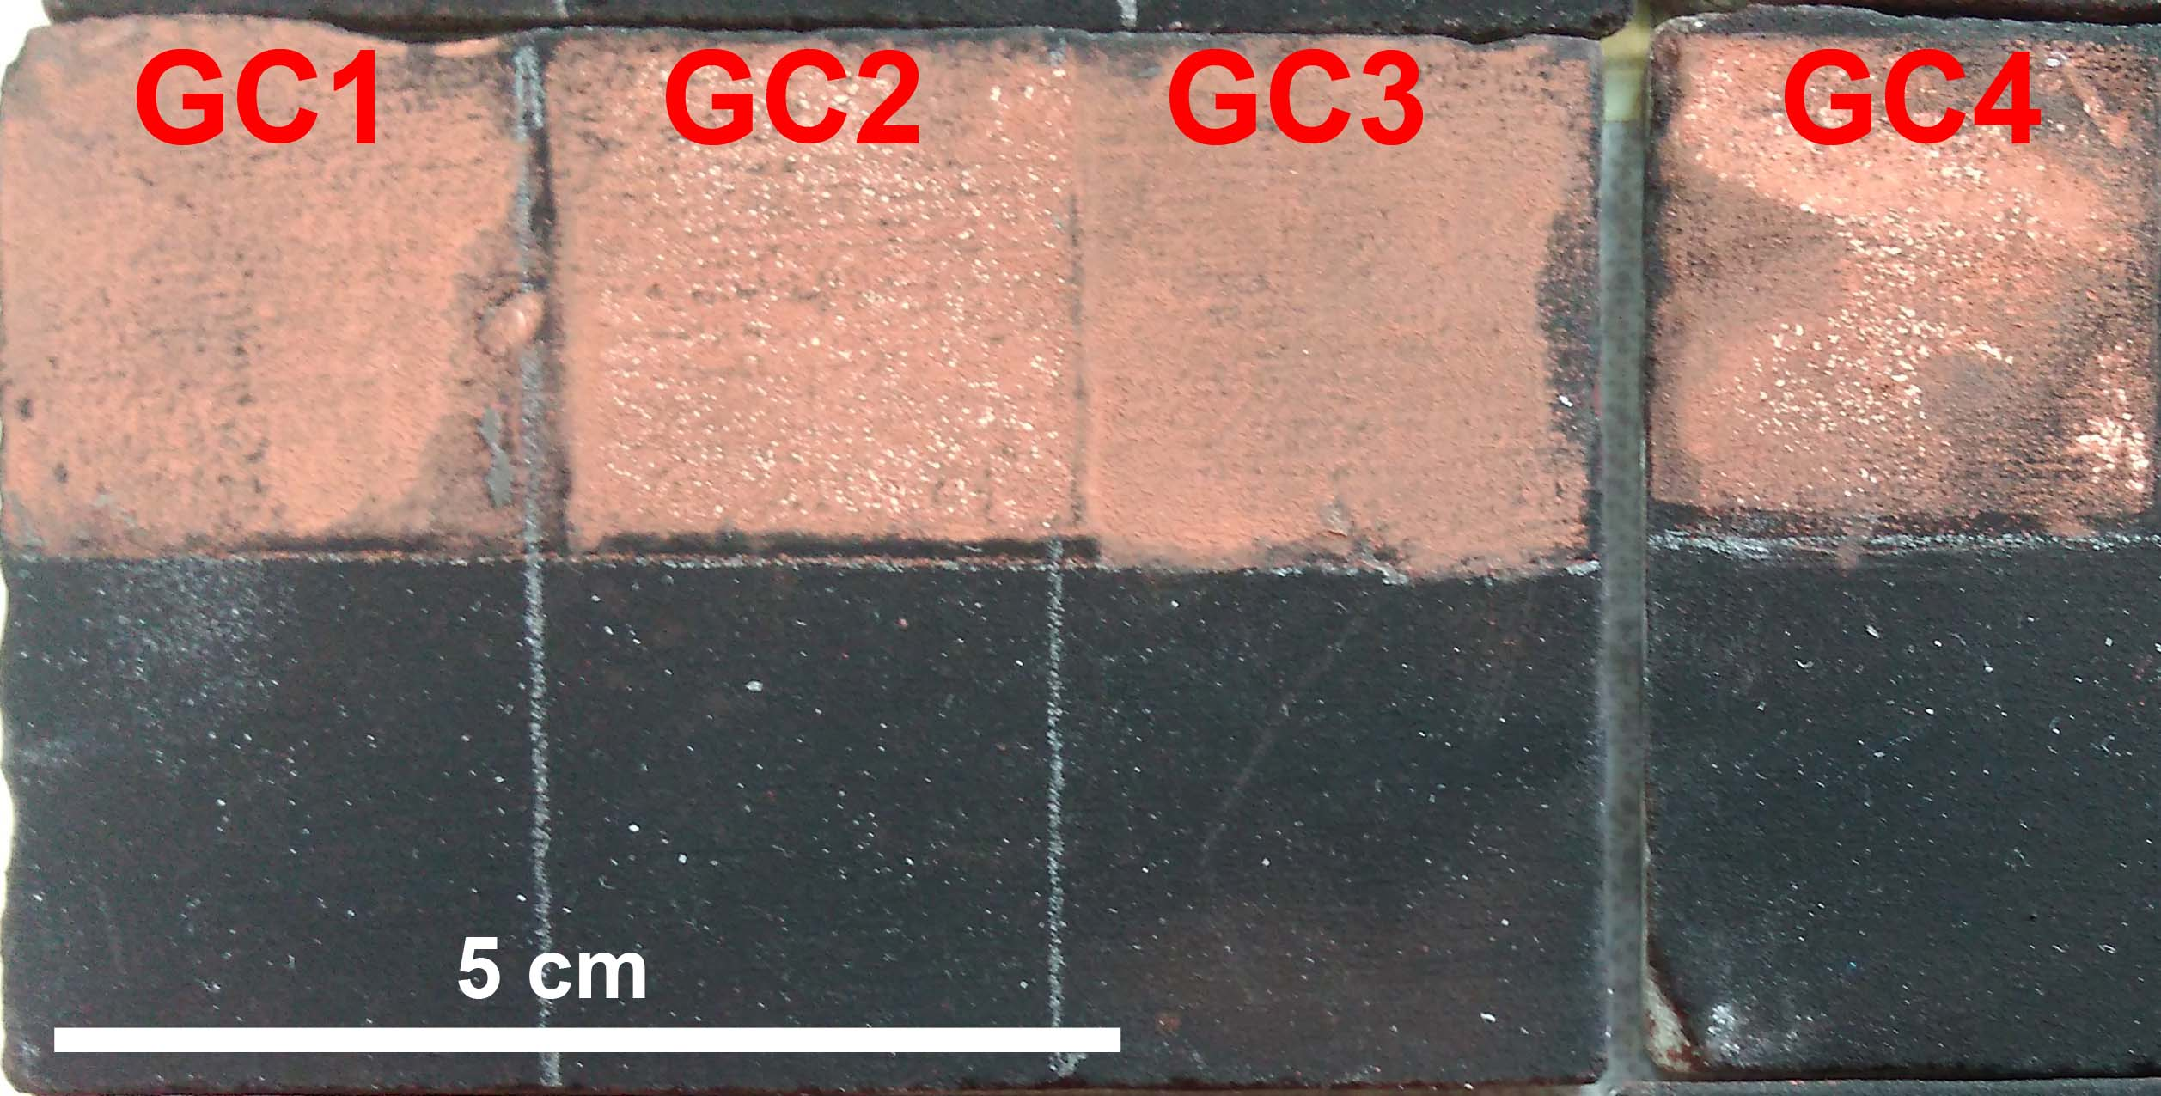

Figure A: Limestone tiles painted with red ochre and covered with soot layers. The upper part is treated with four different gel composites (ten minutes application time) and the lower part is untreated. The image illustrates the ease removal of the soot prepared in the laboratory.

