Sex-specific effects of early life stress exposure on memory performance and medial prefrontal cortex transcriptomic pattern of adolescent mice

Table S1. Primers and probes ID’s or sequences

Gene | Sequence primer forward | Sequence primer reverse
Pgk | TGCACGCTTCAAAAGCGCACG | AAGTCCACCCTCATCACGACCC
Hspa1b | GAAGTCGATGCCCTCGAACA | TTCGACGTGTCCATCCTGAC
Hspb1 | ATGAGTGGTCGCAGTGGTTC | GAAGTGGTTGACGTCCAGGG
Sdf2l1 | CTGCGCACCAGATCCGTATT | CGGTCCAATAGCAGTGCAGG
Anxa3 | TGGGCAGTCCGTGAGTAGAA | ACCTGATGTTCCGTGGTTGT
Cnn2 | AGCTGCGATCACAGACTGAC | CACGCTCCGTACACAGTTCT

Figure S1. Deconvolution of RNA-seq data. (A-D) The proportions of Astrocytes, Pyramidal neurons, Microglia, and Interneurons were estimated in the prefrontal cortex of CT and ELS male and female mice, using single-cell RNA sequencing data as a reference. Data are expressed as mean ± SEM of 6 animals per group. *p<0.05 represents a sex effect only (Two-way ANOVA).
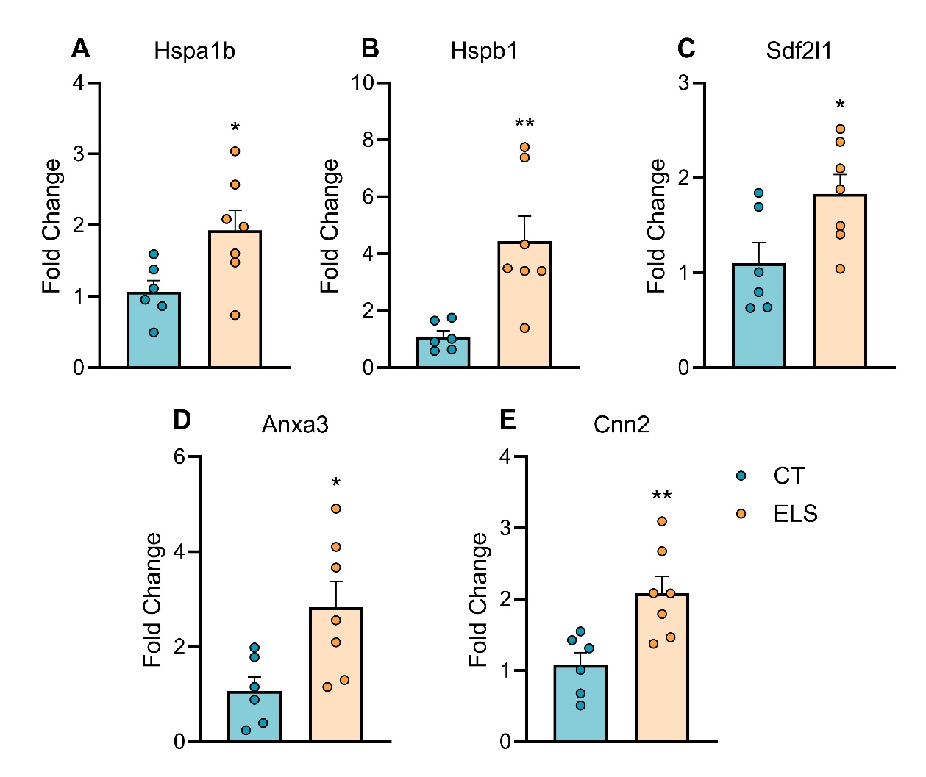
Figure S2. RNA-seq validation by Real-Time PCR. (A-E) Hspa1b, Hspb1, Sdf2l1, Anxa3, and Cnn2 gene expression was measured in the prefrontal cortex of CT and ELS female mice. Data are expressed as mean ± SEM of 6-7 animals per group. *p<0.05; **p<0.01 (Independent T-test).

