Supplementary Material
Discovery and Optimization of 4-(Imidazo[1,2-a]pyrimidin-3-yl)thiazol-2-amine Derivatives as Novel Phosphodiesterase 4 Inhibitors
Zongmin Wu^{a,1}, Furong Zhang ^{a,1}, Zhexin Chenª, Xue Wangª, Xingfu Liuª, Guofeng Yangª, Sen Wangª, Shuheng Huangª, Hai-Bin Luoª, Yi-You Huang^{a,*}, and Deyan Wu^{a,*}

ªKey Laboratory of Tropical Biological Resources of Ministry of Education, School of Pharmaceutical Sciences, Hainan University, Haikou 570228, China

Contents:
1. General Procedures for the Synthesis of target compounds…. ……………….…. S2
2. ¹H NMR, ¹³C NMR and HRMS data for tested compounds……………………. S17
3. HPLC report for tested compounds…………………………………………… . S59

1. General Procedures for the Synthesis of target compounds.
General Experimental Conditions.
All starting materials and reagents were purchased from commercial suppliers (Adamas, Bide, Macklin, Aladdin, Meryer, Rhawn, Boer, and Energy) and used directly without further purification. Chemical HG/T2354-92 silica gel (200-300 mesh, Xinnuo) was used for chromatography, and silica gel plates with fluorescence F254 (0.25 mm, Xinnuo) were used for thin-layer chromatography (TLC) analysis. Reactions requiring anhydrous conditions were performed under argon or a calcium chloride tube. ¹H NMR and ¹³C NMR spectra were recorded at room temperature on a Bruker AVANCE III 400 instrument with tetramethylsilane (TMS) as an internal standard. The following abbreviations are used: s (singlet), br (broad signal), d (doublet), dd (doublet of doublets), t (triplet), q (quartet), and m (multiplet). Coupling constants were reported in Hz. High-resolution mass spectra (HRMS) were recorded on a Agilent 6545 LC/Q-TOF. The purity of compounds was determined by reverse-phase high-performance liquid chromatography (HPLC) analysis confirming to be over 95%. HPLC instrument: SHIMADZU LC-2030 Plus (Column: SHIMADZU C18-AQ 5.0 μm, 4.6 × 250 mm (HSS); Detector: SPD-20A UV/VIS detector, UV at 254 nm; Elution, MeOH in water (80%, v/v); T = 30°C; and flow rate = 1.0 mL/min.
Synthesis of 1-(2-methylimidazo[1,2-a]pyrimidin-3-yl)ethan-1-one (3).
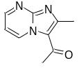To a solution of pyrimidin-2-amine (3.0 g, 31.5mmol) in toluene (5.0 mL) was added 1,1-dimethoxy-N,N-dimethylethan-1-amine (8.5 g, 63 mmol), and the mixture was stirred at 100℃ for 48 hours. After no raw materials remained in the system, which was cooled to room temperature. Chloracetone (3.6 g, 37.8 mmol) was added and mixture was stirred at room temperature for 12 hours. Then it was diluted with methylene chloride (300 mL), adjusted to neutral with saturated sodium bicarbonate aqueous solution, and washed with saturated sodium chloride solution. The organic layer was dried with anhydrous sodium sulfate and concentrated to give a crude, which was recrystallized with ethyl acetate to get the compound 3 as a yellow solid. Yield 88%. ¹H NMR (400 MHz, CDCl3) δ 8.72 (dd, J = 4.2, 2.0 Hz, 1H), 8.30 (d, J = 4.8 Hz, 1H), 7.09 (dd, J = 6.8, 4.3 Hz, 1H), 2.86 (s, 3H), 2.65 (s, 3H).
Synthesis of 2-bromo-1-(2-methylimidazo[1,2-a]pyrimidin-3-yl)ethan-1-one (4).
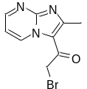To a solution of 1-(2-methylimidazo[1,2-a]pyrimidin-3-yl)ethan-1-one (1.8 g, 10.3 mmol) in glacial acetic acid (20 mL) was added bromine (0.6 mL) in glacial acetic acid (4.0 mL) and the mixture was stirred at room temperature for 35 minutes. After no raw materials remained in the system, the mixture was stirred at 110℃ for 3 hours. Then it was cooled to room temperature and the mixture was stirred at room temperature for 12 hours. The precipitate was filtered and wash with acetone and anhydrous ethanol to get the compound 4 as a brown solid. Yield 96%.¹H NMR (400 MHz, DMSO-d₆) δ 9.91 (dd, J = 6.9, 1.9 Hz, 1H), 8.97 (dd, J = 4.4, 1.9 Hz, 1H), 7.59 (dd, J = 6.9, 4.4 Hz, 1H), 4.91 (s, 2H), 2.87 (s, 3H).
General procedure for the synthesis of compounds L1-L3.
To a solution of 4 (66 mg, 0.32 mmol) in anhydrous ethanol (3.0 mL) was added thioureas (0.32 mmol), and the mixture was then heated at reflux for 12 h. After cooling to room temperature, the solution was concentrated to give a crude, which was purified by silica gel column chromatography to get the product L1-L3 as a yellow solid, respectively.
N-allyl-4-(2-methylimidazo[1,2-a]pyrimidin-3-yl)thiazol-2-amine (L1).
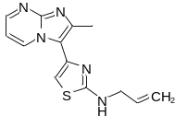Yield 59%, purity 98%. ¹H NMR (400 MHz, DMSO-d₆) δ 9.45 (d, J = 6.0 Hz, 1H), 8.47 (s, 1H), 8.04 (s, 1H), 7.06 (s, 1H), 6.84 (s, 1H), 6.06 – 5.83 (m, 1H), 5.22 (dd, J = 51.7, 13.5 Hz, 2H), 3.97 (s, 2H), 2.54 (s, 3H). ¹³C NMR (101 MHz, DMSO-d₆) δ 168.86, 149.41, 146.84, 143.11, 139.93, 135.54, 134.81, 116.42, 115.83, 108.95, 103.70, 47.18, 15.86; HRMS (ESI) m/z calcd C₁₃H₁₃N₅S⁺ [M+H]⁺ 272.0970, found 272.0968.
N-ethyl-4-(2-methylimidazo[1,2-a]pyrimidin-3-yl)thiazol-2-amine (L2).
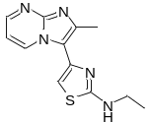Yield 63%, purity 99%. ¹H NMR (400 MHz, DMSO-d₆) δ 9.45 (dd, J = 6.9, 2.0 Hz, 1H), 8.48 (dd, J = 4.1, 2.0 Hz, 1H), 7.84 (t, J = 5.1 Hz, 1H), 7.07 (dd, J = 6.9, 4.1 Hz, 1H), 6.83 (s, 1H), 3.37 – 3.30 (m, 2H), 2.54 (s, 3H), 1.21 (t, J = 7.2 Hz, 3H). ¹³C NMR (101 MHz, DMSO-d₆) δ 168.99, 149.41, 146.83, 143.08, 140.07, 134.74(2C), 115.90, 108.99, 103.33, 39.76, 15.84, 14.82; HRMS (ESI) m/z calcd C₁₂H₁₃N₅S⁺ [M+H]⁺ 260.0970, found 260.0969.
N-methyl-4-(2-methylimidazo[1,2-a]pyrimidin-3-yl)thiazol-2-amine (L3).
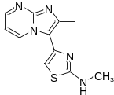Yield 58%, purity 99%. ¹H NMR (400 MHz, DMSO-d₆) δ 9.47 (dd, J = 6.9, 1.9 Hz, 1H), 8.48 (dd, J = 4.0, 1.9 Hz, 1H), 7.79 (d, J = 4.6 Hz, 1H), 7.07 (dd, J = 6.9, 4.1 Hz, 1H), 6.85 (s, 1H), 2.92 (d, J = 4.7 Hz, 3H), 2.54 (s, 3H). ¹³C NMR (101 MHz, DMSO-d₆) δ 169.97, 149.42, 146.85, 143.13, 140.18, 134.83, 115.88, 108.99, 103.52, 31.47, 15.85; HRMS (ESI) m/z calcd C₁₁H₁₁N₅S⁺ [M+H]⁺ 246.0813, found 246.0813.
Synthesis of tert-butyl(4-(2-methylimidazo[1,2-a]pyrimidin-3-yl)thiazol-2-yl)carbamate (5).
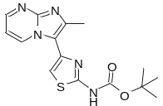Compound 5 was synthesized by the general procedure for synthesis of L1-L3. Yield 95%, ¹H NMR (400 MHz, CDCl₃) δ 9.78 (s, 1H), 9.21 (dd, J = 6.9, 2.0 Hz, 1H), 8.39 (dd, J = 4.1, 2.0 Hz, 1H), 6.94 (s, 1H), 6.67 (dd, J = 6.9, 4.1 Hz, 1H), 2.61 (s, 3H), 1.44 (s, 9H).
Synthesis of 4-(2-methylimidazo[1,2-a]pyrimidin-3-yl)thiazol-2-amine (L4).
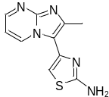To a solution of 5 (416 mg, 1.26 mmol) in tetrahydrofuran (6.9mL) was added trifluoroacetic acid (4.2 mL) and the mixture was stirred at room temperature for 1 hour. Then the solution was concentrated to give a crude, which was purified by silica gel column chromatography to get the product L4 as a yellow solid. Yield 93%, purity 99%. ¹H NMR (400 MHz, DMSO-d₆) δ 9.42 (dd, J = 6.9, 1.8 Hz, 1H), 8.48 (dd, J = 3.9, 1.9 Hz, 1H), 7.26 (s, 2H), 7.07 (dd, J = 6.9, 4.1 Hz, 1H), 6.81 (s, 1H), 2.53 (s, 3H). ¹³C NMR (101 MHz, DMSO-d₆) δ 169.11, 149.40, 146.79, 143.04, 139.84, 134.71, 115.83, 108.82, 104.21, 15.81; HRMS (ESI) m/z calcd C₁₀H₉N₅S⁺ [M+H]⁺ 232.0657, found 232.0659.
Synthesis of N-(4-(2-methylimidazo[1,2-a]pyrimidin-3-yl)thiazol-2-yl)acetamide (L5).
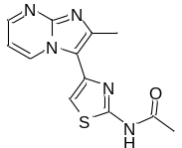To a solution of compound L4 (30 mg, 0.13 mmol) in pyridine (53 μL, 0.65 mmol) was added acetic anhydride (245 μL, 2.6 mmol) and the mixture was stirred at 100℃ for 1 hour. Then it was cooled to room temperature, diluted with ethyl acetate and washed with water. The organic layer was dried with anhydrous sodium sulfate and concentrated to give a crude, which was purified by silica gel column chromatography to get the product L5 as a yellow solid. Yield 82%, purity 98%. ¹H NMR (400 MHz, DMSO-d₆) δ 12.33 (s, 1H), 9.40 (dd, J = 6.8, 1.5 Hz, 1H), 8.52 (dd, J = 3.8, 1.7 Hz, 1H), 7.40 (s, 1H), 7.10 (dd, J = 6.8, 4.1 Hz, 1H), 2.56 (s, 3H), 2.19 (s, 3H). ¹³C NMR (101 MHz, DMSO-d₆) δ 169.16, 158.63, 149.79, 147.06, 143.61, 138.84, 134.42, 115.26, 110.55, 109.04, 22.98, 15.67; HRMS (ESI) m/z calcd C₁₂H₁₁N₅OS⁺ [M+H]⁺ 274.0763, found 274.0766.
General Procedure for the Synthesis of Compounds L6-L9.
To a solution of compound L4 (150 mg, 0.65 mmol) in N, N-dimethylformamide (2.5 mL) was added RCOOH (0.97 mmol) and HATU (741 mg, 1.95 mmol), and the mixture was stirred at room temperature for 10 minutes. Then N, N-diisopropylethylamine (250 mg, 1.95 mmol) was added and the mixture was stirred at 100 ℃ for 20 minutes in a microwave reactor. Then it was cooled to room temperature and diluted with ethyl acetate and water, and the organic layer was washed with saturated sodium chloride solution. The organic layer was dried with anhydrous sodium sulfate and concentrated to give a crude, which was purified by silica gel column chromatography to get the product L6-L9 as a yellow solid, respectively.
2-Methoxy-N-(4-(2-methylimidazo[1,2-a]pyrimidin-3-yl)thiazol-2-yl)acetamide (L6).
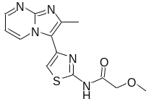Yield 22%, purity 99%. ¹H NMR (400 MHz, DMSO-d₆) δ 12.25 (s, 1H), 9.52 (dd, J = 6.8, 1.4 Hz, 1H), 8.52 (d, J = 2.1 Hz, 1H), 7.45 (s, 1H), 7.10 (dd, J = 6.8, 4.1 Hz, 1H), 4.21 (s, 2H), 3.40 (s, 3H), 2.57 (s, 3H). ¹³C NMR (101 MHz, DMSO-d₆) δ 169.15, 157.94, 149.78, 147.11, 143.70, 139.11, 134.75, 115.18, 110.57, 109.05, 71.13, 59.30, 15.79; HRMS (ESI) m/z calcd C₁₂H₁₁N₅OS⁺ [M+H]⁺ 304.0868, found 304.0869.
3-Methoxy-N-(4-(2-methylimidazo[1,2-a]pyrimidin-3-yl)thiazol-2-yl)propenamide (L7).
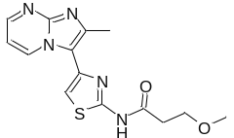Yield 32%, purity 99%. ¹H NMR (400 MHz, DMSO-d₆) δ 12.37 (s, 1H), 9.41 (d, J = 5.0 Hz, 1H), 8.54 (s, 1H), 7.43 (s, 1H), 7.12 (s, 1H), 3.66 (s, 2H), 3.24 (s, 3H), 2.73 (s, 2H), 2.56 (s, 3H). ¹³C NMR (101 MHz, DMSO-d₆) δ 170.23, 158.50, 150.04, 146.94, 143.29, 138.77, 134.52, 115.30, 110.82, 109.22, 68.11, 58.43, 36.13, 15.53; HRMS (ESI) m/z calcd C₁₂H₁₁N₅OS⁺ [M+H]⁺ 318.1025, found 318.1026.
Ethyl 3-((4-(2-methylimidazo[1,2-a]pyrimidin-3-yl)thiazol-2-yl)amino)-3-oxopropanoate (L8).
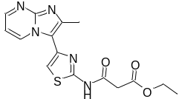Yield 7%, purity 99%. ¹H NMR (400 MHz, DMSO-d₆) δ 12.57 (s, 1H), 9.39 (dd, J = 6.9, 1.8 Hz, 1H), 8.53 (dd, J = 4.0, 1.9 Hz, 1H), 7.49 (s, 1H), 7.12 (dd, J = 6.9, 4.1 Hz, 1H), 4.15 (q, J = 7.1 Hz, 2H), 3.65 (s, 2H), 2.58 (s, 3H), 1.22 (t, J = 7.1 Hz, 3H). ¹³C NMR (101 MHz, DMSO-d₆) δ 167.47, 165.07, 158.27, 149.88, 147.16, 143.81, 139.06, 134.36, 115.16, 111.11, 109.10, 61.42, 42.69, 15.67, 14.49; HRMS (ESI) m/z calcd C₁₂H₁₁N₅OS⁺ [M+H]⁺ 346.0974, found 346.0976.
Methyl 3-((4-(2-methylimidazo[1,2-a]pyrimidin-3-yl)thiazol-2-yl)amino)-3-oxopropanoate(L9).
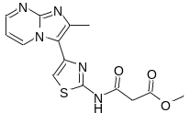Yield 10%, purity 99%. ¹H NMR (400 MHz, DMSO-d₆) δ 12.60 (s, 1H), 9.39 (dd, J = 6.9, 1.9 Hz, 1H), 8.54 (dd, J = 4.1, 1.9 Hz, 1H), 7.50 (s, 1H), 7.12 (dd, J = 6.9, 4.1 Hz, 1H), 3.68 (s, 3H), 3.68 (s, 2H), 2.58 (s, 3H). ¹³C NMR (101 MHz, DMSO-d₆) δ 167.93, 165.01, 158.25, 149.91, 147.14, 143.79, 139.05, 134.38, 115.15, 111.14, 109.13, 52.70, 42.51, 15.66; HRMS (ESI) m/z calcd C₁₂H₁₁N₅OS⁺ [M+H]⁺ 332.0817, found 332.0812.
General procedure for the synthesis of 7a-7f.
To a solution of ammonium thiocyanate (571 mg, 7.5mmol) in acetic acid (25 mL) was added arylamines (5.0 mmol) and the mixture was stirred at 73℃ for 12 hours. Then it was cooled to room temperature, adjusted the pH to neutral with ammonium hydroxide (10 mL), and extracted with ethyl acetate. The organic layer was washed with saturated sodium chloride solution, dried with anhydrous sodium sulfate and concentrated to give a crude, which was purified by silica gel column chromatography to get the product 7a-7f as a white solid, respectively.
1-(4-Methoxyphenyl) thiourea (7a).
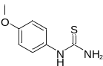Yield 87%. ¹H NMR (400 MHz, DMSO-d₆) δ 9.28 (s, 2H), 7.56 (d, J = 5.9 Hz, 1H), 7.48 (d, J = 2.9 Hz, 1H), 7.21 – 7.18 (m, 1H).
1-(2-Bromo-4-methoxyphenyl) thiourea (7b).
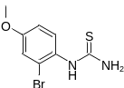Yield 81%. ¹H NMR (400 MHz, DMSO-d₆) δ 9.13 (s, 1H), 7.32 (d, J = 8.8 Hz, 1H), 7.21 (d, J = 2.8 Hz, 1H), 6.94 (dd, J = 8.8, 2.8 Hz, 1H), 3.76 (s, 3H).
1-(4-Chloro-2-fluorophenyl) thiourea (7c).
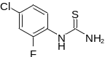Yield 84%. ¹H NMR (400 MHz, DMSO-d₆) δ 9.40 (s, 1H), 7.73 (t, J = 8.6 Hz, 1H), 7.48 (dd, J = 10.4, 2.4 Hz, 1H), 7.25 (ddd, J = 8.7, 2.3, 1.1 Hz, 1H).
1-(4-Chlorophenyl) thiourea (7d).
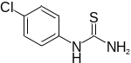Yield 90%. ¹H NMR (400 MHz, DMSO-d₆) δ 9.75 (s, 1H), 7.61 (d, J = 8.8 Hz, 1H), 7.47 (d, J = 8.8 Hz, 2H), 7.38 – 7.31 (m, 3H).
1-(2,6-Difluoro-4-methoxyphenyl) thiourea (7e).
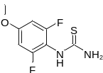Yield 80%. ¹H NMR (400 MHz, DMSO-d₆) δ 8.89 (s, 1H), 7.80 (s, 2H), 6.77 (d, J = 9.5 Hz, 2H), 3.78 (s, 3H).
1-(2,6-Dichloro-4-methoxyphenyl) thiourea (7f).
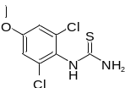Yield 71%. ¹H NMR (400 MHz, DMSO-d₆) δ 9.15 (d, J = 77.6 Hz, 1H), 7.85 – 6.70 (m, 4H), 3.80 (s, 3H).
General Procedures for the Synthesis of L10-L18.
Compound L10-L18 was synthesized by the general procedure for synthesis of L1-L3.
N-(4-methoxyphenyl)-4-(2-methylimidazo[1,2-a] pyrimidin-3-yl) thiazol-2-amine (L10).
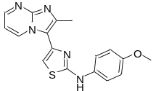Yield 34%, purity 99%. ¹H NMR (400 MHz, DMSO-d₆) δ 10.20 (s, 1H), 9.34 (dd, J = 6.9, 1.9 Hz, 1H), 8.52 (dd, J = 4.1, 1.9 Hz, 1H), 7.53 (d, J = 9.0 Hz, 2H), 7.13 (dd, J = 6.9, 4.1 Hz, 1H), 7.08 (s, 1H), 6.94 (d, J = 9.0 Hz, 2H), 3.74 (s, 3H), 2.58 (s, 3H). ¹³C NMR (101 MHz, DMSO-d₆) δ 164.98, 154.94, 149.63, 147.00, 143.46, 139.81, 134.84, 134.36, 119.69(2C), 115.69(2C), 114.83, 109.18, 105.11, 55.71, 15.73; HRMS (ESI) m/z calcd C₁₆H₁₃N₅OS⁺ [M+H]⁺ 338.1076, found 338.1079.
N-(2-bromo-4-methoxyphenyl)-4-(2-methylimidazo[1,2-a] pyrimidin-3-yl) thiazol-2-amine(L11).
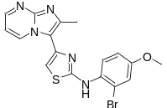Yield 34%, purity 99%. ¹H NMR (400 MHz, DMSO-d₆) δ 9.64 (s, 1H), 9.33 (d, J = 6.0 Hz, 1H), 8.49 (d, J = 1.6 Hz, 1H), 7.74 (d, J = 8.8 Hz, 1H), 7.29 (d, J = 1.9 Hz, 1H), 7.13 – 6.97 (m, 3H), 3.79 (s, 3H), 2.55 (s, 3H). ¹³C NMR (101 MHz, DMSO-d₆) δ 167.50, 157.59, 149.55, 146.91, 143.37, 139.89, 134.49, 132.51, 127.52, 119.36, 118.33, 115.58, 114.99, 109.01, 105.65, 56.21, 15.80; HRMS (ESI) m/z calcd C₁₆H₁₂BrN₅OS⁺ [M+H]⁺ 416.0181, found 416.0182.
N-(4-chloro-2-fluorophenyl)-4-(2-methylimidazo[1,2-a] pyrimidin-3-yl)thiazol-2-amine(L12).
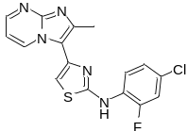Yield 70%, purity 99%. ¹H NMR (400 MHz, DMSO-d₆) δ 9.89 (s, 1H), 9.25 (dd, J = 6.9, 1.9 Hz, 1H), 8.50 (dd, J = 4.0, 1.9 Hz, 1H), 8.16 (dd, J = 9.1, 5.7 Hz, 1H), 7.52 (dd, J = 8.5, 2.9 Hz, 1H), 7.26 (td, J = 8.9, 2.9 Hz, 1H), 7.16 (s, 1H), 7.08 (dd, J = 6.9, 4.1 Hz, 1H) 2.56 (s, 3H). ¹³C NMR (101 MHz, DMSO-d₆) δ 165.38, 159.31, 156.88, 149.66, 146.97, 143.47, 139.46, 134.35, 125.44, 124.58, 117.30 (d, J = 26.0 Hz), 115.50, 115.26 (d, J = 21.9 Hz), 109.17, 107.01, 15.71; HRMS (ESI) m/z calcd C₁₅H₉ClFN₅S⁺ [M+H]⁺ 360.0486, found 360.0483.
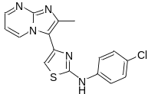N-(4-chlorophenyl)-4-(2-methylimidazo[1,2-a] pyrimidin-3-yl) thiazol-2-amine (L13). Yield 72%, purity 98%. ¹H NMR (400 MHz, DMSO-d₆) δ 10.57 (s, 1H), 9.26 (dd, J = 6.9, 1.9 Hz, 1H), 8.52 (dd, J = 4.1, 1.9 Hz, 1H), 7.68 – 7.61 (m, 2H), 7.41 – 7.33 (m, 2H), 7.19 (s, 1H), 7.14 (dd, J = 6.9, 4.1 Hz, 1H), 2.58 (s, 3H). ¹³C NMR (101 MHz, DMSO-d₆) δ 163.78, 149.72, 147.09, 143.66, 140.31, 139.76, 134.23, 129.40(2C), 125.35, 119.03(2C), 115.54, 109.30, 106.46, 15.67; HRMS (ESI) m/z calcd C₁₅H₁₀ClN₅S⁺ [M+H]⁺ 342.0580, found 342.0578.
N-(2,6-difluoro-4-methoxyphenyl)-4-(2-methylimidazo[1,2-a] pyrimidin-3-yl) thiazol-2-amine(L14).
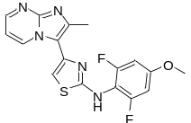Yield 77%, purity 99%. ¹H NMR (400 MHz, DMSO-d₆) δ 9.61 (s, 1H), 9.24 (dd, J = 6.9, 1.9 Hz, 1H), 8.48 (dd, J = 4.0, 1.9 Hz, 1H), 7.09 – 7.00 (m, 2H), 6.91 (d, J = 9.8 Hz, 2H), 3.81 (s, 3H), 2.53 (s, 3H). ¹³C NMR (101 MHz, DMSO-d₆) δ 167.81, 160.20, 159.08, 157.75, 149.58, 146.92, 143.44, 139.92, 134.19, 115.44, 110.40, 108.96, 105.90, 99.40, 99.14, 56.69, 15.69. HRMS (ESI) m/z calcd C₁₆H₁₁F₂N₅OS⁺ [M+H]⁺ 374.0888, found 374.0889.
N-(2,6-dichloro-4-methoxyphenyl)-4-(2-methylimidazo[1,2-a] pyrimidin-3-yl) thiazol-2-amine (L15).
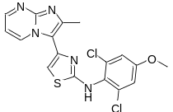Yield: 65%; purity: 99%;¹H NMR (400 MHz, DMSO-d₆) δ 9.79 (s, 1H), 9.26 (dd, J = 6.9, 1.9 Hz, 1H), 8.47 (dd, J = 4.1, 2.0 Hz, 1H), 7.25 (s, 2H), 7.05 (dd, J = 6.9, 4.1 Hz, 1H), 7.01 (s, 1H), 3.84 (s, 3H), 2.53 (s, 3H). ¹³C NMR (101 MHz, DMSO-d₆) δ 168.00, 158.97, 149.56, 146.90, 143.39, 140.06, 135.19, 134.22, 128.45(2C), 115.47(2C), 115.24, 108.92, 105.60, 56.73, 15.73; HRMS (ESI) m/z calcd C₁₆H₁₁Cl₂N₅OS⁺ [M+H]⁺, 406.0296, found 406.0295.
N-(2-chlorophenyl)-4-(2-methylimidazo[1,2-a] pyrimidin-3-yl)thiazol-2-amine (L16).
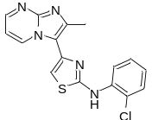Yield: 74%; purity: 97%;¹H NMR (400 MHz, DMSO-d₆) δ 9.98 (s, 1H), 9.39 (dd, J = 6.9, 1.5 Hz, 1H), 8.72 (dd, J = 4.1, 1.6 Hz, 1H), 8.16 (d, J = 8.2 Hz, 1H), 7.50 (d, J = 7.9 Hz, 1H), 7.37 – 7.29 (m, 3H), 7.13 – 7.06 (m, 1H), 2.60 (s, 3H). ¹³C NMR (101 MHz, DMSO-d₆) δ 165.28, 152.85, 144.98, 138.56, 137.79 (d, J = 3.5 Hz), 135.60, 130.26, 128.29, 124.86, 124.13, 122.74(2C), 116.19, 111.44, 109.14, 13.97; HRMS (ESI) m/z calcd C₁₅H₁₀ClN₅S⁺ [M+H]⁺ 342.0580, found 342.0580.
4-(2-Methylimidazo[1,2-a] pyrimidin-3-yl)-N-phenylthiazol-2-amine (L17).
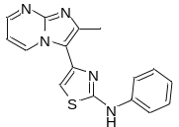Yield: 61%; purity: 99%;¹H NMR (400 MHz, DMSO-d₆) δ 10.66 (s, 1H), 9.58 (dd, J = 6.9, 1.6 Hz, 1H), 9.02 (dd, J = 4.3, 1.6 Hz, 1H), 7.71 (dd, J = 6.9, 4.4 Hz, 1H), 7.64 (d, J = 7.8 Hz, 2H), 7.49 (s, 1H), 7.33 (t, J = 7.9 Hz, 2H), 6.99 (t, J = 7.3 Hz, 1H), 2.69 (s, 3H). ¹³C NMR (101 MHz, DMSO-d₆) δ 164.74, 156.55, 142.80, 141.17, 137.05, 136.19, 133.00, 129.58(2C), 122.30, 117.73(2C), 117.07, 114.12, 110.06, 11.94; HRMS (ESI) m/z calcd for C₁₅H₁₁N₅S⁺ [M+H]⁺ 308.0970, found 308.0972.
N-(2,6-dichlorophenyl)-4-(2-methylimidazo[1,2-a] pyrimidin-3-yl) thiazol-2-amine(L18).
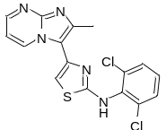Yield: 74%; purity: 99%;¹H NMR (400 MHz, DMSO-d₆) δ 9.98 (s, 1H), 9.18 (dd, J = 6.9, 1.7 Hz, 1H), 8.46 (dd, J = 4.1, 1.9 Hz, 1H), 7.63 (d, J = 8.1 Hz, 2H), 7.38 (t, J = 8.1 Hz, 1H), 7.08 (s, 1H), 7.01 (dd, J = 6.9, 4.1 Hz, 1H), 2.52 (s, 3H). ¹³C NMR (101 MHz, DMSO-d₆) δ 166.71, 149.55, 146.91, 143.45, 139.83, 135.75(2C), 134.07, 133.99, 129.57(2C), 129.46, 115.39, 108.87, 106.19, 15.69; HRMS (ESI) m/z calcd C₁₅H₉Cl₂N₅S⁺ [M+H]⁺ 376.0190, found 376.0193.
General procedure for intermediates of compounds 9a-9d.
Compound 9a-9d was synthesized by the general procedure for synthesis of L1-L3.The same procedure as the synthesis of 7a-7f.
1-(3,5-Dichloropyridin-4-yl) thiourea(9a).
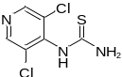Yield 15%. ¹H NMR (400 MHz, DMSO-d₆) δ 10.76 (s, 1H), 8.76 (s, 2H), 8.04 (d, J = 7.4 Hz, 2H).
1-(3,5-Difluoropyridin-4-yl) thiourea(9b).
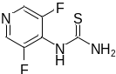Yield 21%. ¹H NMR (400 MHz, DMSO-d₆) δ 9.59 (s, 1H), 8.52 (s, 2H), 7.63 (s, 2H).
1-(2-Chloropyridin-4-yl) thiourea(9c).
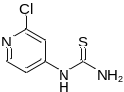Yield 31%. ¹H NMR (400 MHz, DMSO-d₆) δ 8.22 (dd, J = 24.3, 22.4 Hz, 4H), 7.69 (dd, J = 5.7, 1.9 Hz, 1H).
1-(2-Fluoropyridin-4-yl) thiourea(9d).
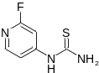Yield 36%. ¹H NMR (400 MHz, DMSO-d₆) δ 8.55 – 7.67 (m, 4H), 7.45 (d, J = 5.6 Hz, 1H).
General Procedures for the Synthesis of L19-L22.
Compound L19-L22 was synthesized by the general procedure for synthesis of L1-L3.
N-(3,5-dichloropyridin-4-yl)-4-(2-methylimidazo[1,2-a] pyrimidin-3-yl) thiazol-2-amine (L19).
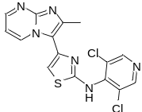Yield 32%, purity 99%. ¹H NMR (400 MHz, DMSO-d₆) δ 10.41 (s, 1H), 9.08 (d, J = 6.0 Hz, 1H), 8.68 (s, 2H), 8.48 (d, J = 1.7 Hz, 1H), 7.28 (s, 1H), 7.05 (dd, J = 6.4, 4.3 Hz, 1H), 2.52 (s, 3H). ¹³C NMR (101 MHz, MeOD) δ 163.98, 150.02(2C), 148.18(2C), 146.73, 142.49, 139.08, 134.09, 127.52, 115.36, 109.54, 108.74(2C), 13.48; HRMS (ESI) m/z calcd C₁₄H₈Cl₂N₆S⁺ [M+H]⁺ 377.0143, found 377.0140.
N-(3,5-difluoropyridin-4-yl)-4-(2-methylimidazo[1,2-a] pyrimidin-3-yl) thiazol-2-amine (L20).
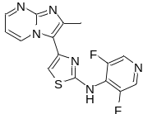Yield 43%, purity 99%. ¹H NMR (400 MHz, DMSO-d₆) δ 9.89 (s, 1H), 9.25 (dd, J = 6.9, 1.9 Hz, 1H), 8.50 (dd, J = 4.0, 1.9 Hz, 1H), 8.16 (dd, J = 9.1, 5.7 Hz, 1H), 7.52 (dd, J = 8.5, 2.9 Hz, 1H), 7.26 (td, J = 8.9, 2.9 Hz, 1H), 7.16 (s, 1H), 7.08 (dd, J = 6.9, 4.1 Hz, 1H), 2.56 (s, 3H). ¹³C NMR (101 MHz, DMSO-d₆) δ 166.71, 149.55, 146.91, 143.45, 139.83, 135.75, 134.07, 133.99, 129.57(2C), 129.46, 115.39, 108.87, 106.19, 15.69; HRMS (ESI) m/z calcd C₁₄H₈F₂N₆S⁺ [M+H]⁺ 345.0734, found 345.0734.
N-(2-chloropyridin-4-yl)-4-(2-methylimidazo[1,2-a] pyrimidin-3-yl) thiazol-2-amine (L21).
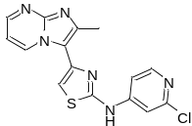Yield 49%, purity 99%. ¹H NMR (400 MHz, DMSO-d₆) δ 11.17 (s, 1H), 9.25 (d, J = 6.9 Hz, 1H), 8.56 (dd, J = 4.0, 1.9 Hz, 1H), 8.22 (d, J = 5.7 Hz, 1H), 7.89 (d, J = 1.6 Hz, 1H), 7.41 (s, 1H), 7.38 (d, J = 5.7 Hz, 1H), 7.14 (d, J = 6.9 Hz, 1H), 2.60 (s, 3H). ¹³C NMR (101 MHz, DMSO-d₆) δ 162.89, 151.39, 151.92, 148.18, 138.58, 134.81(2C), 116.08, 110.64(2C), 110.15, 96.97, 95.82, 14.47.
N-(2-fluoropyridin-4-yl)-4-(2-methylimidazo[1,2-a] pyrimidin-3-yl) thiazol-2-amine (L22).
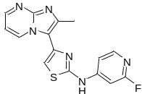Yield 52%, purity 99%. ¹H NMR (400 MHz, DMSO-d₆) δ 11.22 (s, 1H), 9.21 (d, J = 6.9 Hz, 1H), 8.55 (d, J = 4.1 Hz, 1H), 8.06 (d, J = 5.7 Hz, 1H), 7.46 (s, 1H), 7.40 (s, 1H), 7.32 (d, J = 5.9 Hz, 1H), 7.14 (d, J = 6.9 Hz, 1H), 2.59 (s, 3H). ¹³C NMR (101 MHz, DMSO-d₆) δ 165.98, 159.07, 158.69, 156.88, 147.98, 142.76, 136.87, 136.16, 133.08, 120.03, 117.15, 116.82, 114.27, 112.86, 11.36.

2. ¹H NMR, ¹³C NMR and HRMS data for tested compounds.
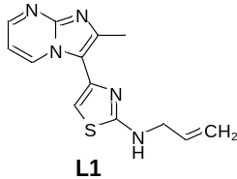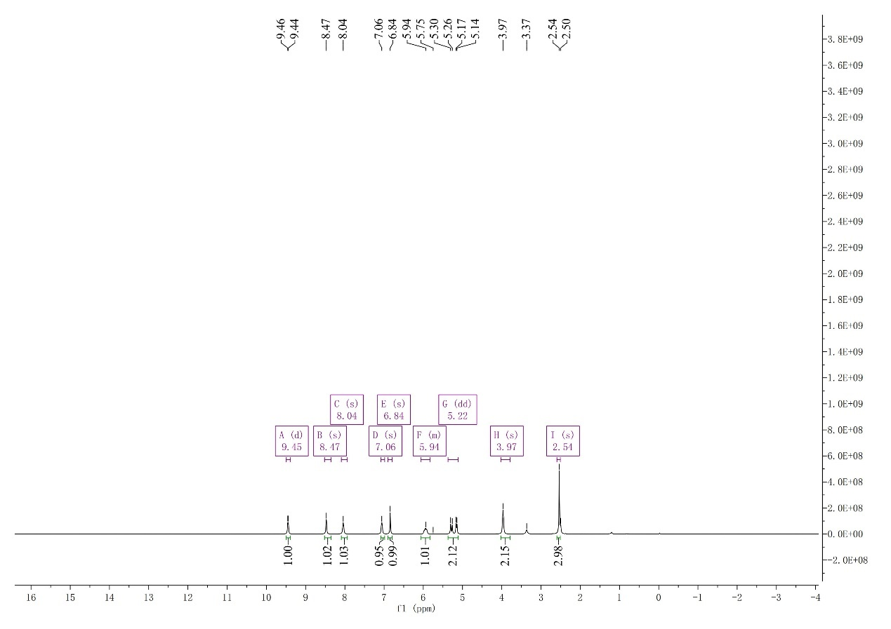

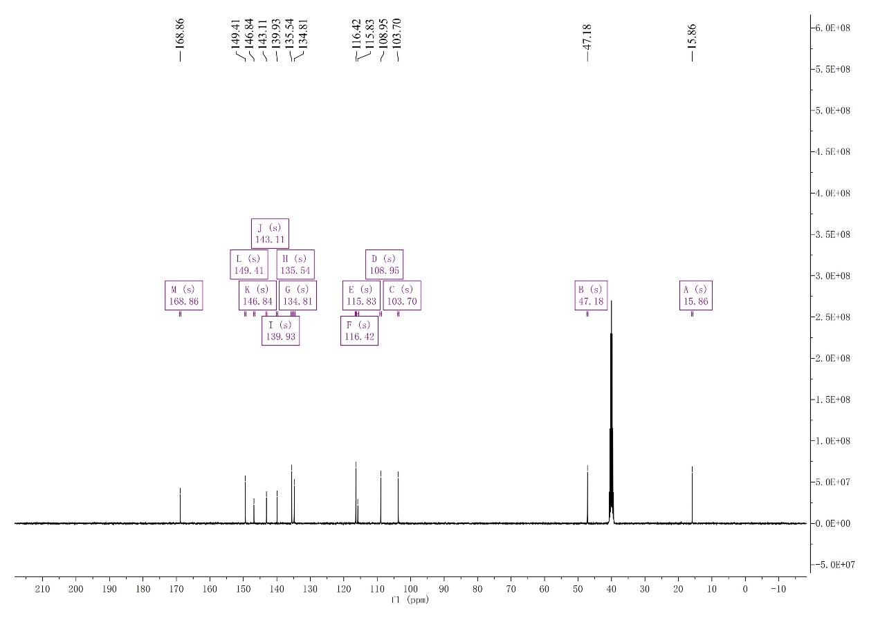
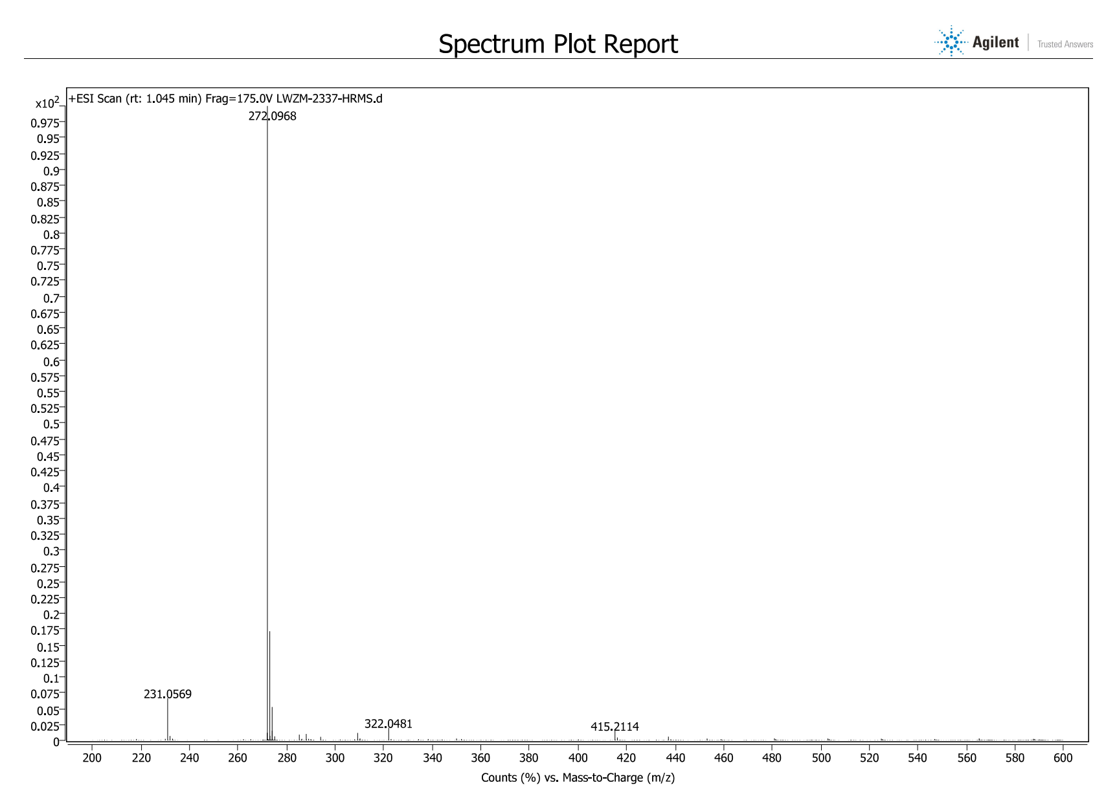

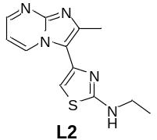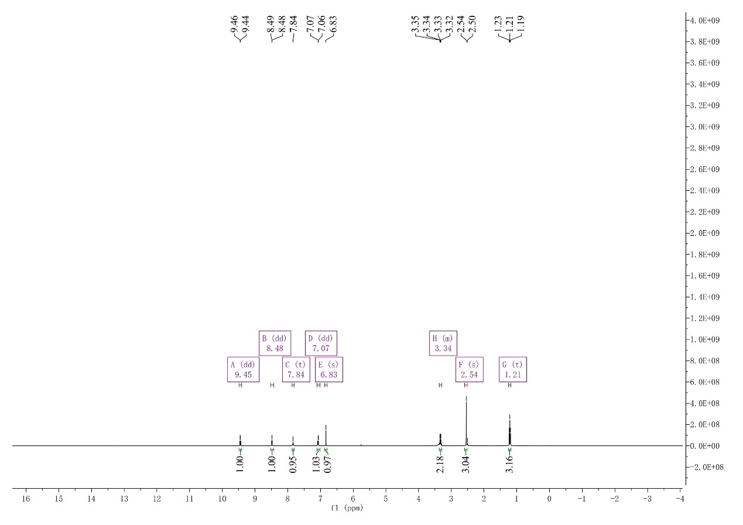
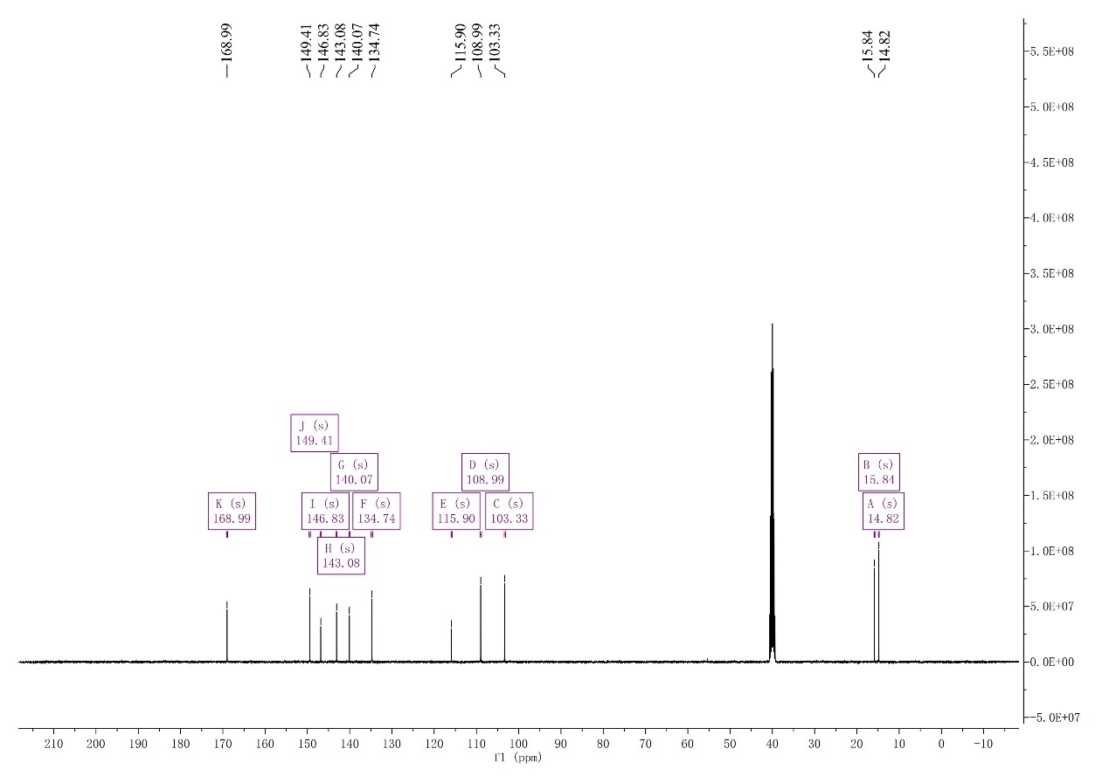

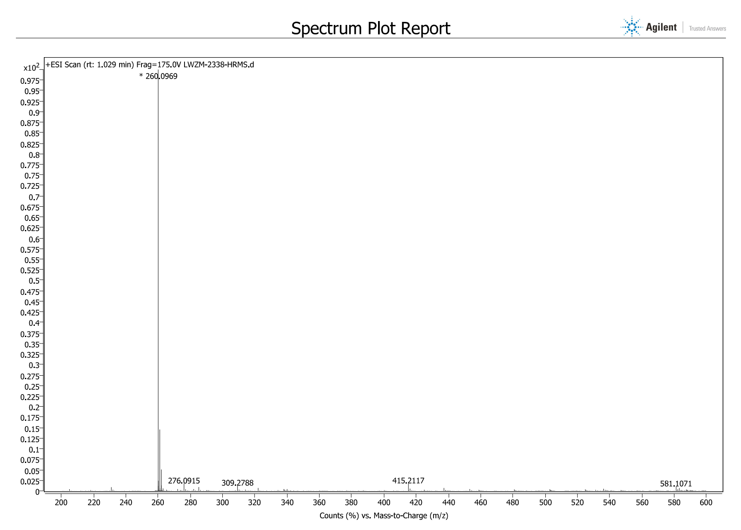
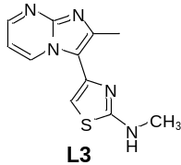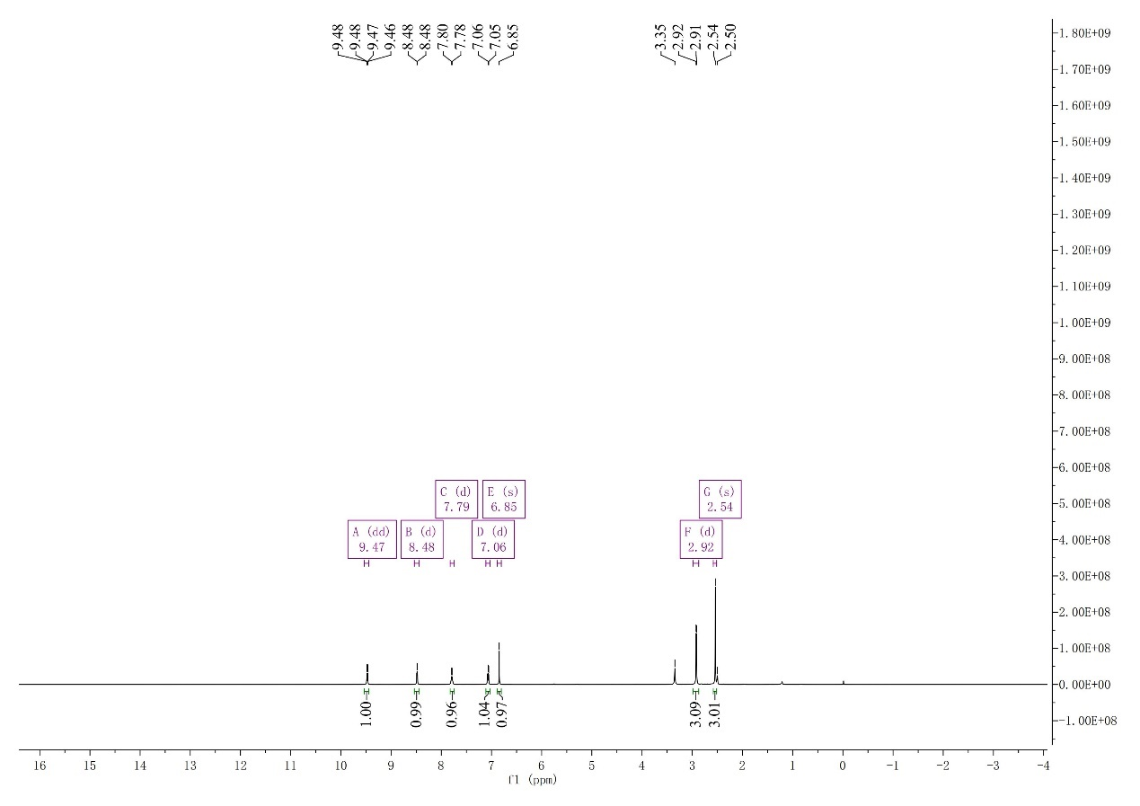
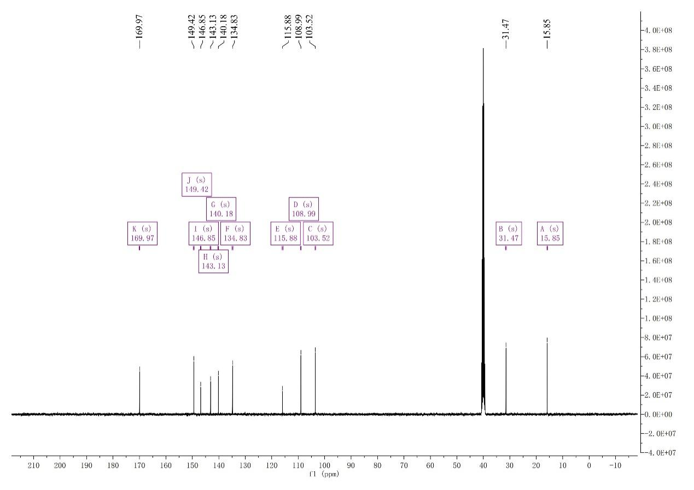
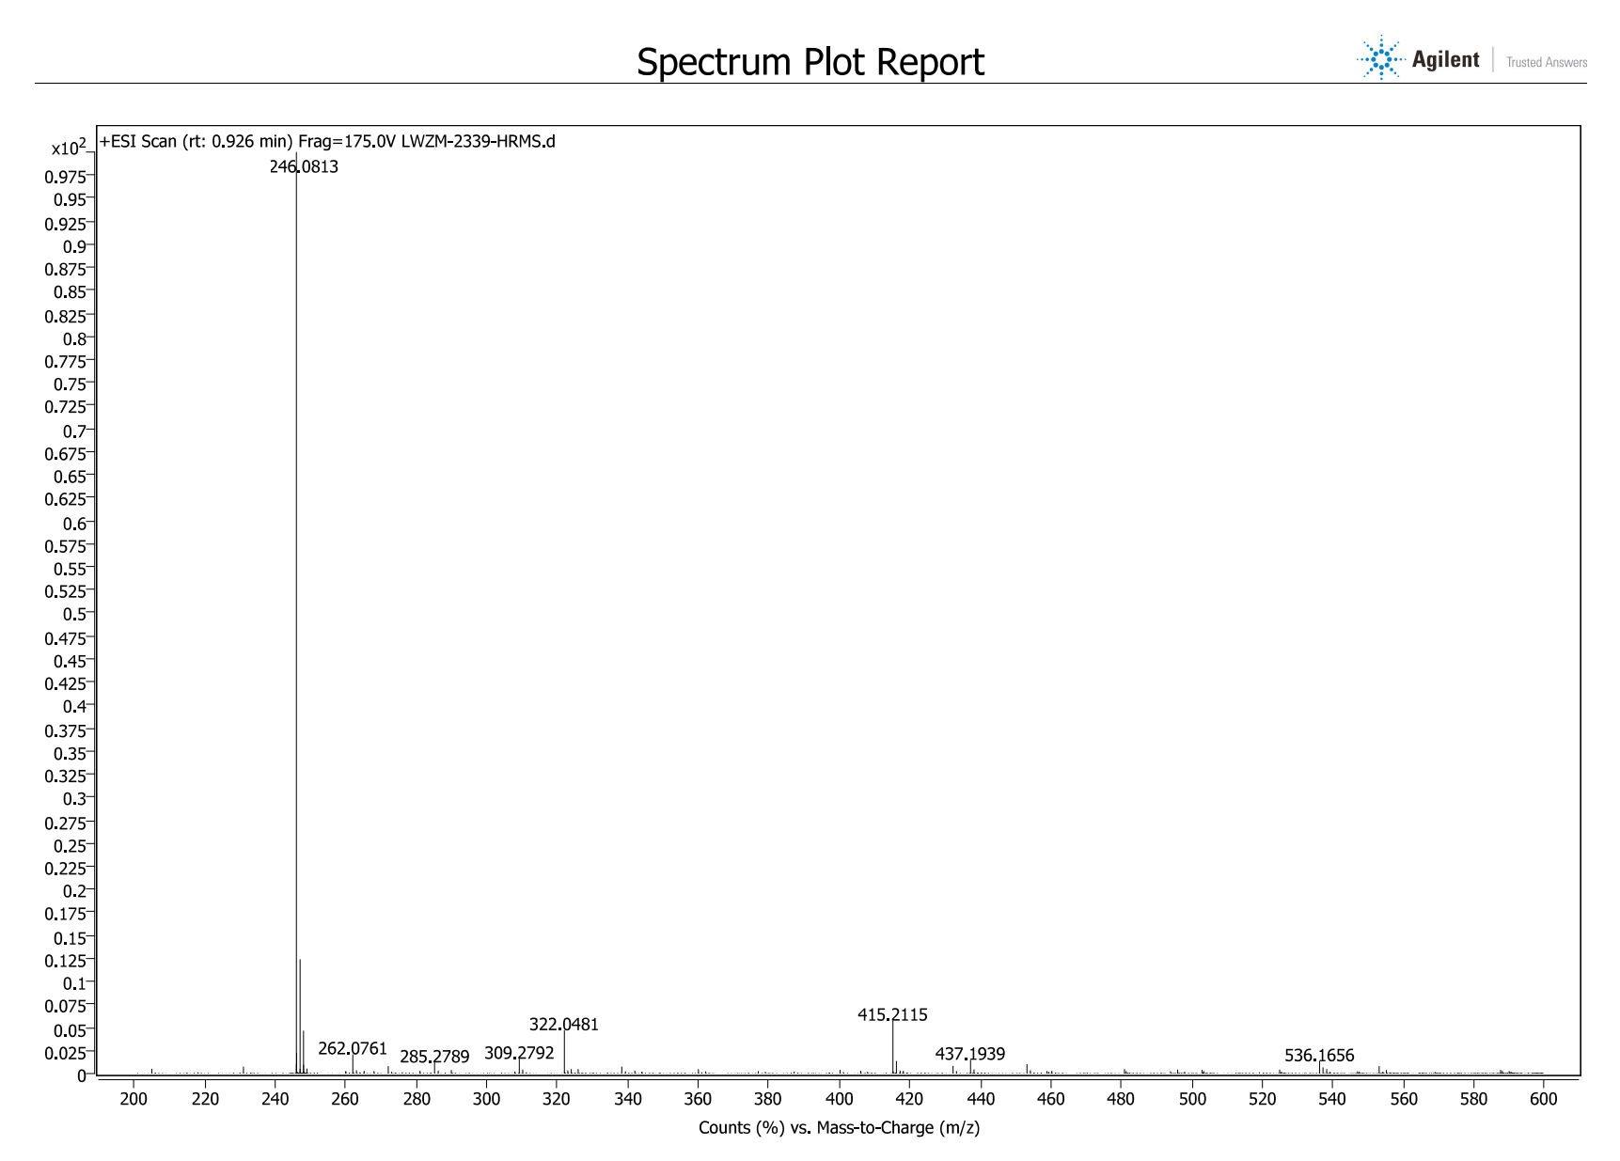
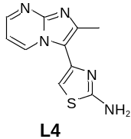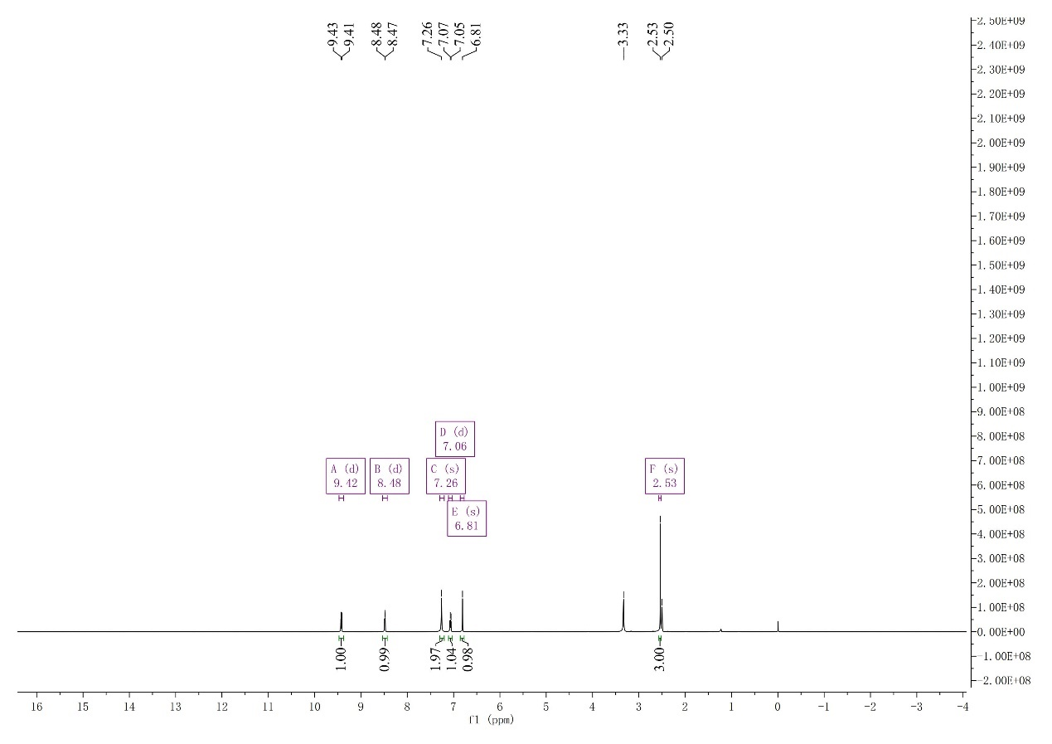
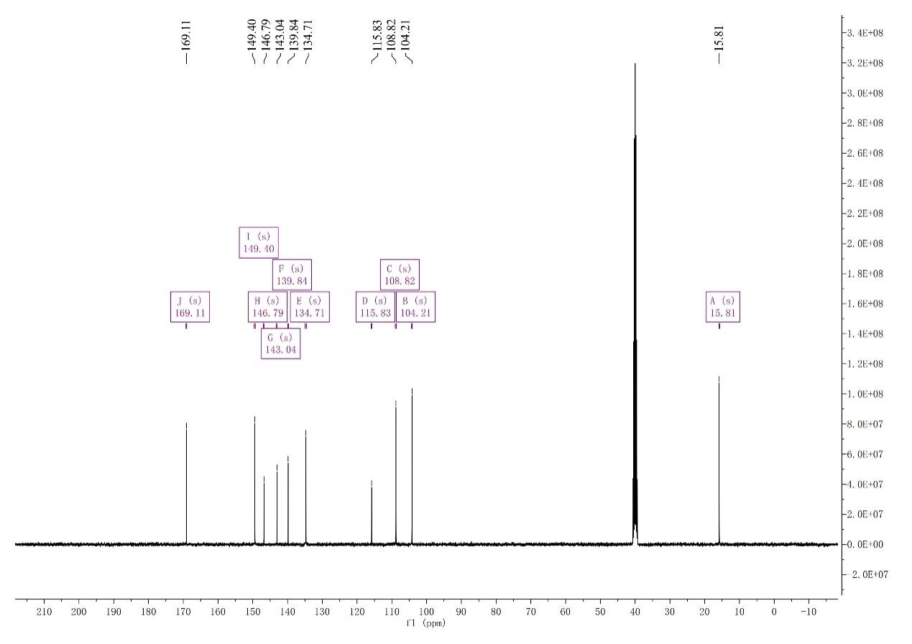
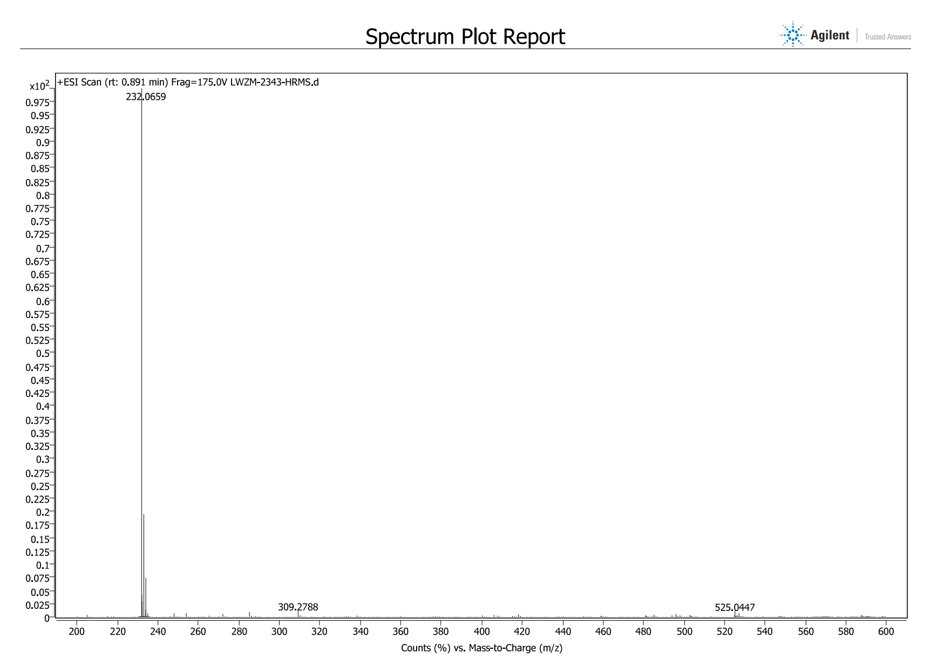
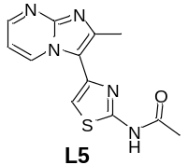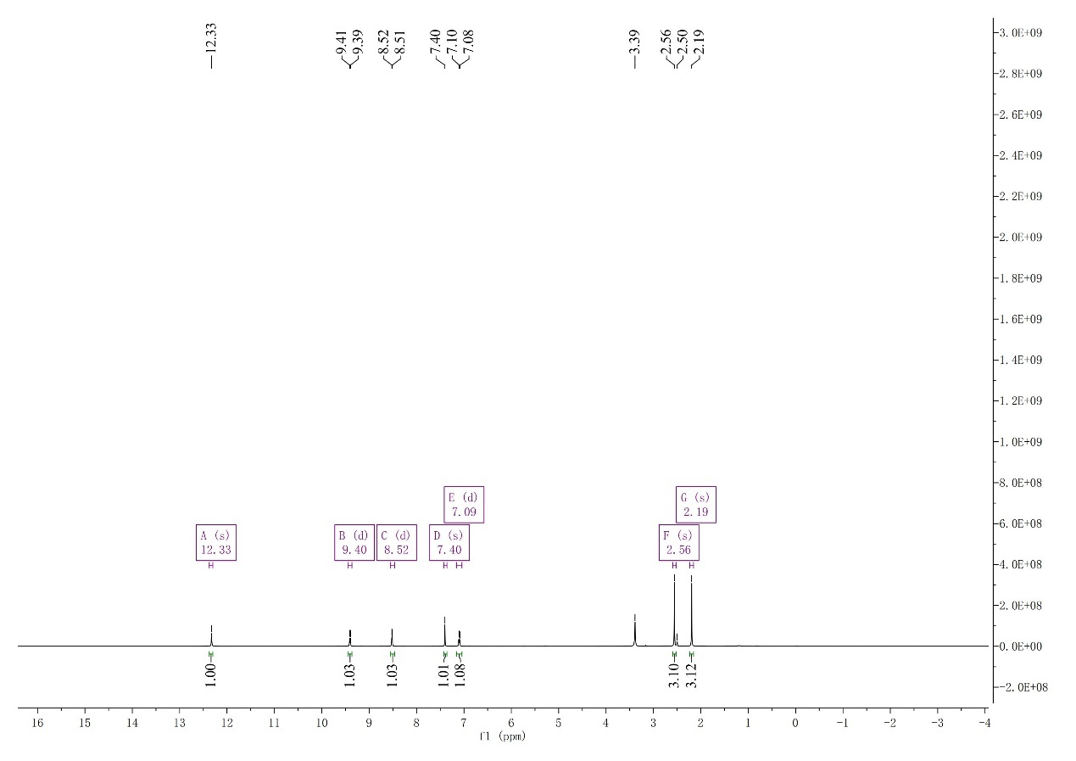
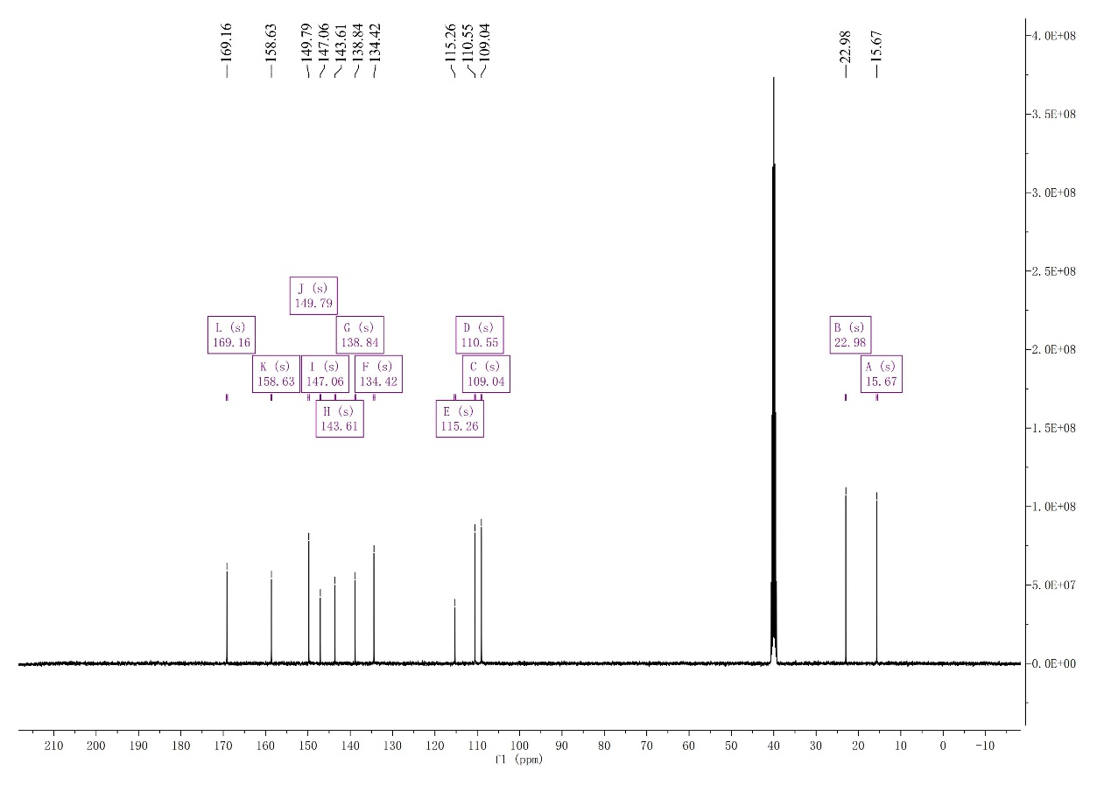
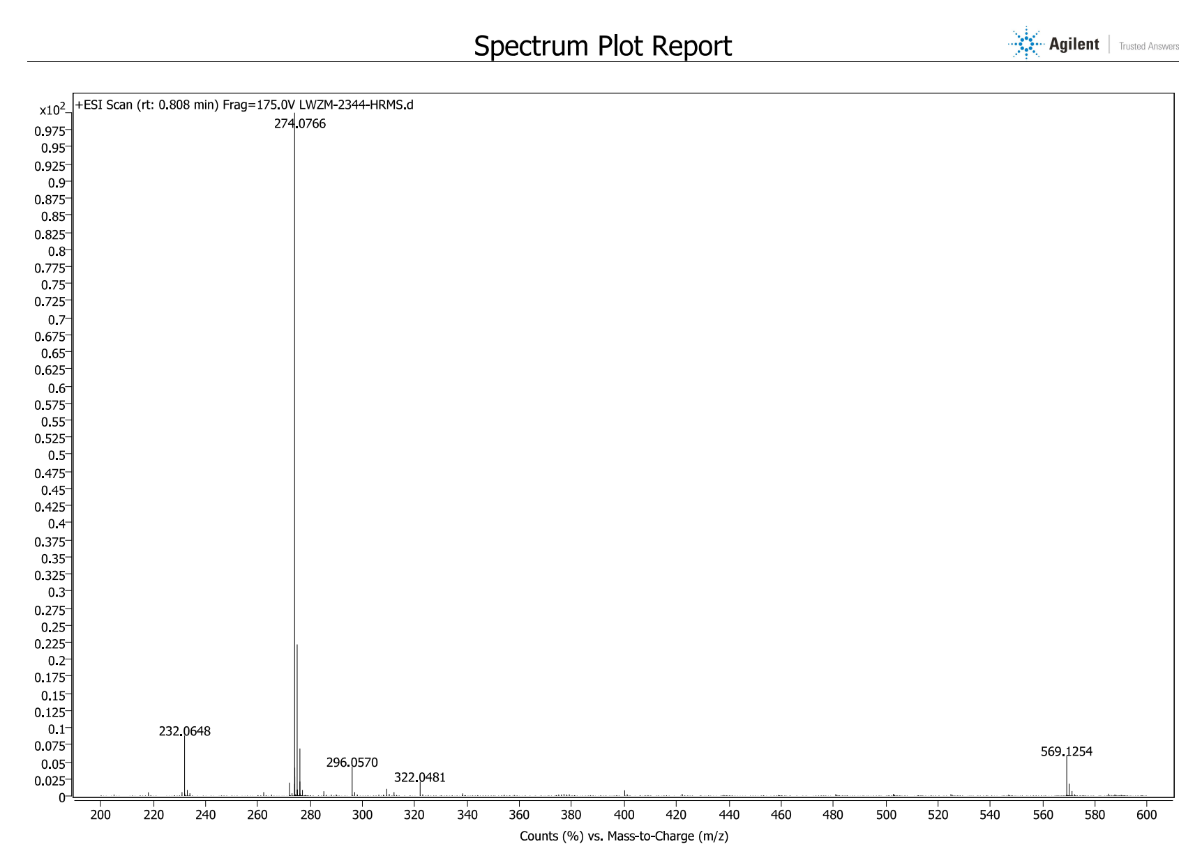
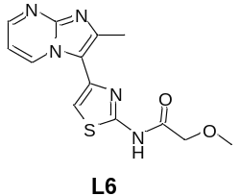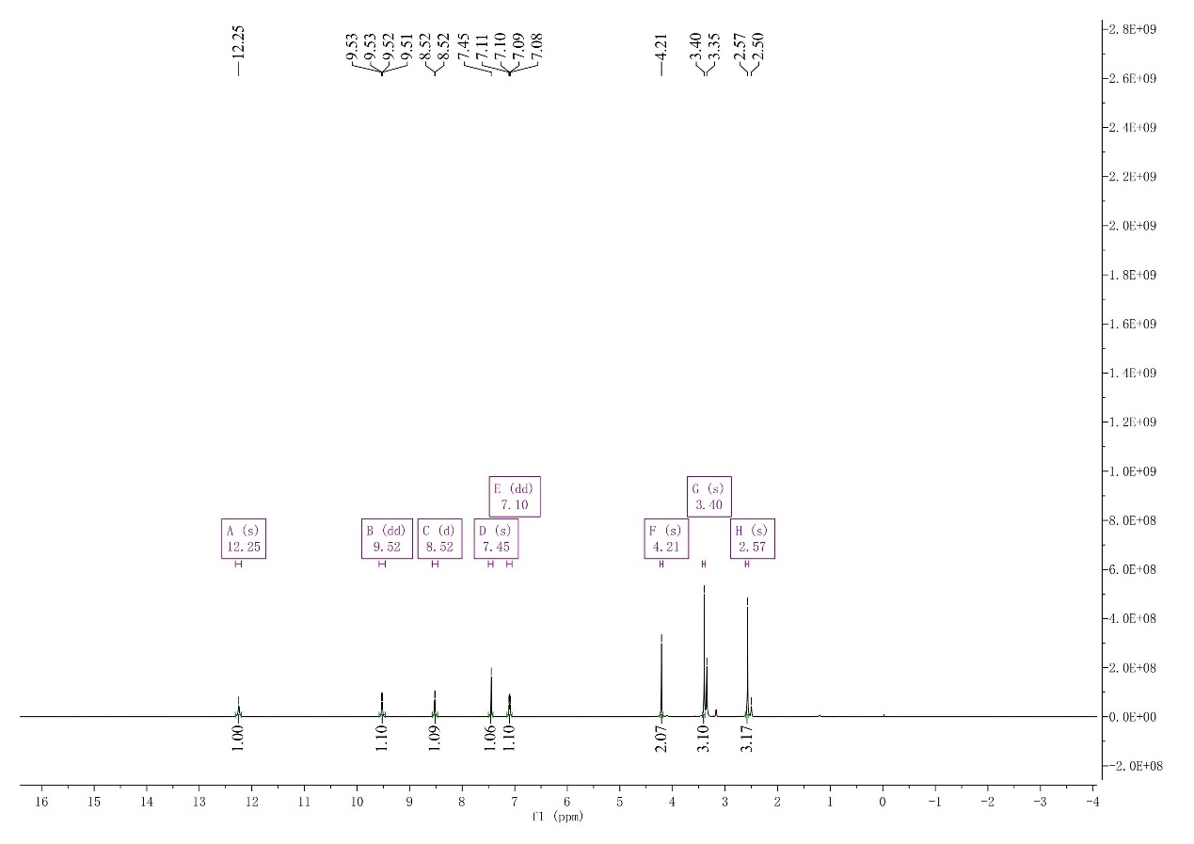
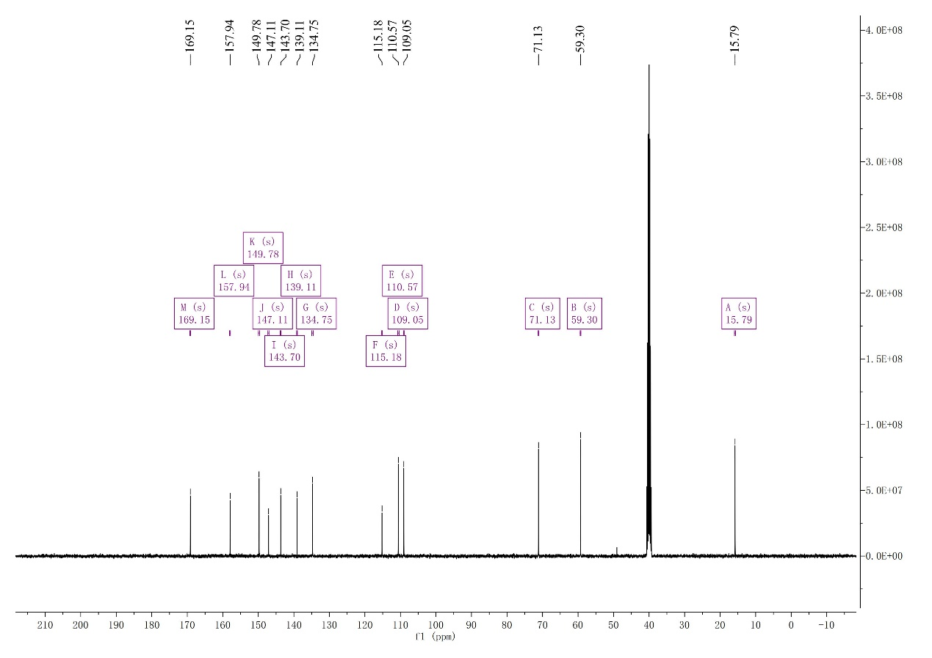
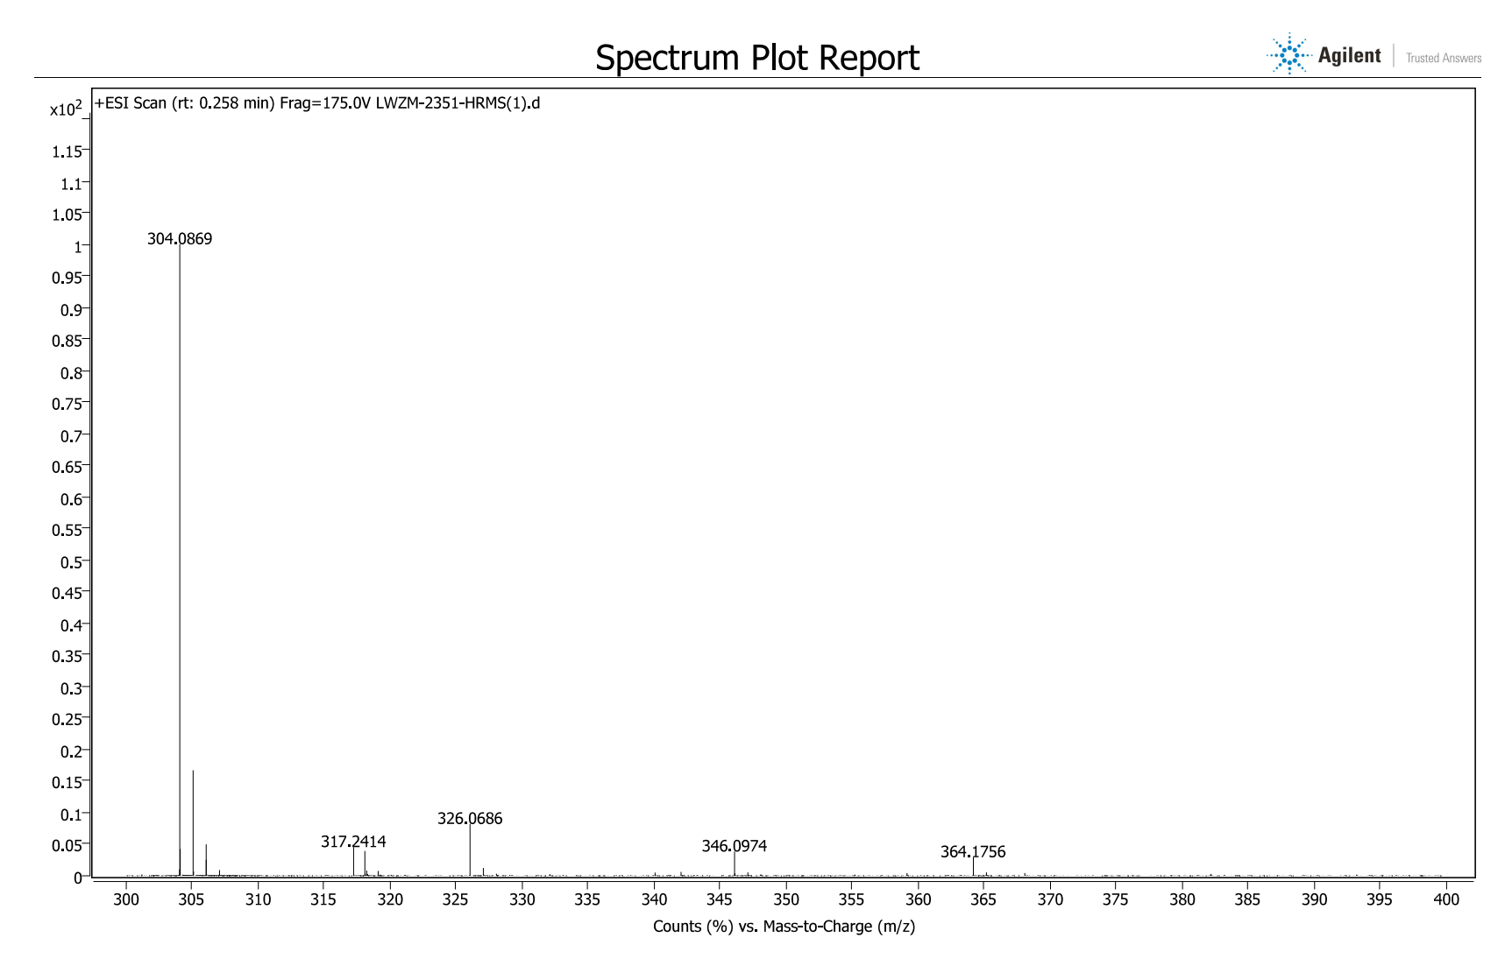
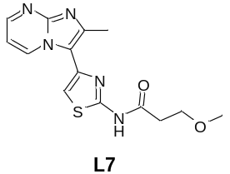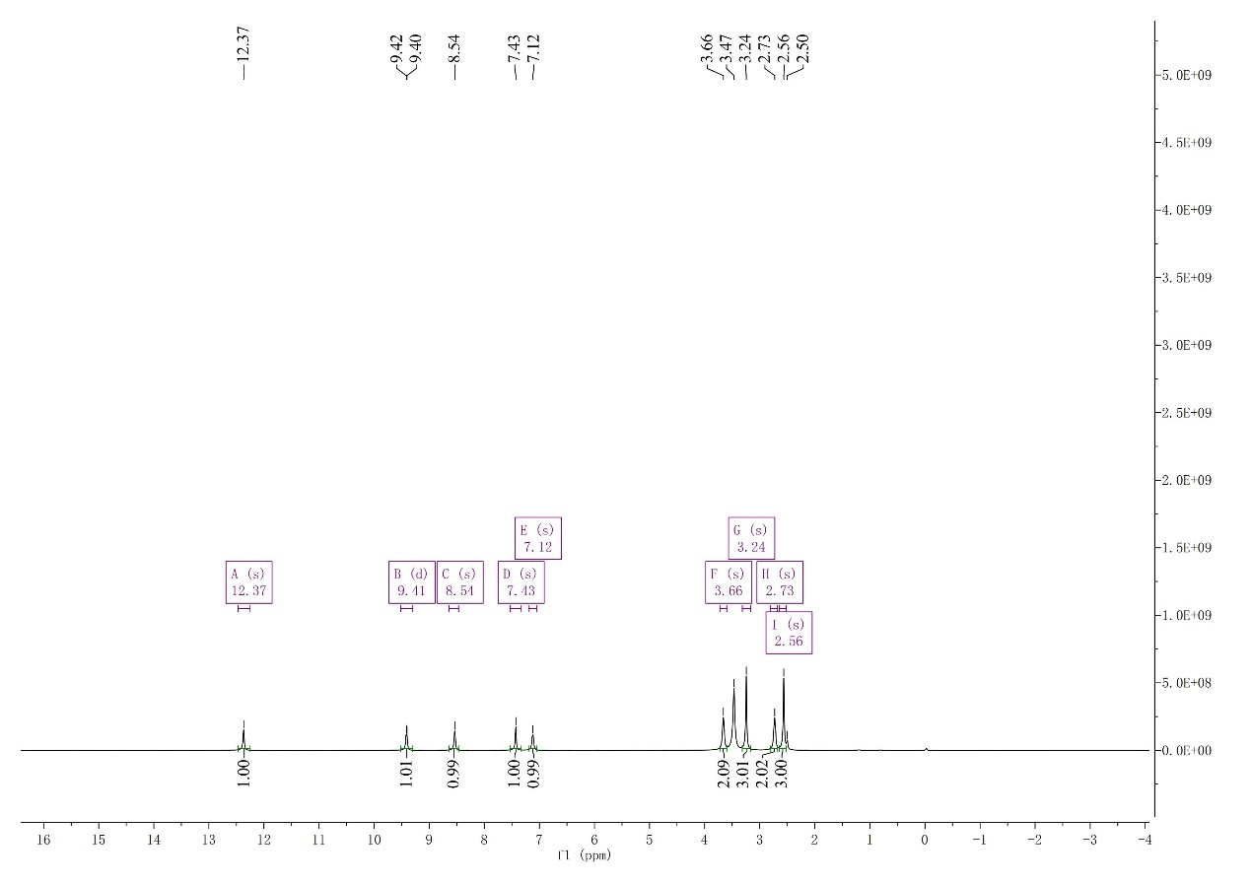
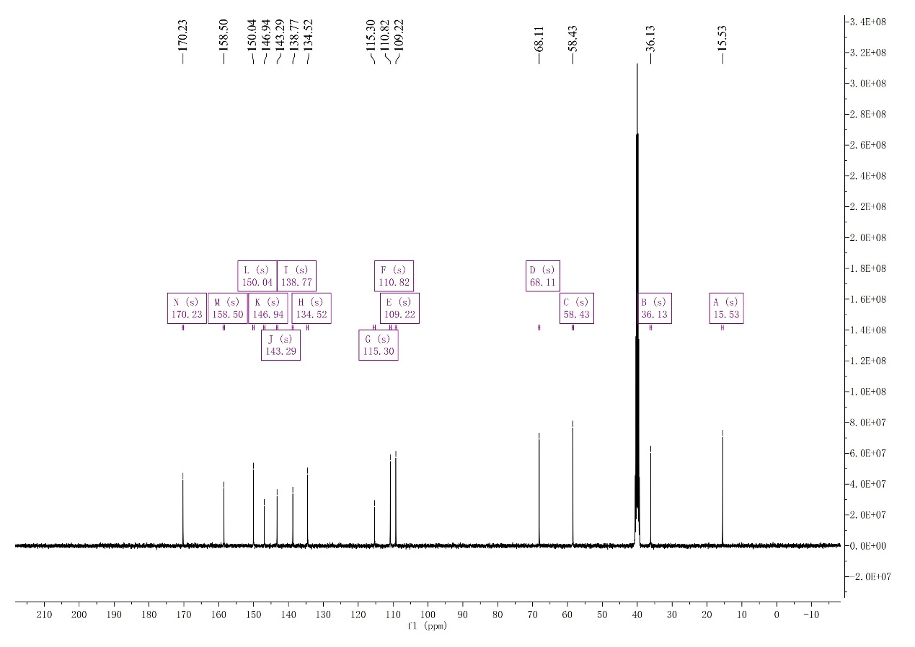
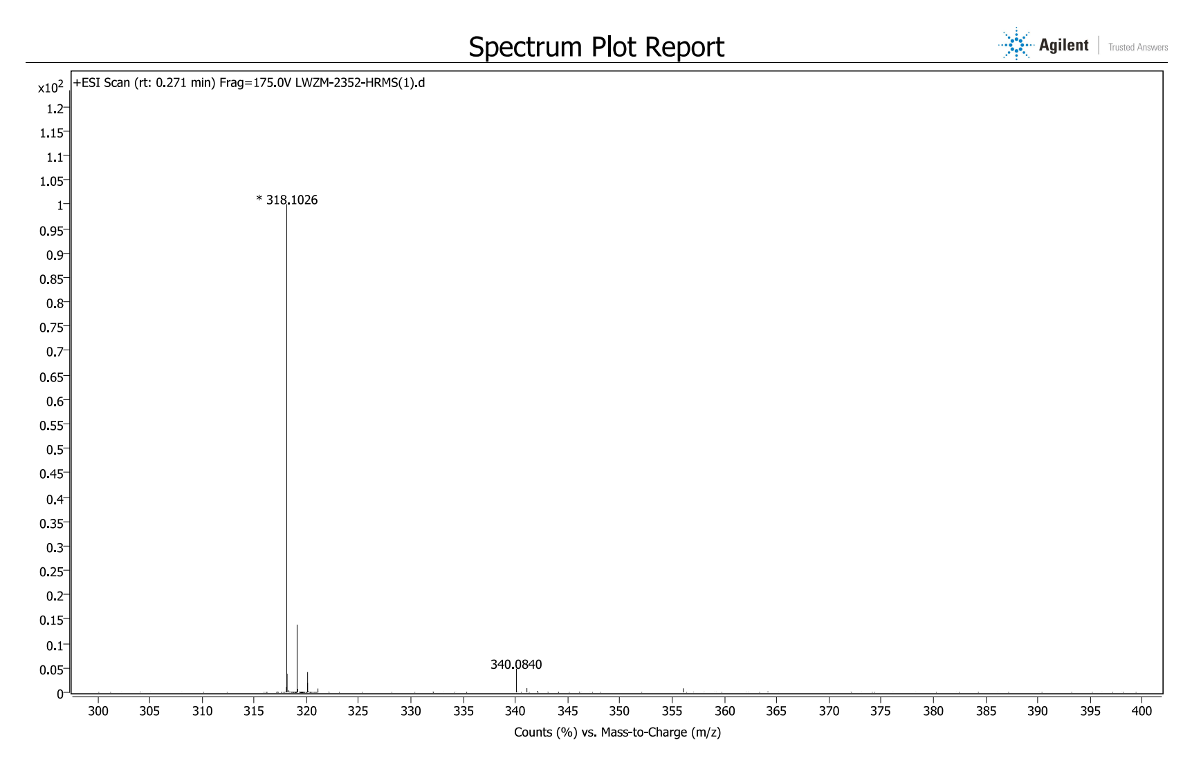
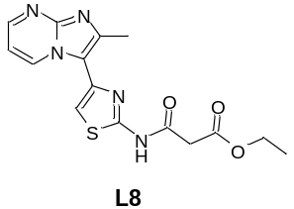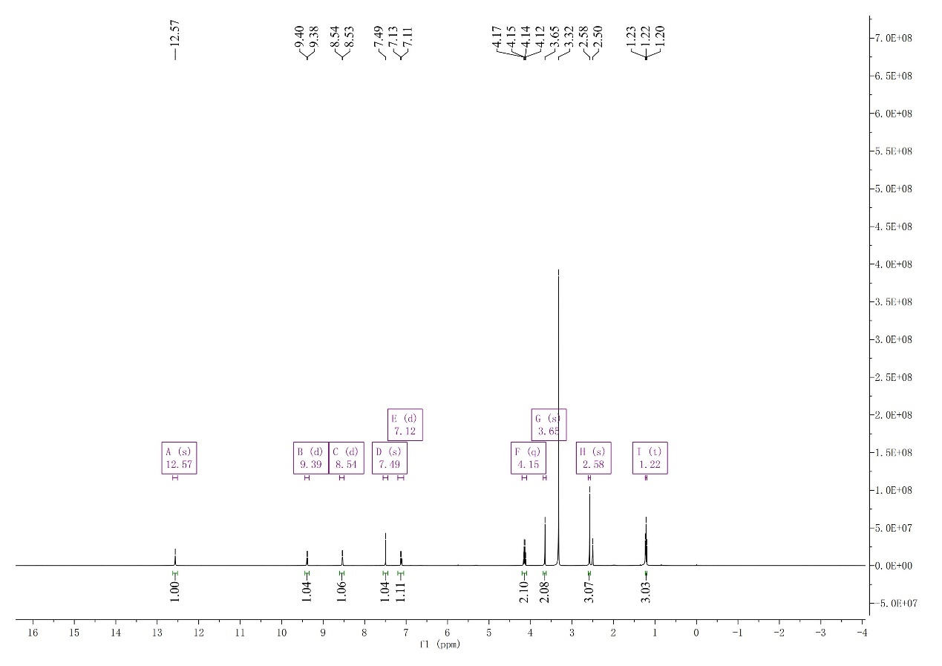
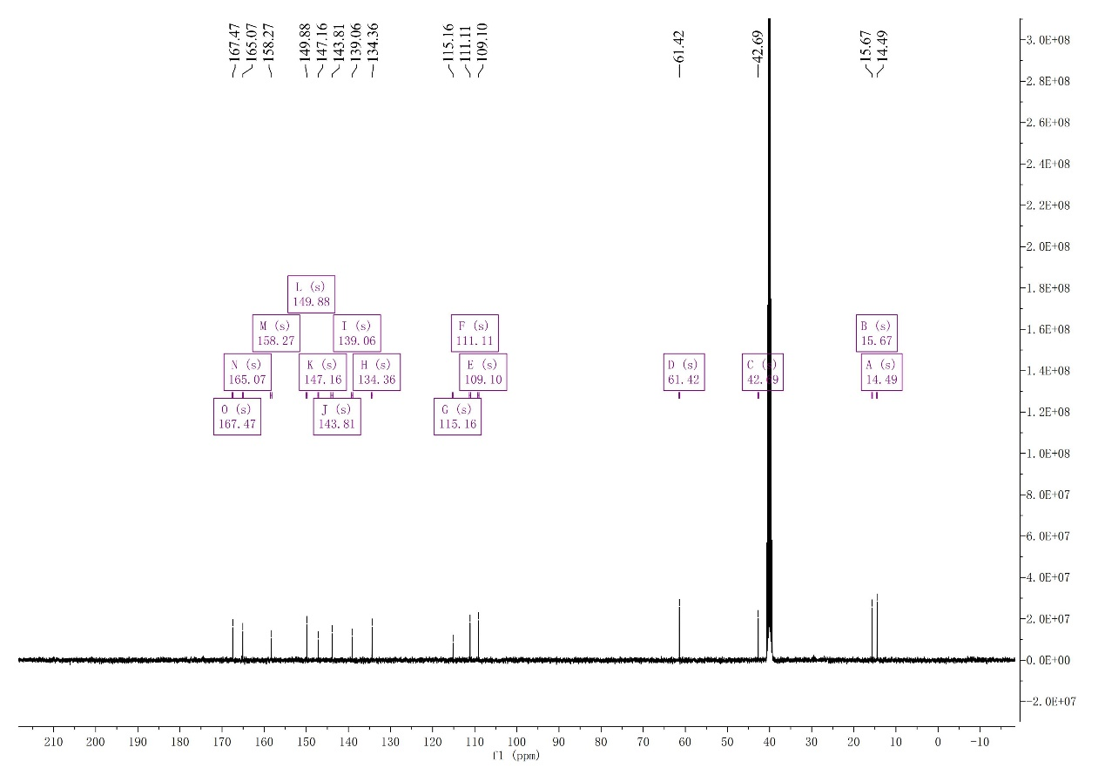
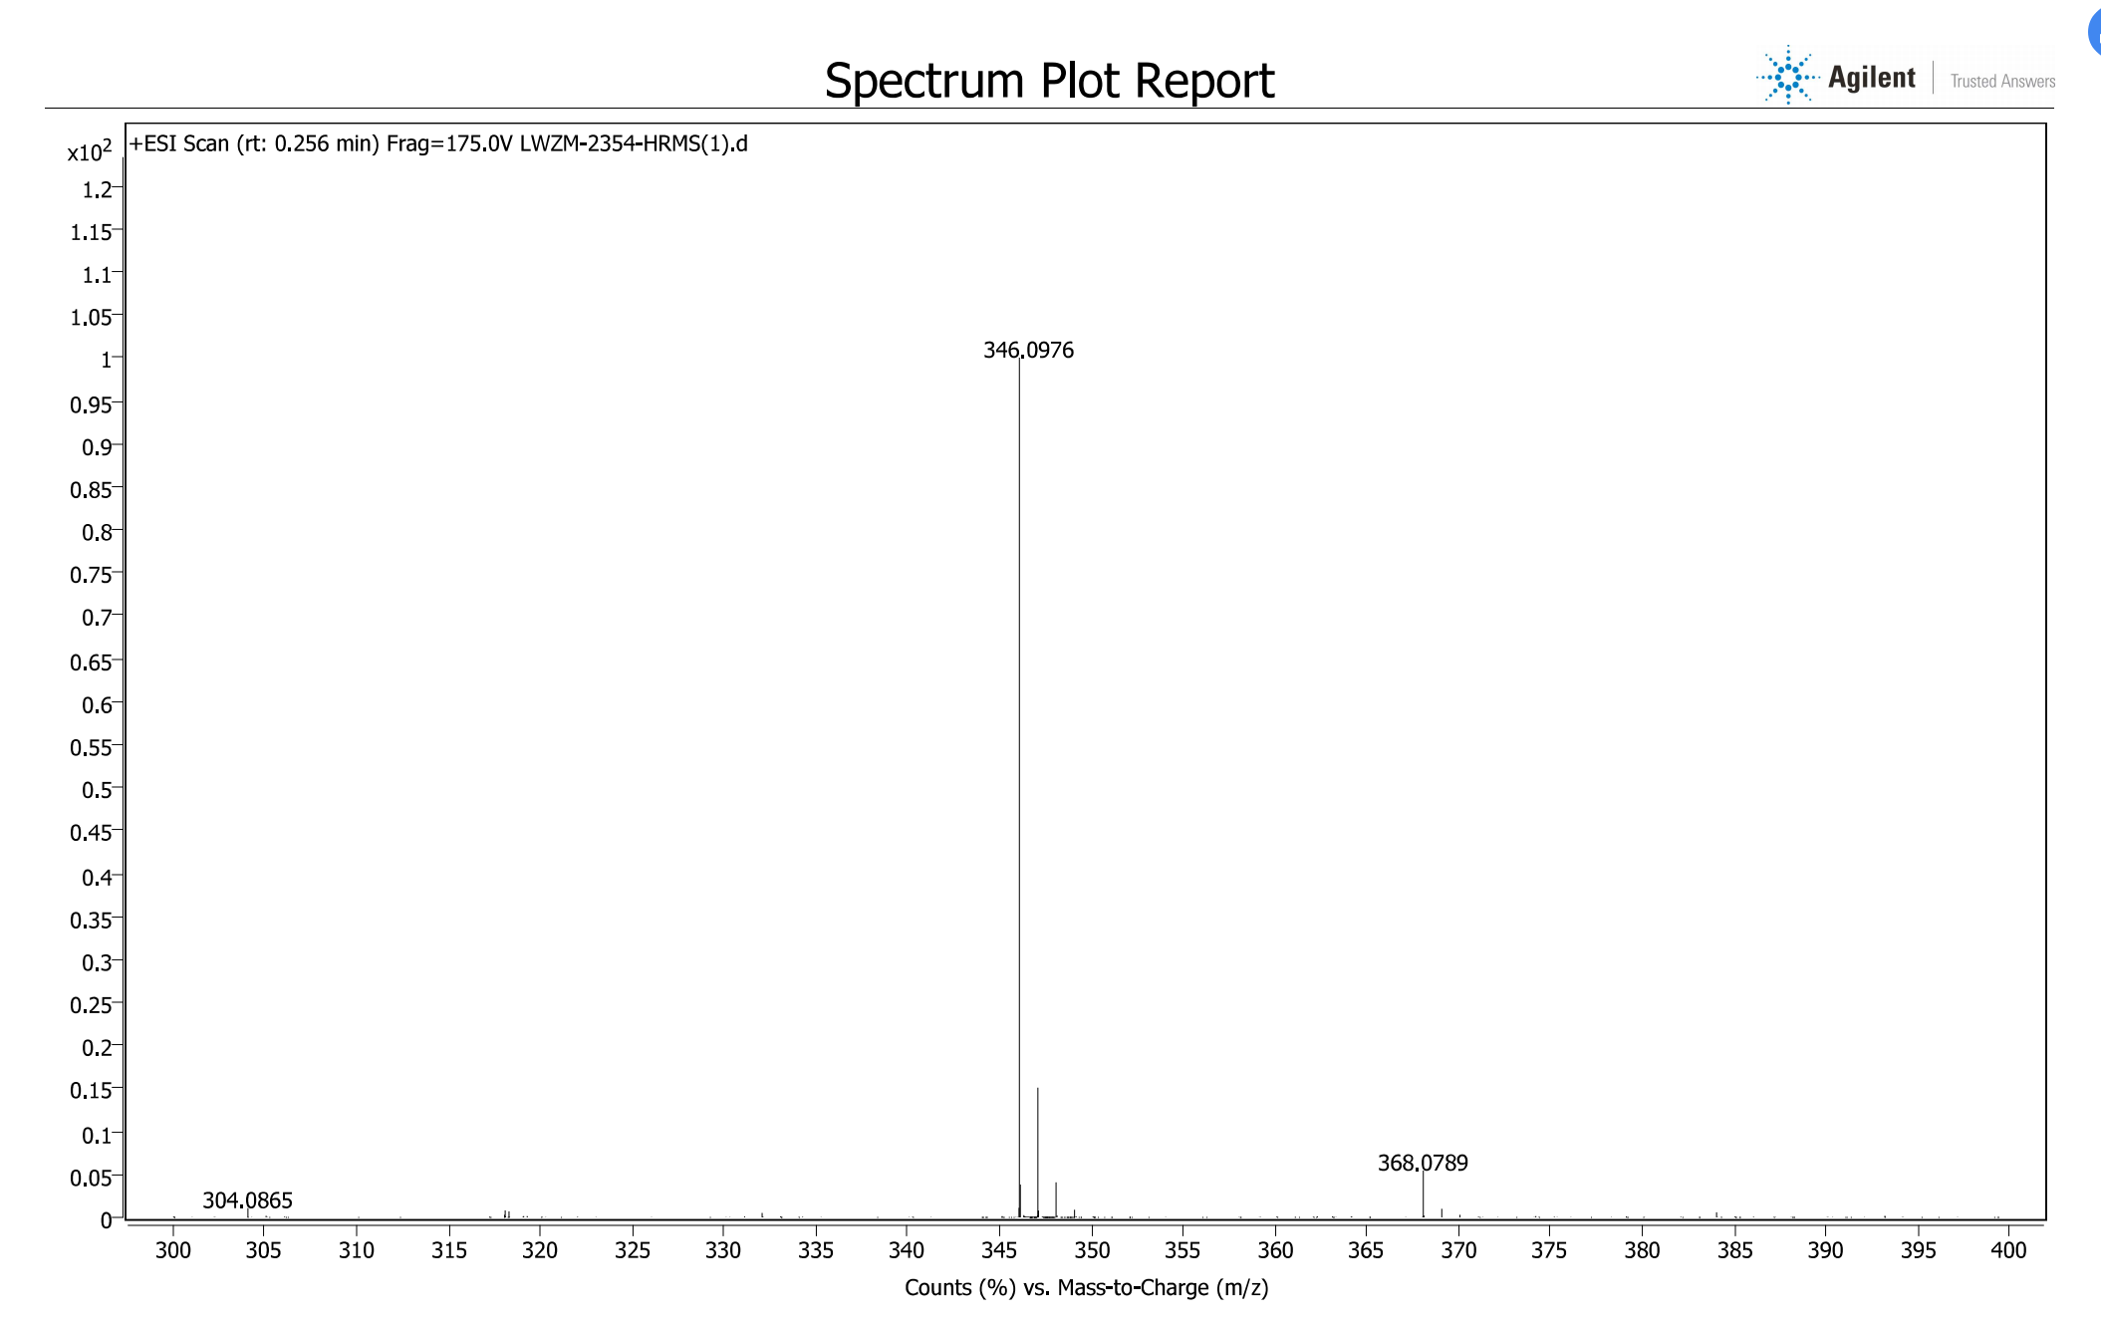
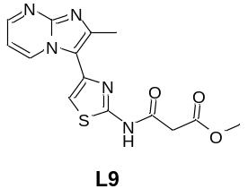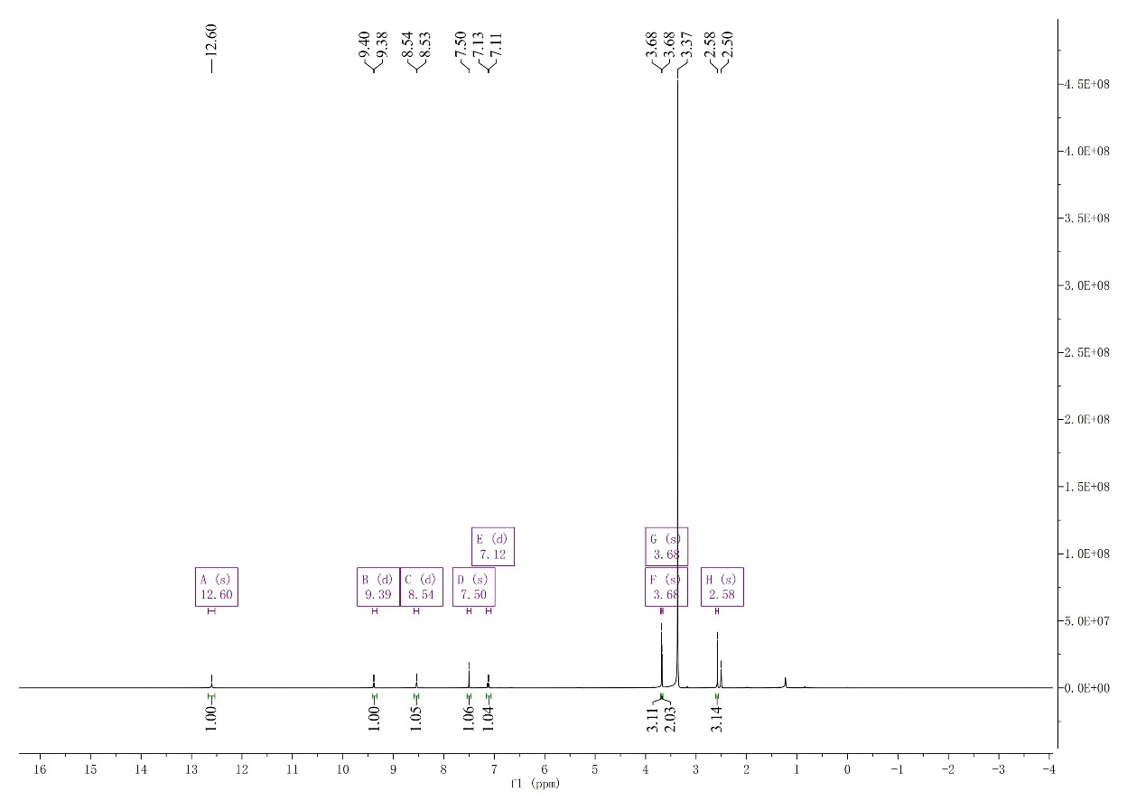
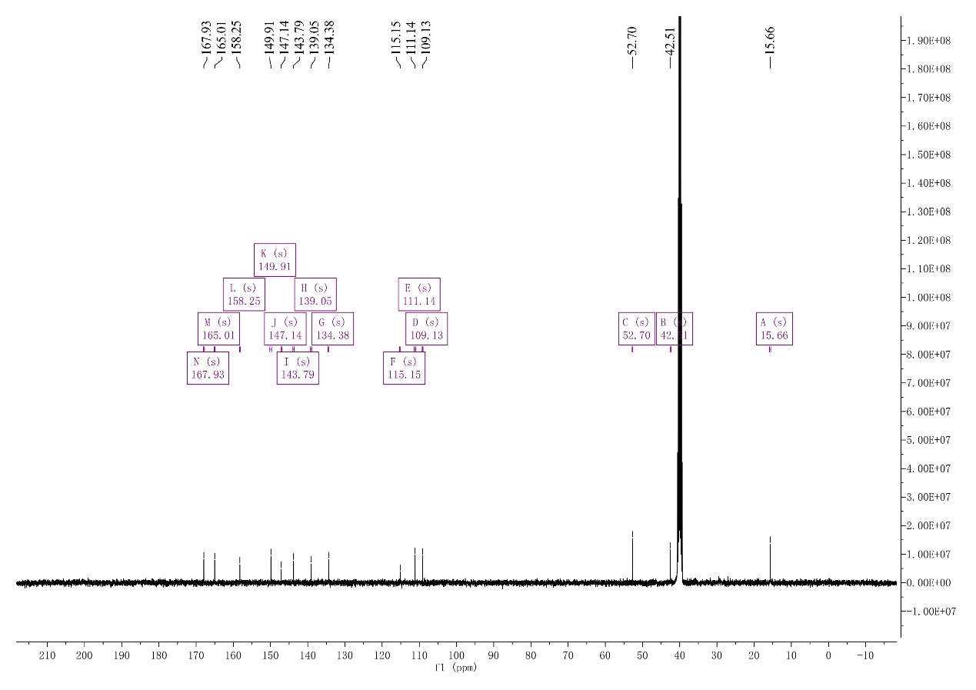
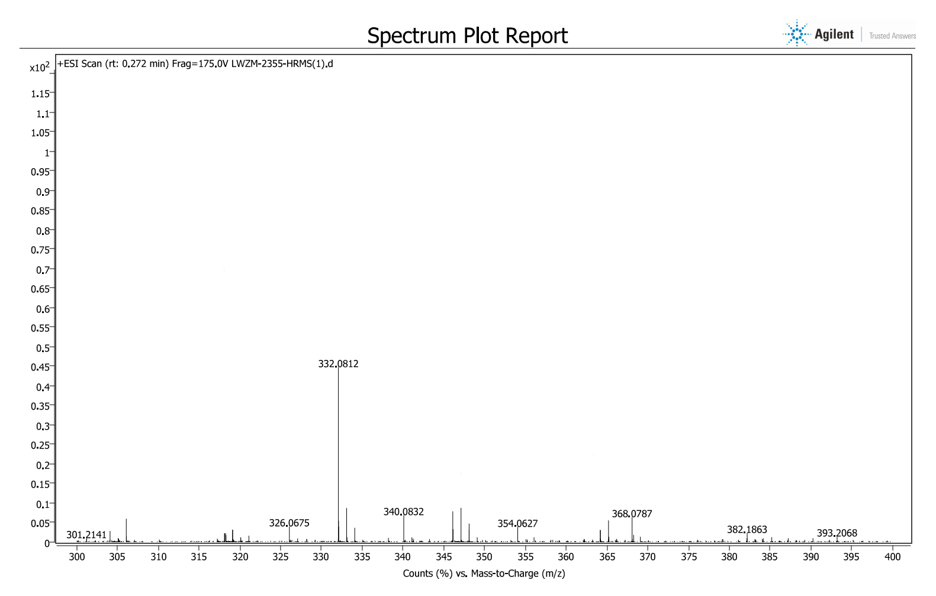
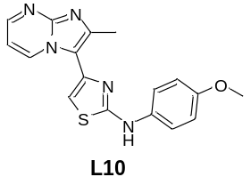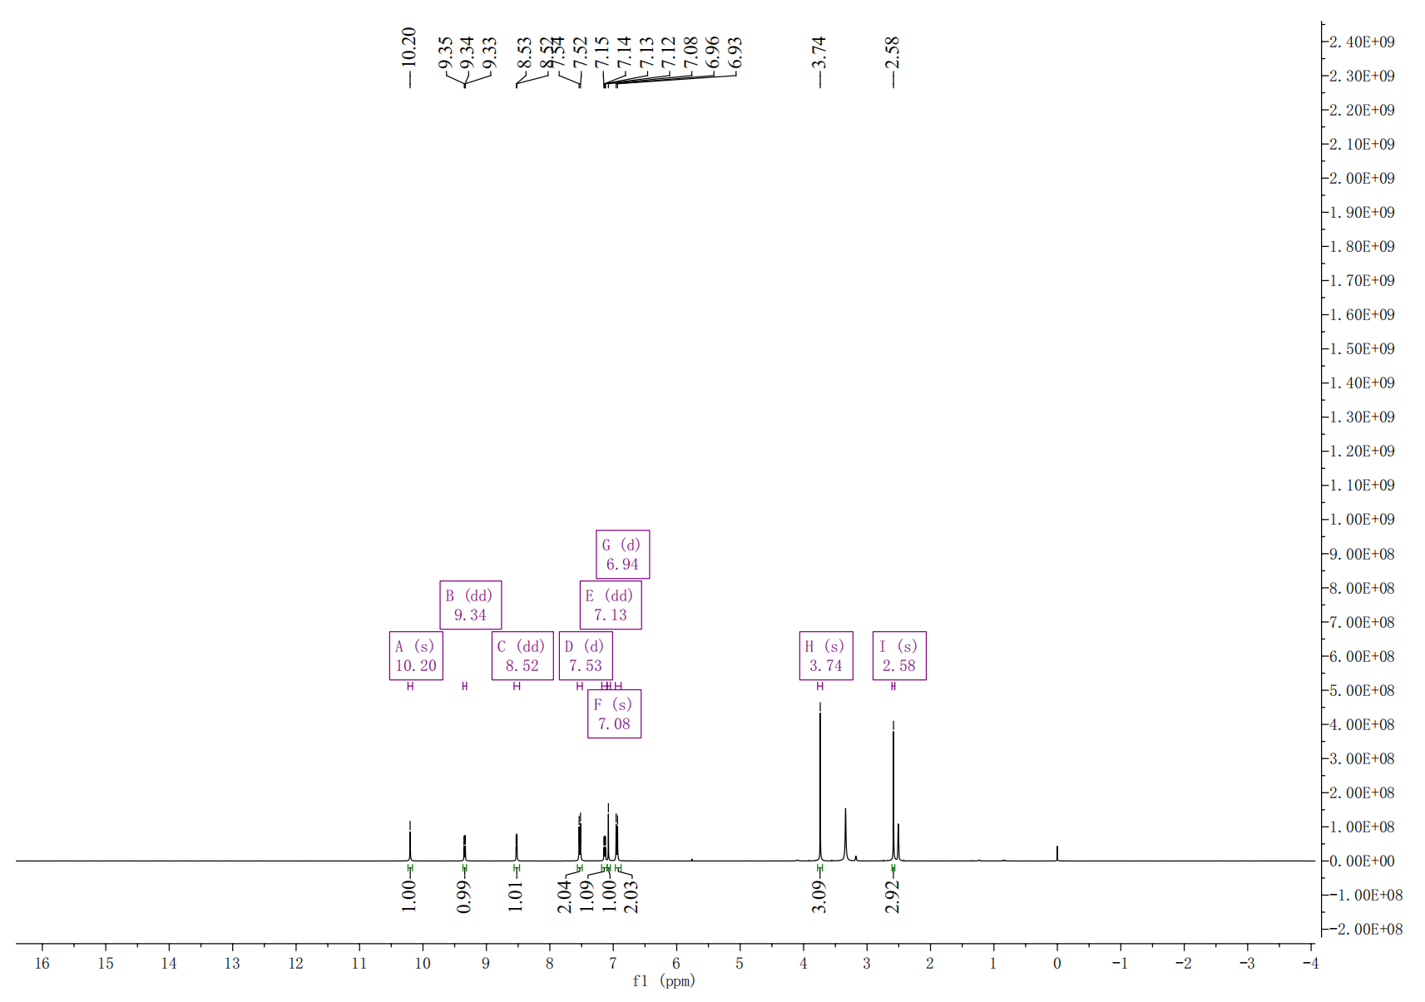
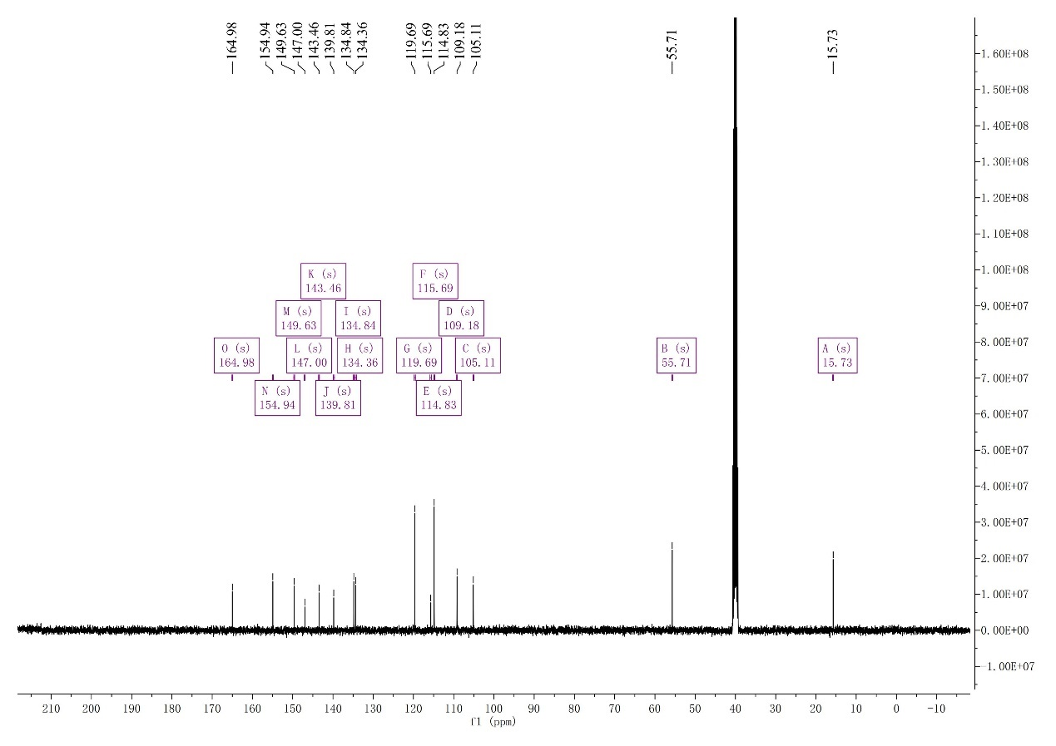
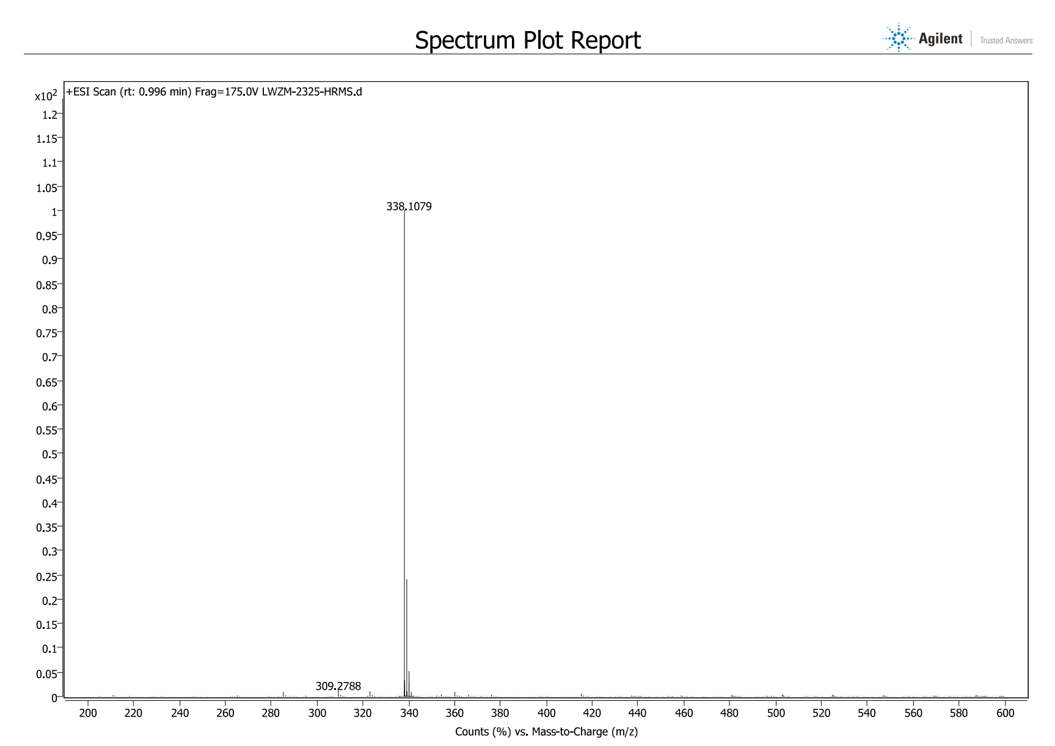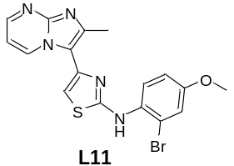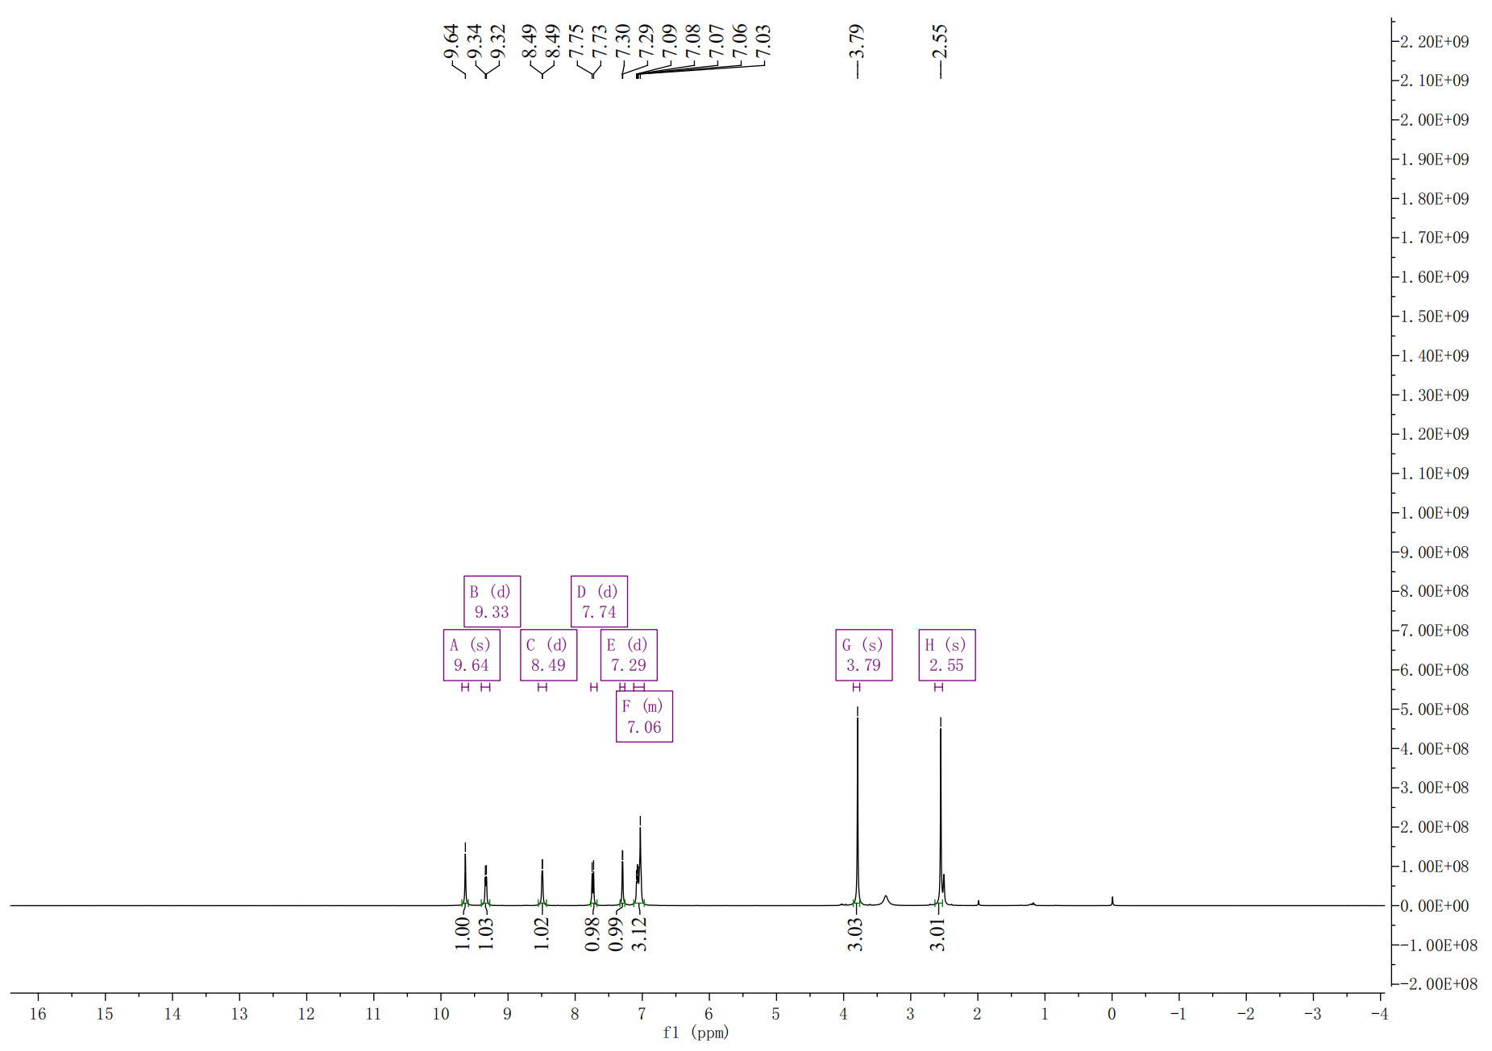
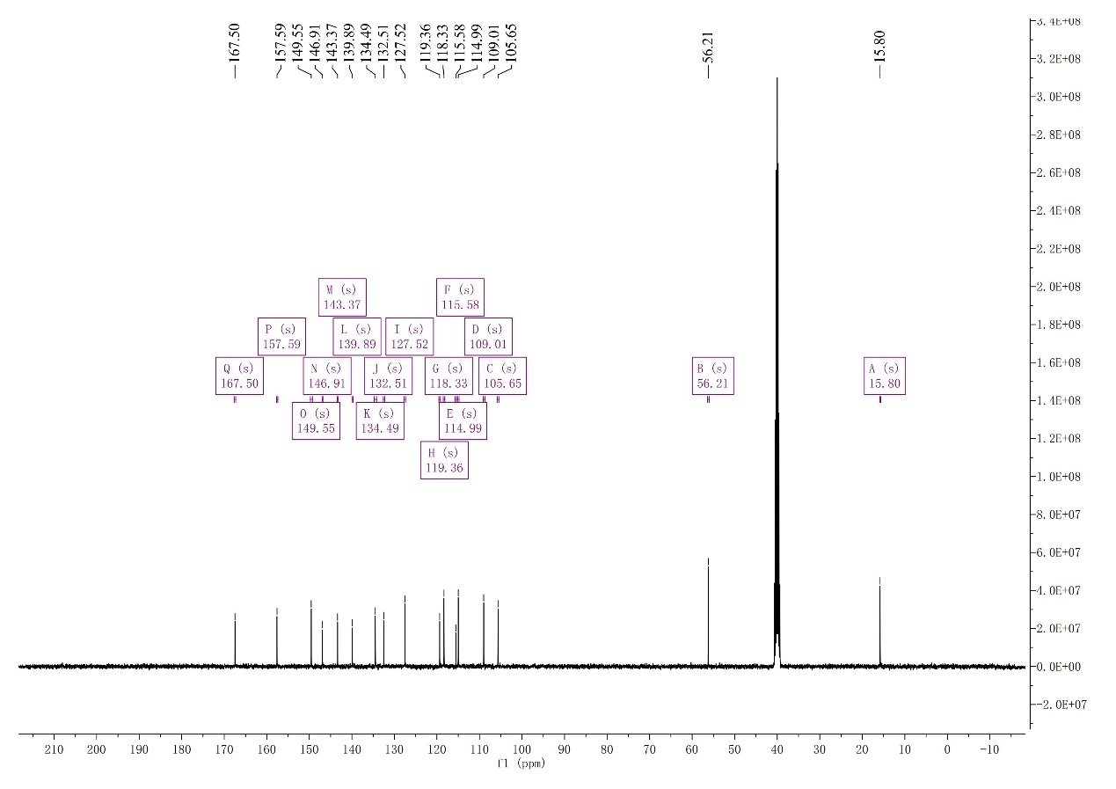
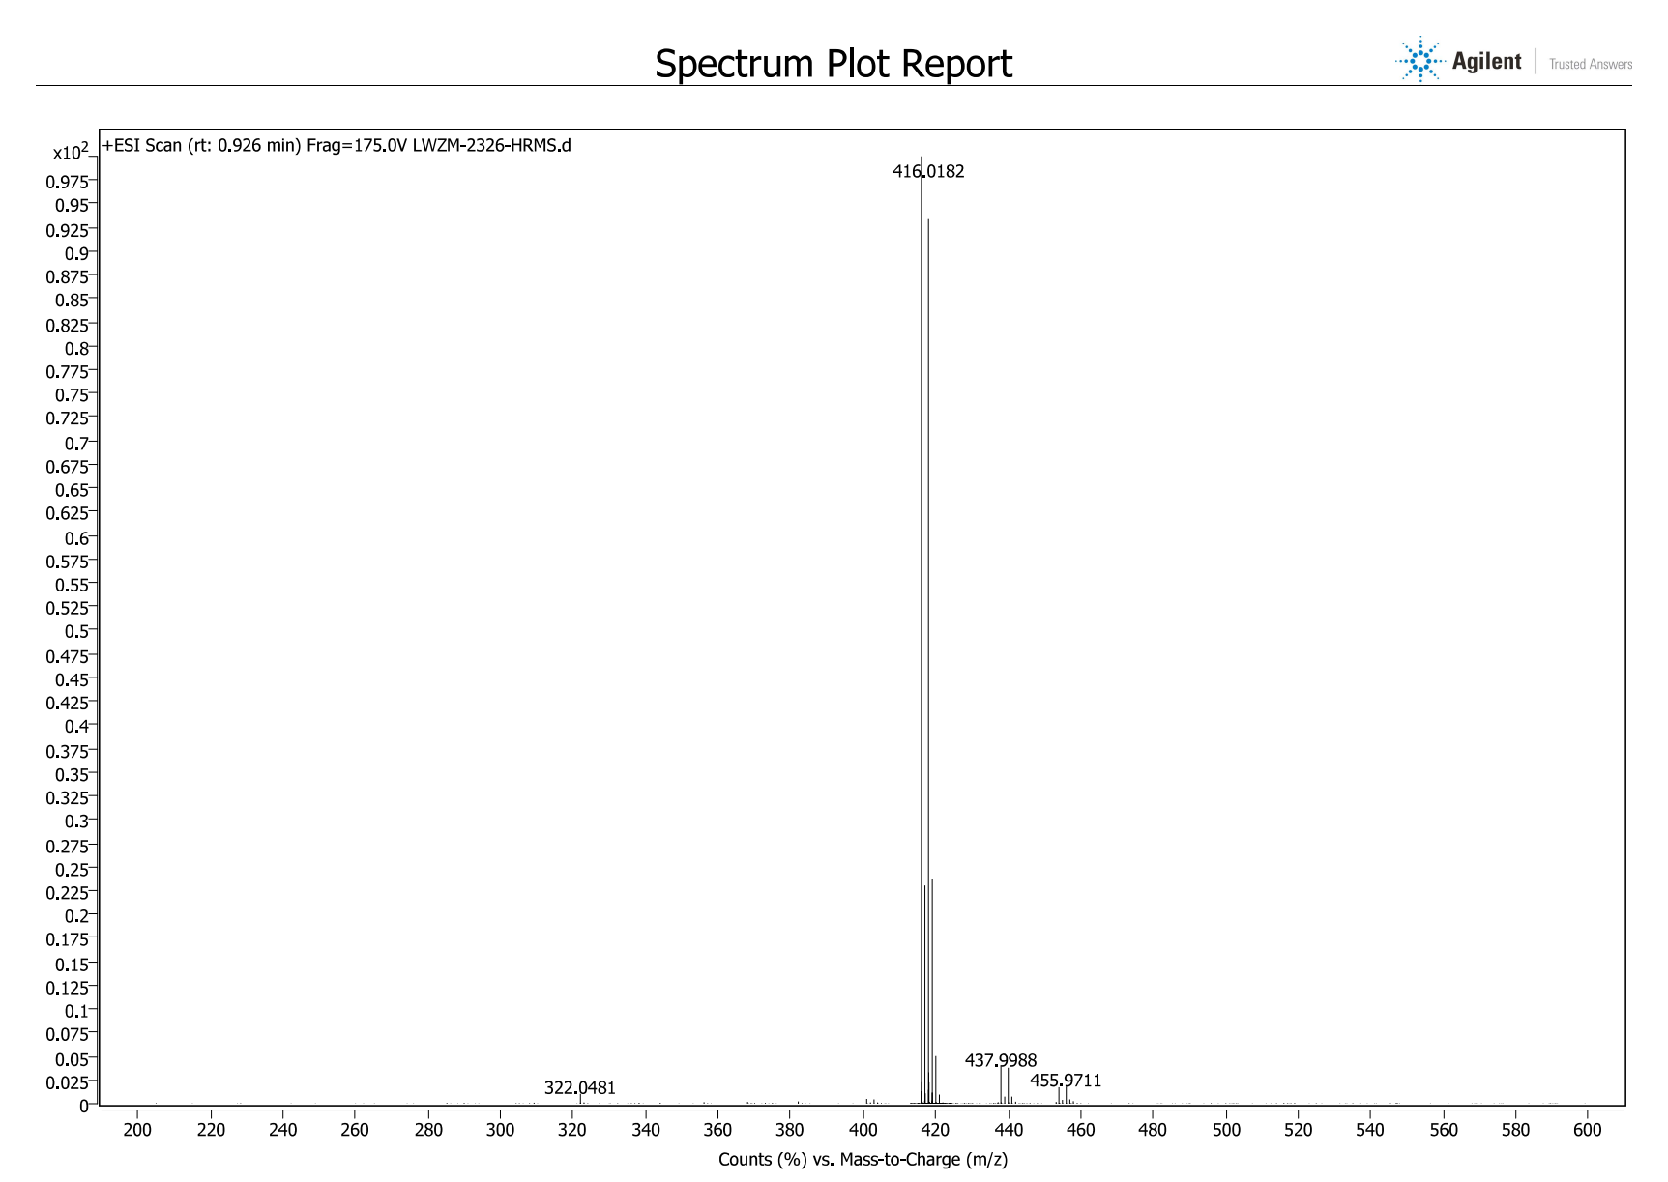
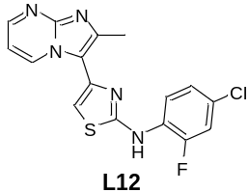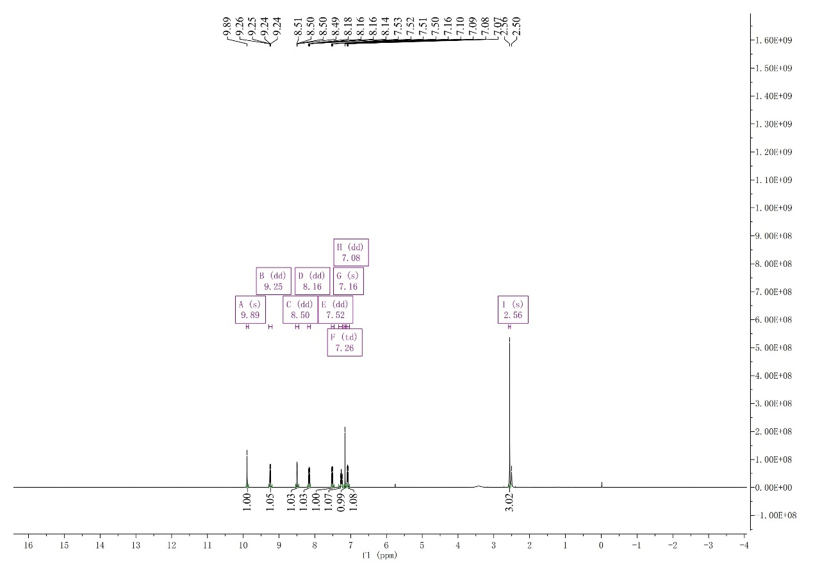
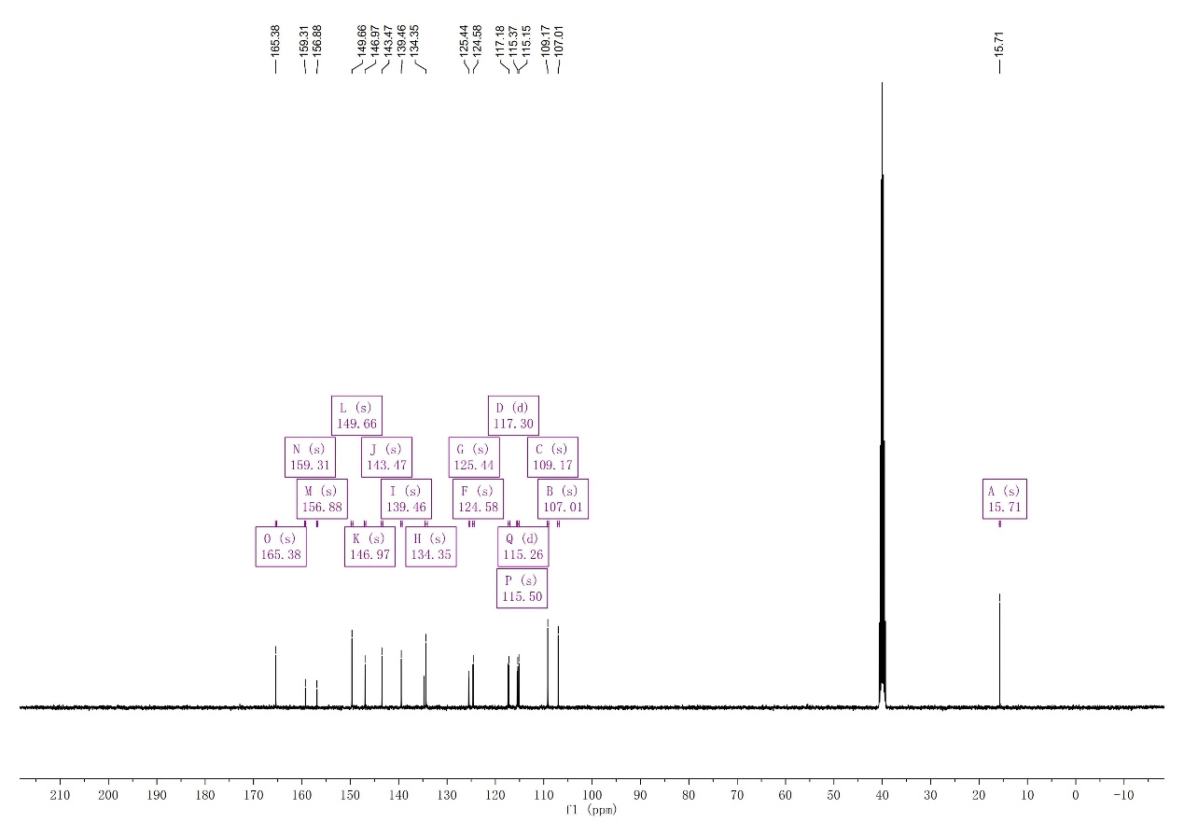
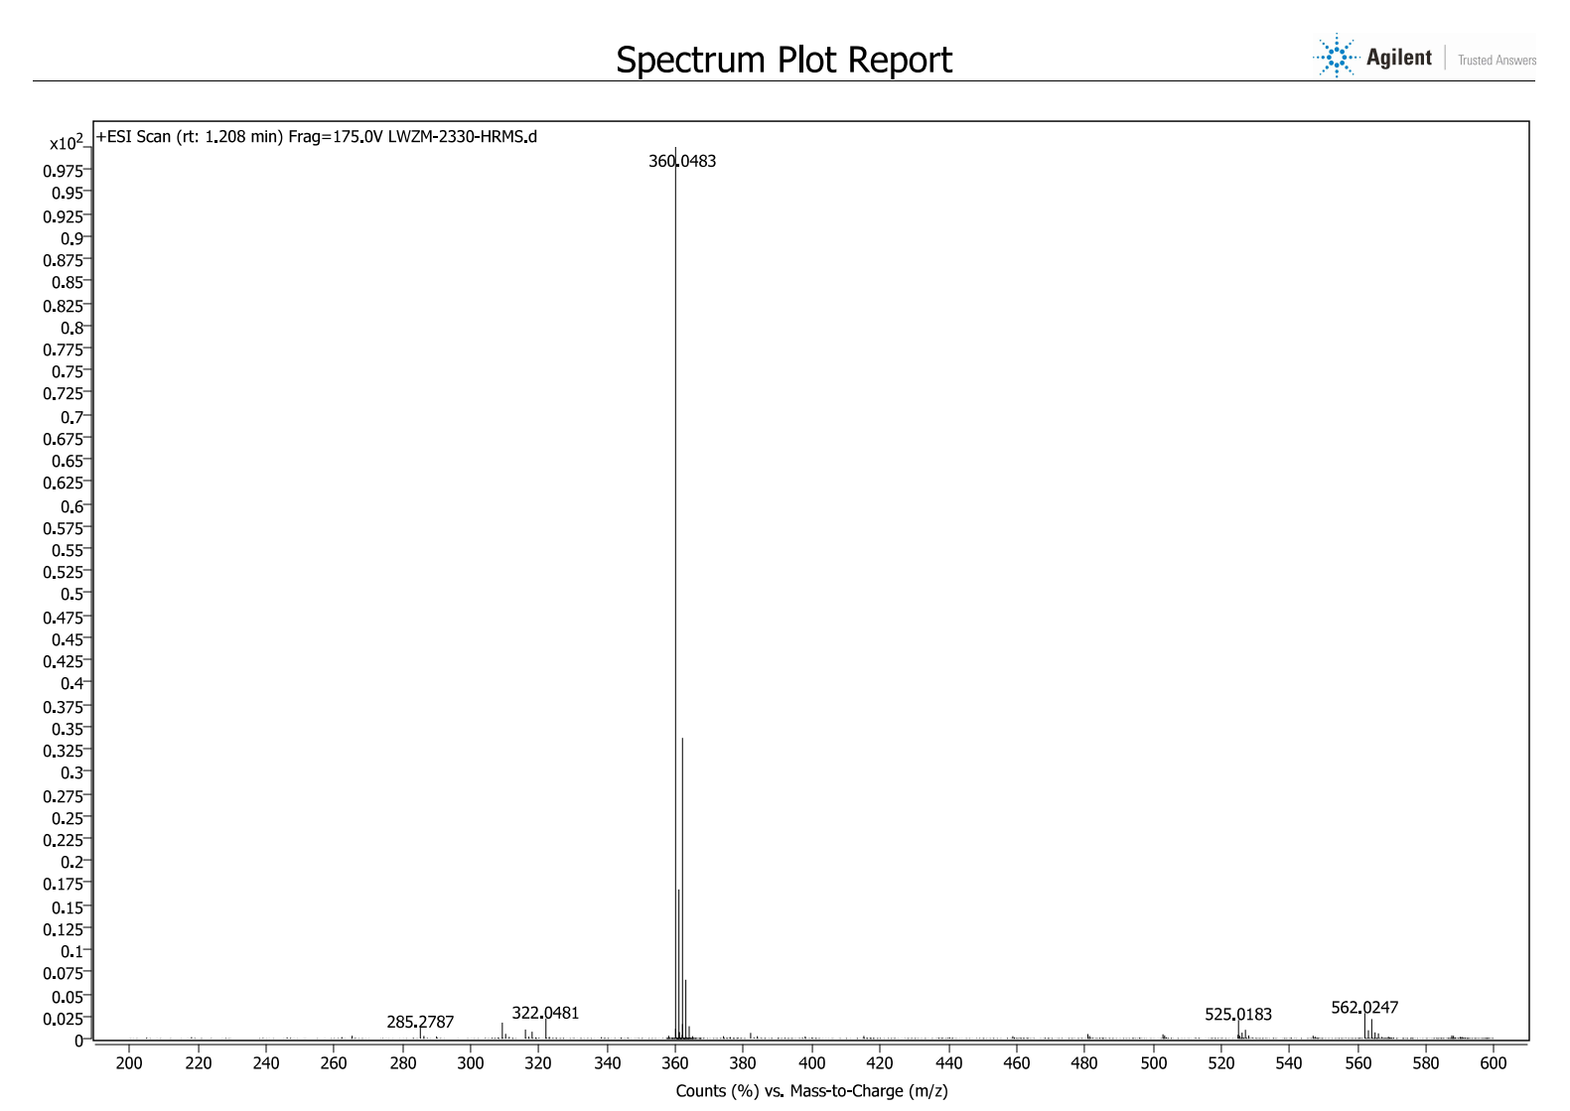
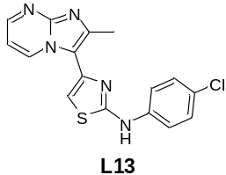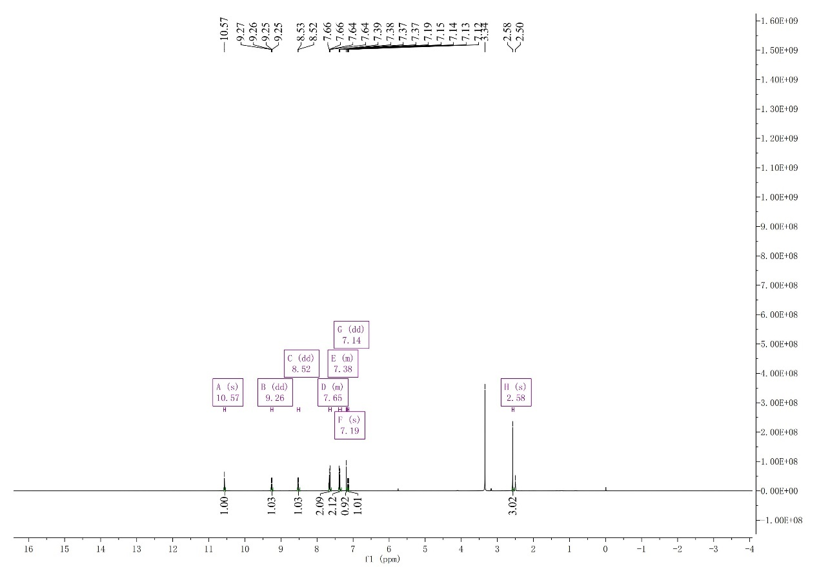
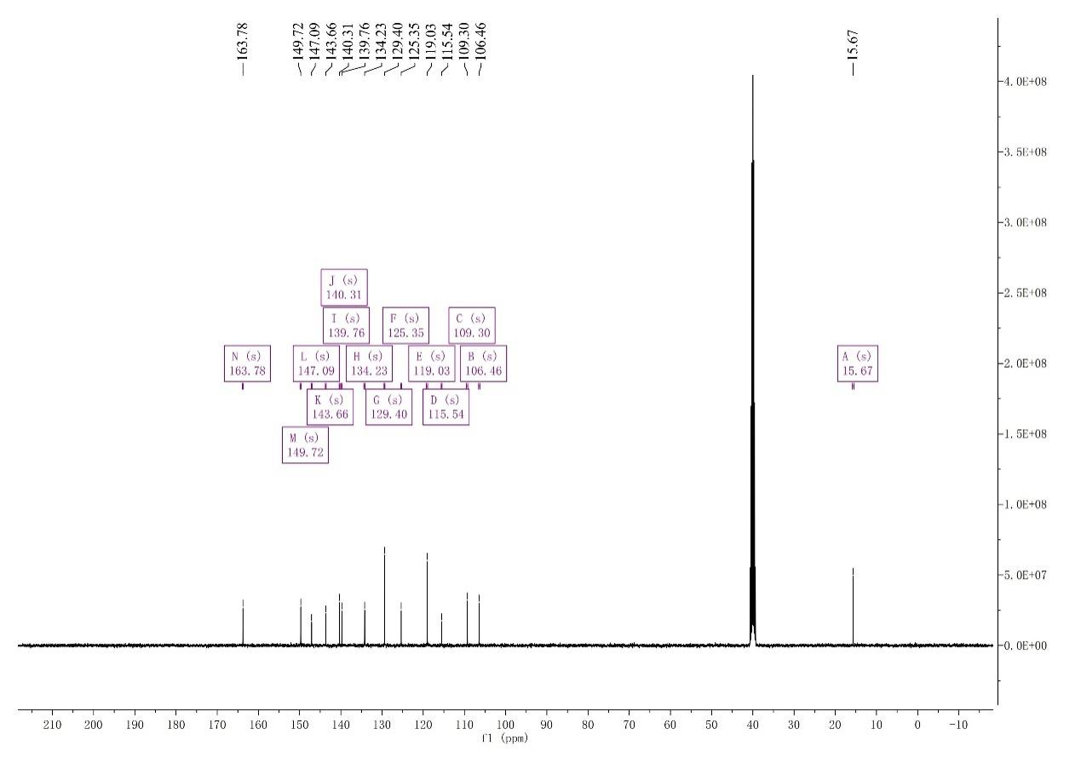
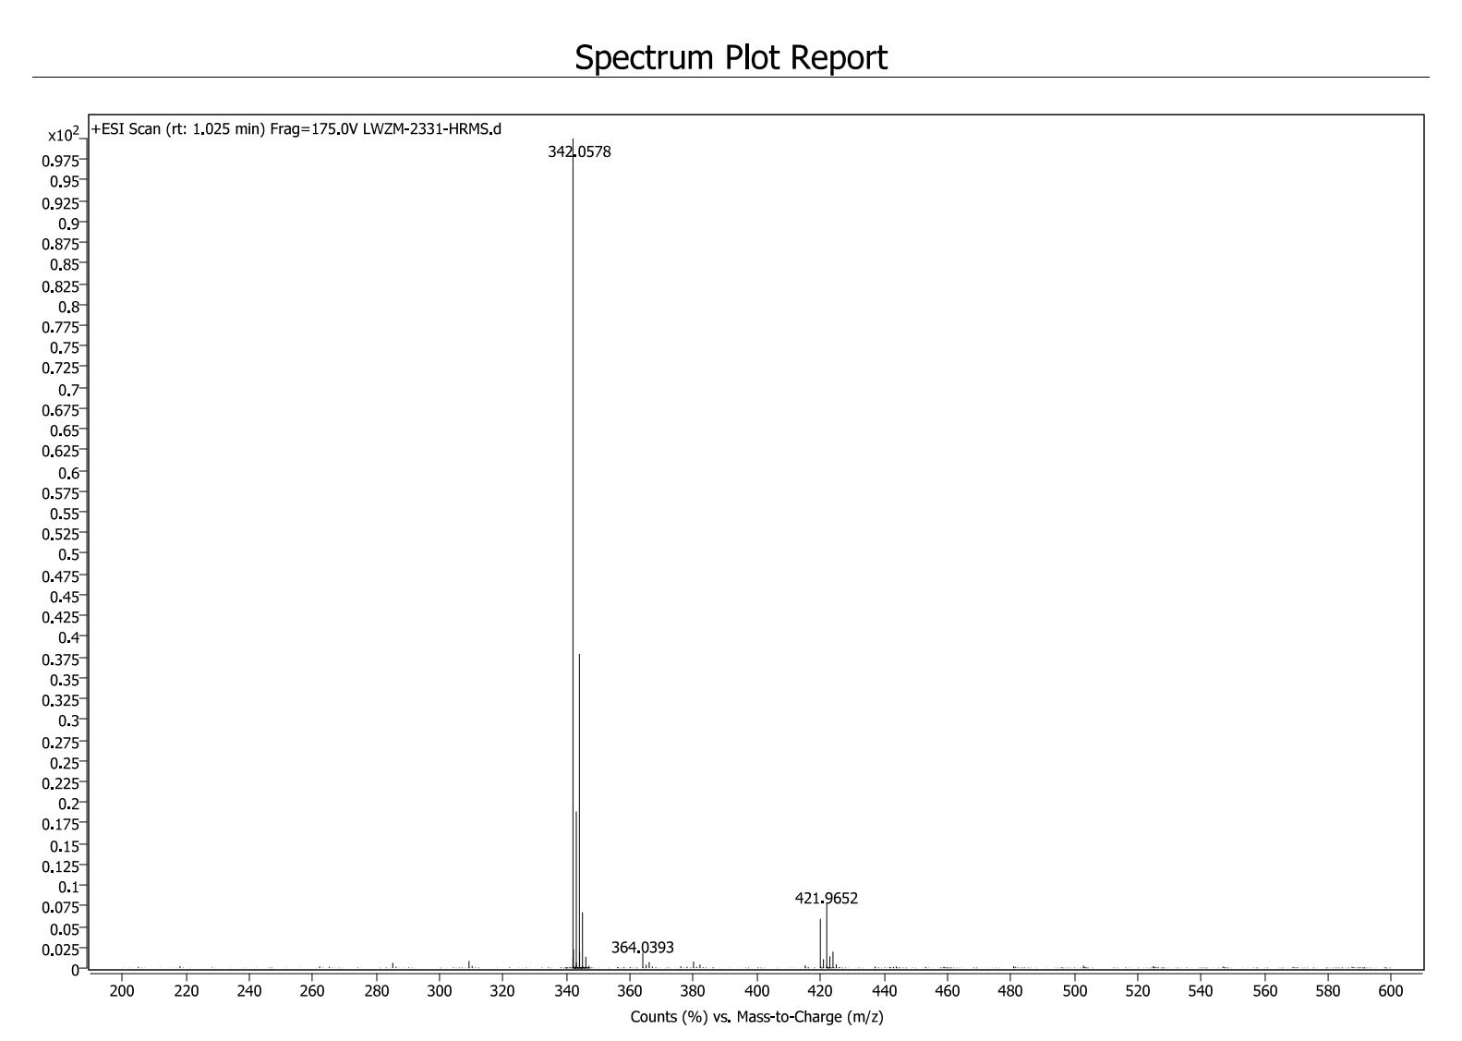
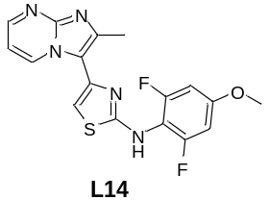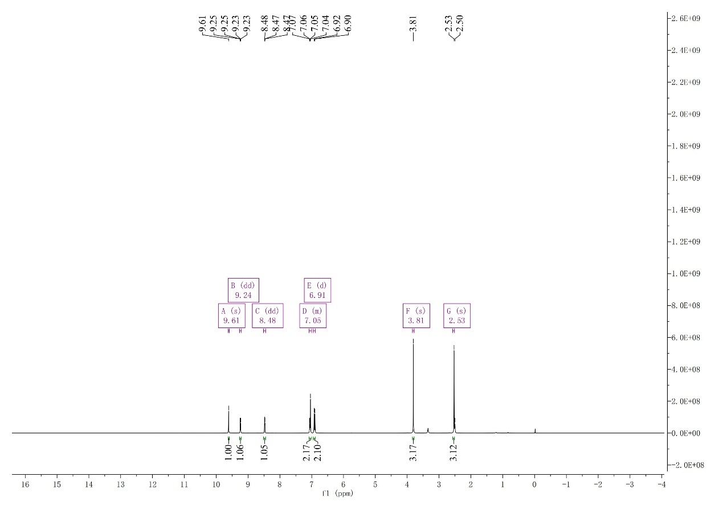
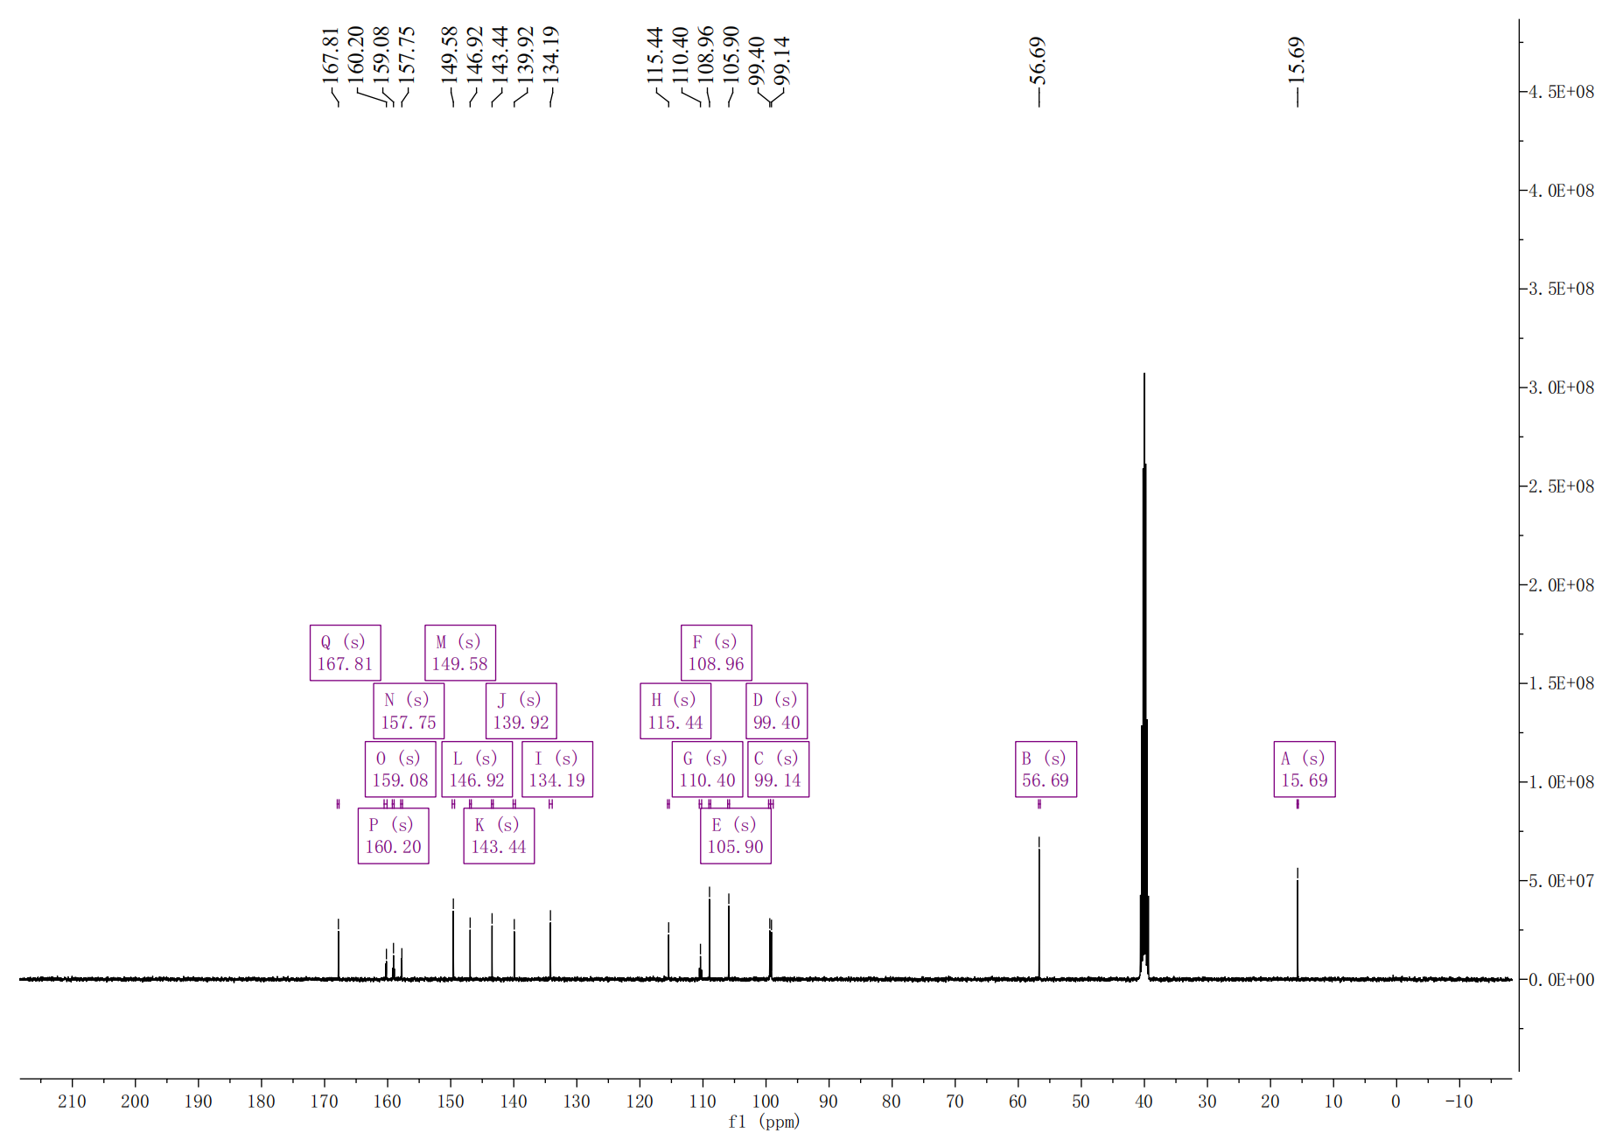
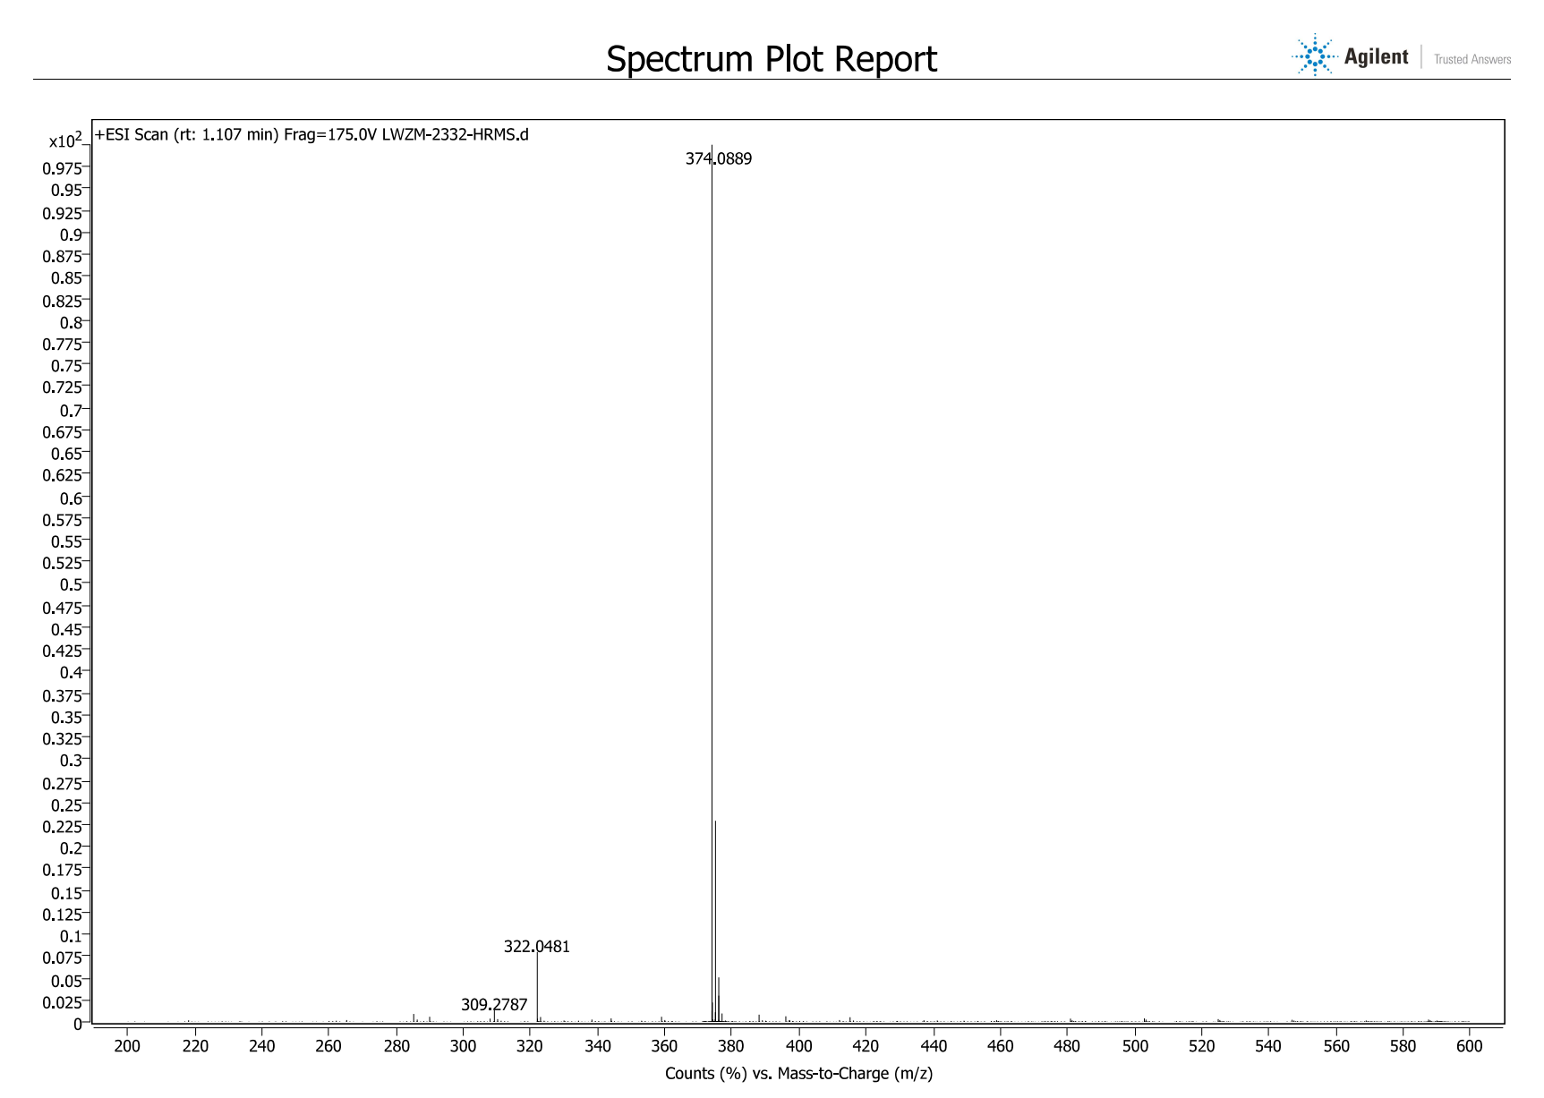
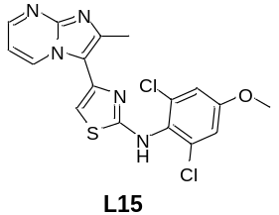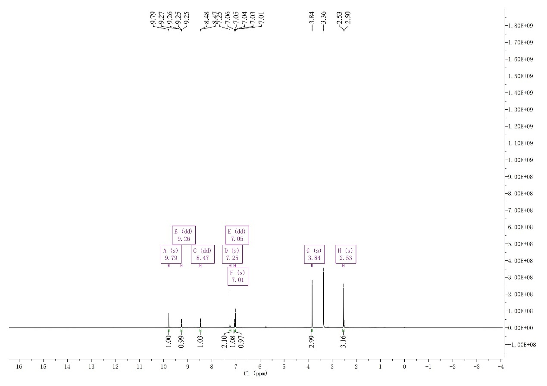
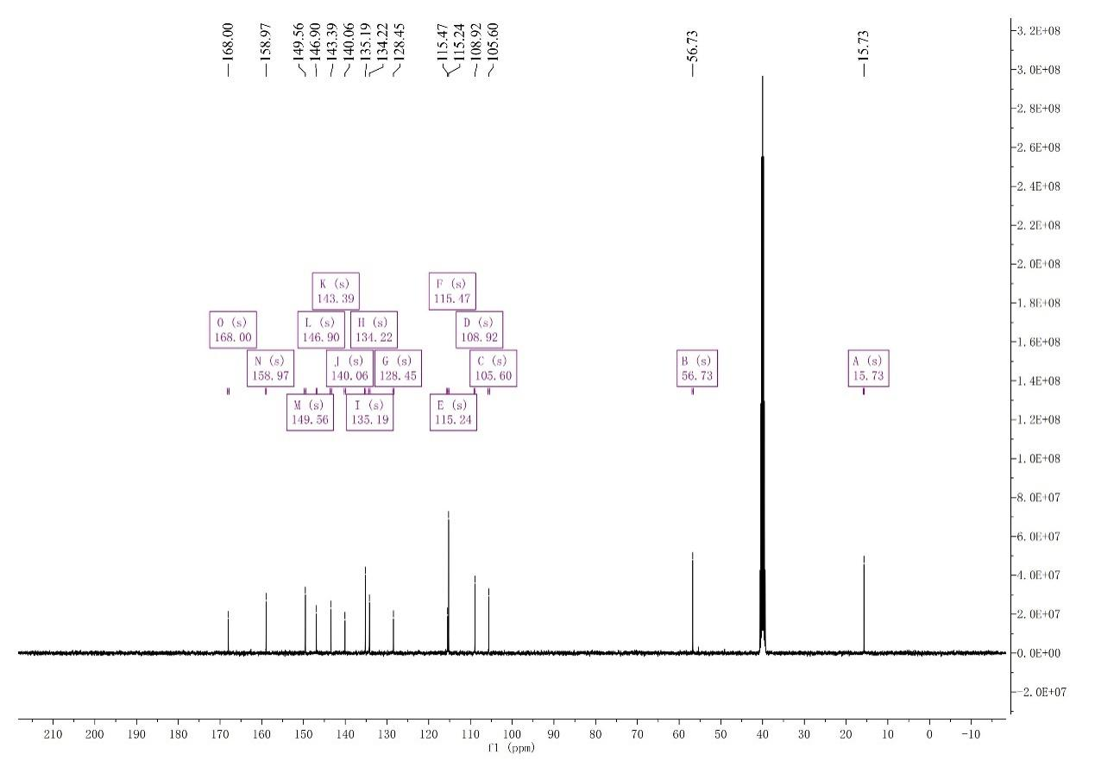
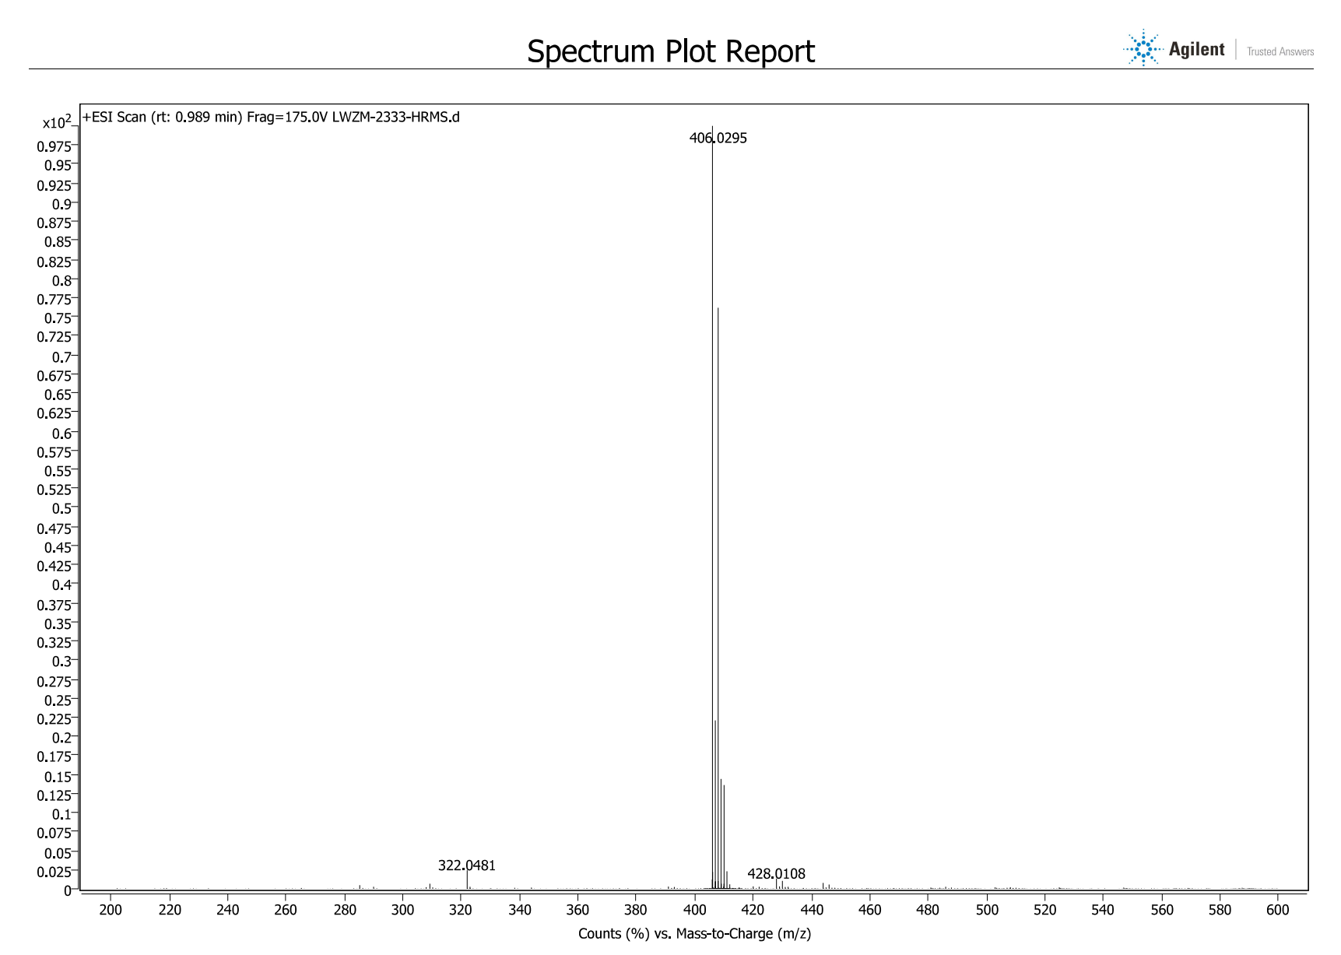
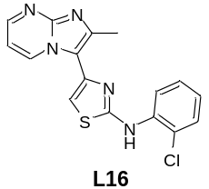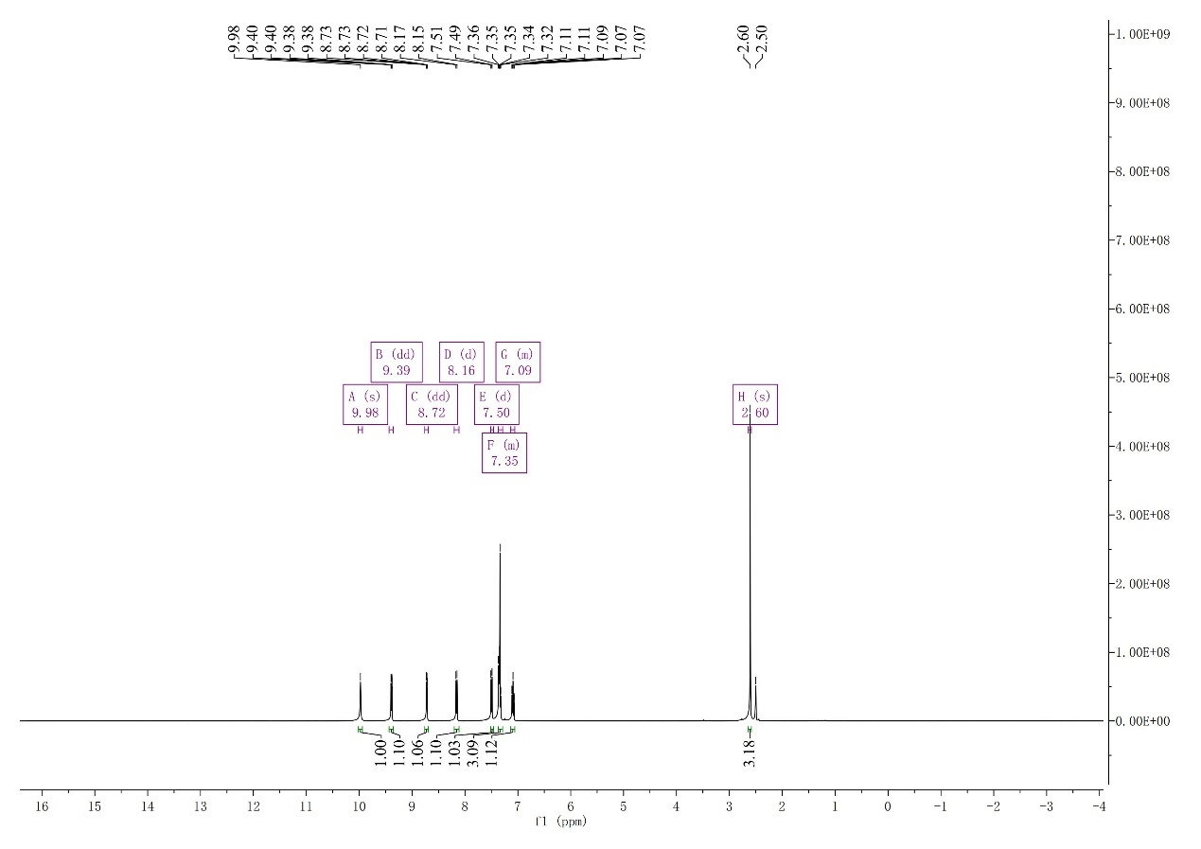
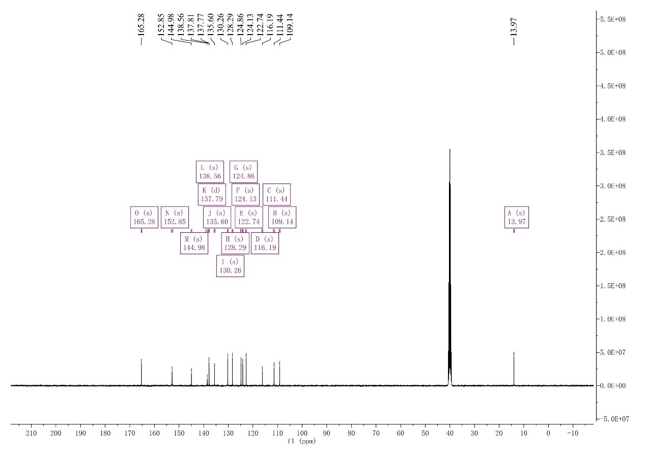
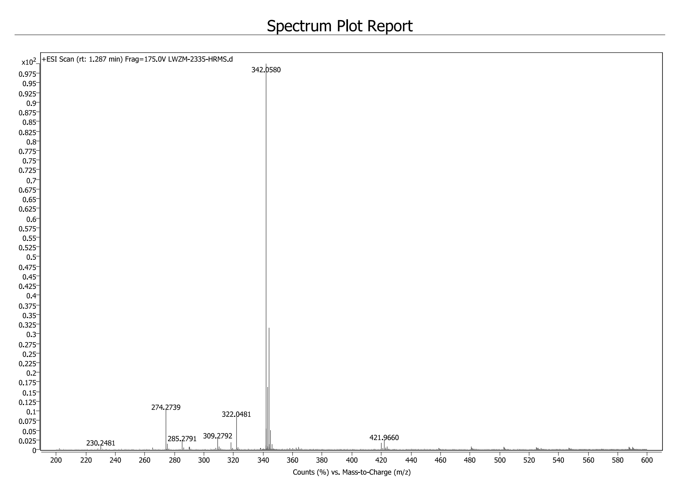
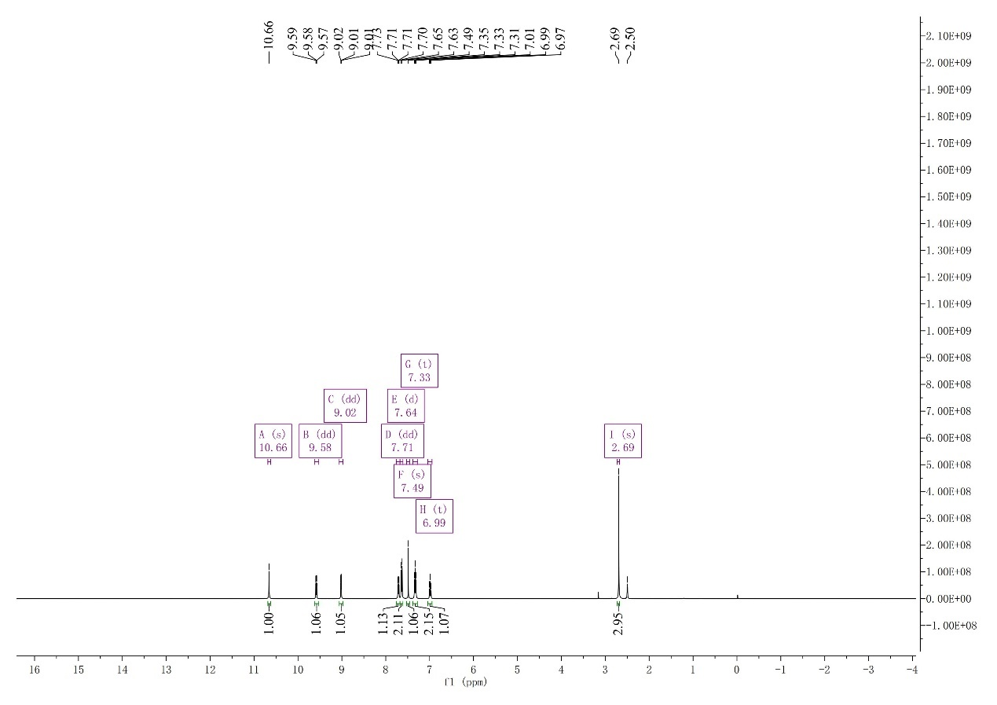
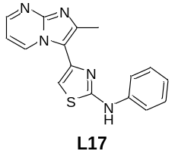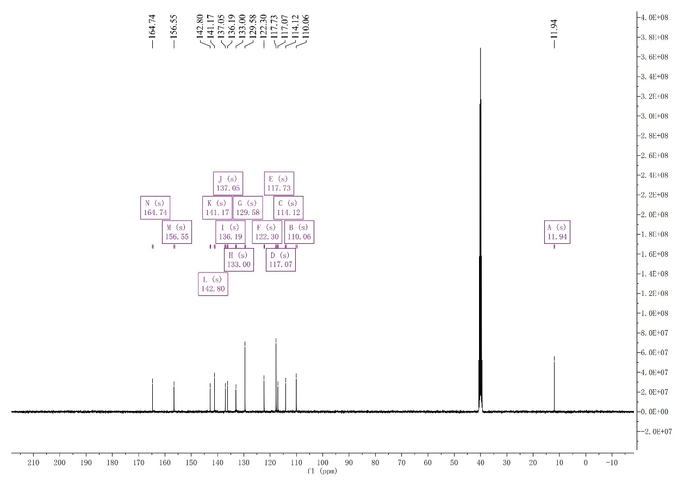
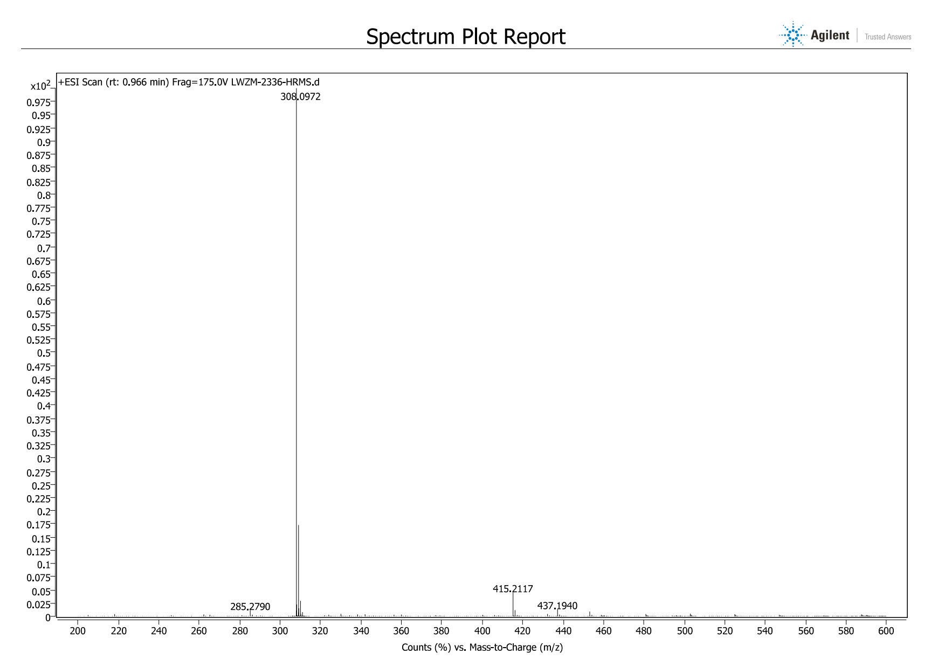
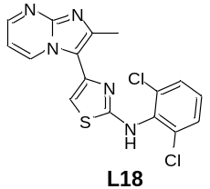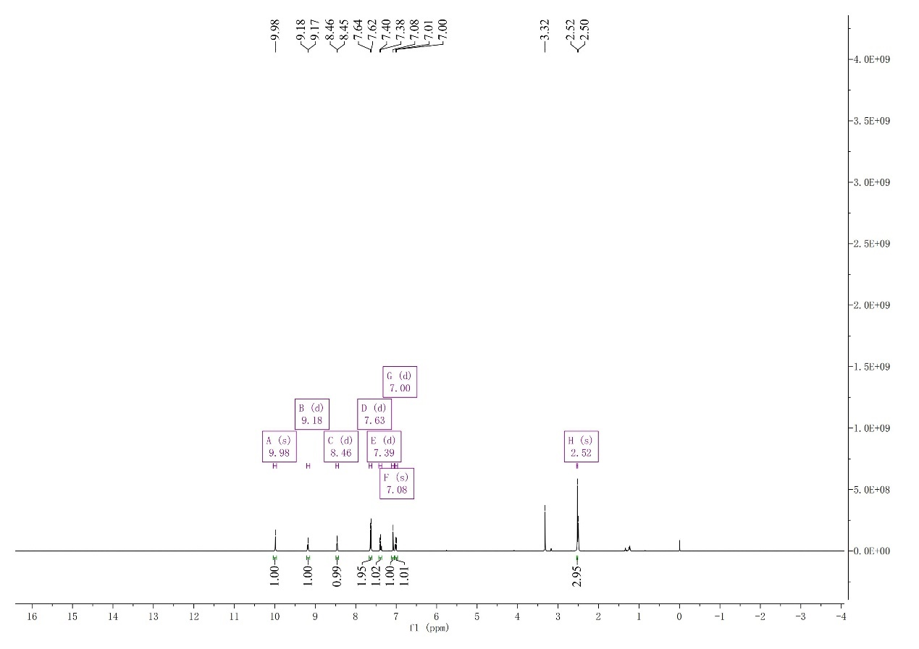
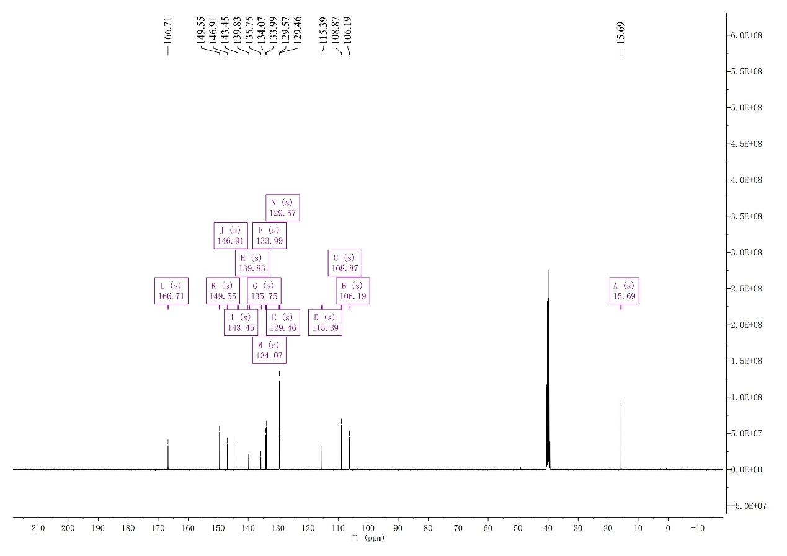
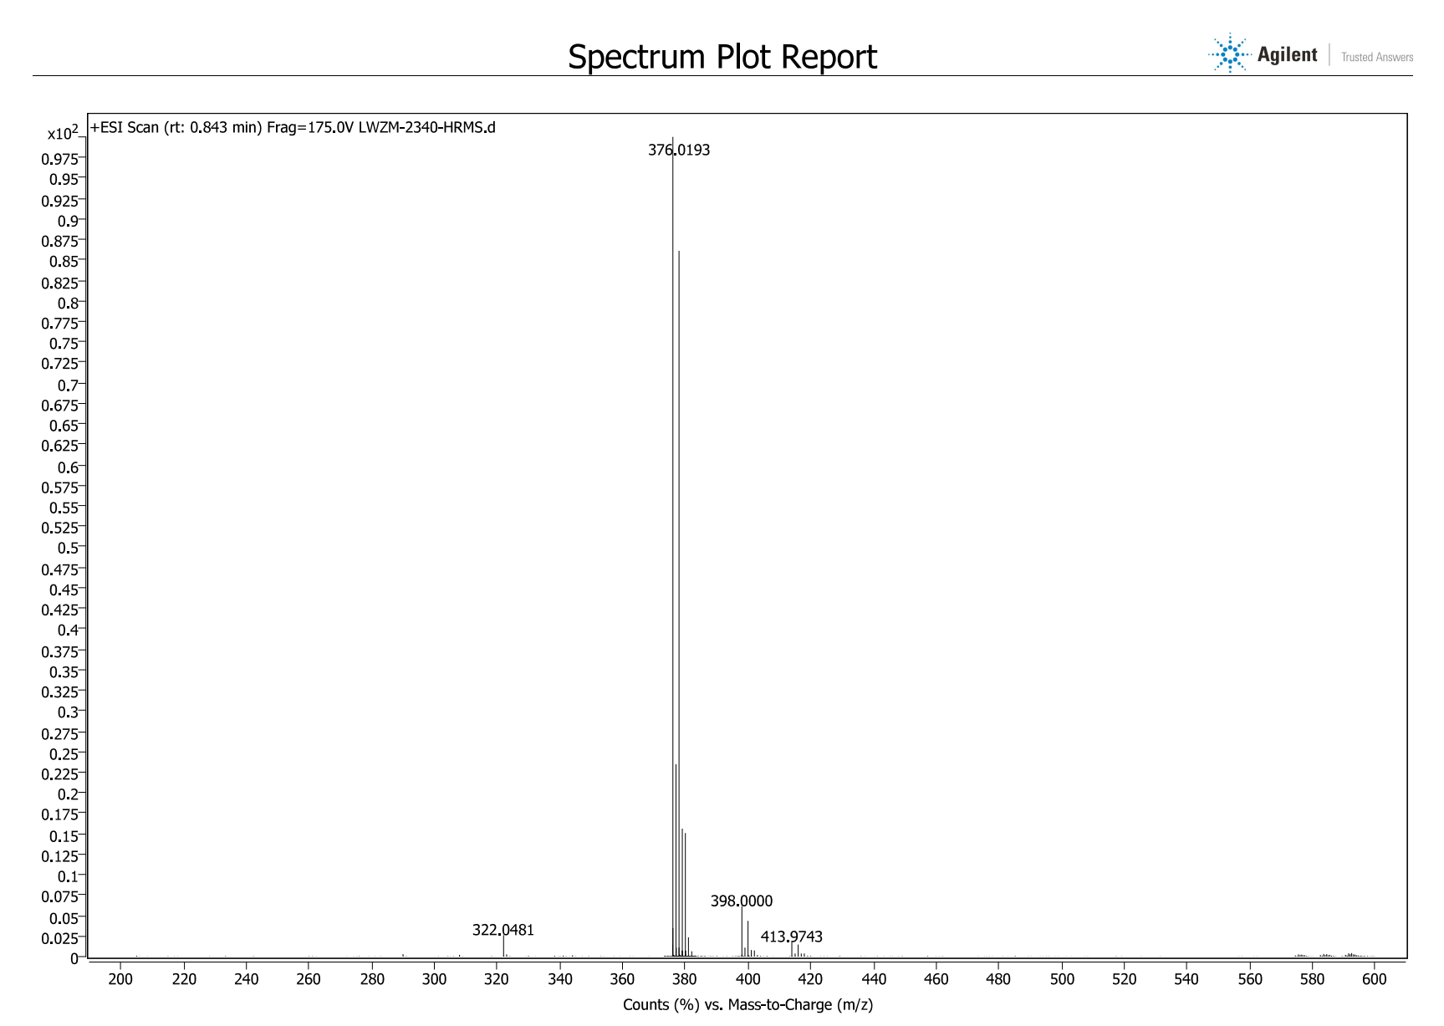
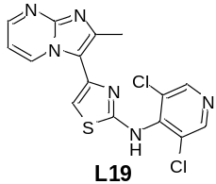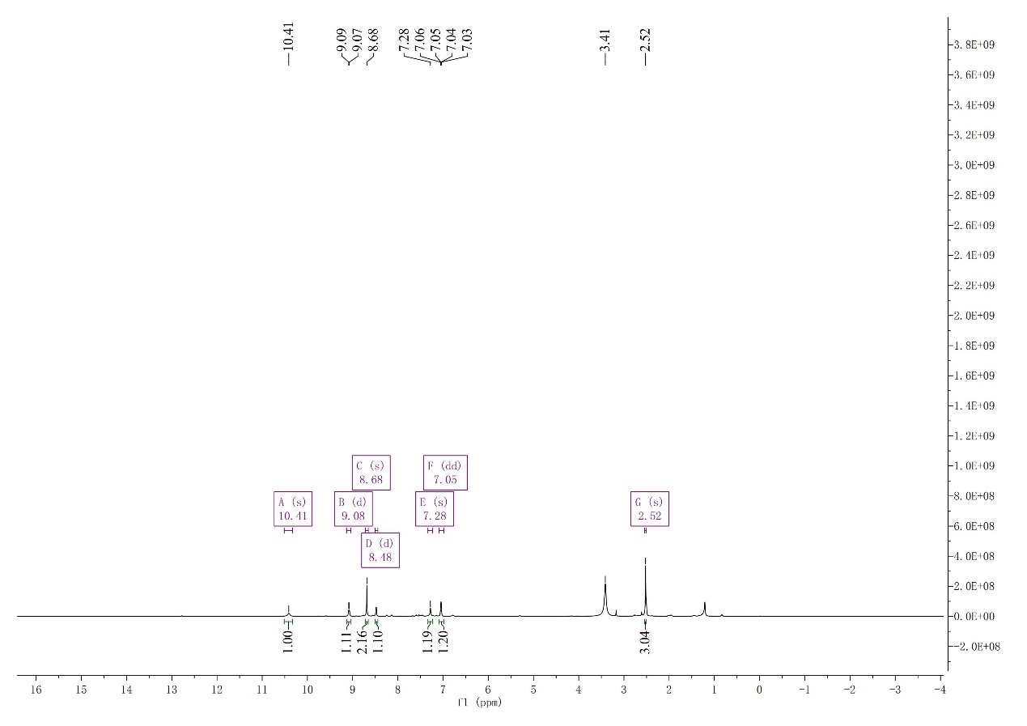
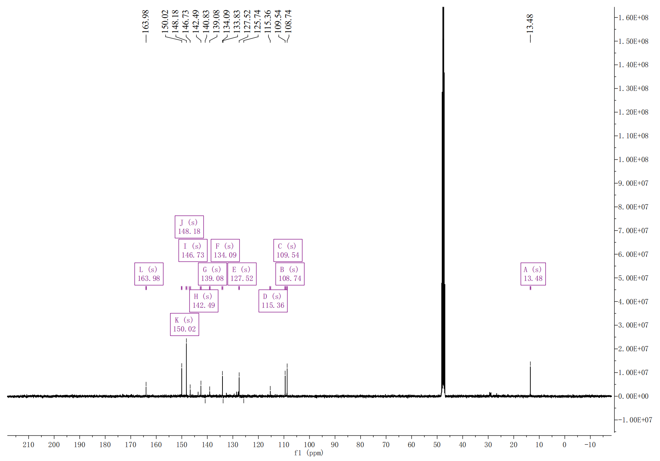
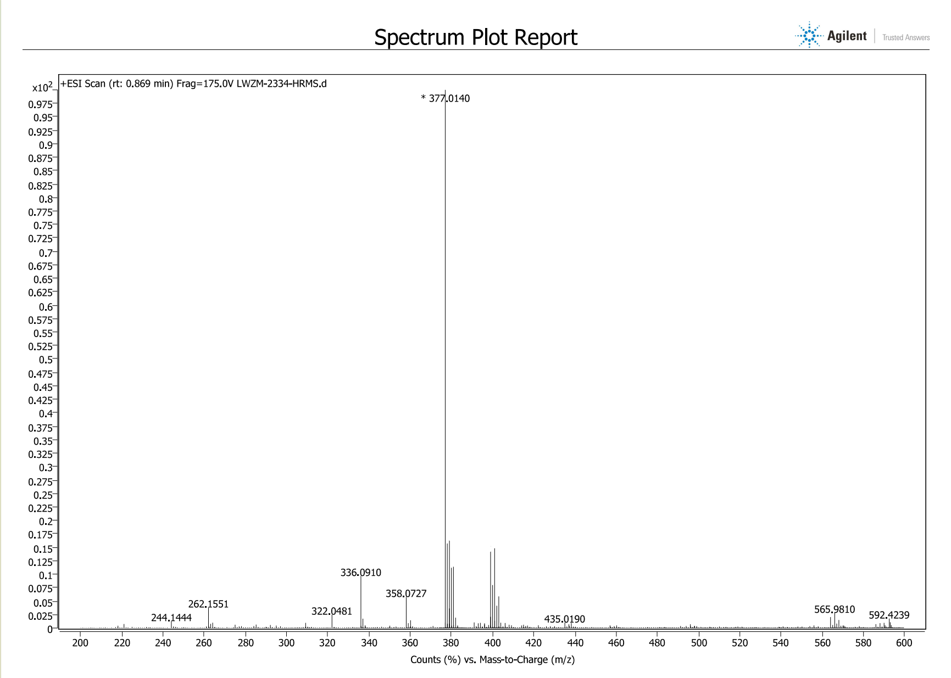
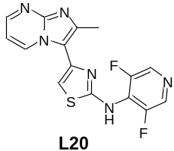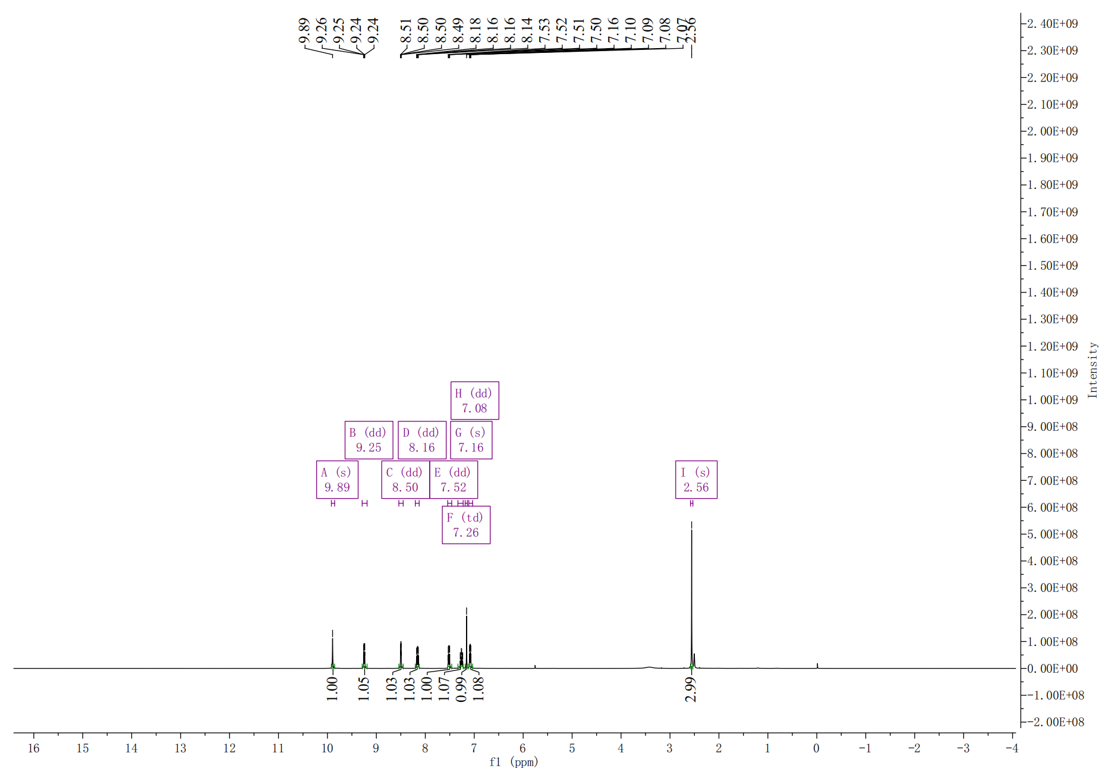
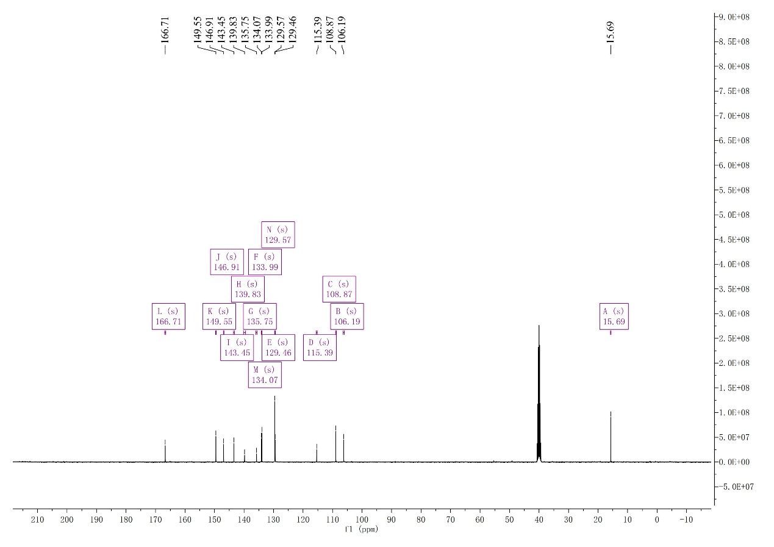
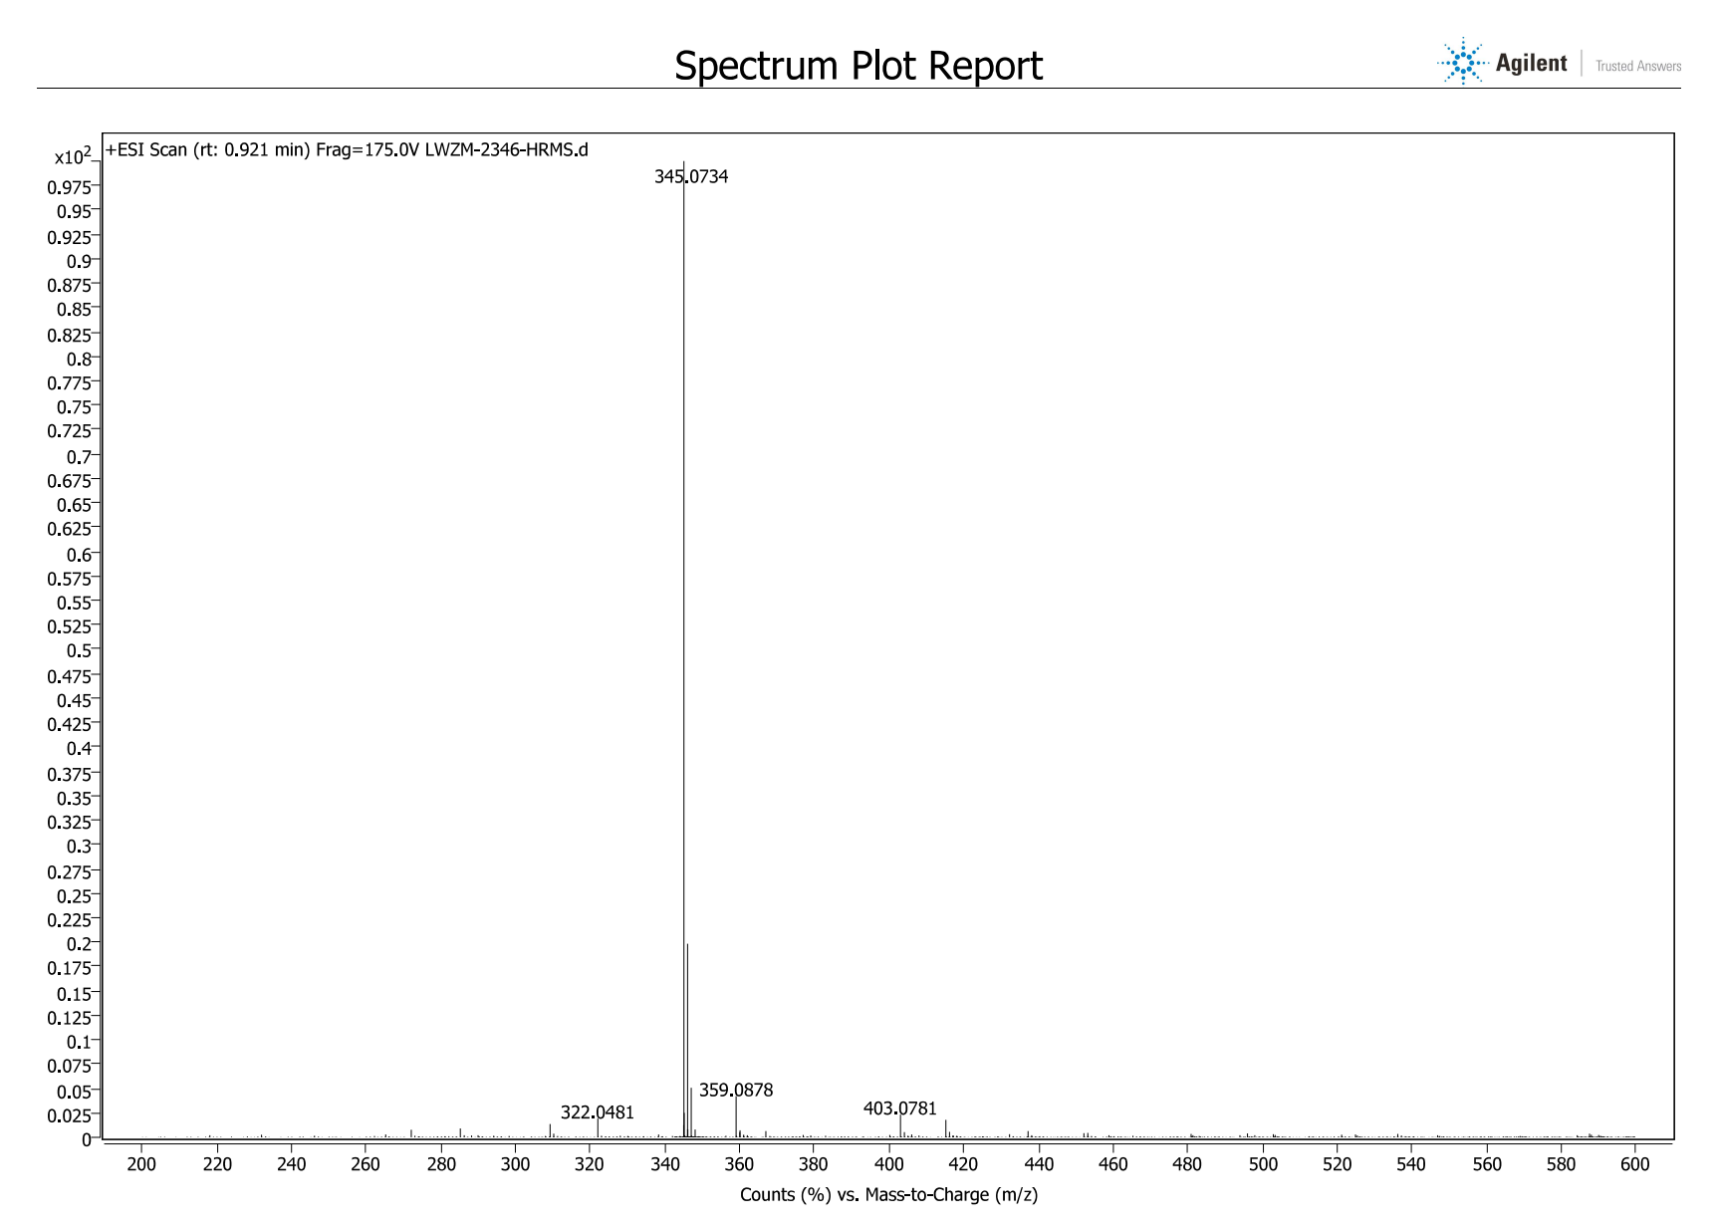
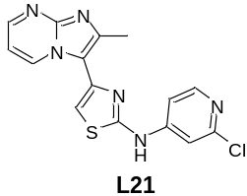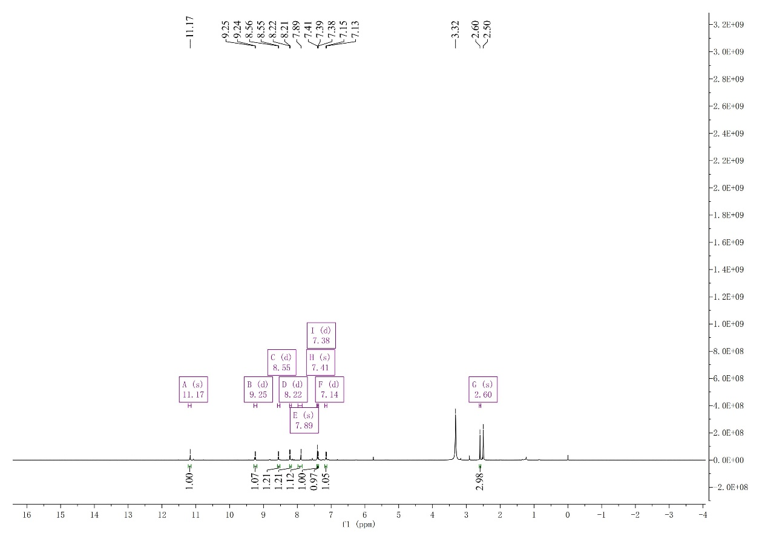
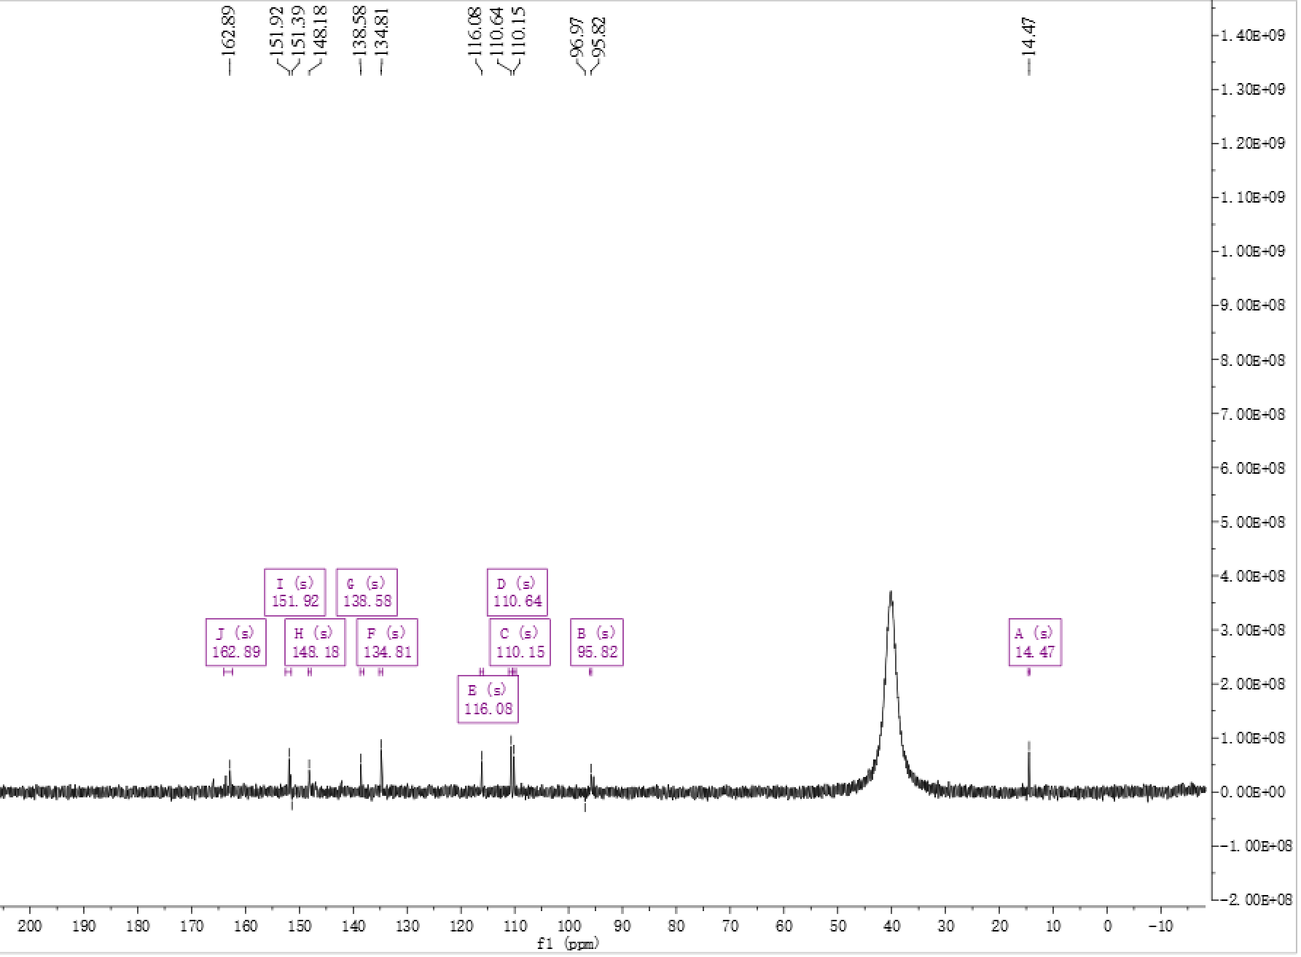
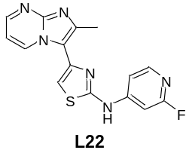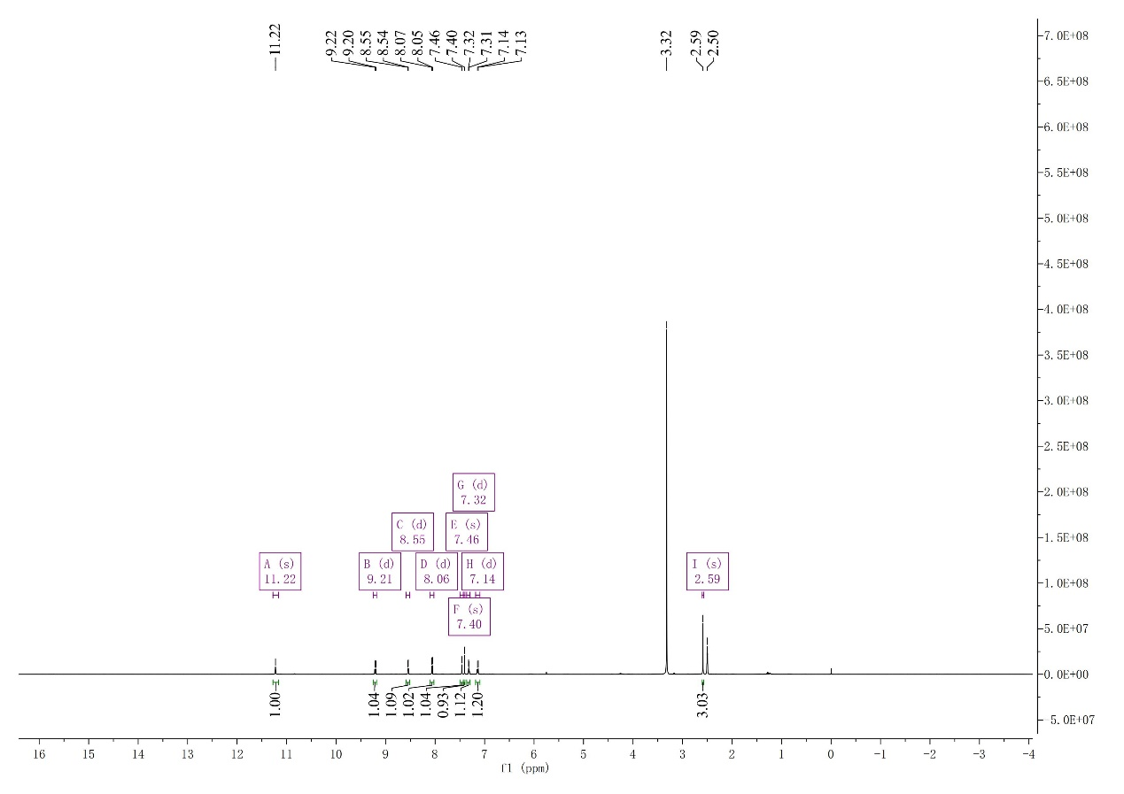
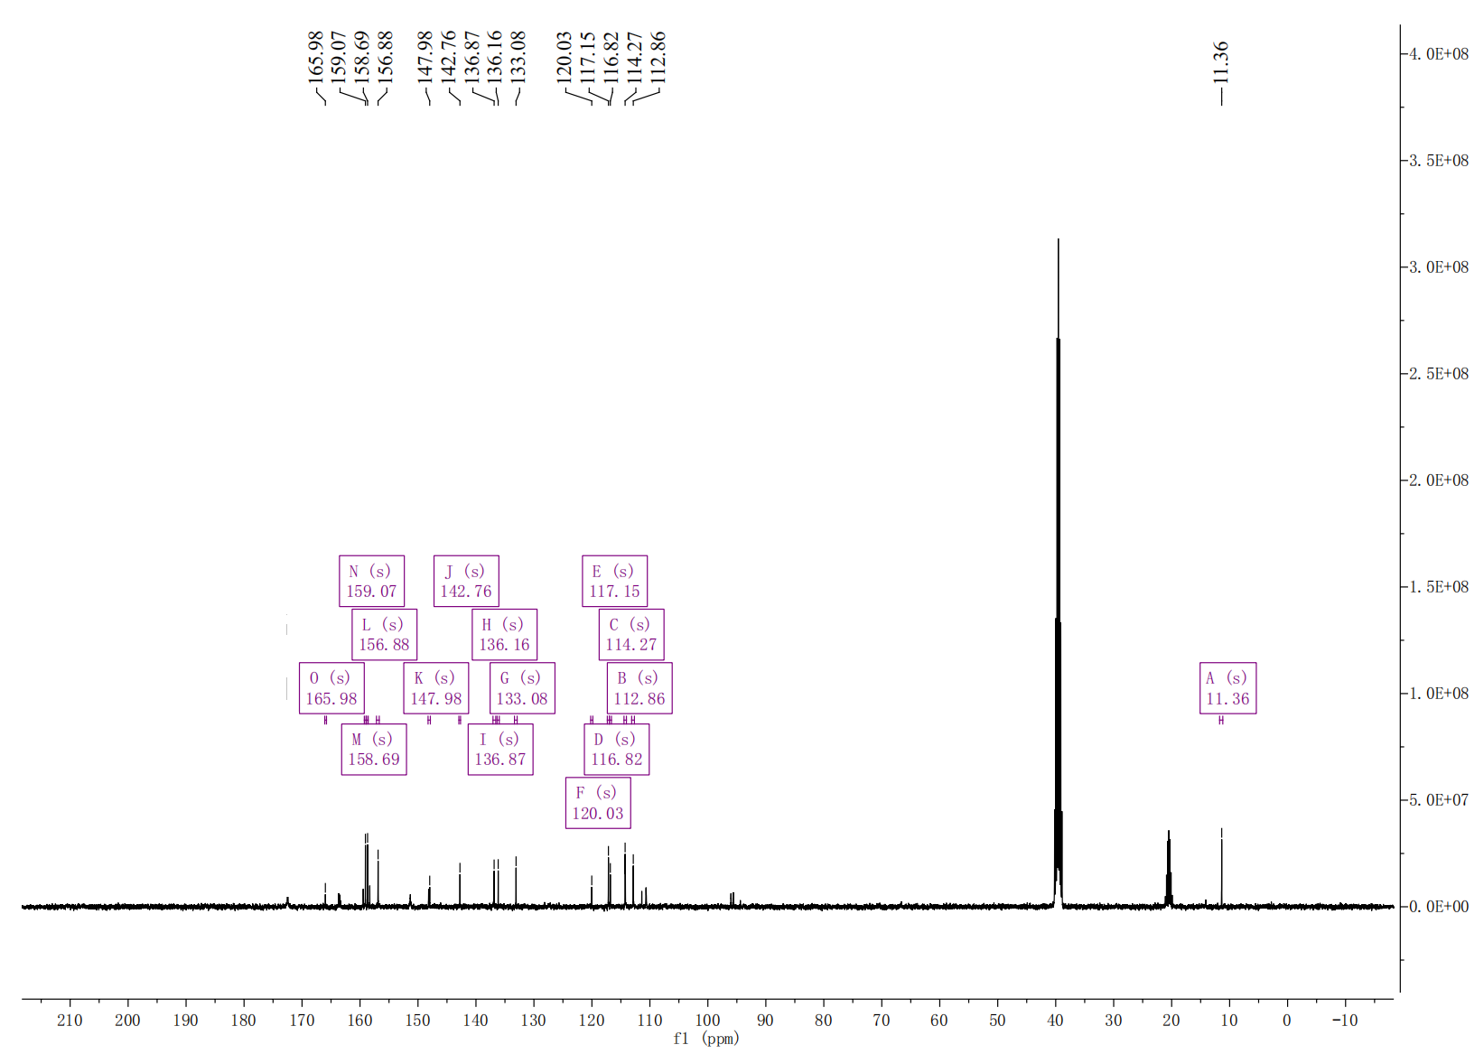
3. HPLC report for tested compounds
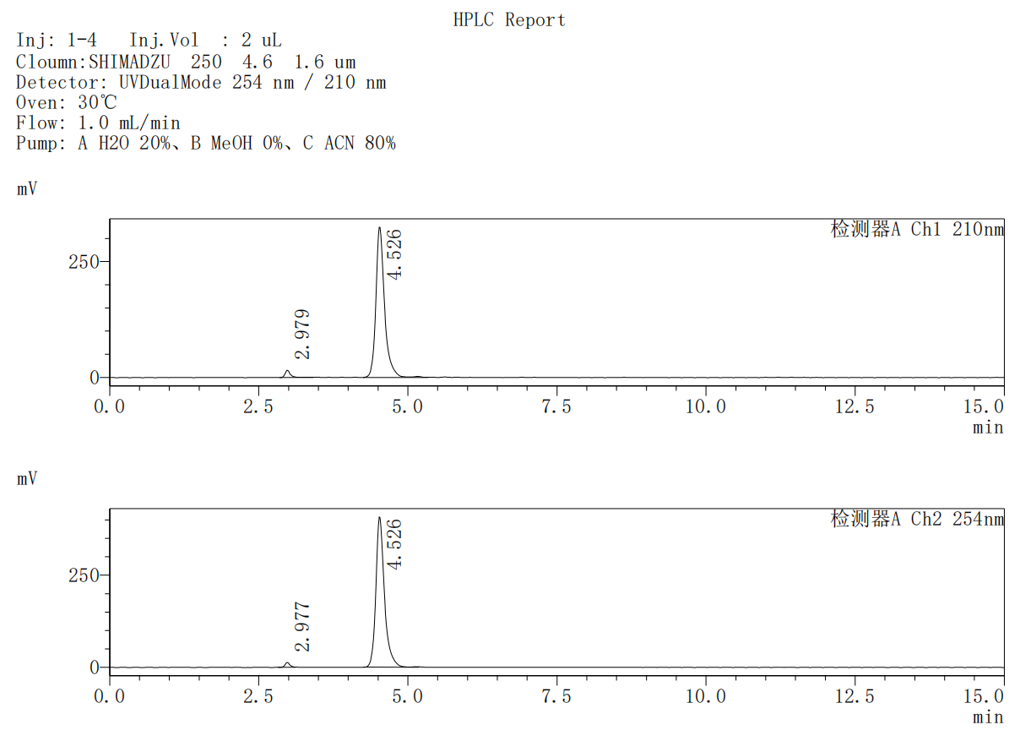
Ch1 210nm
Peak No. | R.T | Area | Area%
1 | 2.979 | 101894 | 3.030
2 | 4.526 | 3260918 | 96.970
Total |  | 3362812 | 100.000
Ch2 254nm
Peak No. | R.T | Area | Area%
1 | 2.977 | 72521 | 1.747
2 | 4.526 | 4078231 | 98.253
Total |  | 4150753 | 100.000

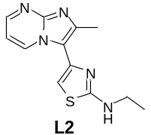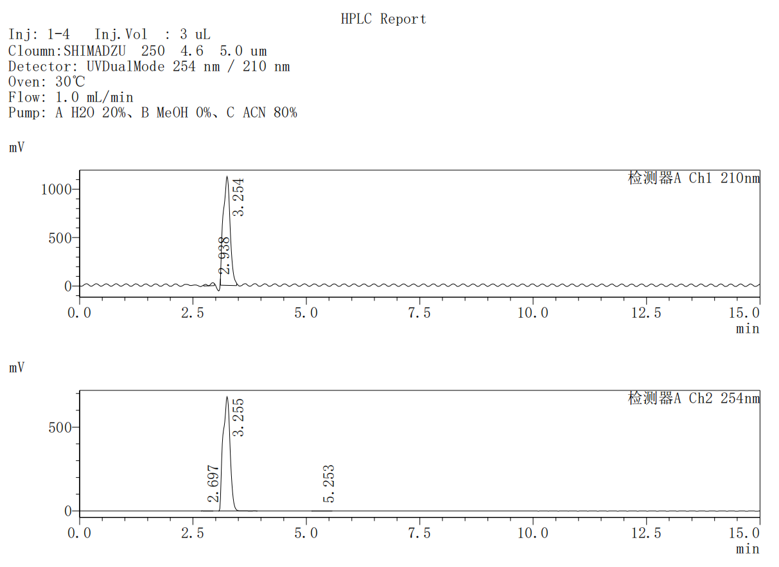
Ch1 210nm
Peak No. | R.T | Area | Area%
1 | 2.938 | 222169 | 1.821
2 | 3.254 | 11978783 | 98.179
Total |  | 12200952 | 100.000
Ch2 254nm
Peak No. | R.T | Area | Area%
1 | 2.697 | 6775 | 0.091
2 | 3.255 | 7395031 | 99.815
3 | 5.253 | 6953 | 0.094
Total |  | 7408758 | 100.000

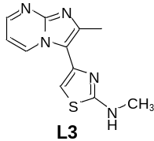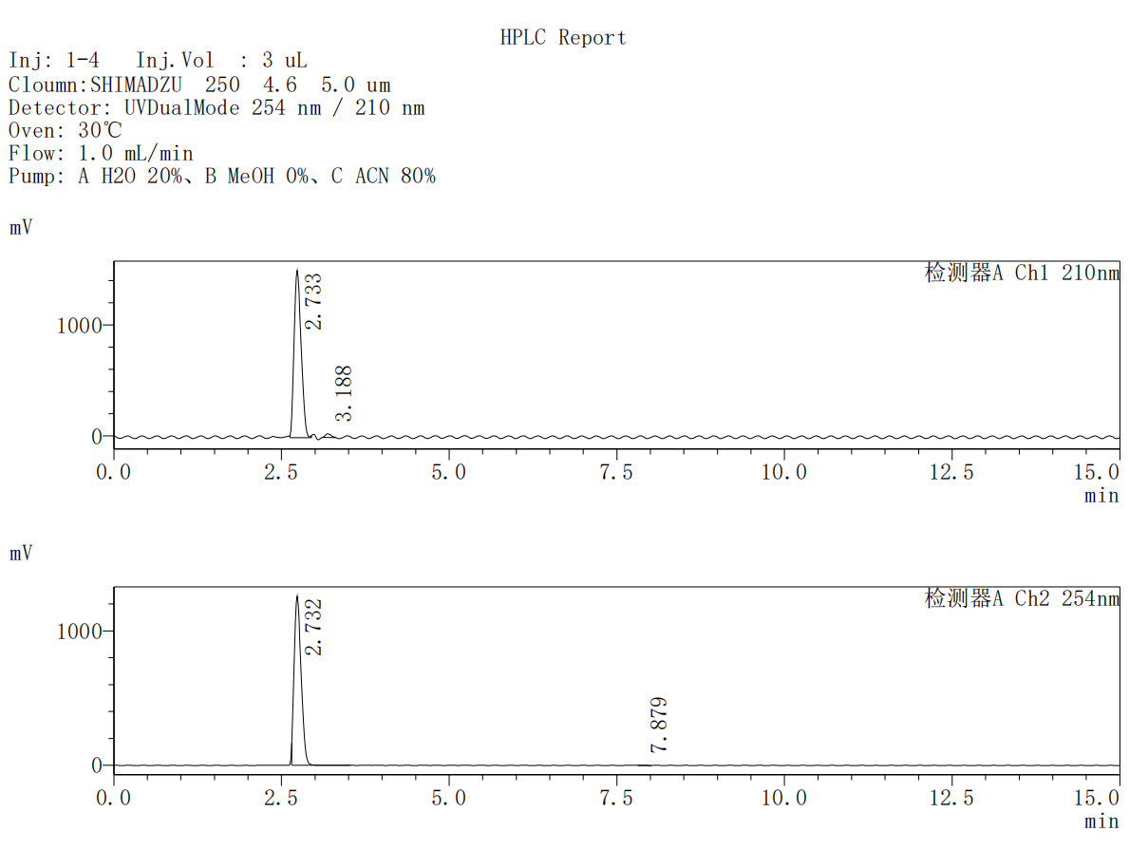
Ch1 210nm
Peak No. | R.T | Area | Area%
1 | 2.733 | 11138464 | 98.192
2 | 3.188 | 205131 | 1.808
Total |  | 11343595 | 100.000
Ch2 254nm
Peak No. | R.T | Area | Area%
1 | 2.732 | 9148819 | 99.961
2 | 7.879 | 3542 | 0.039
Total |  | 9152361 | 100.000

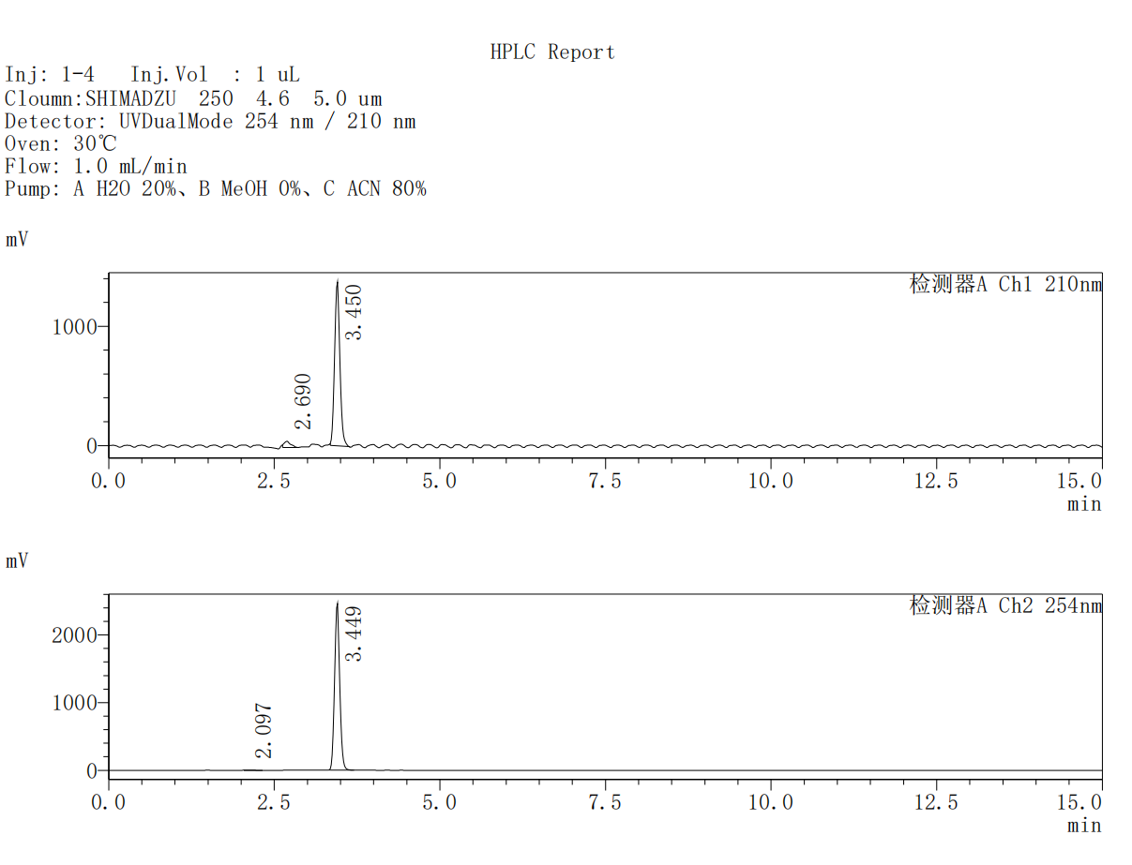
Ch1 210nm
Peak No. | R.T | Area | Area%
1 | 2.690 | 350020 | 4.295
2 | 3.450 | 7798632 | 95.705
Total |  | 8148652 | 100.000
Ch2 254nm
Peak No. | R.T | Area | Area%
1 | 2.097 | 20023 | 0.147
2 | 3.449 | 13600859 | 99.853
Total |  | 13620882 | 100.000

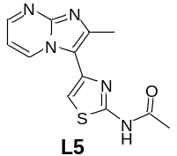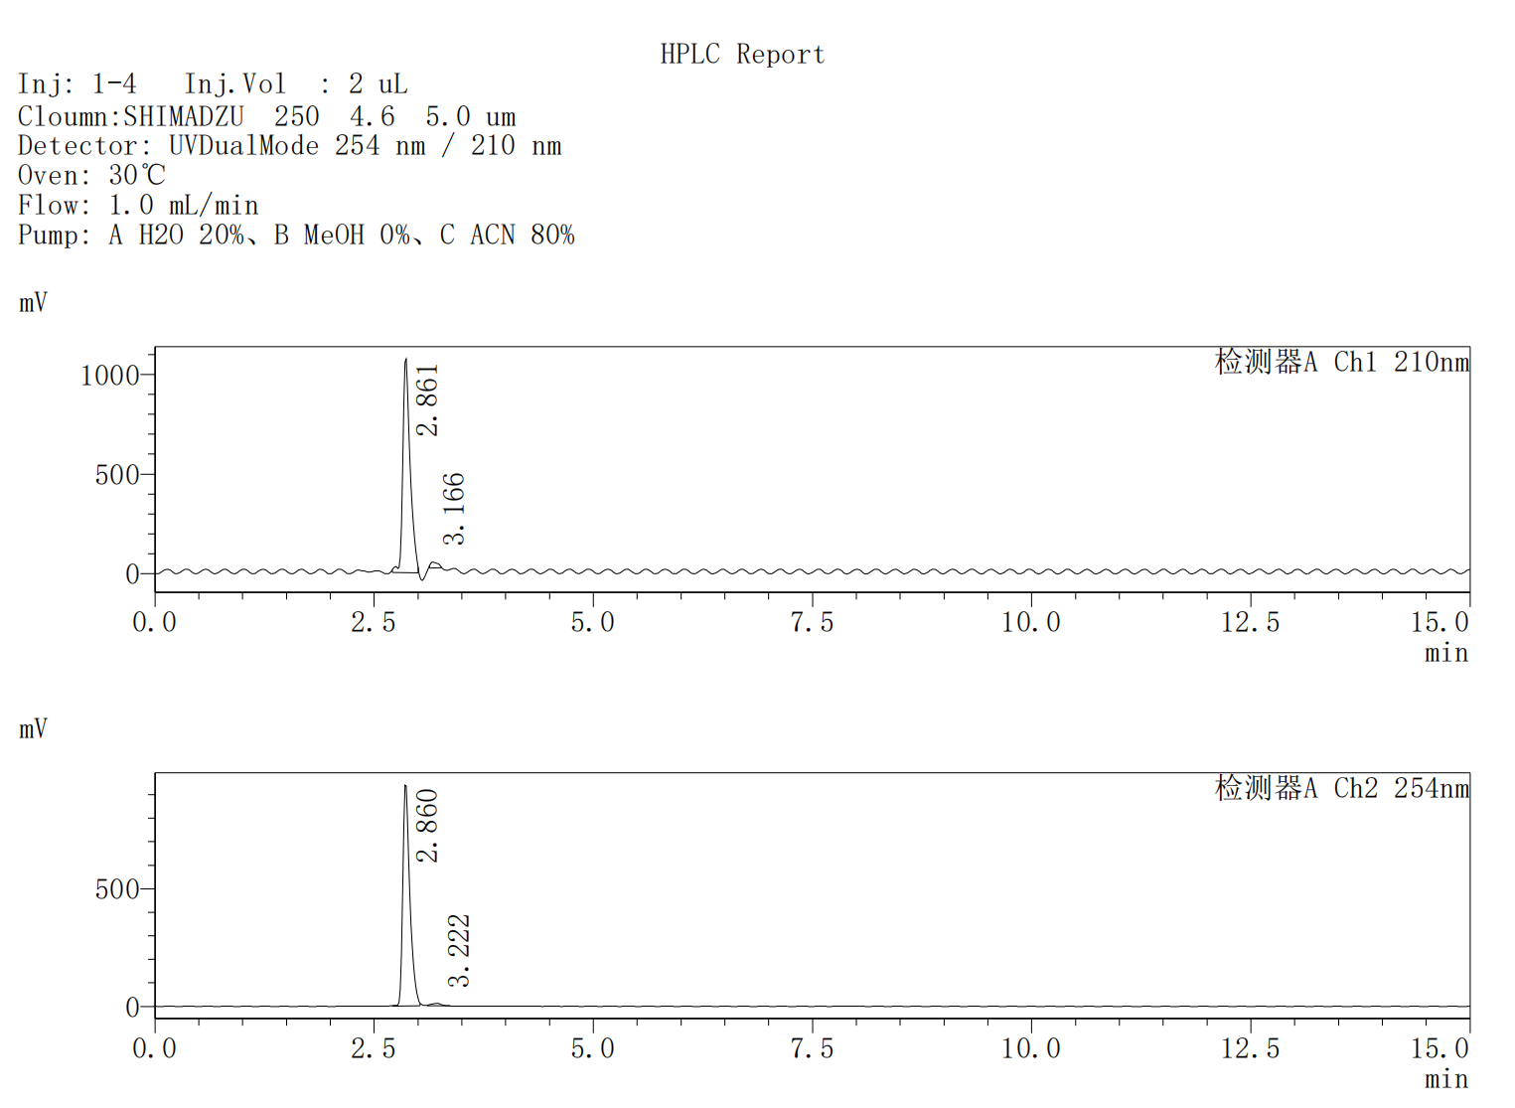
Ch1 210nm
Peak No. | R.T | Area | Area%
1 | 2.861 | 6113340 | 97.236
2 | 3.166 | 173755 | 2.764
Total |  | 6287094 | 100.000
Ch2 254nm
Peak No. | R.T | Area | Area%
1 | 2.860 | 5172267 | 98.344
2 | 3.222 | 87119 | 1.656
Total |  | 5259387 | 100.000

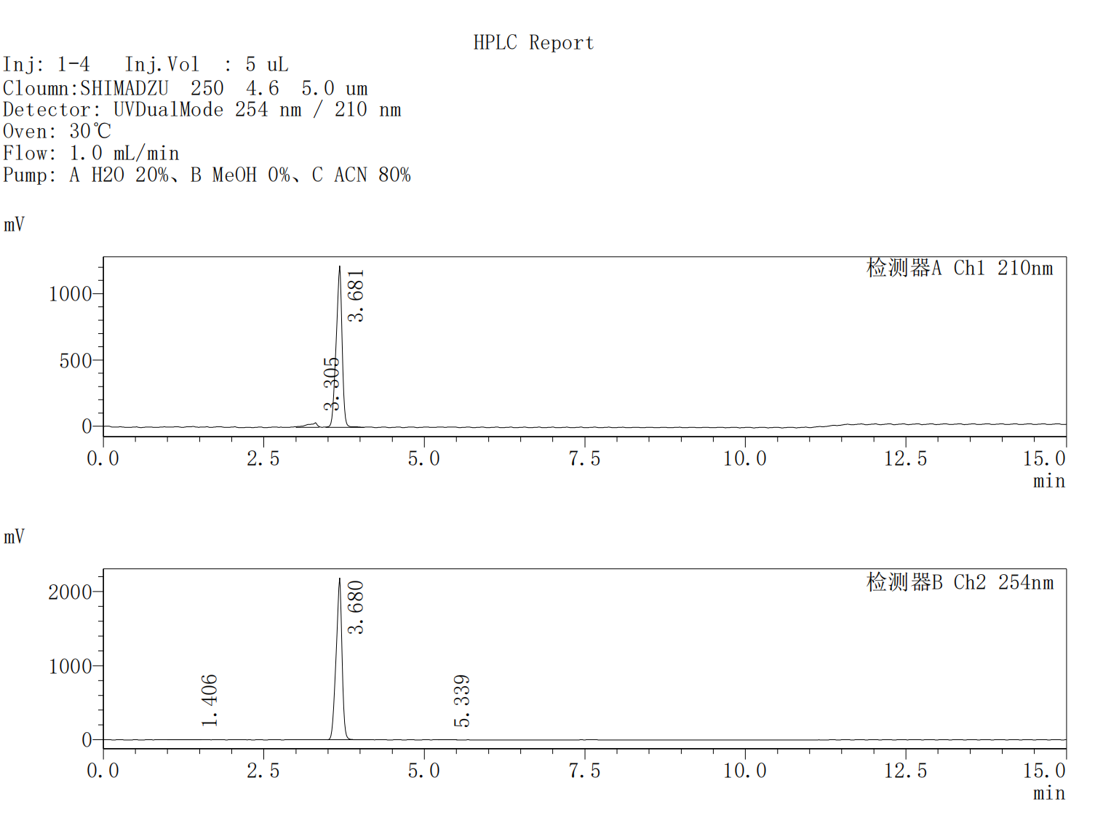
Ch1 210nm
Peak No. | R.T | Area | Area%
1 | 3.305 | 345919 | 4.162
2 | 3.681 | 7964633 | 95.838
Total |  | 8310553 | 100.000
Ch2 254nm
Peak No. | R.T | Area | Area%
1 | 1.406 | 20460 | 0.145
2 | 3.680 | 14112019 | 99.696
3 | 5.339 | 22558 | 0.159
Total |  | 14155038 | 100.000

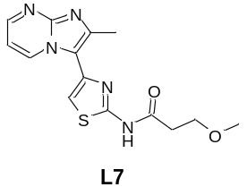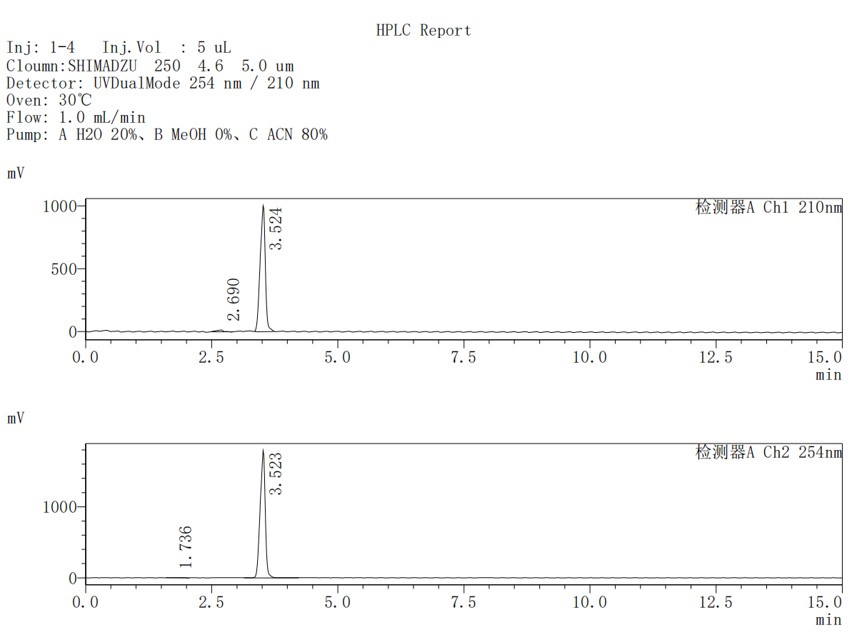
Ch1 210nm
Peak No. | R.T | Area | Area%
1 | 2.690 | 130890 | 1.803
2 | 3.524 | 7127294 | 98.197
Total |  | 7258184 | 100.000
Ch2 254nm
Peak No. | R.T | Area | Area%
1 | 1.736 | 28053 | 0.222
2 | 3.523 | 12600865 | 99.778
Total |  | 12628918 | 100.000

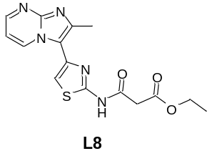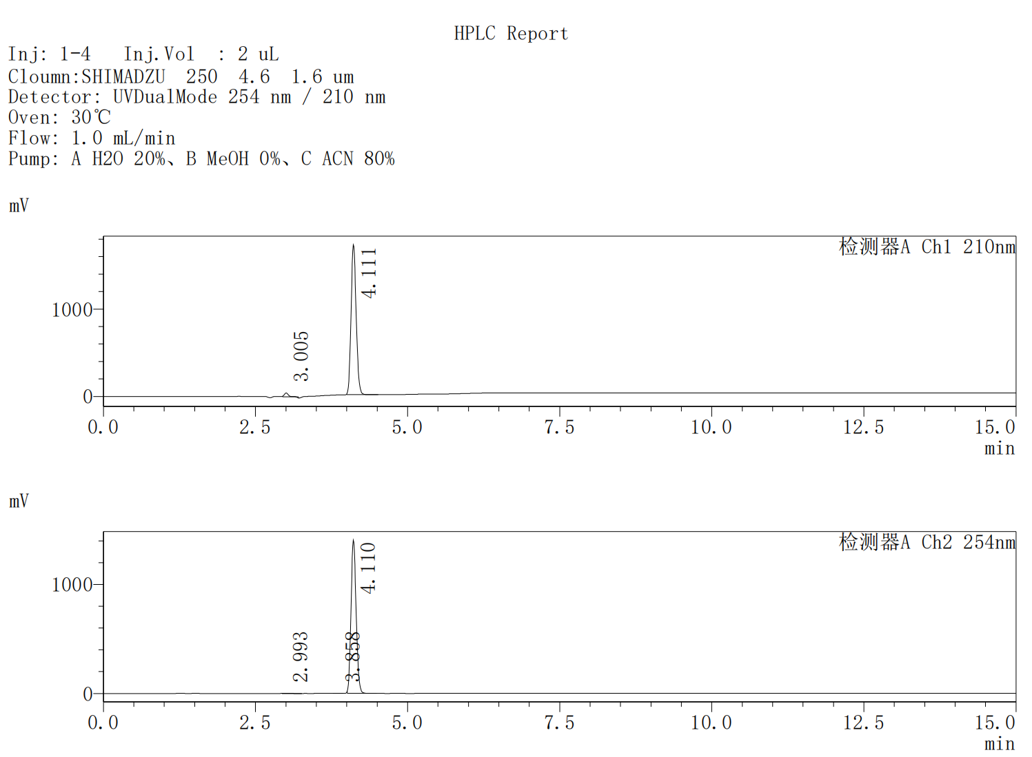
Ch1 210nm
Peak No. | R.T | Area | Area%
1 | 3.005 | 176935 | 1.748
2 | 4.111 | 9945721 | 98.252
Total |  | 10122656 | 100.000
Ch2 254nm
Peak No. | R.T | Area | Area%
1 | 2.993 | 6968 | 0.084
2 | 3.858 | 8045 | 0.097
3 | 4.110 | 8250930 | 99.818
Total |  | 8265943 | 100.000

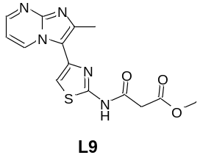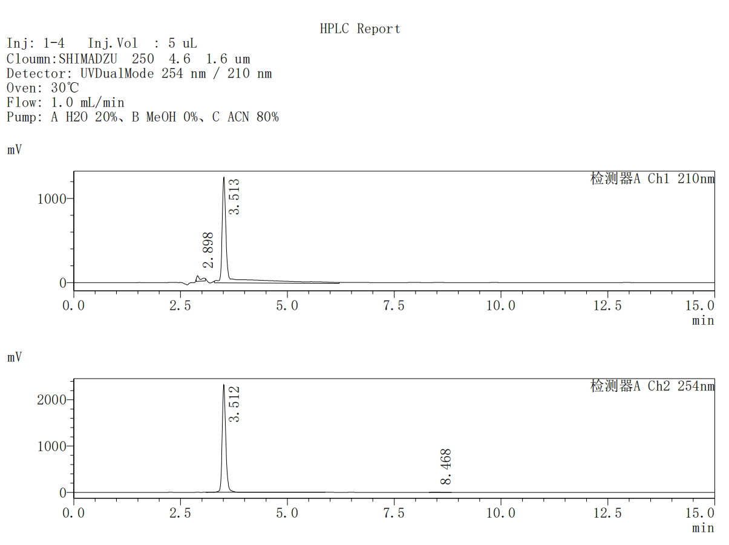
Ch1 210nm
Peak No. | R.T | Area | Area%
1 | 2.898 | 471166 | 4.026
2 | 3.513 | 11232092 | 95.974
Total |  | 11703259 | 100.000
Ch2 254nm
Peak No. | R.T | Area | Area%
1 | 3.512 | 13579627 | 99.958
2 | 8.468 | 5761 | 0.042
Total |  | 13585389 | 100.000

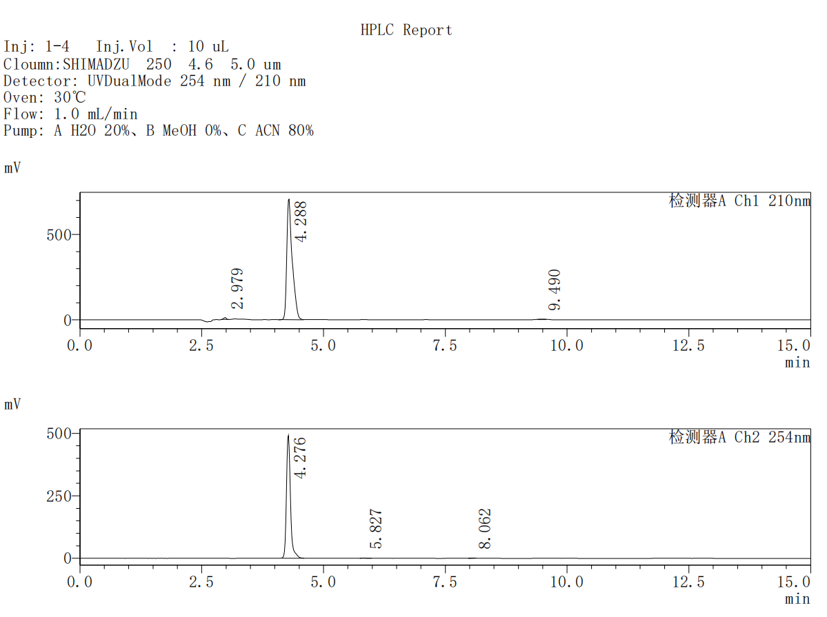
Ch1 210nm
Peak No. | R.T | Area | Area%
1 | 2.979 | 34555 | 0.626
2 | 4.288 | 5461552 | 98.944
3 | 9.490 | 23720 | 0.430
Total |  | 5519827 | 100.000
Ch2 254nm
Peak No. | R.T | Area | Area%
1 | 4.276 | 2777155 | 99.420
2 | 5.827 | 7494 | 0.268
3 | 8.062 | 8694 | 0.311
Total |  | 2793343 | 100.000

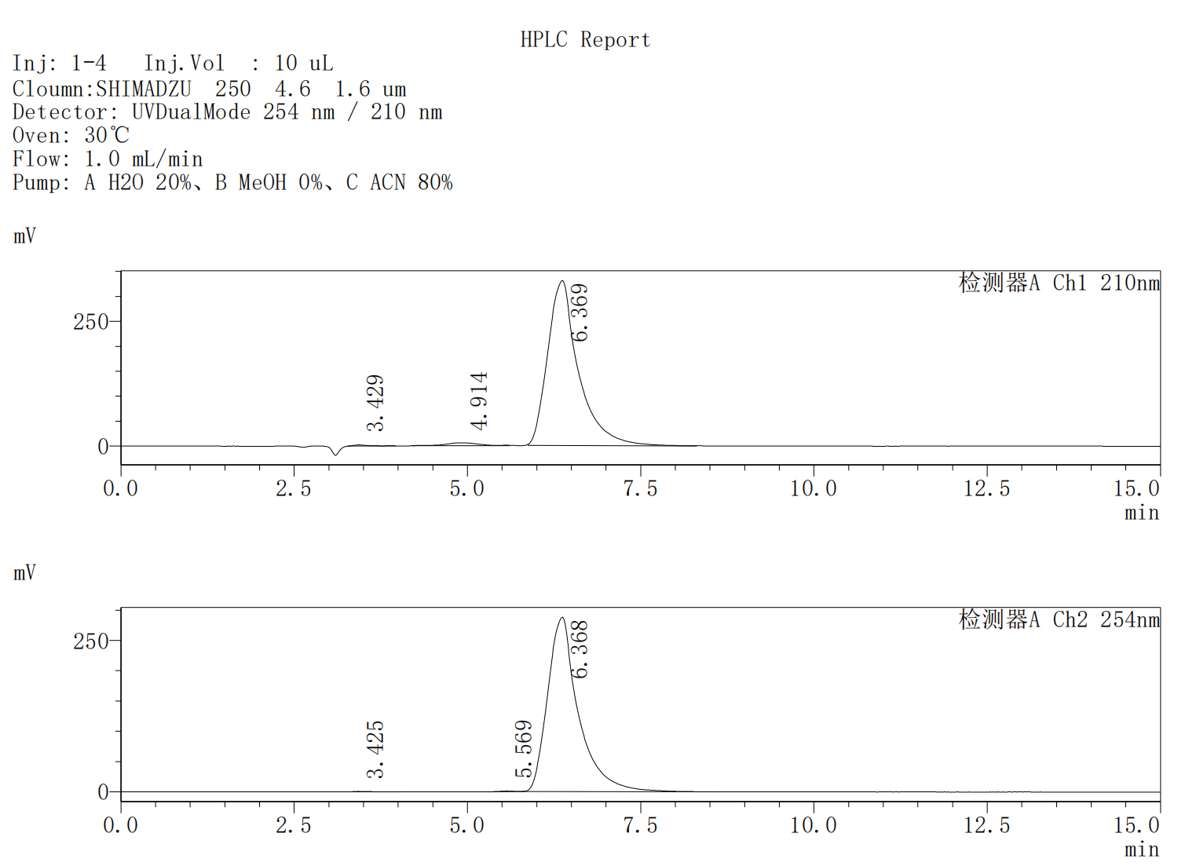
Ch1 210nm
Peak No. | R.T | Area | Area%
1 | 3.429 | 44359 | 0.423
2 | 4.914 | 211352 | 2.014
3 | 6.369 | 10237876 | 97.563
Total |  | 10493587 | 100.000
Ch2 254nm
Peak No. | R.T | Area | Area%
1 | 3.425 | 15049 | 0.169
2 | 5.569 | 12817 | 0.144
3 | 6.368 | 8898479 | 99.688
Total |  | 8926346 | 100.000

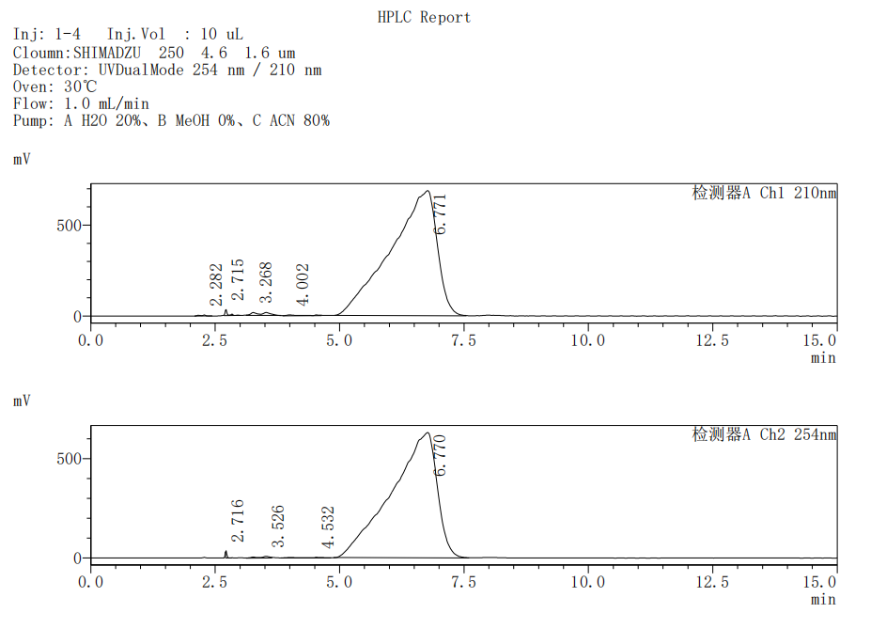
Ch1 210nm
Peak No. | R.T | Area | Area%
1 | 2.282 | 23988 | 0.053
2 | 2.715 | 117453 | 0.261
3 | 3.268 | 321383 | 0.715
4 | 4.002 | 99416 | 0.221
5 | 6.771 | 44363584 | 98.749
Total |  | 44925826 | 100.000
Ch2 254nm
Peak No. | R.T | Area | Area%
1 | 2.716 | 48038 | 0.119
2 | 3.526 | 125858 | 0.312
3 | 4.532 | 78027 | 0.193
4 | 6.770 | 40095902 | 99.376
Total |  | 40347824 | 100.000

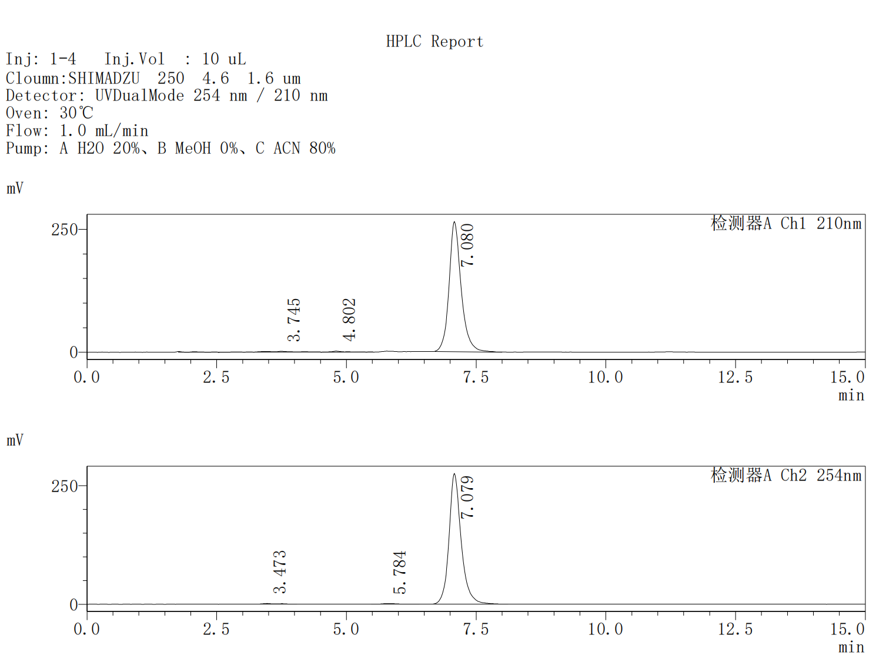
Ch1 210nm
Peak No. | R.T | Area | Area%
1 | 3.745 | 58354 | 1.325
2 | 4.802 | 38285 | 0.869
3 | 7.080 | 4308845 | 97.806
Total |  | 4405485 | 100.000
Ch2 254nm
Peak No. | R.T | Area | Area%
1 | 3.473 | 27173 | 0.597
2 | 5.784 | 25749 | 0.566
3 | 7.079 | 4497562 | 98.837
Total |  | 4550485 | 100.000

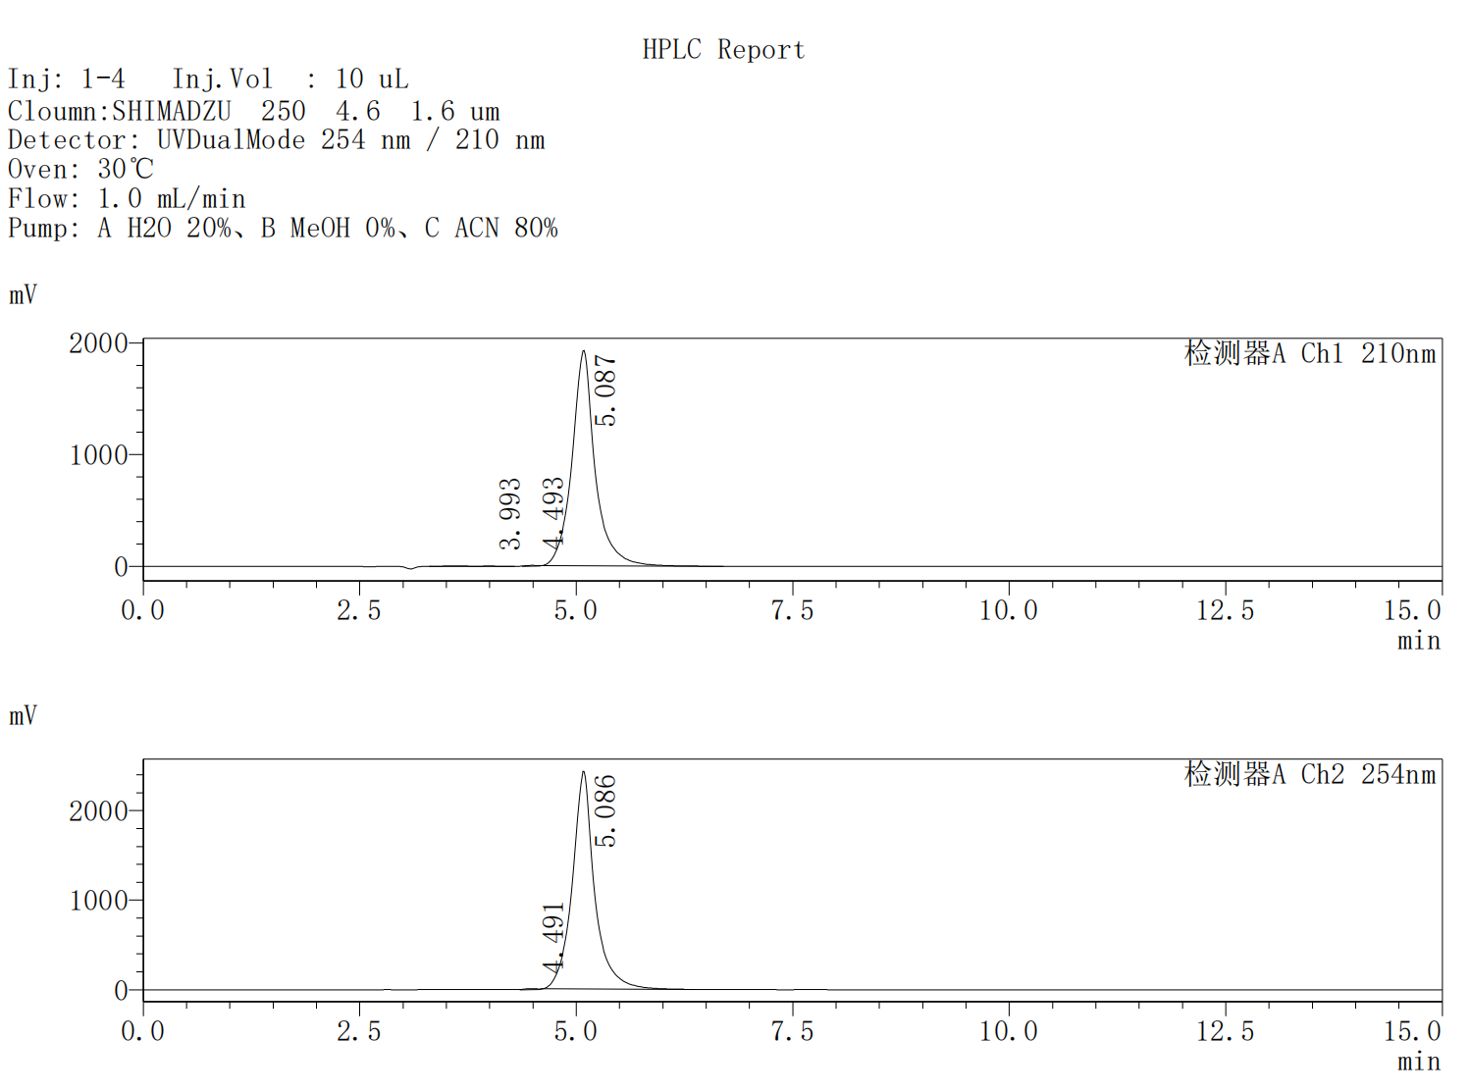
Ch1 210nm
Peak No. | R.T | Area | Area%
1 | 3.993 | 99630 | 0.276
2 | 4.493 | 67047 | 0.186
3 | 5.087 | 35876193 | 99.538
Total |  | 36042870 | 100.000
Ch2 254nm
Peak No. | R.T | Area | Area%
1 | 4.491 | 117067 | 0.267
2 | 5.086 | 43794251 | 99.733
Total |  | 43911318 | 100.000

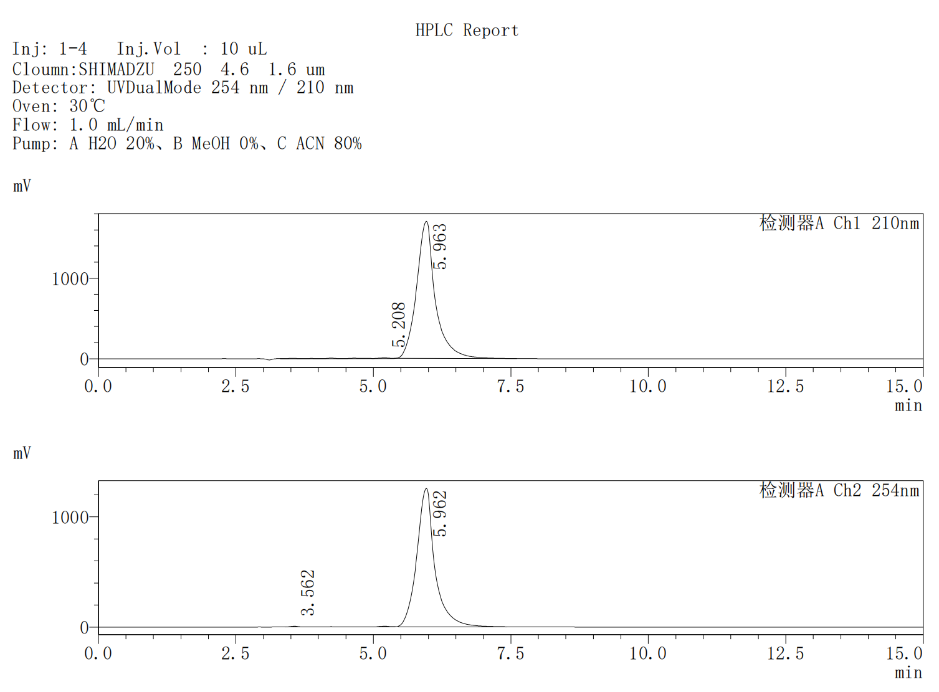
Ch1 210nm
Peak No. | R.T | Area | Area%
1 | 5.208 | 368721 | 0.903
2 | 5.963 | 40456263 | 99.097
Total |  | 40824984 | 100.000
Ch2 254nm
Peak No. | R.T | Area | Area%
1 | 3.562 | 199266 | 0.684
2 | 5.962 | 28941803 | 99.316
Total |  | 29141069 | 100.000

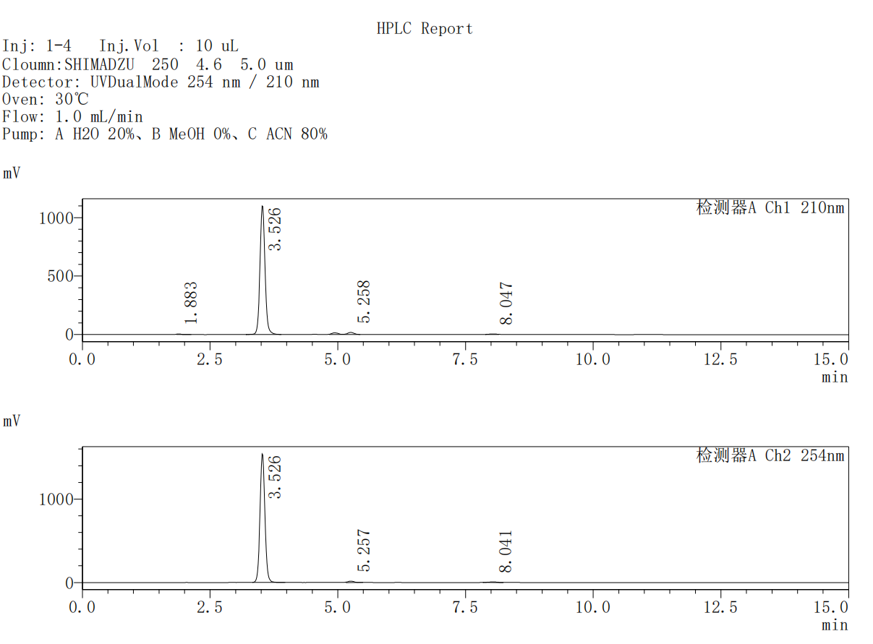
Ch1 210nm
Peak No. | R.T | Area | Area%
1 | 1.883 | 34663 | 0.439
2 | 3.526 | 7522806 | 95.320
3 | 5.258 | 289848 | 3.673
4 | 8.047 | 44875 | 0.569
Total |  | 7892193 | 100.000
Ch2 254nm
Peak No. | R.T | Area | Area%
1 | 3.526 | 10320301 | 97.715
2 | 5.257 | 138386 | 1.310
3 | 8.041 | 102963 | 0.975
Total |  | 10561650 | 100.000

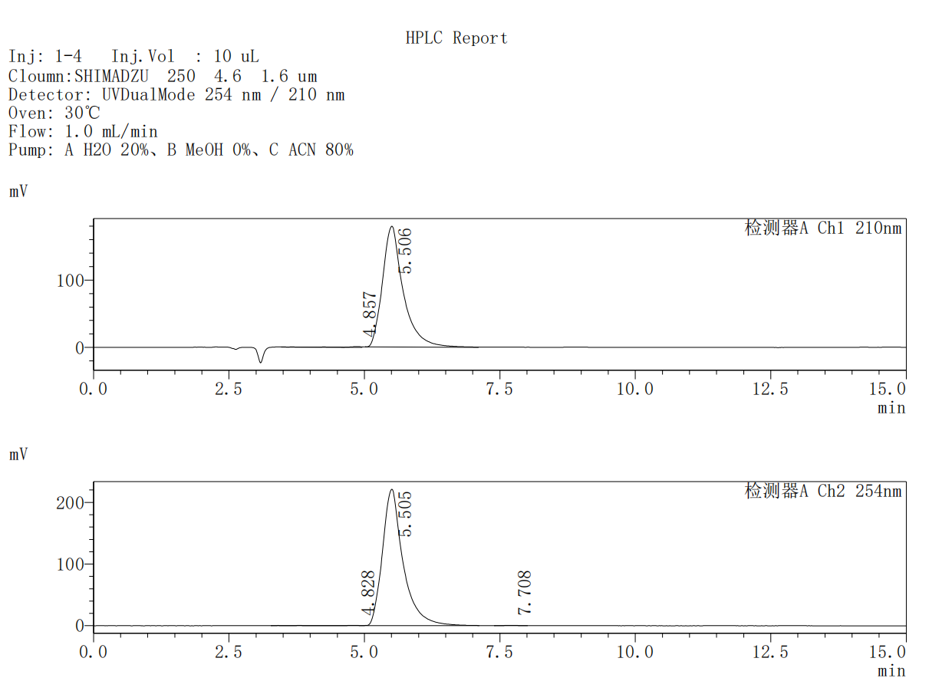
Ch1 210nm
Peak No. | R.T | Area | Area%
1 | 4.857 | 28522 | 0.592
2 | 5.506 | 4792949 | 99.408
Total |  | 4821471 | 100.000
Ch2 254nm
Peak No. | R.T | Area | Area%
1 | 4.828 | 27727 | 0.468
2 | 5.505 | 5883082 | 99.335
3 | 7.708 | 11654 | 0.197
Total |  | 5922464 | 100.000

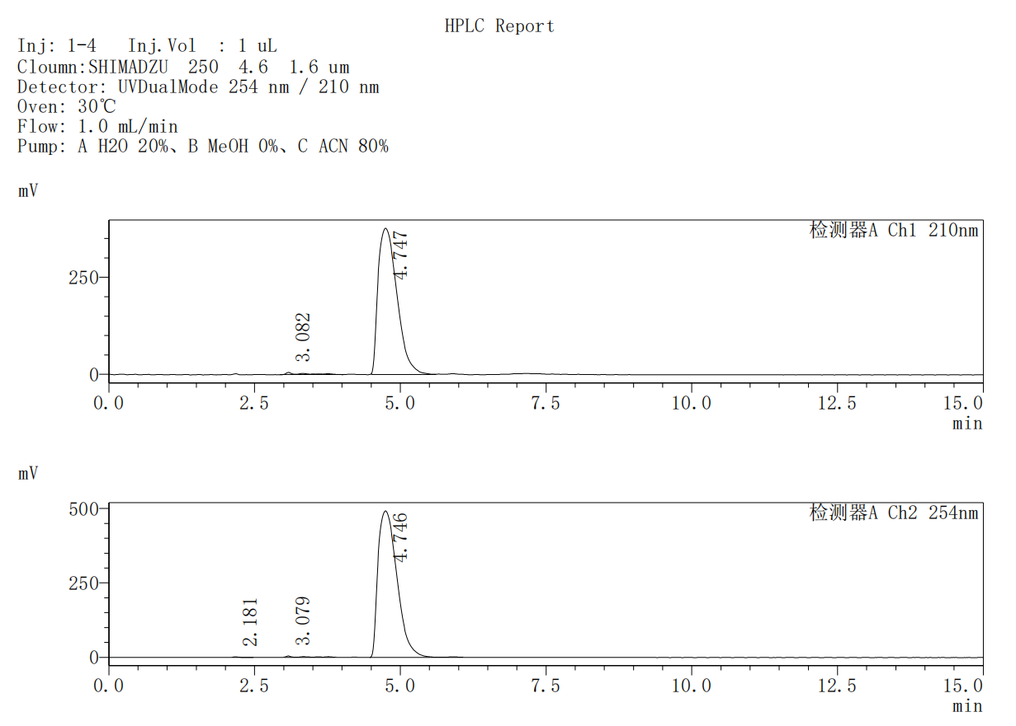
Ch1 210nm
Peak No. | R.T | Area | Area%
1 | 3.082 | 98924 | 1.150
2 | 4.747 | 8499450 | 98.850
Total |  | 8598374 | 100.000
Ch2 254nm
Peak No. | R.T | Area | Area%
1 | 2.181 | 15027 | 0.133
2 | 3.079 | 88211 | 0.782
3 | 4.746 | 11170087 | 99.084
Total |  | 11273324 | 100.000

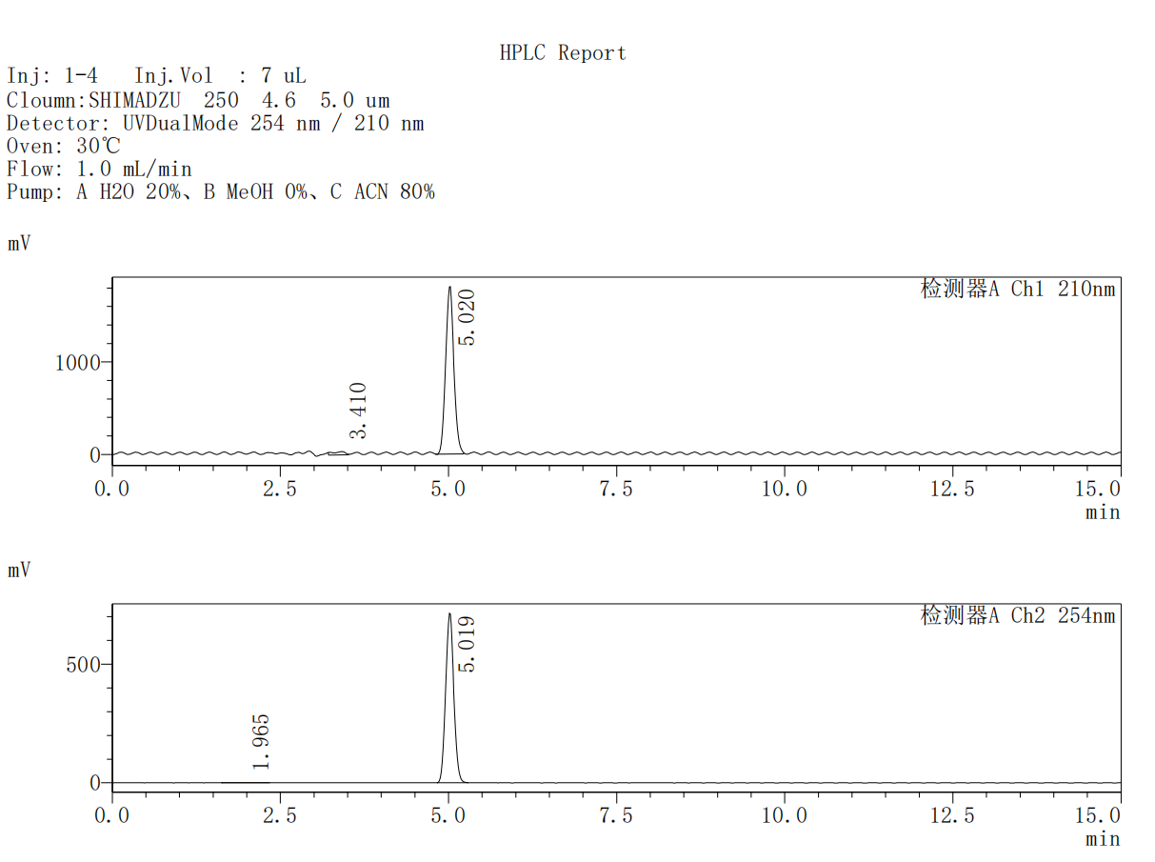
Ch1 210nm
Peak No. | R.T | Area | Area%
1 | 3.410 | 461952 | 2.907
2 | 5.020 | 15430646 | 97.093
Total |  | 15892598 | 100.000
Ch2 254nm
Peak No. | R.T | Area | Area%
1 | 1.965 | 15454 | 0.256
2 | 5.019 | 6014566 | 99.744
Total |  | 6030020 | 100.000

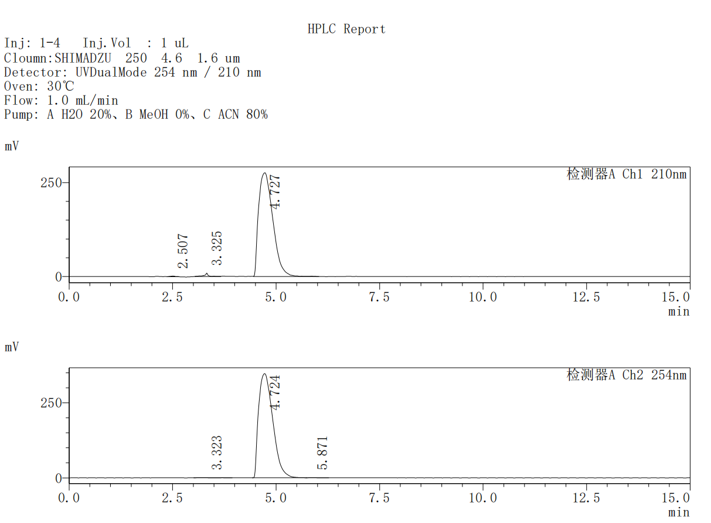
Ch1 210nm
Peak No. | R.T | Area | Area%
1 | 2.507 | 12756 | 0.191
2 | 3.325 | 64407 | 0.965
3 | 4.727 | 6598298 | 98.844
Total |  | 6675461 | 100.000
Ch2 254nm
Peak No. | R.T | Area | Area%
1 | 3.323 | 17052 | 0.205
2 | 4.724 | 8295981 | 99.622
3 | 5.871 | 14444 | 0.173
Total |  | 8327476 | 100.000
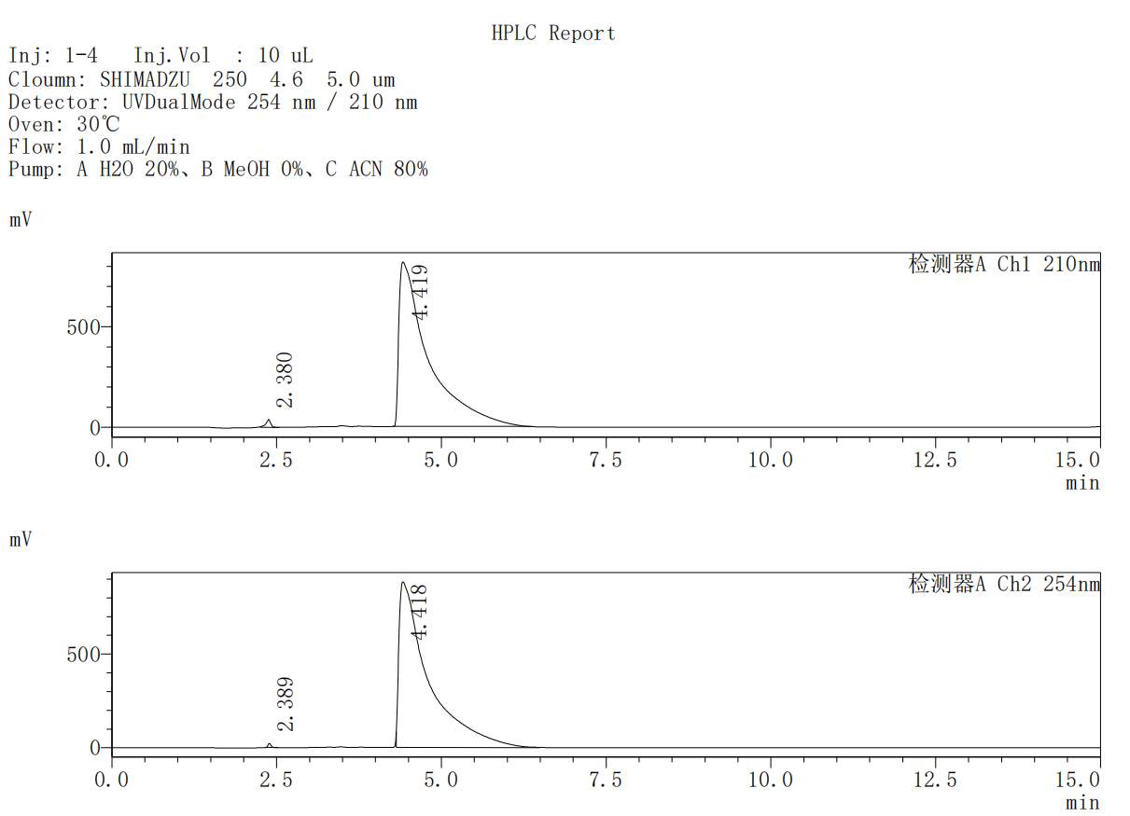
Ch1 210nm
Peak No. | R.T | Area | Area%
1 | 2.380 | 194195 | 0.759
2 | 4.419 | 25387690 | 99.241
Total |  | 25581885 | 100.000
Ch2 254nm
Peak No. | R.T | Area | Area%
1 | 2.389 | 63711 | 0.231
2 | 4.418 | 27538337 | 99.769
Total |  | 27602048 | 100.000

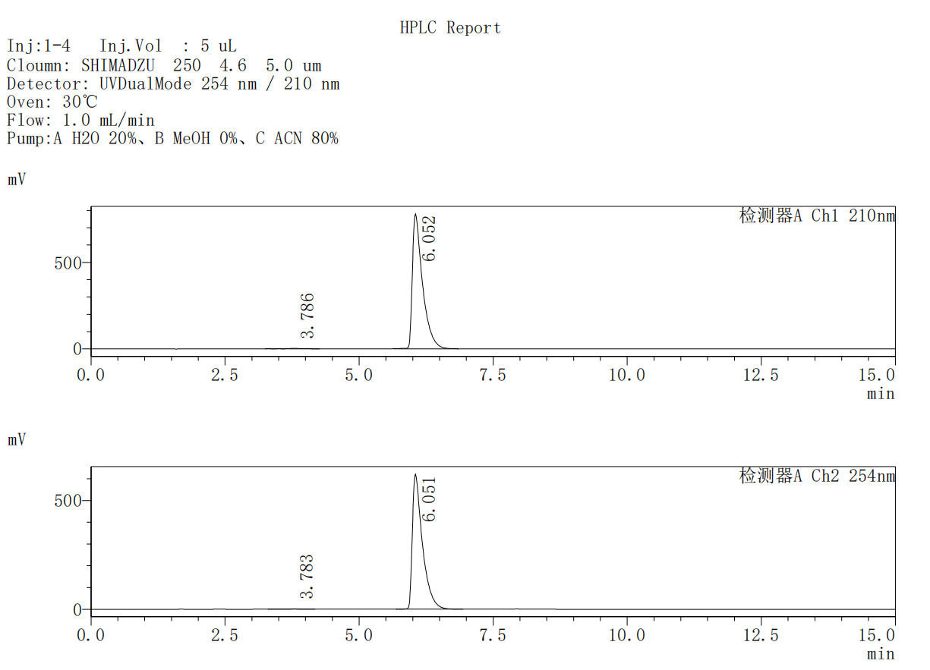
Ch1 210nm
Peak No. | R.T | Area | Area%
1 | 3.786 | 67073 | 0.649
2 | 6.052 | 10264135 | 99.351
Total |  | 10331208 | 100.000
Ch2 254nm
Peak No. | R.T | Area | Area%
1 | 3.783 | 27274 | 0.335
2 | 6.051 | 8125102 | 99.665
Total |  | 8152376 | 100.000

