Table 1. Inhibitory Activities of 4-(imidazo[1,2-a]pyrimidin-3-yl)thiazol-2-amines towards PDE4.
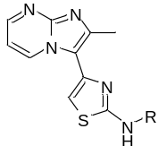
Compounds | R | Inhibitory Rate |  | IC₅₀ (μM)
Compounds | R | 10 μM | 1.0 μM | IC₅₀ (μM)
1 | 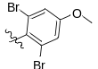 | 99.68% | 27.41% | 4.8±0.2
L1 | 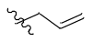 | 32.49% | 0.40% | ＞1.0
L2 | 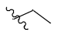 | 21.91% | 0 | ＞1.0
L3 | 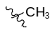 | 100.68% | 0 | ＞1.0
L4 | 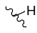 | 27.80% | 17.06% | ＞1.0
L5 | 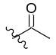 | 35.71% | 23.31% | ＞1.0
L6 | 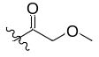 | 5.05% | 5.35% | ＞1.0
L7 | 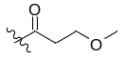 | 3.20% | 0.19% | ＞1.0
L8 | 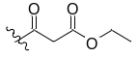 | 5.57% | 4.21% | ＞1.0
L9 | 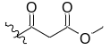 | 8.17% | 4.83% | ＞1.0
L10 | 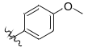 | 42.90% | 3.14% | ＞1.0
L11 | 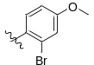 | 48.31% | 21.75% | ＞1.0
L12 | 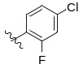 | 60.55% | 0.66% | ＞1.0
L13 | 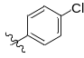 | 80.80% | 13.85% | ＞1.0
L14 | 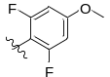 | 56.22% | 21.92% | ＞1.0
L15 | 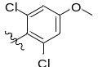 | 102.69% | 32.57% | ＞1.0
L16 | 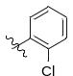 | 60.01% | 1.97% | ＞1.0
L17 | 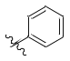 | 56.23% | 6.90% | ＞1.0
L18 | 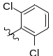 | 86.90% | 39.54% | ＞1.0
L19 | 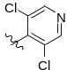 | 114.06% | 70.25% | 0.51±0.02
L20 | 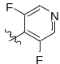 | 115.12% | 74.78% | 2.1±0.2
L21 | 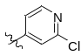 | 45.78% | 36.14% | ＞1.0
L22 | 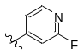 | 51.16% | 9.25% | ＞1.0
Rolipramª | 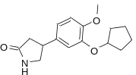 | - | - | 0.59±0.05
ªRolipram, the reference compound.

