Supplementary Information for
Tailoring Asymmetric RuCu Dual-Atom Electrocatalyst toward Ammonia Synthesis from Nitrate

Liu et al.
Contents:
Supplementary Notes 1 to 8
Supplementary Figures 1 to 33
Supplementary Tables 1 to 6
Supplementary References

Supplementary Notes

Supplementary Note. 1 | Pulsed discharge characteristics
- Due to the low resistance of the discharging copper tube, the resistance of the graphene aerogel is several orders of magnitude higher. Despite the peak current exceeding 500 kA, the actual current distributed through the graphene aerogel is relatively low, and the pulse duration is only in the order of tens of microseconds. Consequently, achieving Joule heating of the entire graphene aerogel through pulsed discharge is challenging. However, considering the three-dimensional porous nature of the graphene aerogel, the high-frequency underdamped waveform pulse current is likely to allocate a significant current to the capacitive regions of NGA, resulting in localized Joule heating effects on the N-doped graphene.
- Moreover, the nitrogen-doped graphene contains numerous nanopore defects. When the high-frequency underdamped waveform pulse current passes through this multilevel porous NGA, localized corona plasma effects are generated. These localized plasma effects lead to the explosive decomposition of nearby loaded metal salt nanocrystals, producing gaseous metal cations and halide anions.
- The rapidly varying current induces a toroidal magnetic field within the copper tube, causing the metal cations to move within the rapidly changing electromagnetic field. The nitrogen atoms at the defect sites in the nitrogen-doped graphene hinder and anchor these metal ions, resulting in atomically dispersed metal single atoms. Because the metal salt nanocrystals are uniformly loaded on the nitrogen-doped graphene, the gaseous cations produced at high temperatures are also well-mixed, leading to the formation of metal diatomic pairs anchored at the nanopore sites of the nitrogen-doped graphene.
- Repeated applications of pulsed discharges can vaporize potential alloy clusters, with the nitrogen atoms at the graphene defects anchoring them to form stable asymmetric diatomic structures. Additionally, the transient microsecond-scale decomposition vaporization and subsequent anchoring-cooling processes that form metal diatomic pairs on the NGA exhibit rapid quenching characteristics. This ensures the catalyst's excellent stability.

Supplementary Note. 2 | Characterizations
The morphology of the samples was characterized by transmission electron microscope (TEM, FEI Tecnai G2 20) and field-emission scanning electron microscope (FE-SEM, JEORJSM-7200F). The HAADF-STEM images were obtained by FEI Themis Z at an accelerating voltage of 200 kV. The Raman measurements were carried out with a laser spectrometer at 532 nm on a LabRAM HR Evolution. Powder X-ray diffraction (XRD) was conducted on a Bruker D8 Advance instrument with 455 a Cu Kα irradiation source at a scanning rate of 5° per minute. The metal content was measured by inductively coupled plasma optical emission spectrometry (ICP-OES), which was taken on Agilent 730. The specific surface area distribution of the sample was evaluated on the Advanced Specific Surface Area and Micropore Analyzer (BSD-660M), calculated by N₂ sorption isotherms using the Brunauer-Emmett-Teller (BET) method. The X-ray photoelectron spectroscopy (XPS) measurements were performed with an ESCALAB 250Xi spectrometer using Al Kα nonmonochromatic radiation.

Supplementary Note. 3 | Preparation of Cu SAs/NGA, Cu SAs/NGA
NH₃•H₂O (200 mg) was added to graphene oxide aqueous solution, and then nitrogen-doped graphene hydrogel (NGH) was prepared by hydrothermal method. The NGH was soaked in an ethanol solution of copper acetyl acetone (Cu(acac)₂, or Ru(acac)₃) for 2 hours, washed with distilled water and freeze-dried to obtain nitrogen-doped graphene supported copper acetyl acetone (Cu(acac)₂/NGA, Ru(acac)₃/NGA). It is placed in a tube furnace and pyrolyzed in a nitrogen atmosphere for 2 hours at a heating temperature of 800 ℃ to obtain the Cu SAs/NGA and Ru SAs/NGA.

Supplementary Note. 4 | Electrochemical tests for NO₃RR.
Electrocatalytic nitrate reduction reaction (NO₃RR) measurements were conducted in a conventional three-electrode configuration using an electrochemical workstation (CHI 760E, Chenhua Instrument Factory, Shanghai, China). The system comprised a prepared electrode (1 cm × 1 cm) serving as the working electrode, graphite rods as the counter electrodes, and Ag/AgCl electrodes as the reference electrodes. A Nafion membrane was positioned between the anodic and cathodic compartments of the three-electrode cell. Catalyst inks were prepared by blending the catalyst (5 mg) with isopropanol (0.75 mL), water (0.24 mL), and a 5% Nafion solution (0.01 mL), followed by ultrasonication for 4 hours. Subsequently, 50 μL of the homogeneous catalyst ink was drop-cast onto a piece of carbon paper. Both the cathode and anode compartments were filled with 35 mL of 0.1 M KOH solution. The performance of the NO₃RR was evaluated by introducing an additional 0.1 M KNO₃ to the cathode compartment. Before the NO₃RR experiments, the electrolyte was purged with high-purity Ar (99.99%) for 15 minutes. Linear sweep voltammetry (LSV) measurements were conducted at a scan rate of 5 mV s⁻¹ multiple times until a steady state was achieved. Under continuous stirring at 350 rpm, chronoamperometry (i-t) tests were performed at various applied potentials over 1 hour to assess the electrocatalytic activity for NO₃RR. The concentrations of nitrate, nitrite, and ammonia were quantified using established colorimetric methods. For UV-Vis spectrophotometric analysis, 0.05 mL of the electrolyte was diluted to 5 mL with water, followed by the addition of 0.1 mL of Nessler's reagent to the diluted electrolyte solution. Following a shaking and standing period of approximately 20 minutes, the absorbance was measured at a wavelength of 420 nm. Quantification of nitrate was performed using the following protocol: 10 g of p-sulfanilamide was dissolved in a mixture of 100 mL of water and 25 mL of phosphoric acid. Subsequently, 0.5 g of N-(1-naphthyl)ethylenediamine dihydrochloride was added and dissolved in the solution, which was then diluted to a final volume of 250 mL. For the measurement, 0.05 mL of electrolyte was mixed with 0.5 mL of phosphoric acid for acidification and then diluted to 10 mL with water. Subsequently, 0.2 mL of the color reagent was added to the diluted electrolyte solution. After shaking and standing for about 20 minutes, the absorbance was measured using UV-Vis spectrophotometry at a wavelength of 540 nm. Calibration curves were constructed by plotting the absorbance against different concentrations of nitrite standard solutions. Similar calibration curves were generated for ammonia standard solutions by correlating their concentrations with the corresponding absorbance values. In the electrochemical measurements, the potential relative to the reversible hydrogen electrode was calculated as follows:
NH₃ yield (mol h⁻¹ g⁻¹ cat.) = C_{NH3} × V/(M_{NH3} × t × S)
Faradaic efficiency= (n × F × c × V )/(M × Q) × 100%
where n is the number of electrons transferred, F=96485 C mol⁻¹ the Faraday constant, c(μg mL⁻¹) is the measured NH₃ concentration, V (mL) is the volume of NH₃ cathodic reaction electrolyte, M is the relative molecular mass of products, m is the amount of catalyst supported, Q (C) the total quantity of applied electricity and t (h) the reduction time.

Supplementary Note. 5 | XAFS tests.
The X-ray absorption fine structure (XAFS) spectra of the samples, including Cu, Ru, Ag, Pd K-edge, and Pt L₃ edge, were acquired at the Beijing Synchrotron Radiation Facility. All XAFS data were collected using fluorescence excitation mode. The samples were prepared as disks with a diameter of 13 mm and a thickness of 1 mm. Each spectrum was recorded twice following a stabilization period of 30 minutes at a constant potential.

Supplementary Note. 6 | XAFS data processing
The acquired EXAFS data were processed according to the standard procedures using the Athena and Artemis implemented in the IFEFFIT software packages. The fitting detail is described below: The acquired EXAFS data were processed according to the standard procedures using the ATHENA module implemented in the IFEFFIT software packages. The EXAFS spectra were obtained by subtracting the post-edge background from the overall absorption and then normalizing with respect to the edge-jump step. Subsequently, the χ(k) data of Fourier transformed to real (R) space using a Hanning window (dk=1.0 Å⁻¹) to separate the EXAFS contributions from different coordination shells. To obtain the quantitative structural parameters around central atoms, least-squares curve parameter fitting was performed using the ARTEMIS module of the IFEFFIT software packages. The following EXAFS equation was used:
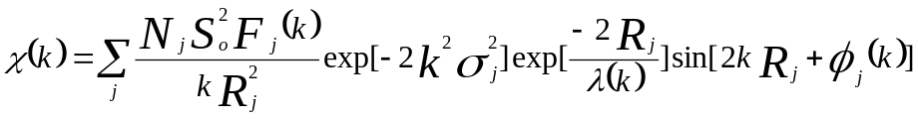
S₀² is the amplitude reduction factor, F_{j}(k) is the effective curved-wave backscattering amplitude, Nj is the number of neighbors in the j^{th} atomic shell, R_{j} is the distance between the X-ray absorbing central atom and the atoms in the j^{th} atomic shell (backscatterer), λ is the mean free path in Å, ϕ_{j}(k) is the phase shift (including the phase shift for each shell and the total central atom phase shift), σ_{j} is the DebyeWaller parameter of the j^{th} atomic shell (variation of distances around the average R_{j}). The functions F_{j}(k), λ, and ϕ_{j}(k) were calculated with the ab initio code FEFF8.2. The additional details for EXAFS simulations are given below. The coordination numbers of model samples (Pt foil) were fixed as the nominal values. The obtained S₀² was fixed in the subsequent fitting of atomically dispersed Pt samples. While the internal atomic distances R, Debye-Waller factor σ², and the edge-energy shift ΔE₀ were allowed to run freely.

Supplementary Note. 7 | In situ synchrotron radiation XAFS measurements
Electrochemical measurements were conducted using a computer-controlled electrochemical analyzer. The working electrode consisted of carbon paper modified with the catalyst, while a graphite rod served as the counter electrode, and an Ag/AgCl electrode was employed as the reference electrode. An organic glass electrochemical cell was utilized for the in situ experiments. This cell features flat walls with a single circular aperture measuring 1.5 cm in diameter. The RuCu DAs/NGA-coated carbon paper was placed in contact with a copper slip, oriented such that the catalyst layer faced inward. Subsequently, the electrolyte solution was introduced into the cell without stirring during the course of the experiments. Electrical connectivity to the electrochemical station was established via the copper tape slip that protruded from the side of the working cell. An organic glass cap, equipped with a reference electrode, was fitted over the cell to maintain a consistent distance between the working and reference electrodes throughout all experiments. XAFS spectra were recorded at various positions on the electrode to assess the homogeneity of the catalyst.

Supplementary Note. 8 | The detail of DFT calculation methods.
Spin-polarized density functional theory (DFT) calculations were performed using the Vienna Ab-initio Simulation Package (VASP)^{1, 2} to investigate the properties of the prepared materials. The calculations employed the Projector Augmented Wave (PAW) method³ with a cutoff energy of 450 eV and utilized the Perdew-Burke-Ernzerhof (PBE) functional³. The DFT-D3 method⁴ was applied to account for van der Waals interactions. A single layer of the Carbon (001) facet was cleaved, accompanied by a vacuum layer of 20 Å, and the structures of RuN₂CuN₃, RuN₄, and CuN₄ were constructed from the carbon layer.
All models were fully relaxed with an energy convergence criterion of 10⁻⁵ eV and a force convergence criterion of 0.02 eV/Å. The calculations utilized the gamma point for the K-point mesh. The adsorption energy (E_ads) was calculated using the following equation 1:
$$E_{ads}=E_{total}-E_{substrate}-E_{adsorbate} (1)$$
The E_{total}, E_{substrate}, and E_{adsorbate} represent the energy of adsorption structure, substrate, and adsorbate, respectively. The free energies have been calculated using the following formula 2,
$$G= E_{DFT}+ZPE-TS (2)$$
The G, E_{DFT}, ZPE, and TS represent the free energy, energy from DFT calculations, zero point energy and entropic contributions, respectively.

Supplementary Figures
Supplementary Fig. 1. Characterizations of the initial GO and NGA. (a) GO aqueous solution. (b) AFM image of GO. (c) The height distribution of single layer GO. (d) The photos of graphene hydrogels and the hydrothermal reactor. (e) A photomacrograph of NGA on a flower. (f) The micro and meso pore distribution of NGA. (g) SEM images of NGA. (h) TEM image of NGA. (i) HRTEM image of NGA. The severe puckering of NGA can be seen under TEM. The single layer feature of GO and N doped-reduced GO was confirmed by AFM and HRTEM.

Supplementary Fig. 2. The schematic diagram and actual photos of high power pulsed discharge system for RuCu DAs/NGA preparation. The voltage and current through the circuit were recorded by oscilloscope during the pulsed discharge process.

Supplementary Fig. 3. Analysis of the pulsed discharge process. (a) The structure schematic diagram of copper discharge containing a sample. (b) The simplified discharge circuit. (c)-(h) The demonstration of pulsed discharge process.

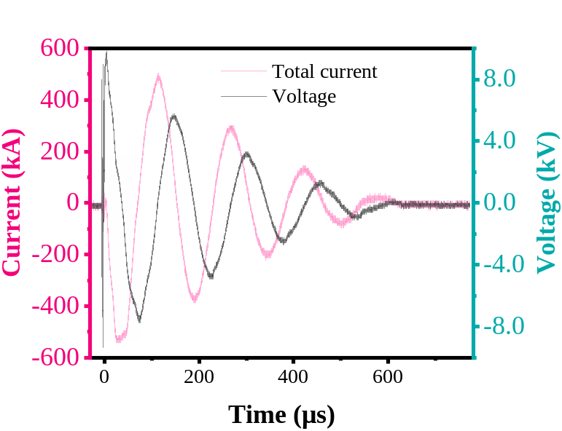
Supplementary Fig. 4. The original curves of voltage and current in the circuit during pulsed discharge.

Supplementary Fig. 5. The schematic diagrams of corona plasma and electromagnetic field effects on the NGA support. (a) The corona plasma on the defects of graphene. (b) The partially enlarged side view of electromagnetic field effects on the NGA. (c) The top view of the magnetic field effect inside the copper discharge.

Supplementary Fig. 6. The schematic diagram of RuCu DAs/NGA formation process by the pulsed discharge method. The six current pulse shock induces the Ru and Cu atoms to disperse and anchor on NGA.

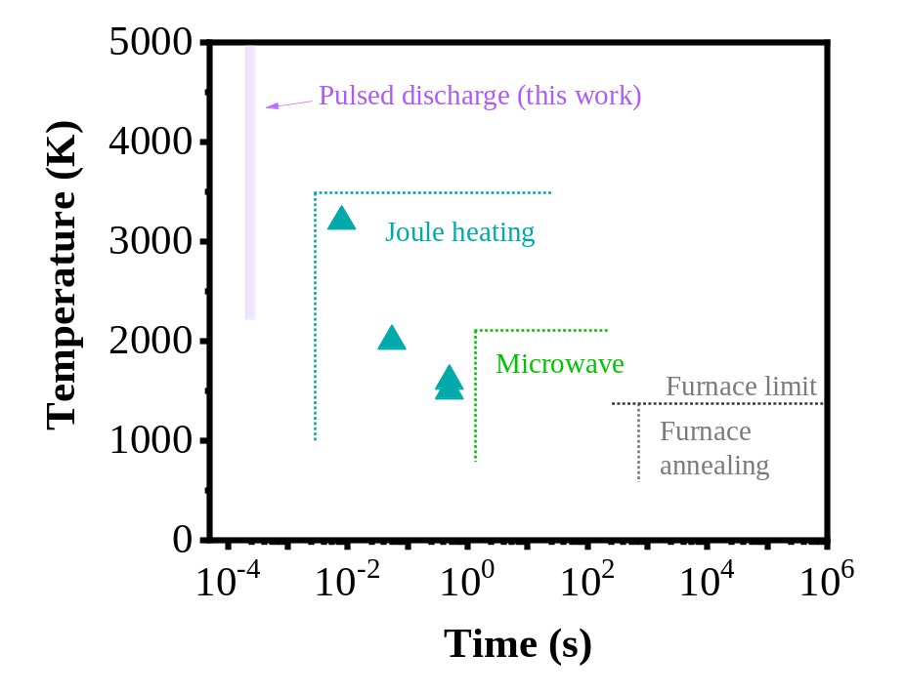
Supplementary Fig. 7. Compared to other synthesis methods on temperature and time for atomically dispersed catalysts. Compared with the reported methods, only our pulsed discharge method can synthesize atomically dispersed catalysts at hundreds of microseconds.

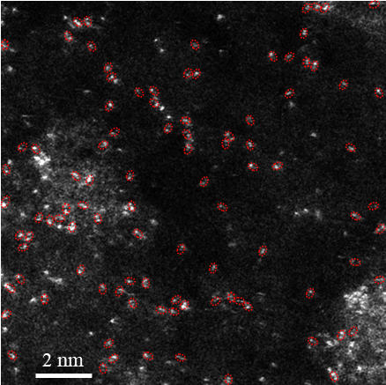
Supplementary Fig. 8. The HADDF-STEM image of RuCu DAs/NGA at different positions. Most of the metal atoms are scattered on NGA in the form of Ru-Cu atomic pairs.

Supplementary Fig. 9. Supplemental characterizations of RuCu DAs/NGA. (a) An HRTEM image of RuCu DAs/NGA. (b) The content curve of each element was scanned in the EDS mapping. (c) Specific element content. (d) The distance of a pair Ru and Cu. The characteristics of single-layer N-doped graphene did not change after pulsed discharge treatment.

Supplementary Fig. 10. The schematic diagram of RuCu DAs/NGA with different angles (between RuCu and the plane of NGA). The angle between RuCu and the surface of NGA is different.

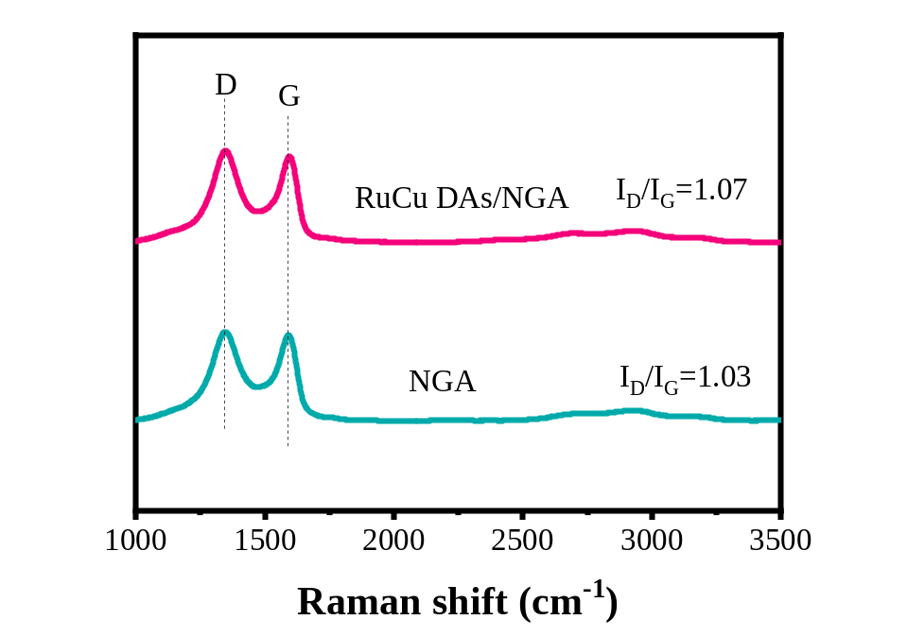
Supplementary Fig. 11. The Raman results of RuCu DAs/NGA and NGA. The defects of RuCu DAs/NGA obtained after pulsed discharge treatment are slightly more than that of NGA.

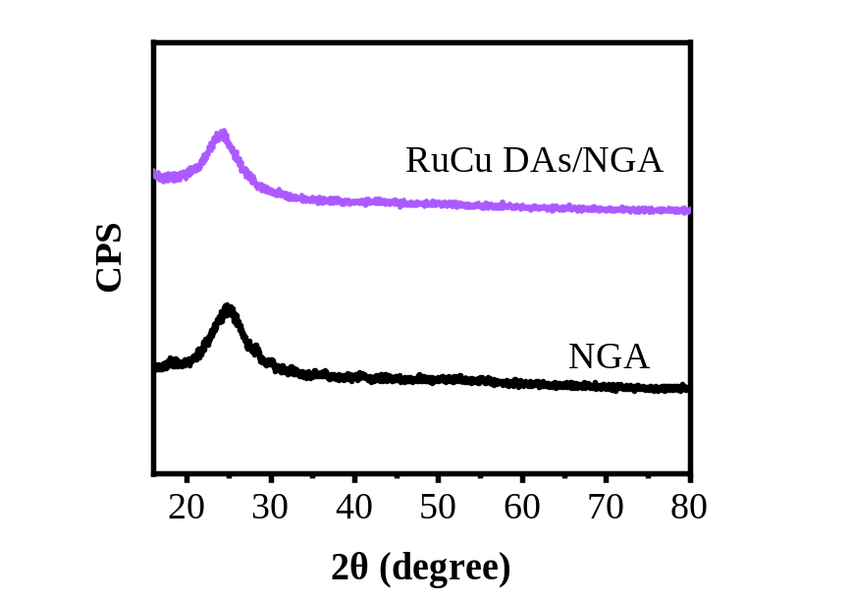
Supplementary Fig. 12. The XRD results of RuCu DAs/NGA and NGA. It is not found Ru or Cu crystals in RuCu DAs/NGA by the XRD tests.

Supplementary Fig. 13. The XPS results of RuCu DAs/NGA. (a) The XPS spectra for the survey scan. (b)-(e) The spectra for C1s, N1s, Cu2p, and Ru3p of RuCu DAs/NGA. (f) The contents of C, N, O, Cu, and Ru in RuCu DAs/NGA.

Supplementary Fig. 14. The XAFS results of RuCu DAs/NGA. (a) The first derivative curves of Cu K-edge XANES absorption edge for RuCu DAs/NGA and references. (b) The Cu K-edge EXAFS fitting results of RuCu DAs/NGA in the k space and (c) q space. (d) The first derivative curves of Ru K-edge XANES absorption edge for RuCu DAs/NGA and references. (e) The Ru K-edge EXAFS fitting result of RuCu DAs/NGA in the k space and (f) q space. (g) N K-edge XANES spectra of the RuCu DAs/NGA.

Supplementary Fig. 15. The Characterizations of PtCu DAs/NGA. (a) A SEM image of PtCu DAs/NGA. (b) The images of HADDF-STEM and (c) HRTEM. (d) The content curve of each element was scanned using EDS mapping. (e) The specific element content of PtCu DAs/NGA. (f) The image of HADDF-STEM for Pt-Cu pair atoms and the corresponding 3D intensity profile. (g) The distance of a pair Pt and Cu. (h) The distance frequency between adjacent Cu and Pt atoms.

Supplementary Fig. 16. The XAFS results of PtCu DAs/NGA. (a) The Cu K-edge XANES spectra of PtCu DAs/NGA and the references (Cu foil and CuO). (b) The first derivative curves of Cu K-edge XANES absorption edge for PtCu DAs/NGA and the references. (c) The valence states of Cu in PtCu DAs/NGA and references are based on the first-order derivative of XANES spectra. (d) Cu K-edge FT k³-weighted EXAFS spectra of PtCu DAs/NGA and references. (e) The Cu K-edge EXAFS fitting results of PtCu DAs/NGA in the k space and (f) q space. (g) The normalized difference spectra for Pt L₃-edge XANES using Pt foil as reference. The oxidation states are fitted by integrating the area of the white-line peak. (h) Calculated Pt oxidation states derived from ΔXANES spectra of PtO₂, PtCu DAs/NGA, and Pt foil are given as a reference. (i) The Pt L₃-edge EXAFS fitting results of PtCu DAs/NGA in the k space and (j) q space. (k) The proposed atomic structure model of PtCu DAs/NGA. (l) The WT-EXAFS results of Cu in PtCu DAs/NGA. (m) The WT-EXAFS results of Pt in PtCu DAs/NGA and references.

Supplementary Fig. 17. The Characterizations of AgCu DAs/NGA. (a) A SEM image of AgCu DAs/NGA. (b) The images of HADDF-STEM and (c) HRTEM. (d) The content curve of each element was scanned in the EDS mapping. (e) The specific element content of AgCu DAs/NGA. (f) The image of HADDF-STEM for Ag-Cu pair atoms and the corresponding 3D intensity profile. (g) The distance of a pair Ag and Cu. (h) The distance frequency between adjacent Cu and Ag atoms.

Supplementary Fig. 18. The XAFS results of AgCu DAs/NGA. (a) The Cu K-edge XANES spectra of AgCu DAs/NGA and the references (Cu foil and CuO). (b) The first derivative curves of Cu K-edge XANES absorption edge for AgCu DAs/NGA and the references. (c) The valence states of Cu in AgCu DAs/NGA and references are based on the first-order derivative of XANES spectra. (d) Cu K-edge FT k³-weighted EXAFS spectra of AgCu DAs/NGA and references. (e) The Cu K-edge EXAFS fitting results of AgCu DAs/NGA in the k space and (f) q space. (g) The first derivative curves of Ag K-edge XANES absorption edge for AgCu DAs/NGA and the references. (h) The valence states of Ag in AgCu DAs/NGA and references are based on the first-order derivative of XANES spectra. (i) The Ag K-edge EXAFS fitting results of AgCu DAs/NGA in the k space and (j) q space. (k) The proposed atomic structure model of AgCu DAs/NGA. (l) The WT-EXAFS results of Cu in AgCu DAs/NGA. (m) The WT-EXAFS results of Ag in AgCu DAs/NGA and references.

Supplementary Fig. 19. The Characterizations of PdCu DAs/NGA. (a) A SEM image of PdCu DAs/NGA. (b) The images of HADDF-STEM and (c) HRTEM. (d) The content curve of each element was scanned in the EDS mapping. (e) The specific element content of PdCu DAs/NGA. (f) The image of HADDF-STEM for Pd-Cu pair atoms and the corresponding 3D intensity profile. (g) The distance of a pair Pd and Cu. (h) The distance frequency between adjacent Cu and Pd atoms.

Supplementary Fig. 20. The XAFS results of PdCu DAs/NGA. (a) The Cu K-edge XANES spectra of PdCu DAs/NGA and the references (Cu foil and CuO). (b) The first derivative curves of Cu K-edge XANES absorption edge for PdCu DAs/NGA and the references. (c) The valence states of Cu in PdCu DAs/NGA and references are based on the first-order derivative of XANES spectra. (d) Cu K-edge FT k³-weighted EXAFS spectra of PdCu DAs/NGA and references. (e) The Cu K-edge EXAFS fitting results of PdCu DAs/NGA in the k space and (f) q space. (g) The first derivative curves of Pd K-edge XANES absorption edge for PdCu DAs/NGA and the references. (h) The valence states of Pd in PdCu DAs/NGA and references based on the first-order derivative of XANES spectra. (i) The Pd K-edge EXAFS fitting results of PdCu DAs/NGA in the k space and (j) q space. (k) The proposed atomic structure model of PdCu DAs/NGA. (l) The WT-EXAFS results of Cu in PdCu DAs/NGA. (m) The WT-EXAFS results of Pd in PdCu DAs/NGA and references.

Supplementary Fig. 21. The profiles of differential charge densities of (a) PtCu DAs/NGA, (b) AgCu DAs/NGA, and (c) PdCu DAs/NGA. The sites of PtN₂, AgN₂, and PdN₂ are the electron-rich zones, which implies higher activity than CuN₃ sites.

Supplementary Fig. 22. UV-vis calibration curves of NH₃ using ammonium chloride solutions of known concentration as the standard solutions. (a) UV-vis curves of indophenol assays with NH₄⁺ and (b) A calibrated curve with different NH₄⁺ concentrations at 655 nm.

Supplementary Fig. 23. (a) The 24 h long-term tests of RuCu DAs/NGA during NO₃RR at -0.3 V and -0.4 V vs. RHE. (b) The yield rate and FE of NH₃ generation for RuCu DAs/NGA at different NO₃⁻ concentrations (-0.4 V vs. RHE). The NH₃ yield rate exhibits a linear enhancement as the NO₃⁻ concentration is varied from 0.01 M to 0.5 M. Specifically, the NH₃ yield rate escalates to 4.2 mg h⁻¹ cm⁻² at 0.5 M NO₃⁻ concentration.

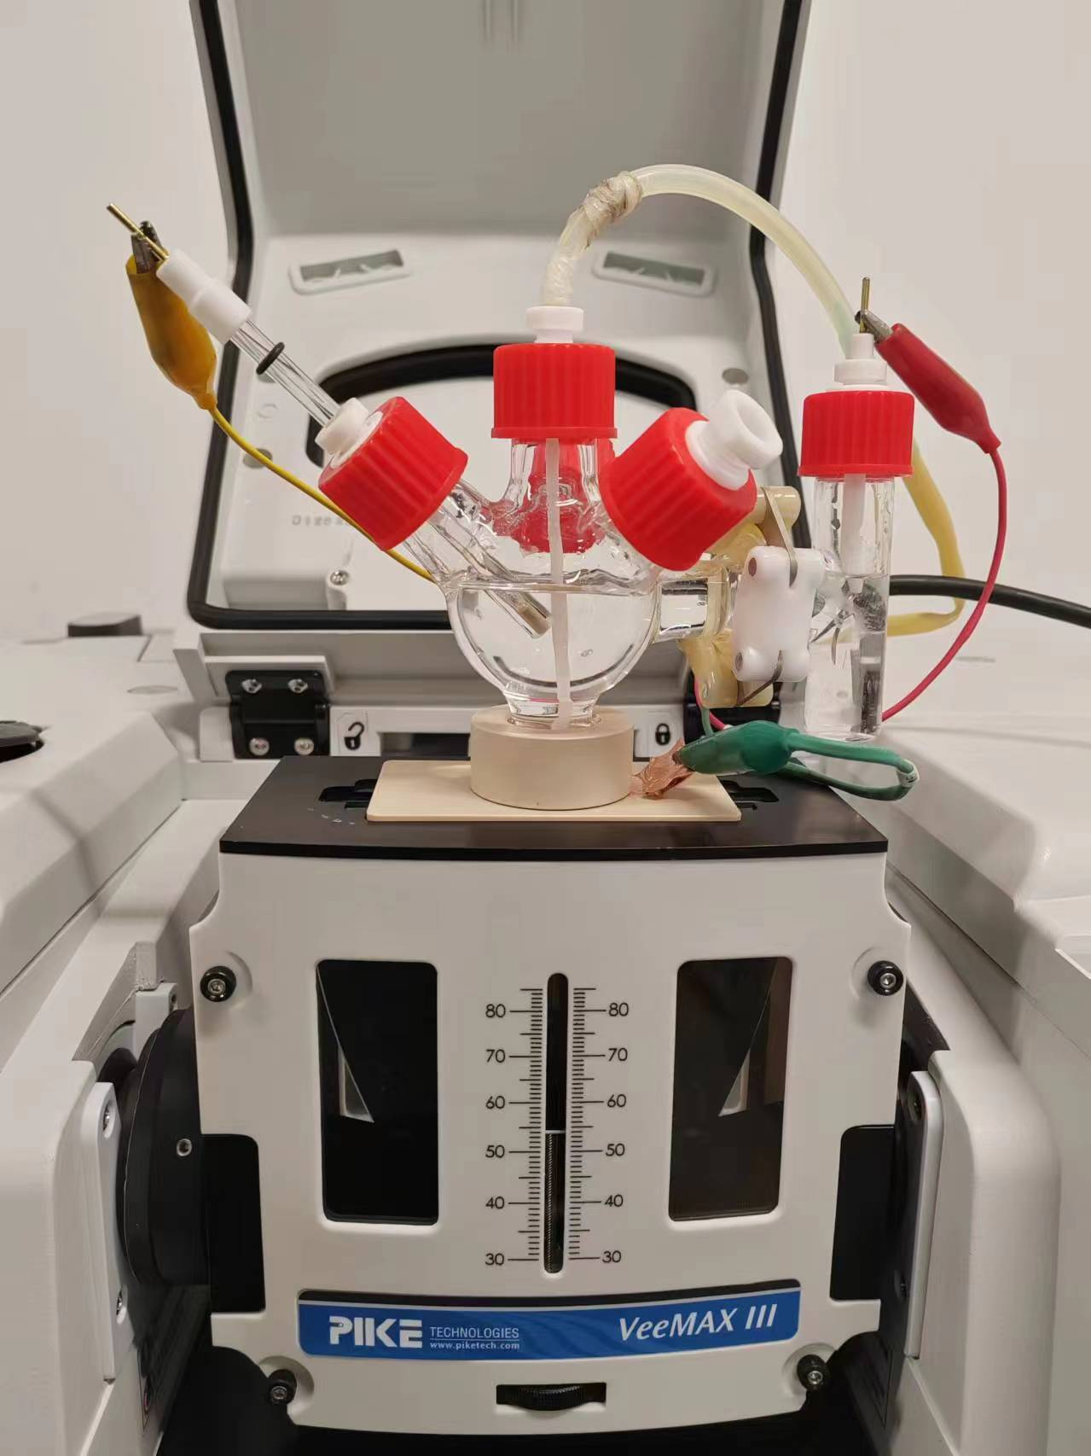
Supplementary Fig. 24. The in situ ATR-SEIRAS device and equipment for NO₃RR measurements.

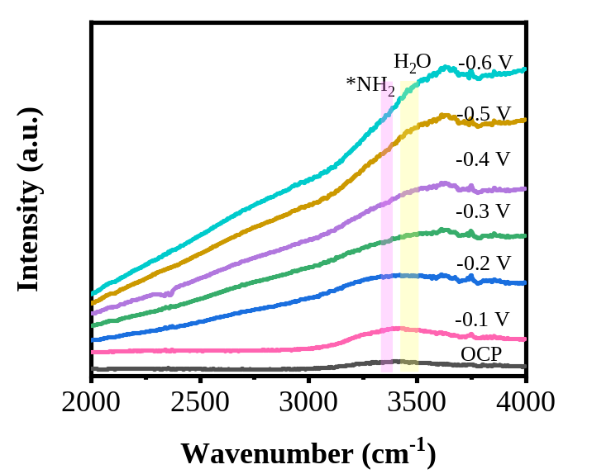
Supplementary Fig. 25. Potential-dependent in situ ATR-SEIRAS spectra (2000-4000 cm⁻¹) during the electrochemical NO₃RR process at different applied potentials (OCP, -0.1 V, -0.2 V, -0.3 V, -0.4 V, -0.5 V, and -0.6 V vs. RHE).

Supplementary Fig. 26. The first-order derivative of XANES spectra during the in situ XAS tests. (a) The first derivative curves of Cu and (b) Ru K-edge XANES absorption edge for RuCu DAs/NGA at different potentials (OCP, -0.1, -0.2, -0.3, -0.4, and -0.5 V vs. RHE).

Supplementary Fig. 27. The fitting results of in situ XAFS of Cu in RuCu DAs/NGA. (a) The Cu K-edge EXAFS fitting results of RuCu DAs/NGA at OCP in the R space, (b) k space, and (c) q space. (d) The WT-EXAFS results of Cu in RuCu DAs/NGA at OCP. (e) The Cu K-edge EXAFS fitting results of RuCu DAs/NGA at -0.1 V vs. RHE in the R space, (f) k space, and (g) q space. (h) The WT-EXAFS results of Cu in RuCu DAs/NGA at -0.1 V vs. RHE. (i) The Cu K-edge EXAFS fitting results at -0.2 V vs. RHE in the R space, (j) k space and (k) q space. (l) The WT-EXAFS results of Cu at -0.2 V vs. RHE. (m) The Cu K-edge EXAFS fitting results at -0.3 V vs. RHE in the R space, (n) k space and (o) q space. (p) The WT-EXAFS results of Cu at -0.3 V vs. RHE. (q) The Cu K-edge EXAFS fitting results at -0.4 V vs. RHE in the R space, (r) k space and (s) q space. (t) The WT-EXAFS results of Cu at -0.4 V vs. RHE. (u) The Cu K-edge EXAFS fitting results at -0.5 V vs. RHE in the R space, (v) k space and (w) q space. (x) The WT-EXAFS results of Cu at -0.5 V vs. RHE. The fitting curve agrees with the experimental curve in q, k, and R space. The best-fit structural parameters are listed in Supplementary Table 5.

Supplementary Fig. 28. The fitting results of in situ XAFS of Ru in RuCu DAs/NGA. (a) The Ru K-edge EXAFS fitting results of RuCu DAs/NGA at OCP in the R space, (b) k space, and (c) q space. (d) The WT-EXAFS results of Ru in RuCu DAs/NGA at OCP. (e) The Ru K-edge EXAFS fitting results of RuCu DAs/NGA at -0.1 V vs. RHE in the R space, (f) k space, and (g) q space. (h) The WT-EXAFS results of Ru in RuCu DAs/NGA at -0.1 V vs. RHE. (i) The Ru K-edge EXAFS fitting results at -0.2 V vs. RHE in the R space, (j) k space and (k) q space. (l) The WT-EXAFS results of Ru at -0.2 V vs. RHE. (m) The Ru K-edge EXAFS fitting results at -0.3 V vs. RHE in the R space, (n) k space and (o) q space. (p) The WT-EXAFS results of Ru at -0.3 V vs. RHE. (q) The Ru K-edge EXAFS fitting results at -0.4 V vs. RHE in the R space, (r) k space and (s) q space. (t) The WT-EXAFS results of Ru at -0.4 V vs. RHE. (u) The Ru K-edge EXAFS fitting results at -0.5 V vs. RHE in the R space, (v) k space and (w) q space. (x) The WT-EXAFS results of Ru at -0.5 V vs. RHE. The fitting curve agrees with the experimental curve in q, k, and R space. The best-fit structural parameters are listed in Supplementary Table 5.

Supplementary Fig. 29. The projected density of states of (a) CuN₄/C and (b) RuN₄/C. The d orbitals of Cu in CuN₄ are further away from the Fermi level compared to Ru in RuN₄, indicating the adsorption of intermediates on CuN₄ is weaker than that on RuN₄.

Supplementary Fig. 30. The evolution process of intermediates from NO₃⁻ to NH₃ product on the CuN₄/C structure.

Supplementary Fig. 31. The evolution process of intermediates from NO₃⁻ to NH₃ product on the RuN₄/C structure.

Supplementary Fig. 32. The evolution process of intermediates from NO₃⁻ to NH₃ product on the RuN₂-CuN₃/C structure.

Supplementary Fig. 33. The differential charge density of the key intermediates (*NO) on (a) CuN₄/C, (b) RuN₄/C, and (c) RuN₂CuN₃/C.

Supplementary Tables

Supplementary Table 1. The current and voltage parameters during pulsed discharge
 | The intensity of the first I peak (I_{m1}, kA) | The width of the first I peak (μs) | The intensity of the second I peak (I_{m2}, kA) | The width of the second I peak (μs)
RuCu DAs/NGA | 524.5 | 70.1 | 482.7 | 83.2

Supplementary Table 2. Structural parameters extracted from the EXAFS fitting. (S₀²=0.86)
Sample | K-edge | Scattering pair | CN | R(Å) | σ²(10⁻³Å²) | ΔE₀(eV) | R factor
Cu foil | Cu | Cu-Cu | 12 | 2.53 | 9.0 | 2.2 | 0.001
CuO | Cu | Cu-O | 4 | 1.95 | 3.8 | 1.4 | 0.003
Ru foil | Ru | Ru-Ru | 12 | 2.67 | 3.5 | 2.3 | 0.008
RuO₂ | Ru | Ru-O | 6 | 1.97 | 2.3 | 3.7 | 0.007
RuCu DAs/NGA | Ru | Ru-N | 2.2 | 2.07 | 4.2 | 2.9 | 0.006
RuCu DAs/NGA | Ru | Ru-Cu | 0.9 | 2.57 | 6.9 | 3.9 | 0.006
RuCu DAs/NGA | Cu | Cu-N | 2.9 | 1.93 | 6.7 | 4.6 | 0.003
RuCu DAs/NGA | Cu | Cu-Ru | 0.8 | 2.58 | 7.9 | 6.4 | 0.003
Cu SAs/NGA | Cu | Cu-N | 3.9 | 1.94 | 5.1 | 2.5 | 0.009
Ru SAs/NGA | Ru | Ru-N | 3.9 | 2.06 | 5.6 | 2.8 | 0.007
S₀² is the amplitude reduction factor; CN is the coordination number; R is the interatomic distance (the bond length between central atoms and surrounding coordination atoms); σ² is the Debye-Waller factor (a measure of thermal and static disorder in absorber-scatterer distances); ΔE₀ is edge-energy shift (the difference between the zero kinetic energy value of the sample and that of the theoretical model). R factor is used to value the goodness of the fitting.
* This value was fixed during EXAFS fitting, based on the known structure.
Error bounds that characterize the structural parameters obtained by EXAFS spectroscopy were estimated as N ± 20%; R ± 1%; σ² ± 20%; ΔE₀ ± 20%.

Supplementary Table 3. Structural parameters extracted from the EXAFS fitting. (S₀²=0.86)
Sample | K-edge | Scattering pair | CN | R(Å) | σ²(10⁻³Å²) | ΔE₀(eV) | R factor
Pt foil | Pt | Pt-Pt | 12 | 2.76 | 4.1 | 10.1 | 0.002
PtO₂ | Pt | Pt-O | 6 | 2.05 | 4.3 | -3.9 | 0.003
PtCu DAs/NGA | Pt | Pt-N | 2.3 | 2.04 | 5.2 | 5.5 | 0.002
PtCu DAs/NGA | Pt | Pt-Cu | 0.9 | 2.45 | 7.6 | 6.1 | 0.002
PtCu DAs/NGA | Cu | Cu-N | 3.2 | 1.94 | 6.9 | 4.8 | 0.005
PtCu DAs/NGA | Cu | Cu-Pt | 1.2 | 2.42 | 6.6 | 6.1 | 0.005
Ag foil | Ag | Ag-Ag | 12 | 2.86 | 9.3 | -5.3 | 0.007
Ag₂O | Ag | Ag-O | 2 | 2.03 | 5.7 | 4.5 | 0.003
Ag₂O | Ag | Ag-Ag | 12 | 3.31 | 11.6 | 5.7 | 0.003
AgCu DAs/NGA | Ag | Ag-N | 2.4 | 2.12 | 6.5 | 3.8 | 0.009
AgCu DAs/NGA | Ag | Ag-Cu | 1.5 | 2.41 | 10.9 | 2.9 | 0.009
AgCu DAs/NGA | Cu | Cu-N | 3.1 | 1.93 | 6.6 | 4.5 | 0.008
AgCu DAs/NGA | Cu | Cu-Ag | 1.4 | 2.38 | 9.8 | 7.1 | 0.008
Pd foil | Pd | Pd-Pd | 12 | 2.71 | 5.2 | -5.6 | 0.006
PdO | Pd | Pd-O | 4 | 2.02 | 3.2 | -1.7 | 0.008
PdCu DAs/NGA | Pd | Pd-N | 2.2 | 1.96 | 2.2 | 4.3 | 0.007
PdCu DAs/NGA | Pd | Pd-Cu | 0.9 | 2.54 | 5.5 | 5.9 | 0.007
PdCu DAs/NGA | Cu | Cu-N | 3.2 | 1.94 | 6.1 | 4.5 | 0.005
PdCu DAs/NGA | Cu | Cu-Pd | 1.0 | 2.56 | 8.9 | 7.2
S₀² is the amplitude reduction factor; CN is the coordination number; R is the interatomic distance (the bond length between central atoms and surrounding coordination atoms); σ² is the Debye-Waller factor (a measure of thermal and static disorder in absorber-scatterer distances); ΔE₀ is edge-energy shift (the difference between the zero kinetic energy value of the sample and that of the theoretical model). R factor is used to value the goodness of the fitting.
* This value was fixed during EXAFS fitting, based on the known structure.
Error bounds that characterize the structural parameters obtained by EXAFS spectroscopy were estimated as N ± 20%; R ± 1%; σ² ± 20%; ΔE₀ ± 20%.

Supplementary Table 4. Comparison of NO₃RR performance between RuCu DAs/NGA and other catalysts reported in the literature.
Electrocatalysts | Electrolyte | Operating potential (V vs. RHE) | Formation rate | FE_{NH3} (%) | Reference
RuCu DAs/NGA | 0.1 M KOH+0.1 M KNO₃ | -0.3 | 1.61 mg h⁻¹ cm⁻² | 97.8 | This work
RuCu DAs/NGA | 0.1 M KOH+0.1 M KNO₃ | -0.4 | 3.07 mg h⁻¹ cm⁻² | 95.6 | This work
RuCu DAs/NGA | 0.1 M KOH+0.1 M KNO₃ | -0.5 | 4.35 mg h⁻¹ cm⁻² | 76.9 | This work
Fe SAC | 0.1 M K₂SO₄ + 0.5 M KNO₃ | -0.66 | ~2.4 mg h⁻¹ cm⁻² | ~75% | Nat. Commun. 12, 2870 (2021).
Fe-PPy SACs | 0.1 M KOH + 0.1 M KNO₃ | -0.7 | 2.75 mg h⁻¹ cm⁻² | ~98% | Energy Environ. Sci. 14, 3522-3531 (2021).
Fe₂TiO₅ | PBS + 0.1 M NaNO₃ | -0.9 | 2.312 mg h⁻¹ cm⁻² | 87.6 | Angew. Chem. Int. Ed. 62, e202215782 (2022).
Ru-MEA | 0.5 M Na₂SO₄ + 0.05 M NaNO₃ | -1.13 | 3.17 mg h⁻¹ cm⁻² | 79.8 | Nano Lett. 23, 7733-7742 (2023).
Pd/TiO₂ | 1 M LiCl + 0.25 M NO₃⁻ | -0.8 | 1.12 mg h⁻¹ cm⁻² | 92.1 | Energy Environ. Sci. 14, 3938-3944 (2021).
Cu-PTCDA | 36 mM NO₃  ⁻,  0.1 mM PBS | -0.4 | 0.44 mg h⁻¹ cm⁻² | 85.9 | Nat. Energy 5, 605-613 (2020).
Defective  CuO | 0.05 M KNO3,  0.05 M H2SO4 | -0.7 | 0.33 mmol h⁻¹ cm⁻² | 89 | Energy Environ. Sci. 14, 3588-3598 (2021).
Cu-N-C SAC | 0.1 M KNO₃,  0.1 M KOH | -1.0 | 4.5 mg h⁻¹ cm⁻² | 84.7 | J. Am. Chem. Soc. 144, 12062-12071 (2022).
Ru SAC | 0.5 M NO₃  ⁻,  1.0 M KOH | -0.6 | 0.15 mmol h⁻¹ cm⁻² | 72.8 | ACS Nano 17,  3483-3491 (2023).
Amorphous  graphene | 1 M NaNO₃ | -0.93 | 3 mg h⁻¹ cm⁻² | 95 | Adv. Mater. 2211856 (2023).
Fe-N/P-C | 0.1 M KOH | -0.4 | 17980 μg h⁻¹ mg_{cat}⁻¹ | 90.3 | Angew. Chem. Int. Ed. 62, e202308044 (2023).
Cu SAGs | PBS(0.1 M, pH=7)+20 mM KNO₃ | -0.8 | 440 μg h⁻¹ cm⁻² | 77.7 | J. Am. Chem. Soc. 145, 11, 6471-6479 (2023).
CuPd/N-C | 0.5 M K₂SO₄+200 ppmNO₃⁻-N | -1.1 V vs. SCE | 0.0904 mmol h⁻¹ mg⁻¹_{cat} | 96.16 | Adv. Mater. 33, 6, 2000381 (2021).
Au₁Cu | 1.5 M KOH+7.5 mM NO₃⁻ | -0.2 | 555 μg h⁻¹ cm⁻² | 98.7 | Appl. Catal. B. 310, 121346 (2022).
Ru_{x}Cu_{y}/rGO | 1 M KOH+0.1 mM KNO₃ | -0.05 | 0.38 mmol cm⁻² h⁻¹ | 98 | Adv. Mater. 35, 19, 2202952 (2023).
Ru_{x}Co_{y} | 1 M KOH+0.1 mM KNO₃ | +0.4 | 1.23 mmol cm⁻² h⁻¹ | 97 | Nat. Catal. 6, 5, 402-414 (2023).
Fe/Cu-NG | 0.1 M KNO₃, 1 M KOH, pH=14 | -0.3 | 1.08 mmol h⁻¹ mg⁻¹  at -0.5 V | 92.51 | Nat. Commun. 14, 3634 (2023).
Ag₃₀Pd₄ | 1 M NaOH+1500 ppm NO₃⁻-N | -0.6 | 1.28 mmol h⁻¹ mg⁻¹_{cat} | 90.1 | ACS Nano. 17, 13, 12747-12758 (2023).
Cu-Ni | 0.01 M KOH + 0.5 M Na₂SO₄ + 100 ppm KNO₃ | E₁ = − 1.2 V, E₂ = 1.4 V | 583 μmol h⁻¹ cm⁻² | 88 | Angew. Chem. Int. Ed. 62, 24, e202217337 (2023).
Pd-Cu | 0.5 M K₂SO₄ + 0.1 M KNO₃ | -0.8 | 295 mg h⁻¹ mg⁻¹_{cat} | 90.9 | Angew. Chem. Int. Ed. 62, 24, e202319029 (2023).
Ni NPs | 1 M NaNO₃ + 1 M NaOH | -0.93 | 15.49 mmol h⁻¹ cm⁻² | 93 | Energy Environ. Sci. 16, 2611-2620 (2023).
RuIn₃/C | 0.1 M KOH + 10 mM KNO₃ | -0.1 | 1.1 mmol h⁻¹ mg⁻¹ | 97.6 | Nat. Commun. 14, 1, 7368 (2023).
CuCoO_{x} NRs | 0.1 M KOH + 1 mM NO₃⁻ | -0.1 | 28.7 ±12.5 μmol h⁻¹ cm⁻² | 93.8 | Adv Mater. 35, 32, 2303050 (2023).
FeCoNiAlTi HEA NPs | 0.2 M K₂SO₄ + 50 mM KNO₃ | -0.5 | 0.52 mg h⁻¹ cm⁻² | 95.23 | Angew. Chem. Int. Ed. e202407589 (2024).

Supplementary Table 5. Structural parameters extracted from the Cu and Ru K-edge in-situ XAFS fitting. (S₀²=0.86)
Sample | K-edge | Scattering pair | CN | R(Å) | σ²(10⁻³Å²) | ΔE₀(eV) | R factor
RuCu DAs/NGA at OCP | Cu | Cu-N | 2.9 | 1.93 | 6.1 | 3.7 | 0.006
RuCu DAs/NGA at OCP | Cu | Cu-Ru | 0.8 | 2.58 | 8.2 | 7.5 | 0.006
RuCu DAs/NGA at OCP | Ru | Ru-N | 2.2 | 2.06 | 3.6 | 2.4 | 0.003
RuCu DAs/NGA at OCP | Ru | Ru-Cu | 0.9 | 2.56 | 4.4 | 3.7 | 0.003
RuCu DAs/NGA at -0.1 V vs. RHE | Cu | Cu-N | 3.0 | 1.93 | 6.4 | 2.4 | 0.005
RuCu DAs/NGA at -0.1 V vs. RHE | Cu | Cu-Ru | 0.9 | 2.57 | 7.5 | -6.8 | 0.005
RuCu DAs/NGA at -0.1 V vs. RHE | Ru | Ru-N | 0.2 | 2.06 | 6.9 | 3.1 | 0.006
RuCu DAs/NGA at -0.1 V vs. RHE | Ru | Ru-Cu | 1.0 | 2.55 | 1.9 | 6.9 | 0.006
RuCu DAs/NGA at -0.2 V vs. RHE | Cu | Cu-N | 2.9 | 1.92 | 2.3 | 4.6 | 0.008
RuCu DAs/NGA at -0.2 V vs. RHE | Cu | Cu-Ru | 0.9 | 2.57 | 9.8 | 4.0 | 0.008
RuCu DAs/NGA at -0.2 V vs. RHE | Ru | Ru-N | 2.1 | 2.04 | 9.1 | -3.1 | 0.004
RuCu DAs/NGA at -0.2 V vs. RHE | Ru | Ru-Cu | 0.9 | 2.55 | 11.0 | 8.7 | 0.004
RuCu DAs/NGA at -0.3 V vs. RHE | Cu | Cu-N | 3.1 | 1.92 | 12.3 | -4.5 | 0.005
RuCu DAs/NGA at -0.3 V vs. RHE | Cu | Cu-Ru | 1.1 | 2.56 | 6.3 | 3.9 | 0.005
RuCu DAs/NGA at -0.3 V vs. RHE | Ru | Ru-N | 2.2 | 2.03 | 11.2 | 1.8 | 0.002
RuCu DAs/NGA at -0.3 V vs. RHE | Ru | Ru-Cu | 1.0 | 2.53 | 5.9 | -6.2 | 0.002
RuCu DAs/NGA at -0.4 V vs. RHE | Cu | Cu-N | 3.3 | 1.91 | 14.4 | 5.7 | 0.008
RuCu DAs/NGA at -0.4 V vs. RHE | Cu | Cu-Ru | 1.0 | 2.54 | 6.5 | 4.6 | 0.008
RuCu DAs/NGA at -0.4 V vs. RHE | Ru | Ru-N | 1.9 | 2.03 | 7.1 | -5.4 | 0.007
RuCu DAs/NGA at -0.4 V vs. RHE | Ru | Ru-Cu | 1.1 | 2.54 | 10.5 | 6.1 | 0.007
RuCu DAs/NGA at -0.5 V vs. RHE | Cu | Cu-N | 3.2 | 1.91 | 4.8 | 1.9 | 0.005
RuCu DAs/NGA at -0.5 V vs. RHE | Cu | Cu-Ru | 1.1 | 2.54 | 9.1 | 2.8 | 0.005
RuCu DAs/NGA at -0.5 V vs. RHE | Ru | Ru-N | 1.9 | 2.03 | 3.2 | 2.5 | 0.002
RuCu DAs/NGA at -0.5 V vs. RHE | Ru | Ru-Cu | 1.3 | 2.52 | 3.8 | 6.2 | 0.002
S₀² is the amplitude reduction factor; CN is the coordination number; R is interatomic distance (the bond length between central atoms and surrounding coordination atoms); σ² is Debye-Waller factor (a measure of thermal and static disorder in absorber-scatterer distances); ΔE₀ is edge-energy shift (the difference between the zero kinetic energy value of the sample and that of the theoretical model). R factor is used to value the goodness of the fitting.
Error bounds that characterize the structural parameters obtained by EXAFS spectroscopy were estimated as N ± 20%; R ± 1%; σ² ± 20%; ΔE₀ ± 20%.

Supplementary Table 6. The reactive steps and relative free energy of the NO₃RR process on RuN₄/C, CuN₄/C, and RuN₂CuN₃/C at U=0 vs. RHE through DFT calculation.
Intermediates | Reaction path | Relative free energy (eV)
Intermediates | Reaction path | RuN₂CuN₃/C | RuN₄/C | CuN₄/C
* | * + NO₃⁻ + 6H₂O + 8e⁻ | 0.000 | 0.000 | 0.000
*NO₃ | *NO₃ + 6H₂O + 9e⁻ | -0.897 | -0.575 | 0.969
*NO₃H | *NO₃H + OH⁻ + 5H₂O + 8e⁻ | -0.262 | 0.184 | 0.460
*NO₂ | *NO₂ + 2OH⁻ + 5H₂O + 7e⁻ | -2.633 | -2.612 | -0.879
*NOOH | *NOOH + 3OH⁻ + 4H₂O + 6e⁻ | -2.411 | -3.104 | -1.289
*NO | *NO + 4OH⁻ + 4H₂O + 5e⁻ | -4.293 | -4.615 | -1.853
*NOH | *NOH + 5OH⁻ + 3H₂O + 4e⁻ | -4.051 | -4.115 | -0.859
*NHOH | *NHOH + 6OH⁻ + 2H₂O + 3e⁻ | -4.390 | -3.908 | -1.582
*NH₂OH | *NH₂OH + 7OH⁻ + H₂O + 2e⁻ | -4.138 | -3.906 | -2.919
*NH₂ | *NH₂ + 8OH⁻ + H₂O + e⁻ | -6.679 | -6.117 | -3.738
*NH₃ | *NH₃ + 9OH⁻ | -6.598 | -6.509 | -5.684
NH₃ | * + NH₃ + 9OH⁻ | -5.664 | -5.664 | -5.664
Where the * represents the adsorption site.

Supplementary References
- Kresse, G., & Furthmüller, J. Efficient iterative schemes for ab initio total-energy calculations using a plane-wave basis set. Physical review B, 54, 11169, (1996).
- Kresse, G., & Joubert, D. From ultrasoft pseudopotentials to the projector augmented-wave method. Physical review B, 59, 1758 (1999).
- Perdew, J. P., Burke, K., & Ernzerhof, M. Generalized gradient approximation made simple. Physical review letters, 77, 3865 (1996).
- Grimme, S., Antony, J., Ehrlich, S., & Krieg, H. A consistent and accurate ab initio parametrization of density functional dispersion correction (DFT-D) for the 94 elements H-Pu. The Journal of chemical physics, 132, 154104 (2010).

