Additional File

Supplementary Methods

1. Blood Collection and Analysis
Blood samples were collected in the morning using venipuncture after an overnight fast. Informed consent was obtained from all participants regarding the collection and genotyping of blood genomic DNA. Genomic DNA was isolated from the blood samples, and single-nucleotide polymorphism genotyping was performed by DNA Link, Inc. (Seoul, Korea) using the Affymetrix Axiom KORV1.0-96 Array (Thermo Fisher Scientific, Waltham, MA, USA) according to the manufacturer’s protocol. The APOE genotypes were derived from rs429358 and rs7412, which were included in the array. pTau-217 was quantified by Janssen R&D [1]. Plasma Aβ40 and Aβ42 were evaluated using validated commercially available plasma assay (Quanterix) [2].

2.1. Neuroimaging Data Acquisition and Processing
2.1. Data acquisition
All participants underwent magnetic resonance imaging (MRI) using a GE DISCOVERY MR750w 3-T scanner located at Ajou University Hospital. Participants were recruited through two pathways: direct hospital visits and referrals from the community mental health center. A three-dimensional (3D) magnetization-prepared rapid gradient echo (MPRAGE) T1-weighted sequence, T2w fluid-attenuated inversion recovery (FLAIR) and diffusion tensor imaging sequences are listed in Supplementary Table 1.

2.2. Structural processing
Data were processed using SPM12 in MATLAB, utilizing fourth-degree B-spline interpolation and a normalized mutual information similarity metric. T2-FLAIR images were co-registered with MPRAGE before multispectral segmentation was performed segmenting the brain into six tissue types (e.g., gray/white matter). To address white matter hyperintensities, we adjusted the number Gaussian components to 2 for white matter, enhancing gray and white matter identification. This generates a deformation field that can be used to normalize functional imaging data. We then computed an automated intracranial volume mask by threshold gray matter, white matter, and cerebrospinal fluid (CSF) probability maps by 0.1, conducted image filling and closing, and then computed a skull-stripped MPRAGE.

2.3. Peak Width of Skeletonized Mean Diffusivity
The Peak Width of Skeletonized Mean Diffusivity (PSMD) was calculated using an automated procedure that was previously developed and tested [3]. We briefly describe an algorithm that primarily uses the FMRIB Software Library (FSL). Calculations were performed using a simple self-sustaining shell script (available at www.psmd-marker.com). This algorithm performed eddy correction, motion correction, and brain extraction (skull removal). This was inputted into dtifit to extract the mean diffusivity and fractional anisotropy. The data were skeletonized using tract-based spatial statistics. All data were normalized to a standard-space FMRIB 1-mm FA template using the functional Neuroimaging Registration Tool in FSL. The FA data were projected onto the skeleton (standard space template threshold of 0.2). The same parameters were used to project the MD simulations onto a standard space. The MD skeletons were further masked (template threshold at FA = 0.3 to avoid partial volume effects from the CSF). The regions adjacent to the ventricles (using a custom mask) were also removed to avoid partial volume effects. PSMD was calculated as the difference between the 95th and 5th percentiles of voxel-based MD values within the skeleton. Higher values indicate a greater distribution between the highest and lowest MD values, which indicates greater diffusivity in the white matter. Greater diffusion in the white matter and a reduction in directionality are the hallmarks of Small vessel disease [3].

2.4. Amyloid Positron Emission Tomography (PET)
To measure the amyloid deposition, the participants underwent ¹⁸F-flutemetamol PET scanning using a Discovery STE/690 PET/CT scanner (GE, Milwaukee, WI, USA); the same protocol was used in all participants. To quantify ¹⁸F-flutemetamol retention, the standard uptake value ratio (SUVR) was obtained using the pons as a reference region. Global cortical ¹⁸F-flutemetamol retention was calculated, using the automated anatomical labeling atlas, from the volume-weighted average SUVRs of 28 bilateral cortical volumes of interest from the frontal, posterior cingulate, lateral temporal, parietal, and occipital lobes [4].

Supplementary Table 1. Clinical characteristics of participants at baseline
 | Site name | Acquisition matrix | Pixel spacing  (mm) | Repetition time (sec) | Echo time (msec) | Flip angle (⁰) | Slice thickness (mm) | Machine
3DT1 | A | 200 x 200 | 0.78 x 0.78 | 7.1-9.9 | 2.84 - 4.8 | 12 | 1 | GE DISCOVERY MR750w
3DT1 | B | 224 x 224 | 0.88 x 0.88 | 7.5 - 8.6 | 2.75 - 3.29 | 12 | 1 | GE DISCOVERY MR750w
FLAIR | A | 260 x 224 | 0.39 x 0.39 | 8.8 – 10 | 86.15 - 128.16 | 160 | 5 | GE DISCOVERY MR750w
FLAIR | B | 260 x 224 | 0.39 x0.39 | 9.6 – 12 | 86.15 - 128.16 | 160 | 5 | GE DISCOVERY MR750w
DTI | A | 112 x 112 | 0.88 x 0.88 | 13.69 - 15.63 | 74.9 - 89.3 | 90 | 2 | GE DISCOVERY MR750w
DTI | B | 112 x 112 | 0.88 x 0.88 | 13.69 - 15.63 | 74.9 - 89.3 | 90 | 2 | GE DISCOVERY MR750w
 | Site name | Acquisition matrix | Pixel spacing  (mm) | Tracer |  |  |  | Machine
PET | A | 128 x 128 | 1.95 x 1.95 | Flutmetamol |  |  |  | GE, Discovery STE
PET | B | 128 x 128 | 1.95 x 1.95 | Flutmetamol |  |  |  | GE, Discovery STE

Supplementary Table 2. Clinical characteristics of participants
 | Total baseline sample (N=288)
 | Mean, Median, or n | SD, IQR, or %
Brain age, mean (SD), years | 75.58 | 4.79
Age, mean (SD), years | 72.53 | 6.86
Education, mean (SD), years | 7.52 | 4.76
Female, n (%) | 201 | 69.60
Comorbidity, n (%)
Hypertension | 149 | 51.60
Diabetes mellitus | 65 | 22.50
Hyperlipidemia | 19 | 6.60
Cardiovascular Disease | 47 | 16.30
CDR, n (%)
0 | 7 | 2.40
0·5 | 233 | 80.60
1 | 42 | 14.50
2 or more | 7 | 2.40
CDR-Sum of Box score, mean (SD) | 2.74 | 2.06
MMSE, mean (SD) | 23.23 | 4.89
BMI, mean (SD) | 23.86 | 3.41
Clinical diagnosis, n (%)
SCD | 19 | 6.6
MCI | 200 | 69.2
Alzheimer’s dementia | 43 | 14.9
SVaD | 10 | 3.5
Other dementia | 17 | 5.8
APOE E4 carrier, n (%) | 76 | 26.3
Abbreviations: SD, standard deviation; IQR, interquartile rage; APOE, apolipoprotein E; CDR, Clinical Dementia Rating; MMSE, Mini-Mental State Examination; BMI, body mass index; SCD, subjective cognitive decline; MCI, mild cognitive impairment; AD, Alzheimer’s disease; SVaD, subcortical vascular dementia

Supplementary Table 3. Mediation analysis among cluster group, plasma pTau, and the MMSE score (n=229)
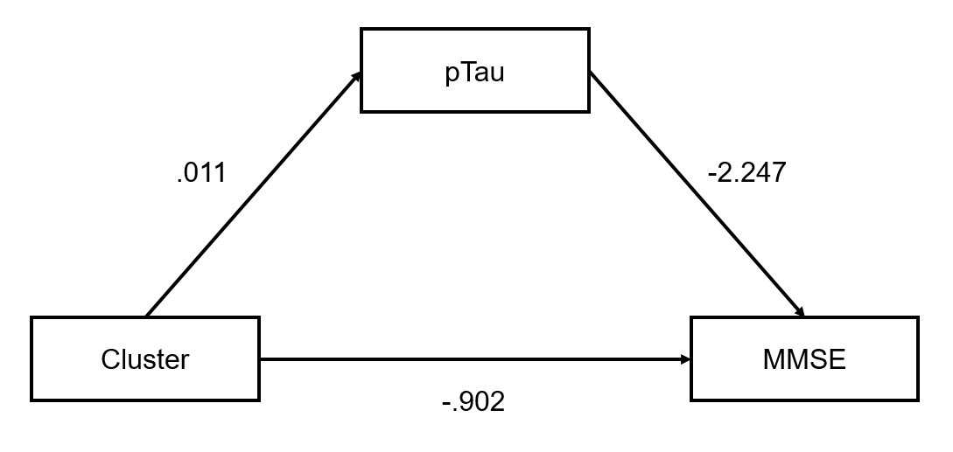
 | Bivariate correlation among Cluster, pTau217, MMSE (n=229)
Cluster group | - |  |  |  | - |  |  |  | -
pTau217 | 0.04 |  |  |  | - |  |  |  | -
MMSE | -0.07 |  |  |  | -0.05 |  |  |  | -
 |  | Coeff (ß) | SE |  | T |  | P | LLCI |  |  | ULCI
Unadjusted analysis
Outcome: pTau217
Cluster group |  | 0.022 | 0.028 |  | 0.762 |  | 0.446 | -0.039 |  |  | 0.072
Outcome: MMSE
Cluster group |  | -0.730 | 0.710 |  | -1.028 |  | 0.304 | -2.011 |  |  | 0.789
pTau 217 |  | -1.001 | 3.483 |  | -0.287 |  | 0.774 | -11.409 |  |  | 0.499
Indirect effect |  | -0.022 | 0.156 |  | -0.138 |  | 0.890 | -0.532 |  |  | 0.017
Direct effect |  | -0.730 | 0.710 |  | -1.028 |  | 0.304 | -2.011 |  |  | 0.789
Total effect |  | -0.752 | 0.702 |  | -1.071 |  | 0.284 | -2.092 |  |  | 0.671
Adjusted analysis
Outcome: pTau217
Cluster group |  | 0.011 | 0.029 |  | 0.384 |  | 0.701 | -0.049 |  |  | 0.063
Sex |  | 0.037 | 0.047 |  | 0.795 |  | 0.427 | -0.032 |  |  | 0.150
Age |  | 0.006 | 0.002 |  | 2.646 |  | 0.008 | 0.002 |  |  | 0.011
Education |  | 0.006 | 0.003 |  | 2.126 |  | 0.033 | 0.001 |  |  | 0.013
Outcome: MMSE
Cluster group |  | -0.902 | 0.660 |  | -1.368 |  | 0.171 | -2.160 |  |  | 0.487
pTau 217 |  | -2.247 | 4.226 |  | -0.532 |  | 0.595 | -13.896 |  |  | -0.493
Sex |  | -0.006 | 0.724 |  | -0.008 |  | 0.993 | -1.436 |  |  | 1.402
Age |  | 0.077 | 0.052 |  | 1.491 |  | 0.136 | -0.005 |  |  | 0.190
Education |  | 0.447 | 0.062 |  | 7.167 |  | <0.001 | 0.329 |  |  | 0.573
Indirect effect |  | -0.025 | 0.199 |  | -0.127 |  | 0.899 | -0.637 |  |  | 0.060
Direct effect |  | -0.902 | 0.660 |  | -1.367 |  | 0.171 | -2.160 |  |  | 0.487
Total effect |  | -0.927 | 0.663 |  | -1.399 |  | 0.162 | -2.249 |  |  | 0.356
Supplementary Table 4. Mediation analysis among cluster group1s, plasma pTau, and the CDR-SB score (n=229)
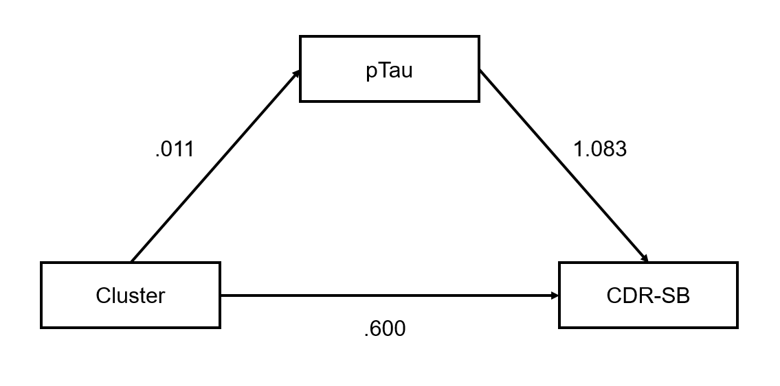
 | Bivariate correlation among Cluster, pTau, CDR-SB (n=229)
Cluster group | - |  |  |  | - |  |  |  | -
pTau217 | 0.04 |  |  |  | - |  |  |  | -
CDR-SB | 0.13 |  |  |  | 0.12 |  |  |  | -
 |  | Coeff (ß) | SE |  | T |  | P | LLCI |  |  | ULCI
Unadjusted analysis
Outcome: pTau217
Cluster group |  | 0.022 | 0.027 |  | 0.786 |  | 0.432 | -0.035 |  |  | 0.071
Outcome: CDR-SB
Cluster group |  | 0.572 | 0.310 |  | 1.847 |  | 0.065 | -0.088 |  |  | 1.159
pTau 217 |  | 0.981 | 2.314 |  | 0.424 |  | 0.671 | 0.008 |  |  | 7.252
Indirect effect |  | 0.021 | 0.121 |  | 0.174 |  | 0.862 | -0.010 |  |  | 0.398
Direct effect |  | 0.572 | 0.310 |  | 1.846 |  | 0.065 | -0.088 |  |  | 1.159
Total effect |  | 0.593 | 0.294 |  | 2.015 |  | 0.044 | 0.034 |  |  | 1.193
Adjusted analysis
Outcome: pTau217
Cluster group |  | 0.011 | 0.028 |  | 0.397 |  | 0.691 | -0.052 |  |  | 0.062
Sex |  | 0.037 | 0.048 |  | 0.769 |  | 0.442 | -0.029 |  |  | 0.157
Age |  | 0.006 | 0.002 |  | 2.730 |  | 0.006 | 0.002 |  |  | 0.011
Education |  | 0.006 | 0.003 |  | 2.082 |  | 0.037 | 0.001 |  |  | 0.013
Outcome: CDR-SB
Cluster group |  | 0.600 | 0.339 |  | 1.773 |  | 0.076 | -0.105 |  |  | 1.251
pTau 217 |  | 1.083 | 2.516 |  | 0.430 |  | 0.667 | 0.081 |  |  | 7.873
Sex |  | 0.062 | 0.354 |  | 0.176 |  | 0.861 | -0.594 |  |  | 0.787
Age |  | -0.012 | 0.025 |  | -0.497 |  | 0.619 | -0.066 |  |  | 0.035
Education |  | -0.030 | 0.032 |  | -0.947 |  | 0.344 | -0.096 |  |  | 0.031
Indirect effect |  | 0.012 | 0.117 |  | 0.104 |  | 0.917 | -0.021 |  |  | 0.376
Direct effect |  | 0.600 | 0.339 |  | 1.772 |  | 0.076 | -0.105 |  |  | 1.251
Total effect |  | 0.612 | 0.328 |  | 1.870 |  | 0.061 | 0.011 |  |  | 1.326
Supplementary Table 5. Mediation analysis among cluster group, plasma ab42, and the MMSE score (n=288)
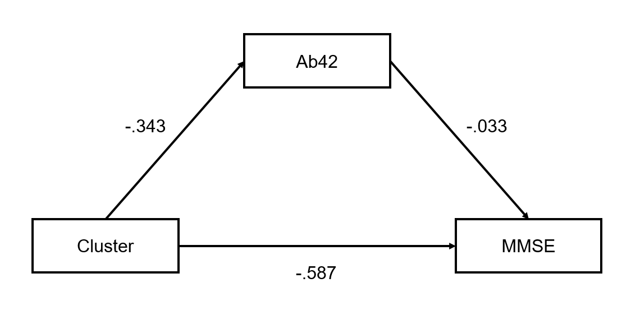
 | Bivariate correlation among Cluster, ab42, MMSE (n=288)
Cluster group | - |  |  |  | - |  |  |  | -
Ab42 | -0.03 |  |  |  | - |  |  |  | -
MMSE | -0.06 |  |  |  | -0.03 |  |  |  | -
 |  | Coeff (ß) | SE |  | T |  | P | LLCI |  |  | ULCI
Unadjusted analysis
Outcome: ab42
Cluster group |  | -0.267 | 0.457 |  | -0.584 |  | 0.560 | -1.139 |  |  | 0.628
Outcome: MMSE
Cluster group |  | -0.581 | 0.611 |  | -0.952 |  | 0.341 | -1.880 |  |  | 0.526
Ab42 |  | -0.039 | 0.079 |  | -0.498 |  | 0.619 | -0.203 |  |  | 0.110
Indirect effect |  | 0.011 | 0.047 |  | 0.225 |  | 0.822 | -0.056 |  |  | 0.128
Direct effect |  | -0.581 | 0.611 |  | -0.951 |  | 0.342 | -1.880 |  |  | 0.526
Total effect |  | -0.571 | 0.607 |  | -0.940 |  | 0.347 | -1.868 |  |  | 0.544
Adjusted analysis
Outcome: ab42
Cluster group |  | -0.343 | 0.478 |  | -0.718 |  | 0.473 | -1.282 |  |  | 0.632
Sex |  | -0.260 | 0.492 |  | -0.530 |  | 0.596 | -1.245 |  |  | 0.690
Age |  | 0.033 | 0.033 |  | 0.981 |  | 0.327 | -0.032 |  |  | 0.098
Education |  | -0.005 | 0.049 |  | -0.098 |  | 0.922 | -0.106 |  |  | 0.090
Outcome: MMSE
Cluster group |  | -0.587 | 0.556 |  | -1.057 |  | 0.291 | -1.667 |  |  | 0.516
Ab42 |  | -0.033 | 0.071 |  | -0.462 |  | 0.644 | -0.174 |  |  | 0.105
Sex |  | -0.010 | 0.619 |  | -0.015 |  | 0.998 | -1.241 |  |  | 1.257
Age |  | 0.051 | 0.044 |  | 1.152 |  | 0.249 | -0.041 |  |  | 0.138
Education |  | 0.418 | 0.055 |  | 7.613 |  | <0.001 | 0.313 |  |  | 0.526
Indirect effect |  | 0.011 | 0.047 |  | 0.240 |  | 0.811 | -0.057 |  |  | 0.139
Direct effect |  | -0.587 | 0.556 |  | -1.056 |  | 0.291 | -1.667 |  |  | 0.516
Total effect |  | -0.576 | 0.556 |  | -1.037 |  | 0.300 | -1.635 |  |  | 0.520
Supplementary Table 6. Mediation analysis among cluster group, plasma ab42, and the CDR-SB score (n=288)
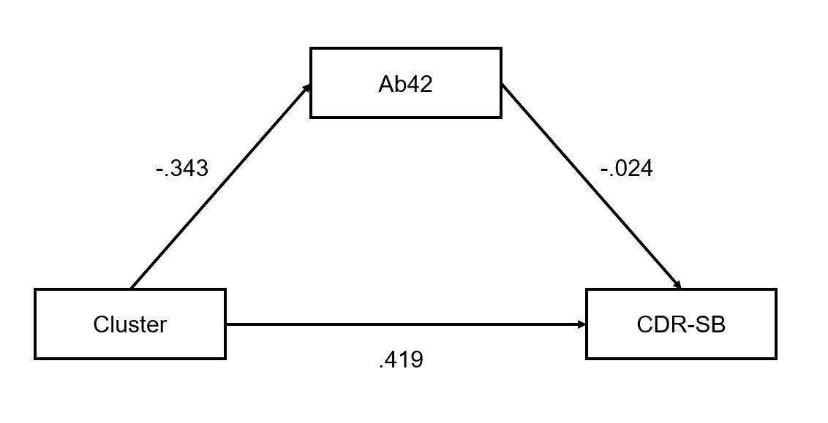
 | Bivariate correlation among Cluster, ab42, CDR-SB (n=288)
Cluster group | - |  |  |  | - |  |  |  | -
Ab42 | -0.03 |  |  |  | - |  |  |  | -
CDR-SB | 0.09 |  |  |  | -0.05 |  |  |  | -
 |  | Coeff (ß) | SE |  | T |  | P | LLCI |  |  | ULCI
Unadjusted analysis
Outcome: ab42
Cluster group |  | -0.267 | 0.464 |  | -0.574 |  | 0.566 | -1.202 |  |  | 0.636
Outcome: CDR-SB
Cluster group |  | 0.406 | 0.257 |  | 1.583 |  | 0.113 | -0.066 |  |  | 0.907
Ab42 |  | -0.025 | 0.033 |  | -0.742 |  | 0.458 | -0.086 |  |  | 0.046
Indirect effect |  | 0.007 | 0.020 |  | 0.323 |  | 0.747 | -0.039 |  |  | 0.047
Direct effect |  | 0.406 | 0.257 |  | 1.582 |  | 0.114 | -0.066 |  |  | 0.907
Total effect |  | 0.413 | 0.257 |  | 1.604 |  | 0.109 | -0.060 |  |  | 0.909
Adjusted analysis
Outcome: ab42
Cluster group |  | -0.343 | 0.478 |  | -0.717 |  | 0.473 | -1.262 |  |  | 0.584
Sex |  | -0.260 | 0.501 |  | -0.520 |  | 0.603 | -1.218 |  |  | 0.799
Age |  | 0.033 | 0.036 |  | 0.911 |  | 0.363 | -0.036 |  |  | 0.104
Education |  | -0.005 | 0.048 |  | -0.100 |  | 0.920 | -0.098 |  |  | 0.087
Outcome: CDR-SB
Cluster group |  | 0.419 | 0.273 |  | 1.533 |  | 0.125 | -0.124 |  |  | 0.974
Ab42 |  | -0.024 | 0.032 |  | -0.744 |  | 0.457 | -0.086 |  |  | 0.041
Sex |  | 0.090 | 0.288 |  | 0.313 |  | 0.754 | -0.434 |  |  | 0.698
Age |  | -0.006 | 0.020 |  | -0.295 |  | 0.768 | -0.046 |  |  | 0.032
Education |  | -0.011 | 0.027 |  | -0.428 |  | 0.668 | -0.061 |  |  | 0.041
Indirect effect |  | 0.008 | 0.022 |  | 0.383 |  | 0.702 | -0.034 |  |  | 0.055
Direct effect |  | 0.419 | 0.273 |  | 1.532 |  | 0.126 | -0.124 |  |  | 0.974
Total effect |  | 0.427 | 0.274 |  | 1.559 |  | 0.119 | -0.120 |  |  | 0.983
Supplementary Table 7. Mediation analysis among cluster group, plasma ab40, and the MMSE (n=265)
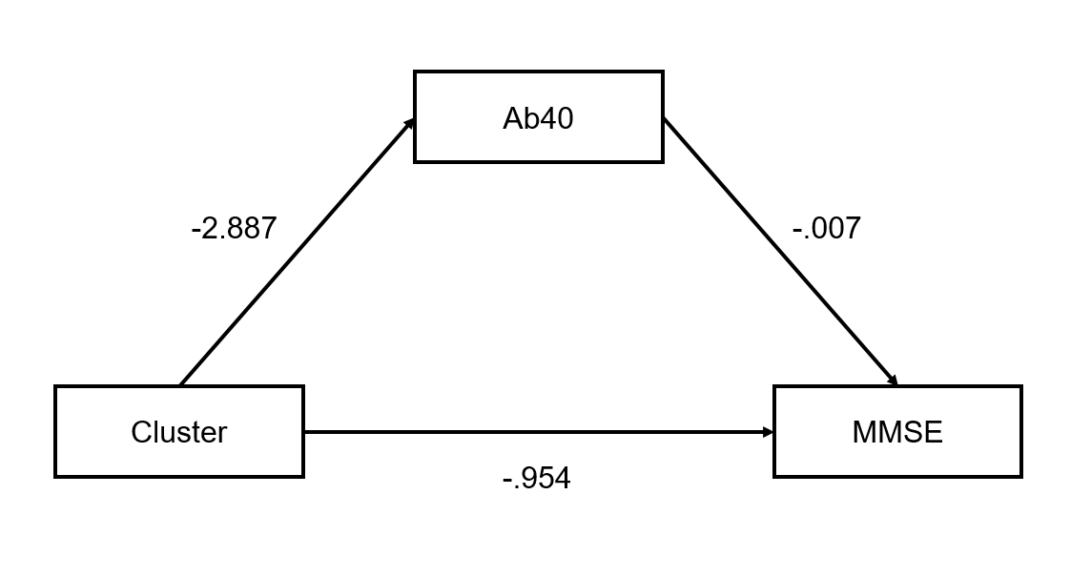
 | Bivariate correlation among Cluster, ab40, MMSE (n=265)
Cluster group | - |  |  |  | - |  |  |  | -
Ab40 | -0.02 |  |  |  | - |  |  |  | -
MMSE | -0.09 |  |  |  | 0.01 |  |  |  | -
 |  | Coeff (ß) | SE |  | T |  | P | LLCI |  |  | ULCI
Unadjusted analysis
Outcome: ab40
Cluster group |  | -1.108 | 3.249 |  | -0.341 |  | 0.733 | -7.409 |  |  | 5.261
Outcome: MMSE
Cluster group |  | -0.934 | 0.632 |  | -1.479 |  | 0.139 | -2.228 |  |  | 0.268
Ab40 |  | 0.002 | 0.010 |  | 0.167 |  | 0.867 | -0.021 |  |  | 0.018
Indirect effect |  | -0.002 | 0.034 |  | -0.053 |  | 0.958 | -0.099 |  |  | 0.041
Direct effect |  | -0.934 | 0.632 |  | -1.478 |  | 0.139 | -2.228 |  |  | 0.268
Total effect |  | -0.936 | 0.631 |  | -1.484 |  | 0.138 | -2.254 |  |  | 0.277
Adjusted analysis
Outcome: ab40
Cluster group |  | -2.887 | 3.416 |  | -0.845 |  | 0.398 | -10.334 |  |  | 3.328
Sex |  | 3.924 | 4.143 |  | 0.947 |  | 0.344 | -3.966 |  |  | 12.800
Age |  | 0.758 | 0.252 |  | 3.013 |  | 0.003 | 0.310 |  |  | 1.266
Education |  | -0.536 | 0.417 |  | -1.287 |  | 0.198 | -1.398 |  |  | 0.263
Outcome: MMSE
Cluster group |  | -0.954 | 0.617 |  | -1.546 |  | 0.122 | -2.332 |  |  | 0.252
Ab40 |  | 0.007 | 0.009 |  | 0.818 |  | 0.413 | -0.011 |  |  | 0.024
Sex |  | -0.052 | 0.669 |  | -0.075 |  | 0.940 | -1.514 |  |  | 1.300
Age |  | 0.048 | 0.046 |  | 1.046 |  | 0.296 | -0.046 |  |  | 0.135
Education |  | 0.417 | 0.060 |  | 6.934 |  | <0.001 | 0.298 |  |  | 0.542
Indirect effect |  | -0.021 | 0.048 |  | -0.441 |  | 0.659 | -0.155 |  |  | 0.044
Direct effect |  | -0.954 | 0.617 |  | -1.545 |  | 0.122 | -2.332 |  |  | 0.252
Total effect |  | -0.975 | 0.622 |  | -1.568 |  | 0.117 | -2.350 |  |  | 0.252
Supplementary Table 8. Mediation analysis among cluster group1s, plasma ab40, and the CDR-SB score (n=265)
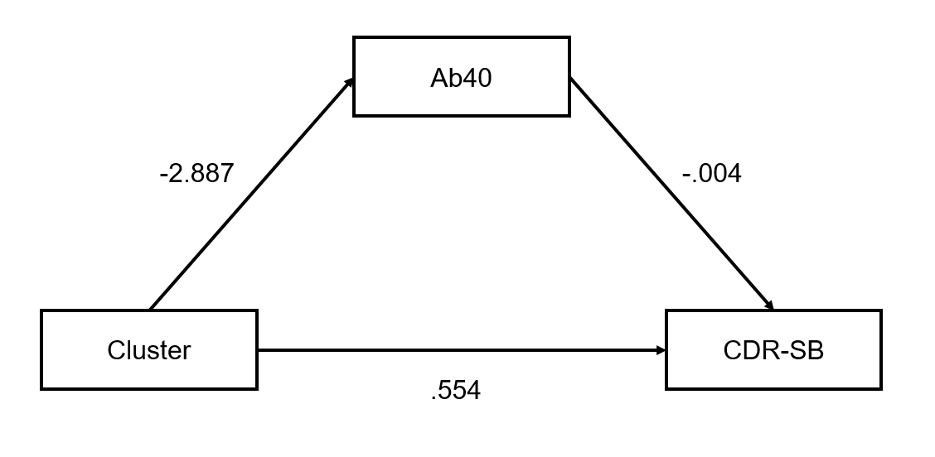
 | Bivariate correlation among Cluster, ab40, CDR-SB (n=265)
Cluster group | - |  |  |  | - |  |  |  | -
Ab40 | -0.02 |  |  |  | - |  |  |  | -
CDR-SB | 0.13* |  |  |  | -0.07 |  |  |  | -
 |  | Coeff (ß) | SE |  | T |  | P | LLCI |  |  | ULCI
Unadjusted analysis
Outcome: ab40
Cluster group |  | -1.108 | 3.158 |  | -0.351 |  | 0.726 | -7.521 |  |  | 4.922
Outcome: CDR-SB
Cluster group |  | 0.538 | 0.277 |  | 1.941 |  | 0.052 | 0.015 |  |  | 1.072
Ab40 |  | -0.004 | 0.004 |  | -1.086 |  | 0.277 | -0.012 |  |  | 0.004
Indirect effect |  | 0.005 | 0.019 |  | 0.260 |  | 0.795 | -0.023 |  |  | 0.054
Direct effect |  | 0.538 | 0.277 |  | 1.940 |  | 0.052 | 0.015 |  |  | 1.072
Total effect |  | 0.543 | 0.277 |  | 1.958 |  | 0.050 | 0.029 |  |  | 1.080
Adjusted analysis
Outcome: ab40
Cluster group |  | -2.887 | 3.392 |  | -0.851 |  | 0.395 | -9.874 |  |  | 3.324
Sex |  | 3.924 | 4.401 |  | 0.892 |  | 0.373 | -3.664 |  |  | 13.338
Age |  | 0.758 | 0.251 |  | 3.026 |  | 0.002 | 0.294 |  |  | 1.275
Education |  | -0.536 | 0.405 |  | -1.324 |  | 0.186 | -1.383 |  |  | 0.239
Outcome: CDR-SB
Cluster group |  | 0.554 | 0.312 |  | 1.776 |  | 0.076 | -0.013 |  |  | 1.231
Ab40 |  | -0.004 | 0.004 |  | -1.054 |  | 0.292 | -0.012 |  |  | 0.005
Sex |  | 0.097 | 0.328 |  | 0.295 |  | 0.768 | -0.531 |  |  | 0.719
Age |  | -0.005 | 0.021 |  | -0.225 |  | 0.822 | -0.042 |  |  | 0.038
Education |  | -0.007 | 0.030 |  | -0.231 |  | 0.818 | -0.068 |  |  | 0.052
Indirect effect |  | 0.013 | 0.023 |  | 0.548 |  | 0.583 | -0.020 |  |  | 0.072
Direct effect |  | 0.554 | 0.312 |  | 1.775 |  | 0.076 | -0.013 |  |  | 1.231
Total effect |  | 0.567 | 0.314 |  | 1.805 |  | 0.071 | 0.002 |  |  | 1.235

Supplementary Table 9. Linear regression analysis for the association of brain age_residual and Bacteroidotaetes^{ǂ}
Independent variables | β | B | SE | 95% CI |  | p value
uncultured | 0.09 | 246.20 | 172.70 | -93.80 | 586.20 | 0.155
Tannerellaceae | 0.09 | 3.47 | 3.28 | -2.99 | 9.93 | 0.291
Rikenellaceae | -0.09 | -5.42 | 4.74 | -14.75 | 3.90 | 0.253
Prevotellaceae | 0.00 | 0.03 | 1.81 | -3.54 | 3.59 | 0.989
Porphyromonadaceae | -0.05 | -225.71 | 310.26 | -836.55 | 385.13 | 0.468
Paludibacteraceae | 0.11 | 20058.15 | 10738.64 | -1083.96 | 41200.26 | 0.063
Muribaculaceae | -0.06 | -14.33 | 18.74 | -51.23 | 22.56 | 0.445
Marinifilaceae | 0.07 | 30.00 | 35.55 | -39.99 | 99.99 | 0.399
Dysgonomonadaceae | -0.02 | -49.05 | 154.36 | -352.95 | 254.84 | 0.751
Barnesiellaceae | -0.10 | -65.52 | 42.73 | -149.64 | 18.60 | 0.126
Bacteroidales_RF16_group | 0.09 | 423.13 | 348.83 | -263.64 | 1109.89 | 0.226
Bacteroidaceae | 0.17 | 2.07 | 0.96 | 0.18 | 3.97 | 0.032
Brain age_residual was calculated (brain age= intercept+β1[age centered] + β2[age centered squared] + β3[sex] + brain age_residual) in the current sample.
ǂ Multiple linear regression model was developed after adjustment for age centered, age centered squared, sex, education, study site, and APOE e4.
Abbreviations: SE, standard error; CI, confidence interval; APOE, apolipoprotein E

Supplementary References
1. Triana-Baltzer G, Moughadam S, Slemmon R, an Kolen K, Theunis C, Mercken M, et al. Development and validation of a high-sensitivity assay for measuring p217+tau in plasma. Alzheimers Dement. 2021;13:e12204.
2. Bellaver B, Puig-Pijoan A, Ferrari-Souza JP, Leffa DT, Lussier FZ, Ferreira PCL, et al. Blood-brain barrier integrity impacts the use of plasma amyloid-β as a proxy of brain amyloid-β pathology. Alzheimers Dement. 2023;19:3815-25.
3. Baykara E, Gesierich B, Adam R, Tuladhar AM, Biesbroek JM, Koek HL, et al. A novel imaging marker for small vessel disease based on skeletonization of white matter tracts and diffusion histograms. Ann Neurol. 2016;80:581-92.
4. Tzourio-Mazoyer N, Landeau B, Papathanassiou D, Crivello F, Etard O, Delcroix N, et al. Automated anatomical labeling of activations in SPM using a macroscopic anatomical parcellation of the MNI MRI single-subject brain. Neuroimage. 2002;15:273-89.

