Supplementary Materials

Appendix S1
Pittsburgh Sleep Quality Index (PSQI)
Sleep quality were evaluated with the 19-item PSQI, by means of questionnaire, which belong to 7 components: subjective sleep quality, sleep latency, sleep duration, habitual sleep efficiency, sleep disturbances, use of sleeping medication, and daytime dysfunction. The overall PSQI score ranged from 0 to 21 points, with higher scores indicating worse sleep quality. The scores > 5 indicating a poor sleep quality. The defined contents of the questionnaire shown as follows¹:
1. During the past month, what time have you usually gone to bed at night?
2. During the past month, how long (in minutes) has it usually taken you to fall asleep each night?
3. During the past month, what time have you usually gotten up in the morning?
4. During the past month, how many hours of actual sleep did you have at night? (Different from the number of hours you spent in bed)
5. During the past month, how often have you had trouble sleeping because you…
a) Difficulty falling asleep (Cannot get to sleep within 30 minutes)
A. Not during the past month B. Less than once a week C. Once or twice a week D. Three or more times a week
b) Wake up in the middle of night or early morning
A. Not during the past month B. Less than once a week C. Once or twice a week D. Three or more times a week
c) Have to get up to the bathroom
A. Not during the past month B. Less than once a week C. Once or twice a week D. Three or more times a week
d) Cannot breathe comfortably
A. Not during the past month B. Less than once a week C. Once or twice a week D. Three or more times a week
e) Cough or snore loudly
A. Not during the past month B. Less than once a week C. Once or twice a week D. Three or more times a week
f) Feel too cold
A. Not during the past month B. Less than once a week C. Once or twice a week D. Three or more times a week
g) Feel too hot
A. Not during the past month B. Less than once a week C. Once or twice a week D. Three or more times a week
h) Have nightmare
A. Not during the past month B. Less than once a week C. Once or twice a week D. Three or more times a week
i) Have pain
A. Not during the past month B. Less than once a week C. Once or twice a week D. Three or more times a week
j) Others
A. Not during the past month B. Less than once a week C. Once or twice a week D. Three or more times a week
6. During the past month, how would you rate your seep quality overall?
A. Very good B. Fairly good C. Fairly bad D. Very bad
7. During the past month, how often have you taken medicine to help you sleep?
A. Not during the past month B. Less than once a week C. Once or twice a week D. Three or more times a week
8. During the past month, how often have you had trouble staying awake?
A. Not during the past month B. Less than once a week C. Once or twice a week D. Three or more times a week
9. During the past month, how much of a problem has it been for you to keep up enough enthusiasm to get things done?
A. No problem at all B. Only a very slight problem C. Somewhat of a problem D. A very big problem
10. During the past month, how often have you had… (please ask your roommate)
a) Loud snoring
A. Not during the past month B. Less than once a week C. Once or twice a week D. Three or more times a week
b) Long pauses between breaths while asleep
A. Not during the past month B. Less than once a week C. Once or twice a week D. Three or more times a week
c) Legs twitching or jerking while you sleep
A. Not during the past month B. Less than once a week C. Once or twice a week D. Three or more times a week
d) Episodes of disorientation or confusion during sleep
A. Not during the past month B. Less than once a week C. Once or twice a week D. Three or more times a week
e) Others
A. Not during the past month B. Less than once a week C. Once or twice a week D. Three or more times a week

■ REFERENCES
(1) Buysse, D. J.; Reynolds, C. R.; Monk, T. H.; Berman, S. R.; Kupfer, D. J. The Pittsburgh Sleep Quality Index: a new instrument for psychiatric practice and research. PSYCHIAT RES. 1989, 28, 193-213.

Table S1
No. | Gender | Age(yrs) | BMI(kg/m2) | PSQI | Disease severity | Time from diagnosis to sampling(ds) | Reinfection | Smoke | Drink | RT-PCR test | Antigen test | Vaccine
1 | female | 41 | 22.86 | 7 | Mild | 315 | No | No | No | Positive | Positive | 4
2 | Female | 36 | 28.23 | 10 | Mild | 345 | No | No | No | / | Positive | 4
3 | Male | 36 | 26.12 | 10 | Mild | 294 | No | Yes | No | Positive | Positive | 4
4 | Female | 41 | 24.03 | 6 | Mild | 359 | Once | No | No | Positive | / | 3
5 | Male | 25 | 26.83 | 10 | Moderate | 335 | No | No | No | Positive | Positive | 4
6 | Female | 28 | 17.50 | 11 | Mild | 412 | No | No | No | Positive | Positive | 4
7 | Male | 30 | 21.45 | 9 | Mild | 409 | No | Yes | No | Positive | Positive | 4
8 | Female | 33 | 21.23 | 15 | Mild | 169 | No | No | No | Positive | Positive | 4
Table 1 Detailed clinical characteristics of participants

Table S2
No. | Sample before COVID-19 | Sampling time | Diagnosis time | Reinfection | Sample after COVID-19 | Sampling time
1 | YD00108 | 2022/9/23 | 2022/12/12 | / | S0187713650 | 2023/10/23
2 | YD00125 | 2022/9/7 | 2022/12/27 | / | S0187713641 | 2023/12/7
3 | YD00191 | 2022/10/19 | 2022/12/29 | / | S0187714329 | 2023/10/19
4 | YD00343 | 2022/8/7 | 2022/12/13 | 2023/7/24 | S0187714492 | 2023/12/7
5 | S0187691548 | 2022/11/11 | 2022/12/18 | / | S0187692399 | 2023/11/18
6 | S0187702522 | 2022/6/29 | 2022/11/12 | / | S0187706085 | 2023/12/29
7 | S0187709745 | 2022/3/29 | 2022/11/15 | / | S0187706064 | 2023/12/29
8 | S0187692633 | 2022/6/1 | 2022/12/20 | / | SLYL0712 | 2023/6/7
Table 2 Detailed sampling and diagnosis time

Table S3
Term | Go_Term_name | pvalue

GO:0047270 | lipopolysaccharide glucosyltransferase II activity | 0.02086
GO:0004084 | branched-chain-amino-acid transaminase activity | 0.02742
GO:0009081 | branched-chain amino acid metabolic process | 0.02742
GO:0019670 | anaerobic glutamate catabolic process | 0.02742
GO:0047307 | diaminobutyrate-pyruvate transaminase activity | 0.03569
GO:0006221 | pyrimidine nucleotide biosynthetic process | 0.03569
GO:0019491 | ectoine biosynthetic process | 0.03569
GO:0016793 | triphosphoric monoester hydrolase activity | 0.03569
GO:0045303 | diaminobutyrate-2-oxoglutarate transaminase activity | 0.03569
GO:0016152 | mercury (II) reductase activity | 0.03569
GO:0000179 | rRNA (adenine-N6,N6-)-dimethyltransferase activity | 0.03569
GO:0004512 | inositol-3-phosphate synthase activity | 0.046
GO:0047200 | tetrahydrodipicolinate N-acetyltransferase activity | 0.046
GO:0004615 | phosphomannomutase activity | 0.046
GO:0019553 | glutamate catabolic process via L-citramalate | 0.046
GO:0004742 | dihydrolipoyllysine-residue acetyltransferase activity | 0.046
GO:0050097 | methylaspartate mutase activity | 0.046
GO:0006021 | inositol biosynthetic process | 0.046

Table 3 GO Term names

Figure S1
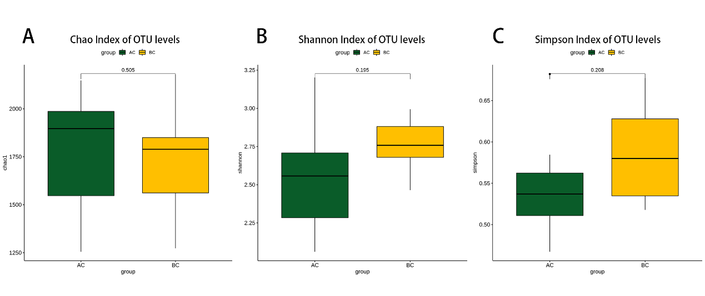
Figure S1 Differences in the diversity and richness of gut microbiota. The Chao (A), Shannon (B), and Simpson (C) index.

Figure S2
Figure S2 (A) Boxplot of the second level relative abundance of two groups applied GO; (B) PCA based on the abundance of functional genes of two groups.

