Appendix
Methods
Viruses and cells
Vero E6 cells with overexpressed TMPRSS2 (Vero E6-T2) were provided by M. Takeda ¹ and were used for isolation and propagation of SARS-CoV-2 viruses². Cells were maintained in DMEM (Gibco) supplemented with 10% fetal bovine serum (FBS; Gibco), 100 units/mL penicillin and 100 µg/mL streptomycin (Gibco). SARS-CoV-2 viruses including the WT and Omicron lineages (BA.1, BA.2, BA.2.12.1, BA.4, BA.5, BF.8, XBB.1.5, XBB.1.9.1, XBB.1.16, CH.1.1, BQ.1.22, EG.5.1, BA.2.86 and JN.1) were used. The virus stocks were titrated in Vero E6-T2 cells, aliquoted and stored frozen at -80°C. All live virus experiments were performed in a biosafety level 3 facility at Li Ka Shing Faculty of Medicine, The University of Hong Kong.

Ex vivo cultures and infection of human respiratory tract
Human non-tumour bronchus (19 donors) and lung tissues (19 donors) were obtained from patients aged 45-81 years undergoing elective surgery in the Department of Surgery at Queen Mary Hospital from June 2022 to Jan 2024 and were removed as part of the clinical care but surplus for routine diagnostic requirements, as described previously ³. The information of tissue donors is listed in the Extended Data Table 2. Bronchus and lung tissues were fragmented and infected at 5 x 10⁵ pfu/mL at 37°C for 1 h. The infected tissue explants were washed three times, placed in fresh medium and incubated at 37°C with 5% CO₂. Mock infected tissues were used as controls. Culture supernatants were collected at indicated times to assess infectious viral titres. Tissues were harvested at endpoints and fixed in 10% formalin for immunostaining. Ethics approval of the use of human tissues was granted by the institutional review board of The University of Hong Kong and the Hospital Authority (Hong Kong West) (IRB approval no: UW 20-862 and UW20-863).

Human airway organoid culture and infection
Human airway organoids were established from human lung tissues as previously described ⁴, and were differentiated into 2-dimensional model as described elsewhere ⁵ with slight modifications. In brief, airway organoids were dissociated into single cells by digestion using TrypLE Express Enzyme (Gibco) at 37°C for 10 min, then sheared with 25-gauge needles and filtered through 40 μm cell strainers. 1.5 x 10⁵ cells were seeded onto 0.4 μm pore size Transwell inserts (Corning) pre-coated with rat tail collagen I (Corning). The cells were cultured in a mixture of airway organoid growth medium and PneumaCult-ALI complete base medium (Stemcell Technologies) at a ratio of 1:1 at 37°C for 3-4 days. After reaching confluency, the 2-dimensional transwell cultures were cultured at air-liquid interface (ALI) in PneumaCult-ALI Maintenance Medium (Stemcell Technologies) and used for infection after 2 weeks of differentiation. Cells at the apical side were infected with viruses at a multiplicity of infection (MOI) of 0.1 at 37°C for 1 h, washed with PBS and cultured at ALI in the same growth medium. At 1, 24 and 48 hpi, culture supernatants from the apical side of transwells were collected for viral titres determination. The transwell cultures were harvested at endpoint in RLT Buffer or fixed in 10% formalin.

Human intestinal enteroid culture and infection
Human intestinal enteroids were established from normal regions of human duodenal tissues as previously described ⁶⁻⁸ with modifications. Intestinal enteroids were derived through isolation of intestinal crypts, grown in 3-dimensional cultures in Matrigel (Corning) and were maintained in an in-house Complete medium with growth factors (CMGF+) supplemented with 10 µM Rho-associated protein kinase inhibitor Y-27632 (Stemcell Technologies) ⁸. Intestinal enteroids were differentiated by incubating in Advanced DMEM/F12 medium (Gibco) supplemented with IntestiCult Organoid Growth Medium (OGM) Human Component A (Stemcell Technologies) and GlutaMAX-I (Gibco) for 3 to 4 days and were dissociated using Gentle Cell Dissociation Reagent (Stemcell Technologies) immediately before infections. Intestinal enteroids were infected with viruses at 10⁶ pfu/mL at 37°C for 1 h, washed with Advanced DMEM/F12 and cultured in Matrigel with the differentiation medium. Culture supernatants were collected at 1, 24, 48 and 72 hpi. Infected intestinal enteroids were lysed in RLT Buffer or fixed in 10% formalin at endpoints.

Caco-2 cell culture and infection
Human colorectal adenocarcinoma Caco-2 cells (ATCC) were cultured on vessel surface coated with rat tail collagen I (Corning), and maintained in Minimum Essential Medium (MEM, Gibco) supplemented with 10% fetal bovine serum (FBS; Gibco), 100 units/mL penicillin and 100 µg/mL streptomycin (Gibco). Cells were split and sub-cultured when reaching 80-90% confluency. 1x10⁵ cells were seeded and cultured for 2 days before virus infections. Infection was performed at MOI 0.1 and culture supernatants were collected at 1, 24 and 48 hpi for viral titres detection. Cells were lysed in RLT Buffer for mRNA expression analysis.

Viral titration
96-well tissue culture plates of confluent Vero E6-T2 cells were prepared one day before the virus titration by 50% tissue culture infectious dose (TCID₅₀) assay. Cells were seeded with 2% FBS/DMEM. Culture supernatants were serially diluted from 0.5-log to 7-log and added onto the cell plates in quadruplicate. The cell plates were observed for CPE after 3 days. The endpoints of viral dilution leading to CPE in 50% of the inoculated wells were used to calculate viral titres using the Spearman-Kärber method. Area-under-curve (AUC) was calculated by integrating the infectious virus titres at 24-72 hpi.

RNA extraction and qPCR
Total RNA was extracted from cell lysates using MiniBEST Universal RNA Extraction Kit (TaKaRa Bio). RNA was reverse transcribed with PrimeScript RT Reagent Kit (TaKaRa Bio). mRNA expressions of viral and cytokine genes were quantified using SYBR Premix Ex Taq II (TaKaRa Bio) and measured with ViiA7 Real-Time PCR System (Applied Biosystems). The gene expression levels were quantified with the respective standards and normalized with β-actin, as previously described².

Drug treatment
To assess the replication in the presence of TMPRSS2 inhibitor and cathepsins inhibitor, camostat mesylate (Sigma-Aldrich) or E64d (Sigma-Aldrich) at 60 µM was added to the Vero E6-T2 cells and human airway organoids 1 h before, during and after infection. Vehicle was used as a negative control. Vero E6-T2 cells and human airway organoids were then infected at a MOI of 0.1. Viral titres in culture supernatants (24-48 hpi) were determined using TCID₅₀ assay.

Immunohistochemistry staining
Infected ex vivo and organoids were fixed with 10% formalin for at least 3 days before being embedded in paraffin blocks and sectioned into 4 µm thickness onto glass slides. For immunohistochemistry, the tissue sections were microwaved in 10 mM citrate buffer for 15 min for antigen retrieval. Endogenous peroxidase activity was stopped by quenching the tissue sections with 3% H₂O₂ for 20 min. The slides were blocked with 10% normal horse serum at room temperature and then incubated with primary antibodies: anti-SARS-CoV-2 nucleoprotein (NP) (40143-T62, Sino Biological) for 90 min at room temperature followed by horseradish peroxidase-conjugated secondary antibodies (Vector Laboratory). The section stainings were developed using NovaRED Substrate Kit (Vector Laboratory) and counterstained for cell nuclei with Mayer’s Hematoxylin. The sections were imaged using the ECLIPSE Ti-S microscope (Nikon Instruments).

Immunofluorescence staining of human intestinal enteroids
Human intestinal enteroids were fixed with 10% formalin for at least 3 days and the fixed organoids were embedded in paraffin blocks. To characterize the SARS-CoV-2-infected cells, double-antibody immunofluorescence staining of SARS-CoV-2 NP antibody with different intestinal markers was performed. The fixed organoids embedded in paraffin block were sectioned and microwaved in 10 mM citrate buffer pH 6.0 for 5 min to expose antigens, blocked with 10% normal goat serum for 10 min at room temperature (RT). The sections were then incubated with SARS-CoV-2 NP antibody along with one of the following antibodies: Villin (Abcam), Mucin-2 (Abcam), Lysozyme C (Dako), or Chromogranin A (Abcam) for 60 min at RT followed by donkey anti-mouse Alexa Fluor 594 and donkey anti-rabbit Alexa Fluor 488 for 60 min at RT in dark. The cell nuclei were counterstained with DAPI (blue). The sections were mounted with fluorescent mounting medium (Dako) and images were taken using Nikon Eclipse Ti-S microscope.

Statistical analysis
Experiments with human ex vivo tissues were performed using at least six different donors, and organoid cultures in three different donors each in duplicate or triplicate. Results were presented as the mean values ± standard deviation (SD). Statistical analyses were performed using two-way ANOVA followed by a Bonferroni multiple-comparison test using GraphPad Prism version 10 (GraphPad Software), with the differences considered to be significant at p values of less than 0.05.
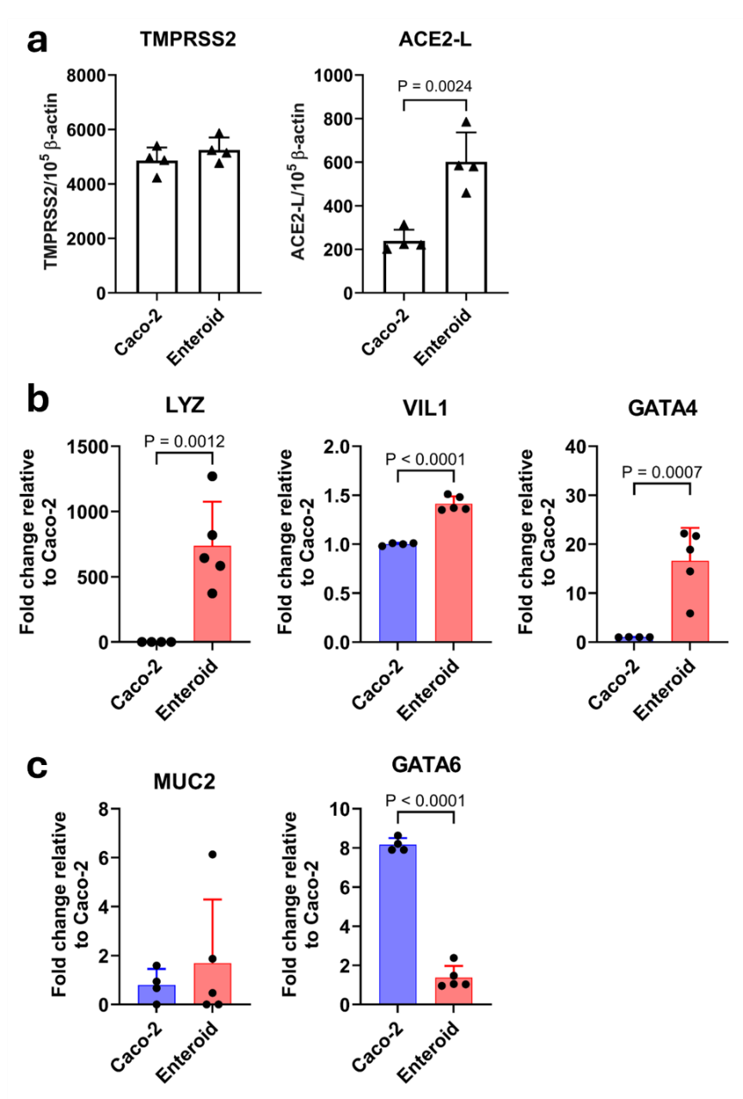
Extended data Figure 1. Expression of TMPRSS2, ACE2-L, cellular markers of colon and intestinal epithelium in Caco-2 and intestinal enteroids. mRNA expression of (a) TMPRSS2, ACE2-L, (b) small intestine cell markers lyzozme (LYZ), villin 1 (VIL1), GATA binding protein 4 (GATA4) and (c) colon cell markers mucin-2 (MUC2) and GATA binding protein 6 (GATA6) in uninfected Caco-2 (n=4) and intestinal enteroids (n=5) were measured by quantitative PCR. Data are the mean ± SD. Statistical analysis was performed using one-way ANOVA followed by Tukey’s post-test.

Extended Data Table 1. Information of virus isolates
Virus | Strain name | Accession ID
WT | hCoV-19/Hong Kong/VM20001061/2020 | EPI_ISL_408975
BA.1 | hCoV-19/Hong Kong/VOC0195-P2/2021 | EPI_ISL_9162578
BA.2 | hCoV-19/Hong Kong/VOC-588-P3-S18-iseq/2022 | EPI_ISL_11222954
BA.4 | hCoV-19/USA/MD-HP30386_HKUP3/2022 | OP099836.1
BA.5 | SARS-CoV-2/human/USA/COR-22-063113/2022 | ON972631.1
BA.2.12.1 | SARS-CoV-2/human/USA/COR-22-062161/2022 | OP589872.1
BA.5.2.1 | hCoV-19/Hong Kong/HKUSPH_WHP7830P2/2022 | EPI_ISL_19205705
XBB.1.5 | hCoV-19/USA/MD-HP40900/2022 | EPI_ISL_16026423
CH.1.1 | hCoV-19/Hong Kong/HKUSPH_VOC1424FP3/2022 | EPI_ISL_19239240
BQ.1.22 | hCoV-19/Hong Kong/HKUSPH_VOC1464P2/2022 | EPI_ISL_19239241
XBB.1.16 | hCoV-19/Hong Kong/HKUSPH_VOC1933P3/2023 | EPI_ISL_18604375
XBB.1.9.1 | hCoV-19/Hong Kong/HKUSPH_VOC1636P3/2023 | EPI_ISL_18604376
EG.5.1 | hCoV-19/Hong Kong/HKUSPH_VOC2249P3/2023 | EPI_ISL_18604378
BA.2.86 | hCoV-19/Hong Kong/HKUSPH_LRS0548P3/2023 | EPI_ISL_18604485
JN.1 | hCOV-19/Hong Kong/HKUSPH_VOC2401P2/2023 | EPI_ISL_18888405

Extended Data Table 2. Information of tissue donor
Patient | Tissue used | Age | Gender
vIRUSES: WT, BA.1, BA.2, BA.2.12.1, BA.4, BA.5, BA.5.2.1
1 | Bronchus and Lung | 68 | M
2 | Bronchus and Lung | 47 | M
3 | Bronchus and Lung | 70 | M
4 | Bronchus and Lung | 75 | M
5 | Bronchus and Lung | 71 | M
6 | Bronchus and Lung | 78 | M
7 | Bronchus | 59 | F
VIRUSES: ba.5, xbb.1.5, ch.1.1, bq.1.22, xbb.1.16, xbb.1.9.1
8 | Bronchus and Lung | 45 | F
9 | Bronchus and Lung | 71 | M
10 | Bronchus and Lung | 73 | M
11 | Bronchus and Lung | 77 | F
12 | Bronchus and Lung | 61 | M
13 | Bronchus and Lung | 76 | M
14 | Lung | 64 | M
viruses: ba.5, xbb.1.16, xbb.1.9.1, eg.5.1, ba.2.86, jn.1
15 | Bronchus and Lung | 55 | F
16 | Bronchus and Lung | 72 | M
17 | Bronchus and Lung | 81 | M
18 | Bronchus and Lung | 56 | F
19 | Bronchus and Lung | 65 | M
20 | Bronchus and Lung | 68 | M

References
1 Matsuyama, S. et al. Enhanced isolation of SARS-CoV-2 by TMPRSS2-expressing cells. Proceedings of the National Academy of Sciences of the United States of America 117, 7001-7003 (2020). https://doi.org:10.1073/pnas.2002589117
2 Hui, K. P. Y. et al. SARS-CoV-2 Omicron variant replication in human bronchus and lung ex vivo. Nature 603, 715-720 (2022). https://doi.org:10.1038/s41586-022-04479-6
3 Hui, K. P. et al. Tropism and innate host responses of influenza A/H5N6 virus: an analysis of ex vivo and in vitro cultures of the human respiratory tract. The European respiratory journal 49 (2017). https://doi.org:10.1183/13993003.01710-2016
4 Hui, K. P. Y. et al. Tropism, replication competence, and innate immune responses of influenza virus: an analysis of human airway organoids and ex-vivo bronchus cultures. The Lancet. Respiratory medicine 6, 846-854 (2018). https://doi.org:10.1016/s2213-2600(18)30236-4
5 Lamers, M. M. et al. SARS-CoV-2 productively infects human gut enterocytes. Science (New York, N.Y.) 369, 50-54 (2020). https://doi.org:10.1126/science.abc1669
6 Ettayebi, K. et al. Replication of human noroviruses in stem cell-derived human enteroids. Science (New York, N.Y.) 353, 1387-1393 (2016). https://doi.org:10.1126/science.aaf5211
7 Mahe, M. M., Sundaram, N., Watson, C. L., Shroyer, N. F. & Helmrath, M. A. Establishment of human epithelial enteroids and colonoids from whole tissue and biopsy. J Vis Exp (2015). https://doi.org:10.3791/52483
8 Chan, J. C. M., Mohammad, K. N., Zhang, L. Y., Wong, S. H. & Chan, M. C. Targeted Profiling of Immunological Genes during Norovirus Replication in Human Intestinal Enteroids. Viruses 13 (2021). https://doi.org:10.3390/v13020155

