Cisplatin kills ovarium cancer cells through the TRPV1-mediated oxidative stress and apoptosis: TRPV1 inhibitor role of eicopentotaneoic acid

Mevlüt Bucak¹, Mustafa Nazıroğlu^{2,3,4}
¹Division of Perinatology, Department of Obstetrics and Gynecology, Ankara Etlik City Hospital, Ankara, Türkiye
² Neuroscience Research Center, Suleyman Demirel University, Isparta, Türkiye
³ BSN Health, Analyses, Innov., Consult., Org., Agricul., Ltd., Isparta, Türkiye
⁴ Department of Biophysics, School of Medicine, Suleyman Demirel University, Isparta, Türkiye

Corresponding author
Prof. Dr. Mustafa NAZIROĞLU, DVM, PhD
Department of Biophysics, School of Medicine,
Suleyman Demirel University, Isparta, TR-32260, Türkiye
E-mail: mustafanaziroglu@sdu.edu.tr

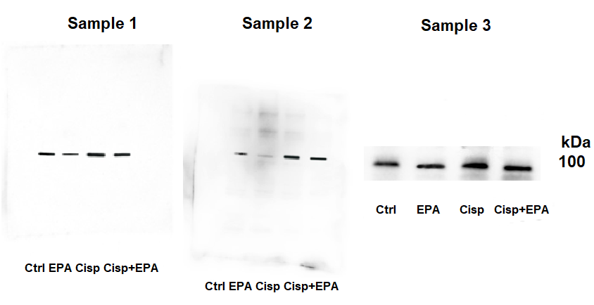

Supplementary Figure 1. The row protein band expression data of TRPV1 in the OVCAR-3 cell line. (n=3). The expression of OVCAR-3 protein levels in the four groups (control (Ctrl), eicopentotaneoic acid (EPA), cisplatin (Cisp), and Cisp + EPA) was assessed using a standard Western blot technique. β-Actin levels were used to control the amount of load.

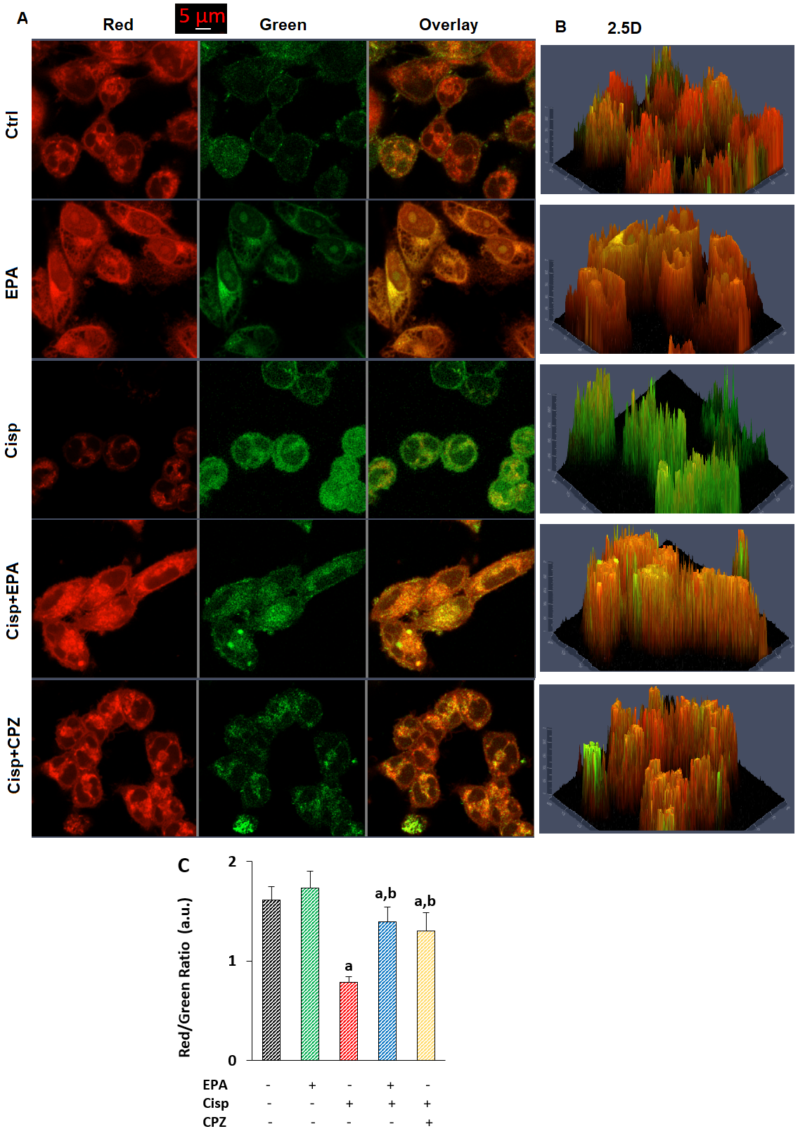
Supplementary Figure 2. The Cisp (25 µM for 24h)-mediated mitochondrial membrane potential (mMP) decrease was enhanced by the EPA and CPZ incubations. The HT29 cells of the groups were stained by incubating them for 15–20 minutes with 2 μM mMP indicating probe (JC-1). LSM-800 confocal microscope was employed to capture the red, green, overlay (A), and 2.5D (B) images. C. The red/green fluorescence intensity ratios as arbitrary unit (a.u.) were measured and plotted. Bars depict the mean ± SD of three independent experiments (25-50 cells each). (ap < 0.05 vs. Ctrl and EPA. bp < 0.05 vs. Cisp).
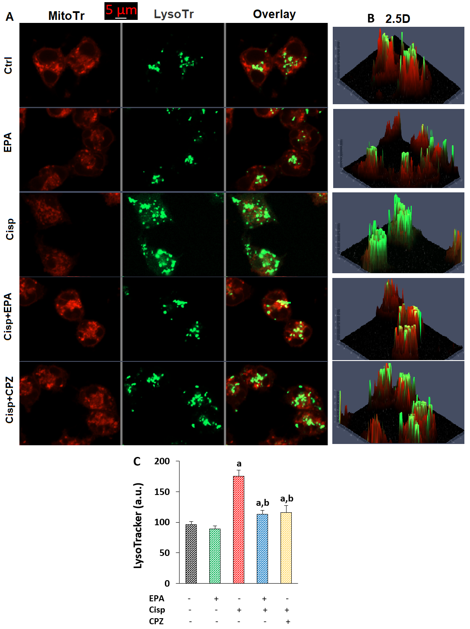
Supplementary Figure 3. The Cisp (25 μM for 24 h)-mediated increase of [lysosomal injury was decreased by the incubations of EPA (100 µM for 24 h) and CPZ (100 μM for 1 h). The Mito Tracker red (MiTr), green (LysoTarcker), overlay (A), and 2.5D (B) images were saved using the LSM-800 confocal microscope connected with a 40x oil objective. A scale bar of 5 μm was maintained. C. The lysosomal injury fluorescence intensity changes as arbitrary unit (a.u.) were measured and plotted. Bars depict the mean ± SD of three independent experiments (25-50 cells each). (ap < 0.05 vs. Ctrl and EPA. bp < 0.05 vs. Cisp).
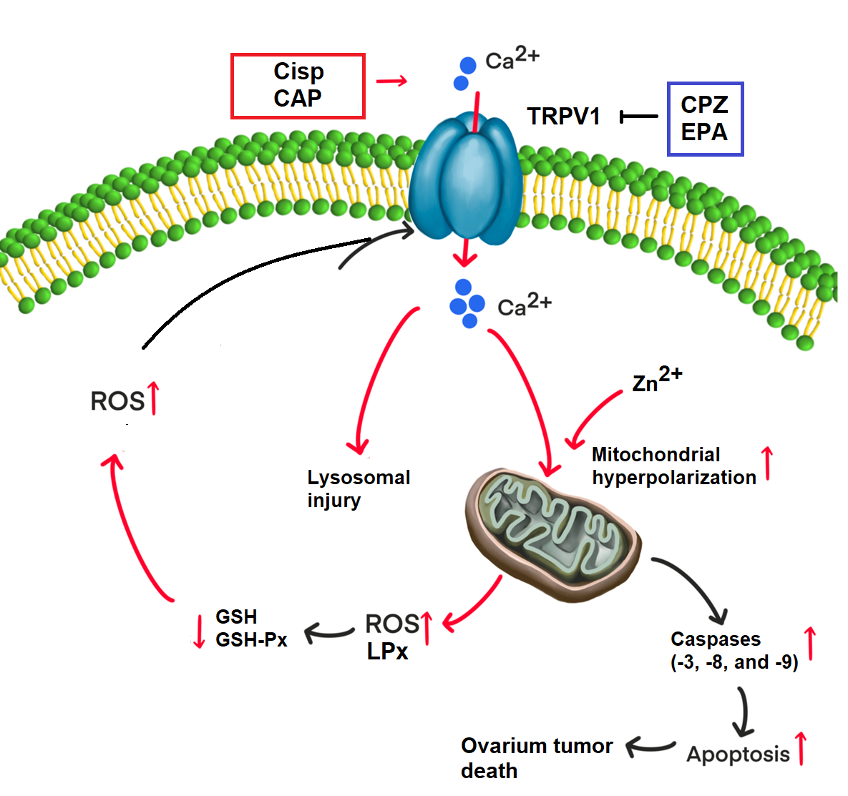Supplementary Figure 4. The possible effect on ovarian tumor death of free reactive oxygen species (ROS) and apoptosis produced by cisplatin (Cisp) via TRPV1 stimulation. Ca²⁺ and Zn²⁺ mediated by TRPV1 activation causes lysosomal damage and accumulates in mitochondria, causing a decrease in mitochondrial potential and an increase in mitochondrial hyperpolarization. The loss of the mitochondrial ability to kill tumor cells then triggers two primary mechanisms: (1) cell death via activation of caspase-3, -8, and -9; and induction of apoptosis. (2) A decrease in glutathione (GSH) and glutathione peroxidase (GSH-Px), but an increase in ROS and lipid peroxidation (LPx). Furthermore, TRPV1 activator, oxidant, and apoptotic effects of Cisp in the cells are enhanced by capsaicin (CAP). The effects of TRPV1 antagonist (capsazepine, CPZ) and the antioxidant eicosapentaenoic acid (EPA) on intracellular free Ca²⁺ concentration in OVCAR-3 cells were attenuated.

