Supplementary Information

Dysbiosis in Maize Leaf Endosphere Microbiome is Associated with Domestication
Ilksen Topcu¹, Julio S Bernal² & Sanjay Antony-Babu¹
¹Department of Plant Pathology and Microbiology, Texas A&M University, College Station, TX
²Department of Entomology, Texas A&M University, College Station, TX

Table S1 Maize genotypes
Maize Genotypes | Origin | Reference*
Perennial teosinte | Jalisco state, Mexico:
Corralitos | Ahuacapán, Autlán (19°36'58"N 104°18'21"W)
Balsas teosinte | Jalisco state, Mexico:
Talpitita | Talpitita, Villa Purificación (19°42’N, 104°48’W)
Los Naranjos | Los Naranjos de Abajo, Ejutla (19°55'27"N 104°04'54"W)
El Cuyotomate | El Cuyotomate, Ejutla (19°58’N, 104°04’W)
El Rodeo | El Rodeo, Tolimán (19°33’N, 104°03’W)
Las Raíces | Las Raíces, Ameca (20°36'21"N 104°13'08"W)
Guachinango | Guachinango, Ameca (20°35'24"N 104°22'51"W)
Mexican Landraces | Veracruz state, México:
Tuxpeño | El Palmar de Susana, Tecolutla (20°20′35.32″N, 96°53′25.42″W) | PI 511649
Mexican inbred lines | México:
CML277 | Ciudad de México, Mexico- Iowa, United States | PI 692142
CML103 | Ciudad de México, Mexico- Iowa, United States | PI 692139
US Landraces | United States:
Gourdseed | Ennis, Texas | PI 414179
Lancaster Sure Crop | Ohio | PI 280061
Reid Yellow Dent | Indiana | PI 213698
US inbred lines | United States:
B73 | Iowa | PI 550473
Hp301 | Indiana | PI 587131
Mo17 | Missouri | PI 558532
W438 | Wisconsin | AMES 29447
*USDA, ARS GRIN reference number
Method S1 Detailed description of DNA extraction using ZymoBIOMICS™ DNA Miniprep Kit (Zymo Research, Irvine, CA, USA) and modified protocol;
Leaf samples were cut into small pieces (~1cm), and placed in to a ZR BashingBeadTM Lysis Tubes to which 750 μl ZymoBIOMICS Lysis Solution was added. The tubes were then fitted to a bead beater (FisherbrandTM Bead Mill 24 Homogenizer, Fisher Scientific, USA) and processed for one minute at 2.40m/s speed. The lysed samples were centrifuged at 10,000 x g for 1 minute, and 400 μl aliquots of the supernatant were transferred to the Zymo-Spin III-F Filter in a collection tube. The lysate was bound to the columns by spinning at 8,000 x g for 1 minute and the flowthrough collected. Following this step, 800 μl of ZymoBIOMICS DNA Binding Buffer and 400 μl of 95% ethanol were added to the filtrate in the collection tube. Subsequently, 800 μl of the mixture from collection tube was transferred to a Zymo-Spin IICR Column in a collection tube and centrifuged at 10,000 x g for 1 minute. Flowthrough from the tube was collected and the process repeated with the addition of 800 μl of buffer and 400 μl of 95% ethanol. Aliquots of 800 μl of the resulting mixture from the tube was transferred to a column in a collection tube and centrifuged at 10,000 x g for 1 minute. To this, 400 μl ZymoBIOMICS DNA Wash Buffer 1 was added in the Zymo-Spin IICR Column in a new Collection Tube and centrifuged at 10,000 x g for 1 minute; removing the flow-through. A further 700 μl ZymoBIOMICS DNA Wash Buffer 2 was added to the Zymo-Spin IICR Column in a collection tube, and centrifuged at 10,000 x g for 1 minute; this time discarding the flow-through. Following this, a 200 μl aliquot of ZymoBIOMICS DNA Wash Buffer 2 was added to the Zymo-Spin IICR Column in a collection tube and centrifuged at 10,000 x g for 1 minute with final discarding of the flow-through. The wash step with the ZymoBIOMICS DNA Wash Buffer 2 was reapeated one more time. Finally, we transferred the Zymo-Spin IICR Column to a clean 1.5 ml PCR tube and add 100 μl Molecular Biology Grade Water, CorningTM directly to the column matrix and incubated the setup for 5 minutes at room temperature. Final DNA extracts were eluted by spinning at 10,000 x g for 1 minute.

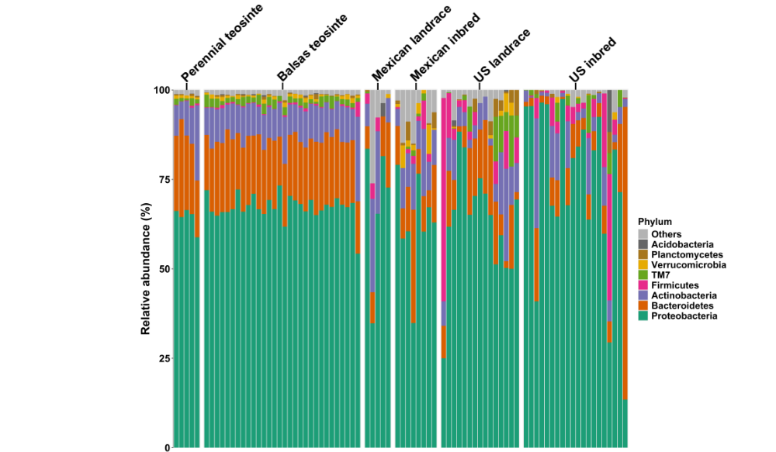

Fig. S1 Stacked bar plot illustrating taxonomic relative abundance (%) of leaf endopshere community composition at the phylum level. Only the most abundant taxa are shown. Each vertical bar represents an individual sample. The samples are categorized based on the maize genotypes indicated at the top. Proteobacteria (67.5%), Bacteroidetes (14.2%), Actinobacteria (9.0%), Firmicutes (3.0%) and TM7 (1.9%) were the most dominant phyla in maize leaf endosphere bacterial communities.

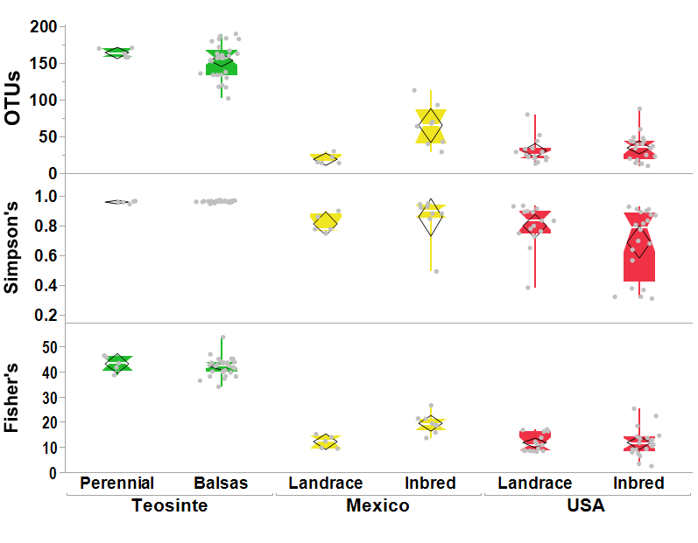Fig. S2 Alpha diversity indices of the bacteria in leaf endopshere among maize genotypes. Box plots showing the number of observed OTUs, Simpson and Fisher diversity indexes, respectively. Comparisons of observed OTUs and Simpson and Fisher diversity indexes of leaf endosphere microbiota across the groups revealed a trend of decreasing diversity from teosinte to Mexican maize (landrace and elite inbred) and US maize (landrace and elite inbred). There was also a consistent decline in diversity from Balsas teosinte to Mexican landrace, suggesting the influence of domestication.

Fig. S3 Principal coordinates analysis (PCoA) of weighted UniFrac (A) and non-parametric multivariate analysis of variance (NMDS) (B) of maize leaf endopshere microbiota. Each point represents a single sample, and colors indicate individual maize genotype. The Weighted Unifrac and NMDS analysis graphs clearly show a distinct divergence between teosinte and maize in variation.

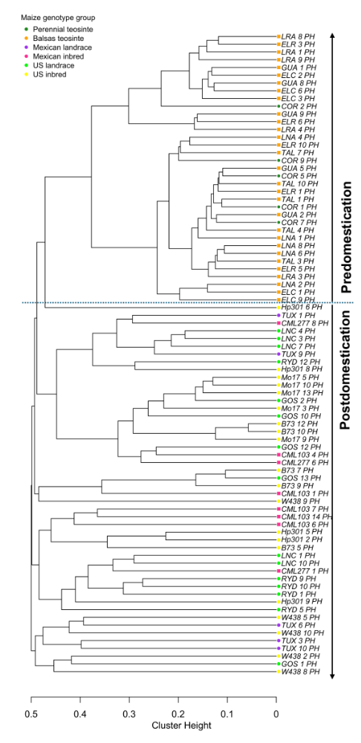

Fig. S4 Cluster-analysis dendrogram of Bray-Curtis distances based on OTU abundances profiles in maize leaf endopshere across all the tested maize genotypes. The dotted line across the dendrogram shows a distinct separation between predomesticated teosinte liness and postdomestication maize samples.

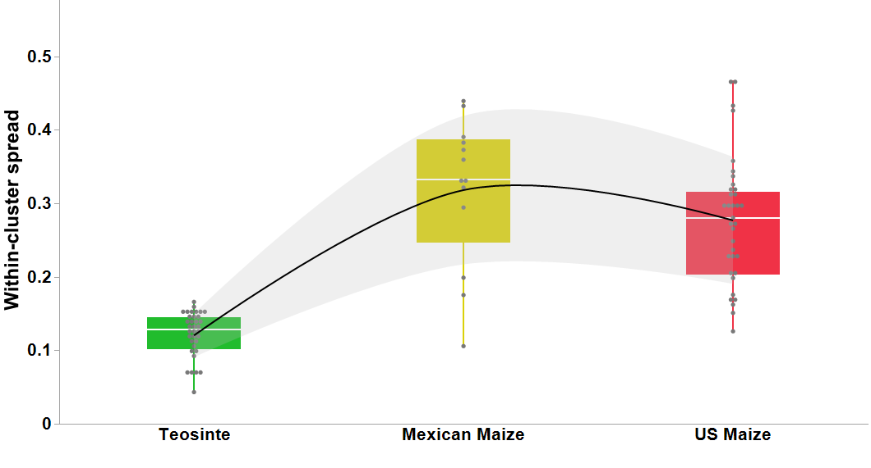
B
A
B
A
A
F_{5,5} = 57.625, P < 0.0001
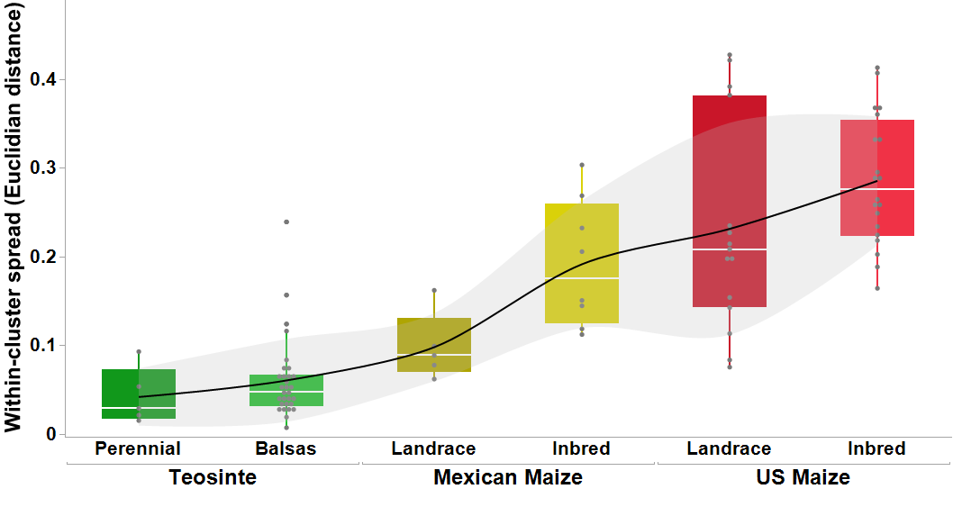
0.0033
0.027
0.292
0.597
0.001
F_{5,5} = 29.516, P < 0.0001

Fig. S5 The within-cluster spread is calculated as the average distance per cluster, measuring the Euclidean distances between each point within the cluster and the centroid of that cluster. Plot A shows that the dispersion within clusters (average distance to centroid) was notably higher in maize, including both Mexican and US varieties, in comparison to teosinte (F5,5 = 57.625, P < 0.0001). Plot B indicated that the dispersion within clusters increased significantly with the northward spread of maize (Mexican vs US landrace, P = 0.001) and with breeding in the USA (US landrace vs US inbred, P = 0.003). However, this spread was not affected by the transition from perennial to annual life history in the teosintes (P = 0.597), domestication (P = 0.292), or breeding in Mexico (P = 0.027).

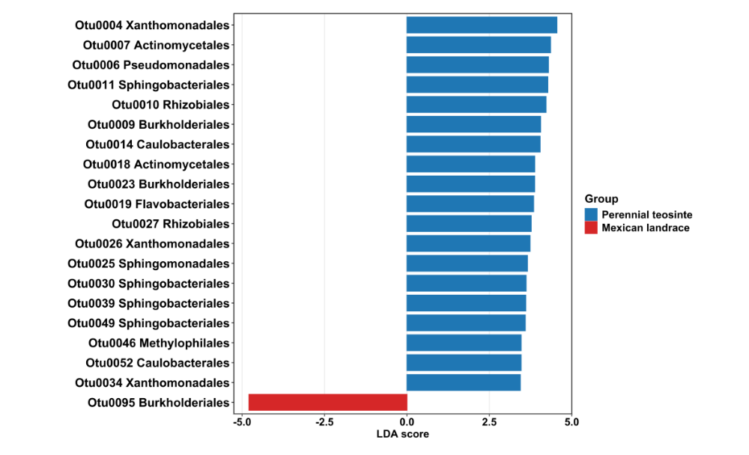
B
A
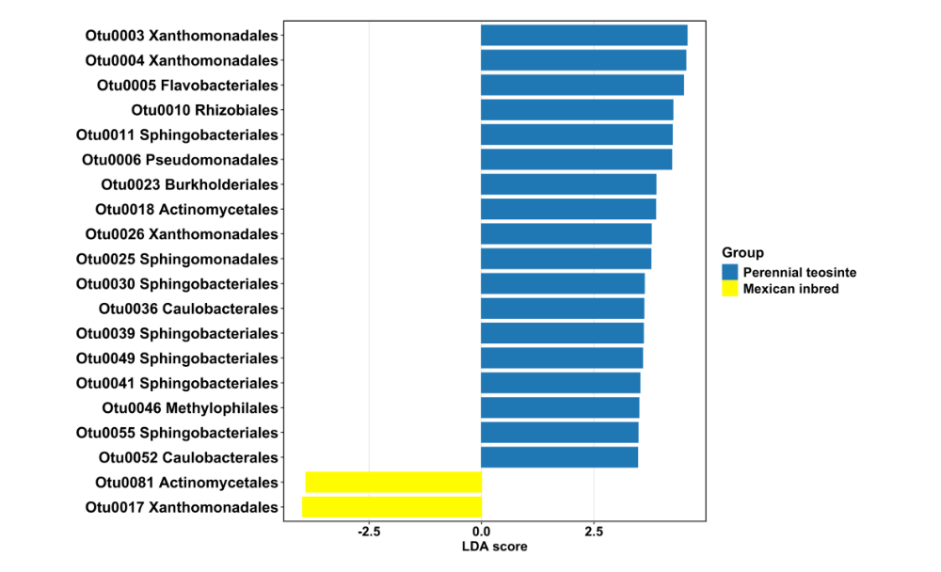

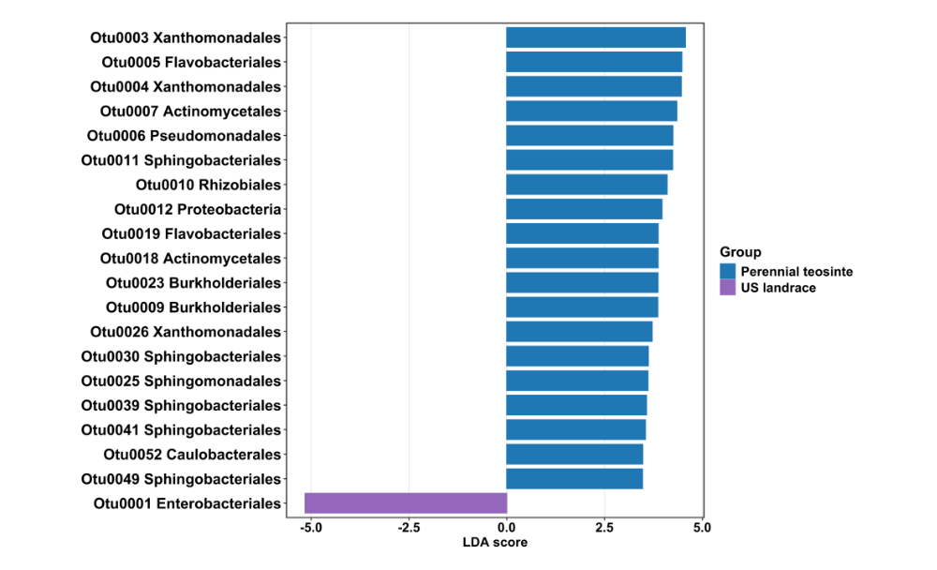
D
C
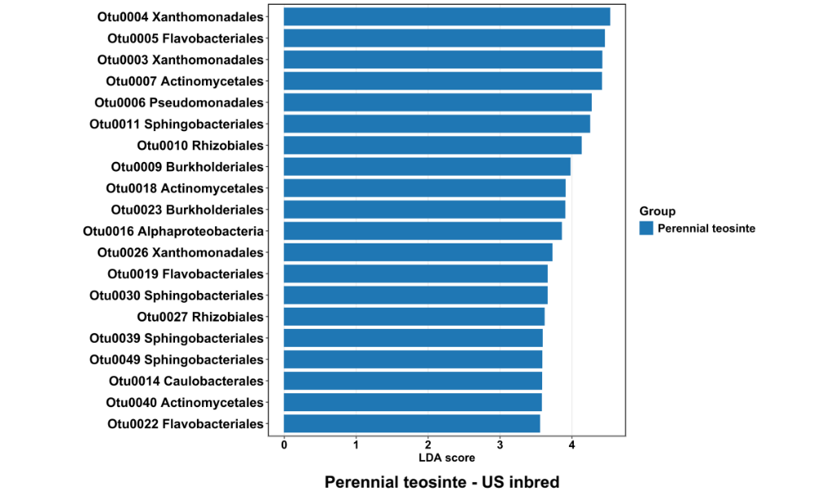
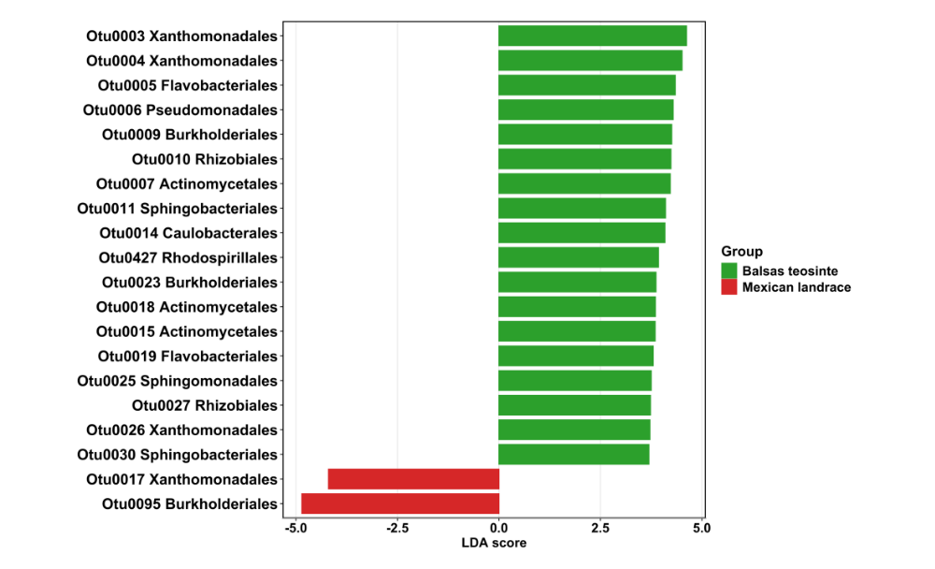
F
E

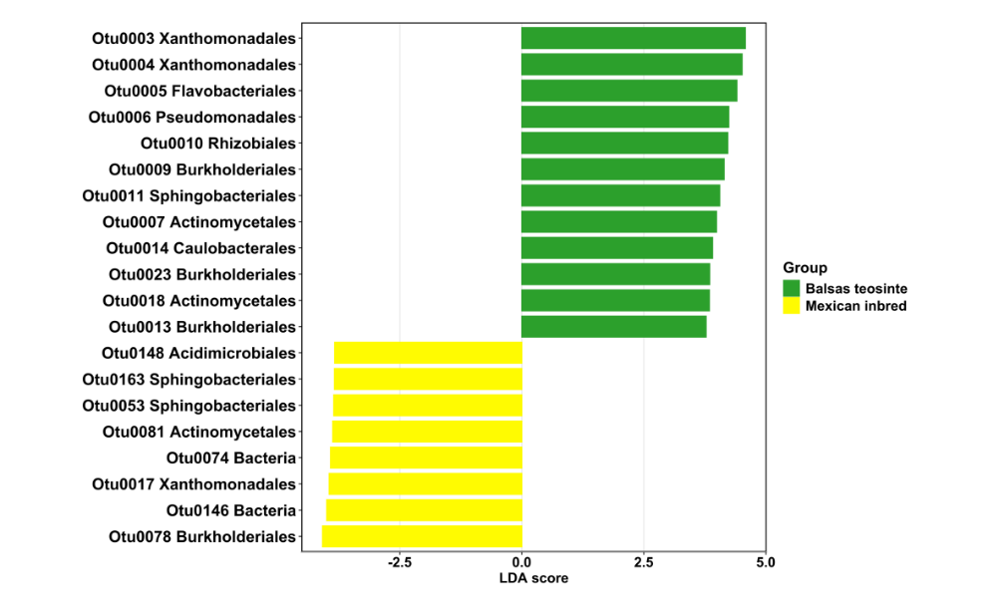
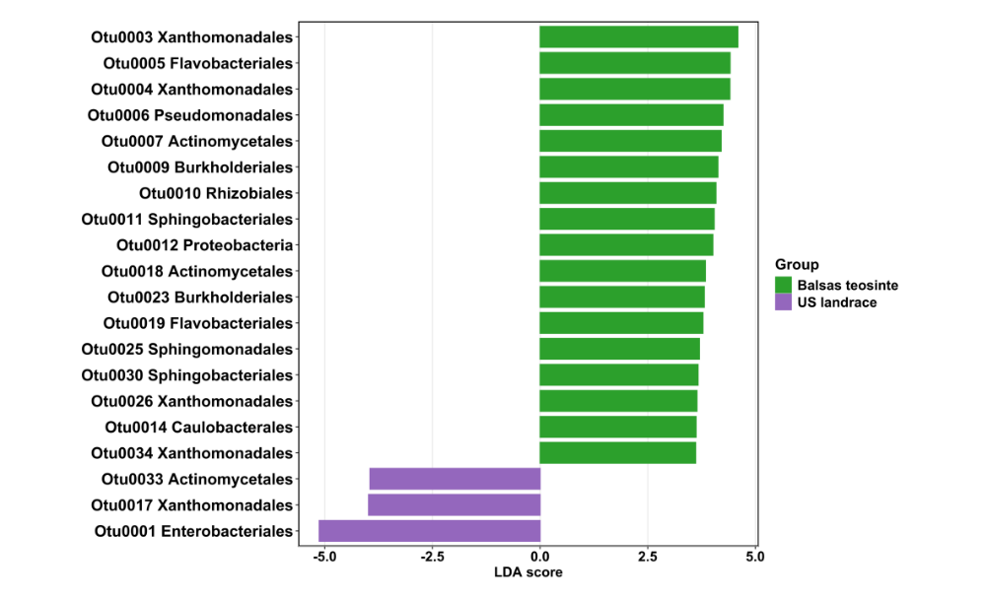
H
G
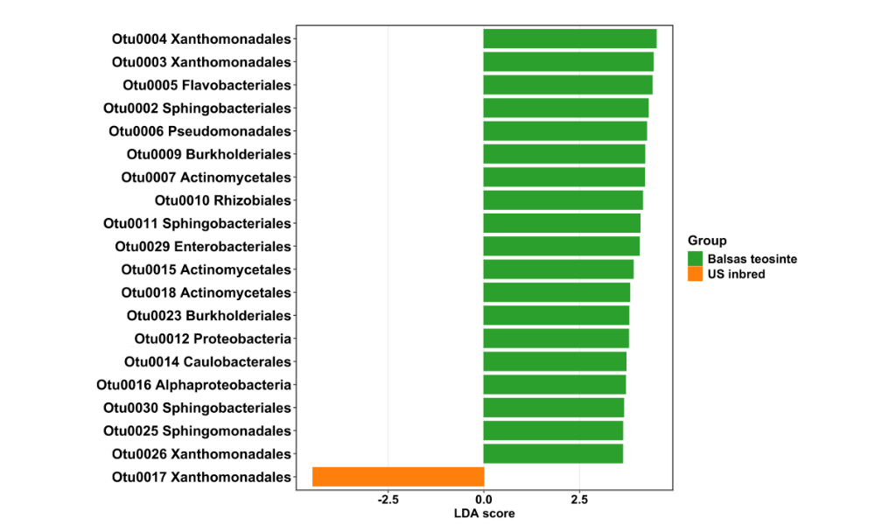
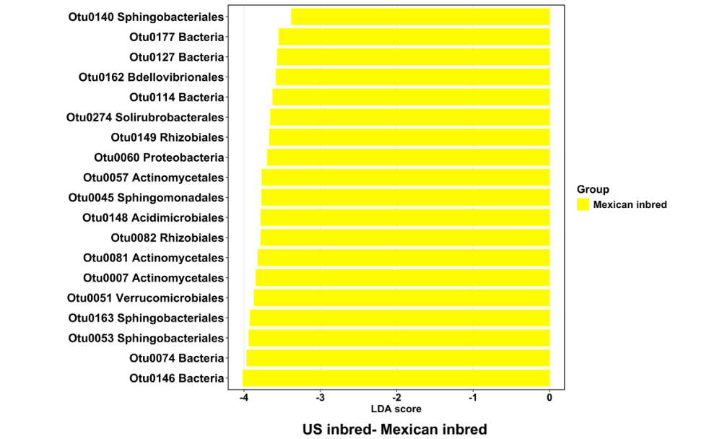
I
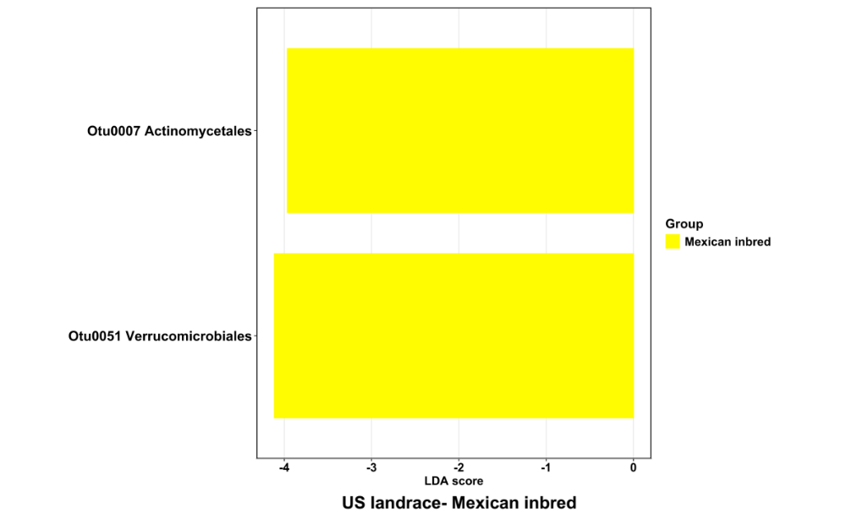
J
Fig S6 Linear discriminant analysis (LDA) effect size (LEfSe) analysis of microbial biomarker taxa in maize leaf endopshere microbiota among maize genotype. Comparisons A) perennial teosinte vs. Mexican landrace B) perennial teosinte vs. Mexican inbred C) perennial teosinte vs. US landrace D) perennial teosinte vs. US inbred E) Balsas teosinte vs. Mexican landrace F) Balsas teosinte vs. Mexican inbred G) Balsas teosinte vs. US landrace H) Balsas teosinte vs. Mexican inbred I) US inbred vs. Mexican inbred J) US landrace vs. Mexican inbred on taxonomic biomarkers are presented. Taxon's LDA score and enriched taxa are represented by horizontal bars, while colors indicate maize genotype. Comparisons based on the Kruskal-Wallis rank-sum test and p-value adjustment (P = 0.05), and the top 20 biomarker taxa with the highest LDA score are shown. The LEfSe analysis for each genotype comparison revealed that most of the differentially abundant taxa were enriched in the teosinte genotypes, including both perennial and Balsas teosinte. No significant taxa were identified in the comparisons between perennial teosinte vs. Balsas teosinte, Mexican landrace vs. Mexican inbred, Mexican landrace vs. US landrace, Mexican landrace vs. US inbred, and US landrace vs. US inbred.

