Dysregulation of Decidual NK Cell Proliferation by Impaired Decidual Cells: A Potential Contributor to Excessive Trophoblast Invasion in Placenta Accreta Spectrum

Authors
You-Zhen Liu^{1†}, Jin-Chung Shih^{2†}, Meng-Shiue Wu³, Thai-Yen Ling^{1*}, Hsin-Hung Lin^{1,3,4,5*}

Institutions
¹Graduate Institute of Pharmacology, National Taiwan University College of Medicine, Taiwan
²Department of Obstetrics and Gynecology, National Taiwan University Hospital, Taipei, Taiwan
³VitaSpring Biomedical Co. Ltd., USA
⁴MediDiamond Inc., Taiwan
⁵LuminX Biotech Co. Ltd., Taiwan

Corresponding Author:
† These authors contributed equally to this work.
* Corresponding author:
Thai-Yen Ling
Associate Professor & Director, Institute of Pharmacology, College of Medicine, National Taiwan University, Taiwan
Tel: 886-2-23123456 ext. 288322; Email: tyling@ntu.edu.tw
Hsin-Hung Lin
Chief Technology Officer, MediDiamond Inc., Taiwan
Tel: 886-2-26558597; Email: HHLin@medidiamondinc.com
Supplementary figures
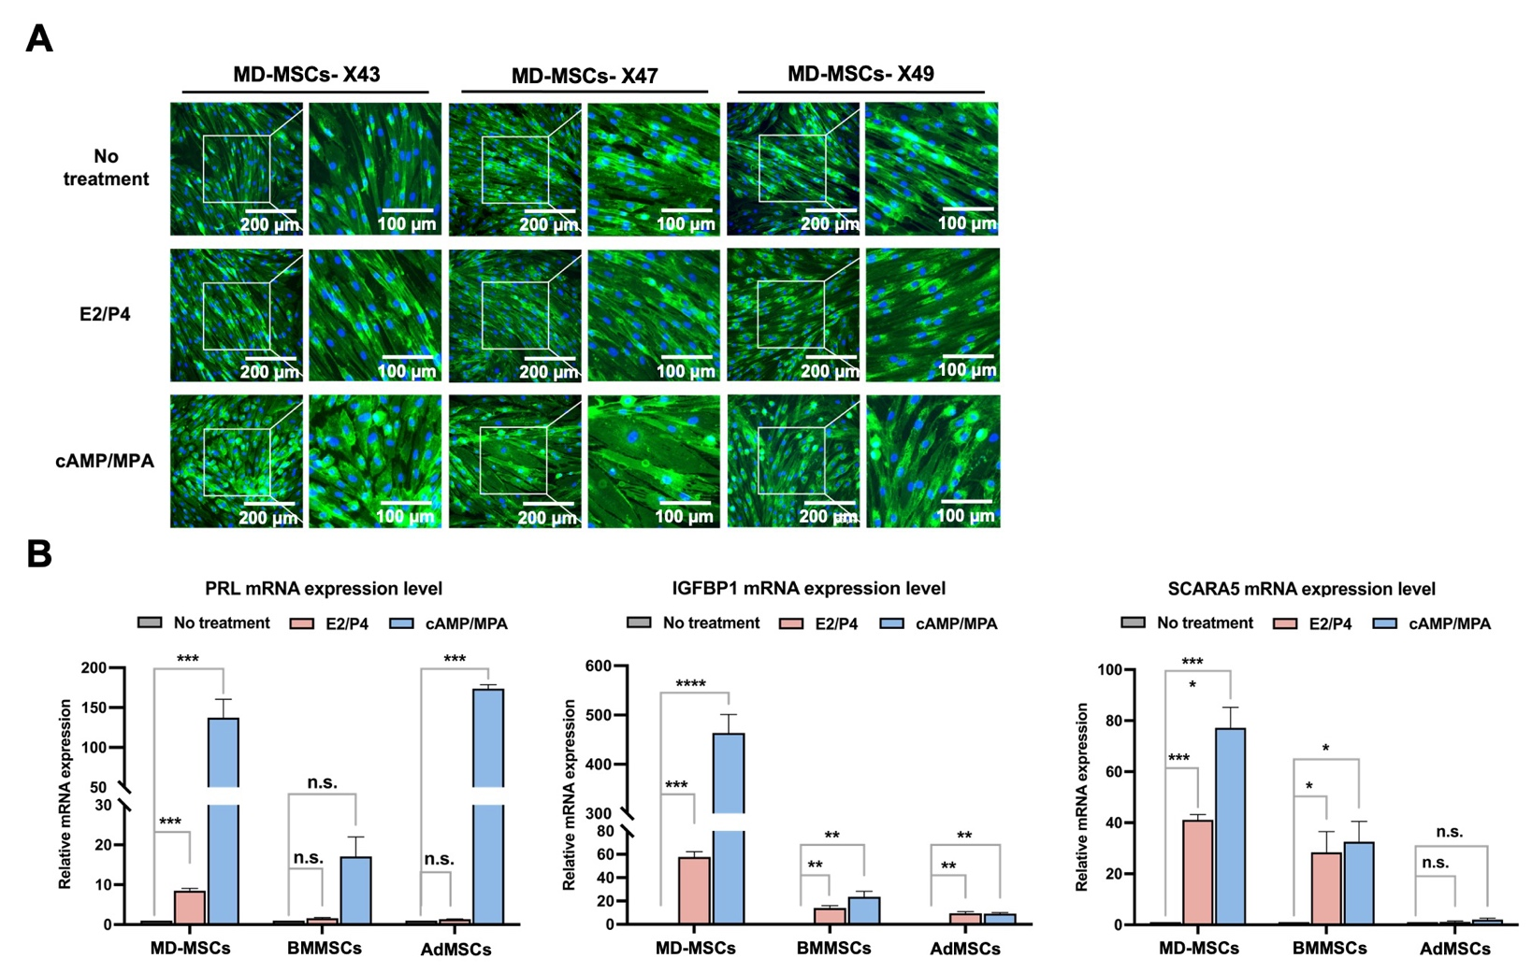
Supplementary Figure 1 ⏐ Characterization of MD-MSCs for decidualization potential.
(A) (a) Representative images and (b) quantified analysis of triplicate biological repeats across three batches of MD-MSCs for evaluating morphological changes under decidualization. (B) Three decidual cell markers, including Prl, Igfbp1, and Scara5, exhibit organ-specific expression through E2/P4 decidualization induction. Values are expressed as mean ± SEM. *p < 0.05, **p < 0.01, ***p < 0.001.
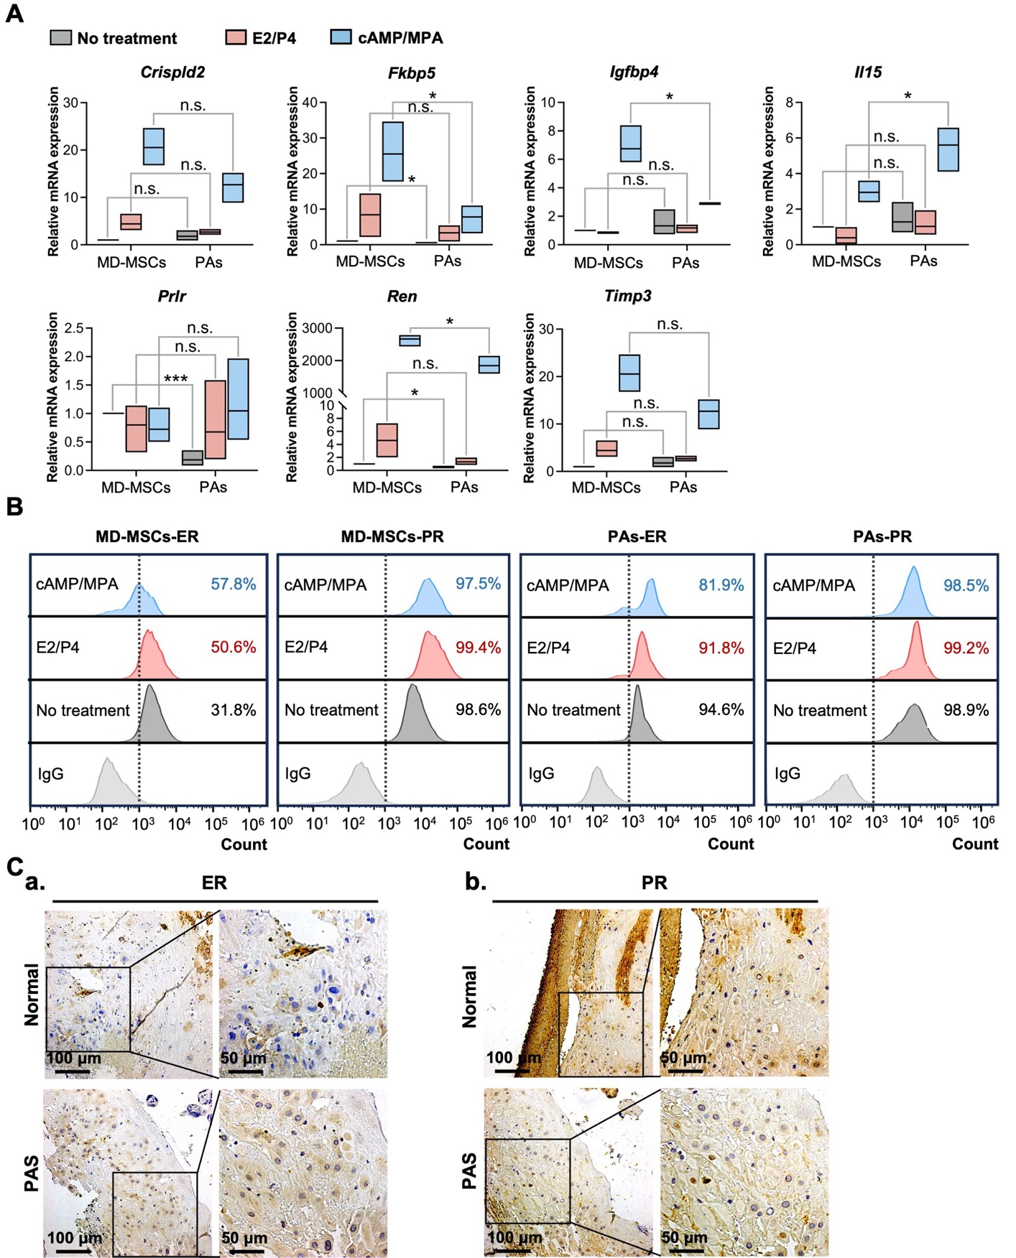
Supplementary Figure 2 ⏐ Characterization of PAs for decidualization defects.
(A) Annotated up-regulated genes are validated with RT-PCR analysis under different decidualization inductions in PAs compared with MD-MSCs. Values are expressed as mean ± SEM. *p < 0.05, **p < 0.01, ***p < 0.001. (B) ER and PR protein expression levels under decidualization treatments in MD-MSCs and PAs. Values are normalized to the IgG control. (C) IHC staining images demonstrate the ER and PR expression levels in normal and pathological placenta biopsies from PAS patients.
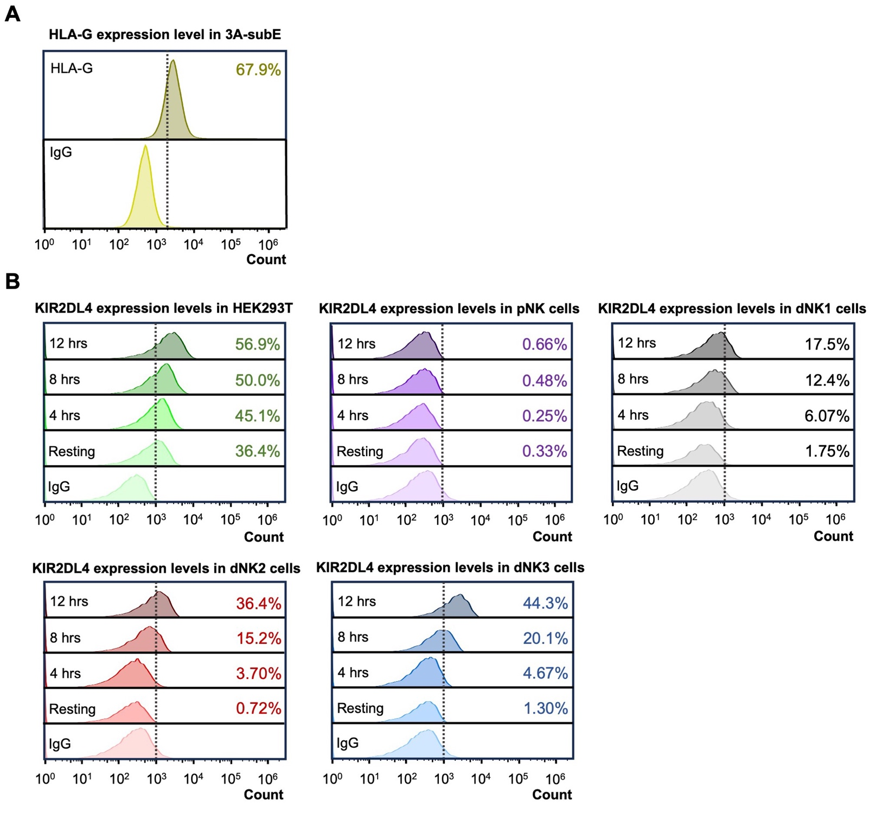
Supplementary Figure 3 ⏐ HLA-G and KIR2DL4 expression levels in trophoblasts and dNK2 cells.
(A) Expression levels of HLA-G on trophoblasts. (B) Measurement of KIR2DL4 expression levels on HEK293T, pNK cells, and dNK cells after co-culturing with trophoblasts at 0 (resting), 4, 8, and 12 hours.
Supplementary tables
Gene | Primer sequences
Human 18srRNA | F | CGC CGC TAG AGG TGA AAT TCT
Human 18srRNA | R | CGA ACC TCC GAC TTT CGT TCT
Human CRIPLD2 | F | ACG GAC GAG ATG AAT GAG GTG G
Human CRIPLD2 | R | GGT GTC ACA TCT GAC GAC TTG G
Human FKBP5 | F | GCG AAG GAG AAG ACC ACG ACA T
Human FKBP5 | R | TAG GCT TCC CTG CCT CTC CAA A
Human IGFBP1 | F | TTTTACCTGCCAAACTGCAACA
Human IGFBP1 | R | CCCATTCCAAGGGTAGACGC
Human IGFBP4 | F | ACC CAC GAG GAC CTC TAC ATC A
Human IGFBP4 | R | CAC ACC AGC ACT TGC CAC GCT
Human IL-15 | F | AAC AGA AGC CAA CTG GGT GAA TG
Human IL-15 | R | CTC CAA GAG AAA GCA CTT CAT TGC
Human PRL | F | GAG GAG CAA ACC AAA CGG CTT C
Human PRL | R | AAG GCG AGA CTC TTC ATC AGC C
Human PRLR | F | CAT GGT GAC CTG CAT CTT TCC G
Human PRLR | R | GTG GGA GGA AAG TCT TGG CAT C
Human REN | F | GAA GAG GCT GAC ACT TGG CAA C
Human REN | R | GCA CCC AAA CAT TGG ACG AAC C
Human SCARA5 | F | GCT GAA CCT GTG TGA GGA TGG T
Human SCARA5 | R | TCA GGA AGA CCA GCA GGT AGA G
Supplementary Table 1. Human primer sequences for RT-PCR

Supplementary Table 2. Antibodies for immunohistochemistry and flow cytometry
Antibodies | Brand | Catalog number | Applications
Recombinant Alexa Fluor® 488 Anti-Estrogen Receptor alpha antibody | abcam | ab194150 | FC/ IHC
Recombinant Alexa Fluor® 647 Anti-Progesterone Receptor antibody | abcam | ab270198 | FC/ IHC
Human SCARA5 Alexa Fluor® 488-conjugated Antibody | R&D | #FAB4900G | FC/ IHC
Human Prolactin Capture Antibody | R&D | Part #842242 | IHC
Human Prolactin Detection Antibody | R&D | Part #842243 | IHC
Human IGFBP1 Capture Antibody | R&D | Part #840402 | IHC
Human IGFBP1 Detection Antibody | R&D | Part #840403 | IHC
FITC anti-human CD3 | Biolegend | 317306 | FC
APC anti-human CD56 | eBioscience | 17-0567-42 | FC
APC anti-human CD158d (KIR2DL4) Antibody | BioLegend | 347008 | FC
Alexa Fluor® 488 anti-human HLA-G Antibody | BioLegend | 335917 | FC
Recombinant Alexa Fluor® 488 Rabbit IgG | abcam | ab199091 | FC
Recombinant Alexa Fluor® 647 Rabbit IgG | abcam | ab199093 | FC
Mouse IgG2B Alexa Fluor® 488-conjugated Isotype Control | R&D | #IC0041G | FC
APC anti-mouse IgG1 Antibody | BioLegend | 406609 | FC
Alexa Fluor® 488 Mouse IgG2a, κ Isotype Ctrl Antibody | BioLegend | 400233 | FC

