Degradation and sorption of the herbicides 2,4-D and quizalofop-P-ethyl and their metabolites in soils from railway tracks
Ignaz J. Buerge,* Pavlina Pavlova, Irene Hanke, Astrid Bächli, and Thomas Poiger
Agroscope, Plant Protection Chemistry, CH-8820 Wädenswil, Switzerland
*Corresponding author e-mail: ignaz.buerge@agroscope.admin.ch; phone: +41 58 460 6383.

Supplementary information

Recoveries, precision, storage stability, and limits of quantification
Recoveries from freshly spiked soils were generally satisfying (87-124%) at all fortification levels (0.01, 0.1, and 1 µg/g), with the exception of the partly low recoveries of 3-OH-CQO (53-95%, Table S2). For 3-OH-CQO, no isotope-labelled internal standard was available. However, since recoveries were consistently low at all spike levels in the respective soils, the analytical procedure for this compound was considered acceptable.
The precision was expressed as relative standard deviation (RSD) of 4 replicate extractions of soil samples spiked with 1 µg/g 2,4-D, QE, or QA, or 0.1 µg/g of the other metabolites. The analytical procedure was well reproducible with RSD values typically ≤5% for all compounds in all soils (exceptions, 6.7% for 2,4-D in soil CS and 8.2% for 3-OH-QA in MBS, Table S2).
The stability of the compounds in frozen soil samples was investigated by comparative analysis of extracts of freshly spiked samples and samples stored in the freezer for 2, 3, or 4 months (spike level, 1 µg/g 2,4-D, QE, or QA, or 0.1 µg/g of the other metabolites). These experiments confirmed that the test substances were stable in all soils, except for QE in MBS and MR with 64% and 32% loss within 4 months, respectively. QE was hydrolyzed to QA, following a first-order kinetics. Corresponding degradation experiments with QE in these soils were therefore corrected, considering first-order degradation to QA during the respective storage time.
Limits of quantification in soil extracts were determined at a signal-to-noise ratio of ≈10 using the primary ion transitions and corresponded to concentrations of ≤0.003 µg/g moist soil. The analytical methods were thus sensitive enough to quantify ≤0.3% of the starting concentration of all test substances in degradation experiments with 2,4-D, QE, or QA, and ≤3% in degradation experiments with 2,4-DCP, 2,4-DCA, 3-OH-QA, and 3-OH-CQO.

Soil adsorption experiments
Preliminary tests
Due to the low organic carbon content of the soils, adsorption was expected to be weak. Therefore, a soil:solution ratio of 1:1 was tested and, in most cases, also used for isotherm measurements (Table S3). Additionally, depending on substance and soil, ratios of up to 1:24 were tested [1]. These tests were performed at a single concentration level (typically at 1 µg/mL).
The time required to reach the adsorption equilibrium was tested by agitation of soil suspensions for various time periods, typically for 4, 7, and 24 h. From the declining concentration in the aqueous phase, the necessary equilibration time was determined by visual assessment. In some cases, however, the equilibration time was reduced to minimize possible losses due to degradation or volatilization.
To account for such losses, concentrations in the total system (soil and water) were determined over varying time periods. From the decline curves, rate coefficients were determined assuming first-order kinetics and correction factors were calculated based on these rate coefficients and the actual equilibration times in the isotherm experiments (Table S3). In some cases, concentrations were determined only at time 0 and 24 h and the concentration ratio C₂₄/C₀ was used as correction factor.

Adsorption isotherms
To achieve adsorption measurements at five concentration levels, spanning two orders of magnitude, dilution series were prepared from an initial solution in 0.01 M CaCl₂ (concentration in the range of 0.36-56 µg/mL, prepared from a methanolic stock solution with 1 mg/mL, for 3-OH-CQO in methanol/0.02 M NaOH (50% v/v)). Concentrations were selected to account for water solubility of the test substances and analytical limit of quantification.

LC-MS/MS analysis of 2,4-D and 2,4-DCP
In the adsorption experiments, 2,4-D and 2,4-DCP were also analyzed with LC-MS/MS. Online enrichment and cleanup (removal of CaCl₂) was achieved by coupling of a SPE cartridge (two stacked Gemini NX C18 pre-column cartridges, 4×3 mm, 5 µm) to a Gemini NX column (C18, 150×2 mm, 5 µm particle size, protected by a Gemini NX pre-column, C18, 4×2 mm) using a column switching technique with a dual 6-port valve system (instrumental scheme, see Figure S1 in [2]). First, sample volumes of 0.1 (2,4-D) or 0.25 mL (2,4-DCP) were injected into a PEEK loop. The valves were then switched so that the sample was transferred to the SPE cartridge during 90 s with water as mobile phase (flow rate, 0.1 and 0.25 mL/min, respectively, delivered by an auxiliary HPLC pump; Jasco PU980, Gross-Umstadt, Germany). After transfer was complete, the valves were switched to allow elution of the enriched compounds to the analytical column.
LC conditions for 2,4-D were as follows: gradient elution with the solvents formic acid (1‰ v/v in water) and methanol (initial conditions, 10% methanol, linear increase to 100% during 15 min, 2 min isocratic hold, initial conditions re-established within 0.1 min, followed by an equilibration time of 2.9 min); flow, 0.2 mL/min. LC conditions for 2,4-DCP: gradient elution with the solvents ammonium acetate (1 mM in water) and methanol (initial conditions, 0% methanol, increase to 50% within 0.1 min, linear increase to 100% during 7.9 min, 2 min isocratic hold, initial conditions re-established within 0.1 min, followed by an equilibration time of 1.9 min); flow, 0.2 mL/min.
The MS was operated in negative mode (ion spray voltage, -4.2 kV, 400°C) and the ion transitions listed in Table S1 were monitored. Quantification was based on peak area ratios relative to the internal standards and in reference to standard solutions in 0.01 M CaCl₂.

Volatilization experiments
Experimental setup for trapping of volatile 2,4-DCP and 2,4-DCA
Further incubation experiments were performed with soil MR to quantify the contribution of volatilization to the overall elimination of 2,4-DCP and 2,4-DCA. For that, soil was filled into a 500-mL two-neck round-bottom flask. The first neck was connected to 100-mL gas washing bottles with glass frits, one at the inlet and two in series at the outlet (Fig. S2). The second neck was closed with a glass stopper and was opened only for sampling. Air was continuously passed through the bottles at a flow of 20 mL/min. The inlet bottle was filled with water to moisturize the air and thus to keep the soil moist, the outlet bottles were filled with 30-80 mL methanol to trap volatile organic compounds. All connections were tightly sealed with high vacuum grease.
Methanol was selected as trapping solvent to facilitate the subsequent sample treatment and derivatization. The effectiveness of the methanol traps was tested by adding 20 µg 2,4-DCP and 20 µg 2,4-DCA dissolved in 1 mL methanol directly into the round-bottom flask (no soil present). Recoveries after 24 h were 88% 2,4-DCP and 99% 2,4-DCA, with the major fraction (>99%) found in the first methanol trap.
For the incubation experiments, a portion of 200 g soil was spiked with 20 µg 2,4-DCP or 2,4-DCA, dissolved in 10 mL water, to a level of 0.1 µg/g. After mixing, the soil was filled into the round-bottom flask and incubated at 20°C for up to 30 days. At appropriate time intervals, aliquots of 10 g soil were removed, filled into 20-mL glass vials together with 10 mL methanol, and stored in a freezer at -20°C until extraction. Concurrently, the two traps were replaced and the methanolic solutions were transferred to 40-mL glass vials and also stored in the freezer.
Soil was extracted as described in the main manuscript. For the analysis of the methanolic trap solutions, aliquots of 10 mL were fortified with internal standards and then mixed with 10 mL deionized water. The subsequent procedure was identical to that for soil extracts.

Volatilization of 2,4-DCP and 2,4-DCA: results
2,4-DCP and 2,4-DCA are volatile compounds and particularly in coarse-textured soils with low organic carbon, volatilization may be a relevant dissipation route. Our experiments with soil MR confirmed that volatilization is an important loss process for 2,4-DCP and 2,4-DCA, at least under the specific experimental conditions (i.e., shallow soil depth). As shown in Fig. S3, up to 24% and 38% of the applied 2,4-DCP and 2,4-DCA, respectively, were volatilized until the end of the experiment.
In incubation studies with agricultural soils and ¹⁴C-radiolabeled 2,4-D, only small amounts of the applied radioactivity was found in traps for organic volatiles (up to 2.1%, note that these studies were not performed with the metabolites themselves) [3]. The soils used in these studies had higher organic carbon and clay contents than our railway soil. Consequently, sorption of 2,4-DCP and 2,4-DCA was higher, which may have limited their volatilization. Besides organic carbon and clay content, soil moisture and air-flow in the system have an influence on volatilization, which makes it difficult to compare results from one experiment to another.
While in our lab experiments, volatilization indeed was an important dissipation process, the situation may be different in a real situation on railway tracks. Ballast or gravel above the soil horizon where the metabolites are formed will limit air exchange and thus the rate of volatilization. On the other hand, temperatures may get quite high in summer, thus increasing volatilization. Finally, volatilization will also depend on the soil depth at which the compounds are formed, and thus on the leaching of 2,4-D to deeper soil layers prior to degradation.

Kinetic analysis
Kinetic analyses of the volatilization experiments with soil MR were performed using the modeling software Aquasim, Version 2.1b [4]. Degradation and volatilization were implemented as first-order processes based on the conceptual model outlined below, and the corresponding rate constants were determined by fitting the modelled curves to measured data. The corresponding kinetic parameters are listed in Table S8. Given the high number of fitted parameters, the uncertainties in some of these parameters are quite high. In the incubation experiment with 2,4-DCP, the formation of 2,4-DCA was low, so that parameters for volatilisation, back reaction to 2,4-DCP and degradation could not be fitted. Therefore, these parameters were taken from the incubation experiment with 2,4-DCA.

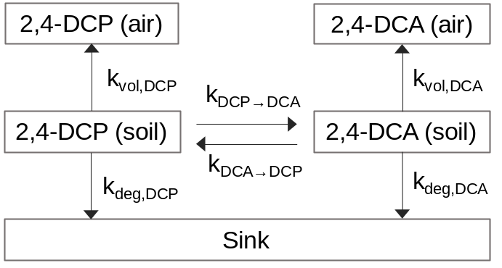

Dissipation of 2,4-DCA and 2,4-DCP, calculated as the sum of the separately fitted processes of degradation, volatilisation and conversion to the respective counterpart, was comparable in these experiments to those of the incubation of the compounds in the same soil in the experiments without trap. For 2,4-DCA, a dissipation half-life of 0.3 d was obtained in both experiments (Table S8 and Table 2) whereas for 2,4-DCP, dissipation in the experiment with volatile trap was somewhat slower (7.0 d vs. 4.1 d). For 2,4-DCA, conversion to 2,4-DCP was the most important process, and volatilisation was equally important as degradation to sink, as determined from the respective rate coefficients in Table S8. For 2,4-DCP, conversion to 2,4-DCA and degradation to sink together are equally important as volatilization.

Table S1
Ion transitions and collision energies used for quantification and confirmation of target compounds and internal standards by LC-MS/MS.

 | primary ion transition (m/z) | collision energy (eV) | secondary ion transition (m/z) | collision energy (eV) | retention time (min)
quizalofop-ethyl (QE) | 373→299 | 25 | 373→271 | 35 | 11.4
quizalofop-ethyl-D₃ (QE-D₃) | 378→304 | 25 | 378→276 | 35 | 11.4
quizalofop-acid (QA) | 343→271 | -19 | 343→243 | -34 | 12.5
quizalofop-acid-D₃ (QA-D₃) | 348→273 | -19 | 348→245 | -34 | 12.5
3-OH-quizalofop-acid (3-OH-QA) | 359→287 | -22 | 359→166 | -25 | 10.4
3-OH-CQO | 195→167 | -22 | 195→131 | -33 | 7.5
2,3-dihydroxyquinoxaline | 161→133 | -23 | 161→90 | -45 | 5.5
2,4-Dª | 219→161 | -15 | 221→163 | -15 | 16.0
2,4-D-D₃ª | 224→166 | -15 | 222→164 | -15 | 16.0
2,4-DCPª | 161→125 | -22 | n/a |  | 7.6
2,4-DCP-D₃ª | 166→129 | -22 | n/a |  | 7.7
ªAnalysis with LC-MS/MS only in adsorption experiments

Table S2
Recoveries and precision of the analysis of 2,4-D, QE, and their metabolites in railway soils.

 | spike level [µg/g moist soil] | 2,4-D | 2,4-DCP | 2,4-DCA | QE | QA | 3-OH-QA | 3-OH-CQO
recovery relative to internal standard [%]
EB | 0.01  0.1  1 | 110  102  101 | 115  101  103 | 105  103  98 | 100  99  107 | 106  101  100 | 96  98  98 | 63  59  77
MBS | 0.01  0.1  1 | 115  113  107 | 104  116  104 | 108  105  100 | 90  102  106 | 101  101  105 | 110  99  99 | 58  61  73
MR | 0.01  0.1  1 | 112  101  102 | 111  99  102 | 109  102  100 | 100  101  100 | 98  102  100 | 95  98  98 | 53  69  84
CS | 0.01  0.1  1 | 111  106  101 | 112  100  102 | 115  101  103 | 124  101  101 | 123  98  106 | 109  87  95 | 73  73  95
precision (relative standard deviation, N=4) [%]
EB | 1 (2,4-D, QE, and QA)  or 0.1 (all others) | 4.0 | 2.8 | 1.5 | 1.8 | 4.4 | 1.3 | 2.5
MBS | 1 (2,4-D, QE, and QA)  or 0.1 (all others) | 3.1 | 2.0 | 2.8 | 0.6 | 2.2 | 8.2 | 3.8
MR | 1 (2,4-D, QE, and QA)  or 0.1 (all others) | 2.6 | 1.1 | 4.6 | 5.4 | 4.4 | 3.3 | 1.7
CS | 1 (2,4-D, QE, and QA)  or 0.1 (all others) | 6.7 | 2.4 | 2.2 | 1.3 | 5.4 | 2.4 | 1.6

Table S3
Soil:solution ratios (R), equilibration times (ET), and correction factors (CF) used for measurement of adsorption isotherms.

 | EB |  |  | MBS |  |  | MR |  |  | CS
 | R | ET | CF | R | ET | CF | R | ET | CF | R | ET | CF
2,4-D | 1 : 1 | 24 h | 1 | 1 : 1 | 24 h | 1 | 1 : 1 | 24 h | 1 | 1 : 1 | 24 h | 1
2,4-DCP | 1 : 2 | 7 h | 0.95 | 1 : 1 | 7 h | 0.97 | 1 : 1 | 16 h | 0.90 | 1 : 1 | 6 h | 0.92
2,4-DCA | 1 : 24 | 24 h | 0.91 | 1 : 1 | 24 h | 0.86 | 1 : 1 | 8 h | 0.96 | 1 : 1 | 24 h | 0.94
QE | 1 : 12 | 2.5 h | 0.98 | 1 : 6 | 2.5 h | 0.71 | 1 : 6 | 2.5 h | 0.87 | 1 : 6 | 2.5 h | 0.92
QA | 1 : 1 | 24 h | 0.91 | 1 : 1 | 24 h | 0.81 | 1 : 1 | 24 h | 1 | 1 : 1 | 24 h | 0.87
3-OH-QA | 1 : 1 | 24 h | 0.94 | 1 : 1 | 24 h | 0.85 | 1 : 1 | 24 h | 1 | 1 : 1 | 24 h | 1
3-OH-CQO | 1 : 1 | 24 h | 0.74 | 1 : 1 | 24 h | 0.73 | 1 : 1 | 24 h | 0.90 | 1 : 1 | 24 h | 0.66

Table S4
Half-lives (DT₅₀) of 2,4-D, 2,4-DCP, and 2,4-DCA in soils from railway tracks and a crushed sand (present study) derived for use in exposure modelling according to [5] and, for comparison, DT₅₀ values estimated from studies with agricultural soils.

 | C_{org}  [%] | T [°C]/ | f_{θ}^{b} | DT₅₀ [d]^{c}
 | C_{org}  [%] | M [%]ª |  | 2,4-D | 2,4-DCP | 2,4-DCA
soils from railway tracks
EB | 0.15  0.31  ≈0.04  <0.06 | 20/35 | 0.70 | 24 (SFO) | 31 (DFOP) | 57 (SFO)
MBS | 0.15  0.31  ≈0.04  <0.06 | 20/60 | 0.89 | 35 (SFO)^{d} | 1.9 (FOMC) | 8.3 (SFO)
MR | 0.15  0.31  ≈0.04  <0.06 | 20/72 | 1.00 | >1000 (SFO)^{d} | 17 (DFOP) | 4.6 (DFOP)
CS | 0.15  0.31  ≈0.04  <0.06 | 20/65 | 1.00 | 203 (SFO)^{d} | 156 (FOMC) | 101 (SFO)
geom. mean, 20°C, pF 2e | ≈0.1 |  |  | 115 | 20 | 22
estimated from agricultural soils^{f} |  |  |  | 66 | 126 | 180
agricultural soils [6]
min-max  geom. mean, 20°C, pF 2 | 0.9-3.7 | 20/50 |  | 1.6-95 | 3.2-6.2 | 11-16
min-max  geom. mean, 20°C, pF 2 | 1.5/1.8/1.8^{g} |  |  | 4.4 | 7.0 | 10
ªT: temperature, M: moisture in % of water holding capacity
^{b}Moisture correction factor, calculated with an EXCEL tool published by [7]
^{c}SFO: simple first-order kinetics, DFOP: double first-order in parallel model, FOMC: first-order multi-compartment model. In case of bi-phasic kinetics, DT₅₀ is calculated considering only the slow phase of degradation: for DFOP, DT₅₀ = ln 2 / k_{slow}; for FOMC, DT₅₀ = DT₉₀/3.32 [5]. DT₅₀ values were then normalized to 20°C and pF 2.
^{d}Only the slow initial phase was considered.
^{e}The values <0.06 % C_{org} and >1000 d for 2,4-D were included as 0.06 % and 1000 d, respectively.
^{f}Calculated as DT₅₀ (agricultural soils) × C_{org} (agricultural soils) / C_{org} (railway soils)
^{g}In degradation studies with 2,4-D/2,4-DCP/2,4-DCA

Table S5
Half-lives (DT₅₀) of quizalofop-P-ethyl (QE), quizalofop-P-acid (QA), 3-OH-QA, and 3-OH-CQO in soils from railway tracks and a crushed sand (present study) derived for use in exposure modelling according to [5] and, for comparison, DT₅₀ values estimated from studies with agricultural soils.

 | C_{org} | T [°C]/ | f_{θ}^{b} | DT₅₀ [d]^{c}
 | [%] | M [%]ª |  | QE |  | QA | 3-OH-QA | 3-OH-CQO
soils from railway tracks
EB | 0.15 | 20/49 | 0.89 | 105 (DFOP) |  | 121 (DFOP) | 32 (SFO) | 258 (DFOP)
MBS | 0.31 | 20/54 | 0.83 | 4.7 (DFOP) |  | 134 (DFOP) | 29 (SFO) | 112 (DFOP)
MR | ≈0.04 | 20/67 | 0.97 | 0.28 (FOMC) |  | >1000 (SFO) | 609 (SFO) | 430 (SFO)
CS | <0.06 | 20/55 | 0.96 | 20 (FOMC) |  | 356 (SFO) | 181 (SFO) | 292 (DFOP)
geom. mean, 20°C, pF 2^{d} | ≈0.1 |  |  | 7.3 |  | 276 | 101 | 246
estimated from agricultural soils^{e} |  |  |  | 11 |  | 456 | 270 | 1323
agricultural soils [8]
min-max | 0.8-4.6 | 20-22/40-70 |  | 0.3-1.1 |  | 7-182 | 7-69 | 42-258
geom. mean, 20°C, pF 2 | 2.8/1.9/1.5/2.1^{f} |  |  | 0.4 |  | 24 | 18 | 63
ªT: temperature, M: moisture in % of water holding capacity
^{b}Moisture correction factor, calculated with an EXCEL tool published by [7]
^{c}SFO: simple first-order kinetics, DFOP: double first-order in parallel model, FOMC: first-order multi-compartment model. In case of bi-phasic kinetics, DT₅₀ is calculated considering only the slow phase of degradation: for DFOP, DT₅₀ = ln 2 / k_{slow}; for FOMC, DT₅₀ = DT₉₀/3.32 [5]. DT₅₀ values were then normalized to 20°C and pF 2.
^{d}The values <0.06 % C_{org} and >1000 d for QA were included as 0.06 % and 1000 d, respectively.
^{e}Calculated as DT₅₀ (agricultural soils) × C_{org} (agricultural soils) / C_{org} (railway soils)
^{f}In degradation studies with QE/QA/3-OH-QA/3-OH-CQO

Table S6
Freundlich adsorption coefficients (K_{F}) and exponents (1/n) of 2,4-D, 2,4-DCP, and 2,4-DCA in soils from railway tracks and a crushed sand (present study, with 95% confidence intervals) and, for comparison, K_{F} values estimated from studies with agricultural soils.

 | pH  (CaCl₂) | C_{org} [%] | K_{F} [mL/g]  2,4-D | 1/n | K_{F} [mL/g]  2,4-DCP | 1/n | K_{F} [mL/g]  2,4-DCA | 1/n
soils from railway tracks
EB | 7.7 | 0.15 | 0.28 (0.26-0.30) | 0.69 (0.66-0.72) | 3.32 (2.31-4.78) | 0.83 (0.72-0.94) | 10 (8.4-13) | 0.58 (0.52-0.64)
MBS | 7.6 | 0.31 | 0.14 (0.13-0.16) | 0.75 (0.71-0.79) | 0.96 (0.82-1.13) | 0.75 (0.70-0.80) | 1.4 (1.1-1.7) | 0.77 (0.71-0.83)
MR | 7.6 | ≈0.04 | 0.04 (0.03-0.05) | 0.62 (0.51-0.74) | 0.08 (0.04-0.14) | 0.63 (0.49-0.77) | 0.43 (0.35-0.53) | 0.47 (0.41-0.53)
CS | 7.5 | <0.06 | 0.07 (0.06-0.08) | 0.61 (0.55-0.67) | 0.14 (0.10-0.21) | 0.88 (0.78-0.99) | 0.93 (0.79-1.09) | 0.65 (0.61-0.70)
geom. mean  arithm. mean |  | ≈0.1 | 0.10 | 0.67 | 0.43 | 0.77 | 1.5 | 0.62
estimated from agricultural soilsª |  |  | 0.02 |  | 0.46 |  | 1.0
agricultural soils [6]^{b}
min-max | 5.0-7.5 | 0.9-4.4 | 0.19-0.83 | 0.78-0.90 | 3-25 | 0.80-0.94 | 10-27 | 0.85-0.95
geom. mean  arithm. mean |  | 1.8 | 0.40 | 0.83 | 8.3 | 0.88 | 18 | 0.92
ªCalculated as K_{F} (agricultural soils) × C_{org} (railway soils) / C_{org} (agricultural soils)
^{b}Soils M800-M822 considered

Table S7
Freundlich adsorption coefficients (K_{F}) and exponents (1/n) of quizalofop-ethyl (QE), quizalofop-acid (QA), 3-OH-QA, and 3-OH-CQO in soils from railway tracks and a crushed sand (present study, with 95% confidence intervals) and, for comparison, K_{F} values estimated from studies with agricultural soils.

 | pH  (CaCl₂) | C_{org} [%] | K_{F} [mL/g]  QE | 1/n | K_{F} [mL/g]  QA | 1/n
soils from railway tracks
EB | 7.7 | 0.15 | 66 (27-165) | 0.76 (0.67-0.86) | 5.4 (3.9-7.6) | 0.81 (0.73-0.88)
MBS | 7.6 | 0.31 | 47 (25-86) | 0.97 (0.90-1.04) | 0.99 (0.76-1.29) | 0.79 (0.73-0.85)
MR | 7.6 | ≈0.04 | 1.5 (1.0-2.2) | 0.77 (0.71-0.82) | 0.17 (0.14-0.20) | 0.76 (0.70-0.82)
CS | 7.5 | <0.06 | 6.5 (4.0-10) | 0.70 (0.64-0.75) | 0.96 (0.73-1.26) | 0.64 (0.58-0.70)
geom. mean  arithm. mean |  | ≈0.1 | 13 | 0.80 | 0.96 | 0.75
estimated from agricultural soilsª |  |  | 1.7 |  | 0.52
agricultural soils [8]
min-max | 4.3-8.1 | 0.06-5.9 | 15-99 | 0.83-0.88 | 0.19-40 | 0.69-0.89
geom. mean  arithm. mean |  | 2.3/1.0^{b} | 39 | 0.86 | 5.2 | 0.81

 | pH  (CaCl₂) | C_{org} [%] | K_{F} [mL/g]  3-OH-QA | 1/n | K_{F} [mL/g]  3-OH-CQO | 1/n
soils from railway tracks
EB | 7.7 | 0.15 | 2.1 (1.9-2.4) | 0.78 (0.74-0.81) | 2.0 (1.7-2.4) | 0.74 (0.69-0.79)
MBS | 7.6 | 0.31 | 0.62 (0.58-0.67) | 0.77 (0.74-0.79) | 3.1 (2.7-3.6) | 0.74 (0.70-0.78)
MR | 7.6 | ≈0.04 | 0.16 (0.14-0.19) | 0.84 (0.78-0.91) | 0.52 (0.47-0.58) | 0.65 (0.61-0.69)
CS | 7.5 | <0.06 | 0.83 (0.73-0.95) | 0.60 (0.57-0.64) | 0.35 (0.29-0.42) | 0.48 (0.42-0.54)
geom. mean  arithm. mean |  | ≈0.1 | 0.65 | 0.75 | 1.0 | 0.65
estimated from agricultural soilsª |  |  | 0.13 |  | 0.50
agricultural soils [8]
min-max | 4.3-8.1 | 0.06-5.9 | 0.8-10 | 0.80-1.07 | 5.5-22 | 0.59-0.80
geom. mean  arithm. mean |  | 2.0/2.0^{c} | 2.6 | 0.93 | 9.9 | 0.66
ªCalculated as K_{F} (agricultural soils) × C_{org} (railway soils) / C_{org} (agricultural soils)
^{b}In adsorption studies with QE/QA
^{c}In adsorption studies with 3-OH-QA/3-OH-CQO

Table S8
Rate coefficients fitted to the data from incubation of 2,4-DCA and 2,4-DCP in soil MR using a trap to capture volatilised components. The dissipation half-lives of 2,4-DCA and 2,4-DCP were estimated using the following equation: DT₅₀=ln2/(k_{deg}+k_{vol}+k_{x→y}).

 |  | incubation of 2,4-DCA |  |  | incubation of 2,4-DCP
k_{deg,DCA} | [d⁻¹] | 0.582 | ± | 0.036ª | 0.582 |  | (fixed)
k_{deg,DCP} | [d⁻¹] | 0.018 | ± | 0.006 | 0.026 | ± | 0.001
k_{vol,DCA} | [d⁻¹] | 0.600 | ± | 0.094 | 0.600 |  | (fixed)
k_{vol,DCP} | [d⁻¹] | 0.058 | ± | 0.033 | 0.048 | ± | 0.003
k_{DCA→DCP} | [d⁻¹] | 1.038 | ± | 0.056 | 1.038 |  | (fixed)
k_{DCP→DCA} | [d⁻¹] | 0.149 | ± | 0.051 | 0.025 | ± | 0.004
DT_{50,DCA} | [d] | 0.31
DT_{50,DCP} | [d] |  |  |  | 7.0
ª Standard deviation of the estimated parameters as provided by the AQUASIM model

Fig. S1. Left: GC-MS (SIM) chromatogram showing the elution of 2,4-DCA, 2,4-DCP-ethyl, and 2,4-D-ethyl in an extract of soil EB, 49 d after application of 1 µg/g 2,4-D. Right: LC-MS/MS (MRM) chromatogram showing the elution of 3-OH-CQO, 3-OH-QA, QE, and QA in an extract of soil EB, 121 d after application of 1 µg/g QE. Signal intensities were arbitrarily normalized.
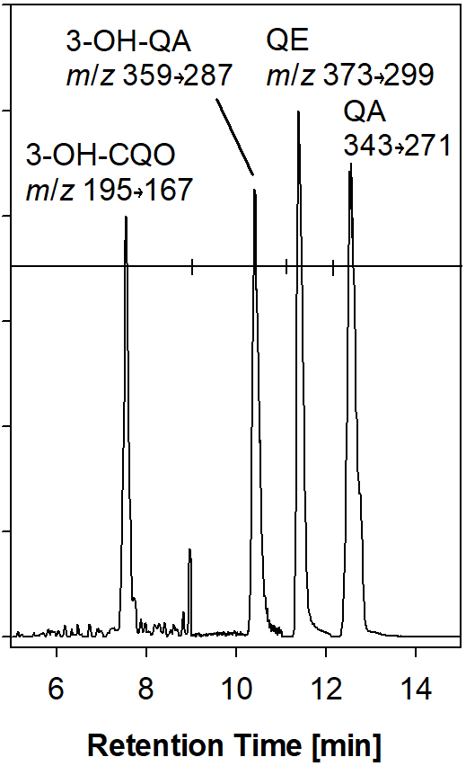
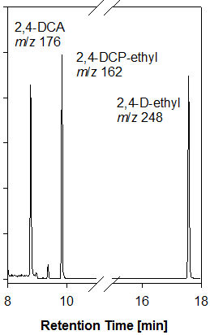

Fig. S2. Experimental setup for trapping of volatile metabolites of 2,4-D.
sampling
2,4-DCA
2,4-DCP
air
water soil methanol methanol
Fig. S3. Volatilization of 2,4-DCP and 2,4-DCA in incubation experiments of 2,4-DCP (left) and 2,4-DCA (right) in soil MR. Symbols show measured concentrations, lines are kinetic fits. Grey colors denote concentrations in soil, orange colors concentrations in traps (cumulative amounts in soil concentration equivalents).

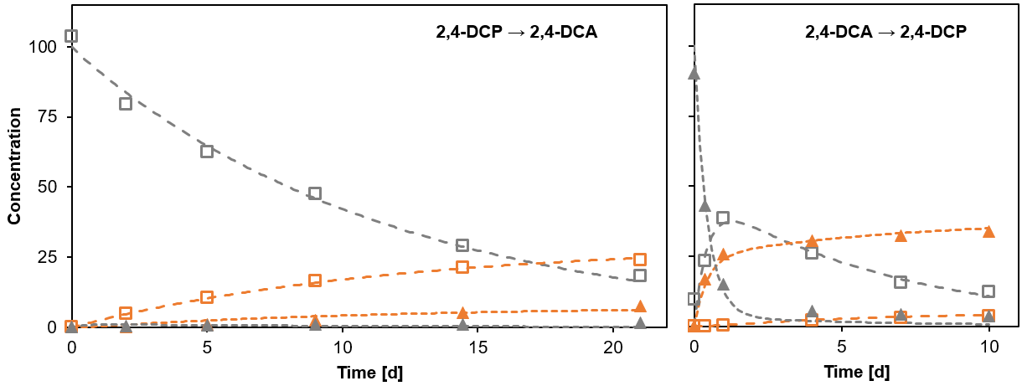

References
[1] Organisation for Economic Co-operation and Development (2000) OECD Guidelines for the Testing of Chemicals: Adsorption-Desorption Using a Batch Equilibrium Method. Vol 106. OECD, p 45
[2] Gulkowska A, Buerge IJ, Poiger T (2014) Online solid phase extraction LC–MS/MS method for the analysis of succinate dehydrogenase inhibitor fungicides and its applicability to surface water samples. Anal Bioanal Chem 406(25): 6419-6427
[3] Rapporteur Member State Hellas (2013) 2,4-D Renewal Assessment Report following the inclusion of the active substance in Annex I of Council Directive 91/414/EEC. Vol 3, Annex B 8 Fate and behaviour in the environment, Athens, pp 636-865
[4] Reichert P (1994) AQUASIM - a Tool for Simulation and Data-Analysis of Aquatic Systems. Water Sci Technol 30: 21-30
[5] FOrum for the Coordination of pesticide fate models and their USe (FOCUS) (2014) Generic guidance for estimating persistence and degradation kinetics from environmental fate studies on pesticides in EU registration.
[6] European Food Safety Authority (2014) Conclusion on the peer review of the pesticide risk assessment of the active substance 2,4-D. EFSA Journal 12(9): 3812 ff.
[7] Federal Environment Agency (UBA) (2012) Input-Decision 3.3 - A simple MS Excel-Tool to select appropriate input parameters for groundwater simulations in the national authorisation process of pesticide products.
[8] European Food Safety Authority (2009) Conclusion regarding the peer review of the pesticide risk assessment of the active substance quizalofop-P. EFSA Journal 7(7): 1-216.

