Supplementary Data
Onion membrane based composite scaffolds incorporated with N-Boc L-cysteine methyl ester enhances mineralization for bone tissue engineering applications.
Sivasankar MV¹, Sreenivasa Rao P^{*1}

Synthesis of N-Boc-L-cysteine methyl ester:
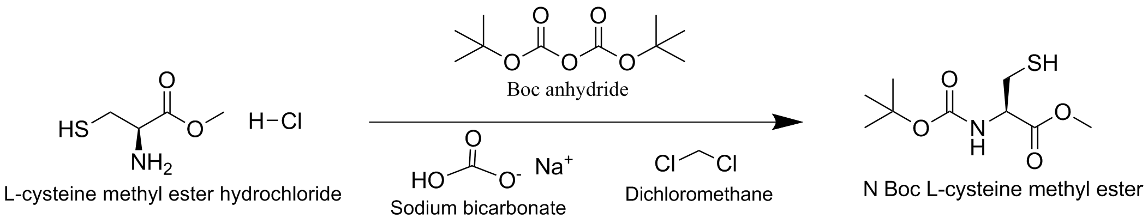
Triethylamine (6.11 ml, 22.0 mmol) was added to a suspension of L-cysteine methyl ester hydrochloride (4) (3.71 g, 20.0 mmol) and anhydrous tetrahydrofuran (25 ml) at 0°C. A solution of di-tert-butyl dicarbonate (4.80 g, 22.0 mmol) in 25 ml of anhydrous tetrahydrofuran was added in portions and the mixture was stirred at room temperature for 2 h. 40 ml of water was added to the solution and the solution was extracted with ethyl acetate (3x50 ml). The combined organic phases were washed with brine, dried over potassium sulphate and the solvent was removed under reduced pressure. The product was purified by flash column chromatography on silica gel (cyclohexane/ethyl acetate, 7/1, v/v) to give N-Boc-L-cysteine methyl ester (7) (4.83 g, 97 %) as a white solid.
¹H NMR (300 MHz, CDCl3): δ = 1.29 (t, J = 7.1 Hz, 3H, CH₃CH₂), 1.45 (s, 9H, t-C₄H₉), 2.97 (dd, J = 4.2, 4.2 Hz, 1 H, SCH_{a}), 2.98 (dd, J = 4.2, 4.2 Hz, 1 H, SCH_{b}), 4.23 (q, J = 7.1 Hz, 2H, CH₃CH₂), 4.57 (ddd, J =7.8, 4.2, 4.2 Hz, 1 H, CHN), 5.42 (br d, J = 7.8 Hz, 1 H, NH)
¹³C NMR (75 MHz, CDCl3): δ = 14.2 (CH₃CH₂), 27.4 (CH₂S), 28.3 (OC(CH₃)₃), 54.8 (CHN), 61.9 (CH₃CH₂), 80.2 (OC(CH₃)₃), 155.1 (NC=O),170.3 (OC=O)
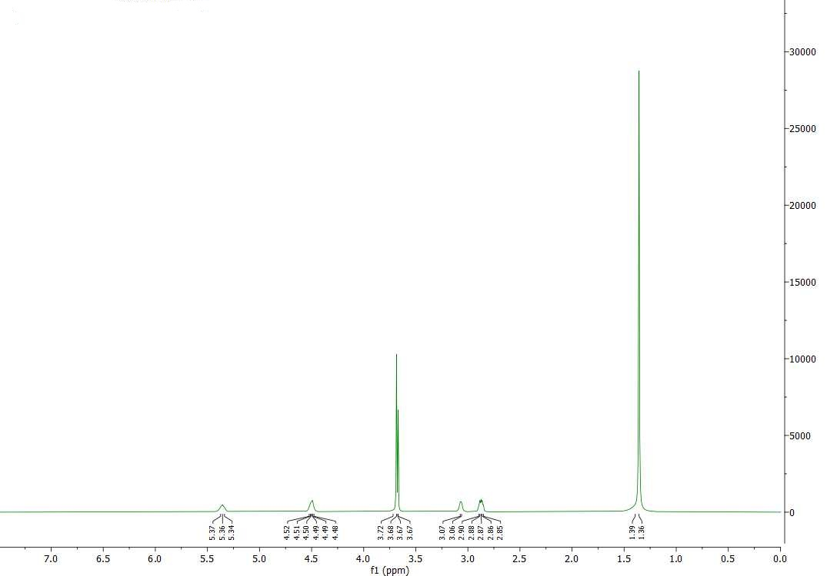
Figure 1: Proton spectrum of N-Boc-L-cysteine methyl ester.
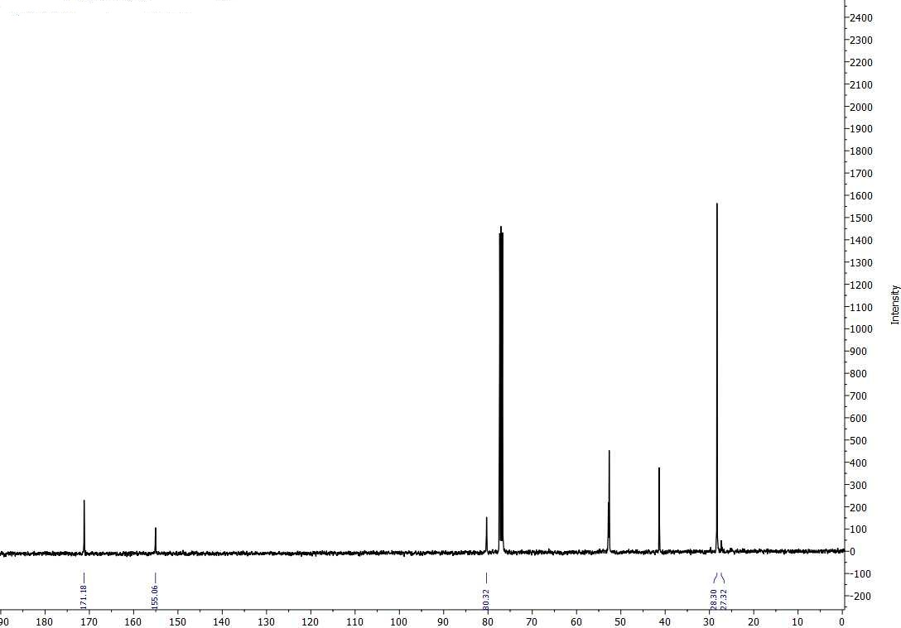
Figure 2: ¹³C spectrum of N-Boc-L-cysteine methyl ester.

Figure 3: Different mathematical models for drug release mechanism (a) Zero order model, (b)
First order model, (c) Higuchi model, (d) Korsmeyer- Peppas model. The correlation coefficients
along with parameter for each model are presented in table below.

Sample | Zero Order |  | First Order |  | Higuchi model |  | Korsmeyer-Peppas
Sample | K | r² | K | r² | K | r² | n | r²
C-MFC-P | 0.0879±0.01 | 0.77 | 0.0030±0.004 | 0.83 | 1.0646±0.067 | 0.93 | 0.235±0.007 | 0.97
C-MFC-P-H | 0.1274±0.02 | 0.82 | 0.004±0.001 | 0.70 | 1.4517±0.14 | 0.93 | 0.249±0.005 | 0.98
C-MFC-P-Zr | 0.1075±0.021 | 0.92 | 0.0034±0.004 | 0.88 | 1.2972±0.083 | 0.91 | 0.26±0.01 | 0.98
Table 1: Release rate constant (k), correlation coefficient (r²) and diffusion release exponent (n) obtained using different mathematical models for drug loaded scaffolds S1 (C-MFC-P), S2 (C-MFC-P-H), and S3 (C-MFC-P-Zr).

