Supplementary Figures and Tables
a
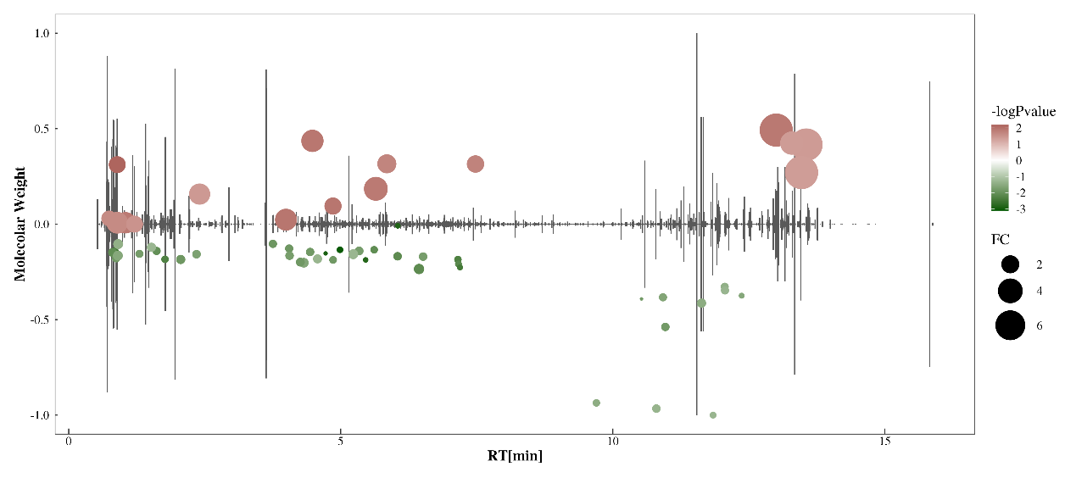
b

Figure S1. Cis-BF-induced the changes in metabolic profiles of the intestinal contents. a, Changes in levels of metabolites (Fold change > 1.5 and p < 0.05) in the intestine content of Xenopus laevis in 0.06 μg/L cis-BF exposure group. b, Enrichment ratio of pathways by KEGG pathway analysis in 0.06 μg/L cis-BF exposure group.
b
a
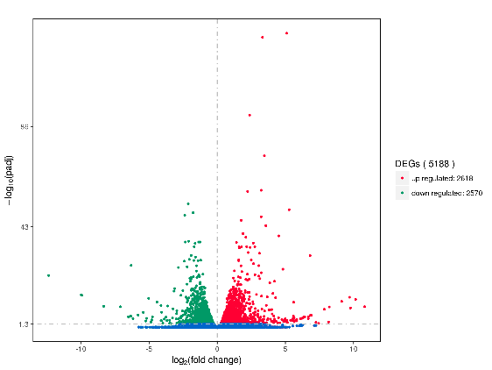
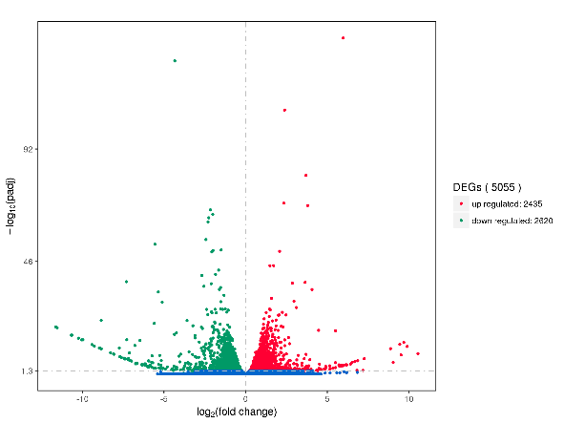
Figure S2. Differential expressed genes in Xenopus laevis liver after exposure to cis-BF. a, 0.06 μg/L cis-BF treatment group; b, 0.3 μg/L cis-BF treatment group.
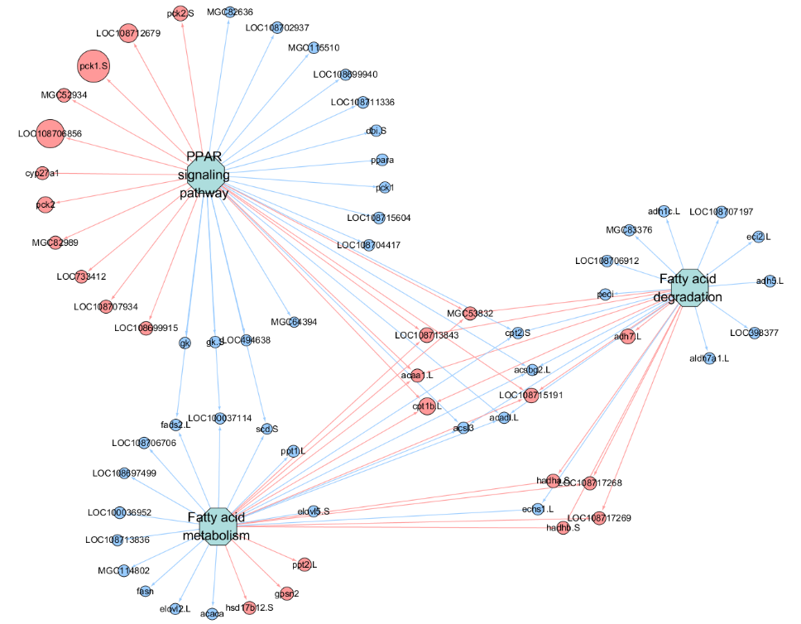
a

b

Figure S3. Hepatic gene expression profile in Xenopus laevis after exposure to 0.06 μg/L cis-BF. a, Network-based analysis of the differentially expressed genes involved in the fatty acid metabolism pathway, PPAR signaling pathway and fatty acid degradation pathway. b, Significant enriched pathways for both differentially expressed genes and differentially changed metabolite
Table S1. The primers for RT-PCR assay.
Gene | Primer sequence | Gene Bank ID
18s | Forward: AACGGCTACCACATCCAAGG  Reverse: CACCAGACTTGCCCTCCAAT | X04025
scd.S | Forward: GGGCTGTCACATTAAACCCTTG  Reverse: AACCTACGTTTCTGGCTGGT | NM_001094340
ppargc1a | Forward: CCCGCTGCATGGCTTAAGAA  Reverse: GCGTAGTGAAACCAACGCAC | XM_018243071
fads2 | Forward: GACGTCCTCAGGTCCCTC  Reverse: CTGGAGAGTTCCCTGACCT | NM_001093384
apoa5 | Forward: GGTGTCAGCAACAAAAACAGCA  Reverse: TTTCAGCCTTACTGCCTGTCA | NM_001110744
ubc | Forward: GTGTAGTGCAGAGCAGAGGG  Reverse: ATGTTTGCTGGTCTGTCGGT | NM_001087396
acat1 | Forward: TTGAGCCAATAGGATCCGGG  Reverse: GTTGTGCAATGCCCGAGTG | NM_001091210
adh5 | Forward: GACAGCCGGGAAGGTCATC  Reverse: GTGTAGGCATCGGTATGGCA | NM_001092958
gcdh | Forward: TCTGACCTGGGCAAGCAATC  Reverse: ATTCCAACCCTCAGTCTCGC | NM_001093154
hacd3 | Forward: TTCGGCTGCCTCTACCCATAG  Reverse:GTAGATTGATGGCAAGTCCCAGAA | XM_018255251
acsl3 | Forward: CGCTCTCAGCGGATTTTGC  Reverse: CGAGATCCCAGAAGATGAGGC | XM_018265809

Table S2. Cis-BF concentrations in exposure solutions at 0 and 24 hours. Data are expressed as the mean ± SEM (n = 3). LOD：limit of detection.
Nominal cis-BF  (μg/L) | Measured Concentrations (μg/L)
 | 0h | 24h
0 | < LOD | < LOD
0.06 | 0.0587 ± 0.002 | 0.0511 ± 0.001
0.3 | 0.287 ± 0.005 | 0.268 ± 0.005

Table S3. Identified significantly changed metabolites in gut samples. (Fold change >1.5, p < 0.05).
Control vs 0.3
Neg
Name | Molecular Weight | RT [min] | FC | Pvalue
6952 | 391.1702 | 0.89 | 1.57 | 0.00
D-(-)-Mannitol | 182.0791 | 0.82 | 3.14 | 0.00
3O959710YK | 108.0423 | 0.81 | 0.57 | 0.00
Nitrosonornicotine | 177.0903 | 4.41 | 2.23 | 0.00
Sulfoglycolithocholic acid | 513.2757 | 9.83 | 0.48 | 0.00
Nicotinuric acid | 180.0536 | 4.56 | 1.81 | 0.00
4,5,6,7-Tetrahydro-1H-imidazo(4,5-c)pyridine-6-carboxylic acid | 167.0694 | 0.89 | 1.77 | 0.00
4-Sulfobenzoic acid | 201.9937 | 4.21 | 0.32 | 0.00
7-Methylxanthine | 166.0478 | 0.76 | 2.20 | 0.01
862I85399W | 136.0638 | 4.56 | 1.79 | 0.01
Kynurenine | 208.0848 | 4.26 | 1.56 | 0.01
1-(sn-glycero-3-phospho)-1D-myo-inositol | 334.0664 | 0.75 | 3.03 | 0.01
1-deoxy-D-altro-heptulose 7-phosphate | 274.0452 | 0.76 | 3.01 | 0.01
L-(-)-Serine | 105.0427 | 0.80 | 0.47 | 0.01
asp-leu | 246.1213 | 0.88 | 0.52 | 0.01
Glycocholic acid | 465.3089 | 10.84 | 0.39 | 0.01
Xylitol | 152.0685 | 0.83 | 1.63 | 0.02
Gluconic acid | 196.0583 | 0.77 | 1.97 | 0.02
NITRILACARB | 197.1162 | 0.89 | 1.99 | 0.02
asp-ser | 220.0695 | 0.75 | 0.60 | 0.02
Prednimustine | 645.2601 | 0.89 | 1.77 | 0.03
2-Aminooctanedioic acid | 189.1002 | 3.86 | 2.00 | 0.03
900T44YNC7 | 133.0739 | 0.82 | 0.60 | 0.03
8-Hydroxyhexadecanedioic acid | 302.2091 | 8.83 | 0.47 | 0.03
L-(+)-Alanine | 89.04774 | 0.81 | 0.43 | 0.03
Baicalin | 446.0849 | 7.54 | 0.35 | 0.03
Soyasaponin I | 942.5237 | 11.07 | 0.51 | 0.03
N-(1-Hydroxycyclopropyl)glutamine | 202.0951 | 0.75 | 0.65 | 0.03
thr-asp | 234.085 | 0.75 | 0.65 | 0.04
3-Indoxyl sulphate | 213.0096 | 4.27 | 0.40 | 0.04
L-Aspartic acid | 133.0376 | 0.75 | 0.45 | 0.04
lysophosphatidylcholine 14:1(9Z)/0:0 | 465.285 | 13.21 | 0.42 | 0.04
889DYX0816 | 323.2822 | 13.26 | 0.37 | 0.05
Asulam | 230.0359 | 1.92 | 1.52 | 0.05
Sucrose | 342.1162 | 0.88 | 2.10 | 0.05
D-Raffinose | 504.1689 | 0.89 | 1.78 | 0.05
1-(beta-D-ribofuranosyl)thymine | 258.0849 | 0.77 | 1.83 | 0.05
Pos
Glutaric acid | 132.04182 | 0.84 | 0.62 | 0.00
Spenolimycin | 346.17321 | 5.97 | 4.20 | 0.00
(5E,7E,10R,12R,13E,16R,17R,18S,22S)-22-Ethyl-10,12,16,18-tetrahydroxy-17-methyloxacyclodocosa-3,5,7,13-tetraen-2-one | 422.26565 | 10.84 | 0.44 | 0.00
1-(4-Amino-4-carboxybutanoyl)-2-piperidinecarboxylic acid | 258.12085 | 0.92 | 1.69 | 0.00
1-Methyl-2,3,4,9-tetrahydro-1H-beta-carboline-1,3-dicarboxylic acid | 274.09452 | 0.88 | 2.56 | 0.00
1-Pentofuranosyl-2,4(1H,3H)-pyrimidinedione | 244.06879 | 0.84 | 0.59 | 0.00
(3S,8aS)-3-(4-Hydroxybenzyl)hexahydropyrrolo[1,2-a]pyrazine-1,4-dione | 260.11529 | 5.74 | 2.09 | 0.00
RGA574NASM | 204.1181 | 0.90 | 2.34 | 0.00
F2201 | 377.15744 | 6.74 | 0.46 | 0.00
Dehydroglycine | 73.01625 | 0.80 | 0.54 | 0.00
2-Amino-5-[2-(4-formylphenyl)hydrazino]-5-oxopentanoic acid | 265.10547 | 0.91 | 2.36 | 0.00
N-Acetylneuraminic acid | 309.10513 | 0.85 | 0.56 | 0.01
Diflucortolone | 394.19377 | 4.30 | 2.80 | 0.01
Glycochenodeoxycholic acid | 449.31311 | 11.95 | 0.06 | 0.01
Stizolobate | 227.04245 | 0.87 | 1.80 | 0.01
MMB-FUBINACA | 383.16566 | 6.41 | 1.79 | 0.01
4-Guanidinobutyric acid | 145.08499 | 0.92 | 2.14 | 0.01
Maltotetraose | 666.21896 | 0.85 | 2.16 | 0.01
ARG-PHE | 321.17905 | 3.20 | 0.54 | 0.01
Paraldehyde | 132.07882 | 4.73 | 1.62 | 0.02
Ornithine | 132.0896 | 0.74 | 0.37 | 0.02
O-glutaroyl-L-carnitine | 275.13607 | 2.05 | 0.58 | 0.02
Cadaverine | 102.11557 | 0.70 | 2.15 | 0.02
Pyroquilon | 173.08382 | 5.04 | 1.61 | 0.02
65GQA237EH | 215.15149 | 9.56 | 1.72 | 0.02
(3aR,4aS,5R,7aS,8S,9aR)-5-Hydroxy-4a,8-dimethyl-3-methyleneoctahydroazuleno[6,5-b]furan-2,6(3H,4H)-dione | 264.13535 | 6.07 | 1.69 | 0.02
Oleanolic acid | 456.35919 | 12.37 | 0.36 | 0.02
Taurocholic acid | 515.29079 | 11.91 | 0.61 | 0.03
FCR6T2IYVU | 160.12104 | 0.87 | 2.50 | 0.03
Nicotinic acid | 123.03195 | 1.16 | 0.34 | 0.03
Testosterone cypionate | 412.2965 | 12.06 | 0.48 | 0.03
Eseridine | 291.15741 | 1.71 | 1.55 | 0.03
Acetylcarnitine | 203.11543 | 2.15 | 1.68 | 0.04
(+)-a(S)-butyr-amido-r-butyrolactone | 171.08933 | 2.19 | 1.64 | 0.05
Hecogenin | 430.30706 | 12.06 | 0.48 | 0.05
0KY44Q8S8O | 448.31772 | 12.06 | 0.49 | 0.05
Control vs 0.06
Neg
Leucyltryptophan | 317.1738 | 7.19 | 0.32 | 0.00
R-L3 | 397.1594 | 0.89 | 1.76 | 0.01
Leu-Val | 230.1629 | 5.61 | 0.40 | 0.01
Imidazoleacetic acid | 126.043 | 3.99 | 3.06 | 0.01
4-Methylhippuric acid | 193.074 | 4.86 | 1.82 | 0.01
1-(4Z,7Z,10Z,13Z,16Z,19Z-docosahexaenoyl)-sn-glycero-3-phosphocholine | 567.3339 | 13.00 | 7.53 | 0.01
Methionylmethionine | 280.0914 | 4.86 | 0.42 | 0.01
Danegaptide | 291.1217 | 4.26 | 0.50 | 0.01
Oxadixyl | 278.1264 | 5.65 | 3.69 | 0.01
Manidipine | 610.2856 | 10.97 | 0.47 | 0.01
Chenodeoxycholic acid 3-sulfate | 472.2491 | 10.53 | 0.27 | 0.01
met-thr | 250.0986 | 1.30 | 0.45 | 0.02
Vorinostat | 264.1472 | 6.51 | 0.48 | 0.02
omecamtiv mecarbil | 401.1858 | 5.85 | 2.26 | 0.02
Ecdysone | 464.3152 | 10.92 | 0.45 | 0.02
1-[(9Z)-hexadecenoyl]-sn-glycero-3-phosphocholine | 493.3191 | 11.63 | 0.53 | 0.03
Deoxycorticosterone 21-glucoside | 984.5294 | 9.70 | 0.40 | 0.03
2'-Deoxyinosine | 252.0857 | 2.41 | 2.85 | 0.04
1-Hexadecanoyl-sn-glycero-3-phosphocholine | 495.3322 | 13.56 | 7.26 | 0.04
2-[(5Z,8Z,11Z)-icosatrienoyl]-sn-glycero-3-phosphoethanolamine | 503.3005 | 13.29 | 3.53 | 0.04
JQH2H7EVAZ | 358.287 | 13.47 | 7.59 | 0.04
(7Z,21S,25R)-25,28-Dihydroxy-28-oxido-18-oxo-28-{[(1S,5R)-2,3,4,6-tetrahydroxy-5-(phosphonooxy)cyclohexyl]oxy}-19,23,27-trioxa-28lambda~5~-phosphaoctacos-7-en-21-yl (6Z,9Z,12Z)-6,9,12-octadecatrienoate | 1012.527 | 10.80 | 0.47 | 0.04
Methyl O-sulfo-L-tyrosinate | 275.0461 | 4.57 | 0.52 | 0.05
Meprobamate | 218.1266 | 1.52 | 0.54 | 0.05
Pos
Threonylglutamine | 247.1161 | 0.83 | 0.51 | 0.00
tert-Butyl N-[1-(aminocarbonyl)-3-methylbutyl]carbamate | 230.1625 | 4.99 | 0.35 | 0.00
Valylmethionine | 248.1188 | 4.72 | 0.27 | 0.00
Heptenal | 112.0891 | 6.05 | 0.30 | 0.00
a-Aspartylphenylalanine | 280.1051 | 5.46 | 0.30 | 0.00
1-Pentofuranosyl-2,4(1H,3H)-pyrimidinedione | 244.0688 | 0.84 | 0.61 | 0.00
Tolycaine | 278.1621 | 7.15 | 0.40 | 0.00
met-gln | 277.1087 | 1.77 | 0.40 | 0.00
dapdiamide A | 300.1439 | 7.16 | 0.36 | 0.01
2-{4-[2-(Trifluoromethyl)quinolin-4-yl]piperazino}ethan-1-ol | 325.1392 | 6.44 | 0.65 | 0.01
Methionylleucine | 262.1344 | 6.04 | 0.48 | 0.01
Lys-Pro | 243.1576 | 0.81 | 0.51 | 0.01
Methionylserine | 236.0825 | 1.62 | 0.45 | 0.01
Telmisartan | 514.2385 | 4.48 | 3.19 | 0.01
L-dihydroanticapsin | 201.0997 | 3.75 | 0.46 | 0.01
gamma-glutamylmethionine | 278.0928 | 2.06 | 0.54 | 0.01
Butalbital | 224.1155 | 4.05 | 0.46 | 0.01
Arg-pro | 271.1636 | 0.87 | 0.48 | 0.01
Isocytosine | 111.0431 | 1.04 | 2.91 | 0.01
N~6~-[(2R)-3,4-Dihydro-2H-pyrrol-2-ylcarbonyl]-L-lysine | 241.142 | 4.44 | 0.47 | 0.01
3-Morpholino-4-tetrahydro-1H-pyrrol-1-ylcyclobut-3-ene-1,2-dione | 236.1155 | 5.34 | 0.50 | 0.02
leu-gln | 259.1525 | 4.06 | 0.48 | 0.02
1,12-Dihydroxy-1,6,12,17-tetraazacyclodocosane-2,5,13,16-tetrone | 400.231 | 7.48 | 1.86 | 0.02
Proline | 115.0632 | 0.87 | 1.53 | 0.02
Alanyltyrosine | 252.1103 | 2.35 | 0.48 | 0.02
Ornithine | 132.0896 | 0.74 | 1.51 | 0.02
Cytosine | 111.0431 | 0.89 | 3.01 | 0.02
Methyl alpha-aspartylphenylalaninate | 294.1206 | 4.32 | 0.59 | 0.02
Oleanolic acid | 456.3592 | 12.37 | 0.31 | 0.03
lys-leu | 259.1891 | 0.90 | 0.60 | 0.03
Methional | 104.0295 | 1.21 | 1.77 | 0.03
Testosterone cypionate | 412.2965 | 12.06 | 0.44 | 0.04
Dinotefuran | 202.1075 | 0.91 | 0.61 | 0.04
Hecogenin | 430.3071 | 12.06 | 0.45 | 0.05
(3beta,16beta,23R)-20-Hydroxy-16,23:16,30-diepoxydammar-24-en-3-yl 6-deoxy-alpha-L-mannopyranosyl-(1->2)-[beta-D-xylopyranosyl-(1->2)-beta-D-glucopyranosyl-(1->3)]-alpha-L-arabinopyranoside | 1044.548 | 11.84 | 0.36 | 0.05
Ala-Tyr | 252.11 | 5.23 | 0.61 | 0.05

Table S4. Enriched KEGG pathways after exposure to cis-BF.
MapTitle | Pvalue | x | y | n | N | EnrichDirect | MetaIDs
Control vs 0.3
neg
Secondary bile acid biosynthesis | 0.01 | 3 | 8 | 4 | 47 | Over | Glycocholic acid, Cholic acid,  Taurochenodeoxycholic acid
Primary bile acid biosynthesis | 0.02 | 3 | 9 | 4 | 47 | Over | Glycocholic acid, Cholic acid,  Taurochenodeoxycholic acid
Bile secretion | 0.012 | 3 | 9 | 4 | 47 | Over | Glycocholic acid, Cholic acid,  Taurochenodeoxycholic acid
Cholesterol metabolism | 0.03 | 2 | 4 | 4 | 47 | Over | Taurochenodeoxycholic acid
pos
Secondary bile acid biosynthesis | 0.01 | 2 | 3 | 5 | 76 | Over | Glycocholic acid, Glycochenodeoxycholic acid
Cholesterol metabolism | 0.01 | 2 | 3 | 5 | 76 | Over | Glycocholic acid, Glycochenodeoxycholic acid
Primary bile acid biosynthesis | 0.02 | 2 | 4 | 5 | 76 | Over | Glycocholic acid, Glycochenodeoxycholic acid
Control vs 0.06
pos
Pyrimidine metabolism | < 0.001 | 4 | 7 | 4 | 76 | Over | 5-Methylcytosine, Cytosine

Table S5. Enrichment ratio of pathways by KEGG analysis in 0.06 and 0.3 μg/L cis-BF exposure groups.
KEGGID | Description | GeneRatio | BgRatio | pvalue | padj | Count
Control vs 0.3
xla03060 | Protein export | 29/1795 | 39/8395 | 2.03E-12 | 3.22E-10 | 29
xla04141 | Protein processing in endoplasmic reticulum | 92/1795 | 268/8395 | 4.58E-07 | 3.64E-05 | 92
xla03030 | DNA replication | 23/1795 | 53/8395 | 0.000254 | 0.010523 | 23
xla01230 | Biosynthesis of amino acids | 40/1795 | 112/8395 | 0.000321 | 0.010523 | 40
xla03008 | Ribosome biogenesis in eukaryotes | 38/1795 | 105/8395 | 0.000331 | 0.010523 | 38
xla00970 | Aminoacyl-tRNA biosynthesis | 25/1795 | 62/8395 | 0.000545 | 0.014437 | 25
xla04145 | Phagosome | 71/1795 | 234/8395 | 0.000712 | 0.016178 | 71
xla03320 | PPAR signaling pathway | 36/1795 | 103/8395 | 0.000988 | 0.018997 | 36
xla00250 | Alanine, aspartate and glutamate metabolism | 21/1795 | 51/8395 | 0.001075 | 0.018997 | 21
xla00520 | Amino sugar and nucleotide sugar metabolism | 27/1795 | 73/8395 | 0.001593 | 0.025323 | 27
xla01200 | Carbon metabolism | 58/1795 | 190/8395 | 0.001801 | 0.025436 | 58
xla00500 | Starch and sucrose metabolism | 21/1795 | 53/8395 | 0.00192 | 0.025436 | 21
xla00860 | Porphyrin and chlorophyll metabolism | 17/1795 | 40/8395 | 0.002094 | 0.025613 | 17
xla03013 | RNA transport | 72/1795 | 249/8395 | 0.002728 | 0.030979 | 72
xla01212 | Fatty acid metabolism | 28/1795 | 80/8395 | 0.003372 | 0.035742 | 28
xla04136 | Autophagy - other | 20/1795 | 53/8395 | 0.004737 | 0.047069 | 20
xla00071 | Fatty acid degradation | 23/1795 | 64/8395 | 0.005192 | 0.048564 | 23
Control vs 0.06
xla01200 | Carbon metabolism | 78/1798 | 188/8434 | 2.20E-10 | 3.47E-08 | 78
xla00010 | Glycolysis / Gluconeogenesis | 48/1798 | 105/8434 | 1.73E-08 | 1.37E-06 | 48
xla01230 | Biosynthesis of amino acids | 47/1798 | 111/8434 | 4.20E-07 | 2.21E-05 | 47
xla00270 | Cysteine and methionine metabolism | 32/1798 | 68/8434 | 1.89E-06 | 7.48E-05 | 32
xla00020 | Citrate cycle (TCA cycle) | 25/1798 | 51/8434 | 1.02E-05 | 0.000323 | 25
xla00640 | Propanoate metabolism | 23/1798 | 49/8434 | 5.52E-05 | 0.001455 | 23
xla04145 | Phagosome | 75/1798 | 238/8434 | 0.000128 | 0.002447 | 75
xla00480 | Glutathione metabolism | 33/1798 | 84/8434 | 0.00013 | 0.002447 | 33
xla00620 | Pyruvate metabolism | 26/1798 | 61/8434 | 0.000139 | 0.002447 | 26
xla04068 | FoxO signaling pathway | 74/1798 | 236/8434 | 0.000169 | 0.002664 | 74
xla04136 | Autophagy - other | 23/1798 | 53/8434 | 0.000242 | 0.003274 | 23
xla03320 | PPAR signaling pathway | 38/1798 | 104/8434 | 0.000249 | 0.003274 | 38
xla00630 | Glyoxylate and dicarboxylate metabolism | 24/1798 | 57/8434 | 0.000312 | 0.003786 | 24
xla01212 | Fatty acid metabolism | 30/1798 | 80/8434 | 0.000656 | 0.007402 | 30
xla00280 | Valine, leucine and isoleucine degradation | 28/1798 | 74/8434 | 0.000832 | 0.008759 | 28
xla04146 | Peroxisome | 42/1798 | 125/8434 | 0.000924 | 0.009122 | 42
xla00980 | Metabolism of xenobiotics by cytochrome P450 | 24/1798 | 62/8434 | 0.001323 | 0.011851 | 24
xla00260 | Glycine, serine and threonine metabolism | 26/1798 | 69/8434 | 0.00135 | 0.011851 | 26
xla04216 | Ferroptosis | 27/1798 | 73/8434 | 0.001521 | 0.012649 | 27
xla00071 | Fatty acid degradation | 24/1798 | 63/8434 | 0.001712 | 0.013262 | 24
xla00250 | Alanine, aspartate and glutamate metabolism | 21/1798 | 53/8434 | 0.001847 | 0.013262 | 21
xla00500 | Starch and sucrose metabolism | 21/1798 | 53/8434 | 0.001847 | 0.013262 | 21
xla04910 | Insulin signaling pathway | 69/1798 | 235/8434 | 0.002011 | 0.013814 | 69
xla00330 | Arginine and proline metabolism | 27/1798 | 75/8434 | 0.002399 | 0.015791 | 27
xla00380 | Tryptophan metabolism | 24/1798 | 65/8434 | 0.002789 | 0.017432 | 24
xla00190 | Oxidative phosphorylation | 61/1798 | 206/8434 | 0.002869 | 0.017432 | 61
xla00982 | Drug metabolism - cytochrome P450 | 23/1798 | 62/8434 | 0.003159 | 0.018484 | 23
xla03060 | Protein export | 16/1798 | 39/8434 | 0.004166 | 0.023505 | 16
xla00860 | Porphyrin and chlorophyll metabolism | 16/1798 | 40/8434 | 0.005593 | 0.030471 | 16
xla00830 | Retinol metabolism | 23/1798 | 65/8434 | 0.006207 | 0.032692 | 23
xla00561 | Glycerolipid metabolism | 32/1798 | 99/8434 | 0.006878 | 0.035057 | 32
xla00983 | Drug metabolism - other enzymes | 29/1798 | 90/8434 | 0.010245 | 0.049697 | 29
xla00220 | Arginine biosynthesis | 13/1798 | 32/8434 | 0.01038 | 0.049697 | 13
xla03015 | mRNA surveillance pathway | 41/1798 | 137/8434 | 0.010715 | 0.049792 | 41

Table S6. The results of gene transcription levels.
Gene | Seq (Fold change) | PCR (Fold change)
scd | 0.292 | 0.213
ppargc1a | 0.371 | 0.446
fads2 | 0.864 | 0.912
apoa5 | 2.335 | 2.603
ubc | 0.798 | 0.705
acat1 | 0.598 | 0.524
adh5 | 0.697 | 0.743
gcdh | 1.479 | 1.689
hacd3 | 0.597 | 0.498
acsl3 | 0.725 | 0.601

