Supplementary data
Genome-wide ribosome profiling reveals dynamic translational landscape in Arabidopsis seedling roots under simulated microgravity
Peipei Xu^{1*#}, Yilin Yang^{1,2*}, Jinbo Hu¹, Weiming Cai^{1#}, Huiqiong Zheng^{1#}
¹Laboratory of Photosynthesis and Environment, CAS Center for Excellence in Molecular Plant Sciences, Shanghai Institute of Plant Physiology and Ecology, Chinese Academy of Sciences, No. 300 Fenglin Road, Shanghai 200032, China
²University of Chinese Academy of Sciences, Beijing 100039, China
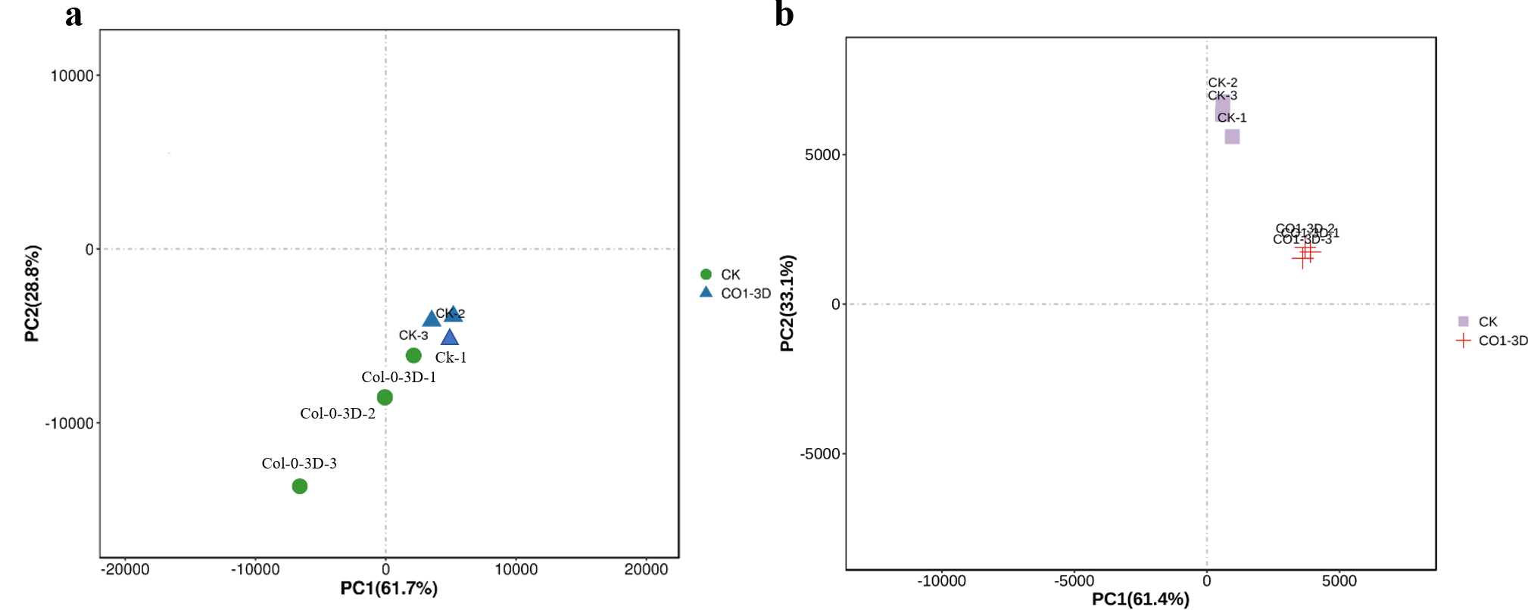
Supplementary Figure 1. The PCA analysis.
a. The gene translation information and (b) mRNA abundance was used to carry out Principal Component Analysis (PCA) using R (http://www.r-project.org/) in order to study the distance relationship between samples with the intention of reducing the dimensionality of the data in CK (normal growth) and Col-0 3D (simulated microgravity) samples. This method employs variance decomposition to identify the most significant elements and structures in the data, reflecting the intricate composition relationship between samples. This is achieved by analyzing the two eigenvalues of the horizontal and vertical coordinates, which effectively reveal the aggregation pattern of samples from complex data. The results demonstrate that samples with similar compositions tend to cluster closely in the PCA plot, while samples from different effective treatments exhibit their own aggregated distribution.
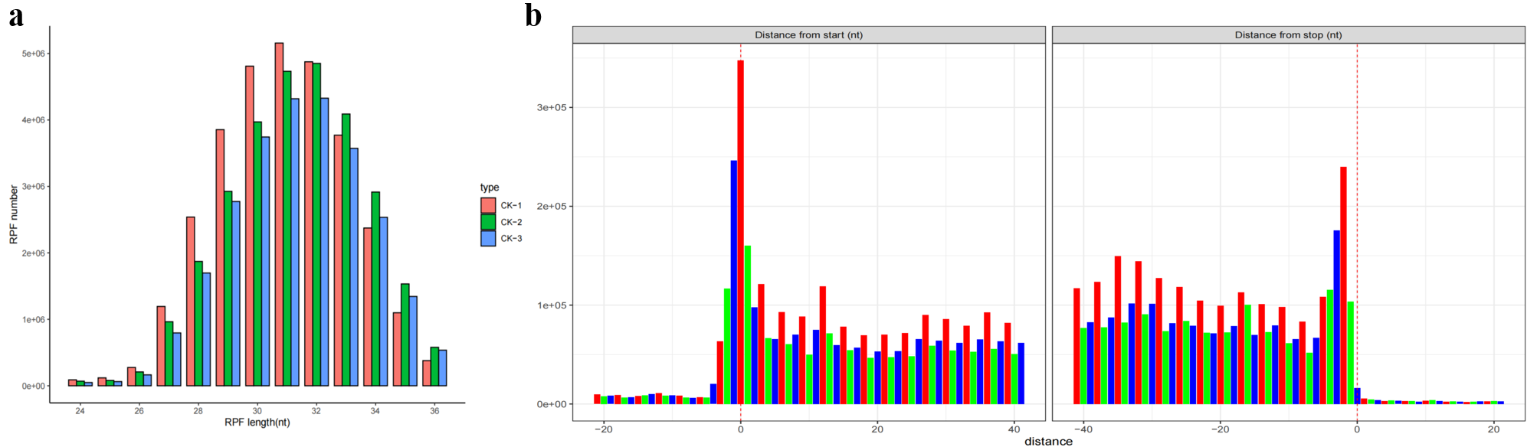
Supplementary Figure 2. The characteristics of ribosome profiling data in normal growth Arabidopsis seedling root.
(a) Length distribution of ribosome protected fragments (RPFs) in normal growth Arabidopsis seedlings. The read, green and bule bars refer to three biological replicates. (b) Three-nucleotide periodicity at the first 40 nt and the last 40 nt of CDS in normal growth Arabidopsis seedlings.
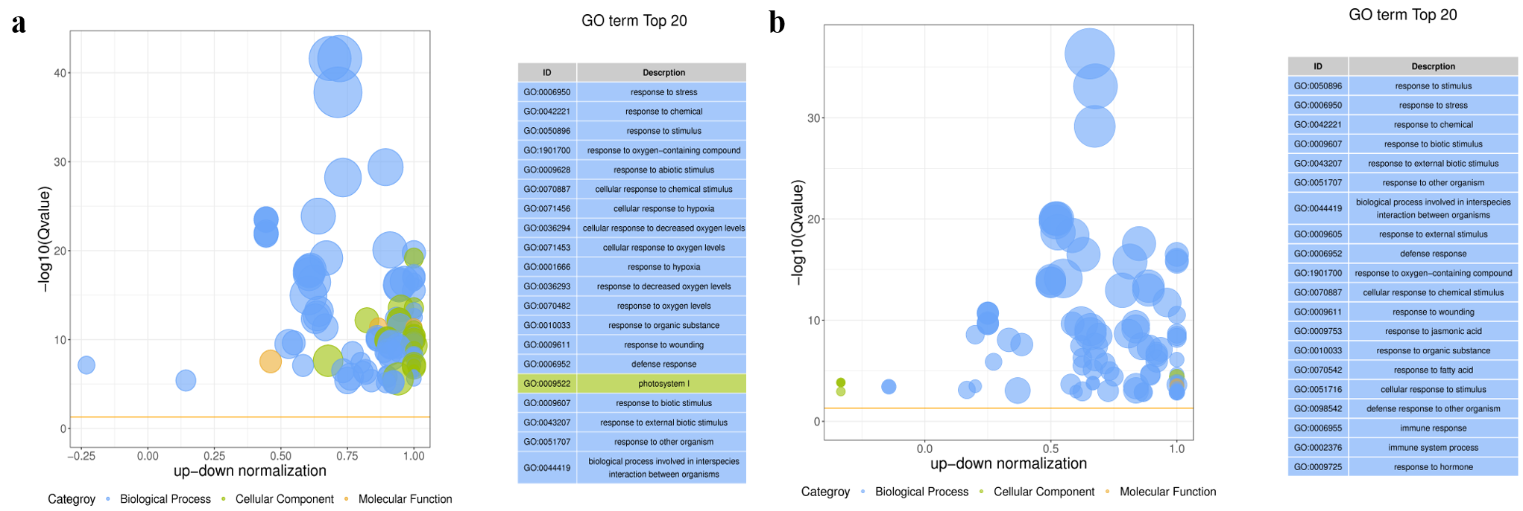
Supplementary Figure 3. The Gene Ontology (GO) analysis of altered translational and transcriptional genes.
The Gene Ontology (GO) is an internationally standardized classification system for gene function. It provides a dynamically updated controlled vocabulary to comprehensively describe the attributes of genes and gene products in organisms. GO has three ontologies, which describe the molecular function, cellular component, and biological process of a gene. The fundamental unit of GO is the term (term, node), with each term corresponding to an attribute. GO functional analysis provides both categorical annotation of GO functions of genes and significance enrichment analysis of GO functions of genes. Firstly, the differential genes are mapped to each term of the GO database (http://www.geneontology.org/) and the number of differential genes in each term is calculated, thus obtaining the statistics of the number of differential genes in the list of differential genes with a certain GO function. Hypergeometric tests are then applied to identify GO entries that are significantly enriched in differential genes compared to background.
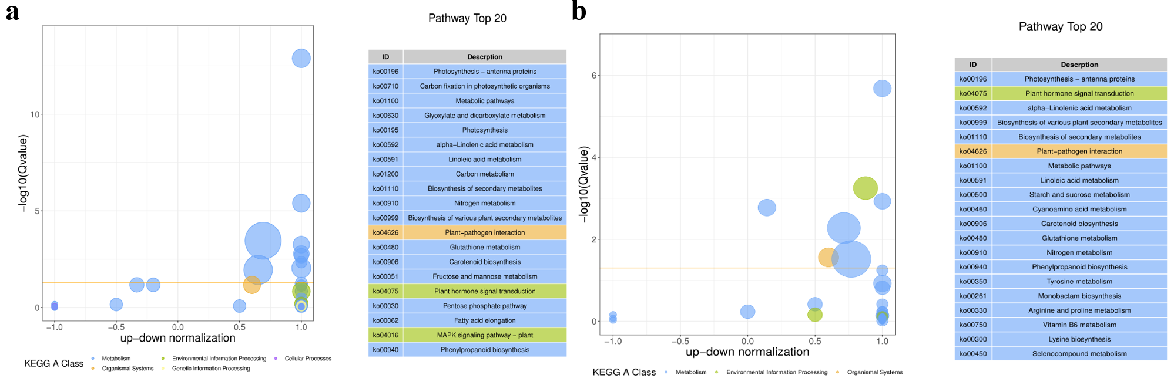
Supplementary Figure 4. The KEGG enrichment analysis of altered translational and transcriptional genes.
In organisms, different genes interact with each other to perform their biological functions. Pathway-based analysis is a useful approach for further understanding the biological functions of genes. KEGG is the primary public database on pathways. Pathway significance enrichment analysis was performed using KEGG Pathway as a unit, and hypergeometric test was used to identify pathways that were significantly enriched in different genes compared with the whole background. The pathway-level significant enrichment can identify the principal biochemical metabolic pathways and signal transduction pathways involved in the differential genes.
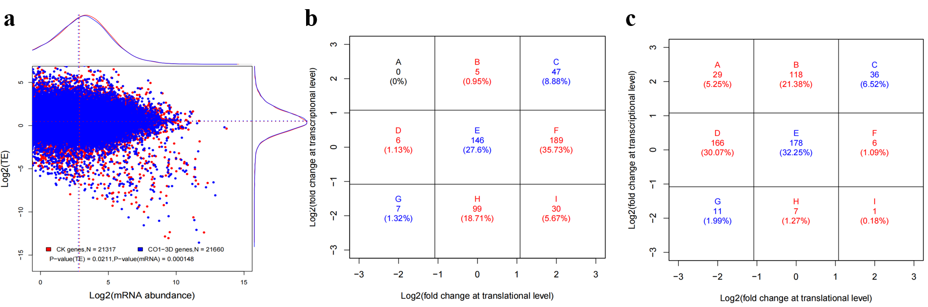
Supplementary Figure 5 The global distribution of translational efficiency (TE) in normal growth and simulated microgravity seedling roots.
a. presenting an overview of the log2-transformed TE and corresponding mRNA abundance. Genes in normal growth and simulated microgravity seedling roots are represented by red and blue spots, respectively, with the density of TE and mRNA abundance shown along the axes. The distribution of genes with (b) decreased TE and (c) increased TE in nine responsive patterns and the distribution of genes with increased TE in nine responsive patterns are illustrated. The numbers of genes with increased and decreased TE were obtained from Figure 5b, with the nine responsive groups labeled from group A to group I.
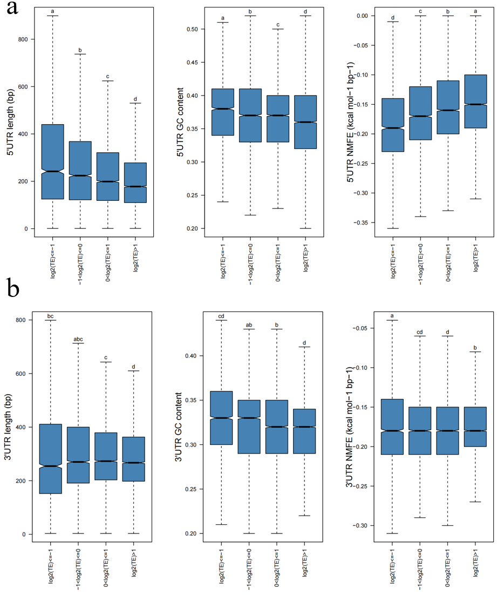
Supplementary Figure 6. The transcription efficiency (TE) of genes in normal growth seedling roots
The transcription efficiency (TE) of genes is influenced by sequence features such as NMFE, sequence length, and GC content in different TE groups based on log2(TE) values. The NMFE, sequence length, and GC content features of the (a) 5′ UTR, and (b) 3′ UTR in different TE groups in normal growth seedlings are shown. The letters a, b, and c indicate significant differences as determined by Student's t-test (p-value).
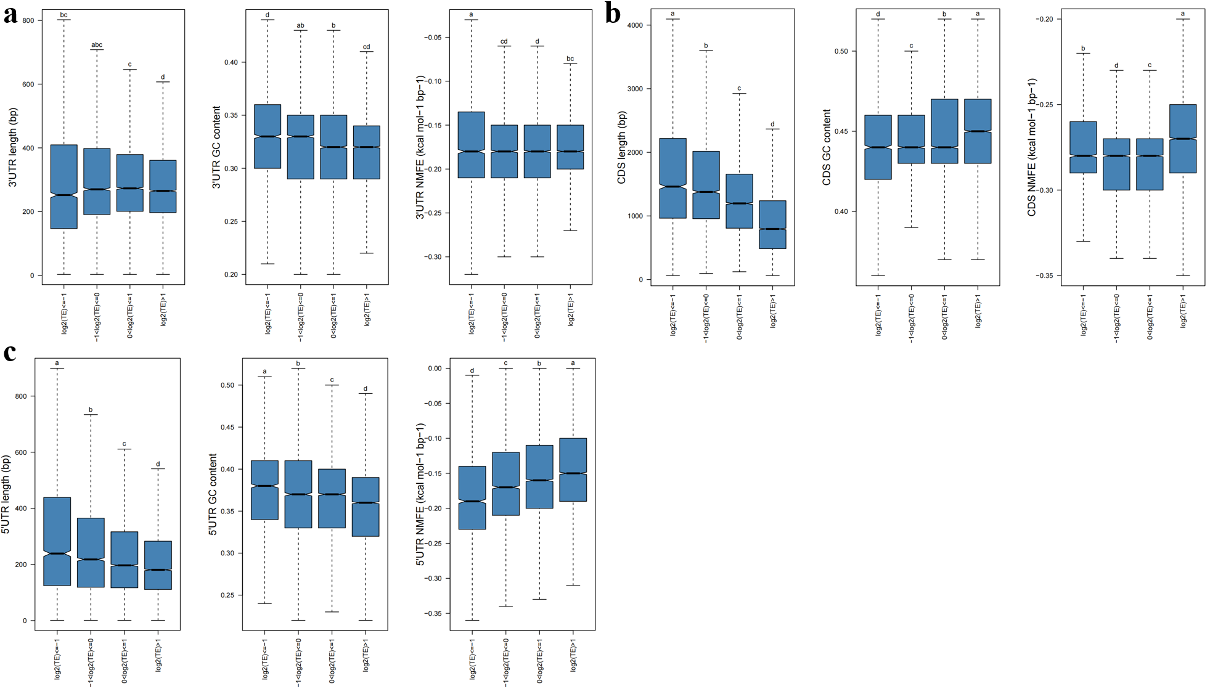
Supplementary Figure 7. The transcription efficiency (TE) of genes in simulated microgravity seedling roots.
The transcription efficiency (TE) of genes is influenced by sequence features such as NMFE, sequence length, and GC content in different TE groups based on log2(TE) values. The NMFE, sequence length, and GC content features of the 5′ UTR in different TE groups in normal growth samples are displayed in Figures d, e, and f, respectively. Furthermore, the NMFE, sequence length, and GC content features of the (a) 3′ UTR, (b) CDS, and (c) 5′ UTR in different TE groups in simulated microgravity seedlings are shown. The letters a, b, and c indicate significant differences as determined by Student's t-test (p-value).
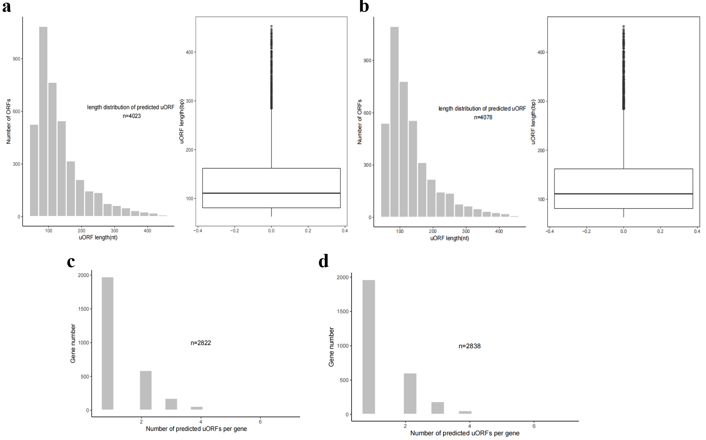
Supplementary Figure 8. The genome-wide prediction of upstream open reading frames (uORFs).
The figure indicates the length distribution of all predicted uORFs, statistics for the number of predicted uORFs per gene, and the length distribution of translated uORFs in the normal growth (a, c) and simulated microgravity (b, d) seedling roots.
Supplementary Table 1. Alignment statistics for Ribosome Profiling reads.
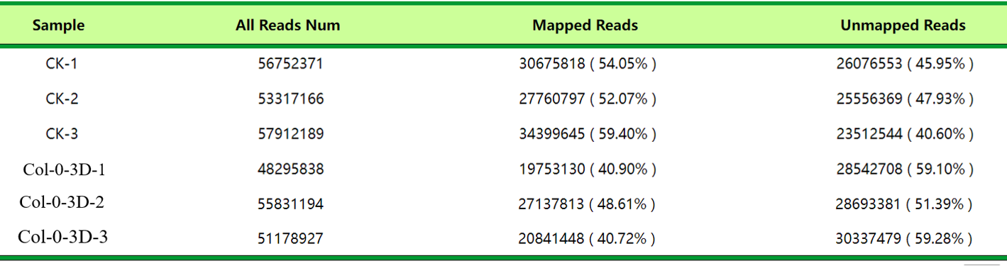 Mapping efficiency was defined as the total number of mapped reads (including unique and multiple mapped reads) divided by the number of total inputs reads in CK (normal growth) and Col-0 3D (simulated microgravity) samples. Unique mapping efficiency was the proportion of unique reads divided by total mapped reads.
Supplementary Table 2. Alignment statistics for RNA-seq reads.
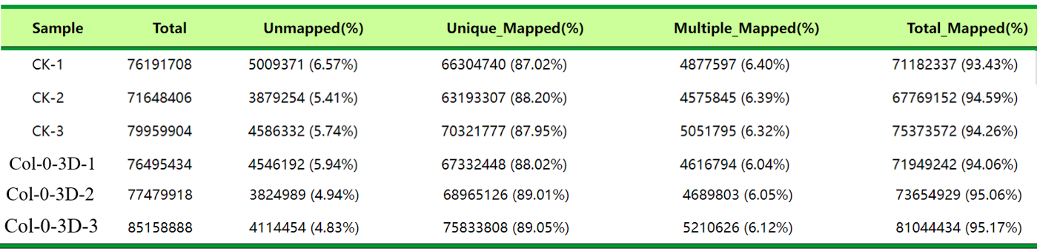 Mapping efficiency was defined as the total number of mapped reads (including unique and multiple mapped reads) divided by the number of total inputs reads in CK (normal growth) and Col-0 3D (simulated microgravity) samples. Unique mapping efficiency was the proportion of unique reads divided by total mapped reads.

