Global analysis of countries’ exposure to climate driven simultaneous staple crop failures: Supplementary Information
Anna Murgatroyd^{1,*}, Jasper Verschuur², Kyle Frankel Davis^{3,4}, Marta Tuninetti⁵ and Jim W. Hall⁶

¹ School of Engineering, Newcastle University, Newcastle upon Tyne, United Kingdom
² Delft University of Technology, Delft, Netherlands
³ Department of Geography and Spatial Sciences, University of Delaware, USA
⁴ Department of Plant and Soil Sciences, University of Delaware, USA
⁵ Department of Environment, Land and Infrastructure Engineering, Politecnico di Torino, Italy
⁶Oxford Programme for Sustainable Infrastructure Systems (OPSIS), Environmental Change Institute, University of Oxford, Oxford, United Kingdom

*corresponding author: anna.murgatroyd@newcastle.ac.uk
School of Engineering, Newcastle University, Newcastle upon Tyne, NE1 7RU, United Kingdom

Supplementary Figures
Trade network adjustments, such as those observed in the last decade, may exacerbate or dampen a country’s exposure to disruptions in staple crop production. Figure S1 and S2 mirror those presented in the main manuscript, but use 2012-2016 trade network data instead of more recent 2017-2021 trade network data.
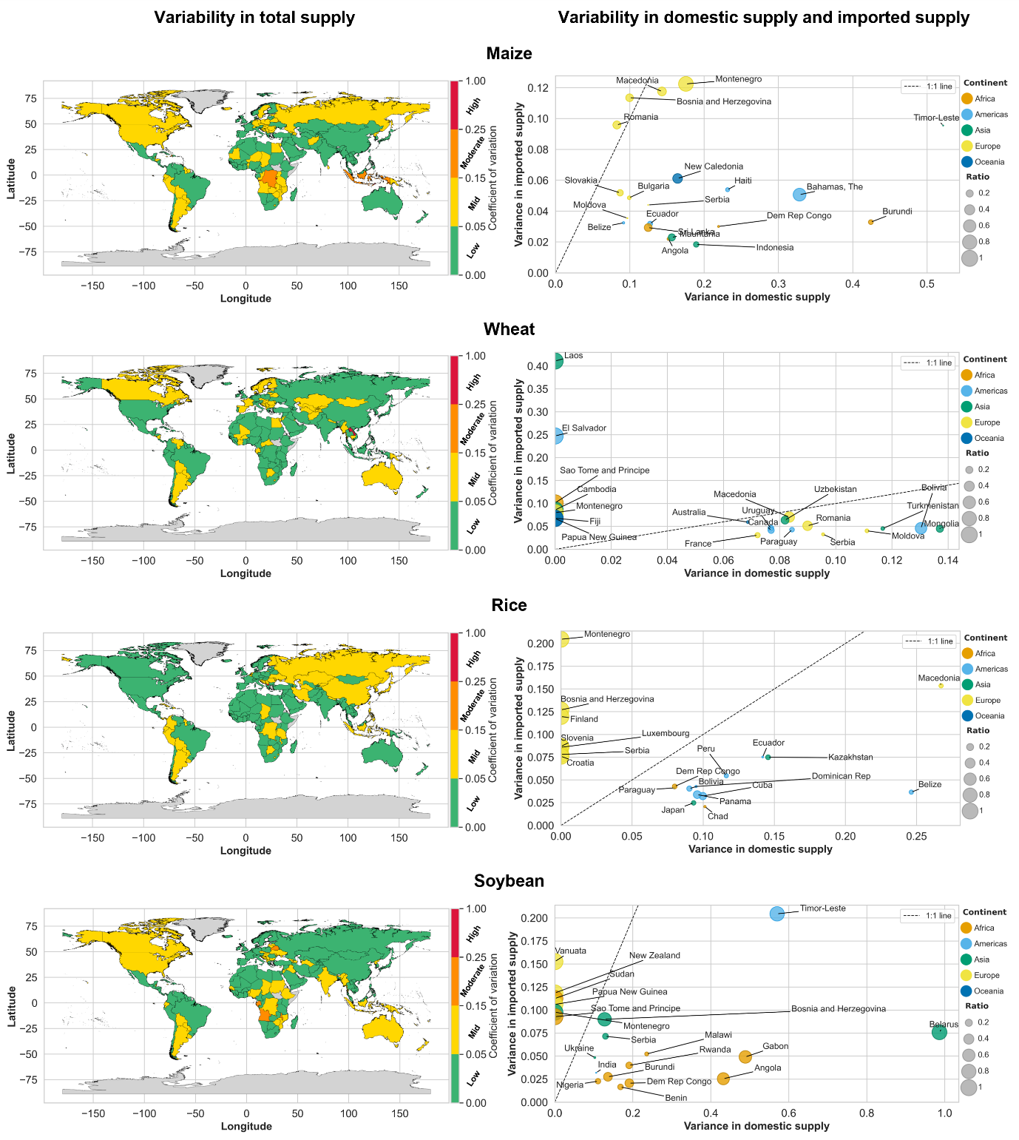
Figure S1. (Left) Country level variability in total supply of imported and domestic staple crops, where variability is measured by the coefficient of variation. Crop variability is divided into four categories: low, mid, moderate and high. (Right) Coefficient of variation of domestic crop production and imported supply of the top 20 ranked countries by variability in total supply. Scatter points are shaded by continent, and scaled by the ratio of imported crop tonnage to total crop supply, where a large circle indicates a high import ratio. Metrics illustrated use 2012-2016 trade network data.

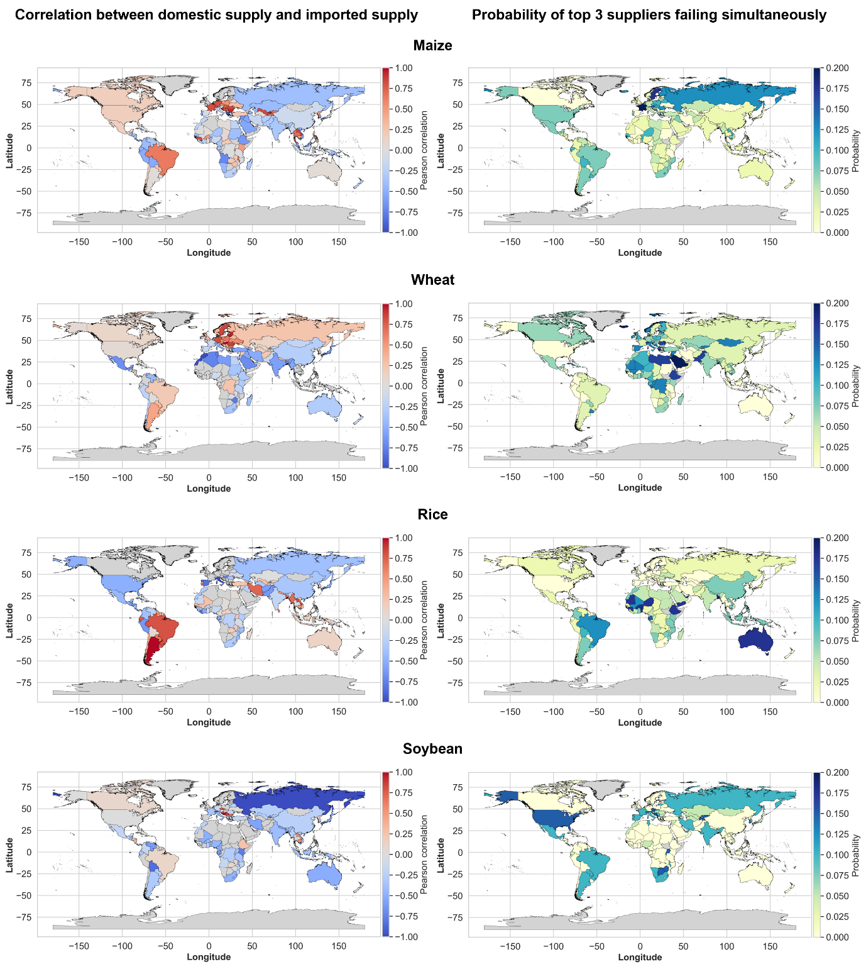
Figure S2. (Left) Probability of an importing country’s top three suppliers failing simultaneously. (Right) Pearson correlation between domestic production and production in a country’s food import supplying countries. Metrics illustrated use 2012-2016 trade network data.

